Case Report

Non-surgical periodontal management of nifedipine-
Induced gingival overgrowth: A case report

.
ABSTRACT

Introduction
Gingival overgrowth is a common adverse effect associated with long-term use of antihypertensive, anticonvulsant, and immunosuppressant drugs, influenced by drug-related factors and periodontal status.
Case Presentation
A 40-year-old patient presented with nifedipine-induced gingival enlargement affecting function, aesthetics, and oral hygiene. Nonsurgical periodontal therapy, including scaling, root planing, and oral hygiene reinforcement, was performed without altering medication.
Discussion
Progressive reduction in gingival overgrowth was observed, with complete resolution achieved through meticulous plaque control and regular supportive periodontal therapy, avoiding surgical intervention.
Conclusion
Nonsurgical management can effectively treat drug-induced gingival overgrowth, with long-term stability achievable through consistent maintenance and patient compliance.

Keywords: Gingiva Hyperplasia, Nifedipine/Adverse Effects, Periodontal pocket, Calcium Channel Blockers, Oral Hygiene/ Education, Plaque prevention & control.

1. INTRODUCTION

An increasing number of pharmacological agents have been implicated in the development of gingival enlargement. In the context of drug-induced gingival changes, the terms gingival enlargement or gingival overgrowth are now preferred, replacing the previously used terms gingival hyperplasia and gingival hypertrophy. These earlier terminologies are considered less accurate, as they do not adequately represent the complex histological characteristics of gingival tissues altered by pharmacological influences.¹ More than 20 drugs associated with gingival enlargements. Anticonvulsants, immunosuppressives, and antihypertensive medicines are the three primary pharmacological classes.² Gingival overgrowth does not develop in all individuals receiving these medications, and among affected patients, the degree and severity vary considerably. Nifedipine, a widely prescribed calcium channel blocker, is commonly used in the management of hypertension and certain types of angina. Among its several side effects, enlargement of the gingiva is the most notable and clinically significant in dentistry. This condition, linked to nifedipine use, was first documented in 1984.³
Different treatment options can be suggested to manage gingival overgrowth; they can be categorized as nonsurgical approach and surgical approach. The nonsurgical approach focuses on controlling the inflammatory element of the gingiva, while the surgical approach is used to remove the fibrotic portion in cases of marked severity unresponsive to conservative measures.⁴ This case report highlights the successful nonsurgical management of nifedipine- induced gingival overgrowth, monitored over a 2-year follow-up period.

2. Case description

A 40-year-old female reported with a chief complaint of swollen and bleeding gums in both the upper and lower jaws, persisting for the past one year. Her medical history indicated a diagnosis of hypertension ten years prior, for which she had been on nifedipine therapy since then. On general examination, the patient appeared moderately built and adequately nourished.
Intraoral examination revealed generalized gingival enlargement involving the maxillary and mandibular arches, affecting the marginal gingiva, attached gingiva, and interdental papillae. The enlargement was most pronounced in the mandibular anterior region and less severe in the right maxillary and mandibular quadrants. Clinical examination revealed diffusely enlarged gingiva that was pale pink, firm in consistency, and exhibited irregular contours partially covering the tooth crowns (Figure 1).
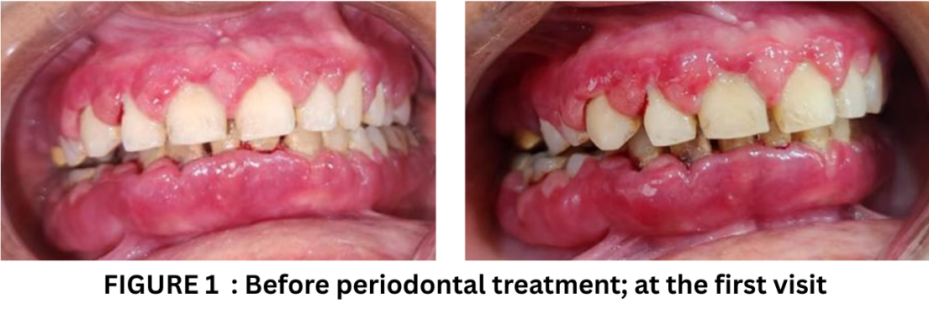

The tissues showed profuse bleeding on provocation, with increased probing depths and accumulation of plaque and calculus. The patient reported difficulty in mastication and speech, challenges in maintaining oral hygiene, and expressed concerns regarding esthetics. Additionally, she complained of halitosis and bleeding gums during toothbrushing. Correlating the history and clinical examinations, the case was diagnosed as combined gingival enlargement.
The management approach involved nonsurgical periodontal therapy, beginning with oral hygiene instructions, followed by full-mouth scaling and root planing, along with polishing of all rough dental surfaces and systemic antibiotics, Doxycycline 100mg for 5 days. At the 2- month recall, a substantial reduction in gingival inflammation was observed, along with notable improvement in periodontal health and oral hygiene maintenance. Accordingly, a supportive periodontal therapy regimen was initiated, which included reiteration of oral hygiene instructions and full-mouth scaling at 6-month intervals. This comprehensive approach led to total remission of the gingival overgrowth, thereby obviating the need for surgical management. or modification of the patient’s medication. At the end of 2 years, favourable condition of the gingival health was achieved with NSPT and supportive periodontal therapy.

3. discussion

Nifedipine is a calcium channel blocker, prescribed for the management of hypertension and some forms of angina. Long term use of nifedipine is associated with gingival overgrowth and its prevalence varied from 14%12 to 83%.^{5,6} The first reported case of gingival hyperplasia due to nifedipine use was reported by Lederman et al. in 1984.⁷ Drug-induced gingival overgrowth is multifactorial in origin. Non-modifiable risk factors include age and genetic predisposition, whereas modifiable factors comprise tooth morphology, poor oral hygiene, pharmacokinetic variables, existing periodontal disease, increased probing pocket depth, as well as the duration and dosage of the drug; additionally, the drug’s effect on growth factors further influences the pattern and severity of the condition.⁸ Drug-induced gingival enlargement may become clinically evident as early as 1–3 months following the initiation of calcium channel blocker (CCB) therapy. The enlargement may present as either localised or generalised and typically begins with the expansion of the interdental papilla. Over time, it may progress into a lobulated or nodular mass involving both the marginal and interdental gingiva. In the present case, the enlargement was most pronounced in the mandibular anterior region and comparatively less severe in the right maxillary and mandibular quadrants. Marked gingival overgrowth can create areas that are difficult to access during routine oral hygiene practices. Consequently, the enlarged gingival tissues provide a favourable environment for dental plaque accumulation, thereby increasing the risk of inflammation. Inadequate oral hygiene further exacerbates this condition, as plaque-induced inflammation can intensify the gingival overgrowth associated with ongoing pharmacological therapy.
Typically, the condition manifests as ‘pseudo’ pockets caused by gingival overgrowth beneath the gingival margin, producing deeper probing depths without significant attachment loss. In certain instances, the overgrowth may extend over the tooth crowns, even reaching the occlusal surface and causing masticatory interference, as observed in the present case.
Although calcium channel blockers (CCBs) exert no direct effect on the alveolar bone, the associated gingival enlargement can promote bacterial biofilm accumulation and hinder effective oral hygiene, thereby increasing the risk of persisting inflammation, periodontitis, alveolar bone and tooth loss, as well as halitosis.⁶
Numerous postulates have been proposed to explain the etiopathogenesis of calcium channel blocker (CCB)-induced gingival overgrowth. Among these, the most extensively studied mechanisms involve the roles of matrix metalloproteinases (MMPs), pro-inflammatory cytokines, and gingival fibroblasts.^{11,12,13}
Therapeutic strategies for periodontal management range from non-surgical interventions to comprehensive approaches that integrate both non-surgical and surgical modalities. A multidisciplinary approach, coupled with early intervention in cases of drug-induced gingival enlargement, offers the greatest potential for favourable clinical outcomes [15]. Phase I periodontal therapy should prioritise meticulous oral hygiene practices, including structured oral hygiene instruction (OHI) and repeated sessions of scaling and root planing. This initial therapeutic approach has been shown to be effective, with the potential to reduce gingival enlargement by up to 40% [16].
A thorough scaling and root planing (SRP) combined with proper oral hygiene instruction can often eliminate the need for surgical approach in cases of drug-induced gingival enlargement. In the present scenario, drug substitution was not considered or implemented in this case. The patient was subjected to mechanical therapy (SRP) for the removal of the local factors along with systemic antibiotics (doxycycline 100mg, once daily, for 5 days). The patient received strict instructions on maintaining proper oral hygiene at home, including the correct brushing technique. At a 15-day follow-up, a reduction in inflammation was noted, especially in the mandibular arch. At 6 months the patient demonstrated marked reduction in gingival inflammation, improved plaque control, better oral hygiene practices, and overall good gingival health. Thorough subgingival scaling and curettage was performed every six months, and the patient remained under regular follow-up for two years. At the end of 2- year follow-up, a drastic reduction in gingival size was observed (Figure 2 & 3), attributed to multiple SRP sessions, strict oral hygiene instructions, and improved patient compliance. Non-surgical management of DIGO is a significantly less invasive approach compared to surgical methods and can yield favorable treatment outcomes.
Evidence in the literature supports the effectiveness of NSPT in the management of drug-induced gingival overgrowth without the need for surgical intervention. Sam G and Sebastian SC ¹⁷ demonstrated that thorough scaling, root planing, and improved oral hygiene can result in significant reduction of nifedipine-induced gingival enlargement. Similarly, a systematic review and meta-analysis by Hu J et al.¹⁸ on cyclosporin A–induced cases highlighted that stringent plaque control combined with non-surgical periodontal therapy and supportive periodontal care plays a crucial role in reducing gingival overgrowth and maintaining long-term remission.

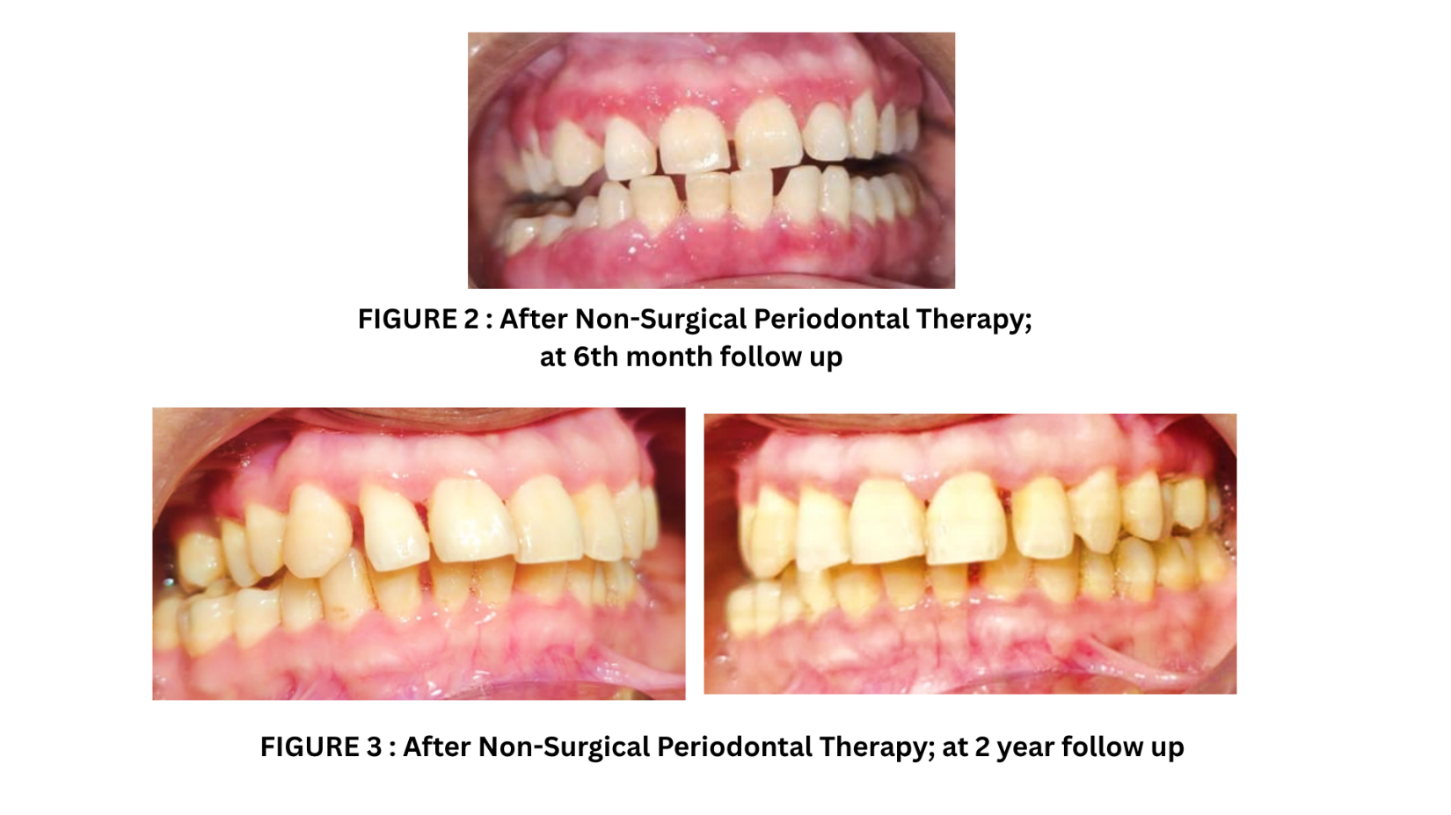

Supportive periodontal therapy (SPT) plays a crucial role in maintaining long-term gingival health following non-surgical periodontal treatment, particularly in cases of drug-induced gingival overgrowth. While initial therapy can significantly reduce inflammation and gingival enlargement, sustained improvements are highly dependent on regular follow-up care and meticulous oral hygiene practices. SPT helps in early detection and management of recurrent inflammation or overgrowth, ensuring periodontal stability.¹⁴ Equally important is the patient’s motivation and compliance, as consistent plaque control and adherence to professional maintenance schedules greatly influence treatment outcomes. Educating the patient about the relationship between medication use, oral health, and health of periodontal structures is vital for preventing recurrence and preserving gingival architecture.

4. Conclusion

Supportive periodontal therapy (SPT) plays a crucial role in maintaining long-term gingival health following non-surgical periodontal treatment, particularly in cases of drug-induced gingival overgrowth. While initial therapy can significantly reduce inflammation and gingival enlargement, sustained improvements are highly dependent on regular follow-up care and meticulous oral hygiene practices. SPT helps in early detection and management of recurrent inflammation or overgrowth, ensuring periodontal stability. Equally important is the patient’s motivation and compliance, as consistent plaque control and adherence to professional maintenance schedules greatly influence treatment outcomes. Educating the patient about the relationship between medication use, oral health, and health of periodontal structures is vital for preventing recurrence and preserving gingival architecture.

Consent
As per international standards or university standards, patient(s) written consent has been collected and preserved by the author(s).

Ethical Approval:

As per international standards or university standards written ethical approval has been collected and preserved by the author(s).

Disclaimer (Artificial intelligence)

Author(s) hereby declare that NO generative AI technologies such as Large Language Models (ChatGPT, COPILOT, etc.) and text-to-image generators have been used during the writing or editing of this manuscript.

References

- Informational Paper: Drug-Associated Gingival Enlargement. J Periodontol. 2004 Oct;75(10):1424-31.
- Bakshi SS, Choudhary M, Agrawal A, Chakole S. Drug-Induced Gingival Hyperplasia in a Hypertensive Patient: A Case Report. Cureus. 2023;15(2):e34558.
- Sunil PM, Nalluswami JS, Sanghar SJ, Joseph I. Nifedipine-induced gingival enlargement: Correlation with dose and oral hygiene. J Pharm Bioall Sci 2012;4:191-193.
- Mavrogiannis M, Ellis JS, Thomason JM, Seymour RA. The management of drug- induced gingival overgrowth. J Clin Periodontol. 2006 Jun;33(6):434-439.
- Eslami M, Baghaii F, Jalayer Nadery N. An Investigation on gingival hyperplasia induced by nifedipine. J Dent (Tehran) 2004:1:33-37.
- Livada R, Shiloah J. Calcium channel blocker-induced gingival enlargement. J Hum Hypertens.2014:28(1):10-14.
- Lederman D, Lumerman H, Reuben S, Freedman PD. Gingival hyperplasia associated with nifedipine therapy. Report of a case. Oral Surg Oral Med Oral Pathol.1984;57(6):620-622.
- Alanija L, Chandran Selvaraj RS, Ramamurthy S, Ulaganathan A, C V. The Management of Drug-Induced Gingival Enlargement in a Patient With Preexisting Periodontitis. Cureus. 2024 Jan 12;16(1):e52190.
- Bharti V, Bansal C. Drug-induced gingival overgrowth: The nemesis of gingiva unravelled. J Indian Soc Periodontol. 2013;17(2):182-187.
- Samudrala P, Chava VK, Chandana TS, Suresh R. Drug-induced gingival overgrowth: A critical insight into case reports from over two decades. J Indian Soc Periodontol.2016;20(5):496-502.
- Barclay S, Thomason JM, Idle JR, Seymour RA. The incidence and severity of nifedipine-induced gingival overgrowth. J Clin Periodontol. 1992; 19(5): 311–314.
- Johnson RB, Zebrowski EJ, Dai X. Synergistic enhancement of collagenous protein synthesis by human gingival fibroblasts exposed to nifedipine and interleukin-1-beta in vitro.J Oral Pathol Med. 2000;29(1):8-12.
- Pernu HE, Knuuttila ML, Huttenen KR, Tiilikainen AS. Drug-induced gingival overgrowth and class I1 major histocompatibility antigens. Transplantation.1994;57(12):1811-3.
- Silva SD, Hisse-Gomes G, Rilling-Nova Cruz LE, Aitken-Saavedra JP, Martos J. Non-surgical periodontal treatment for drug-influenced gingival enlargement: a four-year follow-up case report. International journal of interdisciplinary dentistry. 2021 Aug;14(2):184-6.
- Tonsekar, P.; Tonsekar, V. Calcium-Channel-Blocker-Influenced Gingival Enlargement: A Conundrum Demystified. Oral. 2021;1(3):236-249.

- Kantarci A, Cebeci I, Tuncer O, Carin M, Firatli E. Clinical effects of periodontal therapy on the severity of cyclosporin A-induced gingival hyperplasia. J Periodontol.1999;70(6):587-593.
- Sam G, Sebastian SC. Nonsurgical management of nifedipine induced gingival overgrowth. Case Rep Dent. 2014;2014:741402.
- Hu J, Ruan Y, Lin N, Zhang Y, Mao X, Bai J, Yang X, Liu S, Lv X. Non-surgical treatment of cyclosporin A-induced gingival overgrowth: A systematic review and meta-analysis. Medicine (Baltimore). 2025 Jul 18;104(29):e43434.

