Original Research Article

Comparative In vitro Analysis of Microbial Load Reduction on Dental Burs and Endodontic Files Following Different Decontamination Methods

.
ABSTRACT

Background: Dental instruments when reused poses significant risks of cross-infection. Autoclaving is the gold standard for sterilization, but repeated cycles can degrade the cutting efficiency of burs and files
Aims: This study aims to evaluate the sterilization efficacy of a chemically enhanced glutaraldehyde solution using a 4-hour immersion protocol, compared to standard moist heat sterilization and 70% alcohol.
Study design: In vitro Comparative study
Place and Duration of Study: Department of Pediatric and Preventive Dentistry, in collaboration with the Department of Microbiology, at Mar Baselios Dental College, between July 2025 and December 2025.
Methodology: A total of 120 clinically contaminated instruments (diamond burs, hand K-files, and rotary NiTi files) were divided into four groups (n=30): Group A (70% Isopropyl Alcohol), Group B (4-hr Glutaraldehyde solution), Group C (Autoclave) and Group D (Control). Post-treatment, samples were incubated in Brain Heart Infusion Broth and plated on Brain Heart Infusion (BHI) agar to quantify Colony Forming Units (CFU/mL)
Results: Both the Autoclave and 4-hour glutaraldehyde solution groups achieved complete elimination of viable microorganisms. Statistical analysis via ANOVA and Tukey's post-hoc test revealed no significant difference in efficacy between the two methods (P >.05). Conversely, 70% alcohol demonstrated significantly inferior performance, leaving residual contamination on all instrument types (P < .001).
Conclusion: The 4-hour glutaraldehyde protocol is an ideal decontamination method, demonstrating microbial reduction levels comparable to the efficacy achieved by autoclaving. This offers a time-efficient and non-corrosive alternative for maintaining the longevity of heat-sensitive dental instruments.

Keywords: Sterilization, Glutaraldehyde, Autoclave, Dental Burs, Endodontic Files, Microbial Load, Infection Control

1. INTRODUCTION

Decontamination is defined as the disinfection or sterilization of toxin or agent-contaminated articles to make them safe for use or disposal (Hawley and Kozlovac, 2005). In modern dental practice, the strict sterilization of instruments that enter sterile tissues or the vascular system is non-negotiable for the prevention of cross-contamination. Endodontic files and dental burs, often heavily contaminated with necrotic pulp tissue, blood, and saliva, pose a unique challenge due to their complex geometry and flutes, which can harbor pathogens such as Enterococcus faecalis and Candida albicans (Yenni et al.,2017; Pooja et al.,2022). Recent investigations have further complicated this paradigm by demonstrating that even newly manufactured, seemingly pristine endodontic files frequently harbor viable bacterial spores directly from their commercial packaging, mandating rigorous pre-sterilization before their first clinical application (Surender et al., 2023). Furthermore, the microscopic surface roughness and topographical irregularities of these metallic instruments heavily dictate the degree of debris retention, rendering basic wiping or soaking protocols highly unpredictable (Almohareb et al., 2025). While liquid chemical sterilization, often referred to as cold sterilization, is a common alternative to heat-based methods, its protocols remain inconsistent. Previous literature indicates that standard 2% glutaraldehyde requires a full 12-hour immersion to achieve complete sterilization, whereas shorter durations, such as 30 minutes, have been proven unreliable for eliminating resistant microbial loads. (Yenni et al.,2017; Kumar et al 2015). This significant variability necessitates a standardized, time-efficient protocol that bridges the gap between efficacy and clinical practicality. To address this, enhanced aldehyde formulations have been developed that combine glutaraldehyde with synergists like 1,6-dihydroxy-2,5-dioxahexane. These chemically advanced solutions are designed to achieve sporicidal activity in just 4 hours while incorporating corrosion inhibitors to protect delicate instruments. Despite the moist heat sterilization method, autoclaving remains the gold standard for infection control, but has notable demerits regarding instrument longevity. Repeated exposure to high temperatures up to 121°C and pressure often leads to the corrosion of carbon steel and the dulling of cutting edges on NiTi files, significantly reducing their clinical lifespan and efficiency (Zhao et al., 2016). Consequently, there is a pressing need for a sterilization method that balances high-level disinfection with instrument preservation. Therefore, the rationale of this study was to identify a reliable alternative that mitigates thermal damage without compromising patient safety. The aim of this in vitro comparative study was to evaluate whether the alcohol and 4-hour glutaraldehyde solution can match the decontamination efficacy of the standard autoclave on contaminated dental burs and endodontic files.

2. Materials and methods

This in vitro study was conducted at the Department of Pediatric and Preventive Dentistry in collaboration with the Department of Microbiology at Mar Baselios Dental College, Kothamangalam, Ernakulam. The research was carried out over six months from July 2025 to December 2025, following ethical approval from the Institutional Review Board with Project number IEC/MBDC/022025/31. The sample size was determined using G*Power software (α = 0.05, power = 80%, anticipated large effect size f = 0.53), which yielded a minimum requirement of 10 instruments per subgroup. A total sample size of 120 instruments, was selected from dental procedures performed in 30 individuals, comprising of 40 Dental Diamond Burs (Mani, Inc., Tochigi, Japan), 40 Stainless Steel Hand K-files (Size 20, 21 mm; Mani, Inc., Tochigi, Japan) and 40 Rotary NiTi Files (ProTaper Gold; Dentsply Sirona, Ballaigues, Switzerland). All instruments were subjected to a standard pre-sterilization cycle before clinical use. The study samples were retrieved immediately following routine dental procedures, specifically cavity preparation using dental burs and biomechanical root canal preparation using endodontic files. Following the collection, instruments were rinsed with sterile Phosphate-Buffered Saline (PBS) to eliminate gross organic debris. To purposefully simulate a worst-case clinical scenario of bioburden challenge, mechanical cleaning via manual scrubbing or ultrasonic baths was intentionally omitted before the decontamination protocols. Each type of instrument (n=40) was randomly divided into four groups consisting of 10 instruments per group, representing 10 samples from different individuals, using a computer-generated random number table to ensure unbiased allocation. Group A included instruments decontaminated with alcohol. Instruments were fully immersed in a sterile glass container containing 70% Isopropyl Alcohol for 15 minutes. After immersion, instruments were retrieved aseptically, rinsed in distilled water and allowed to air-dry. Group B (Korsolex Rapid), instruments were immersed in a 5% solution of Korsolex Rapid (Bode Chemie/Raman & Weil) for 4 hours as per the manufacturer's guidelines. Following immersion, the instruments were retrieved using an aseptic technique and rinsed with sterile distilled water. Group C (Autoclave) instruments were packaged and sterilized in an autoclave (Tanda, 23 L; Woson Medical Instrument Co., Ltd., China) at 121°C and 15 psi for 30 minutes. Contaminated instruments of Group D (Control) received no decontamination treatment to serve as a baseline for microbial load.

2.1 Microbiological Analysis

Under sterile conditions, each instrument was transferred to a test tube containing 4mL Brain Heart Infusion (BHI) Broth and incubated at 37 °C for 24 hours. Following incubation, a 100 μL aliquot from each tube was lawn cultured onto Brain Heart Infusion agar and incubated for 24 hours at 37 °C. Colonies were quantified using a digital colony counter, and CFU/mL were calculated.
2.2 Statistical Analysis

Data were recorded in Microsoft Excel and analyzed using SPSS. The comparison of mean microbial growth (CFU/mL) across the four sterilization groups (Autoclave, Korsolex, Alcohol, and Control) for burs, hand files and rotary files was performed using One-Way Analysis of Variance (ANOVA), followed by Tukey's post-hoc test for pairwise comparisons between the specific groups. A P-value of less than 0.05 (P<0.05) was considered statistically significant.

3. results and discussion

Microbial load was quantitatively evaluated for hand files, rotary files and dental burs across the three decontamination and control groups. Results are presented as mean microbial growth (CFU/mL), and were compared and evaluated across the study groups.

Assessment of Microbial Load Reduction

Hand Files

In the Hand Files group, the control specimens exhibited a mean microbial count of 1.18 × 10³ CFU/mL. The Alcohol group showed a reduction in microbial load, with a mean of 1.01 × 10² CFU/mL. In contrast, both the Glutaraldehyde and Autoclave groups achieved complete sterilization, demonstrating no microbial growth.

Rotary Files

For Rotary files, the control group showed a mean microbial growth of 1.14× 10³ CFU/mL. The Alcohol disinfection resulted in a mean count of 2.25× 10¹ CFU/mL. Consistent with the hand files, both the Glutaraldehyde and Autoclave groups showed complete elimination of microorganisms.

Dental Burs

The control samples showed a mean growth of 1.14× 10³ CFU/mL. The Alcohol group had a mean load of 2.59× 10¹ CFU/mL. However, the Glutaraldehyde and Autoclave groups both demonstrated superior efficacy with no microbial growth.

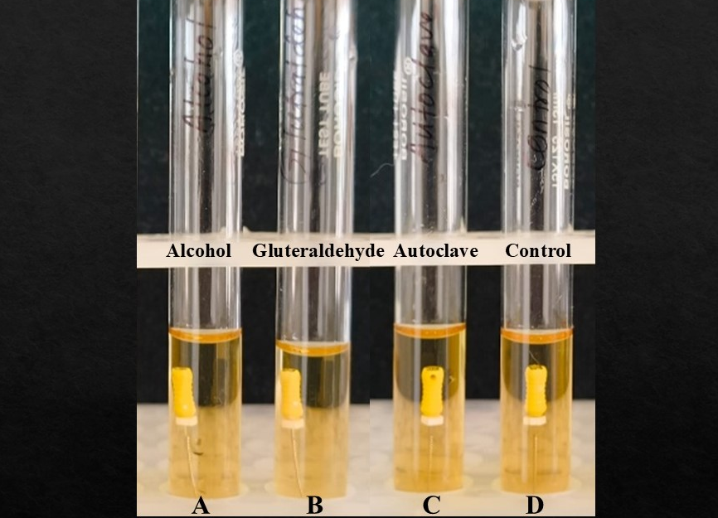

Fig 1: Post-incubation BHI broth containing endodontic hand files following decontamination protocols, along with the control group, before CFU analysis

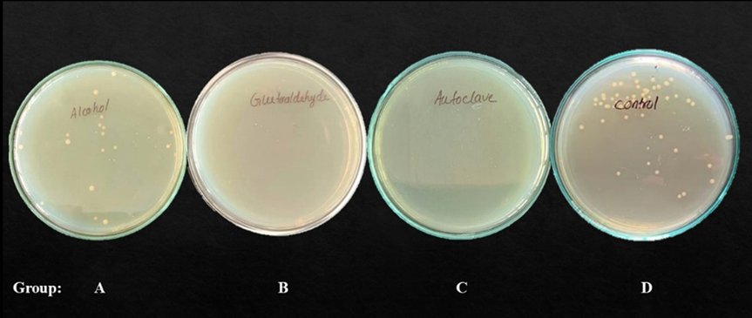

Fig 2: BHI agar plates showing microbial growth after different decontamination protocols

Table 1: Microbial load (CFU/mL) following various decontamination protocols across endodontic hand files, rotary files and dental burs.

Bacterial growth in Hand files
 | Number | Mean | S. D | S. E
Alcohol | 10 | 1.01×10¹ | 1.14×10¹ | 0.36×10¹
Glutaraldehyde | 10 | 0 | 0 | 0
Autoclave | 10 | 0 | 0 | 0
Control | 10 | 1.18x10³ | 0.11×10³ | 0.035×10³
Bacterial growth in Rotary files
 | Number | Mean | S. D | S. E
Alcohol | 10 | 2.25 × 10¹ | 2.72 × 10¹ | 0.86× 10¹
Glutaraldehyde | 10 | 0 | 0 | 0
Autoclave | 10 | 0 | 0 | 0
Control | 10 | 1.14 ×10² | 0.72× 10² | 0.22× 10²
Bacterial growth in Burs
 | Number | Mean | S. D | S. E
Alcohol | 10 | 2.59× 10¹ | 2.51× 10¹ | 0.79× 10¹
Glutaraldehyde | 10 | 0 | 0 | 0
Autoclave | 10 | 0 | 0 | 0
Control | 10 | 1.14 × 10³ | 0.58× 10² | 0.18× 10²

3.1 Statistical inference

One-way ANOVA indicated significant differences in microbial reduction across all three instrument categories: Hand files (F = 7.814, P = .002), Rotary files (F = 6.806, P=.004), and Dental burs (F = 10.642, P< .001). The analysis revealed that both the Autoclave and Glutaraldehyde groups achieved identical performance, with complete elimination of microbial growth. Tukey's post-hoc analysis confirmed the absence of any statistically significant difference between these two methods (P > .05), confirming their equivalent efficacy, regardless of the instrument’s surface geometry. Alcohol was significantly better than control and consistently demonstrated residual contamination, with mean values ranging from 1.01 × 10² to 2.59× 10¹ CFU/mL. Post-hoc comparisons statistically confirmed that while alcohol significantly reduced microbial load compared to the control (P < .05), it is significantly inferior to both autoclaving and glutaraldehyde immersion (P < .001), rendering it inadequate for the decontamination of complex dental instruments.

4. DISCUSSION

The primary objective of this study was to identify a sterilization protocol that ensures patient safety while preserving the longevity of delicate dental instruments. Our results confirm that Korsolex Rapid (Raman and Weil Pvt, India), when used for 4 hours, achieves complete elimination of viable microbes from naturally contaminated dental instruments, with the same efficacy as the gold standard, autoclave. A key strength of this study lies in its use of naturally contaminated instruments rather than those inoculated with a single laboratory strain. Different bacterial strains were obtained from dental instruments during the study, consistent with the complex oral microflora and pathogenic species. The control plates revealed heterogeneous microbial growth, including Streptococcus spp., Micrococcus spp., Staphylococcus spp., Enterococcus faecalis and Candida albicans. Recent literature emphasizes the necessity of this realistic approach. Scanning electron microscopy (SEM) evaluations have revealed that clinically utilized endodontic instruments remain heavily coated with stubbornly adherent biological remnants, even following standard processing procedures (Almehmadi & Alghamdi, 2022). Furthermore, contemporary reviews highlight that the microbial load on reusable dental instruments is highly resilient; pathogens construct tenacious biofilms that frequently survive standard manual cleaning protocols and act as dangerous reservoirs for cross-contamination (Patiño-Marín et al., 2025). By challenging sterilization protocols with this realistic, polymicrobial bioburden, we validated the broad-spectrum, penetrative capacity of the 4-hour Korsolex protocol against the varied pathogens encountered in daily practice. Traditional clinical paradigms often assume that brand-new files extracted straight from commercial packaging are inherently sterile. However, recent in vitro microbiological profiling of freshly opened endodontic blister packs has conclusively shattered this assumption by revealing a startling presence of aerobic spore-forming bacilli and Gram-positive cocci, likely stemming from residual manufacturing biofilms and non-sterile warehousing (Surender et al., 2023).Therefore, establishing a robust, non-degrading 4-hour chemical immersion protocol provides clinicians with a highly practical mechanism to ensure the high-level baseline decontamination of newly purchased instruments before they are ever introduced into a patient's root canal system. The architectural design of endodontic files and dental burs significantly complicates decontamination because the intricate flutes of hand instruments frequently harbor biological remnants that are difficult to remove with standard cleaning protocols (Jovanović-Medojević et al., 2023). This challenge is magnified in rotary NiTi files, where complex kinematics inherently promote the retention of microbial loads (Küçükkaya Eren et al., 2021). Furthermore, advanced SEM and energy-dispersive X-ray (EDX) evaluations emphasize that the inherent microscopic surface roughness of these alloys actively traps calcium and phosphorus-rich dentinal debris. These analyses proved that basic chemical wiping or enzymatic spraying frequently fails to dislodge this trapped bioburden due to the microscopic asymmetrical valleys along the cutting blades. A successful cold sterilization chemical cannot merely wash the surface; it must possess an extremely low surface tension to deeply penetrate these microscopic anatomical crevices (Almohareb et al., 2025). Our results confirm that the enhanced glutaraldehyde successfully navigated these topographical barriers. Standard glutaraldehyde functions by alkylating the amino and sulfhydryl groups of proteins, a process that kills vegetative bacteria rapidly but requires up to 12 hours for spores (McDonnell & Russell, 2001). When reviewing contemporary literature, the efficacy of generic glutaraldehyde is highly inconsistent. For instance, an in vitro analysis comparing standard glutaraldehyde against autoclaving revealed residual microbial turbidity in the glutaraldehyde group, leading to the conclusion that it could not match the absolute efficacy of the autoclave (Ameer et al., 2022). The superior performance of Korsolex Rapid over conventional glutaraldehyde regimens aligns with its synergistic chemistry, specifically through the addition of 1,6-Dihydroxy 2,5-Dioxahexane. This synergistic combination facilitates faster penetration of the chemical into the microbial cell wall, effectively reducing the required sporicidal time to 4 hours. Goel et al. (2025) reported that 2.45% glutaraldehyde, when used for 4 hours, achieved 100% disinfection against E. faecalis, comparable to autoclaving and peracetic acid. While Goel et al. used generic glutaraldehyde, our study confirms that the specific dual-aldehyde formulation of Korsolex Rapid reliably achieves this result, offering a standardised commercial solution for clinicians. The sterilization failure reported by Yenni et al. (2017) can be attributed to their short 30-minute cycle, insufficient for reliable sporicidal activity. Conversely, Venkatasubramanian et al. (2010) demonstrated that even extending the immersion time to 12 hours achieved only 80% efficacy, mirrored by Raju et al. (2013). The poor performance of 70% isopropyl alcohol (Group A) corroborates the findings of Pooja et al., (2022) and Sajjanshetty et al., (2014) that alcohol acts primarily as a surface disinfectant, inadequate for complex critical instruments. It evaporates too rapidly to penetrate the debris-laden flutes of burs and files, making it unsuitable for critical instrument decontamination. This severe inadequacy is heavily corroborated by a recent real-world clinical survey, which evaluated contaminated dental burs retrieved directly from active daily practices. Their microbiological assessments revealed a disturbing 40.5% contamination rate, primarily featuring pathogenic Staphylococcus aureus and Bacillus species, on burs that had merely been wiped with alcohol or soaked in mild disinfectants without subsequent thermal processing. Our 77.4% reduction rate perfectly mirrors their clinical conclusion that non-pressurized, volatile chemical dips are fundamentally incapable of rendering highly abrasive dental burs safe for patient reuse (Alhamdani et al., 2024).

Clinically, the 4-hour Korsolex Rapid protocol offers a pragmatic “middle ground” for high-volume practices, matching the efficacy of autoclave, without thermal damage, minimizing corrosion risk and reducing the turnaround time compared with overnight glutaraldehyde immersion. This is particularly advantageous for instrument longevity, directly impacting procedural efficiency and cost. However, proper pre-cleaning remains indispensable, as organic debris can shield microorganisms and reduce disinfectant penetration. A primary limitation of this research is the reliance on aerobic culture techniques, which do not account for obligate anaerobes. Additionally, standard Colony Forming Unit (CFU) counts fail to detect viable but non-culturable (VBNC) bacteria. While these organisms remain metabolically active and potentially infectious, they can only be identified through molecular diagnostics. Consequently, we conclude that a 4-hour glutaraldehyde immersion provides high-level decontamination equivalent to the efficacy of autoclaving. Future research should utilize advanced molecular viability assays, such as Polymerase Chain Reaction (PCR), to monitor the degradation of pathogen DNA or RNA. Furthermore, incorporating Scanning Electron Microscopy (SEM) would allow for a detailed visual and quantitative assessment of surface wear, blade dulling, and micro-crack development in Nickel-Titanium (NiTi) files following thermal versus chemical processing.

5. CONCLUSION

In conclusion, Korsolex Rapid (4-hour immersion) represents a clinically viable sterilization method for dental burs and endodontic files, comparable in efficacy to the gold standard autoclave while offering superior instrument preservation through reduced corrosion risk and the avoidance of thermal damage. This enhanced dual-aldehyde formulation also provides a markedly shorter turnover time compared with traditional overnight glutaraldehyde protocols, whereas 70% isopropyl alcohol is insufficient for reliable decontamination of complex dental instruments and should not be used as a primary sterilization method.

CONSENT

Not applicable

ETHICAL APPROVAL

Applicable. IEC/MBDC/022025/31

COMPETING INTERESTS DISCLAIMER:
Authors have declared that they have no known competing financial interests OR non-financial interests OR personal relationships that could have appeared to influence the work reported in this paper.

Disclaimer (Artificial intelligence)

Author(s) hereby declare that NO generative AI technologies such as Large Language Models (ChatGPT, COPILOT, etc.) and text-to-image generators have been used during the writing or editing of this manuscript.

REFERENCES

Hawley, R.J., Kozlovac, J.P. (2005). Decontamination. In: Lindler, L.E., Lebeda, F.J., Korch, G.W. (eds) Biological Weapons Defense. Infectious Disease. Humana Press. https://doi.org/10.1385/1-59259-764-5:333

Yenni, M., Bandi, S., Avula, S. S., Margana, P. G., Kakarla, P., & Amrutavalli, A. (2017). Comparative evaluation of four different sterilization methods on contaminated endodontic files. CHRISMED Journal of Health and Research, 4(3), 194–197.

Pooja, H. R., Nagar, P., Mascarenhas, A. N., & Shree, C. C. (2022). Care or neglect of burs: A comparative study of different sterilization methods. SRM Journal of Research in Dental Sciences, 13(2), 54–57.

Surender, L. R., Nirmala, S., Reddy, N., Chukka, R. R., Reddy, S. D., & Kumar, N. (2023). Sterilization of new endodontic hand files Stored in dental office inventory: An in vitro study. Cureus, 15(3).

Almohareb, R. A., Barakat, R. M., Alzahrani, H., Alkhattabi, R., Alsaeed, R., Faludah, S., & Alsaqat, R. (2025). Evaluation of Pre-Sterilization Cleaning Protocols on Endodontic Files Using SEM: Effects on Elemental Composition and Surface Roughness. Crystals, 15(8), 684.

Kumar, K. V., Kumar, K. K., Supreetha, S., Raghu, K. N., Veerabhadrappa, A. C., & Deepthi, S. (2015). Pathological evaluation for sterilization of routinely used prosthodontic and endodontic instruments. Journal of International Society of Preventive and Community Dentistry, 5(3), 232–236.

Zhao, D., Shen, Y., Peng, B., & Haapasalo, M. (2016). Effect of autoclave sterilization on the cyclic fatigue resistance of thermally treated nickel–titanium instruments. International Endodontic Journal, 49(10), 990–995.

Raman & Weil. Korsolex Rapid® - Environment & surface disinfectant. rwscience. https://ramanweil.com/products/korsolex-rapid

Almehmadi, A. H., Alghamdi, F. T., & Alghamdi, F. (2022). Microbial culture and scanning electron microscopic evaluation of endodontic hand files: an in vitro study. Cureus, 14(6).

Patiño-Marín, N., García, L. D. V., López, E. C. A., Medina-Solís, C. E., Zumarán, A. M., Rider, R. M., ... & Salas Sr, M. (2025). Sterilization and disinfection: ensuring infection control in dental practices. Cureus, 17(2).

Jovanović-Medojević, M., Opačić-Galić, V., Geler, K., & Pavlica, D. (2023). Comparison of the efficiency of cleaning and disinfection protocols for hand endodontic instruments. Vojnosanitetski pregled, 80(7), 596-603.

Eren, S. K., Uzunoğlu-Özyürek, E., & Karahan, S. (2021). Influence of reciprocating and rotary instrumentation on microbial reduction: a systematic review and meta-analysis of in vitro studies. Restorative Dentistry & Endodontics, 46(2).

McDonnell, G., & Russell, A. D. (2001). Antiseptics and disinfectants: Activity, action, and resistance. Clinical Microbiology Reviews, 14(1), 227.

Ameer, B., Khatib, M. S., Peerzade, S. M., Bambawale, A., Damade, Y., & Mannur, N. A. (2022). Comparing sterilization of endodontic hand files by four different methods: An in vitro study. International journal of clinical pediatric dentistry, 15(2), 149.

Goel, S., Mistry, L. N., Jawdekar, A. M., Deshpande, S., & Bhattacharjee, M. (2025). A comparison of disinfecting ability of peracetic acid, glutaraldehyde and autoclaving on endodontic K-files tested against Enterococcus faecalis: An in-vitro study. Cureus, 17(4).
Venkatasubramanian, R., Das, U. M., & Bhatnagar, S. (2010). Comparison of the effectiveness of sterilizing endodontic files by 4 different methods: An in vitro study. Journal of Indian Society of Pedodontics and Preventive Dentistry, 28(1), 2–5.

Raju, T. B., Garapati, S., Agrawal, R., Reddy, S., Razdan, A., & Kumar, S. K. (2013). Sterilizing endodontic files by four different sterilization methods to prevent cross-infection: An in-vitro study. Journal of International Oral Health, 5(6), 108.

Sajjanshetty, S., Hugar, D., Hugar, S., Ranjan, S., & Kadani, M. (2014). Decontamination methods used for dental burs: A comparative study. Journal of Clinical and Diagnostic Research, 8(6), ZC39.

Alhamdani, G. M., Neamah, B. A. H., & Al-Masoody, A. H. (2024). Sterilisation Efficiency of Dental Burs and Bacterial Species Investigation in Dental Clinics: Comparison Study. Maaen Journal for Medical Sciences, 3(4), 7.

