Original Research Article
PREVALENCE OF RHESUS ANTIBODIES (ANTI-C, -D, AND -E) AMONG PREGNANT WOMEN IN EKPOMA, EDO STATE, NIGERIA

ABSTRACT
Rhesus alloimmunisation remains a major cause of haemolytic disease of the newborn (HDN), particularly in Rh-negative women exposed to Rh-positive fetal red blood cells. This study investigated the prevalence of Rhesus (Rh) antibodies—specifically anti-C, anti-D, and anti-E—among pregnant women in Ekpoma, Edo State, Nigeria. A cross-sectional design was employed, involving 101 pregnant women recruited from two antenatal clinics using simple random sampling. Blood samples were tested for Rh antigen status using tile agglutination, and antibody screening was performed via the indirect antiglobulin test. Sociodemographic and obstetric data were also collected and analyzed using SPSS version 21, with p ≤ 0.05 considered statistically significant. The study found that the prevalence of each Rh antibody (anti-C, anti-D, and anti-E) was approximately 1%, with all three detected in a single nulliparous woman aged 18–24 years. No statistically significant associations (p>0.05) were observed between antibody prevalence and maternal age, gestational age, marital status, or parity. These findings suggest a low burden of Rh alloimmunisation in the study area, but emphasize the continued need for routine antenatal Rh antibody screening and prophylactic intervention to prevent HDN. Further studies with larger samples and inclusion of transfusion history are recommended.

Keywords: Pregnancy, antibody screening, Rhesus (Rh) antibodies, blood group system

INTRODUCTION
The Rhesus (Rh) blood group system is another classification system that describes the presence or absence of the Rh factor (also called the D antigen) on the surface of the red blood cells (RBCs). People who have the Rh factor on their RBCs are Rh positive, while those who lack the Rh factor are Rh negative (Hedberg et al., 2021). Pregnancy is the period when a baby grows inside a woman’s uterus, typically lasting about 40 weeks from the last menstrual period to delivery (Spong, 2013; Patel & Modi, 2017). This period is divided into three stages, known as trimesters (Okagbue et al., 2019). During pregnancy, a woman’s body undergoes many changes to support the developing baby (Kazma et al., 2020). To help ensure a safe pregnancy and healthy baby, regular check-ups, called antenatal care, are essential. One important part of antenatal care is knowing the mother’s blood group, which helps protect the baby's health (Qiu-he et al., 2022).
Blood groups are systems based on antigens found on red blood cells. These antigens are determined by specific genes, which may be inherited together or exist as different versions (Mitra et al., 2014). According to the International Society of Blood Transfusion (2023), there are 45 known blood group systems with over 360 antigens. The ABO system, discovered by Karl Landsteiner in 1900, was the first to be identified and involves antigens on red blood cells (Ward et al., 2020). Despite this discovery, problems during blood transfusion still occurred until 1940 when Landsteiner and Weiner discovered the Rhesus (Rh) factor, making transfusion safer (Gundrajukuppam et al., 2016). The Rh system is the second most important after ABO in transfusion medicine, and the antigens from both systems are highly likely to cause immune reactions (Anifowoshe et al., 2017; Legese et al., 2021). The Rhesus factor is particularly important in cases of blood transfusion and during pregnancy. If a person who is Rh-negative receives blood from an Rh-positive donor, their body may recognize the Rh factor as a foreign antigen and mount an immune response, potentially leading to serious complications. Similarly, during pregnancy, if an Rh-negative mother carries an Rh-positive foetus, there is a risk of the mother developing antibodies against the Rh factor which can cross the placenta and cause Haemolytic Disease of the Newborn (HDN) in subsequent pregnancies (Babatope et al., 2025).
The Rh blood group includes proteins found on red blood cells, with the Rh factor being the most clinically important protein-based system (Flegel, 2007). These antigens are lipoproteins sparsely located on the red cell surface. With 56 known Rh antigens, it is the largest blood group system (Kahar, 2022). The main Rh antigens of medical concern are D, C, E, c, and e, with the D antigen being the most likely to trigger an immune response—50 times more than C and E (Nagamuthu et al., 2016). Because of their high potential to cause immune reactions, both Rh and ABO antigens are included in pre-transfusion testing (Lefrère & Berche, 2010; Gundrajukuppam et al., 2016).
A person who has the D antigen is Rh-positive, while someone without it is Rh-negative. If Rh-negative individuals come into contact with Rh-positive blood, their bodies can make antibodies that may lead to serious, sometimes fatal, haemolytic reactions. Understanding how common Rh antigens are in a population helps in many medical areas like blood transfusions, pregnancy care, and paternity testing (Jahanpour et al., 2017).
Rh antibody testing checks if a woman has developed antibodies against the Rh factor, which is important for pregnancy and the baby's health (Health Engine, 2018). Most Rh antibodies are of the IgG type, which do not trigger complement but attach to red blood cells, leading to their breakdown in the spleen (extravascular haemolysis). Antibodies such as anti-D, anti-C, anti-e, and anti-c can cause severe transfusion reactions (Dean, 2005). These antibodies usually develop when a person is exposed to foreign antigens through transfusion or pregnancy and are called alloantibodies (LabCE, 2020). This study therefore, aimed to assess the prevalence of Rhesus antibodies (anti-C, -D, and -E) among pregnant women in Ekpoma, Edo State, Nigeria.
MATERIALS AND METHODS
Study Area
This research was carried out in Ekpoma, which serves as the administrative headquarters of Esan West Local Government Area in Edo State. Ekpoma is located between latitudes 6°40′N and 6°45′N, and longitudes 6°5′E and 6°10′E (Nwaopara & Blackies, 2014). According to the National Population Commission (NPC, 2006), the town had a population of 125,842, made up of 63,785 males and 62,057 females. Most residents practice Christianity. Ekpoma is a semi-urban town, and its people are mainly involved in farming, trading, teaching, and working in the public sector (Iyevhobu et al., 2023). The area falls within the tropical savannah region, with an average yearly temperature of 30.5°C and annual rainfall of about 19.23 mm (7.57 inches) (Siloko & Siloko, 2023). Ekpoma includes several communities such as Eguare, Iruekpen, Emaudo, Ujoelen, Ihumudumu, Illeh, Uke, Uhiele, Ujemen, Ukpenu, Idoa, Ukhun, Egoro, Emuhi, Igor, and Idumebo (Aziegbe, 2006). The town is home to Ambrose Alli University, which is the first university owned by Edo State, and it also has a functioning post office (Babatope et al., 2022).
Study Population
A total of 101 pregnant women attending the antenatal clinics of two healthcare centres in Ekpoma (Ujoelen Primary Healthcare Centre and Ukpenu Primary Healthcare Centre) participated in this research.
Ethical Approval
Ethical clearance for this study was granted by the Health Research Ethics Committee of Ambrose Alli University under approval number 34/24. Before taking samples, informed consent was obtained from all participants after they were fully briefed on the goals and significance of the research.
Research Design
This study was a cross-sectional investigation aimed at determining the prevalence of Rhesus antibodies (anti-C, -D, and -E) among pregnant women in Ekpoma, Edo State, Nigeria. The practical work, which included sample collection and laboratory analysis, was carried out over a two-month period (May to June 2024). The researcher collected the samples at antenatal clinics, and the analysis was performed at the Medical Diagnostic Laboratory, Faculty of Medical Laboratory Science, Ambrose Alli University, Ekpoma.
Sample Size
The sample size was calculated to ensure a 95% confidence level, based on an expected prevalence of 4.7% from a previous study in Edo State (Adewoyin et al., 2023). The formula used to determine the sample size was provided by Araoye (2004).
Sample size = $\frac{Z^{2}Pq}{d^{2}}$
Where: Z = confidence level (95%) = 1.96
P = sample proportion = 4.7% = 0.047
q = 1.0 - P = 1 - 0.047 = 0.953
d = margin of error = 0.05
Sample size = $\frac{{1.96}^{2} × 0.047 × 0.953}{{0.05}^{2}}$
Sample size = 68.82764224 ~ 69 samples
To accommodate for sampling error, a total of one hundred and one (101) pregnant women were used for this study.
Sampling Technique
This study used a simple random sampling method, which ensures that every individual in the study population has an equal chance of being selected.
Inclusion and Exclusion Criteria
The study included pregnant women who gave their consent and were attending the selected antenatal clinics in Ekpoma, Edo State. Pregnant women who did not give consent or who were not attending the selected antenatal clinics in Ekpoma were excluded from the study.
Collection
Information about the participants' socio-demographic details (such as age, marital status, level of education, job, religion, and ethnicity) and obstetric history (including gestational age, number of pregnancies, and history of abortion or miscarriage) was gathered using a questionnaire before blood samples were collected.
Sample Collection
Three millilitres (3 ml) of venous blood was drawn from the median cubital vein of each participant into a container containing ethylene diamine tetra-acetic acid (EDTA). All standard aseptic procedures were followed before and during the blood collection process.
Sample Analysis
The samples were analysed by Rhesus typing and antibody screening.
Rhesus Typing
Serological typing of Rh C, D and E was carried out manually on tiles using commercially available anti-C, anti-D, and anti-E antisera. Rhesus controls were added to determine the efficacy of the antisera.
- Principle
The principle is based on antigen-antibody reaction.
- Reagents
Antisera (anti-C, anti-D, and anti-E)
Patient’s whole blood
Known red cell (control) (Ochei & Kolhatkar, 2007)
- Procedure
A drop of each specific antiserum was placed on a clean, clearly labelled white tile. Two drops of the test blood sample were then added to each antiserum. The mixture was thoroughly combined and gently rocked for no more than two minutes. To check for agglutination, a small amount of the mixture was transferred with a clean Pasteur pipette onto a microscope slide for examination. Rhesus positive and negative controls were also processed using the same method (Ochei & Kolhatkar, 2007).
- Interpretation of Results
Agglutination : Rh positive
No agglutination : Rh negative (Ochei & Kolhatkar, 2007)
The Rh-negative samples were centrifuged within an hour after sample collection and the sera was separated and stored in a plain container at -20°c until time for analysis (Otomewo et al., 2020).
Antibody Screening
The Rh-antibody screening was performed by the indirect antihuman globulin test (IAT, Indirect Coombs’ Test.
- Principle
The test is based on the principle of antigen-antibody reaction.
- Reagents
5% washed red cell suspension (Rh -C, -D, and -E positive) in saline.
Patient’s serum
Antihuman globulin serum
IgG coated red cells.
Known serum (control) (Ochei & Kolhatkar, 2007)
- Procedure
A portion of 5% red blood cell suspension was combined with three to four parts of the patient's serum. This mixture was incubated at 37 °C for 45 to 60 minutes. Following incubation, the tube was centrifuged at 1000 g for 15 to 20 seconds and examined for signs of haemolysis or agglutination. If agglutination occurred at this stage, the procedure was halted, as it would not be due to Rhesus antibodies, which are IgG and require enhancement to show visible agglutination. In cases of partial haemolysis, the reaction was documented, and testing continued. The red cells were then washed a minimum of three times, ensuring that as much of the supernatant as possible was discarded during each wash. The cells were resuspended in saline by gentle tapping, followed by centrifugation. After resuspension, two drops of anti-human globulin (AHG) serum were added. The contents were mixed and centrifuged again at 1000 g for 15 to 20 seconds. Tubes were inspected both macroscopically and microscopically for agglutination, and results were recorded. If no agglutination was observed initially, the tube was allowed to rest at room temperature for five minutes, re-centrifuged, and re-examined. In the absence of a reaction, a drop of IgG-coated red cells was added to confirm test validity; the tube was then centrifuged and checked once more. A positive control containing a known antibody was run alongside the test to ensure accuracy (Ochei & Kolhatkar, 2007).
- Results
A positive reaction after addition of AHG serum and allowing the tube to stand for 5 minutes and recentrifuge = positive indirect Coombs’ test.
A positive reaction after addition of IgG indicates a negative indirect Coombs’ test
A negative reaction after the addition of AHG and also IgG indicates is invalid and the test must be repeated (Ochei & Kolhatkar, 2007).
Statistical Analysis
The results were displayed in tables and figures using frequencies and percentages. Statistical evaluation was carried out using the chi-square test through the Statistical Package for the Social Sciences (SPSS), version 21. A p-value of 0.05 or less was regarded as statistically significant, whereas values above 0.05 were considered not significant.
RESULTS
The sociodemographic and obstetric characteristics of the studied subjects are presented in Table 1 below. Most of the subjects were within the age range of 25-30 years, 54 (53.47%), followed by 18-24 years, 30 (29.70%), 31-36 years, 12 (11.88%), and 37-45 years, 5 (4.95%). Most of the subjects were married, 90 (89.11%), while others were single, 11 (10.89%). Most of the subjects worked in the informal sector, 83 (82.18%), while others worked in the formal sector, 7 (6.93%), were students, and 4 (3.96%) were housewives. Most of the subjects have received secondary education, 52 (51.49%) as their highest level of education, while for others it was tertiary education, 24 (23.76%) and primary education, 21 (20.79%), although some have received no formal education, 7 (6.93%). Most of the subjects practised Christianity, 90 (89.11%), while others practised Islam, 11 (10.89%). Most of the subjects were in their second trimester, 49 (48.51%), while others were in their third, 35 (34.65%) and first trimester, 17 (16.83%). Most of the subjects were nulliparous, 53 (52.48%), while others were low multiparous, 43 (42.57%), and grand multiparous, 5 (4.95%). Most of the subjects have not had a miscarriage before, 95 (94.06%), but others have had a miscarriage, 6 (5.94%). Most of the subjects have never had an abortion, 96 (95.05%), but 5 (4.95%), have had an abortion.
Table 1: Sociodemographic and Obstetric Characteristics of the Studied Subjects
Characteristic | Subgroups | n | %
Age (years) | 18-24 | 30 | 29.70
 | 25-30 | 54 | 53.47
 | 31-36 | 12 | 11.88
 | 37-45 | 5 | 4.95
 |  | 101 | 100.00
Marital Status | Single | 11 | 10.89
 | Married | 90 | 89.11
 |  | 101 | 100.00
Occupation | Formal | 7 | 6.93
 | Informal | 83 | 82.18
 | Housewife | 4 | 3.96
 | Student | 7 | 6.93
 |  | 101 | 100.00
Education | Primary | 21 | 20.79
 | Secondary | 52 | 51.49
 | Tertiary | 24 | 23.76
 | Nil | 4 | 3.96
 |  | 101 | 100.00
Religion | Christianity | 90 | 89.11
 | Islam | 11 | 10.89
 |  | 101 | 100.00
Gestational Age | First trimester | 17 | 16.83
 | Second trimester | 49 | 48.51
 | Third trimester | 35 | 34.65
 |  | 101 | 100.00
Parity | Nulliparous (0) | 53 | 52.48
 | Low multiparity (1, 2, 3) | 43 | 42.57
 | Grand multiparity (>3) | 5 | 4.95
 |  | 101 | 100.00
Miscarriage(s) | Yes | 6 | 5.94
 | No | 95 | 94.06
 |  | 101 | 100.00
Abortion(s) | Yes | 5 | 4.95
 | No | 96 | 95.05
 |  | 101 | 100.00

Figure 1 presents the prevalence of anti-C, anti-D and anti-E antibodies among the studied subjects. As indicated in the table, the majority of the participants were negative for these antibodies, 100 (99.01%), while only 1 (0.99%) of the subjects had the anti-C, anti-D and anti-E antibodies in each case.
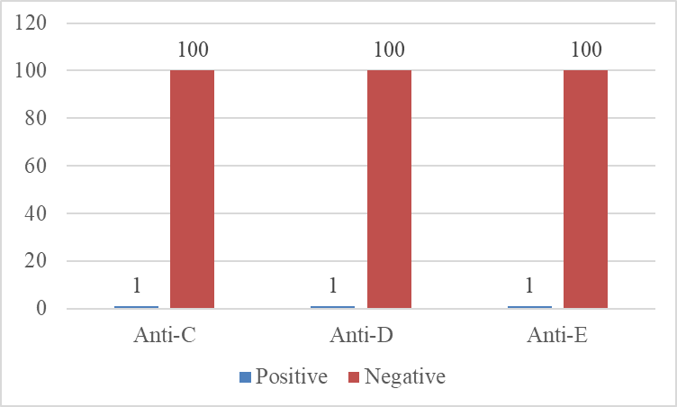
Figure 1: Prevalence of Anti-C, Anti-D and Anti-E Antibodies Among the Studied Subjects

Figure 2 depicts Rhesus antibody test outcomes (anti-C, anti-D, anti-E) across age groups. There was total negativity (100%) of each of the antibodies in the age groups of 25-30, 31-36, and 37-45 years. The sole positive case of all studied antibodies was in the age range of 18-24, giving anti-C, anti-D and anti-E prevalence of 3.3% in this age range and the remaining 29 (96.7%) were negative. There was no significant difference in the antibody positivity with respect to age (p>0.05).
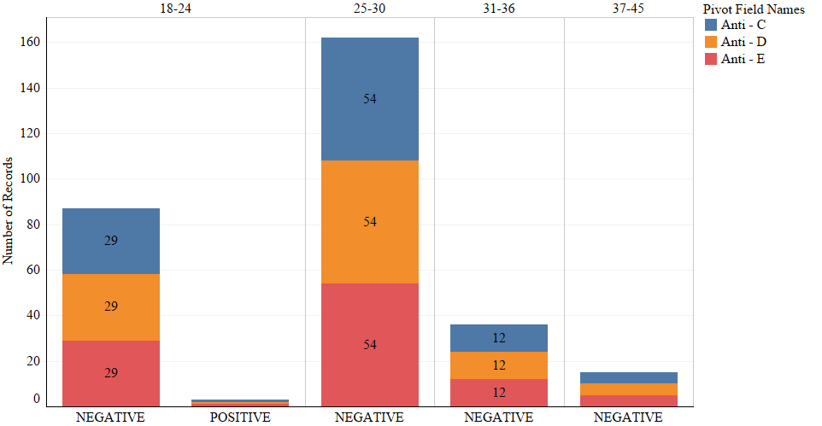
Figure 2: Rhesus Antibody Prevalence in Relation to Maternal Age of the Studied Subjects

Figure 3 shows the Rhesus antibody prevalence in relation to marital status of the studied subjects. All the married subjects had no prevalence of the Rhesus antibodies. On the contrary, only 1 (9.1%) of the married subjects had all tested Rh antibodies, while the others, 10 (90.9%) were negative for the antibodies. The difference was not significant (p>0.05).
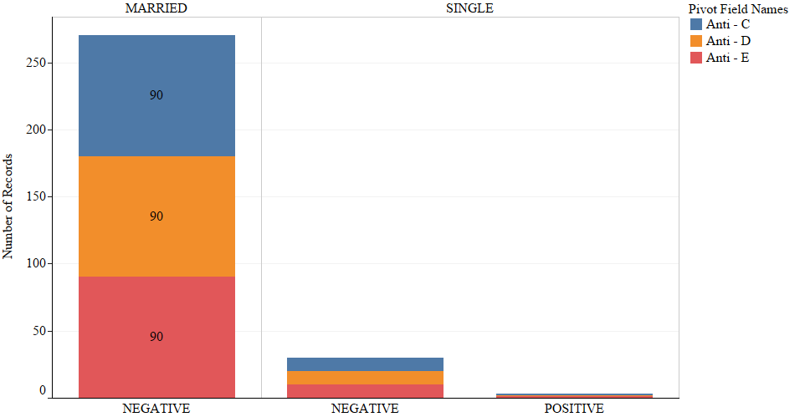
Figure 3: Rhesus Antibody Prevalence in Relation to Marital Status of the Studied Subjects
Figure 4 shows the Rhesus Antibody prevalence in relation to the gestational age of the studied subjects. Anti-C, anti-D and anti-E positivity was only found among those in their second month of pregnancy (first trimester), resulting in a prevalence of 1 (20%) each in that gestational age. The subjects belonging to other gestational ages had no prevalence of the anti-C, anti-D and anti-E antibodies. The difference was not significant (p>0.05).

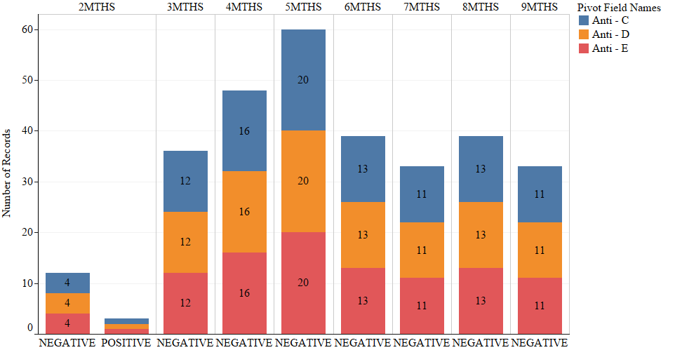
Figure 4: Rhesus Antibody Prevalence in Relation to Gestational Age of the Studied Subjects.

Figure 5 presents the Rhesus antibody prevalence in relation to parity of the studied subjects. The lone anti-C, anti-D and anti-E positive case was found in only a woman who was nulliparous, resulting in a prevalence of 1.9% each among the nulliparous pregnant women. Anti-C, anti-D and anti-E antibodies were not found among low multiparous and grand multiparous women. The difference was not significant (p>0.05).
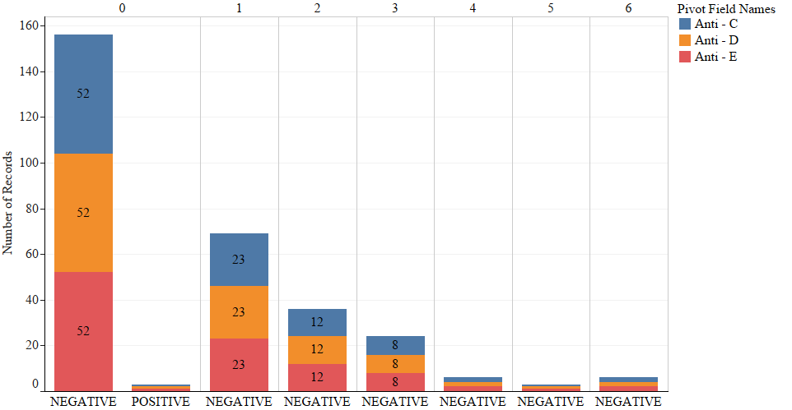
Figure 5: Rhesus Antibody Prevalence in Relation to Parity of the Studied Subjects

DISCUSSION
In this study, the prevalence of anti-C antibody was approximately 1%. This indicates the rarity of the alloantibody in the study area as only 1 in 100 subjects has the antibody. Although the anti-C has lower clinical importance compared to anti-D, cases of HDN associated with maternal transfer of this antibody have also been reported in the literature (Jung et al., 2023). Hence, the low anti-C prevalence in this study is protective against HDN. The anti-C prevalence in this study is lower than the 3% and 1.2% previously reported among pregnant women in Plateau (Chinedu et al., 2023) and Rivers State (Jeremiah et al., 2011), respectively, but higher than the 0.2% estimated in India (Golia et al., 2024). This discrepancy reflects the distribution of blood group antibodies among diverse populations.
In this study, anti-D prevalence was approximately 1%. Maternal production of anti-D is responsible for most cases of HDN and greater severity compared to other Rh antibodies (Dean, 2005). This indicates that 1% of pregnancies in Ekpoma, can result in severe HDN, in the absence of prompt management, such as the administration of Rhogam. RhoGAM contains a type of antibody called an immunoglobulin that stops the mother's body from making Rh antibodies against the baby's blood (Kumpel, 2022). The above prevalence is lower than the 1.1% earlier reported from India (Golia et al., 2024). Furthermore, studies from Lagos State (Otomewo et al., 2020) and Rivers State (Jeremiah et al., 2011) indicated no prevalence of anti-D among pregnant women.
Anti-E was only detected in approximately 1% of the studied subjects. Anti-E both a naturally occurring and an immune antibody (Yousuf et al., 2019). As a naturally-occuring antibody, it can be detected in the blood of women who were not previously sensitised (Palma et al., 2018). However, Naturally occurring anti-E is usually not clinically significant. No case of HDN or DHTR associated with naturally occurring anti-E has been reported (Rajendran et al., 2020). A previous study reported anti-E prevalence of 4.5% in Jos (Chinedu et al., 2023). In India, the prevalence of anti-E was 0.2% (Golia et al., 2024). Moreover, in a Rivers State study, there was 0.6% prevalence of anti-E (Jeremiah et al., 2011). Cases of HDN associated with anti-E have also been reported in the literature (Usman et al., 2013).
In this study, the Rhesus antibodies were detected only among those aged 18-24 years, with one subject having all three antibodies. The age difference was hence not significant (p>0.05). This implies that the Rh alloimmunisation of pregnant women occurs independently of their age as a product of previous pregnancies, miscarriages, abortion, ectopic pregnancies and blood transfusions (Al-Dughaishi et al., 2016). In this study, the positive woman had previously had an abortion. Furthermore, marital status was not associated with Rh antibody status (p>0.05), although anti-C, D and E were only found among a single woman who was pregnant. No logical reason was found to explain this occurrence as previous studies barely considered marital status as a factor of interest in the sociodemographic variables influencing Rh alloimmunisation.
In this study, the Rh antibodies were only detected among an individual who was in her first trimester and had never previously given birth. The findings related to parity is quite odd considering that high parity is an additional risk for Rh allomunisation due to the possibility of mixing of the neonate's blood with maternal blood in each pregnancy (Al-Joudi, 2000). With successive pregnancies, fetal antigens enhance antibody response in the mother which increases the severity (Saha et al., 2021). Viewed in the context of this study, it indicates that the lone antibody positivity was more of a function of other means instead of pregnancy-related exchange. However, as information regarding previous transfusions was not collected from the study participants, the above explanation remains inconclusive. In the case of the trimester differences in Rh antibody status, there was no logical reason to attribute this discrepancy.
CONCLUSION
This study revealed a low prevalence (approximately 1%) of anti-C, anti-D, and anti-E antibodies among pregnant women in Ekpoma, indicating a relatively low risk of Rh alloimmunisation and hemolytic disease of the newborn (HDN) in the region. The rarity of anti-C antibodies suggests a limited threat, although their role in HDN remains documented in medical literature. The anti-D prevalence, while also low, is still clinically significant due to its strong association with HDN and the need for prophylactic interventions such as Rhogam. Anti-E antibodies were detected at a level consistent with some global findings, and their contribution to HDN remains important. Interestingly, Rh antibodies were only detected in women aged 18–24, with no clear association to age, marital status, or parity, which aligns with findings that alloimmunisation can occur independently of these factors. The detection of antibodies in a first-trimester, nulliparous woman points toward a possible history of blood transfusion, although this could not be confirmed due to a lack of data. Overall, the findings underscore the importance of routine antenatal antibody screening and further research into potential contributing factors such as transfusion history in this population.

COMPETING INTERESTS DISCLAIMER:
Authors have declared that they have no known competing financial interests OR non-financial interests OR personal relationships that could have appeared to influence the work reported in this paper.

Disclaimer (Artificial intelligence)

Author(s) hereby declare that NO generative AI technologies such as Large Language Models (ChatGPT, COPILOT, etc.) and text-to-image generators have been used during the writing or editing of this manuscript.

REFERENCES
Adewoyin, A. S., Adeyemi, O., Ande, A. B. & Awodu, O. A. (2023). Immune erythrocyte alloantibodies among pregnant women attending an antenatal clinic in a tertiary health facility, Benin City, Nigeria. Journal of Applied Haematology, 14(1), 1-6.
Al-Dughaishi, T., Al Harrasi, Y., Al-Duhli, M., Al-Rubkhi, I., Al-Riyami, N., Al Riyami, A., Pathare, A. V. & Gowri, V. (2016). Red cell alloimmunization to Rhesus antigen among pregnant women attending a tertiary care hospital in Oman. Oman Medical Journal, 31(1), 77–80.
Al-Joudi, F. S. (2000). Incidence of Rhesus isoimmunization in Rhesus-negative mothers in Ramadi, Iraq, in the mid-1990s. Eastern Mediterranean Health Journal, 6(5-6), 1122-1125.
Anifowoshe, A. T., Owolodun, O. A., Akinseye, K. M., Iyiola, O. A. & Oyeyemi, B. F. (2017). Gene frequencies of ABO and Rh blood groups in Nigeria: A review. Egyptian Journal of Medical Human Genetics, 18(3), 205-210.
Araoye, M. O. (2004). Sample size determination. In Research Methodology with Statistics for Health and Social Sciences. Nathadex Publishers, Ilorin. (pp. 115-121).
Aziegbe, F. I. (2006). Sediment sources, redistribution, and management in Ekpoma, Nigeria. Journal of Human Ecology, 20(4), 259-268.
Babatope, I. O., Iyevhobu, K. O., Orukotan, R. I. & Ukhurebor, G. O. (2022). Seroprevalence of transfusion–transmissible infections (TTIs) among prospective blood donors in Ambrose Alli University, Ekpoma, Nigeria. North American Academic Research, 5(10), 142-153.
Chinedu, N. O., Obadiah, D. D., Salawu, L., Ezra, D. J., Jasini, J., Amandy, O. O. & Charity, I. (2023). Frequency of red cell alloantibodies among pregnant women receiving antenatal care in a tertiary health facility in Jos, Nigeria. Asian Hematology Research Journal, 6(4), 192-201.
Dean, L. (2005). Blood Groups and Red Cell Antigens. Retrieved from https://www.ncbi.nlm.nih.gov/books/NBK2269/ 18th March, 2024.
Flegel, W. A. (2007). The genetics of the Rhesus blood group system. Blood Transfusion, 5(2), 50–57.
Golia, S., Tiwari, A. K., Aggarwal, G., Khetrapal, A., Tyagi, S. K., Jain, C., Gupta, S. & Pawar, S. (2024). Prevalence of unexpected red blood cell antibodies in pregnant women and follow-up of pregnancy outcome in pregnant women treated with intra-uterine transfusion. Asian Journal of Transfusion Science, 18(1), 45–50.
Gundrajukuppam, D. K., Vijaya, S. B. K., Rajendran, A. & Sarella, J. D. (2016). Prevalence of principal Rh blood group antigens in blood donors at the blood bank of a tertiary care hospital in Southern India. Journal of Clinical and Diagnostic Research, 10(5), EC07.
Health Engine (2018). Rhesus Antibodies Test. Retrieved from https://healthinfo.healthengine.com.au/rhesus-antibodies-test 17th April, 2024.
International Society of Blood Transfusion [ISBT] (2023). Red Cell Immunogenetics and Blood Group Terminology. Retrieved from https://www.isbtweb.org/isbt-working-parties/rcibgt.html on 3rd December, 2023.
Iyevhobu, K. O., Omolumen, L. E. & Aliemhe, C. A. (2023). Assessment of multidrug resistant bacteria in paper naira notes. Mathews Journal of Immunology & Allergy, 7(1), 1-14.
Jahanpour, O., Pyuza, J. J., Ntiyakunze, E. O., Mremi, A. & Shao, E. R. (2017). ABO and Rhesus blood group distribution and frequency among blood donors at Kilimanjaro Christian Medical Center, Moshi, Tanzania. Biomedical Central Research Notes, 10, 1-5.
Jahanpour, O., Pyuza, J. J., Ntiyakunze, E. O., Mremi, A. & Shao, E. R. (2017). ABO and Rhesus blood group distribution and frequency among blood donors at Kilimanjaro Christian Medical Center, Moshi, Tanzania. Biomedical Central Research Notes, 10, 1-5.
Jeremiah, Z. A., Mordi, A., Buseri, F. I. & Adias, T. C. (2011). Frequencies of maternal red blood cell alloantibodies in Port Harcourt, Nigeria. Asian Journal of Transfusion Science, 5(1), 39–41.
Jung, G., Kim, J. K., Kim, S. J. & Kim, H. H. (2023). Neonatal hemolytic disease caused by anti-e and anti-C antibodies treated with intensive phototherapy: A case report. Neonatal Medicine, 30(3), 79-82.
Kahar, M. A. (2022). Determination of C, c, E and e antigens prevalence in Rh D negative individuals: is it good exercise with utilities in clinical blood transfusion practices?. Journal of Clinical & Diagnostic Research, 16(11), 16-19.
Kazma, J. M., van den Anker, J., Allegaert, K., Dallmann, A. & Ahmadzia, H. K. (2020). Anatomical and physiological alterations of pregnancy. Journal of Pharmacokinetics and Pharmacodynamics, 47(4), 271-285.
Kumpel, B. (2022). Results of Clinical Trials of RhoGAM* in Women by W. Pollack et al., 1968. Transfusion, 62(3), 533-538.
LabCE (2020). Characteristics of Rh Antibodies. Retrieved from https://www.labce.com/spg1471339_characteristics_of_rh_antibodies.aspx 21st April, 2024.
Lefrère, J. J. & Berche, P. (2010). Karl Landsteiner discovers the blood groups. Transfusion Clinique et Biologique, 17(1), 1-8.
Legese, B., Shiferaw, M., Tamir, W. & Tiruneh, T. (2021). Distribution of ABO and Rhesus blood group phenotypes among blood donors at Bahir Dar Blood bank, Amhara, Northwest Ethiopia: a retrospective cross-sectional study. Journal of Blood Medicine, 849-854.
Mitra, R., Mishra, N. & Rath, G. P. (2014). Blood groups systems. Indian Journal of Anaesthesia, 58(5), 524–528.
Nagamuthu, E. A., Mudavath, P., Prathima, P. & Bollipogu, S. (2016). Prevalence of rhesus negativity among pregnant women. International Journal of Research in Medical Sciences, 4(8), 3305-3309.
National Population Commission [NPC] (2006). Nigeria national census: population by local government area and sex. Retrieved from https://gazettes.africa/archive/ng/2009/ng-government-gazette-dated-2009-02-02-no-2.pdf on 1st December, 2023.
Nwaopara, A. O. & Blackies, H. O. T. (2014). The incidence of human induced community road dilapidation: A case study of Ekpoma, Edo-Nigeria. International Journal of Community Research, 3(3), 80-85.
Ochei, J. & Kolhatkar, A. (2007). Blood Group Serology (Immunohaematology). In Medical Laboratory Science: Theory and Practice (pp. 350-366). Tata McGraw Hill Publishing, New Delhi.
Okagbue, H. I., Adamu, P. I., Bishop, S. A., Oguntunde, P. E., Opanuga, A. A. & Akhmetshin, E. M. (2019). Systematic review of prevalence of antepartum depression during the trimesters of pregnancy. Open Access Macedonian Journal of Medical Sciences, 7(9), 1555–1560.
Otomewo, L., John-Olabode, S., Okunade, K., Olorunfemi, G. & Ajie, I. (2020). Prevalence of rhesus C and D alloantibodies among rhesus-negative women of child bearing age at a tertiary hospital in South-West Nigeria. Nigerian Journal of Clinical Practice, 23(12), 1759-1766.
Palma, J., Tokarz-Deptuła, B., Deptuła, J. & Deptuła, W. (2018). Natural antibodies - facts known and unknown. Central-European Journal of Immunology, 43(4), 466–475.
Patel, N. & Modi, P. (2017). A study of maternal and foetal outcome in postdate pregnancy. International Journal of Scientific Research, 6(9), 2015-2018.
Qiu-he, C. H. E. N., Qian, C. H. E. N. & Lin, Z. H. A. N. G. (2022). Relationship between ABO blood group and pregnancy complications. Journal of Sichuan University (Medical Sciences), 53(5), 935-940.
Rajendran, V., Nair, R., Poornima, A. P. & Gupta, D. (2020). A case of naturally occurring anti-E mimicking anti-A1. Global Journal of Transfusion Medicine, 5(2), 228-229.
Saha, S. C., Rai, R., Bagga, R., Jain, A., Mukhopadhyay, K. & Kumar, P. (2021). Pregnancy outcome of Rh D alloimmunized pregnancies: A tertiary care institute experience of a developing country. Journal of Obstetrics and Gynaecology of India, 71(6), 583–590.
Siloko, I. U. & Siloko, E. A. (2023). An investigation on interdependence between rainfall and temperature in Ekpoma, Edo State, Nigeria. Iranian (Iranica) Journal of Energy & Environment, 14(3), 197-204.
Spong, C. Y. (2013). Defining “term” pregnancy: recommendations from the Defining “Term” pregnancy workgroup. Journal of American Medical Association, 309(23), 2445-2446.
Usman, A. S. I., Mustaffa, R., Ramli, N. & Diggi, S. A. (2013). Haemolytic disease of the foetus and newborn caused by anti-E. Asian Journal of Transfusion Science, 7(1), 84-85.
Ward, S. E., O’Sullivan, J. M. & O’Donnell, J. S. (2020). The relationship between ABO blood group, von Willebrand factor, and primary hemostasis. Blood, The Journal of the American Society of Haematology, 136(25), 2864-2874.
Yousuf, R., Thalith, N. F. A., Loong, T. Y. & Leong, C. F. (2019). Naturally occurring ‘enzyme only’anti-E antibody: a rare occurrence. Bangladesh Journal of Medical Science, 18(4), 818-819
I.O., Babatope, Iyevhobu, K.O., Otabor, O.J., Ijeamiran, O.A., Imafidon, S., Akaba, M., Ekeazue, H., et al. 2025. “ABO, Rhesus Blood Groups and Haemoglobin Genotype Pattern of the Undergraduate Students in Ekpoma, Nigeria”. International Blood Research & Reviews 16 (4):11-21. https://doi.org/10.9734/ibrr/2025/v16i4365.

Hedberg, P., Sirel, M., Moll, K., Kiwuwa, M.S., Hoglund, P., Ribacke, U. & Wahlgren, M. (2021). Red blood cell group A antigen affects the ability to heparin and PfEmP1 antibodies to disrupt plasmodium falciparum rosettes. Malaria Journal, 20(1), 441

