Review Article

Advances in Propagation of Teak (Tectona grandis): Global Trends, Emerging Technologies and Future Prospects

.
ABSTRACT
Teak (Tectona grandis) is one of the world’s most valuable tropical hardwoods, yet large-scale plantation expansion is constrained by inefficient and variable propagation systems. This review synthesizes global advances in teak propagation from 1990–2026, covering seed-based methods, vegetative propagation, clonal forestry, micropropagation, somatic embryogenesis, and emerging molecular technologies. Conventional seed propagation remains dominant in low-input systems but suffers from poor and irregular germination (10–60%), prolonged dormancy (2–8 weeks), and high stand variability (CV 30–60%), resulting in relatively low productivity of only 4–10 m³ ha⁻¹ yr⁻¹. Vegetative propagation through stem cuttings improves rooting success to 40–85% and increases productivity by 20–40%, though clone-dependent variability persists. Clonal forestry based on mini-cuttings represents a major technological breakthrough, achieving 70–90% rooting success, reducing stand variability to 10–20%, and increasing mean annual increment (MAI) to 10–18 m³ ha⁻¹ yr⁻¹, with productivity gains of 40–100% over seed-derived plantations. Micropropagation and integrated tissue culture systems offer the highest performance, producing 30–50 shoots per explant annually, achieving 70–95% acclimatization survival, and raising MAI to 14–22 m³ ha⁻¹ yr⁻¹, equivalent to 80–150% productivity gains. Somatic embryogenesis shows transformative future potential, with embryo induction rates of 40–70%, regeneration efficiencies of 40–80%, and theoretical multiplication exceeding 1000 plants from a single explant. Global trends reveal a decisive transition from seed-based systems toward precision clonal and biotechnology-assisted propagation, particularly in Asia and Latin America. Emerging innovations including temporary immersion bioreactors, genomic-assisted breeding, bio-inoculants, artificial intelligence, and climate-smart propagation strategies are redefining teak forestry. The review concludes that integrating advanced clonal and molecular propagation systems is essential for developing high-yield, genetically uniform, and climate-resilient teak plantations worldwide.
Keywords: Tectona grandis; teak propagation; clonal forestry; micropropagation; somatic embryogenesis; mini-cuttings; elite clone multiplication; productivity improvement.
1. INTRODUCTION
Tectona grandis (teak) is one of the most valuable tropical hardwood species, globally recognized for its superior wood quality, durability, and high economic returns, making it a cornerstone of plantation forestry in tropical and subtropical regions (Kollert and Kleine, 2017; Midgley et al., 2017; Evans and Turnbull, 2004; Bhol and Parida, 2024). Native to South and Southeast Asia, teak has been widely introduced across Africa and Latin America and is now cultivated in more than 60 countries under diverse ecological conditions (FAO, 2020; FAO, 2022). Increasing global demand for premium timber, coupled with restrictions on harvesting from natural forests, has intensified reliance on plantation forestry as a sustainable source of teak wood (Lamb, 2011; Kollert and Kleine, 2017).
Despite its importance, teak propagation remains a major bottleneck in plantation development. Conventional seed-based propagation is characterized by low and irregular germination (10–60%), mainly due to a hard pericarp and complex dormancy mechanisms (Kjaer and Foster, 1996; Baskin and Baskin, 2014; Bhol et al., 2024; Behera et al., 2015). Germination variability, influenced by seed source and environmental factors, leads to inconsistent nursery performance and heterogeneous plantation stands (White et al., 2007; Monteuuis et al, 2011; Monteuuis, 2021; Behera et al., 2016; Parida et al., 2022). This variability results in uneven growth, poor stem form, and reduced wood quality, ultimately limiting productivity and economic returns (Zobel and Talbert, 1984; Midgley et al., 2017; Behera and Bhol, 2016; Pradhan et al., 2017; Pradhan et al., 2020,).
Vegetative propagation techniques, including stem cuttings and coppice shoot management, have been developed to multiply superior genotypes. However, teak is difficult to propagate vegetatively, particularly from mature tissues, due to physiological aging and reduced endogenous auxin levels (Husen and Pal, 2006; Husen, 2012; Monteuuis, 2021). Rooting success varies widely (40–85%) depending on genotype, environment, and hormonal treatments such as indole-3-butyric acid (IBA) (Tiwari et al., 2002; Monteuuis and Goh, 2015). Nonetheless, advances in clonal forestry especially mini-cutting and clonal hedge systems have significantly improved propagation efficiency and enabled large-scale deployment of elite planting material (Chaix et al., 2011; Monteuuis and Goh, 2015; Singh. 2023).
Biotechnological approaches have further accelerated teak propagation. Micropropagation using nodal explants allows rapid multiplication of elite genotypes, while temporary immersion bioreactors enhance shoot proliferation and reduce physiological disorders (Akram and Aftab, 2009; Aguilar et al., 2019). Improved in vitro rooting and acclimatization have also increased survival and field establishment (Mendoza de Gyves et al., 2007; Tiwari et al., 2002).
Recent studies have provided deeper insights into molecular and physiological mechanisms of propagation. Advances in somatic embryogenesis highlight the role of auxin–cytokinin signaling pathways in plant regeneration (Deo et al., 2010; Ramakrishnan et al., 2023; Zhou et al., 2024). Emerging protocols using zygotic embryos and in vitro-derived explants have improved regeneration efficiency (Meenakshi et al., 2025), while cost-effective micropropagation techniques are enhancing commercial feasibility. These developments mark a transition from experimental to operational-scale biotechnology.
Propagation methods are closely linked to plantation productivity and sustainability. Clonal and biotechnology-assisted systems significantly improve growth, uniformity, and wood quality, resulting in higher mean annual increment (MAI) compared to seed-based plantations (Midgley et al., 2017; Goh and Monteuuis, 2016). The integration of bio-inoculants such as PGPR and AMF further enhances seedling vigor and field establishment.
These advances are particularly important under changing climatic conditions. Climate-resilient plantation systems increasingly depend on improved propagation technologies to ensure productivity and carbon sequestration (IPCC, 2019; IPCC, 2023; Griscom et al., 2017). Globally, forestry is shifting toward precision-based, high-productivity systems, where improved propagation can increase productivity by 40–150% and reduce rotation periods (Goh et al., 2013, Monteuuis and Goh, 2014; Midgley et al., 2015).
Given these advancements, a comprehensive synthesis of propagation techniques is essential. This review aims to (i) evaluate global trends in propagation of Tectona grandis, (ii) assess emerging technologies including clonal forestry and biotechnology, and (iii) identify future prospects for developing efficient, scalable, and climate-resilient propagation systems.

2. material and methods
The present study adopted a systematic review methodology to synthesize global advances in the propagation of Teak (Tectona grandis).

2.1 Literature Search Strategy
A comprehensive literature search was conducted across major international scientific databases, including Web of Science, Scopus, Google Scholar, Science Direct, and Springer Link. The search covered publications from 1990 to 2026, encompassing both foundational and recent advances in teak propagation. A structured keyword-based search strategy using was applied using words such as: Tectona grandis and propagation/ germination/ vegetative propagation/ clonal forestry/ micropropagation/ tissue culture/ somatic embryogenesis, nursery techniques, etc. Additional keywords such as teak seed dormancy, mini-cuttings, temporary immersion systems, and bio-inoculants in forestry, etc were included to broaden the scope. Backward and forward citation tracking (snowballing) was also employed to identify additional relevant studies (Kollert and Kleine, 2017; Midgley et al., 2015).

2.2 Data Extraction
Relevant data from selected studies were systematically extracted and compiled into structured datasets. The following variables were recorded:
- Propagation method (seed, cuttings, mini-cuttings, micropropagation, somatic embryogenesis)
- Germination percentage and dormancy characteristics
- Rooting percentage and survival rates
- Multiplication rate (propagules per cycle)
- Time required for plantable stock
- Environmental conditions (temperature, humidity, substrate)
- Hormonal treatments (e.g., IBA, NAA, cytokinins)
(viii)Field performance indicators (survival %, growth rate, MAI)
- Geographic and ecological context
The selection of variables was guided by standard forestry and propagation studies to ensure comparability across different propagation systems (Goh and Monteuuis, 2016; Midgley et al., 2014).

2.3 Classification of Propagation Techniques
For analytical clarity, propagation techniques were categorized into four major groups:
(i) Seed-based propagation (dormancy and germination studies)
- Vegetative propagation (cuttings, coppice shoots)
- Clonal forestry systems (mini-cuttings, clonal hedges)
- Biotechnological approaches (micropropagation, somatic embryogenesis)
This classification framework aligns with contemporary approaches in clonal forestry and tree improvement studies (Monteuuis and Goh, 2014; Chaix et al., 2011).

3. results and discussion

3.1 Advances in Propagation Methods of Tectona grandis
The synthesis of global literature reveals a clear progression in teak propagation methods, ranging from conventional seed-based systems to advanced clonal and biotechnological approaches. Each method exhibits distinct advantages and limitations in terms of efficiency, scalability, and plantation productivity. Among these, seed-based propagation remains the most traditional and widely practiced approach, particularly in low-input forestry systems, although it is constrained by biological and genetic limitations.

3.1.1 Seed-Based Propagation: Dormancy Constraints and Incremental Improvements
Seed-based propagation of Tectona grandis remains the most widely practiced conventional method of teak multiplication, yet it is fundamentally constrained by low, irregular, and asynchronous germination. Germination percentages generally range from 10–60%, mainly due to the combined effects of mechanical and physiological dormancy, where the hard lignified endocarp restricts water uptake and internal hormonal controls delay embryo activation (Kjaer and Foster, 1996; Baskin and Baskin, 2014; Palupi et al., 2010). This dormancy-induced delay may extend germination by 2–8 weeks, causing uneven seedling emergence and poor nursery uniformity.
As summarized in Table 1, several pre-sowing treatments have been developed to overcome these dormancy barriers. Mechanical scarification improves imbibition by weakening the hard seed coat and increases germination by 10–25%, although it remains labor-intensive and difficult to scale in commercial nurseries (Baskin and Baskin, 2014). Chemical treatments such as sulfuric acid (H₂SO₄) and potassium nitrate (KNO₃) have shown stronger effects, improving germination by 28–37%, particularly under controlled nursery conditions (Velusamy and Vanangamudi, 2003; Salve et al., 2026). Similarly, alternate wetting–drying cycles are widely adopted as a low-cost pretreatment to enhance seed permeability and improve germination consistency (Palupi et al., 2010; Midgley et al., 2015).
Table 1. Advances in Seed-Based Propagation of Tectona grandis
Aspect | Observations/ Findings | Quantitative Range / Effect | Practical Implication | Key References
Seed Structure & Dormancy | Hard stony endocarp restricts water uptake; physiological dormancy present | Germination: 10–60% | Major limitation in nursery establishment | Kjaer and Foster (1996); Baskin and Baskin (2014); Palupi et al. (2010)
Mechanical Dormancy | Physical barrier due to lignified pericarp delays germination | Delay: 2–8 weeks (variable) | Requires pretreatment for uniform germination | Baskin and Baskin (2014); Palupi et al. (2010)
Mechanical Scarification | Removal/weakening of seed coat improves imbibition | Germination increase: +10–25% | Effective but labor-intensive | Baskin and Baskin (2014)
Chemical Treatments (H₂SO₄, KNO₃) | Chemical stimulation improves germination | Germination increase: +28–37% | Useful in controlled nursery conditions | Velusamy and  Vanangamudi (2003); Salve et al. (2026)
Provenance Variation | Significant variation in germination and vigor among seed sources | Variation: up to 2–3 fold difference | Selection of superior seed sources critical | Kjaer and Foster (1996); Midgley et al. (2015)
Seedling Uniformity | High variability in growth and morphology | CV: 30–60% | Poor stand uniformity | White et al. (2007)
Adoption in Forestry Systems | Widely used in low-input and smallholder systems | Dominant method in Africa & rural Asia | Cost-effective and simple | Kollert and Kleine (2017)
Productivity Implication | Variable growth and wood quality in plantations | MAI: 4–10 m³ ha⁻¹ yr⁻¹ | Limits industrial plantation performance | Midgley et al. (2014)
Scope for Improvement | Seed orchard development and provenance selection needed | Potential gain: +20–40% productivity | Critical for future seed-based systems | Kollert and Kleine (2017); White et al. (2007)
A major challenge in seed propagation is the strong provenance-dependent variation in seed performance. Germination capacity and seedling vigor may vary by as much as 2–3 fold among seed sources, indicating that genotype and origin significantly influence propagation success (Kjaer and Foster, 1996; Midgley et al., 2015). This variation translates directly into high heterogeneity in seedling growth, reflected in coefficients of variation (CV) of 30–60%, resulting in plantations with uneven stem form, variable height growth, and inconsistent wood quality (White et al., 2007; Goh and Monteuuis, 2016). Such heterogeneity reduces silvicultural efficiency and complicates stand management.
The productivity implications are substantial. Seed-origin plantations typically achieve a mean annual increment (MAI) of only 4–10 m³ ha⁻¹ yr⁻¹, which is considerably lower than the productivity levels reported for clonal plantations (Midgley et al., 2015; Goh and Monteuuis, 2016). Lower productivity reflects both genetic variability and uneven stand development, making seed propagation less suitable for industrial forestry systems where uniformity and predictable yields are critical.
Despite these drawbacks, seed-based propagation remains indispensable in low-input forestry systems, especially in Africa and rural Asia, where low cost, operational simplicity, and minimal infrastructure requirements make it the preferred option (Kollert and Kleine, 2017). It also plays an important role in afforestation programs, restoration forestry, and conservation of genetic diversity.

3.1.2 Vegetative Propagation: Influence of Juvenility and Hormonal Regulation
Vegetative propagation of Tectona grandis has emerged as an important improvement over seed-based systems because it enables multiplication of selected elite genotypes while reducing genetic variability in plantations. The data presented in Table 2 show that stem cuttings, coppice shoots, and hedge-derived cuttings are the principal vegetative propagules used in teak, with overall rooting success ranging from 40–85%, depending on propagule type, physiological age, genotype, and nursery environment (Husen and Pal, 2006; Monteuuis and Goh, 2014). This indicates that vegetative propagation is biologically feasible but highly sensitive to internal and external factors.
Table 2. Advances in Vegetative Propagation of Tectona grandis
Aspect | Observations / Findings | Quantitative Range / Effect | Practical Implication | Key References
Propagation Method | Stem cuttings, coppice shoots, hedge-derived cuttings | Moderate success under nursery conditions | Widely used intermediate technique | Husen and Pal (2006); Goh and Monteuuis (2016)
Rooting Success | Strongly influenced by physiological age and environment | 40–85% rooting | Variable reliability across conditions | Husen and Pal (2006); Goh and Monteuuis (2016)
Juvenility Effect | Juvenile and coppice shoots show higher rooting than mature tissues | Rooting increase: +25–50% | Juvenility critical for propagation success | Monteuuis and Goh (2014)
Source of Cuttings | Coppice shoots > hedge shoots > mature crown shoots | Significant variation in rooting efficiency | Selection of planting material essential | Goh and Monteuuis (2016); Husen and Pal (2006)
Hormonal Regulation (IBA) | Indole-3-butyric acid enhances root initiation | Rooting increase: +20–40% (optimal 1000–3000 ppm) | Standard practice in nurseries | Tiwari et al. (2002); Husen and Pal (2006)
Substrate Influence | Well-drained media (sand, vermiculite, cocopeat) improves rooting | Rooting increase: +10–20% | Nursery media optimization needed | Husen and Pal (2006)
Seasonal Effect | Higher rooting during active growth periods | Variation: +15–30% | Timing of propagation critical | Monteuuis and Goh (2014)
Field Establishment | Moderate survival compared to clonal systems | Survival: 60–80% | Suitable for small to medium-scale plantations | Midgley et al. (2015)
Operational Limitation | High variability and lower scalability | Not ideal for industrial scale | Transitional method toward clonal forestry | Monteuuis and Goh (2014)
A major finding from Table 2 is the strong influence of juvenility on rooting performance. Juvenile and coppice-derived shoots consistently root better than mature crown tissues, with rooting enhancement of 25–50%, demonstrating that physiological age is the most critical determinant of rooting success (Monteuuis and Goh, 2014). The ranking of cutting sources coppice shoots > hedge shoots > mature crown shoots clearly indicates that rejuvenated propagules possess superior physiological competence for adventitious root formation. This reflects higher endogenous auxin levels, reduced lignification, and stronger meristematic activity in juvenile tissues, making coppicing and hedge management essential for maintaining propagation efficiency.
Hormonal regulation plays an equally important role in root induction. As shown in Table 2, application of indole-3-butyric acid (IBA) at optimal concentrations of 1000–3000 ppm increases rooting success by 20–40%, confirming its central role in stimulating adventitious root initiation (Tiwari et al., 2002; Husen and Pal, 2006). The detailed phytohormonal data in Table 3 further demonstrate that different combinations of auxins and additives significantly influence rooting response. For example, Anantha and Vijayalakshmi (1994) obtained 60–80% rooting using IBA + NAA + sucrose treatment, while Ansari et al. (2002) reported 50.83% rooting using high-dose IBA (1000 ppm) combined with thiamine. These findings indicate that both hormone concentration and exposure duration are critical for optimizing rooting protocols.
Table 3. Phytohormones used for vegetative propagation of teak by different researchers
Phytohormone | Duration | Percent of rooting | References
NAA 100 /  IBA+NAA 200 ppm | 24 hours | 60 % | Nautiyal et al. (1991)
IBA 100/200 ppm  NAA 100 ppm | 24 hours | 40% | Nautiyal et al. (1992)
IBA 100 + NAA  100 +Sucrose 100 ppm | 2-3 hours | 60-80% | Anantha and Vijayalakshmi (1994)
lM-200 +Thiamine 200 ppm | 18 hours | 50% | Palanisamy et al. (1995)
IBA 1000 ppm | 30 minutes | - | Mundt (1997)
IBA 1000 ppp + Thiamine 800 ppm | 18 hours | 50.83 % | Ansari et al. (2002)
Thiamine - 800/1200 ppm  + IBA 250 ppm + IAA 125 ppm + NAA 125 ppm | 24 hours | 47.0 - 47.5 % | Singh et al. (2005)
IBA 150 ppm | - | 53.18% | Sawitri et al. (2020)
A clear trend observed in Table 3 is that lower hormone concentrations are generally applied for longer durations (18–24 hours), whereas higher concentrations are used for shorter exposure periods, such as 30 minutes in the case of IBA 1000 ppm (Mundt, 1997). This suggests that rooting response depends not only on hormone dosage but also on absorption kinetics and physiological status of the cutting material. Such variation highlights the need for genotype-specific hormone standardization in teak nurseries.
Environmental conditions significantly influence rooting success as well. Well-drained media such as sand, vermiculite, and cocopeat improve rooting by 10–20%, mainly by providing better aeration and moisture balance around the cutting base (Husen and Pal, 2006). Seasonal timing also has a strong effect, with rooting increasing by 15–30% during active vegetative growth periods, when carbohydrate reserves and endogenous hormonal activity are highest (Monteuuis and Goh, 2014). These findings emphasize that nursery environment must be carefully optimized to maximize propagation efficiency.
Field establishment of rooted cuttings remains moderate, with survival rates ranging between 60–80%, which is lower than survival typically achieved in advanced clonal mini-cutting systems (Midgley et al., 2015). Although adequate for small- and medium-scale plantation development, this survival range limits the economic efficiency of vegetative propagation under industrial plantation forestry.
Despite its advantages, vegetative propagation remains constrained by several operational limitations. High genotype-dependent variability, environmental sensitivity, and relatively low scalability reduce its suitability for large industrial deployment. As indicated in Table 2, these constraints position vegetative propagation as a transitional propagation technology, bridging conventional seed systems and advanced clonal forestry approaches rather than serving as a final industrial solution.

3.1.3 Clonal Forestry: A Paradigm Shift in Teak Propagation
Clonal propagation has emerged as the most advanced and commercially effective propagation system for teak, overcoming many of the biological and operational limitations associated with seed-based and conventional vegetative methods. The data summarized in Table 4 indicate that mini-cutting systems derived from clonal hedges now constitute the dominant clonal propagation technique, enabling multiplication rates of 15–25 propagules per cycle, thereby greatly enhancing propagation efficiency (Monteuuis and Goh, 2014; Tiwari et al., 2002). This high multiplication potential reflects the effectiveness of hedge-based rejuvenation systems in maintaining juvenile physiological status and sustained rooting competence.
Table 4. Advances in Clonal propagation of Tectona grandis
Aspect | Observations / Findings | Quantitative Range / Effect | Practical Implication | Key References
Propagation Technique | Mini-cuttings derived from clonal hedges | Multiplication: 15–25 propagules/cycle | Rapid mass propagation of elite clones | Monteuuis and Goh (2014); Tiwari et al. (2002)
Rooting Success | High rooting under controlled nursery conditions | 70–90% rooting | Reliable and scalable propagation method | Monteuuis and Goh (2014); Chaix et al. (2011)
Uniformity of Planting Stock | Clonal plants show reduced variability | CV reduced to 10–20% | Uniform plantations and improved management | White et al. (2007); Chaix et al. (2011)
Rotation Period | Reduced due to faster growth | Reduction: 20–40% | Faster timber production cycles | Midgley et al. (2015)
Infrastructure Requirement | Requires mist chambers, hedge gardens | Moderate–high investment | Suitable for organized plantations | Goh and Monteuuis (2016)
Global Adoption | Widely adopted in Asia and Latin America | Expanding globally | Industrial plantation standard | Kollert and Kleine (2017)
A major advantage of clonal forestry is its consistently high rooting performance. Rooting success under controlled nursery environments ranged from 70–90%, substantially exceeding that observed in conventional vegetative propagation systems. Such high rooting reliability is attributable to the combined effects of juvenile propagule selection, controlled microclimatic nursery conditions, and optimized rooting protocols (Monteuuis and Goh, 2014; Chaix et al., 2011). These findings confirm that clonal mini-cutting systems provide a biologically stable and operationally scalable propagation platform suitable for mass multiplication of elite teak genotypes.
The most significant silvicultural benefit observed in clonal systems is the marked reduction in planting stock variability. As shown in Table 4, coefficient of variation (CV) in clonal plantations is reduced to 10–20%, compared with substantially higher variability in seed-origin plantations (White et al., 2007; Chaix et al., 2011). This reduction in phenotypic heterogeneity results in more uniform stem form, synchronized growth rates, and predictable stand structure, all of which are essential for efficient plantation management and timber quality optimization. Improved uniformity also facilitates silvicultural interventions such as thinning, pruning, and harvesting.
Another important outcome of clonal propagation is the shortening of plantation rotation periods. Elite clonal plantations demonstrate faster growth rates, leading to rotation reductions of 20–40% relative to conventional plantations (Midgley et al., 2015). This accelerated growth cycle directly improves economic returns by reducing time to harvest and increasing annualized productivity. The shorter rotation period is particularly valuable in industrial plantation forestry, where rapid capital turnover is a major economic objective.
Despite these advantages, clonal propagation requires more sophisticated infrastructure than traditional propagation systems. Successful implementation depends on specialized nursery facilities including mist chambers, clonal hedge gardens, controlled rooting environments, and trained technical personnel. As indicated in Table 4, these requirements involve moderate to high investment costs, which may limit adoption in low-resource forestry systems (Goh and Monteuuis, 2016). Consequently, clonal forestry is currently most feasible in organized plantation enterprises with access to technical and financial resources.
The global adoption pattern further reflects the growing industrial importance of clonal forestry. Clonal teak propagation is now widely practiced in Asia and Latin America, where commercial plantation systems have integrated elite clone deployment into large-scale production models (Kollert and Kleine, 2017). Countries such as India, Indonesia, Brazil, and Costa Rica have demonstrated substantial gains in plantation productivity and wood quality through clonal forestry, establishing it as the industrial standard for teak plantation development.

3.1.4 Micropropagation and Tissue Culture: Towards Mass Multiplication
Micropropagation has emerged as a highly promising biotechnological approach for large-scale multiplication of elite genotypes of Tectona grandis, offering a level of precision and multiplication efficiency beyond conventional clonal propagation systems. The data presented in Table 5 indicate that tissue culture-based propagation has significantly advanced teak multiplication by enabling rapid shoot proliferation, high genetic fidelity, and large-scale production of uniform planting stock.
One of the major strengths of teak micropropagation lies in the versatility of explant sources. Nodal segments, shoot tips, and zygotic embryos have all shown high regeneration potential under in vitro conditions, allowing reliable initiation of cultures from diverse genetic materials (Akram and Aftab, 2009). Among these, nodal explants are particularly advantageous because they retain pre-existing meristems, reducing somaclonal variation and enhancing regeneration consistency. The ability to utilize multiple explant sources broadens the applicability of micropropagation across breeding programs and elite clone multiplication systems.
Table 5. Advances in Micropropagation of Tectona grandis
Aspect | Observations / Findings | Quantitative Range / Effect | Practical Implication | Key References
Explant Source | Nodal segments, shoot tips, zygotic embryos | High regeneration potential | Consistent multiplication | Akram and Aftab (2009)
Multiplication Rate | Rapid shoot proliferation under controlled media | 30–50 shoots/explant/year | High-output propagation system | Akram and Aftab (2009)
Rooting and Acclimatization | Improved survival through ex vitro rooting | 70–95% survival | Efficient plant establishment | Mendoza de Gyves et al. (2007)
Temporary Immersion Systems (TIBs) | Enhanced nutrient uptake and shoot growth | Multiplication increase: +30–50% | Cost-effective scaling | Aguilar et al. (2019)
Genetic Fidelity | High clonal uniformity maintained | >95% true-to-type plants | Reliable elite clone multiplication | Goh et al. (2013)
Cost Consideration | High initial and operational cost | Cost 2–3× higher than cuttings | Suitable for high-value plantations | Goh and Monteuuis (2016)
A notable outcome highlighted in Table 5 is the high multiplication efficiency achieved under optimized culture conditions. Shoot proliferation rates of 30–50 shoots per explant per year demonstrate the exceptional multiplication capacity of micropropagation compared with conventional vegetative methods (Akram and Aftab, 2009). This rapid multiplication potential makes tissue culture especially valuable where elite clones are scarce and rapid stock expansion is required. Such multiplication rates enable year-round propagation independent of seasonal constraints, which is a major advantage over nursery-based systems.
Rooting and acclimatization remain critical stages in successful micropropagation. The development of ex vitro rooting techniques has significantly improved plant establishment, with survival rates ranging from 70–95%, as reported in Table 5 (Mendoza de Gyves et al., 2007). Ex vitro rooting reduces handling time, lowers contamination risk, and simplifies transition from laboratory to nursery conditions. High acclimatization success indicates that tissue-cultured teak plantlets can be effectively hardened and established under nursery conditions, improving commercial viability.
A major technological breakthrough in recent years is the introduction of temporary immersion bioreactor systems (TIBs), which have substantially enhanced multiplication efficiency. As shown in Table 5, TIBs increase multiplication rates by 30–50% by improving nutrient uptake, reducing hyperhydricity, and promoting healthier shoot growth (Aguilar et al., 2019). These systems represent a significant advance toward automation and cost-effective scaling of teak micropropagation, making industrial-scale tissue culture increasingly feasible.
Another important advantage of micropropagation is the maintenance of high genetic fidelity. More than 95% of regenerated plantlets remain true-to-type, ensuring clonal uniformity and preserving the desirable traits of elite genotypes (Goh et al., 2013). This high level of genetic stability is particularly important in teak, where plantation uniformity directly influences timber quality, growth predictability, and management efficiency. The preservation of genetic integrity makes micropropagation one of the most reliable systems for elite clone deployment.
Despite these substantial advantages, cost remains a major limitation. As indicated in Table 5, the production cost of tissue-cultured plants is approximately 2–3 times higher than conventional cutting-based propagation, due to expenses associated with sterile laboratory facilities, skilled labour, media preparation, and infrastructure maintenance (Goh and Monteuuis, 2016). These costs currently restrict large-scale adoption mainly to high-value plantation systems and breeding programs where superior genetic gains justify higher investment.

3.1.5 Somatic Embryogenesis and Molecular Advances
Somatic embryogenesis represents one of the most advanced frontiers in teak biotechnology, offering a highly scalable pathway for clonal multiplication, elite genotype fixation, and integration with next-generation molecular breeding tools. The data summarized in Table 6 indicate that although somatic embryogenesis in teak is still largely experimental, it has demonstrated substantial potential to transform propagation systems from conventional clonal multiplication into precision forestry platforms.
Table 6. Advances in Somatic Embryogenesis in Tectona grandis
Aspect | Observations / Findings | Quantitative Range / Effect | Practical Implication | Key References
Embryo Induction | Derived from juvenile tissues and callus cultures | Induction success: 40–70% | Potential for large-scale cloning | Deo et al. (2010)
Regeneration Efficiency | Conversion of embryos into plantlets | 40–80% regeneration | Promising but variable | Goh et al. (2013)
Molecular Regulation | Controlled by auxin–cytokinin signaling pathways | Gene expression changes significant | Understanding regeneration biology | Ramakrishnan et al. (2023); Zhou et al. (2024)
Multiplication Potential | Very high theoretical multiplication capacity | >1000 plants from single explant (potential) | Mass cloning capability | Deo et al. (2010)
Genetic Improvement | Suitable for integration with genomics and breeding | Enables elite genotype fixation | Precision forestry tool | Goh et al. (2013)
Commercial Status | Mostly experimental stage | Limited field deployment | Future technology | Ramakrishnan et al. (2023)
Future Potential | Integration with gene editing and AI | High innovation scope | Next-generation propagation system | Zhou et al. (2024)
A major breakthrough in teak somatic embryogenesis is the successful induction of embryos from juvenile tissues and callus cultures. Embryo induction rates range from 40–70%, indicating that teak possesses considerable embryogenic competence under optimized in vitro conditions (Deo et al., 2010). Juvenile tissues are particularly responsive because of their higher cellular plasticity and greater dedifferentiation capacity. This induction efficiency is significant because it establishes the biological feasibility of large-scale embryogenic culture systems for teak mass propagation.
Following embryo induction, regeneration of somatic embryos into viable plantlets remains a critical determinant of system efficiency. Regeneration rates reported in Table 6 vary between 40–80%, suggesting that conversion of embryos into plantlets is promising but still inconsistent across genotypes and culture conditions (Goh et al., 2013). Such variability reflects the complex interaction between genotype, culture medium composition, hormone balance, and developmental stage of embryos. Although regeneration efficiency remains lower than desirable for commercial mass production, current outcomes confirm the technical viability of embryo-to-plantlet conversion in teak.
One of the most important recent advances lies in the understanding of molecular regulation mechanisms governing embryogenesis. Contemporary studies have demonstrated that somatic embryogenesis in teak is strongly regulated by auxin–cytokinin signaling pathways involving genes such as AUX/IAA, ARF, SAUR, and ARR, which control embryogenic competence, polarity establishment, and embryo maturation (Ramakrishnan et al., 2023; Zhou et al., 2024). These molecular insights represent a major scientific milestone because they provide a mechanistic basis for improving regeneration efficiency through targeted manipulation of developmental pathways.
A remarkable advantage of somatic embryogenesis is its extremely high multiplication potential. Unlike cutting- or shoot-based systems, embryogenic cultures theoretically allow production of more than 1000 plants from a single explant, making this approach one of the most powerful mass cloning technologies available (Deo et al., 2010). This multiplication capacity far exceeds conventional clonal hedge systems and offers enormous promise for rapid expansion of elite planting stock once protocols become fully optimized.
Somatic embryogenesis also holds exceptional value for genetic improvement and precision breeding. Because embryogenic cultures can be synchronized with genomic selection, molecular markers, and transformation systems, they enable fixation and rapid multiplication of elite genotypes with superior growth, wood quality, and stress tolerance traits (Goh et al., 2013). This makes somatic embryogenesis a key enabling technology for integrating propagation with modern genomics-assisted breeding programs.
Despite these major advantages, commercial deployment remains limited. As shown in Table 6, somatic embryogenesis in teak is still largely confined to research laboratories, with very limited field-scale application (Ramakrishnan et al., 2023). Major barriers include: Strong genotype dependency, Inconsistent regeneration reproducibility, High laboratory costs and Complex protocol standardization. These limitations currently prevent widespread commercial adoption, despite the technology’s high theoretical potential.
The future significance of somatic embryogenesis lies in its compatibility with emerging technologies such as gene editing, artificial intelligence, and automated bioreactor systems. Integration with CRISPR-based genome editing could allow precise trait improvement at embryogenic stages, while AI-assisted culture optimization may enhance regeneration efficiency through predictive media formulation and growth monitoring (Zhou et al., 2024). These innovations position somatic embryogenesis as a cornerstone technology for next-generation teak propagation.

3.1.6 Comparative Performance and Productivity Implications
The comparative evaluation of propagation methods in Tectona grandis revealed marked differences in productivity, stand uniformity, wood quality, and scalability across propagation systems (Table 7 and Fig 1). Seed propagation recorded the lowest mean annual increment (MAI), ranging from 4–10 m³ ha⁻¹ yr⁻¹, and exhibited the highest stand variability with coefficient of variation (CV) values between 30–60%. This wide variability reflects the heterogeneous genetic nature of seed-derived populations, resulting in inconsistent growth performance and variable wood characteristics. Although seed propagation remains suitable for low-input forestry and smallholder plantations because of its simplicity and low cost, its limited predictability restricts its suitability for industrial plantation forestry. Similar observations were reported by Midgley et al. (2015), who noted that seed-raised teak plantations often suffer from uneven stand development and reduced uniformity.
Table 7. Comparative Performance and Productivity Implications of Propagation Methods in Tectona grandis
Propagation Method | MAI (m³ ha⁻¹ yr⁻¹) | Productivity Gain over Seed (%) | Stand Uniformity (CV %) | Wood Quality | Scalability | Key Implication | Key References
Seed Propagation | 4–10 | Baseline | 30–60 | Variable | High (low-input systems) | Suitable for smallholders; high variability limits industrial use | Midgley et al. (2015); Goh and Monteuuis (2016)
Vegetative Propagation (Cuttings) | 6–12 | +20–40% | 20–35 | Moderate–Good | Moderate | Improved performance but still variable | Goh and Monteuuis (2016); Husen and Pal (2006)
Clonal Forestry (Mini-cuttings) | 10–18 | +40–100% | 10–20 | High | High (organized plantations) | Major improvement in productivity and uniformity | Midgley et al. (2015)
Micropropagation / Integrated Systems | 14–22 | +80–150% | 5–15 | Very High | Moderate–High (high-tech systems) | Highest productivity and precision forestry | Goh and Monteuuis (2016)
Vegetative propagation through stem cuttings showed moderate improvement over seed propagation, with MAI increasing to 6–12 m³ ha⁻¹ yr⁻¹ and productivity gains of 20–40%. Stand uniformity also improved, with CV values declining to 20–35%, indicating better genetic consistency among propagated plants. This method enables partial capture of elite genetic traits and has been recognized as a practical improvement over conventional seed systems, especially in regions where advanced clonal infrastructure is unavailable. However, variability among rooting success and clone responsiveness still limits complete uniformity, as observed by Husen and Pal (2006), who reported genotype-dependent differences in rooting efficiency in teak cuttings.
Clonal forestry based on mini-cuttings demonstrated substantial gains in plantation performance, with MAI ranging from 10–18 m³ ha⁻¹ yr⁻¹ and productivity increases of 40–100% over seed propagation (Fig 2). The reduction in CV to 10–20% indicates a much more uniform plantation structure, which directly contributes to predictable stand growth and standardized wood properties. The higher productivity in clonal plantations is primarily attributable to the multiplication of genetically superior, tested clones selected for rapid growth, stem form, and wood quality. Midgley et al. (2015) emphasized that clonal teak forestry has transformed plantation productivity in tropical regions by enabling precision matching of genotype to site conditions.
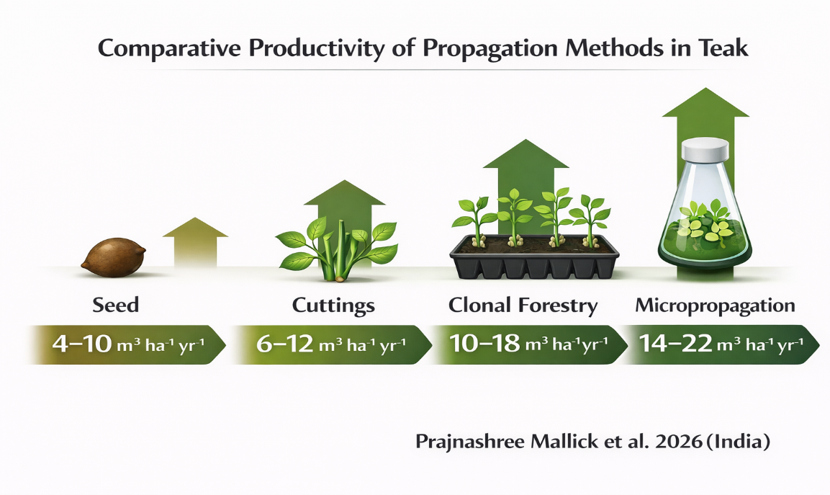
Fig 1. Pictorial depiction of comparative productivity of propagation methods of Teak
Micropropagation and integrated propagation systems recorded the highest productivity among all methods, with MAI values of 14–22 m³ ha⁻¹ yr⁻¹ and productivity gains reaching 80–150% above seed-derived plantations. These systems also achieved the greatest stand uniformity, with CV reduced to only 5–15%, reflecting near-genetic homogeneity and precise multiplication of elite genotypes. Wood quality under these systems was rated very high, owing to strict clonal fidelity and superior genotype selection. Goh and Monteuuis (2016) highlighted that micropropagation offers a powerful platform for mass multiplication of elite teak clones while preserving genetic integrity, making it central to future high-value plantation forestry. Nevertheless, the requirement for sophisticated laboratory facilities, skilled manpower, and higher establishment costs may limit widespread adoption in developing forestry sectors.
The advances in Teak propagation methods from seed to biotechnological methods are pictorially summarised in Fig 2. The evolutionary trend of propagation is consistently improving the
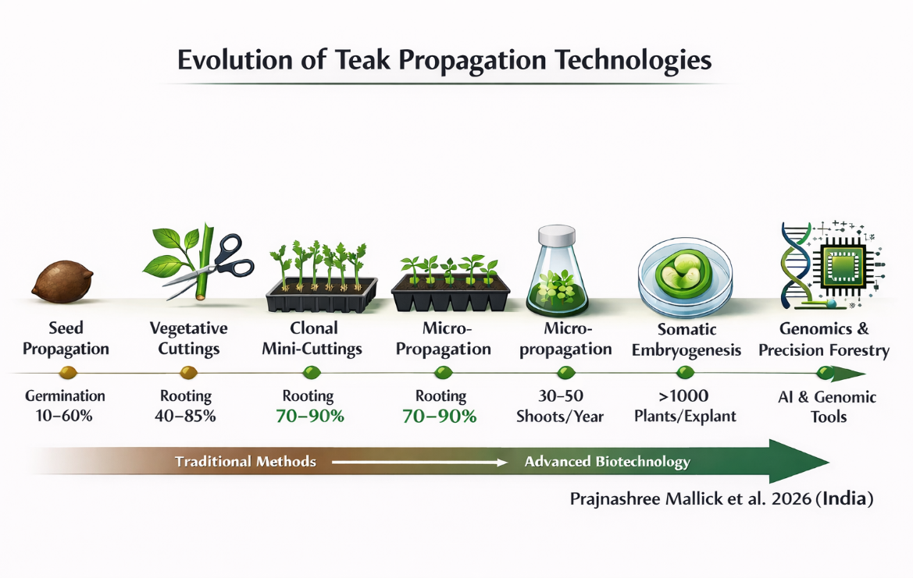
Fig 2. Evolution of Teak propagation technologies
quantitative, qualitative and environment aspects of plantation forestry of Teak.

3.2 Global Trends in Advances in Propagation of Teak
The global propagation landscape of Tectona grandis has undergone a marked transition over the past three decades, shifting from conventional seed-based systems to technologically advanced, clonal and biotechnological approaches. This transformation has been driven by the increasing demand for high-quality timber, the need for uniform plantations, and the imperative to enhance productivity under changing climatic conditions (Kollert and Kleine, 2017; Midgley et al., 2015; FAO, 2022 and Fig 3).
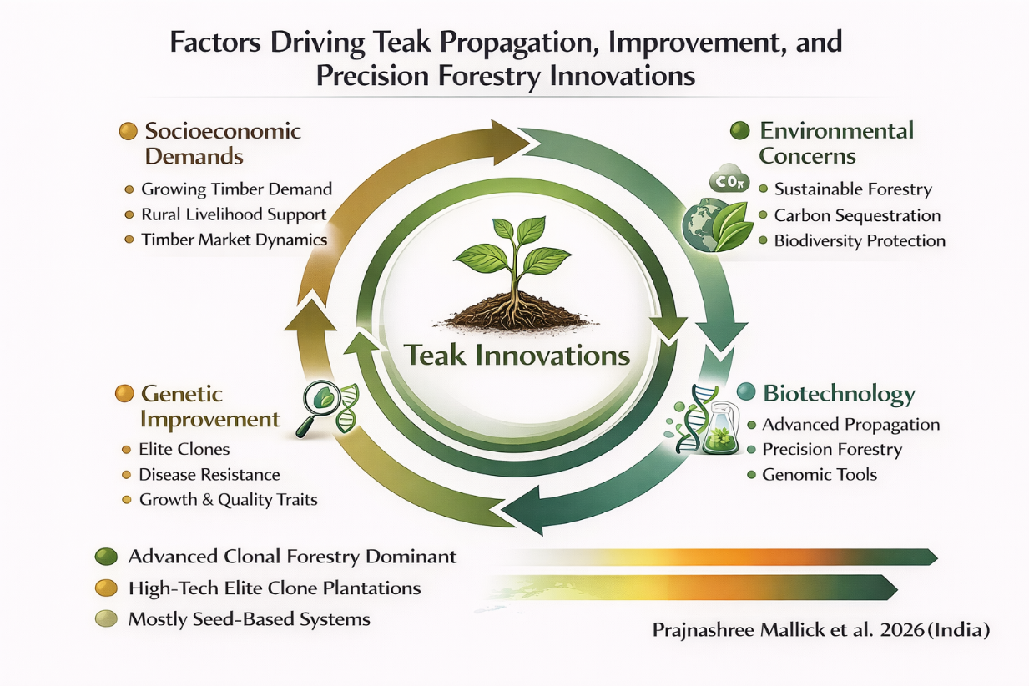
Fig 3. Factors driving Teak propagation, improvement, and precision forestry innovations
3.2.1 Transition from Seed-Based to Clonal Systems
Historically, teak plantations relied predominantly on seed-based propagation due to its simplicity and low cost. However, widespread challenges such as poor germination, high genetic variability, and inconsistent growth performance have led to a gradual shift toward clonal forestry systems (Kjaer and Foster, 1996; Goh and Monteuuis, 2016).
Globally, clonal propagation particularly through mini-cutting and hedge-based systems has become the dominant method in industrial plantations, enabling the deployment of genetically superior planting material with improved uniformity and productivity (Monteuuis and Goh, 2014; Tiwari et al., 2002). This transition is most evident in Southeast Asia and Latin America, where large-scale commercial plantations have adopted clonal technologies to achieve higher returns and shorter rotation cycles (Midgley et al., 2015).

3.2.2 Regional Patterns in Propagation Practices

(i) Asia (India, Indonesia, Thailand)
Asia remains the traditional centre of teak cultivation and innovation in propagation techniques. Countries such as India and Indonesia have advanced clonal forestry programs, supported by research institutions and plantation industries (Kollert and Kleine, 2017). In India, both public and private sectors are increasingly adopting mini-cutting techniques and improved nursery practices, while Indonesia has integrated clonal propagation into large-scale plantation systems. The regional scenario has been depicted in Fig 4.
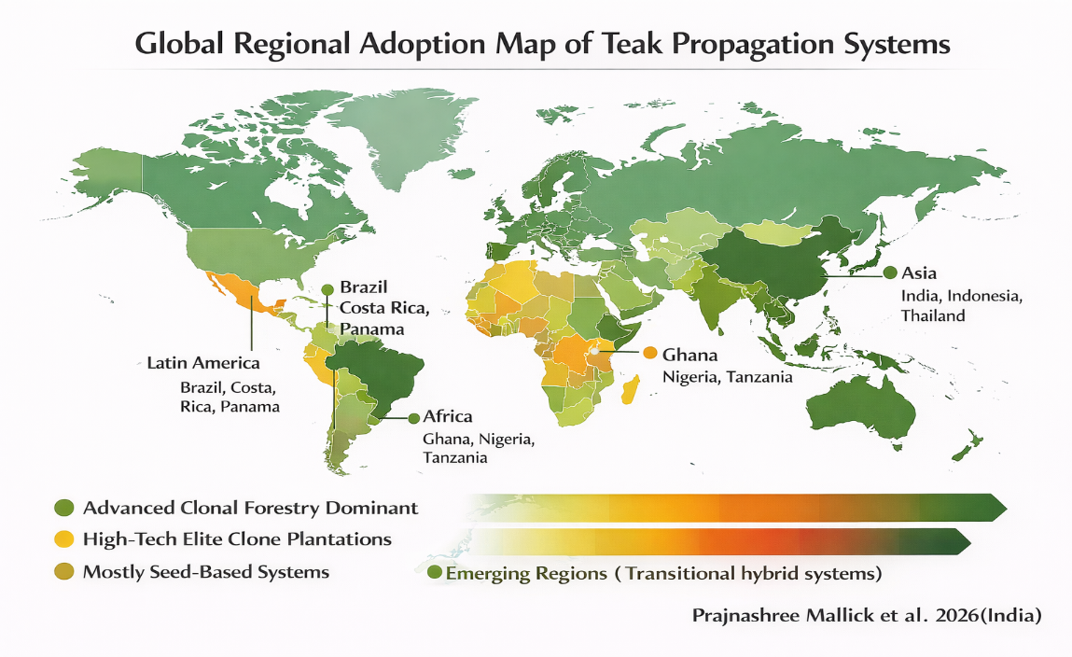
Fig 4. Global Regional Adoption Map of Teak Propagation Systems

(ii) Latin America (Brazil, Costa Rica, Panama)
Latin America has emerged as a global leader in high-productivity teak plantations, largely due to the adoption of clonal propagation and improved management practices. Brazil, in particular, has demonstrated significant gains in mean annual increment (MAI) through the use of elite clones and optimized silviculture. The region’s success highlights the importance of integrating propagation technologies with site-specific management.

(iii) Africa (Ghana, Nigeria, Tanzania)
In Africa, teak propagation remains largely seed-based, especially in smallholder and low-input systems. However, there is a growing interest in clonal forestry and improved nursery techniques, supported by international development programs (Kollert and Kleine, 2017). Limited infrastructure and technical capacity currently constrain widespread adoption of advanced propagation methods.

3.2.3 Emergence of Biotechnological Approaches
In recent years, micropropagation and tissue culture technologies have gained prominence as tools for mass multiplication of elite genotypes. Advances in in vitro propagation, including temporary immersion systems and ex vitro rooting, have improved multiplication efficiency and plantlet survival (Akram and Aftab, 2009).
More recently, somatic embryogenesis and molecular biology approaches have provided new insights into regeneration processes, enabling more precise control over propagation (Deo et al., 2010; Zhou et al., 2024). Although still at an experimental or semi-commercial stage, these technologies represent the next frontier in teak propagation, particularly for integrating genetic improvement with large-scale deployment.

3.2.4 Integration of Nursery Innovations and Biological Inputs
A notable global trend is the integration of bio-inoculants such as plant growth-promoting rhizobacteria (PGPR) and arbuscular mycorrhizal fungi (AMF) into nursery practices. These biological inputs have been shown to enhance seedling vigour, nutrient uptake, and field establishment, particularly under stress conditions.
This trend reflects a broader movement toward sustainable and eco-friendly propagation systems, reducing dependency on chemical inputs and improving long-term soil health.

3.3.5 Digitalization and Precision Forestry
Emerging trends in global forestry include the adoption of digital tools, automation, and precision nursery management systems. Technologies such as automated misting systems, sensor-based environmental control, and data-driven decision support are increasingly being integrated into propagation and nursery operations.
Although still in early stages for teak, these innovations are expected to enhance propagation efficiency, reduce labour costs, and improve consistency in planting material quality.

3.2.6 Climate-Resilient Propagation Strategies
Climate change has introduced new challenges for teak cultivation, including variability in rainfall, temperature extremes, and increased pest and disease pressures. As a result, there is growing emphasis on developing climate-resilient propagation systems, including the selection of drought-tolerant clones and improved nursery practices (IPCC, 2019; IPCC, 2023).
Propagation technologies are increasingly being aligned with site-specific climatic conditions, ensuring that planting material is adapted to future environmental scenarios.
This transition reflects a broader paradigm shift toward genetically improved, high-yield, and climate-smart plantation systems, where propagation technologies play a central role in determining productivity and sustainability outcomes (Midgley et al., 2015; Goh and Monteuuis, 2016).

3.3 Emerging Technologies in Propagation of Teak
Recent decades have witnessed a paradigm shift in teak propagation, with the emergence of advanced biotechnological and precision-based approaches that aim to overcome the limitations of conventional methods. These emerging technologies are increasingly enabling rapid multiplication, genetic fidelity, scalability, and climate resilience, thereby redefining modern teak forestry systems (Goh and Monteuuis, 2016).

3.3.1 Somatic Embryogenesis and Cellular Totipotency
Somatic embryogenesis (SE) has emerged as one of the most promising technologies for large-scale clonal propagation of teak, exploiting cellular totipotency to regenerate plants from somatic tissues (Deo et al., 2010). Embryogenic cultures can be induced from juvenile tissues using optimized combinations of plant growth regulators such as 2,4-D, BA, and TDZ, achieving moderate to high induction efficiency (Deo et al., 2010; Goh et al., 2013).
At the molecular level, SE is regulated by complex hormonal signaling pathways involving auxin, cytokinin, and abscisic acid. Recent transcriptomic studies have identified key regulatory genes such as AUX/IAA, ARF, and SERK that control embryogenic competence and development (Ramakrishnan et al., 2023; Zhou et al., 2024). These findings provide a mechanistic basis for improving regeneration efficiency and reproducibility.
However, genotype dependency and variability in embryo conversion remain significant challenges, limiting large-scale operational deployment (Goh and Monteuuis, 2016).

3.3.2 Advanced Micropropagation Systems and Bioreactor Technology
Micropropagation has evolved into a robust system for rapid multiplication of elite genotypes, with multiplication rates reaching 30–50 shoots per explant annually (Akram and Aftab, 2009). The adoption of temporary immersion bioreactors (TIBs) has further enhanced propagation efficiency by improving nutrient uptake, reducing hyperhydricity, and increasing shoot proliferation (Aguilar et al., 2019).
Ex vitro rooting and acclimatization techniques have significantly improved plantlet survival (70–95%), making micropropagation more commercially viable (Mendoza de Gyves et al., 2007). Additionally, tissue culture enables the production of disease-free and genetically uniform planting material, which is essential for maintaining plantation health and productivity (Goh et al., 2013).
Despite these advantages, high operational costs and genotype-specific responses remain key constraints (Goh and Monteuuis, 2016).

3.3.3 Synthetic Seeds and Encapsulation Technology
Synthetic seed technology, involving encapsulation of somatic embryos in protective matrices, represents an emerging approach for germplasm conservation and propagation. Although still in early stages for teak, this technology has demonstrated potential for easy storage, transport, and mechanized sowing, as reported in other forestry species (Goh et al., 2013; Goh and Monteuuis, 2016).
Its future application in teak propagation is expected to enhance scalability and reduce dependence on conventional nursery systems.

3.3.4 Molecular Breeding and Genomic-Assisted Propagation
Advances in molecular biology are facilitating the integration of genomics with propagation technologies, enabling more efficient selection and multiplication of elite genotypes. Molecular markers and gene expression studies are increasingly being used to identify traits associated with rooting ability, growth performance, and stress tolerance (White et al., 2007; Ramakrishnan et al., 2023). The identification of key genes regulating somatic embryogenesis and hormone signaling pathways provides opportunities for genetic improvement and precision propagation (Zhou et al., 2024). These approaches are expected to accelerate breeding programs and improve propagation success rates.

3.3.5 Integration of Bio-inoculants with Biotechnology
A novel advancement in teak propagation is the integration of bio-inoculants such as plant growth-promoting rhizobacteria (PGPR) and arbuscular mycorrhizal fungi (AMF) with tissue culture and nursery systems. Studies have demonstrated that inoculated plantlets exhibit improved growth, nutrient uptake, and stress tolerance. This integrated approach enhances survival during acclimatization and field establishment, effectively bridging the gap between laboratory propagation and field performance.

3.3.6 Automation, Artificial Intelligence, and Precision Nursery Systems
Emerging trends in propagation include the adoption of automation and precision nursery technologies, such as sensor-based environmental control, automated irrigation systems, and data-driven decision support tools. Although still in early stages for teak, these technologies are expected to improve propagation efficiency, reduce labour costs, and enhance consistency in plant quality (Midgley et al., 2015). Such advancements align with the broader shift toward precision forestry, where propagation and management practices are optimized using technological tools.

3.3.7 Climate-Smart Propagation Technologies
Propagation technologies are increasingly being aligned with the need for climate-resilient forestry systems. This includes the development of drought- and heat-tolerant clones, as well as the use of biotechnology to enhance stress tolerance (IPCC, 2019; IPCC, 2023). The integration of propagation techniques with climate modeling and site-specific management strategies ensures that planting material is better adapted to future environmental conditions (Griscom et al., 2017).

3.4 Future Prospects in Propagation of Teak
The next decade will likely redefine teak propagation through the convergence of genetics, biotechnology, digitalization, and sustainability science. Building on the transition from seed-based systems to clonal and in vitro approaches, future pathways are expected to focus on precision propagation, cost-effective scaling, and climate resilience, enabling consistent, high-yield plantations under variable environments.

3.4.1 Genomics-Enabled Propagation and Precision Breeding
A major frontier lies in integrating genomics with propagation systems. High-throughput genotyping, genome-wide association studies (GWAS), and transcriptomics can accelerate the identification of elite, stress-tolerant, and fast-growing genotypes. Coupling these tools with clonal propagation and somatic embryogenesis will enable rapid deployment of superior clones with predictable performance (White et al., 2007; Ramakrishnan et al., 2023; Zhou et al., 2024).
Emerging techniques such as genomic selection and gene editing (e.g., CRISPR/Cas systems) hold promise for improving traits such as rooting ability, drought tolerance, and wood quality, thereby enhancing propagation efficiency and plantation productivity.

3.4.2 Scaling Up Micropropagation and Bioreactor Systems
Despite significant advances, the large-scale adoption of micropropagation is still constrained by cost and technical complexity. Future efforts will focus on automation, low-cost media formulations, and modular bioreactor systems, enabling industrial-scale production of planting material. The refinement of temporary immersion systems (TIBs) and continuous culture bioreactors is expected to increase multiplication rates while reducing labor and operational costs (Aguilar et al., 2019). Integration with ex vitro rooting and acclimatization protocols will further enhance scalability and field performance.

3.4.3 Synthetic Seeds and Germplasm Conservation
The development of synthetic seed technology offers a promising avenue for long-term storage, transport, and mechanized planting of elite germplasm. Future research should focus on improving encapsulation efficiency, storage longevity, and field conversion rates, making this technology commercially viable for teak.
Such approaches will be particularly important for conservation of genetic resources and rapid dissemination of improved planting material across regions.

3.4.4 Integration of Bio-inoculants and Microbiome Engineering
Future propagation systems will increasingly incorporate plant–microbiome interactions. The use of PGPR, AMF, and endophytic microbes is expected to evolve into targeted microbiome engineering, where beneficial microbial consortia are tailored to enhance growth, nutrient uptake, and stress tolerance. This integration will reduce dependency on chemical inputs and contribute to sustainable, low-carbon forestry systems.

3.4.5 Digitalization and Smart Nursery Systems
The adoption of digital tools and artificial intelligence (AI) will play a transformative role in teak propagation. Smart nurseries equipped with:
- Sensor-based climate control
- Automated irrigation and misting systems
- AI-driven decision support
will enable real-time optimization of propagation conditions, improving efficiency and reducing variability. Data-driven approaches will also facilitate predictive modeling of growth and survival, enhancing plantation planning and management (Midgley et al., 2015).

3.4.6 Climate-Resilient and Site-Specific Propagation Strategies
Climate change is expected to significantly influence teak growth and distribution. Future propagation strategies will need to prioritize:
- Development of drought- and heat-tolerant clones
- Matching genotypes to site-specific climatic and edaphic conditions
- Integration of propagation with climate modeling and risk assessment
Such approaches will ensure the establishment of resilient plantations capable of sustaining productivity under changing environmental conditions (IPCC, 2019; IPCC, 2023; Griscom et al., 2017).

3.4.7 Towards Integrated Propagation–Productivity Frameworks
Future research should move beyond isolated propagation studies toward integrated frameworks linking propagation methods with field performance, economics, and ecosystem services.
This includes:
- Long-term trials comparing propagation systems across regions
- Quantification of impacts on MAI, rotation length, and carbon sequestration
- Integration with value chains and market dynamics
Such holistic approaches will provide a stronger scientific basis for policy formulation and large-scale plantation development.

3.4.8 Strategic Research Priorities
To fully realize the potential of emerging technologies, the following priorities are critical:
- Standardization of propagation protocols across genotypes and regions
- Reduction of costs in tissue culture and clonal propagation systems
- Integration of biotechnology with traditional silvicultural practices
- Capacity building and technology transfer, particularly in developing regions
- Strengthening collaboration between research institutions, industry, and policymakers
4. Conclusion
Propagation of Tectona grandis has evolved from traditional seed-based methods to advanced clonal and biotechnological systems, significantly improving plantation productivity and uniformity. Seed propagation remains important for low-input forestry but is limited by poor germination, high variability, and lower yields. Clonal forestry and mini-cutting systems have greatly enhanced rooting success, stand uniformity, and productivity, while micropropagation offers the highest multiplication efficiency for elite genotypes. Emerging technologies such as somatic embryogenesis and molecular breeding hold strong potential for precision teak improvement. The advantages of advanced teak propagation technologies are pictorially concluded in Fig 5.
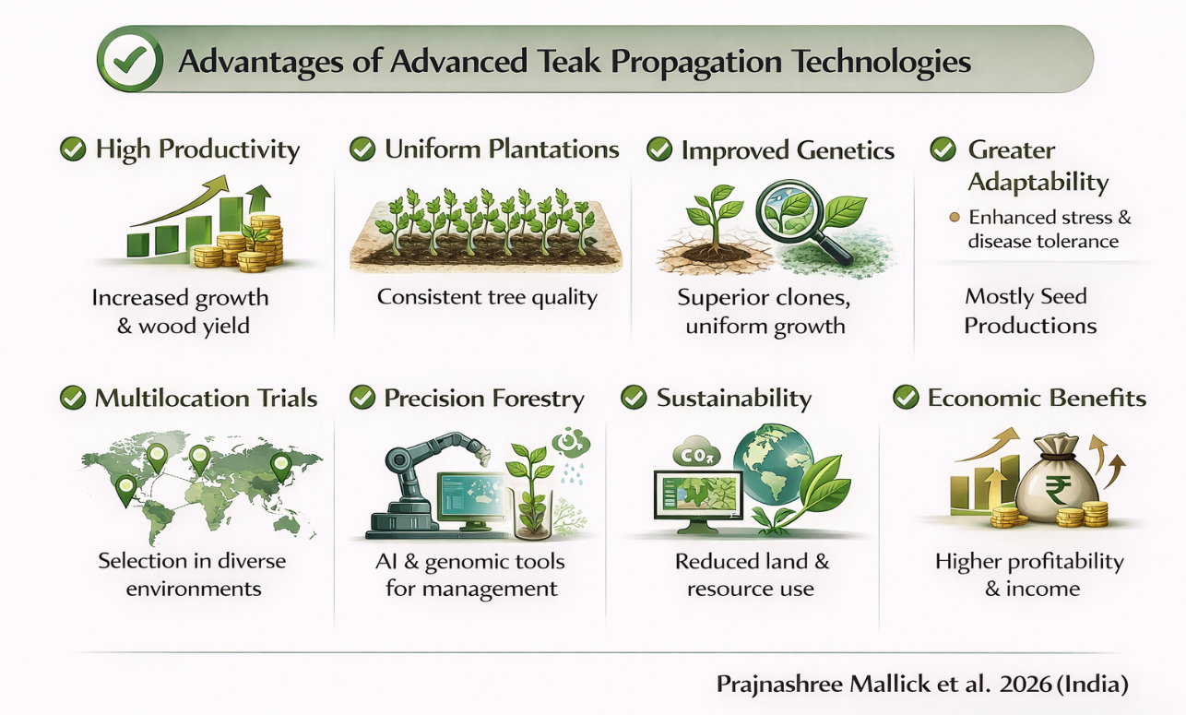
Fig 5. Advantages of advanced teak propagation technologies
Overall, the future of teak forestry depends on integrating cost-effective, climate-resilient, and scalable propagation technologies to ensure sustainable high-yield timber production.

Competing interests
Authors have declared that no competing interests exist.

Consent (where ever applicable)

All authors have given consent for publication of the manuscript.

Ethical approval (where ever applicable)

All authors declare that there is no ethical issue.

COMPETING INTERESTS DISCLAIMER:
Authors have declared that they have no known competing financial interests OR non-financial interests OR personal relationships that could have appeared to influence the work reported in this paper.
Disclaimer (Artificial intelligence)

Author(s) hereby declare that NO generative AI technologies such as Large Language Models (ChatGPT, COPILOT, etc.) and text-to-image generators have been used during the writing or editing of this manuscript.

5.0 REFERENCES
Aguilar, M., Garita, K., Kim, Y., Kim, J. & Moon, H. (2019). Simple Protocol for the Micropropagation of Teak (Tectona grandis Linn.) in Semi-Solid and Liquid Media in RITA® Bioreactors and ex Vitro Rooting. American Journal of Plant Sciences, 10(07):1121-1141. DOI: 10.4236/ajps.2019.107081.
Akram, M. & Aftab, F. (2009). An efficient method for clonal propagation and in vitro establishment of softwood shoots from epicormic buds of teak (Tectona grandis L.). For. Stud. China 11, 105–110 (2009). https://doi.org/10.1007/s11632-009-0018-1.
Anantha, P.H.S. & G. Vijayalakshmi. (1994). Vegetative propagation of teak through branch cuttings and sprouts. Tree Breeding and Propagation, 3: 8-9.
Ansari, S.A., S Sharma, N.C. Pant & A. K. Mandal. (2002). Synergism between IBA and thiamine for induction and growth of adventitious roots in Tectona grandis. J. Sustainable For., l5:99-112.
Baskin, C.C. & Baskin, J.M. (2014). Seeds: Ecology, Biogeography, and Evolution of Dormancy and Germination. Academic Press.
Behera, M.K. & Bhol, N. (2016). Inter-clonal variation in teak fruit parameters. Indian Forester, 142(11):1061–1064.
Behera, M.K., Bhol, N. & Lenka, D. (2015). Variation in phenology and reproductive biology in a clonal seed orchard of teak. International Journal of Ecology and Environmental Sciences, 41(3–4): 189–193.
Behera, M.K., Bhol, N., Parida, A.K. & Pradhan, T.R. (2016). Genetic diversity in teak clones. Journal of Applied and Natural Science, 8(1): 273–278.
Bhol, N. & Parida, S. (2024). Silviculture of Important Trees. Elite Publishing House, New Delhi, India.
Bhol, N., Roshan, R., Parida, S. & Dash, A. (2024). Seed characteristics and seedling quality of selected teak clones in eastern India. International Journal of Plant & Soil Science, 36(6): 720–732.
Chaix, G., O. Monteuuis, C. Garcia, D. Alloysius, J. Gidiman, R. Bacilieri & D. K. S. Goh (2011): Genetic variation in major phenoty patan traits among diverse genetic origins of teak (Tectona grandis L.f.) planted in Taliwas, Sabah, East Malaysia. Annals of Forest Science, 68: 1015–1026.
Deo, P.C., Tyagi, A.P., Taylor, M., Harding, R. & Becker, D. (2010). Factors affecting somatic embryogenesis and transformation in modern plant breeding. The South Pacific Journal of Natural and Applied Sciences, 28: 27-40.
Evans, J. &Turnbull, J. (2004). Plantation Forestry in the Tropics. Oxford University Press.
FAO. (2020). Global Forest Resources Assessment 2020. Food and Agriculture Organization of United Nations, Rome.
FAO. (2022). Global Teak Resources and Market Assessment 2022. Food and Agriculture Organization of United Nations, Rome.
Goh, D.K.S. & Monteuuis, O. (2016) Teak. In: Sung Park, Y., Bonga, J.M. and Moon, H.K., Eds., Vegetative Propagation of Forest Trees, National Institute of Forest Science (NIFoS), Seoul, 425-440.
Goh, D.K.S., Y. Japarudin, A. Alwi, Lapammu M., Flori A. & Monteuuis O. (2013). Growth differences and genetic parameter estimates of 15 teak (Tectona grandis L.f.) genotypes of various ages clonally propagated by microcuttings and planted under humid tropical conditions. Silvae Genetica, 62: 4–5.
Griscom, B.W., Adams, J., Ellis, P.W., et al. (2017). Natural climate solutions. Proceedings of the National Academy of Sciences, 114: 11645–11650. https://doi.org/10.1073/pnas.1710465114.
Husen, A. (2012). Clonal Propagation of Teak (Tectona grandis Linn. f.) - Adventitious Root Formation: Influence of Physiological and Chemical Factors. DOI: 10.13140/RG.2.1.1564.0083.
Husen, A. & Pal, M. (2006). Variation in Shoot Anatomy and Rooting Behaviour of Stem Cuttings in Relation to Age of Donor Plants in Teak (Tectona grandis Linn. f.). New Forests, 31(1):57-73. DOI: 10.1007/s11056-004-6794-5.
IPCC (2019). Climate Change and Land: An IPCC Special Report on Climate Change, Desertification, Land Degradation, Sustainable Land Management, Food Security, and Greenhouse Gas Fluxes in Terrestrial Ecosystems. Intergovernmental Panel on Climate Change.
IPCC (2023). Climate Change 2023: Synthesis Report. Intergovernmental Panel on Climate Change.
Kjaer, E.D. & Foster, G.S. (1996). The economics of tree improvement of teak. Technical Note 43. DANIDA Forest Seed Centre, Humlebaek, Denmark.
Kollert W. & Kleine M. 2017.The Global Teak Study Analysis, Evaluation and Future Potential of Teak Resources.International Union of Forest Research Organizations (IUFRO). ISBN: 978-3-902762-77-1.
Kollert, W. & Kleine, M. (2017). The Global Teak Study: Analysis, Evaluation and Future Potential of Teak Resources. FAO, Rome.
Lamb, D. (2011). Regreening the Bare Hills. Tropical Forest Restoration in the Asia-Pacific Region. Springer.
Meenakshi, R., Sivakumar, B., Balasubramanian, A., Revathi, R., Devanand, P.S., Sujatha, K.B., Sujith, P.P., Ramesh, K.R., Ravikarthik, K. & Eniya, A. (2025). Evaluating the effectiveness of teak tissue culture in ex situ conservation, with a focus on its practical implementation and challenges in commercialforestry. Plant Science Today.
Mendoza de Gyves, Royani JI & Rugini E. (2007). Efficient method of micropropagation and in vitro rooting of teak (Tectona grandis L.) focusing on large-scale industrial plantations. Annals of Forest Science, 64 (1). DOI: 10.1051/forest:2006090.
Midgley, S., Somaiya, R.T., Stevens, P.R., Brown, A., Nguyen, Duc Kien & Laity, R. (2015). Planted teak: global production and markets, with reference to Solomon Islands. ACIAR Technical Reports No. 85. Australian Centre for International Agricultural Research: Canberra. 92 pp. Available at: www. http://aciar.gov.au/publication/tr85.
Midgley, S.J., Stevens, P.R. & Arnold, R.J. (2017). Hidden assets: Asia’s smallholder wood resources and their contribution to supply chains of commercial wood. Australian Forestry, 80 (1):1-16. DOI: 10.1080/00049158.2017.1280750.
Monteuuis, O. and Goh, D.K.S. (2014). Field growth performances of teak genotypes of different ages clonally produced by rooted cuttings, in vitro microcuttings, and meristem culture, Can J For Res., 45:9-14. DOI: 10.1139/cjfr-2014-0339.
Monteuuis, O., Goh DKS, Garcia C, Alloysius D, Gidiman J, Bacilieri R, Chaix G (2011) Genetic variation of growth and tree quality traits among 42 diverse genetic origins of Tectona grandis planted under humid tropical conditions in Sabah, East Malaysia. Tree Genet Genomes 7:1263–1275.
Monteuuis, O. (2021). Clonal Teak. In: Ramasamy, Y., Galeano, E., Win, T.T. (eds) The Teak Genome. Compendium of Plant Genomes. Springer, Cham. https://doi.org/10.1007/978-3-030-79311-1-10.
Mundt, T. 1997. Vegetative propagation of teak (Tectona grandis) by cutting. TEAKNET Newsletter 7, 3-4.
Nautiyal, S., U. Singh and K. Gurumurthi. 1992. Rooting response of branch cuttings of teak (Tectona grandis) as influenced by growth hormones and position of the cuttings on the crowm. Indian Forester, 118 (2): 112-121 (1992).
Nautiyal, S., U. Singh & K. Gurumurti. (1991). Rooting response of branch cuttings of teak (Tectona grandis) as influenced by season and growth hormones. lndian For., 1 : 249-255.
Palanisamy, K., Ansari, S. A. & Mandal, A. K. (1995). Standardization of vegetative propagation technology of teak, sissoo, neem,karanj and bamboos. In: Proceedings of International Workshop on Forestry Research Methods, Vani Printers, Dehra Dun, pp.18-19.
Palupi, E.R., Owens, J.N., Sadjad, S., Sudarsono & Solihin D.D. (2010). The importance of fruit set, fruit abortion, andpollination success in fruit production of teak (Tectona grandis). Canadian Journal of Forest Research, 40(11):2204-2214. DOI: 10.1139/X10-160.
Parida, S., Kunhamu, T.K., Bhol, N. (2022). Efficacy of biodegradable containers in nursery Salraised teak seedlings. Indian Journal of Ecology, 49(5), 1896–1900.
Pradhan, T.R., Bhol, N., Lenka, D. & Behera, M.K. (2017). Productivity of selected teak clones. The Bioscan, 12(1), 259–263.
Pradhan, T.R., Bhol, N., Parida, A.K. & Behera, M., (2020). Growth behavior and phenology of some teak clones. Indian Forester, 146(9), 801–805.
Ramakrishnan, M., Zhou, M., Ceasar, S.A., Ali, D.J., Maharajan, T., Vinod, K.K., Sharma, A., Ahmad, Z & Wei, Q. (2023). Epigenetic modifications and miRNAs determine the transition of somatic cells into somatic embryos. Plant Cell Rep., 42(12):1845-1873. doi: 10.1007/s00299-023-03071-0.
Salve, Anand., Ahirwar, G.K., Lather, Arun & Pateriya Aakash. (2026). Influence of presowing treatments on seed germination, seedling growth, and early development of teak (Tectona grandis). International Journal of Research in Agronomy, 9(1): 411-415.
Sawitri, M. N., Indrioko, S. and Widiyatno. (2020). The effects of rooting media, IBA, and clones on rooting ability of Teak’s shoot cutting. IOP Conf. Ser.: Earth Environ. Sci., 449.
Singh, S. (2023). Clonal Multiplication of Teak (Tectona grandis L. f.). In Clonal Forestry - Principles and Practices, Narendra Publishing House, New Delhi.
Singh, S., Kumar, P. and Ansari, S.A. (2005). Clonal propagation of teak (Tectona grandis) by composite treatment of auxin with thiamine. Indian Journal of Forestry, 28 (2):108- 111.
Tiwari, S.K., Tiwari, K.P. & Siril, E.A. (2002). An improved micropropagation protocol for teak.
Plant Cell, Tissue and Organ Culture, 71: 1–6, Kluwer Academic Publishers.
Velusamy, M. & Vanangamudi, K. (2003). Studies on enhancing seed germination and seedling vigour in teak (Tectona grandis). Journal of Tropical Forest Science, 15(1): 51-58.
White, T.L., Adams, W.T. & Neale, D.B., (2007). Forest Genetics. CAB International.
Zhou, W., Yang, G., Pan, D., Wang, X., Han, Q., Qin, Y., Li, K. & Huang, G. (2024). Analysis of the plant hormone expression profile during somatic embryogenesis induction in teak (Tectona grandis). Front. Plant Sci., 15:1429575. doi: 10.3389/fpls.2024.1429575.
Zobel, B. & Talbert, J. (1984). Applied Forest Tree Improvement. Wiley.

