Original Research Article
Characterization of Plant Growth-Promoting Potential of Root Nodule Endophytes from Albizia lebbeck (L.) Benth

Abstract
Albizia lebbeck (L.) Benth. is a leguminous tree with significant potential in agroforestry. Root nodules are known to harbour rhizobia as well as non‑rhizobial endophytes with plant growth‑promoting (PGP) traits. The present study was undertaken to isolate and characterize endophytic bacteria from root nodules of A. lebbeck. A total 48 bacterial isolates were isolated and purified from root nodules of A. lebbeck and were screened qualitatively for four PGP traits; IAA production, ammonia production, phosphate solubilization and chitinase activity. Identification of the effective PGP bacterial strains were done by sequencing of 16S rRNA gene. Results revealed that 52.08 % of bacterial isolates exhibited IAA production, 50 % of bacterial isolates exhibited ammonia production, while 31.25 % isolates showed phosphate solubilization. Chitinase activity was present in only one bacterial isolate (Al-DOB7). Pseudomonas sp. Al-DOB7 were identified as multifunctional PGP bacteria and showed all four PGP activity screened. Three bacterial isolates; Rhizobium sp. Al-Am1, Rhizobium sp Al-Kh2 and Ensifer sp. Al-Rs5 exhibited IAA production, ammonia production and phosphate solubilization. Further quantitative screening and greenhouse validation of these nodule-associated bacteria are essential for their sustainable application in agricultural and agroforestry systems.
Keywords: Albizia lebbeck, endophytes, PGPR, IAA, phosphate solubilization, Chitinase

1. Introduction
Albizia lebbeck (L.) Benth., commonly known as Siris, is a deciduous, fast‑growing multipurpose tree. It is distributed in tropical and subtropical regions of the world. It is valued for its timber, fodder, soil improvement properties and traditional medicinal uses (Hussain et al., 2024). A. lebbeck forms symbiotic associations with nitrogen‑fixing bacteria for nitrogen fixation (Rasche & Cadisch, 2009). Besides rhizobia, root nodules of legumes harbour a diverse community of non‑rhizobial endophytic bacteria that do not form nodules but colonize the nodule interior (Martínez‑Hidalgo & Hirsch, 2017; Wang et al., 2022). These endophytes, often referred to as “opportunistic” or “co‑resident” bacteria, can include species of Bacillus, Pseudomonas, Enterobacter, Paenibacillus and others (Pandya et al., 2015; Saini et al., 2023). These PGP bacteria contribute to plant growth through multiple mechanisms including production of phytohormones such as indole‑3‑acetic acid (IAA), solubilization of insoluble phosphate, production of siderophores and antimicrobial compounds and enhancement of stress tolerance (Pandya et al., 2015; Tariq et al., 2021; Singh et al., 2024).
The diversity and plant growth‑promoting (PGP) potential of rhizobial and non‑rhizobial endophytes associated with A. lebbeck nodules remain largely uncharacterized. The present study was undertaken to isolate and characterize both rhizobial and non‑rhizobial endophytic bacteria from root nodules of A. lebbeck and to evaluate their PGP activities, including IAA production, phosphate solubilization, ammonia production and chitinase activity. These PGP isolates may provide functional diversity of nodule endophytes for designing effective microbial inoculants that can enhance the growth of A. lebbeck and other legumes.

2. Material and Methods
2.1 Isolation of Bacterial isolates
Bacteria were isolated from excavated root nodules of A. lebbeck. Nodules were surface sterilized through immersing and rinsing periodically 90% ethanol for about 1 min, 0.1 % (w/v) and antifungal agent BavistinR for about 30 sec followed by 1% sodium hypochlorite (NaOCl) for 4 minutes. Nodules were crushed and exudate was streaked on a plate containing YEMA-CR media. Plates were incubated at 30-35 °C, after 3-4 days colonies with different morphologies were picked and streaked subsequently until pure colonies were obtained. Purified rhizobial strains were maintained on YEMA petri plates at 28°C.
2.2 IAA production
Method given by Gordon and Weber (1951) was used for screening of IAA producing microbes. YEM Broth supplemented with 1 mM L-tryptophan were inoculated with bacterial strains and incubated at 28 ºC for 10 days in complete dark. After incubation, cultures were centrifuge at 10,000 rpm for 15 min to separate bacterial cells. 2ml of the supernatant was mixed with 2 drops of orthopohosphoric acid and 4 ml of the Salkowski reagent (1 ml 0.5 FeCl₃ solution in 50 ml of 35% of perchloric acid). Development of pink color was recorded as positive results for IAA production.
2.3 Ammonia Production
Release of ammonia by microbes is a result of deamination of amino acids. Peptone water was prepared for testing of ammonia production by RNB strains. Bacterial strains were incubated at 28 ºC for 48-72 hours. After incubation 1 ml of Nessler’s reagent was added to each tube. Presence of yellow color indicates small amount of ammonia production, while deep orange to brownish color indicates maximum production of ammonia (Cappuccino & Sherman, 2013).
2.4 Phosphate solubilization
Phosphate is one of the vital nutrient, which is not available freely. Several microbes are known to secrete some organic acids which solubilize the insoluble phosphates into available form. PVK agar medium was used to determine phosphate solubilization (Pikovskaya, 1948). Spot inoculation of bacterial strain was done on PVK agar medium and incubated at 28 ºC for 48-72 hours. Formation of clear zone around the colonies was considered as positive result.
2.5 Chitinase activity
Chitinase are the group of enzyme that decomposes chitin, a homo polysaccharide made up of monomers of N- acetyl glucosamine composed by glycoside β-(1-4) bonds. To screen chitinase activity colloidal chitin agar medium was used (Kim et al., 2003). Bacterial isolates were spot inoculated and kept for 48-72 hours at 28 ºC. To check results plates were flooded with iodine solution. Formation of clear zone around the colonies was considered as positive result.
2.6 Identification of bacterial isolates
DNA was extracted using the method described by Cheng and Jiang, 2006. The 16S rRNA gene was amplified using the universal bacterial primers 8F (5′-AGAGTTTGATCCTGGCTCAG-3′) and 1492R (5′-GGTTACCTTGTTACGACTT-3′), as described by Weisburg et al. (1991). The resulting sequences were analyzed using the BLASTn algorithm against the National Center for Biotechnology Information (NCBI) database to identify the bacterial isolates.
3. Results and Discussion
Plant growth-promoting (PGP) bacteria promote plant growth through multiple mechanisms. These mechanisms include biological nitrogen fixation (BNF), phosphate solubilization and mineralization, siderophore production, IAA synthesis, ACC deaminase activity, chitinases enzymes Production (Khatoon et al., 2020; Grover et al., 2021; De Andrade et al., 2023). Besides rhizobia, a large number of studies have shown the presence of diverse non-nodulating bacteria—such as Pseudomonas spp., Bacillus spp., Azospirillum spp., Enterobacter spp. within legume nodules (Pandya et al., 2015; Martínez‑Hidalgo & Hirsch, 2017; Wang et al., 2022, Saini et al., 2023). The root nodules of A. lebbeck harbour nitrogen‑fixing rhizobia as well as endophytic bacteria with distinct plant growth‑promoting potential. The present study focuses on a detailed characterization of PGP activities of endophytes from A. lebbeck nodules.
Bacterial colonies purified were white, opaque, mucilaginous and exopolysaccharide producing. Maximum strains were found to be fast growing. Forty-eight bacterial isolates were isolated and purified and were further screened for multiple plant growth-promoting (PGP) activities, including ammonia production, phosphate solubilization, indole-3-acetic acid (IAA) production and chitinase activity (Fig. 1). Indole 3-acetic acid (IAA) production is considered as one of the key mechanisms of PGP that stimulates root elongation and lateral root formation (Duca et al., 2014). IAA production by rhizobia strains was reported by many workers (Arora et al., 2001; Ghosh & Basu, 2002; Mandal et al., 2007; Sridevi & Mallaiah, 2007, Gallarato et al., 2015; Ahmed et al., 2021). In our study, IAA production was observed in 25 isolates out of forty-eight (Fig. 2); although the amount of IAA produced was varied from low, intermediate to high production (Table 1). Five bacterial isolates (Al-Am1, Al-Am18, Al-Barr2, Al-Kh2, Al-DOB7) showed high IAA production. Ammonia production by bacteria results in the accumulation of ammonia in the rhizosphere. Ammonia production was observed in the many isolates, around 50 % of strains were able to produce ammonia (Fig. 2, 3). Four isolates (Al-DOB7, Al-RS5, Al-Za3, Al-Za12) exhibited strong positive responses, while twenty isolates showed medium to low-level ammonia production (Table 1).
Phosphate solubilization is also important PGP trait in phosphorus limiting soils (Khan et al., 2016). The P solubilizing bacteria produces low molecular weight organic acids which helps to dissolve the unavailable soil P (Deubel, 2000). Phosphate solubilization was comparatively restricted, with only 31.25 % efficient solubilizers strains (Fig. 2, 3). Bacterial strains Al-Aj13, Al-Am4, Al-Bi2, Al-Dept4, Al-Kh4, Al-PC5, Al-RS2, Al-Rs4, Al-Rs5, Al-Shiv2, Al-Am1, Al-Kh2, Al-Barr2, Al-DOB7 and Al-Za12 showed low to medium phosphate solubilization activity. Alikhani et al., (2006) also reported 44% of isolated strains including Bradyrhizobium, Mesorhizobium and Ensifer were able to solubilize phosphate. Pandya et al., (2015) and Singh et al., (2024) also reported non‑rhizobial endophytes as efficient phosphate solubilizers.
Chitinase enzyme is a cell wall hydrolytic enzyme that have role in controlling fungi possessing chitin as cell wall component. Mehboob et al., (2011) found that strains of Mesorhizobium and Rhizobium isolated from root nodules of chickpea, mung bean and lentil have chitinase activity. In our study, chitinase activity was detected only in Al-DOB7 (Fig. 2, Table 1).
Four bacterial strains (Al-Am1, Al-Kh2, Al-Rs5 and Al-DOB7) were selected for sequencing of the 16S rRNA gene for identification. Closest BLASTn match of these sequences along with sequence similarity has been showed in table 2. Strain Al-Am1 and Al-Kh2 showed 100 % and 99.90% of sequence similarity with type strain Rhizobium aegyptiacum 1010 respectively. Bacterial strain Al-Rs5 showed 99.55% sequence similarity to closest type strain Ensifer mexicanum ITTG-R7. Bacterial strain Al-DOB7 with maximum PGP traits was identified as Pseudomonas sp. and showed 96.96% of sequence similarity with type strain Pseudomonas juntendi BML3.
The present study of the Plant Growth Promoting Rhizobacteria (PGPR) showed IAA production (52.08 %) and ammonia production (50.00 %) as the most common traits, followed by phosphate solubilization (31.25%), whereas chitinase activity was observed in only one isolate Al-DOB7 (2.08%). Species of Pseudomonas genus is widely reported to have multiple PGP activities such as nutrient-mobilizing, phytohormone production and antagonistic activity against plant pathogens (Caulier et al., 2018; Khalifa et al., 2022; Singh et al., 2022; Msaddak et al., 2023). In our study, bacterial isolate Pseudomonas sp Al-DOB7 showed all four PGP activities. Pseudomonas strains have been reported as opportunists nodule endophytes from nodules of different legumes (Zhao et al., 2018; Ferchichi et al., 2019; Hnini et al., 2023; Msaddak et al., 2023). Similarly, numerous studies have reported the isolation of other opportunists non-nodulating rhizobacteria from leguminous hosts exhibiting diverse plant growth-promoting (PGPR) traits (Hnini & Aurag, 2024). Acinetobacter spp. from Medicago sativa L. (Tafaroji et al., 2022); Bacillus spp. PSB10 and Enterobacter asburiae from Cicer arietinum L. (Wani et al., 2007; Saikia et al., 2023) showed positive indole-3-acetic acid (IAA) production, phosphate solubilization and siderophore activity.
Rhizobial species from genera such as Rhizobium, Bradyrhizobium, Ensifer and Mesorhizobium has been reported to exhibit additional plant growth-promoting activities beyond nodulation (Charest et al., 2005, Korir et al., 2017; Wang et al., 2020, Yadav et al., 2022). In this study, three bacterial isolates, Rhizobium sp. Al-Am1, Rhizobium sp. Al-Kh2 and Ensifer sp. Al-Rs5 showed three PGP activities i.e. IAA production, phosphate solubilization and ammonia production. Several Rhizobium species also demonstrated strong PGPR potential including Rhizobium sp. from C. arietinum L. and Lens culinaris (Alinia et al., 2022; Banjare et al., 2023).
4. Conclusion
The PGP ability of rhizospheric and endophytic bacteria have diverse functional potential. Their ability to enhance plant growth makes them valuable components of sustainable agricultural practices. In the present study, Pseudomonas sp. Al-DOB7, Rhizobium sp. Al-Am1, Rhizobium sp. Al-Kh2 and Ensifer sp. Al-Rs5 were identified as a potent PGPR. These nodules associated bacteria could further investigated for quantitative screening, greenhouse validation and formulation studies for biocontrol and biofertilizer development.

Table 1. Plant growth promoting activities of nodule endophytes isolated from A. lebbeck
PGP activity | Low | Medium | High
Ammonia production | Al-Aj11, Al-Am18, Al-Am8, Al-Bi2, Al-Dept4, Al-Gm2, Al-Jh1, Al-Jh4, Al-Jh7, Al-Kh4, Al-Kh5, Al-RS1, Al-RS14, Al-Za9 | Al-Jh 8, Al-Am4, Al-Am1, Al-Kh2, Al-RS13, Al-RS3 | Al-DOB7, Al-RS5, Al-Za3, Al-Za12
Phosphate solubilization | Al-Aj13, Al-Am4, Al-Bi2, Al-Dept4, Al-Kh4, Al-PC5, Al-RS2, Al-Rs4, Al-Rs5, Al-Shiv2 | Al-Am1, Al-Kh2, Al-Barr2, Al-DOB7, Al-Za12 | -
IAA production | Al-Bi4, Al-Dept9, Al-Jh 8, Al-Jh1, Al-Jh7, Al-Kh6, Al-Kis11, Al-PC4, Al-RS14, Al-RS3, Al-Rs5, Al-Shiv2, Al-Za9 | Al-Aj13, Al-Am3, Al-Am5, Al-Gm2, Al-Gm4, Al-Za3, Al-Za7 | Al-Am1, Al-Am18, Al-Barr2, Al-Kh2, Al-DOB7
Chitinase activity | - | Al-DOB7 | -

Table 2. Identification of bacterial strains isolated from A. lebbeck on the basis of 16S rRNA gene sequence.
S. No. | Bacterial strains | Genbank accession no. | Closest type strain | % Similarity with closest type strain
1 | Rhizobium sp. Al-Am1 | PZ291824 | Rhizobium aegyptiacum strain 1010 | 100
2 | Rhizobium sp. Al-Kh2 | PZ291825 | Rhizobium aegyptiacum strain 1010 | 99.90
3 | Ensifer sp. Al-Rs5 | PZ291826 | Ensifer mexicanum ITTG-R7 | 99.55
4 | Pseudomonas sp. Al-DOB7 | PZ291827 | Pseudomonas juntendi strain BML3 | 96.96

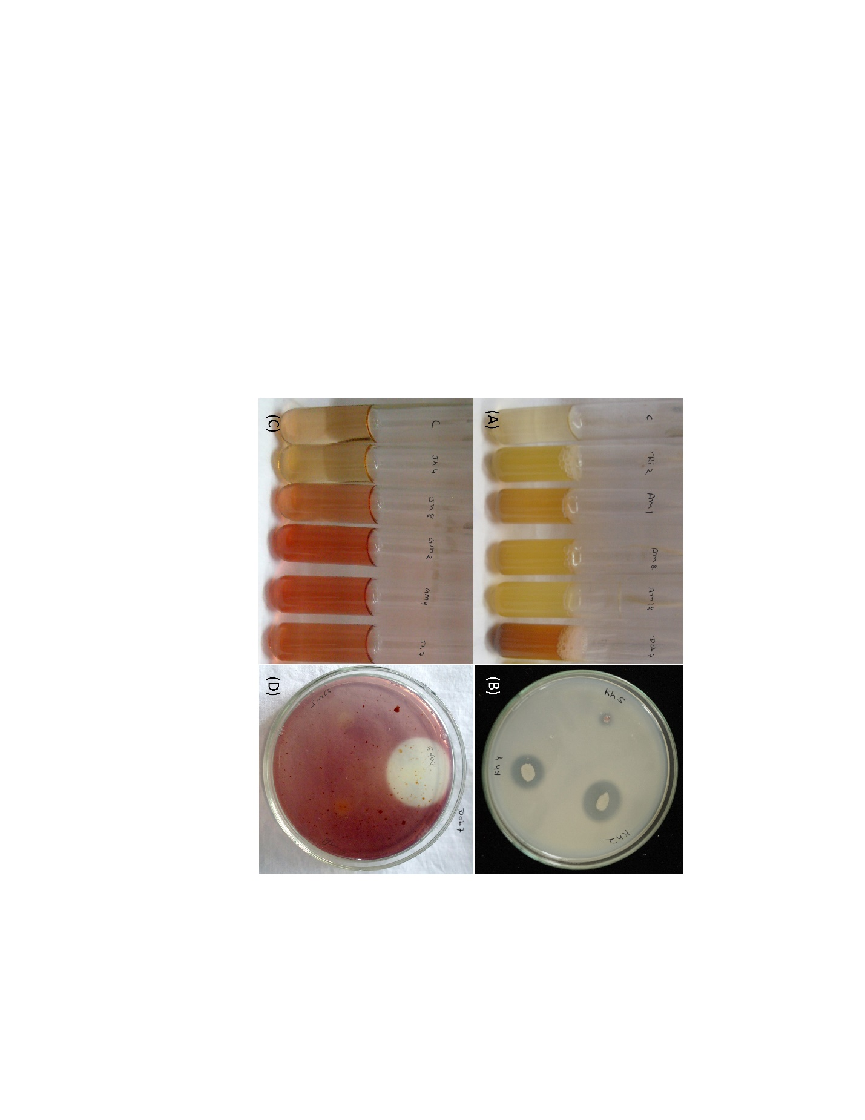
Fig. 1 Screening of PGP activity of nodule endophyte isolated from A. lebbeck (A) Ammonia production (B) Phosphate solubilization (C) IAA production (D) Chitinase activity
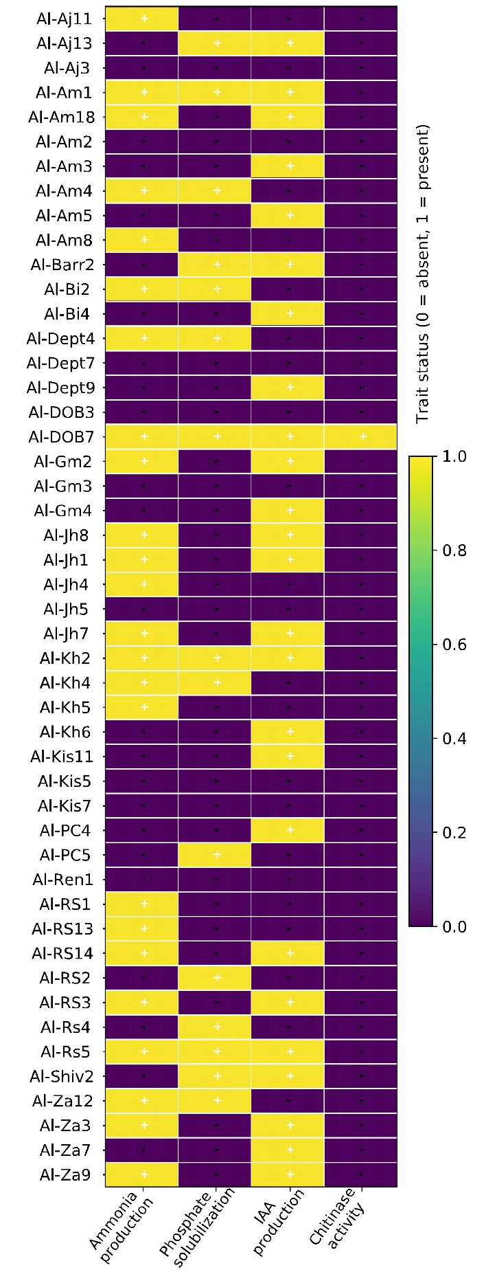
Fig. 2 Heatmap of PGPR traits of endophytic bacteria isolated from A. lebbeck
Fig. 3 PGP trait frequency (%) of bacterial isolates isolated from A. lebbeck

COMPETING INTERESTS DISCLAIMER:
Authors have declared that they have no known competing financial interests OR non-financial interests OR personal relationships that could have appeared to influence the work reported in this paper.

Disclaimer (Artificial intelligence)

Author(s) hereby declare that NO generative AI technologies such as Large Language Models (ChatGPT, COPILOT, etc.) and text-to-image generators have been used during the writing or editing of this manuscript.

REFERENCES
- Ahmed, B., Shahid, M., Syed, A., Rajput, V. D., Elgorban, A. M., Minkina, T., et al. (2021) Drought tolerant enterobacter sp. leclercia adecarboxylata secretes indole-3-acetic acid and other biomolecules and enhances the biological attributes of vigna radiata (L.) r. wilczek in water deficit conditions. Biology, 10(11),1149.
- Alikhani, H. A., Saleh-Rastin, N., & Antoun, H. (2006). Phosphate solubilization activity of rhizobia native to Iranian soils. Plant and Soil, 287, 35–41.
- Alinia, M., Kazemeini, S. A., Dadkhodaie, A., Sepehri, M., Mahjenabadi, V. A. J., Amjad, et al. (2022). Co-application of ACC deaminase-producing rhizobial bacteria and melatonin improves salt tolerance in common bean (Phaseolus vulgaris L.) through ion homeostasis. Scientific Reports, 12, 22–105.
- Arora, N. K., Kang, S. C., & Maheshwari, D. K. (2001). Isolation of siderophore-producing strains of Rhizobium meliloti and their biocontrol potential against Macrophomina phaseolina that causes charcoal rot of groundnut. Current Science, 25, 673-677.
- Banjare, U., Patel, A., & Pandey, A. (2023). Biochemical and molecular evaluation of Rhizobium spp. and its growth promotion studies with lentil (Lens culinaris Medik. L.). Journal of Pure and Applied Microbiology, 17(1), 155-166.
- Cappuccino, J. G. & Sherman, N. (2013). Microbiology: A Laboratory Manual (10th ed.). London: Pearson Education Limited.
- Caulier, S., Gillis, A., Colau, G., Licciardi, F., Liépin, M., Desoignies, N., et al. (2018). Versatile antagonistic activities of soil-borne Bacillus spp. and Pseudomonas spp. against Phytophthora infestans and other potato pathogens. Frontiers in Microbiology, 9, 143. https://doi.org/10.3389/fmicb.2018.00143
- Charest, C., McLean, A., & Beleschi, S. (2005). Rhizobium leguminosarum bv. viciae promotes arbuscular mycorrhizal colonization and growth of Vicia faba L. in phosphorus-limited soil. Mycorrhiza, 15(6), 439–447.
- Cheng, H. R., & Jiang, N. (2006). Extremely rapid extraction of DNA from bacteria and yeasts. Biotechnology Letters, 28(1), 55–59.
- De Andrade, L. A., Santos, C. H., Frezarin, E. T., Sales, L. R., & Rigobelo, E. C. (2023). Plant growth-promoting rhizobacteria for sustainable agricultural production, Microorganisms, 11(4), 1088. https://doi.org/10.3390/microorganisms11041088
- Deubel, A., Gransee, A., & Merbach, W. (2000). Transformation of organic rhizodeposits by rhizoplane bacteria and its influence on the availability of tertiary calcium phosphate. Journal of Plant Nutrition and Soil Science, 163(4), 387–392.
- Duca, S., Lorv, J., Patten, C. L., Rose, D., & Glick, B. R. (2014). Indole-3-acetic acid in plant-microbe interactions. Antonie van Leeuwenhoek, 106(1), 85–125.
- Ferchichi, N., Toukabri, W., Boularess, M., Smaoui, A., Mhamdi, R., & Trabelsi, D. (2019). Isolation, identification and plant growth promotion ability of endophytic bacteria associated with lupine root nodule grown in Tunisian soil. Archives of Microbiology, 201, 1333–1349.
- Gallarato, L. A., Paulucci, N. S., Chiappero, J., Cesari, A. B., Reguera, Y. B., Vicario, et al. Stress physiology in Azospirillum and other PGPRs. In Handbook for Azospirillum: Technical Issues and Protocols (pp. 319-330). Cham: Springer International Publishing.
- Ghosh, A. C., & Basu, P. S. (2002). Growth behaviour and bioproduction of indole acetic acid by a Rhizobium sp. isolated from root nodules of a leguminous tree Dalbergia lanceolaria. Indian Journal of Experimental Biology, 40(7), 796–801.
- Gordon, S. A., & Weber, R. P. (1951). Colorimetric estimation of indoleacetic acid. Plant Physiology, 26(1), 192.
- Grover, M., Bodhankar, S., Sharma, A., Sharma, P., Singh, J., & Nain, L. (2021). PGPR as crop yield enhancers and biological control agents: Mechanisms and applications, Plants, 10(4), 692.
- Hnini, M. & Aurag J (2024). Prevalence, diversity and applications potential of nodules endophytic bacteria: a systematic review. Frontiers in Microbiology, 15, 1386742.
- Hnini, M., Taha, K. & Aurag, J. (2023). Molecular identification and characterization of phytobeneficial osmotolerant endophytic bacteria inhabiting root nodules of the Saharan tree Vachellia tortilis subsp. raddiana. Archives of Microbiology, 205, 45.
- Hussain, M. I., Abideen, Z., & Rasheed, R. (2024). Multipurpose uses of Albizia lebbeck: A review of its ecological and economic significance. Agroforestry Systems, 98, 345–360.
- Khalifa, M. W., Rouag, N., & Bouhadida, M. (2022). Evaluation of the antagonistic effect of Pseudomonas rhizobacteria on Fusarium wilt of chickpea. Agriculture, 12(3), 429. https://doi.org/10.3390/agriculture12030429
- Khan, M. S., Zaidi, A., & Ahmad, E. (2016). Phosphate Solubilizing Microorganisms: Principles and Application of Microphos Technology. Springer.
- Khatoon, Z., Huang, S., Rafique, M., Fakhar, A., Kamran, M. A., & Santoyo, G. (2020). Plant growth promoting bacteria (PGPB)-induced plant adaptations to stresses: An updated review. Microbiological Research, 231, 126358.
- Kim, K. J., Yang, Y. J., & Kim, J. G. (2003). Purification and characterization of chitinase from Streptomyces sp. M-20. Journal of Biochemistry and Molecular Biology, 36(2), 185–189.
- Korir, H., Mungai, N. W., Thuita, M., Hamba, Y., & Masso, C. (2017). Co-inoculation effect of rhizobia and plant growth promoting rhizobacteria on common bean growth in a low phosphorus soil. Frontiers in plant science, 8, 141.
- Mandal, S. M., Mondal, K. C., Satyahari Dey, S. D., & Pati, B. R. (2007). Optimization of cultural and nutritional conditions for Indole-3-Acetic Acid (IAA) production by a Rhizobium sp. isolated from root nodules of Vigna mungo (L.) Hep-per. Research Journal of Microbiology, 2(3), 239–246.
- Martínez‑Hidalgo, P. & Hirsch, A. M. (2017). The nodule microbiome: N2‑fixing rhizobia do not live alone. Phytobiomes, 1(2), 70–82.
- Mehboob, I., Zahir, Z. A., Arshad, M., Tanveer, A., & Azam, F. (2011). Growth promoting activities of different Rhizobium spp. in wheat. Pakistan Journal of Botany, 43(3), 1643–1650.
- Miljaković, D., Marinković, J., Tamindžić, G., Đorđević, V., Tintor, B., Milošević, D., et al. (2022). Bio-priming of soybean with Bradyrhizobium japonicum and Bacillus megaterium: Strategy to improve seed germination and the initial seedling growth. Plants, 11(15), 1927.
- Msaddak, A., Quiñones, M. A., Mars, M., & Pueyo, J. J. (2023). The beneficial effects of inoculation with selected nodule-associated PGPR on white lupin are comparable to those of inoculation with symbiotic rhizobia. Plants, 12, 4109.
- Pandya, M., Kumar, G. N. & Rajkumar, S. (2015). Invasion of rhizobial infection thread by non‑rhizobia: a novel finding in soybean. Plant and Soil, 386, 85–97.
- Pikovskaya, R. I. (1948). Mobilization of phosphorus in soil in connection with vital activity of some microbial species. Mikrobiologiya, 17, 362–370.
- Rasche, F. & Cadisch, G. (2009). The molecular diversity of rhizobia associated with Acacia and Albizia species in tropical agro‑ecosystems. Plant and Soil, 321, 247–266.
- Saikia, J., Kotoky, R., Debnath, R., Kumar, N., Gogoi, P., Yadav, A., et al. (2023). De novo genomic analysis of Enterobacter asburiae EBRJ12, a plant growth-promoting rhizobacteria isolated from the rhizosphere of Phaseolus vulgaris L. Journal of Applied Microbiology, 134, lxac090.
- Saini, R., Dudeja, S. S. & Giri, R. (2023). Non‑rhizobial endophytes from chickpea nodules: diversity and plant growth‑promoting attributes. Journal of Applied Microbiology, 134(1), lxac011.
- Singh, A., Kumar, V., & Gupta, A. (2024). Synergistic effect of co‑inoculation of rhizobia and plant growth‑promoting rhizobacteria on growth and yield of leguminous crops: a meta‑analysis. Microbiological Research, 278, 127534.
- Singh, P., Singh, R. K., Zhou, Y., Wang, J., Jiang, Y., Shen, N., et al. (2022). Unlocking the strength of plant growth promoting Pseudomonas in improving crop productivity in normal and challenging environments: a review. Journal of Plant Interactions, 17(1), 220–238. https://doi.org/10.1080/17429145.2022.2029963
- Sridevi, M., & Mallaiah, K. V. (2007). Production of indole-3-acetic acid by Rhizobium isolates from Sesbania species. African Journal of Microbiology Research, 1(7), 125-128.
- Tafaroji, S. H., Abtahi, A., Jafarinia, M., & Ebadi, M. (2022). The effect of plant growth-promoting rhizobacteria producing ACC-deaminase, IAA, siderophore and phosphate solubilization on growth indices, chlorophyll, proline and protein in alfalfa at different levels of salinity. Plant Production, 45.
- Tariq, M., Hameed, S., Yasmeen, T. & Ali, A. (2021). Plant growth‑promoting endophytic bacteria from Albizia nodules: diversity and potential for biofertilizer development. Brazilian Journal of Microbiology, 52, 1249–1262.
- Wang, R., Xu, J., & Zhang, Y. (2020). Genomic insights into the plant growth-promoting traits of Rhizobium, Bradyrhizobium, Ensifer, and Mesorhizobium genera. Journal of Basic Microbiology, 60(11-12), 940–955.
- Wang, X., Yang, Y., & Zhang, L. (2022). Non‑rhizobial endophytes in legume root nodules: diversity, functions and applications. Frontiers in Microbiology, 13, 876234.
- Wani, P. A., Khan, M. S., & Zaidi, A. (2007). Chromium reduction, plant growth–promoting potentials, and metal solubilization by Bacillus sp. isolated from alluvial soil. Current Microbiology, 54(3), 237–243.
- Weisburg, W. G., Barns, S. M., Pelletier, D. A., & Lane, D. J. (1991). 16S ribosomal DNA amplification for phylogenetic study. Journal of Bacteriology, 173(2), 697–703.
Yadav, P., Chandra, R., & Pareek, N. (2022). Plant growth-promoting Mesorhizobia as a potential inoculant for chickpea (Cicer arietinum L.): A review. Quarterly Research Journal of Plant and Animal Sciences, 37.
- Zhao, L., Xu, Y. & Lai, X. (2018). Antagonistic endophytic bacteria associated with nodules of soybean (Glycine max L.) and plant growth-promoting properties. Brazilian Journal of Microbiology, 49, 269–278.

