Original Research Article
HORMONES AND SOLUBLE SUGARS CONTENTS COMPARISION ON CUCUMBER CULTIVARS WITH DIFFERENT INFLORESCENCE GROWTH HABIT

ABSTRACT
In flowering plants, the arrangement of flowers on a stem becomes an inflorescence, and a huge variety of inflorescence architecture occurs in nature. Inflorescence architecture also affects crop yield. Cucumber (Cucumis sativa L) possesses two types of stem growth habits. One type is the indeterminate stem, in which the terminal bud continues the vegetative activity of shoot apical meristem (SAM) during most of the growing season; the second type is the determinate stem, in which the vegetative activity of SAM ceases when it becomes a terminal flower. This research is important as it contribute to crop production by clarifying how plant hormones and total soluble sugars influence the development of different inflorescence architectures in Cucumis sativa, Understanding the physiological differences between determinate and indeterminate growth habits can support the development of improved cucumber varieties with higher yields and better flowering patterns. The study also provides valuable insights into the complex regulation of the shoot apical meristem, a key process in plant developmental biology. The study was carried out at Nanjing agricultural university (cucumber laboratory) to investigate the variation of plant hormones and total soluble sugars on cucumber varieties with different inflorescence growth habit, two cucumber varieties (CUS82 and CUS226) with determinate and CCMC with indeterminate inflorescence were used. Shoot tips and stem samples were collected in three replicates at different stages, each replicate included 10 and 5 plants for the shoot tip and the stem sample respectively. Plant hormones (Gibberellic acid, Cytokinin, Indole Acetic Acid) and total soluble sugars contents were determined using enzyme-linked immunosorbent assay (ELISA) technique. All statistical analyses were performed using STATISTICA version 6.0 (Stat Soft Inc., USA, 2001) package and graphs were generated using Graph prism. In this study, we highlight recent findings on the variation of plant hormones and TSS on cucumber varieties with different inflorescence architecture. Results shows that plant hormones and total soluble sugars contents on both shoot tip and stem varies significantly between the cucumber varieties with different inflorescence at various stages of plant growth, however relationship between hormones and TSS with physiological and regulation mechanism of inflorescence growth habit is not well understood and therefore further research is needed to relate how hormones and TSS affect the genes or the pathways that regulate terminal flower formation.

Key words: Cucumis sativus L, Determinate growth, Indeterminate growth, terminal flower, shoot apical meristem, plant hormones, total soluble sugars

INTRODUCTION
Roles of phytohormones on plant growth and developments
Plants continuously generate new tissues and organs through the activity of populations of undifferentiated stem cells, referred to as meristems since plant meristems can modulate their activity, they provide the developmental flexibility that allows plants to adapt their development in reaction to the environment (Scheres, 2007; Vernoux et al., 2010) The hormone interactions have several mechanisms, which act at both levels of hormone response and biosynthesis in creating a delicate response network (Hadi et al., 2015; Weiss and Ori, 2007). The impact of gibberellins, cytokinin and, auxin (IAA) were considered as essential for plant growth and development process (De Bruyne et al., 2014; Depuydt and Hardtke, 2011). Plant hormones regulate all stages of growth and development from embryogenesis to senescence (Davies, 2004; Pop et al., 2011a).
Gibberellins are plant growth hormones which promote cell division and regulate numerous physiological processes including seed germination, stem elongation, leaf, root and reproductive organs expansion(Achard et al., 2009; Colebrook et al., 2014; Schwechheimer and Willige, 2009). Several studies described the inhibition of gibberellin biosynthetic pathway by growth retardants in order to control crop production. Growth retardants were employed to reduce the shoot system, thereby lowering the risk of lodging in cereal crops, also used in making ornamental plants more compact with better canopy structure as well as improving the formation of reproductive structures in many other crops.(Liangjiu et al., 1990; Rademacher, 2018; Sridharan et al., 2009; Sridharan et al., 2015). Previously, its effects were reported in decreasing the stem length and also was involved in vascular formation. It is also utilized in boosting the growth of agronomic and horticultural crops(Kuai et al., 2015; Wang et al., 1986).
Cytokinin are produced in growing areas such as root tips and meristems and are known to promotes cell division. They travel through the xylem to their working destinations, such as leaves and stems. Cytokinins perform several functions performed in plants, including stimulation of growth and cell differentiation in stems and roots with auxins, promotion of growth and development of chloroplasts, and production of anti-aging effects on some plant partsand more importantly cytokinin provides a younger and healthier look to plants. Moreover, cytokinins are now known to exhibit a wide range of other physiological effects on a variety of plants and plant tissues. Most cytokinins occur as free purine bases, nucleosides or nucleotides and as t-RNA constituents. They can be divided into the different groups such as: isopentenyladenine (iP) and derivatives, zeatin (Z) and derivatives, dihydrozeatin (DHZ) and derivatives (Svolacchia, N., & Sabatini, S, 2023). The plant hormone auxin (Indole-3-acetic acid) plays an instrumental role in meristem biology. Indole-3-acetic acid (IAA) is the most common, naturally occurring, plant hormone of the auxin class. indole acetic acid (IAA) (Auxin) is a natural auxin which is produced by plants, bacteria and fungi. In plants, IAA is critical for plant growth and development. The phytohormone auxin (IAA) has been shown to play a central role in the regulation of leaf growth and developmentby controlling leaf initiation, specification of growth axes, morphogenesis and marginal patterning (Kumud et al., 2017; Shwartz et al., 2016)
The concentrations of endogenous auxins. Indole-3-acetic acid (IAA) is one of the main endogenous auxins, but it is relatively labile (Ludwig-Müller, 2000). Other endogenous auxins, such as indole-3- butyric acid (IBA), are more stable and travel more efficiently by polar transport (Frick, E. & Strader, L., 2018). Polar transport down the stem is the main mechanism of in plants depend on their rates of biosynthesis, transport, conjugation, and catabolism (Kramer and Ackelsberg, 2015) transport of auxins that are synthesized in apical meristems (Ludwig-Muller, 2011; Pop et al., 2011b; Woodward and Bartel, 2005). Auxins are now considered important regulators of, for example, embryo development, meristem organization, apical dominance, and lateral root formation (Davies, 2013; Figueiredo et al., 2016; Korasick et al., 2013; Pop et al., 2011a; Woodward and Bartel, 2005).
Roles of Total soluble sugar (TSS) on plant growth and development
Total soluble sugar (TSS) content is not only the main photosynthate in higher plants, but also the main form of carbohydrate metabolism and temporary storage. (Liu et al., 2011) indicated that the soluble sugar content plays a very important role in carbohydrate metabolism. (Wang et al., 2008) reported that the photosynthate exists as a form of water-soluble carbohydrate and its main components are soluble sugar, starch and cellulose. Soluble sugar levels have also been shown to affect other phase changes, such as the onset of senescence (Paul and Pellny, 2003). Endogenous leaf sugar levels tend to increase during senescence. Similarly, application of exogenous sugars stimulates the early stages of senescence. Leaf senescence is the last step in the life cycle of plants. During the process, materials used to build up leaves during vegetative growth are remobilized and transported into the developing organs (Smart, 2006; Smart et al., 1995; Williams and Leopold, 1989). Although senescence occurs in an age-dependent manner in many species (Guiamet et al., 1991; Nam, 1997), its initiation and progression can be modulated by a variety of environmental factors such as temperature, mineral deficiency, and drought conditions, as well as by internal factors such as plant growth regulators
Cucumber (Cucumis sativus L.) is an economically important vegetable crop and is widely cultivated in the world with a total harvest of more than two million hectares in 2016. It is the second largest of the Cucurbits family and globally ranking 4th in quantity of world vegetable production. Cucumis sativa L also possesses two types of stem growth habits. One type is the indeterminate stem, in which the terminal bud continues the vegetative activity of SAM during most of the growing season; the inflorescences of this type are axillary racemes (Liu et al., 2010). The second type is the determinate stem, in which the vegetative activity of SAM ceases when it becomes an inflorescence; this type has both axillary racemes and a terminal raceme.
The objective of this study was to investigate the variation of hormones and soluble sugar contents on shoot tip and stem of different cucumber (Cucumis sativus L.) varieties with different inflorescence growth habit. In this context, Knowledge on the level of their concentration on cucumber with different inflorescence growth my give insight to more research on whether they are involved in any ways either directly influencing the formation of terminal flower or indirectly by regulating physiological mechanism or the genes that triggers the formation of terminal flower in cucumber (Cucumis sativus L.)
Materials and Methods
Experimental Material
The experiment was carried out at Baima experimental farm of Nanjing Agricultural University, Jiangsu Province of China which is located at Latitude 32º 3' 4.96'' N, and Longitude 118º 36' 38.78'' W. Three cucumber varieties CUS82 and CUS226 both with determinate growth and CCMC with indeterminate growth were obtained from the cucumber laboratory gene bank and grown during 2019 spring and 2019 autumn seasons. The soil at the experimental site is a clay loam. The experimental design was a completely randomized block design.
For planting, seeds of the above named cucumber varieties were treated with hot water at between 50-55 ⁰c for a period of 3-4 hrs. and then seeds were put at a temperature of 25-28 ⁰c for pregermination to occur which took 1-2 days depending on the environmental temperature, the pregerminated seeds were transferred in to small trays where they stayed for 3 weeks during spring season and two week during autumn season and then transplanted into the experimental greenhouses with drip irrigation and black polythene mulch. 60 replicates of each cultivar were transplanted using a complete block design of which 30 replicates of every cultivar were removed during every time of destruction sample collection.
Sample Collection for Hormones and Soluble Sugar Determination
Shoot tips and stem samples were collected at 3 and 4 different stages respectively. The different stages were designated as Stage 1 (when the plant has only one true leaf), stage 2 (three true leaves) stage 3 (flowering stage) and Stage 4 (terminal flower stage) only for the stem since at this time the determinate shoot tip was converted into flower and therefore no tip. Samples were collected in three replicates, each replicate for hormones included 15 and 10 plants for the shoot tip and the stem respectively. During sample correction the shoot apex at different mentioned stages were carefully expunged from 15 shoot tip per replicate and immediately put in liquid nitrogen, also about 3mm of the stem from 10 plants per replicate was cut and put in a 2ml tube and immediately put in a liquid nitrogen. All the sample were taken to the cucumber laboratory and kept in the negative 80 ⁰c fridge until the time for hormones and soluble sugar determinations

Determination of hormone and total soluble sugar contents
A total of 0.3 g (dry weight) of stems andshoot tips from at least 10 and 15 individual plants for stem and shoot tip respectively wereused for measurements of soluble sugar and determinationof hormone contents (Rosa et al., 2009). To quantify content of, GAs, CK and IAA contents,0.2-g fresh tissues samples were prepared for phytohormoneextractions, hormonal analysis andquantification were performed using the enzyme-linkedimmunosorbent assay (ELISA) technique(Dobrev and Kamınek, 2002). Afterthorough grinding in liquid nitrogen, the samples were extracted overnight with extracting solution at 4 °C in the dark. The homogenate was filtered and methanol fractions of the extracts were collected after centrifugation, passed through a Sep-PakC₁₈ cartridge (Waters Ass., Milford, MA) and dried under N₂. The residues were dissolved in phosphate buffer. TheELISA for GA, CK and IAA was performed on a96-well microtitration plate. After adding standard hormone,sample extracts and antibodies, the coated plateswere incubated for 40 min at 37 °C. After rinsing fourtimes, 100 μL peroxidase-labelled goat antirabbit immunoglobulinwas added to each well and the plate wasincubated for 40 min at 37 °C. Coloured substrate (phenylenediamine)was added to each well, and thereaction was halted by the addition of 3 M H2SO4. Absorbance at 490 nm was detected using an ELISAspectrophotometer and used to calculate, GA,CK and IAA contents(Weiler et al., 1981). Each sample was measuredthree times, with three replicates and each replicate was composed of 10 plant for stem samples and 15 plants for shoot tip sample.
Data analysis
Data for endogenous hormone and soluble sugar contents are presented as mean ± SD for three replicates.15 and 10 plants were considered as one replicate for shoot tip and stem respectively), a non-parametric Analysis of Variance (Kruskal Wallis test) was applied to calculate the significant differences between the comparisons (corrected p ≤ 0.05). The parameters that contributed significantly to the final score were determined by Multiple comparisons of mean ranks. All statistical analyses were performed using STATISTICA version 6.0 (Stat Soft Inc., USA, 2001) package. Graphs were generated using Graph prism.

Results
The performance of cucumber plants with different growth habits is shown in Figure 1. In indeterminate genotype (CCMC), the shoot apex growth developed continually, with the elongation of stem, and its inflorescence growing definitely (Figure.1a, e). Also, result indicated that the shoot apex of CCMC had regular differentiation (Figure.1C). On the other hand, determinate genotype (D226) produced a cluster of flower buds at an early stage about 25 days after planting (Figure.1b). We also observed significantly higher number of floral primordia at the shoot apex in the section of D226 compared to CCMC (Figure. d). More so, as the development of the stem terminates, a cluster of flowers was formed at the shoot apex of D226,
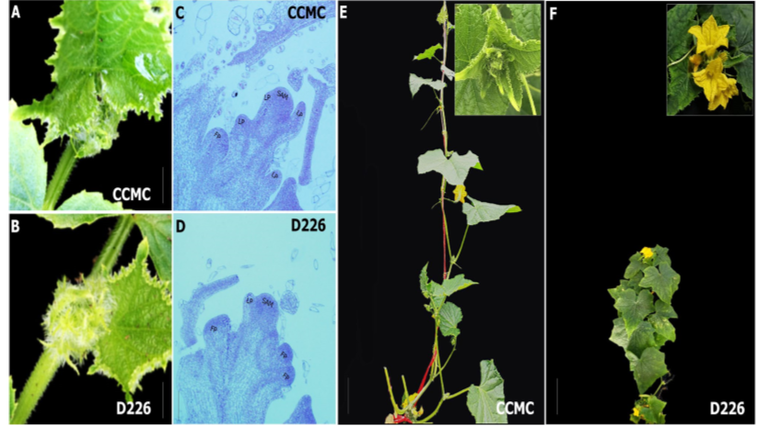
Figure 1: Phenotypic differences in growth habit between cucumber varieties with indeterminate (CCMC) and determinate (D226) growth habit. a–d Show the changes at shoot apexes of CCMC and D226, 25 days after planting. CCMC (e) maintained growth steadily, while D226 (f) already had terminal flowers at the same time of assessments
Comparisons of Gibberellin contents on shoot tips and the stem between indeterminate (CCMC) and determinate (CUS82 and CUS226) cucumber (Cucumis sativa. L) varieties
Gibberellins contents at the shoot tip differed significantly (P<0.001) during all the tested stage of growth and it was significantly higher on determinate varieties compared to indeterminate variety, GA content of indeterminate variety remained the same during all the tested stages, similarly GA levels did not change significantly on determinate variety from stage one to stage two, however the level increased significantly during stage 3, Figure 2. Also GA levels on the stem differed significantly(P<0.001) between indeterminate and determinate varieties with determinate varieties having significantly (P<0.001) higher GA content in the four stages compared to indeterminate variety, Figure 3, and similar with the tip, the GA content on the stem were not significantly different among the different varieties from one stage to another, Figure 3.

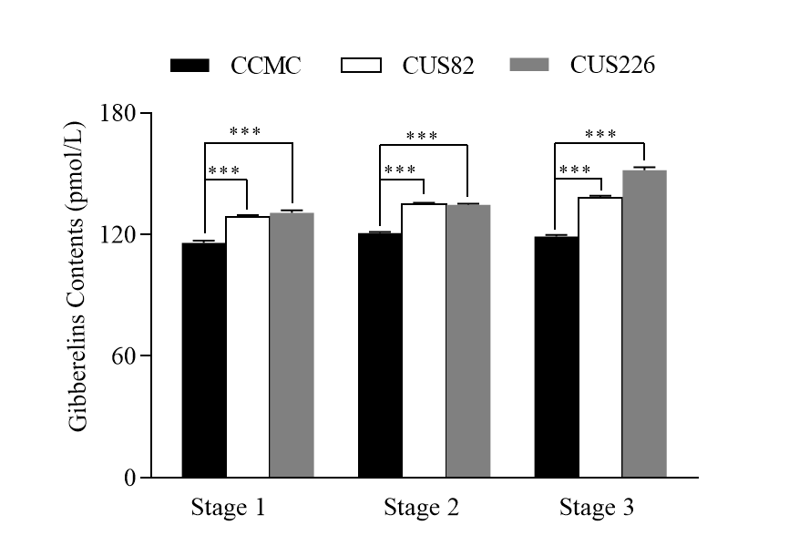
Figure 2: Gibberellins contents at the shoot tips of different cucumber varieties with different inflorescence growth habitdetermined at different growth stages. Data are means of three replicates (± SD). Note: * Mean significant at 0.05 level (P<0.05), ** Mean significant at 0.01 level (P<0.01) and *** Mean significant at 0.001 level (P<0.001)

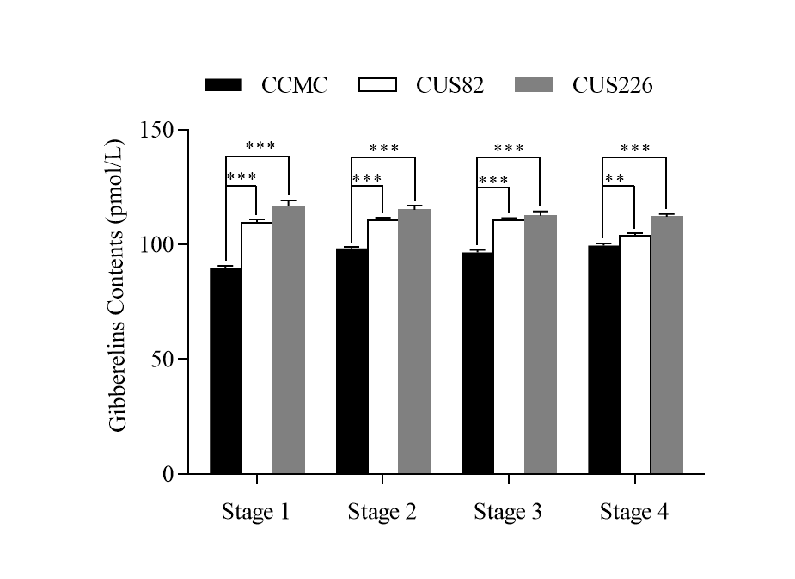
Figure 3: Gibberellins contents on the stem of different cucumber varieties with different inflorescence growth habit determined at different growth stages. Data are means of three replicates (± SD). Note: * Mean significant at 0.05 level (P<0.05), ** Mean significant at 0.01 level (P<0.01) and *** Mean significant at 0.001 level (P<0.001)
Comparisons of Cytokinins contents on shoot tips and the stem between indeterminate (CCMC) and determinate (CUS82 and CUS226) cucumber (Cucumis sativa. L) varieties
Cytokinin levels on the shoot tip was significantly different at (P<0.001) between the indeterminate and the two determinate varieties during the first stage of growth and at (P<0.01) between CCMC and CUS82 during the second and the third stage, and significant at, (P<0.05) levels between CCMC and CUS226 during the second and the third stage, Figure 4. the level of CK for indeterminate variety increased significantly during all the three stages of plant growth. However, the CK levels did not change significantly on both determinate varieties during the three stages, Figure 4. During the first stage the CK levels on shoot tip of indeterminate variety was significantly lower (P<0.001) than that of both determinate varieties, however on stage 2 and 3, the GA levels of indeterminate cultivar increased and becomes significantly higher at (P<0.05) and (P<0.01) for CUS226 and CUS82 respectively, as the level of CK for determinate varieties did not change much from one stage to another, Figure 4.
Similarly, the CK levels on stem for indeterminate varieties increased significantly during all the three stages, though the CK levels for determinate varieties was significantly higher than that of indeterminate varieties during stage 1, 2 and 3 at (P<0.001) Figure 5. However, the ck level was not significantly different during stage 4 between CCMC and CUS82 and only significant at (P<0.01) between CCMC and CUS226, Figure 5. The CK levels on stem of determinate varieties increased slightly from stage one to stage 3 but decreased significantly during stage 4, Figure 5.
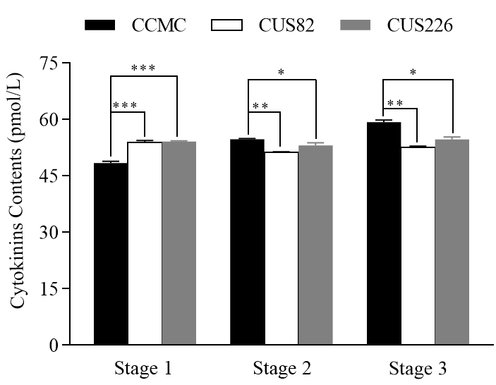
Figure 4: Cytokinin contents at the shoot tips of different cucumber varieties with different inflorescence growth habit determined at different growth stages. Data are means of three replicates (± SD). Note: * Mean significant at 0.05 level (P<0.05), ** Mean significant at 0.01 level (P<0.01) and *** Mean significant at 0.001 level (P<0.001)

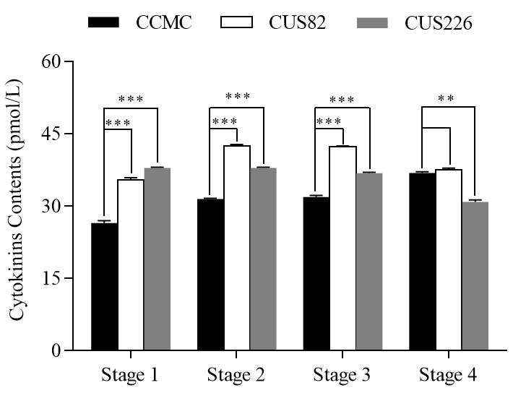
Figure 5 Cytokinin contents on the stem of different cucumber varieties with different inflorescence growth habit determined at different growth stages. Data are means of three replicates (± SD). Note: * Mean significant at 0.05 level (P<0.05), ** Mean significant at 0.01 level (P<0.01) and *** Mean significant at 0.001 level (P<0.001)
Comparisons of Indole Acetic Acid content on shoot tips and the stem between indeterminate (CCMC) and determinate (CUS82 and CUS226) cucumber (Cucumis sativa. L) varieties
Indole Acetic Acid content on shoot tip was significantly different (P<0.001) during the three tested stages of growth, the IAA levels were significantly higher on determinate varieties across all the three tested growth stages, Figure 6. The IAA levels of indeterminate variety remained nearly the same and did not change significantly during three stages, however the IAA levels on determinate varieties increased significantly from stage one to stage two and did not change significantly during stage three. Figure 6. Similarly, the IAA levels on the stem had significant difference between determinate and indeterminate varieties during all the stages of growth, at level (P<0.05) during stage 1 and (P<0.001) during stage 3 and 4, Figure 6-7. Unlike on the shoot tips the IAA levels on the stem were significantly higher on the indeterminate variety compared to determinate varieties. IAA levels changed significantly among all the varieties from stage 1 to stage 2, however it did not change significantly from stage 2 to stage 3 and 4, Figure 7
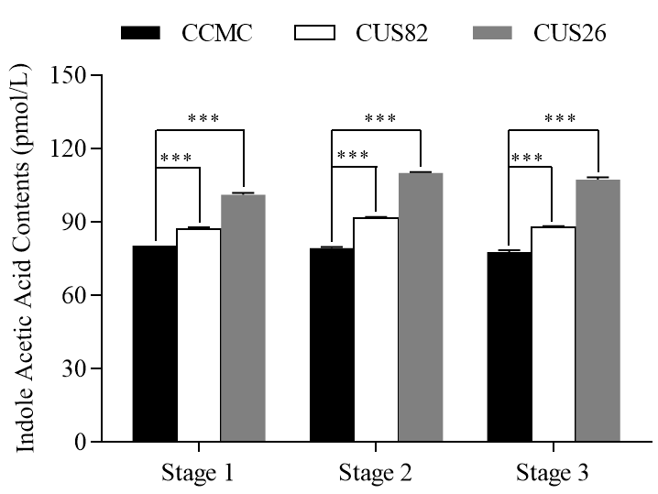
Figure 6: Indole Acetic Acid contents at the shoot tips of different cucumber varieties with different inflorescence growth habit determined at different growth stages. Data are means of three replicates (± SD). Note: * Mean significant at 0.05 level (P<0.05), ** Mean significant at 0.01 level (P<0.01) and *** Mean significant at 0.001 level (P<0.001)

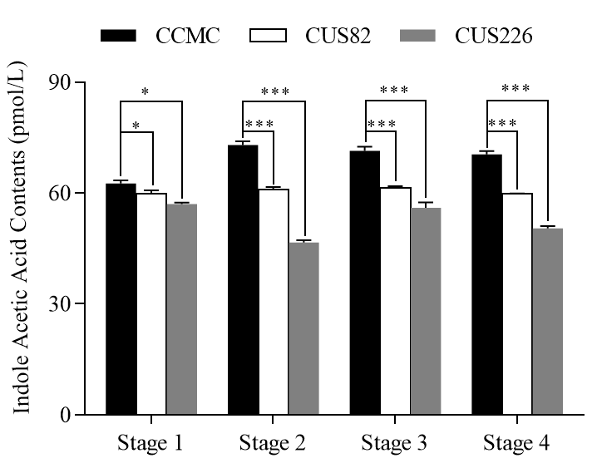
Figure 7: Indole Acetic Acid contents on the stem of different cucumber varieties with different inflorescence growth habit determined at different growth stages. Data are means of three replicates (± SD). Note: * Mean significant at 0.05 level (P<0.05), ** Mean significant at 0.01 level (P<0.01) and *** Mean significant at 0.001 level (P<0.001)
Comparison of total soluble sugars content on shoot tips and the stem between indeterminate (CCMC) and determinate (CUS82 and CUS226) cucumber (Cucumis sativa. L) varieties
The results of total soluble sugar comparison indicated that indeterminate variety (CCMC) had significantly lower levels (P<0.01) of soluble sugars at the shoot tips compared to the two determinate varieties during the first stage of growth, Figure 8, however the sugar levels for indeterminate variety increased significantly at (P<0.01) and (P<0.001) during stage two and three respectively and became significantly higher than those of determinate varieties which decreased from stage 1 to stage 3, Also notably the soluble sugar levels on determinate varieties were the same across all the stages, Figure 8. On the stem the sugar levels were not significantly different among all the varieties during stage one of plant growth, Figure 8, also during stage 2, sugar levels were only significantly higher at (P<0.05) between indeterminate CCMC and determinate CUS226, while its was not significantly different with CUS82. During stage 3 the sugar levels increased for determinate varieties increased significantly and became significantly higher at (P<0.001) than in indeterminate variety, Figure 9, however, during stage 4 the sugar levels on indeterminate variety continue to increase at the same time decreasing on both determinate varieties and therefore it was significantly higher (P<0.001) on indeterminate variety compared to determinate varieties, Figure 9.
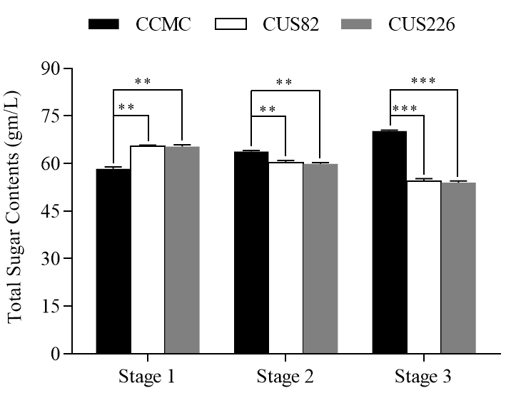
Figure 8: Total soluble sugar contents at the shoot tips of different cucumber varieties with different inflorescence growth habit determined at different growth stages. Data are means of three replicates (± SD). Note: * Mean significant at 0.05 level (P<0.05), ** Mean significant at 0.01 level (P<0.01) and *** Mean significant at 0.001 level (P<0.001)

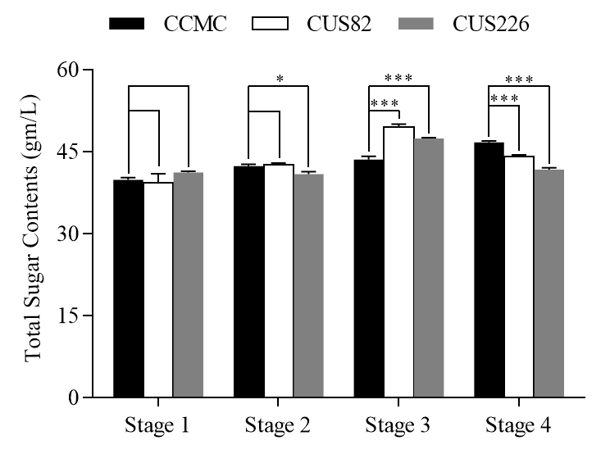
Figure 9: Total soluble sugar contents on the stem of different cucumber varieties with different inflorescence growth habit determined at different growth stages. Data are means of three replicates (± SD). Note: * Mean significant at 0.05 level (P<0.05), ** Mean significant at 0.01 level (P<0.01) and *** Mean significant at 0.001 level (P<0.001)

DISCUSSION
INVOLVEMENT OF PYTOHORMONES IN PLANT INFLORESCENCE ARTCITECTURE
The determinate/indeterminate growth habit is an important agronomical trait in the production of cucumber and many other vegetable crops. In cucumber production under protected environments, indeterminate growth habit is ideal as it can be harvested throughout the production period hence leads to fruits sustainability and extend the growing season to maximize yield, while in certain production systems, like the once-over machine harvest system, determinate cucumber may be advantageous (Fazio et al. 2013).
Gibberellins (GAs) have been shown to affect flowering in a species-dependent manner: in long-day and biennial plants they have been shown to promote flowering, whereas in other plants, including fruit trees, they have shown to inhibit it. Recently GA pathway, which promotes flower induction has been identified in Arabidopsis. (Xu et al., 2022) discovered that gibberellin class of plant hormones are implicated in the control of flowering in several plant species. In Arabidopsis, severe reduction of endogenous gibberellins has been reported to delays flowering in long days and prevents flowering in short days, which is in agreement with our finding where we observed that an increase in GA level on the shoot tip of the determinate varieties during the production of terminal flower while the level on indeterminate variety remained significantly low, Figure 3.
Exogenous application of GAs has been reported to accelerates flowering in wild-type Arabidopsis, particularly in short days (Langridge, 1957) and causal connection between endogenous GA levels and flowering in Arabidopsis has been confirmed with several GA biosynthesis and signaling mutants. However, this study is in contrast with other studies which reported that GA treatment during the flowering induction period reduces the number of flowers. Involvement of gibberellins (GAs) has been suggested in the regulation of floral induction in Mango, study done by (Irene et al., 2001; Lenahan et al., 2006; Lord and Eckard, 1987) including mango (Tomer and E., 1984)reported that GA inhibits flower induction in many fruit tree, this result suggest that GA effect on cucumber is the same as that found on model plant Arabidopsis which may suggest that cucumber (Cucumis sativa. L) varieties and Arabidopsis share the same mechanism while this are in contrast with the influence of GA on fruit trees.
In this study we observed high content of GA on determinate varieties during the flowering stage which was in agreement with report by (Chen, 1987) who reported high GA activity during early flower bud. (Jutamanee, 1989; Tongumpai et al., 1989)found that GA concentration in the shoots increases before panicle emergence in some plants, which subsequently flower. These studies support our work which reported high concentration of GA on determinate varieties during flowering stages. These reports indicate that GA is involved in the regulation of floral induction in plant. Examination of the relationship between flowering and GA metabolism could provide evidence of GA involvement in floral induction in plants. However, the mechanism through which GA regulate flower formation need to be studies further at genetic level to unfold the genetic mechanism or pathway involved in this regulation
In this study the level of Ck on the shoot tip was observed to differ significantly between the cucumber varieties with different inflorescence growth habit with determinate varieties having significantly (P<0.001) lower levels of CK during terminal flowering stage than indeterminate variety. (Miyawaki et al., 2006) reported that increasing cytokinin concentrations and signaling activity increase meristem size and activity. Reduced meristem activity often leads to conversion of an IM into a terminal flower, which subsequently affects inflorescence architecture. Work in rice and in Arabidopsis showed that cytokinin levels affects meristem activity and inflorescence complexity. The current study agreed with a study done on Arabidopsis atipt3 5 7 triple mutants and atipt1 3 5 7 quadruple mutants which reported lower levels of cytokinin, leads to reduced IM size, and consequently the formation of a terminal flower, and conversion of an indeterminate inflorescence to a determinate inflorescence (Miyawaki et al., 2006).
Taken together, the results described above show that cytokinin may promote inflorescence complexity in different ways, by promoting meristem activity of IMs, and by promoting indeterminate lateral meristem formation in inflorescences that form terminal flower. Manipulating cytokinin levels directly or indirectly in crops is expected to change inflorescence complexity to increase yields (Ashikari and M., 2005; Kempin et al., 1995; Kurakawa et al., 2007; Li et al., 2013; Zhang et al., 2012b).
The content of IAA was significantly high on the shoot tip of determinate compared to indeterminate varieties, on contrast the IAA content was much less on stem of determinate compared to indeterminate stem.The phytohormone auxin (IAA) has been shown to playa central role in the regulation of leaf growth and developmentby controlling leaf initiation, specification of growthaxes, morphogenesis and marginal patterning (Kumud et al., 2017; Shwartz et al., 2016). A key feature for auxin functions its differential distribution in precise locations within aspecific spatiotemporal developmental context, resulting inthe formation of auxin gradients which are essential for plantgrowth and development (Koenig et al., 2009; Shwartz et al., 2016; Vanneste and Friml, 2009). Studies in Arabidopsis have demonstratedthat local auxin activity gradient is generated by acell-to-cell Polar Auxin Transport (PAT) system mediatedpredominantly by the auxin efflux carrier PIN-FORMED1(PIN1), which transports auxin out of the cell in the directionof PIN localization (Friml et al., 2004; Michniewicz et al., 2007; Vanneste and Friml, 2009; Wiśniewska et al., 2006); whereas PIN1 polar localizationin a particular plasma membrane domain is proposed tobe mainly controlled through phosphorylation/dephosphorylationby the Ser/Thr protein kinase PINOID (PID) (Friml
INVOLVEMENT OF TOTAL SOLUBE SUGARS IN PLANT INFLORESCENCE ARTCITECTURE
Plant carbohydrate status has been suggested to play a dominant role in flower bud formation in many crops (Monselise and Goldschmidt, 2011) For example, in mango, carbohydrate level has been reported to be associated with the intensity of flower induction (Chacko and Ananthanarayanan, 1982; Pongsomboon et al., 1997; Suryanarayana, 1978) but there is no reliable evidence of the role of carbohydrates in floral induction. In Arabidopsis, starch acts as a major integrator of plant growth (Nakagawa et al., 2012)and sucrose acts as an important signal. (Hisamatsu and King, 2008; Phavaphutanon et al., 2000; Skylar, 2011), reported that high carbohydrate reserves within the shoots maybe necessary for off-season flowering caused by paclobutrazol in mango. Their reports suggest that both endogenous GA and carbohydrate levels are related to the floral induction process affected flowering in plants.
Total soluble sugar (TSS) content is not only the main photosynthate in higher plants, but also the main form of carbohydrate metabolism and temporary storage. In this study we observed that the level of soluble sugars increase from stage one onward for indeterminate cultivar but in determinate type it decreases during the production of terminal flower, (Liu et al., 2011) indicated that the soluble sugar content plays a very important role in carbohydrate metabolism and has a close relationship with photosynthesis and production , this may explain the reduction of sugars during terminal flowering as more energy is required for production and many leaves are not photosynthetically active at this stage however on determinate type the sugar content continue to increase as the level of soluble sugar content was a sign of the supply ability of leaves and reflected transformation and ability of stem and shoot tips to use assimilates this was in agreement by a study done by (Kumudini et al., 2001). (Xiao-hui et al., 2007). Wang reported that the photosynthate exists as a form of water-soluble carbohydrate and its main components are soluble sugar, starch and cellulose. Differences in water-soluble carbohydrates between cucumber cultivars with different growth habit was significant with indeterminate cultivar have more sugars on the shoot tip compared with indeterminate type. WSC in shoot tips increased throughout the growing season, while WSC contents in stems decreased during the terminal flowering stage. This decrease may indicate that soluble sugars as metabolically active carbohydrate is a factor involved during terminal flower formation. Soluble sugars help to ensure an adequate supply of building materials and energy to carry out specific developmental programs. For example, in-vivo and invitro experiments suggest that in some plant species, increasing sugar levels delay seed germination and stimulate the induction of flowering and senescence. In other words, it may be beneficial for plants to adjust the timing with which nutrient-intensive events occur to supply enough materials and energy for successful completion of those events. Levels of sugars, such as sucrose, have been postulated to affect the timing at which some plant species flower (Bernier et al., 1993), this was observed in determinate varieties where soluble sugars on stem increases sharply during stage 3 (flowering stage) and decrease during terminal flower formation stage. Soluble sugar levels have also been shown to affect other phase changes, such as the onset of senescence (Paul and Pellny, 2003). Endogenous leaf sugar levels tend to increase during senescence. Similarly, application of exogenous sugars stimulates the early stages of senescence. During the process, materials used to build up leaves during vegetative growth are remobilized and transported into the developing organs (Smart, 2006). Although senescence occurs in an age-dependent manner in many species (Noodén, 1988), its initiation and progression can be modulated by a variety of environmental factors such as temperature, mineral deficiency, and drought conditions, as well as by internal factors such as plant growth regulators (Uddin et al., 2008 and Wang et al., 2008) Since senescence can be induced by a large number of different conditions, and several signaling pathways are involved in the regulation of senescence (Buchanan‐Wollaston et al., 2003), it is possible that environmental signals are integrated by sugar signaling. For example, experiments on sugar regulated senescence indicate that leaf senescence can be induced by growing Arabidopsis plants in the presence of 2% glucose in combination with low nitrogen supply (Pourtau et al., 2004; Wingler et al., 2004). Affymetrix Gene Chip data confirmed that changes in gene expression during glucose-induced senescence are characteristic of developmental senescence. Similarly, (Stessman et al., 2002) found that hexoses accumulate in senescing Arabidopsis leaves. However, the question remains as to what causes the strong accumulation of hexoses despite the decline in photosynthetic carbon assimilation in senescing leaves. A possible source of hexoses is the breakdown of starch. In addition, (Jongebloed et al., 2004) showed that phloem blockage by callus deposition could lead to an age-dependent sugar accumulation.
Conclusion
In conclusion the study highlighted that cytokinin may promote inflorescence complexity in different ways, by promoting meristem activity of IMs, and by promoting indeterminate lateral meristem formation in inflorescences that form terminal flower. Also the phytohormone auxin (IAA) has been shown to playa central role in the regulation of leaf growth and developmentby controlling leaf initiation, specification of growthaxes, morphogenesis and marginal patterning. Higher total soluble sugars in determinate plants during terminal flowering stage could indicate a higher capacity to store soluble sugars at this developmental stage, while the lower level observed in the indeterminate plants could indicate higher demands for cell division or elongation. This May also reflect the differences in the overall development of the inflorescence in the two different type of inflorescence growth

Data Availability
The data is available from the corresponding author upon reasonable request.

COMPETING INTERESTS DISCLAIMER:
Authors have declared that they have no known competing financial interests OR non-financial interests OR personal relationships that could have appeared to influence the work reported in this paper.

References
Achard, P., Gusti, A., Cheminant, S., Alioua, M., Dhondt, S., Coppens, F., Beemster, G. T., and Genschik, P. (2009). Gibberellin signaling controls cell proliferation rate in Arabidopsis. Current biology19, 1188-1193.
Ashikari, and M. (2005). Cytokinin Oxidase Regulates Rice Grain Production. Science309, 741-745.
Bernier, G., Havelange, A., Houssa, C., Petitjean, A., and Lejeune, P. C. (1993). Physiological Signals That Induce Flowering. Plant Cell5, 1147-1155.
Chacko, E. K., and Ananthanarayanan, T. V. (1982). Accumulation of Reserve Substances in Mangifera indica L. During Flower Initiation. Zeitschrift Für Pflanzenphysiologie106, 281-285.
Chen, W. (1987). Endogenous growth substances in relation to shoot growth and flower bud development of mango. Journal of the American Society for Horticultural Science112, 360–363.
Colebrook, E. H., Thomas, S. G., Phillips, A. L., and Hedden, P. (2014). The role of gibberellin signalling in plant responses to abiotic stress. Journal of Experimental Biology217, 67-75.
Davies, P. J. (2013). "Plant hormones: physiology, biochemistry and molecular biology," Springer Science & Business Media.
De Bruyne, L., Höfte, M., and De Vleesschauwer, D. (2014). Connecting growth and defense: the emerging roles of brassinosteroids and gibberellins in plant innate immunity. Molecular plant7, 943-959.
Depuydt, S., and Hardtke, C. S. (2011). Hormone signalling crosstalk in plant growth regulation. Current Biology21, R365-R373.
Fazio, F., Marafioti, S., Torre, A., Sanfilippo, M., Panzera, M., & Faggio, C. (2013). Haematological and serum protein profiles of Mugil cephalus: effect of two different habitats. Ichthyological research, 60(1), 36-42.
Figueiredo, D. D., Batista, R. A., Roszak, P. J., Hennig, L., and Köhler, C. (2016). Auxin production in the endosperm drives seed coat development in Arabidopsis. Elife5, e20542.
Frick, E. M., & Strader, L. C. (2018). Roles for IBA-derived auxin in plant development. Journal of Experimental Botany, 69(2), 169-177.
Friml, J., Yang, X., Michniewicz, M., Weijers, D., Quint, A., Tietz, O., Benjamins, R., Ouwerkerk, P. B., Ljung, K., and Sandberg, G. (2004). A PINOID-dependent binary switch in apical-basal PIN polar targeting directs auxin efflux. Science306, 862-865.
Guiamet, J., Schwartz, E., Pichersky, E., and Noodén, L. (1991). Characterization of cytoplasmic and nuclear mutations affecting chlorophyll and chlorophyll-binding proteins during senescence in soybean. Plant Physiology96, 227-231.
Hadi, S., Al-Khalifah, N. S., and Moslem, M. A. (2015). Hormonal Basis of Shees' Fruit Abnormality in Tissue Culture Derived Plants of Date Palm. International Journal of Agriculture Biology17.
Hisamatsu, T., and King, R. W. (2008). The nature of floral signals in Arabidopsis. II. Roles for FLOWERING LOCUS T (FT) and gibberellin. ournal of experimental botany59, 3821-3829.
Irene, Garcı́a-Pallas, and, Val, and, and Blanco (2001). The inhibition of flower bud differentiation in ‘Crimson Gold’ nectarine with GA3 as an alternative to hand thinning.
Jongebloed, U., Szederkényi, J., Hartig, K., Schobert, C., and Komor, E. (2004). Sequence of morphological and physiological events during natural ageing and senescence of a castor bean leaf: sieve tube occlusion and carbohydrate back‐up precede chlorophyll degradation. Physiologia Plantarum120, 338-346.
Jutamanee, K. (1989). Changes in level of gibberellin-like substances during vegetative growth and flowering of mango (Mangifera indica L.) cv. Khiew Sawoey. agris.fao.org.
Kempin, S., Savidge, B., and Yanofsky, M. (1995). Molecular basis of the cauliflower phenotype in Arabidopsis. Science267, 522-525.
Koenig, D., Bayer, E., Kang, J., Kuhlemeier, C., and Sinha, N. (2009). Auxin patterns Solanum lycopersicum leaf morphogenesis. Developmental Biology136, 2997-3006.
Korasick, D. A., Enders, T. A., and Strader, L. C. (2013). Auxin biosynthesis and storage forms. Journal of experimental botany64, 2541-2555.
Kramer, E. M., and Ackelsberg, E. M. (2015). Auxin metabolism rates and implications for plant development. Front Plant Sci6.
Kuai, J., Yang, Y., Sun, Y., Zhou, G., Zuo, Q., Wu, J., and Ling, X. (2015). Paclobutrazol increases canola seed yield by enhancing lodging and pod shatter resistance in Brassica napus L. Field Crops Research180, 10-20.
Kumud, S., N., M. M., Malgorzata, Z., M., B. D., Tom, B., Lieven, D. V., Els, P., S., B. G. T., and Kris, V. (2017). Alteration in Auxin Homeostasis and Signaling by Overexpression Of PINOID Kinase Causes Leaf Growth Defects in Arabidopsis thaliana. Frontiers in Plant Science8, 1009-.
Kumudini, S., Hume, D. J., and Chu, G. (2001). Genetic improvement in short season soybeans. Crop science41, 391-398.
Kurakawa, T., Ueda, N., Maekawa, M., Kobayashi, K., Kojima, M., Nagato, Y., Sakakibara, H., and Kyozuka, J. (2007). Direct control of shoot meristem activity by a cytokinin-activating enzyme. Nature445, 652.
Langridge (1957). Effect of day-length and gibberellic acid on the flowering of Arabidopsis. Nature180, 36.
Lenahan, O. M., Whiting, M. D., and Elfving, D. C. (2006). Gibberellic Acid Inhibits Floral Bud Induction and Improves `Bing' Sweet Cherry Fruit Quality. Hortscience 41.
Li, S., Zhao, B., Yuan, D., Duan, M., Qian, Q., Tang, L., Wang, B., Liu, X., Zhang, J., and Wang, J. (2013). Rice zinc finger protein DST enhances grain production through controlling Gn1a/OsCKX2 expression. Proceedings of the National Academy of Sciences110, 3167-3172.
Liangjiu, W., Wenqun, S., and Youshen, L. (1990). A preliminary study on dwarfing effect of paclobutrazol on narcissus plants and its possible mechanism [J]. Acta Horticulturae Sinica4.
Liu, B., Li, Y.-S., Liu, X.-B., Wang, C., Jin, J., and Herbert, S. (2011). Lower total soluble sugars in vegetative parts of soybean plants are responsible for reduced pod number under shading conditions. Australian Journal of Crop Science5, 1852.
Lord, E. M., and Eckard, K. J. (1987). Shoot Development in Citrus sinensis L. (Washington Navel Orange). I. Floral and Inflorescence Ontogeny. Bot Gaz146, 320-326.
Ludwig-Muller (2011). Auxin conjugates: their role for plant development and in the evolution of land plants. Journal of Experimental Botany62, 1757-1773.
Michniewicz, M., Zago, M. K., Abas, L., Weijers, D., Schweighofer, A., Meskiene, I., Heisler, M. G., Ohno, C., Zhang, J., and Huang, F. (2007). Antagonistic regulation of PIN phosphorylation by PP2A and PINOID directs auxin flux. Cell130, 1044-1056.
Miyawaki, K., Tarkowski, P., Matsumoto-Kitano, M., Kato, T., Sato, S., Tarkowska, D., Tabata, S., Sandberg, G., and Kakimoto, T. (2006). Roles of Arabidopsis ATP/ADP isopentenyltransferases and tRNA isopentenyltransferases in cytokinin biosynthesis. Proceedings of the National Academy of Sciences103, 16598-16603.
Monselise, S. P., and Goldschmidt, E. E. (2011). "Alternate Bearing in Fruit Trees," Palgrave Macmillan UK, Horticultural Reviews.
Moon, J., Suh, S. S., Lee, H., Choi, K. R., and Lee, I. (2003). The SOC1 MADS-box gene integrates vernalization and gibberellin signals for flowering in Arabidopsis. Plant Journal35, 613-623.
Nakagawa, M., Honsho, C., Kanzaki, S., Shimizu, K., and Utsunomiya, N. (2012). Isolation and expression analysis of FLOWERING LOCUS T-like and gibberellin metabolism genes in biennial-bearing mango trees. Scientia Horticulturae139, 108-117.
Nam, H. G. (1997). The molecular genetic analysis of leaf senescence. Current Opinion in Biotechnology8, 200-207.
Noodén, L. D. (1988). The phenomenon of senescence and aging. San Diego: Academic Press 1-50.
Paul, M. J., and Pellny, T. K. (2003). Carbon metabolite feedback regulation of leaf photosynthesis and development. Journal of Experimental Botany54, 539-547.
Phavaphutanon, L., Krisanapook, K., Pichakum, A., and Jutamanee, K. (2000). CHANGES OF TOTAL NON-STRUCTURAL CARBOHYDRATES WITHIN SHOOTS OF a??NAM DOK MAIa?? MANGO AFTER PACLOBUTRAZOL APPLICATION. Acta Horticulturae Sinica, 559-566.
Pongsomboon, W., Subhadrabandhu, S., and Stephenson, R. A. (1997). Some aspects of the ecophysiology of flowering intensity of mango (Mangifera Indica L.) cv. Nam dok mai in a semi-tropical monsoon asian climate. Sci.Hort70, 45-56.
Pop, T. I., Pamfil, D., and Bellini, C. (2011b). Auxin control in the formation of adventitious roots. Notulae Botanicae Horti Agrobotanici Cluj-Napoca39, 307-316.
Pourtau, N., Marès, M., Purdy, S., Quentin, N., Ruël, A., and Wingler, A. (2004). Interactions of abscisic acid and sugar signalling in the regulation of leaf senescence. Planta219, 765-772.
Rademacher, W. (2018). Chemical regulators of gibberellin status and their application in plant production. Annual Plant Reviews online, 359-403.
Rosa, M., Hilal, M., González, J. A., Prado, F. E., and biochemistry (2009). Low-temperature effect on enzyme activities involved in sucrose–starch partitioning in salt-stressed and salt-acclimated cotyledons of quinoa (Chenopodium quinoa Willd.) seedlings. Plant physiology47, 300-307.
Scheres, B. (2007). Stem-cell niches: nursery rhymes across kingdoms. Nature Reviews Molecular Cell Biology8, 345.
Schwechheimer, C., and Willige, B. r. C. (2009). Shedding light on gibberellic acid signalling. plant bio12, 57-62.
Shwartz, I., Levy, M., Ori, N., and Bar, M. (2016). Hormones in tomato leaf development. Developmental Biology, S0012160616301075.
Smart, C. M. (2006). Gene expression during leaf senescence. New Phytologist126, 419-448.
Sridharan, R., Manivannan, P., Kishorekumar, A., and Panneerselvam, R. (2009). Membrane integrity and riboflavin content of Raphanus sativus L. as affected by triazole growth retardants. Middle-East J Sci Res b4, 52-6.
Sridharan, R., Raja, S., and Sakthivel, P. J. (2015). Eff ect of triazole compounds on induced changes in growth biomass and biochemical content of white radish (Raphanus sativus L.). Journal of Plant Stress Physiology, 43-48.
Stessman, D., Miller, A., Spalding, M., and Rodermel, S. (2002). Regulation of photosynthesis during Arabidopsis leaf development in continuous light. Photosynthesis Research72, 27-37.
Suryanarayana (1978). Seasonal changes in sugars, starch, nitrogen and C: N ratio in relation to flowering in mango. Plant biochemical journal5, 108–117.
Svolacchia, N., & Sabatini, S. (2023). Cytokinins. Current Biology, 33(1), R10-R13.
Tomer, and E. (1984). Inhibition of flowering in mango by gibberellic acid. Sci. Hort24, 299-303.
Tongumpai, P., Jutamanee, K., Sethapakdi, R., and Subhadrabandhu, S. (1989). Variation in level of gibberellin-like substances, during vegetative growth and flowering of mango cv. Khiew Sawoey. In "III International Mango Symposium 291", pp. 105-108.
Uddin, M. I., Qi, Y., Yamada, S., Shibuya, I., Deng, X.-P., Kwak, S.-S., Kaminaka, H., and Tanaka, K. (2008). Overexpression of a new rice vacuolar antiporter regulating protein OsARP improves salt tolerance in tobacco. Plant cell physiology49, 880-890.
Vanneste, S., and Friml (2009). Auxin: A Trigger for Change in Plant Development. Cell 136, 1005–1016
Vernoux, T., Besnard, F., and Traas, J. (2010). Auxin at the shoot apical meristem. Cold Spring Harbor Perspectives in Biology2, a001487.
Wang, S. Y., Sun, T., and Faust, M. (1986). Translocation of paclobutrazol, a gibberellin biosynthesis inhibitor, in apple seedlings. Plant physiology82, 11-14.
Wang, X.-h., Xu, K.-z., Li, D.-y., Zhang, Z.-a., Wu, Z.-h., Chen, Z.-y., and Zhang, R. (2008). Variation of soulble sugar content and specific leaf weight during the genetic improvement of soybean cultivars. Soybean Science26, 879.
Weiler, E., Jourdan, P., and Conrad, W. (1981). Levels of indole-3-acetic acid in intact and decapitated coleoptiles as determined by a specific and highly sensitive solid-phase enzyme immunoassay. Planta153, 561-571.
Weiss, D., and Ori, N. (2007). Mechanisms of Cross Talk between Gibberellin and Other Hormones. Plant Physiology144, 1240-1246.
Williams, R. J., and Leopold, A. C. (1989). The glassy state in corn embryos. Plant Physiology89, 977-981.
Wingler, A., Marès, M., and Pourtau, N. (2004). Spatial patterns and metabolic regulation of photosynthetic parameters during leaf senescence. New Phytologist161, 781-789.
Wiśniewska, J., Xu, J., Seifertová, D., Brewer, P. B., Růžička, K., Blilou, I., Rouquié, D., Benková, E., Scheres, B., and Friml, J. (2006). Polar PIN localization directs auxin flow in plants. Science312, 883-883.
Woodward, A. W., and Bartel, B. (2005). Auxin: regulation, action, and interaction. Annals of botany95, 707-735.
Xu, X., Tao, J., Xing, A., Wu, Z., Xu, Y., Sun, Y., ... & Wang, Y. (2022). Transcriptome analysis reveals the roles of phytohormone signaling in tea plant (Camellia sinensis L.) flower development. BMC plant biology, 22(1), 471.
Zhang, L., Zhao, Y.-L., Gao, L.-F., Zhao, G.-Y., Zhou, R.-H., Zhang, B.-S., and Jia, J.-Z. (2012b). <em>TaCKX6-D1</em>, the ortholog of rice <em>OsCKX2</em>, is associated with grain weight in hexaploid wheat. New Phytol. 195, 574–584.

