Diversification of rice based cropping system under aerobic rice cultivation in South Gujarat, India

Abstract
Crop diversification has been recognised as an effective management system which can enhance the productivity, judicious uses of resources and sustainable agriculture. There is need to diversify rice based cropping system to enhance the productivity, resilience and soil health. This system involves incorporating vegetables, pulses oilseeds and other cereals either during fallow periods or in place of rice. A field experiment was carried out at the Main Rice Research Centre, Navsari Agricultural University, Navsari, Gujarat during 2021-22 to 2023-24 in kharif and rabi seasons to study the diversification of rice based cropping system under aerobic rice cultivation in South Gujarat region. Eight different rice based cropping systems viz., T₁: Rice-Sweetcorn, T₂: Rice-Cabbage, T₃: Rice-Indian bean (vegetable purpose), T₄: Rice - Indian bean (seed purpose), T₅: Rice - Green gram, T₆: Rice-Chickpea T₇: Rice-Sorghum and T₈: Rice-Mustard were evaluated in randomized block design with four replications. The results showed that different rice based cropping system did not significantly affect rice yield in kharif seasons. However, it gave higher yield in pulses crop as compared to other crop system. Rabi crops significantly differed among them with producing expected yield during experimental period. The significantly higher rice equivalent yield (20.45 t/ha) was obtained with rice-indian bean (vegetable purpose) cropping system as compared to rest of the systems. Among all the cropping systems, rice-indian bean (vegetable purpose) maintain soil chemical properties as compared to other systems. Thus, under aerobic rice cultivation method among different cropping system, rice-indian bean (vegetable purpose) system was found as the efficient, most productive and improved soil chemical properties in South Gujarat.

Key words: Aerobic rice, cropping system, rice equivalent yield, soil properties
Introduction
Rice is a major staple food crop during the kharif season, and rice-based cropping systems dominate agricultural production in South Gujarat. However, increasing water scarcity, labour shortages, and climate change pose significant threats to the sustainability and profitability of conventional transplanted rice cultivation, which is inherently water-intensive throughout its growth cycle. Anticipated future water constraints further exacerbate these challenges. In this context, aerobic rice technology has been proposed as a viable alternative to reduce water consumption, decrease labour requirements, mitigate greenhouse gas emissions, and enhance environmental sustainability. Given the combined pressures of water scarcity and climate change, aerobic rice cultivation is increasingly recognised as a sustainable production strategy (Jana, 2012). In addition, crop substitution and diversification have been identified as important approaches to address the challenges associated with climatic variability and aberrant weather conditions.
There is a growing need to diversify rice-based cropping systems to improve productivity, enhance system resilience, and maintain soil health. Crop diversification typically involves the inclusion of vegetables, pulses, oilseeds, and other cereal crops either during fallow periods or as replacements for rice (Kassam et al., 2009). Such diversified systems incorporate crops capable of biological nitrogen fixation, thereby improving soil fertility, reducing soil erosion, and increasing overall system productivity. Furthermore, the post-rainy and rabi seasons provide important opportunities for crop diversification, which can enhance farm income, strengthen economic stability, improve market access, and promote more efficient use of irrigation water and labour resources (Banjara et al., 2021). Crop diversification is widely recognised as an effective agricultural management strategy that improves resource-use efficiency, enhances productivity, and supports sustainable agriculture. By integrating crops with varying market values and uses, it also helps reduce economic risk, stabilise farm incomes, and improve household nutritional security (Pingali, 2012). Evidence further suggests that crop diversity can mitigate weather-related production risks and increase farm income by approximately 13%, although this may require supportive policy interventions for non-diversified farming households (Basantaray et al., 2024). Moreover, the inclusion of legumes, oilseeds, and vegetables within rice-based systems has been shown to enhance nutrient cycling and soil structure, thereby improving plant health and overall system productivity (Mohanty et al., 2025).
Within aerobic rice-based cropping systems, diversification remains underexplored. In particular, the cultivation of pulses during the post-rainy season has the potential to improve productivity, increase profitability, and sustain soil health. Therefore, the present study was undertaken to identify the most productive and economically viable cropping system for aerobic rice cultivation in South Gujarat.

Materials and Methods
A field experiment was conducted during 2021-22 to 2023-24 of kharif and rabi seasons at Main Rice Research Centre, Navsari Agricultural University, Navsari. The Main Rice Research Centre is geographically located at 20° 92’ N latitude and 72° 90’ E longitude at an altitude of 11 m above the mean sea level. The experimental soil was vertisol, alkaline in nature, low in available nitrogen, medium in available phosphorus and high in available potassium. The experiment was laid out in randomized block design (RBD) with four replications and consisted 8 treatments with kharif and rabi crops. The cropping systems as follows: T₁: Rice-Sweetcorn, T₂: Rice – Cabbage, T₃: Rice-Indian bean var., GNIB 21 (vegetable purpose), T₄: Rice - Indian bean var., GW 2 (seed purpose), T₅: Rice - Green gram, T₆: Rice-Chickpea, T₇: Rice-Sorghum and T₈: Rice–Mustard. In kharif season aerobic rice var. GNR-8 was sown at 30 cm line (row) spacing before onset of monsoon i. e. in last week of May and first week of June and harvested on fortnight of October. The recommended dose of fertilizer for rice is 100-30-0 kg NPK ha⁻¹ and nitrogen was applied in three splits viz., 40 % as basal, 40 % at tillering stage and 20 % at panicle initiation stage after sowing. Full dose of P was applied as basal to the crop. Biocompost @ 5 t ha⁻¹ applied and incorporated before sowing.

The rabi crops were sown in between last week of November and first week of December and harvested upto March during all the years of experimentation. The recommended fertilizer dose (NPK kg ha⁻¹) and spacing (cm) for rabi crops were: Sweetcorn:120-60-60 and 60 x 20, Cabbage: 200-75-37.5 and 30 x 60, Indian bean: 40-40-00 and 30 x 10, Green gram and chickpea:20-40-00 and 30 x 10, Sorghum: 80-40-00 and 45 x 10 and mustard:50-50-00 and 45 x 15. The nutrients were applied through the fertilizers like urea, single super phosphate and muriate of potash. Full dose of P and K and half dose of N were applied as basal dose before sowing/planting of the crops and the remaining N was applied in split doses as per recommendations in the region for various crops.

All other cultural operations and irrigation schedules were carried out uniformly across treatments in accordance with the recommended agronomic practices for rice and rabi crops. To enable comparison of system productivity across different crop sequences, the yields of all crops were converted into rice equivalent yield on a price basis.
Soil chemical properties, including organic carbon, pH, and electrical conductivity (EC), were determined using the Walkley and Black (1934) method, a glass electrode pH meter, and a conductivity bridge, respectively, as described by Jackson (1973). Available nitrogen and phosphorus were estimated using the alkaline potassium permanganate method (Subbiah and Asija, 1956) and Olsen’s method (Olsen et al., 1954), respectively. The experimental data were subjected to statistical analysis using analysis of variance (ANOVA) appropriate for a randomized block design, following the standard procedures outlined by Panse and Sukhatme (1985).

Results and Discussion
Rice growth, yield and its attributes
The pooled results of yield and its attributes of rice are presented in Table 1. The results revealed that the different rice based system significantly influenced only the plant height while panicle/m² and test weight were not significantly influenced. Almost all the cropping sequence remained at par with each other except T₁ and T₂ sequences. Grain and straw yield of rice were not significantly influenced due to different rice based systems. Khedwal et al., (2023) reported that rice output falls when cereals such as maize, fodder sugarbeet and maize are included in the cropping system. However, it found higher with pulse crop as compared to other crop system. Inclusion of a pulse crop in the rice-based cropping system may have advantages well beyond the N addition through biological nitrogen fixation, sparing soil N and supporting succeeding rice crop. Upadhaya et al., (2022) reported that in diversification system adoption of vegetables and legumes crop enhance the productivity.

Rabi crops yield:
The yield of rabi crops is given in table 2. The data indicated that all the crops performed well and consistent. The average yield recorded for sweet corn was 14476 kg ha⁻¹; cabbage-12688 kg ha⁻¹; indian bean (veg.)-3054 kg ha⁻¹; indian bean (seed) - 613 kg ha⁻¹; greengram-1050 kg ha⁻¹; chickpea-1460 kg ha⁻¹; sorghum-2887 kg ha⁻¹ and mustard-1777 kg ha⁻¹.

Rice equivalent yield:
In this crop sequence study, rice equivalent yield (REY) was computed, and the results are presented in Table 2. The findings revealed that the rice–Indian bean (vegetable purpose) sequence (T3) recorded a significantly higher rice equivalent yield (20.45 t ha⁻¹) compared with the other cropping sequences evaluated. This superior performance may be attributed to the higher yield potential and premium market price of Indian bean, which collectively contributed to an increase in system-level productivity in terms of REY.
These findings are consistent with Singh et al. (2011), who reported that vegetable-based cropping systems exhibit substantially higher system productivity than other cropping configurations. Leguminous crops are also known to possess deep root systems and an inherent capacity for nutrient recycling. Through biological nitrogen fixation, improved soil structural conditions, and nutrient addition via leaf litter decomposition, legumes enhance soil fertility and nutrient-use efficiency, thereby contributing to higher overall system productivity (Ladha and Kundu, 1997; Dwivedi et al., 2003). Similarly, Mishra et al. (2007) observed that the inclusion of vegetables and pulses within rice-based cropping systems significantly improves total system productivity.

Soil properties:
After harvest of rice -first year and at the end of crop sequences, soil pH and EC was not significantly influenced due to different cropping sequences (Table 3). However, soil pH and EC were found lower at the end of crop sequence. Porter et al., (1995) reported that there is imbalance in the carbon and nitrogen cycles due to soil acidification in rice- pulse cropping system. Soil organic carbon and available nutrients were increased at the end of the crop sequence (Table 4). Soil organic carbon % were found significantly improved with pulse crops and sorghum. Legumes crops addition in cropping sequence improves oil organic carbon and nitrogen pools, enhancing availability of the nutrients for the rice crop and decreasing nutrient losses (Yao et al., 2025) . Kumar et al., (2008) also observed that inclusion of leguminous crop in crop system improves the soil organic carbon, availability of nitrogen and phosphorus in the soil. Inclusions of legumes crops maintaining soil available nutrients and soil organic carbon in rice based cropping systems (Jat et al. 2012). Crop diversification and crop rotation have essential impact of soil health and quality in agriculture (Vukicevich et al., 2016). Arvadiya et al., (2025) reported that pulses crops in rice based systems improved soil organic carbon and available soil nutrient balance.
Conclusion
Based on overall findings, it can be concluded that sowing of aerobic rice followed with diversified rice based cropping systems under South Gujarat, rice-indian bean (vegetable purpose) cropping system gave higher rice equivalent yield and net return along with improvement in soil chemical properties.

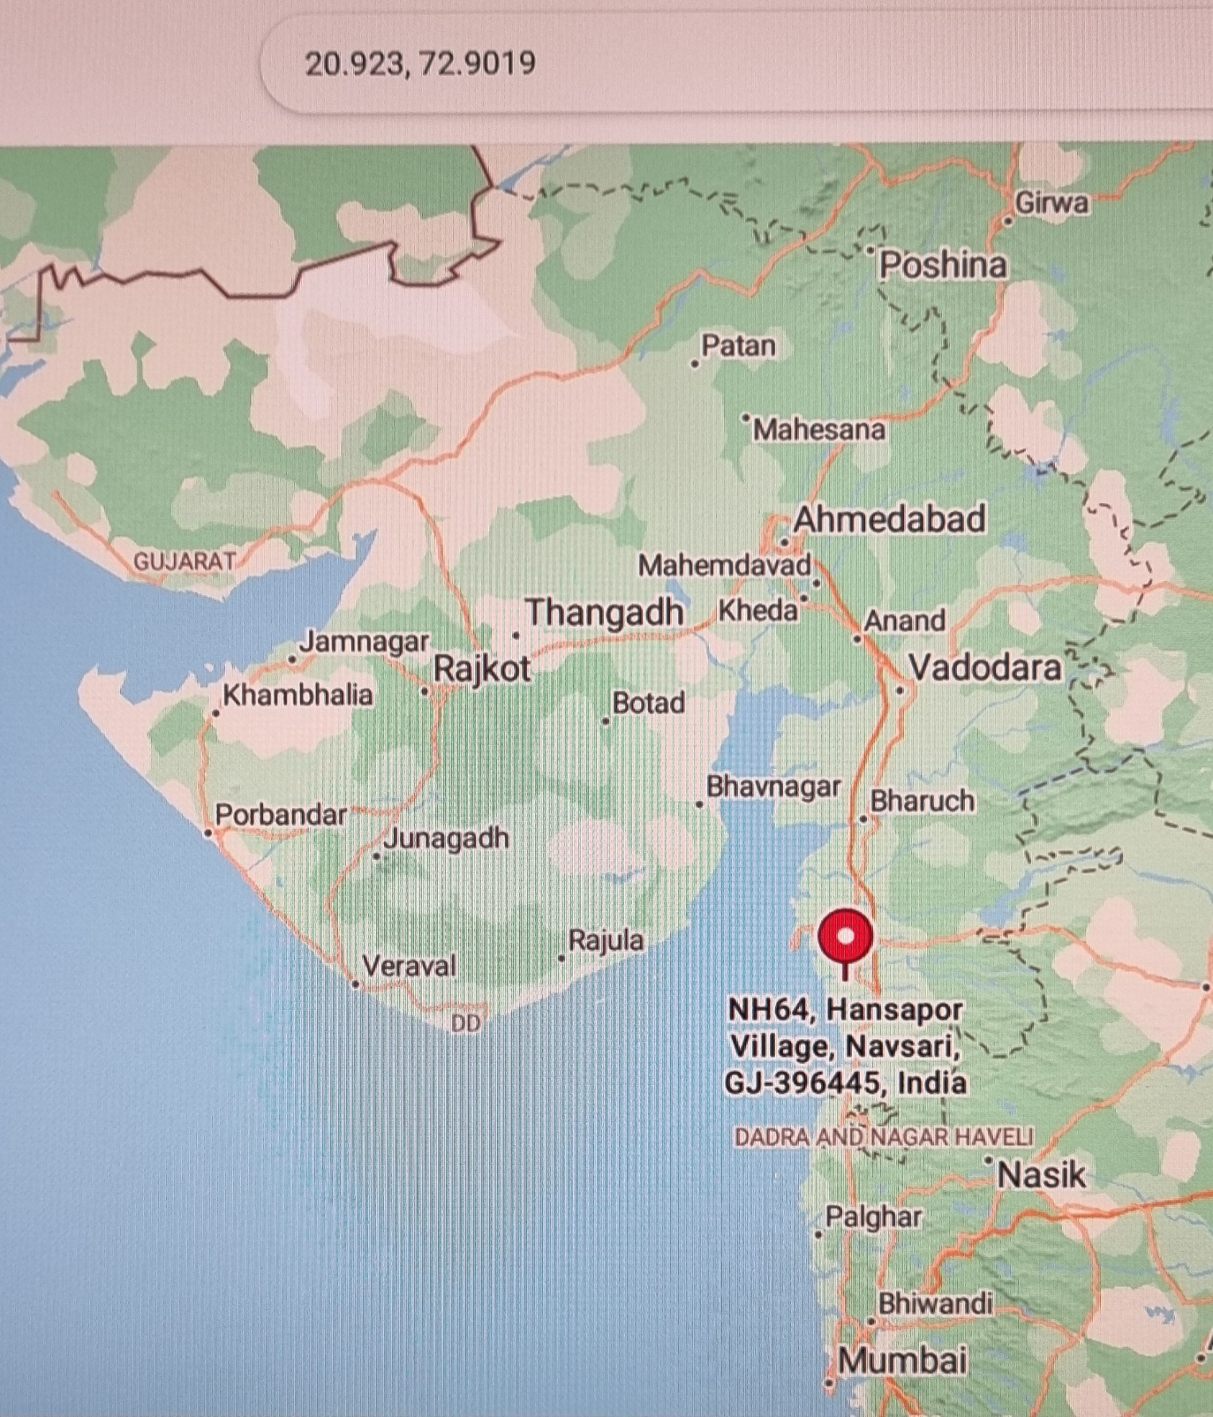 Figure 1: Experimental location (20.923,72.9019)
Experimental site

Table 1: Effect of diversified rice based system on rice yield and its attributes (Pooled)
Treatments | Plant height at harvest (cm) | Panicles/m² | Test weight (g) | Grain yield (kg ha⁻¹) | Straw yield (kg ha⁻¹)
T₁: Rice-Sweetcorn | 105.11 | 214 | 25.99 | 4873 | 6176
T₂: Rice-Cabbage | 107.18 | 216 | 26.06 | 4795 | 6351
T₃: Rice-Indian bean (veg.) | 111.38 | 223 | 25.97 | 5140 | 6278
T₄: Rice-Indian bean (seed) | 115.78 | 222 | 26.09 | 5202 | 6210
T₅: Rice-Green gram | 118.43 | 226 | 27.05 | 5179 | 6393
T₆: Rice-Chickpea | 120.96 | 231 | 27.06 | 5290 | 6439
T₇: Rice-Sorghum | 111.61 | 219 | 26.56 | 4923 | 6026
T₈: Rice-Mustard | 112.01 | 217 | 26.76 | 4919 | 6100
S.Em. ± | 4.34 | 7.72 | 0.87 | 209 | 254
C.D. at 5% | 12.27 | NS | NS | NS | NS

Table 2: Effect of diversified rice based system on rabi crop yield and rice equivalent yield (Pooled)
Treatments | Cob/head/grain/pod/seed yield (kg ha⁻¹) | Straw/ stover/ fodder yield (kg ha⁻¹) | Rice equivalent yield (t ha⁻¹)
T₁: Rice-Sweetcorn | 14476 | 21715 | 18.40
T₂: Rice-Cabbage | 12688 | 20853 | 16.52
T₃: Rice-Indian bean (veg.) | 3054 | 3658 | 20.45
T₄: Rice-Indian bean (seed) | 613 | 3765 | 9.11
T₅: Rice-Green gram | 1050 | 2176 | 11.77
T₆: Rice-Chickpea | 1460 | 2153 | 11.72
T₇: Rice-Sorghum | 2887 | 7532 | 11.10
T₈: Rice-Mustard | 1777 | 2907 | 13.72
S. Em. ± | - | - | 0.36
C.D. at 5% | - | - | 1.02

Table 3: Soil pH and EC after harvest of different crops

Treatment | After harvest of first year rice (2021-22) |  | At the end of crop sequence (2023-24)
Treatment | Soil pH_{2.5} | Soil EC (dS m⁻¹) | Soil pH_{2.5} | Soil EC (dS m⁻¹)
T₁: Rice-Sweetcorn | 7.96 | 0.52 | 7.79 | 0.49
T₂: Rice-Cabbage | 8.00 | 0.54 | 7.63 | 0.51
T₃: Rice-Indian bean (veg.) | 7.98 | 0.48 | 7.69 | 0.47
T₄: Rice-Indian bean (seed) | 7.98 | 0.49 | 7.56 | 0.49
T₅: Rice-Green gram | 7.96 | 0.48 | 7.69 | 0.50
T₆: Rice-Chickpea | 7.95 | 0.49 | 7.71 | 0.51
T₇: Rice-Sorghum | 8.02 | 0.54 | 7.93 | 0.54
T₈: Rice-Mustard | 8.11 | 0.55 | 7.88 | 0.54
S. Em. ± | 0.25 | 0.02 | 0.25 | 0.02
C.D. at 5% | NS | NS | NS | NS

Table 4: Soil OC % and available nutrients after harvest of different crops

Treatment | After harvest of first year rice (2021-22) |  |  | At the end of crop sequence (2023-24)
Treatment | Soil OC % | Available nitrogen (kg ha⁻¹) | Available phosphorus (kg ha⁻¹) | Soil OC % | Available nitrogen (kg ha⁻¹) | Available phosphorus (kg ha⁻¹)
T₁: Rice-Sweetcorn | 0.50 | 219.13 | 41.22 | 0.50 | 282.26 | 42.70
T₂: Rice-Cabbage | 0.50 | 216.25 | 39.07 | 0.49 | 284.12 | 43.44
T₃: Rice-Indian bean (veg.) | 0.52 | 237.13 | 43.64 | 0.57 | 286.15 | 46.14
T₄: Rice-Indian bean (seed) | 0.51 | 234.73 | 42.46 | 0.57 | 277.66 | 45.02
T₅: Rice-Green gram | 0.50 | 230.26 | 41.00 | 0.56 | 284.96 | 43.68
T₆: Rice-Chickpea | 0.50 | 228.07 | 42.10 | 0.55 | 282.08 | 44.81
T₇: Rice-Sorghum | 0.49 | 218.53 | 41.64 | 0.51 | 280.88 | 43.25
T₈: Rice-Mustard | 0.48 | 221.15 | 40.74 | 0.49 | 283.85 | 43.58
S. Em. ± | 0.02 | 11.10 | 1.66 | 0.02 | 12.77 | 1.38
C.D. at 5% | NS | NS | NS | 0.06 | NS | NS

Disclaimer (Artificial intelligence)
Author(s) hereby declare that NO generative AI technologies such as Large Language Models (ChatGPT, COPILOT, etc.) and text-to-image generators have been used during the writing or editing of this manuscript.

COMPETING INTERESTS DISCLAIMER:
Authors have declared that they have no known competing financial interests OR non-financial interests OR personal relationships that could have appeared to influence the work reported in this paper.
REFERENCES
- Arvadiya, L. K., Gudadhe, N. N., Garde, Y. A., Desai, L. J., Patel, P. K., Usadadiya, V. P. & Virdia, H. M. (2025). Purpose-wise diversification of component crops in rice-based systems for enhancing productivity, soil health, income, family and livestock nutrition. European Journal of Agronomy, 168: 127635.
- Banjara, T.R., Bohra, J.S., Kumar, S., Singh, T., Shori, A. & Prajapat, K. (2021). Sustainable alternative crop rotations to the irrigated rice-wheat cropping system of Indo- Gangetic plains of India. Archive of Agronomy and Soil Science, 68 (11), 1568–1585. https://doi.org/ 10.1080/03650340.2021.1912324.
- Basantaray, A.K., Acharya, S. & Patra, T. (2024). Crop diversification and income of agricultural households in India: an empirical analysis. Discov. Agric. 2, 8. https:// doi.org/10.1007/s44279-024-00019-0.
- Dwevedi, B.S., Shukla, A.K., Singh, V.K. & Yadav, R.L. (2003). Improving nitrogen and phosphorus use efficiency through inclusion of forage cowpea in rice-wheat cropping sequence in Indo-Gangetic plain. Field Crop Research, 80, 167–193.
- Jackson, M.L. (1973). Soil Chemical Analysis; Prentice Hall of India Pvt. Ltd.: New Delhi, India.
- Jana, K. (2012). Aerobic Rice System towards Tackling Climate Change. SATSA Mukhopatra - Annual Technical Issue, 16: 81-88.
- Jat, R. A., Dungrani, R. A., Arvadia, M. K. & Sahrawat, K. L (2012). Diversification of rice (Oryza sativa L.)-based cropping systems for higher productivity, resource-use efficiency and economic returns in south Gujarat, India. Archives of Agronomy and Soil Science, 58 (4-6):561-572.
- Kassam, A., Friedrich, T., Shaxson, F. & Pretty, J. (2009). The spread of conservation agriculture: justification, sustainability and uptake. International Journal of Agricultural Sustainability, 7(4), 292–320.
- Khedwal, R.S., Chaudhary, A., Sindhu, V.K., Yadav, D. B., Kumar, N., Chhokar, R. S., Poonia, T. M., Kumar Y. & Dahiya, S. (2023). Challenges and technological interventions in rice–wheat system for resilient food–water–energy-environment nexus in North-western Indo-Gangetic Plains: a review. Cereal Research Communication, 51, 785–807. https://doi.org/10.1007/s42976-023-00355-9.
- Kumar, A., Tripathi, H.P., Yadav, R.A. & Yadav, S.R. (2008). Diversification of rice (Oryza sativa)–wheat (Triticum aestivum) cropping system for sustainable production in eastern Uttar Pradesh. Indian Journal of Agronomy. 53(1):18–21.
- Ladha, J.K. & Kundu, D.K. (1997). Legumes for sustaining soil fertility in low land rice. In Extending Nitrogen Fixation Research to Farmer’s Fields: Proceeding of an International Workshop on Managing Legume Nitrogen Fixation in the Cropping System of Asia; International Crops Research Institute for the Semi-Arid Tropics (ICRISAT): Patancheru, India, pp. 76–102.
- Mishra, M.M., Nanda, S.S., Mohanty, M., Pradhan, K.C. & Mishra, S.S. (2007). Crop diversification under rice based cropping system in western Orissa. In Proceedings of the 3rd National Symposium on Integrated Farming Systems, Meerut, India, 26–28 October 2007.
- Mohanty, L. K., Priyanka, E., Vijaykumar, R., Suryawansh, A., Panotra, N., Girwani, T. & Saikanth, D.R.K. (2025). Diversification of rice based cropping system for sustaining plant and soil health. Journal of Scientific Research and Reports, 31 (6):756-768.
- Olsen, C.R., Cole, C.V., Wantanabe, F.S. & Dean, L.A. (1954). Estimation of Available P in Soil by Extraction with Sodium Bicarbonate. USDA, Washington, DC, USA, p. 19.
- Panse, V. G. & Sukhatme, P. V. (1957). Publication and information division Statistical Indian methods for agricultural workers. Council of Agricultural Research. New Delhi. pp. 87-89.
- Pingali, P. L. (2012). Green Revolution: Impacts, limits, and the path ahead. Proceedings of the National Academy of Sciences, 109 (31), 12302–12308.
- Porter, W.M., Mc, Lay C.D.A., & Dolling, P.J. (1995). Rates and sources of acidification in agricultural systems of southern Australia. In: Date, R.A., Grundon, N.J., Rayment, G.E., Probert, M.E. (Eds.), Plant–Soil Interactions at Low pH. Netherlands: Kluwer Academic Publishers, Dordrecht, pp. 75–83. https://doi.org/10.1007/978- 94-011-0221-6_10.
- Singh, R.D. (2010). Food security for increasing rural livelihood under limited water supply through adoption of diversified crops and crop sequences. In Resource Conservation Technologies for Food Security and Rural Livelihood; Khan, A.R., Singh, S.S., Bharti, R.C., Srivastava, T.K., Khan, M.A., Eds.; Agrotech Publishing Academy: Udaipur, India, pp. 342–355.
- Singh, R.D., Shivani Khan, A.R. & Chandra, N. (2011). Sustainable productivity and profitability of diversified rice-based cropping systems in an irrigated ecosystem. Archive of Agronomy and Soil Science, 58, 859–869.
- Subbiah, B.V. & Asija, G.L. (1956). A rapid procedure for the determination of available nitrogen in soils. Current Science, 25, 259–260.
- Upadhaya, B., Kishore, K., Kumar, V. Kumar, N., Kumar S., Yadave, V. K., Kumar, R., Gaber, A., Laing A M., Brestic, M. & Hossain A. (2022). Diversification of Rice-Based Cropping System for Improving System Productivity and Soil Health in Eastern Gangetic Plains of India Agronomy, 12, 2393. https://doi.org/10.3390/agronomy12102393.
- Vukicevich, E., Lowery, T., Bowen, P., Úrbez-Torres, J.R. & Hart, M. (2016). Cover crops to increase soil microbial diversity and mitigate decline in perennial agriculture. A review. Agron. Sustain. Dev. 36, 48. https://doi.org/10.1007/s13593-016-0385-7.
- Walkley, A.J. & Black, I.A. (1934). Estimation of soil organic carbon by the chromic acid titration method. Soil Sci. 37, 29–38.
- Yao, W., Yang, Y., Beillouin, D., Zhao, J., Olesen, J.E., Zhou, J., Smith, P., Zeng, Z., Lambers, H., Rillig, M.C., Wanger, T.C. & Zang, H. (2025). Legume-rice rotations increase rice yields and carbon sequestration potential globally. One Earth 8 (2), 101170. https://doi.org/10.1016/j.oneear.2024.12.006.

