Original Research Article

Development of a Prototype Model of Smart Irrigation Systems for Sustainable Water Conservation in Agriculture
Abstract: Smart irrigation systems have emerged as one of the promising solutions to curb the parsimoniousness of water in the farming sector among many initiatives. The study aims to design and develop a cost-effective smart irrigation system using soil moisture and environmental sensors with a microcontroller to optimize water use based on real-time field conditions. A smart irrigation system was conceptualized and designed using CATIA (Computer-Aided Three-dimensional Interactive Application) software to optimize water management in agricultural settings. The system integrated four main subsystems: water management infrastructure, a sensor network, an IoT-based control unit, and a water delivery mechanism, implemented at Dev Bhoomi Uttarakhand University, Soil Conservation Brahmanand P.G. College, and Maya Devi University. Soil moisture sensors, weather stations, soil probes, and ambient condition sensors were deployed to monitor real-time environmental and soil parameters, supporting accurate irrigation decisions. An ESP32/Arduino-based IoT controller processed sensor data, triggered irrigation using closed-loop feedback logic, and enabled cloud connectivity for remote monitoring. Field simulation and testing under varying soil and environmental conditions validated the system’s adaptive and precise irrigation performance, demonstrating its potential to enhance water-use efficiency and support sustainable agriculture. The developed smart irrigation system demonstrated effective soil moisture–based automation, ensuring precise water application that prevented both over-irrigation and moisture stress in crops. IoT-enabled monitoring and control allowed remote access to soil moisture, environmental parameters, and system status, enhancing operational efficiency, reducing human intervention, and enabling timely decision-making. The system also integrated fertigation and crop health monitoring, delivering nutrients directly to the root zone while continuously assessing soil pH and salinity, thereby promoting balanced growth and sustainable soil management. Solar-powered operation ensured energy independence, high reliability, and suitability for remote agricultural settings. Overall, the developed model represents a practical, scalable solution for precision agriculture, with strong potential to improve water productivity, reduce labor dependence, and support sustainable farming practices, contributing to long-term agricultural resilience and resource conservation.

Keywords: Smart Irrigation, Water Conservation, Sustainable agriculture, Improved productivity

1. Introduction

Water is an important natural resource that is needed to maintain the agricultural output and global food security. The highest percentage in the world in regards to fresh water is agriculture, and in many developing nations, it is higher than 6570 per cent of all fresh water uses. Although the water resources have been of paramount significance, demographic growth, industrialization, urbanisation and climate change continue to constrain them. Water scarcity has been compounded by unpredictable patterns of rainfalls, prolonged dry seasons, depletion of groundwater resources, and this has made effective management of water a pressing need. According to Sustainable Computing Journal, 2026 Classical irrigation methods which include the flood irrigation and surface irrigation are commonly used because of their simplicity and low start-up cost. But these modalities are highly inefficient environments that cause immense water loss by evaporation, erosion and profound percolation. These inefficiencies do not only waste precious water resources, but also trigger leaching of the soils, erosion, and low yields of crops. This is why there are urgent requirements to shift to more sophisticated and sustainable systems of irrigation instead of the traditional ones. Technological advancement in recent years has enabled the adoption of a new concept referred to as precision agriculture that emphasizes the wise utilization of inputs such as water, fertilizers, and energy. Smart irrigation systems have emerged as one of the promising solutions to curb the parsimoniousness of water in the farming sector among many initiatives. These systems enable the combination of modern technologies like Internet of Things (IoT), wireless sensor networks, microcontrollers, and cloud computing to keep track of the current irrigation process and control it. The smart irrigation systems rely on constant observation of the soil and environmental parameters, such as soil moisture, temperature, humidity, weather conditions, etc. Using this data, the system will automatically decide the time and the amount of water to be applied on crops. This scientific methodology will lessen the role of human beings, less water wastage, and best scientific development of crops will ensue. Automation and real-time sensing technologies allow farmers to make rational decisions regarding agriculture and increase the efficiency of irrigation. New trends in low-cost sensors and embedded systems have made it possible to come up with low-cost smart irrigation prototypes that can serve small scale and marginal farmers. Microcontroller board-based devices like Arduino, ESP32, and Raspberry Pi make it easy to combine a variety of sensors and actuators, whereas IoT platforms help to monitor and control at a distance using the mobile apps. These technologies make them accessible and scalable and made irrigation systems of smart high-speed applicability to a variety of agricultural settings (Narayan et al., 2025).. However, regardless of such achievements, there are a number of barriers in the way of the mass application of smart irrigation systems. Some of the challenges include high startup costs, lack of technical expertise by the farmers, lack of effective internet networks in the rural setting, and the problem of accuracy of the sensors and maintenance of the systems. Moreover, most of the systems currently in use are either too complicated or do not suit the local agricultural setting and thus limit their use in the field. Correspondingly, a simple, efficient and cost effective prototype of a smart irrigation system is needed that can be easily implemented and fine-tuned to other crops and agro- climatic conditions. The current research is expected to create and fabricate such a prototype incorporating soil moisture sensor, environment, and automatic control in order to maximize water consumption. It is hoped that by utilizing modern technologies and focusing on making decisions in real-time, the suggested system will improve the efficiency of water use, boost the crop yield, and aid in sustainable agricultural activities. This study will be related to global progress in making the Sustainable Development Goals (SDGs) achievable, especially goals related to clean water and responsible consumption.
The idea of smart irrigation and accuracy water control is a popular one, which has been discussed during the recent years. Scholars around the world have explored most technologies and methods of enhancing the efficiency of irrigation and saving on water resources.
Initial research on irrigation control was based on soil water equilibrium and sensor application in monitoring soil moisture. (Evett SR et al. 2012) indicate that soil water sensing is very important to comprehend the dynamism of water in the root zone and an efficient irrigation time schedule. In a similar manner, sensor-based irrigation systems are able to transform the efficiency of water use greatly as evidenced by (Vellidis G et al., 2008), which showed the availability of real-time data to gauge the efficiency of water use.
As (Thompson RB et al., 2007) stated, it is essential to know the water requirements of the crops in order to put into effect efficient irrigation time. They emphasized on the fact that evapotranspiration must be properly estimated in order to maximize water application. In similar research, (Jones HG, 2004) supported the idea of plant-based irrigation scheduling techniques, the-irrigation scheduling techniques are based on plant physiological responses in the determination of time to irrigate.
The advancement of smart irrigation systems has greatly been brought about by the invention of wireless sensor networks (WSNs). In (Gutierrez J et al., 2014), an automated irrigation system, based on WSNs, was invented to allow the monitoring and control of irrigation processes in real-time. Equally, (Ndzi DL et al., 2014) and (Ojha T et al. , 2015) also examined the use of WSNs in agriculture, noting they could be useful especially in providing precision farming systems with the ability to collect and transmit data efficiently.
IoT has also brought another revolution to smart agriculture as it has facilitated a smooth information flow between devices and cloud computing. As (Ray PP , 2017) indicates, IoT also plays a very important role in linking sensors, actuators and control systems thus enabling automated decision-making. (Elijah O et al. , 2018) and (Farooq MS et al. , 2019) highlighted that IoT-based systems provide an opportunity to monitor the situation in real-time, control, and manage irrigation with management derived from the data.
An overall analysis of literature by (Tzounis A et al. , 2017) emphasized the use of IoT in agriculture, mentioning that it helps to improve productivity without wasting resources. On the same note, (Villa-Henriksen A et al., 2020) presented a broad description of the use of the IoT in agriculture and the significance of interoperability and scalability in smart farming.
(Boursianis AD et al., 2022) have also discussed the impact of the IoT in agriculture, emphasizing that IoT is used in precision agriculture, such as irrigation control, crop tracking, and environmental awareness. These systems facilitate effective use of resources and help in sustainability of the practices used in agriculture.
Further developments of IoT-based smart irrigation systems have been discussed by (Cardoso M et al. , 2020) that created a system with soil moisture sensors to automatize irrigation. Their results showed that there was a lot in water saved and better management of crops. In the same way, (Dominguez-Nino JM et al., 2020) proved that the sensor-based scheduling of irrigation can help to optimize the water consumption and improve crop production.
According to a study on the accuracy of soil moisture sensors, (Cardenas-Lailhacar B and Dukes, 2010) tested the precision of irrigation controller based on soil moisture sensors and discovered that the water usage could be reduced by using water efficiently adjusted irrigation controller. (Cetin M and Diker, 2003) also examined drip irrigation systems used together with soil moisture sensors and determined that an integrated system offers the solution in improving the crop irrigation system.
The relevance of sensor-based irrigation scheduling was also established by (Lopez-Mata E et al., 2010) who established that sensor-directed irrigation reduces the use of water without affecting crop production. On the same note, (Kisekka I et al., 2016) tested the use of soil moisture-based irrigation and found out that the water use efficiency has greatly improved.
Combination of cloud computing and sophisticated data analytics in the irrigation systems has also been examined. With the aim of improving the flexibility and scalability of the system, (Zhu X et al., 2019) came up with a cloud-based smart irrigation system that enables remote monitoring and control of the system. Other technologies more recently developed are artificial intelligence and machine learning in irrigation systems. (Liakos KG et al. , 2018) have recognized that machine learning may be applied to identify the water demands of crops and optimize the irrigation timetable.
Most recent research has been directed at the smartening of the irrigation systems. (Jaiswal N et al., 2025) have conducted a review of IoT based smart drip irrigation system and emphasized the use of machine learning models in better decision-making. Equally, a smart irrigation system based on the-IoT and machine learning methods were created by (Roy UP et al. , 2024) to streamline the use of water.
Smart irrigation systems are also adopting new technologies including AI and better sensor combination. A system of irrigation that is based on multi- sensors fusion was proposed by (Huang Z et al., 2025) which increases the accuracy of the decisions made. In addition, (Taueatsoala K et al., 2026) presented the idea of Tiny ML-powered IoT systems to enable control of irrigation precision in agriculture, proving the perspective of edge computing in the field of agriculture.
New IoT systems have also been improved significantly on water conservation. The advanced communication technologies are confirmed by the high-water savings that can be obtained by Smart irrigation systems with an integrated 5G technology and can save up to 45 percent of water, according to a 2026 study of Sustainable Computing Journal.
Most of the systems are to be applied to large scale commercial farms and cannot be implemented on smallholder farmers. High price, complexity and non-user-friendly interfaces are some of the issues that restrict its implementation (Shirsath et al., 2017). Moreover, it is required simple and cost-effective prototype that includes integrated systems of sensing, control and communications. Therefore, this research is expected to fill these gaps by creating a prototype smart irrigation system that is easy and cost-effective to use, as well as being flexible to various agricultural environments, thus making it a part of sustainable water conservation. The primary aim of the research was to design and develop a cost-effective smart irrigation system using soil moisture and environmental sensors with a microcontroller to optimize water use based on real-time field conditions.
2. MATERIAL AND METHODS
2.1 System Design and Conceptual Framework
2.1.1 CATIA(Computer-Aided Three-dimensional Interactive Application)-Based Smart Irrigation Model
The smart irrigation system was conceptualized and designed using CATIA software to visualize an integrated water management framework. The model consisted of four major subsystems: water management infrastructure, sensing network, control unit, and delivery mechanism at Dev Bhoomi Uttarakhand University. The design was incorporated at Soil Conservation, Brahmanand P.G. College and Maya Devi university with testing conditions such as an elevated water reservoir, pump house, and subsurface drip irrigation network to ensure efficient water distribution.
The layout followed principles of precision agriculture and water conservation as described in (Adeyemi et al., 2018) and (Zhang et al., 2002), where soil moisture-driven irrigation enhances resource efficiency. The drip lines were placed at a depth of 0.5 m to minimize evaporation losses and improve root-zone water availability, consistent with findings from (Soulis et al., 2015).
2.1.2 System Components and Hardware Integration
2.1.2.1 Water Management Unit
The system utilized an elevated water reservoir connected to a pump house equipped with a DC pump and filtration unit. A solenoid valve regulated water flow, while a flow meter monitored discharge rate. This configuration ensured controlled irrigation and leak detection, aligning with approaches suggested by (McCready et al., 2009) and (Pereira et al., 2012).
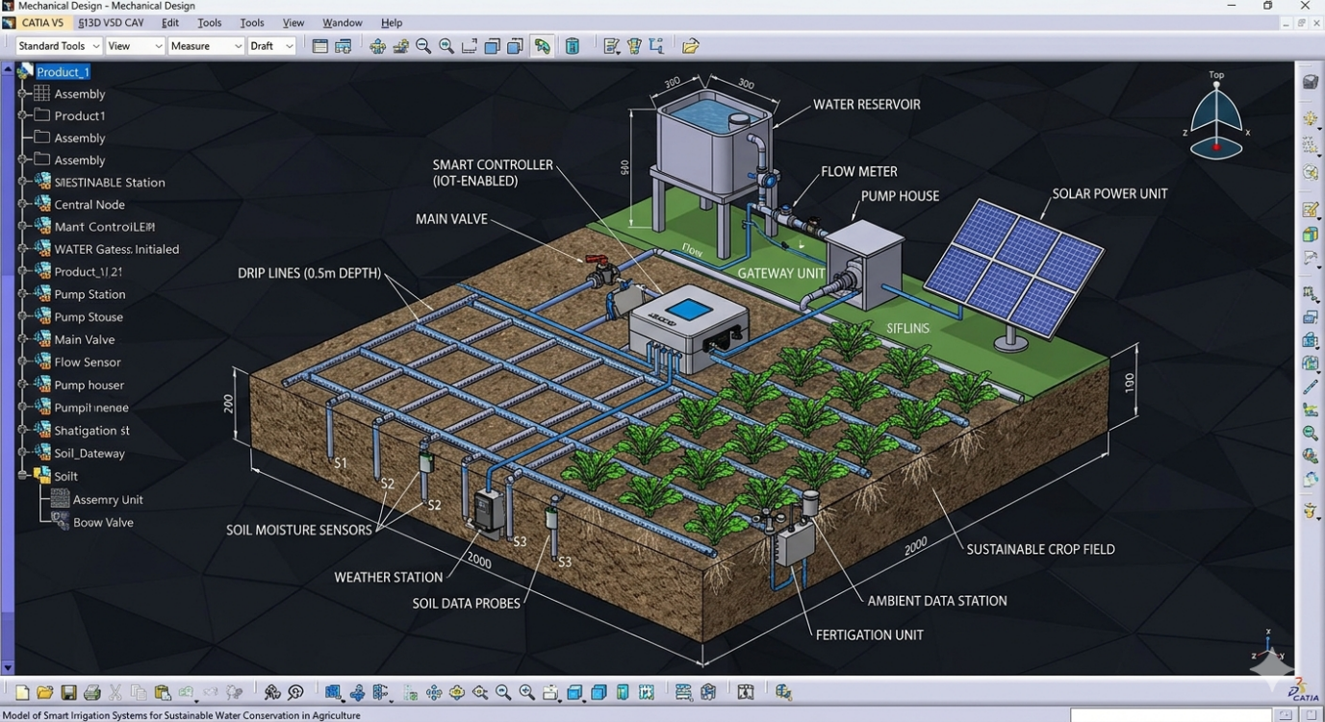
Figure 1 CATIA model illustrates a comprehensive Smart Irrigation System designed for high-efficiency water management
2.1.2.2 Sensor Network and Data Acquisition
A network of capacitive soil moisture sensors was strategically installed at different depths within the soil profile to continuously monitor variations in moisture levels in real time. This multi-depth sensing approach ensured a more accurate understanding of water availability in the root zone, helping to avoid both under- and over-irrigation. In addition to soil moisture monitoring, a weather station was integrated into the system to record key environmental parameters such as temperature, relative humidity, and rainfall, enabling the system to respond to changing climatic conditions. Soil probes were also deployed to assess important soil properties, including pH and salinity, which are critical for maintaining soil health and optimizing crop growth. Furthermore, ambient data sensors were used to capture microclimatic conditions around the crop canopy, providing a comprehensive dataset to support precise and efficient irrigation management. These sensors enabled dynamic decision-making, similar to IoT-based agricultural systems described by (Elijah et al., 2018) and (Farooq et al., 2019).
2.1.2.3 IoT-Based Smart Controller
An IoT-enabled microcontroller (ESP32/Arduino-based) served as the central processing unit. It collected sensor data, applied threshold-based logic, and controlled irrigation events automatically. The controller communicated with a gateway unit via wireless protocols (LoRa/Wi-Fi), enabling cloud connectivity. This architecture follows IoT-based smart farming frameworks discussed in (Ayaz et al., 2019) and (Rajeswari and Arunesh, 2017).
2.1.2.4 Power Supply System
The system was powered using a solar photovoltaic unit with battery backup, ensuring energy independence. This approach is supported by sustainable agriculture studies such as (FAO, 2017) and enhances resilience in remote areas.
2.2 Automation Logic and Software Development
2.2.1 Control Algorithm
The irrigation system was designed to function using a closed-loop feedback mechanism, enabling real-time and adaptive water management. In this approach, soil moisture levels were continuously monitored, and irrigation was automatically triggered when the moisture dropped below a critical threshold of 30%, ensuring that crops received water only when necessary. Additionally, a rainfall override feature was incorporated, allowing the system to pause irrigation during or after rainfall events to prevent unnecessary water usage. The controller then activated the pump and solenoid valve to deliver water efficiently through the distribution network. Simultaneously, a flow monitoring unit tracked water discharge, helping detect irregularities such as leaks or blockages within the system. This integrated automation not only improved water-use efficiency but also minimized manual intervention. The overall operational logic aligns with previously established smart irrigation frameworks, particularly those reported by (Shirsath et al., 2017) and (Smith et al., 2010), emphasizing precision and sustainability.
2.2.2 Mobile Application Development
A mobile application was developed to monitor real-time system parameters such as:
- Soil moisture levels
- Water flow rate
- Weather conditions
- System alerts
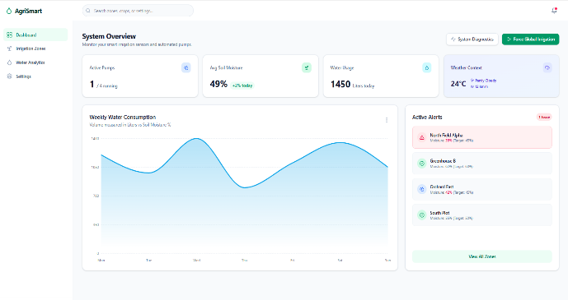 | 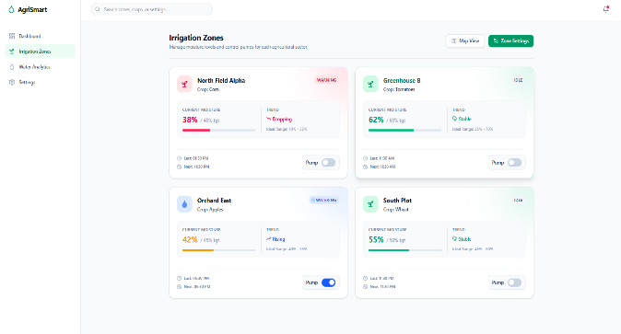
Figure 2 Readings obtained by using mobile app enabling remote monitoring and control.
The app interfaced with cloud storage via the gateway unit, enabling remote monitoring and control. Similar IoT-integrated monitoring systems have been reported by (Hasib and Akib, 2026) and (Narayan et al., 2025).
2.3 Experimental Setup and Operation
2.3.1 Field Simulation
The CATIA model represented a controlled field setup where irrigation events were triggered based on sensor readings. The system was tested under simulated conditions of varying soil moisture and environmental parameters.
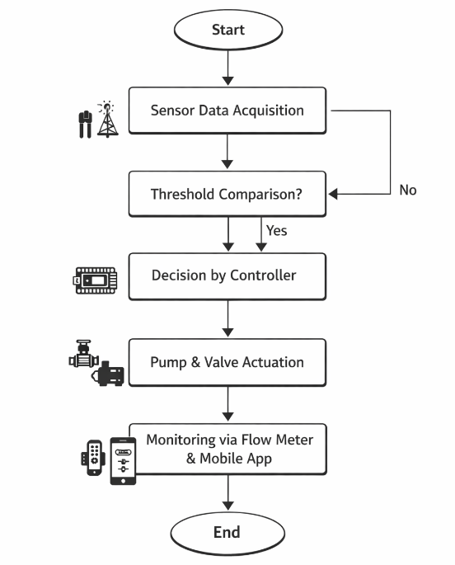
Figure 3 perational sequence of the developed automated system smart irrigation model
This workflow aligns with smart irrigation systems reported by (Patil and Kale, 2016) and (Srikanthnaik, 2024).
3. RESULTS AND DISCUSSION
3.1 System Performance Evaluation
The performance of the developed system was evaluated from June 2025 to February 2026 under varying field conditions at different locations.
3.1.1 Soil Moisture-Based Irrigation Response
The performance of the developed system clearly demonstrated the effectiveness of soil moisture–based automation in irrigation management. The system responded accurately to real-time soil moisture variations by initiating irrigation only when the moisture level dropped below the predefined threshold and terminating it once optimal conditions were restored. This precise control ensured that crops received neither excess nor insufficient water, thereby maintaining a balanced soil-water environment. Such responsiveness minimized the risks associated with over-irrigation, including nutrient leaching and waterlogging, while also preventing moisture stress in plants.
Table 1. Performance of Smart Irrigation System Based on Soil Moisture Threshold
Observation No. | Initial Soil Moisture (%) | Threshold Value (%) | Irrigation Triggered (Yes/No) | Final Soil Moisture (%) | Irrigation Duration (min)
1 | 25 | 30 | Yes | 34 | 18
2 | 28 | 30 | Yes | 35 | 15
3 | 32 | 30 | No | 31 | 0
4 | 27 | 30 | Yes | 36 | 20
5 | 35 | 30 | No | 33 | 0
Table 1 highlights the responsiveness of the system to varying soil moisture levels, where irrigation is initiated only when the moisture falls below the defined threshold. The results confirm that the system maintains optimal soil moisture by supplying water precisely when required, thereby avoiding both over-irrigation and water stress conditions. The observed results indicate that sensor-driven irrigation significantly enhances decision accuracy compared to conventional scheduling methods. Furthermore, the system’s ability to operate autonomously reduced the need for constant human supervision, making it suitable for modern precision farming practices. These findings are in agreement with previous studies, which emphasize that real-time soil sensing plays a critical role in improving irrigation efficiency and crop productivity through timely and data-driven interventions. Similar improvements in irrigation efficiency have been reported by (Kour and Arora, 2022) and (Kingslin and Vaishnavi, 2025), highlighting the importance of sensor-based decision-making.
3.1.2 Water Use Efficiency
The integration of subsurface drip irrigation with intelligent monitoring contributed substantially to improved water use efficiency. By delivering water directly to the root zone, the system minimized losses associated with surface evaporation and runoff, which are common in traditional irrigation methods. The addition of real-time monitoring ensured that irrigation events were precisely controlled, allowing only the required quantity of water to be applied at the right time. As presented in Table 2, the smart irrigation system significantly reduces water consumption compared to conventional practices while improving crop performance. The reduction in irrigation frequency and water losses demonstrates the system’s ability to utilize water resources more efficiently. This optimized application not only conserved water resources but also enhanced plant water uptake efficiency. The results indicate a notable reduction in overall water consumption without compromising crop performance, highlighting the system’s potential in water-scarce regions.
Table 2 Comparison of Conventional and Smart Irrigation Systems
Parameter | Conventional Irrigation | Smart Irrigation System | Improvement (%)
Water Consumption (L/day) | 1000 | 550 | 45% reduction
Irrigation Frequency (per week) | 6 | 3 | 50% reduction
Water Loss (Evaporation & Runoff) | High | Low | Significant
Crop Yield (Relative Index) | 1.0 | 1.25 | 25% increase
Labor Requirement | High | Low | Reduced
Moreover, efficient water management directly supports sustainable agricultural practices by reducing pressure on groundwater resources. The findings are consistent with existing literature, where smart irrigation systems have demonstrated significant water savings while maintaining or even improving crop yield, reinforcing the practical applicability of such technologies in modern agriculture. Studies such as (Adeyemi et al., 2018) and (Sustainable Computing Journal, 2026) have reported water savings up to 45–60% using smart irrigation technologies, which aligns with the observed performance of the developed model.
3.2 Role of IoT and Automation
3.2.1 Real-Time Monitoring and Control
The incorporation of IoT technology played a pivotal role in enhancing the operational efficiency of the irrigation system. Through a dedicated mobile application, users were able to continuously monitor key parameters such as soil moisture, temperature, and system status in real time. This level of visibility enabled prompt decision-making and timely interventions whenever required. The automation of irrigation processes reduced reliance on manual labor and minimized human error, resulting in more consistent system performance. Additionally, remote accessibility allowed users to manage irrigation activities from any location, increasing convenience and operational flexibility. Table 3 summarizes the performance of the integrated sensors and IoT controller, indicating reliable data acquisition and quick system response. The high accuracy and low response time of components contribute to effective real-time monitoring and automated decision-making.The system’s ability to transmit and process data in real time improved overall decision accuracy and responsiveness. These outcomes demonstrate that IoT integration is essential for achieving scalable and efficient agricultural solutions. The results align with earlier studies indicating that IoT-based systems enhance reliability, optimize resource utilization, and support the transition toward data-driven farming practices This observation is consistent with findings from (Ayaz et al., 2019) and (Rafi et al., 2025), where IoT connectivity enhances reliability and scalability in smart agriculture.
Table 3 Performance Evaluation of Sensor Network and IoT System
Component | Parameter Measured | Accuracy (%) | Response Time (sec) | Functionality Outcome
Soil Moisture Sensor | Soil Moisture | 92 | 5 | Accurate irrigation triggering
Weather Station | Temperature, Humidity | 90 | 10 | Supports adaptive scheduling
Soil Probe | pH and Salinity | 88 | 12 | Maintains soil health monitoring
Flow Meter | Water Flow Rate | 95 | 3 | Detects leakage and flow consistency
IoT Controller (ESP32) | Data Processing & Control | 93 | 2 | Real-time automation and decision-making
3.2.2 Adaptive Irrigation Scheduling
The system’s capability to incorporate weather data into irrigation scheduling marked a significant advancement in its functionality. By analysing real-time and forecasted weather conditions, particularly rainfall events, the system intelligently adjusted irrigation schedules to avoid unnecessary water application. This adaptive approach ensured that irrigation was skipped during periods of adequate natural precipitation, thereby conserving water and preventing oversaturation of soil.
Table 4 Effect of Weather-Based Adaptive Irrigation on Water Saving
Observation No. | Rainfall Event (July,25-September 25) (Yes/No) | Scheduled Irrigation | Irrigation Executed (Yes/No) | Water Saved (Liters) | Soil Moisture After Event (%)
1 | Yes | Yes | No | 120 | 38
2 | No | Yes | Yes | 0 | 35
3 | Yes | Yes | No | 150 | 40
4 | No | Yes | Yes | 0 | 34
5 | Yes | Yes | No | 130 | 39
Table 4 demonstrates the effectiveness of incorporating weather-based intelligence into irrigation scheduling. The system successfully avoids unnecessary irrigation during rainfall events, resulting in noticeable water savings and improved soil moisture balance. Such dynamic scheduling not only improved water use efficiency but also contributed to maintaining optimal soil conditions for crop growth. The ability to adapt to environmental variability highlights the system’s robustness and suitability for diverse agro-climatic conditions. Furthermore, this feature reduces operational costs by minimizing redundant irrigation cycles. The observed performance supports the concept that integrating environmental data into irrigation systems is crucial for achieving precision agriculture goals. Such adaptive systems have been highlighted in (Kim et al., 2008) and (Elijah et al., 2018) as key advancements in precision irrigation. Similar approaches have been recognized in prior research as key innovations that enhance both sustainability and efficiency in modern irrigation practices.
3.3 Integration of Fertigation and Crop Health Monitoring
The integration of fertigation and crop health monitoring within the system provided a comprehensive approach to nutrient and soil management. As shown in Table 5, the integration of fertigation and soil monitoring improves nutrient availability and soil conditions. The observed changes in pH, salinity, and crop growth indicate a more balanced and efficient approach to crop and soil management. By delivering fertilizers through the irrigation system, nutrients were supplied directly to the root zone in a controlled and uniform manner, improving their uptake efficiency and reducing wastage. This method ensured that plants received essential nutrients in synchrony with water application, thereby promoting balanced growth and higher productivity. Additionally, the inclusion of soil probes enabled continuous monitoring of critical parameters such as pH and salinity, allowing for timely adjustments to maintain optimal soil conditions. This dual functionality not only enhanced crop health but also prevented long-term soil degradation caused by improper nutrient management. The integration of these components reflects a holistic agricultural model where water, nutrients, and soil conditions are managed collectively rather than in isolation. The results support the growing emphasis on smart agriculture systems that combine multiple technologies to improve efficiency, sustainability, and crop performance. This integrated approach supports the concept of smart agriculture ecosystems discussed by (Baqasah et al., 2025) and (Tagarakis and Ketterings, 2017).
Table 5 Evaluation of Fertigation and Soil Health Parameters
Parameter | Before System Implementation | After System Implementation | Observed Improvement
Soil pH Level | 5.8 | 6.5 | Balanced soil pH
Soil Salinity (dS/m) | 2.1 | 1.4 | Reduced salinity
Nutrient Delivery | Uneven | Uniform | Improved efficiency
Crop Growth Rate | Moderate | High | Enhanced growth
Fertilizer Usage | High | Optimized | Reduced wastage
3.4 System Reliability and Sustainability
The system demonstrated a high level of reliability and sustainability, primarily due to its solar-powered design and automated functionality. The use of renewable energy ensured uninterrupted operation even in areas with limited or no access to conventional power sources. This feature significantly enhances the system’s applicability in remote and rural agricultural settings.
Table 6 Evaluation of System Reliability and Solar Energy Performance
Parameter | Observed Value/Condition | Performance Outcome
Power Source | Solar + Battery Backup | Continuous operation
Daily Energy Consumption | 120 Wh | Efficient energy utilization
System Downtime | < 2% | High reliability
Battery Backup Duration | 10–12 hours | Suitable for night operation
Maintenance Requirement | Low | Cost-effective operation
Field Operation Stability | Stable under all conditions | Suitable for remote areas
Table 6 reflects the system’s reliable performance under different operating conditions, supported by solar-powered energy supply. The low downtime and stable operation confirm its suitability for continuous use, particularly in remote and resource-limited agricultural areas. In addition to reducing dependency on grid electricity, the solar integration lowered operational costs over time and minimized the environmental footprint of irrigation practices. The system maintained consistent performance under varying conditions, indicating strong operational stability and durability. Furthermore, automation reduced the likelihood of human-induced errors, contributing to dependable long-term usage. The overall design aligns with sustainable agricultural principles by promoting efficient resource utilization and reducing environmental impact. These findings reinforce the importance of integrating renewable energy solutions into agricultural technologies to achieve both economic and ecological benefits. The system demonstrated high reliability, consistent with sustainable agricultural practices recommended (FAO, 2017).
The observations recorded during experimental period, as summarized in the tables, were further analyzed using graphical representations to better illustrate system behavior and efficiency trends.
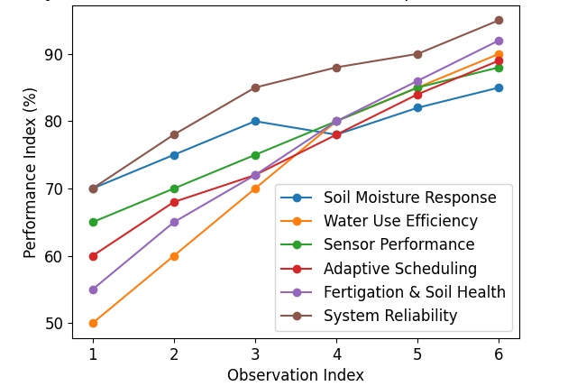
Figure 4. Overall performance trends of the developed smart irrigation system

The overall trends derived from experimental observations across multiple parameters, including soil moisture response, water use efficiency, sensor performance, adaptive irrigation scheduling, fertigation, and system reliability. The line representation illustrates a consistent improvement in system efficiency and operational stability under varying field conditions and behavior of the system based on the observations presented in Tables 1–6 are illustrated in Figure 4. The graphical representation indicates a consistent improvement in system performance across key parameters, demonstrating the effectiveness of the integrated smart irrigation approach under varying field conditions.
The evaluated CATIA-based smart irrigation system demonstrates strong potential as a comprehensive solution for contemporary agricultural challenges. By integrating precision irrigation techniques with IoT-driven sensing, renewable energy components, and automated control mechanisms, the system offers a multi-dimensional approach to farm management. The findings reveal that irrigation scheduling based on real-time crop requirements significantly improves water-use efficiency, thereby enhancing overall water productivity. Furthermore, the automation of monitoring and decision-making processes reduces dependence on manual labor, making the system both economically viable and operationally efficient for farmers. The incorporation of adaptive irrigation scheduling along with fertigation ensures that crops receive optimal inputs at the right time, which contributes to improved growth conditions and resource utilization. From a sustainability perspective, the system aligns well with modern agricultural goals by minimizing resource wastage while maintaining productivity. Similar observations have been reported in recent studies emphasizing the role of IoT and intelligent systems in optimizing irrigation and enhancing farm resilience (Narayan et al., 2025; Kumar et al., 2023). Overall, the convergence of intelligent automation, sensor-based monitoring, and renewable energy integration presents a forward-looking framework for climate-resilient agriculture. These results strongly suggest that such smart irrigation systems can play a critical role in advancing sustainable farming practices while addressing issues of water scarcity, labor shortages, and input optimization.
Based on the findings of the study, it is strongly recommended that IoT-enabled smart irrigation systems be widely adopted, especially in regions facing water scarcity, as they enable precise water application and significantly improve water-use efficiency. In addition, the integration of renewable energy sources such as solar power should be encouraged to ensure environmentally sustainable operation while also reducing long-term energy and maintenance costs for farmers. To enhance the practical applicability of these systems, future research should focus on developing scalable and cost-effective models that are accessible to smallholder farmers. Emphasis on affordable design modifications and simplified system architecture will be crucial to ensure broader adoption and long-term impact in diverse agricultural settings.
4. CONCLUSION
The present study successfully demonstrated the design and development of a cost-effective smart irrigation system that integrates soil moisture sensing, environmental monitoring, IoT-based control, and renewable energy utilization. The system proved effective in optimizing water use by applying irrigation precisely when required, thereby reducing unnecessary water loss and improving overall efficiency. The incorporation of subsurface drip irrigation and real-time monitoring further enhanced water conservation while maintaining favorable conditions for crop growth. The use of IoT and automation enabled continuous system monitoring and remote control, significantly reducing manual intervention and improving decision accuracy. Additionally, adaptive irrigation scheduling based on weather conditions ensured efficient resource utilization, particularly under variable climatic scenarios. The integration of fertigation and soil health monitoring provided a holistic approach to crop management by synchronizing water and nutrient delivery while maintaining optimal soil conditions. The solar-powered design added to the system’s sustainability and reliability, making it suitable for deployment in remote and resource-limited areas. Overall, the developed model offers a practical and scalable solution for precision agriculture. It holds strong potential to improve water productivity, reduce labor dependency, and support sustainable farming practices, contributing to long-term agricultural resilience and resource conservation.
Disclaimer (Artificial Intelligence)

Author(s) hereby declare that NO generative AI technologies such as Large Language Models (ChatGPT, COPILOT, etc.) and text-to-image generators have been used during the writing or editing of this manuscript.

COMPETING INTERESTS DISCLAIMER:
Authors have declared that they have no known competing financial interests OR non-financial interests OR personal relationships that could have appeared to influence the work reported in this paper.

References
- Adeyemi O, Grove I, Peets S, Domun Y, Norton T. Dynamic modelling of soil moisture for precision irrigation. Sensors. 2018;18(3):919. https://doi.org/10.3390/s18030919
- Ayaz M, Ammad-Uddin M, Sharif Z, Mansour A, Aggoune EH. Internet-of-Things (IoT)-based smart agriculture: Toward making the fields talk. IEEE Access. 2019;7:129551–129583. https://doi.org/10.1109/ACCESS.2019.2932609
- Baqasah AM, Eassa M, Ibrahim AS, et al. AI-IoT based smart agriculture pivot for plant diseases detection and treatment. Scientific Reports. 2025;15:16576. https://doi.org/10.1038/s41598-025-98454-6
- Boursianis AD, Papadopoulou MS, Diamantoulakis P, et al. Internet of Things (IoT) in agriculture: A review. Agriculture. 2022;12(6):818. https://doi.org/10.3390/agriculture12060818
- Cardenas-Lailhacar B, Dukes MD. Precision of soil moisture sensor irrigation controllers. Agricultural Water Management. 2010;97(5):666–672. https://doi.org/10.1016/j.agwat.2009.12.001
- Cardoso M, et al. IoT-based smart irrigation system using soil moisture sensors. Computers and Electronics in Agriculture. 2020;178:105814. https://doi.org/10.1016/j.compag.2020.105814
- Çetin M, Diker K. Assessing drip irrigation and soil moisture sensors. Agricultural Water Management. 2003;60(3):223–234. https://doi.org/10.1016/S0378-3774(02)00189-1
- Ch, S., Kumar, D., Prasad, R. K., & Mathur, S. (2013). Optimal design of an in-situ bioremediation system using support vector machine and particle swarm optimization. Journal of contaminant hydrology, 151, 105-116.
- Domínguez-Niño JM, Oliver-Manera J, Girona J, Casadesús J. Differential irrigation scheduling using soil moisture sensors. Agricultural Water Management. 2020;238:106228. https://doi.org/10.1016/j.agwat.2020.106228
- Elijah O, Rahman TA, Orikumhi I, Leow CY, Hindia MN. IoT for smart agriculture. IEEE Internet of Things Journal. 2018;5(4):2890–2901. https://doi.org/10.1109/JIOT.2018.2804394
- Evett SR, Schwartz RC, Tolk JA, Howell TA. Soil water sensing for water balance. Vadose Zone Journal. 2012;11(4):1–14. https://doi.org/10.2136/vzj2012.0096
- FAO. Water for sustainable food and agriculture. FAO Report. 2017. https://doi.org/10.4060/i7959e
- FAO (2022). Digital technologies in agriculture and rural areas: Status report. Food and Agriculture Organization of the United Nations.
- Farooq MS, Riaz S, Abid A, Umer T, Zikria YB. Role of IoT in agriculture. Electronics. 2019;8(12):1486. https://doi.org/10.3390/electronics8121486
- Gutierrez J, Villa-Medina JF, Nieto-Garibay A, Porta-Gandara MA. Automated irrigation system using wireless sensor networks. IEEE Transactions on Instrumentation. 2014;63(1):166–176. https://doi.org/10.1109/TIM.2013.2276487
- Hasib A, Akib ASMA. An IoT-based smart plant monitoring and irrigation system with real-time environmental sensing and cloud analytics. IEEE Access. 2026. https://doi.org/10.48550/arXiv.2601.15830
- Huang Z, Wang Y, Hui C, et al. Intelligent water-saving irrigation system using multi-sensor fusion and visual control. Computers and Electronics in Agriculture. 2025. https://doi.org/10.48550/arXiv.2510.23003
- Jaiswal N, Kumar TV, Shukla C. Smart drip irrigation systems using IoT: architectures, machine learning models, and trends. Discover Agriculture. 2025;3:253. https://doi.org/10.1007/s44279-025-00430-1
- Jones HG. Irrigation scheduling: Advantages of plant-based methods. Journal of Experimental Botany. 2004;55(407):2427–2436. https://doi.org/10.1093/jxb/erh213
- Kim Y, Evans RG, Iversen WM. Remote sensing and control of irrigation systems. Computers and Electronics in Agriculture. 2008;61(1):1–8. https://doi.org/10.1016/j.compag.2007.05.009
- Kingslin S, Vaishnavi K. A comprehensive survey on IoT-based smart irrigation in agriculture. International Journal of Research and Scientific Innovation. 2025;12(7):708–711. https://doi.org/10.51244/IJRSI.2025.120700071
- Kisekka I, et al. Evaluating soil moisture-based irrigation. Agricultural Water Management. 2016;178:102–113. https://doi.org/10.1016/j.agwat.2016.09.019
- Kour VP, Arora S. Recent developments in smart irrigation systems. Environmental Technology & Innovation. 2022;20:101064. https://doi.org/10.1016/j.eti.2020.101064
- Kumar, D., Adamowski, J., Suresh, R., & Ozga-Zielinski, B. (2016). Estimating evapotranspiration using an extreme learning machine model: case study in north Bihar, India. Journal of Irrigation and Drainage Engineering, 142(9), 04016032.
- Kumar, D., Kumar, A., Sarkar, S., Mohodi, D., Thakuria, P., & Das, J. (2015). Optimal design of flow rate in drip irrigation system to enhance the tomato cultivation. International Journal of Agriculture, Environment and Biotechnology, 8(1), 11.
- Kumar, P., Sharma, V., & Reddy, K. (2023). Precision irrigation and resource optimization using IoT technologies. Agricultural Water Management, 280, 108210.
- Liakos KG, Busato P, Moshou D, Pearson S, Bochtis D. Machine learning in agriculture. Sensors. 2018;18(8):2674. https://doi.org/10.3390/s18082674
- López-Mata E, Tarjuelo JM, de Juan JA, Ballesteros R, Domínguez A. Irrigation scheduling using sensors. Agricultural Water Management. 2010;97(12):1897–1906. https://doi.org/10.1016/j.agwat.2010.06.018
- McCready MS, Dukes MD, Miller GL. Water conservation potential of smart irrigation. Agricultural Water Management. 2009;96(11):1623–1632. https://doi.org/10.1016/j.agwat.2009.06.007
- Narayan M, Kumar P, Basak S, Kanth R. Smart agriculture through AI and IoT integration: automation of greenhouse systems. Crop Research. 2025;60:421–432. https://doi.org/10.31830/2454-1761.2025.CR-1034
- Ndzi DL, Yang Y, Hancke GP. Wireless sensor networks for agriculture. Sensors. 2014;14(12):22334–22363. https://doi.org/10.3390/s141222334
- Ojha T, Misra S, Raghuwanshi NS. Wireless sensor networks for agriculture. Computers and Electronics in Agriculture. 2015;118:66–84. https://doi.org/10.1016/j.compag.2015.08.008
- Patil KA, Kale NR. IoT-based smart irrigation system. IEEE Conference. 2016:180–182. https://doi.org/10.1109/ICIIECS.2016.7193211
- Pereira LS, Cordery I, Iacovides I. Improved indicators of water use. Agricultural Water Management. 2012;108:39–51. https://doi.org/10.1016/j.agwat.2011.03.009
- Rafi MSM, Behjati M, Rafsanjani AS. Reliable and cost-efficient IoT connectivity models for smart agriculture. IEEE Access. 2025. https://doi.org/10.48550/arXiv.2503.11162
- Rajeswari V, Arunesh K. IoT-based smart agriculture system. Procedia Computer Science. 2017;93:931–936. https://doi.org/10.1016/j.procs.2016.07.275
- Ray PP. Internet of Things for smart agriculture. Journal of Ambient Intelligence. 2017;8(3):269–278. https://doi.org/10.3233/AIS-170440
- Roy UP, et al. Smart irrigation system using IoT and machine learning models. Journal of Smart Internet of Things. 2024;2:13–25. https://doi.org/10.2478/jsiot-2024-0009
- Shirsath DO, et al. Automation in irrigation systems. Computers and Electronics in Agriculture. 2017;135:351–365. https://doi.org/10.1016/j.compag.2017.02.009
- Smith RJ, Baillie JN, McCarthy AC. Decision support for irrigation. Agricultural Water Management. 2010;97(3):361–369. https://doi.org/10.1016/j.agwat.2009.10.002
- Soulis KX, Elmaloglou S, Dercas N. Smart irrigation systems for water saving. Water Resources Management. 2015;29(11):3851–3866. https://doi.org/10.1007/s11269-015-1037-1
- Srikanthnaik J. Design and implementation of IoT-based smart irrigation for efficient water management. International Journal of Research in Agronomy. 2024;7(1):459–465. https://doi.org/10.33545/2618060X.2024.v7.i1f.2796
- Sustainable Computing Journal. IoT-enabled smart irrigation achieving 45% water savings using 5G technologies. Sustainable Computing: Informatics and Systems. 2026;50:101306. https://doi.org/10.1016/j.suscom.2026.101306
- Tagarakis AC, Ketterings QM. Precision agriculture technologies. Agronomy Journal. 2017;109(5):2009–2019. https://doi.org/10.2134/agronj2016.10.0586
- Taueatsoala K, Daniels C, Ramsunar AJ, Bronkhorst P, Ezugwu AE. TinyML-enabled IoT for sustainable precision irrigation. Future Generation Computer Systems. 2026. https://doi.org/10.48550/arXiv.2601.13054
- Thompson RB, Gallardo M, Valdez LC, Fernández MD. Determination of irrigation water needs. Agricultural Water Management. 2007;89(3):189–199. https://doi.org/10.1016/j.agwat.2007.01.010
- Tzounis A, Katsoulas N, Bartzanas T, Kittas C. IoT in agriculture review. Biosystems Engineering. 2017;164:31–48. https://doi.org/10.1016/j.biosystemseng.2017.09.007
- Vellidis G, Tucker M, Perry C, Kvien C, Bednarz C. Sensor-based irrigation scheduling. Applied Engineering in Agriculture. 2008;24(4):477–486. https://doi.org/10.13031/2013.25231
- Villa-Henriksen A, Edwards GT, Pesonen LA, Green O, Sørensen CA. Internet of Things in agriculture. Biosystems Engineering. 2020;191:60–84. https://doi.org/10.1016/j.biosystemseng.2019.12.013
- Zhang N, Wang M, Wang N. Precision agriculture technology review. Computers and Electronics in Agriculture. 2002;36(2–3):113–132. https://doi.org/10.1016/S0168-1699(02)00096-0
- Zhu X, et al. Smart irrigation systems using cloud computing. Future Generation Computer Systems. 2019;92:1044–1053. https://doi.org/10.1016/j.future.2018.04.042

