Survey on cultivation practices and soil fertilization methods in sorghum (Sorghum bicolor L. Moench) cropping systems in Karakoro, Northern of Côte d’Ivoire
Abstract
In Côte d’Ivoire, soil fertility is a major challenge for the sustainability of agricultural systems. The progressive degradation of arable land is exacerbated by the intensive use of chemical fertilizers, resulting in declining crop yields and increased environmental risks. This study, conducted in Karakoro (Northern of Côte d’Ivoire), aimed to contribute to the development of a soil fertility management strategy for sorghum-based systems by characterizing cropping practices and soil fertilization methods. Data were collected through individual surveys, focus group discussions, and semi-structured interviews. A total of 175 sorghum producers were surveyed regarding cultivated varieties, cropping techniques, constraints, and fertilization practices. The results revealed a strong predominance of red-grained sorghum (99.3%), mainly used for local beer production, household consumption, and marketing. The dominant cropping practices were animal-drawn ploughing and furrow sowing (98%). The main constraints identified included soil infertility (71.7%), climate variability, high input costs, and pest pressure. Fertilization practices relied primarily on mineral fertilizers (NPK and urea), applied in microdoses, while compost use was entirely absent across the study area. However, farmers expressed increasing interest in compost derived from plant residues due to its local availability. These findings highlight the need for simple and context-adapted solutions. The integration of organic fertilizers with agroecological practices could enhance soil restoration and improve the sustainability and resilience of sorghum-based cropping systems in northern Côte d’Ivoire.
Keywords: Sorghum bicolor, soil fertility, agroecology, compost, Côte d'Ivoire
INTRODUCTION
Cereals constitute the foundation of human and animal nutrition worldwide, thus playing a fundamental role in food security and the socio-economic development of tropical regions. Sorghum (Sorghum bicolor (L.) Moench), an annual cereal belonging to the Poaceae family, occupies a central place in the agricultural systems of tropical and subtropical regions (Khalifa and Eltahir, 2023). Nearly 68% of the global areas devoted to sorghum cultivation are concentrated in about ten developing countries, mainly located in Sub-Saharan Africa, South Asia, and Central America (Kumara et al., 2024). Through its multiple forms of consumption (grains, flour, porridge, fritters), sorghum plays a central role in human diets. Its residues, used as fodder, enhance its agronomic value while providing rural communities with a significant contribution in energy, proteins, and micronutrients (Wendmu et al., 2023).
At the global level, sorghum ranks fifth among the major cultivated cereals, after maize, rice, wheat, and barley (Khalifa and Eltahir, 2023). In Sub-Saharan Africa, it accounts for approximately 20 to 22% of cereal areas (Macauley and Ramadjita, 2015), but yields remain low, often below one ton per hectare, due to poor soil fertility and climatic variability (Dube et al., 2023). In Côte d’Ivoire, sorghum is the fourth most cultivated cereal, with an annual production estimated at more than 70,000 tons, concentrated in the northern savannas (N’Nan Diby et al., 2025). However, its cultivated areas have significantly declined since the 1980s, due to land pressure, the low productivity of local varieties compared to improved ones (Siéné et al., 2025), their inadequacy to new climatic constraints, and the increasing infertility of soils (Liaqat et al., 2024).
In this context, soil infertility emerges as one of the most pressing constraints, hindering agricultural productivity. Farming practices have shifted toward intensification characterized by the use of chemical fertilizers which, although effective in the short term, remain costly and largely inaccessible to smallholder farmers (Dimkpa et al., 2023). Their uncontrolled application generates negative impacts on the environment and the sustainability of agricultural systems, such as soil and water pollution, acidification, and greenhouse gas emissions (Peñuelas et al., 2023). Thus, the exclusive use of mineral fertilizers does not allow for the sustainable restoration of soil fertility in tropical regions (Krasilnikov et al., 2022).
In view of these limitations, the use of organic fertilizers, particularly composts, appears as a promising alternative. However, few studies have thoroughly documented the sorghum varieties cultivated, their socio-economic uses, as well as soil fertilization practices in sorghum farming systems in Karakoro. This insufficiency in existing research justifies the implementation of a field survey among producers.
The central question that guided this research was to determine the current practices of soil fertility management and sorghum cultivation methods in Karakoro, and to assess the extent to which the adoption of organic fertilizers, particularly composts, can serve as a sustainable alternative to chemical fertilizers. The working hypothesis was that the improvement of cropping practices, combined with the adoption of organic fertilizers, represents a sustainable strategy to restore soil fertility and increase sorghum productivity.
The overall objective of this study was to analyze, through a field survey, the cropping practices and soil fertilization methods in sorghum farming systems in Karakoro, in order to identify sustainable alternatives to chemical fertilizers. More specifically, the study aimed to: (i) characterize the sorghum varieties cultivated and their socio-economic uses; (ii) identify the main agronomic and socio-economic constraints related to this crop; and (iii) evaluate fertilization practices as well as the potential adoption of composts as an alternative to chemical fertilizers.
1. Material and Methods
1.1. Study area
The study was conducted in Korhogo department, the capital of the Poro region in northern Côte d’Ivoire (Figure 1). The area is located between longitudes 5°36′ and 5°54′ West and latitudes 9°24′ and 9°36′ North (N’Guessan et al., 2019). Vegetation is dominated by Sudanian savannah, characterized by grasses and woody species such as shea tree (Vitellaria paradoxa) and African locust bean (Parkia biglobosa) (Missa et al., 2026).
The region experiences a tropical Sudanian climate, with a rainy season from May to October and a dry season marked by the Harmattan wind. Annual rainfall ranges from 1,200 to 1,400 mm, which is favorable for rainfed cereal production, including sorghum and maize (Kouassi et al., 2022). Temperatures vary between 21°C and 35°C, with an annual average of approximately 27°C (Coulibaly et al., 2024). Soils are predominantly ferruginous and sandy-clayey, generally low in organic matter but suitable for crop production when supported by appropriate fertilization practices (Koné et al., 2022).
1.2. Study materials
1.2.1. Plant material
The study focused on sorghum (Sorghum bicolor), a cereal crop of major importance in local farming systems. Both local and improved varieties were considered, reflecting the diversity of genetic resources cultivated by farmers.
1.2.2. Data collection tools
Data were collected using structured survey questionnaires, including both closed- and open-ended questions, as well as semi-structured interview guides. The questionnaires were designed to obtain quantitative information on farmers’ practices and perceptions, while the interviews provided more detailed qualitative insights. These tools were administered to sorghum producers in Karakoro and surrounding villages.
1.3. Methods
1.3.1. Selection of study sites
The selection of survey sites was based on several criteria, including the importance of sorghum production, village accessibility, and the predominance of agricultural activities. Based on these criteria, seven villages were selected: Djelokaha and Dossoulokaha (north), Dopinakaha and Pokaha (south), Tawolokaha and Loyérikaha (east), and Karakoro (west of Korhogo) (Figure 1).
1.3.2. Sampling procedure
A total of 175 sorghum producers were surveyed, with 25 respondents per village. A convenience sampling approach was adopted, targeting individuals actively involved in sorghum cultivation. Respondents were selected with the assistance of local guides appointed by village authorities, based on their experience and relevance to the study objectives.
Data collection
Data collection was conducted over a seven-week period, from April 1 to May 20, 2025, with approximately one week spent in each village. Individual semi-structured interviews were the primary method used, complemented by informal discussions to gain deeper insights into specific topics.
The questionnaire covered several key aspects:
- cropping practices (land preparation, varieties cultivated, and selection criteria such as drought tolerance, yield potential, growth cycle, adaptability, and marketability);
- fertilization management (types of fertilizers used, application frequency, and methods of application, including compost use);
- farmers’ knowledge and perceptions (understanding of composting techniques, experiences, perceived benefits, and constraints).
Due to linguistic diversity, interpreters were used when necessary to ensure effective communication and accurate data collection. To enhance data reliability, survey results were cross-checked with field observations and existing literature from the study area.
1.4. Statistical analysis
Quantitative data were collected using KoboToolbox software (version 2.025.03b) and analyzed using SPSS software (version 26) to generate descriptive and comparative statistics.
Qualitative data from interviews were analyzed using thematic content analysis to identify key patterns in farmers’ perceptions and experiences.
Microsoft Excel was used to produce tables and figures for data presentation.
2. Results and discussion
2.1. Results
Varietal distribution of sorghum in Poro region
The distribution of sorghum varieties cultivated in the Poro region is presented in Figure 2. The results indicate a strong predominance of red-grained sorghum, cultivated by 99.3% of the surveyed farmers, compared to only 0.7% for white-grained sorghum.
Uses of sorghum according to variety
The different uses of red- and white-grained sorghum are summarized in Table 1. All respondents (100%) for local beer production used Red-grained sorghum. It was also widely used for household consumption (65.28%) and market sales (78.45%), with a smaller proportion allocated to animal feed (12.36%).
In contrast, white-grained sorghum was not used for local beer production (0%). Its use was primarily oriented toward animal feed (87.64%), followed by household consumption (34.72%) and market sales (21.55%).

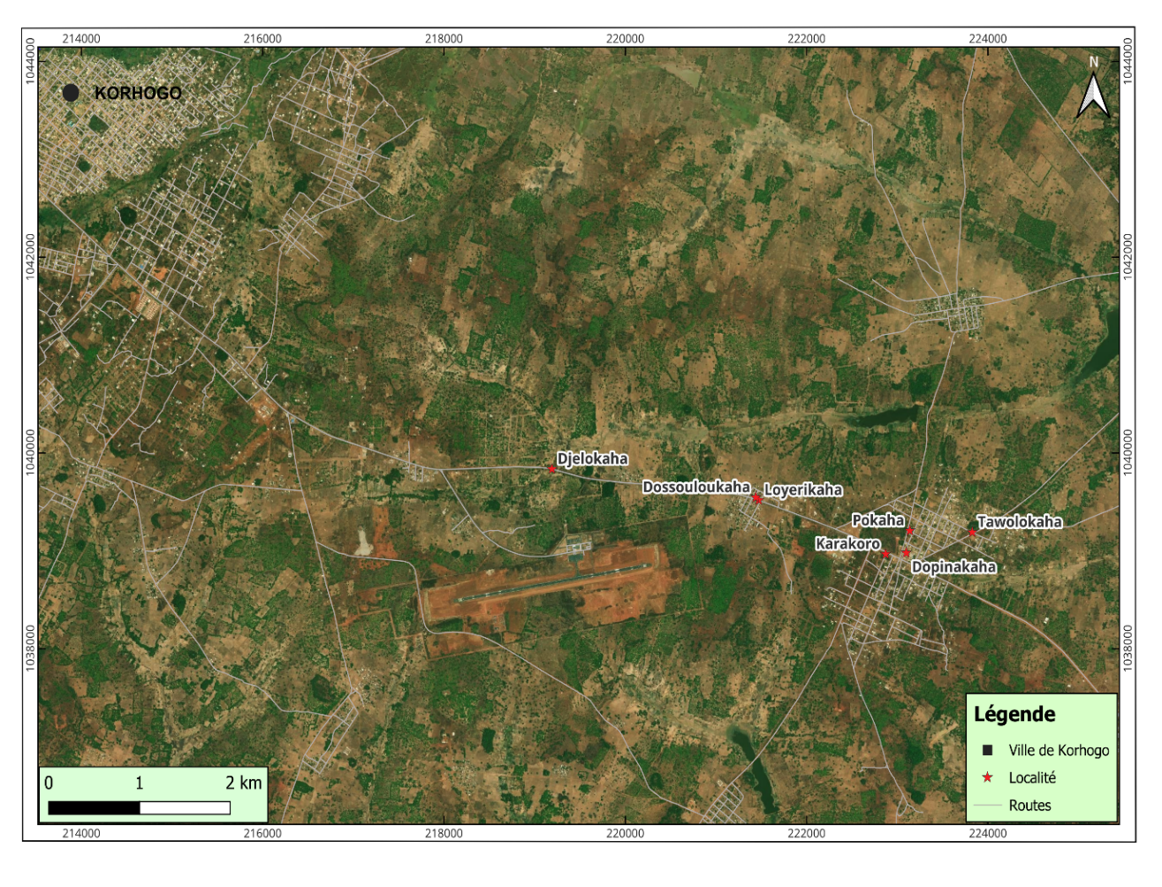
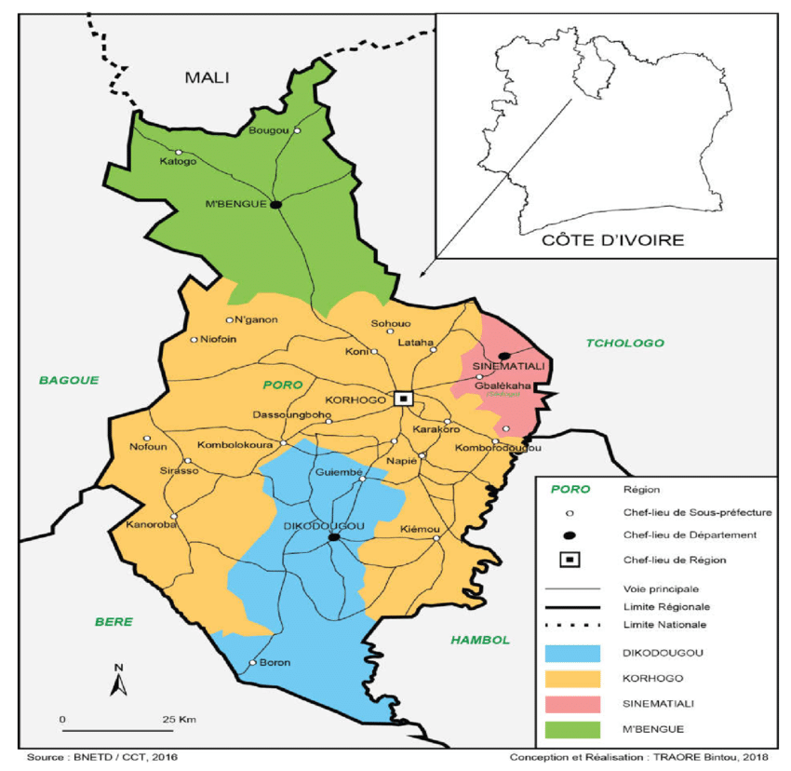
KORHOGO

Figure 1: Map of the location of Karakoro and surrounding localities in Poro region
Source: GPS field surveys, cartographic processing under QGIS (2025)
Comparative advantages of sorghum varieties
The perceived advantages of red- and white-grained sorghum are illustrated in Figure 3. According to farmers, red-grained sorghum offers several benefits, including desirable taste for beverage production (72.35%), high drought tolerance (74.33%), high productivity (86.38%), and strong cultural value (92.55%).
Conversely, white-grained sorghum was associated with lower scores across these criteria, with 27.65% for taste, 25.67% for drought tolerance, 13.62% for productivity, and 7.45% for cultural value.
Cropping practices in sorghum production
The main cropping practices adopted by farmers are presented in Table 2. Two types of ploughing were identified: manual and animal-drawn ploughing. Animal traction was overwhelmingly dominant (98%), whereas manual ploughing accounted for only 2%, and no use of mechanized ploughing was reported. Regarding sowing methods, the vast majority of farmers (98.6%) practiced furrow sowing. Flat sowing and ridge sowing were rarely used, each representing only 0.7% of cases.
In terms of weed management, more than half of the farmers (59.3%) combined mechanical and chemical weeding methods. Chemical weeding alone was practiced by 27.3% of respondents, while 13.3% relied exclusively on mechanical weeding using hand tools.

Figure 2: Proportion of red grain sorghum and white sorghum grown in the Poro region

Table 1: Comparative uses of red and white grain sorghum
 | Proportion of use (%)
Areas of use | Red sorghum grains | White sorghum grains
Local beer | 100 | 0
Porridge and family meals | 65.28 | 34.72
Animal feed | 12.36 | 87.64
Market sales | 78.45 | 21.55

Benefits

Figure 3: Comparison of the benefits of red and white sorghum

Table 2: Cultural practices and their application
Cultivation practices | Application methods | Proportion (%)
Ploughing | Harnessed | 98
Ploughing | Manual | 2
Ploughing | Mechanics | 00
Sowing | Furrow | 98.6
Sowing | Main course | 0.7
Sowing | Board | 0.7
Weeding | Chemical + Mechanical | 59.3
Weeding | Chemical | 27.3
Weeding | Mechanics | 13.3

Constraints related to sorghum cultivation
The main agronomic and socio-economic constraints encountered by farmers are presented in Table 3. Poor soil fertility was the most frequently reported agronomic constraint (35.2%), followed by climate variability (28.5%). Other constraints included the unsuitability of improved varieties (13.5%), low productivity of local varieties (12.1%), and pest and disease pressure (10.7%).
Among socio-economic constraints, the high cost of agricultural inputs was the most frequently cited (40.3%), followed by land pressure (30.5%). Limited financial resources were reported by 18.2% of respondents, while the ageing farming population represented 11%.
Fertilization practices adopted by sorghum farmers
Types of fertilizers used
The types of fertilizers used by farmers are presented in Table 4. Mineral fertilizers were predominant, with NPK being the most widely used (60%), followed by urea (34.87%) and foliar fertilizers (5.13%).
Among organic fertilizers, cow dung was the most commonly used (56.62%), followed by poultry manure (43.38%). Notably, compost was not used at all by the surveyed farmers (0%).

Table 3: Agronomic and socio-economic constraints in sorghum cultivation
Type of constraints | Causes of stress | Use proportion (%)
Agronomics | Climate | 28.5
Agronomics | Poor soils | 35.2
Agronomics | Pest and disease pressures | 10.7
Agronomics | Low production of local varieties | 12.1
Agronomics | Unsuitability of improved varieties | 13.5
Socio-economic | High cost of inputs | 40.3
Socio-economic | Land pressure | 30.5
Socio-economic | Ageing population | 11
Socio-economic | Lack of financial means | 18.2

Mineral fertilizer application methods
The methods used for mineral fertilizer application are summarized in Table 5. Microdosing was the dominant method, used by 80% of farmers for NPK and 75% for urea. Broadcast application and side placement were less common.
Foliar fertilizers were mainly applied through spraying (80%), while other application methods remained marginal

Table 4: Sorghum fertilization practices by producer
Types of fertilizers | Fertilizer Names | Proportion (%)
Chemical fertilizers | NPK | 60
Chemical fertilizers | Urea | 34.87
Chemical fertilizers | Foliar Fluid | 5.13
Organic fertilizers | Cow dung | 56.62
Organic fertilizers | Poultry droppings | 43.38
Organic fertilizers | Compost | 00

Mineral fertilizer application methods
The methods used for mineral fertilizer application are summarized in Table 6. Microdosing was the dominant method, used by 80% of farmers for NPK and 75% for urea. Broadcast application and side placement were less common.
Foliar fertilizers were mainly applied through spraying (80%), while other application methods remained marginal.

Table 5: Proportions of mineral fertilizer application methods in sorghum cultivation
 | Proportion of use (%)
Method of supply | NPK | Urea | Foliar fertilizer
Microdose | 80 | 75 | 7.3
Stolen | 5 | 7 | 2.7
Side | 10 | 15 | 10
Spraying | 5 | 3 | 80

Timing of mineral fertilizer application
The timing of fertilizer application is presented in Table 6. NPK was generally applied early, mainly during the first and second weeks after sowing. In contrast, urea was applied later, with peak application occurring in the fourth week.
Foliar fertilizers were applied as a complementary input, with application increasing from the third week and reaching a maximum in the fourth week before declining slightly thereafter.
Frequency of fertilizer application
The frequency of mineral fertilizer application is illustrated in Figure 4. Most farmers applied NPK (70%) and urea (85%) only once per cropping cycle. Foliar fertilizers were almost exclusively applied once (98%). Multiple applications remained limited across all fertilizer types.
Quantities of mineral fertilizers applied
The quantities of NPK and urea applied per planting hole are presented in Table 7. NPK was most commonly applied at a rate of 50 g per planting hole (53%), followed by 40 g (31%) and 30 g (16%).
Urea was predominantly applied at 30 g per planting hole (69%), with smaller proportions applying 40 g (20%) and 50 g (11%).
Foliar fertilizers were mainly applied at a rate of 2 L/ha (67%), followed by 3 L/ha (20%) and 1 L/ha (13%) (Figure 5).

Table 6: Distribution of mineral fertilizers by application period
 | Proportion of use (%)
Periods of application | NPK | Urea | Foliar fertilizer
1 SAS | 30 | 7 | 1.3
2 SAS | 20 | 13 | 5.7
3 SAS | 40 | 10 | 28
4 SAS | 5 | 50 | 40
5 SAS | 5 | 20 | 25
SAS = Week After Sowing

Frequency

Figure 4: Distribution of application frequencies of mineral fertilizers

Table 7: Quantities of NPK and urea per pocket
 | Proportion of use (%)
Quantities (g/pocket) | NPK | Urea
30 | 16 | 69
40 | 31 | 20
50 | 53 | 11

Figure 5: Foliar fertilizer rates per hectare

Characteristics of organic fertilizer inputs in sorghum cultivation
Organic fertilization practices
Application methods of organic fertilizers
The application methods for organic fertilizers are shown in Figure 6. Cow dung was mainly applied by broadcasting (68%), followed by side placement (22%), while microdosing remained limited (10%).
Poultry manure was predominantly applied by side placement (82%), with microdosing (12%) and broadcasting (6%) being less common.
Timing of organic fertilizer application
As shown in Table 8, all organic fertilizers were applied before sowing. Cow dung was mainly applied four weeks before sowing (65%), followed by three weeks before sowing (25%).
Poultry manure was primarily applied three weeks before sowing (52%) and two weeks before sowing (30%).
Frequency of organic fertilizer application
Most farmers applied organic fertilizers only once per cropping cycle. Cow dung was applied once by more than 98% of respondents, while poultry manure was applied once by 80% of farmers, with a minority splitting applications into two or more doses (Figure 7).
Method of supply

Figure 6: Methods of application of organic fertilizers by sorghum producers
Table 8: Distribution of organic amendments by period of application
 | Proportion of application (%)
Period of application | Cow dung | Poultry droppings
2 SVS | 10 | 30
3 SVS | 25 | 52
4 SVS | 65 | 18
SVS = Week Before Sowing

Figure 7: Preponderance of a single application of organic amendments
Quantities of organic fertilizers applied
The quantities of organic fertilizers applied are presented in Table 9. Cow dung was most commonly applied at 10,000 kg/ha (59%), while poultry manure was mainly applied at 8,000 kg/ha (45%). Lower application rates were less frequently reported.
Table 9: Differences in the quantities mobilized between cow dung and poultry manure
 | Proportion of use (%)
Quantity (kg/ha) | Cow dung | Poultry droppings
2500 | 6 | 11.5
5000 | 15 | 13.5
8000 | 20 | 45
10000 | 59 | 30

Perception and adoption potential of compost
The perception of compost use among farmers is presented in Table 10. The results indicate a complete absence of compost production and use (100%) across the study area.
However, nearly all respondents (99.67%) expressed willingness to adopt composting practices, provided they receive adequate training and technical support.

Factors influencing compost adoption
The main factors encouraging compost adoption are presented in Figure 8. The absence of specific fertilizers for sorghum was the most frequently cited factor (44.3%), followed by the high cost of mineral fertilizers (37.7%) and the availability of organic materials (18%).

Table 10: Sorghum producer’s perception of compost use
 | Producers perception | Proportion (%)
Compost production | Yes | 0
Compost production | No | 100
Usage | Yes | 0
Usage | No | 100
Fit to use | Yes | 99,67
Fit to use | No | 0,33

Factors

Figure 8: Evolution of the factors favorable to the use of composts

2.2. Discussion
The agronomic and socio-economic analysis of sorghum cultivation in Karakoro (Poro region) revealed a strong predominance of red-grained sorghum. This dominance (99.3%) can be explained by its cultural and dietary importance, particularly its use in traditional beer production, as well as its agronomic advantages, including drought tolerance, high productivity, and desirable taste. These characteristics make it well adapted to local environmental conditions and farmers’ needs.
These findings are consistent with those of Yemata, (2022), who reported that red-grained sorghum is particularly suited to the dry conditions of West Africa due to its tolerance to water stress. The high cultural value attributed to this variety (92.55%) also supports the conclusions of Wendmu et al. (2023), who emphasized the central role of sorghum in African traditions, both as a staple food and as a socio-cultural resource.
In contrast, white-grained sorghum remains marginal (0.7%) and is mainly used for animal feed. It is generally perceived as less efficient in terms of productivity, drought resistance, and taste. However, studies such as Waongo et al. (2018) have shown that certain white-grained varieties may exhibit improved resistance to pests, suggesting that their limited adoption may depend on specific agroecological conditions.
The results also showed that farmers predominantly rely on animal-drawn ploughing (98%). This practice can be attributed to the availability of draft animals, ease of use, and its effectiveness in expanding cultivated areas while reducing labor constraints. N'guessan et al., (2019), who highlighted the importance of animal traction in improving productivity and labor efficiency in sorghum systems, reported similar observations.
Regarding sowing practices, the predominance of furrow sowing (98.6%) may be explained by its efficiency in water management and its ability to ensure uniform crop establishment. Musyimi et al. (2022) also recommended row or furrow sowing in African agricultural systems, as it facilitates weeding operations and enhances productivity. Furrow sowing is reported to facilitate early sowing of wheat which enhances crop productivity compared to conventional sowing methods (Haque et al., 2025).

In terms of weed management, the combined use of mechanical and chemical methods by 59.3% of farmers reflects a strategy aimed at maximizing weed control efficiency and securing yields. The exclusive use of either chemical (27.3%) or mechanical (13.3%) weeding may be linked to financial or technical limitations. These findings align with those of Etiabi, et al. (2021), who demonstrated that integrated weed management significantly reduces weed pressure and improves crop performance.
Beyond cropping practices, farmers face several agronomic and socio-economic constraints that influence their production strategies. Poor soil fertility emerged as the most critical agronomic constraint (35.2%), which is characteristic of savannah ecosystems where soils are generally low in organic matter. Ouédraogo et al. (2022) similarly identified soil fertility decline as a major limitation to cereal production in West Africa.
Climate variability, reported by 28.5% of respondents, highlights the increasing impact of climate change on agricultural systems. Megnonhou et al., (2025) confirmed that rainfall variability significantly affects sorghum yields. Pest and disease pressures (10.7%) were less frequently mentioned, possibly because farmers have developed local management strategies or because other constraints are perceived as more critical. However, Chantereau et al. (2013) emphasized that pests such as Striga remain major threats to sorghum production in Africa.
From a socio-economic perspective, the high cost of agricultural inputs (40.3%) was identified as the main constraint. This reflects the growing dependence on fertilizers and herbicides, which are often unaffordable for smallholder farmers. Tadele, (2017) similarly highlighted input costs as a major barrier to agricultural intensification in sub-Saharan Africa.
Land pressure (30.5%) further illustrates increasing competition for arable land, driven by population growth and urban expansion. This observation is consistent with Boserup’s (1965) theory linking population growth to agricultural intensification. Limited financial resources (18.2%) and the ageing farming population (11%) also reflect structural challenges affecting the sustainability of agricultural systems. According to Wittman (2021), generational renewal remains a critical issue for the future of agriculture in Africa.
In response to these constraints, fertilization strategies play a crucial role in maintaining sorghum productivity. The results indicate a strong reliance on mineral fertilizers, particularly NPK (60%) and urea (34.87%). The timing of application reflects an adaptation to crop nutrient requirements, with early NPK application supporting crop establishment and later urea application meeting nitrogen demands during vegetative growth. These findings are consistent with those of Madukwe et al. (2023) and (Ostmeyer et al., 2022).
The predominance of single fertilizer applications may reflect a cost-minimization strategy aimed at reducing financial risks. This is in line with the observations of Sissoko and Lebailly (2019), who reported that Sahelian farmers tend to adopt low-cost and risk-averse practices. The use of microdosing (e.g., 50 g of NPK and 30 g of urea per planting hole) further supports this strategy, as it allows for efficient fertilizer use while minimizing losses. Similar conclusions were drawn by Demisie, (2018), who demonstrated the effectiveness of microdosing in improving nutrient use efficiency in low-input systems.
In addition to mineral fertilizers, organic amendments such as cow dung (56.62%) and poultry manure (43.38%) play a significant role due to their availability and low cost. Integrating organic manures with mineral fertilizers enhance crop yield compare to sole use of chemical fertilizers, as well as improve the soil fertility in a sustainable basis (Haque et al., 2015, 2018). Vanlauwe et al. (2015) emphasized the importance of organic inputs in improving soil fertility and ensuring the sustainability of cropping systems.
The application methods of these organic inputs reflect practical adaptations. Cow dung is mainly applied by broadcasting, which is a simple and traditional method, whereas poultry manure is more frequently applied by side placement, likely due to its higher nutrient concentration. Localized application improves nutrient availability and uptake efficiency, as highlighted by Vanlauwe et al. (2015).
The timing of organic fertilizer application, typically two to four weeks before sowing, reflects an agronomic strategy aimed at enhancing soil structure and nutrient availability prior to crop establishment. This is particularly important given the slow nutrient release associated with organic amendments. The relatively high application rates observed are consistent with the low nutrient content of these materials and the need to compensate for poor soil fertility, as noted by Giller et al. (2011).
Despite the widespread use of organic inputs, the complete absence of compost use remains a notable finding. However, the overwhelming willingness of farmers (99.67%) to adopt composting practices suggests significant potential for its integration. The lack of adoption may be attributed to limited technical knowledge, insufficient extension services, and the labor-intensive nature of compost production. These observations are consistent with those of Ayuke et al. (2011) and Vanlauwe et al. (2015).
Finally, the main factors encouraging compost adoption include the lack of sorghum-specific fertilizers, the high cost of mineral inputs, and the widespread availability of organic materials. These factors highlight the potential of compost as a locally adapted, cost-effective, and sustainable alternative for improving soil fertility and enhancing the resilience of sorghum-based cropping systems.

Conclusion
In Karakoro (northern Côte d’Ivoire), sorghum cultivation is dominated by the red-grained variety, valued for its agronomic and cultural qualities. Farmers’ cropping practices reflect pragmatic adaptations to local conditions, yet declining soil fertility remains the most critical constraint, exacerbated by climate variability and high input costs.
Fertilization strategies combine mineral fertilizers applied through microdosing, which are effective in the short term, with organic amendments that contribute to sustainable soil fertility. The integration of these two approaches, within an integrated soil fertility management framework, appears promising for reconciling productivity and sustainability.
The absence of compost uses highlights gaps in extension services and farmer training. Promoting compost adoption, alongside improved access to appropriate inputs, is essential to enhance soil fertility, strengthen system resilience, and ensure the long-term sustainability of sorghum cultivation under changing climatic conditions.

COMPETING INTERESTS DISCLAIMER:
Authors have declared that they have no known competing financial interests OR non-financial interests OR personal relationships that could have appeared to influence the work reported in this paper.

Disclaimer (Artificial intelligence)

Author(s) hereby declare that NO generative AI technologies such as Large Language Models (ChatGPT, COPILOT, etc.) and text-to-image generators have been used during the writing or editing of this manuscript.

References
- Ayuke, F. O., Brussaard, L., Vanlauwe, B., Six, J., Lelei, D. K., Kibunja, C. N et Pulleman, M. M. (2011). Soil fertility management: Impacts on soil macrofauna, soil aggregation and soil organic matter allocation. Applied soil ecology, 48(1), 53-62.
- Boserup, E. (1965). The Conditions of Agricultural Growth: The Economics of Agrarian Change under Population Pressure. Aldine Publishing. Chicago, USA. 124 p.
- Chantereau, J., Cruz, J. F., Ratnadass, A., Trouche, G et Fliedel, G. (2013). Le sorgho (p. 264).
- Charyulu, D. K., Afari-Sefa, V., et Gumma, M. K. (2024). Trends in Global Sorghum Production: Perspectives and Limitations. In Omics and Biotechnological Approaches for Product Profile-Driven Sorghum Improvement (pp.1-19). Singapore: Springer Nature Singapore.
- Coulibaly, K. A., N’Da, K. C., Sylla, D., Dibi-Anoh, P. A et Goula, B. T. A. (2024). Persistance des Séquences Pluvieuses et Risques d’Inondations de 1971 à 2022 en Côte d’Ivoire. European Scientific Journal, ESJ, 20(9).
- Demisie, W. (2018). Fertilizer microdosing technology in sorghum, millet and maize production at small-scale level in Africa: A review. International Journal of Advanced Scientific Research Development, 5(4), 39-49.
- https://doi.org/10.26836/IJASRD/2018/V5/I4/50407.
- Dimkpa, C., Adzawla, W., Pandey, R., Atakora, WK, Kouame, AK, Jemo, M et Bindraban, PS (2023). Engrais pour la sécurité alimentaire et nutritionnelle en Afrique subsaharienne : un aperçu des implications sur la santé des sols. Frontières de la science du sol, 3, 1123931.
- Dube, F., Mujeyi, A., Moyo, M. P and Mukondwa, O. (2023). Advances in Sorghum Production in Smallholder Farming Systems of Africa. In Towards Sustainable Food Production in Africa: Best Management Practices and Technologies (pp. 187-205).
- Etiabi, B., Koulibaly, B et Traore, H. (2021). Inventaire des mauvaises herbes et des méthodes de lutte contre l’enherbement dans les exploitations de la zone cotonnière Est du Burkina Faso. International Journal of Biological and Chemical Sciences, 15(4), 1421-1434.
- Giller, KE, Tittonell, P., Rufino, MC, Van Wijk, MT, Zingore, S., Mapfumo, P et Vanlauwe, B. (2011). Communiquer la complexité : évaluation intégrée des compromis concernant la gestion de la fertilité des sols dans les systèmes agricoles africains pour soutenir l’innovation et le développement. Agricultural systems, 104 (2), 191-203.
- Haque MA, Jahiruddin M, and Bell RW (2025). Early sowing of wheat with minimum tillage on wet soils increases yield potential and phosphorus fertilizer requirements on the coastal ecosystem. J Soil Sci Plant Nutr 25:1047–1058. https://doi.org/10.1007/s42729-024-02183-0.
- Haque MA, Jahiruddin M, Islam MS, Rahman MM, and Saleque MA. 2018. Effect of bioslurry on the yield of wheat and rice in the wheat–rice cropping system. Agric Res. 7(4):432-442. https://doi.org/10.1007/s40003-018-0333-7.
- Haque MA, Jahiruddin M, Rahman MM and Saleque MA. (2015). Usability of bioslurry to improve system productivity and economic return under potato-rice cropping system. Research in Agriculture, Livestock and Fisheries. 2(1):27-33. https://doi.org/10.3329/ralf.v2i1.23026.
- Khalifa, M and Eltahir, E. A. (2023). Assessment of global sorghum production, tolerance, and climate risk. Frontiers in Sustainable Food Systems, 7, 1184373.
- Koné, I., Kouadio, K. K. H., Kouadio, E. N., Agyare, W. A., Owusu-Prempeh, N., Amponsah, W., and Gaiser, T., (2022). Assessment of soil fertility status in cotton-based cropping systems in Côte d’Ivoire. Frontiers in Soil Science, Volume 2, Article 959325. https://doi/10.3389/fsoil.2022.959325. 36 p.
- Kouassi, A. M., Kouao, J. M et Kouakou, K. E. (2022). Caractérisation intra-annuelle de la variabilité climatique en Côte d’Ivoire. Bulletin de l’association de géographes français. Géographies, 99(99-2), 289-306.
- Krasilnikov, P., Taboada, M. A and Amanullah. (2022). Fertilizer use, soil health and agricultural sustainability. Agriculture, 12(4), 462.
- Liaqat, W., Altaf, M. T., Barutçular, C., Mohamed, H. I., Ahmad, H., Jan, M. F and Khan, E. H. (2024). Sorghum: a star crop to combat abiotic stresses, food insecurity, and hunger under a changing climate: a review. Journal of Soil Science and Plant Nutrition, 24(1), 74-101.
- Macauley, H et Ramadjita, T. (2015). Cultures céréalières : riz, maïs, millet, sorgho, blé. Nourrir l'Afrique, 2015, vol. 36, p. 2017-2021.
- Madukwe, D. K., Amapu, I. Y and Aliku, O. (2023). Yield response of sorghum to micronutrient-fortified fertilizer in the Savanna agroecological zone of Nigeria. FARA Research Report, 7(27), 351. https://doi.org/10.59101/frr072327.
- Megnonhou, S., Montcho, D., Akpo, E., Dandjlessa, J et Agbangla, C. (2025). Analyse Bibliographique des Impacts Climatiques sur la Culture du Sorgho et Implications pour l’Amélioration de sa Résilience en Afrique de l’Ouest. Sciences et Technologies pour l’Agriculture Durable, 4(1), 176-189.
- Missa, K., Soro, D., Dro, B et Koné, M. W. (2026). Composition floristique et diversité du peuplement ligneux en zone de savane soudanienne de la Côte d’Ivoire. VertigO. La revue internationale en sciences de l'environnement.
- N'guessan, KA, Kouakou, KE, Alui, KA et Yao, A. (2019). Stratégies et pratiques paysannes de gestion durable de la fertilité des sols dans le département de Korhogo au Nord de la Côte d'Ivoire. Afrique Science, 15 (4), 245-258.
- Ouedraogo, A., Kabore, F et Kabore, O. (2022). Perception de la fertilité des sols et stratégies d’adaptation des producteurs agricoles à Samandéni (Burkina Faso). Int. J. Biol. Chem. Sci, 16(4), 1536-1553.
- Penuelas, J., Coello, F and Sardans, J. (2023). A better use of fertilizers is needed for global food security and environmental sustainability. Agriculture and Food Security, 12(1), 5.
- Siéné Laopé, A. C., Bayala, R., Yapi, A.-F and N’Guettia, T. V. F. (2025). Agronomic performance of local and improved sorghum varieties in Sudanian area, North of Côte d’Ivoire. International Journal of Plant and Soil Science, 37(3).
- Sissoko, P. (2019). Le microdosage d’engrais : une technique d’amélioration des moyens d’existence des producteurs pauvres au Sahel. Cas des exploitations agricoles à base de mil et de sorgho au Mali. Thèse de doctorat, Université de Liège, Gembloux Agro-Bio Tech, 269 p. https://hdl.handle.net/2268/233860.
- Tadele, Z. (2017). Raising crop productivity in Africa through intensification. Agronomy, 7(1), 22.
- Vanlauwe, B., Descheemaeker, K., Giller, K. E., Huising, J., Merckx, R., Nziguheba, G., Wendt, J and Zingore, S. (2015). Integrated soil fertility management in sub-Saharan Africa: Unravelling local adaptation. SOIL, 1(1), 491–508. https://doi.org/10.5194/soil-1-491-2015.
- Waongo, A., Traore, F., Sankara, F., Dabire-Binso, C et Sanon, A. (2018). Evaluation du potentiel de développement de Rhyzopertha dominica F. (Coleoptera: Bostrichidae) sur deux variétés locales de sorgho (Sorghum bicolor [L.] Moench) du Burkina Faso. International Journal of Biological and Chemical Sciences, 12(5), 2143-2151.
- Wendmu, TA, Gebrelibanos, TS, Kovi, MR, Ring, KH, De Boer, HJ, Abera, FA et Westengen, OT (2023). « Les gens rassemblés autour du sorgho » : pratiques culturelles et diversité du sorgho dans le nord de l'Éthiopie. Écologie humaine, 51 (5), 923-935.
- Wittman, H. (2021). Promoting youth engagement and employment in agriculture and food systems. High Level Panel of Experts on Food Security and Nutrition, Committee on World Food Security. Rome: FAO. 164 p. https://www.fao.org/cfs/cfs-hlpe.
- Yemata, O. F. (2022). Etude de l’adaptation du sorgho aux agrosystèmes de saison sèche en Afrique de l’Ouest et du Centre. Doctoral dissertation, Université de Dschang. https://hal.science/tel-03969552v1.

