Original Research Article
Effect of bio-inoculants seed treatment on growth and yield of wheat in the Garo Hills of Meghalaya

ABSTRACT
Wheat has been an integral food crop since human civilization. The crop has multiple roles in food system and consumed in a several ways i.e. chapati, bread, biscuit, cake etc. For effective, quality and sufficient productivity, crop nutrition must be ensured. Addition of bio-fertilizers are the cheapest source of crop nutrition as well as sustainable management practice. Hence, to evaluate the effectiveness of different bio-inoculants a field experiment was conducted to on biofertilizers seed treatments and its combinations effect on the growth and yield of wheat (Triticum aestivum L.) in the rabi season. The study included seed inoculation with different biofertilizers such as T₁: control plot, T₂: Trichoderma at 10g kg⁻¹ seed, T₃: Azotobactor at 10ml kg⁻¹ seed, T₄: PSB (Phosphate solubilizing bacteria) at 10ml kg⁻¹ seed, T₅: KSB (Potassium solubilizing bacteria) at 10ml kg⁻¹ seed, T₆: ZSB (Zinc solubilizing bacteria) at 10 ml kg⁻¹ seed. The results revealed that biofertilizer application significantly influenced growth parameters including plant height, number of tillers, dry matter accumulation, and crop growth rate. Yield attributes such as number of spikes m⁻², spike length, and grains spike⁻¹ were also significantly improved compared with the control. Among the treatments, seed treatment with ZSB at 10 ml kg⁻¹ seed recorded the highest growth and yield attributes, resulting in greater grain (1333.3 kg ha⁻¹) and straw yield (2500 kg ha⁻¹). The highest gross return (₹ 66,666), net return (₹ 35393), and benefit–cost (2.13) ratio were recorded under seed treatment with ZSB at 10 ml kg⁻¹ seed (T₆), which can be attributed from its superior growth and yield attributes. The improvement in crop performance may be attributed to enhanced nutrient solubilization, improved nutrient uptake, and increased microbial activity in the rhizosphere. The findings suggest that biofertilizer application can be an effective and sustainable strategy for improving the growth and productivity of wheat.

Keywords: Biofertilizers; seed treatment; nutrient uptake; yield; wheat.

INTRODUCTION
Wheat (Triticum aestivum L.) is also called as “King of Cereals” is second most important crop grown in India after rice, both in terms of area and production. It occupies an area and productivity of 734.1 M ha and 3425.5 kg/ha⁻¹ respectively (FAO STAT, 2018). The NEH region produces around 1.83 Mt of wheat with the productivity level of around 1.75 t/ha, which is rather low as compared to the national average of 2.9 t/ha. (Chanda et al. 2010). Hill agriculture is more prone to soil erosion and land degradation resulting poor productivity. In the context - of wheat cultivation in the Garo Hills, the major challenges in wheat cultivation are mainly due to limited resources, poor technological practices and weak dissemination of modern technologies. However, wheat cultivation in NEH (North-Eastern Hill) region has significant prospects for boosting productivity due to their fertile soils and favourable climate. So, farmers in the Northeast, especially in Meghalaya, are increasingly adopting wheat cultivation to improve food security and income. Despite the inherent fertility of NEH soils, biofertilizer application can further improve crop productivity by enhancing nutrient solubilization and plant nutrient availability (Layek et al. 2021).
The crop productivity has increased in a traditional agricultural practice, but resulted in many modern-day problems such as soil health depletion, low soil-biological activity, loss of natural reserve leading to less profitability to the farmers (Saini et al. 2025). Biofertilizers play an important role in the growth of the plant as well as they bring down the cost of chemical fertilizers by cutting amount of chemical fertilizer application (Adesemoye et al. 2009). Carrier-based biofertilizers such as Azotobacter, Azospirillum, and phosphate-solubilizing bacteria can be used to supplement nutrient supply and reduce dependence on chemical fertilizers. These microbial inputs enhance nitrogen fixation, phosphorus solubilization, and root growth, which are particularly beneficial under the low-fertility acidic soils typical of the region (Panwar, 2014; Timofeeva et al. 2023). Zinc is required during protein synthesis, DNA–protein interaction, growth hormone production, seed development, production of chlorophyll and protects plants from stress conditions (Hassan et al. 2020). Potassium solubilizing bacteria (KSB), Phosphate solubilizing bacteria (PSB), Zinc solubilizing bacteria (ZSB)-these biofertilizers are capable of solubilizing the inorganic potassium, phosphorus, zinc from insoluble forms and made it available to crops and important for enhancement of wheat production (Glick, 2012; Sethi et al. 2025). The relationship between nutrient levels and crop performance is crucial for ensuring proper mineral nutrition, efficient fertilizer use, and minimizing environmental impacts. This approach is beneficial in increasing resource use efficiency by reducing the input needed to produce a certain output. More precisely, efficient nutrient management approach suitable to specific ago-climatic conditions is one of the key agronomic strategies to boost wheat production in the sub-tropical hill situation of NEH. Therefore, the use of biofertilizer inoculation in wheat cultivation in the Garo Hills represents an important strategy for improving soil health, nutrient availability, and productivity under rainfed and resource-limited farming systems. Considering all above facts, the study was conducted during rabi season of 2024-2025 at Rural Development and Agricultural Production (RDAP) Farm of the North-Eastern Hill University (NEHU), Tura Campus, with an objective to find out the best suitable biofertilizer and its performance in wheat in the agro-climatic condition of the Garo Hills of Meghalaya.

MATERIALS AND METHODS
A field experiment was conducted at Rural Development and Agricultural Production (RDAP) farm of North-Eastern Hill University (NEHU) Tura campus situated at a latitude of 25.52º N, longitude of 90.22º E and altitude of 349-1,181.10 m above mean sea level. The focus of this experiment was to examine the growth, yield and economics of wheat variety HD-3369 in Randomized Block Design (RBD) with six treatments and three replications. The crop received 302.2 mm rainfall during the crop period. Maximum temperature ranged from 24–27 °C, minimum from 14–27 °C, and average humidity was 74.8% during the cropping period. The soil was characterized with 7.34 pH, Electrical conductivity (EC) of 0.283 dsm⁻¹, organic content of 0.59% and available NPK is 258.7 kg ha ⁻¹, 11.25 kg ha ⁻¹ and 173.3 kg ha ⁻¹ respectively. The field was ploughed two times with a power tiller, followed by land levelling to obtain a clean seedbed. The seed treatment included, T₁: control, T₂: Trichoderma at 10g kg⁻¹ seed, T₃: Azotobactorat10ml kg⁻¹ seed, T₄: PSB at 10ml kg⁻¹ seed, T₅: KSB at 10ml kg⁻¹ seed, T₆: ZSB at 10ml kg⁻¹ seed. The treated seed at80 kg ha⁻¹ was manually sown on 22nd October, 2024 at RDAP farm with the row and plant spacing of 20 cm x 5 cm. 6 times light irrigation was given throughout its growth cycle and manual weeding with a hand hoe (khurpi) was done 2–3 times at 20, 35, and 45 days after sowing.
Data was assembled at 30 DAS (Days after sowing), 60 DAS, 90 DAS and at harvest for growth attributing characters including plant height (cm), number of tillers plant⁻¹, dry weight (g per plant), crop growth rate (CGR) (g/plant/day). Yield attributes were noted at maturity i.e. number of spikes per m⁻², length of spike (cm), number of grain spike⁻², test weight (g), seed yield (kg ha⁻¹), straw yield (kg ha⁻¹), harvest index (%). Experimental data was statistically analysed by the standard technique of analysis of variance (ANOVA) and significance was tested by F-test at 5% level of significance (Gomez and Gomez, 1984). All the significant treatments were compared by critical difference (CD) values, and significant treatment differences were identified using Duncan’s multiple range test (DMRT) (Duncan, 1955).

RESULTS AND DISCUSSION
Effect of different bio-inoculants on crop growth of wheat
Seed treatment with Zinc solubilising bacteria (ZSB) at 10ml kg⁻¹ recorded the best growth performance of wheat across different phenological stages. In contrast, the control treatment exhibited the lowest values regarding plant height whereas Azotobacter at 10 ml kg⁻¹ seed treatment resulted in the lowest values for other growth parameters viz. no. of tillers, dry weight, crop growth rate (CGR) in wheat (Fig. 1-4). The positive response may be attributed to the ability of zinc-solubilizing bacteria to convert insoluble forms of zinc into plant-available forms, thereby improving enzymatic activity, photosynthesis, and overall metabolic processes. (Nitu et al., 2020). Agriculturally important microbes help plants achieve optimal growth through a variety of methods, including better nutrient uptake, root and shoot development, and improved soil quality, microbes assist plants in achieving optimal growth. Thus, increase the availability of vital macronutrients and micronutrients, fix nitrogen, and solubilize phosphorus and zinc to encourage plant growth. Additionally, they are crucial in reducing the negative impacts that different abiotic stress on plants (Upadhyay et al. 2025).
The CGR of wheat is a critical parameter determining the overall yield and productivity of the crop. Enhanced CGR observed under ZSB inoculation indicates improved nutrient uptake and better physiological efficiency, particularly in zinc mobilization and utilization. The significant effect of bio-fertilizers applied singly for improving organic matter of rhizosphere soil was noteworthy in the form of carriers. Bio-inoculants not only support plant growth but also contribute to soil health. Patel et al., (2020) highlighted how inoculation improved soil microbial diversity and activity, resulting in better nutrient cycling. Healthy soil contributes to more robust wheat crops which is particularly relevant in the nutrient poor soils of North-East India.

Effect on Yield attributes:
Yield attributes and yield, including number of spikes m⁻², spike length, grains spike⁻¹, seed yield and straw yield, were significantly highest with ZSB at10 ml kg⁻¹ seed (T₆) followed by KSB at10 ml kg⁻¹ seed (T₅) whereas the lowest values were recorded under control (T₁) treatments (Table 1-2). Biofertilizers had no significant effect on spike length, test weight, and harvest index. This finding is consistent with previous research that has shown the positive impact of certain biofertilizer on crop growth and yield (Kumar et al., 2018). The superior performance of ZSB at 10 ml kg⁻¹ seed (T₆) may be attributed due to enhance nutrient uptake due to insoluble zinc into plant available form through secretion of organic acids and chelating compound thereby improved photosynthetic activity, root growth and crop yield and productivity (Kamran et al. 2017; Sharma et al., 2019).
Straw yield was the augmenting effect of increased vegetative growth through plant height, number of tillers and plant dry weight. Biofertilizers can add 30-300 kg of nitrogen per hectare (by fixation), liberate growth-promoting substances, and boost crop yield by 10 to 50%. They are less expensive, pollutant free, and dependent on clean energy sources, and improves the soil. Biofertilizers enhance microbial activity in the rhizosphere, facilitating nutrient release and biological fixation, thereby improving nutrient availability to the crop. Such mechanism leads to improved yield attributes, and ultimately higher grain yield. Biofertilizer, particularly those that fix nitrogen like rhizobium, K-solubilizing bacteria (KSB), P-solubilizing bacteria (PSB) application play an essential role in the yield improvement of plants. Plants generally depend on biofertilizer and phosphorus levels application through the soil and improve the yield of wheat crop (Shahwar et al., 2023).

Effect on economics of wheat
The maximum gross return, net return and B:C ratio were recorded in seed treatment with ZSBat10 ml kg⁻¹ seed (T₆). The lowest gross return, net return and B:C ratio were reported in seed treatment with Azotobacter at 10ml kg⁻¹ seed (T₃). These results corroborate the findings of Kumar and Menon (2021) that biofertilizers are cost- effective and eco-friendly, making them a sustainable choice for modern agriculture. It also indicates that the use of biofertilizers can lower input costs by 30%, enhancing the profitability of wheat. Apart from immediate cost benefits, biofertilizers enhance long-term economic sustainability by improving soil fertility (Dwivedi et al., 2020). The adoption of biofertilizers in wheat cultivation aligns with international farming practices, ensuring better access to global markets.
CONCLUSION
The present study reveals that Trichoderma, Potassium solubilizing bacteria and Zinc solubilizing bacteria performed positively on growth, yield and economic parameter in wheat. However, Azatobactor and PSB performance need to be explored under various situation, rate and effectivity of microbes. Among the various treatments, seed treatment with ZSB at 10 ml kg⁻¹ seed (T₆) reported to have highest growth, yield attributes, yield, net return and B:C ratio in wheat cultivated under Garo hills condition of Meghalaya. Effectivity of microbes may differ under different situation. The different bio-fertilizers combination can also be explored for better understanding on the effect of wheat growth and productivity in the Garo hills of Meghalaya. No negative effect of bio-inoculates in wheat has bee observed.
Disclaimer (Artificial Intelligence)
Authors declare that no generative AI and large language model have been used in any form of preparation of this manuscript.
Competing interests
Authors declared no competing interests.

REFERENCE

- Adesemoye, A.O., Torbert, H. A., & Kloepper, J. W. (2009). Plant growth-promoting rhizobacteria allow reduced application rates of chemical fertilizers. Microbial Ecology, 58(4), 921–929.
- Chanda, T. K, Sati, K., Robertson, C. & Arora, C. (2010) Fertilizer statistics, 55th edn. The Fertilizer Association of India, New Delhi.
- Duncan, D. M. (1955). Multiple Range and Multiple F-Test. Biometric. 11: 1–42.
- Dwivedi, A. K., Meena, R. S., & Yadav, R. P. (2020). Effect of integrated nutrient management on soil health and wheat productivity under long-term experiment. Indian Journal of Agronomy, 65(2), 179–183.
- FAO STAT, (2018). Statistical database of Food and Agriculture Organization.
- Glick, B. R. (2012). Plant growth‐promoting bacteria: mechanisms and applications. Scientifica, 1, 963401. https://doi.org/10.6064/2012/963401.
- Hassan, M. U., Aamer, M., Umer Chattha, M., Haiying, T., Shahzad, B., Barbanti, L., Nawaz, M., Rasheed, A., Afzal, A., Liu, Y., & Guoqin, H. (2020). The critical role of zinc in plants facing the drought stress. Agriculture, 10(9), 396. https://doi.org/10.3390/agriculture10090396.
- Kamran, S., Shahid, I., Baig, D. N., Rizwan, M., Malik, K. A. & Mehnaz, S. (2017). Contribution of Zinc Solubilizing Bacteria in Growth Promotion and Zinc Content of Wheat. Frontier in Microbiology, 8:2593. https://doi.org/10.3389/fmicb.2017.02593.
- Kumar, A & Menon, S. (2021). A Review on Effect of Biofertilizers on Agricultural Crops. International Journal of Research and Analytical Reviews, 8(2), 841-852.
- Kumar, M. S., Reddy, G. C., Phogat, M., & Korav, S. (2018). Role of bio-fertilizers towards sustainable agricultural development. Journal of Pharmacognosy and Phytochemistry, 7(6), 1915–1921.
- Layek, J., Das, A., Krishnappa, R., Ramkrushna, G. I., Chowdhury, S., & Das, S. (2021). Intensifying rice (Oryza sativa) based cropping system through pulses and oilseeds in North-East India. The Indian Journal of Agricultural Sciences, 91(6), 819–823. https://doi.org/10.56093/ijas.v91i6.114241.
- Nitu, R, Kaur, R, & Kaur, S. (2020). Zinc solubilizing bacteria to augment soil fertility – A comprehensive review. International Journal of Agricultural Sciences and Veterinary Medicine, 8(1), 38–44.
- Panwar, A. S. (2014). Integrated nutrient management for sustaining wetland rice (Oryza sativa) production in mid hills altitude of Meghalaya. The Indian Journal of Agricultural Sciences, 84(7), 828–831. https://doi.org/10.56093/ijas.v84i7.41988
- Patel, A.R., Verma, P., Mori, C.V., & Parmar, V.K. (2020). Effect of fertility levels with micronutrient fortification and bio-enhancer on growth and yield of onion (Allium cepa L.). Biological Forum – An International Journal, 15(12), 34 – 44.
- Saini, A., Manuja, S., Singh, G., Binda, A. D., Sahoo, C., Singh, A., Yadi, R., Johnson, R., Joel, J. M., & Fayezizadeh, M. R. (2025). Effect of cultivation practices on productivity and nutrient dynamics of wheat varieties under northern hill zone of India. BMC Plant Biology, 25, 497. https://doi.org/10.1186/s12870-025-06436-7.
- Sethi, G., Behera, K.K., Sayyed, R. et al. (2025). Enhancing soil health and crop productivity: the role of zinc-solubilizing bacteria in sustainable agriculture. Plant Growth Regulator, 105, 601–617. https://doi.org/10.1007/s10725-025-01294-7
- Shahwar, D., Mushtaq, Z., Mushtaq, H., Alqarawi, A. A., Park, Y., Alshahrani, T. S., & Faizan, S. (2023). Role of microbial inoculants as bio fertilizers for improving crop productivity: A review. Heliyon, 9(6), e16134. https://doi.org/10.1016/j.heliyon.2023.e16134.
- Sharma, P., Singh, R., & Meena, R. K. (2019). Effect of integrated nutrient management on growth, yield attributes and yield of black wheat (Triticum aestivum L.) under late sown condition. International Journal of Research in Agronomy, 7(6), 707–710.
- Timofeeva, A. M., Galyamova, M. R., Sedykh, S. E. (2023). Plant Growth-Promoting Soil Bacteria: Nitrogen Fixation, Phosphate Solubilization, Siderophore Production, and Other Biological Activities. Plants. 12(24):4074. https://doi.org/10.3390/plants12244074.
- Upadhayay, V. K., Gangola, S., Taj, G., Gaurav, K., Rani, A., Kumar, S., Garg, S., Gupta, G., Ali, H., Siddiqui, S., Alamri, S. A. M., Mittal, A., Alrumman, S. A. & Pandey, M. (2025). Zinc-solubilizing bacterial consortia: a promising approach for zinc biofortification of crops. Frontier in Microbiology, 16:1575514. doi: 10.3389/fmicb.2025.1575514.
- Yadav, A. N., Verma, P., & Kumar, S. (2020). The role of biofertilizers in soil health improvement and sustainable farming. Asian Journal of Research in Crop Science, 5(3), 1–12.

Fig. 1: Effect of different biofertilizers on plant height(cm) at harvest in wheat

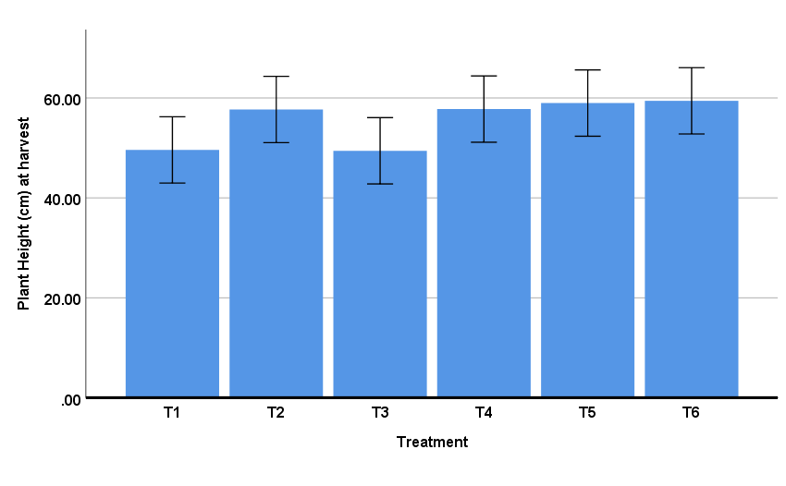

Fig. 2: Effect of different biofertilizers on no. of tillers plant⁻¹ at harvest in wheat

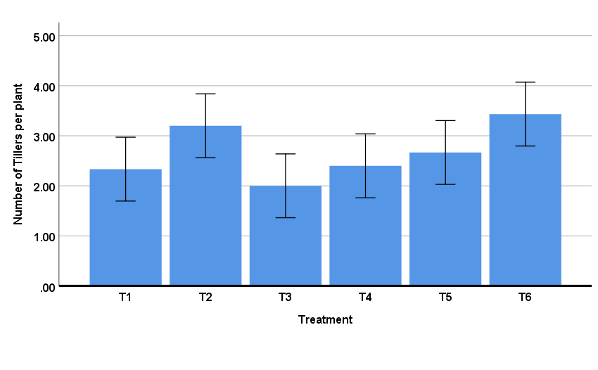

Fig. 3: Effect of different biofertilizers on dry weight (g per plant) at harvest in wheat

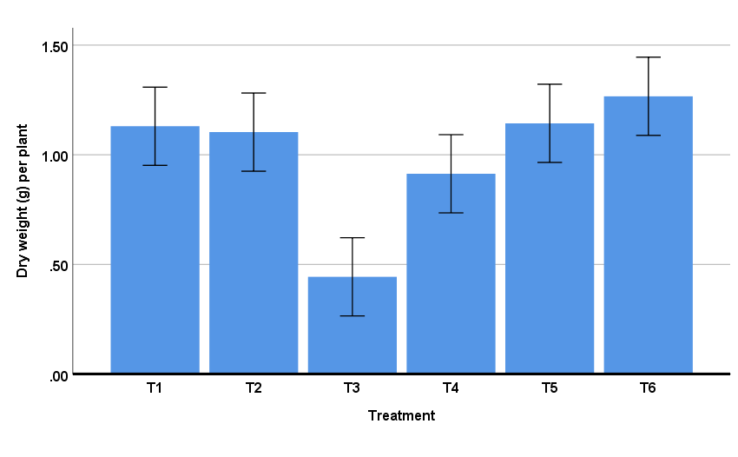

Fig. 4: Effect of different biofertilizers on crop growth rate (CGR) in wheat

Table 1: Effect of different bio-inoculants on different yield attributes in wheat

Treatments | Yield attributes
Treatments | No. spike per m⁻² | Length of spike | No. of grain spike⁻¹
T₁: Control | 77.1^{c} | 5.13 | 17.20^{ab}
T₂: Seed treatment with Trichodermaat10 ml kg⁻¹ seed | 85.1^{bc} | 5.03 | 14.27^{bc}
T₃: Seed treatment with Azatobactorat10 ml kg⁻¹ seed | 69.2^{c} | 4.8 | 13.47^{c}
T₄: Seed treatment with PSBat10 ml kg⁻¹ seed | 67.7^{c} | 5.57 | 18.27ª
T₅: Seed treatment with KSBat10 ml kg⁻¹ seed | 96.6^{b} | 5.73 | 19.47ª
T₆: Seed treatment with ZSBat10 ml kg⁻¹ seed | 108.9ª | 5.87 | 19.53ª
SEm± | 2.83 | 0.70 | 1.04
CD | 9.05 | NS | 3.33
Means followed by same letter are not significantly different while different letters indicate significant differences (p< 0.05) under Duncan’s multiple range test, NS= Not significant
Table 2: Effect of different bio-inoculants on different yields in wheat
Treatments | Yields
Treatments | Seed yield kg ha⁻¹ | Straw yield kg ha⁻¹ | Test weight (g) | Harvest index (%)
T₁: Control | 666.7^{b} | 1440.2^{cd} | 3.09 | 31.31
T₂: Seed treatment with Trichodermaat10 ml kg⁻¹ seed | 722.2^{b} | 1777.8^{bc} | 3.22 | 27.79
T₃: Seed treatment with Azatobactorat10 ml kg⁻¹ seed | 583.3^{b} | 1222.2^{d} | 2.72 | 31.64
T₄: Seed treatment with PSBat10 ml kg⁻¹ seed | 592.2^{b} | 1247.0^{d} | 3.10 | 32.79
T₅: Seed treatment with KSBat10 ml kg⁻¹ seed | 944.4^{b} | 2055.4^{b} | 3.04 | 31.62
T₆: Seed treatment with ZSBat10 ml kg⁻¹ seed | 1333.3ª | 2500.0ª | 3.15 | 34.84
SEm± | 111.0 | 150.9 | 0.28 | 3.57
CD | 354.4 | 481.6 | NS | NS
Means followed by same letter are not significantly different while different letters indicate significant differences (p< 0.05) under Duncan’s multiple range test, NS= Not significant

Table 3: Effect of different biofertilizers on Economics in wheat (₹ ha⁻¹)
Treatment | Economics (₹ ha⁻¹)
Treatment | Cost of  cultivation | Gross return | Net return | B:C  ratio
T₁: Control | 30633 | 34855 | 4222 | 1.14
T₂: Seed treatment with Trichodermaat10 ml kg⁻¹ seeds | 31633 | 39500 | 7867 | 1.25
T₃: Seed treatment with Azatobactorat10 ml kg⁻¹ seed | 31113 | 30194 | -918 | 0.97
T₄: Seed treatment with PSBat10 ml kg⁻¹ seed | 31113 | 30703 | -409 | 0.99
T₅: Seed treatment with KSBat10 ml kg⁻¹ seeds | 31273 | 49499 | 18226 | 1.58
T₆: Seed treatment with ZSBat10 ml kg⁻¹ seed | 31273 | 66666 | 35393 | 2.13
*₹ is INR currency; ₹85.77 ~ USD 1.

