Eco-friendly Management of Alternaria leaf spot of Gerbera (Gerbera jamesonii Bolus ex. Hooker F) caused by Alternaria alternata (Pers.; Fr.) in North East India

ABSTRACT
Gerbera (Gerbera jamesonii Bolus ex. Hooker F) includes the family Asteraceae, is an enormous and extremely profitable cut flower, which is grown in a wide range of environmental conditions globally. Based on in vitro studies the highest percentage of mycelial growth inhibition was seen in Allium sativum (10% conc.) and T. harzianum (86.66% and 81.38%), respectively. Concurrently, Hexaconazole (0.1%) showed a maximum mycelial growth inhibition of 100.00% against A. alternata. The in vivo field experiments were conducted for two seasons at Horticulture experimental farm, AAU, Jorhat-13 in the year 2022 and Hexaconazole (0.1%) were recorded lowest disease incidence (16.52%) and per cent disease severity (11.76%) with highest per cent disease reduction (79.43% and 85.59%) of leaf spot caused by A. alternata. When gerbera was treated with T. harzianum [Org-Trichojal (@ 5ml/l)], the yield-attributing traits and growth parameters gradually enhanced.
Key words: Gerbera, Alternaria alternata, Hexaconazole, Org-Trichojal
1. INTRODUCTION
Floriculture represents the most rapidly expanding sector in the North Eastern Region, including Assam, due to its diverse topography, altitude, favorable agro-climatic conditions, and fertile soil, which facilitate year-round production of tropical, sub-tropical, and temperate flowers [1]. Assam ranks top with 7.13 thousand tons of production, accounting for 3.99% of overall production in India [2]. Gerbera a popular commercial cut flower, is a member of the Asteraceae family and belongs to order Asterales. It is grown all over the world in a variety of climates. Its graceful beauty, hardiness, ability to withstand transit, and long shelf life make it a popular choice for cut flowers and attractive potted plants on the international market. It also has good export potential [3].
Gerbera is susceptible to numerous fungal diseases, with Alternaria leaf spot, stemming from Alternaria alternata, being the most destructive disease. It affects all gerbera varieties of both open and protected environments and affects both the quantity and quality of flowers [4]. In general, using chemicals to control disease is more commercially viable; but, using chemicals continuously and carelessly poses major risks to both human and the environment. Bio-agents are becoming increasingly important in plant disease control techniques because of growing awareness of the dangers associated with chemical pesticides and the adoption of alternative bio-approaches, such as the usage of plant extract and beneficial biocontrol agents [5]. The current study aims to isolate and characterize the most serious fungal pathogen Alternaria alternata associated with gerbera, as well as assess the effectiveness of various botanicals, bioagents, and chemicals against the pathogen both in vitro and in vivo. This is because Alternaria leaf spot is so common and there is not enough information about it.
2. MATERIALS AND METHODS
2.1 Isolation and Purification of the pathogen
The tissue isolation protocol from Ricker & Ricker [6] was followed for isolating the pathogen. The fungal culture underwent purification via single-spore isolation methodology [7].
2.2 Morpho-Cultural characteristics
Pathogen identification and characterization was performed using standard reference methods [8 & 9]. The Methuen Handbook of Color was used to assess the fungus's colony color [10].
Observations on the morphological characteristics of mycelium, conidiophores, and conidia were made using the reference paper [11]. The size of the conidia was determined and microphotographed taken using a computer-generated micrometre. For taxonomic confirmation and species-specific classification, the purified fungal culture was delivered to the National Centre of Fungal Taxonomy (NCFT).
2.3 Molecular Characteristics
Species identification through molecular analysis was performed by Bioserve Biotechnologies India Pvt. Ltd., utilizing 18s ITS gene sequencing. Evolutionary relationships were established by comparing sequences against the NCBI (National Centre for Biotechnology Information) nucleotide database through BLAST (Basic Local Alignment Search Tool) analysis. The obtained sequences were deposited in NCBI to receive accession numbers. Sequence alignment was conducted using MEGA 6.0 software [12] with multiple sequence alignment tools. A phylogenetic tree was generated using the Maximum-Likelihood approach in MEGA 6.0, employing 500 bootstraps.
2.4 Pathogenicity test
Healthy gerbera saplings of highly susceptible variety (Red Gem) were chosen to perform the pathogenicity test. The healthy gerbera leaves were surface sterilized with NaOCl (1%) before being washed using sterilized distilled water. Small puncture wounds were created on the leaf surfaces using a sterilized needle (pin-pricking approach). The organism's spore suspension (1X10⁹ spore/mL of water) was sprayed on the upper surface of the leaves using a hand sprayer and bit inoculation method was done using a sterile cork borer and bit was positioned on the leaves upper surface. Each inoculated plant was individually enclosed in clear, ventilated polypropylene covers to maintain humidity above 90% for 48 hours. Control involving sterile distilled water spraying were included with three replications. Symptom development was observed and reported at routine intervals. Upon typical symptoms appearance on inoculated specimens, the causal agents were reisolated to confirm Koch’s postulates.
2.5 In vitro efficacy of different botanicals against A. alternata
2.6 Preparation of plant extracts with cold water
Fresh rhizomes, bulbs, and leaves of A. indica, C. longa, and A. sativum were thoroughly rinsed using sterile distilled water. A 100 g of cleaned plant tissues were ground using a pre-chilled pestle and mortar with an equivalent volume of (100 mL) sterilized water (1:1 W/V). The resulting extract was filtered with muslin cloth and centrifuged for 20 minutes at 10, 000 rpm at room temperature. The supernatant was used as a 100 per cent basic stock solution. The plant extract was purified using a bacterial membrane filter (RanDisc, PVDF 0.22µm) under sterile conditions. The efficacy of the 10% concentration was tested against A. alternata using the poisoned food technique [13]. Each of the treatments was replicated in five times. The percentage inhibition of mycelial growth was calculated using the formula proposed by Vincent [14]. Based on the in vitro effectiveness of the botanicals against A. alternata, the most effective one was chosen for field evaluation.
I = ( $\frac{C-T}{C}$)×100
Where, I= Inhibition of mycelial growth, C= Growth in control, T= Growth in treatment
2.7 In vitro efficacy of biocontrol agents against A. alternata
Four different biocontrol agents viz., Trichoderma harzianum, Trichoderma viride, Trichoderma pseudokoningii, and Pseudomonas fluorescens were assessed against the pathogen by dual culture technique [15]. All the biocontrol agents were collected from the Nano Laboratory, Department of Plant Pathology, Assam Agricultural University, Jorhat-13.
2.8 In vitro efficacy of chemicals against A. alternata
Three systemic chemical fungicides such as Hexaconazole (0.1%), Difenoconazole (0.1%), and Propiconazole (0.1%), were taken and an in vitro efficacy test against pathogens was performed by the poisoned food technique. To attain the required fungicide concentration, an adequate amount of tested fungicides was systematically mixed with molten cooled PDA media in conical flasks based on the presence of the active ingredient. A 5 mm diameter culture disc from a week-old pure culture of A. alternata was placed on petri plates and incubated in a BOD incubator at 28±1ºC until complete growth was achieved in the control; each treatment was performed in five replications.
2. 9 In vivo field experiments
The best botanical, biocontrol agent and chemical found in the above in vitro were further selected for efficacy test as foliar spray for the management of A. alternata in gerbera (var. red gem) under open conditions.
2.10 Artificial inoculation of pathogen
Three-month-old gerbera plants (var. red gem) were grown in field conditions and the pathogen was inoculated into the plants employing the Micro Droplet Inoculation Technique (MDIT) described by Munaut [16]. Treatments were given as a foliar spray within 7 days of the onset of symptoms and subsequent applications were done at 14-day intervals. Disease incidence was recorded 30 days after the second foliar spray.
2.11 Observations recorded for field experiment
i) Disease Incidence (%)
The disease incidence was calculated using the following formula [9]:
ii) Per cent Disease severity (PDS)
Disease intensity was evaluated using a 0 – 5 rating scale [17] with six categories established based on the percentage of leaf area affected.

Chart 1. Per cent Disease severity
Category | Leaf area infected (%)
0 | Disease free
1 | 0.1-10.0
2 | 10.1-25.0
3 | 25.1-50.0
4 | 50.1-75.0
5 | >75

The Per cent disease severity was computed by using the following formula [18].
iii) Per cent disease reduction (PDR)
The disease control was calculated with the following formula:
PDR=$( \frac{Disease \left(\%\right) in control-Disease \left(\%\right) in treatment}{Disease \left(\%\right)in control}$ ) X100
2.12 Yield parameters
The yield parameters from each plot were recorded 30 days after the application of the second treatment and data are means of two seasons. Yield and growth parameters like Suckers per plant, Flower per plant, Diameter of flower (cm), Length of the flower stalk (cm), Self-life of flower (days), Vase life of flower (days), Shoot length (cm) and root length (cm) were recorded.
2.13 Statistical analysis
CRD was employed for in vitro and RBD was followed for field experiments. The data were collected and analyzed using Fisher’s method of analysis of variance. Variance in the data was examined following the procedure outlined by [19]. The percentage values were converted after Gomez and Gomez [20] and transformed by the angular transformation.

3. RESULTS AND DISCUSSION
3.1 Symptomatology
Gerbera leaves infected with A. alternata developed brown, tiny, dispersed spots that enlarged and merged over time to produce massive, oval, round, or uneven brown to black spots showing concentric ring patterns. In severe infections, lesions coalesce rapidly until the leaves appeared blighted [Supplementary Fig 1]. Similar types of symptoms in gerbera have been reported by several researchers [21 & 22].
3.2 Morpho-cultural characteristics
The colony colour on PDA medium showed whitish aerial mycelium that progressively turned light greyish and brown to dark greyish. The reverse side of the culture in the petri dish was observed to be dark black in colour. Microscopic examination showed simple, septate, light to dark brown conidiophores with long, pale brown conidia measuring 22.35 - 30.52 x 5.27-8.95 µm, with 3-5 transverse and 0-3 longitudinal septa. Conidia are typically ovoid to ellipsoid in shape, with a cylindrical beak and dark brown coloration. They are known to be borne only or in groups of 5 to 8 [Supplementary Fig 2]. Based on these morpho-cultural characteristics, the fungal pathogen was identified as an Alternaria alternata (Fr.) Keissler. This identification of fungus was confirmed by the National Centre of Fungal Taxonomy (NCFT), New Delhi as Alternaria alternata (Fr.) Keissler and assigned the NCFT No. 9629.19. All these parameters corresponded with those reported by Nagrale who investigated comparable morphological characters of the pathogen [21, 22, 23, 24] and also recorded the similar observations.
3.3 Molecular characterization
Based on the molecular characterization and nBLAST results depicts that isolate Alt01 having 91.69% similarity with Alternaria alternata and in the basis of ITS region sequencing the fungi were confirmed as Alternaria alternata [25]. Phylogenetic analysis was carried out by comparing the query sequence with database of NCBI (Fig. 1).
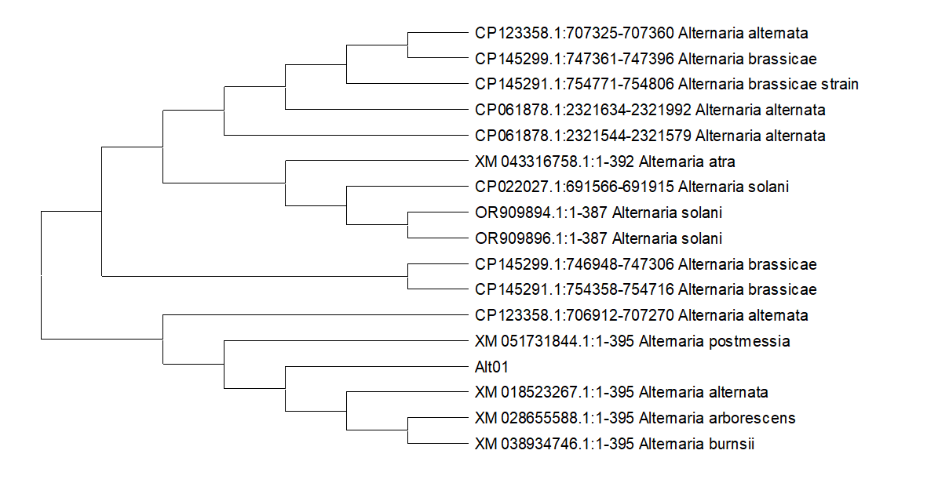Fig. 1. A phylogenetic tree constructed with 500 bootstrap replicates and the maximum likelihood approach is used to showing the genetic relationships between the fungal strain "Alt01" and other isolates.
3.4 Pathogenicity test
The pathogenicity of the fungus was ascertained using Robert Koch's theory on potted gerbera plants. Initial symptoms were developed at 7 days post-inoculation, and characteristic symptoms were occurred after 10 days. The control plants exhibited no symptoms [Supplementary Fig 3]. The first indication of A. alternata was the minute circular spots appearance at the tips and borders of the leaflets. Such dark brown patches grew to cover a wide region of the leaflets. Re-isolation of the pathogen were confirmed a similarity to the original culture of the pathogen. Accordingly, Alternaria alternata was confirmed as the causal agents of the diseases [23 & 25].
3.5 In vitro efficacy of botanicals against A. alternata
According to the findings of present study, all the botanical considerably reduced the pathogen mycelial growth rate in comparison to the control Fig. 2(A). Among the botanicals evaluated against A. alternata the treatment T3 inhibited mycelial growth of (86.66%), followed by T8 and T5, which inhibited mycelial growth by 77.22% and 76.77%, respectively. The lowest inhibition of mycelial growth of the pathogen was detected in T₂ (67.44%) [Supplementary Fig 4]. The findings of Raja [26] who found that garlic was the best in inhibiting the mycelial growth of A. tenuissima causing leaf spot and fruit rot of brinjal which showed 100.00%, 88.70% and 76.10% inhibiting over control at 15%, 10%, 5% (V/V) respectively. Mycelial growth inhibition of A. alternata might be due to presence alkaloid, phenol, tannin, glycoside, saponin, flavonoid, terpenoidetc in the plant extracts which possess antimicrobial activity against a number of microorganisms [27].
3. 6 In vitro efficacies of biocontrol agents against A. alternata
The results shown in Fig. 2 (B) revealed that all biocontrol agents significantly suppressed the mycelial growth of A. alternata relative to control. Treatment T2 inhibited the highest mycelial growth rate (76.41%) among the biocontrol agents. The lowest inhibition (66.41%) on mycelial growth of the pathogen was noted in T₄ [Supplementary Fig 5]. Yamuna [28] studied in vitro bioefficacy of different bioagents against A. alternata causing fungal fruit rot in pomegranate and reported T. harzianum proved to be most effective exhibiting highest mycelial inhibition (82.11%). This inhibition of mycelial growth of the pathogen might be due to the principle of mycoparasitism with the antagonist for nutrition by secreting cell wall degrading enzymes. Trichoderma spp. synthesizes cellulase and chitinase which degrade the pathogen’s cellulose and chitin and utilized the derived carbon source and thus inhibits the growth of the pathogen [29].
3.7 In vitro efficacy of chemicals against A. alternata
The results shown in Fig. 2(C) depicted that all the chemicals substantially diminished the mycelial growth as compared to the control [Supplementary Fig. 6]. Treatment T2 was found to exhibit the highest per cent inhibition (100%) on the mycelial growth of A. alternata and followed by T3 and T4 with inhibitions of 90.74% and 88.14%, respectively. The findings of the present investigation are correspondence with Gholve [30] who observed 94.5 per cent inhibition of A. alternata of gerbera with Hexaconazole 5EC (0.1%). Similarly, Bhat [31] observed inhibitory effect of Tebuconazole 250EC and Hexaconazole 5EC against A. alternata of gerbera which are agreeable with the present study.

(A)

(B)

(C)
Fig 2 (A-C): In vitro efficacy of botanicals, biocontrol agents and chemicals against Alternaria alternata
3.8 Effect of treatments on disease occurrence of Alternaria leaf spot under field condition
Based on the findings of in vitro experiments, the most effective treatment was selected for efficacy test against A. alternata under field conditions. The effect of treatments on field condition were displayed in Table 1 and results showed that all the treatment could significantly reduce the disease incidence and disease severity of the A. alternata except control in field condition. Per cent disease incidence (16.52%) and disease severity (11.76%) were significantly low in treatment T₄ with maximum (79.43% and 85.59%) percent disease reduction (PDR) respectively compared with untreated control. Highest per cent disease incidence (80.32%) and disease severity (81.65%) were recorded in the treatment T₁ (Control) where no treatment was applied [Supplementary Fig. 7]. The findings of the present investigations were corresponded with Nagrale [23] who conducted field experiment using fungicides against Alternaria leaf blight of gerbera and reported effectiveness of Difenoconazole (0.1%), Propiconazole (0.25%) and Hexaconazole (0.1%) with 94.21, 93.09 and 92.41 percent disease control. Likewise, several other workers also noticed the effectiveness of Hexaconazole (0.1%), Carbendazim (12%) + Mancozeb (63%) (0.2%), Propineb 70WP (0.2%) in reducing the incidence of chrysanthemum leaf blight caused by A. alternata in field conditions [32]. Several workers have detailed the efficiency of T. harzianum for the control of diseases resulted by A. alternata [3]. These reports are consistent with the current investigation. Trichoderma spp. suppressing the growth of A. alternata and Fusarium spp. and they will compete for nutrient and space, mycoparasitism and antibiosis are the most common mode action. Trichoderma spp. secretes many antifungal compounds like pyrones, isopyrones, peptides, and trichothenes that kill pathogens. The relatively high concentration of cell wall degrading enzymes is produced by T. harzianum which inhibit and kill the pathogen [33].
3.9 Effect of the treatment on plant growth parameters in field condition
The data showed in the Table 2 suggested that all the treatments consisting of botanical, biocontrol agent and chemical were found to be significantly superior as compared to control. Maximum number of suckers (21.00 nos./plant), flower (42.25 nos./plant), Diameter of flower (6.25 cm), Length of the flower (39.32 cm), Shelf life of the flower (18.75 days), Vase life of the flower (14.50 days), shoot and root length (34.72 and 18.30), was observed in T_{2:} T. harzianum (Org-Trichojal @ 5ml/l). The outcomes of this field study are consistent with the research conducted by Deka and Talukdar [34], who examined the performance of twelve gerbera cultivars (Gerbera jamesonii Bolus) under open field conditions in Assam. The cultivars were found varied significantly in terms of vegetative, flowering, and floral characteristics. The cultivar Red Gem produced the highest number of leaves per plant (46.55 nos), suckers per plant (24.04 nos), and the highest plant spread (54.10 cm), according to the mean performance of the cultivars. The results indicated that bio-agents might be having some growth promoting effects on plants. Growth promoting effects by Trichoderma spp. has been reported in other crops by several workers. On the other hand, Trichoderma secretes growth promoting hormones viz., zeatin, gibberelic acid, gluconic acid, citric acid and fumaric acid and has good capacity to uptake soil nutrients with higher productivity [3]. Several previous researchers agree on these aspects of enhanced growth promotion on application of bioagents due to a potential synergistic effect. Bio agents like Trichoderma spp. and P. fluorescens has a great potentiality in the enhancement of reproductive as well as vegetative status of treated plants [35]. Strains of Trichoderma spp. have been reported to solubilize insoluble forms of Iron, Manganese, Zinc and rock phosphate and thus making them available for plants [36]. Shetty [37] found that the application of Trichoderma spp. for disease control in vegetable crops resulted in enhanced germination, leaf area, dry weight of roots and shoots, and early flowering.
Table 1: Effect of treatments on disease occurrence of Alternaria leaf spot under field condition
Treatments | 30 Days after spraying
Treatments | PDI in field condition | PDR over control in field  condition | Per cent disease  severity in field condition | Per cent disease severity reduction over control in field condition
T₁: Control (A. alternata) | 80.32 (63.70) * | --- | 81.65 (64.67) * | ---
T₂: T. harzianum (Org-Trichojal @ 5ml/l) | 19.40 (26.15) | 75.84 | 17.85 (25.01) | 78.13
T₃: A. sativum (10 conc.) | 22.11 (28.06) | 72.47 | 20.11 (26.65) | 75.37
T₄: Hexaconazole (0.1%) | 16.52 (24.00) | 79.43 | 11.76 (20.06) | 85.59
T₅: T. harzianum (Org-Trichojal) + A. sativum | 22.62 (28.41) | 71.83 | 21.26 (27.47) | 73.96
T₆: A. sativum + Hexaconazole | 21.76 (27.82) | 72.90 | 21.06 (27.33) | 74.20
T₇: T. harzianum (Org-Trichojal) + Hexaconazole | 23.43 (28.96) | 70.82 | 22.51 (28.34) | 72.43
T₈: T. harzianum (Org-Trichojal) + A. sativum + Hexaconazole | 21.17 (27.41) | 73.64 | 19.41 (26.15) | 76.22
S. Ed (±) | 0.937 |  | 1.216
CD _{(P=0.05)} | 2.334 |  | 3.029

(Data are mean of four replications, PDR-Per cent disease reduction over control, * Data in the parentheses are angular transformed value)

Table 2: Effect of treatment combinations on plant growth parameters under field condition

Treatments | No. of suckers  per plant | No. of Flower  per plant | Diameter of  flower (cm) | Length of the  flower stalk (cm) | Self-life of flower (days) | Vase-life of flower (days) | Shoot  length (cm) | Root  length (cm)
T₁ | 14.00* | 31.50 | 5.02 | 31.97 | 14.75 | 11.50 | 26.65 | 13.47
T₂ | 21.00 | 42.25 | 6.25 | 39.32 | 18.75 | 14.75 | 34.72 | 18.30
T₃ | 17.50 | 40.00 | 5.75 | 36.80 | 16.25 | 14.25 | 29.35 | 17.30
T₄ | 20.25 | 42.00 | 6.05 | 38.62 | 18.00 | 14.50 | 33.50 | 18.22
T₅ | 19.75 | 39.75 | 5.25 | 36.55 | 17.75 | 13.00 | 31.40 | 16.60
T₆ | 18.75 | 39.75 | 5.80 | 37.40 | 17.50 | 13.50 | 29.65 | 17.65
T₇ | 19.50 | 41.00 | 5.90 | 36.17 | 17.00 | 12.75 | 30.07 | 15.97
T₈ | 20.00 | 41.75 | 6.10 | 38.00 | 18.25 | 14.00 | 32.15 | 17.50
S. Ed (±) | 0.601 | 2.043 | 0.161 | 0.639 | 0.657 | 0.925 | 0.747 | 0.736
CD_{(P=0.05)} | 1.258 | 4.277 | 0.388 | 1.338 | 1.337 | 1.936 | 1.563 | 1.542

(*Data are mean of four replications)

4. CONCLUSION
From the present study, it can be concluded that among the fungal diseases of gerbera, the incidence of leaf spot caused by Alternaria alternata was found to be most common in Assam condition. The severity of Alternaria leaf spot of gerbera can be significantly reduced by using Hexaconazole (0.1%). Trichoderma harzianum based bio formulation Org-Trichojal (@5mL/L) was also found to be effective against the pathogens. Application of Org-Trichojal (T. harzianum) significantly increased the flower yield with enhanced plant growth parameters under both pot and field conditions. Although, foliar application of fungicides was found effective in reducing the incidence of Alternaria leaf spot but its application alone should be preferably avoided because chemical control measures are not only uneconomical but also potentially hazardous for the ecological and environmental health.

COMPETING INTERESTS DISCLAIMER:
Authors have declared that they have no known competing financial interests OR non-financial interests OR personal relationships that could have appeared to influence the work reported in this paper.
Disclaimer (Artificial intelligence)

Author(s) hereby declare that NO generative AI technologies such as Large Language Models (ChatGPT, COPILOT, etc.) and text-to-image generators have been used during the writing or editing of this manuscript.

ReFERENCES
1. Kumar R, De L L and Bujarbaruah K.M. 2007. Potentialities of floriculture in North Eastern Region. Technical Bulletin No. 29. Published by ICAR Research Complex for NEH Region, Umroi, Meghalaya, India. DOI: 10.13140/RG.2.2.21620.91528
2. Anonymous, 2021-22. National Horticulture Database, National Horticulture Board, Govt. of India.
3. Saikia B, Mazumder N, Gogoi S and Dutta P. 2022. Integrated management of leaf blight of Gerbera (Gerbera jamesonii Bolus ex. Hooker F) caused by Botrytis cinerea (Pers.; Fr.). Journal of Mycology and plant pathology 52 (2): 155-171
4. Saikia B, Mazumder N and Dutta P. 2020. Studies on foliar fungal diseases of Gerbera (Gerbera jamesonii) in high humid condition of Assam. Bulletin of Environment, Pharmacology and Life Sciences 9 (2): 111-115.
5. Sobia C, Rashida P, Mirza A M, Safina N and Naila A. 2015. Morpho-physiological studies, management and screening of tomato germplasm against Alternaria solani, the causal agent of tomato early blight. International Journal of Agricultural Biology 17(1): 112-118.
6. Riker A J and Riker R S. 1936. Introduction of Research on Plant Diseases. John Swift Co., New York, p. 177.
7. Johnston A and Booth C. 1983. Plant Pathologists Pocket Book. Common Wealth Mycological Institute, Kew, Surrey, England. p. 439.
8. Mathur S B. and Kongsdal O. 2003. Common Laboratory Seed Health Testing Methods for Detecting Fungi. First edition. International Seed Testing Association, Bassersdorf, Switzerland. pp. 425.
9. Agrios G N. 2005. Plant pathology, 5th edn, Elsevier Academic Press, Burlington, Mass. p. 952.
10. Kornerup A and Wanscher J H. 1967. Methuen Handbook of colour. Publ. by Methuen and Co. Ltd., 11 Newsletter Lane, London, E.C. 4.
11. Dipak T N, Anil P. G, Sanjay G, and Lalan S. Fungicidal management of Alternaria alternata (Fr.) Keissler causing blight of gerbera (Gerbera jamesonii H. Bolus ex J.D. Hook). (2012). Journal of Applied and Natural Science, 4(2), 220-227. https://doi.org/10.31018/jans.v4i2.253
12. Tamura K, Stecher G, Peterson D, Filipski A and Kumar S. 2013. MEGA6: molecular evolution genetics analysis version 6.0. Molecular Biology Evolution 30: 2725-2729.
13. Nene, Y.L. and Thapliyal, P.N. (1979) Fungicides in Plant Disease Control. 2nd Edition, Oxford and IBH Pub. Co., New Delhi. Pp. 508.
14. Vincent J M. 1947. Distortion of fungal hyphae in the presence of certain inhibitors. Nature 59: 850.
15. Dennis C and Webster J. 1971. Antagonistic properties of species groups of Trichoderma production of volatile antibiotics. Trans British Mycological Society 57: 41-48.
16. Munaut F, Hamide N and Marate H. 1997. A standardized microdroplet inoculation technique for analysis of the interaction between Colletotrichum gloeosporioides and Stylosanthes guianensis. Parasitica 53 (4): 117-125.
17. Dar J, Hassan M, Bhat Z, Bhat M, Padder S, Ahmad J. (2024). To Study the Status of Alternaria Leaf Blotch on Apple under Kashmir Conditions. Journal of Scientific Research and Reports. 30. 640-646. 10.9734/jsrr/2024/v30i82285
18. Wheeler, B.E.J. 1969 An Introduction to Plant Diseases. Wiley and Sons, London, 374 p.
19. Snedecor G.W and Cochran W.G 1989. Statistical methods (8th ed.) Ames: Iowa State University Press. DOI:10.1017/S0021859600074104
20. Gomez K A and Gomez A. 1984. Statistical Procedure for Agricultural Research. 2nd ed. John Wiley and Sons, New York. pp. 139-153.
21. Borah M, Rajkhowa M and Ali S. 2019. Occurrence of diseases in floricultural crops in and around Jorhat, Assam. International Journal of Econmic Plant 6: 054-063.
22. Hoque S, Khanam M, Naher T M (2023). Survey and Identification of Pathogenic Diseases Affecting Gerbera Plants. International Journal of Biosciences 23(5):60-70.
23. Nagrale D T, Gaikwad A P, Goswami S and Sharma L. 2012. Fungicidal management of Alternaria alternata (Fr.) Keissler causing blight of gerbera (Gerbera jamesonii H. Bolus ex J.D. Hook). Journal of Applied Natural Science 4(2): 220-227.
24. Bhat H A, Ahmed K, Ahanger R A, Qazi N A, Nisar A D and Ganie S A. 2013. Status and Symptomatology of Alternaria leaf blight (Alternaria alternata) of Gerbera (Gerbera jamesonii) in Kashmir Valley. African Journal of Agricultural Research 8(9): 819-823.
25. Farhood S and Hadian S. 2012. First report of Alternaria leaf spot on gerbera in North of Iran. Advance in Environmental Biology 6 (2): 621-624.
26. Raja, P. 2010. Fungitoxic properties of plant extracts against Alternaria tenuissima: new sp. infecting eggplant in India. Indian Phytopathology, 63(1): 45-46. https://epubs.icar.org.in/index.php/IPPJ/article/view/11042.
27. Gandhiraja N, Sriram S, Meena V, Srilakshini J K, Sasikumar C and Rajeswari R. 2009. Phytochemical screening and antimicrobial activity of the plant extract of Mimosa pudica L. against selected microbes. Ethnobotanical Leaflets 13: 618-624.
28. Yamuna C, Sree B, Prasanna V and Chiranjeevi C. 2020. In vitro evaluation of fungicides against fungal foliar pathogens of cotton. International Journal of Chemical Studies 8: 2829-2835.
29. Singh S. 2025. Antagonistic Potential of Trichoderma spp. and Pseudomonas fluorescens Against Sclerotinia sclerotiorum in Mustard. International Journal of Science and Research (IJSR). 1236-1241. 10.21275/SR25822120833.
30. Gholve V, Jogdand S, Suryawanshi A. 2014. Evaluation of fungicides, botanicals and bioagents against Alternaria leaf blight caused by Alternaria macrospora in cotton. J. Cotton Res. Dev. 28 (2) 327-331
31. Bhat H, Ahmad K, Wani S, Magón C, Ahanger R, Bhat A, Dar S (2017). Fungicidal management of leaf blight of gerbera (Gerbera jamesonii Hook) in Kashmir valley. 384-387
32. Ravikumar M R, Yadahalli K B, and Yashaswini S. (2016). Management of leaf blight of chrysanthemum caused by Alternaria alternata in Northern Karnataka. Indian Phytopathology, 69(4s): 384-386. https://epubs.icar.org.in/index.php/IPPJ/article/view/71337.
33. Philip B, Behiry S I, Salem M Z M. et al. 2024.Trichoderma afroharzianum TRI07 metabolites inhibit Alternaria alternata growth and induce tomato defense-related enzymes. Sci Rep 14, 1874 https://doi.org/10.1038/s41598-024-52301-2
34. Deka K and Talukdar M C. 2014. Evaluation of Different Gerbera (Gerbera jamesonii Bolus) Cultivars for Growth and Flower Characters under Assam Conditions. Journal of Krishi Vigyan. 2(2): 35-38.
35. Mathivanan N, Srinivasan, K and Chelliah S. 2000. Field evaluation of Trichoderma viride Pers. ex. S. F. Gray and Pseudomonas fluorescens Migula against foliar diseases of groundnut and sunflower. Journal of Biological Control 14(1): 31-34.
36. Altomare C, Norvell W A, Bjorkman J and Harman G E. 1999. Solubilization of Phosphates and Micronutrients by the Plant-Growth-Promoting and Biocontrol Fungus Trichoderma harzianum Rifai 1295-22. Applied Environmental Microbiology 65(7): 2926–2933.
37. Shetty G P, Meghana A, Mahesh G, Niranjan H G 2025. An insightful review on the impact of Trichoderma species as potent biocontrol agents for enhancing crop resilience. Int. J. Adv. Biochem. Res.9(4):377-390. DOI: 10.33545/26174693.2025.v9.i4e.4123

Supplementary

- Symptomatology of Alternaria leaf spot
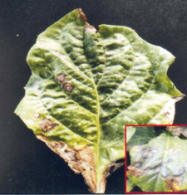
Fig 1: Typical symptoms observed in leaves
- Morpho-cultural characteristics
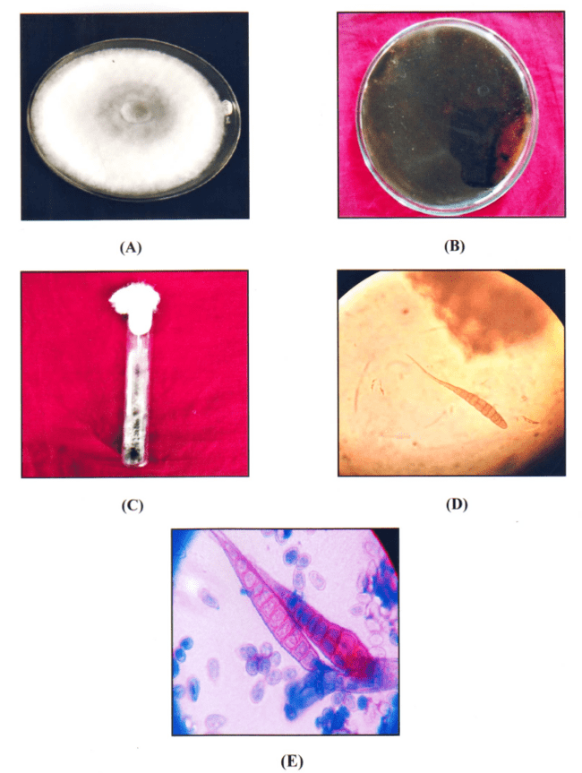
Fig 2. (A-E): Cultural and morphological characteristics of A. alternata on PDA media
A. Pure culture of A. alternata in PDA (7 days old culture), B. Reverse view of A. alternata in Petri plate, C. A. alternata on culture tube, D. Microscopic view of conidia (10X), E. Microscopic view of conidia (40X)

3. Pathogenicity test
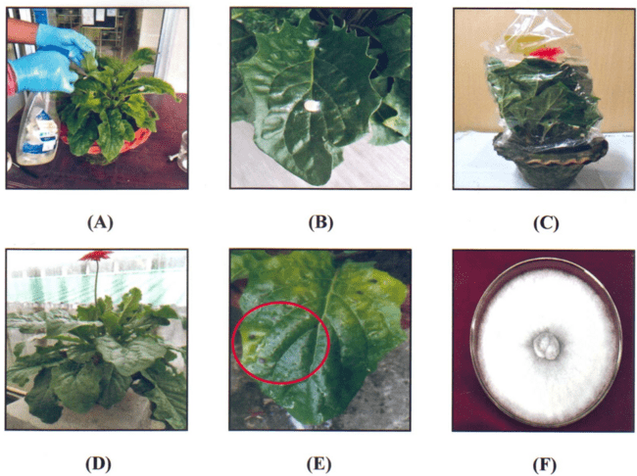
Fig. 3 (A-F): Pathogenicity test of A. alternata on healthy gerbera plant
A. Pathogenicity test by Pin-pricked method, B. Pathogenicity test by Mycelial Bit Inoculation Technique (MBIT), C. Plants covered with transparent perforated polypropylene bag, D. Control plant E.7 days after inoculation of A. alternata developed initial symptoms, F. Re-isolation of A. alternata from infected leaf

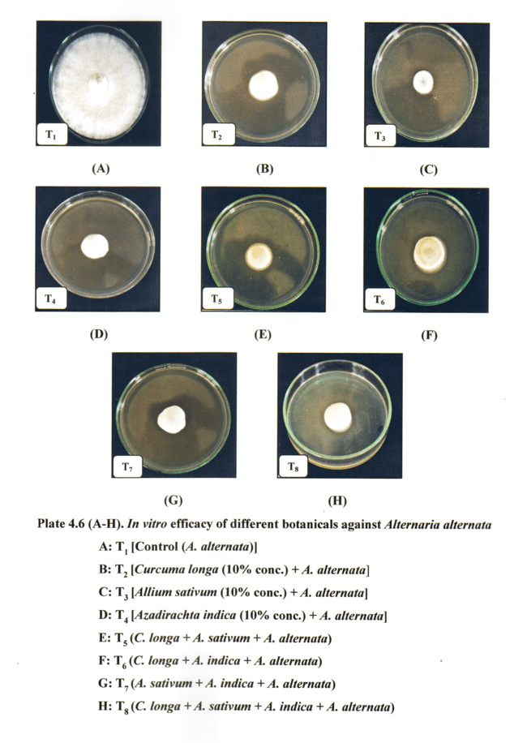
Fig. 4: In vitro efficacy of different botanicals against mycelial growth of A. alternata

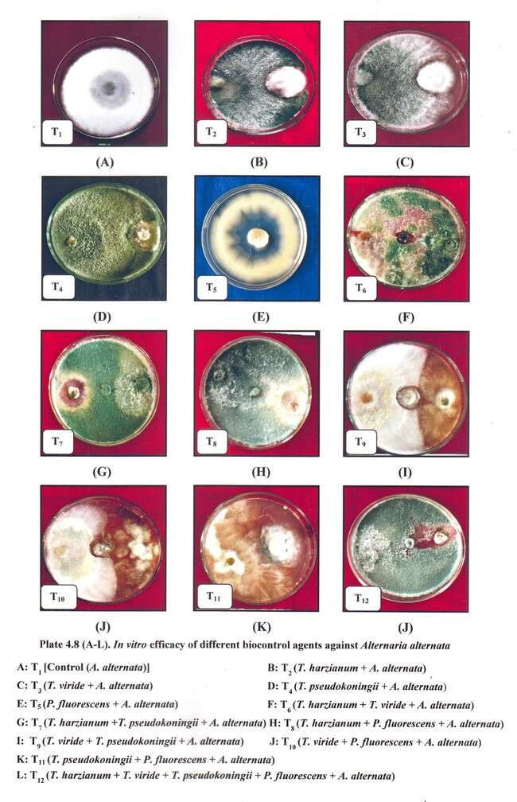
Fig. 5: In vitro efficacy of different biocontrol agents against mycelial growth of Alternaria alternata

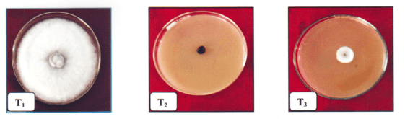
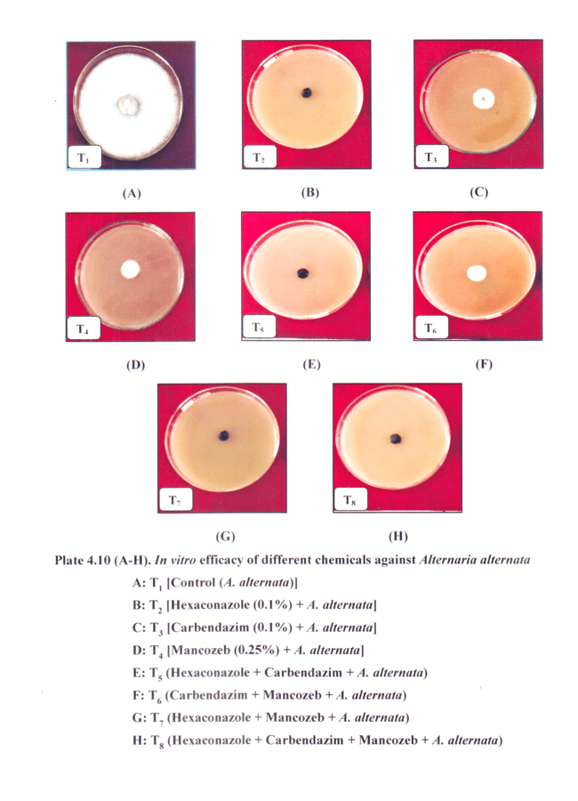
Fig. 6: In vitro efficacy of different chemicals against on mycelial growth of A. alternata
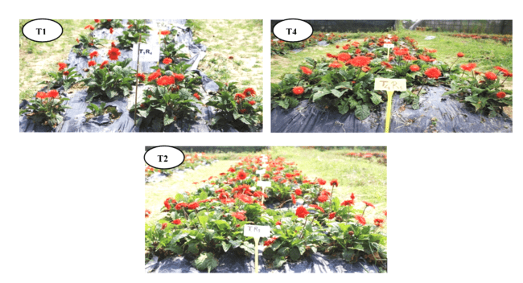
Fig. 7 (A-C): In vivo effect of different treatment combinations against Alternaria leaf spot under field condition

