Case Report

Regenerative Endodontic Treatment of an Immature Permanent Tooth with Trauma-Induced Arrested Root Development: A Case Report

ABSTRACT:
Pulpal necrosis in permanent teeth with trauma-induced incomplete root development complicates treatment planning because of the presence of an open apex and thin dentinal walls. This case report aimed to evaluate the clinical and radiographic outcomes of regenerative endodontic treatment performed in a maxillary left central incisor with trauma-induced incomplete root development. In a 16-year-old female patient, an open apex, arrested root development, and periapical pathology were identified in tooth #21. Regenerative endodontic treatment, including canal disinfection, calcium hydroxide medication, induction of apical bleeding, and placement of a coronal barrier with MTA NeoPUTTY, was performed. At the 6- and 9-month follow-ups, the patient remained asymptomatic, and radiographic findings indicated continued root development. Regenerative endodontic treatment may be considered an effective approach for managing permanent teeth with trauma-induced incomplete root development.

KEYWORDS:
Regenerative endodontic treatment; immature permanent tooth; dental trauma; open apex.

INTRODUCTION
Traumatic injuries occurring during the permanent dentition period constitute important clinical problems, particularly in young permanent teeth with incomplete root development, as they may damage the pulp and lead to infection and necrosis of the pulpal tissue [1]. In such cases, while conventional root canal treatment is challenges because of the wide apical opening, regenerative endodontic treatment offers the potential to support revascularization of the pulp and continuation of root development [2]. Traditional apexification methods may increase the risk of fracture in these teeth because the root canal walls remain thin and weak. In contrast, regenerative approaches aim to restore the biological and structural integrity of the tooth by promoting dentin formation and thickening of the root canal walls [3]. In this context, regenerative endodontic treatment in immature permanent teeth with necrotic pulp contributes to an improved prognosis by promoting continued root development [4].
This treatment approach focuses on key objectives such as elimination of infection, resolution of symptoms, continuation of root development, thickening of dentinal walls, and induction of apical maturation in permanent teeth with post-traumatic pulp necrosis and incomplete root development [5]. Particularly in necrotic teeth with an open apex, this approach may provide significant advantages for long-term prognosis by supporting dentin barrier formation and increasing root length and thickness [6].
This case report aimed to evaluate the clinical and radiographic outcomes of regenerative endodontic treatment performed in a permanent maxillary central incisor with trauma-induced incomplete root development and to demonstrate the potential of this treatment approach. This case report was prepared in accordance with the CARE case report guidelines.

CASE REPORT

Figure 1. Clinical decision-making and treatment flow for tooth #21.

Open apex, arrested root development, and periapical pathology in tooth #21
Diagnosis and regenerative endodontic treatment in two visits
Follow-up: asymptomatic course and continued root development
Clinical and radiographic examination
History of dental trauma
The aim of this case report was to evaluate the clinical and radiographic outcomes of regenerative endodontic treatment performed in a maxillary left central incisor with incomplete root development in a 16-year-old female patient with a history of trauma. A 16-year-old female patient was evaluated in our clinic because of inadequate root development in tooth #21 associated with previous dental trauma. Clinical and radiographic examinations revealed an immature root structure, arrested root development, and findings consistent with periapical pathology in the affected tooth (Figure 2).
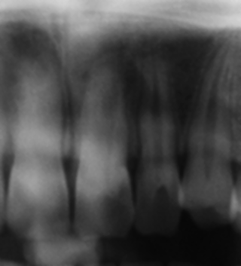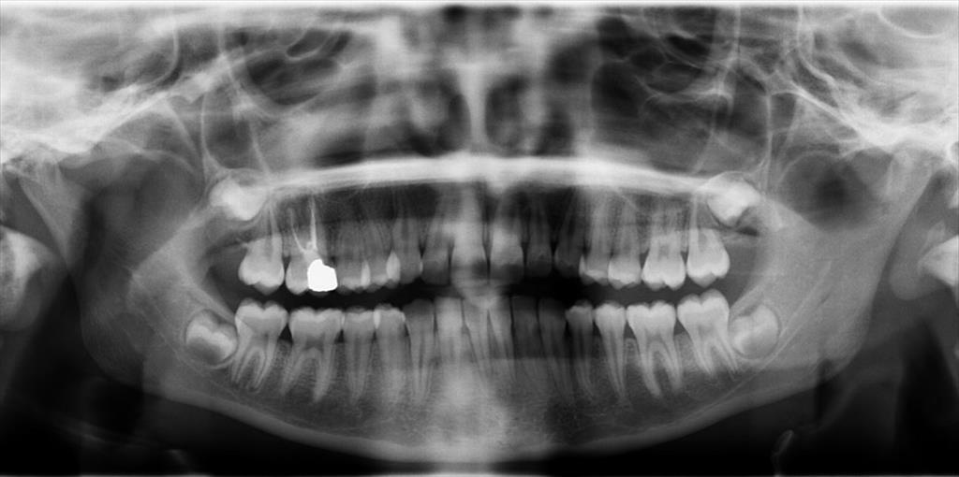
b
a
Figure 2. a) Baseline periapical radiograph showing an open apex, incomplete root development, and findings consistent with periapical pathology in tooth #21. b) Baseline panoramic radiograph.
The clinical appearance of the affected tooth was evaluated on the preoperative intraoral photograph (Figure 3). Based on the clinical and radiographic findings obtained, regenerative endodontic treatment was planned for tooth #21.
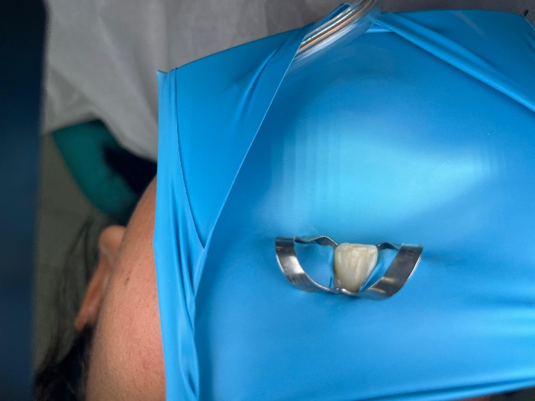
Figure 3. Preoperative intraoral photograph.
At the first visit, the working length was determined after access cavity preparation. Mechanical instrumentation of the canal was avoided, and emphasis was placed on disinfection of the root canal system. The canal system was irrigated with 1.5% sodium hypochlorite solution (NaOCl) (Microvem, Istanbul, Turkey) and saline [7]. At this stage, the aim was to reduce the intracanal microbial load while preserving the delicate structure present in the root canal walls. Following irrigation, calcium hydroxide paste (Imicryl, Izmir, Turkey) was placed into the canal to maintain intracanal disinfection. The access cavity was then sealed with the temporary restorative material Cavit G (3M ESPE, Seefeld, Germany), and the patient was scheduled for a second visit 10 days later.
At the second visit, the patient was found to be asymptomatic. After removal of the temporary restoration, the calcium hydroxide medicament was cleaned from the canal. The canal system was then irrigated with 17% EDTA. Excess irrigant solution within the canal was subsequently removed using sterile paper points [ProTaper Ultimate Conform Fit Paper Points, Dentsply Maillefer, Ballaigues, Switzerland]. In accordance with the biological principles of regenerative endodontic treatment, bleeding was induced beyond the apical region to allow formation of a natural blood clot within the canal (Figure 4). The resulting blood clot was intended to serve as a biological scaffold for continuation of the regenerative process.
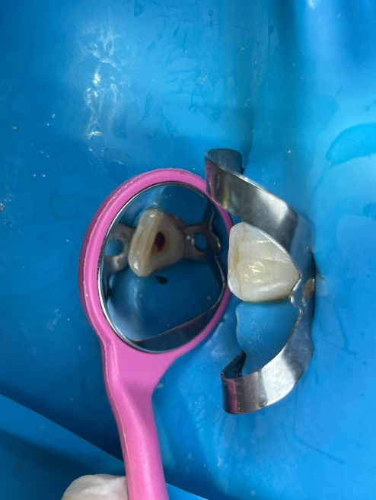
Figure 4. Induction of bleeding beyond the apical region and formation of a blood clot within the canal during the second visit.
After stabilization of the blood clot at an appropriate level, the premixed bioceramic material MTA NeoPUTTY (Avalon Biomed Inc., Bradenton, FL, USA) was placed in the coronal one-third of the canal as a coronal barrier material (Figure 5).
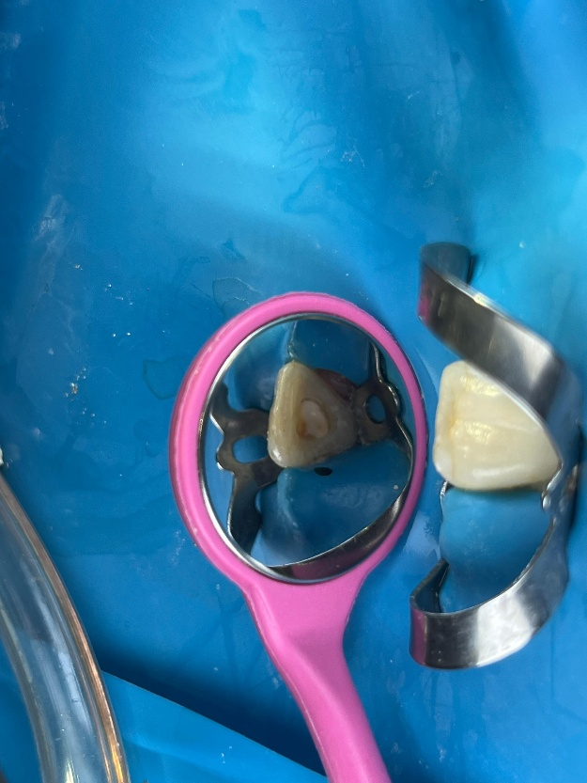
Figure 5. Placement of NeoPUTTY MTA in the coronal one-third of the canal as a coronal barrier material.
Thereafter, the treatment was completed with a permanent restoration using the glass ionomer filling cement Nova Aqua GIF (Imicryl, Konya, Turkey) and the resin composite material Estelite Anterior Quick (Tokuyama Dental, Tokyo, Japan) (Figure 6). In this way, both the establishment of an adequate coronal barrier and the maintenance of long-term coronal sealing were intended.
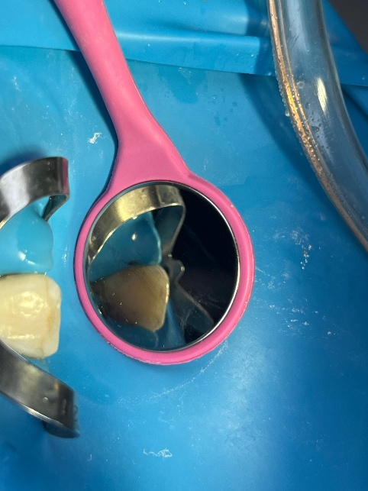
Figure 6. Completed permanent restoration with glass ionomer cement and resin composite material.
The patient was enrolled in a regular follow-up program after treatment. The patient remained asymptomatic throughout the 6-month follow-up period. Clinical evaluation revealed no pain, tenderness, or any additional clinical complaint associated with the affected tooth. At the 6-month radiographic follow-up, findings indicative of an increase in root length, thickening of the dentinal walls, and maturation in the apical region were observed (Figure 7). These clinical and radiographic findings indicate that regenerative endodontic treatment performed in permanent teeth with trauma-induced incomplete root development can provide infection control, eliminate clinical symptoms, and support continued root development in the short term.
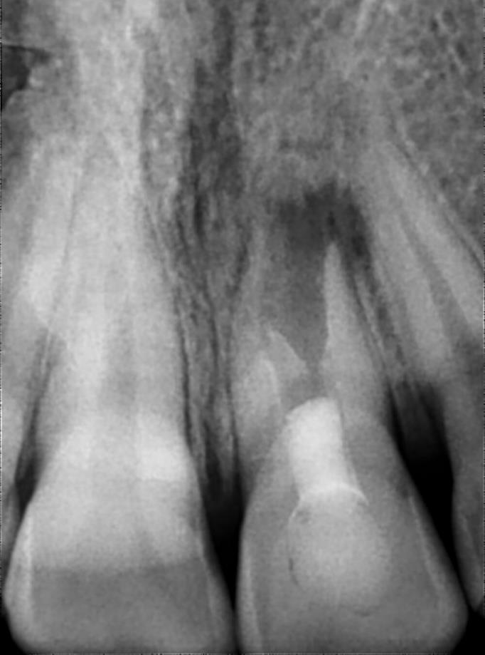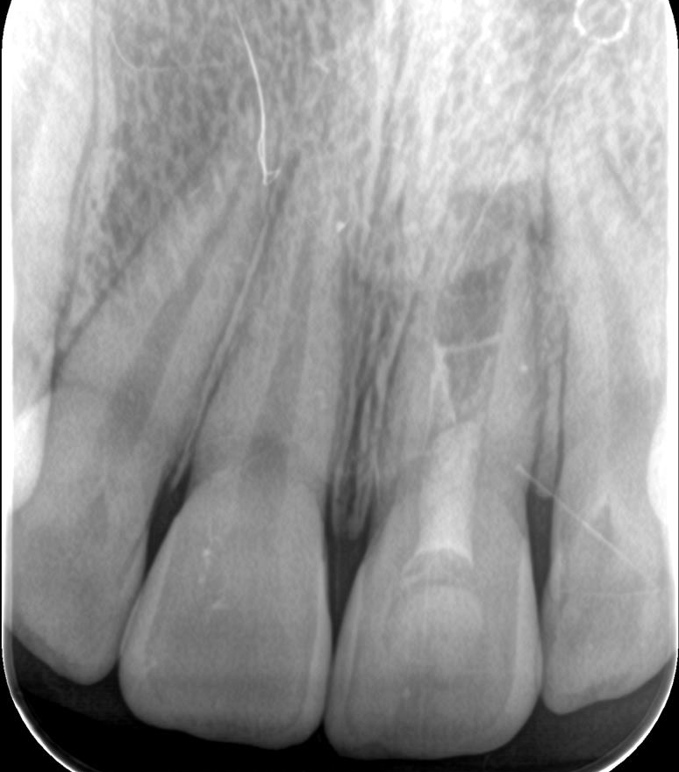
a
b
Figure 7.
a) Periapical radiograph at the 6-month follow-up.
b) Periapical radiograph at the 9-month follow-up.

DISCUSSION
In permanent teeth with trauma-induced incomplete root development, regenerative endodontic treatment has the potential to strengthen the structural integrity of the tooth by providing advantages such as increased root length, thickening of the dentinal walls, and apical closure compared with apexification procedures [3,8]. Such injuries, which are particularly common in maxillary central incisors, lead to pulp necrosis, arrest root development, and increase the risk of fracture with conventional treatment approaches. The approach used in this case report provided a biologically based solution to these problems by promoting continuation of root development following infection control. The fact that regenerative endodontic treatment aims to regenerate the damaged pulp-dentin complex long-term prognosis in such cases [9].
In this case, after regenerative treatment performed in tooth #21 of a 16-year-old female patient in the presence of necrotic pulp and periapical pathology, clinical asymptomatic status was achieved at the 6- and 9-month follow-ups; radiographically, favorable findings in terms of increased root length, thickening of the dentinal walls, and apical maturation were observed. Similar case reports in the literature have also reported outcomes such as root maturation, periapical healing, and resolution of symptoms following revascularization procedures [10–12]. These findings suggest that regenerative endodontic treatment may achieve the expected clinical and radiographic goals. This interpretation is also supported by recent systematic review evidence reporting favorable outcomes of regenerative endodontic procedures in permanent teeth, while emphasizing that treatment success may vary depending on clinical conditions and case selection [13]
Resolution of symptoms ensured that the patient’s daily functions were not affected, while continuation of root development supported the biomechanical durability of the tooth. Thickening of the dentinal walls and apical maturation indicate reinforcement of the root canal walls following elimination of infection, and these changes are consistent with regenerative endodontic cases reported in the literature [6,14]. However, the healing observed in this single case also reflects individual variation and does not provide sufficient data for generalization.
In the biological approach applied, calcium hydroxide medication was used for infection control; chelation of the dentin surface was targeted with 17% EDTA; natural scaffold formation was achieved by inducing apical bleeding; NeoPUTTY MTA contributed to the prevention of microleakage as a coronal barrier [15]; and permanent coronal sealing was intended with glass ionomer and resin composite restoration [10]. The combined use of these components clinically supported the revascularization process of the root canal system under sterile conditions [16].
This case demonstrates the short-term clinical applicability of regenerative endodontic treatment in a traumatically injured immature maxillary central incisor and presents promising results in terms of root maturation [17]. Nevertheless, because this is a single case and the follow-up period was limited to 9 months, it is not possible to draw definitive conclusions regarding the long-term prognosis; therefore, studies with larger sample sizes and longer follow-up periods are needed.
Although favorable short-term clinical and radiographic outcomes were observed in this case, regenerative endodontic treatment may not always result in predictable success. Possible causes of failure include persistent intracanal infection, inadequate disinfection, insufficient coronal sealing, failure to establish a stable intracanal blood clot, and patient-related factors affecting follow-up. Careful case selection, strict infection control, adequate coronal sealing, and regular follow-up may help reduce the risk of unfavorable outcomes.

CONCLUSION

Regenerative endodontic treatment performed in permanent teeth with trauma-induced incomplete root development showed favorable outcomes in this case in terms of eliminating clinical symptoms and supporting continued root development during short-term follow-up. The radiographic findings observed at the 6- and 9-month follow-ups suggest progression toward thickening of the dentinal walls and apical maturation. Regenerative endodontic treatment may be considered an effective treatment option in traumatized immature permanent teeth; however, more clinical data are needed to establish long-term outcomes.

Consent

Written informed consent was obtained from the patient and/or the patient’s legal guardian before treatment.

Disclaimer (Artificial intelligence)

Author(s) hereby declare that NO generative AI technologies such as Large Language Models (ChatGPT, COPILOT, etc.) and text-to-image generators have been used during the writing or editing of this manuscript.

REFERENCES

1. Özdemir DS, Altan H. A complicated trauma case in immature permanent teeth. J Int Dent Sci. 2020;1:8-11.
2. Alsofi L. Regenerative Endodontics for Upper Permanent Central Incisors after Traumatic Injury: Case Report with a 3-year Follow-up. J Contemp Dent Pract. 2019 Jan;20(8):974–7. doi:10.5005/jp-journals-10024-2618 PubMed PMID: 31797857.
3. García‐Godoy F, Murray PE. Recommendations for using regenerative endodontic procedures in permanent immature traumatized teeth. Dent Traumatol. 2011 Jul;28(1):33–41. doi:10.1111/j.1600-9657.2011.01044.x PubMed PMID: 21794081.
4. Genç AS, Kocaaydın S. Regenerative endodontic treatments performed on immature permanent teeth. Aydin Dent J. 2025;11(2):179-191.
5. Kahler B, Lin LM. A Review of Regenerative Endodontics: Current Protocols and Future Directions. J Istanbul Univ Fac Dent; 2017. Available from: doi:10.17096/jiufd.53911 PubMed PMID: 29354308.
6. Forghani M, Parisay I, Maghsoudlou A. Apexogenesis and revascularization treatment procedures for two traumatized immature permanent maxillary incisors: a case report. Restor Dent Endod. 2013 Jan;38(3):178–178. doi:10.5395/rde.2013.38.3.178 PubMed PMID: 24010086.
7. Kim SG, Malek M, Sigurdsson A, Lin LM, Kahler B. Regenerative endodontics: a comprehensive review. Int Endod J. 2018 Dec;51(12):1367-1388. doi: 10.1111/iej.12954. Epub 2018 Jun 11. PMID: 29777616.
8. Wikström A, Brundin M, Lopes MF, Sayed M, Tsilingaridis G. What is the best long-term treatment modality for immature permanent teeth with pulp necrosis and apical periodontitis? European Archives of Paediatric Dentistry. 2021. p. 311–40. doi:10.1007/s40368-020-00575-1 PubMed PMID: 33420674.
9. Dörterler ÖC, Ayhan F. Biomaterial selection and tissue engineering applications in regenerative endodontic treatment. Eur J Sci Technol. 2021;(23):31-42. doi:10.31590/ejosat.842306.
10. Kritika S, Sujatha V, Narasimhan S, Kumar S, Mahalaxmi S. Prospective cohort study of regenerative potential of non vital immature permanent maxillary central incisors using platelet rich fibrin scaffold. Sci Rep. 2021 Jul;11(1). doi:10.1038/s41598-021-93236-2 PubMed PMID: 34211068.
11. Kumar JK, Surendranath P, Eswaramoorthy R. Regeneration of immature incisor using platelet rich fibrin: report of a novel clinical application. BMC Oral Health. 2023 Feb;23(1). doi:10.1186/s12903-023-02759-9 PubMed PMID: 36732777.
12. NB N, Poornima P, Khan M, Mathew MG, Soni AJ. A Comparative Evaluation of Revascularization Done in Traumatized Immature, Necrotic Anterior Teeth with and without Platelet-rich Fibrin: A Case Report. Int J Clin Pediatr Dent. 2020 Jan;13(1):98–102. doi:10.5005/jp-journals-10005-1738 PubMed PMID: 32581489.
13. Rizk HM, Al-Deen MSS, Emam AA. Pulp Revascularization/Revitalization of Bilateral Upper Necrotic Immature Permanent Central Incisors with Blood Clot vs Platelet-rich Fibrin Scaffold A Split-mouth Double-blind Randomized Controlled Trial. Int J Clin Pediatr Dent. 2020 Jan;13(4):337–43. doi:10.5005/jp-journals-10005-1788 PubMed PMID: 33149405.
14. Li J, Zheng L, Daraqel B, Liu J, Hu Y. Treatment outcome of regenerative endodontic procedures for necrotic immature and mature permanent teeth: a systematic review and meta-analysis based on randomised controlled trials. Oral Health Prev Dent. 2023;21:141-152. doi:10.3290/j.ohpd.b4100877. PMID: 37195330.
15. Faiz Arslanparcasi H, Edebal TH. In vitro evaluation of the effects of different bone grafts on the surface microhardness of NeoPUTTY and MTA Angelus. Sci Rep. 2026 Apr 17. doi:10.1038/s41598-026-49482-3
16. Glynis A, Foschi F, Kefalou I, Koletsi D, Tzanetakis GN. Regenerative Endodontic Procedures for the Treatment of Necrotic Mature Teeth with Apical Periodontitis: A Systematic Review and Meta-analysis of Randomized Controlled Trials. J Endod. 2021 Jun;47(6):873–82. doi:10.1016/j.joen.2021.03.015 PubMed PMID: 33811981.
17. Agarwal N, Kour M. Regenerative Endodontics in Traumatized Young Permanent Tooth. J Trauma Treat. 2018 Jan;7(1). doi:10.4172/2167-1222.1000416

