INDUCTION OF PROLONGED CUSHING’S SYNDROME DUE TO PROLONGED THERAPEUTIC USE OF CORTICOSTEROIDS

ABSTRACT
Background: The long-term ingestion of external corticosteroids can lead to iatrogenic Cushing’s syndrome and are known to be adverse drug reactions that are prevented. There are many nonspecific symptoms associated with iatrogenic Cushing’s syndrome that often mimic other dermatologic or systemic conditions and may therefore go undetected. If there has been long-term use of an external corticosteroid, there are also considerations if the external corticosteroid is withdrawn suddenly. It can lead to a delayed crisis.
Case report: 53-year-old hypertensive female patient presented with skin thickening and hyperpigmentation over the abdomen and the lower extremities; generalized pruritus; exertional dyspnea; weakness; recent history of a chest pain; and fall. The patient reported medical history of taking chronic non-steroidal anti-inflammatory medication and external corticosteroids for joint pain. Clinical examination showed pallor, mild pedal edema, hypertension, skin atrophy, and scaliness. When laboratory tests were performed, low serum cortisol levels, concentric left ventricular hypertrophy with diastolic dysfunction Grade I, mild anemia, thrombocytopenia, hyperbilirubinemia, and mild renal impairment were obtained.
Treatment/ result: The patient was treated with antihypertensives, supportive care, gradual tapering of steroids and dermatology consult.
Conclusion: This case demonstrates that there is chronic adrenal suppression from due to long-term exposure of corticosteroids. Low cortisol level confirms the diagnosis of Cushing’s syndrome due to exogenous steroid use as compared to endogenous causes. In the evaluation of abnormal skin or systemic changes, always ask the patient about use of corticosteroids; it is important to taper corticosteroids appropriately so sudden withdrawal does not result in a crisis.
Keywords: Cushing’s syndrome, adverse reaction, dermatology, cortisol, skin hyperpigmentation.

INTRODUCTION
Long-term exposure to elevated glucocorticoid levels can produce various clinical manifestations of Cushing’s syndrome and may contribute to increased morbidity and mortality. Advances in understanding the genetic and molecular mechanisms underlying excessive cortisol secretion from adrenal lesions and excessive ACTH secretion from pituitary or ectopic tumors have improved diagnostic and therapeutic strategies. Modern biochemical testing, imaging modalities, surgical techniques, and radiotherapy approaches have enhanced patient outcomes. The main objective of treatment is to restore normal cortisol levels in order to reverse complications and reduce mortality risk. Complete and selective removal of the causative tumor is essential for normalization of the hypothalamic–pituitary–adrenal axis, preservation of pituitary function, and prevention of recurrence. New pharmacological therapies provide additional options for patients with persistent hypercortisolism. Long term monitoring remains necessary due to associated comorbidities. ^{(1,7)} Cushing syndrome is a hormonal disorder caused by prolonged exposure of body tissues to high levels of cortisol. Cortisol,⁽²⁾ often referred to as the body’s stress hormone, is secreted by the adrenal glands and is essential for regulating glucose metabolism, immune function, inflammatory responses, and insulin activity. Cushing’s syndrome was initially described in 1912 by the neurosurgeon Harvey Cushing. The incidence ranges from 0.7–2.4 cases per million population annually. Common clinical manifestations include a rounded “moon” face, fat accumulation over the upper back (buffalo hump), fatigue, fragile skin, osteoporosis, recurrent infections, hyperglycemia, hypertension, and sleep disturbances. Women may experience hirsutism and menstrual irregularities, while men often present with infertility and erectile dysfunction. Endogenous causes include pituitary adenomas, adrenal tumors, and ACTH‑secreting tumors, whereas exogenous causes are commonly due to prolonged high‑dose corticosteroid therapy. Studies suggest higher prevalence among women, particularly in the 30–40-year age group. ⁽³⁾Cushing syndrome primarily involves excessive ACTH stimulation of the adrenal glands, resulting in elevated cortisol levels. Common manifestations include weight gain, facial puffiness, hypothyroidism, protruding eyes, and buffalo hump. The average incidence of newly diagnosed cases is reported as 24 per million per year. Cushing’s disease occurs more frequently in women than men with a ratio of approximately 15:1. Remission was achieved in 87.5% of reported cases following treatment. ^{(4,6)}

Epidemiology and causes
The reported annual incidence of Cushing’s syndrome is approximately 0.2–5 cases per million individuals. The median age at diagnosis is approximately 41.4 years, and females are more commonly affected than males in a ratio of about 3:1. Increased prevalence has been observed among individuals with uncontrolled type 2 diabetes, hypertension, and early-onset osteoporosis. Endogenous forms of Cushing’s syndrome are broadly categorized as ACTH-dependent and ACTH-independent types. ACTH‑dependent causes most commonly involve pituitary corticotrophin adenomas (Cushing’s disease), while ectopic ACTH secretion accounts for a smaller proportion. Some ectopic tumors remain undetected for years. Rare cases involve CRH‑secreting tumors such as neuroendocrine tumors, medullary thyroid carcinoma, and pheochromocytoma. ACTH‑independent causes include adrenal adenomas, carcinomas, bilateral macronodular adrenal hyperplasia, and primary pigmented nodular adrenocortical disease. ^{(5,8)}
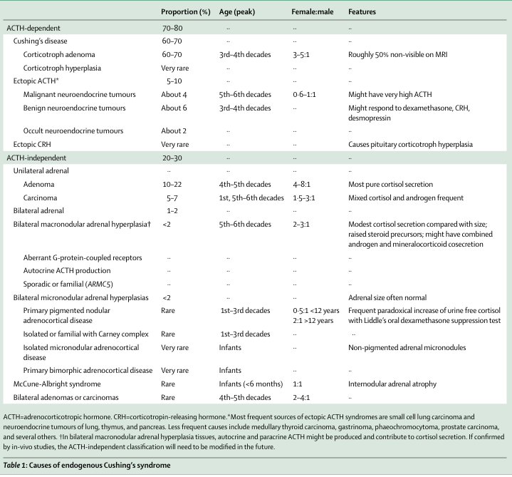

Fig 1. Prevalence of ACTH-dependent and ACTH-independent Cushing’s syndrome

Pathophysiology
Corticotropin-releasing hormone (CRH), secreted by the hypothalamus, controls the release of ACTH from the anterior pituitary gland. ACTH is derived from proopiomelanocortin and stimulates cortisol production from the adrenal cortex. Cortisol normally regulates its own production through a negative feedback mechanism involving the hypothalamus and pituitary gland. In Cushing’s syndrome, this regulatory mechanism becomes disrupted.
The most common form, Cushing’s disease, results from a pituitary adenoma that produces excessive ACTH. These tumors may exhibit partial resistance to cortisol’s feedback inhibition. Ectopic ACTH production may occur in malignancies such as small‑cell lung carcinoma, leading to severe hypertension, hypokalemia, hyperglycemia, and muscle weakness. Some ectopic tumors resemble pituitary‑dependent disease in diagnostic testing, making differentiation challenging. ACTH‑independent forms involve adrenal adenomas, carcinomas, or nodular hyperplasia that autonomously secrete cortisol. Bilateral micronodular hyperplasia may occur in younger patients and can be associated with genetic conditions such as Carney complex. Adrenal incidentalomas discovered during imaging are usually non‑functional, though a small proportion may progress to overt hypercortisolism. Iatrogenic Cushing’s syndrome can result from prolonged glucocorticoid therapy or, rarely, exogenous ACTH administration. ^{(9,10)}

CASE DESCRIPTION
A 52-year-old female patient presented to the General Medicine outpatient department with complaints of persistent headache, facial puffiness, progressive weight gain, and generalized weakness for the past six months. She also reported irregular menstrual cycles and a tendency to bruise easily. There was no history of seizures, loss of consciousness, or previously diagnosed endocrine disorders.
The patient was a known hypertensive for the past three years but was irregular with her medications. On further inquiry, it was revealed that she had been taking oral corticosteroids continuously for nearly eight months for joint pain without proper medical supervision.
There was no significant family history of endocrine illness. She was a non-smoker and non-alcoholic.
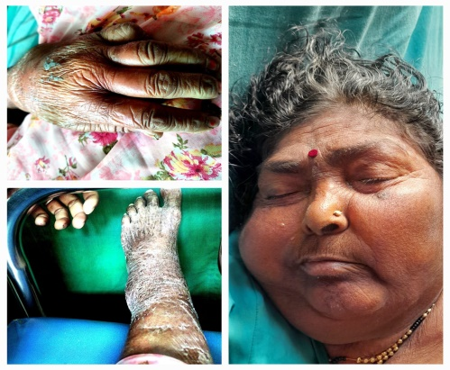
Fig 2. Female patient suspected of Cushing’s syndrome

Clinical diagnosis and on examination
On examination, the patient was conscious, cooperative, and well-oriented. Her vital signs were: blood pressure 160/100 mmHg, pulse rate 88 beats per minute, respiratory rate 18 breaths per minute, and temperature 98.4°F. Physical examination revealed classical features suggestive of Cushing’s syndrome including moon-shaped face, central obesity, purple abdominal striae, facial acne, and proximal muscle weakness. Systemic examination did not reveal any
additional abnormalities. Based on clinical findings, Cushing’s syndrome was suspected.

Table 1. Laboratory investigations

TEST | RESULT | NOTES
Serum cortisol | 28 µg/dl | Very low
Hemoglobin | 11.7 g/dl | Mild anemia
WBC count | 8660 /mm³ | Normal
Platelets | 0.96 lakh /mm³ | Mild thrombocytopenia
Total bilirubin | 2.8 mg/dl | Elevated
Ast | 52 u/l | Mildly elevated
Alp | 154 u/l | Elevated
Albumin | 3.0 g/dl | Low
Creatinine | 1.3 mg/dl | Mildly elevated
Urea | 19 mg/dl | Normal
Urine albumin | Nil | Normal
Urine sugar | Nil | Normal
Urine microscopy | Nad | Normal
Urinary free cortisol level |  | Elevated
Fasting blood glucose | 168 mg/dl | Increased
Serum potassium | 3.2 mEq/l | Reduced
Dexamethasone suppression test | Low-dose | Elevated

Treatment
The patient was initially taking Prednisolone 20 mg once daily along with Amlodipine 5 mg once daily. A gradual steroid tapering schedule was initiated under close monitoring to prevent adrenal crisis.
The clinical pharmacist played an important role in identifying steroid misuse and counseling the patient regarding the risks associated with long-term unsupervised corticosteroid therapy. Blood pressure and blood glucose levels were monitored regularly.
post-intervention management included Amlodipine 5 mg once daily, Metformin 500 mg twice daily for steroid-induced hyperglycemia, and potassium supplementation. Lifestyle modifications such as dietary control and regular physical activity were advised.
The patient was followed up for three months, during which her symptoms gradually improved and cortisol levels began to normalize.

DISCUSSION
Cushing's syndrome remains the most prevalent form of hypercortisolism globally, predominantly resulting from prolonged exogenous glucocorticoid therapy, as observed in this 53-year-old hypertensive female who self-administered corticosteroids for chronic joint pain. Her clinical presentation—encompassing skin thickening and hyperpigmentation over the abdomen and lower extremities, generalized pruritus, exertional dyspnea, weakness, low serum cortisol levels, mild anemia, thrombocytopenia, hyperbilirubinemia, mild renal impairment, and concentric left ventricular hypertrophy with grade I diastolic dysfunction—exemplifies the multisystemic repercussions commonly documented in such cases. This patient's dermatologic manifestations, including skin atrophy, scaliness, thickening, and hyperpigmentation, align closely with established literature on iatrogenic Cushing's, where cutaneous changes often precede systemic recognition and mimic primary dermatoses. Comparable case reports describe adrenal suppression with suppressed cortisol following long-term dexamethasone use, as in a 32-year-old male on oral tablets exhibiting hypertension and weakness, or intranasal misuse leading to hypokalemia and similar skin alterations. In contrast to endogenous Cushing's syndrome—characterized by pituitary adenomas (approximately 70% of cases) or adrenal tumors with elevated cortisol and ACTH (incidence 0.7-2.4 per million)—exogenous forms feature hypothalamic-pituitary-adrenal axis suppression, underscoring the diagnostic utility of low cortisol levels.
Management in this instance entailed gradual steroid tapering, antihypertensives, supportive measures, and dermatology consultation, effectively mitigating adrenal crisis risk and restoring axis function—a strategy corroborated by pharmacoepidemiologic guidelines emphasizing multidisciplinary oversight. The pivotal involvement of clinical pharmacists in identifying misuse, providing counseling, and ensuring rational deprescribing highlights their role in averting adverse drug reactions, particularly in unsupervised chronic therapy scenarios. This case reinforces the imperative for clinicians to probe corticosteroid history in patients presenting with nonspecific dermatoses or systemic symptoms, especially among hypertensives or chronic pain sufferers, to facilitate early intervention and curb iatrogenic morbidity.

CONCLUSION
This case emphasizes the importance of rational corticosteroid prescribing and strict monitoring during long-term therapy. Early diagnosis and timely intervention significantly improve patient outcomes. The involvement of a multidisciplinary team, including clinical pharmacists, plays a vital role in optimizing therapy and preventing medication-related complications.
Cushing's syndrome with adrenal suppression, dermatologic changes like hyperpigmentation and skin thickening, and systemic complications including hypertension, anemia, and cardiac dysfunction in a 53-year-old hypertensive female. Successful management through gradual steroid tapering, antihypertensives, supportive care, and pharmacist-led counseling prevented adrenal crisis and restored hypothalamic-pituitary-adrenal axis function, highlighting the value of multidisciplinary pharmacovigilance.
Clinicians must routinely screen for occult corticosteroid exposure in patients presenting with nonspecific skin or systemic symptoms—particularly among those with chronic joint pain or comorbidities—to enable early recognition, rational deprescribing, and mitigation of iatrogenic morbidity.

CONSENT

As per international standards or university standards, patient(s) written consent has been collected and preserved by the author(s).

ETHICAL APPROVAL

It is not applicable.

DISCLAIMER (Artificial Intelligence)

Author(s) hereby declares that no generative ai technologies such as large language models (ChatGPT, copilot, etc.) and text-to-image generators have been used during writing or editing of this manuscript.

COMPETING INTERESTS

Authors have declared that no competing interests exist.

REFERENCES

- Lacroix A, Feelders RA, Stratakis CA, Nieman LK. Cushing’s syndrome. Lancet. 2015;386:913-27.
- Chabre O, Goichot B, Zenaty D, Bertherat J. Cushing syndrome: epidemiology and clinical aspects. Pan Afr Med J. 2014;17:237. doi:10.11604/pamj.2014.17.237.3332.
- Bansal P, Goyal A, Cusick A, Lahan S, Dhaliwal HS, et al. Cushing syndrome. J Drug Deliv Ther. 2022;12(6):I-III.
- Sharma ST, Nieman LK, Feelders RA. Cushing’s syndrome: epidemiology and developments in disease management. J Drug Deliv Ther. 2019;9(4-s):598-600.
- Newell-Price J, Trainer P, Besser M, Grossman A. The diagnosis and differential diagnosis of Cushing’s syndrome and pseudo-Cushing’s states. Lancet. 2001;357:783-91.
- Singh A, et al. Dexamethasone-induced exogenous Cushing's syndrome: a case report. Int J Pharm Sci Res Rev. 2023;85(6).
- Al-Buriahi MN, et al. A case of iatrogenic Cushing's syndrome following use of an over-the-counter supplement. Cureus. 2023;15(3):e36020.
- Erdogdu IH, et al. Skin manifestations of Cushing's syndrome. An Bras Dermatol. 2016;91(5):579-582.
- MedlinePlus. Exogenous Cushing syndrome. Updated 2025. Available from: https://medlineplus.gov/ency/article/000389.htm.
- Joseph RM, et al. Iatrogenic Cushing's syndrome caused by intranasal application of dexamethasone. Korean J Pediatr. 2017;60(4):130-133.

