Intraoperative Finding of Heterotopic Ossification in the Anterior Abdominal Wall: A case report

Abstract :
Abdominal heterotopic ossification is a rare entity, most commonly occurring following trauma or surgery. We report the case of a 75-year-old female patient managed for appendiceal peritoneal carcinomatosis, in whom heterotopic ossification of the anterior abdominal wall, located within the deep parietal aponeurosis, was incidentally discovered during cytoreductive surgery without HIPEC.

A total omentectomy with multiple biopsies and resection at the appendiceal base was performed. Histopathological examination revealed a moderately differentiated appendiceal adenocarcinoma with a low-grade mucinous component and vascular emboli, as well as mature osseous debris without associated tumor proliferation.

The postoperative course was uneventful, with favorable clinical recovery. The patient was referred to oncology for further management.

This case highlights the potential role of prior surgery, chronic inflammation, and the tumor microenvironment in the development of heterotopic ossification. Recognition of this entity is crucial due to the risk of misinterpretation as tumor progression and its intraoperative implications.

Keywords: heterotopic ossification, Osteogenic metaplasia, Anterior abdominal wall, Surgical scar

Introduction :

Heterotopic ossification is a heterogeneous pathological process characterized by the formation of bone outside the skeletal system, within muscles and soft tissues. It can be considered a dysregulated tissue repair process and represents a common complication of trauma and surgical procedures (Xu et al., 2022). In practice, the term encompasses any ectopic bone formation occurring outside the skeletal system, involving skeletal striated muscles, fascia, tendons, ligaments, subcutaneous tissue, skin, the vascular wall, or more broadly, any connective tissue site (1).
Beyond this anatomical and topographical diversity, the cellular mechanisms underlying the formation and progression of heterotopic ossification are also heterogeneous, as demonstrated by experimental studies using lineage-tracing animal models (Lees-Shepard & Goldhamer, 2018).
Furthermore, the fundamental mechanisms of osteogenesis are not uniform and may proceed through either intramembranous or endochondral ossification (1).

A case of abdominal heterotopic ossification located within the deep parietal aponeurosis is reported, incidentally discovered during cytoreductive surgery. This observation highlights an unusual localization occurring in the context of appendiceal adenocarcinoma with peritoneal carcinomatosis.

Case presentation :
We report the case of a 75-year-old female patient with a medical history of type 2 diabetes for 2 years, treated with oral antidiabetic drugs (gliclazide), and arterial hypertension for 3 years, managed with amlodipine 5 mg.
She was also followed for a toxic multinodular goiter and was receiving antithyroid therapy (carbimazole).
The patient had previously undergone an open cholecystectomy via a right subcostal laparotomy 8 years earlier.
She was initially operated on for a latero-uterine mass. Surgical exploration revealed a mass originating from the appendix, with no evidence of peritoneal carcinomatosis. Histopathological examination of the appendectomy specimen demonstrated a well-differentiated appendiceal adenocarcinoma infiltrating the lamina propria, with mucin extravasation beyond the appendiceal serosa and a positive appendiceal resection margin.
A thoraco-abdomino-pelvic computed tomography scan was performed as part of the staging work-up, revealing small right latero-uterine and subcecal nodular lesions (Figure 1). No pulmonary, hepatic, or osseous metastatic lesions were identified.

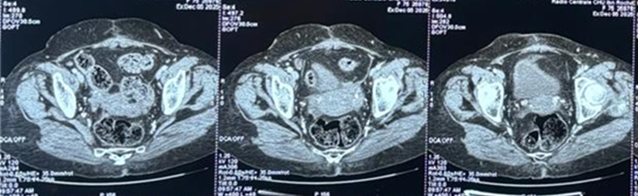
Figure 1: CT scan images showing right latero-uterine and subcecal nodular lesions.( blue star)

The patient’s case was discussed at a multidisciplinary team meeting, which recommended a right ileo-hemicolectomy combined with hyperthermic intraperitoneal chemotherapy (HIPEC).

The patient was subsequently readmitted for further management. On admission, a comprehensive preoperative assessment was performed. Clinical examination was unremarkable except for the presence of a right subcostal scar and a midline laparotomy scar. Preoperative laboratory investigations were within acceptable limits for surgery. The patient underwent standard preoperative preparation, including optimization of her general condition, strict glycemic control, and a pre-anesthetic evaluation.

Surgery was performed via a midline laparotomy. Upon incision, unusual formations consisting of bone-like debris were identified within the deep parietal aponeurosis, with a hard and calcified appearance (Figure 2). Further exploration of the abdominal cavity revealed diffuse peritoneal carcinomatosis nodules, with a Sugarbaker Peritoneal Cancer Index of 20/39.
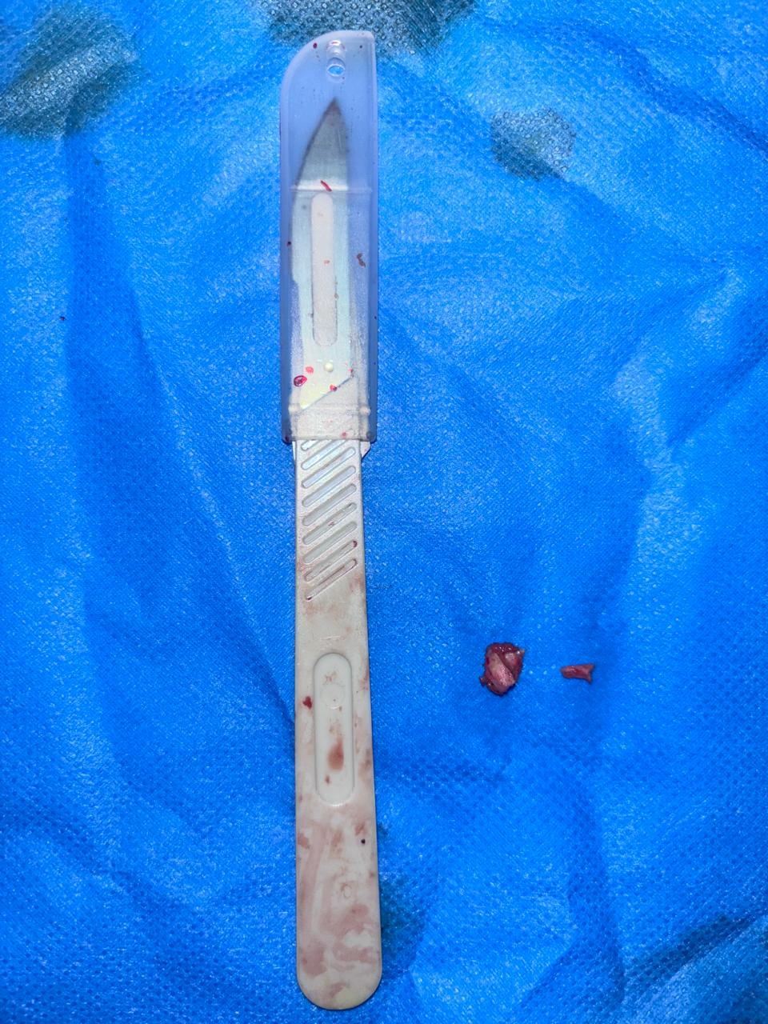
Figure 2: Bone debris found in deep parietal aponeurosis

Based on these intraoperative findings, a total omentectomy was performed without HIPEC, along with resections at the appendiceal base and multiple biopsies throughout the abdominal cavity, including removal of bony debris.

Histopathological examination confirmed the mature osseous nature of the debris, with no evidence of associated tumor proliferation. Moreover, the surgical specimen and the various biopsies revealed a moderately differentiated, invasive adenocarcinoma with a low-grade mucinous component and vascular emboli. The resections at the appendiceal base were involved by the tumor.

Postoperative recovery was uneventful, with favorable clinical evolution and return of bowel function on postoperative day 1. The patient was subsequently referred to oncology for further management.

Discussion :
Heterotopic ossification is forming a new bone in tissues that do not normally ossify. HO was first reported in 1901 by Askanazy and Lubarsh in a case report study[2] . The range of HO is wide from minute foci to large clinically significant ossification. The incidence of HO in abdominal scars is extremely low. [3]
Heterotopic ossification (HO) is a bone formation in a tissue other than the skeletal system. however, it is a pathological condition that might be observed during the healing process of abdominal incisions in the midline [4]

Previous abdominal surgeries may act as triggering factors by inducing local tissue injury, inflammation, and creating a microenvironment conducive to osteogenic differentiation (5). The inflammatory milieu associated with peritoneal carcinomatosis and mucinous tumors may further promote heterotopic bone formation through osteoinductive signaling pathways (6).
Metaplastic transformation of mesenchymal stromal cells into osteoblast-like cells has been proposed as a plausible mechanism underlying postoperative abdominal heterotopic ossification (1).

Previous studies have reported heterotopic ossification in different anatomical sites, most commonly following trauma or surgical procedures. However, abdominal wall involvement remains rare in literature. Reported cases suggest multifactorial pathogenesis involving surgical injury, inflammation, and local tissue remodeling. In the present case, the association with peritoneal carcinomatosis and a mucinous tumor environment further supports a potential role of tumor-related osteoinductive factors, which has been infrequently described.

Surgeons should be aware of this rare entity, as it may complicate surgical dissection or be misinterpreted as disease progression on imaging studies.
The pathophysiology of abdominal heterotopic ossification remains poorly understood; however, it is increasingly recognized as a consequence of dysregulated osteogenic signaling in non-skeletal tissues. In the present case, several factors may have synergistically contributed to ectopic bone formation, including prior abdominal surgeries, chronic inflammation related to peritoneal carcinomatosis, and a mucin-rich tumor microenvironment (7). These factors may have led to aberrant osteogenic differentiation of mesenchymal cells (8).
Aberrant activation of osteoinductive pathways, particularly bone morphogenetic protein (BMP) and transforming growth factor-beta (TGF-β) signaling, may promote osteogenic differentiation of local mesenchymal stromal cells within the deep parietal aponeurosis (3). Additionally, mechanical stress and wound healing processes may further potentiate osteogenesis through mechanotransduction and hypoxia-related pathways.

This supports the concept that heterotopic ossification represents a maladaptive tissue repair response rather than a true neoplastic process (1).

This study has limitations inherent to a single case report, including limited generalizability and the lack of long-term follow-up data. In addition, the proposed pathophysiological mechanisms remain speculative.

This manuscript highlights that prior surgery, long-term inflammation, and tumor-related factors may collectively contribute to abnormal bone formation, a mechanism that remains poorly understood. The identification of bone tissue in the absence of cancer dissemination emphasizes the importance of thorough diagnostic evaluation. Misdiagnosis may lead to incorrect staging and inappropriate treatment strategies. Therefore, awareness of this condition is essential for surgeons and multidisciplinary teams to avoid unnecessary tissue resection and to improve patient care.

Conclusion:
Abdominal heterotopic ossification is a rare entity, most commonly occurring secondary to trauma or surgery. In the present case, it was incidentally identified within the deep parietal aponeurosis during cytoreductive surgery for appendiceal peritoneal carcinomatosis.
Although prior surgical history, chronic inflammation, and the tumor microenvironment may be associated with heterotopic ossification, the exact pathophysiological mechanisms remain speculative.
Recognition of this entity is important for surgeons, as it may be misinterpreted as tumor progression and may have relevant intraoperative implications.

Consent: Written informed consent was obtained from the patient for publication of this case report and accompanying images.

Disclaimer (Artificial Intelligence)
The authors declare that generative AI tools (e.g., ChatGPT) were used for language editing only. All scientific content and conclusions are the sole responsibility of the authors.

References:

- Meyers C, Lisiecki J, Miller S, et al. Heterotopic ossification: A comprehensive review. JBMR Plus. 2019;3(4):e10172.
- Askanazy M., Lubarsch M.Q. Zur Kenntniss der Knochenbildungen in Lunge und Pleura. Deutsch Path Gesellsch. 1901;3:102–114.
- Karimi M, Mousavi SA. "Heterotopic abdominal wall ossification: A case report" information. Int J Surg Case Rep. 2024 Apr;117:109469. doi: 10.1016/j.ijscr.2024.109469. Epub 2024 Mar 7. PMID: 38460290; PMCID: PMC10943427
- Akıncı O, Kutluk F, Cin S, Ertürk S, Yüceyar S, Perek A. Heterotopic ossification of the anterior abdominal wall. Turk J Surg. 2022 Jun 29;38(2):208-210. doi: 10.47717/turkjsurg.2022.4008. PMID: 36483167; PMCID: PMC9714656.
- Pape HC, Marsh S, Morley JR, et al. Current concepts in the development of heterotopic ossification. J Bone Joint Surg Br. 2004;86(6):783–787.
- Ranganathan K, Loder S, Agarwal S, et al. Heterotopic ossification: Basic-science principles and clinical correlates. J Bone Joint Surg Am. 2015;97(13):1101–1111.
- Mantovani A, Allavena P, Sica A, et al. Cancer-related inflammation. Nature. 2008;454(7203):436–444.
- Reardon MJ, Tillou A, Mody DR, et al. Heterotopic calcification in abdominal incisions. Ann Surg. 1997;226(3):397–402.
- Xu Y, Huang M, He W, He C, Chen K, Hou J, Huang M, Jiao Y, Liu R, Zou N, Liu L and Li C (2022) Heterotopic Ossification: Clinical Features, Basic Researches, and Mechanical Stimulations. Front. Cell Dev. Biol. 10:770931. doi: 10.3389/fcell.2022.770931
- Lees-Shepard, J. B., & Goldhamer, D. J. (2018). Stem cells and heterotopic ossification: Lessons from animal models. Bone, 109, 178–186. https://doi.org/10.1016/j.bone.2018.01.029

