Flow Cytometric Detection of CK19-Positive Circulating Tumor Cells in Bone Marrow and Peripheral Blood in Metastatic Breast Cancer: A Case Report

Abstract

Metastatic breast cancer represents the most advanced stage, where the accurate and rapid identification of neoplastic cells is essential for clinical management and prognostic assessment. Although immunohistochemistry is the gold standard, flow cytometry emerges as a robust and sensitive complementary diagnostic method for detecting circulating tumor cells. We report a breast cancer patient with bone marrow metastasis and demonstrate the utility of a novel flow cytometry protocol for tumor cell detection. A 39-year-old woman, with no family history of cancer, identified a right breast nodule in January 2025. Imaging studies and biopsy with immunohistochemistry confirmed invasive lobular carcinoma (ER+, PR+, HER2−). Bone scintigraphy revealed multiple metastatic lesions. Bone marrow aspiration showed infiltration by tumor cells, with flow cytometry identifying 4.0% of non-hematologic (CD45−) large cells expressing epithelial markers (Ber-EP4+, Pan-CK+++) and breast tumor markers (GCDFP-15+, CK-19+++). Peripheral blood analysis using the Bulk Lysis protocol detected 2.5% circulating tumor cells. This case highlights that standardized flow cytometry protocols provide a rapid and, reliable and non-invasive approach for detecting tumor cells in different samples. The integration of this technique into clinical practice can significantly enhance disease monitoring and early detection of metastasis in breast cancer patients.

Keywords: Metastatic breast cancer, neoplastic cells, prognostic assessment, biopsy

- INTRODUCTION

Breast cancer is the most common neoplasm among women worldwide and the leading cause of cancer-related deaths. A rapid diagnosis with the correct establishment of prognosis and staging is essential for choosing the appropriate treatment and increasing the survival of breast cancer patients (1,2). However, approximately 20–30% of early-stage breast cancer patients develop metastases, with nearly 90% of these cases resulting in mortality (3). The most common sites of metastasis include bone, liver, and lung (4). Bone marrow metastasis (BMM) represents a rare yet highly aggressive condition, often manifesting as hematologic abnormalities such as anemia and thrombocytopenia. While up to 68.8% of metastatic breast cancer patients develop bone metastases, many of which involve micro metastases to the bone marrow (4).
Detecting BMM can be diagnostically challenging, particularly when involvement is subtle or focal (5). The immunohistochemistry (IHC) is routinely employed but may have limitations and in this context, flow cytometry emerges as a sensitive and complementary tool for detecting tumor cells in blood (6,7) and in bone marrow samples (8), even in solid tumors. Herein, we showed a breast cancer patient with BMM and the utility of a novel protocol by flow cytometry for the investigation of tumor cells.

- CASE REPORT

In January 2025, a 39-year-old woman with no prior medical conditions or family history of cancer, presented with a right breast lump. In February 2025, she was referred for a breast ultrasound, which showed partially defined and irregular nodules located in the upper quadrant of the right breast measuring 1.0x 0.8x 0.9 cm, 1.61 x 1.8 x 1.1 cm and 2.3 x 1.1 x 1.9 cm (BIRADS 5). Furthermore, the exam revealed the presence of axillary, pectoral, supraclavicular and infraclavicular lymph node enlargement on the right side. After the examination, a core biopsy was performed and in March 2025, the diagnosis was made for invasive lobular carcinoma, grade 2, strong positive estrogen receptor (ER) (+) (80%), weak positive progesterone receptor (PR) (+) (20%), negative HER2 (score zero) and proliferation index (Ki67%) of 40% by IHQ.
A bone scan was performed to assess the presence of bone metastases due to the patient’s reported pain. This exam detected multiple bone lesions secondary to the underlying pathology, confirming the presence of bone metastases. Therefore, she was referred to a clinical oncologist in our hospital (April 2025), who ordered a bone marrow aspiration for myelogram analysis and immunophenotyping by flow cytometry and immunohistochemistry to assess the possibility of bone marrow infiltration.
The bone marrow examination revealed normal bone marrow for age, along with the presence of clumps of non-hematological cells, which may be consistent with infiltration by non-hematological neoplasia. For flow cytometry analysis, the bone marrow was washed once with Phosphate-Buffered Saline (PBS) in a 1:1 ratio to remove lipids and cellular debris. Subsequently, the sample was stained with a panel of monoclonal antibodies using both surface and cytoplasmic staining techniques. Flow cytometric analysis revealed (Figure 1) 4.0% non-hematological cells of epithelial origin. The expression of GCDFP-15+ and CK-19+++ in non-hematological cells may be suggestive of breast carcinoma infiltration. Furthermore, the non-hematological cells were evaluated for HER2, PR and KI67 expression (Figure 2). The results showed HER2 negativity, 33.1% PR positivity and 55% of proliferation index. Peripheral blood was also evaluated by flow cytometry using the new protocol established in our laboratory to detect circulating tumor cells (Figure 3) (6), and it was possible to detect 2.5% breast tumor cells (CK-Pan +++, CK-19+++, CD45-).

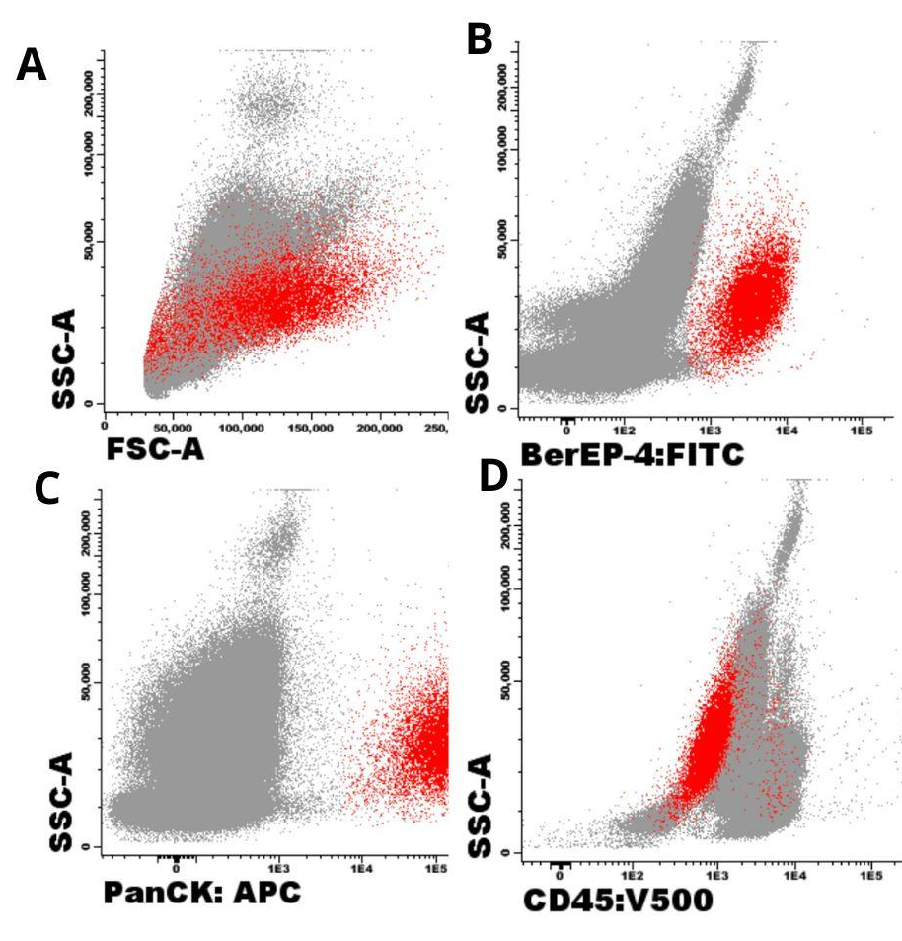

Figure 1. Dot plots representing immunophenotyping by flow cytometry of the bone marrow biopsy. In red, medium to large cells with high complexity (A) that display an epithelial phenotype: BerEP-4 ++ (B), PanCK+++ (C), and CD45- (C).

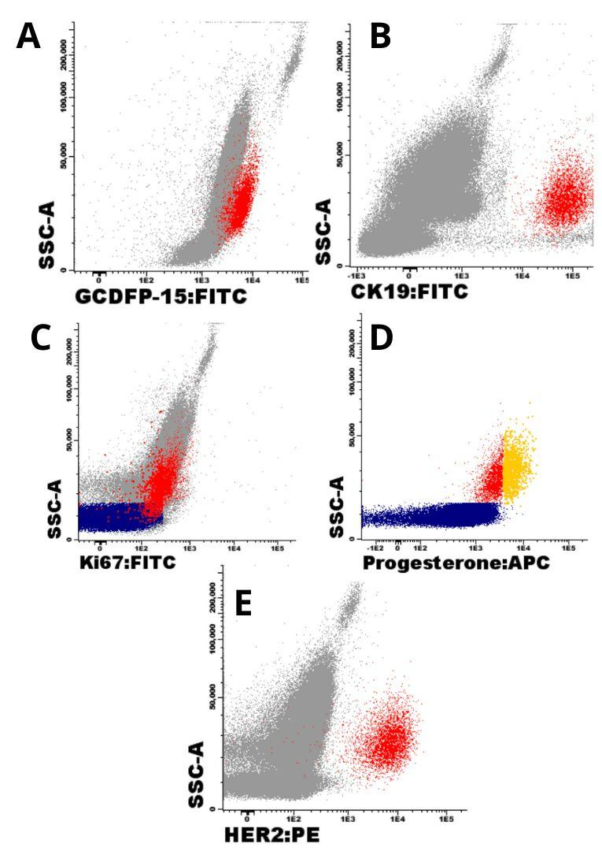

Figure 2. Dot plots representing immunophenotyping by flow cytometry of the bone marrow biopsy. In red, medium to large cells with high complexity that display a breast cancer phenotype: GCDFP-15+ (A), Cytokeratin 19 (CK-19) +++ (B), Ki67 55% (C), Receptor of progesterone +/- (33,10%) (D) and HER2- (E). In blue, lymphocytes that were used as a control. In yellow, the percentage of positivity of progesterone receptor.

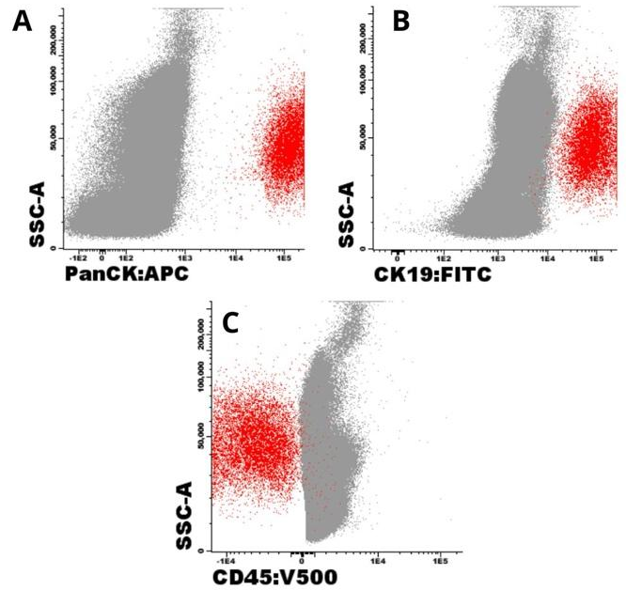

Figure 3. Dot plots representing immunophenotyping by flow cytometry of the peripheral blood. In red, circulating tumor cells that display a breast cancer phenotype: PanCK+++ (A), CK-19+++ (B), and CD45- (C).

The results of bone marrow infiltration by flow cytometry was consistent with the immunohistochemical evaluation (Figure 4), the gold standard for diagnosis, which observed metastatic infiltration by lobular carcinoma, with a positive immunophenotype for ER (+) (>66%), PR(+) (33 to 66%), HER2 (-) (score zero – ultra low), a proliferation index (40 to 50%), CK-19 (+) (strong and diffuse) and a cytokeratin cocktail (Pan-CK) (+) (strong and diffuse).

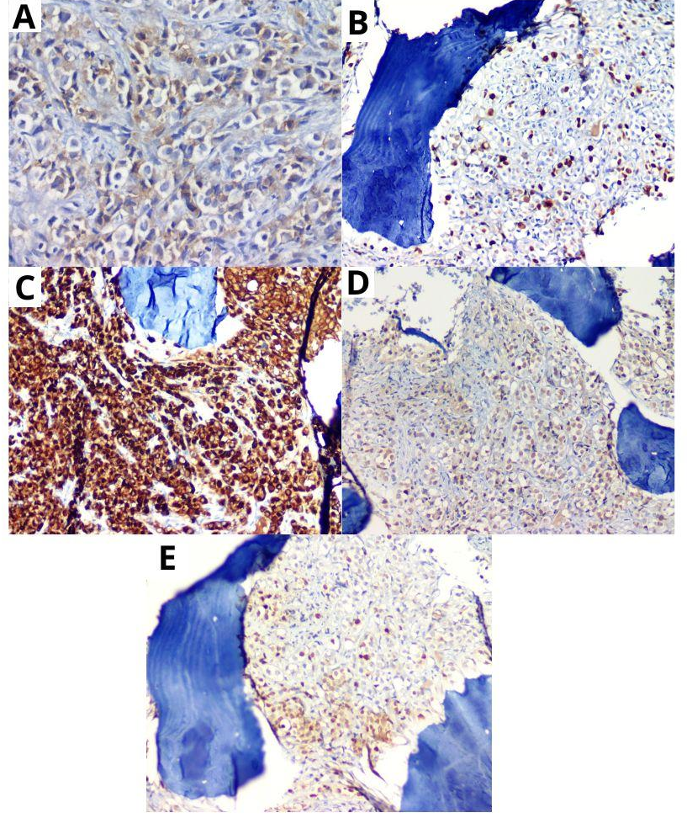

Figure 4. (A) Very rare membrane HER2 elements, score 0 (x40). (B) Tumor cells with IHC reaction to anti-Ki67 antibody (x20). (C) Strong and diffuse expression of CK-19 (x20) (D) Positive for ER (x20). (E) Weak positive for PR (x20).

Based on these results, paclitaxel was administered on Days 1, 8, and 15 every 21 days indefinitely. After starting chemotherapy, the patient reported decreased bone pain, decreased morphine use, and is stable.

- DISCUSSION

Breast cancer is a heterogeneous disease composed of distinct subtypes characterized by unique epidemiological patterns (9,10). Globally, breast cancer accounts for roughly one-third of all malignancies in women, with mortality representing approximately 15% of diagnosed cases (11). Many of these deaths result from metastatic disease, with the bone being one of the most frequent sites of metastasis (12).
Bone marrow involvement in breast cancer, also referred to as bone marrow metastasis, is a serious complication that impairs marrow function when cancer cells disseminate to this compartment (13). Upon reaching the bone marrow, tumor cells interact with the perivascular and endosteal niches, where they may either proliferate and colonize or enter a dormant state (14). In breast cancer, especially in estrogen receptor-positive (ER+) cases, this dormancy can persist from months to decades (14,15). Both lymph node (LN) status and the presence of disseminated tumor cells (DTCs) in the bone marrow are independent predictors of poor prognosis. However, the mechanisms dictating whether tumor cells spread via lymphatic or hematogenous routes remain unclear, and whether these are distinct processes is still under investigation (16).
Clinically, detecting brown bone holds significant prognostic implications. Studies have shown that the presence of DTCs in the bone marrow of breast cancer patients correlates with an increased risk of disease recurrence and reduced overall survival (14,15). Furthermore, identifying bone marrow and blood metastases can influence treatment strategies, including the consideration of systemic therapies with better bone marrow penetration or closer monitoring of disease progression (10).
Diagnosis of bone marrow metastasis typically combines imaging and bone marrow biopsy, particularly when cytopenia is present (12,13). The bone marrow biopsy is referred for a myelogram and immunohistochemistry analysis (gold standard). However, these methods may have limitations, especially when neoplastic infiltration is minimal or focal (16-20). In this context, flow cytometry has emerged as a sensitive and complementary diagnostic tool. While extensively used in hematologic malignancies, its application in detecting solid tumor cells in the bone marrow is less established but increasingly studied (21, 22).
Flow cytometry enables the detection of rare tumor cells based on specific immunophenotypic profiles, such as the expression of epithelial markers (e.g., BerEP-4, cytokeratins), the absence of hematopoietic markers like CD45 and the expression of breast markers (e.g., GCDFP-15, CK-19). This distinction is critical for accurately identifying and quantifying circulating tumor cells (CTCs) in both peripheral blood and bone marrow (6).
In the present case, flow cytometry provided essential diagnostic insights that were similar to the findings of the myelogram and immunohistochemistry. Immunophenotypic analysis by flow cytometry allowed precise characterization of neoplastic cells in the marrow, underscoring the importance of incorporating flow cytometry into the diagnostic workflow for suspected bone marrow metastases in solid tumors. It is worth noting that flow cytometry is a rapid technique, providing results in less than 4 hours. It is relatively inexpensive and offers high sensitivity and reproducibility compared to other methodologies. Furthermore, flow cytometry analysis also detected circulating tumor cells in the peripheral blood of these patients, which shows that there are cells in circulation that can form new metastatic sites beyond the bone marrow. These findings suggest that flow cytometry could also be utilized to evaluate treatment response and provide continuous disease monitoring, offering a minimally invasive approach to track tumor dynamics over time.
Early detection and treatment of bone marrow involvement in breast cancer can profoundly impact survival and quality of life. Chemotherapy can improve bone marrow function and extend survival in many cases (15). Ultimately, this case highlights the diagnostic value of flow cytometry in identifying bone marrow and blood metastases from breast cancer and supports its integration as a complementary tool to conventional methods, enhancing the detection of minimal marrow involvement, the detection of circulating tumor cells in blood, and contributing to more precise patient management.

- CONCLUSIONS

This report highlights the relevance of standardizing flow cytometry protocols for the detection of non-hematological cells in different biological samples, which contributes to the diagnosis and monitoring of patients with metastatic solid neoplasms.

Funding: This study was supported by grants and fellowships from National Council for Scientific and Technological Development - CNPq (n° 402416/2023-6) and Foundation for the Support of the Scientific and Technological Research of Santa Catarina (FAPESC). Santos-Silva MC is a recipient of a research fellowship from CNPq (Brazil).

Ethical Approval: The study received approval by the Ethical Committee of Federal University of Santa Catarina with protocol no: 75361223.6.0000.0121/2023.

Consent
As per international standards or university standards, patient(s) written consent has been collected and preserved by the author(s).

Disclaimer (Artificial intelligence): Author(s) hereby declare that NO generative AI technologies such as Large Language Models (ChatGPT, COPILOT, etc.) and text-to-image generators have been used during the writing or editing of this manuscript.

References

- NORDENSKJÖLD AE, FOHLIN H, ARNESSON LG, EINBEIGI Z, HOLMBERG E, ALBERTSSON P, et al. Breast cancer survival trends in different stages and age groups – a population-based study 1989–2013. Acta Oncologica 2018. 58:45-51.

- SIEGEL RL, MILLER KD, FUCHS HE, JEMAL A. Cancer Statistics, 2021. Ca: A Cancer Journal for Clinicians 2021.71:7-33.

- Agostini M, Mancini M, Candi E. Long non-coding RNAs affecting cell metabolism in cancer. Biol Direct. (2022) 17:26. doi: 10.1186/s13062-022-00341-x

- Zuo Q, Park NH, Lee JK, Madak Erdogan Z. Liver metastatic breast cancer: epidemiology, dietary interventions, and related metabolism. Nutrients. (2022) 14:2376. doi: 10.3390/nu14122376

- ZHANG, Lanxin; CHEN, Fengxi; XU, Lingzhi; LI, Ning; ZHUO, Qiping; GUO, Yijin; WANG, Xueqing; WEN, Meijie; ZHAO, Zuowei; LI, Man. Comprehensive review of solid tumor bone marrow metastasis. Critical Reviews In Oncology/Hematology, [S.L.], v. 194, p. 104248, fev. 2024.

- Vieira DSC, Walter LO, Cunha-Silva ME, Silva LO, Costa HZ, Cardoso CC, Schmitt FCL, Santos-Silva,MC. Bulk-lysis protocols as a sensitive method for investigation of circulating CK19 cells in the peripheral blood of patients with breast cancer by flow cytometry. Analytical Methods (2025). Doi: https://doi.org/10.1039/d5ay00295h

- Wang, N., Shi, L., Li, H., Hu, Y., Du, W., Liu, W., ... & Qu, X. (2012). Detection of circulating tumor cells and tumor stem cells in patients with breast cancer by using flow cytometry: a valuable tool for diagnosis and prognosis evaluation. Tumor Biology, 33(2), 561-569.

- Cabioglu, N., Igci, A., Yildirim, E. O., Aktas, E., Bilgic, S., Yavuz, E., ... & Deniz, G. (2002). An ultrasensitive tumor enriched flow-cytometric assay for detection of isolated tumor cells in bone marrow of patients with breast cancer. The American journal of surgery, 184(5), 414-417.

- Xiong, X., Zheng, LW., Ding, Y. et al. Breast cancer: pathogenesis and treatments. Sig Transduct Target Ther 10, 49 (2025). https://doi.org/10.1038/s41392-024-02108-4

- Wu J, Fan D, Shao Z, et al. CACA Guidelines for Holistic Integrative Management of Breast Cancer. Holist Integr Oncol. 2022;1(1):7. doi:10.1007/s44178-022-00007-8

- World Health Organization. Breast cancer. 2021. https://www.who.int/news-room/fact-sheets/detail/breast-cancer (accessed 10 January 2022)

- Kim M. Y. (2021). Breast Cancer Metastasis. Advances in experimental medicine and biology, 1187, 183–204. https://doi.org/10.1007/978-981-32-9620-6_9

- SÜTCÜOğLU, Osman; ÖZDEMIR, Nuriye; YAZđCđ, Ozan; ÖZET, Ahmet. Bone marrow involvement in breast cancer. Current Problems In Cancer, [S.L.], v. 46, n. 1, p. 100785, fev. 2022.

- Mayhew V, Omokehinde T, Johnson RW. Tumor dormancy in bone. Cancer Rep (Hoboken). 2020;3(1):e1156. doi:10.1002/cnr2.1156

- Yang R, Jia L, Lu G, Lv Z, Cui J. Symptomatic bone marrow metastases in breast cancer: A retrospective cohort study. Front Oncol. 2022 Dec 19;12:1042773. doi: 10.3389/fonc.2022.1042773. PMID: 36605432; PMCID: PMC9808780.

- Hartkopf AD, Banys M, Krawczyk N, et al. Bone marrow versus sentinel lymph node involvement in breast cancer: a comparison of early hematogenous and early lymphatic tumor spread. Breast Cancer Res Treat. 2012;131(2):501-508. doi:10.1007/s10549-011-1802-x

- Zhang, L., Chen, F., Xu, L., Li, N., Zhuo, Q., Guo, Y., Wang, X., Wen, M., Zhao, Z., & Li, M. (2023). Comprehensive review of solid tumor bone marrow metastasis.. Critical reviews in oncology/hematology, 104248 . https://doi.org/10.1016/j.critrevonc.2023.104248.

- Yang, R., Jia, L., & Cui, J. (2024). Mechanism and clinical progression of solid tumors bone marrow metastasis. Frontiers in Pharmacology, 15. https://doi.org/10.3389/fphar.2024.1390361.

- Arslantaş, E., Aycicek, A., Özkara, S., Karagenç, A., Tekgündüz, S., Yıldırgan, D., Güçer, T., Kaçar, A., Hançerli, Ö., Ertürk, S., Uysalol, E., & Bayram, C. (2024). Comparison of Bone Marrow Biopsy and Flow Cytometry in Demonstrating Bone Marrow Metastasis of Neuroblastoma. Diagnostics, 14. https://doi.org/10.3390/diagnostics14242776.

- Popov, A., Druy, A., Shorikov, E., Verzhbitskaya, T., Solodovnikov, A., Saveliev, L., Tytgat, G., Tsaur, G., & Fechina, L. (2019). Prognostic value of initial bone marrow disease detection by multiparameter flow cytometry in children with neuroblastoma. Journal of Cancer Research and Clinical Oncology, 145, 535-542. https://doi.org/10.1007/s00432-018-02831-w.

- WOPEREIS, Sandro; WALTER, Laura Otto; VIEIRA, Daniella Serafin Couto; RIBEIRO, Amanda Abdalla Biasi; FERNANDES, Bráulio Leal; WILKENS, Renato Salerno; SANTOS-SILVA, Maria Cláudia. Evaluation of ER, PR and HER2 markers by flow cytometry for breast cancer diagnosis and prognosis. Clinica Chimica Acta, [S.L.], v. 523, p. 504-512, dez. 2021.

- Vieira DSC, Wopereis S, Walter LO, et al. Analysis of Ki-67 expression in women with breast cancer: Comparative evaluation of two different methodologies by immunophenotyping. Pathol Res Pract. 2022;230:153750. doi:10.1016/j.prp.2021.153750

