Soil and Vegetation Responses to Mining Disturbance Across Substrates in Tropical Dry Deciduous Forests, Prayagraj, India

Abstract
Mining induced landscape degradation poses a critical ecological threat to tropical forests. Grounded in disturbance ecology, this study compares the effects of stone and silica sandstone mining on soil physicochemical properties and vegetation structure to assess whether the ecological responses are generalizable or substrate-specific. Field data were collected along a distance gradient from mining sites, integrating soil analyses with phytosociological assessment. Soil fertility parameters including water holding capacity, total organic carbon, nitrogen, and phosphorus, were consistently reduced near mines and increased with distance, indicating clear disturbance gradients, whereas potassium showed an opposite trend. Soil moisture exhibited site-specific pattern, with higher values near the stone mine likely due to sparse vegetation cover. PERMANOVA confirmed strong zonal structuring of soil properties, with depth effects significant only at the stone site, indicating contrasting vertical recovery dynamics. Vegetation responses mirrored these patterns, with low species richness, reduced diversity, and dominance of pioneer taxa near mines, followed by gradual recovery. However, the silica sandstone site retained sparse woody vegetation and more balance IVI near the mines, suggesting greater structural resilience of plant community. Together, these findings demonstrate that substrate type mediates soil-vegetation recovery, influencing both successional trajectories and ecosystem stability. The study advance disturbance ecology by highlighting substrate-dependent recovery pathways and provides a transferable framework for restoration of mining-impacted tropical forests.
Keywords: Disturbance Ecology, PERMANOVA, Phytosociology, Quarrying, Successional Dynamics
1. Introduction
Mining is an intensive land use that fundamentally alters ecosystem structure and function. This degradation is one of the most persistent and spatially extensive anthropogenic pressures on terrestrial ecosystems worldwide. Open cast extraction of minerals and building materials disrupts soil structure, hydrology, and vegetation cover, thereby destabilizing the ecological balance and reducing long term productivity of landscapes. Globally, mining contributes to extensive habitat loss, fragmentation, and topsoil depletion, driving both biodiversity decline and soil fertility loss (Belay et al., 2020; Erener, 2011; Pal & Mandal, 2017; Yang et al., 2022). In India, where rapid infrastructural expansion has intensified mineral extraction, open cast operations such as stone and silica sandstone mining have become significant contributors to localized ecological degradation and landscape transformation (Mishra, 2015; Prajapati et al., 2020).
In tropical dry deciduous forests, the stability and functioning of ecosystems depend strongly on reciprocal soil-vegetation interactions. Soil, as the primary reservoir of plant nutrients, water, and microbial communities, plays a foundational role in terrestrial ecosystems (Ma et al., 2020). Soil governs nutrient supply, water availability, and microbial activity that sustain plant growth (Gong et al., 2019; Liu et al., 2021), while vegetation modifies soil structure and chemistry through litter inputs, root turnover, and symbiotic microbial processes (Dungait et al., 2012; Gu et al., 2022). These feedbacks form the foundation of ecosystem resilience, where recovery of vegetation enhances soil fertility, and improved soil conditions, in turn, facilitate further vegetation establishment. When mining removes topsoil, disrupts hydrological continuity, and eliminates vegetation cover, these positive feedback collapse, leading to a self-reinforcing cycle of nutrient depletion and inhibited regeneration (Kidinda et al., 2023; Zifcakova, 2020). Consequently, the rate and trajectory of ecological recovery depend on how quickly these soil-vegetation feedbacks are re-established following the disturbance.
The theoretical framework for understanding these patterns lies in disturbance ecology, which suggests that ecosystem structure and function are regulated by the interaction among the intensity, frequency, and recovery capacity of disturbances. Disturbances such as mining resets successional trajectories by removing biomass, modifying substrate composition, and altering microclimate. Ecosystem resilience, and the capacity to recover structure and function depends on propagule availability, substrate characteristics, and feedback mechanisms between soil fertility and vegetation assembly (Liu et al., 2021; Wu et al., 2024). However, resilience in mined landscapes is often constrained by physical compaction, altered hydrology, and nutrient depletion, leading to slow or arrested succession (Gong et al., 2019; Pal & Mandal, 2017). Comparative analyses across different mining substrates can thus reveal how geological and edaphic contexts govern these recovery pathways, contributing to a broader understanding of disturbance-recovery dynamics in tropical ecosystems.
While the ecological impacts of individual mining types have been documented, stone quarrying for its compaction and dust pollution (Akanwa et al., 2017; Belay et al., 2020; Pal & Mandal, 2017), and silica sandstone extraction for its erosion and leaching effect (Mishra, 2015; Dubey & Dubey, 2011; Grbeš, 2015), a comparative evaluation across mining systems under uniform climatic conditions remain scarce.
Addressing this gap, this study compares the impact of stone mining and silica sandstone mining on soil physicochemical properties and plant community structure along a distance gradient from the mining site, within tropical dry deciduous forest ecosystems of northern India. Using a unified sampling design and spatial gradient based framework, this study examines how two different mining substrate restructure soil physicochemical properties and vegetation organization across disturbed forest landscapes. By jointly evaluating horizontal distance effects, vertical soil differentiation, and vegetation-soil linkages, the study assesses disturbance responses that are consistent with broader disturbance ecology theory and also contingent on underlying geological characteristics. By doing so, the study advances the understanding of how anthropogenic disturbances restructure forest ecosystems, and provides a transferable framework for restoration and policy interventions.
2. Material and Methods
2.1. Study Area
The study was conducted in two forest sites located in Prayagraj, Uttar Pradesh, India (Fig. 1); one near an abandoned stone mine in Meja (25º07’39” N, 82º04’02” E), and other near silica sandstone mine in Shankargarh (25º15’25” N, 81º35’13” E). Both regions experience a tropical climate with mean annual temperature of 25º C to 30º C, and mean annual rainfall ranging between 850 to 1000 mm, concentrated during monsoon months, followed by prolonged dry seasons extending for five to six months. The natural vegetation of the area represents a tropical dry deciduous forest, characterized by mixed strata of trees, shrubs, and herbs adapted to moderate rainfall, high temperature fluctuations, and seasonal drought.
Fig. 1: Map of The Study Area
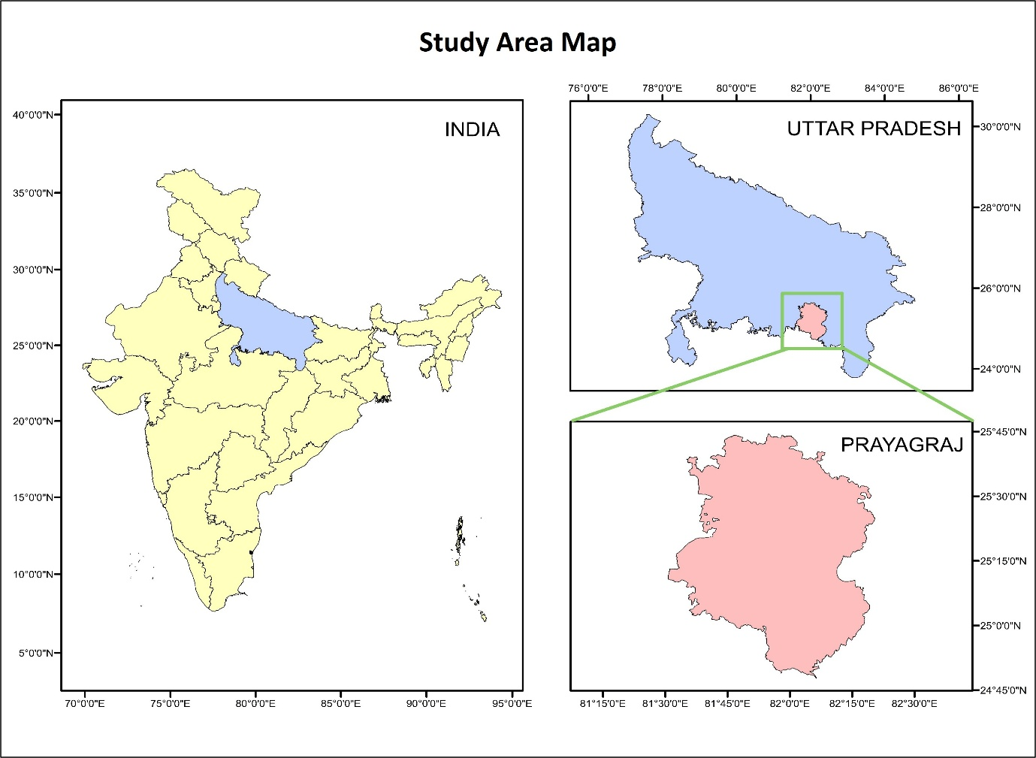

2.2. Sampling Design
Based on pilot survey of both the sites, a stratified distance based approach was used to capture a gradient of mining impact. Three zones were defined:
- Zone 1 (Z1): Adjacent to the mine (0 km)
- Zone 2 (Z2): 1 km from the mine
- Zone 3 (Z3): 2 km from the mine
Each zone comprised 15 sampling points, yielding a total of 45 sampling points per study site. Soil samples were collected at two depths per point: surface (0-20 cm, designated as A) and subsurface (20-40 cm, designated as B), to assess vertical variation in soil properties. Vegetation data were collected using quadrat method with nested quadrats, of size 30×30 m for trees, 3×3 m for shrubs, and 1×1 m for herbs (Vandita & Dubey, 2025).
2.3. Soil Analysis
Soil samples were analyzed for physicochemical properties using standard protocol. Soil Moisture (SM) content was estimated by oven drying 100g soil sample at 80°C to constant weight. Water Holding Capacity (WHC) was measured by saturation and drainage method. Soil pH was measured using pH meter, and Electrical Conductivity (EC) was measured using conductivity meter. Total Organic Carbon (TOC) was estimated using Walkley and Black method, available nitrogen using the Kjeldahl digestion method, available phosphorus by Oslen method, and available potassium using flame photometry.
2.4. Statistical Analysis
Statistical analyses were conducted to assess variation in soil physicochemical properties across zones and depths, and to compare patterns between the two mining sites. All statistical procedures were executed in RStudio (version 4.5.1).
Prior to multivariate testing, multicollinearity among soil variables was checked (Variance Inflation Factor < 5), and then variables were standardized to eliminate scale effects. Homogeneity of multivariate dispersion among groups was evaluated (P > 0.05) to validate the use of Permutational Multivariate Analysis of Variance (PERMANOVA) for subsequent analyses. A Euclidean dissimilarity matrix was then constructed based on standardized data to examine the effects of Zone, Depth, and their interaction on overall soil physicochemical composition using two-factor PERMANOVA with 999 permutations. Principal Coordinates Analysis (PCoA) was performed on the Euclidean dissimilarity matrix to visualize patterns of multivariate soil variation across zones and soil depths.
2.5. Vegetation Analysis
The Importance Value Index (IVI) was used to assess the overall ecological significance of each species within the community and was computed as the sum of relative density, relative frequency, and relative dominance, as used by (Curtis & Mcintosh, 1951).
Species richness was estimated using Margalef’s index (Margalef, 1973), which accounts for the number of species in relation to the total number of individuals.
SR = (S-1)/ln N
Where, SR = Margalef’s index of species richness
S = total number of species
N = total number of individuals
Species diversity was assessed using the Shannon-Wiener Diversity Index (H’) (Weaver, 1963), which reflects both species richness and the evenness of species distribution.
H’ = -$\sum_{i=1}^{S}{pi\log{pi}}$
Where, S= no. of species,
pi= proportion of total sample belonging to i^{th} species
Species evenness was calculated using Pielou’s Evenness Index (J) (Pielou, 1966), indicating how evenly individuals are distributed among the species.
J = H’/log S
Where, S = total number of species
Concentration of Dominance (CD) (Simpson, 1949) was estimated to understand the extent to which a few species dominate the community structure.
CD = $\sum_{i=1}^{S}{(ni/N)²}$
Where, S = total number of species;
ni = number of individuals of a particular species;
N = total number of individuals
3. Results
3.1. Soil Physicochemical Properties
Soil physicochemical attributes showed notable spatial variation across distance gradient between both landscapes (Table 1 & 4). At both, stone mining & silica sandstone mining site, proximity to the mine corresponded with a decline in soil fertility parameters. At both the sites, WHC, TOC, EC, and available N and P were lowest in Zone 1 and progressively increased with distance (Fig. 2 & 4), revealing a clear disturbance gradient. Soil pH remained nearly neutral (6.7-7.2) across all zones. TOC increased across the distance gradient mirroring gains in organic matter.
In contrast, at stone mining site, SM was paradoxically higher near the mine in Zone 1B (7.42 ± 0.61 %) and lowest in Zone 3A (3.73 ± 0.34 %) (Fig. 2). This inverse pattern likely reflects suppressed transpiration and minimal plant uptake in Zone 1, where vegetation was sparse and herbaceous. Available potassium was highest adjacent to the mine at both sites, plausibly due to enhanced mineral weathering and limited nutrient uptake.
3.2. Multivariate Patterns of Soil Property Variation
PERMANOVA confirmed that mining distance significantly structured soil heterogeneity at both sites. The assumption of homogenous multivariate dispersion within groups was satisfied for both the sites (P > 0.05), ensuring model validity.
At the stone mining site, the two-factor PERMANOVA showed that distance from the mine (Zones) was a highly significant (P = 0.001) determinant of soil properties, explaining 59.5% of the total variation (R² = 0.595). Depth also contributed significantly (P = 0.001), accounting for 12.5% of the variation, whereas the zone × depth interaction effect was insignificant (p = 0.424). This confirms that spatial variation across zones was the dominant driver of soil composition heterogeneity, with a secondary effect of depth.
At silica mining site, the zonal effect was even stronger, explaining 64.2% of the variations. Depth effect, however, was not significant (P = 0.059), confirming that soil properties did not differ significantly between surface and subsurface layers. At this site as well the zone × depth interaction effect was insignificant (P = 0.065), indicating that the depth related variations did not differ systematically among zones.
The PCoA ordination depicted the distinct multivariate soil responses to stone mining and silica sandstone mining. The stone mining site (Fig. 3), showed both strong zonal segregation and a pronounced depth related separation, with surface and subsurface soils forming partially distinct clusters withing zones. In contrast, at the silica mining site (Fig. 5), soil physicochemical properties were structured predominantly by zone, with a strong and ordered separation along the primary axis and substantial overlap between depths within each zone; as also confirmed by PERMANOVA results where the depth effect was found insignificant and horizontal disturbance gradients outweighed vertical differentiation.
3.3. Vegetation Composition and Diversity
Vegetation composition reflected distinct contrast in successional status between the two sites and along the distance gradients. At stone mining site, Zone 1 was nearly barren, supporting only herbaceous vegetation. Besides herbs, Zone 2 contained sparse shrubs and a single tree species (P. pinnata), while Zone 3 supported complete vegetation strata with higher species richness and structural complexity (Table 2 & 3). Species richness and diversity indices for herbs increased with distance, indicating gradual reassembly and reduced dominance. Shrubs and tree layers also showed higher evenness and lower dominance in Zone 3, indicating more stable communities.
At silica mining site, all the three vegetation strata were present in the Zone 1, though it consisted of only few species in each stratum. Among tree species in Zone 1, S. siamea had highest IVI (189.34), followed by B. serrata (72.37), and A. indica as low as 38.29, reflecting dominance and ecological influence of a single tree species in this zone which contributes most to the community structure (Table 5). Species richness, diversity and evenness of herbs and trees improved with distance, but shrub diversity peaked in Zone 2, indicating mid-successional heterogeneity (Table 6). The persistence of woody species in all zones at this site and more balanced IVI distribution across strata indicate toward substrate dependent recovery trajectory.
Table 1: Soil physicochemical properties of stone mining site
Parameter | Zone | Min | Max | Mean | *SD | Parameter | Zone | Min | Max | Mean | *SD
Soil Moisture (%) | 1A | 4.76 | 6.68 | 5.78 | 0.64 | WHC (%) | 1A | 33 | 42 | 37.93 | 2.49
Soil Moisture (%) | 1B | 6.24 | 8.24 | 7.42 | 0.61 | WHC (%) | 1B | 28 | 37 | 32.33 | 2.58
Soil Moisture (%) | 2A | 3.5 | 4.35 | 3.79 | 0.25 | WHC (%) | 2A | 47 | 56 | 51.73 | 2.58
Soil Moisture (%) | 2B | 3.79 | 4.88 | 4.30 | 0.35 | WHC (%) | 2B | 42 | 49 | 45.93 | 2.05
Soil Moisture (%) | 3A | 3.3 | 4.43 | 3.73 | 0.34 | WHC (%) | 3A | 58 | 65 | 61.33 | 2.02
Soil Moisture (%) | 3B | 3.56 | 5.84 | 4.60 | 0.61 | WHC (%) | 3B | 53 | 60 | 56.60 | 1.88
pH | 1A | 6.8 | 7.1 | 6.97 | 0.11 | Electrical Conductivity (dS/m) | 1A | 0.34 | 0.38 | 0.36 | 0.01
pH | 1B | 6.7 | 7.1 | 6.85 | 0.15 | Electrical Conductivity (dS/m) | 1B | 0.34 | 0.4 | 0.37 | 0.02
pH | 2A | 6.8 | 7.2 | 7.00 | 0.15 | Electrical Conductivity (dS/m) | 2A | 0.42 | 0.51 | 0.46 | 0.03
pH | 2B | 6.7 | 7.1 | 6.90 | 0.13 | Electrical Conductivity (dS/m) | 2B | 0.43 | 0.53 | 0.48 | 0.03
pH | 3A | 6.8 | 7.2 | 6.97 | 0.13 | Electrical Conductivity (dS/m) | 3A | 0.47 | 0.53 | 0.51 | 0.02
pH | 3B | 6.7 | 7.1 | 6.90 | 0.11 | Electrical Conductivity (dS/m) | 3B | 0.47 | 0.54 | 0.52 | 0.02
Total Organic Carbon (%) | 1A | 0.54 | 0.94 | 0.75 | 0.12 | Available Nitrogen (mg/kg) | 1A | 55.19 | 73.74 | 66.03 | 6.14
Total Organic Carbon (%) | 1B | 0.47 | 0.85 | 0.65 | 0.11 | Available Nitrogen (mg/kg) | 1B | 39.87 | 57.24 | 48.89 | 5.52
Total Organic Carbon (%) | 2A | 0.84 | 1.26 | 1.01 | 0.14 | Available Nitrogen (mg/kg) | 2A | 65.96 | 85.72 | 76.36 | 7.59
Total Organic Carbon (%) | 2B | 0.66 | 1.11 | 0.85 | 0.13 | Available Nitrogen (mg/kg) | 2B | 48.15 | 69.45 | 58.44 | 7.52
Total Organic Carbon (%) | 3A | 1.2 | 2.28 | 1.75 | 0.32 | Available Nitrogen (mg/kg) | 3A | 69.34 | 110.64 | 89.70 | 14.41
Total Organic Carbon (%) | 3B | 1.07 | 1.91 | 1.54 | 0.27 | Available Nitrogen (mg/kg) | 3B | 53.84 | 96.25 | 71.96 | 13.97
Available Phosphorus (mg/kg) | 1A | 12.44 | 17.87 | 15.01 | 1.82 | Available Potassium (mg/kg) | 1A | 235.75 | 263.83 | 252.43 | 9.09
Available Phosphorus (mg/kg) | 1B | 8.15 | 14.56 | 11.40 | 2.09 | Available Potassium (mg/kg) | 1B | 230.15 | 259.48 | 247.13 | 9.23
Available Phosphorus (mg/kg) | 2A | 13.48 | 18.59 | 15.81 | 1.41 | Available Potassium (mg/kg) | 2A | 218.45 | 246.49 | 232.52 | 9.26
Available Phosphorus (mg/kg) | 2B | 8.49 | 14.09 | 11.73 | 1.53 | Available Potassium (mg/kg) | 2B | 211.48 | 239.68 | 224.91 | 8.97
Available Phosphorus (mg/kg) | 3A | 18.43 | 26.56 | 22.44 | 2.80 | Available Potassium (mg/kg) | 3A | 213.94 | 238.79 | 226.88 | 8.65
Available Phosphorus (mg/kg) | 3B | 13.59 | 21.06 | 17.09 | 2.56 | Available Potassium (mg/kg) | 3B | 203.54 | 229.72 | 217.65 | 8.14
(*SD = Standard deviation)
Fig. 2: Soil physicochemical properties, Soil Moisture (SM), Water Holding Capacity (WHC), pH, Electrical Conductivity (EC), Total Organic Carbon (TOC), Available Nitrogen (N), Available Phosphorus (P), Available Potassium (K), of stone mining site

Fig. 3: Principal Coordinates Analysis (PCoA) of soil physicochemical properties of stone mining site
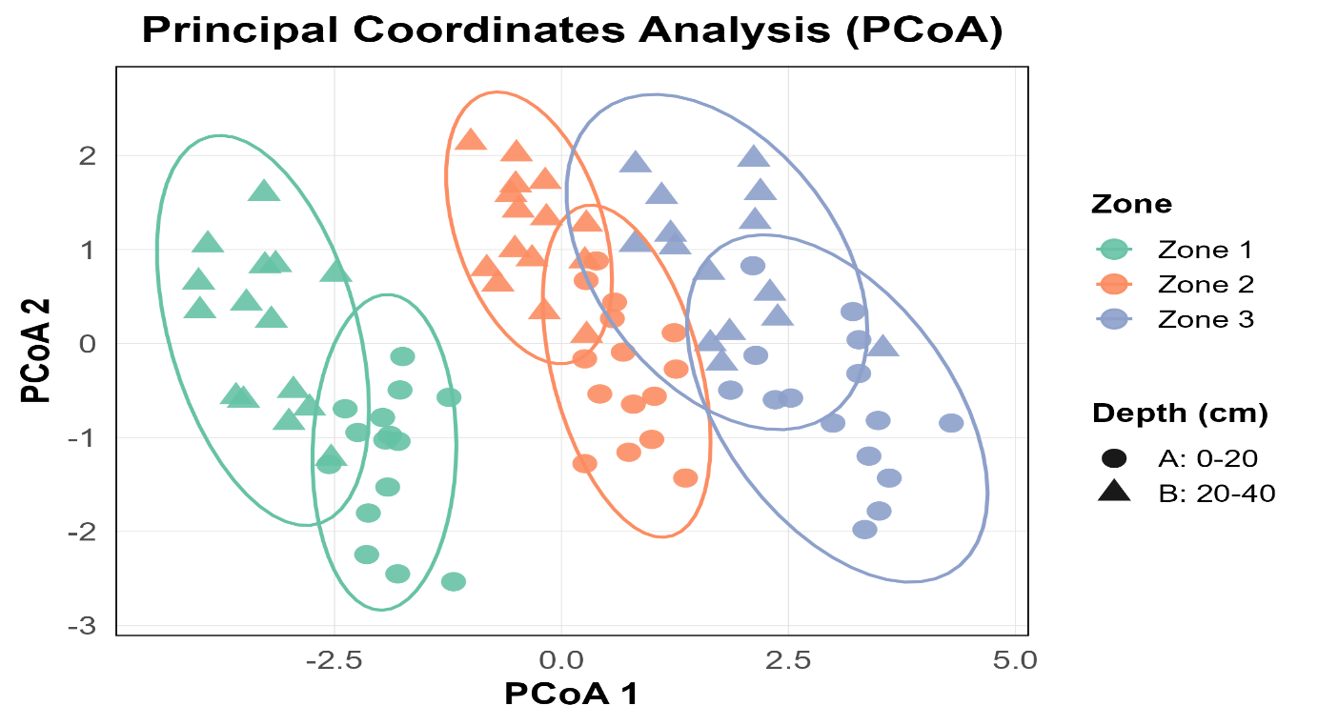Table 2: Plant species and IVI score of stone mining site
Zone 1 |  | Zone 2 |  | Zone 3
Plant | IVI | Plant | IVI | Plant | IVI
Herb Species |  | Herb Species |  | Herb Species
Setaria pumila | 66.85 | Setaria pumila | 70.23 | Ocimum gratissimum | 48.10
Ocimum gratissimum | 49.27 | Ocimum gratissimum | 53.04 | Setaria pumila | 45.67
Melochia corchorifolia | 46.56 | Elytraria acaulis | 41.50 | Blepharia repens | 33.32
Spermacoce hispida | 39.59 | Spermacoce hispida | 32.63 | Chenopodium album | 30.70
Indigofera tinctoria | 30.53 | Hemidesmus indicus | 18.28 | Alloteropsis cimicina | 29.72
Merremia tridentata | 18.89 | Croton bonplandifolium | 17.72 | Elytraria acaulis | 26.89
Cassia pumila | 14.74 | Merremia tridentata | 17.45 | Corcorus aestuans | 21.98
Alloteropsis cimicina | 12.29 | Sida cordata | 13.71 | Justicia prostrata | 18.48
Hemidesmus indicus | 11.52 | Ipomoea pes-tigridis | 12.92 | Indigofera leanea | 15.90
Desmodium triflorum | 9.76 | Desmodium triflorum | 12.27 | Desmodium triflorum | 14.64
 |  | Cassia pumila | 10.25 | Hemidesmus indicus | 14.60
 |  | Shrub Species |  | Shrub Species
 |  | Ziziphus jujuba | 132.37 | Lantana camara | 120.79
 |  | Prosopis juliflora | 97.00 | Ziziphus jujuba | 106.74
 |  | Lantana camara | 70.62 | Prosopis juliflora | 72.48
 |  |  |  | Tree Species
 |  |  |  | Madhuca longifolia | 112.23
 |  |  |  | Butea monosperma | 94.07
 |  |  |  | Senna siamea | 93.70

Table 3: Species richness, species diversity, species evenness, and concentration of dominance for different vegetation strata across the three zones of stone mining site
Parameter | Z1 HERB |  | Z2 HERB | Z3 HERB | Z2 SHRUB | Z3 SHRUB | Z3 TREE
Species Richness |  | 1.21 | 1.29 | 1.38 | 0.46 | 0.57 | 0.34
Species Diversity |  | 0.68 | 0.83 | 0.91 | 0.47 | 0.47 | 0.39
Species Evenness |  | 0.68 | 0.79 | 0.87 | 0.98 | 0.98 | 0.81
Concentration of Dominance |  | 0.32 | 0.22 | 0.16 | 0.35 | 0.35 | 0.44

Table 4: Soil physicochemical properties of silica mining site
Parameter | Zone | Min |  | Max | Mean | *SD | Parameter | Zone | Min | Max | Mean | *SD
Soil Moisture (%) | 1A | 2.46 |  | 3.34 | 2.89 | 0.64 | WHC (%) | 1A | 27 | 34 | 30.27 | 2.25
Soil Moisture (%) | 1B | 2.68 |  | 3.61 | 3.13 | 0.61 | WHC (%) | 1B | 29 | 37 | 32.73 | 2.66
Soil Moisture (%) | 2A | 3.97 |  | 5.61 | 4.83 | 0.25 | WHC (%) | 2A | 34 | 43 | 38.40 | 2.95
Soil Moisture (%) | 2B | 4.56 |  | 5.93 | 5.27 | 0.35 | WHC (%) | 2B | 37 | 46 | 40.67 | 3.04
Soil Moisture (%) | 3A | 5.97 |  | 8.02 | 7.00 | 0.34 | WHC (%) | 3A | 42 | 54 | 47.40 | 3.94
Soil Moisture (%) | 3B | 6.87 |  | 8.63 | 7.84 | 0.61 | WHC (%) | 3B | 48 | 61 | 55.00 | 4.28
pH | 1A | 6.9 |  | 7.2 | 7.02 | 0.09 | Electrical Conductivity (dS/m) | 1A | 0.35 | 0.39 | 0.37 | 0.01
pH | 1B | 6.8 |  | 7.1 | 6.94 | 0.09 | Electrical Conductivity (dS/m) | 1B | 0.36 | 0.4 | 0.38 | 0.01
pH | 2A | 6.9 |  | 7.1 | 6.99 | 0.08 | Electrical Conductivity (dS/m) | 2A | 0.36 | 0.39 | 0.38 | 0.01
pH | 2B | 6.8 |  | 7 | 6.90 | 0.08 | Electrical Conductivity (dS/m) | 2B | 0.37 | 0.41 | 0.39 | 0.02
pH | 3A | 6.9 |  | 7.2 | 7.05 | 0.11 | Electrical Conductivity (dS/m) | 3A | 0.38 | 0.45 | 0.41 | 0.02
pH | 3B | 6.8 |  | 7.1 | 6.95 | 0.10 | Electrical Conductivity (dS/m) | 3B | 0.39 | 0.46 | 0.42 | 0.02
Total Organic Carbon (%) | 1A | 0.66 |  | 1.24 | 0.95 | 0.20 | Available Nitrogen (mg/kg) | 1A | 56.78 | 73.21 | 65.25 | 5.59
Total Organic Carbon (%) | 1B | 0.61 |  | 1.03 | 0.82 | 0.13 | Available Nitrogen (mg/kg) | 1B | 55.32 | 71.56 | 62.70 | 5.40
Total Organic Carbon (%) | 2A | 0.93 |  | 2.13 | 1.50 | 0.33 | Available Nitrogen (mg/kg) | 2A | 68.79 | 83.01 | 75.25 | 4.74
Total Organic Carbon (%) | 2B | 0.69 |  | 1.74 | 1.16 | 0.29 | Available Nitrogen (mg/kg) | 2B | 65.97 | 78.5 | 72.51 | 4.31
Total Organic Carbon (%) | 3A | 1.34 |  | 2.29 | 1.84 | 0.31 | Available Nitrogen (mg/kg) | 3A | 83.29 | 97.12 | 90.36 | 4.32
Total Organic Carbon (%) | 3B | 1.08 |  | 1.93 | 1.61 | 0.28 | Available Nitrogen (mg/kg) | 3B | 69.25 | 86.4 | 76.52 | 5.43
Available Phosphorus (mg/kg) | 1A | 12.82 |  | 19.58 | 16.36 | 2.12 | Available Potassium (mg/kg) | 1A | 251.88 | 278.11 | 265.49 | 8.66
Available Phosphorus (mg/kg) | 1B | 12.05 |  | 17.62 | 15.06 | 1.74 | Available Potassium (mg/kg) | 1B | 245.19 | 271.88 | 258.81 | 9.06
Available Phosphorus (mg/kg) | 2A | 22.18 |  | 27.53 | 24.86 | 1.72 | Available Potassium (mg/kg) | 2A | 220.78 | 246.05 | 234.02 | 8.54
Available Phosphorus (mg/kg) | 2B | 21.48 |  | 25.33 | 23.43 | 1.31 | Available Potassium (mg/kg) | 2B | 218.92 | 241.1 | 231.00 | 7.81
Available Phosphorus (mg/kg) | 3A | 27.88 |  | 32.11 | 29.98 | 1.41 | Available Potassium (mg/kg) | 3A | 216.78 | 239.01 | 229.26 | 7.20
Available Phosphorus (mg/kg) | 3B | 24.87 |  | 28.12 | 26.28 | 1.11 | Available Potassium (mg/kg) | 3B | 214.63 | 236 | 226.47 | 7.20
(*SD = Standard deviation)
Fig. 4: Soil physicochemical properties, Soil Moisture (SM), Water Holding Capacity (WHC), pH, Electrical Conductivity (EC), Total Organic Carbon (TOC), Available Nitrogen (N), Available Phosphorus (P), Available Potassium (K), of silica mining site
Fig. 5: Principal Coordinates Analysis (PCoA) of soil physicochemical properties of silica mining site
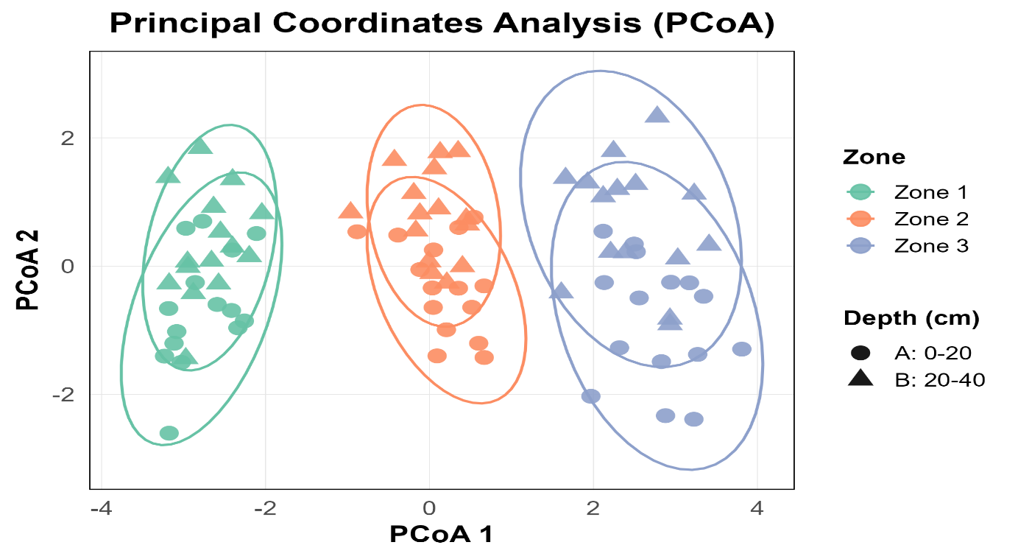Table 5: Plant species and IVI score of silica mining site
Zone 1 |  | Zone 2 |  | Zone 3
Plant | IVI | Plant | IVI | Plant | IVI
Herb Species |  | Herb Species |  | Herb Species
Ocimum gratissimum | 95.80 | Gomphrena celosioides | 59.18 | Evolvulus alsinoides | 24.78
Heteropogon contortus | 70.18 | Indigofera linnaei | 47.32 | Cynodon dactylon | 38.44
Eragrostis tenella | 68.86 | Euphorbia hirta | 43.61 | Ocimum gratissimum | 83.29
Evolvulus alsinoides | 38.99 | Euphorbia prostrata | 20.93 | Indigofera linnaei | 25.94
Sida acuta | 26.12 | Ocimum gratissimum | 66.88 | Heteropogon contortus | 43.89
Shrub Species |  | Heteropogon contortus | 62.05 | Sida acuta | 24.44
Lantana camara | 145.39 | Shrub Species |  | Tridax procumbens | 46.36
Prosopis juliflora | 154.61 | Carissa spinarum | 66.05 | Justicia prostrata | 12.84
Tree Species |  | Ziziphus nummuralifolia | 47.58 | Shrub Species
Senna siamea | 189.34 | Lantana camara | 71.33 | Prosopis juliflora | 51.53
Boswellia serrata | 72.37 | Ziziphus oenoplia | 42.11 | Lantana camara | 84.61
Azadirachta indica | 38.29 | Olax scandens | 38.40 | Carissa spinarum | 61.73
 |  | Prosopis juliflora | 34.54 | Ziziphus nummuralifolia | 50.93
 |  | Tree Species |  | Ziziphus oenoplia | 51.19
 |  | Butea monosperma | 52.28 | Tree Species
 |  | Azadirachta indica | 36.32 | Tectona grandis | 43.44
 |  | Senna siamea | 67.74 | Acacia catechu | 53.50
 |  | Acacia catechu | 39.19 | Holoptelea integrifolia | 44.51
 |  | Tectona grandis | 29.14 | Butea monosperma | 42.38
 |  | Pongamia pinnata | 75.32 | Senna siamea | 52.34
 |  |  |  | Pongamia pinnata | 31.06
 |  |  |  | Azadirachta indica | 32.77

Table 6: Species richness, species diversity, species evenness, and concentration of dominance for different vegetation strata across the three zones of silica mining site
 | Z1 HERB | Z2 HERB | Z3 HERB | Z1 SHRUB | Z2 SHRUB | Z3 SHRUB | Z1 TREE | Z2 TREE | Z3 TREE
Species Richness | 0.57 | 0.68 | 0.93 | 0.21 | 0.92 | 0.74 | 0.52 | 0.89 | 0.99
Species Diversity | 0.57 | 0.70 | 0.82 | 0.27 | 0.65 | 0.58 | 0.39 | 0.63 | 0.79
Species Evenness | 0.81 | 0.89 | 0.90 | 0.89 | 0.84 | 0.83 | 0.82 | 0.81 | 0.93
Concentration of Dominance | 0.32 | 0.23 | 0.17 | 0.57 | 0.29 | 0.33 | 0.45 | 0.29 | 0.18

4. Discussion
Open-cast stone and silica sandstone mining alter soil quality and vegetation composition, but the extent and mechanisms of degradation differ between the two. The gradient based approach revealed consistent decline in organic matter, nutrient availability, and structural complexity near the mines, followed by progressive recovery with distance. At both the mining site, zone closest to the mine consistently showed lower organic matter, reduced nutrient availability, poorer water retention, and simplified plant communities; reflecting severe degradation (Gong et al., 2019; Qian et al., 2017), however, the substrate characteristics shaped these trajectories.
4.1. Soil Nutrient Dynamics
Across both landscapes, nitrogen and phosphorus concentration increased with distance from the mine, suggesting that organic matter accumulation and microbial activity govern nutrient recovery (Gu et al., 2022; Kidinda et al., 2023). Spatial effects explained the majority of total variation in soil attributes, confirming that mining induced disturbance act as a dominant organizing force in the soil environment. Zone 2 and 3, with greater inputs of litter and root biomass, showed improved TOC and WHC, corroborating earlier findings that organic matter enhances fertility and soil water retention (Dungait et al., 2012; Li et al., 2024). Near the mines, minimal vegetation cover reduces litter input and microbial turnover, suppressing nitrogen mineralization (Zifcakova, 2020). Available potassium remained relatively higher in Zone 1 at both sites, likely due to accelerated mineral weathering from exposed substrates, and reduced plant uptake consistent with patterns in disturbed forest soils (Zhang et al., 2024).
The site specific contrasts in vertical patterns highlight distinct recovery mechanisms. Depth significantly influenced soil parameters at the stone mining site but not at silica mining site; indicating that compaction restricts biological activity to surface layers in case of stone mining, but enhanced infiltration and vertical mixing of fine sediments at silica mining site results in comparatively homogenized soil physicochemical properties across depths and a weakened vertical stratification. This pronounced heterogeneity confirms that soil recovery is a substrate dependent process.
4.2. Vegetation Structure and Successional Dynamics
Vegetation structure mirrored the edaphic conditions. Since soil physicochemical properties and resources availability are the primary determinants of plant nutrition, they directly influence the physiological and ecological characteristics of vegetation, thereby shaping population dynamics and diversity patterns (Wu et al., 2024). The stone mining site displayed slow successional trajectory, dominated by short-lived herbs and devoid of mature woody strata, indicative of severe stress and low propagule availability. The gradual reappearance of shrubs and trees in distal zones signals incipient recovery but limited resilience.
Conversely, the silica sandstone site sustained woody vegetation, though sparse, even at high disturbance levels, suggesting greater regenerative capacity. The presence of all strata in Zone 1 and more balanced IVI distribution across zones indicate that despite edaphic depletion, the sandstone substrate permits quicker recolonization. This comparative evidence demonstrates that substrate type mediates successional pace and community stability, advancing understanding of disturbance-recovery linkages in tropical dry forests.
4.3. Soil-Vegetation Feedbacks and Ecological Recovery
The co-recovery of soil fertility and plant diversity highlights strong soil-vegetation feedbacks, as also reported by (Liu et al., 2021). Higher diversity leads to more complex root systems, enhanced microbial associations, and litter heterogeneity, collectively reinforcing soil structure and nutrient availability (Dungait et al., 2012; Maria Silva Rodrigues et al., 2016). These feedback dynamics represent ecological resilience where re-establishing vegetation diversity catalyzes edaphic recovery and long term stability.
4.4. Management and Policy Implications
The substrate based comparison extends beyond local inference, contributing to broader disturbance ecology theory demonstrating how mining substrate determines the spatial extent of ecosystem degradation. This comparative framework refines understanding of how biophysical heterogeneity shapes recovery trajectories in tropical dry deciduous forest systems. Despite both sites representing hard-rock mining systems, the distinct multivariate soil responses, depth effects, and successional pathways demonstrate that even seemingly similar lithological contexts can generate different ecological outcomes.
The management need to tailor the restoration strategies to substrate characteristics which ultimately govern soil recovery, vegetation reassembly, and associated ecosystem functions. Policy framework in such mining landscapes need to adopt differentiated buffer zone regulations proportional to the spatial footprint of degradation.
4.5. Future Direction
While the discussed patterns of disturbance provide insights into post-mining landscape recovery, the study is constrained by spatial data, and does not include temporal datasets or soil biotic components, which may also influence recovery dynamics. Addressing these factors through long-term monitoring, and broader geographic replication would further refine the understanding of post-mining ecosystem recovery.
5. Conclusion
Integrating two different mining systems, stone and silica sandstone mining, within a unified gradient based framework, this research provides comparative evidence that while both forms of extraction impose severe ecological stress, their impacts on soil and vegetation operate through distinct yet interconnected pathways. The comparative design advances understanding of disturbance ecology by showing that, although both mining types deplete soil organic carbon, nutrient availability, and vegetation diversity, substrate characteristics fundamentally shapes the magnitude and spatial configuration of degradation. Stone mining, characterized by compaction and reduced porosity, restricted the recovery to surface layers and delayed vegetation re-establishment, whereas silica sandstone mining produced more diffused and erosion driven alterations but facilitated faster recolonization.
Soil-vegetation linkages also exhibited both generalizable and site specific patterns. The co-recovery of soil fertility and plant diversity with distance from the mines highlight a consistent, positive feedback between edaphic recovery and vegetation assembly. Yet, the contrasting spatial-vertical dynamics across substrates indicate that resilience mechanisms are locally mediated by soil texture, structure, organic load, and hydrology.
The value of soil and vegetation metrics as integrative indicators of recovery, highlighted in this study, supports tailored interventions including mechanical decompaction, organic enrichment, and surface stabilization with nutrient augmentation. Integrating the soil and vegetation indicators into rehabilitation policies can improve the sustainability of mining operations and the effectiveness of ecosystem restoration. By demonstrating how disturbance type governs the coupling of soil and vegetation recovery, this study advances the understanding of disturbance ecology and provides a transferable framework for substrate-specific restoration in tropical dry forests.
Disclaimer (Artificial intelligence)

Author(s) hereby declare that NO generative AI technologies such as Large Language Models (ChatGPT, COPILOT, etc.) and text-to-image generators have been used during the writing or editing of this manuscript.

Reference
Akanwa, A. O., Okeke, F. I., Nnodu, V. C., & Iortyom, E. T. (2017). Quarrying and its effect on vegetation cover for a sustainable development using high-resolution satellite image and GIS. Environmental Earth Sciences, 76(14), 505. https://doi.org/10.1007/s12665-017-6844-x
Ashutosh, M. (2015). Impact of silica mining on environment. Journal of Geography and Regional Planning, 8(6), 150–156. https://doi.org/10.5897/JGRP2015.0495
Belay, L., Birhane, E., Zenebe, A., Weldu, A., Chiemela, S. N., & Solomon, N. (2020). Effects of stone mining on woody plant species diversity and selected soil properties in northern Ethiopia. Environmental Systems Research, 9(1), 12. https://doi.org/10.1186/s40068-020-00171-8
Curtis, J. T., & Mcintosh, R. P. (1951). An Upland Forest Continuum in the Prairie-Forest Border Region of Wisconsin AN UPLAND FOREST CONTINUUM IN THE PRAIRIE-FOREST BORDER REGION OF WISCONSIN1. In Source: Ecology (Vol. 32, Number 3).
Dubey, K., & Dubey, K. P. (2011). Impact of mining on tree diversity of the silica mining forest area at Shankargarh, Allahabad, India. Journal of Forestry Research, 22(4), 527–532. https://doi.org/10.1007/s11676-011-0172-x
Dungait, J. A. J., Hopkins, D. W., Gregory, A. S., & Whitmore, A. P. (2012). Soil organic matter turnover is governed by accessibility not recalcitrance. Global Change Biology, 18(6), 1781–1796. https://doi.org/10.1111/j.1365-2486.2012.02665.x
Erener, A. (2011). Remote sensing of vegetation health for reclaimed areas of Seyitömer open cast coal mine. International Journal of Coal Geology, 86(1), 20–26. https://doi.org/10.1016/j.coal.2010.12.009
Gong, Y., Ling, H., Lv, G., Chen, Y., Guo, Z., & Cao, J. (2019). Disentangling the influence of aridity and salinity on community functional and phylogenetic diversity in local dryland vegetation. Science of The Total Environment, 653, 409–422. https://doi.org/10.1016/J.SCITOTENV.2018.10.358
Grbeš, A. (2015). A Life Cycle Assessment of Silica Sand: Comparing the Beneficiation Processes. Sustainability, 8(1), 11. https://doi.org/10.3390/su8010011
Gu, Z., Feng, K., Li, Y., & Li, Q. (2022). Microbial characteristics of the leachate contaminated soil of an informal landfill site. Chemosphere, 287, 132155. https://doi.org/10.1016/j.chemosphere.2021.132155
Kidinda, L. K., Doetterl, S., Kalbitz, K., Bukombe, B., Babin, D., Mujinya, B. B., & Vogel, C. (2023). Relationships between geochemical properties and microbial nutrient acquisition in tropical forest and cropland soils. Applied Soil Ecology, 181, 104653. https://doi.org/10.1016/j.apsoil.2022.104653
Li, H., Chen, W., Zhang, C., & Liang, H. (2024). Coupling relationship between soil properties and plant diversity under different ecological restoration patterns in the abandoned coal mine area of southern China. https://doi.org/10.5194/egusphere-2024-305
Liu, X., Tan, N., Zhou, G., Zhang, D., Zhang, Q., Liu, S., Chu, G., & Liu, J. (2021). Plant diversity and species turnover co-regulate soil nitrogen and phosphorus availability in Dinghushan forests, southern China. Plant and Soil, 464(1–2), 257–272. https://doi.org/10.1007/s11104-021-04940-x
Ma, T., Deng, X., Chen, L., & Xiang, W. (2020). The soil properties and their effects on plant diversity in different degrees of rocky desertification. Science of The Total Environment, 736, 139667. https://doi.org/10.1016/J.SCITOTENV.2020.139667
Margalef, R. (1973). Information theory in ecology.
Maria Silva Rodrigues, P., Ernesto Gonçalves Reynaud Schaefer, C., de Oliveira Silva, J., Gomes Ferreira Júnior, W., Manoel dos Santos, R., & Viana Neri, A. (2016). The influence of soil on vegetation structure and plant diversity in different tropical savannic and forest habitats Downloaded from. In Journal of Plant Ecology Advance Access (Vol. 28). http://jpe.oxfordjournals.org/
Pal, S., & Mandal, I. (2017). Impacts of Stone Mining and Crushing on Stream Characters and Vegetation Health of Dwarka River Basin of Jharkhand and West Bengal, Eastern India. Journal of Environmental Geography, 10(1–2), 11–21. https://doi.org/10.1515/jengeo-2017-0002
Pielou, E. C. (1966). The measurement of diversity in different types of biological collections. Journal of Theoretical Biology, 13, 131–144. https://doi.org/10.1016/0022-5193(66)90013-0
Prajapati, S. S., Nandi, S. S., Deshmukh, A., & Dhatrak, S. V. (2020). Exposure profile of respirable crystalline silica in stone mines in India. Journal of Occupational and Environmental Hygiene, 17(11–12), 531–537. https://doi.org/10.1080/15459624.2020.1798011
Qian, D., Yan, C., Xing, Z., & Xiu, L. (2017). Monitoring coal mine changes and their impact on landscape patterns in an alpine region: a case study of the Muli coal mine in the Qinghai-Tibet Plateau. Environmental Monitoring and Assessment, 189(11), 559. https://doi.org/10.1007/s10661-017-6284-9
Simpson, E. H. (1949). Measurement of diversity. Nature, 163(4148), 688.
Vandita, & Dubey, K. (2025). Standardization of Quadrat Dimensions for Phytosociology in Meja Forest, Prayagraj, India. Indian Journal of Tropical Biodiversity 33(1), 50-53.
Weaver, W. (1963). The mathematical theory of communication. University of Illinois press.
Wu, H., Liu, Y., Zhang, T., Xu, M., & Rao, B. (2024). Impacts of Soil Properties on Species Diversity and Structure in Alternanthera philoxeroides-Invaded and Native Plant Communities. Plants, 13(9). https://doi.org/10.3390/plants13091196
Yang, K., Wang, S., Cao, Y., Li, S., Zhou, W., Liu, S., & Bai, Z. (2022). Ecological Restoration of a Loess Open-Cast Mining Area in China: Perspective from an Ecological Security Pattern. Forests, 13(2), 269. https://doi.org/10.3390/f13020269
Zhang, B., Hu, G., Xu, C., Hu, C., Zhong, C., Chen, S., & Zhang, Z. (2024). Effects of Natural Vegetation Restoration on Soil Physicochemical Properties in Tropical Karst Areas, Southwestern China. Forests, 15(7), 1270. https://doi.org/10.3390/f15071270
Zifcakova, L. (2020). Factors Affecting Soil Microbial Processes. In Carbon and Nitrogen Cycling in Soil (pp. 439–461). Springer Singapore. https://doi.org/10.1007/978-981-13-7264-3_13

