Original Research Article

Assessment of Suitable Sites for Solid Waste Management in Prayagraj City, India Using the Analytical Hierarchy Process and Geospatial Techniques.

Abstract
The Identification of suitable sites for solid waste disposal remains a significance challenge in rapidly developing cities due to public health concerns and environmental sustainability. The goal of this study is to identify a suitable area for solid waste disposal of the Prayagraj city using geospatial techniques and analytical hierarchy process (AHP). Seven different criteria such as slope, LULC, lithology, geomorphology, distance from road, distance from railway, distance from river has been obtained and spatial thematic maps were generated in GIS environment. The datasets used for this study were obtained from the ISRO website, OpenStreetMap, and Sentinel-2 imagery. A multi-criteria decision-making approach based on the AHP method was applied to assign weights to all criteria for identifying suitable locations for waste disposal. All the different criteria maps of the study area were generated and overlaid in GIS environment to generate the final suitability map, which was classified into highly suitable, moderate suitable and not suitable area. The result of the study area shows that about 3.87 % of the study area come under most suitable site, 26.45 % come under moderately suitable and 69.68 % come under not suitable area. This study supports the selection of waste disposal sites and provides valuable guidance to municipal authorities and decision makers in addressing environmental issues and improving public health.
Keyword: Solid waste management, Suitable site, Geographical information system (GIS), analytical hierarchy process (AHP), Prayagraj city, India
Introduction
Over the past few centuries, global human population has experienced substantial growth, increasing from approximately 1 billion in 1800 to more than 8 billion in the early 21st century (Ritchie et al., 2023). According to United Nations Department of Economic and Social Affairs Population Division (2022) human population in developing country has risen from 66% in 1950 to 83% in 2022 and projected to reach 86% by 2050. In developing country, growth of commercial activities in urban centres drives the migration of rural populations to cities contributing the high solid waste generation (Parrot et al., 2009; Desta et al., 2025). In India solid waste generation has shown a marked increase, rising from approximately 100 g per capita per day in smaller towns to about 500 g per capita per day in larger urban centers (Jaybhaye, Mundhe, and Bhalachandra, 2014). Improper disposal of such waste can lead to significant environmental contamination, resulting in adverse health effects associated with water, air, and soil pollution (Aydi et al., 2013; Barakat et al., 2017; Malo et al., 2024; Desta et al., 2025). Most of the Indian city, scientific site selection for disposal of waste material is still a big challenge for government and the researchers (Majid et al., 2021; Malo et al., 2024). Selection of suitable location based on acceptable criteria can minimizes environmental and public health impacts (Kahraman et al., 2018; Wang et al., 2018).
The Multi-criteria decision-making (MCDM) approaches based on the analytic hierarchy process (AHP) and geospatial approach (Remote sensing, GIS, and GPS) play a crucial role in assessment of landfill site selection. Remote sensing techniques provide near real time satellite data that help in preparation of multiple thematic layers essential inputs for the identification and selection of suitable sites. GIS is tool to collect and store the information for planning and decision making in the spatial domain (Pandey, et al., 2012; Gbanie et al., 2013; Soyaslan, 2025; ). However, MCDA addresses the complexity of all criteria for selection of for solid waste disposal sites and facilitates the identification of optimal alternative solutions (Cheng et al., 2002). One of the most widely and accepted MCDA approach in identifying the potential site is Analytic hierarchy process (AHP) (Sharma et al., 2018; Aderoju et al., 2020; Hameed, M. 2026). AHP is pair-wise comparisons matrix to evaluate the f weightings for different criteria used. Many previous studies used in Remote sensing, GIS and AHP to identify the suitable area for selection of suitable site for waste disposal (Chanhthamixay et al., 2017; Kamdar et al.,2019; Hazarika and Saikia 2020; Doorga et al., 2022; Malo et al., 2024; Soyaslan et al., 2025).
The objective of this study is to identify potential landfill sites in Prayagraj, one of the most important and holy cities in India. The municipal area is highly congested due to continuous migration of population from surrounding regions, driven by its role as a major educational hub. Additionally, the city holds significant religious importance as the confluence of the Ganga River and Yamuna River occurs here, attracting a large number of tourists and pilgrims throughout the year.
Material and Method
Study area
Prayagraj district is situated at latitude of 25° 28′ 12″ N and longitude of 81° 52′ 48″ E in the southern part of the Uttar Pradesh (Fig.1). Prayagraj district is Doab region between the Ganga and Yamuna is dominated by fertile alluvial soils with moderate moisture, while the southern and eastern non-Doab areas resemble Bundelkhand–Bagelkhand, being dry and rocky.
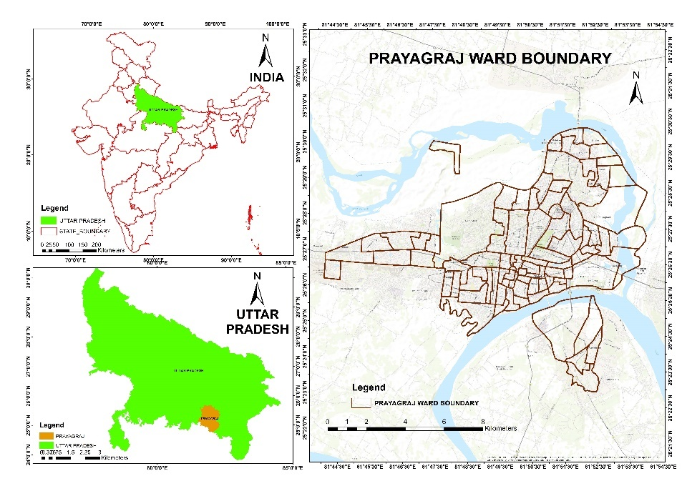
Fig1. Location map of study area
Methodology
Data used
Different thematic including slope, LULC, lithology, geomorphology, distance from roads, distance from railways, and distance from rivers were collected. The slope of the study area was derived from ASTER Digital Elevation Model (DEM), downloaded from the NASA Earth data repository. Sentinel-2 Imagery was acquired from Copernicus Data Space Ecosystem to create LULC map. Lithology and geomorphology maps used in this study were obtained from the Bhuvan Portal. Spatial data for roads, railways, and rivers were collected from OpenStreetMap dataset. Detail of all data sources, along with corresponding URLs, are provided in Table 1.
Table 1. Source of data
Data | Source
Land use/Land cover | Sentinel-2 Imagery (2024), Copernicus Data Space Ecosystem
Geomorphology | ISROBhuvanPortal (https://www.bhuvan.nrsc.gov.in)
Lithology | ISROBhuvanPortal (https://www.bhuvan.nrsc.gov.in )
Slope | ASTER Digital Elevation Model, NASA Earthdata (https://www.earthdata.nasa.gov
Road | OpenStreetMap (https://www.openstreetmap.org)
Rail | OpenStreetMap (https://www.openstreetmap.org)
River | Open Street Map (https://www.openstreetmap.org)

Methodology
A method was developed to find the suitable location for solid waste disposal. In this study, seven criteria were taken into consideration to meet the selection of scientific landfill sites. The various criteria were considered that is slope, LULC, Lithology, geomorphology, distance from road, distance from railway, distance from river for site selection modelling. In this process ArcGIS software and Multi criteria decision analysis (MCDM) techniques has been used for analysis. Analytic Hierarchy Process (AHP) developed by Saaty (1980) is widely used MCDA methods.
Multi-criteria decision analysis
Assigning the weight to different criteria to find the suitable sites for waste disposal is most challenging tasks for researcher and policy maker. In case of multiple criteria used for analysis deciding the weight to the criteria is completed. In this study AHP techniques was used to address the complex decision-making problem and to develop a structure decision hierarchy.
Ranking method
The ranks were assigned to the various criteria used in this study and their respective sub-classes based on area of study, expert judgment and from previous studies (Desta et al.,2025; Dwivedi et al.,2024). This process incorporated the relative importance of each parameter in influencing site suitability, ensuring a systematic and objective evaluation within the decision-making framework. In this study each class of thematic layer ranging from 1 to 5, where 1 indicate least and 5 indicate highest weight (Table 2).
Table 2 Class Priority in different Layers
Land use | Suitability Score (Lowest 1; Highest 5)
Flooded Vegetation | 1
Water | 1
Crop | 2
Scrub land | 2
Bare ground | 5
Built-up | 1
Tree | 2
Geomorphology | Suitability Score (Lowest 1; Highest 5)
Alluvial Plain | 3
Settlement | 2
Waterbody | 1
Flood Plain | 1
Lithology | Suitability Score (Lowest 1; Highest 5)
Gravel/Sand, Silt | 2
Clayey Sand | 3
Sandy Clay | 2
Settlement | 2
Water Body | 1
Slope | Suitability Score (Lowest 1; Highest 5)
Gentle | 2
Level | 4
Distance from Road (m) | Suitability Score (Lowest 1; Highest 5)
<= 500 | 1
>500 and <=1000 | 5
>1000 and <=2000 | 4
>2000 | 2
Distance from Railway (m) | Suitability Score (Lowest 1; Highest 5)
<= 1000 | 1
>1000 | 5
Distance from River (m) | Suitability Score (Lowest 1; Highest 5)
<= 500 | 1
>500 and <=1000 | 3
>1000 and <=2000 | 4
>2000 | 5

Estimating consistency of pairwise comparison matrix
The AHP is used to generate the ratio matrix using pairwise comparison matrix. This method uses scale with value 1 to 9 where 1 indicate ‘lowest’ and 9 indicate ‘highest’ value (Saaty 1980).
Step1
The values of each column were summed separately within the matrix
$L_{ij}=\sum_{n=1}^{n}{C_{ij}}$ …………………………………. [1]
Where, $L_{ij}$ = total column value of matrix
$C_{ij}$ = criteria used in study
Step2
Divide each element in the matrix by its total row.
$X_{ij}$= $\frac{C_{ij}}{\sum_{n=1}^{n}{C_{ij}}}$ ………………………………….. [2]
Where $X_{ij}$ = normalized of matrix
Step3
After that number of criteria was divided by the row sum to find the standard weight
$W_{ij}$ = $\frac{\sum_{j=1}^{n}{X_{ij}}}{N}$………………………………… [3]
Step4
Consistency vector ($λ$) and consistency index (CI) was calculated
$λ$ = $\sum_{i=1}^{n}{{CV}_{ij}}$ …………………………………… [4]
CI =$\frac{λ-n}{n-1}$ …………………………………… 5]
n = No. of criteria
λ= Consistency vector
Step 5
Consistency ratio (Cr) was calculated by
Cr = $\frac{CI}{RI}$………………………………………….. [6]
Where, RI = random inconsistency

Random consistency index (RI) values to different criteria(n) were obtained from Saaty, (1980)

Table 3. Random inconsistency values (Saaty, 1980)

n | 2 | 3 | 4 | 5 | 6 | 7 | 8 | 9
RI | 0 | 0.52 | 0.9 | 1.12 | 1.24 | 1.32 | 1.41 | 1.45

A CR value of less than 0.10 indicates acceptable consistency in the pairwise comparisons (Saaty, 1980; Desta et al., 2023).

Assessment of Site Suitability for Waste Disposal
Total score (TS) for each criterion was calculated using the weighted linear combination method proposed by Saaty (1980):
TS = $\sum{W×R }$……………………………………………………... [7]
Where, TS = Total Score, W = weight of the criterion and R = weight of the corresponding feature.
The suitable site for waste disposal is then calculated using rather calculator in GIS environment adding weight of all criteria.
SSWD = LULC, LI, SL, SO, PR, PRO, PRL .............................................. [8]
Where, SSWD = Suitable site for waste disposal, LULC = Land use and Land cover, GE= Geomorphology, LI= Lithology, SL = Slope, SO= Soil, PR= Proximity to River, PRO= Proximity to Road, PRL= Proximity to
Railway lines.

Result and Discussion
In this study seven criteria were used such as slope, LULC, Lithology, geomorphology, distance from road, distance from railway, distance from river to find the suitable waste dumping sites of Prayagraj city. The thematic layers were created in GIS environment using ArcGIS software.
Land use Land cover map (LULC)
LULC map is created using Sentinal2 satellite data which is having 10m spatial resolution. Many studies have used different classification techniques to identify various land use and land cover (LULC) classes. (Kumar et al., 2018; Mahmoud et al., 2022; Hameed et al., 2026). In this study supervised classification techniques has been used to classified the different land cover classes. The study area is classified into Bare ground, built up area, Crop, Flooded vegetation, scrub land, Tree and Water (Fig.2e). Weight for different land cover classes has been assigned, lowest weight was assigned to built-up land, and water bodies, while the highest weight was assigned to bare ground. The suitability map for LULC has been develop based on ranking (Table 2).
Road/ Railway/River proximity
Distance from roads, railway and water is always important for suitability for waste disposal site selection. Waste disposal site should not be very close to the road, railway, and river. In this study a road buffer zone was created in to four classes that is ≤ 500, >500 and ≤1000, >1000 and ≤2000, >2000 m from centre of road (Fig. 2k). The distance ≤ 500 is given lowest weight while the >500 and ≤1000m range was assign the highest weights. The railway is having two buffers ≤ 1000 and >1000. Lowest weight is given to ≤ 1000 whereas highest weight is given to >1000 (Fig. 2i). The river buffer zone was created in to four classes that is ≤ 500, >500 and ≤1000, >1000 and ≤2000, >2000m (Fig.2m). The distance ≤ 500 is given lowest weight while the >2000m was assign the highest weights. The detail of weight for all buffer zone for railway, road and river is given in table 2.
Slope
Slope is important factor to understand how waste disposal site can be identified so that environmental and health risks can be minimized. In this study slope of the area is classified into Gentle and level classes. The gentle slope was taken into consideration for suitable site because level class come into river site (fig.2g).
Lithology
The lithology of the study area is categorized into Clayey Sand, Gravel/Sand, Silt, Sandy Clay, Settlement, Water Body. Most of the area is covered by settlement followed by gravel sand and silt. The highest weight is given to Clayey Sand whereas lowest weight is given to waterbody (Table2, Fig.2c).
Geomorphology
Geomorphology play important role in identifying the safe and appropriate site for disposal of waste. In this study area Geomorphology is classified into Alluvial Plain, Settlement, Waterbody, and Flood Plain (2a). Highest weight has been given to Alluvial Plain whereas lowest weight is given to Flood plain. Highest weight is given to Alluvial Plain because it has Gentle and uniform slope with thick soil cover.
Pair wise comparison matrix using AHP
The relative weight of each criterion has been determine using pairwise comparison matrix within AHP method. Based on relative importance of criterion, ranks are assigned. In this study weight are assigned using Saaty’ s technique (Saaty 1977). The scale ranging from 1 to 9, where 1 value determined ‘equal important’ and 9 determined ‘most important’. The pair wise comparison matrix was created using the slope, LULC, Lithology, geomorphology, distance from road, distance from railway, distance from river and shown in table4. The consistency of the pairwise comparison matrix was calculated, which shows the Consistency Ratio (CR) of 0.065 (Table 5).

Table 4 Pairwise AHP comparison
 | Slope | Geomorphology | Lithology | LULC | Distance from Road | Distance from River | Distance from Rail line
Slope | 1 | 1 | 5 | 7 | 4 | 4 | 8
Geomorphology | 1 | 1 | 7 | 8 | 7 | 3 | 8
Lithology | 0.2 | 0.1 | 1 | 2 | 1 | 3 | 3
LULC | 0.1 | 0.1 | 0.5 | 1 | 1 | 3 | 3
Distance from Road | 0.3 | 0.1 | 1 | 1 | 1 | 2 | 2
Distance from River | 0.3 | 0.3 | 0.3 | 0.3 | 1 | 1 | 2
Distance from Rail line | 0.1 | 0.1 | 0.3 | 0.3 | 1 | 1 | 1

Table 5 Evaluation Score
Consistency Ratio CR | 0.065
Principal eigen value | 7.523

Ranking of Criteria for Site Suitability Analysis Based on AHP
The suitable criteria used in this study indicates that Geomorphology has the highest weight (36.90%) and its rank first followed by slope (31.50%), The other criteria including Lithology (8.90%), Distance from Road (7.10%), LULC (7.10%), Distance from River (5.40%) and Distance from Rail line (3.10%) have also played important role on site suitability. This ranking reflects the relative importance of each criterion in the decision-making process. Similar findings have been reported in previous studies, where these criteria play a significant role in the selection of solid waste disposal sites (Irhoumah et al.,2014, Malo et al., 2024).

Table 6 Rank assign to different criteria using AHP
Suitability Criteria | Priority | Rank
Slope | 31.50% | 2
Geomorphology | 36.90% | 1
Lithology | 8.90% | 3
LULC | 7.10% | 5
Distance from Road | 7.10% | 4
Distance from River | 5.40% | 6
Distance from Rail line | 3.10% | 7

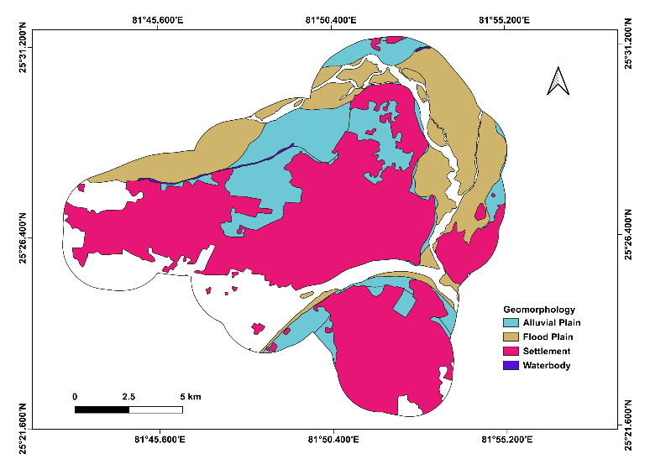  (a) Geomorphology map of study area | 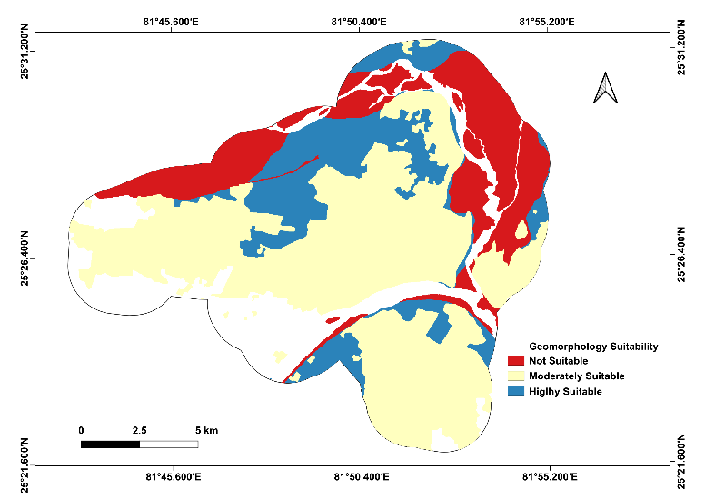  (b) Suitability map of Geomorphology
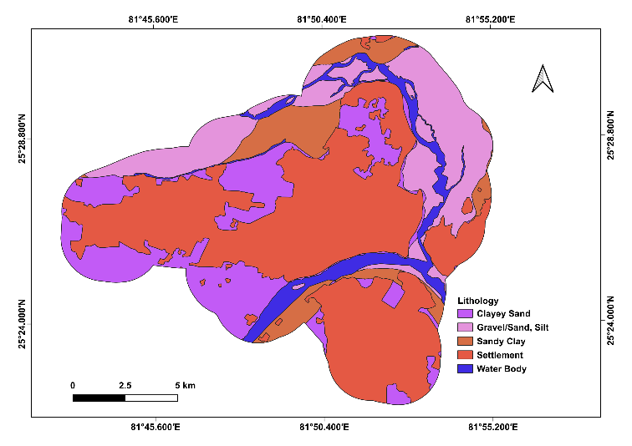  (c) Lithology map of study area | 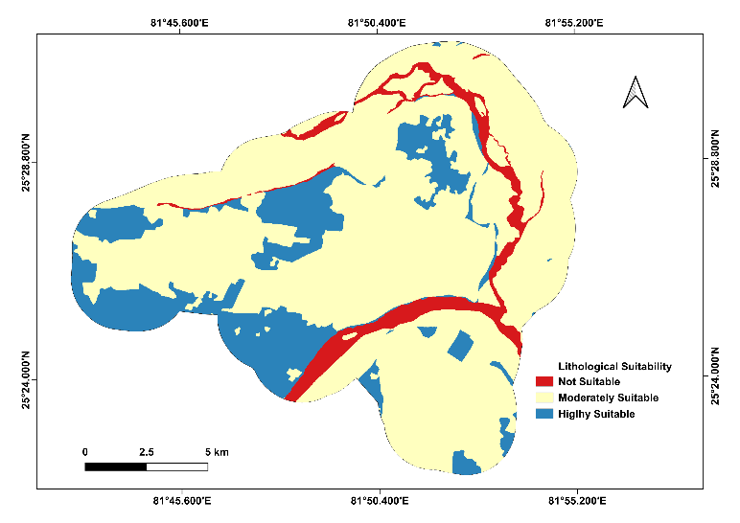  (d) Suitability map of Lithology
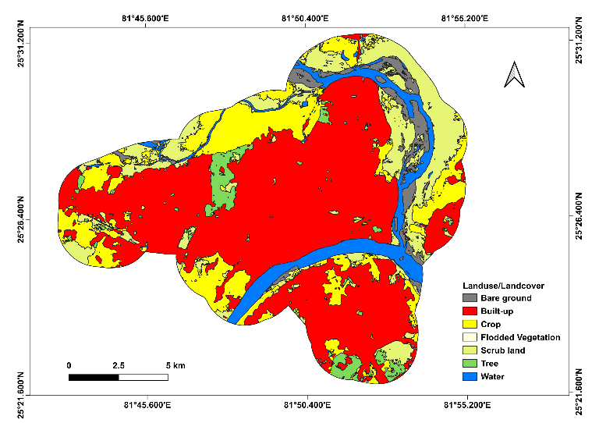  (e) LULC map of study area | 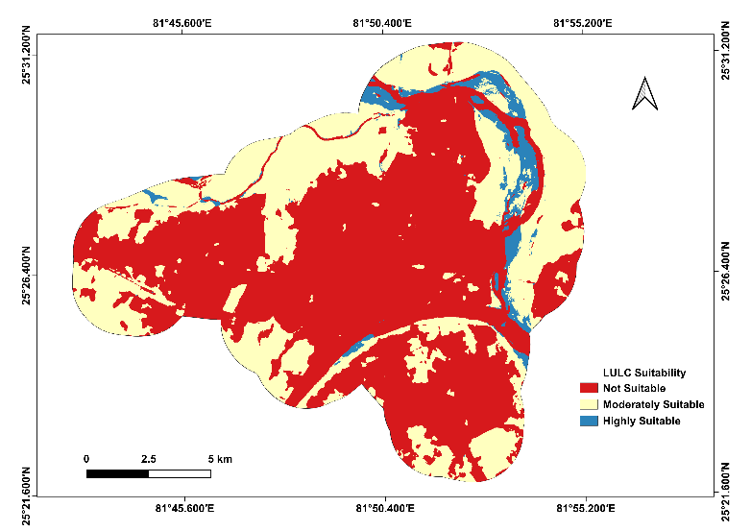  (f) Suitability map of LULC
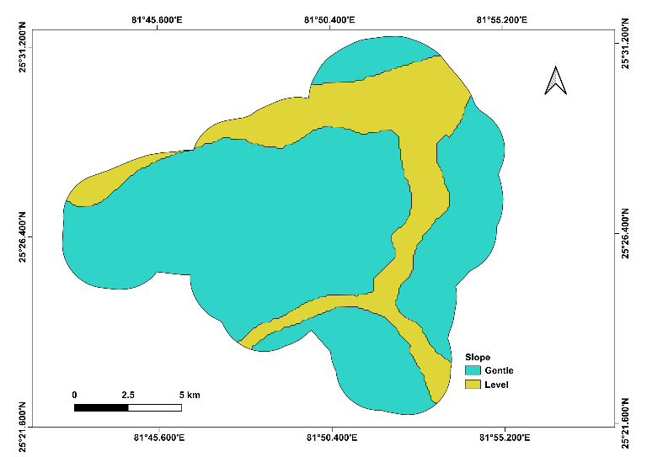  (g) Slope map of study area | 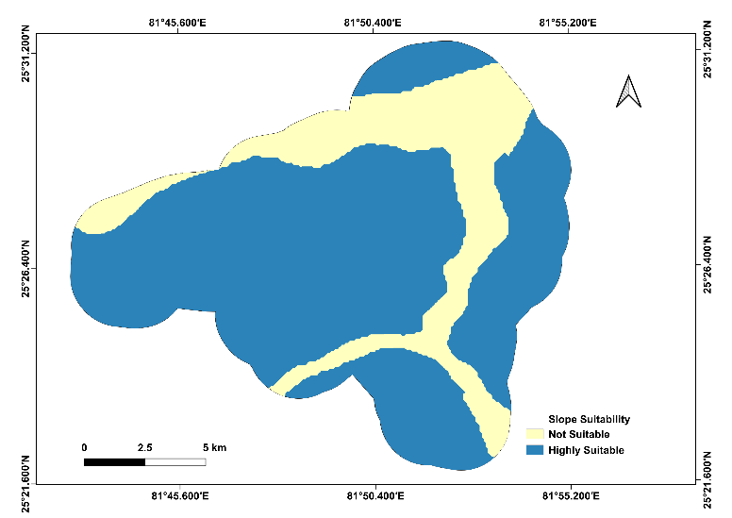  (h) Suitability map of Slope
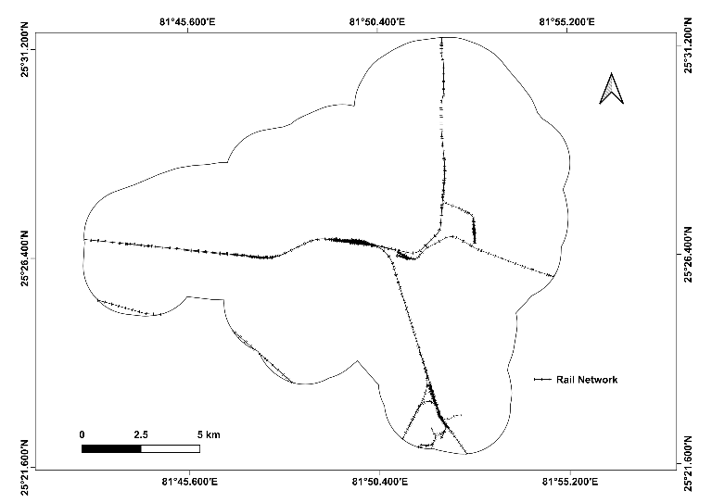  (i) Railway map of study area | 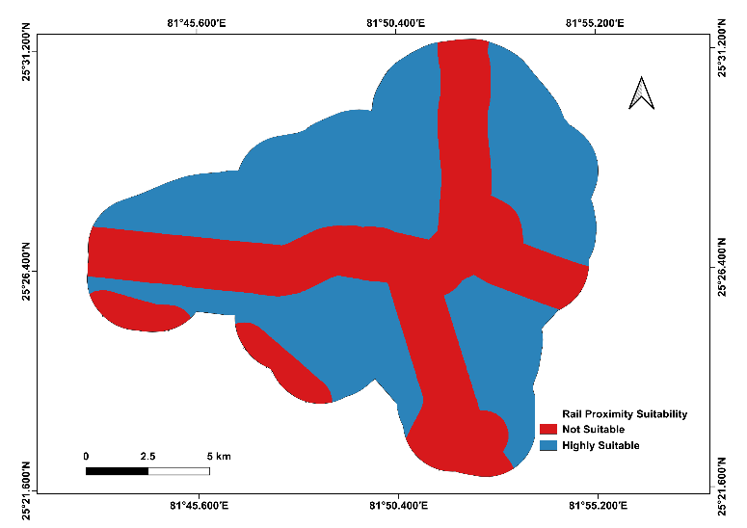  (j) Suitability map of Railway
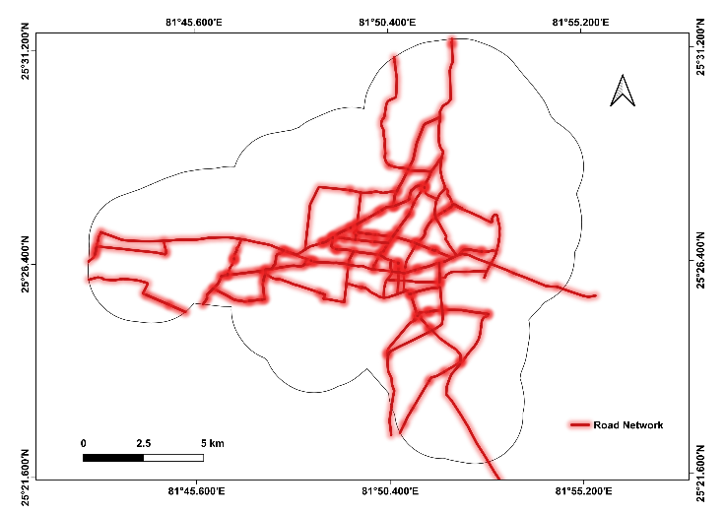  (k) Road map of study area | 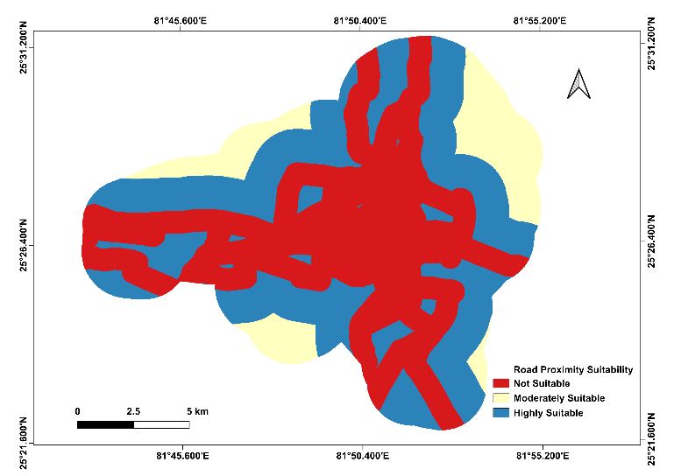  (l)Suitability map of Road
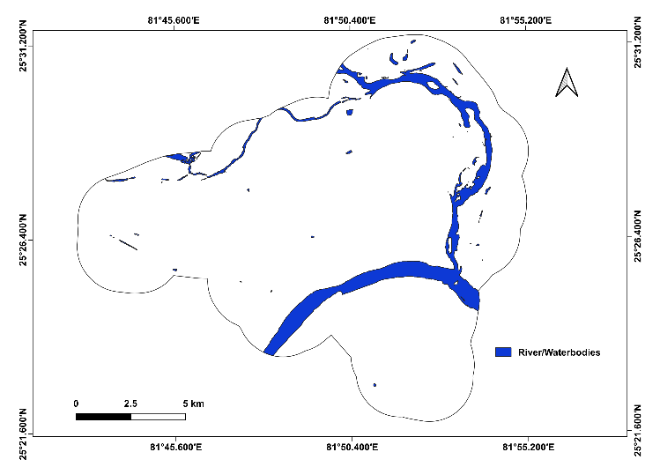  (m) River map of study area | 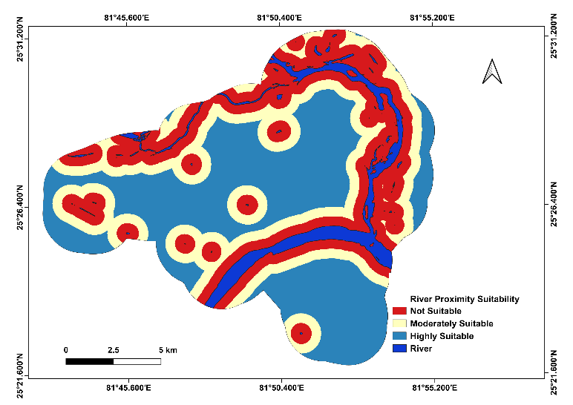  (n) Suitability map of River
Fig. 2 Suitability map of the study area.

Final suitability map using AHP
All the seven suitability maps were overlaid in GIS environment and was reclassified into three 3 classes. These classes are high suitable, moderate suitable and not suitable area. The high suitable area found in this study area is 3.87%, moderate suitable area found to be 26.45% whereas not suitable area is found to be 69.68% (Table 7 and fig. 3).

Table 7 Area Statistics for Final Suitability Map
Class | Hectare | Percentage (%)
Not Suitable | 14868.94 | 69.68
Moderately Suitable | 5643.721 | 26.45
Highly Suitable | 825.056 | 3.87
Total | 21337.72 | 100

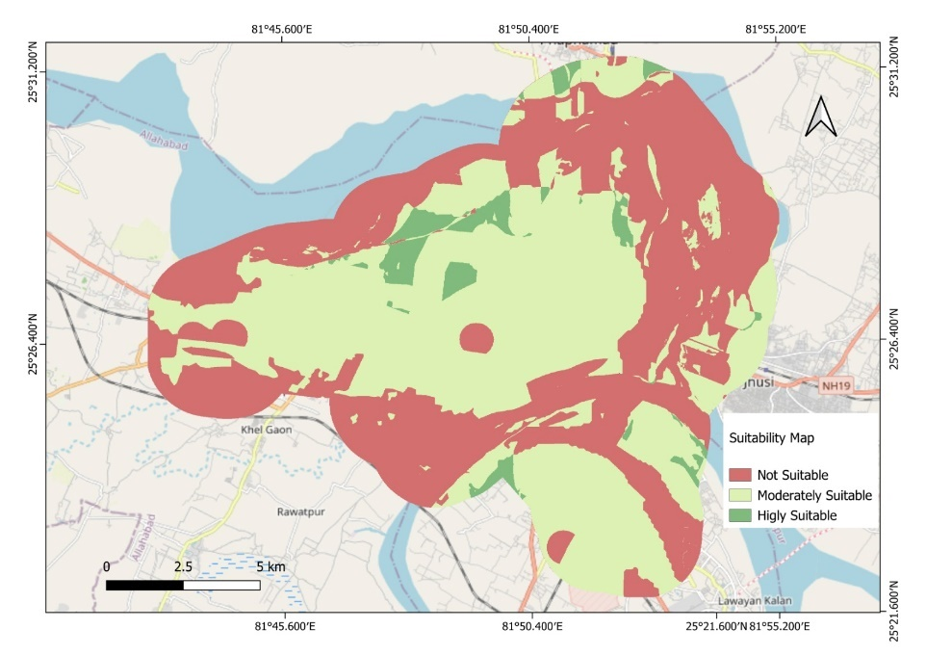
Fig.3 Final site suitability zones of the study area
Conclusion and Recommendation
In Prayagraj city due to insufficient potential site for waste disposal garbage was dump in the road side which causes environmental problem. The continuous growth of population in city area has resulted in a rapid increase in solid waste generation. Prayagraj city is also a pilgrimage centre that attract large number of people throughout the year from all over the India resulting significant increase in solid waste generation. In this study seven criteria (LULC, geomorphology, lithology, slope, distance from road, railway, and river) have been used to understand the importance of implementing AHP and geospatial technology to identify the optimal landfill site for waste disposal. The total of 3.87% of study area was identified as waste disposal sites. This study identifies the alternative potential area for waste disposal. The geospatial technology used in this study to collect the data which has been used in this study whereas AHP techniques is used to calculate the weight of all criteria. The findings of this study recommend that local stakeholders and urban planners adopt GIS- and Analytical Hierarchy Process (AHP)–based approaches to identify suitable waste disposal sites. This approach not only reduces the time and cost associated with conventional methods but also improves accuracy, minimizes environmental and public health risks, and supports sustainable urban planning. Therefore, the application of GIS and AHP techniques can significantly enhance the efficiency and reliability of waste disposal site selection in rapidly growing urban areas.

Disclaimer (Artificial intelligence)

Author(s) hereby declare that NO generative AI technologies such as Large Language Models (ChatGPT, COPILOT, etc.) and text-to-image generators have been used during the writing or editing of this manuscript.

Reference
Aderoju OM, Dias GA, Gonçalves AJ (2020) A GIS-based analysis for sanitary landfill sites in Abuja, Nigeria. Environ Dev Sustain 22: 551–574. https://doi.org/10.1007/s10668-018-0206-z
Aydi A, Zairi M, Dhia HB. Minimization of environmental risk of landfill site using fuzzy logic, analytical hierarchy process, and weighted linear combination methodology in a geographic information system environment. Environ Earth Sci. 2013;68:1375–89. https:// doi. org/10. 1007/ s12665- 012- 1836-3.
Barakat A, Hilali A, Baghdadi ME, Touhami F. Landfill site selection with GIS-based multi-criteria evaluation technique. A case study in Béni Mellal-Khouribga Region, Morocco. Environ Earth Sci. 2017;76(12):413. https:// doi. org/ 10. 1007/ s12665- 017- 6757-8.
C. Kahraman, S. Cebi, S.C. Onar, B. Oztaysi, A novel trapesoidal intuitionistic fuzzy information axiom approach: an application to multicreteria landfill site selection, Eng. Applicat. Artif. Intell. 67 (2018) 157–172, https://doi.org/10.1016/j.engappai.2017.09.009.
Chanhthamixay B, Vassanadumrongdee S, Kittipongvises S. Assessing the sustainability level of municipal solid waste management in Bangkok, Thailand by wasteaware benchmarking indicators. Appl Environ Res. 2017;39(3):49–61. https:// doi. org/ 10. 35762/ AER. 2017. 39.3.6
Cheng, S., C. W. Chan, and G. H. Huang. 2002. “Using Multiple Criteria Decision Analysis for Supporting Decisions of Solid Waste Management.” Journal of Environmental Science and Health, Part A 37, no. 6: 975–990.
Desta, M. D., Tesseme, T., Yigezu, T. T., & Nigussie, A. B. (2025). Assessment of landfill site suitability using GIS, remote sensing, and the multi-criteria decision-making (AHP) approach, Ethiopia. Geology, Ecology, and Landscapes, 9(2), 662–675. https://doi.org/10.1080/24749508.2023.2256549
Doorga, J.R.S, Rughooputh, D.D.V, Chung, S.Y, McGivern, A (2022). A geospatial approach for addressing long-term solid waste management issues: Extracting value from waste. J Clean Prod 334:130282. https://doi.org/10.1016/j.jclepro.2021.130282
Gbanie SP, Tengbe PB, Momohb JS, Medo J, Kabba VTS (2013) Modelling landfill location using geographic information systems (GIS) and multi-criteria decision analysis (MCDA): case study Bo, Southern Sierra Leone. Appl Geogr 36:3–12. https://doi.org/10. 1016/j.apgeog.2012.06.013
Hannah Ritchie, Lucas Rodés-Guirao, Edouard Mathieu, Marcel Gerber, Esteban Ortiz-Ospina, Joe Hasell, and Max Roser (2023) - “Population Growth” Published online at OurWorldinData.org. Retrieved from: 'https://ourworldindata.org/population-growth'
Hazarika, R., & Saikia, A. (2020). Landfill site suitability analysis using AHP for solid waste management in the Guwahati Metropolitan Area, India. Arabian Journal of Geosciences, 13, 1148. https://doi.org/10.1007/s12517-020-06156-2
İskender Soyaslan İ. (2025) Landfill site suitability analysis for sustainable solid waste management using AHP and GIS in Burdur Lake Basin, Türkiye. MethodsX. 2025 Aug 5;15:103555. doi: 10.1016/j.mex.2025.103555. PMID: 40837080; PMCID: PMC12361799.
Irhoumah JMS, Agarwal VC, Lal D, Kumar M (2014) Determination of suitable site for solid waste disposal using remote sensing and GIS techniques in Allahabad Municipality area. Int J Eng Res Technol 3(6).
Hameed, M. (2026). Identification of ground water potential zone of Giridih District, Jharkhand, India using geospatial technologies. Advances in Research, 27, 249–261. https://doi.org/10.9734/air/2026/v27i21619
Hameed, M. R., Fatah, B. A., Hasan, S. F., & Shareef, M. A. (2026). Assessing the classification of land use and land cover using dual polarization (VV, VH) radar data: An analysis of the Kirkuk Governorate in Iraq. International Journal for Scientific Research (IJSR), 5(3).
Mahmoud, A. S., Mezali, M. R., Hameed, M. R., & Naje, A. S. (2022). A framework for improving urban land cover using object and pixel-based techniques via remotely sensed data. Nature Environment and Pollution Technology, 21(5), 2189–2200. https://doi.org/10.46488/NEPT.2022.v21i05.013
Jaybhaye, R., N. Mundhe, and D. Bhalachandra. 2014. “Site Suitability for Urban Solid Waste Disposal Using Geoinformatics: A Case Study of Pune Municipal Corporation, Maharashtra, India.” International Journal of Advanced Remote Sensing and GIS 3, no. 1: 769–783.
Kamdar I, Ali S, Bennui A, Techato K, Jutidamrongphan W. Municipal solid waste landfill siting using an integrated GIS-AHP approach: a case study from Songkhla, Thailand. Resour Conserv Recycl. 2019;149:220–35. https:// doi. org/ 10. 1016/j. resco nrec. 2019. 05. 027.
Majid M, Mir BA. Landfill site selection using GIS-based multi-criteria evaluation technique. A case study of Srinagar city, India. Environ Chall. 2021;3: 100031. https:// doi. org/ 10. 1016/j. envc. 2021. 100031.
Malo, S. K., Mandal, D., Chakraborty, K., & Saha, S. (2024). Identification of potential landfill site suitability for urban solid waste disposal of Balurghat Municipality of Dakshin Dinajpur District using GIS and multi-criteria decision-making approach. Discover Applied Sciences. 6. 10.1007/s42452-024-05877-3.
Parrot, L., Sotamenou, J., & Dia, B. K. (2009). Municipal solid waste management in Africa: Strategies and livelihoods in Yaoundé, Cameroon. Waste Management, 29 (2), 986–995
Pandey, P.C, Sharma, L.K, Nathawat, M.S (2012) Geospatial strategy for sustainable management of municipal solid waste for growing urban environment. Environ Monit Assess 184:2419–2431. https://doi.org/10.1007/s10661-011-2127-2
Saaty, T. L. (1977): A scaling method for priorities in hierarchical structures. – Journal of Mathematical Psychology 15(3): 234-281.
Saaty, T. L. (1980): The Analytic Hierarchy Process: Planning, Priority Setting, Resources Allocation. – McGraw Hill, New York
Sharma A, Ganguly R, Gupta, A K(2018) Matrix method for evaluation of existing solid waste management system in Himachal Pradesh, India. J Mater Cycles Waste Manag 20:1813–1831. https://doi.org/10.1007/s10163-018-0703-z
United Nations Department of Economic and Social Affairs Population Division. (2022). World population prospects 2022. UNCTADstat (based on UN DESA data).
Y. Wang, J. Li, D. An, B. Xi, J. Tang, Y. Wang, Y. Yang (2018). Site selection for municipal solid waste landfill considering environmental health risks, Resources, Conserv. Recycl. 138, 40–46, https://doi.org/10.1016/j.resconrec.2018.07.008.

