Simulating Surface Runoff Response to Land Use Change Using ArcSWAT in Jonk Subbasin

Abstract
Land use and land cover (LULC) changes are widely recognized as key drivers of hydrological variability, particularly in tropical regions where observational data are often limited. The present study evaluates the influence of long-term LULC transformations on surface runoff dynamics in the Jonk sub-basin of the Mahanadi River basin using the Arc Soil and Water Assessment Tool (ArcSWAT). Multi-temporal spatial datasets, including satellite-derived LULC maps, soil information, and a Digital Elevation Model (DEM), were integrated with hydro-meteorological data for the period 1991–2021. The watershed was delineated into 11 sub-watersheds and further discretized into 277 Hydrological Response Units (HRUs) to represent spatial heterogeneity.
Model calibration (1993–2010) and validation (2011–2021) showed strong performance with R² = 0.83 and NSE = 0.82, indicating reliable simulation of streamflow. Analysis of LULC changes revealed a significant expansion of agricultural and built-up areas, accompanied by a decline in forest cover. These changes resulted in increased Curve Number values and reduced infiltration capacity, ultimately leading to a 9–11% increase in mean annual surface runoff. The study highlights the critical role of anthropogenic land transformations in altering watershed hydrology and emphasizes the need for sustainable land management strategies in data-scarce regions.
Keywords: LULC change, ArcSWAT model, surface runoff, hydrological modeling, tropical watershed
1. Introduction
Rapid population growth and socio-economic development have significantly accelerated land use transformations across the globe, particularly in developing countries such as India where dependence on land resources is high. The expansion of agriculture, deforestation, and urbanization has altered natural landscapes, thereby influencing hydrological processes at multiple spatial and temporal scales. Among these processes, surface runoff plays a crucial role in determining water availability, flood potential, and soil erosion dynamics within a watershed system.
Changes in LULC directly affect the physical characteristics of the land surface, including vegetation cover, soil structure, and permeability. Forested areas generally enhance infiltration and evapotranspiration while reducing surface runoff, whereas agricultural and built-up areas tend to increase runoff due to soil compaction and reduced infiltration capacity. Over time, such transformations can significantly modify the hydrological response of a basin, leading to increased flood risks, reduced groundwater recharge, and degradation of water resources. Several studies have highlighted the sensitivity of runoff processes to land use changes, particularly in monsoon-dominated regions where rainfall intensity is high (Mishra et al., 2024)
In data-scarce regions, where long-term hydrological observations are limited, physically based models such as the Arc Soil and Water Assessment Tool (ArcSWAT) provide an effective approach to simulate watershed processes. ArcSWAT has been widely applied for assessing the impacts of land use and climate variability on hydrological responses due to its capability to integrate spatial and temporal datasets. The Jonk sub-basin, a tributary of the Mahanadi River, represents a typical tropical watershed undergoing rapid land transformation. Despite its importance, limited studies have quantified the long-term hydrological impacts of LULC changes in this basin.
Therefore, the present study aims to analyze the impact of decadal LULC changes on surface runoff dynamics using ArcSWAT modeling. The findings provide valuable insights into the interaction between land transformation and hydrological processes and support sustainable watershed management in data-limited environments.
2. Materials and Methods
2.1 Study Area
The Jonk sub-basin, located in eastern-central India, covers an area of approximately 3330 km² and lies between latitudes 20°28′N to 21°42′N and longitudes 82°25′E to 82°34′E. The basin exhibits diverse topography, with elevations ranging from 203 m to 868 m above mean sea level. The Jonk river originates from the Khariar Hills, Nuapada district of Odisha and flows through Mahasamund, Gariyaband and meets Mahanadi River at Shivrinarayan of Balodabazar district of Chhattisgarh.The northern region is predominantly hilly, whereas the southern portion consists of relatively flat plains, resulting in spatial variability in runoff generation.

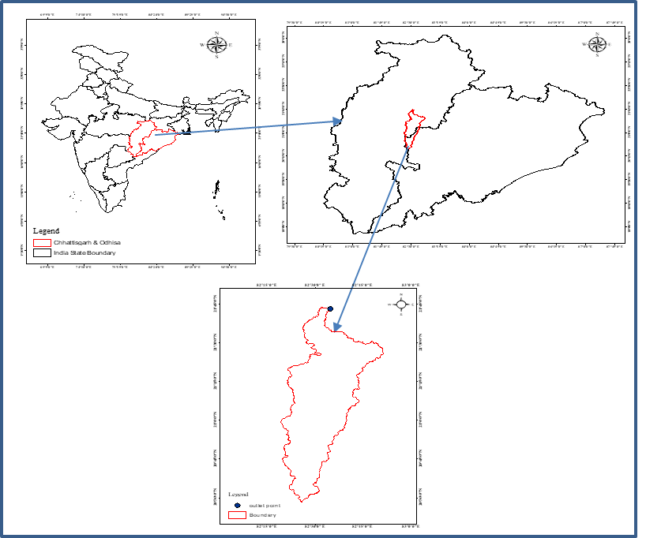
Fig.1: Location map of the study area
The climate of the basin is tropical monsoon type, characterized by an average annual rainfall of approximately 1237 mm, with nearly 80% occurring during the monsoon season (June to September). Temperature variations are significant, with hot summers and mild winters. The dominant land use is agriculture, followed by forest and settlements. Soil types in the region are mainly clay loam and sandy loam, which play a critical role in influencing infiltration and runoff processes.
2.2 Data Collection and Processing
A comprehensive dataset was compiled, including hydro-meteorological, topographic, soil, and land use data. Daily rainfall and temperature data for the period 1991–2021 were obtained from the Central Water Commission, while additional climatic variables were sourced from the NASA POWER database. A 30 m resolution SRTM DEM was used to derive watershed characteristics such as slope, drainage network, and flow direction.
LULC maps were generated from satellite imagery for different time periods to capture decadal changes. Soil data were obtained from national databases. All datasets were processed within a GIS environment to ensure spatial consistency, including projection transformation, resolution matching, and data cleaning.
Table 1: Data Sources used in ArcSWAT model
S. No. | Variable | Data Source and Methodology
1. | Remote Sensing Data | Digital Elevation Model (DEM) derived from Shuttle Radar Topography Mission (SRTM).
2. | Land Use/Land Cover (LULC) | Satellite imagery obtained from USGS Earth Explorer;  - Landsat 4-5 (TM) sensor (28/10/1991)  - Landsat 7 (ETM+) sensor (26/09/2001)  - Landsat 7 (ETM+) sensor (21/09/2011)  - Landsat 8 satellite Image (02/10/2021)
3. | Soil Data | Soil information acquired from the National Bureau of Soil Survey and Land Use Planning (NBSS&LUP).
4. | Climate Data | Meteorological parameters such as rainfall, temperature, relative humidity, wind speed, and sunshine duration collected from NASA website for Prediction of Worldwide Energy Resource (POWER) Climatology Resource for Agroclimatology

2.3 Arc Soil and Water Assessment Tool (ArcSWAT) Model Setup
The Soil and Water Assessment Tool (ArcSWAT) is a physically based, watershed-scale hydrological model developed to assess the long-term impacts of land use and management practices on large river basins. It operates on a daily time step and simulates key components of the hydrological cycle, including surface runoff, evapotranspiration, infiltration, groundwater flow, and sediment and nutrient transport (Arnold et al., 1997; Arnold et al., 2001). Developed by the USDA and integrated with ArcGIS, ArcSWAT allows spatial analysis by dividing a watershed into sub-basins based on topography and further into Hydrological Response Units (HRUs) defined by land use, soil type, and slope (Arnold et al., 1999). In this study, DEM data were processed using ArcGIS to delineate the watershed and derive flow direction and accumulation, while land use maps for 1991 and 2021 were generated using supervised classification. Soil and meteorological data were also incorporated as model inputs, and the integrated dataset was used in ArcSWAT to simulate surface runoff and analyze hydrological responses, as supported by Gassman et al. (2007).
2.4 Hydrological Water Balance
The hydrological cycle within a watershed involves continuous interactions between atmospheric inputs and land surface processes. To simulate these processes, the SWAT model applies a water balance approach at the level of Hydrological Response Units (HRUs), enabling detailed representation of spatial variability. The soil water balance equation is fundamental for estimating soil moisture by accounting for precipitation, surface runoff, evapotranspiration, percolation, and groundwater flow (Setegn et al., 2008). The equation is expressed as:
$$SW_{f}=SW_{i}+\sum_{t=1}^{t}{(}R_{d}-Q_{r}-E_{e}-W_{sp}-Q_{gw})$$
where $SW_{f}$is the final soil water content (mm), $SW_{i}$is the initial soil water content (mm), $R_{d}$denotes precipitation (mm), $Q_{r}$represents surface runoff (mm), $E_{e}$is evapotranspiration (mm), $W_{sp}$indicates percolation into the vadose zone (mm), and $Q_{gw}$is groundwater return flow (mm). This equation ensures a comprehensive representation of water movement within the soil system.
2.5 Surface Runoff Estimation
Surface runoff in the ArcSWAT model is computed at the HRU level and later aggregated to obtain the total watershed response, improving simulation accuracy. In this study, the Soil Conservation Service Curve Number (SCS-CN) method was used to estimate runoff, as it integrates land use and soil characteristics into a single parameter (Arnold et al., 1998; Adornado and Yoshida, 2010). The Curve Number (CN) is an empirical parameter ranging from 0 to 100, where higher values indicate greater runoff potential and lower infiltration capacity.
The CN value is influenced by soil type, land use, and antecedent moisture conditions (AMC), which represent the soil moisture condition prior to rainfall. To adjust CN for different moisture conditions, the following relationships are used:
$$CN_{I}=CN_{II}-\frac{20(100-CN_{II})}{(100-CN_{II})+e^{\left[2.54-0.064(100-CN_{II})\right]}} \\ CN_{III}=CN_{II}-e^{\left[0.00673(100-CN_{II})\right]}$$
where $CN_{I}$, $CN_{II}$, and $CN_{III}$correspond to dry, normal, and wet soil conditions, respectively. Based on the CN value, the potential maximum retention parameter $S$is calculated using:
$$S=25.49\left(\frac{1000}{CN} − 10\right)$$
The retention parameter $S$reflects the soil’s ability to store water and is inversely related to CN. A CN value of 100 indicates completely impervious conditions with zero retention ($S=0$), whereas lower CN values represent higher infiltration and storage capacity.
2.6 Model Framework
The SWAT model, integrated with the ArcSWAT interface in ArcGIS, provides a comprehensive framework for hydrological simulation (Olivera et al., 2006). The modeling process begins with watershed delineation using Digital Elevation Model (DEM) data, through which stream networks, flow direction, flow accumulation, and outlet points are generated. The watershed is divided into sub-basins, which are further subdivided into HRUs by overlaying land use, soil, and slope data. This approach allows for detailed spatial representation of hydrological processes across the basin.
The ArcSWAT model is subject to uncertainties arising from input data quality, parameter sensitivity, and model assumptions, which can affect the accuracy of simulated hydrological processes. Additionally, it often underestimates peak flows and may not fully capture extreme events or localized watershed dynamics due to its semi-distributed nature.
2.7 Model Simulation
The simulation process involves several steps, including watershed delineation, HRU analysis, preparation of input data, and execution of the model. DEM data are used to define watershed boundaries and drainage patterns. HRUs are created by integrating land use, soil, and slope information to represent homogeneous units. Meteorological data, including rainfall, temperature, wind speed, relative humidity, and solar radiation, are organized into input tables and incorporated into the model. The SWAT model is then executed on a continuous time step to simulate hydrological processes.
Calibration and validation are essential to improve model reliability. In this study, these processes were carried out using the SWAT-CUP tool, which integrates various algorithms for parameter optimization and uncertainty analysis. The Sequential Uncertainty Fitting (SUFI-2) method was used to calibrate the model and evaluate uncertainty (Kumar et al., 2017).
2.8 Model Performance Evaluation
The performance of the SWAT model was evaluated using statistical indicators such as the coefficient of determination (R²) and Nash–Sutcliffe Efficiency (NSE), which are widely used for hydrological model assessment (Goswami et al., 2005; Moriasi et al., 2007). The NSE is calculated as:
$$NSE=1-\frac{\sum_{i=1}^{n}{(}Y_{obs,i}-Y_{sim,i})^{2}}{\sum_{i=1}^{n}{(}Y_{obs,i}-Y_{mean})^{2}}$$
where $Y_{obs}$represents observed values, $Y_{sim}$represents simulated values, $Y_{mean}$is the mean of observed data, and $n$is the number of observations. NSE values range from $-∞$to 1, with values closer to 1 indicating better model performance.
The coefficient of determination (R²) measures the degree of correlation between observed and simulated values and ranges from 0 to 1. Higher values indicate better agreement between datasets. According to standard evaluation criteria, model performance is considered satisfactory when $R^{2}≥0.65$and $NSE≥0.5$(Moriasi et al., 2007).
3. Results and Discussion
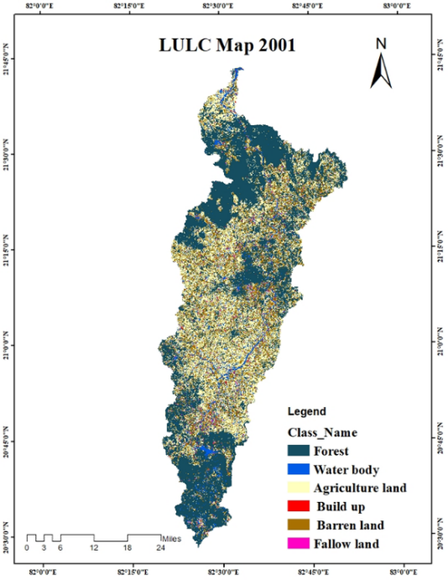
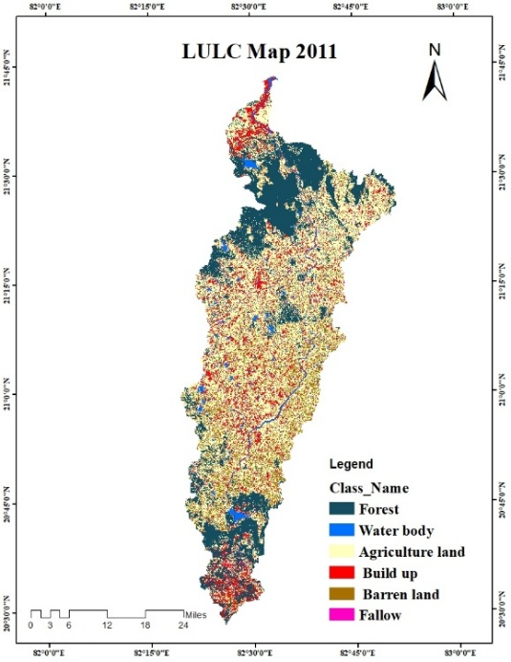
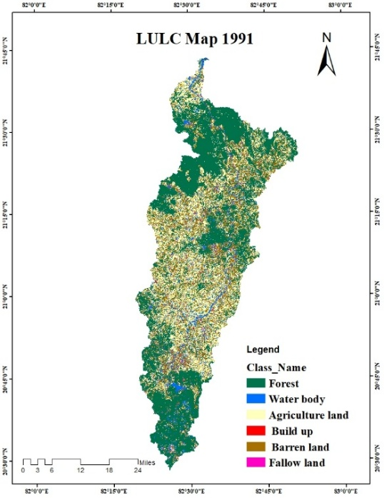
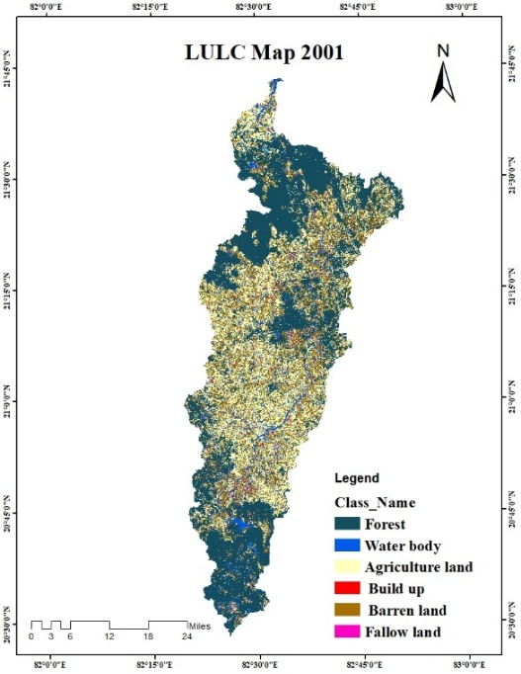
The ArcSWAT model effectively reproduced the hydrological behavior of the Jonk sub-basin, providing a reliable basis for evaluating the impact of LULC changes on surface runoff. Although slight underestimation of peak flows was observed, which is common in hydrological simulations due to uncertainties in extreme rainfall events, the overall model performance remained satisfactory. The results indicate that the model captured both the temporal variability and magnitude of streamflow with reasonable accuracy.

Fig 2: LULC map of Jonk subbasin

Table 2: Accuracy assessment of lulc maps
Year | Overall Classification Accuracy | Overall Kappa Coefficient
1991 | 87.87% | 0.837
2001 | 88.25% | 0.861
2011 | 85.5% | 0.821
2021 | 89.23% | 0.882

Analysis of LULC changes over the study period revealed a clear shift from natural to anthropogenic landscapes. Agricultural land increased significantly from 36.03% to 41.44%, reflecting intensified farming activities, while forest cover declined from 34.52% to 30.02%. Built-up areas also expanded, indicating increasing urbanization and human intervention in the basin. These transformations have altered the land surface characteristics, directly influencing hydrological processes.
Table 3: Land use change in 1991 and 2021
Land use/Land cover | Area in km²
Land use/Land cover | 1991 | 2001 | 2011 | 2021
Barren land | 480 | 455.6 | 400 | 340
Fallow land | 36.2 | 45.65 | 37.54 | 30
Forest land | 1150 | 1066 | 959.63 | 1000
Agriculture | 1200 | 1232 | 1265 | 1380
Built-up | 162 | 285 | 398.9 | 199.26
Water body | 192.4 | 190.7 | 190 | 181.44

Land use/Land cover | Percent change (%)
Land use/Land cover | 2001 | 2011 | 2021
Barren land | - 5.83 | -17.32 | -29.67
Fallow land | 26.00 | 3.62 | - 15.40
Forest land | -15.73 | -23.74 | -37.42
Agriculture | 5.76 | 8.50 | 19.14
Built-up | 75.08 | 145.21 | 210.64
Water body | -0.92 | - 1.28 | -5.73

The impact of these changes on surface runoff was evident from the increase in Curve Number values, which rose from 73.1 to 83.6 over time. This increase indicates reduced infiltration capacity and higher runoff potential. Consequently, mean annual surface runoff increased from 340.82 mm to 377.29 mm, representing an approximate rise of 9–11%. The increase in runoff was more pronounced in
areas dominated by agriculture and steep slopes, were reduced vegetation cover and soil compaction limit water infiltration. Seasonal analysis further showed increased runoff during post-monsoon periods, suggesting reduced soil moisture retention and faster drainage.
Table 4: Variation of surface runoff in 1991 and 2021
Month | Surface runoff (cms)
Month | 1991 | 2001 | 2011 | 2021
January | 2.31 | 2.12 | 2.07 | 1.94
February | 1.98 | 1.82 | 1.78 | 1.66
March | 3.01 | 2.77 | 2.70 | 2.52
April | 3.99 | 3.67 | 3.59 | 3.35
May | 5.35 | 5.02 | 2.12 | 4.49
June | 16.62 | 18.10 | 15.95 | 21.56
July | 26.91 | 28.33 | 30.22 | 35.81
August | 22.89 | 26.33 | 28.20 | 30.78
September | 15.57 | 17.12 | 20.01 | 24.67
October | 10.89 | 11.58 | 11.50 | 13.26
November | 3.01 | 2.77 | 2.70 | 2.52
December | 2.36 | 2.17 | 2.12 | 1.98

Month | % change
Month | 2001 | 2011 | 2021
January | -8.62 | 9.44 | 47.02
February | 0.32 | -0.32 | 28.18
March | 2.05 | -2.00 | 0.76
April | -29.00 | 40.84 | 47.39
May | 1.34 | -1.32 | -22.99
June | 7.23 | -6.75 | -12.28
July | 1.67 | -1.64 | -4.59
August | 0.38 | -0.38 | -1.78
September | -0.51 | 0.51 | 5.16
October | -1.76 | 1.79 | 12.66
November | -2.83 | 2.91 | 19.94
December | -3.16 | 3.26 | 26.37

Spatial variability analysis indicated that sub-watersheds with higher forest cover exhibited relatively stable hydrological responses, whereas regions with intensive land use changes experienced higher runoff. These findings demonstrate the combined influence of land use, soil, and topography on watershed hydrology.
The observed increase in runoff has important environmental implications, including reduced groundwater recharge, increased flood risk, and enhanced soil erosion. Therefore, sustainable land management practices such as afforestation, soil conservation, and controlled urban expansion are essential to mitigate these impacts.
3.1 Sensitivity analysis
Data sets | r² | NSE
Calibrated period | 0.83 | 0.82
Validated period | 0.84 | 0.88
Sensitivity analysis is a method used to evaluate how variations in independent parameters influence a dependent variable under a defined set of assumptions. In this study, sensitivity analysis was applied to identify the parameters that have the greatest impact on model outputs. The most influential parameters were then adjusted during the calibration process. The permissible ranges for these parameters were selected based on previous research studies and guidelines provided in the SWAT-CUP manual. Among all the parameters considered, five were identified as highly sensitive: hydraulic conductivity, threshold water depth, baseflow, soil evaporation compensation factor, and slope steepness.
Table 5: Performance evaluation of the ArcSWAT model

The SWAT model was calibrated and validated against monthly surface runoff data using the Sequential Uncertainty Fitting-2 (SUFI-2) algorithm. Model calibration and simulation were carried out for the period from 1991 to 2010, with an initial warm-up period from 2011 to 2021 to stabilize the model. Calibration was performed using the SWAT-CUP tool (Abbaspour et al., 2007) to enhance the model’s accuracy and overall performance. The goal was to achieve reliable statistical indicators such as the coefficient of determination (R²) and Nash–Sutcliffe Efficiency (NSE). After calibration, the model produced R² and NSE values of 0.83 and 0.82, respectively.
The SUFI-2 sensitivity analysis indicates that HRU_SLP (t = -10.24, p = 0.00) is the most sensitive parameter, followed by GWQMN and OV_N, showing strong influence on model outputs. Parameters such as RCHRG_DP exhibit moderate sensitivity, while commonly important parameters like **CN2 and ALPHA_BF show relatively low sensitivity in this watershed. Overall, the results suggest that topographic and flow resistance parameters dominate runoff simulation, whereas soil and groundwater delay parameters have comparatively lesser influence under the given conditions.
Parameter Name |  | t – Stat | P – Value | Sensitivity Rank
R_ESCO.bsn |  | -0.06 | 0.94 | 14
R_SOL_AWC. Sol |  | 0.21 | 0.82 | 13
A_CN2.mgt |  | -0.23 | 0.81 | 12
V_ALPHA_BF.gw |  | -0.59 | 0.55 | 11
V_GW_DELAY.gw |  | 0.61 | 0.54 | 10
R_CH_K2.rte |  | 0.72 | 0.47 | 9
R_ GW_REVAP.gw | -0.75 |  | 0.45 | 8
R_CH_N2.rte | -0.89 |  | 0.37 | 7
R_EPCO.bsn | -1.07 |  | 0.28 | 6
A SLSUBBSN.hru | 1.29 |  | 0.19 | 5
R_RCHRG_DP.gw | 2.03 |  | 0.04 | 4
R_OV_N.hru | 4.15 |  | 0.00 | 3
V GWQMN.gw | 4.24 |  | 0.00 | 2
A HRU_SLP.hru | -10.24 |  | 0.00 | 1
Table 6: Sensitivity Analysis Result of Parameters

Model validation was conducted for the period 2011 to 2021 to assess the reliability of the calibrated model. This step was also performed using the SWAT-CUP interface. During validation, the R² and NSE values improved to 0.84 and 0.88, respectively. Since both statistical indicators exceeded acceptable performance thresholds, the model results were considered satisfactory and reliable.
The variations in annual surface runoff for the Jonk subbasin over the past decade are summarized in Table 6, indicating a noticeable upward trend in runoff values. The results suggest that surface runoff has increased over time. The ArcSWAT model successfully captured these changes with a high level of reliability. By operating on a monthly time scale, the model was able to represent fluctuations in runoff with considerable accuracy.
Table 7: Observed vs Simulated Discharge for monthly time step
Year | Observed Discharge (m³/s) | Simulated Discharge (m³/s)
1991 | 622.57 | 454.82
2021 | 371.78 | 402.66

4. Conclusion
The study reveals that LULC changes in the Jonk sub-basin, particularly the increase in agriculture (36.03% to 41.44%) and built-up areas alongside a decline in forest cover (34.52% to 30.02%), have significantly increased surface runoff. This is reflected in the rise of Curve Number (73.1 to 83.6) and mean annual runoff (340.82 mm to 377.29 mm, ~9–11%), with notable increases during monsoon months. The SWAT model performed reliably (R² up to 0.84, NSE up to 0.88), confirming the strong impact of land transformation on hydrology. Overall, the results highlight increased flood risk and reduced infiltration, emphasizing the need for sustainable land management practices.
Disclaimer (Artificial intelligence)

Author(s) hereby declare that NO generative AI technologies such as Large Language Models (ChatGPT, COPILOT, etc.) and text-to-image generators have been used during the writing or editing of this manuscript.

References
- Abbaspour, K. C. (2011). SWAT-CUP: SWAT Calibration and Uncertainty Programs – A User Manual. Swiss Federal Institute of Aquatic Science and Technology (Eawag), Dübendorf, Switzerland.
- Abbaspour, K. C., Johnson, C. A., & van Genuchten, M. T. (2004). Estimating uncertain flow and transport parameters using a sequential uncertainty fitting procedure. Vadose Zone Journal, 3(4), 1340–1352.
- Arnold, J. G., Moriasi, D. N., Gassman, P. W., Abbaspour, K. C., White, M. J., Srinivasan, R., Harmel, R. D., Van Griensven, A., Van Liew, M. W., Kannan, N., & Jha, M. K. (2012). SWAT: Model use, calibration, and validation. Transactions of the ASABE, 55(4), 1491–1508.
- Arnold, J. G., Srinivasan, R., Muttiah, R. S., & Williams, J. R. (1998). Large area hydrologic modeling and assessment: Part I—Model development. Journal of the American Water Resources Association, 34(1), 73–89.
- Bewket, W., & Sterk, G. (2005). Dynamics in land cover and its effect on streamflow. Hydrological Processes, 19(2), 445–458.
- Bosch, J. M., & Hewlett, J. D. (1982). A review of vegetation effects on water yield. Journal of Hydrology, 55(1–4), 3–23.
- Costa, M. H., Botta, A., & Cardille, J. A. (2003). Effects of large-scale changes in land cover on river discharge. Journal of Hydrology, 283(1–4), 206–217.
- Fohrer, N., Haverkamp, S., Eckhardt, K., & Frede, H. G. (2001). Hydrologic response to land use changes on the catchment scale. Physics and Chemistry of the Earth, 26(7–8), 577–582.
- Gassman, P. W., Reyes, M. R., Green, C. H., & Arnold, J. G. (2007). The Soil and Water Assessment Tool: Historical development, applications, and future research directions. Transactions of the ASABE, 50(4), 1211–1250.
- Khoi, D. N., & Suetsugi, T. (2014). Hydrological response to land-use change. Hydrological Processes, 28(3), 640–652.
- Li, Z., Liu, W. Z., Zhang, X. C., & Zheng, F. L. (2009). Impacts of land use change on hydrology. Journal of Hydrology, 377(1–2), 35–42.
- Mishra, V. K., Khalkho, D., Pandey, V. K., & Verma, S. (2024). Decadal Change in Land Use and Land Cover Dynamics: A Comprehensive Assessment of the Kharun Catchment. Journal of Scientific Research and Reports, 30(12), 630-639.
- Moriasi, D. N., Arnold, J. G., Van Liew, M. W., Bingner, R. L., Harmel, R. D., & Veith, T. L. (2007). Model evaluation guidelines for systematic quantification of accuracy in watershed simulations. Transactions of the ASABE, 50(3), 885–900.
- Neitsch, S. L., Arnold, J. G., Kiniry, J. R., & Williams, J. R. (2011). Soil and Water Assessment Tool Theoretical Documentation Version 2009. Texas Water Resources Institute, Texas A&M University, USA.
- Niehoff, D., Fritsch, U., & Bronstert, A. (2002). Land-use impacts on storm-runoff generation. Journal of Hydrology, 267(1–2), 80–93.
- Setegn, S. G., Srinivasan, R., Dargahi, B., & Melesse, A. M. (2008). Soil erosion vulnerability assessment. Hydrological Processes, 23(26), 3738–3750.
- Shrestha, S., & Kazama, F. (2007). Surface water quality assessment. Environmental Modelling & Software, 22(4), 464–475.
- Yang, X., & Lo, C. P. (2002). Using satellite imagery to detect land use and land cover changes. International Journal of Remote Sensing, 23(9), 1775–1798.
- Zhang, M., Dawes, W. R., & Walker, G. R. (2001). Response of evapotranspiration to vegetation changes. Water Resources Research, 37(3), 701–708.

