Trait Dynamics and Genetic Variability Studies in Rice under Contrasting Water Regime

Abstract
Background: Rice is a major staple crop globally but is highly vulnerable to abiotic stresses, especially drought, which severely affects yield and food security. Drought disrupts plant growth and development, though adaptive traits vary among genotypes, making evaluation important for identifying resilient varieties.
Aim- The study aimed at accessing the effect of drought on yield and yield attributing traits as compared to the irrigated environment followed by identification of genotypes conferring high and stable agronomic performance under contrasting field moisture environment
Study design- Augmented design
Methodology- Total 103 genotypes including three checks were grown in bot irrigated and drought field which was induced at reproductive stage. The data was taken for key agronomic traits along with grain yield. Comparative statistical including ANOVA, correlation, Genetic variability studies and Principal component analysis to unveil how the relative values for different agronomic traits varied in two contrasting environments.
Result-The ANOVA revealed significant variation in the panel the variation for which increased under drought stress. Harvest index, spikelet fertility and flag leaf width were identified as important traits contributing toward grain yield under drought. Superior genotypes in terms of better grain yield under drought environment were tall in stature with increased flag leaf width, more number of effective tillers, improved spikelet fertility and better harvest index
Conclusion- The traits identified as important contributor for grain yield under drought can be given preference while selected stable drought resilient genotypes.

- INTRODUCTION-
Rice is the most widely cultivated cereal crop, serving as the staple food for more than half of the global population and contributing substantially daily calorie intake (FAO, 2024). Despite its global importance, rice productivity is highly vulnerable to abiotic stresses, particularly drought, salinity, flood and mineral toxicity (Sarma et al., 2023). Among these, drought stress during reproductive stage is especially critical, as it severely reduces grain yield and poses a major threat to food security (Sakran et al., 2025). Rice is naturally adapted to irrigated and waterlogged conditions, with more than 53% of the global rice area under irrigation, consequently its production is strongly depended on the fresh water availability. However, increasing water scarcity, erratic rainfall and reduced precipitation relative to evapotranspiration demand have intensified yield instability in rice production systems (Subramanian et al., 2025).
Drought stress affects rice growth and development through several physiological and morphological disruption, including reduced cell expansion, impaired photosynthesis and decreased nutrition uptake. These limitations ultimately lead to poor panicle development, spikelet sterility and significant yield reduction. The severity of drought effects largely depends on the timing, intensity and duration of the stress, with reproductive stage drought being particularly detrimental to the plant’s growth and development. In response, rice plants exhibit a range of adaptive mechanisms such as deeper root system, improved water use efficiency, osmotic adjustment and maintenance of leaf turgor under systems under limited water availability. The expression of these adaptive traits varies widely among genotypes, highlighting the importance of evaluating diverse germplasm to identify lines capable of sustaining productivity and superior grain quality under moisture deficit conditions.
The challenge for sustaining rice yields under water limited conditions underscores the need to explore genetic variability in rice germplasm. Variability studies provide insight into the extent of genetic diversity for key agronomic traits contributing towards overall grain yield. Identifying genotypes with superior performance under stress conditions enables breeders to select promising donors for prebreeding and genetic improvement programmes.
Characterizing germplasm lying in the genebank for such traits is highly critical to identify promising candidate. Genebank lines, landraces and traditional varieties have shown with remarkable resilience under stress, often outperforming the modern checks in yield stability and physiological efficiency (De et al., 2023). It makes is vital to conduct variability studies as foundation and one of the first step towards breeding drought tolerant rice varieties. The present research aims at characterizing the diverse rice genotypes belonging to different rice subpopulations for a suite of agronomic traits under drought stress relative to normal irrigated conditions (IC) and identifying the outperforming genotypes which may further be potentially considered as donors in breeding programmes for drought improvement.

MATERIAL AND METHOD-
2.1 Plant Material and Experimental Design
The study was carried out at the experimental fields of Indira Gandhi Krishi Vishwavidyalaya (IGKV), Raipur, using a set of 103 rice genotypes (Appendix Table A1). This panel included three check varieties namely two widely cultivated megavarieties, IR64 and Samba Mahsuri, along with the drought tolerant variety Sahbhagi Dhan. The test entries were drawn from the 3K Rice Genome Panel, ensuring broad genetic diversity and representation of global rice germplasm.
The experiment was laid out in an augmented randomized block design (Federer, 1956) with five blocks, each containing 23 entries including the three checks. This design allowed replicated checks to provide reliable estimates of experimental error, while unreplicated test entries maximized genetic coverage. Seeds were pre-treated at 50 °C for 48 hours to break dormancy before sowing. Each plot measured 2.0 m × 1.8 m, with a spacing of 20 cm × 20 cm between rows and plants, ensuring uniform plant density across treatments.
  - Environmental Conditions and Data Collection-
The trial was conducted under two contrasting environments: an irrigated field representing favourable conditions and a water-stress field simulating drought. To impose drought stress at the reproductive stage, irrigation was withheld once more than 50% of the plants reached panicle initiation, and field water was drained completely. The intensity of stress was monitored using tensiometers and soil moisture readings to quantify drought severity. Agronomic data were recorded for key traits including days to 50% flowering (DFF), plant height (PH), panicle length (PL), flag leaf length (FLL), flag leaf width (FLW), number of effective tillers (NET), harvest index (HI), grain yield (Yield), and thousand-grain weight (TGW).

2.3. Statistical Analysis
Data analysis was performed using R statistical software, following procedures for augmented block design (Federer, 1956). Analysis of variance (ANOVA) was used to partition variability among genotypes, checks, and blocks. Genotypic variance (GV) was estimated as the difference between phenotypic variance (PV) and environmental variance (EV). Genotypic and phenotypic coefficients of variation (GCV and PCV) were calculated following Burton (1952). Heritability (h²) in the broad sense was estimated as GV/PV (Falconer and Mackay, 1996). Genetic advance (GA) was calculated as:
GA=k×σp×h2
where k=2.06 at 5% selection intensity and σp is the phenotypic standard deviation. Genetic advance as percent of mean (GAM) was derived as:
GAM=GA/ Mean×100
The Standard Error of Difference (SED) was estimated separately for test vs. check, check vs. check, and test vs. test comparisons. Critical Difference (CD) at 5% was obtained as tα×SED, and Least Significant Increase (LSI) thresholds were derived by adding CD to the best check mean (Afifah et al.,2020). This enabled identification of entries statistically superior to the checks, thereby validating the performance of promising genotypes against established megavarieties.
- RESULT AND DISCUSSION-
Hundred test entries sourced from 13 countries belonging to 11 subpopulation classes were systematic grown in two field conditions viz: irrigated and drought. The drought was imposed at reproductive stage to explore its effect on yield and yield- component traits. For imposing drought, field was drained when 50% of the plot attended heading stage. During the reproductive stage, the tensiometer reading varied from -20kPa to -56kPa (Figure 1a) while the soil moisture (Figure 1b) gradually dropped from 25% to as low as 10%, wherein common dry spells during the reproductive phase were evident with no rainfall observed during reproductive stage.
Figure-1 Soil data trend. (a)Soil moisture and (b) tensiometer reading trend during reproductive stage
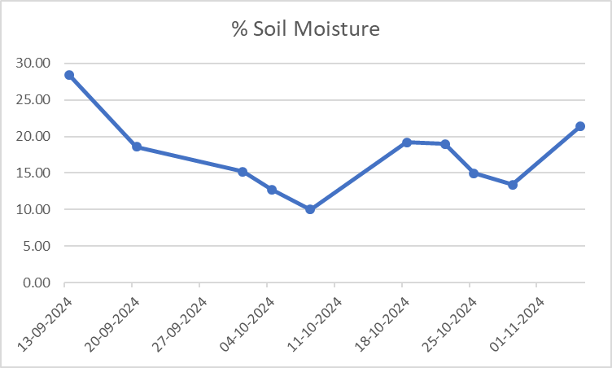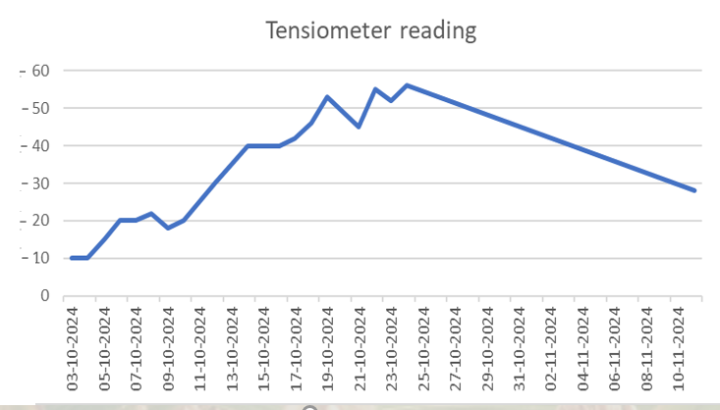

3.1 Analysis of Variance –
The analysis of variance (ANOVA) of all traits under irrigated condition showed the significant results across the environments for most of the traits. The block effect (unadjusted) for the irrigated season and the treatment effects (adjusted as well as unadjusted) was significant for days to 50% flowering (DFF), plant height (PH), yield, and thousand seed weight (TSW). Similarly, the effects due to checks and varieties were also significant (Table 1a, 1b) for DFF, PH, harvest index (HI), and TSW, indicating that the test entries differed from the standard checks. However, the adjusted block effects were non-significant for all the traits, suggesting homogeneity in block evaluation. The mean square due to checks vs. varieties was significant for DFF, PH, HI, and TSW, but non-significant for panicle length (PL), flag leaf length (FLL), leaf fresh weight (LFW), spikelet fertility (SF), and sterile spikelets (SS). This indicates that the test entries were significantly different from the checks for most traits, but not for these specific characters. Overall, the ANOVA results confirmed that the experimental design was effective in partitioning variability, and that substantial genetic differences existed among the genotypes under irrigated condition.

Table 1a- ANOVA for Irrigated condition, Treatment Adjusted
Source of Variation | Df | DFF | PH | PL | FLL | FLW | NET | HI | Yield | SF | SS | TGW
Block (ignoring Treatments) | 4 | 10.62ns | 300.11* | 5.67ns | 33.16ns | 0.02ns | 3.01ns | 99.07ns | 326.41** | 21.8ns | 21.8ns | 12.4**
Treatment (ignoring Blocks) | 102 | 92.84** | 502.13** | 9.23ns | 36.86ns | 0.05ns | 2.4ns | 45.49ns | 105.86** | 57.26ns | 57.26ns | 23**
Treatment: Check | 2 | 1088.6** | 389.79* | 16.86ns | 30.54ns | 0.09ns | 9.45* | 217.79* | 64.39ns | 68.05ns | 68.05ns | 194.08**
Treatment: Test and Test vs. Check | 100 | 72.93** | 504.37** | 9.07ns | 36.99ns | 0.05ns | 2.25ns | 42.04ns | 91.39ns | 57.04ns | 57.04ns | 19.58**
Residuals | 8 | 6.1 | 69.45 | 5.09 | 16.43 | 0.03 | 1.69 | 26.94 | 36.62 | 42.54 | 42.54 | 1.42
1b. ANOVA for Irrigated condition, Block Adjusted
Source of Variation | Df | DFF | PH | PL | FLL | LFW | NET | HI | Yield | SF | SS | TSW
Treatment (ignoring Blocks) | 102 | 93.01 ** | 513.63 ** | 9.41 ns | 37.83 ns | 0.05 ns | 2.49 ns | 48.61 ns | 103.07 ns | 56.11 ns | 56.11 ns | 23.32 **
Treatment: Check | 2 | 1088.60 ** | 389.79 * | 16.86 ns | 30.54 ns | 0.09 ns | 9.45 * | 217.79 * | 64.39 ns | 68.05 ns | 68.05 ns | 194.08 **
Treatment: Test | 99 | 35.62 ** | 469.16 ** | 9.23 ns | 38.27 ns | 0.05 ns | 2.27 ns | 41.30 ns | 73.23 ns | 55.17 ns | 55.17 ns | 19.57 **
Treatment: Test vs. Check | 1 | 3782.88 ** | 5163.27 ** | 12.16 ns | 9.27 ns | 0.00 ns | 10.62 * | 434.25 ** | 3134.36 ** | 125.36 ns | 125.36 ns | 53.43 **
Block (eliminating Treatments) | 4 | 6.40 ns | 6.82 ns | 0.93 ns | 8.49 ns | 0.01 ns | 0.58 ns | 19.34 ns | 14.98 ns | 51.07 ns | 51.07 ns | 4.12 ns
Residuals | 8 | 6.1 | 69.45 | 5.09 | 16.43 | 0.03 | 1.69 | 26.94 | 36.62 | 42.54 | 42.54 | 1.42

The analysis of variance (ANOVA) of all traits under drought condition (DC) showed variability due to different sources (Table 2a, 2b). The block effect (unadjusted) for the drought season was significant for plant height (PH) and flag leaf width (FLW), indicating some influence of field heterogeneity on these traits. The treatment effects (adjusted as well as unadjusted) were highly significant for DFF, PH, PL, FLL, FLW, NET, HI and TGW. The effects due to checks and varieties were also significant for DFF, PH, PL, FLL, FLW, NET, HI, yield, SF, SS, and TGW, confirming that the standard checks differed markedly from the test entries. The adjusted block effects, however, were largely non-significant for most traits, suggesting homogeneity in block evaluation under drought. The mean square due to checks vs. varieties was significant for DFF, PH, PL, FLL, FLW, NET, HI, and TGW, but non-significant for yield, SF, and SS. This indicates that the test entries were significantly different from the checks for most morphological traits, but not for reproductive traits under drought stress.

2a. ANOVA for Drought condition, Treatment adjusted
Source of Variation | Df | DFF | PH | PL | FLL | FLW | NET | HI | Yield | SF | SS | TGW
Blocks (ignoring treatments) | 4 | 2.72 ns | 302.68** | 1.93 ns | 19.14* | 0.20** | 0.20** | 2.27 ns | 205.32** | 150.62 ns | 354.60 ns | 25.44**
Treatments (eliminating blocks) | 102 | 96.37** | 585.96** | 7.40** | 34.87** | 0.06** | 0.06** | 3.23* | 123.70 ** | 63.58 ns | 266.95 ns | 19.30**
Checks | 2 | 960.27** | 2300.27** | 46.89** | 34.97* | 0.17** | 0.17** | 9.11** | 798.80** | 559.16* | 1308.18* | 170.91**
Tests + Test vs Check | 100 | 79.09** | 551.68** | 6.61* | 34.87** | 0.06** | 0.06** | 3.11* | 110.20 ns | 53.67 ns | 246.12 ns | 16.27**
Residuals | 8 | 11.85 | 10.98 | 1.44 | 4.56 | 0 | 0 | 0.9 | 74.78 | 79.65 | 274.6 | 2.95
2b. ANOVA for Drought condition, Block Adjusted
Source of Variation | Df | DFF | PH | PL | FLL | FLW | NET | HI | Yield | SF | SS | TGW
Treatment (ignoring Blocks) | 102 | 95.40 ** | 594.68 ** | 7.47 ** | 35.45 ** | 0.06 ** | 3.27 * | 130.03 ns | 67.92** | 278.99 ns | 246.34 ns | 20.22 **
Treatment: Check | 2 | 960.27 ** | 2300.27 ** | 46.89 ** | 34.97 * | 0.17 ** | 9.11 ** | 798.80 ** | 559.16 * | 1308.18 * | 1308.18 * | 170.91 **
Treatment: Test | 99 | 38.38 * | 467.19 ** | 6.63 * | 34.11 ** | 0.06 ** | 3.04 * | 116.65 ns | 54.79 ns | 256.32 ns | 220.97 ns | 16.70 **
Treatment: Test vs. Check | 1 | 4009.80 ** | 9804.92 ** | 11.27 * | 169.21 ** | 0.64 ** | 14.33 ** | 116.84 ns | 385.88 ns | 465.55 ns | 634.45 ns | 67.93 **
Block (eliminating Treatments) | 4 | 27.50 ns | 80.31 ** | 0.29 ns | 4.38 ns | 0.05 ** | 1.29 ns | 43.90 ns | 39.87 ns | 47.38 ns | 47.38 ns | 1.88 ns
Residuals | 8 | 11.85 | 10.98 | 1.44 | 4.56 | 0 | 0.9 | 74.78 | 79.65 | 274.6 | 274.6 | 2.95
Days to 50% flowering (DFF), plant height (PH), panicle length (PL), flag leaf length (FLL), flag leaf width (FLW), number of effective tillers (NET), harvest index (HI), grain yield (Yield), and thousand-grain weight (TGW)

3.2 Identification of Potential Genotypes-
The Least Significant Increase (LSI) analysis was employed to identify test entries that were statistically superior to the best check varieties for yield and its major components. Under irrigated condition (Table 4), none of the test entries surpassed the LSI thresholds for yield, SF, TGW and NET. Although several entries recorded values higher than some checks namely IRIS_313-10560 (Yield = 43.45 g), IRIS_313-8147 (TGW = 39.17 g), and IRIS_313-11462 (NET = 11.6). Among the checks, IR64 was superior for yield and TSW, Sahbhagi Dhan for SF, and Samba Mahsuri for NET, confirming their continued statistical advantage under irrigated conditions. Similarly, under drought condition (Table 5), none of the test entries surpassed the LSI thresholds for yield, SF, TSW, or NET. Entries such as IRIS_313-10976 (Yield = 46.75 Q/ha) and IRIS_313-10020 (NET = 11.40) showed relatively strong performance compared to some checks, but their adjusted means remained below the respective LSI thresholds. In this environment, Sahbhagi dhan was identified as the overall best check for grain yield and most of the yield contributing traits. It is worth noticing that most of better performing genotypes under irrigated condition belonged to indica subpopulation while those in drought stress belonged to aus and admixture subpopulation. Notably, this finding is consistent with previous studies that emphasize the importance of aus rice as a genetic reservoir for drought tolerance, owing to its evolutionary adaptation to rainfed ecosystems (Casartelli et al.,2018). The aus group has been widely known as a source of alleles for stress resilience, including traits such as early maturity, deep rooting, and osmotic adjustment, which directly contribute to yield stability under drought (Yadav et al.,2019; Bin and Zhang, 2018; Kumar et al., 2014).
3.3 Genetic Variability under Irrigated Condition (IC)-
The variability analysis under irrigated condition revealed that several traits were under strong genetic control (Table 3). PH exhibited high genotypic and phenotypic coefficients of variation (GCV = 16.05%, PCV = 17.39%), coupled with very high heritability (85.20%) and high genetic advance as percent of mean (GAM = 30.57%). This indicates strong additive gene action, making PH a reliable trait for selection (Ganapati et al., 2020). Similarly, TGW showed high heritability (92.77%) and high GAM (35.44%), confirming its stability and amenability to direct selection. Yield displayed high variability (GCV = 22.81%, PCV = 32.26%), moderate heritability (49.99%), and high GAM (33.27%), suggesting that yield improvement under irrigated conditions can be achieved through direct selection, although environmental effects remain significant (Burton, 1952). Traits such as FLL also showed moderate heritability (57.08%) and high GAM (22.49%), indicating usefulness in selection. In contrast, SF and NET recorded low heritability (22.90% and 25.42%, respectively) and low GAM, reflecting strong environmental influence and limited scope for direct selection.
3.4 Genetic Variability under Drought Condition (DC)-
Under drought stress, variability patterns shifted markedly (Table 4). PH again showed high heritability (97.65%) and high GAM (34.26%), confirming its stability across environments. FLW exhibited very high heritability (92.12%) and exceptionally high GAM (49.15%), suggesting strong genetic control and high potential for improvement under stress. TGW and NET also recorded high heritability (82.31% and 70.19%) with high GAM (32.24% and 32.02%), making them dependable traits for drought tolerance breeding (Venuprasad et al., 2007). In contrast, yield showed high variability (GCV = 25.66%, PCV = 45.93%) but only moderate heritability (31.21%), indicating that environmental variance predominated. SF was particularly unstable, with very low heritability (2.66%) and negligible GAM (3.38%), confirming that this trait is strongly environment-dependent and unreliable for selection under drought. This finding corroborates the previous study (Ali et al., 2010).
Table 3 - Genetic variability measures under irrigated environment
Trait | Mean | Range | GCV | PCV | Heritability | GA | GA as% of mean | SeD (Test vs Check) | LSI
DFF | 76.07 | 56.27 – 109 | 7.14 | 7.85 | 82.88 | 10.2 | 13.41 | 3.12 | 6.42
PH | 124.56 | 68.11 – 166.71 | 16.05 | 17.39 | 85.2 | 38.07 | 30.57 | 10.54 | 21.72
PL | 23.89 | 12.23 – 29.00 | 8.52 | 12.72 | 44.89 | 2.81 | 11.78 | 2.85 | 5.87
FLL | 32.38 | 17.83 – 55.15 | 14.43 | 19.1 | 57.08 | 7.28 | 22.49 | 5.13 | 10.57
FLW | 0.75 | 0.39 – 1.27 | 15.94 | 28.9 | 30.42 | 0.14 | 18.13 | 0.23 | 0.47
NET | 8.66 | 3.20 – 11.47 | 8.77 | 17.39 | 25.42 | 0.79 | 9.12 | 1.65 | 3.4
HI | 32.43 | 15.13 – 50.47 | 11.69 | 19.82 | 34.78 | 4.61 | 14.22 | 6.57 | 13.53
Yield | 26.53 | 8.44 – 45.71 | 22.81 | 32.26 | 49.99 | 8.83 | 33.27 | 7.65 | 15.76
SF | 84.02 | 59.21 – 98.28 | 4.23 | 8.84 | 22.9 | 3.51 | 4.18 | 8.25 | 16.99
SS | 15.98 | 1.72 – 40.79 | 22.25 | 46.49 | 22.9 | 3.51 | 21.97 | 8.25 | 16.99
TGW | 23.89 | 13.19 – 40.33 | 17.84 | 18.52 | 92.77 | 8.47 | 35.44 | 1.5 | 3.09
Days to 50% flowering (DFF), plant height (PH), panicle length (PL), flag leaf length (FLL), flag leaf width (FLW), number of effective tillers (NET), harvest index (HI), grain yield (Yield), and thousand-grain weight (TGW)
Table 4 - Genetic variability measures under Drought environment
Trait | Mean | Range | GCV | PCV | Heritability | GA | GA as% of mean | SeD (Test vs Check) | LSI
DFF | 77.31 | 55 – 110.20 | 6.66 | 8.01 | 69.13 | 8.84 | 11.43 | 4.35 | 8.96
PH | 127.09 | 65.07 – 175.13 | 16.81 | 17.01 | 97.65 | 43.54 | 34.26 | 4.19 | 8.63
PL | 23.68 | 13.90 – 29.55 | 9.62 | 10.87 | 78.26 | 4.16 | 17.56 | 1.52 | 3.13
FLL | 32 | 20.62 – 51.49 | 16.99 | 18.25 | 86.63 | 10.44 | 32.62 | 2.7 | 5.56
FLW | 0.91 | 0.36 – 1.81 | 24.82 | 25.86 | 92.12 | 0.45 | 49.15 | 0.08 | 0.16
NET | 7.88 | 0.30 – 11.58 | 18.53 | 22.11 | 70.19 | 2.52 | 32.02 | 1.2 | 2.47
HI | 29.33 | 0 – 75.19 | 22.06 | 36.82 | 35.9 | 8 | 27.27 | 10.94 | 22.53
Yield | 19.43 | 0.16 – 41.32 | 25.66 | 45.93 | 31.21 | 5.7 | 29.33 | 11.29 | 23.27
SF | 66.88 | 0 – 101.86 | 6.39 | 24.78 | 6.65 | 2.04 | 3.05 | 20.96 | 43.18
SS | 32.22 | 0 – 105.60 | 22.72 | 51.42 | 19.53 | 6.48 | 20.11 | 20.96 | 43.18
TGW | 21.53 | 9.67 – 37.12 | 17.22 | 18.98 | 82.31 | 6.94 | 32.24 | 2.17 | 4.47
Days to 50% flowering (DFF), plant height (PH), panicle length (PL), flag leaf length (FLL), flag leaf width (FLW), number of effective tillers (NET), harvest index (HI), grain yield (Yield), and thousand-grain weight (TGW), GA (Genetic advance), LSI (Least significant increase)
3.5 Comparative analysis-
Based on yield under drought, top ten lines were selected for comparative analysis (Table 5). In PH was observed to be higher under DC than under IC for most of these entries. The reason for this could be strong linkage or pleotropic effect of abiotic stress resistance genes to tall height (Vikram et al.,2015). Reduced competition for resources among fewer tillers can result in taller plants under stress, even though overall biomass is lower. There was also consistent increase in flag leaf width and few entries also showed increase in leaf length. Flag leaf length and width have found to be positively correlated to rice yield under drought (Abarshahr et al., 2011; Sohrabi et al., 2012). Rice genotypes characterized by a thicker culm and larger flag leaves tend to show anatomical modifications such as expanded bundle sheath and vascular bundle areas. These plants also possess wider xylem and phloem vessels along with greater spacing between veins, which reflects structural adaptation (Wu et al., 2011). Morphologically, such lines usually produce fewer tillers but compensate with bigger panicles that carry more grains, and the grains themselves are heavier. However, this advantage is offset by reduced seedset and a higher incidence of blighted grains, meaning that the overall yield remains comparable to that of normal- culm plants. Although their performance under drought stress was not directly evaluated, certain features like increased interveinal distance may be disadvantageous in water-limited environments, as they could hinder efficient water transport. On the other hand, traits such as enhanced photosynthetic capacity of the flag leaf and improved culm transport efficiency are potentially beneficial under stress conditions, making these structural modifications relevant for breeding programs aimed at resilience. IRIS_313-9547 was found to be most consistent genotypes in terms of grain yield across the environment with yield of 33.76 q/ha and 33.50 q/ha in IC and DC respectively. In the Drought stress environment, the highest yielding test genotype was IRIS_313-10881 with grain yield of 46.75 q/ha. However, the yield of this genotype under irrigated condition was 29.3 q/ha, indicating that the genotype is more adapted to water stress environment but is not better performing under normal irrigated condition. The lower yield of drought adapted genotypes is the result of their specific adaptation to water limited condition and needs performance validation in diverse environments.
Table 5 - Comparative Analysis of Top Ten Entries Based of Yield under drought-
Entries | DFF |  | PH |  | PL |  | FLL |  | FLW |  | NET |  | HI |  | Yield |  | SF |  | SS |  | TGW
Entries | IC | DC | IC | DC | IC | DC | IC | DC | IC | DC | IC | DC | IC | DC | IC | DC | IC | DC | IC | DC | IC | DC
IRIS_313-10881 | 86 | 85 | 118.02 | 127.80 | 27.1 | 24.50 | 29.5 | 30.74 | 0.88 | 1.18 | 7.2 | 8.20 | 47.71 | 67.45 | 29.43 | 46.75 | 84.1 | 65.51 | 15.9 | 34.49 | 22.32 | 10.51
IRIS_313-10976 | 70 | 72 | 108.04 | 125.00 | 24.3 | 29.36 | 32.9 | 30.74 | 0.86 | 1.04 | 7.6 | 8.20 | 38.78 | 50.70 | 33.94 | 36.93 | 78.7 | 83.45 | 21.3 | 16.54 | 27.53 | 24.21
IRIS_313-9547 | 70 | 72 | 125.20 | 120.20 | 26.5 | 27.36 | 30.9 | 32.74 | 0.54 | 1.10 | 9.2 | 7.80 | 42.45 | 44.26 | 33.76 | 33.50 | 85.4 | 62.62 | 14.6 | 37.38 | 30.39 | 25.50
IRIS_313-11599 | 72 | 74 | 124.82 | 124.00 | 21.5 | 19.26 | 27.7 | 25.20 | 0.54 | 0.62 | 8.6 | 9.80 | 22.15 | 39.23 | 18.60 | 32.34 | 90.7 | 85.04 | 9.3 | 14.95 | 26.68 | 25.61
IRIS_313-11224 | 74 | 75 | 118.80 | 125.00 | 21.9 | 20.86 | 30.5 | 25.06 | 0.74 | 0.76 | 6.0 | 7.80 | 41.64 | 33.77 | 35.20 | 29.18 | 90.7 | 63.66 | 9.3 | 36.34 | 24.45 | 22.04
IRIS_313-12139 | 73 | 75 | 114.40 | 118.60 | 26.7 | 25.90 | 26.3 | 28.00 | 1.04 | 1.12 | 7.0 | 7.40 | 32.64 | 38.88 | 23.55 | 29.11 | 90.7 | 84.14 | 9.3 | 15.86 | 21.68 | 22.94
IRIS_313-11157 | 76 | 77 | 137.62 | 142.80 | 24.6 | 21.90 | 31.7 | 29.40 | 1.24 | 1.08 | 9.2 | 5.80 | 41.86 | 35.80 | 41.73 | 29.06 | 91.7 | 75.58 | 8.3 | 24.42 | 24.51 | 21.77
IRIS_313-11476 | 67 | 67 | 79.29 | 110.60 | 21.1 | 23.44 | 29.9 | 34.20 | 0.58 | 0.90 | 9.4 | 6.80 | 41.26 | 37.35 | 26.83 | 27.88 | 93.1 | 79.05 | 6.9 | 20.94 | 24.49 | 21.42
IRIS_313-8147 | 68 | 67 | 113.81 | 111.20 | 22.3 | 23.96 | 26.9 | 31.45 | 0.46 | 0.58 | 8.0 | 9.00 | 21.87 | 33.25 | 13.98 | 27.71 | 79.9 | 79.56 | 20.1 | 20.44 | 39.17 | 35.89
IRIS_313-11458 | 62 | 63 | 72.08 | 71.60 | 19.8 | 20.74 | 27.6 | 27.46 | 0.54 | 1.02 | 10.6 | 8.80 | 38.34 | 45.64 | 17.53 | 27.64 | 83.7 | 90.36 | 16.3 | 9.64 | 22.62 | 23.92
Days to 50% flowering (DFF), plant height (PH), panicle length (PL), flag leaf length (FLL), flag leaf width (FLW), number of effective tillers (NET), harvest index (HI), grain yield (Yield), and thousand-grain weight (TGW), IC (Irrigated Condition), DC(Drought Condition)

3.6 Correlation among Agronomic Traits in Contrasting Environments-
The correlation analyses under drought and irrigated conditions (figure 2a, 2b) revealed both common and environment specific relationships among agronomic traits. Across both environments, HI consistently showed a strong positive correlation with yield, confirming its universal role in determining productivity through efficient biomass partitioning (Khanam et al.,2026). Similarly, PH was positively associated with PL and FLL, indicating that taller plants tend to develop larger reproductive structures regardless of water availability. TGW also correlated positively with yield in both conditions, reinforcing grain weight as a stable yield component (Subedi et al., 2024).
However, the strength and direction of correlations varied between environments. Under irrigated conditions, yield was positively correlated with DFF (r = 0.53) and NET (r = 0.33), suggesting that later maturing, high tillering genotypes exploit abundant resources to maximize productivity. In contrast, under drought, yield was negatively correlated with DFF (r = –0.20), highlighting the advantage of early flowering for stress escape (Bhandari et al., 2023). Flag leaf traits also showed interesting result. Under drought, FLW showed a very strong positive correlation with yield (r = 0.87), emphasizing its role in enhancing photosynthetic efficiency and assimilate transport under stress (Wu et al., 2011). In irrigated conditions, however, correlations between flag leaf traits and yield were weaker, reflecting that leaf morphology plays a smaller role when water is abundant. Reproductive traits further distinguished the environments. Under drought, SF correlated positively with yield (r = 0.38), while SS were negatively correlated (r = –0.34), confirming that reproductive resilience is critical under stress. In irrigated conditions, these correlations were weaker, as fertility is less constrained when water is available.
Figure 2- Correlation analysis among agronomic traits under (a) Irrigated Environment; (b) Drought Condition-
(a)
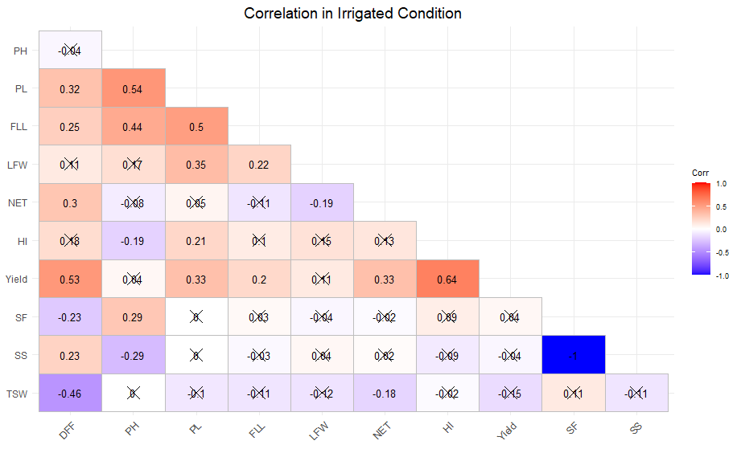

(b)
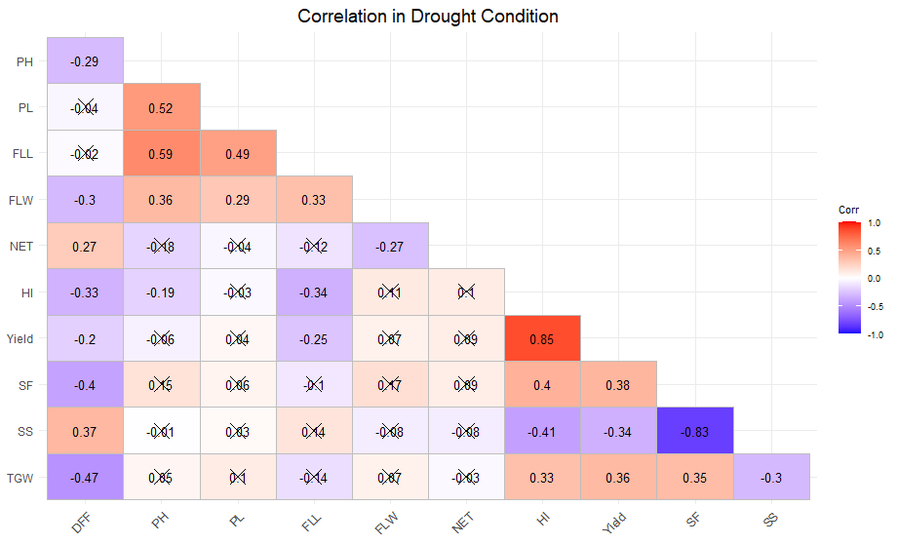
The overall correlation analysis showed both shared physiological bases of yield and environment specific drivers. Traits such as HI, PH, and TGW consistently contributed to yield across environments, making them reliable selection criteria in breeding programs. However, the contrasting correlations of DFF, NET, and flag leaf traits illustrate adaptive tradeoffs: under drought, early flowering, wider flag leaves, and higher spikelet fertility are key to yield stability, whereas under irrigation, later flowering and increased tillering dominate yield performance. The result also suggests the concept of yield penalty trade-offs in drought tolerant rice, where genotypes adapted to stress often underperform under irrigation due to conservative resource use (Swamy et al., 2017). Integrating stress adaptive traits (e.g., qDTY QTLs) with high yield backgrounds is therefore essential to develop genotypes that perform well across diverse environments.
3.7 Principal Component Analysis-
The principal component analysis revealed clear differences in trait contributions under irrigated and drought conditions. Under irrigated condition (Figure 3), the first three components explained 61.5% of the total variation (PC1 = 24.5%, PC2 = 21.3%, PC3 = 15.8%), while under drought (Figure 4) the first three accounted for 63.4% (PC1 = 29.4%, PC2 = 23.0%, PC3 = 10.9%). Such result revealed potential of relatively small number of trait combinations for representation of most of the genetic variability among the genotypes, which is consistent with recent multivariate studies in rice germplasm that reported similar clustering of yield related traits in the first three PCs (Prakash et al., 2024).
The loading further clarified the trait contributions. Under irrigated conditions, PC1 was dominated by panicle length, days to 50% flowering, and yield, reflecting a productivity axis where later flowering and longer panicles contributed to higher yield potential. In contrast, PC1 under drought was driven by harvest index, spikelet fertility, yield, and thousand grain weight, with sterile spikelets loading negatively. This axis highlighted the importance of fertility and biomass allocation when water is limiting, which was also observed by (Ahmad et al., 2022).

Figure 3- Principal Component Analysis Under Irrigated Condition (a)Variance explained by each principal component on (b) PCA biplot and relative allocation of genotypes beteen PC1 and PC2 (c) Contribution of each traits for variance in first two PCs based on loadings
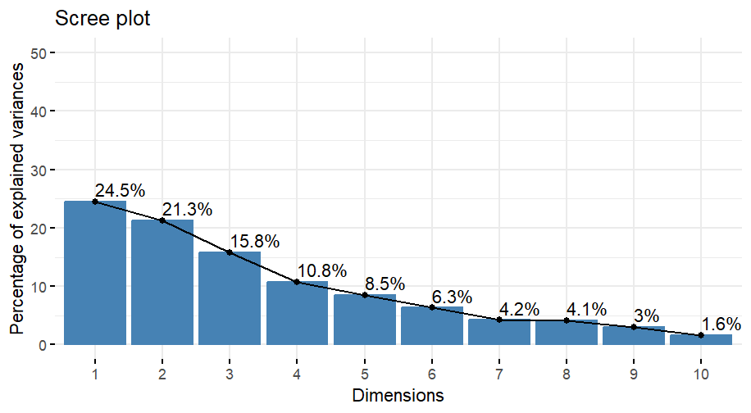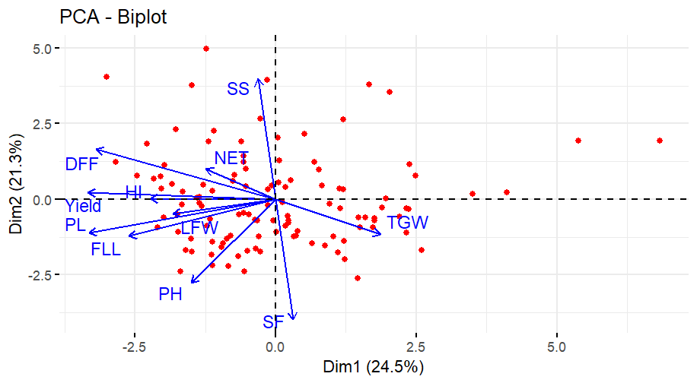
- (b)
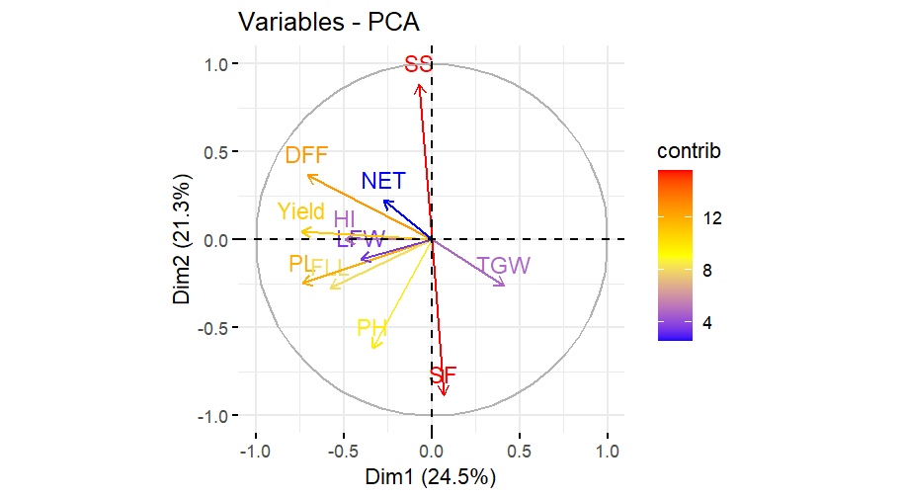
(c )
PC2 in the irrigated dataset was defined by spikelet fertility and sterile spikelets, alongside plant height, separating genotypes based on reproductive efficiency and stature. Conversely, PC2 under drought was dominated by plant height, panicle length, and flag leaf length, showing that morphological traits became more critical discriminators under stress. Similar findings were reported by Cal et al. (2019), who emphasized the role of plant stature and leaf morphology in drought adaptation.
PC3 in irrigation highlighted net effective tillers, harvest index, and yield, emphasizing tillering and partitioning efficiency. Under drought, however, PC3 was characterized by net effective tillers and days to 50% flowering, suggesting that tiller number and flowering time were key adaptive traits. This agrees with the fact that early flowering is a major drought escape mechanism (Swamy et al., 2017).
The PCA scores further revealed effect of environment on behaviour of yield and yield components. High yielding, late flowering lines with longer panicles clustered along PC1 in irrigation, while genotypes with superior fertility and grain weight aligned with PC1 under drought. Fertility traits separated genotypes along PC2 in irrigated condition, whereas plant stature and leaf morphology dominated PC2 under drought. Tillering and partitioning traits contributed to PC3 in both environments. Overall, the comparison showed that yield under irrigation is primarily driven by reproductive duration and panicle traits, while yield under drought depends on harvest index, spikelet fertility, and grain weight stability. Tillering plays a role in both environments, but under drought it is closely linked with flowering time as an adaptive mechanism (Gu et al.,2022).
Figure 4- Principal Component Analysis Under Drought Condition (a)Variance explained by each principal component on (b) PCA biplot and relative allocation of genotypes beteen PC1 and PC2 (c) Contribution of each traits for variance in first two PCs based on loadings
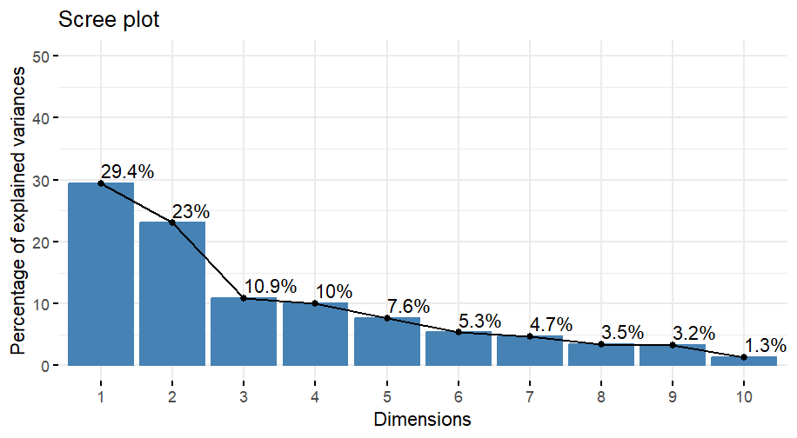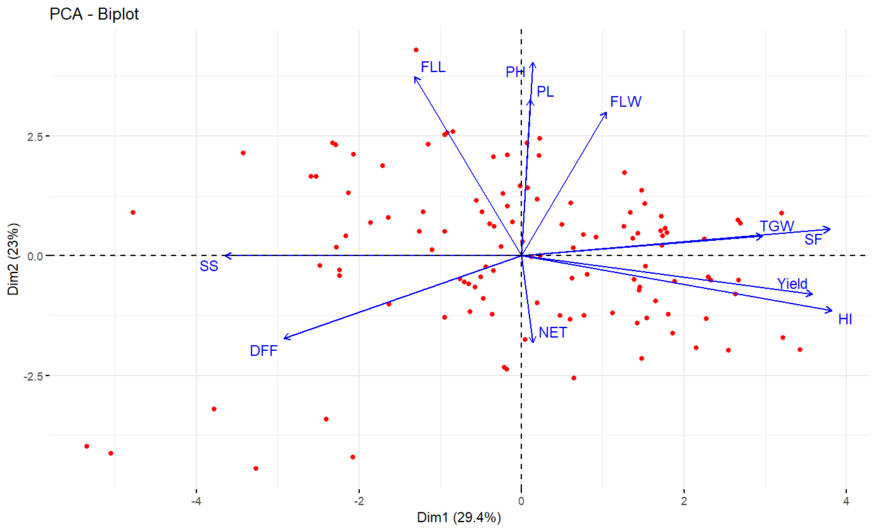
- (b)
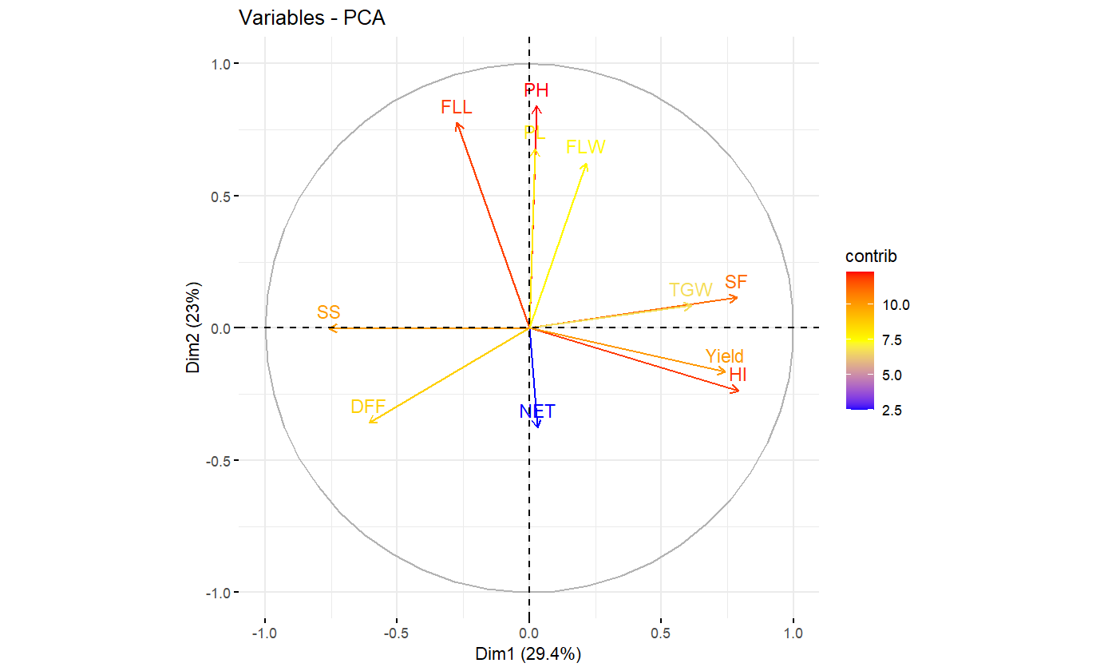
(c )

- CONCLUSION-
The study highlights how drought stress affects grain yield and yield-related agronomic traits. In the study, we observed the variation in key agronomic trait sets in contrasting water availability environment. Drought adapted genotypes in terms of yield were identified as one with taller stature, greater flag leaf dimensions, better fertility and harvest index. Harvest index was identified as more important yield contributing trait in case of stress environment as compared to non-stress environment. Such trait values are attributed to better photosynthetic efficiency and resource partitioning in stress adapted plants under stress environment. Lines with better yield under water limited environment may not be better yielding under irrigated and high input environment due to their specific adaptation. Moreover, the pronounced effect of the drought lowered the heritability of yield and yield attributing traits under the stress environment as that of irrigated condition. The superior lines with regards to yield under drought can be directly used as donor or they can be improved through prebreeding in order to bring them in mainstream breeding system. Further the molecular assessment can be done to validate these lines for availability of drought tolerance linked molecular markers.

Disclaimer (Artificial intelligence)

Author(s) hereby declare that NO generative AI technologies such as Large Language Models (ChatGPT, COPILOT, etc.) and text-to-image generators have been used during the writing or editing of this manuscript.
Reference-
Abarshahr M, Rabiei B, Lahigi HS. Assessing genetic diversity of rice varieties under drought stress conditions. Not Sci Biol. 2011;3(1):114-23.
Ahmad H, Zafar SA, Naeem MK, Shokat S, Inam S, Rehman MAU, Khan MR. Impact of pre-anthesis drought stress on physiology, yield-related traits, and drought-responsive genes in green super rice. Front Genet. 2022;13:832542.
Bhandari U, Gajurel A, Khadka B, Thapa I, Chand I, Bhatta D, Shrestha J. Morpho-physiological and biochemical response of rice (Oryza sativa L.) to drought stress: A review. Heliyon. 2023;9(3).
Bin Rahman AR, Zhang J. Preferential geographic distribution pattern of abiotic stress tolerant rice. Rice. 2018;11(1):10.
Burton GW. Quantitative inheritance in grasses;1952.
Cal AJ, Sanciangco M, Rebolledo MC, Luquet D, Torres RO, McNally KL, Henry A. Leaf morphology, rather than plant water status, underlies genetic variation of rice leaf rolling under drought. Plant Cell Environ. 2019;42(5):1532-44.
Casartelli A, Riewe D, Hubberten HM, Altmann T, Hoefgen R, Heuer S. Exploring traditional aus-type rice for metabolites conferring drought tolerance. Rice. 2018;11(1):9.
De A, Dey A, Raha S, Kar DK. Agronomic evaluation of rice (Oryza sativa) landraces for sustainable crop resilience in a changing climate. 2023.
Federer WT. Augmented (or hoonuiaku) designs; 1956.
Ganapati RK, Rasul MG, Sarker U, Singha A, Faruquee M. Gene action of yield and yield contributing traits of submergence tolerant rice (Oryza sativa L.) in Bangladesh. Bull Natl Res Cent. 2020;44(1):8.
Gu H, Zhang K, Chen J, Gull S, Chen C, Hou Y, Liang G. OsFTL4, an FT-like gene, regulates flowering time and drought tolerance in rice (Oryza sativa L.). Rice. 2022;15(1):47.
Hill WG, Mackay TF. DS Falconer and Introduction to quantitative genetics. Genetics. 2004;167(4):1529-36.
Khanam S, Perves M, Afridi N. Exploiting physiological efficiency and genetic insights in rice through integrating trait–yield dynamics across multi-environment trials. Plant Physiol Rep. 2026;45(12):1-15.
Kumar A, Dixit S, Ram T, Yadaw RB, Mishra KK, Mandal NP. Breeding high-yielding drought-tolerant rice: genetic variations and conventional and molecular approaches. J Exp Bot. 2014;65(21):6265-78.
Prakash S, Reddy SS, Chaudhary S, Vimal SC, Kumar A. Multivariate analysis in rice (Oryza sativa L.) germplasms for yield attributing traits. Plant Sci Today. 2024;11(1):64-75.
Sakran RM, Ghazy MI, Gaballah MM, Hussein FA, Aamer SM, Ghazy HA, Abdelghany AM. Genetic variability in physiological and agronomic traits of newly developed rice lines under well-watered and water-deficit conditions. BMC Plant Biol. 2025;25(1):1291.
Sarma B, Kashtoh H, Lama Tamang T, Bhattacharyya PN, Mohanta YK, Baek KH. Abiotic stress in rice: visiting the physiological response and its tolerance mechanisms. Plants. 2023;12(23):3948.
Sohrabi M, Rafii MY, Hanafi MM, Siti Nor Akmar A, Latif MA. Genetic diversity of upland rice germplasm in Malaysia based on quantitative traits. Sci World J. 2012;2012(1):416291.
Subedi S, Gawali S, Lamichhane S, Regmi B, Ghimire D, Kharel R. Assessment and characterization of agro-morphological characteristics of rice landraces in Nepal. Cogent Food Agric. 2024;10(1):2415389.
Subramanian S, Ramamoorthy P, Alagesan S, Amalraj JJ, Muthurajan R, Alagarsamy S, Thathapalli Prakash P. Unraveling the genetic potential of Indian rice germplasm for reproductive stage drought tolerance. Front Plant Sci. 2025;16:1454299.
Swamy BM, Shamsudin NAA, Rahman SNA, Mauleon R, Ratnam W, Sta Cruz MT, Kumar A. Association mapping of yield and yield-related traits under reproductive stage drought stress in rice (Oryza sativa L.). Rice. 2017;10(1):21.
Vikram P, Swamy BM, Dixit S, Singh R, Singh BP, Miro B, Kumar A. Drought susceptibility of modern rice varieties: an effect of linkage of drought tolerance with undesirable traits. Sci Rep. 2015;5(1):14799.
Wu LL, Liu ZL, Wang JM, Zhou CY, Chen KM. Morphological, anatomical, and physiological characteristics involved in development of the large culm trait in rice. Aust J Crop Sci. 2011;5(11):1356-63.
Yadav S, Sandhu N, Singh VK, Catolos M, Kumar A. Genotyping-by-sequencing based QTL mapping for rice grain yield under reproductive stage drought stress tolerance. Sci Rep. 2019;9(1):14326.

Appendix:
Table A1- Genotypes and check used in the experiments
S.No | Genotype | Country | Subpopulation
1 | IRIS_313-8409 | Viet Nam | Indx
2 | IRIS_313-11171 | India | Aus
3 | IRIS_313-11919 | India | ind2
4 | IRIS_313-11645 | India | ind2
5 | IRIS_313-10380 | Philippines | Aus
6 | IRIS_313-11599 | India | ind2
7 | IRIS_313-8988 | India | ind2
8 | IRIS_313-10845 | India | Aus
9 | IRIS_313-11600 | India | ind2
10 | IRIS_313-11167 | India | ind2
11 | IRIS_313-11240 | India | Indx
12 | IRIS_313-8383 | Philippines | Indx
13 | IRIS_313-10858 | India | Indx
14 | IRIS_313-12078 | Viet Nam | Indx
15 | IRIS_313-10603 | Bangladesh | Aus
16 | IRIS_313-11446 | India | ind2
17 | IRIS_313-10917 | Philippines | Indx
18 | IRIS_313-9783 | Afghanistan | Admix
19 | IRIS_313-8814 | Bhutan | Aro
20 | IRIS_313-9949 | Sri Lanka | Trop
21 | IRIS_313-9484 | India | Indx
22 | IRIS_313-11197 | India | Indx
23 | IRIS_313-11887 | Philippines | ind1B
24 | IRIS_313-9351 | India | ind2
25 | IRIS_313-9287 | India | ind2
26 | IRIS_313-11479 | India | Trop
27 | IRIS_313-10896 | India | Admix
28 | IRIS_313-11677 | Thailand | ind3
29 | IRIS_313-9570 | China | Indx
30 | IRIS_313-10879 | India | Admix
31 | IRIS_313-8603 | India | Indx
32 | IRIS_313-7856 | Thailand | Subtrop
33 | IRIS_313-8172 | Philippines | Admix
34 | IRIS_313-11345 | Philippines | Indx
35 | IRIS_313-8771 | India | Aus
36 | IRIS_313-10449 | China | ind1A
37 | IRIS_313-12232 | China | Indx
38 | IRIS_313-12210 | Viet Nam | Indx
39 | IRIS_313-11618 | India | Aus
40 | IRIS_313-7778 | Viet Nam | Indx
41 | IRIS_313-9137 | India | Aus
42 | IRIS_313-11303 | India | Indx
43 | IRIS_313-8796 | India | ind2
44 | IRIS_313-9368 | Bangladesh | Aus
45 | IRIS_313-8454 | Taiwan | ind1A
46 | IRIS_313-11691 | Bhutan | Subtrop
47 | IRIS_313-10020 | Sri Lanka | Aus
48 | IRIS_313-10859 | India | Indx
49 | IRIS_313-10881 | India | Admix
50 | IRIS_313-10348 | India | Indx
51 | IRIS_313-11738 | India | ind2
52 | IRIS_313-9610 | India | Aus
53 | IRIS_313-11476 | India | Aus
54 | IRIS_313-9695 | Pakistan | Aus
55 | IRIS_313-11157 | Taiwan | ind1A
56 | IRIS_313-7690 | Philippines | Indx
57 | IRIS_313-11224 | Bangladesh | ind2
58 | IRIS_313-11835 | Thailand | Indx
59 | IRIS_313-10857 | India | Admix
60 | IRIS_313-11597 | India | ind2
61 | IRIS_313-11462 | India | Aus
62 | IRIS_313-10976 | Bangladesh | Aus
63 | IRIS_313-11195 | Myanmar | Subtrop
64 | IRIS_313-10836 | India | ind2
65 | IRIS_313-11048 | Bangladesh | Aus
66 | IRIS_313-11199 | India | Indx
67 | IRIS_313-11060 | Bangladesh | Aus
68 | IRIS_313-10878 | India | Aus
69 | IRIS_313-8580 | Thailand | Subtrop
70 | IRIS_313-11175 | India | Aus
71 | IRIS_313-9547 | India | ind2
72 | IRIS_313-9048 | Bhutan | Subtrop
73 | IRIS_313-7699 | Philippines | Indx
74 | IRIS_313-10675 | India | Indx
75 | IRIS_313-10549 | Pakistan | Aus
76 | IRIS_313-12139 | Nepal | Aus
77 | IRIS_313-12180 | Nepal | Indx
78 | IRIS_313-10361 | Philippines | Indx
79 | IRIS_313-11237 | Taiwan | ind1B
80 | IRIS_313-11955 | China | ind1A
81 | IRIS_313-11458 | India | Aus
82 | IRIS_313-10849 | India | Aus
83 | IRIS_313-8435 | India | ind1A
84 | IRIS_313-10737 | Nepal | Aus
85 | IRIS_313-10928 | Thailand | ind3
86 | IRIS_313-11213 | Bangladesh | Aus
87 | IRIS_313-10224 | China | ind1A
88 | IRIS_313-11176 | India | Indx
89 | IRIS_313-10733 | Nepal | Indx
90 | IRIS_313-11322 | Bangladesh | Aus
91 | IRIS_313-11029 | Pakistan | Aus
92 | IRIS_313-8342 | Sri Lanka | Aus
93 | IRIS_313-10560 | China | ind1A
94 | IRIS_313-10930 | Bangladesh | Aus
95 | IRIS_313-8568 | India | ind2
96 | IRIS_313-11917 | India | Aus
97 | IRIS_313-10513 | Philippines | Indx
98 | IRIS_313-11745 | China | ind1A
99 | IRIS_313-8147 | India | Temp
100 | IRIS_313-10676 | India | Admix
101 | Check-1 (IR64)
102 | Check- 2 (Sahbhagi dhan)
103 | Check-3 (Samba mahsuri)

