Analysis of the Impact of Agroforestry on Rural Economy and Community Welfare in Durg, Chhattisgarh, India
Abstract
Agroforestry, the integration of trees with crops and livestock, is widely recognized as a sustainable land-use system that enhances productivity, livelihood security, and environmental stability. The present study aimed to evaluate agroforestry practices in Patan Tehsil of Durg District, Chhattisgarh, with a focus on system types, biomass production, carbon storage, and economic returns across different farmer categories. A field-based survey using a stratified random sampling approach was conducted to collect primary data from farmers. The results revealed the dominance of agri-silviculture systems, along with the presence of horti-silviculture and integrated tree–crop–livestock systems. Agroforestry practices contributed to improved farm diversification, enhanced biomass accumulation, and increased carbon stock potential. In addition, integrated systems demonstrated better economic performance and livelihood support compared to conventional practices. Overall, the study highlights the significant role of agroforestry in promoting sustainable agriculture and climate resilience in the region. It also emphasizes the need for clear methodological approaches and standardized procedures for reliable estimation of biomass and carbon stocks.
Keywords: Agroforestry system, Biomass, Carbon Stock, Benefit Cost Ratio and Economic Returns

1 Introduction
Agroforestry, the intentional integration of trees with crops and/or livestock, has emerged as a sustainable land-use system with significant potential for improving rural livelihoods and ecological stability in developing countries (Rizvi et al., 2024). In India, where a large proportion of the population depends on agriculture, particularly in states like Chhattisgarh, smallholder and tribal farmers form the primary population influenced by agroforestry interventions. Despite its long-standing presence, adoption remains uneven across different regions and communities.
Agroforestry systems, including traditional practices such as home gardens and silvopasture, as well as modern approaches such as Smart Agroforestry (SAF), are promoted to enhance productivity, diversify income, and improve environmental sustainability. National initiatives, such as the National Agroforestry Policy (2014) and the Sub-Mission on Agroforestry, aim to encourage tree-based farming systems that integrate ecological and economic benefits. These interventions are particularly relevant in regions such as the Durg district, where agriculture remains the backbone of rural livelihoods.
Compared to conventional monocropping systems, agroforestry offers multiple advantages, including higher productivity, diversified income sources, and improved resilience to climate variability. Empirical evidence suggests that agroforestry systems outperform traditional farming in terms of soil health, carbon sequestration, and long-term sustainability, while reducing vulnerability to environmental and economic shocks (Jung and Vendrametto, 2025).
Agroforestry contributes significantly to household income (approximately 28%) and has been shown to reduce poverty levels, improve food security, and enhance livelihood resilience (Tebkew et al., 2024). Ecologically, it supports soil fertility, increases carbon storage, and promotes biodiversity. In regions such as the Chhattisgarh Plain, agroforestry systems have demonstrated improvements in soil organic carbon, nitrogen content, and microbial activity, reinforcing their role in sustainable land management (Thakur et al., 2026).
Despite substantial evidence of the benefits of agroforestry, there remains a lack of location-specific, district-level empirical studies that comprehensively assess its socio-economic and ecological impacts. Many existing studies are limited in scale and duration and are often conducted under controlled conditions rather than real-world farming systems (Sahu et al., 2025). Therefore, the present study adopts a field-based analytical approach to evaluate the impact of agroforestry on the rural economy and community welfare in Durg, Chhattisgarh, focusing on key dimensions such as income, employment, food security, ecological sustainability, and social wellbeing.

- Material and Methods
The survey was conducted in Patan Tehsil, Durg District, Chhattisgarh, which lies between 21° 01' 48.00" N, 81° 31' 48.00" E. Patan is situated at an elevation of 280 m above mean sea level on the left bank of the Kharun River at a distance of 8 km from Patan. The climate of Patan is mostly characterized by an average temperature of 36–40ºC in the summer. During the winter, the temperature can drop as low as 7ºC and rise as high as 45ºC in the summer. The study was conducted by random stratified sampling method in which 10 Gram Panchayats was choosen viz. Sankara, Motipur, Jamgaon (M), Kopedih, Jheet, Amlidih, Bhatagaon, Ruhi, Auri and Funda.
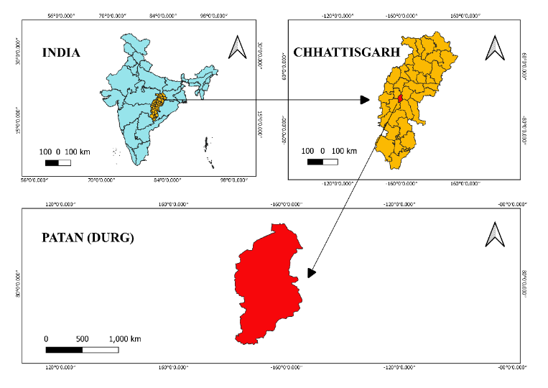
Fig,1 : Map of the Study Area

2.1 Sampling Procedure:
From each Panchayat, farmers were divided into three different categories based on their land holdings, that is, marginal (<1 ha), small (1-2 ha), and medium (2-5 ha), and from each category, 10 farmers were selected. Relevant information about the study was collected through a pre-tested schedule by conducting personal interviews with each household head.
2.2 Identification of Existing Agroforestry Systems
Agroforestry systems existing in the study area were identified based on the structure (nature and arrangement) and function (role of output) of the components (Nair, 1985). However, the stratified classification of agroforestry practices given by Zou and Sanford,1990) was used to indicate the type of systems and system units.
2.3 Agriculture Crop and Grass Biomass
The biomass production in cultivated land was determined by taking random samples of Kharif and Rabi crops in the farmer’s field by making quadrates of size 1m x 1m. The total harvest method was performed by digging out the crop plant along with the roots falling within the quadrate. The soil was gently removed by tapping it. The roots and shoots of the crops were segregated and stored in different paper bags. All crop samples were washed to remove soil and oven-dried at 70°C until a constant weight was achieved. The dried root and shoot samples of each crop species were weighed to determine the aboveground and belowground biomass of each species. Sharma et.al. (2023)
Grass biomass was calculated after harvesting the grasses by laying out quadrates of size 1m ×1m. The soil was gently removed by tapping. Roots of different species were segregated and stored in separate paper bags. All plant samples were oven-dried at 70°C until a constant weight was achieved. The dried samples of the roots and shoots of each species were weighed to determine the aboveground and belowground biomass of each species. Sharma et.al. (2023).
2.4 Trees Biomass and Carbon Storage
For the measurement of tree biomass, regression equations relating tree circumference to biomass developed by Singh and Mishra (1979) and computation protocols described by Singh and Singh (1991) were used. In brief, the mean GBH value for each species for a girth class will be used in the regression equations to obtain an estimate of the biomass for that girth class. This value was then multiplied by the density of trees or shrubs in that girth class. The estimate will be averaged to obtain the mean estimate for the sites. Furthermore, to estimate carbon storage and assimilation, the carbon concentration of different components was multiplied by the dry biomass, as described by Singh (2010).
Regression equation: Log Y = a+b log X. where as X is girth (cm) of the tree and Y is dry weight of the tree (Kg). The value of “a” and “b” varies from species to species .
2.5 Economic Returns
The present harvestable biomass from each functional unit in a system was considered to determine total returns from the system, while the total cost incurred on production and cultural management was considered to estimate the net returns, following Sharma et al.. (2021). Production cost refers to the total expenses incurred in producing one acre of a crop. It was calculated as per the prevalent rates in the market, following Chisanga et al.. (2013). Gross Returns are the utilizable biomass of each functional unit in a system given the current market value for estimating total returns from a system, following Chisanga et al.. (2013) .Net returns are the difference between gross returns and production costs, following Sharma et al.. (2021). Benefit Cost ratio is the net returns per rupee invested ratio was calculated as per following formula Followed by Himshikha and Singh (2017)
Benefit cost ratio= Total discounted benefits/ Total discounted costs
- RESULTS AND DISCUSSION
  - Identification of Existing Agroforestry System
    - Integration of Agroforestry between Tree and Crop
Table 1 presents the data on the identification of agroforestry systems among different farmer categories in the study area.
The data clearly demonstrate that two different types of agroforestry systems were practiced in the study area under various farmer categories. These include Agri-silviculture (93%) and Horti-Silviculture (7%). These systems deliver the needs of farmers, including broad features such as food, firewood, forage, fruit, timber wood, and income. The study showed that the predominant agroforestry system among the marginal, small, and medium categories was the Agri-Silviculture system, followed by the Horti-Silviculture system. The Agri-Silviculture system was adopted by the highest percentage of farmers in the medium farmer category (49.46), whereas the Horti-Silviculture system was adopted by the lowest number of farmers.
Table 1: Agroforestry System under different farmer categories
S.No. | System  Types | Different Category Practiced  Agro-Forestry Systems |  |  | Total
S.No. | System  Types | Marginal  Category | Small  Category | Medium  Category | Total
1. | AS | 8  (8.60) | 39  (41.93) | 46  (49.46) | 93
2. | HS | 0 | 5  (71.42) | 2  (28.57) | 7
 | Overall | 8 | 44 | 48 | 100

Note: AS: Agri-Silviculture; HS: Horti-Silviculture

Fig.2: Agroforestry systems identified in the study area under different categories of farmers.
3.1.2 System Units and Associated Crops and Tree Species in Various Agroforestry Systems Adopted by Marginal Farmers
Table 2 illustrates the adoption of the Agri-Silviculture system among marginal farmers, where Oryza sativa is predominantly cultivated in association with multipurpose tree species such as Terminalia arjuna, Acacia nilotica, Mangifera indica, Azadirachta indica, and Butea monosperma. This integration reflects farmers’ preference for securing staple food needs while simultaneously deriving benefits from trees in the form of timber, fruits, fodder and fuelwood. These species contribute to soil enrichment, microclimate regulation, and erosion control. Thus, the system provides both subsistence and supplementary income, ensuring livelihood security and sustainable resource management for marginal farmers. kumar et al. (2024) found similar type of study in the Deoghar District, Jharkhand, India.
Table 2: Associated Crops and Tree Species in Agri-Silviculture System (Marginal Farmers)
Agroforestry System | Associated Crops | Tree Species
Agri-Silviculture | Oryza Sativa | Terminalia arjuna, Acacia nilotica, Azadirachta indica , Butea monosperma
3.1.3 System Units and Associated Crops and Tree Species in Various Agroforestry Systems Adopted by Small Farmers
Table 3 illustrates that small farmers adopted both Agri-silviculture and Horti-silviculture systems with a preference for multipurpose tree species. In Agri-silviculture, paddy and mustard were grown with trees like Acacia nilotica, T. arjuna, Z. mauritiana, and A. indica, ensuring food security along with timber and fuelwood. In Horti-silviculture, papaya, banana, and marigold were integrated with Acacia nilotica and Ziziphus mauritiana, providing additional income through fruits and flowers. Acacia nilotica was the most dominant species, reflecting its adaptability and multiple uses. Overall, small farmers selected tree–crop combinations that enhanced their subsistence, income, and ecological stability.

Table 3: Associated Crops and Tree Species in Agri-Silviculture System (Small Farmers)
Agroforestry System | Associated Crops | Tree Species
Agri-Silviculture | Oryza Sativa | Terminalia arjuna, Acacia nilotica, Ziziphus mauritiana, Delonix regia, Eucalyptus spp., Azadirachta indica, Tectona grandis
Agri-Silviculture | Brassica juncea | Acacia nilotica
Horti-Silviculture | Tagetes Patula | Acacia nilotica, Azadirachta indica
Horti-Silviculture | Carica papaya | Ziziphus mauritiana
Horti-Silviculture | Musa paradisiaca | Acacia nilotica

3.1.4 System Units and Associated Crops and Tree Species in Various Agroforestry Systems Adopted by Medium Farmers
Table 4 illustrates that medium farmers have a wider adoption of both agri-silviculture and horti-silviculture systems, reflecting greater landholding capacity and flexibility for crop diversification. In agri-silviculture, rice (Oryza sativa) was the dominant crop, integrated with tree species such as Terminalia arjuna, Acacia nilotica, Ziziphus mauritiana, Eucalyptus spp., Azadirachta indica, Butea monosperma, Dalbergia sissoo, and Leucaena leucocephala. This combination shows a clear emphasizes ensuring staple food production while simultaneously deriving benefits from timber, fodder, and fuelwood. Maize (Zea mays) was also cultivated under Acacia nilotica and Eucalyptus spp., indicating farmers’ preference for fast-growing, adaptable tree species that do not compete heavily with annual crops.
In horti-silviculture, semi-medium farmers demonstrated considerable crop diversity. Vegetables such as tomato (Lycopersicum esculentum), lablab bean (Lablab purpureus), cabbage (Brassica oleracea), cowpea (Vigna unguiculata), and ivy gourd (Coccinia grandis) were integrated with Acacia nilotica. Similarly, gourds such as bottle gourd (Lagenaria siceraria), bitter gourd (Momordica charantia), and sponge gourd (Luffa aegyptiaca) were grown alongside Eucalyptus spp., while Terminalia arjuna supported sponge gourd, bitter gourd, and chili (Capsicum annuum) cultivation. Azadirachta indica was associated with ivy gourd, reflecting its role in providing shade, medicinal benefits, and soil improvement.
Compared to marginal and small farmers, medium farmers adopted more diversified and market-oriented cropping patterns. The integration of vegetables and gourds alongside multipurpose trees not only ensures household nutrition but also provides opportunities for regular cash income from the vegetable markets. Moreover, the dominance of Acacia nilotica and Eucalyptus spp. across both systems highlights their ecological adaptability, multipurpose value, and farmers’ reliance on species that provide rapid economic returns. ranjan et al. (2017) found a similar type of study in the Koderma district of Jharkhand.
Table 4: Associated Crops and Tree Species in Agri-Silviculture System (Semi-Medium Farmers)
Agroforestry System | Associated Crops | Tree Species
Agri-Silviculture | Oryza Sativa | Terminalia arjuna, Acacia nilotica, Ziziphus mauritiana, Eucalyptus spp., Azadirachta indica, Butea Monosperma, Dalbergia sissoo, Leucaena leucocephala
Agri-Silviculture | Zea mays | Acacia nilotica, Eucalyptus spp.
Horti-Silviculture | Lycopersicum esculentum,  Lablab purpureus, Brassica oleracea, Vigna unguiculata, Coccinia grandis | Acacia nilotica
Horti-Silviculture | Lagenaria siceraria, Momordica charantia, Coccinia grandis, Luffa aegyptiaca | Eucalyptus spp.
Horti-Silviculture | Luffa aegyptiaca, Momordica charantia, Capsicum annuum | Terminalia arjuna
Horti-Silviculture | Coccinia grandis | Azadirachta indica
Horti-Silviculture | Brassica oleracea | Mangifera indica

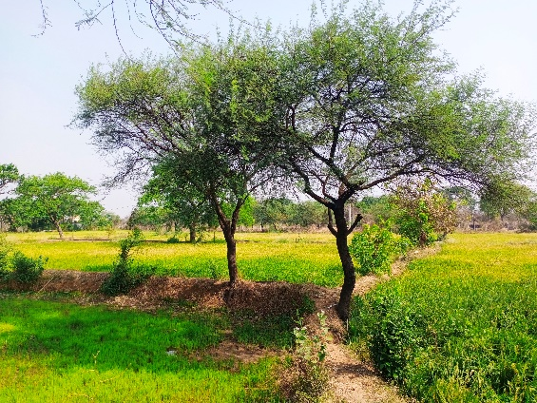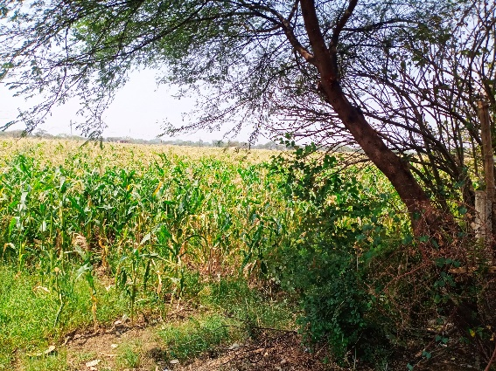
(Oryza Sativa + Acacia nilotica) (Zea mays + Acacia nilotica)
Plate 1: Agri-Silviculture system categories and corresponding units of the study area
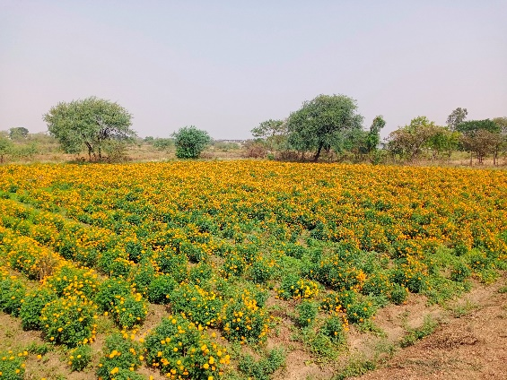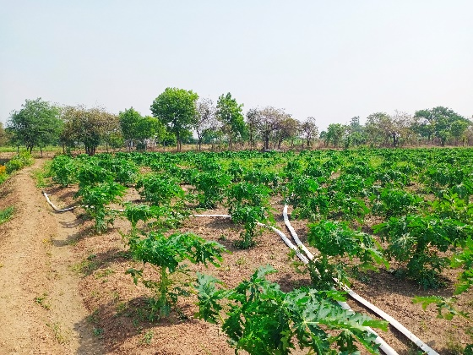
(Tagetes Patula + Acacia nilotica) (Carica papaya + Acacia nilotica)
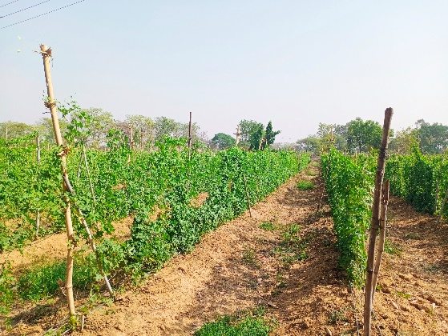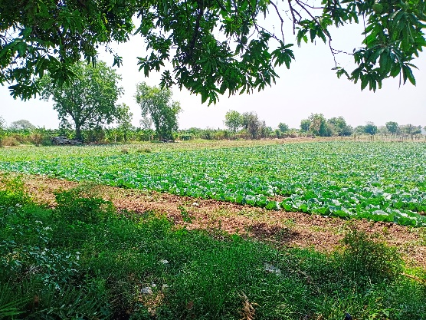
(Momordica charantia + Babool) (Brassica oleracea + Mangifera indica)
Plate 2: Horti-Silviculture system categories and corresponding units of the study area
3.2 Integration of Agroforestry between Tree/Crop and Animal Component
In the study area, four distinct tree–crop–animal components were identified, reflecting the multifunctional nature of the agroforestry systems adopted by farmers. The Oryza Sativa + Poultry combination represented a typical Agri-Silvi-Pastoral approach, where staple food production was integrated with poultry rearing. This system not only provides household food security but also offers regular cash income and nutritional support through eggs and meat, making it highly suitable for smallholders with limited resources.
The Artocarpus heterophyllus Lam. + Fisheries + Poultry system illustrated a more diversified and intensive model. Jackfruit (Artocarpus heterophyllus Lam.) trees provided seasonal fruit and shade, while fish culture in ponds contributed to protein supply and cash earnings. Poultry serves as a complementary component by utilizing farm residues and providing manure, thereby enhancing nutrient cycling. This integration demonstrates how farmers optimize available land and water resources for multiple outputs. In the Carica papaya + Fisheries system, fruit production was combined with aquaculture to ensure dual income streams. Papaya (Carica papaya) offers quick returns as a short-duration fruit crop, whereas fisheries ensure regular earnings and improved household nutrition. Similarly, the Ziziphus mauritiana + Fisheries combination highlighted the use of drought-tolerant tree species (Ziziphus mauritiana) alongside fish farming, reflecting farmer’s adaptive strategies under varying Agro-climatic conditions.
Overall, these integrated systems underline farmers’ preference for multi-enterprise agroforestry models that ensure food, nutrition, and livelihood security. The inclusion of poultry and fisheries alongside trees and crops indicates a shift from purely subsistence farming to sustainable, income-oriented practices. Such diversified models not only reduce economic risks but also improve ecological sustainability through efficient resource utilization and recycling.
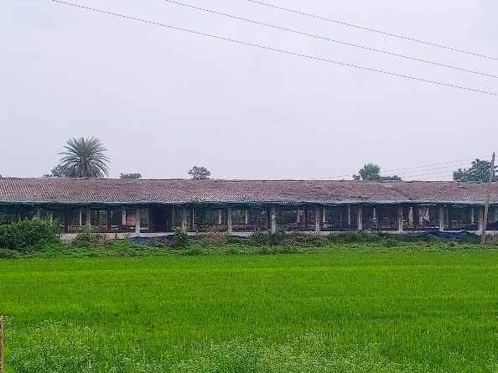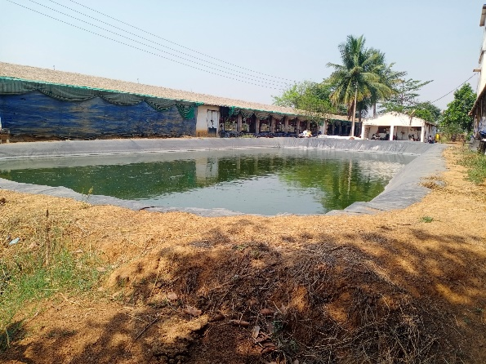
Oryza Sativa + Poultry Artocarpus heterophyllus Lam.
+ Fisheries + Poultry
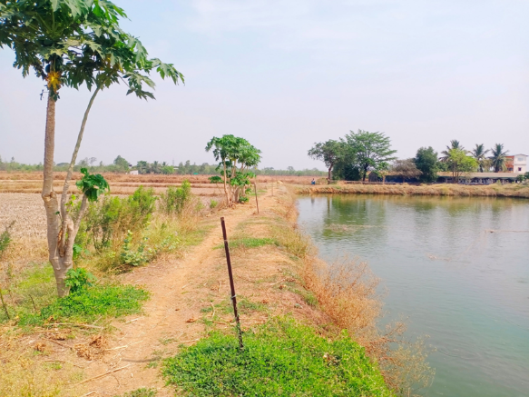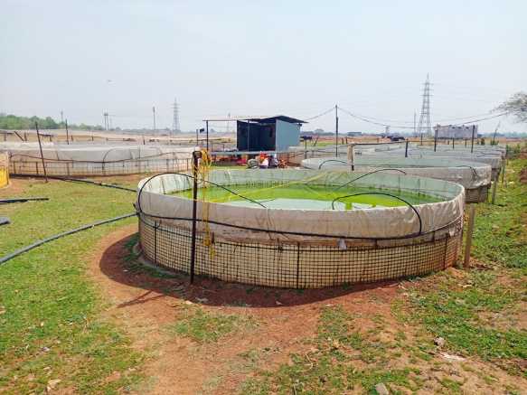
Carica papaya + Fisheries Ziziphus mauritiana + Fisheries
Plate 3: Integration of Agroforestry between Tree/Crop and Animal Component in the study area
3.3 Agriculture Crop Biomass
Table 5 illustrates the assessment of agricultural crop biomass, which revealed significant variations across farmer categories in terms of above-ground biomass (AGB), below-ground biomass (BGB), and total biomass (TB). Among marginal farmers, the recorded AGB was 6.32 t ha⁻¹ and BGB 1.26 t ha⁻¹, contributing to a total biomass of 7.58 t ha⁻¹. This relatively lower value may be attributed to smaller landholdings, limited input use, and subsistence-oriented cropping practices.Small farmers showed the highest contribution with an AGB of 17.02 t ha⁻¹ and BGB of 3.49 t ha⁻¹, amounting to 20.51 t ha⁻¹ of total biomass. This indicates a greater emphasis on crop intensification, better resource utilization, and the adoption of improved practices compared to marginal farmers. Medium farmers recorded an AGB of 17.96 t ha⁻¹ and BGB of 3.7 t ha⁻¹, resulting in a TB of 21.66 t ha⁻¹. The high below-ground biomass in this category reflects deeper rooting systems associated with crop diversity and possibly longer-duration or perennial species.At the overall level, agricultural crops accounted for 41.30 t ha⁻¹ of AGB and 8.45t ha⁻¹ of BGB, with a combined total of 49.75 t ha⁻¹. Similar findings were reported by Chavan et al. (2023) for Poplar and Eucalyptus-Based Agroforestry Systems in the Indo-Gangetic Plains of India.
Table 5: Agriculture Crop Biomass in (t ha⁻¹) of different Farmer categories

Type of Farmer | AGB t ha⁻¹ | BGB t ha⁻¹ | TB t ha⁻¹
Marginal | 6.32 | 1.26 | 7.58
Small | 17.02 | 3.49 | 20.51
Medium | 17.96 | 3.7 | 21.66
Overall | 41.30 | 8.45 | 49.75

Note: AGB: Above Ground Biomass, BGB: Below Ground Biomass, TB: Total Biomass
3.4 Horticulture Crop Biomass
The assessment of horticultural crop biomass in Table 6 revealed significant contributions from both small and medium farmers, with variations in aboveground biomass (AGB), belowground biomass (BGB), and total biomass (TB). Small farmers recorded an AGB of 23.22 t ha⁻¹ and BGB of 4.66 t ha⁻¹, contributing a total biomass of 27.88 t ha⁻¹. This indicates that smallholders are effectively utilizing their limited landholdings by cultivating high-value horticultural crops that ensure both household nutrition and supplementary income.
Medium farmers showed comparatively higher values, with an AGB of 30.72 t ha⁻¹ and BGB of 7.21 t ha⁻¹, resulting in a total biomass of 37.93 t ha⁻¹. The greater biomass accumulation under medium farmers can be attributed to larger landholdings, better management practices, and greater adoption of perennial or longer-duration horticultural crops, which contribute substantially to root biomass.
At the overall level, horticultural crops accounted for 53.94 t ha⁻¹ of AGB and 11.87 t ha⁻¹ of BGB, resulting in a total of 65.81 t ha⁻¹ of AGB. A similar result was found by Singh et al. (2020) in the Navsari district of Gujarat.
Table 6. Horticulture Crop Biomass in (t ha⁻¹) of different Farmer categories
Type of Farmer | AGB t ha⁻¹ | BGB t ha⁻¹ | TB t ha⁻¹
Small | 23.22 | 4.66 | 27.88
Medium | 30.72 | 7.21 | 37.93
Overall | 53.94 | 11.87 | 65.81

Note: AGB: Above Ground Biomass, BGB: Below Ground Biomass, TB: Total Biomass
3.5 Tree Biomass in Agri-Silviculture System
The tree biomass assessment under the agri-silviculture system in Table.7 showed distinct variations across farmer categories, with contributions distributed among the bole, branch, leaf, and root components. Among marginal farmers, the total biomass was (517.32 ± 297.19 t ha⁻¹), of which branches (215.33 ± 79.96 t ha⁻¹) contributed the maximum share, followed by roots (164.17 ± 179.36 t ha⁻¹), and bole wood (126.09 ± 35.02 t ha⁻¹). The relatively higher proportion of branch and root biomass suggests that marginal farmers maintain multipurpose trees with extensive canopies and rooting systems, potentially for shade, fodder, and fuelwood.
Small farmers recorded the highest total tree biomass (603.18 ± 92.15 t ha⁻¹), with bole (151.39 ± 20.98 t ha⁻¹) and branch (240.25 ± 42.07 t ha⁻¹) components dominating. This indicates a preference for timber- and fuelwood-oriented tree species, reflecting a balanced approach to income generation and on-farm utility. Leaf biomass was (14.39 ± 1.75 t ha⁻¹), contributing relatively less, but it plays a crucial role in nutrient cycling through litterfall. Root biomass (197.15 ± 27.35 t ha⁻¹) was also substantial, demonstrating the importance of underground carbon reserves.
Medium farmers accounted for (540.57 ± 71.07t ha⁻¹) of the total tree biomass, with branch biomass (225.25 ± 33.53 t ha⁻¹) as the largest contributor. Root biomass (171.48 ± 20.52 t ha⁻¹) and bole biomass (131.65 ± 15.72 t ha⁻¹) followed, whereas leaf biomass remained minimal (12.19 ± 1.3 t ha⁻¹). The distribution suggests that medium farmers maintain relatively fewer but mature trees with well-developed canopy and root structures, ensuring ecological stability and resource conservation.
The total tree biomass under the agri-silviculture system was (1661.05 ± 460.41 t ha⁻¹), with branches contributing the largest share (680.83 ± 155.56 t ha⁻¹), followed by roots (532.87 ± 223.71 t ha⁻¹), bole wood (409.13 ± 71.72 t ha⁻¹), and leaves (38.29 ± 5.89 t ha⁻¹). This distribution pattern underscores the multifunctional role of trees in providing timber, fodder, fuelwood, carbon sequestration, and enhancing soil fertility. Sharma et al. (2023) found similar type of study in the in low hills of north-western Himalayas.
3.6 Tree Biomass in Horti-Silviculture System
The estimation of tree biomass under small and medium farmers in the Horti-silviculture table 8 revealed considerable differences in biomass partitioning among bole, branch, leaf, and root components. For small farmers, the total tree biomass was (138.54 ± 55.71 t ha⁻¹), with the root component (50.08 ± 17.12 t ha⁻¹) contributing the highest share, followed by branches (46.06 ± 24.33 t ha⁻¹) and bole biomass (38.49 ± 13.13 t ha⁻¹). Leaf biomass was relatively lower (3.91 ± 1.13 t ha⁻¹), yet it plays a vital role in nutrient cycling and organic matter return to the soil. The dominance of root biomass in smallholder systems reflects the presence of younger, fast-growing trees with strong rooting capacity, which enhance soil stability and carbon sequestration.
Medium farmers recorded a much higher total tree biomass of (429.29 ± 61.47 t ha⁻¹), nearly three times greater than small farmers. Among the components, branch biomass (182.33 ± 28.98 t ha⁻¹) and bole biomass (103.33 ± 13.61 t ha⁻¹) dominated, followed by root biomass (134.61 ± 17.75 t ha⁻¹) and leaf biomass (9.42 ± 1.13 t ha⁻¹). This distribution pattern suggests that medium farmers maintain more mature and well-managed tree stands, emphasizing timber and fuelwood production, while simultaneously ensuring below-ground carbon storage through substantial root biomass.
The total tree biomass across small and medium farmers was (567.83 ± 117.18 t ha⁻¹), with branches contributing the largest share (227.39 ± 53.31 t ha⁻¹), followed by roots (184.72 ± 34.89 t ha-1) and bole biomass (141.85 ± 26.75 t ha⁻¹). Leaves contributed the smallest fraction (13.36 ± 2.28 t ha⁻¹), though their ecological role in nutrient cycling remains critical. Kumar et al. (2022) find similar type of study in Ber (Ziziphus mauritiana Lam.) Based Traditional Agroforestry System in Gumla District, Jharkhand.
3.7 Carbon Storage in Trees in Agri-Silviculture System
The estimation of carbon storage in trees under different farmer categories table. 9 revealed significant variations in carbon partitioning among bole, branch, leaf, and root components. Among marginal farmers, the total carbon storage was (434.36 ± 69.47 t ha⁻¹), with branches (98.32 ± 36.51 t ha⁻¹) contributing the highest share, followed by roots (58.65 ± 16.32 t ha⁻¹) and bole biomass (54.85 ± 15.21 t ha⁻¹). Leaf carbon storage was relatively low (5.47 ± 1.74 t ha⁻¹), but it remains ecologically important in nutrient cycling and organic matter return. The dominance of branch and root carbon reflects farmers’ preference for multipurpose tree species that provide both above-ground utility (fuelwood, fodder) and below-ground ecological services.
Small farmers recorded the highest carbon storage, with a total of (412.60 ± 38.83 t ha⁻¹). Branches (269.63 ± 19.18 t ha⁻¹) and bole (65.84 ± 9.09 t ha⁻¹) were the dominant contributors, while roots accounted for (70.42 ± 9.76 t ha⁻¹). This distribution suggests that small farmers maintain a relatively higher tree density and adopt species with strong timber and fuelwood value, ensuring both livelihood support and significant carbon sequestration.
Medium farmers showed a total carbon storage of (227.05 ± 30.04 t ha⁻¹), slightly lower than small farmers but higher than marginal farmers. Within this category, branches (102.87 ± 15.31 t ha⁻¹) and bole (57.25 ± 6.83 t ha⁻¹) contributed the maximum share, followed by roots (61.26 ± 7.31 t ha⁻¹) and leaves (5.67 ± 0.59 t ha⁻¹). This pattern reflects mature and well-maintained tree stands that balance ecological and economic functions.
The total tree carbon storage across all categories amounted to (1074.01 ± 138.65 t ha⁻¹), with branches contributing the largest share (470.82 ± 71.00t ha⁻¹), followed by roots (184.69 ± 34.87 t ha⁻¹), bole (141.82 ± 26.74 t ha⁻¹), and leaves (13.33 ± 2.26 t ha⁻¹). Saleem et al. (2023) find similar type of study in the north-western Himalaya, India.
3.8 Carbon Storage in Trees in Horti-Silviculture System
The analysis of carbon storage in trees among small and medium farmers table.10 revealed notable differences in both total carbon and its partitioning among bole, branch, leaf, and root components. Small farmers stored a total of (60.20 ± 23.43 t ha⁻¹), with branch carbon (23.76 ± 11.10 t ha⁻¹) contributing the largest share, followed by root (17.88 ± 6.10 t ha⁻¹) and bole (16.74 ± 5.70 t ha⁻¹) carbon. Leaf carbon was minimal (1.82 ± 0.529 t ha⁻¹), reflecting the relatively low biomass allocation to foliage. The distribution indicates that smallholders maintain younger or fast-growing trees that provide timber, fuelwood, and fodder while also contributing to soil carbon through root biomass.
Medium farmers exhibited significantly higher total carbon storage of (546.10 ± 76.44 t ha⁻¹), with branches (303.91 ± 38.52 t ha⁻¹) and roots (180.81 ± 18.79 t ha⁻¹) as major contributors. Bole carbon (44.95 ± 5.92 t ha⁻¹) also contributed substantially, while leaf carbon remained comparatively low (16.43 ± 1.58 t ha⁻¹). This pattern suggests that medium farmers manage more mature and well-established trees, emphasizing timber production and long-term carbon sequestration.
At the combined level, the total carbon storage across both farmer categories was (606.30 ± 99.87 t ha⁻¹), with branches contributing the highest fraction (327.67 ± 49.62 t ha⁻¹), followed by roots (198.69 ± 24.89t ha⁻¹), bole (141.82 ± 26.74 t ha⁻¹), and leaves (18.25 ± 2.109 t ha⁻¹). The dominance of branch and root carbon highlights the importance of tree structure in carbon sequestration and demonstrates the ecological significance of agroforestry systems in mitigating climate change. kaler et al.(2024) found similar type of study in the Shiwalik region of Himalaya in India.
3.9 Economic Returns of different type of agroforestry System
3.9.1 Economic Returns and Benefit Cost Ratio from Tree and Crop Combination
The economic analysis of different agroforestry systems among various farmer categories in table. 11 revealed significant variations in gross return, net return, and benefit-cost (B:C) ratio. Among marginal farmers, the Agri-Silviculture system generated a gross return of ₹70,2234.38, with a cultivation cost of ₹20,625, resulting in a net return of ₹49,609.38 and a B:C ratio of 2.43. This indicates that even on small landholdings, integrating trees with crops provides substantial economic benefits over input costs, highlighting its potential for livelihood support.
Small farmers practicing Agri-Silviculture achieved a gross return of ₹158,436.15, with cultivation costs of ₹48,992.31, yielding a net return of ₹109,443.84 and a B:C ratio of 2.65. Similarly, medium farmers in the same system obtained a higher gross return of ₹343,229.17 but with proportionally higher costs (₹105,734.38), resulting in a net return of ₹237,494.79 and a B:C ratio of 2.20. These results indicate that while medium farmers realize higher absolute profits due to larger landholdings, small farmers achieve slightly better efficiency in terms of returns per unit cost.
Horti-Silviculture systems demonstrated higher economic efficiency, particularly for medium farmers, who achieved a gross return of ₹69,965.38 against a cost of ₹13,576.92, giving a net return of ₹56,338.46 and an exceptional B:C ratio of 7.02. This high ratio reflects the profitability of integrating high-value horticultural crops with tree species, which ensures quick returns and better market-oriented income. Small farmers in horti-silviculture also benefited significantly, with a net return of ₹2,68,750 and a B:C ratio of 2.58, demonstrating the economic viability of diversified systems even for farmers with limited resources. Singh et al. (2018) found similar type of study in the Haridwar.
3.9.2 Economic Returns and Benefit Cost Ratio from Tree and Animal Combination
The economic analysis of integrated animal and fishery-based agroforestry systems in table.12 demonstrated significant profitability and efficient resource utilization across small and medium farmers. Among small farmers, the Poultry + Fisheries system generated a gross return of ₹15,00,000 with cultivation costs of ₹5,00,000, resulting in a net return of ₹10,00,000 and a B:C ratio of 2.0. This indicates that combining poultry and fishery enterprises provides a reliable source of income while optimizing farm resources.
Small farmers practicing only Fisheries achieved a gross return of ₹8,50,000 against a cost of ₹2,50,000, giving a net return of ₹6,00,000 and a higher B:C ratio of 2.4. This suggests that, although absolute returns are lower than integrated systems, fisheries alone are more cost-efficient per unit of investment.
Medium farmers engaged in Poultry rearing achieved the highest economic benefit, with a gross return of ₹20,00,000 cost of ₹5,00,000 net return of ₹15,00,000 and a B:C ratio of 3.0. This highlights the greater scale of operation, higher market access, and better resource management, which significantly enhance profitability. Similar type of study in the integrated farming system finds out by paramesh et al.(2022).

Table 7. Tree biomass in (t ha⁻¹ ± SE) of Agri-Silviculture System under Different Farmer Categories
Type of Farmer | Bole | Branch | Leaf | Root | Total
Marginal | 126.09 ± 35.02 | 215.33 ± 79.96 | 11.71 ± 2.84 | 164.17 ± 179.36 | 517.32 ± 297.19
Small | 151.39 ± 20.98 | 240.25 ± 42.07 | 14.39 ± 1.75 | 197.15 ± 27.35 | 603.18 ± 92.15
Medium | 131.65 ± 15.72 | 225.25 ± 33.53 | 12.19 ± 1.3 | 171.48 ± 20.52 | 540.57 ± 71.07
Total (t ha⁻¹ ± SE) | 409.13 ± 71.72 | 680.83 ± 155.56 | 38.29 ± 5.89 | 532.8 ± 227.23 | 1661.05 ± 460.41

Table 8 – Tree biomass in (t ha⁻¹ ± SE) of Horti-Silviculture System under Different Farmer Categories
Type of Farmer | Bole | Branch | Leaf | Root | Total
Small | 38.49 ± 13.13 | 46.06 ± 24.33 | 3.91 ± 1.13 | 50.08 ± 17.12 | 138.54 ± 55.71
Medium | 103.33 ± 13.61 | 181.33 ± 28.98 | 9.42 ± 1.13 | 134.61 ± 17.75 | 429.29 ± 61.47
Total (t ha⁻¹ ± SE) | 141.82 ± 26.74 | 227.39 ± 53.31 | 13.33 ± 2.26 | 184.69 ± 34.87 | 567.83 ± 117.18

Table 9 - Carbon storage in (t ha⁻¹ ± SE) of trees of Agri-Silviculture system under different farmer categories
Type of Farmer | Bole | Branch | Leaf | Root | Total
Marginal | 54.85 ± 15.21 | 98.32 ± 36.51 | 5.45 ± 1.74 | 58.65 ± 16.32 | 434.36 ± 69.78
Small | 65.84 ± 9.09 | 269.63 ± 19.18 | 6.71 ± 0.80 | 70.42 ± 9.76 | 412.60 ± 38.83
Medium | 57.25 ± 6.83 | 102.87 ± 15.31 | 5.67 ± 0.59 | 61.26 ± 7.31 | 227.05± 30.04
Total (tha⁻¹ ± SE) | 177.94 ± 31.13 | 470.82 ± 71.00 | 17.83 ± 3.13 | 190.33 ± 33.39 | 1074.01 ± 138.65

Table 10 - Carbon storage in (t ha⁻¹ ± SE) of trees of Horti-Silviculture system under different farmer categories
Type of Farmer | Bole | Branch | Leaf | Root | Total
Small | 16.74 ± 5.70 | 23.76 ± 11.10 | 1.82 ± 0.529 | 17.88 ± 6.10 | 60.20 ± 23.43
Medium | 44.94 ± 17.55 | 303.91 ± 38.52 | 16.43 ± 1.58 | 180.81 ± 18.79 | 546.10 ± 76.44
Total(t ha⁻¹ ± SE) | 61.68 ± 23.25 | 327.67 ± 49.62 | 18.25 ± 2.109 | 198.69 ± 24.89 | 606.30 ± 99.87

Table 11 - Economic Returns and Benefit Cost Ratio of different agroforestry System
Type of Farmer | Agroforestry System | Gross Return ₹ | Cost of Cultivation ₹ | Net Return ₹ | B:C Ratio
Marginal | Agri-Silviculture | 702234.375 | 20625 | 49609.38 | 2.43
Small | Agri-Silviculture | 158436.15 | 48992.31 | 109443.84 | 2.65
Medium | Agri-Silviculture | 343229.17 | 105734.38 | 237494.79 | 2.20
Small | Horti-Silviculture | 362500 | 93750 | 268750 | 2.58
Medium | Horti-Silviculture | 69965.38 | 13576.92 | 56338.46 | 7.02
Table 12 - Economic Returns and Benefit Cost Ratio of different agroforestry System (Tree and Animal Combination)
Type of Farmer | System | Associated Tree/Crop | Gross Return ₹ | Cost of Cultivation ₹ | Net Return ₹ | B:C Ratio
Small | Poultry + Fisheries | Artocarpus heterophyllus Lam | 1500000 | 500000 | 1000000 | 2
Small | Fisheries | Carica papaya and Ziziphus mauritiana | 850000 | 250000 | 600000 | 2.4
Medium | Poultry | Oryza Sativa | 2000000 | 500000 | 1500000 | 3

- Conclusion
The present study highlights the significant role of agroforestry systems in enhancing livelihood security, economic returns, and ecological sustainability in Patan Tehsil of Durg District, Chhattisgarh. The predominance of agri-silviculture systems, along with the adoption of horti-silviculture and integrated tree–crop–animal systems, reflects farmers’ adaptive strategies to diversify production and reduce risk under varying socio-economic conditions. The findings demonstrate that agroforestry systems contribute not only to improved farm income and resource-use efficiency but also to ecological benefits such as biomass accumulation and carbon sequestration. Diversified systems, particularly those integrating horticulture and livestock components, show strong potential for enhancing resilience and supporting sustainable rural livelihoods. However, the study also reveals important methodological limitations, particularly in the estimation of biomass and carbon stocks, where clearer procedures, standardized equations, and validated conversion factors are required. Addressing these issues is essential to improve the accuracy and reliability of agroforestry assessments. Overall, agroforestry emerges as a viable pathway for sustainable agricultural development and climate change mitigation in the region. Future research should focus on refining methodological approaches, validating field data, and promoting location-specific models that enhance both economic and ecological outcomes.
Disclaimer (Artificial Intelligence)
Author(s) hereby declare that NO generative AI technologies such as Large Language Models (ChatGPT, COPILOT, etc) and text-to-image generators have been used during writing or editing of manuscripts.
Acknowledgement
Thankful for my supervisor Dr. Yamini Baghel , Department of Silviculture and Agroforestry, College of Forestry and Research Station, Sankara-Patan, MGUVV, Durg , Chhattisgarh, India for them guidance and moral support.
References
Chavan, S. B., Dhillon, R. S., Sirohi, C., Uthappa, A. R., Jinger, D., Jatav, H. S., Chichaghare, A. R., Kakade, V., Paramesh, V., Kumari, S., Yadav, D. K., Minkina, T., and Rajput, V. D. (2023). Carbon Sequestration Potential of Commercial Agroforestry Systems in Indo-Gangetic Plains of India: Poplar and Eucalyptus-BasedAgroforestrySystems. Forests, 14(3),559. https://doi.org/10.3390/f14030559.
Chisanga, K., Bhardwaj, D. R., and Sharma, S. (2013). Bio-economic appraisal of agroforestry systems in Dry Temperate Western Himalayas. Journal of Tree Sciences, 32(1&2): 43-48.
Himshikha and Singh. C. (2017). Economics of Poplar based Agroforestry models adopted by the farmers in Haridwar, Uttarakhand. Indian Journal of Ecology, 44: 804-811.
Jung, D. R., and Vendrametto, O. (2025). Agroforestry for Food Security and Public Health: A Comprehensive Review. International journal of environmental research and public health, 22(4), 645. https://doi.org/10.3390/ijerph22040645
Kaler, N. S., Sharma, P., Kumari, P., Attri, V., Sharma, S. D., Dhaka, R. K., and Sharma, K. (2024). Carbon sequestration potential and economic benefits of agroforestry in Shiwalik region of Himalaya in India. International Journal of Research in Agronomy, 38-44. DOI:10.33545/2618060X.2024.v7.i3Sa.383
Kumar, D., Oraon, P. R., Singh, B. K., Kumar, A., and Toppo, A. (2022). Biomass and Carbon Stock in Ber (Ziziphus mauritiana Lam.) based Traditional Agroforestry System. Indian Journal of Agroforestry, 24(1), 1-6.
Kumar, P., Oraon, P., Kumar, J., and Singh, B. K. (2024). Evaluation of Agroforestry Practices in Deoghar District, Jharkhand, India. Journal of Scientific Research and Reports, 30(10), 110-123. DOI: 10.9734/jsrr/2024/v30i102437
Nair, P. R. (1985). Classification of agroforestry systems. Agroforestry systems, 3, 97- 128.
Paramesh, V., Ravisankar, N., Behera, U., Arunachalam, V., Kumar, P., Solomon Rajkumar, R., ... and Rajkumar, S. (2022). Integrated farming system approaches to achieve food and nutritional security for enhancing profitability, employment, and climate resilience in India. Food and energy security, 11(2), e321. DOI:10.1002/fes3.321
Ranjan, R., Shekhar, S., and Singh, C. V. (2017). Diagnostic survey of existing farming system and agro forestry practices in the Koderma District of Jharkhand, India. Int.J.Curr.Microbiol.App.Sci, 6(9),1936-1943. https://doi.org/10.20546/ijcmas.2019.809.185
Rizvi, J., Dhyani, S. K., Arunachalam, A., Rouge, J.-C., and Singh, A. (2024). The success of a national agroforestry policy in India has become a model for other countries (Policy Brief No. 9240). CIFOR-ICRAF. https://doi.org/10.17528/cifor-icraf/009240
Sahu, T., Baghel, Y., Paikra, N., and Chandrakar, P. (2025). Analysis of agroforestry system for improving rural livelihoods: A review. International Journal of Research in Agronomy, 8(8, Special Issue), 484–487. https://doi.org/10.33545/2618060X.2025.v8.i8Sd.3563
Saleem, I., Mugloo, J. A., Pala, N. A., Bhat, G. M., Masoodi, T. H., Mughal, A. H., ... and Mehraj, B. (2023). Biomass production, carbon stock and sequestration potential of prominent agroforestry systems in north-western Himalaya, India. Frontiers in Forests and Global Change, 6, 1192382. DOI:10.3389/ffgc.2023.1192382
Sharma, H., Pant, K. S., Bishist, R., Gautam, K. L., and Ludarmani Kumar, D. (2023). Carbon stock potential of agroforestry systems in low hills of north-western Himalayas. The Indian Journal of Agricultural Sciences, 93(6), 642-646. DOI:10.56093/ijas.v93i6.123589
Sharma, H., Pant, K. S., Bishist, R., Gautam, K. L., Dogra, R., Kumar, M., and Kumar, A. (2023). Estimation of biomass and carbon storage potential in agroforestry systems of north western Himalayas, India. Catena, 225, 107009. DOI:10.1016/j.catena.2023.107009
Sharma, J., Sharma, S. D., Sharma, K., and Sharma, D. (2021). Appraisal of biological yield and economic returns of existing agroforestry systems in Tehsil Bangana of Una District of Himachal Pradesh, India. Biological Forum-An International Journal (Vol. 13, No. 2, pp. 413-419).
Singh, K.P. and Mishra, R. 1979. Structure and functioning of Natural Modified and silvicultural Ecosystems in Eastern Uttar Pradesh, 160 pp. Final Technical Report (1975-1978), MAB, Research Project, Banaras Hindu University.
Singh, L. 2010. Impact of land use on vegetation and soil carbon, net primary productivity and nitrogen budget in Tropical dry deciduous forest of Barnawapara Sanctuary. Final Technical Report. I.G.K.V., Raipur, MoEF Funded Project.
Singh, L. and Singh, J.S. (1991). Species structure, dry matter dynamics and carbon flux of a dry tropical forest in India. Annals of Botany, 68: 263-273.
Singh, N. R., Arunachalam, A., Dobriyal, M. J., Bhusara, J., and Gunaga, R. (2020). Crop biomass and yield patterns of dominant agroforestry systems of Navsari district, Gujarat, India. Indian Journal of Agroforestry, 19(2). https://epubs.icar.org.in/index.php/IJA/article/view/102932
Singh, R., Singh, C., and Gulati, A. (2018). Performance and economic evaluation of Melia composita and Emblica officinalis based agroforestry models in Haridwar and SAS Nagar districts. Indian Journal of Agroforestry, 20(1), 65-72. https://epubs.icar.org.in/index.php/IJA/article/view/96716
Tebkew, M., Asfaw, Z., Worku, A. et al. Contribution of agroforestry practices to income and poverty status of households in Northwestern Ethiopia. Discov Agric 2, 48 (2024). https://doi.org/10.1007/s44279-024-00062-x
Thakur, R., Sarvade, S., Shrivastava, A. K., Rai, S. K., Bisen, N. K., Bhalawe, S., & Lodhi, A. S. (2026). Unveiling the legacy of traditional agroforestry systems and their role in enriching soil carbon and nitrogen dynamics in the Chhattisgarh Plain Region. Frontiers in Agronomy, 8, 1739828. https://doi.org/10.3389/fagro.2026.1739828
Zou, X.,and Sanford Jr, R. L. (1990). Agroforestry systems in China: a survey and classification. Agroforestry systems, 11(1), 85-94.

