Influence of abiotic factors on the occurrence of mustard aphid, Lipaphis erysimi (Kalt.) on Indian mustard (Brassica juncea L.)
Abstract
Mustard (Brassica juncea) is a major oilseed crop in India, valued for its high oil content, nutritional significance, and diverse industrial and agricultural applications. However, its productivity is substantially constrained by insect pests, particularly the mustard aphid (Lipaphis erysimi), which is responsible for considerable losses in both yield and quality. A field experiment was undertaken to investigate the effects of abiotic factors on the incidence of the mustard aphid (Lipaphis erysimi Kalt.) infesting Indian mustard (Brassica juncea L.) at the Entomology Research Farm, College of Agriculture, Rajmata Vijayaraje Scindia Krishi Vishwa Vidyalaya (RVSKVV), Gwalior, Madhya Pradesh. The results indicated that aphid infestation was first recorded during the 52nd Standard Meteorological Week (SMW), with a mean population of 8.4 aphids per 10 cm of the central apical twig per plant. The population subsequently increased, reaching a peak during the 6th SMW, with an average density of 193.00 aphids per 10 cm of the central apical twig per plant. This peak infestation coincided with prevailing maximum and minimum temperatures of 25.7°C and 6.8°C, respectively. These findings highlight the critical role of abiotic factors, particularly temperature, in influencing the population dynamics of mustard aphid. Minimum temperature showed a significant negative correlation (-0.838*), suggesting that lower temperatures corresponded with higher aphid populations. Maximum temperature and morning relative humidity exhibited a positive but statistically non-significant association, whereas evening relative humidity and rainfall demonstrated a negative, non-significant relationship. Conclusion is that the aphid population is maximum in the February 2nd week so that the management practices should be applied to reduce the population level below economic damage.
Keywords: Aphid, Correlation, Indian mustard, Population, Weather parameters.
Introduction
Mustard (Brassica juncea L.) is a major oilseed crop belonging to the family Cruciferae (Brassicaceae) and is widely recognised in India as rai or sarson. Several related species—including Indian mustard, toria, yellow sarson, brown sarson, gobhi sarson, karan rai, and taramira—are cultivated in over 50 countries worldwide. Among these, brown sarson, commonly referred to as Indian mustard (B. juncea), is the most extensively cultivated species.
In India, mustard cultivation is primarily concentrated in the northern plains, particularly across the states of Rajasthan, Uttar Pradesh, Madhya Pradesh, Haryana, Gujarat, West Bengal, Assam, Bihar, Jharkhand, Punjab, Himachal Pradesh, and Jammu and Kashmir (Venkattakumar and Padmaiah, 2010). The crop is valued primarily for its oil content, which typically ranges from 32 to 42 per cent. Mustard seeds and oil are widely utilised in food preparation, including pickles and vegetables, while the oil also serves as a raw material in the manufacture of soaps and cosmetic products. The residual by-product obtained after oil extraction, commonly referred to as oil cake, is used as nutritious cattle feed.
In addition to its economic importance, mustard oil possesses notable medicinal properties. It is rich in mono-unsaturated and polyunsaturated fatty acids, which are beneficial for cardiovascular health. Furthermore, it exhibits antibacterial and antifungal properties, contains vitamin E that supports skin health, and is a source of antioxidants that help protect the body against various diseases (Uddin, 2021).
India ranks third globally in terms of both production and cultivated area of oilseed crops. It is among the three major oilseed crops, alongside groundnut and soybean, collectively contributing approximately 25% of total oilseed production (Sen et al., 2017). In India, mustard is cultivated over an area of 9.18 million hectares, with a total production of 13.26 million metric tonnes and a productivity of 1,444 kg/ha. In Madhya Pradesh, it is grown on 1.01 lakh hectares, yielding a production of 1.55 lakh tonnes and a productivity of 1,540 kg/ha (Anonymous, 2023). In Gwalior district, the total cultivated area under mustard is 63368 ha with about 110260 metric tons of production and productivity of 1583 kg/ha (Anonymous, 2022).
Insect pests represent major biotic constraints that pose a serious threat to mustard cultivation from germination through to harvest. Approximately 50 insect species have been reported to infest rapeseed–mustard crops in India (Sharma and Singh, 2010). Among these, key pests include aphids, painted bugs, mustard sawflies, leaf miners, flea beetles, cabbage leaf webbers, and diamondback moths, all of which substantially reduce mustard productivity (Arvind et al., 2024). In particular, the principal aphid species infesting rapeseed–mustard in India include Lipaphis erysimi, Brevicoryne brassicae L., and Myzus persicae Sulzer (Sarangdevot et al., 2006). Of these, Lipaphis erysimi, commonly known as the mustard or turnip aphid, is regarded as one of the most destructive pests and a major limiting factor in mustard production. It is capable of causing yield losses of up to 96 per cent, along with a reduction in oil content of approximately 5–6 per cent (Bakhetia and Sekhon, 1989; Shylesha et al., 2006). The mustard aphid, L. erysimi (Kaltenbach) (Hemiptera: Aphididae), infests the crop at all growth stages, thereby exerting a persistent and detrimental impact on plant development, yield, and overall crop quality.
The cell sap from leaves, flower buds, flowers, twigs and pod of the mustard plants sucked by both the nymph and adults. The sticky good amount of honey dew is secreted by them, which responsible for the growth of sooty mold fungus and the fungus makes the pods and leaves dirty black (Awasthi, 2002). Apart from sucking cell sap, it also acts as a vector of many viral diseases (Rana, 2005)
Abiotic factors that impact peak populations, crop production, and oil content all have an impact on the frequency of these insect pest populations. Adopting appropriate management techniques is crucial for increasing output and improving oil content. The relationship between insect pest populations and climatic variables including temperature, relative humidity, and rainfall is revealed by the analysis of meteorological data. In this study, we looked at the correlations between meteorological conditions and the population dynamics of many insect pests that harm mustard.
Materials and Methods
The present investigation was carried out during the rabi season of 2024–2025 at the Entomology Research Farm, College of Agriculture, Rajmata Vijayaraje Scindia Krishi Vishwa Vidyalaya (RVSKVV), Gwalior, Madhya Pradesh. Meteorological observations, comprising maximum and minimum temperatures, morning and evening relative humidity, and rainfall data, were procured from the Agro-meteorological Observatory of the College of Agriculture, Gwalior. Seeds of the mustard cultivar ‘Kranti’ were sown manually on 23 November 2024, with a spacing of 30 cm between rows and 10 cm between plants. The population dynamics of the mustard aphid were assessed at weekly intervals from its first appearance until its complete disappearance. Aphid abundance was recorded from the upper 10 cm of the central apical shoot of five randomly selected plants per plot. The recorded aphid population was subsequently analysed in relation to key abiotic variables, including temperature, relative humidity, and rainfall. All the agronomic practices were carried out (without spray of insecticide) and the crop were allowed to have natural infestation. All the data was subjected to statistical analysis of the weather factors with pest incidence, such as Pearson correlation coefficients.
Statistical analysis:
$$Correlation ‘r’=\frac{\sum{xy-}\frac{\sum{x.\sum{y}}}{n}}{\sqrt{\left\{\sum_{x}{2 }-\frac{\left((\sum{x})^{2}\right)}{n}\right\}\left\{\sum_{y}{2 }-\frac{\left((\sum{y})^{2}\right)}{N}\right\}}}$$
Where, r = Simple correlation coefficient
x = Independent variable i.e., abiotic factors
y = Dependent variable i.e., biotic factors
n = Number of set of observations
Regression studies:
y = a + bx
Where,
a = Intercept
b = Regression coefficient
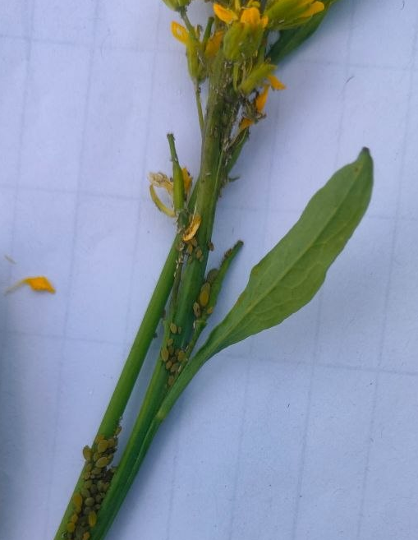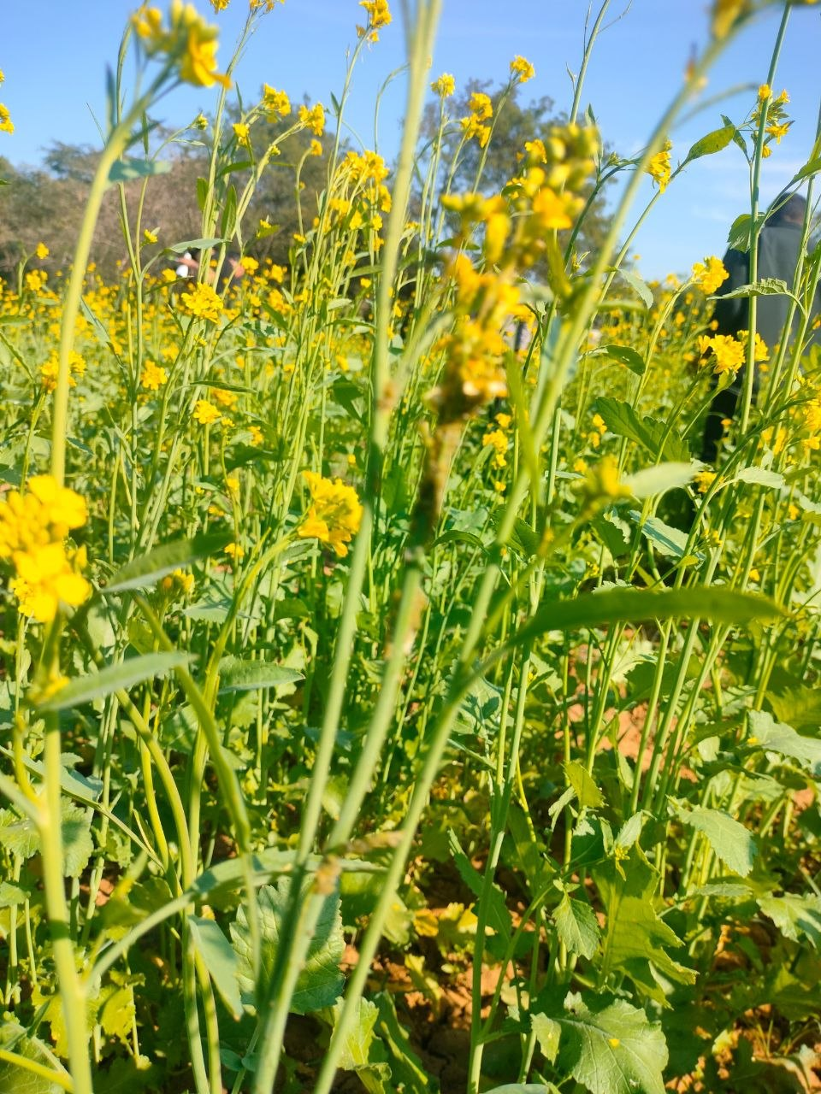
Fig. 1: Mustard aphids Fig. 2: Mustard crop
Results and Discussion
Population of Aphid on Mustard
Changes in population of mustard aphid L. erysimi due to changes in weather parameters viz., maximum, minimum temperature, relative humidity of morning and evening periods and rainfall as shown in Table 1 was observed and recorded during the experiment duration.
Aphid
The incidence of aphid on mustard was initially observed during the 52nd Standard Meteorological Week (27th December 2024) with a mean population of 8.4 aphid per 10 cm central apical twig per plant when the prevailing maximum and minimum temperature was 22.7°C and 12.1°C, morning and evening relative humidity was 95.1% and 56.7% and aphid population was active upto harvesting. Data revealed that the aphid population was maximum during 6th standard week (07 February 2025) i.e., 193.00 aphids per 10 cm central apical twig per plant when the prevailing maximum and minimum temperature was 25.7°C and 6.8°C, morning and evening relative humidity was 89.1% and 44.7% and no precipitation was recorded whereas minimum population was observed on 52nd standard week i.e., 27th December when the maximum temperature was 22.7°C and minimum temperature was 12.1°C with morning and evening relative humidity between 89.0 to 57.3 per cent and 2.5 mm precipitation.
To assess the influence of abiotic factors on aphid incidence, the correlation coefficient was calculated between the mean populations of aphid and various weather parameters. Most simple correlations between mustard aphid populations and weather factors were found to be non-significant. Aphid numbers showed a weak, non-significant positive association with maximum temperature (0.098). In contrast, minimum temperature had a significant negative correlation with aphid populations (-0.838*), suggesting that lower night temperatures favored higher aphid abundance. Morning relative humidity had a positive but non-significant correlation with aphid populations (0.362), whereas evening relative humidity showed a negative, non-significant association (-0.375). Rainfall also displayed a negative correlation (-0.334), though this too was not statistically significant in relation to aphid population levels.
The incidence of aphid on mustard was initially observed during the 52nd Standard Meteorological Week and remain upto harvesting. Peak of the aphid population was observed during 6th SMW. The aphid population exhibited a significant negative correlation with minimum temperature, whereas its associations with maximum temperature, morning and evening relative humidity, and rainfall were found to be non-significant.
The present findings are consistent with earlier studies. Pradhan et al. (2020) reported that mustard aphid populations first appeared during the 51st Standard Meteorological Week (SMW) (third week of December) and remained active until the 9th SMW (first week of March 2019), with peak population (50.33 aphids per 10 cm twig) recorded during the 6th SMW (second week of February). Similarly, Chand et al. (2022) observed the initial appearance of aphids in the last week of December (52nd SMW), followed by a gradual increase, reaching maximum levels during the second week of February (6th SMW). These observations are further corroborated by Choudhary et al. (2023), who reported that aphid incidence commenced in early December, persisted throughout the cropping season, and attained peak population levels between the first and second weeks of February. Their correlation analysis indicated a non-significant relationship between aphid population and relative humidity. In addition, Kishor et al. (2023) documented the highest aphid intensity during mid-February (6th SMW) and established a negative correlation with average temperature. The current results are also in agreement with Yadav et al. (2023), who reported a significant negative correlation between aphid population and temperature. Likewise, Shukla and Kumar (2024) observed that aphid incidence extended from the last week of December to the first week of March, with peak infestation occurring in the second week of February. Furthermore, Singh et al. (2026) identified a significant negative correlation between aphid population and minimum temperature. Overall, these studies collectively support the present findings, indicating that mustard aphid populations typically emerge in late December, increase progressively, and reach peak levels during February, with temperature playing a critical role in influencing their population dynamics.
Table-1: Population dynamics of mustard aphid, (L. erysimi) in relation to abiotic factors during Rabi season 2024-25.
 | Aphid population/10cm central apical twig/plant | Meteorological parameters
 | Aphid population/10cm central apical twig/plant | Temperature (ºC) |  | Relative humidity (%) |  | Rainfall
SMW | Aphid population/10cm central apical twig/plant | Maximum | Minimum | Morning | Evening | (mm)
52 | 8.4 | 22.7 | 12.1 | 89 | 57.3 | 2.5
1 | 15.4 | 20.1 | 7.3 | 95.1 | 56.7 | 0
2 | 44.6 | 21 | 6.3 | 93.9 | 58.1 | 1.6
3 | 73.8 | 21.1 | 7.8 | 93.6 | 57.1 | 0
4 | 93.2 | 24.7 | 6 | 91.6 | 50.7 | 0
5 | 123.8 | 27.6 | 8.6 | 92.1 | 39.1 | 0
6 | 193 | 25.7 | 6.8 | 89.1 | 44.7 | 0
7 | 170.8 | 29 | 9.7 | 86.1 | 37.6 | 0
8 | 85.8 | 28.2 | 10.6 | 88.6 | 37.4 | 4
9 | 20.6 | 31.3 | 13.7 | 83.9 | 33.7 | 0
10 | 6.2 | 31.2 | 9.9 | 80.3 | 34.9 | 0
SMW= Standard meteorological Week
Table-2: Correlation of population of mustard aphid with weather parameters.
Insect | Weather parameters
Insect | Temperature (ºC) |  | Relative Humidity % |  | Rainfall (mm)
Insect | Maximum | Minimum | Morning | Evening | Rainfall (mm)
Aphid | 0.098^{NS} | -0.838* | 0.362^{NS} | -0.375^{NS} | -0.334^{NS}
*Significant at 0.05% level, NS=non-Significant
Conclusion
This research concludes the lowest aphid population of 8.4 aphids per 10 cm central apical twig per plant occurred on December 27, 2024 (52nd SMW) and the highest aphid population of 193 aphids per 10 cm central apical twig per plant was observed on February 7, 2025, during the 6th standard week (SMW). Minimum temperature showed a significant negative correlation (-0.838*), suggesting that lower temperatures corresponded with higher aphid populations. Therefore, farmers should implement management strategies prior to February in order to prevent the population from reaching its peak. There was a limitation that the trial was conducted in a season so that proper examination of effect of weather parameters was lack.
Disclaimer (Artificial intelligence)
Author(s) hereby declares that NO generative AI technologies such as Large Language Models
(ChatGPT, COPILOT, etc.) and text-to-image generators have been used during the writing or
editing of this manuscript.
References
Anonymous, (2022). Agriculture statistics- District wise crop wise area-production-yield, Farmers Welfare and Agriculture Development Department, Madhya Pradesh, In Assistance with Ministry of Agriculture, Government of India: 9-10.
Anonymous, (2023). Agriculture statistics at a glance. Government of India Ministry of Agriculture & Farmers Welfare Department of Agriculture & Farmers Welfare Economics & Statistics Division: 52-53.
Arvind, Jat, B. L., Chand, A., Kumar, S., Yadav, M. S. and Redhu, M. (2024). Population Dynamics of Mustard aphid and its natural enemies. Indian Journal of Entomology 1- 4, Ref. No. e24478.
Awasthi, V.B. (2002). Introduction to General and Applied Entomology, Scientific Publisher, Jodhpur (India), 266-71.
Bakhetia, D.R.C., & Sekhon, B.S. (1989). Insect pests and their management in rapeseed mustard. J. of Oilseeds Res. 6: 269-73.
Chand, A., Khinchi, S.K., Kumawat, K.C., Hussain, A., & Sharma, S.L. (2022). Quantitative and qualitative status of insect pests of mustard, Brassica juncea (L.) Czern and Coss and their natural enemies. J. Pharm. Inn. 11 (1): 412-415.
Choudhary, S., Meena, R. K., Jat, B. L., Hussain, A., & Sharma, P. (2023). Population dynamics of mustard aphid, Lipaphis erysimi (Kalt.) on cauliflower in relation to biotic and abiotic factors. Intern. J. of Enviro. and Climate Change 13(11): 2322-2328.
Kishor, R., Malik, Y. P., Sirajuddin, Mishra, P. K., Kushwaha, D., & Verma, S. K. (2023). Correlation Between the Seasonal Incidence of Aphids and Coccinellids on the Indian Mustard in Different Varieties and Sowing Dates. International Journal of Environment and Climate Change 13 (11):1452-66.
Pradhan, P. P., Borkakati, R. N., & Saikia, D. K. (2020). Seasonal incidence of insect pests and Natural enemies of mustard in relation to meteorological parameters. J. of Ent. and Zool. Stud. 8(1): 1538-1542.
Rana, J. (2005). Performance of Lipaphis erysimi (Homoptera: Aphididae) on different Brassica species in a tropical environment. Eur. J. Entomol. 103: 81–84.
Sarangdevot, S. S. Kumar, A. & Chundawat, G. S. (2006). Field bio-efficacy of some newer insecticides against aphids infesting tomato crop. Pestology 30(3): 20-22.
Sen, K., Samanta, A., Hansda, A., Dhar, P.P., & Samanta, A. (2017). Bio-efficacy and economics of some insecticides against mustard aphid, Lipaphis erysimi (Kalt.) infesting mustard. J. of Crop and Weed 13(2): 235-237.
Sharma, P. & Singh, Y. P. (2010). Directrate of Rapeseed-mustard, Indian Council of Agriculture Research, Sewar, 321303, Bharatpur (Rajasthan). Annual National Language Journal 1: 4751.
Shukla, A., & Kumar, A. (2024). Population dynamics of mustard aphid lipaphis erysimi (kalt.) and its coccinellid predators. Ind. J. of Ent. Online published Ref. No. e24553.
Shylesha, A. N., Azad Thakur, N.S., Pathak, K.A., Rao, K. R., Saikia, K., Surose, S., Kodandaram, N. H. & Kalaishekar, A. (2006). Integrated management of insect pest of crops in north eastern hill region. Technical Bulletin No. 19. ICAR RC for NEH Region, Umiam, p. 50.
Singh, R.; Singh, D. & Rao V.U.M. (2026). Effect of abiotic factors on mustard aphid (Lipaphis erysimi, Kalt) on Indian brassica. Indian j. agric. Res. 41(1): 67-70.
Tiwari, A., Singh, H., Singh, B., Alok & Sharma, A. (2025). Biotic and abiotic factors as variables in population build-up of mustard aphid (Lipaphis erysimi Kalt.) in the western Gangetic planes of India. Intern. J. of Environ. and Climate Change 15(2): 112-122.
Uddin, A. (2021). Study of aphid on mustard, Lipaphis erysimi (Kalt) at Northern Madhya Pradesh. M.Sc. Thesis, Rajmata Vijayaraje Scindia Krishi Vishwa Vidyalaya, Gwalior.
Venkattakumar, R., & Padmaiah, M. (2010). Adoption behaviour of oilseed growers in India. Indian Res. J. of Ext. 10(3): 75-83.
Yadav, R. V., Kumar, V. & Saxena, R. (2023). Population dynamics of aphid and their natural enemies in mustard based on meteorological parameters using principal component analysis. Journal of Agrometeorology 25(3): 458–461.

