Morphometric Characterization and Hydrological Interpretation of the Shastri Watershed Using Geospatial Techniques
Abstract
Geomorphological characteristics of a watershed play a critical role in controlling drainage patterns, runoff behavior, erosion processes, and groundwater potential. Hence, quantitative geomorphometric analysis is essential to understand the relationship between terrain features and hydrological responses. The present study evaluates the geomorphometric attributes of the Shastri watershed and their hydrological implications using geospatial techniques. Remote Sensing (RS) and Geographic Information Systems (GIS) were employed to derive morphometric parameters from 30 m resolution CARTOSAT-DEM and Survey of India (SOI) topographic maps for watershed delineation and drainage extraction.The computed linear, areal, and relief parameters indicate an elongated basin geometry, as evidenced by low values of form factor, elongation ratio, and circularity ratio. High basin relief, along with moderate relief ratio and ruggedness number, suggests significant terrain variability, which enhances runoff velocity and increases erosion susceptibility. The asymmetry factor further indicates uneven slope development, affecting spatial runoff distribution. Overall, the watershed demonstrates moderate to high runoff potential, particularly during intense rainfall events. The study confirms the effectiveness of RS-GIS techniques in generating reliable morphometric insights and highlights their importance in watershed management and sustainable planning.
Keywords: Geospatial Technique, Morphometric analysis, Stream network, Watershed etc.
- Introduction:
Land and water resources are progressively declining due to increasing population pressure and associated anthropogenic activities. Watersheds represent fundamental geomorphic and hydrological units formed through complex interactions among topography, climate, and hydrological processes. Geomorphology focuses on the physical and chemical processes operating on or near the Earth’s surface that shape landforms and govern their evolution over time (Clarke., 1966). Morphometry involves the quantitative assessment of watershed geometry and drainage systems, enabling the evaluation of linear, areal, and relief characteristics of a basin (Ingle et al., 2025).Drainage networks constitute vital landscape elements that are highly responsive to topographic conditions, which influence their structure and fluvial dynamics. These networks, including stream patterns and river systems, vary spatially and temporally due to the influence of geomorphology, geology, structural controls, and vegetation (Rekha et al., 2011). Physiographic features such as basin shape, drainage density, and slope gradient significantly influence hydrological responses within a watershed. Analysis of these features provides insights into runoff generation, flow distribution, and water availability.
Morphometric characteristics strongly control hydrological processes such as flood peaks, sediment transport, and soil erosion (Shekar and Mathew, 2023; Shekar et al., 2023). These parameters quantitatively describe the size, shape, and spatial arrangement of landforms (Clarke, 1996; Agarwal, 1998; Reddy et al., 2002). Morphometric analysis typically includes linear, areal, and relief aspects, often evaluated using GIS-based techniques (Agarwal, 1998), which offer comprehensive understanding of watershed characteristics.With advancements in geospatial technologies, Remote Sensing (RS) and GIS have become efficient tools for rapid and accurate computation of morphometric parameters (Singh et al., 2013; Gautam et al., 2021). In this study, RS and GIS techniques are applied to analyze the morphometric characteristics of the Shastri watershed, aiming to understand its hydrological behavior and support decision-making for water resource planning and watershed management.

- Material and Methods
  - Description of Study Area:
The Shastri watershed, located within the Shastri River basin in the Konkan region, was selected for the present study. The geographical extent of the watershed lies between latitudes 17°6.200′ N to 17°22.800′ N and longitudes 73°36.000′ E to 73°42.000′ E. The total area of the watershed is approximately 151 km² (15,100 ha).The region receives an average annual rainfall of about 3,300 mm, predominantly during the southwest monsoon season (June–September). Orographic effects associated with the Western Ghats significantly enhance rainfall intensity, resulting in rapid runoff, high soil saturation, and marked seasonal discharge. The elevation within the watershed ranges from 26.05 m to 987 m above mean sea level (MSL). The location map of the study area is presented in Figure 1.
  - Database Used
The study utilized topographic maps (1:50,000 scale) and Digital Elevation Model (DEM) data. The toposheets were obtained from the Survey of India (SOI). A 30 m resolution Cartosat-1 DEM was used for terrain analysis, downloaded from the Bhoonidhi Portal (link: https://earthexplorer.usgs.gov/). The DEM is suitable for watershed delineation, slope analysis, drainage extraction, and geomorphological investigations. The DEM representation is shown in Figure 4.
  - Software Used
QGIS (Version 3.18, released February 2021), an open-source geospatial software developed by the QGIS Development Team, was used for analysis. The software facilitated watershed delineation, thematic map preparation, drainage network extraction, and computation of morphometric parameters, including linear, areal, and relief aspects.

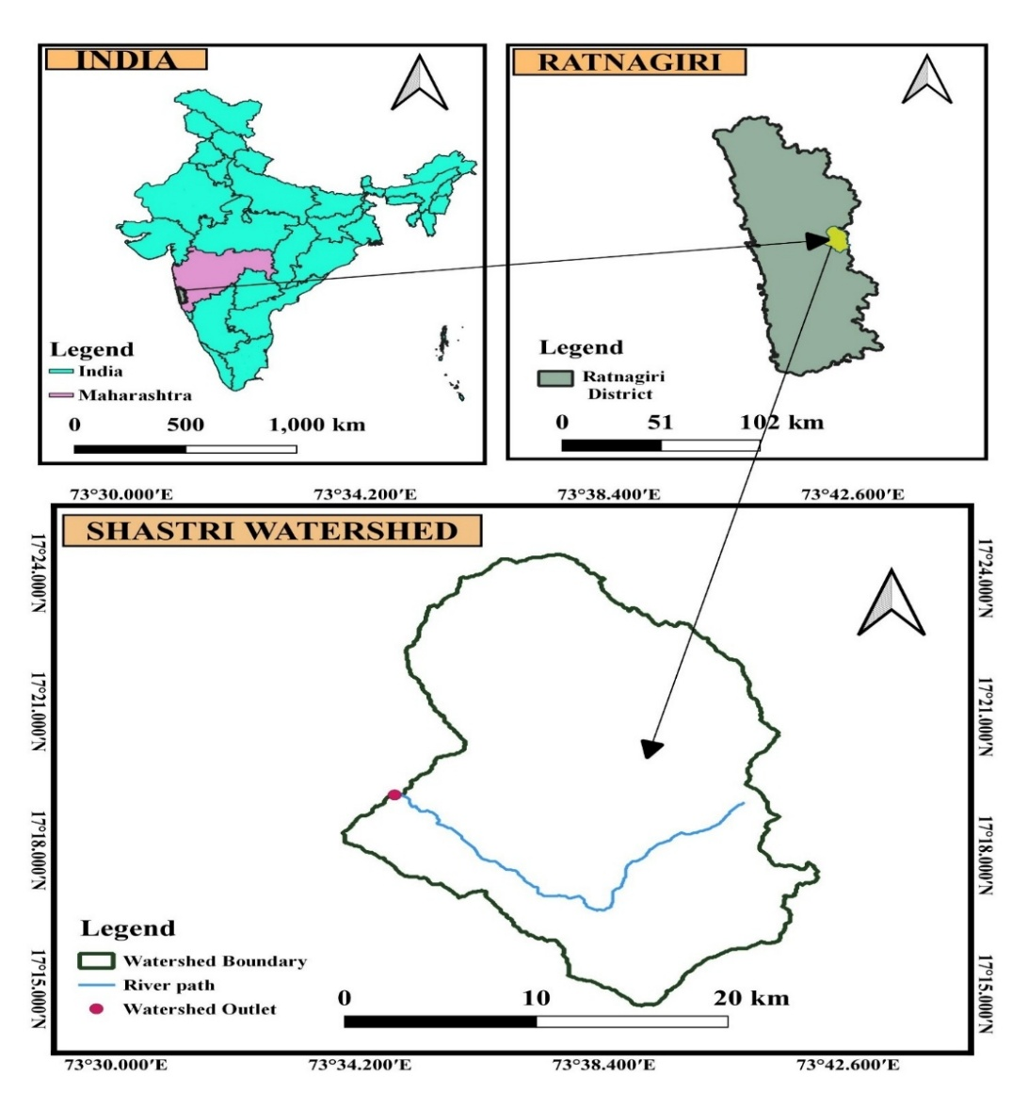
Figure 1. Location Map of Study Area
  - Extraction of watershed boundary and drainage network
A watershed is a topographically defined hydrological unit that collects and conveys runoff from precipitation to a common outlet such as a river, lake, or reservoir through interconnected flow paths. The workflow for watershed boundary extraction in the QGIS 3.18 environment is illustrated in Figure 2.
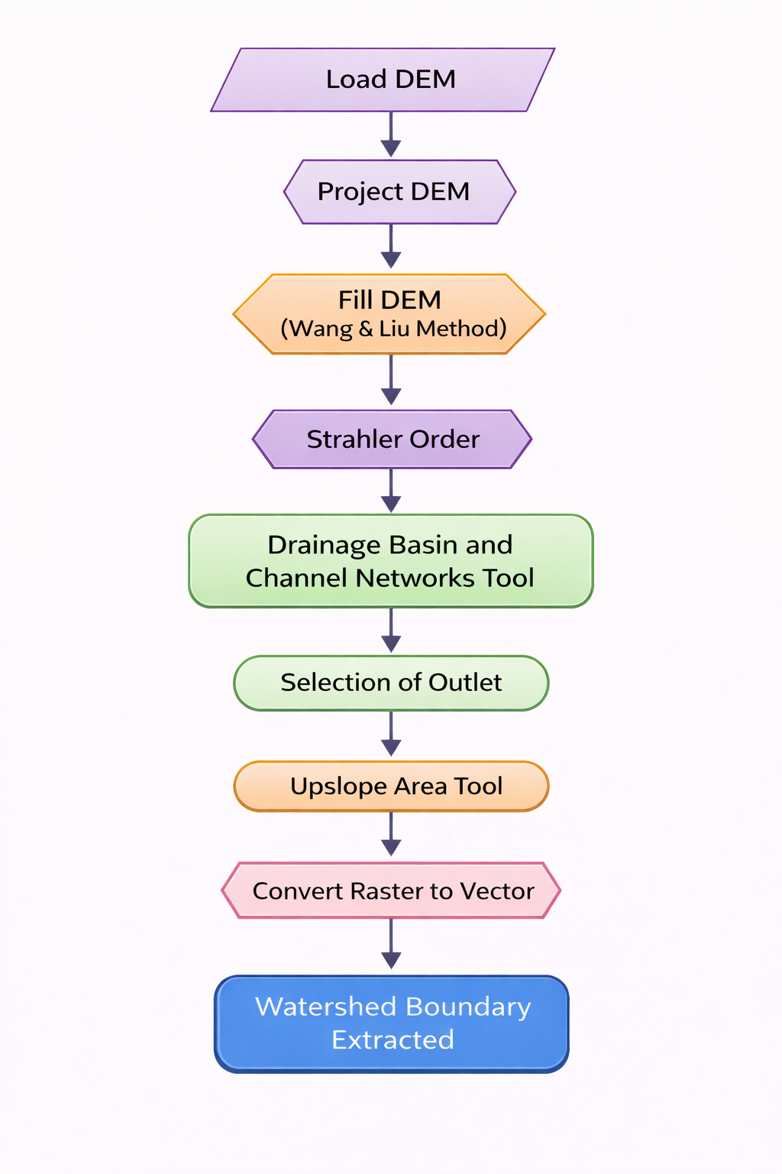
Figure 2. Flowchart showing steps for extracting boundary of watershed
  - Estimation of geomorphometric parameters
Morphometric analysis is an effective approach for understanding the interrelationship among various drainage characteristics. The geomorphological properties of a watershed are categorized into stream characteristics, basin shape attributes, drainage network features, and slope characteristics. These are broadly classified into three groups:
2.5.1. Linear aspects (One dimension)
2.5.2. Areal aspects (Two dimension)
2.5.3. Relief aspects (Three dimension)
2.5.1. Linear parameters
Linear parameters describe the characteristics of the drainage network and stream system. These include watershed area, perimeter, basin length, stream order, stream number, stream length, mean stream length, stream length ratio, bifurcation ratio, and rho coefficient. These parameters were calculated using standard formulae (Table 1).
- Watershed Area (A)
Watershed area (A) is the area enclosed within the watershed boundary; directly influences streamflow.
- Watershed Perimeter (P)
It is defined as the length of the watershed boundary along the ridge line.
- Length of Watershed ($L_{μ}$)
It is the extended linear dimension of the basin collateral to the principal drainage line which travels the largest quantity of stream flow (Schumm., 1956).
- Stream Order (u)
The stream order represents the degree of stream branching within watershed. Horton (1945) first introduced it. Strahler (1957) defines first order streams as the smallest tributaries with no branching. When two first order streams come together, a second order channel segment is generated. A third order stream appears when two 2nd order streams connect and so on in that manner main channel discharges a large quantity of water indicated as the highest order stream of a drainage basin.
- Stream Number (N_{u})
The number of streams of each order in a given watershed is known as stream number. Horton (1945) stated that the inverse geometric sequence forms between the order-wise number of stream segments with order number.
- Stream Length (L_{u})
Stream length (Lu) for the watershed has been calculated using Horton law. Stream length describes the surface runoff characteristics of a basin. The stream having smaller length is indicative of areas with larger slopes with finer textures whereas longer streams with relatively larger length are characteristics of flatter gradient.
- Mean Stream length(L_{um})
Mean stream length is a ratio of the Mean stream length of a given order to the mean stream length of next lower order (Horton, 1945). The value of L_{um} increases as the order number increases.
- Stream length ratio(R_{l})
Horton (1945) defined the stream length ratio, R_{l}, as the ratio of mean length, Lu of segments of order u to mean length of segments of the immediate lower order,-
- Bifurcation Ratio(R_{b})
It is the ratio between total numbers of streams in a one order (Nu) to the number of next higher order (N_{u} + 1) (Schumm., 1956). It can be measures surface water potential and hydrographs of a watershed (Jain et al., 2000).
- Rho coefficient($ρ$)
Rho coefficient is calculated by dividing the stream length ratio to the bifurcation ratio. The relation between the drainage density and physiographic development of basin is determined by Rho coefficient (Horton., 1945).
Table 1. Formulas for calculating different Linear parameters
Sr No. | Morphometric  parameters | Estimation method/formula | Unit | Range | References
Linear Aspects
1 | Watershed Area $(A$) | QGIS Software | Sq.km | - | -
2 | Watershed Perimeter $(P$) | QGIS Software | km | - | -
3 | Length of the Watershed${(L}_{μ}$) | QGIS Software | km | - | -
4 | Stream Order (u) | Hierarchical rank | - | - | Strahler (1957)
5 | Stream Number (N_{u}) | QGIS Software | - | - | Horton (1945)
6 | Stream length (L_{u}) | L_{u}= Lu₁+Lu₂+………+Lu_{n} | km | - | Horton (1945)
7 | Mean Stream length (L_{u}) | L_{u} =$\frac{L_{u}}{N_{μ}}$ | km | - | Strahler  (1957)
8 | Stream length ratio (R_{l}) | R_{l}=$\frac{L_{u}}{L_{μ-1}}$ | Dimensionless | - | Horton (1945)
9 | Bifurcation Ratio(R_{b}) | R_{b}=$\frac{N_{u}}{N_{u+1}}$ | Dimensionless | Range of 3 to 5 | Schumm (1956), Strahler (1957)
10 | Rho coefficient($ρ)$ | $$ρ=\frac{R_{l}}{R_{b}}$$ | Dimensionless | 0 to 1 | Horton (1945)

2.5.2. Areal parameters
The areal parameters of drainage morphometric analysis encompass quantitative indices that describe the spatial configuration and hydrological behavior of a drainage basin. These include the form factor, Circularity ratio, elongation ratio, shape index drainage density, stream frequency, textural ratio, drainage intensity and asymmetric factor. The areal morphometric parameters were derived using established mathematical formulations, with their detailed computational expressions provided in Table 2.
- Form factor (F_{f})
Form factor is expressed as the ratio of the watershed area to the square of the basin length (Horton, 1932). Lower values of this parameter indicate a more elongated basin shape, whereas higher values suggest a relatively compact basin. Basins with higher form factor values tend to produce higher peak flows over shorter durations.
- Elongation ratio (R_{e})
Schumm (1956) described the elongation ratio as the ratio between the diameter of a circle having the same area as the drainage basin and the basin’s maximum length. Typically, Re values range from 0.6 to 1.0 across diverse climatic and geological conditions.
- Circularity ratio (R_{c})
The circularity ratio is a dimensionless parameter that reflects the extent to which a drainage basin approaches a circular shape. It is comparable to the elongation ratio in representing basin form and is defined as the ratio of the basin area to the area of a circle having the same perimeter as the basin (Miller, 1953).
- Shape index (S_{w})
The shape factor is defined as the inverse of the form factor and is expressed as the ratio of the square of basin length to the basin area (Horton, 1945). This parameter is of considerable hydrological significance, as it exerts a strong influence on streamflow dynamics and sediment transport processes along the flow path (Sangma and Guru, 2020).
- Drainage density (D_{d})
Drainage density is the ratio of total stream length of all the orders per unit basin area (Horton.,1945). D_{d} is a numerical measure of landscape dissection and runoff potential (Chorley., 1969).
- Drainage Intensity (D_{i})
Drainage intensity is the proportion of stream frequency to the drainage density (Faniran., 1968).
- Stream frequency (F_{s})
Stream frequency of a basin is defined as the number of streams per unit area( Horton .,1945). stream frequency indicates high permeable geology and low relief (Soni et al., 2013).
- Texture ratio (R_{t})
Texture ratio (Rt) is defined as the ratio of the total number of first-order streams to the perimeter of the basin. It serves as an indicator of the degree of boundary irregularity or surface roughness within a watershed.
- Drainage texture (D_{t})
Drainage texture is defined as the ratio of the total number of stream segments, across all stream orders, to the perimeter of the drainage basin (Horton, 1945). On the basis of this index, Smith (1950) classified drainage texture into five distinct categories: values less than 2 indicate very coarse texture; values between 2 and 4 represent coarse texture; values between 4 and 6 correspond to moderate texture; values between 6 and 8 denote fine texture; and values greater than 8 are classified as very fine drainage texture.
- Compactness coefficient (C_{c})
Strahler (1964) defined compactness coefficient as the ratio of watershed perimeter to perimeter of a circle of a watershed area. It is greater than or equal to unity, in which value 1 indicates that basin has perfectly circular shape and greater value indicate more deviation from the circular shape of basin (Horton.,1945)
- Constant of channel maintenance (C)
Schumm (1956) has used the inverse of the drainage density having the dimension of length as a property termed constant of channel maintenance. It indicates magnitude of drainage basin surface area required to sustain one linear km of length stream segment.
- Length of overland flow (L_{g})
Horton (1945) described the length of overland flow as the horizontal distance travelled by surface runoff from the drainage divide to the nearest stream channel before it becomes channelized. This parameter plays a significant role in influencing both the hydrological response and the physiographic evolution of a watershed.
- Infiltration number (I_{f})
It is calculated as the product of drainage density (Dd) and stream frequency (Sf). This parameter shows an inverse relationship with infiltration capacity and a direct influence on surface runoff (Faniran, 1968).
- Lemniscate ratio (k)
The lemniscate ratio (k) is an index used to evaluate the deviation of a watershed’s shape from an ideal figure-eight (lemniscate) form. It is expressed as the ratio of the basin length measured along the main channel to the total area of the watershed (Chorley, 1957).
- Asymmetry Factor (A_{f})
The asymmetry factor (Af) is used to identify tectonic tilting perpendicular to the direction of flow within a drainage basin (Sangma and Balamurugan, 2017). An Af value of 50% indicates that the drainage system is in a stable and balanced condition
Table 2. Formulas for calculating different Areal parameters
Sr No. | Morphometric  parameters | Estimation method/formula | Unit | Range | References
Areal Aspects
1 | Form factor (F_{f}) | F_{f} = $\frac{A}{{L_{μ}}^{2}}$ | Dimensionless | 0 to 1  0= strongly elongated shape  1= circular shape | Horton (1945)
2 | Elongation ratio (R_{e}) | $R_{e}$=$2×\frac{\sqrt{\frac{A}{π}}}{L_{μ}}$ | Dimensionless | 0 = Highly elongated  1 = circular | Schumm (1956),  Strahler (1957)
3 | Circularity ratio (R_{s}) | R_{s}=4$π×\frac{A}{P^{2}}$ | Dimensionless | 0 = in line  1= circle | Chougale and Jagdish (2017), Miller (1953)
4 | Shape index (S_{w}) | S_{w}=$\frac{L_{b}^{2}}{A}$ | Dimensionless | Greater than 1 | Horton (1945)
5 | Drainage density (D_{d}) | D_{d}=$\frac{L_{μ}}{A}$ | km/km² | 0.55 to 2.09  (Humid region). | Horton (1945), Joji et al.(2013).
6 | Drainage Intensity (D_{i}) | $$Di=\frac{F_{s}}{D_{d}}$$ | Km⁻¹ | - | Faniran (1968)
7 | Stream frequency (F_{s}) | F_{s}=$\frac{N_{μ}}{A}$ | km⁻² | - | Horton (1945)
8 | Texture ratio (R_{t}) | R_{t}=$\frac{N_{1}}{P}$ | Dimensionless | - | Ozdemir and Bird (2009)
9 | Drainage texture (D_{t}) | D_{t}= $\frac{N_{u}}{P}$ | km⁻¹ | > 8 = very fine.  6–8= fine, 4–6= moderate  2–4 =coarse  And  < 2= very coarse | Horton (1945), Smith (1950)
10 | Compactness coefficient (C_{c}) | Cc =$\frac{P_{b}}{2{(πA)}^{0.5}}$ | Dimensionless | 𝐶𝑐 varies with ≥1  1= Circular  >1=Deviation from circular shape | Strahler (1957)
11 | Constant of channel maintenance (C) | $$C=\frac{1}{D_{d}}$$ | km²/km | - | Schumm (1956)
12 | Length of overland flow (L_{g}) | $$Lg=\frac{1}{{2D}_{d}}$$ | km | <0.2 km= Short flow length  0.2 to 0.3 km= moderate condition  >0.3 km= Longer flow path | Chandrashekar et al. (2015),Horton (1945)
13 | Infiltration number (I_{f}) | $$If=D_{d}×F_{s}$$ | Number/km³ | - | Faniran (1968)
14 | Lemniscate ratio (k) | $$k=\frac{L_{μ}^{2}}{4A}$$ | Dimensionless | - | Chorley (1957)
15 | Asymmetry Factor (Af) | $$Af=\frac{{(A}_{r })}{\left(A_{t}\right)}×100$$ | Percentage | AF > 50% tilting left downstream  AF < 50%= titling right Downstream | Gardner et al.(1987)

2.5.3. Relief parameters
Relief parameters in morphometric analysis represent the degree of elevation variation and the overall topographic energy of a watershed. These characteristics are typically assessed using indices such as basin relief, relief ratio, relative relief, and ruggedness number. In this study, all relief-related morphometric parameters were calculated using established geomorphological equations, with their detailed formulations provided in Table 3.
- Basin relief (H)
Basin relief refers to the difference in elevation between the highest point (H_{max}) and the lowest point (H_{min}) within a drainage basin (Hadley and Schumm., 1961).
- Relief Ratio (R_{r})
Relief ratio is a dimensionless parameter defined as the ratio of total basin relief to basin length, and it serves as an indicator of the overall slope characteristics of a watershed (Schumm., 1956).
- Relative Relief (R_{hp})
Relative relief is determined using the formulation proposed by Melton (1957). It is expressed as the percentage ratio of the maximum basin relief to the basin perimeter
- Ruggedness Number (Rn)
The ruggedness number is a dimensionless parameter calculated as the product of basin relief and drainage density. Higher values of this index are typically associated with mountainous or hilly terrains, whereas lower values are characteristic of relatively flat regions.
Table 3. Formulas for calculating different Relief parameters
Sr No. | Morphometric  parameters | Estimation method/formula | Unit | Range | References
Relief Aspects
1 | Basin relief (H) | H=H_{max} - H_{min} | m | < 500 m= low ,  500–850 m= moderate ,  > 850 m= high | Hadley and Schumm (1961), Prabhakaran and Raj.( 2018).
2 | Relief Ratio(Rr) | $$Rr=\frac{H}{L_{μ}}$$ | Dimensionless | - | Schumm (1956)
3 | Relative Relief(Rhp) | $$Rhp=R×\frac{100}{P}$$ | Dimensionless | - | Melton (1957)
4 | Ruggedness Number(Rn) | $R_{n}$= H$×D_{d}$ | Dimensionless | 0 to 1  Near to 0= Smooth surface  Nearer to 1= Rough surface | Strahler (1957)

- Results and Discussion
The hydrological response of the watershed was evaluated using morphometric characteristics, including linear, areal, and relief parameters. Table 7 presents the complete set of morphometric results derived through GIS-based analysis and standard computational methods, and the detailed interpretation of these parameters is discussed in the following sections.
  - Linear morphometric parameters
- Watershed Area: The total drainage area of the basin was estimated to be 151 km².
- Watershed Perimeter: The computed perimeter is 77.74 km, which reflects the overall shape, boundary complexity, and spatial extent of the watershed.
- Watershed Length: The length of the study watershed was measured as 13 km.
- Stream Order: The drainage network extracted from the CARTOSAT DEM indicates that the basin reaches up to fifth-order streams, reflecting a well-organized and mature fluvial system. The spatial distribution of stream orders is illustrated in Figure 5.
- Stream Number: The watershed contains a total of 94 stream segments, including 69 first-order, 17 second-order, 5 third-order, 2 fourth-order, and 1 fifth-order streams. The logarithmic relationship between stream order and stream number demonstrates an inverse geometric pattern, forming an approximately linear trend (Figure 3). This behavior suggests a fairly uniform lithological composition within the basin. The consistent reduction in stream frequency with increasing order reflects the gradual merging of flow paths, governed by runoff accumulation, channel network evolution, and the underlying structural and geomorphic characteristics of the watershed.

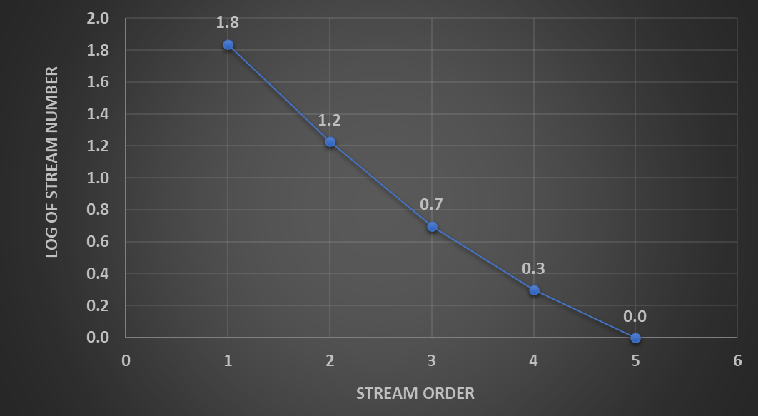

Figure 3. Graphical representation of log₁₀ of stream number V/s stream order
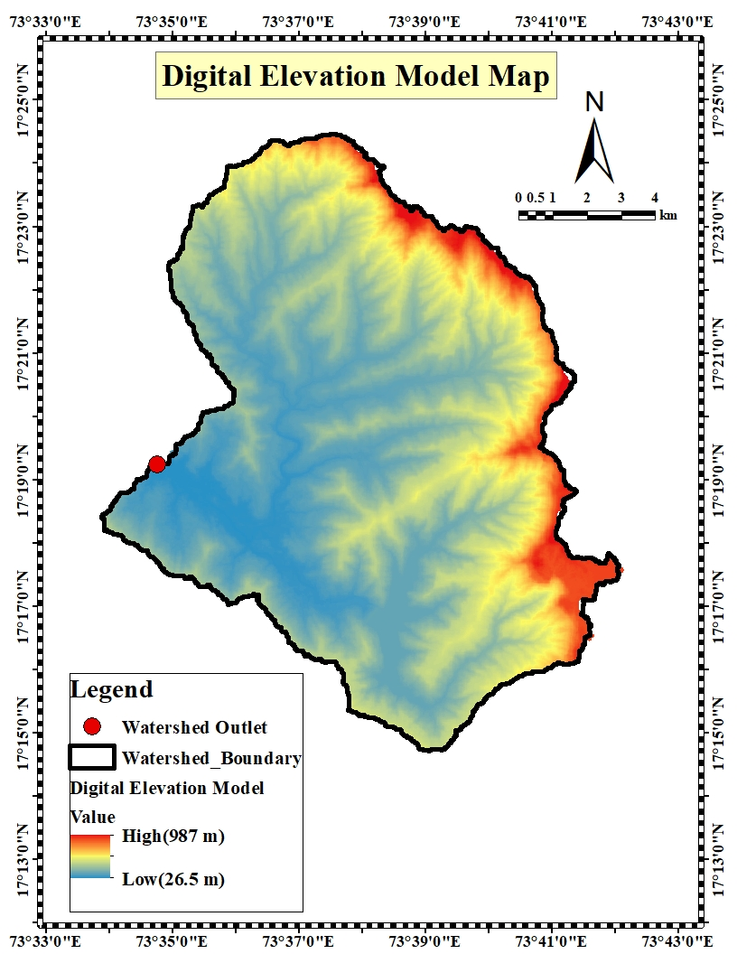
Figure 4. Digital Elevation Model map of Shastri watershed

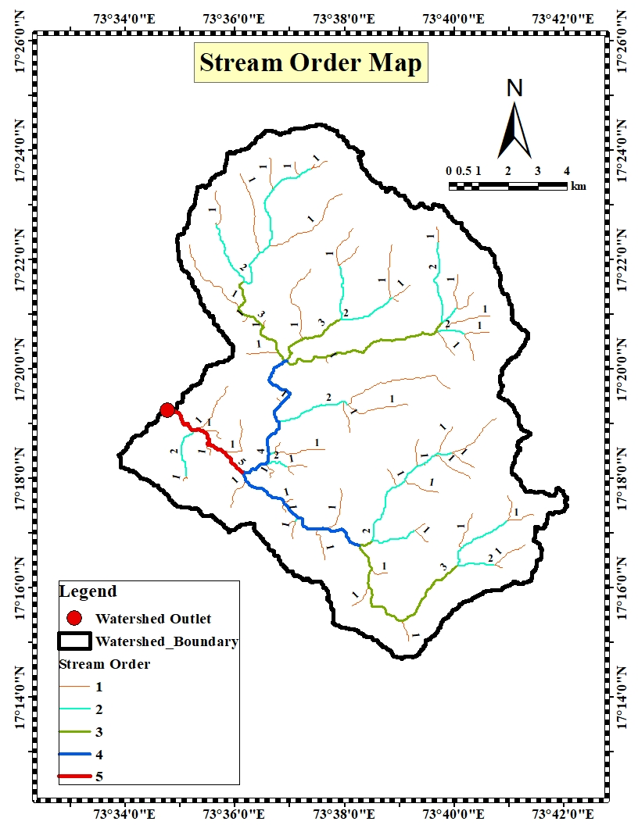
Figure 5. Stream order map of Shastri watershed
- Stream length and Mean stream length: The calculated values of stream length and mean stream length are presented in Table 4.
Table 4. Computed values of Stream Order, Stream Number, and Stream Length
Stream Order(u) | Stream Numbers(Nu) | Stream Length (km) | Mean Stream Length(km)
I | 69 | 70.97 | 1.03
II | 17 | 32.58 | 1.92
III | 5 | 19.68 | 3.94
IV | 2 | 11.07 | 5.54
V | 1 | 3.58 | 3.58
Total | 94 | 137.88
Mean |  | 27.58 | 3.20

- Stream Length ratio : The calculated stream length ratios for successive stream orders are 0.46 (II/I), 0.60 (III/II), 0.56 (IV/III), and 0.32 (V/IV). The stream length ratio from DEM suggests an area in its early geomorphic stages with a high potential for future changes and non-uniform hydrological behavior(Neelam kumari et al., 2023). The corresponding values of the stream length ratio are presented in Table 5.
Table 5. Values of stream length ratio for watershed
Stream order | Stream Length Ratio
II/I | 0.46
III/II | 0.60
IV/III | 0.56
V/IV | 0.32
Mean | 0.49

- Bifurcation ratio: In this study, the bifurcation ratio varies between 2.00 and 4.06, with an average value of 2.99. Such values indicate that the watershed is characterized by moderately to highly dissected and undulating terrain conditions. The detailed bifurcation ratio values are presented in Table 6.
Table 6. Values of Bifurcation ratio for watershed
Stream Order | Bifurcation Ratio(R_{b})
I/II | 4.06
II/III | 3.4
III/IV | 2.5
IV/V | 2
Mean | 2.99

- Rho Coefficient: The value of 0.16 of Rho coefficient indicate less hydrologic storage.

  - Areal morphometric parameters
1. Form factor: The computed form factor 0.29 indicates that the watershed possesses an elongated basin configuration.
2. Elongation ratio: The elongation ratio of 0.35 reflects an elongated basin morphology with moderate slope characteristics.
3. Circularity ratio: The Circularity ratio 0.31 further confirms the elongated nature of the watershed and suggests relatively uniform geological conditions.
4. Shape index: The shape index value of 3.41 indicates a high degree of basin elongation.
5. Drainage density: The drainage density 0.91 km/km² is low, implying the presence of permeable subsurface materials.
6. Drainage Intensity : The drainage intensity value 0.68 km⁻¹ is low, suggesting susceptibility to flash flooding during high-intensity rainfall events.
7. Stream frequency: The stream frequency 0.62 km⁻¹is low, indicating dominance of permeable geological formations within the watershed.
8. Texture ratio: The texture ratio value of 0.89 indicates a fine drainage texture.
9. Drainage Texture: The drainage texture 6.88 km⁻¹classifies the basin under the fine drainage texture category.
10. Compactness coefficient: The value 1.10 indicates low structural disturbance and a mature to old geomorphic stage of basin development.
11. Constant of channel maintenance: The computed value of 1.10 suggests that the basin has experienced relatively low structural disturbance and has reached a mature to old geomorphic stage.
12. Length of overland flow: The estimated value 0.55suggests moderate runoff generation due to appreciable infiltration capacity and longer flow path.
13. Infiltration number: The infiltration number 0.57indicates moderate runoff conditions supported by adequate infiltration.
14. Lemniscate ratio : The calculated value 0.85 reflects a favorable basin geometry with better flood attenuation potential.
15. Asymmetry Factor: The asymmetry factor 17.69% indicates relatively higher slope development on the right side of the basin compared to the left.

3.3.Relief morphometric parameters
1. Basin relief: In the present investigation, the maximum basin relief was estimated to be 960.95 m. This reflects pronounced topographic variation and suggests the presence of significant vertical dissection.
2. Relief Ratio : The relief ratio of the study area was computed as 0.04, which implies a relatively elongated basin configuration with a gentle overall slope, influencing runoff characteristics and drainage efficiency.
3. Relative Relief: The relative relief value was found to be 1.23, indicating moderate to high terrain steepness. This suggests a greater susceptibility to erosion processes and enhanced surface runoff.
4. Ruggedness Number: The ruggedness number was calculated as 0.88, signifying a moderately high degree of terrain roughness. This reflects considerable topographic irregularities and the presence of sharp geomorphic features within the watershed.

Table 7. Computed results of morphometric analysis of Shastri watershed
Sr No. | Morphometric  parameters | Unit | Result
A. Linear Aspects
1 | Watershed Area $(A$) | Sq.km | 151
2 | Watershed Perimeter $(P$) | km | 77.74
3 | Length of the Watershed${(L}_{μ}$) | km | 13
4 | Stream Order (u) | Dimensionless | 1 -5
5 | Stream Number (N_{u}) | Dimensionless | 94
6 | Stream length (L_{u}) | km | As given in Table
7 | Mean Stream length (L_{u}) | km | As given in Table
8 | Stream length ratio (R_{l}) | Dimensionless | As given in Table
9 | Bifurcation Ratio(R_{b}) | Dimensionless | As given in Table
10 | Rho coefficient($ρ)$ | Dimensionless | 0.16
B. Areal Aspects
1 | Form factor (F_{f}) | Dimensionless | 0.89
2 | Elongation ratio (R_{e}) | Dimensionless | 0.60
3 | Circularity ratio (R_{s}) | Dimensionless | 0.31
4 | Shape index (S_{w}) | Dimensionless | 1.12
5 | Drainage density (D_{d}) | km/km² | 0.91
6 | Drainage Intensity (D_{i}) | km⁻¹ | 0.62
7 | Stream frequency (F_{s}) | km⁻² | 0.89
8 | Texture ratio (R_{t}) | Dimensionless | 6.88
9 | Drainage texture (D_{t}) | km⁻¹ | 0.00
10 | Compactness coefficient (C_{c}) | Dimensionless | 1.79
11 | Constant of channel maintenance (C) | km²/km | 1.10
12 | Length of overland flow (L_{g}) | km | 0.55
13 | Infiltration number (I_{f}) | Number/km³ | 0.57
14 | Lemniscate ratio (k) | Dimensionless | 0.28
15 | Asymmetry Factor (Af) | Percentage | 0.68
C. Relief Aspects
1 | Basin relief (H) | m | 960.95
2 | Relief Ratio(Rr) | Dimensionless | 0.07
3 | Relative Relief(Rhp) | Dimensionless | 1.23
4 | Ruggedness Number(Rn) | Dimensionless | 0.88

4. Conclusion
The qualitative morphometric analysis of the watershed was carried out and it reveals that its hydrological response is strongly governed by basin geometry, drainage characteristics, and relief conditions. The watershed analysis shows an elongated basin (area 151 sq.km, perimeter 77.74 km, length 13 km) with 5th-order streams (N_{u}=94, R_{b} moderate, ρ=0.16). Low form factor (0.89), elongation ratio (0.60), and Circularity ratio (0.31) indicate elongated shape of basin. Moderate drainage density (0.91 km/km²), stream frequency (0.89 km⁻²), and infiltration number (0.57) suggest permeable soils with limited runoff under normal rain. High basin relief (960.95 m), relief ratio (0.07), relative relief (1.23), and ruggedness number (0.88) enhance erosion potential during intense storms. Asymmetry factor (0.68%) shows uneven slope development. Overall, the basin exhibits moderate-high runoff potential with rapid flow concentration, requiring soil conservation measures. These findings highlight the need for appropriate watershed management and soil conservation measures to mitigate runoff-induced impacts.
DISCLAIMER (ARTIFICIAL INTELLIGENCE)
The author(s) declare that no generative artificial intelligence tools, including large language models (such as ChatGPT, Copilot, etc.) or text-to-image generation systems, were utilized in the preparation or revision of this manuscript.
5.References
Agarwal C.S.1998. Study of drainage pattern through aerial data in Naugarh area of Varanasi district Uttar Pradesh. Journal of the Indian Society of Remote Sensing. 26:169-175.
Chandrashekar H, Lokesh K.V, Mohommad. S, Kumar M, Roopa J and Ranganna G. 2015. GIS-Based Morphometric Analysis of Two Reservoir Catchments of Arkavati River, Ramanagaram District, Karnataka. Aquatic Procedia.4:1345-1353.
Chorley R.J. 1969. The Drainage Basin as the Fundamental Geomorphic Units, Water, Earth and Man: A Synthesis of Hydrology, Geomorphology and Socio-Economic Geography. Methuen and Co Ltd., London;c. p. 588.
Chougale S.S and Jagdish B. S. 2017. Morphometric analysis of Kadvi River basin, Maharashtra using geospatial techniques. Current World Environment.12:635-645.
Clarke, J. I. 1966.Morphometry from map, Essays in geomorphology. Elsevier Publishing Company, New York.235-274.
Faniran, A. 1968.The Index of Drainage Intensity: A Provisional New Drainage Factor. Australian Journal of Science, 31:326-330.
Gardner, R.H., Milne, B.T., O Neill, R.V. and Turner, M.G. 1987. Neutral Models for the Analysis of Broad Scale Landscape Patterns. Landscape Ecology.1:19-28 .
Gautam V.K, Kothari M, Singh P.K, Bhakar S.R and Yadav K.K.2021. Determination of geomorphological characteristics of Jakham River Basin using GIS technique. Indian Journal of Ecology. 48(6): 1627-1634.
Hadley, R. F., and Schumm, S. A. 1961. Sediment sources and drainage-basin characteristics in upper Cheyenne River basin. U.S. Geological Survey, Water-Supply Paper 1531-B, 198. https://doi.org/10.3133/wsp1531
Horton, R. E. 1932. Drainage basin characteristics. Transactions of the American Geophysical Union.13:350-361.
Horton, R. E. 1945. Erosional development of streams and their drainage basins: Hydrophysical approach to quantitative morphology. Geological Society of America Bulletin, 56(3):275-370. https: 10.1130/0016-7606(1945)56[275:EDOSAT]2.0.CO;2
Ingle P.M, Prajapati G.V and Labade P.2025.Characterization of watershed using Morphometric Analysis - A review. Trabilizing trends in sustainable climate-resilient precision agriculture.section-1: 136-158.
Jain, A. O., Thaker, T. P., Misra, A. K., Singh, A. K., and Kumari, P. 2021. Determination of sensitivity of drainage morphometry towards hydrological response interactions for various datasets. Environment, Development and Sustainability, 23(2):1799-1822. https://doi.org/10.1007/s10668-020-00652-x
Melton, M. A. 1957. An analysis of the relations among elements of climate, surface properties, and geomorphology. Technical Report No. 11, Office of Naval Research Project NR 389-042, Department of Geology, ONR, Columbia University, New York.
Miller. V. C. 1953. A quantitative geomorphic study of drainage basin characteristics in the Clinch Mountain area, Virginia and Tennessee. Project NR389-042, Technical Report: 3, Columbia University, Department of Geology, ONR, Geography Branch, New York.
Neelam Kumari, Ayare B.L., Bhange H.N., Ingle P.M and Kasture M.C.2023. Geospatial analysis of morphometric parameters in the Kal River Basin, Western Konkan: Implications for hydrological characteristics. The Pharma Innovation Journal.12(12S): 2657-2667.
Ozdemir, H. and Bird. D. 2009. Evaluation of morphometric parameters of drainage networks derived from topographic maps and DEM in point of floods. Environmental Geology.56:1405–1415.
Prabhakaran. A and Raj.N.2018. Drainage Morphometric Analysis for Assessing form and Processes of the watersheds of Pachamalai hills and its Adjoinings, Central Tamil Nadu, India. Applied Water Science.8:31-49.
Reddy, G. P. O., Maji, A. K., and Gajbhiye, K. S. (2002). GIS for morphometric analysis of drainage basins. GIS India, 4(11), 9-14.
Rekha, V.B., George, A.V., Rita, M., 2011. Morphometric Analysis and Micro-watershed Prioritization of Peruvanthanam Sub-watershed, the Manimala River Basin, Kerala. South India. Environment Resource Engineering Management.3 (57):6–14.
Sangma, F., and Guru, B. 2020. Watersheds Characteristics and Prioritization Using Morphometric Parameters and Fuzzy Analytical Hierarchical Process (FAHP): A Part of Lower Subansiri Sub-Basin. Journal of the Indian Society of Remote Sensing, 48(12).
Sangma, F. and Guru, B. 2020. Watersheds characteristics and prioritization using morphometric parameters and fuzzy analytical hierarchical process (FAHP): A part of Lower Subansiri sub-basin. Journal of the Indian Society of Remote Sensing, 48(3):473–496. https://doi.org/10.1007/s12524-019-01091-6
Schumm, S. A. 1956. Evolution of drainage systems slopes in badlands in Perth Amboy, New Jersey. Geological Society of America Bulletin, 67:597–646.
Schumm, S. A. 1956. Evolution of drainage systems slopes in badlands in Perth Amboy, New Jersey. Geological Society of America Bulletin.67:597–646.
Shekar P.R, and Mathew A.2023.Delineation of groundwater potential zones and identification of artificial recharge sites in the Kinnerasani Watershed, India, using remote sensing-GIS, AHP, and Fuzzy-AHP techniques. AQUA - Water Infrastructure, Ecosystem Society. jws2023052.
Shekar P.R, Mathew .A, Pandey .A and Bhosale A.2023.A comparison of the performance of SWAT and artificial intelligence models for monthly rainfall–runoff analysis in the Peddavagu River Basin, India. AQUA—Water Infrastructure, Ecosystem Society. Sep 1,72(9):1707-30.
Singh P, Thakur J.K. and Singh U.C.2013. Morphometric analysis of Morar river basin Madhya Pradesh India using remote sensing and GIS techniques. Environmental Earth Sciences 68: 1967-1977.
Smith K.G. 1950.Standards for grading texture of erosional topography. American Journal of Science.248:655-668.
Strahler, A. N. 1952. Hypsometric (area-altitude) analysis of erosional topography. Geological Society of America Bulletin.63:1117–1142.
Strahler, A. N. 1957. Quantitative analysis of watershed geomorphology. Transactions of the American Geophysical Union.38:913–920.
Vittala S.S, Govindaiah S and Gowda H.H. 2004. Morphometric Analysis of Sub-Watersheds in The Pavagada Area of Tumkur District, South India Using Remote Sensing and GIS Techniques. Journal Indian Society Remote Sensing. 32(4):351-362.

