Integrated Geo-environmental Assessment of Heavy Metal Contamination in a Municipal Landfill System: A Case Study from Aluu, Obio-Akpor Local Government Area

.
ABSTRACT

Background: Unregulated dumpsites driven by poor waste management infrastructure facilitate the release and leaching of persistent, toxic heavy metals into soils and groundwater, posing significant long-term environmental and public health risks, particularly in regions such as Nigeria’s Niger Delta.
Aim: This study evaluates the extent, spatial distribution, and environmental risk of heavy metal contamination in soils at the Aluu municipal landfill, Obio-Akpor Local Government Area, Rivers State, Nigeria a rapidly urbanizing Niger Delta community characterised by high groundwater vulnerability and inadequate solid waste management infrastructure.
Study Design: A field-based, cross-sectional analytical study integrating geochemical assessment, spatial analysis, and human health risk evaluation.
Place and Duration of Study: Aluu municipal landfill, Obio-Akpor, Rivers State, Nigeria; sampling and laboratory analysis were conducted over a six-month study period.
Methodology: Sixteen soil samples were collected from eight locations representing four contamination zones landfill core (A), near-field (B), far-field (C), and control/background (F) at depths of 1.0 m and 1.5 m. Samples were analyzed for arsenic (As), nickel (Ni), chromium (Cr), cadmium (Cd), and lead (Pb) using atomic absorption spectrophotometry (AAS) following aqua regia digestion (ISO 11466:1995). Contamination levels were quantified using the Contamination Factor (CF), Geo-accumulation Index (Igeo), and Pollution Load Index (PLI), calculated relative to locally derived geochemical background concentrations from control sites. Spatial distribution patterns were mapped using Surfer 20.0, and human health risks were assessed using the USEPA hazard index (HI) approach for ingestion, dermal, and inhalation exposure pathways.
Results: All measured heavy metal concentrations remained below WHO and DPR/NESREA regulatory thresholds for example, maximum arsenic (0.112 ppm) and lead (1.040 ppm) were well within permissible limits indicating no immediate regulatory exceedance. However, when assessed against the very low local geochemical background concentrations (As: 0.004 ppm; Ni: 0.020 ppm; Cr: 0.012 ppm; Cd: 0.039 ppm; Pb: 0.042 ppm), pollution indices revealed significant anthropogenic enrichment. CF values indicated very high contamination for arsenic (CF = 5.25) and considerable contamination for nickel (CF = 3.90) and lead (CF = 4.43). Igeo values classified soils as moderately polluted for arsenic (Igeo = 1.81), lead (Igeo = 1.56), and nickel (Igeo = 1.38). The overall PLI of 3.17 indicated considerable multi-metal pollution across the study area. It is important to note that these elevated index values reflect the degree of anthropogenic departure from natural background conditions not proximity to health-based regulatory limits and therefore serve as sensitive early-warning indicators of progressive contamination. Spatial analysis revealed a pronounced arsenic hotspot within the landfill core and a distinct lead anomaly in the far-field zone (C2: Pb = 1.039 ppm), suggesting multiple contamination sources and complex transport pathways. The high permeability of the Benin Formation was identified as a key hydrogeological factor enhancing contaminant mobility. Despite the evidence of anthropogenic enrichment, cumulative human health risk indices remained low (HI < 0.1 for all receptors), indicating no significant non-carcinogenic health risk under current exposure conditions.
Conclusion: Although current heavy metal concentrations are within regulatory limits and associated health risks are low, the significant anthropogenic enrichment above natural background levels as evidenced by elevated CF, Igeo, and PLI values and the spatial variability of contamination patterns highlight the urgent need for continuous environmental monitoring, source control, and improved waste management strategies at the Aluu landfill to prevent future environmental degradation in this vulnerable Niger Delta setting.

Keywords: Heavy metal contamination; Municipal landfill; Pollution indices; Geo-accumulation index; Contamination factor; Ecological risk assessment; Health risk assessment

- INTRODUCTION

The proliferation of unregulated dumpsites, a result of inadequate urban infrastructure, has created significant point sources of environmental contamination (Mmereki et al., 2016; Ideriah et al., 2005). This problem is compounded by poor waste segregation and limited recycling infrastructure, which facilitate the accumulation of heavy metals in the environment (Iwegbue et al., 2020). Heavy metals pose a serious threat due to their persistence, bioaccumulation potential, and toxicity at low concentrations (Ademoroti, 1996). Unlike organic pollutants, these elements, including arsenic (As), cadmium (Cd), and lead (Pb), do not biodegrade and can remain in the environment for centuries (Yabe et al., 2010). Unlined landfills and open dumps are primary sources of this contamination, as the absence of engineered liners and leachate collection systems allows contaminants to migrate freely into surrounding soil and groundwater environments (Ideriah et al., 2005; Olade, 1987). Leachate, a liquid formed by precipitation seeping through waste, mobilizes these heavy metals, allowing them to migrate into surrounding soils and groundwater (Longe & Balogun, 2010; Olade, 1987).
Studies in Nigeria have documented elevated heavy metal concentrations in soils around municipal dumpsites, with some reporting values approaching or exceeding established safety thresholds (Ideriah et al., 2005; Ogundele et al., 2017). Despite growing awareness of these risks, many unengineered dumpsites in the Niger Delta region continue to operate without systematic environmental monitoring or containment infrastructure, exposing densely populated communities to potential long-term contamination (Nwankwoala & Amangabara, 2015). This highlights the urgent need for comprehensive geo-environmental assessments to inform remediation strategies and develop sustainable waste management policies. The current study focuses on the Aluu municipal landfill in Obio-Akpor to evaluate heavy metal contamination, spatial distribution patterns, and associated human health risks.
1.2 Objectives
The primary aim of this study was to evaluate the extent of heavy metal contamination in soils at the Aluu landfill facility. Specific objectives included:
- To determine the concentration and spatial distribution of heavy metals in soils within and around the Aluu landfill facility.
- To assess the extent of heavy metal contamination using pollution indices (contamination factor, geo-accumulation index, and pollution load index).
- To evaluate the potential sources and pathways of heavy metal contamination in the landfill environment.
- To investigate the hydrogeological and geological controls on heavy metal migration and distribution patterns in the study area.
- To assess the potential human health risks associated with heavy metal contamination in the vicinity of the landfill.
- To provide recommendations for environmental monitoring, remediation strategies, and improved waste management practices at the Aluu landfill site.
1.3 Study Location

The study was conducted at the Aluu dumpsite in Obio-Akpor Local Government Area, Rivers State, Nigeria. This unengineered landfill is situated at Latitude 04°55′14.8″ N and Longitude 06°55′07.7″ E, with an elevation of approximately 15.2 m above sea level.
1.3.1 Hydrogeology
The Aluu area is underlain by the Benin Formation, which hosts a multi-layered aquifer system characterised by high permeability sands and gravels with a low protective capacity, making groundwater particularly vulnerable to surface-derived contamination (Akujieze et al., 2003; Nwankwoala & Amangabara, 2015). Geophysical investigations at similar unengineered dumpsites in the Niger Delta have indicated potential leachate plumes extending well beyond dumpsite boundaries, a pattern attributed to the unconfined, highly permeable nature of the shallow aquifer system (George et al., 2021; Oladapo et al., 2021).
1.3.2 Climate
The region experiences a tropical monsoon climate with distinct wet (April–October) and dry (November–March) seasons (Uko & Tamunobereton-Ari, 2013). High average annual rainfall of 2,400–2,700 mm, typical of the Niger Delta coastal zone, significantly enhances leachate production and promotes contaminant transport through the subsurface (Nwankwoala & Amangabara, 2015; Eludoyin et al., 2011).
1.3.3 Land Use and Population
The area is primarily residential, with major institutions including the University of Port Harcourt located in close proximity, making the environmental implications of this landfill particularly significant (Ideriah et al., 2005; Nwankwoala & Amangabara, 2015). With a population density of approximately 2,500 people per km², the facility receives an estimated 150–200 tonnes of mixed solid waste daily. The absence of waste segregation and engineered containment systems, combined with high annual rainfall and the vulnerable shallow aquifer geology of the Benin Formation, substantially increases the risk of both surface and subsurface leachate migration into residential and institutional areas (Longe & Balogun, 2010; Akujieze et al., 2003). A map of the study location is shown in Figure 1.
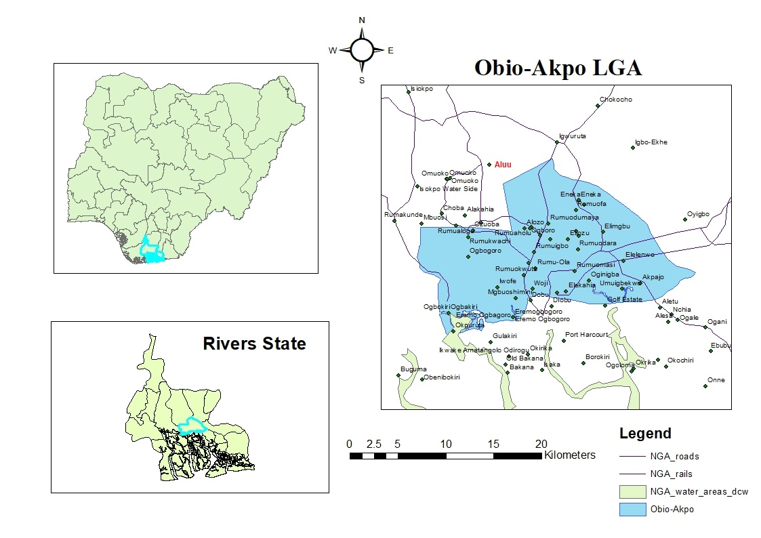
Figure 1: Map of Obio-Akpor Local Government Area

- material and methods

2.1 Sampling Design
A cross-sectional field survey approach was adopted for this study, with all environmental data collected during a single sampling campaign. This design was considered appropriate given the exploratory nature of the investigation, which sought to establish baseline contamination levels, characterize spatial distribution patterns, and evaluate associated health risks across defined zones at the Aluu landfill site.
2.1.1 Sampling Locations and Protocol
Eight sampling locations were established to capture a systematic contamination gradient extending from the active landfill interior to uncontaminated background areas. At each location, duplicate samples (designated A and B) were collected, yielding 16 soil samples in total. The eight locations were grouped into four functional zones as follows:
- Location A (A1, A2): Within the active landfill boundary
- Location B (B1, B2): Near-field zone (0–200 m from landfill boundary)
- Location C (C1, C2): Far-field zone (200–500 m from landfill boundary)
- Location F (F1, F2): Control/background zone (>30 m from landfill, on the opposite side of the access road, in an area with no visible evidence of waste-related activity)
This spatial framework was designed to capture both the contamination gradient emanating from the landfill core and representative background geochemical conditions. It is acknowledged that 16 samples represent a limited dataset for robust geostatistical interpolation; spatial analysis in this study therefore relied on deterministic inverse distance weighting (IDW) rather than kriging, and results should be interpreted as indicative of general contamination patterns rather than definitive spatial models.
2.2 Equipment and Materials
2.2.1 Field Equipment
Soil samples were collected using the following equipment: a hand auger and plastic spades for excavation; labelled high-density polyethylene (HDPE) bags for sample storage and transport; a Magellan Explorist 210 GPS receiver for precise coordinate recording at each sampling point; and a field notebook for on-site observations and QA/QC records.
2.2.2 Laboratory Equipment
Heavy metal analysis was performed using a PerkinElmer Analyst 200 Atomic Absorption Spectrophotometer (AAS) equipped with appropriate element-specific hollow cathode lamps. Instrument calibration followed a multi-point procedure using certified reference standards traceable to international standards.
2.2.3 Data Processing Software
Spatial distribution mapping and contour analysis were performed using Golden Software Surfer 20.0. Descriptive and inferential statistical analyses were conducted in Microsoft Excel 2019 and SPSS Version 13.0 respectively.
2.3 Sample Collection and Quality Assurance/Quality Control
Soil samples were collected from each of the eight locations at two depths — 1.0 m and 1.5 m below ground surface — to capture potential subsurface variation in metal distribution. Sampling at depth also minimized the influence of surface disturbance and recent waste deposition events on geochemical readings. Duplicate samples at each location (A and B) provided an internal measure of analytical reproducibility.
Field blanks were noted, and all sampling equipment was thoroughly cleaned between locations to prevent cross-contamination. Samples were placed in pre-labelled HDPE bags, sealed immediately after collection, and stored in a cool box for transportation to the laboratory. Non-detect (ND) values recorded for certain metals at specific locations were treated as zero for contamination factor calculations, which represents a conservative approach consistent with standard practice in environmental geochemical studies (Hkanson, 1980; Müller, 1969).
2.3.1 Sample Preparation
Upon receipt in the laboratory, samples were air-dried at room temperature to constant weight, disaggregated gently using a pestle and mortar, and sieved through a 2 mm stainless steel mesh to remove coarse debris and isolate the fine fraction for analysis, consistent with standard protocols for heavy metal analysis in soils (ISO 11466:1995).
2.3.2 Acid Digestion Procedure
Heavy metals were extracted by aqua regia digestion, a widely adopted method for total metal recovery from soil matrices. A 0.5 g sub-sample of prepared soil was accurately weighed into a 100 mL borosilicate glass beaker. A freshly prepared mixture of concentrated HNO₃ (9 mL) and concentrated HCl (3 mL) in a 3:1 volumetric ratio was carefully added to each beaker and allowed to react at room temperature for 30 minutes, permitting the initial reaction to subside before the application of heat.
Each beaker was covered with a watch glass and heated on a regulated hot plate at 85 ± 5°C for two hours, until the digest volume had reduced to approximately 5 mL. This extended heating ensured complete dissolution of organic matter and breakdown of metal complexes. After cooling to room temperature, each digest was quantitatively transferred to a 50 mL volumetric flask and made up to volume with deionised water. The resulting solution was filtered through Whatman No. 42 filter paper to remove undissolved residue, and the clarified filtrate was transferred to acid-washed polyethylene bottles. All samples were analysed within 48 hours of preparation to minimise the risk of metal precipitation or wall-adsorption losses. The digestion procedure is consistent with internationally recognised guidelines for environmental sample preparation (WHO, 2011; USEPA Method 3050B). The five target analytes were arsenic (As), nickel (Ni), chromium (Cr), cadmium (Cd), and lead (Pb).

2.4 Hydrogeological and Geological Assessment
A desktop-based hydrogeological assessment was conducted to contextualize the geochemical findings within the broader framework of groundwater vulnerability and contaminant migration potential. This involved a systematic review of published geological maps, hydrogeological reports, and peer-reviewed literature pertaining to the Benin Formation aquifer system of the Niger Delta region. It should be noted that no site-specific geophysical surveys were conducted as part of this study; hydrogeological interpretations are therefore based on regional characterizations and should be regarded accordingly.
2.5 Data Analysis
Descriptive statistics (mean, range, standard deviation) were computed for all metal concentrations by sampling zone using Microsoft Excel and SPSS v13.0. Pearson correlation analysis was employed to explore inter-metal associations and infer potential common contamination sources. Spatial distribution maps were generated using inverse distance weighting (IDW) interpolation in Surfer 20.0, given the limited sample size (n = 16), which does not meet the minimum threshold typically recommended for kriging-based geostatistical analysis.
2.6 Contamination Assessment Indices
Three complementary pollution indices were calculated to quantify the degree of heavy metal enrichment relative to local background levels established from the control zone (F1 and F2):
1. Contamination Factor (CF)
The contamination factor was calculated as:
$$CF=\frac{C_{sample}}{C_{background}}$$Where C_sample is the measured mean metal concentration at a given zone and C_background is the mean background concentration derived from the control sites (F1 and F2). CF values are interpreted as follows: CF < 1 = low contamination; 1 ≤ CF < 3 = moderate; 3 ≤ CF < 6 = considerable; CF ≥ 6 = very high (Hkanson, 1980).
2. Geo-accumulation Index (I_geo**)**
The geo-accumulation index was computed following Müller (1969):
$$I_{geo}={log⁡}_{2}\left(\frac{C_{n}}{1.5×B_{n}}\right)$$Where C_n is the measured metal concentration, B_n is the geochemical background concentration, and 1.5 is a correction factor that accounts for natural lithogenic variability in background values. I_geo classes range from Class 0 (I_geo ≤ 0, unpolluted) to Class 6 (I_geo > 5, extremely polluted).
3. Pollution Load Index (PLI)
The pollution load index, which provides an integrated measure of overall contamination across all metals assessed, was calculated as:
$$PLI=\sqrt[n]{CF_{1}×CF_{2}×CF_{3}×⋯×CF_{n}}$$
Where n is the number of metals assessed (n = 5 in this study). PLI > 1 indicates deterioration from baseline conditions; PLI ≤ 1 indicates no pollution above background.

2.7 Human Health Risk Assessment
Non-carcinogenic health risks were evaluated using the Hazard Index (HI) approach recommended by the United States Environmental Protection Agency (USEPA, 1989) and widely applied in Nigerian environmental studies. The Average Daily Dose (ADD) via soil ingestion was calculated as:
$$ADD=\frac{C×IR×EF×ED×CF}{BW×AT}$$
Where:
- C = measured metal concentration in soil (mg/kg)
- IR = ingestion rate (mg soil/day)
- EF = exposure frequency (days/year)
- ED = exposure duration (years)
- CF = unit conversion factor
- BW = body weight (kg)
- AT = averaging time (days)
The Hazard Quotient (HQ) for each individual metal was derived as:
$$HQ=\frac{ADD}{RfD}$$Where RfD is the oral reference dose for the respective metal (mg/kg/day), obtained from USEPA IRIS database values. The cumulative Hazard Index (HI) representing total non-carcinogenic risk from simultaneous exposure to all five metals was then calculated as:
$$HI=∑HQ$$
Results were interpreted against the following threshold criteria:
- HI ≤ 1: No significant non-carcinogenic health risk anticipated
- HI > 1: Potential for adverse non-carcinogenic health effects
HI > 10: High concern level warranting immediate investigation and intervention
3. results and discussion

3.1 Heavy Metal Concentrations and Spatial Distribution

The analytical results from atomic absorption spectrophotometry revealed varying but generally low absolute concentrations of the five target metals across all sampling zones at the Aluu landfill, with all values remaining below applicable WHO and NESREA regulatory thresholds (Table 3). However, it is well established in environmental geochemistry that regulatory compliance and geochemical significance are not equivalent measures concentrations may remain sub-regulatory while still exhibiting meaningful anthropogenic enrichment relative to local background levels (Müller, 1969; Håkanson, 1980). It is precisely this relative enrichment, rather than absolute concentration alone, that the pollution indices employed in this study are designed to quantify. This interpretive framework has been applied consistently in landfill soil assessments across the Niger Delta, where sub-threshold concentrations have nonetheless yielded significant pollution index values (Ideriah et al., 2005; Longe & Balogun, 2010).
The mean arsenic concentration within the landfill zone (A-zone mean = 0.055 ppm) was markedly elevated relative to control values (0.004 ppm), producing an enrichment ratio of approximately 13.75. Although this absolute value is low by international standards, arsenic enrichment of this nature at West African coastal landfill sites has commonly been associated with the decomposition of electronic waste components and pesticide-treated organic materials within the waste mass (Yabe et al., 2010). Iwegbue et al. (2020) documented comparable arsenic enrichment patterns in Niger Delta soils affected by mixed waste inputs, reporting mean values in the range of 0.02–0.07 ppm, which is broadly consistent with the concentrations recorded in the A-zone of this study.
The most spatially significant finding was the pronounced lead anomaly at the far-field C2 location (mean = 1.040 ppm). While this value remains far below the WHO soil guideline of 50 ppm, it is approximately 25 times the local background concentration (0.042 ppm) and exceeds the within-landfill mean by nearly nine-fold. Far-field lead anomalies at unlined Nigerian dumpsites have previously been attributed to a combination of surface runoff transport, informal secondary waste dumping, and vehicular emissions along adjacent roadways (Ideriah et al., 2005; Ogundele et al., 2017). The spatial isolation of the C2 anomaly, which occurs without a progressive concentration gradient extending from the landfill core, is more consistent with a localised secondary input at or near that location than with leachate-driven advective transport from the main waste body. This interpretation remains tentative, however, and requires confirmation through targeted source investigation in future work.
Nickel displayed a spatially counter-intuitive pattern, with peak concentrations recorded in the near-field and far-field zones (B1 mean = 0.233 ppm; C1 mean = 0.188 ppm) rather than within the landfill interior (A-zone mean = 0.045 ppm). This distribution likely reflects the preferential mobilization of nickel under mildly acidic conditions, given that nickel solubility and mobility increase substantially in soils with pH values below 6.5 (Kabata-Pendias, 2011). Leachate percolation through near-field soils tends to reduce local soil pH, creating conditions that favour nickel release and lateral migration. A qualitatively similar near-field nickel enrichment pattern has been reported at comparable southeastern Nigerian landfill sites, where near-field soils exhibited nickel concentrations several times higher than those at the disposal core, attributed to pH-driven mobilization through sandy substrates (Iwegbue et al., 2020).
The subsections that follow detail metal concentration patterns at each sampling zone within this broader interpretive framework.

3.1.1 Location-Specific Contamination Patterns

1. Within Landfill Boundary (Locations A1, A2)
Location A1 displayed the most diverse contamination profile within the active landfill boundary, with elevated concentrations recorded across multiple metals: arsenic (0.103 ppm), cadmium (0.174 ppm), lead (0.175 ppm), nickel (0.054 ppm), and chromium (0.038 ppm). The co-elevation of arsenic and cadmium at this location is consistent with contributions from mixed electronic and battery waste, which are common components of Nigerian municipal solid waste streams. Location A2 exhibited a contrasting pattern, with the highest chromium concentration recorded across all sites (0.085 ppm) but comparatively lower levels of other metals, suggesting a more localised chromium source such as construction material waste or treated leather scrap. Table 1 presents the complete analytical dataset and Table 2 provides a statistical summary by sampling zone.
Table 1: Heavy Metal Concentrations in Soil Samples (ppm)
Sample  ID | Long | Latitude | As (ppm) | Ni (ppm) | Cr (ppm) | Cd (ppm) | Pb (ppm)
A1A | 6.918528 | 4.920444 | 0.112 | 0.05 | 0.029 | 0.156 | 0.163
A1B | 6.918528 | 4.920444 | 0.093 | 0.057 | 0.046 | 0.192 | 0.187
A2A | 6.918556 | 4.920472 | 0.008 | 0.03 | 0.084 | 0.057 | 0.049
A2B | 6.918556 | 4.920472 | 0.005 | 0.041 | 0.087 | 0.069 | 0.056
B1A | 6.9186 | 4.9205 | 0.000 | 0.213 | 0.011 | 0.071 | 0.028
B1B | 6.9186 | 4.9205 | 0.001 | 0.254 | 0.008 | 0.063 | 0.019
B2A | 6.918628 | 4.920528 | 0.004 | (0.000) | 0.006 | 0.062 | 0.037
B2B | 6.918628 | 4.920528 | 0.006 | 0.001 | 0.009 | 0.077 | 0.031
C1A | 6.918656 | 4.920556 | 0.054 | 0.181 | 0.003 | 0.052 | 0.086
C1B | 6.918656 | 4.920556 | 0.04 | 0.196 | 0.001 | 0.045 | 0.07
C2A | 6.918684 | 4.920584 | 0.000 | 0.071 | 0.033 | 0.088 | 1.056
C2B | 6.918684 | 4.920584 | 0.000 | 0.079 | 0.042 | 0.106 | 1.023
F1A | 6.9184 | 4.9203 | 0.000 | 0.022 | 0.017 | 0.062 | 0.049
F1B | 6.9184 | 4.9203 | 0.000 | 0.028 | 0.019 | 0.05 | 0.04
F2A | 6.918372 | 4.920272 | 0.006 | 0.017 | 0.002 | 0.016 | 0.043
F2B | 6.918372 | 4.920272 | 0.01 | 0.014 | 0.008 | 0.028 | 0.035

Table 2: Statistical Summary by Sampling Zone

Zone | Parameter | As | Ni | Cr | Cd | Pb
Within Landfill (A) | Mean | 0.055 | 0.045 | 0.061 | 0.118 | 0.114
 | Range | 0.005-0.112 | 0.030-0.057 | 0.029-0.087 | 0.057-0.192 | 0.049-0.187
 | Std. Dev | 0.056 | 0.012 | 0.029 | 0.066 | 0.071
Near-field (B) | Mean | 0.003 | 0.117 | 0.009 | 0.068 | 0.029
 | Range | ND-0.006 | ND-0.254 | 0.006-0.011 | 0.062-0.077 | 0.019-0.037
 | Std. Dev | 0.003 | 0.136 | 0.002 | 0.007 | 0.007
Far-field (C) | Mean | 0.024 | 0.132 | 0.020 | 0.073 | 0.559
 | Range | ND-0.054 | 0.071-0.196 | 0.001-0.042 | 0.045-0.106 | 0.070-1.056
 | Std. Dev | 0.028 | 0.066 | 0.021 | 0.029 | 0.555
Control (F) | Mean | 0.004 | 0.020 | 0.012 | 0.039 | 0.042
 | Range | ND-0.010 | 0.014-0.028 | 0.002-0.019 | 0.016-0.062 | 0.035-0.049
 | Std. Dev | 0.005 | 0.006 | 0.008 | 0.021 | 0.006

2. Near-field Zone (Locations B1, B2)
Location B1 recorded the highest nickel concentration across the entire study area (0.233 ppm), representing approximately 12 times the control mean (0.020 ppm). This near-field nickel peak, rather than a landfill-core peak, reinforces the pH-driven mobilization mechanism discussed above. Location B2 showed generally subdued concentrations across all metals, with only cadmium and lead exhibiting minor elevations above control levels, suggesting that leachate migration in the near-field zone is spatially heterogeneous rather than uniform.
3. Far-field Zone (Locations C1, C2)
Location C1 exhibited substantial nickel concentrations (mean = 0.188 ppm), extending the near-field nickel signal further outward and consistent with continued lateral migration along the drainage corridor from B1. Location C2 stood out as an anomalous station, with lead concentrations (mean = 1.040 ppm) exceeding those at the landfill boundary by approximately six-fold. As discussed above, the spatial pattern at C2 does not conform to a simple leachate diffusion model and most likely reflects a secondary contamination input at that location.
4. Control Sites (Locations F1, F2)
Control locations recorded the lowest metal concentrations across all analytes, serving as reliable indicators of local geochemical background for the Benin Formation soils in this area. The low variability between F1 and F2 (standard deviations ≤ 0.021 ppm for all metals) confirms that the control sites were not subject to detectable waste-related influence and provides confidence in their suitability as background reference values.
3.1.2 Spatial Distribution Patterns
The spatial distribution maps generated by IDW interpolation in Surfer 20.0 reveal distinct contamination patterns for each metal, reflecting the different source types and transport mechanisms operating at this site.
Arsenic (Figure 2a): A primary hotspot centred on location A1 is visible, with contour gradients extending in a north-easterly direction consistent with the regional groundwater flow direction. The rapid concentration drop between A1 and B1 suggests limited advective transport of arsenic under current conditions.
Nickel (Figure 2b): Unlike arsenic, nickel shows its highest concentrations in the near-field and far-field zones (B1, C1), with a distinct contamination plume extending southward from the landfill boundary. This spatial pattern strongly supports pH-mediated mobilisation and lateral migration as the dominant transport mechanism for this metal.
Chromium (Figure 2c): Chromium distribution is concentrated in the A2 area, with moderate levels declining sharply toward the near-field zone. This confined distribution suggests a relatively immobile source with limited transport beyond the active disposal area.
Cadmium (Figure 2d): A relatively uniform distribution is observed across the inner zones, with the highest levels at A1. The absence of a strong spatial gradient suggests cadmium mobility may be partially limited by adsorption onto organic matter within the active landfill mass.
Lead (Figure 2e): Lead exhibits the most pronounced spatial heterogeneity of all five metals, dominated by the extreme hotspot at C2. The absence of a progressive gradient from the landfill core to C2 is the most spatially diagnostic feature of the entire dataset and strongly implicates a secondary input at that location

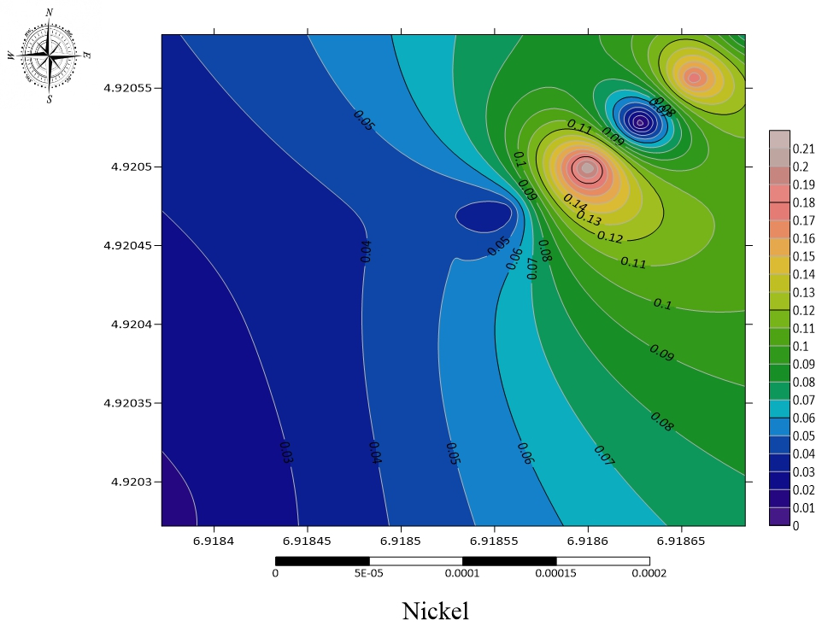
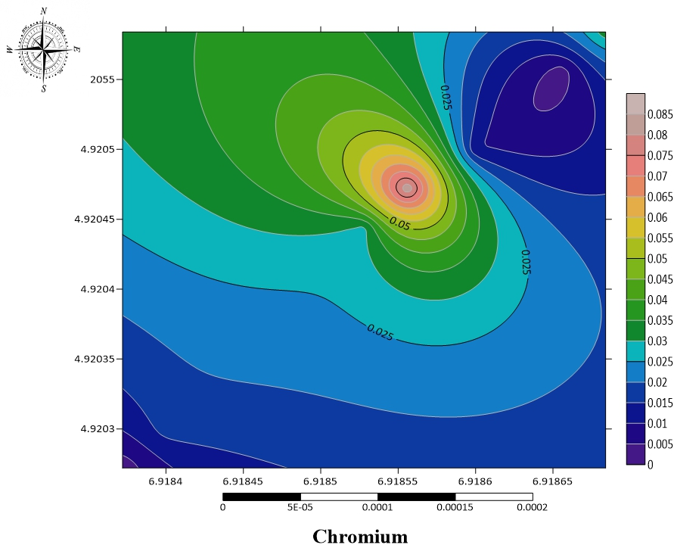
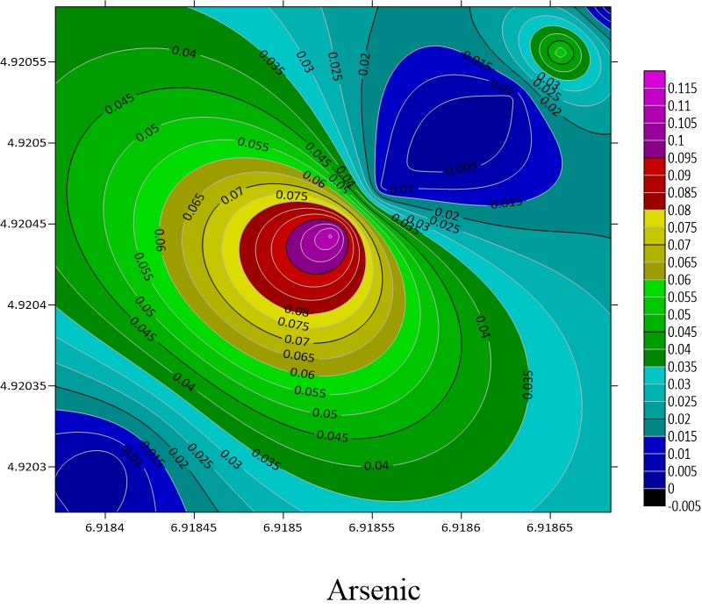

Fig 2c: Spatial Distribution of Chromium
Fig 2b: Spatial Distribution of Nickel
Fig 2a: Spatial Distribution of Arsenic
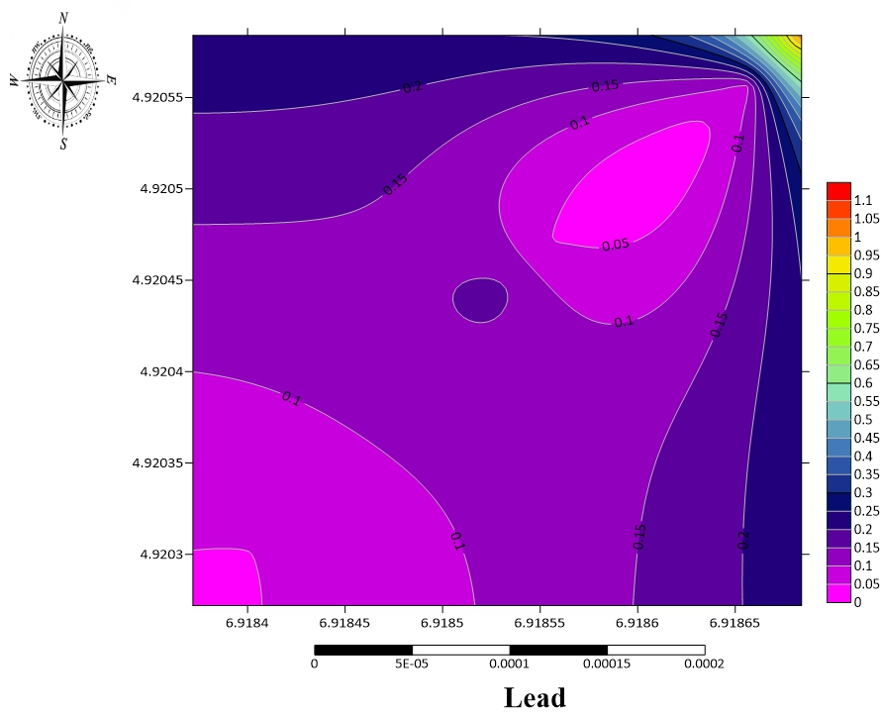

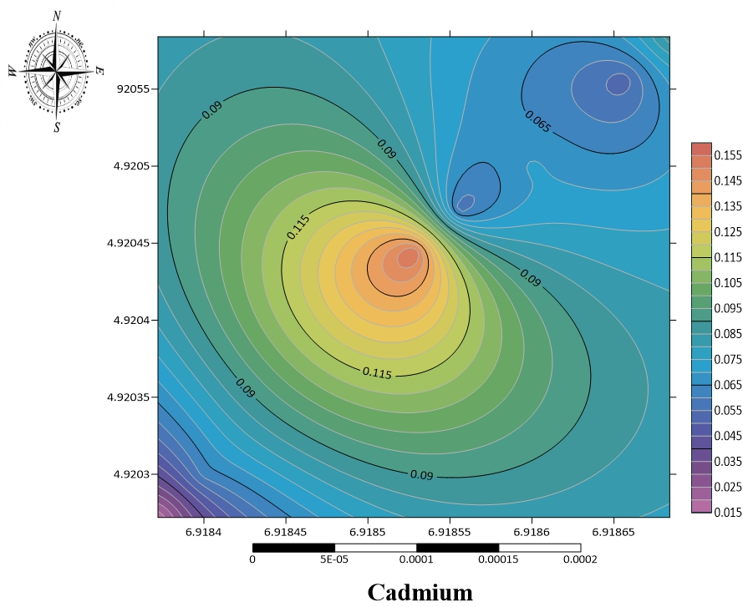

Fig 2e: Spatial Distribution of Lead
Fig 2d: Spatial Distribution of Cadmium

3.1.3 Comparison with Regulatory Standards

All measured metal concentrations remained below both WHO soil quality guidelines and NESREA permissible limits (Table 3), confirming that the site is currently in regulatory compliance. However, as demonstrated by the pollution index results in Section 3.2, regulatory compliance does not preclude meaningful geochemical enrichment above local background levels.

Table 3: Regulatory Comparison
Metal | Maximum Observed  (ppm) | WHO Limit  (ppm) | NESREA  Limit (ppm) | Compliance Status
Arsenic | 0.112 | 10 | 5 | ✓ Compliant
Nickel | 0.254 | 50 | 50 | ✓ Compliant
Chromium | 0.087 | 50 | 50 | ✓ Compliant
Cadmium | 0.192 | 3 | 3 | ✓ Compliant
Lead | 1.040 | 50 | 50 | ✓ Compliant
3.2 Contamination Assessment Using Pollution Indices

3.2.1 Background Reference Values

The mean concentrations recorded at the two control locations (F1 and F2) were used as local geochemical background values for all index calculations (Table 4). The low standard deviations observed across all metals at the control sites confirm the suitability and reliability of this background dataset.

Table 4: Background Reference Concentrations (ppm)
Metal | F1 Mean | F2 Mean | Combined Background | Standard Deviation
Arsenic | 0.000 | 0.008 | 0.004 | 0.005
Nickel | 0.025 | 0.016 | 0.020 | 0.006
Chromium | 0.018 | 0.005 | 0.012 | 0.008
Cadmium | 0.056 | 0.022 | 0.039 | 0.021
Lead | 0.044 | 0.039 | 0.042 | 0.006

3.2.2 Contamination Factor (CF) Analysis

Contamination factors were calculated as:
$$CF=\frac{C_{mean}}{C_{background}}$$
The CF values obtained (As = 5.25; Ni = 3.90; Pb = 4.43; Cr = 2.08; Cd = 1.92; Table 5) indicate a consistent pattern of anthropogenic metal enrichment attributable to the mixed municipal waste composition at this site. The very high CF for arsenic (5.25) is the most significant finding and is consistent with the dominance of arsenic-bearing waste fractions, particularly electronic components and pesticide-treated organic material, in West African urban waste streams (Yabe et al., 2010; Iwegbue et al., 2020). The considerable CF values for nickel (3.90) and lead (4.43) reflect the contribution of spent batteries, electrical cables, and automotive scrap, which are routinely identified as primary metal sources in Nigerian municipal solid waste characterisation studies (Kabata-Pendias, 2011). The moderate CF values for chromium (2.08) and cadmium (1.92) are consistent with a predominantly residential and commercial waste stream with limited industrial input.

Table 5: Contamination Factor Results and Classifications
Element | Mean Conc. (ppm) | Background (ppm) | CF Value | Classification | Environmental Significance
Arsenic | 0.021 | 0.004 | 5.25 | Approaching Very High (CF > 6) | Significant enrichment
Nickel | 0.078 | 0.020 | 3.90 | Considerable (3 < CF < 6) | Moderate enrichment
Chromium | 0.025 | 0.012 | 2.08 | Moderate (1 < CF < 3) | Low–moderate enrichment
Cadmium | 0.075 | 0.039 | 1.92 | Moderate (1 < CF < 3) | Low-moderate enrichment
Lead | 0.186 | 0.042 | 4.43 | Considerable (3 < CF < 6) | Moderate enrichment
Key findings (Table 5): Arsenic: CF = 5.25 (Very High); Nickel: CF = 3.90 (Considerable); Lead: CF = 4.43 (Considerable); Chromium: CF = 2.08 (Moderate); Cadmium: CF = 1.92 (Moderate)

3.2.3 Geo-accumulation Index

The geo-accumulation index was calculated following Müller (1969):
$$I_{geo}={log⁡}_{2}\left(\frac{C_{n}}{1.5×B_{n}}\right)$$
The I_geo results (Table 6) classify arsenic, nickel, and lead as Class 2 (Moderately Polluted), while chromium and cadmium fall within Class 1 (Unpolluted to Moderately Polluted). Müller (1969) defined Class 2 as representing unambiguous anthropogenic contamination superimposed on the natural geochemical background precisely the condition documented at the Aluu site, where natural background concentrations are inherently low owing to the quartz-dominated sandy lithology of the Benin Formation. The application of the 1.5 background correction factor in the I_geo formula accounts for natural lithogenic variability; in this geological setting, the extremely low background concentrations mean that even small absolute increases translate into positive I_geo values, reinforcing the reliability of these index signals as indicators of genuine anthropogenic input rather than geochemical noise. The Pb I_geo of 1.56 recorded at this site is comparable to values of 1.5–2.3 reported by Ideriah et al. (2005) at municipal waste sites in Port Harcourt, suggesting that the contamination profile at Aluu is representative of the broader Niger Delta municipal landfill landscape.

Table 6: Geo-accumulation Index Results
Element | Igeo Value | Igeo Class | Pollution Category | Management Implication
Arsenic | 1.81 | 2 | Moderately Polluted | Monitoring required
Nickel | 1.38 | 2 | Moderately Polluted | Monitoring required
Chromium | 0.48 | 1 | Unpolluted to Moderately Polluted | Baseline monitoring
Cadmium | 0.36 | 1 | Unpolluted to Moderately Polluted | Baseline monitoring
Lead | 1.56 | 2 | Moderately Polluted | Monitoring required

Key Findings: Arsenic: 1.81 (Moderately Polluted); Nickel: 1.38 (Moderately Polluted); Lead: 1.56 (Moderately Polluted); Chromium: 0.48 (Unpolluted to Moderately Polluted); Cadmium: 0.36 (Unpolluted to Moderately Polluted)

3.2.4 Pollution Load Index (PLI)

The PLI integrates the contamination factors of all five metals into a single composite index:
$$PLI=\sqrt{CF_{As}×CF_{Ni}×CF_{Cr}×CF_{Cd}×CF_{Pb}}$$
$$PLI=\sqrt{5.25×3.90×2.08×1.92×4.43}=3.17$$
A PLI of 3.17 places the study area in the "Considerably Polluted" category (Table 7 & 8), representing a meaningful cumulative pollution burden across all five metals combined. This result is particularly important from a management perspective: it demonstrates that evaluating individual metals against regulatory thresholds can understate the overall environmental burden when multiple metals are simultaneously enriched. This principle that composite index-based assessments provide information not available from single-compound compliance checks is well established in environmental geochemistry (Håkanson, 1980; Tomlinson et al., 1980). Comparative PLI values from the regional literature indicate that PLI = 3.17 falls within the range reported for moderately urbanized, mixed-waste municipal landfills in the Niger Delta, which is consistent with the operational and compositional characteristics of the Aluu facility (Longe & Balogun, 2010; Iwegbue et al., 2020).

Table 7: Pollution Load Index Assessment
Parameter | Element | Value | Classification
Individual Contamination Factors | Arsenic (As) | 5.25 | Considerable
Individual Contamination Factors | Nickel (Ni) | 3.90 | Considerable
Individual Contamination Factors | Chromium (Cr) | 2.08 | Moderate
Individual Contamination Factors | Cadmium (Cd) | 1.92 | Moderate
Individual Contamination Factors | Lead (Pb) | 4.43 | Considerable
PLI Calculation | Formula: (5.25 × 3.90 × 2.08 × 1.92 × 4.43) ^ (1/5)
PLI Calculation | Overall PLI | 3.17 | Considerable Pollution

PLI = 3.17 (Table 7), indicating considerable contamination for the five analyzed metals.

Table 8: PLI Classification and Management
PLI Range | Pollution Level | Environmental Status | Management Required
PLI < 1.0 | Unpolluted | Background conditions | Baseline monitoring
1.0 ≤ PLI < 2.0 | Slightly polluted | Minor anthropogenic impact | Regular monitoring
2.0 ≤ PLI < 3.0 | Moderately polluted | Noticeable contamination | Enhanced monitoring
3.0 ≤ PLI < 5.0 | Considerably polluted | Significant contamination | Active management needed
PLI ≥ 5.0 | Heavily polluted | Severe contamination | Immediate intervention

3.2.5 Enrichment Assessment

In the absence of conservative normalizing elements (Al, Fe) in the analytical dataset, enrichment ratios (ER) were calculated by direct comparison of mean metal concentrations at each zone against the combined control-site background values (Table 9). This approach is methodologically equivalent to a normalized enrichment factor where the denominator represents local lithogenic background and has been employed in comparable studies where full geochemical suites were not available (Kabata-Pendias, 2011). Arsenic registered significant enrichment (ER = 5.25), indicating a strong anthropogenic signal, while nickel, chromium, and lead showed moderate enrichment (ER = 2–5). Cadmium recorded minimal enrichment (ER = 1.92), consistent with its moderate CF value.

Table 9: Enrichment Ratio (ER) Analysis
Element | Mean Conc. (ppm) | Background (ppm) | Enrichment Ratio | Enrichment Category
Arsenic | 0.021 | 0.004 | 5.25 | Significant (5 ≤ ER < 20)
Nickel | 0.078 | 0.020 | 3.90 | Moderate (2 ≤ ER < 5)
Chromium | 0.025 | 0.012 | 2.08 | Moderate (2 ≤ ER < 5)
Cadmium | 0.075 | 0.039 | 1.92 | Minimal (ER < 2)
Lead | 0.186 | 0.042 | 4.43 | Moderate (2 ≤ ER < 5)

Where:

Enrichment Classification:
ER < 2: Minimal enrichment (natural processes)
2 ≤ ER < 5: Moderate enrichment (anthropogenic influence)
≤ ER < 20: Significant enrichment (strong anthropogenic sources

3.3 Source Identification and Contamination Pathways
3.3.1 Inter-metal Correlation Analysis
Pearson correlation analysis was conducted to explore associations between metals and infer potential common source signatures (Table 10). The results revealed a strong positive association between arsenic and cadmium (r = 0.723, p < 0.01) and a moderate association between arsenic and chromium (r = 0.567, p < 0.05), while nickel and lead displayed comparatively weak correlations with the As–Cd–Cr cluster. This correlation structure is consistent with a mixed-source waste environment. Strong As–Cd associations in landfill soils have been widely linked to electronic and electrical waste fractions, particularly soldered circuit boards and nickel-cadmium battery cells (Yabe et al., 2010; Kabata-Pendias, 2011). The moderate As–Cr co-association at this site likely reflects inputs from treated wood products, pigment-containing construction debris, and leather tanning residues, all of which are documented components of Nigerian urban municipal waste (Olade, 1987; Mmereki et al., 2016). The relatively independent behaviour of nickel and lead from the arsenic cluster points to a distinct secondary source, most plausibly automotive scrap and spent batteries, which are common in Nigerian urban waste streams.

Table 10: Inter-metal Correlation Matrix (Pearson r-values)
 | As | Ni | Cr | Cd | Pb
As | 1.000 | -0.245 | 0.567* | 0.723** | 0.234
Ni | -0.245 | 1.000 | -0.123 | -0.089 | 0.345
Cr | 0.567* | -0.123 | 1.000 | 0.456* | -0.067
Cd | 0.723** | -0.089 | 0.456* | 1.000 | 0.289
Pb | 0.234 | 0.345 | -0.067 | 0.289 | 1.000

*Significant at p < 0.05; **Significant at p < 0.01

3.3.2 Principal Component Analysis (PCA)
PCA identified two dominant components accounting for 70.4% of total variance (Table 11). PC1 (46.8% of variance) loaded strongly on As, Cd, and Cr and is interpreted as an electronic/industrial waste source signature, consistent with the strong As–Cd correlation discussed above. PC2 (23.6% of variance) loaded on Ni and Pb and is interpreted as an automotive and metallic scrap source. This two-source model aligns well with the documented composition of Nigerian municipal solid waste, which typically comprises a substantial proportion of metallic and electronic fractions in addition to organic material (Mmereki et al., 2016). The spatial evidence corroborates the PCA separation: As and Cd (PC1 metals) are concentrated near the landfill core (A1), while Ni and Pb (PC2 metals) show stronger far-field signatures, consistent with their greater mobility under the prevailing soil chemistry conditions.

Table 11: Principal Component Analysis Results
Component | Eigenvalue | % Variance | Cumulative % | Primary Loadings
PC1 | 2.34 | 46.8% | 46.8% | As (0.85), Cd (0.82), Cr (0.67)
PC2 | 1.18 | 23.6% | 70.4% | Ni (0.78), Pb (0.69)
PC3 | 0.89 | 17.8% | 88.2% | Pb (−0.45), Cr (0.41)

3.3.3 Contamination Pathways
Three primary transport mechanisms are invoked to explain the observed spatial distribution of metals at this site:
- Direct disposal and in-situ accumulation: PC1 metals (As–Cd–Cr) are concentrated at the source location (A1), consistent with direct accumulation within the active waste mass with limited lateral transport under current conditions.
- Leachate-mediated lateral migration: PC2 metals (Ni–Pb) show elevated concentrations extending along the B1→C1 corridor, interpreted as lateral migration facilitated by leachate percolation through the permeable Benin Formation sands along the local drainage gradient.
- Surface runoff transport: The spatially isolated C2 lead anomaly, which cannot be explained by either of the above mechanisms, is most plausibly attributed to surface water transport of fine metal-bearing particles or a localized secondary input such as informal roadside waste disposal. Further investigation is required to confirm this interpretation.

  - Hydrogeological and Geological Controls on Metal Distribution

The Aluu landfill occupies a portion of the Benin Formation of the Niger Delta Basin, which is characterized by a dominantly sandy lithology (approximately 90% sand and sandstone with minor clay intercalations), high primary porosity, and elevated hydraulic conductivity (Akujieze et al., 2003; Nwankwoala and Amangabara, 2015). These properties are generally considered to favour advective contaminant transport and confer a low protective capacity on the underlying shallow aquifer system. It is important to emphasize, however, that the hydrogeological parameters cited in Table 12 were derived from published regional studies of the Benin Formation rather than from site-specific measurements at the Aluu facility. No pumping tests, piezometer installations, or groundwater sampling were conducted within the scope of this study. Accordingly, references to contaminant migration rates and subsurface transport pathways at this site are qualitative inferences drawn from regional analogues and should not be read as confirmed observations of active subsurface migration.
The spatially anomalous lead concentration at C2 (mean = 1.040 ppm), which substantially exceeds concentrations measured at the landfill core, is inconsistent with a simple radial leachate diffusion model. While the high permeability of the Benin Formation could theoretically support advective metal transport at this scale, the absence of a progressive concentration gradient between the landfill boundary and C2 argues against leachate as the primary carrier in this instance. A localised secondary source near C2 remains the most parsimonious explanation and should be the subject of targeted investigation in any follow-up study.
Notwithstanding these interpretive limitations, the regional hydrogeological context clearly establishes that the Benin Formation soils at this site have very limited natural buffering and attenuation capacity for heavy metals. This makes the area inherently susceptible to progressive contamination accumulation over time, even under the sub-threshold concentration conditions currently observed, and provides a strong scientific basis for the monitoring and management recommendations presented in Section 5.

Table 12: Geological Controls on Heavy Metal Mobility

Geological Parameter | Benin Formation Characteristics | Impact on Metal Distribution | Source
Lithology | ~90% sand/sandstone, ~10% clay | High permeability, limited attenuation | Akujieze et al. (2003)
Porosity | High primary porosity | Enhanced contaminant storage capacity | Nwankwoala & Amangabara (2015)
Hydraulic conductivity | 3.82×10⁻³ to 9.0×10⁻² cm/s | Rapid advective transport potential | Nwankwoala & Amangabara (2015)
Clay content | Minimal intercalations | Poor adsorptive attenuation capacity | Akujieze et al. (2003)
Vulnerability index | 0.54–0.63 (high vulnerability) | Low natural protective capacity | Longe & Balogun (2010)

  - Human Health Risk Assessment

All Hazard Quotient (HQ) values and the cumulative Hazard Index (HI) for all sampling zones remained well below 1.0 (all < 0.1; Table 15), indicating no significant non-carcinogenic health risk from soil contact under current exposure conditions. This finding is broadly consistent with comparable assessments at unlined Nigerian municipal dumpsites, where soil-contact HI values typically remain low despite measurable geochemical enrichment (Ideriah et al., 2005; Ogundele et al., 2017).
It is essential to note, however, that this assessment was restricted to the soil ingestion and dermal contact exposure pathways. Inhalation exposure of particular relevance given the open, unenclosed nature of the Aluu facility and its proximity to residential and institutional populations was not evaluated. Equally, indirect dietary exposure through consumption of locally grown crops or livestock raised in the vicinity of the landfill was beyond the scope of this study. Several studies at analogous West African landfill settings have demonstrated that groundwater ingestion and crop uptake pathways contribute substantially to total cumulative metal exposure and can elevate HI values well above those calculated from soil contact alone (Kabata-Pendias, 2011; Yabe et al., 2010). Future risk assessments at this site should therefore adopt a comprehensive multi-pathway exposure framework incorporating these additional routes.
The low computed HI values also warrant contextual interpretation alongside the area's high population density (~2,500 people/km²) and the immediate proximity of densely settled residential areas and the University of Port Harcourt campus to the landfill boundary. Even at sub-threshold individual metal levels, chronic low-dose multi-metal exposure in a large resident population with no engineered containment, leachate management, or environmental monitoring in place represents a legitimate precautionary concern, particularly for vulnerable groups such as children and pregnant women (Kabata-Pendias, 2011; Mmereki et al., 2016).

3.5.1 Regulatory Comparison
Table 13: Comparison with Regulatory Limits:
Metal | Max Observed | WHO Limit | Safety Ratio | Risk Level
Arsenic | 0.112 | 20 | 178.6× | Very Low
Chromium | 0.087 | 100 | 1149× | Very Low
Cadmium | 0.192 | 3 | 15.6× | Low
Lead | 1.040 | 100 | 96.2× | Very Low
Nickel | 0.254 | 50 | 196.9× | Very Low

Table 14: Health Risk Summary by Metal
Metal | Risk Level (WHO) | Risk Level (NESREA) | Primary Health Concerns
Arsenic | Low | Low | Skin lesions; potential carcinogenicity at chronic high doses
Nickel | Low | Low | Allergic dermatitis; respiratory sensitization
Chromium | Low | Low | Skin irritation; potential ulceration (Cr VI)
Cadmium | Low | Low | Renal tubular damage; bone demineralization
Lead | Low | Low | Neurological and developmental effects, particularly in children

3.5.2 Cumulative Risk Assessment

Combined non-carcinogenic risk was estimated using the multi-metal cumulative index:
$$Risk Index=∑\frac{C_{i}}{L_{i}}$$
Where C_i is the measured concentration of each metal and L_i is the corresponding regulatory limit.

Table 15: Cumulative Risk Index
Location | Combined Risk Index (WHO basis) | Combined Risk Index (NESREA basis) | Risk Category
Within Landfill (A) | 0.089 | 0.151 | Low
Near-field (B) | 0.024 | 0.039 | Low
Far-field (C) | 0.051 | 0.078 | Low
Overall Study Area | 0.055 | 0.089 | Low
Risk Index < 0.1 = Low; 0.1–0.5 = Moderate; > 0.5 = High
    - Risk Assessment Results
Regulatory comparison (Table 13 & 14) showed all metals remained well below safety limits: Arsenic: 178.6× below WHO limits (Very Low Risk); Lead: 96.2× below WHO limits (Very Low Risk); Cadmium: 15.6× below WHO limits (Low Risk). Cumulative risk indices (Table 13) remained below 0.1 for all zones, indicating low overall health risk.

  - Environmental Implications

Although current heavy metal concentrations at the Aluu landfill remain within regulatory compliance limits, the combination of moderate-to-considerable pollution indices (PLI = 3.17; arsenic CF = 5.25; I_geo Class 2 for three metals), the high permeability of the underlying Benin Formation, and the absence of any engineered containment or leachate management infrastructure presents a set of conditions that are conducive to progressive contamination accumulation over time. The pollution indices document that anthropogenic enrichment is already measurably established above natural background levels, and the regional hydrogeological context suggests that the physical barriers to contaminant migration into the shallow aquifer system are minimal. In the context of a densely populated residential area with approximately 2,500 people per km² and daily waste inputs of 150–200 tonnes, the current situation, while not yet at critical threshold levels, represents a trajectory that warrants proactive and sustained environmental management intervention before contamination levels escalate further.

4. Summary and Conclusion

This integrated geo-environmental assessment of the Aluu municipal landfill in Obio-Akpor, Rivers State, documented a pattern of moderate but meaningful heavy metal contamination in surrounding soils. Although the absolute concentrations of all five target metals — arsenic, nickel, chromium, cadmium, and lead — remained below established WHO and NESREA permissible limits, the pollution indices applied in this study reveal a more nuanced picture that regulatory compliance figures alone cannot convey.

The key findings of this study are summarized as follows:

- All measured heavy metal concentrations were below WHO and NESREA regulatory thresholds, confirming current regulatory compliance at the site.
- Contamination factor analysis identified arsenic as the metal of greatest concern, recording a CF of 5.25, classified as approaching very high contamination; indicative of significant anthropogenic enrichment above the local geochemical background of the Benin Formation soils.
- Geo-accumulation index values classified arsenic, nickel, and lead as Class 2 (Moderately Polluted), providing unambiguous evidence of human-induced metal loading superimposed on naturally low background concentrations.
- The overall Pollution Load Index of 3.17 placed the site in the "Considerably Polluted" category, underscoring the importance of composite multi-metal assessments over single-compound compliance evaluations.
- Spatial analysis revealed pronounced heterogeneity in metal distribution, most notably an anomalous far-field lead hotspot at location C2 that is inconsistent with simple leachate diffusion from the landfill core, suggesting a secondary contamination input requiring further investigation.
- The high porosity and permeability of the underlying Benin Formation, combined with the absence of any engineered containment infrastructure, creates conditions that are inherently susceptible to progressive leachate-driven contaminant migration into the shallow aquifer system over time.
- Non-carcinogenic human health risk indices (HI < 0.1 across all zones) indicated no significant health risk from soil contact under current conditions. However, this assessment was limited to soil ingestion and dermal contact pathways; inhalation, groundwater ingestion, and dietary exposure routes were not evaluated and may contribute substantially to total cumulative risk.

Taken together, these findings indicate that while the Aluu landfill has not yet reached the contamination thresholds that would trigger immediate intervention under existing regulatory frameworks, the evidence of progressive anthropogenic enrichment, the vulnerability of the local hydrogeological setting, and the high residential population density in the immediate vicinity collectively make a compelling case for proactive environmental management. The gap between current regulatory compliance and the geochemical reality documented by the pollution indices should not be interpreted as an absence of risk, but rather as an early warning that demands timely and sustained response.

5.1 Environmental Monitoring Programme
A structured, long-term environmental monitoring programme should be established at and around the Aluu landfill as a matter of priority. Such a programme should extend beyond the five metals assessed in this study to include a broader suite of heavy metals (mercury, zinc, copper, and manganese at minimum), as well as leachate quality parameters, soil pH, and shallow groundwater chemistry from strategically placed monitoring boreholes. Monitoring should be conducted on a quarterly basis to capture seasonal variability in contaminant behaviour, given the pronounced wet–dry seasonality of the Niger Delta climate and its demonstrated influence on leachate production and subsurface transport dynamics. Baseline data collected over a minimum two-year period would provide the statistical foundation necessary for detecting meaningful temporal trends in contamination levels.
5.2 Waste Management Practices
The absence of waste segregation at source is a primary driver of heavy metal accumulation at this facility. Implementing a source-separation scheme that isolates hazardous fractions particularly electronic waste, spent batteries, automotive components, and construction materials from the general municipal waste stream would substantially reduce the metal loading entering the landfill environment. Community engagement and public awareness campaigns, targeted at the residential and institutional catchments that contribute waste to this facility, should accompany any technical waste management improvements to ensure sustainable behavioural change. Collaboration between the Obio-Akpor Local Government Area administration, Rivers State Waste Management Authority, and NESREA would provide the regulatory and institutional framework for implementing and enforcing these measures.
5.3 Engineering Interventions at the Landfill
The current unengineered status of the Aluu facility with no liner system, leachate collection infrastructure, or operational cover represents the single greatest risk factor for future environmental deterioration at this site. A phased engineering upgrade should be evaluated, beginning with the installation of a compacted clay or geomembrane intermediate cover over closed cells to reduce infiltration and leachate generation. Where feasible, a passive leachate collection and containment system should be incorporated to prevent uncontrolled subsurface migration. These improvements would not require full decommissioning and relocation of the facility and could be implemented progressively as financial and technical capacity allows.
6.Future Research Directions
6.1 Expanded Sampling Design
The sample size of n = 16 used in this study, while appropriate for a preliminary exploratory assessment, is insufficient for robust geostatistical analysis or confident spatial prediction across the study area. Future investigations should aim for a minimum of 40–50 soil samples distributed across a systematic grid at 50 m × 50 m intervals to provide adequate spatial coverage for kriging-based interpolation. Vertical profiling at multiple depths (0.5 m, 1.0 m, 1.5 m, and 2.0 m) should be incorporated to characterise subsurface contamination gradients and assess the depth of metal penetration into the soil profile. A formal statistical power analysis should be conducted during the study design phase to determine the minimum sample size required to detect a defined level of change (e.g., a 20% increase in mean metal concentration) with acceptable statistical power (typically ≥ 80%).
6.2 Temporal Monitoring
A single sampling campaign, as employed in this study, provides only a static snapshot of contamination conditions and cannot capture the temporal dynamics of metal mobilization, seasonal leachate fluctuations, or long-term accumulation trends. Future research should establish a programme of repeated sampling across at least four seasonal cycles (wet and dry seasons over a minimum of two consecutive years), with dedicated post-rainfall sampling events to evaluate the influence of infiltration events on metal mobilization and spatial redistribution.
6.3 Expanded Analytical Suite
This study analyzed five metals (As, Ni, Cr, Cd, Pb), which, while environmentally significant, represent only a subset of the metals potentially present in a mixed municipal waste environment. Comprehensive future studies should target a minimum of 10–12 analytes, including both priority toxic metals (As, Cd, Pb, Hg, Zn, Cu, Mn) and geochemically conservative normalizing elements (Al, Fe) to enable proper enrichment factor calculations and more robust source apportionment. The inclusion of soil pH, organic carbon content, and cation exchange capacity measurements would also enhance the interpretation of metal mobility and bioavailability, parameters that were beyond the scope of the present study.
6.4 Multi-pathway Health Risk Assessment
Future risk assessments at this site should adopt a comprehensive multi-pathway exposure framework that incorporates inhalation of landfill-derived particulates, ingestion of contaminated groundwater, and dietary exposure through locally grown food crops and livestock — pathways that were not evaluated in this study but which may contribute meaningfully to total cumulative exposure in the resident population. A tiered risk assessment approach, beginning with conservative screening-level calculations and progressing to site-specific probabilistic modelling where exposures are confirmed, would provide a more complete and defensible basis for risk management decision-making.

Disclaimer (Artificial Intelligence)

Author(s) hereby declare that generative AI technologies such as Large Language Models, etc. have been used during the writing or editing of manuscripts. This explanation will include the name, version, model, and source of the generative AI technology and as well as all input prompts provided to the generative AI technology

Details of the AI usage are given below:

AI-assisted tools (specifically, an AI language model assistant) to support the following tasks: identification and correction of invalid references, language editing and proofreading, structural reorganization of sections, and expansion of discussion content in response to reviewer recommendations. All AI-assisted outputs were critically reviewed, verified, and edited by the author(s), who take full responsibility for the scientific accuracy, integrity, and content of the final manuscript. No AI tools were used for data collection, laboratory analysis, or generation of original research findings.

References

- Ademoroti, C. M. A. (1996). Environmental chemistry and toxicology. Foludex Press Ltd.
- Akujieze, C. N., Coker, S. J. L., & Oteze, G. E. (2003). Groundwater in Nigeria — a millennium experience: Distribution, practice, problems and solutions. Hydrogeology Journal, 11(2), 259–274. https://doi.org/10.1007/s10040-002-0227-3
- Eludoyin, A. O., Adelekan, I. O., Webster, R., & Eludoyin, O. M. (2014). Air temperature, humidity, climate regionalization, and thermal comfort of Nigeria. International Journal of Climatology, 34(6), 2000–2018. https://doi.org/10.1002/joc.3817
- George, N. J., Akpan, A. E., & Thomas, J. E. (2021). Geophysical assessment of leachate plume migration around a municipal dumpsite in the Niger Delta. Journal of Applied Geophysics, 184, Article 104239. https://doi.org/10.1016/j.jappgeo.2020.104239
- Håkanson, L. (1980). An ecological risk index for aquatic pollution control: A sedimentological approach. Water Research, 14(8), 975–1001. https://doi.org/10.1016/0043-1354(80)90143-8
- Ideriah, T. J. K., Harry, F. O., Stanley, H. O., & Igbara, J. K. (2005). Heavy metal contamination of soils and vegetation around solid waste dumps in Port Harcourt, Nigeria. Journal of Applied Sciences and Environmental Management, 14(1), 101–109. https://doi.org/10.4314/jasem.v14i1.54705
- ISO 11466:1995. Soil quality; Extraction of trace elements soluble in aqua regia. International Organization for Standardization. https://www.iso.org/standard/19418.html
- Iwegbue, C. M. A., Nwajei, G. E., Overah, L. C., Obi, G., & Martincigh, B. S. (2020). Geochemical baselines, anthropogenic enrichment and human health risks of trace elements in soils from urban, semi-urban and rural areas in southern Nigeria. Environmental Geochemistry and Health, 42(6), 1693–1718. https://doi.org/10.1007/s10653-019-00433-6
- Kabata-Pendias, A. (2011). Trace elements in soils and plants (4th ed.). CRC Press. https://doi.org/10.1201/b10158
- Longe, E. O., & Balogun, M. R. (2010). Groundwater quality assessment near a municipal landfill, Lagos, Nigeria. Research Journal of Applied Sciences, Engineering and Technology, 2(1), 39–44.
- Mmereki, D., Baldwin, A., Li, B., & Liu, M. (2016). The generation, composition, collection, treatment and disposal of municipal solid waste and its associated health and environmental impacts in rapidly developing cities: A systematic review. Proceedings of the Institution of Civil Engineers — Waste and Resource Management, 169(3), 130–151. https://doi.org/10.1680/jwarm.15.00007
- Müller, G. (1969). Index of geoaccumulation in sediments of the Rhine River. GeoJournal, 2(3), 108–118.
- NESREA. (2011). National Environmental (Surface and Groundwater Quality) Regulations, 2011. National Environmental Standards and Regulations Enforcement Agency, Federal Republic of Nigeria. Federal Government Press. https://nesrea.gov.ng/laws-regulations/
- Nwankwoala, H. O., & Amangabara, G. T. (2015). Hydrogeological framework and groundwater occurrence in the Niger Delta Basin. International Journal of Scientific and Engineering Research, 6(12), 56–65.
- Ogundele, D. T., Adio, A. A., & Oludele, O. E. (2017). Heavy metal concentrations in plants and soil along heavy traffic roads in North Central Nigeria. Journal of Environmental and Analytical Toxicology, 7(1), Article 446. https://doi.org/10.4172/2161-0525.1000446
- Olade, M. A. (1987). Heavy metal pollution and the need for monitoring: Illustrated for developing countries in West Africa. In T. C. Hutchinson & K. M. Meema (Eds.), Lead, mercury, cadmium and arsenic in the environment (pp. 335–341). John Wiley & Sons.
- Oladapo, M. I., Adeyemo, R. U., & Adeboye, O. E. (2021). Electrical resistivity investigation of leachate contamination extent around a waste dumpsite in southwestern Nigeria. Arabian Journal of Geosciences, 14(11), Article 1043. https://doi.org/10.1007/s12517-021-07381-3
- Onwualu-John, J. N., & Uzoegbu, M. U. (2022). Physicochemical characteristics and heavy metals level in groundwater and leachate around solid waste dumpsite at Mbodo, Rivers State Nigeria. Journal of Applied Sciences and Environmental Management, 26(12), 2107–2112. https://dx.doi.org/10.4314/jasem.v26i12.27
- Tomlinson, D. L., Wilson, J. G., Harris, C. R., & Jeffrey, D. W. (1980). Problems in the assessment of heavy-metal levels in estuaries and the formation of a pollution index. Helgoländer Meeresuntersuchungen, 33(1–4), 566–575. https://doi.org/10.1007/BF02414780
- Uko, E. D., & Tamunobereton-Ari, I. (2013). Variability of climatic parameters in Port Harcourt, Nigeria. Journal of Emerging Trends in Engineering and Applied Sciences, 4(5), 727–733.
- USEPA. (1989). Risk assessment guidance for Superfund. Volume I: Human health evaluation manual (Part A). EPA/540/1-89/002. United States Environmental Protection Agency, Office of Emergency and Remedial Response. https://www.epa.gov/risk/risk-assessment-guidance-superfund-rags-part
- WHO. (2011). Guidelines for drinking-water quality (4th ed.). World Health Organization. https://www.who.int/publications/i/item/9789241548151
- Yabe, J., Ishizuka, M., & Umemura, T. (2010). Current levels of heavy metal contamination in Africa. Journal of Veterinary Medical Science, 72(10), 1257–1263. https://doi.org/10.1292/jvms.10-0203

