Perceptions of Communities on Climate Change and Climate Variability in the Lake Chad Basin, Diffa Region
Abstract
In a Sahelian context characterized by high hydroclimatic variability, the Diffa region is experiencing rainfall and temperature disturbances that are increasing the vulnerability of agropastoral systems. This study combines a survey of 234 households and the analysis of simulated climate data (1995–2025) to jointly assess perceptions of climate change and hydroclimatic dynamics. Climate variability is analysed using the SPI and SPEI indices, while trends and ruptures are examined using the Mann–Kendall and Petttt tests. The results show that agriculture dominates (> 60%), followed by livestock. Perceptions point to intense rainfall (11.2%), rising temperatures (10.6%) and irregular seasons. Climate indices reveal an intensification of extremes (TX90p = 41.88 °C; TN90 = 27.36 °C; R95p = 10.43 mm). The analysis of the SPI and SPEI indicates a high variability and a significant trend towards wetting (τ = 0.122 to 0.497; p < 0.001), with breaks around 2010–2018. Statistical analyses indicate negative effects of temperatures and positive effects of water conditions on livelihoods. These results underscore the need to strengthen tailored adaptation strategies.
Keywords: Climate change and variability, Lake Chad, adaptation, strategies, Diffa, Niger.
- INTRODUCTION
Climate change is one of the major drivers disrupting socio-ecological systems worldwide. Rising temperatures, shifts in rainfall regimes, and the intensification of extreme events directly affect rain-fed agricultural and pastoral systems (Masson-Delmotte et al., 2021 ; Dosio et al., 2021). Beyond instrumental observations, however, the perception of climate change by local communities plays a decisive role in shaping adaptive responses. Recent studies indicate that these perceptions are constructed from lived experiences, climate memory, and socio-economic factors, which in turn influence the adoption of adaptation strategies (Ayal et al., 2021).
The Sahel is widely recognized as a climate “hotspot”, characterized by strong interannual rainfall variability and a warming trend exceeding the global average (Dosio et al., 2021). Despite a partial recovery of rainfall since the 1990s, the region continues to experience increasing seasonal irregularity and a growing frequency of extreme events, particularly floods (Sanogo et al., 2022). In the Lake Chad Basin, these climatic dynamics interact with anthropogenic and demographic pressures, exacerbating the vulnerability of agropastoral systems and increasing dependence on natural resources (Okpara et al., 2021). Regional studies indicate that Sahelian populations perceive rising temperatures, a shortening of the rainy season, and increasing climatic unpredictability, perceptions that influence agricultural and pastoral decision-making (Salack et al., 2022).
Niger is among the countries most exposed to climate hazards due to its Sahelian location and its strong dependence on rain-fed agriculture. Recent climatic analyses highlight a significant warming trend and increased rainfall variability, characterized by the alternation of droughts and floods (Ozer et al., 2020). Studies conducted among Nigerien farmers show that the majority perceive these changes and adjust their practices through modifications in cropping calendars, the use of early-maturing varieties, and the diversification of livelihood activities (Issa et al., 2022).
In the Diffa region, which is part of the Lake Chad Basin, these dynamics take on a particular dimension. Agro-pastoral communities report increasing rainfall irregularity, rising temperatures, and a higher frequency of extreme events. These perceptions are reflected in the implementation of endogenous adaptation strategies, including crop diversification, increased pastoral mobility, improved soil management, and adjustments in herd size (Issa et al., 2022). However, adaptive capacities remain constrained by structural and socio-economic limitations. Therefore, the combined analysis of community perceptions, observed climatic variability, and adaptation strategies provides a better understanding of vulnerability and resilience dynamics in the Lake Chad Basin, particularly in the Diffa region.
Objectives
- To analyze community perceptions of climate variability and climate change.
- To identify the adaptation strategies adopted by agropastoral communities in response to climate variability.
- METHODOLOGY
2.1. Study Area Description
The Diffa region is located in the extreme southeastern part of Niger, between 13°–15° N and 10°–14° E. It covers an area of approximately 156,906 km² and shares borders with Nigeria, Chad, and Libya (Fig-1). As part of the Lake Chad Basin, the region lies within the Sahelian zone, which is characterized by high hydroclimatic variability (Okpara et al., 2021). The climate ranges from Sahelian to Sahelo-Saharan, with a short rainy season from June to September and annual rainfall between 200 and 400 mm, characterized by strong interannual variability (Ozer et al., 2020). Temperatures frequently exceed 40 °C during the hot season. Recent climatic trends indicate a significant warming pattern and an increasing alternation between droughts and floods in the Sahel (Dosio et al., 2021). The local economy mainly relies on rain-fed agriculture (millet and sorghum), pastoral livestock farming, and fishing. This strong dependence on natural resources, combined with environmental degradation and socio-economic pressures, increases the vulnerability of households to climate variability and climate change.
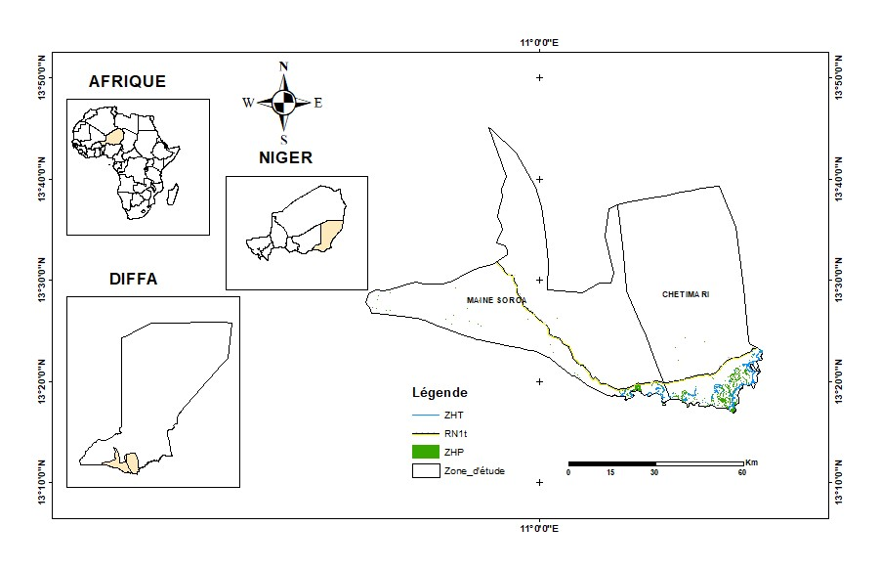
Fig. 1 : Location Map of the Study Area
2.2. Climate of the Diffa Region
The ombrothermic curve of Diffa highlights a hot and dry Sahelian climate, characterized by high temperatures throughout the year (≈ 26.7 °C) and low annual rainfall (≈ 294 mm), concentrated within a short rainy season (July–August) (Fig 2). The long dry season (8 to 9 months) and the nearly permanent water deficit, exacerbated by high evapotranspiration, limit the length of the growing season and increase the vulnerability of agropastoral systems.
These climatic conditions have significant impacts on agropastoral activities. In agriculture, the variability and short duration of rainfall reduce crop cycles and expose crops to frequent water stress, leading to yield declines and a shift toward short-cycle varieties. In livestock farming, the reduction of fodder and water resources promotes herd mobility and increases pressure on grazing lands. Overall, these constraints contribute to weakening production systems and increasing the vulnerability of rural households.

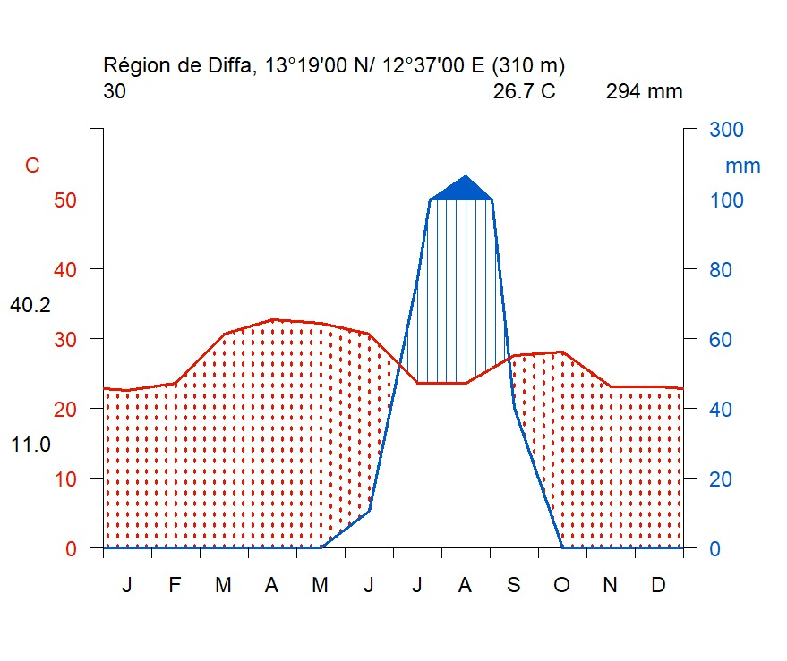
Fig. 2. Ombrothermic Curve of the Diffa Region
2.3. Sampling and Data Collection
2.3.1. Sampling
The present study was conducted in the communes of Chetimari in the south and N’Guel Bely and Foulatari in the north of the Diffa region. Due to security constraints in the study area, the research was limited to these three communes, which were relatively accessible for data collection. The selection also focused on villages located close to the communes. The surveyed villages include Gamari, Madouri, Boudouri, Kabi Bagara, Kabi Kollo, Kill Manga, Dassoram, Goujou, and Tacha Rogo, located within the communes of Chetimari, N’Guel Bely, and Foulatari, representing a total of 12 villages. These villages were selected primarily based on their accessibility. In addition, they possess significant natural resources and local potentials, while at the same time being highly exposed to the impacts of climate change, making them relevant for the objectives of this study.
The sample size was determined using the method proposed by Dagnelie (1998):
$$N=\frac{U_{1-α/2}^{2} P(1-P)}{d^{2}}$$
Where:
- N = sample size
- P = expected proportion of a response in the population (set by default at 0.5)
- U₁₋α/₂ = confidence level corresponding to 1.96
- d = margin of error (0.05)
- α = significance level (0.05)

Three sub-sites (Chetimari, Foulatari, and N’Guel Bely) in the Lake Chad Basin, within the Diffa region, were selected due to their proximity to vulnerable ecosystems (Fig-3). The study employed stratified random sampling, in which the number of households surveyed in each locality was determined proportionally to that locality's share of the total population. This approach ensured that each locality was adequately represented in the sample. The total number of households in each village/site was divided by the sample size (N) in order to determine the sampling interval.
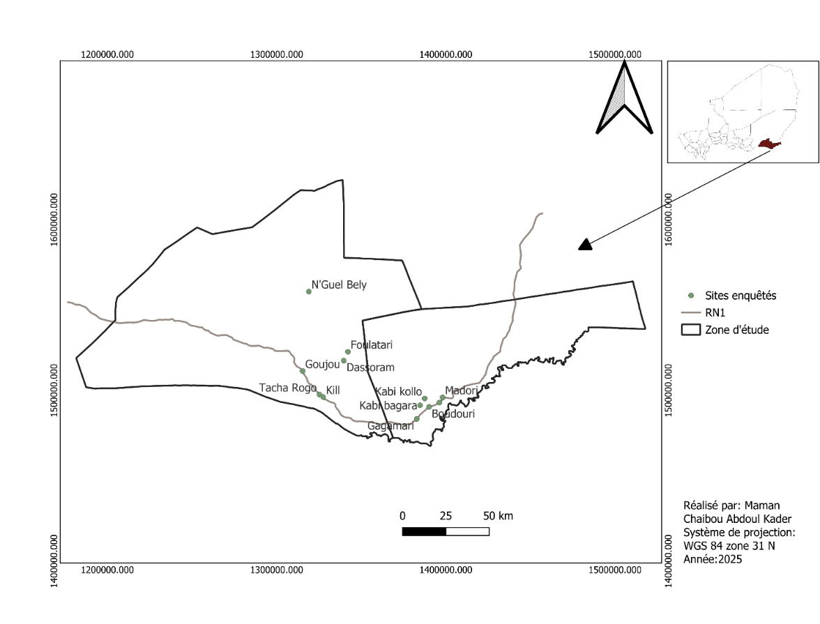
Fig. 3. Location Map of the Survey Sites
2.3.2. Data Collection
To conduct this study, two categories of data were collected:
- Survey data (social data)
The household survey questionnaire was divided into three sections : Section A (General information about the respondent), Section B (Perception of climate and observed changes), and Section C (Impacts of climate change on livelihoods). Section B also gathered community assessments regarding their perception of climatic factors such as rainfall and temperature, as well as their evaluation of the impacts of climate change.
Face-to-face interviews were mainly conducted at the respondents’ homes, with each interview lasting approximately 20 to 30 minutes. The respondents were adult household members (≥ 40 years old), preferably household heads or their spouses. Prior to the survey, the questionnaire was pre-tested in five households in the village of Kourou to ensure its relevance and clarity.
The questionnaire was translated from French into the respondents’ local languages (Hausa, Kanuri, and Fulani) to facilitate better understanding. As recommended by Pearce et al. (2009), the ethical procedures followed in this research took into account local norms, language considerations, and the confidentiality of respondents, while ensuring their voluntary participation in the survey.
- Climatic data (meteorological data)
The climatic data used to analyze climate change and variability, as well as to calculate extreme climate and drought indices, were obtained from the NASA POWER database (https://power.larc.nasa.gov/).
The following variables were downloaded:
- Daily maximum temperatures from 1995 to 2025 ;
- Daily minimum temperatures from 1995 to 2025 ;
- Daily precipitation data from 1995 to 2025.
2.4. Data Analysis and Processing
The data collected for this study originate from both socio-economic surveys conducted among 234 households in 12 villages in the Diffa region and simulated climatic data derived from satellite-based databases and climate reanalysis products (NASA POWER : https://power.larc.nasa.gov/).
A data cleaning process was performed to correct inconsistencies, verify missing values, and harmonize variables. Qualitative responses were converted into quantitative variables (binary or categorical coding) to facilitate statistical analysis. Descriptive statistics (frequencies, percentages, and distributions) were used to analyze the socio-economic profile of respondents, their perceptions of climate change, the perceived impacts on livelihoods, and the adaptation strategies adopted by communities. Statistical analyses and graphical outputs were produced using the R software, which enabled the creation of bar charts and comparative graphs illustrating community perceptions, the impacts of climate change, and adaptation strategies. Daily climatic data (maximum and minimum temperatures, and precipitation) covering the period 1995–2025 were analyzed to identify climatic trends and variability. Annual averages, moving averages, and graphical analyses were used to highlight the evolution of temperatures (Tmax and Tmin) and interannual rainfall variability. Extreme climate indices were calculated in accordance with the recommendations of the Expert Team on Climate Change Detection and Indices (ETCCDI), which provides standardized definitions for the analysis of climate extremes at the international level. Drought conditions were assessed using the Standardized Precipitation Index (SPI) and the Standardized Precipitation Evapotranspiration Index (SPEI) at 3-, 6-, and 12-month timescales. Trend detection was performed using the non-parametric Mann–Kendall test, while structural breaks were identified using the Pettitt test (Table-1).

Table 1. Definition of indices/tests and formulas
Index / Test | Full name | Definition | Interpretation | Mathematical formulas
TX90p | Percentage of days with Tmax > 90th percentile | Annual (or seasonal) proportion of days when the daily maximum temperature exceeds the 90th percentile of the reference period | Indicates the frequency of extremely hot days
TN90p | Percentage of days with Tmin > 90th percentile | Proportion of warm nights when the daily minimum temperature exceeds the 90th percentile | Indicates an increase in warm nights
R95p | Very intense precipitation | Annual total of daily precipitation exceeding the 95th percentile | Measures the intensity of extreme rainfall
SPI | Standardized Precipitation Index | Standardized index based only on precipitation, calculated at different time scales (3, 6, 12 months) | Negative values = drought; positive values = wet conditions | SPI = (Pᵢ − μ) / σ Where Pᵢ is the cumulative precipitation at the considered timescale, μ is the mean, and σ is the standard deviation.
SPEI | Standardized Precipitation Evapotranspiration Index | Standardized index based on the climatic water balance (Precipitation − Potential Evapotranspiration), sensitive to global warming | Incorporates the effect of evaporative demand | Dᵢ = Pᵢ − PETᵢ SPEI = (Dᵢ − μᴅ) / σᴅ Where Dᵢ is the water balance, μᴅ the mean, and σᴅ the standard deviation.
Mann–Kendall Test | Non-parametric test for monotonic trend | Assesses the presence of a significant trend in a time series without assuming a normal distribution | Tau > 0: increasing trend; Tau < 0: decreasing trend | S = Σ Σ sign(xⱼ − xᵢ) for j > i Tau = S / [n(n−1)/2]
Pettitt Test | Non-parametric change-point test | Detects a significant break (regime shift) in a time series | Identifies the year of structural change | **Kₜ = max
- RESULTS
3.1. Socio-economic Profile of the Respondents
The results show a clear dominance of agriculture, which represents the main activity across all study sites, with proportions generally exceeding 60% and reaching 100% in Boudouri, Goujou, Kill Manga, Kourou, and Tacha Rogo. Livestock farming constitutes the second most important activity, particularly among women, with high frequencies observed in Foulatari (75%), Dassoram (60%), Kabi Kolo (100%), and N’Guelbelly (100%). Trade remains a secondary activity but reaches notable levels in Gamari (23.8% among men and 33.3% among women) and Madouri (30.8% among men). Fishing and public service employment remain marginal activities, accounting for less than 5% of respondents (Fig-4).
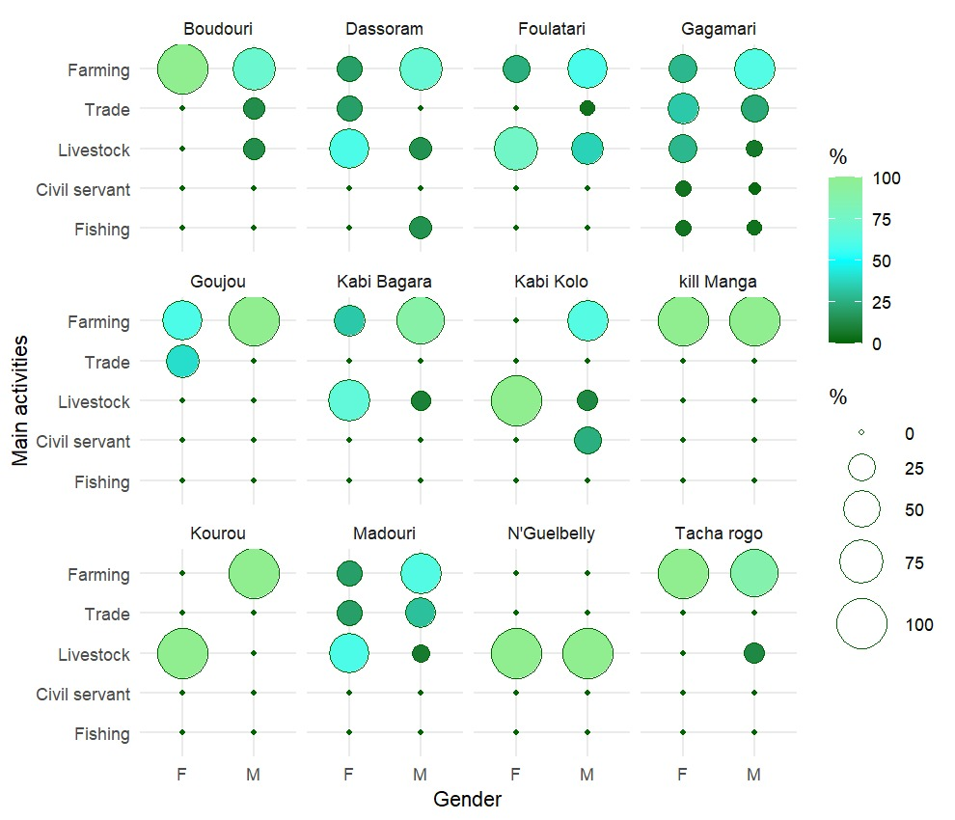
Fig. 4. Socio-economic Profile of the Respondents
3.2. Community Perceptions of Climate and Observed Changes
Figure 5 shows that local populations perceive climate change through several indicators, with perception levels ranging between 7.4% and 11.2%. The most frequently cited phenomena include intense rainfall (11.2%), rising temperatures (10.6%), and variability in the rainy season, particularly late onset (10.6%), as well as strong winds (10.7%), indicating a high sensitivity to extreme climatic events and seasonal disruptions. In contrast, floods (7.4%) and the early end of the rainy season (8.7%) are less frequently mentioned. Overall, these results indicate that local populations mainly associate climate change with increasing climatic variability rather than with a gradual modification of average climatic conditions.
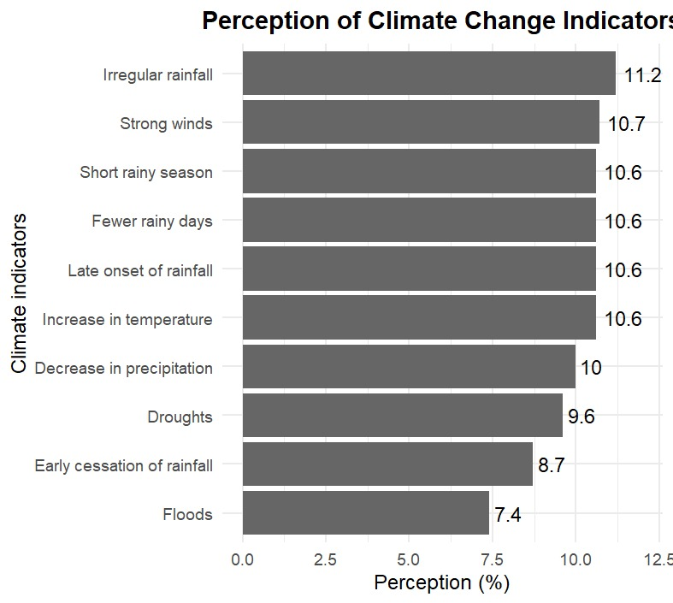
Fig. 5. Community Perceptions of Climate Change

3.3. Climate Trends
3.3.1. Calculation of Extreme Climate Indices
- Analysis of the TX90p Index
The results of the analysis show the evolution of maximum temperatures (Tmax) over time; the calculated TX90p index is 41.88 °C for the reference period 1995–2014. A day is considered extremely hot when the maximum temperature exceeds 41.9 °C, corresponding on average to 36 to 37 days per year (10% of 365 days) (Fig 6). In a Sahelian context such as Diffa, such a frequency of extreme heat has direct repercussions on socio-economic activities. These include reduced agricultural productivity due to water and heat stress affecting crops, declining livestock performance, reduced capacity for outdoor work (agriculture, trade, construction), increased energy expenditures related to cooling, and heightened health risks such as dehydration and heatstroke. Thus, this high threshold reflects not only pronounced climatic intensity but also heightened vulnerability of local livelihoods to thermal extremes.
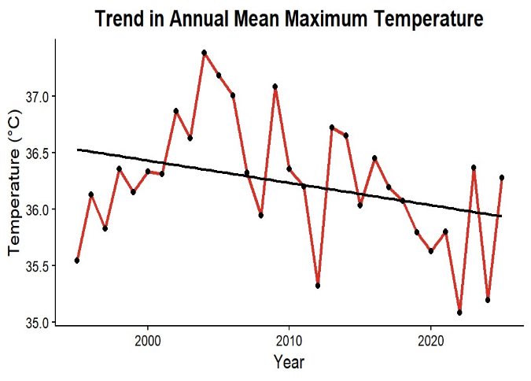
Fig. 6. Evolution of Maximum Temperatures (Tmax) from 1995 to 2025
- Analysis of the TN90 Index
The analysis of the evolution of minimum temperatures (Tmin) indicates that TN90 = 27.36 °C, meaning that during the reference period, about 10% of nights (approximately 36–37 nights per year) recorded minimum temperatures exceeding 27.3 °C (Fig 7). In a Sahelian context such as Diffa, where nighttime temperatures during the hot season may exceed 28 °C, this situation reflects the persistence of nocturnal heat. From a socio-economic perspective, the limited nighttime cooling increases thermal stress among populations, reduces the quality of rest and work capacity the following day, and raises health risks. It may also affect agricultural productivity, particularly the nighttime metabolic processes of crops, and reduce livestock well-being, while increasing energy needs for cooling. Thus, a high TN90 value reflects continuous thermal pressure, which can weaken local livelihoods and adaptive capacities.
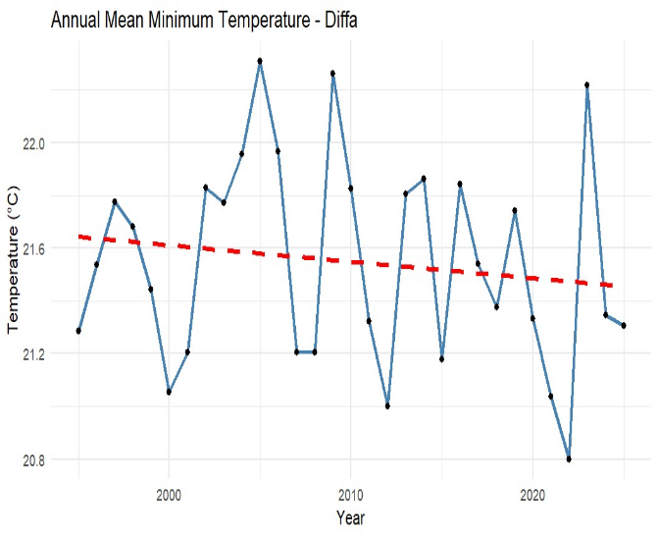
Fig. 7. Evolution of Minimum Temperatures (Tmin) from 1995 to 2025
- Analysis of the R95p Index
The analysis of this index, R95p = 10.43 mm, indicates that 5% of rainy days record precipitation amounts exceeding 10.4 mm/day, characterizing a rainfall regime where precipitation is generally infrequent but occasionally marked by intense events (Fig 8). In a Sahelian region such as Diffa, this pattern corresponds to short but intense convective rainfall events. From a socio-economic perspective, this irregularity promotes rapid runoff, sudden floods, and soil degradation, while reducing the effectiveness of water infiltration for rain-fed agriculture. Consequently, these conditions can weaken agricultural production, affect local infrastructure, and increase the exposure of rural households to hydrometeorological hazards.
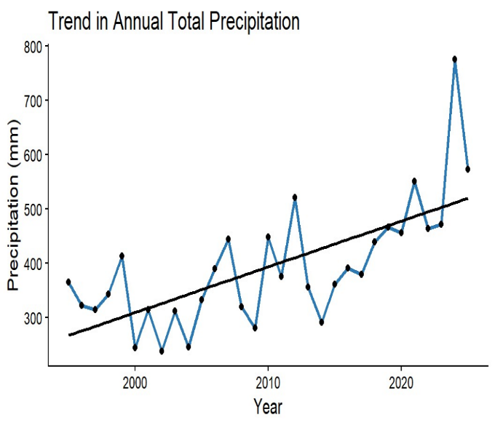
Fig. 8. Evolution of Rainfall from 1995 to 2025

3.4. Impacts of Climate Change on Livelihoods
3.4.1. Impact of Climate Change on Agricultural Production
Figure 9 indicates that farmers perceive the impacts of climate change mainly through decreasing rainfall (16.45%) and the late onset of the rainy season (15.37%), followed by rising temperatures (13.79%), soil degradation (13.70%), and increased pest pressure (13.29%). Similar to the other perception figures, these results highlight a strong sensitivity of farmers to rainfall variability and climate-related constraints directly affecting agricultural activities, while phenomena perceived as more occasional, such as excess rainfall (5.73%), are less frequently mentioned. This convergence across the different figures indicates a consistent perception of climate change, mainly centered on seasonal disturbances and their direct effects on production and livelihoods. These changes directly affect agricultural production at all stages of the cropping cycle, from germination to harvest, by reducing crop emergence, limiting vegetative growth, disrupting flowering, and ultimately leading to a significant decline in yields and the quality of agricultural outputs.
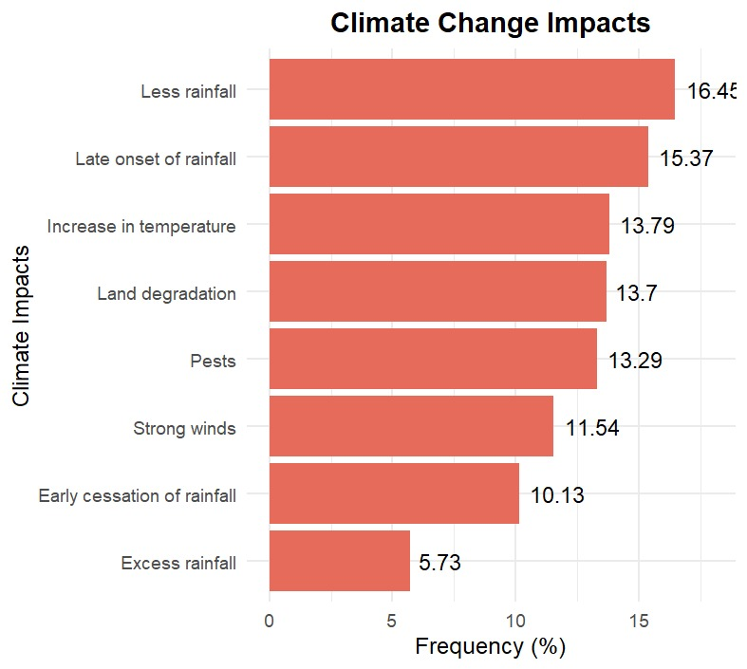
Fig. 9. Impacts of Climate Change on Agricultural Production
3.3.2. Livestock Herders’ Adaptation Strategies to Climate Change
Figure 10 presents the adaptation practices implemented by livestock herders in response to climatic constraints, with a predominance of reducing herd size (10.56%), diversifying fodder resources (10.19%), and changing livestock breeds (10.19%). Practices related to securing livestock feed and water access, such as feed supplementation, improvement of water points, and fodder storage, are also widely adopted, whereas modifications in transhumance patterns and optimization of livestock watering practices appear less frequent. Overall, these results show that herders tend to prioritize practical, flexible, and directly applicable adaptation strategies, aimed at reducing the vulnerability of livestock production systems to climate variability.
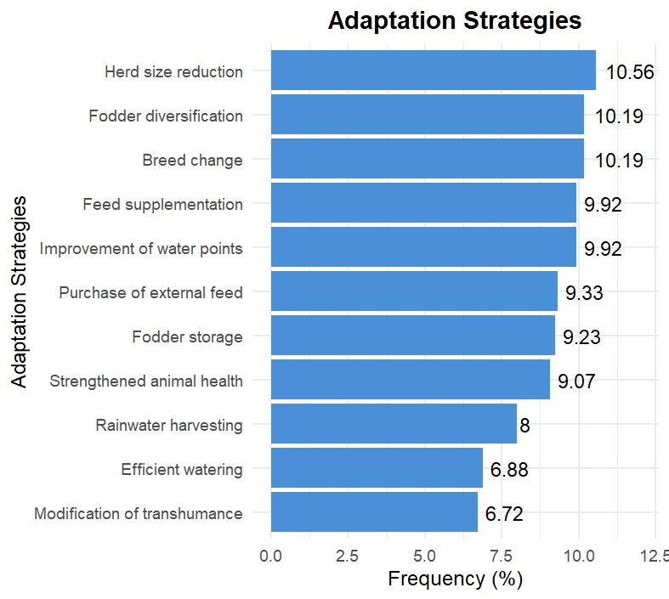
Fig. 10. Livestock Herders’ Adaptation Strategies to Climate Change

3.3.3. Farmers’ Adaptation Strategies to Climate Change
Figure 11 shows that farming communities primarily prioritize adaptation strategies directly related to securing agricultural production and livelihoods, particularly pest control (12.6%), the adoption of drought-resistant crops (12.3%), and environmental restoration actions such as reforestation (11.3%). In contrast, strategies related to specific extreme risks, such as the adoption of flood-resistant crops (6.8%), are less frequently implemented.
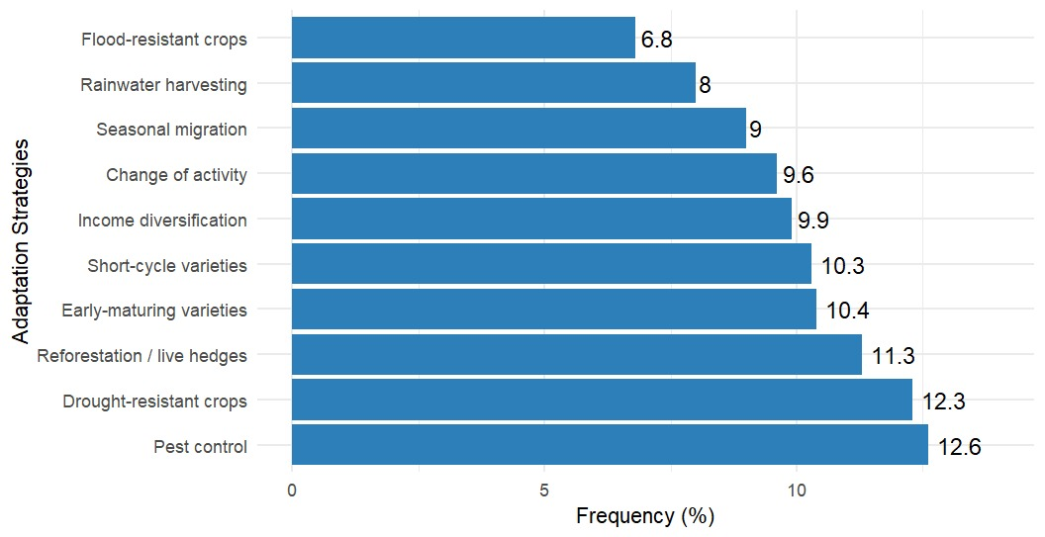
Fig. 11. Farmers’ Adaptation Strategies to Climate Change

3.4.2. Analysis of Drought Indices
- Analysis of the SPI at 3-month, 6-month, and 12-month timescales
The multi-scale analysis of the SPI reveals strong variability in short-term drought conditions (3 months), while a more structural dynamic emerges at the annual scale (12 months). A phase of prolonged hydrological deficit is observed until the early 2010s, followed by a shift toward wetter conditions after 2015. This transition may indicate a change in the regional rainfall regime (Fig 12).
Fig. 12. A : SPI at the 3-month timescale; B : SPI at the 6-month timescale; C : SPI at the 12-month timescale.
- Mann–Kendall and Pettitt Tests on SPI at 3-, 6-, and 12-Month Timescales
The Mann–Kendall test reveals a significant positive trend at all timescales, increasing from SPI-3 to SPI-12, while the Pettitt test identifies a structural break around 2010, marking the transition from a dry regime to a wetter phase (Table -2). This evolution reflects a sustained hydrological recovery, which could improve water availability and agricultural production. However, the intensification of extreme events indicates increasing climatic variability, whose socio-economic impacts remain strongly dependent on the adaptive capacity of local communities.
Table 2. Results of the Mann–Kendall trend test and Pettitt change-point test applied to the SPI indices at 3-, 6-, and 12-month time scales for the period 1995–2025 in the Diffa region.
Index | Time scale (months) | MK (τ) | MK p-value | Pettitt p-value | Break year
SPI | 3 | 0.211 | 0 | 0 | 2018
SPI | 6 | 0.292 | 0 | 0 | 2010
SPI | 12 | 0.497 | 0 | 0 | 2010

- Analysis of SPEI at the 3-, 6-, and 12-month time scales
The SPEI confirms the transition toward a wetter regime observed with the SPI, but it further highlights the role of atmospheric evaporative demand. The recent humidification does not necessarily imply a reduction in climate risk; rather, it is accompanied by an increase in extreme events, thereby intensifying the exposure of Sahelian socio-ecological systems (Fig 13).

Fig. 13. D : SPEI at the 3-month time scale; E : SPEI at the 6-month time scale; F : SPEI at the 12-month time scale.
- Mann–Kendall and Pettitt tests on SPEI at the 3-, 6-, and 12-month time scales
The Mann–Kendall test reveals a significant positive trend in the SPEI at all time scales (τ increasing from 0.122 to 0.309; p < 0.001), while the Pettitt test identifies a structural break in 2016, indicating a shift toward a wetter hydroclimatic regime and a sustained hydrological recovery. This evolution may improve agricultural yields, pasture regeneration, and water availability; however, the intensification of extremes simultaneously increases the risks of flooding, erosion, and instability of agro-pastoral systems, making the socio-economic benefits highly dependent on local adaptive capacities (Table-3).
Table 3 : Results of the Mann–Kendall (MK) and Pettitt tests on SPEI at the 3-, 6-, and 12-month time scales
Index | Time scale (months) | MK (τ) | MK p-value | Pettitt p-value | Break year
SPEI | 3 | 0.122 | 5e-04 | 1e-04 | 2016
SPEI | 6 | 0.205 | 0e+00 | 0e+00 | 2016
SPEI | 12 | 0.309 | 0e+00 | 0e+00 | 2016

- Comparative analysis of SPEI and SPI at the 3-, 6-, and 12-month time scales
The overall positive trend observed in both SPI and SPEI, particularly at the 12-month scale, suggests a relative improvement in long-term moisture conditions in the Diffa region, which could be favorable for rain-fed agriculture, pasture regeneration, and groundwater recharge. However, the strong variability observed at the 3- and 6-month scales indicates the persistence of abrupt dry or wet episodes that may disrupt agricultural calendars, affect pastoral production, and damage infrastructure during periods of excessive rainfall. Furthermore, the larger deviations observed in SPEI highlight the influence of thermal stress, which may offset the benefits of increased rainfall by intensifying evapotranspiration. Thus, despite an overall trend toward wetter conditions, local livelihoods remain vulnerable to intra-annual climate variability and hydroclimatic extremes.
Fig.14. Multi-scale hydroclimatic trends (SPI/SPEI) over the period 1995–2025.
- Mann–Kendall (MK) and Pettitt Tests on SPI/SPEI (1995–2025)
The results of the Mann–Kendall (MK) test highlight highly significant positive trends in both SPI and SPEI at all temporal scales, indicating a gradual shift toward wetter conditions in the Diffa region (Fig 14). In addition, the Pettitt test identifies structural breaks in the hydroclimatic regime between 2010 and 2018, marking a notable change in rainfall and hydrological dynamics. From a socio-economic perspective, this reconfiguration may support agricultural production, pastoral resource availability, and groundwater recharge, while simultaneously increasing the exposure of territories to intense rainfall events and flooding risks. Furthermore, the divergence observed between SPI and SPEI highlights the influence of warming through evapotranspiration, which may partially offset the benefits associated with increased precipitation. Thus, despite an overall favorable trend, the detected variability and regime shifts imply significant adaptation challenges for local socio-economic systems (Table-4).
Table 4: Analysis of Hydroclimatic Trends and Breakpoints (Mann–Kendall and Pettitt Tests) – (1995–2025)
Index | Time Scale (months) | MK_tau | MK_pvalue | Pettitt_pvalue | Break Year
SPEI | 3 | 0.122 | 5e-04 | 1e-04 | 2016
SPEI | 6 | 0.205 | 0e+00 | 0e+00 | 2016
SPEI | 12 | 0.309 | 0e+00 | 0e+00 | 2016
SPI | 3 | 0.211 | 0e+00 | 0e+00 | 2018
SPI | 6 | 0.292 | 0e+00 | 0e+00 | 2010
SPI | 12 | 0.497 | 0e+00 | 0e+00 | 2010

    - Relationship between climate variability and livelihoods (correlation/regression)
Statistical analysis combining Spearman correlation and multiple regression shows significant relationships between climate variability and livelihoods. The results show a negative correlation between extreme temperatures (TX90p, TN90) and agricultural productivity, reflecting the unfavourable effect of heat stress on crops and livestock. Conversely, the SPI and SPEI indices show a positive correlation with agricultural performance, indicating that improved water conditions promote production. However, intense rainfall events (R95p) are associated with yield instability due to runoff and flooding phenomena. Regression analysis confirms these trends, with positive and significant coefficients for SPI and SPEI (p < 0.05), while maximum temperatures exert a significant negative effect. These results underline that the combined increase in rainfall and temperature does not necessarily imply an improvement in production conditions, due to the intensification of evapotranspiration. Thus, hydroclimatic variability appears to be a determining factor in the vulnerability of agropastoral systems.

- DISCUSSION
The predominance of agriculture in the analysed areas highlights the high dependence of Sahelian millennials on rainfed cropping systems, which are particularly sensitive to climate and sea variability (Hamerr et al., 2025). This dependence amplifies the vulnerability of household income, as well as food security and the variability of food security. The breeding, as experienced by the women, is crucially important for the dissemination of income sisters and acts as an agricultural safety net (Slayi et al., 2023). On the other hand, trade and fishing remain sequential in terms of markets, driven by limited market capacity and inadequate structural structure (OECD/SWAC, 2025). Significantly, this is a key factor in the systemic vulnerability of households to climatic hazards.
Community perceptions rising temperatures, erratic rainfall, and increased extreme events are consistent with the findings of the Intergovernmental Panel on Climate Change (2021), which highlights an intensification of climate extremes in West Africa. Several recent studies (Sanogo et al., 2022; Ouédraogo et al., 2023) confirm the increasing disruptions in agricultural calendars, while Sultan et al. (2019) and Roudier et al. (2020) highlight yield declines related to water and heat stress. The predominance of perceptions related to the delay and decrease in rainfall highlights the central role of rainfall variability in the weakening of production systems.
The adaptation strategies observed reduction in herd size, diversification of forage resources, adoption of drought-tolerant varieties, phytosanitary control, and environmental restoration mainly reflect reactive and short-term responses. These strategies are part of a framework of incremental adaptation, often constrained by financial and institutional limitations (FAO, 2021; IPCC, 2022), but remain consistent with the agroecological approaches recommended to strengthen local resilience (Abid et al., 2020; Ouédraogo et al., 2021).
Extreme climatic indices confirm the intensification of environmental constraints. The high values of TX90p (41.88 °C) and TN90 (27.36 °C) indicate an increase in daytime and nighttime heat extremes, consistent with regional projections of an increased frequency of heatwaves in West Africa (Odunmorayo et al., 2025; Siabi et al., 2024). This persistence of heat increases crop water stress, reduces livestock productivity and increases health risks. In addition, the R95 index (10.43 mm) highlights a rainfall pattern characterized by rare but intense events, in line with the observations of Aryee et al. (2024) and recent analyses published in Theoretical and Applied Climatology (2025), which highlight an increased concentration of rainfall and a higher risk of flooding in the Sahel.
The multi-scale analysis of the SPI and SPEI in the Diffa region, based on the Mann-Kendall test and the Petttt test, reveals a transition to wetter conditions after the early 2010s, accompanied by structural breaks in the hydroclimatic regime. This evolution suggests a relative hydrological recovery, potentially favourable to rainfed agriculture and the recharge of water resources. However, the divergence between the SPI and the SPEI highlights the increasing influence of atmospheric evaporative demand, indicating that warming could offset the benefits of increased precipitation. Thus, despite an overall trend towards wetting, the intensification of extremes and intra-seasonal variability continues to maintain a high vulnerability of agropastoral systems, placing these results in a broader regional dynamic of warming and increasing hydroclimatic instability.
This study has some limitations related to the quality and availability of climate data, as well as the potentially subjective nature of community perceptions. In addition, the divergences between SPI and SPEI, related to the consideration of evaporative demand, can influence the interpretation of trends. Future research integrating multi-source data and longitudinal approaches would allow for further analysis of the interactions between climate variability and adaptation strategies in the Lake Chad Basin
- CONCLUSION
The results highlight a significant evolution of the hydroclimatic regime in the Diffa region, characterized by positive trends detected by the Mann–Kendall test and structural breaks confirmed by the Pettitt test. The combined analysis of the SPI and SPEI indices reveals increased rainfall variability and an intensification of thermal extremes, with a more pronounced signal at the annual scale. The consistency between instrumental observations and community perceptions strengthens the robustness of the findings and confirms the existence of a recent hydroclimatic change.
These dynamics reflect a reconfiguration of the regional climate regime, which may durably affect the functioning of agropastoral systems. Therefore, the integration of multi-scale statistical analyses and socio-empirical approaches appears essential for a comprehensive understanding of climate trajectories and their territorial implications.
Despite some limitations, these findings highlight the importance of integrated approaches combining scientific data and local knowledge to strengthen sustainable adaptation strategies in the Lake Chad Basin.

Disclaimer (Artificial intelligence)
Author(s) hereby declare that generative AI technologies such as Large Language Models, etc. have been used during the writing or editing of manuscripts. This explanation will include the name, version, model, and source of the generative AI technology and as well as all input prompts provided to the generative AI technology
Yes, for the narrative, AI was used and especially for the translation (French-English).

- REFERENCES
- Abid, M., Scheffran, J., Schneider, U. A., & Elahi, E. (2020). Farmer perceptions of climate change, observed trends and adaptation of agriculture in Pakistan. Environmental Management, 63(1), 110–123. https://doi.org/10.1007/s00267-018-1113-7
- Afrobarometer. (2022). Les Africains et le changement climatique : perceptions, impacts et adaptation (Policy Paper No. 97). Accra, Ghana. 24p.
- Aryee, J. N. A., Afrifa, F. O. T., Agyapong, K.-H., Gyau Frimpong, N. A., Quagraine, K. T., & Davies, P. (2024). Quantifying climatic heavy-precipitation-induced floods in West Africa using multiple precipitation indices. Scientific African, 25, e02309. https://doi.org/10.1016/j.sciaf.2024.e02309
- Ayal, D. Y., Leal Filho, W., & Biesbroek, R. (2021). Determinants of climate change perception and adaptation strategies in Sub-Saharan Africa. Climate Risk Management, 32, 100300. 12 pages. https://doi.org/10.1016/j.crm.2021.100300
- Dosio, A., Jones, R. G., Jack, C., Lennard, C., Nikulin, G., & Hewitson, B. (2021). Projected future temperature and precipitation extremes over Africa. Earth’s Future, 9(11), e2021EF002092. 18 pages. https://doi.org/10.1029/2021EF002092
- Dagnelie, P. (1998). Statistique théorique et appliquée : Tome 2, Inférence statistique à une et à deux dimensions. Bruxelles : De Boeck & Larcier, 659 p
- FAO. (2021). Pastoralism and climate change in the Sahel. Rome: Food and Agriculture Organization of the United Nations. 24p.
- Intergovernmental Panel on Climate Change (2023). Climate Change 2023: Synthesis Report. Contribution of Working Groups I, II and III to the Sixth Assessment Report (AR6). IPCC.
- IPCC. (2022). Climate Change 2022: Impacts, Adaptation and Vulnerability. Contribution of Working Group II to the Sixth Assessment Report. Cambridge: Cambridge University Press. 3949p.
- Issa, S., Moussa, I. B., & Soumana, I. (2022). Farmers’ perception of climate variability and adaptation strategies in Niger. Sustainability, 14(9), 5432. 16 pages.
https://doi.org/10.3390/su14095432
- Masson-Delmotte, V., Zhai, P., Pirani, A., et al. (2021). Climate change 2021: The physical science basis. Climate Dynamics, 58, 1–34. 34 pages.
https://doi.org/10.1007/s00382-021-06060-1
- OCDE / CSAO. (2025). Commerce et diversification des moyens d’existence en Afrique de l’Ouest. Paris: OCDE. 138p.
- Odunmorayo, M. T., Alani, B. O., & Adefisan, E. A. (2025). Projected change in occurrence and severity of heatwaves over West Africa as simulated by CMIP6 models. Journal of Disaster Science and Management, 1, Article 16. https://doi.org/10.1007/s44367-025-00017-z
- Okpara, U. T., Stringer, L. C., & Dougill, A. J. (2021). Climate variability and socio-ecological vulnerability in the Lake Chad Basin. Regional Environmental Change, 21, 85. 14 pages. https://doi.org/10.1007/s10113-021-01800-9
- Okpara, U. T., Stringer, L. C., & Dougill, A. J. (2021). Climate variability and socio-ecological vulnerability in the Lake Chad Basin. Regional Environmental Change, 21, 85. 14 pages. https://doi.org/10.1007/s10113-021-01800-9
- Ouédraogo, M., Barbier, B., & Barry, S. (2023). Perceptions paysannes du changement climatique et stratégies d’adaptation en Afrique de l’Ouest sahélienne. Climate and Development, 15(3), 245–258.
- Ozer, P., Hountondji, Y.-C., Laminou Manzo, O., & Yabi, I. (2020). Trends and variability in rainfall and temperature over Niger. Theoretical and Applied Climatology, 141, 1621–1635. 15 pages. https://doi.org/10.1007/s00704-020-03246-9
- Ozer, P., Hountondji, Y.-C., Laminou Manzo, O., & Yabi, I. (2020). Trends and variability in rainfall and temperature over Niger. Theoretical and Applied Climatology, 141, 1621–1635. 15 pages. https://doi.org/10.1007/s00704-020-03246-9
- Pearce, T. D., Ford, J. D., Laidler, G. J., Smit, B., Duerden, F., Allarut, M., Andrachuk, M., Baryluk, S., Dialla, A., Elee, P., Goose, A., Ikummaq, T., Joamie, E., Kataoyak, F., Loring, E., Meakin, S., Nickels, S., Shappa, K., Shirley, J., & Wandel, J. (2009). Community collaboration and climate change research in the Canadian Arctic. Polar Geography, 28(1), 10–27. https://doi.org/10.1111/j.1751-8369.2008.00094.x
- Rainfall variability and drought in West Africa: challenges and implications for rainfed agriculture. (2025). Theoretical and Applied Climatology, 156, Article 41. https://doi.org/10.1007/s00704-024-05251-8
- Roudier, P., Alhassane, A., Baron, C., & Sultan, B. (2020). Assessing the impacts of climate variability and change on agricultural systems in West Africa. Climatic Change, 159(4), 583–601.
https://doi.org/10.1007/s10584-020-02692-1
- Salack, S., Giannini, A., Diakhate, M., et al. (2022). Climate extremes and agricultural risk in the Sahel. Weather and Climate Extremes, 36, 100456. 11 pages.
https://doi.org/10.1016/j.wace.2022.100456
- Sanogo, K., Moussa, B., Yabi, J. A., & Baco, M. N. (2022). Stratégies d’adaptation des ménages agricoles face au changement climatique en Afrique de l’Ouest. Climate and Development, 14(4), 345–357.
- Sanogo, K., Traoré, B., & Diarra, S. (2022). Changements climatiques et perceptions locales dans les zones agro-pastorales du Sahel. Journal of Arid Environments, 196, 104657.
- Sanogo, S., et al. (2022). Flood intensification in the Sahel: Evidence from recent decades. Journal of Hydrology, 608, 127659. 13pages. https://doi.org/10.1016/j.jhydrol.2022.127659
- Siabi, E. K., Awafo, E. A., Kabobah, A. T., … & Yazdanie, M. (2024). Quantifying future climate extreme indices: implications for sustainable urban development in West Africa, with a focus on the Greater Accra region. Discover Sustainability, 5, Article 167. https://doi.org/10.1007/s43621-024-00352-w
- Sultan, B., Defrance, D., & Iizumi, T. (2019). Evidence of crop production losses in West Africa due to historical global warming in two crop models. Scientific Reports, 9, 12834. https://doi.org/10.1038/s41598-019-49167-0
- Zorom, M., Hien, M., & Somda, J. (2021). Perceptions locales des risques climatiques et vulnérabilité des systèmes agricoles au Burkina Faso. Sustainability, 13(9), 487. 41p.

