Heavy Metal Pollution in Soils at Informal Waste Electrical and Electronic Equipment (WEEE) Recycling Sites in Benin

ABSTRACT
Introduction: Informal management of Waste Electrical and Electronic Equipment (WEEE) can lead to the release of heavy metals into surrounding soils, posing environmental concerns.
Aims: This study aims to assess heavy metal contamination in soils at informal WEEE management sites in three cities of Benin (Abomey-Calavi, Cotonou, and Natitingou).
Methodology: Soil samples were collected from informal WEEE sites and analyzed for eight heavy metals including arsenic (As), cadmium (Cd), chromium (Cr), copper (Cu), iron (Fe), nickel (Ni), lead (Pb), and zinc (Zn). Metal concentrations were determined using atomic absorption spectrometry and UV Visible spectrophotometry. The geoaccumulation index (Igeo) was applied to evaluate the degree of soil contamination.
Results: The results showed very low metal concentrations at non-burning sites, with negative or zero Igeo values (class 0), indicating the absence of pollution. Only isolated cases of cadmium reached class 1 (unpolluted to moderately polluted). In contrast, the burning site in Abomey-Calavi exhibited extreme contamination levels, particularly for Cd (119.08 mg/kg, Igeo > 9, class 6), Pb (503.02 mg/kg, class 5), and Cu (416.97 mg/kg, class 4).
Conclusion: These findings highlight the significant impact of open burning practices at informal WEEE sites, which create severe soil pollution hotspots and pose substantial risks to environmental quality and public health.

Keywords: WEEE, Heavy metals, Soils, Igeo, Contamination, Benin.

1. Introduction
Waste electrical and electronic equipment (WEEE) currently represents the fastest-growing waste stream worldwide, with an estimated generation of over 62 million tonnes in 2022 and an annual increase of 3 to 5% (Owusu-Sekyere et al., 2024). This waste consists of complex materials and contains more than a thousand substances, including numerous heavy metals (Pb, Cd, Cu, Ni, Cr, Zn, As) considered hazardous to the environment and human health (Yekeen et al., 2016; Udousoro et al., 2025). Informal WEEE recycling, widespread in Africa and Asia, often involves the burning of cables and electronic boards or dismantling—practices that promote the accumulation of these contaminants in soils (Ackah, 2019; Pibul et al., 2023).

Several studies conducted worldwide confirm that these practices lead to significant heavy metal accumulation in soils. At Agbogbloshie (Ghana), a emblematic informal recycling site in West Africa, extreme levels of lead and copper were observed in surface soils, far exceeding international guideline values (Ackah, 2019; Teye & Tetteh, 2023). In Guiyu, China, lead and cadmium reach 448.7 mg/kg and 0.71 mg/kg respectively—concentrations several times higher than those in reference areas (Yekeen et al., 2016). Similar trends have been reported in Thailand and Bangladesh, where informal repair and recycling activities are associated with notable soil contamination (Abedin et al., 2025; Pibul et al., 2023). These findings underscore the scale of the issue and the need for reliable assessment tools to characterize pollution levels. The geoaccumulation index (Igeo), developed by Müller, is widely used to estimate the intensity of metal contamination in soils. It classifies sites into seven categories ranging from 0 (unpolluted) to 6 (extremely polluted) by comparing measured concentrations with geochemical background values (Akanchise et al., 2020). Numerous studies have shown that informal WEEE burning sites exhibit high Igeo values for Cd, Pb, and Cu, reflecting situations of heavy to extreme pollution, while certain metals such as Cr or As sometimes remain at background levels (Owusu-Sekyere et al., 2024; Udousoro et al., 2025; Fosu-Mensah et al., 2017).

However, while these dynamics are well documented in some West African countries (Ghana, Nigeria) and Asia (China, Thailand, Bangladesh), few studies exist in Benin, where WEEE management remains largely informal. Estimating e-waste quantities can be difficult in Benin for various reasons. These include the fraudulent entry of most equipment, both new and second-hand, which therefore goes unrecorded in statistics. E-waste proliferates along roadsides or in illegal dumpsites. This method of WEEE management exacerbates the nuisances they cause in the environment. In the country's various regions, end-of-life e-waste, after multiple unsuccessful repairs, undergoes no appropriate treatment. In Cotonou, as in other cities across the country, non-recoverable e-waste residues are stored in warehouses, discarded in illegal dumpsites, buried near repair workshops, or burnt. These practices lead to the accumulation of heavy metals in soils, with environmental and health consequences.

In this context, the present study aims to assess metal contamination of soils in Abomey-Calavi, Cotonou, and Natitingou, distinguishing between passive disposal sites and a burning site. The objective is to measure heavy metal concentrations, calculate the Igeo to determine pollution levels, and compare the results obtained with international guidelines values as well as with observations from the literature.

2. Materials and Methods
2.1. Study Area
The study was conducted in three cities in Benin: Cotonou, Abomey-Calavi, and Natitingou.
These locations were chosen due to the presence of informal management sites or waste electrical and electronic equipment (WEEE) dumps. Furthermore, these three selected cities reflect the country's different realities through their geographical distribution, covering both the South, with Cotonou and Abomey-Calavi, and the North, with Natitingou, thereby ensuring territorial and socio-economic representativeness while providing favorable conditions for observing WEEE management. Cotonou is located in the Littoral department and is the economic capital of Benin. It hosts the main seaport and serves as a hub for commerce and industry. Abomey-Calavi is a rapidly expanding municipality located in the Atlantic department and is experiencing rapid population growth. Natitingou, in the northwest of the country, represents a less industrialized area, chosen for comparison with more urbanized zones.

2.2. Sampling
The soil sampling methodology adopted in this study follows the guidelines of ISO 18400-101:2017, which provides a framework for preparing and implementing a sampling plan, ensuring the representativeness and reliability of the collected samples. Soil sampling was carried out at WEEE disposal or informal treatment sites in the three studied cities (Cotonou, Abomey-Calavi, and Natitingou) using a stainless-steel auger to limit contamination. At each site, a sampling plan was implemented according to a three-point sampling scheme spaced 50 meters apart, covering a total distance of 100 meters per site. In Cotonou and Abomey-Calavi, samples were collected following a uniform protocol: three points spaced 50 m apart at each site, with two depths per point (0–20 cm and 20–40 cm). In Natitingou, the protocol was adapted based on local constraints: the first site was sampled at both depths (0–20 cm and 20–40 cm), while subsequent sites were sampled only at the surface (0–20 cm).
Each sample was uniquely coded and accompanied by precise location information (city, site, and depth) to ensure traceability. A total of 72 samples were collected. The samples were manually retrieved directly into clean, labeled plastic bags, then grouped into appropriate bags. The samples were immediately transported to the laboratory.

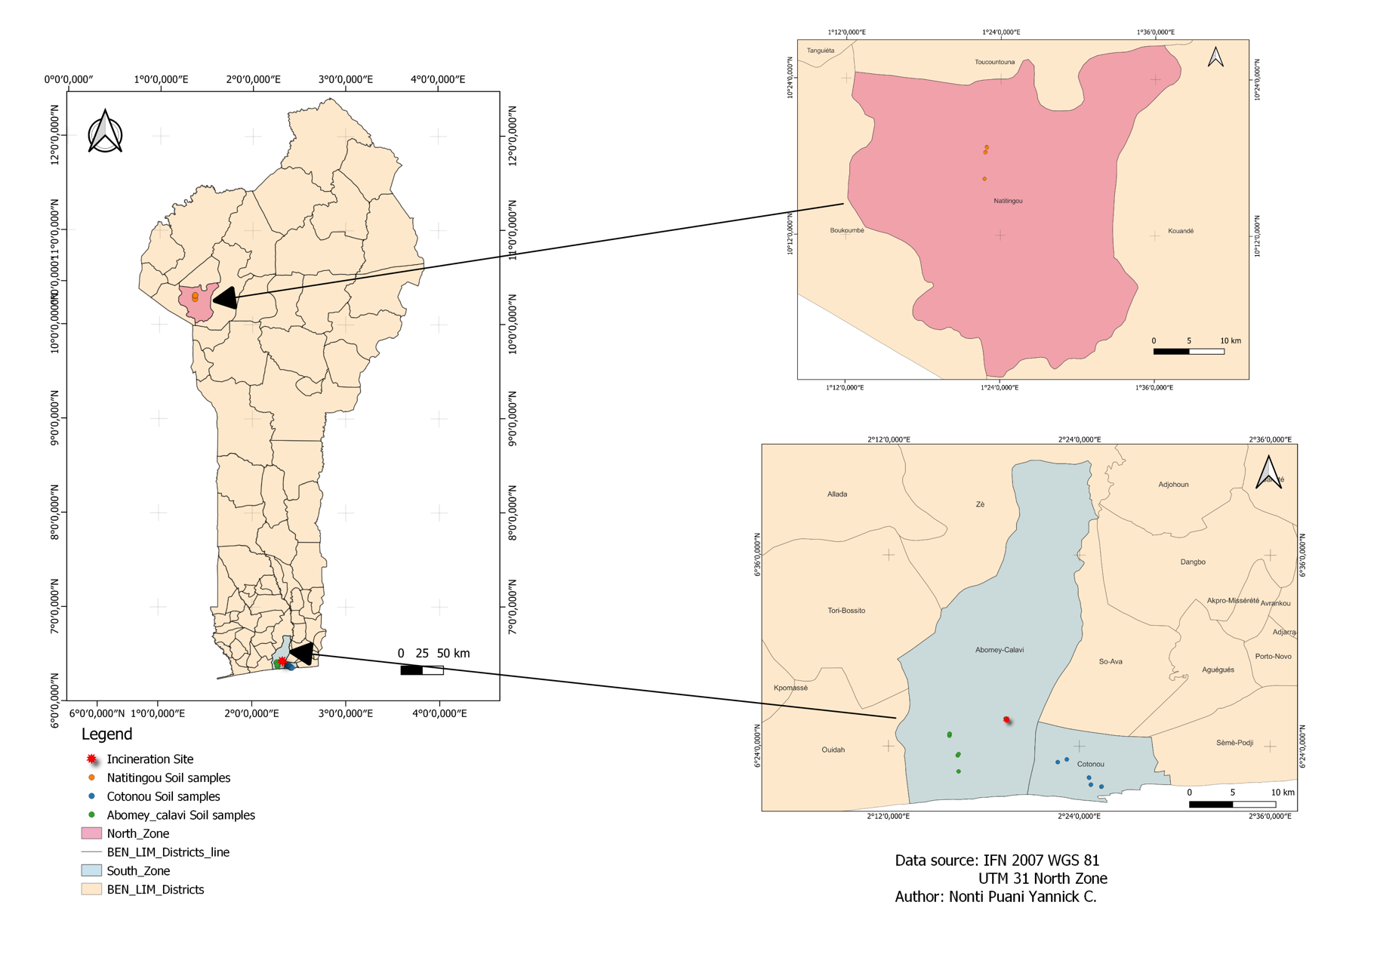
Fig. 1. Location of sampling sites
2.3. Laboratory Analyses
2.3.1. Soil Preparation at the Laboratory of National Institute of Agricultural Research of Benin (INRAB)
Upon arrival at the laboratory, the samples were air-dried for 24 hours to reduce their natural moisture content. Once dry, they were first sieved to remove coarse particles, stones, or unrepresentative debris. The resulting fractions were then manually ground using a porcelain mortar until a fine, homogeneous powder was obtained. This powder was processed using a 2 mm mesh sieve in accordance with standard recommendations for sample preparation for physicochemical analyses. Finally, the prepared samples were stored in hermetically sealed plastic bags, and kept in a dry environment at room temperature (ISO, 2007), pending use for analyses. This preparation follows ISO 11464:2006 standard.

2.3.2. Soil Preparation at the Laboratory (Iasi)
The soil samples were first dried in an oven (80 °C) and then weighed. Ten grams of dry soil were subsequently transferred into beakers and digested by successive addition of concentrated nitric acid and heating on a hot plate at 200 °C, until complete mineralization was achieved. The solution was then diluted with distilled water and filtered into 50 ml volumetric flasks. The process was repeated, if necessary, until a clear solution was obtained, indicating the absence of residual organic matter, following the ISO 16729:2013 standard.

2.3.3. Analytical Technique
Metal concentrations were determined by atomic absorption spectrometry (AAS) and UV-Visible spectrophotometry.
AAS was used for the quantification of copper (Cu), cadmium (Cd), lead (Pb), nickel (Ni), arsenic (As), and zinc (Zn). This technique is based on measuring the absorbance of light by atoms vaporized in a flame, with each metal detected at a specific wavelength using a hollow cathode lamp.
The solutions resulting from mineralization were analyzed after preparing standard solutions for each metal. The flow rate of the air-acetylene mixture was optimized to ensure flame stability. Calibration curves obtained from standard solutions were used to calculate sample concentrations, expressed in mg/kg. This method refers to the ISO 8288:1986 standard and Standard Methods 3111 B (2017).
Spectrophotometry was used for the analysis of iron (Fe) and chromium (Cr).
For iron, the method is based on the formation of a red complex between Fe³⁺ and thiocyanate ion (KSCN), measured at a wavelength of 480 nm. Standard solutions were prepared from Fe and KSCN stock solutions, and sample concentrations were calculated from the calibration curve.
For chromium, a colored complex was formed with diphenyl carbazide, whose absorbance was measured at 540 nm. Standard solutions prepared from the stock solution were used to establish the calibration curve. These methods conform to ISO 6332:1988 (iron determination), ISO 11083:1994 (chromium determination), and Standard Methods 3500-Fe B (2017).

2.4. Statistical Analyses
Statistical analyses were performed using R software. Metal concentration data were first organized in Excel before processing. Differences in concentrations between sites were assessed using the Kruskal-Wallis test, which is better suited for environmental data. When significant differences were observed, Dunn's post-hoc test was used to identify sites with significant variations. To examine relationships between metals, Spearman correlations were calculated. Furthermore, Principal Component Analysis (PCA) was conducted to highlight associations between metals and characterize similarities or differences between sites. The measured concentrations were then compared with guideline values to assess the potential contamination risk. Finally, the pollution level was estimated using the geoaccumulation index (Igeo), calculated according to the formula proposed by Müller (1969):
$$Igeo = \log^{2}\left(\frac{Cn}{1,5*Bn}\right) (1)$$
Where Cn corresponds to the measured concentration and Bn to the geochemical background value of the element from the literature (Turekian & Wedepohl, 1961). The values obtained were interpreted according to the seven classes defined by Müller.
3. Results
3.1. Metal Concentrations in Soils
Descriptive statistical analysis of heavy metal concentrations in soil samples collected from Abomey-Calavi, Cotonou, and Natitingou shows variations depending on the site.
Overall, arsenic (As) levels remain extremely low, often below 0.005 mg/kg, with zero medians for all three cities, indicating an absence of significant contamination by this element. Cadmium (Cd) reveals a marked presence across cities: while mean concentrations are low in Cotonou (0.077 mg/kg) and Natitingou (0.167 mg/kg), Abomey-Calavi presents a much higher mean value (3.95 mg/kg) with a maximum reaching 119 mg/kg. This value is explained by the presence of the WEEE burning site, which constitutes a point source of pollution and strongly influences the mean. Copper (Cu) and iron (Fe) follow a similar trend: levels are low in Cotonou and Natitingou but abnormally high in Abomey-Calavi (respective means of 23.18 and 123.33 mg/kg), with maximum values (416.97 mg/kg for Cu and 2040.32 mg/kg for Fe), again due to the burning site. For lead (Pb) and zinc (Zn), means remain low in all cities, but Abomey-Calavi still stands out with maximum values (503.02 mg/kg for Pb and 1.06 mg/kg for Zn), reflecting localized rather than widespread pollution. Nickel (Ni) and chromium (Cr) also exhibit low to moderate concentrations, with respective maximum values of 226.83 mg/kg and 7.78 mg/kg in Abomey-Calavi, compared to much lower levels in the other two cities. Overall, these results suggest that metal contamination of soils by WEEE remains limited at most study sites. However, the waste burning area in Abomey-Calavi constitutes a marked anomaly, with elevated levels of several heavy metals, illustrating the direct impact of burning practices on soil pollution (See Table A1 in appendix).

3.2. Spatial Variability of Metals
Comparison between cities shows that all metals except As vary significantly across cities. Kruskal-Wallis analysis (Table A2 in appendix) revealed significant differences in concentrations between sites for the majority of studied metals (Cd, Cu, Fe, Pb, Zn, Ni, Cr; p < 0.05), with the exception of arsenic (p = 0.078), whose variations were not significant. Dunn's post-hoc tests (Table A3 in appendix) allowed for detailed inter-site comparisons. Results indicate that lead (Pb) and cadmium (Cd) exhibited the most marked differences, with significantly higher concentrations in Abomey-Calavi compared to other localities (p < 0.001). Furthermore, a clear difference was observed between Cotonou and Natitingou (p < 0.001 for Pb; p = 0.0027 for Cd). Copper (Cu) and zinc (Zn) also showed significant variations, particularly between Abomey-Calavi and other sites (p < 0.05), as well as between Cotonou and Natitingou (p = 0.025 and p = 0.032, respectively). For iron (Fe) and nickel (Ni), differences were significant between Abomey-Calavi and other sites (p = 0.001 and p = 0.003 respectively), as well as between Cotonou and Natitingou (p < 0.05). Chromium (Cr) showed a significant difference only between Abomey-Calavi and other localities (p = 0.038).

3.3. Specific Analysis of the Burning Site
The results shown in the figure reveal marked differences in the distribution of heavy metals according to the studied sites.

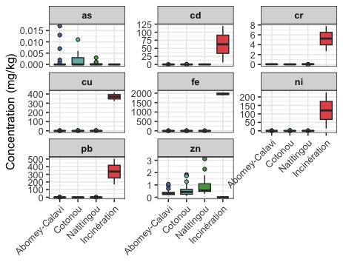
Fig.2. Comparison of heavy metal concentrations between cities and the burning site.

Overall, arsenic (As), cadmium (Cd), copper (Cu), iron (Fe), lead (Pb), zinc (Zn), nickel (Ni), and chromium (Cr) concentrations are very low in soils collected from Abomey-Calavi, Cotonou, and Natitingou, with values close to zero for the majority of samples. In contrast, a completely different situation is observed at the WEEE burning site in Abomey-Calavi. The boxplots show extremely high concentrations for practically all metals analyzed. This strong differentiation thus highlights a characteristic of pollution from WEEE burning, where soils accumulate very high levels of heavy metals, far beyond the variability observed in other cities.
3.4 Correlations Between Metals

The matrix shows that several metals exhibit strong positive correlations.
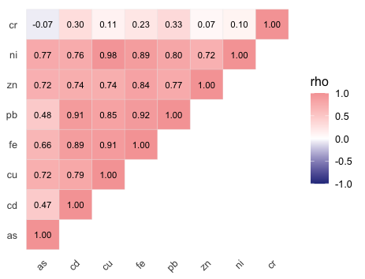
Fig.3. Correlation between metals
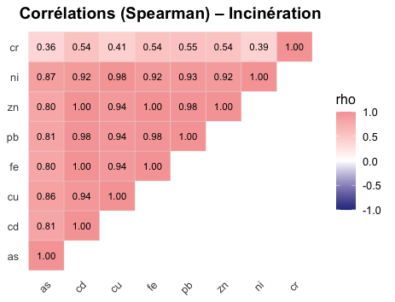
Fig. 4. Correlation between metals at the burning site

Figure 3 illustrates the correlations between metals. Strong associations are observed between Cu–Fe (ρ = 0.91), Cu–Pb (ρ = 0.85), Fe–Pb (ρ = 0.92), Zn–Fe (ρ = 0.84), and Zn–Pb (ρ = 0.77), reflecting the joint presence of these elements in electrical and electronic equipment as well as their simultaneous release during dumping and incineration activities. Nickel is very strongly correlated with base metals, particularly with Cu (ρ = 0.98), Fe (ρ = 0.89), and Zn (ρ = 0.72). Cadmium shows moderate correlations with Cu (ρ = 0.79) and Fe (ρ = 0.80), while arsenic is only weakly correlated with other metals (ρ between 0.30 and 0.48). Chromium stands out with very weak or even negative correlations (ρ = –0.07 with As; ρ = 0.10–0.33 with other metals). Figure 4, focusing on the burning site, reveals a different situation. Correlations appear extremely strong and homogeneous among almost all studied metals. Cu, Fe, Pb, Zn, and Ni form an almost perfectly correlated block (ρ > 0.90). Cd and As also join this group with high coefficients (ρ > 0.80), contrary to what was observed at other sites, where their behavior appeared more diffuse or independent. Cr, although less correlated (ρ = 0.36–0.55), remains associated with the group.
Principal Component Analysis (PCA) confirms these trends while providing a visual synthesis (Figure 5). The first dimension (59.1% of variance) opposes a group of base metals (Fe, Cu, Pb, Ni, Cd, Cr) to As and Zn, while the second dimension (16.7%) highlights the specificity of Cd

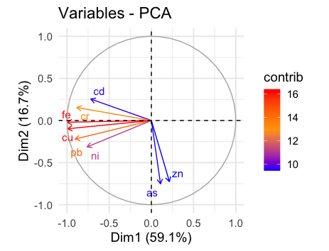
Fig. 5. Correlation circle

Long arrows close to the circle, such as those for iron, copper, lead, and nickel, reflect a good representation of these elements by the two axes and confirm their strong correlations. Cadmium lies in the same general direction as this group, suggesting an association, but with a slightly distinct position that highlights certain particularities. Arsenic and zinc projects are opposite to this block, indicating a negative relationship with the base metals and different behavior. Thus, the arrows in the circle show a block of strongly linked metals (Fe, Cu, Pb, Ni, Cd), opposed to As and Zn.
3.5. Comparison with International Standards
Maximum concentrations observed in soils from Abomey-Calavi (excluding incineration), Cotonou, and Natitingou are reported in Table 1. The interpretation of results is based on guideline values defined in the BRGM methodological report (Mossmann & Koch-Mathian, 2001), which proposes source definition values (VDSS) for various heavy metals in soils.

Table 1. Heavy metal concentrations in soils outside the burning site
Metal  (mg/kg MS) | Abomey-Calavi  (max) | Cotonou (max) | Natitingou (max) | Guideline Values (France VDSS)
As | 0.017 | 0.011 | 0.003 | 19
Cd | 4.49 | 0.283 | 0.358 | 10
Cu | 2.34 | 2.34 | 4.49 | 95
Fe | 3.70 | 3.70 | 6.39 | –
Pb | 0.571 | 0.036 | 0.571 | 200
Zn | 1.83 | 1.83 | 3.12 | 4500
Ni | 1.27 | 1.27 | 0.74 | 70
Cr | 0.060 | 0.057 | 0.057 | 65

The levels of As, Cd, Cu, Pb, Zn, Ni, and Cr are low, with values generally below international reference thresholds.
In Abomey-Calavi, the maximum concentrations measured were 0.017 mg/kg for As, 4.49 mg/kg for Cd, 2.34 mg/kg for Cu, 2040.32 mg/kg for Fe, 503.02 mg/kg for Pb, 3.12 mg/kg for Zn, 1.27 mg/kg for Ni, and 0.060 mg/kg for Cr. In Cotonou, the maximum values were 0.011 mg/kg (As), 0.283 mg/kg (Cd), 2.34 mg/kg (Cu), 3.70 mg/kg (Fe), 0.036 mg/kg (Pb), 1.83 mg/kg (Zn), 1.27 mg/kg (Ni), and 0.057 mg/kg (Cr). Finally, in Natitingou, the maximum concentrations reached 0.003 mg/kg (As), 0.358 mg/kg (Cd), 4.49 mg/kg (Cu), 6.39 mg/kg (Fe), 0.571 mg/kg (Pb), 3.12 mg/kg (Zn), 0.737 mg/kg (Ni), and 0.057 mg/kg (Cr).

Table 2. Heavy metal concentrations at the burning site
Metal  (mg/kg MS) | Burning site (max) | Guideline Values (France VDSS) | Exceedance
As | 0 | 19 | No
Cd | 119.08 | 10 | Yes
Cu | 416.97 | 95 | Yes
Fe | 2040.32 | – | —
Pb | 503.02 | 200 | Yes
Zn | 0 | 4500 | No
Ni | 7.78 | 70 | No
Cr | 0.060 | 65 | No

The results for the burning site (Table 2) reveal particularly high levels for certain metals. Maximum concentrations reach 119.08 mg/kg for Cd, 416.97 mg/kg for Cu, and 503.02 mg/kg for Pb, values exceeding reference thresholds. Fe also shows elevated levels (2040.32 mg/kg). In contrast, Ni (7.78 mg/kg) and Cr (0.060 mg/kg) levels remain low.
3.6. Geoaccumulation Index (Igeo)
The geoaccumulation index (Igeo) was calculated for soils from WEEE disposal sites in Abomey-Calavi, Cotonou, and Natitingou, as well as for the burning site in Abomey-Calavi. In the three cities (excluding incineration), Igeo values for all heavy metals are predominantly in class 0 (unpolluted). A few isolated samples show slightly positive indices for cadmium, corresponding to class 1 (unpolluted to moderately polluted), but overall remain below critical thresholds (Table 3). In contrast, soils from the burning site exhibit significantly higher values. The maximum Igeo reaches 9.63 for cadmium (class 6: extremely polluted), followed by lead (4.07; class 5: heavily to extremely polluted) and copper (3.47; class 4: heavily polluted). Nickel appears in class 2 (moderately polluted), while chromium remains in class 0 (unpolluted) (Table 4).

Table 3. Igeo by city (excluding burning site)
Metal | Abomey-Calavi (Igeo max ; Class) | Cotonou (Igeo max ; Class) | Natitingou (Igeo max ; Class)
As | −7.05 → Class 0  (unpolluted) | −7.68 → Class 0  (unpolluted) | −9.55 → Class 0  (unpolluted)
Cd | 0.07 → Class 1  (unpolluted to moderately polluted) | 0.92 → Class 1  (unpolluted to moderately polluted) | 1.25 → Class 2  (unpolluted to moderately polluted)
Cu | −5.15 → Class 0  unpolluted) | −4.00 → Class 0  (unpolluted) | −3.06 → Class 0  (unpolluted)
Pb | −10.30 → Class 0  (unpolluted) | −9.70 → Class 0  (unpolluted) | −5.72 → Class 0  (unpolluted)
Zn | −6.65 → Class 0  (unpolluted) | −5.86 → Class 0  unpolluted) | −5.09 → Class 0  (unpolluted)
Ni | −7.49 → Class 0  (unpolluted) | −6.33 → Class 0  (unpolluted) | −7.11 → Class 0  unpolluted)
Cr | −11.10 → Class 0  (unpolluted) | −11.20 → Class 0  (unpolluted) | −11.20 → Class 0  (unpolluted)

The geoaccumulation index (Igeo) classification proposed by Müller is provided in the appendix for reference.

Table 4. Igeo at the Incineration Plant
Metal | Igeo max | Class (Müller, 1969)
As | − | −
Cd | 9.63 | Class 6 (extremely polluted)
Cu | 3.47 | Class 4 (heavily polluted)
Pb | 4.07 | Class 4 (heavily polluted)
Zn | − | −
Ni | 1.15 | Class 2 (moderately polluted)
Cr | −4.12 | Class 0 (unpolluted)

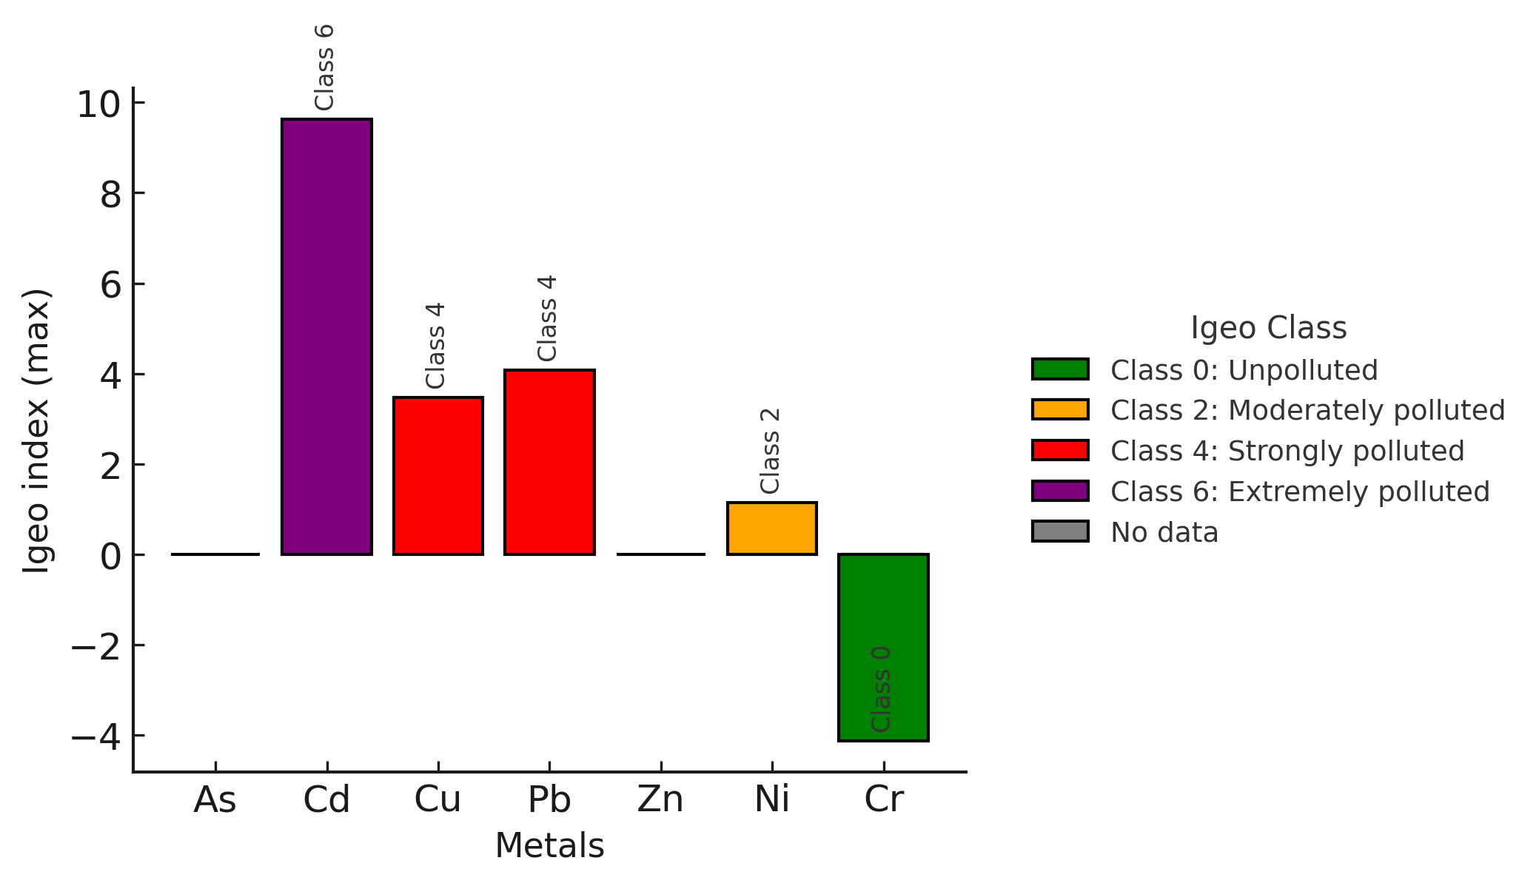
Fig. 6. Geoaccumulation index at the burning site

Figure 6 illustrates the differences between metals at the burning site. Cadmium (Cd) reaches an Igeo greater than 9, placing it in class 6 (extremely polluted). Lead (Pb) presents an Igeo greater than 4, corresponding to class 5 (heavily to extremely polluted). Copper (Cu) falls into class 4 (heavily polluted), while Nickel (Ni) is classified in class 2 (moderately polluted). Although its level is less critical than Cd, Pb, or Cu, its notable presence remains concerning. Chromium (Cr) shows a negative Igeo, indicating an unpolluted state according to this index. This figure demonstrates that the burning site is a contamination hotspot. Unlike other sites, where soils were classified as "unpolluted," here several metals far exceed reference values.
4. Discussion
Comparative analysis of maximum heavy metal concentrations in soils collected from Abomey-Calavi (excluding the burning site), Cotonou, and Natitingou shows that the measured values remain far below international guideline values (VDSS – France). Maximum arsenic concentrations reach 0.017 mg/kg in Abomey-Calavi, 0.011 mg/kg in Cotonou, and 0.003 mg/kg in Natitingou, very low levels compared to the guideline value of 19 mg/kg. This suggests an absence of notable arsenic contamination. For cadmium, maximum observed values are 4.49 mg/kg in Abomey-Calavi, 0.283 mg/kg in Cotonou, and 0.358 mg/kg in Natitingou, well below the intervention threshold of 10 mg/kg. Although cadmium is recognized as one of the most toxic metals (WHO, 2021), it appears here at low levels, reflecting limited anthropogenic pressure on the studied soils outside the burning site. Copper concentrations are also low, with maximum values of 2.34 mg/kg in Abomey-Calavi and Cotonou, and 4.49 mg/kg in Natitingou, remaining far below the critical value of 95 mg/kg. Iron, with a maximum concentration of 6.39 mg/kg in Natitingou, is naturally more abundant than other elements but is not among the critical heavy metals according to international standards. Lead is observed at levels between 0.036 mg/kg in Cotonou and 0.571 mg/kg in Natitingou, well below the 200 mg/kg limit. Zinc levels, with a maximum value of 3.12 mg/kg in Natitingou, also appear very low compared to the threshold of 4500 mg/kg. Finally, nickel and chromium do not exceed 1.27 mg/kg and 0.060 mg/kg respectively, placing them well below the critical thresholds of 70 mg/kg for nickel and 65 mg/kg for chromium. These results indicate virtually no contamination in the studied soils, excluding incineration, with levels below alert and intervention thresholds.
This situation contrasts sharply with the findings at the Abomey-Calavi burning site. Concentrations measured there are exceptionally high for certain metals. Cadmium reaches 119.08 mg/kg, far exceeding the critical value of 10 mg/kg, indicating severe contamination linked to the combustion of electronic components and plastics. Copper reaches 416.97 mg/kg, a value well above the threshold, and lead peaks at 503.02 mg/kg, exceeding the 200 mg/kg threshold, confirming the presence of residues from batteries and printed circuit boards. These exceedances reflect direct inputs from burning practices and highlight a major environmental and health risk, with lead recognized as a potent neurotoxicant (WHO, 2021). Iron, with a value of 2040.32 mg/kg, illustrates significant accumulation, although no guideline value exists for this element. Finally, nickel and chromium remain at 7.78 mg/kg and 0.060 mg/kg respectively, thus below critical values. The burning site thus stands out for alarming levels of Cd, Cu, and Pb, confirming that WEEE incineration constitutes a direct and massive source of soil pollution.
Comparison with the literature helps contextualize these results. In Ibadan, Nigeria, Adesokan et al. (2016) showed that while lead varied between 269 and 5650 mg/kg and copper between 203 and 3483 mg/kg, other metals exhibited significantly lower values. Chromium was measured between 3.3 and 42.4 mg/kg, nickel between 0.14 and 24 mg/kg, and cadmium often below 2.5 mg/kg. Similar observations have been reported in several African cities where waste mismanagement contributes to heavy metal contamination of soils and surrounding ecosystems. Studies conducted in N’Djamena (Chad), Dakar (Senegal), Abidjan (Côte d’Ivoire), and Lomé (Togo) have documented elevated concentrations of trace metals in soils located near electronic repair workshops, municipal landfills, or uncontrolled dumpsites, sometimes leading to accumulation in plants and agricultural products (Diop et al., 2023; Assy et al., 2023; Koumoubi Krega, 2024; Yandi et al., 2024). These findings highlight the role of poorly managed waste streams as important sources of metal release into urban environments. These results confirm that even in areas of intense activity, certain metals show low levels. The values obtained in Cotonou and Natitingou soils are therefore consistent with these orders of magnitude for metals. In China, in the city of Guiyu, Yekeen et al. (2016) reported mean concentrations of 448.7 mg/kg for Pb, 0.71 mg/kg for Cd, 63.9 mg/kg for Cr, and 806.5 mg/kg for Mn. However, the authors emphasize that in reference areas such as schoolyards and agricultural lands, pollution indices remained low, with a hazard index close to 0.99 for childhood exposure via soil, reflecting non-critical exposure. Here we find a similarity with the Cotonou and Natitingou sites where concentrations are very low, showing that, as in Guiyu, pollution is highly heterogeneous and depends on proximity to burning areas. In Vietnam, Uchida et al. (2018) demonstrated similar contrasts. While burnt soils exhibited copper values between 22 and 3000 mg/kg and lead between 26 and 2200 mg/kg, neighboring rice paddies showed lower levels, close to background concentrations for certain elements like nickel and molybdenum. This observation aligns with results obtained outside the burning site in Abomey-Calavi, Cotonou, and Natitingou, where measured metals remain low. In Ghana, the study by Sulemana et al. (2023) in Kumasi showed that the geoaccumulation index varied greatly depending on metals: while copper and zinc indicated high pollution, aluminum presented an Igeo ≤ 0, reflecting an absence of contamination. These results confirm that certain elements, even in areas known for pollution, are found in low concentrations, which aligns with the situation measured for arsenic, nickel, or chromium at our sites. The study by Owusu-Sekyere et al. (2024) at Agbogbloshie revealed very high surface levels, with lead concentrations reaching up to 35,300 mg/kg. However, the authors emphasize that in deeper layers, between 30 and 100 cm, concentrations decreased markedly. This illustrates that, even in the most contaminated sites, pollution can be limited to surface strata, while deeper layers exhibit low levels. This observation relates to our results in Cotonou and Natitingou, where surface measurements were already low, suggesting diffuse but not accumulated contamination. Comparison between our results and previous studies confirms a common pattern: soil pollution by heavy metals from WEEE is highly heterogeneous. Burning sites, such as the Abomey-Calavi incineration site or the workshops described in Vietnam and Ghana, exhibit extreme concentrations, while peripheral, agricultural, reference, or deeper areas show significantly lower levels. Our results for Abomey-Calavi (excluding incineration), Cotonou, and Natitingou thus align with international observations highlighting the coexistence of highly contaminated hotspots and low-concentration areas.
The geoaccumulation index (Igeo) results show a marked contrast between soils from conventional disposal sites (Abomey-Calavi, Cotonou, and Natitingou) and those from the burning site in Abomey-Calavi. At non-burning sites, in Abomey-Calavi, Cotonou, and Natitingou, almost all heavy metals exhibit negative or near-zero Igeo values, corresponding to class 0, indicating unpolluted soils. Only a few isolated cases of cadmium show slightly positive indices (class 1, unpolluted to moderately polluted), but they do not indicate widespread contamination. These results indicate an absence of significant soil pollution, despite the presence of electronic waste. The situation is different at the Abomey-Calavi burning site. Here, cadmium reaches Igeo values greater than 9, class 6, corresponding to an extremely polluted level. Lead falls between classes 5 and 6, indicating heavily to extremely polluted soil. Copper is classified in class 4, indicating heavy pollution, while nickel reaches class 2, moderate pollution. In contrast, chromium remains classified as unpolluted.
This difference between sites aligns with observations made in other contexts. In Accra, Ackah (2019) calculated the geoaccumulation index in soils from Agbogbloshie and Ashaiman. Results showed that surface soils from burning and dismantling areas were heavily contaminated with lead and copper, with Igeo values classified in the extreme category. In contrast, certain elements such as chromium, iron, arsenic, and barium exhibited Igeo values less than or equal to zero, indicating an absence of contamination. This heterogeneity is comparable to that observed at our sites, where only a few metals reach high classes, while others remain unpolluted (Ackah, 2019). The results of Owusu-Sekyere et al. (2024) confirm this dynamic. In their study on informal e-waste processing at Agbogbloshie, the geoaccumulation index revealed high accumulation of copper, lead, and cadmium, with indices ranging from moderately to extremely polluted depending on the areas studied. However, in certain deeper layers and at reference sites, Igeo values remained low, reflecting limited or no contamination. This spatial and vertical variability reflects well the contrast we observe between our non-burning sites, generally unpolluted, and the Abomey-Calavi burning site, where values reach extreme classes (Owusu-Sekyere et al., 2024). In Nigeria, Udousoro et al. (2025) also highlighted, through Igeo, situations of severe contamination. Cadmium emerged as a major pollutant, with Igeo values classified in the heavily to extremely polluted categories. Other metals like arsenic or cobalt exhibited much lower indices, ranging from unpolluted to moderately polluted. This observation is consistent with our results, where cadmium dominates the pollution index at the burning site, while elements like arsenic and chromium remain classified as unpolluted (Udousoro et al., 2025).
Global comparison thus shows that at electronic waste disposal sites, Igeo values are low (class 0), confirming an absence of notable contamination. In contrast, burning sites appear as true environmental pollution hotspots, where certain metals reach the highest classes. This finding is general, observed at Abomey-Calavi but also in Accra (Ackah, 2019), in analyses of specific processes at Agbogbloshie (Owusu-Sekyere et al., 2024), and at Nigerian sites studied by Udousoro et al. (2025). Our results thus confirm that electronic waste incineration constitutes a major source of metal pollution, in contrast to simple accumulation sites where soils remain generally unpolluted. This difference highlights the central role of management practices: disposal poses limited risk, while burning generates acute pollution and potentially serious impacts on human health through inhalation or ingestion and on ecosystems through bioaccumulation and transfer. Despite the relevant results obtained in this study, several limitations should be acknowledged. First, the sampling campaign was conducted during a single period, which does not allow the evaluation of seasonal variations in heavy metal concentrations in soils. Furthermore, the number of sampling sites remains relatively limited, which may restrict the spatial representativeness of contamination within the study area. In addition, this work focused only on the assessment of total metal concentrations and did not consider metal speciation or bioavailability, which play an important role in their mobility, environmental transfer, and potential toxicity. Future research could include longer term monitoring, a larger number of sampling sites, as well as the assessment of metal bioavailability and the associated ecological and human health risks.
5. Conclusion
The assessment of soils collected from Abomey-Calavi, Cotonou, and Natitingou reveals that, excluding incineration, almost all heavy metals exhibit very low concentrations and negative or near-zero geoaccumulation indices (Igeo). These results indicate that soils remain generally unpolluted, despite the presence of electronic waste at these sites. Only a few isolated cases of cadmium reach slightly positive values, reflecting localized but not widespread contamination. In contrast, the Abomey-Calavi burning site constitutes a major environmental pollution hotspot, with extreme concentration levels for cadmium, lead, and copper, reaching Igeo classes 6, 5, and 4 respectively. Overall, our results highlight a marked duality between disposal sites, generally unpolluted, and combustion areas where heavy metal concentrations reach alarming levels. These observations align with conclusions from other studies conducted in West Africa and Asia, confirming that incineration constitutes the main source of soil contamination by metals from WEEE. These findings call for urgent measures such as strict prohibition of electronic waste burning, establishment of formal collection, recycling, and treatment systems, and development of national regulations adapted to WEEE challenges. Organized management would help limit environmental and health impacts while recovering resources contained in this waste within a perspective of circular economy and sustainability.

DISCLAMER (ARTIFICIAL INTELLIGENCE)
Author(s) hereby declare that NO generative AI technologies such as Large Language Models (ChatGPT, COPILOT, etc.) and text-to-image generators have been used during the writing or editing of this manuscript.
REFERENCES
Abedin, M. J., Wangwongwatana, S., Bhuiyan, M. N. H., Moniruzzaman, M., Norkaew, S., Tan, Q., & Liang, L. (2025). Assessments of heavy metal contamination found in environmental samples from informal e-waste recycling communities in Chattogram City, Bangladesh. Journal of Hazardous Materials Advances, 19, 100845. https://doi.org/10.1016/j.hazadv.2025.100845
Ackah, M. (2019). Soil elemental concentrations, geoaccumulation index, non-carcinogenic and carcinogenic risks in functional areas of an informal e-waste recycling area in Accra, Ghana. Chemosphere, 235, 908–917. https://doi.org/10.1016/j.chemosphere.2019.07.014
Adesokan, M. D., Adie, G. U., & Osibanjo, O. (2016). Soil pollution by toxic metals near e-waste recycling operations in Ibadan, Nigeria. Journal of Health and Pollution, 6(11), 26–33. https://doi.org/10.5696/2156-9614-6-11.26
Akanchise, T., Boakye, S., Borquaye, L. S., Dodd, M., & Darko, G. (2020). Distribution of heavy metals in soils from abandoned dump sites in Kumasi, Ghana. Scientific African, 10, e00614. https://doi.org/10.1016/j.sciaf.2020.e00614
American Public Health Association (APHA), American Water Works Association (AWWA), & Water Environment Federation (WEF). (2017). 3111 B: Metals by Flame Atomic Absorption Spectrometry. In Standard Methods for the Examination of Water and Wastewater (23rd ed.). Washington, DC: APHA. https://www.standardmethods.org/doi/10.2105/SMWW.2882.043
American Public Health Association (APHA), American Water Works Association (AWWA), & Water Environment Federation (WEF). (2017). 3500-Fe B: Iron by Phenanthroline. In Standard Methods for the Examination of Water and Wastewater (23rd ed.). Washington, DC: APHA. https://www.standardmethods.org/doi/10.2105/SMWW.2882.055
Assy, H. C., Yapi, D. Y. A., & Dan, G. C. (2023). Impact des décharges sauvages sur la qualité des cultures maraîchères dans le district d’Abidjan. Afrique Science, 23(6), 93–103. https://www.afriquescience.net/admin/postpdfs/5a72242860a59d7838114955febbda57.1718281632.pdf
Diop, T., Diarra, A., Diallo, M. A., & Dione, M. M. (2023). Impact d'une décharge urbaine sur la contamination métallique des sols : cas de la décharge de Mbeubeuss (Dakar). International Journal of Biological and Chemical Sciences, 16(6), 2992–3002. https://doi.org/10.4314/ijbcs.v16i6.41
Fosu-Mensah, B. Y., Addae, E., Yirenya-Tawiah, D., & Nyame, F. (2017). Heavy metals concentration and distribution in soils and vegetation at Korle Lagoon area in Accra, Ghana. Cogent Environmental Science, 3(1), 1405887. https://doi.org/10.1080/23311843.2017.1405887
International Organization for Standardization. (1986). ISO 8288:1986 – Water quality — Determination of cobalt, nickel, copper, zinc, cadmium and lead — Flame atomic absorption spectrometric methods. Geneva, Switzerland: ISO.https://www.iso.org/standard/15408.html
International Organization for Standardization. (1988). ISO 6332:1988 – Water quality — Determination of iron — Spectrometric method using 1,10-phenanthroline. Geneva, Switzerland: ISO. https://www.iso.org/standard/12630.html
International Organization for Standardization. (1994). ISO 11083:1994 – Water quality — Determination of chromium(VI) — Spectrometric method using 1,5-diphenylcarbazide. Geneva, Switzerland: ISO. https://cdn.standards.iteh.ai/samples/19070/188e8eea9daf4460a39dce7dd553aefd/ISO-11083-1994.pdf
International Organization for Standardization. (2006). ISO 11464:2006 – Soil quality — Pretreatment of samples for physico-chemical analysis. Geneva, Switzerland: ISO. https://www.iso.org/standard/37718.html
International Organization for Standardization. (2007). ISO 18512:2007 – Soil quality — Guidance on long and short term storage of soil samples. Geneva, Switzerland: ISO. https://cdn.standards.iteh.ai/samples/38721/0f71e117f8be460d897dd1af360dbe4e/ISO-18512-2007.pdf
International Organization for Standardization. (2013). ISO 16729:2013 – Soil quality — Digestion of nitric acid soluble fractions of elements. Geneva, Switzerland: ISO. https://www.iso.org/standard/57562.html
International Organization for Standardization. (2017). ISO 18400-101:2017 – Soil quality — Sampling — Part 101: Framework for the preparation and application of a sampling plan. Geneva, Switzerland: ISO. https://www.iso.org/standard/62842.html
Koumoubi Krega. (2024). Contamination du mercure issu des déchets d’équipements électriques et électroniques sur les sols et les eaux à N’Djamena. AFLASH – Revue scientifique. https://aflash-revue-mdou.org/article/114/pdf
Mossmann, J.-R., & Koch-Mathian, J.-Y. (2001). Gestion des sites (potentiellement) pollués et évaluation simplifiée des risques. Suivi de la mise en œuvre de la version 2 (Rapport BRGM/RP-51216-FR, 44 p., 2 annexes). Orléans, France: Bureau de Recherches Géologiques et Minières (BRGM) https://infoterre.brgm.fr/rapports/RP-51216-FR.pdf
Müller, G. (1969). Index of geoaccumulation in sediments of the Rhine River. GeoJournal, 2, 108–118. https://www.sciepub.com/reference/428983?
Owusu-Sekyere, K., Aladago, D. A., Leverenz, D., Oteng-Ababio, M., & Kranert, M. (2024). Environmental impacts on soil and groundwater of informal e-waste recycling processes in Ghana. Sustainability, 16(11), 4347. https://doi.org/10.3390/su16114347
Pibul, P., Jawjit, S., & Yimthiang, S. (2023). Soil heavy metal pollution from waste electrical and electronic equipment of repair and junk shops in southern Thailand and their ecological risk. Heliyon, 9(9), e20438. https://doi.org/10.1016/j.heliyon.2023.e20438
Shroder, J. F. (Éd.). (2013). Treatise on Geomorphology (Vols. 1-14). Elsevier.
https://www.sciencedirect.com/referencework/9780080885223/treatise-on-geomorphology
Sulemana, A., Koduah, M., Owiredu, S., Tengan, C. L., Agyare, E. A., Boateng, K. S., & Nsafoah, E. K. (2023). Spatial distribution of heavy metals in e-waste contaminated site at Akwatia-Line, Kumasi, Ghana. SSRN Electronic Journal. https://ssrn.com/abstract=4547135
Teye, A. K., & Tetteh, I. K. (2023). Heavy metal pollution resulting from informal e-waste recycling in the Greater Accra Region of Ghana. In Heavy Metals – Recent Advances. IntechOpen. https://doi.org/10.5772/intechopen.112397
Turekian, K. K., & Wedepohl, K. H. (1961). Distribution of the elements in some major units of the earth’s crust. Geological Society of America Bulletin, 72(2), 175–192. https://doi.org/10.1130/0016-7606(1961)72[175:DOTEIS]2.0.CO;2
Uchida, N., Matsukami, H., Someya, M., Tue, N. M., Tuyen, L. H., Viet, P. H., Takahashi, S., Tanabe, S., & Suzuki, G. (2018). Hazardous metals emissions from e-waste-processing sites in a village in northern Vietnam. Emerging Contaminants, 4, 11–21. https://doi.org/10.1016/j.emcon.2018.10.001
Udousoro, I. I., Umoh, E., Udo, E., Akpan, J., & Akpan, E. (2025). Assessment of electronic waste for heavy metal pollution in soils: Application of contamination and ecological risk indices. Environmental Pollution and Management. https://doi.org/10.1016/j.epm.2025.09.003
Yandi, G., Bokobana, E. M., Mawussi, G., Koba, K., & Sanda, K. (2024). Potentiel de bioaccumulation de quelques métaux lourds par Moringa oleifera L. de décharge dans la ville de Lomé et ses banlieues au Togo. Agronomie Africaine, 36(1), 63–72. https://www.inter-reseaux.org/wp-content/uploads/ajol-file-journals_7_articles_275863_66b386d0d6f96-1.pdf
Yekeen, T. A., Xu, X., Zhang, Y., Wu, Y., Kim, S., Reponen, T., Dietrich, K. N., Ho, S. M., Chen, A., & Huo, X. (2016). Assessment of health risk of trace metal pollution in surface soil and road dust from e-waste recycling area in China. Environmental Science and Pollution Research, 23(17), 17511–17524. https://doi.org/10.1007/s11356-016-6896-6

APPENDIX
Table A1. Descriptive statistics of heavy metal concentrations (mg/kg) by city
City | As (mean ± sd ; min–max) | Cd (mean ± sd ; min–max) | Cu (mean ± sd ; min–max) | Fe (mean ± sd ; min–max) | Pb (mean ± sd ; min–max) | Zn (mean ± sd ; min–max) | Ni (mean ± sd ; min–max) | Cr (mean ± sd ; min–max)
Abomey-Calavi | 0.001 ± 0.004 ; 0–0.017 | 3.95 ± 21.04 ; 0–119.08 | 23.18 ± 91.67 ; 0–416.97 | 123.33 ± 483.23 ; 0.22–2040.32 | 21.01 ± 92.89 ; 0–503.02 | 0.33 ± 0.22 ; 0–1.06 | 7.57 ± 40.09 ; 0–226.83 | 0.36 ± 1.43 ; 0–7.78
Cotonou | 0.002 ± 0.003 ; 0–0.011 | 0.08 ± 0.08 ; 0–0.28 | 0.40 ± 0.72 ; 0–2.34 | 1.09 ± 1.03 ; 0.13–3.70 | 0.01 ± 0.01 ; 0–0.036 | 0.58 ± 0.50 ; 0.12–1.83 | 0.22 ± 0.39 ; 0–1.27 | 0.02 ± 0.02 ; 0–0.057
Natitingou | 0.000 ± 0.001 ; 0–0.003 | 0.17 ± 0.08 ; 0.04–0.36 | 0.99 ± 1.48 ; 0–4.49 | 1.99 ± 1.87 ; 0.46–6.39 | 0.22 ± 0.15 ; 0.10–0.57 | 1.01 ± 0.90 ; 0.28–3.12 | 0.16 ± 0.24 ; 0–0.74 | 0.04 ± 0.02 ; 0–0.057

Table A2. Kruskal-Wallis test results
Metal | χ² (Kruskal–Wallis) | ddl | p-value
As | 5.09 | 2 | 0.078
Cd | 20.92 | 2 | <0.001
Cu | 18.42 | 2 | <0.001
Fe | 12.73 | 2 | 0.0017
Pb | 30.91 | 2 | <0.0001
Zn | 12.65 | 2 | 0.0018
Ni | 12.62 | 2 | 0.0018
Cr | 7.48 | 2 | 0.023

Table A3. Dunn's post-hoc test results (pairwise comparisons)
Metal | Comparison | Z | Adjusted p(BH)
Cd | Abomey-Calavi vs others | -4.57 | <0.001
Cd | Cotonou – Natitingou | -3.12 | 0.0027
Cr | Abomey-Calavi vs others | 2.49 | 0.038
Cu | Abomey-Calavi vs others | -4.16 | <0.001
Cu | Abomey-Calavi vs others | -2.53 | 0.017
Cu | Cotonou – Natitingou | -2.25 | 0.025
Fe | Abomey-Calavi vs others | -3.55 | 0.001
Fe | Cotonou – Natitingou | -2.30 | 0.032
Ni | Abomey-Calavi vs others | -3.28 | 0.003
Ni | Abomey-Calavi vs others | -2.50 | 0.018
Pb | Abomey-Calavi vs others | -5.45 | <0.0001
Pb | Cotonou – Natitingou | -4.66 | <0.0001
Zn | Abomey-Calavi vs others | -3.54 | 0.0012
Zn | Cotonou – Natitingou | -2.31 | 0.032

Igeo class reminder (Müller, 1969)
Class 0: Igeo ≤ 0 → Unpolluted
Class 1: 0 < Igeo ≤ 1 → Unpolluted to moderately polluted
Class 2: 1 < Igeo ≤ 2 → Moderately polluted
Class 3: 2 < Igeo ≤ 3 → Moderately to heavily polluted
Class 4: 3 < Igeo ≤ 4 → Heavily polluted
Class 5: 4 < Igeo ≤ 5 → Heavily to extremely polluted
Class 6: Igeo > 5 → Extremely polluted

