Assessment of the state of knowledge, risk prevention, and natural disaster management in the agrosylvopastoral areas of urban perimeter of Ngozi (2012–2024)

Abstract

This study assesses knowledge, risk prevention, and natural disaster management in the agrosylvopastoral areas of the urban perimeter of Ngozi for the period 2012–2024. A representative sample of 206 participants was surveyed, including 175 community members (168 agropastoralists out of a total population of 16,807 and 7 neighborhood leaders out of 7), 7 administrative officials at the communal, provincial, and regional levels out of 7, and 24 representatives of private organizations out of 24. Data were collected through focus groups, interviews, field observations, photographs, and map analyses, and were analyzed both qualitatively and quantitatively.
The results reveal significant knowledge gaps: only 28.6% of neighborhood leaders and 21.4% of agropastoralists are aware of the roles of local civil protection teams, compared to 85.7% of administrative officials and 75% of private organization representatives. Moreover, 100% of neighborhood leaders and agropastoralists are unaware of the existence of the Risk Prevention Plan, compared with only 14.3% of administrative officials and 29.2% of private organization representatives. These gaps are mainly explained by the limited dissemination of information.
Participants proposed solutions such as a rational urban land use master plan, masonry drainage channels, and agroforestry practices. However, implementation remains limited, and waste management systems are lacking. This study highlights the insufficient culture of risk prevention in Ngozi and emphasizes the importance of strengthening awareness, education, and stakeholder coordination.
Keywords: Risks, disasters, risk prevention, disaster management.
1. Introduction

Faced with the imminent threat of climate change, disasters associated with the increasing vulnerability of urbanized societies have become a major concern. According to previous studies, more than half of the world’s population now resides in urban areas (UN-Habitat, 2010; Béatrice Quenau, 2013), and rapidly expanding cities experience exponential population growth, thereby amplifying risks in already exposed urban zones where multiple assets are concentrated, including populations, economic activities, and both material and immaterial resources.
Until recently, Burundi appeared to be relatively less exposed to natural risks and disasters. However, over the past few decades, the country has experienced extreme weather events, such as droughts, floods, storms, hail, and landslides. These events are frequently linked to torrential rainfall, which appears to be occurring more often and with potentially greater intensity and destructiveness than in the past.
In this context, the urban perimeter of Ngozi Province in northern Burundi is not immune to these globally recognized natural risks and disasters. Nyengayenge (2002) notes that the landscape of Ngozi’s urban center is characterized by hills ranging from 1,500 to 1,900 meters in elevation from west to east. The steep terrain is organized into watersheds, favoring surface runoff and consequently intensifying soil erosion, particularly on geologically soft and fragile soils.
The high population density in the city of Ngozi further contributes to the occurrence and exacerbation of natural disaster risks. The absence of a well-defined and enforced urban and peri-urban master plan has led the population to engage in inappropriate practices, thereby triggering additional disaster risks.
Within this context, this study investigates local perceptions and the challenges related to risk prevention and natural disaster management in the agrosylvopastoral areas of the urban perimeter of Ngozi. The objective is to support local communities by enhancing their understanding of existing risks and natural hazards. Additionally, the study aims to help these communities identify evidence-based strategies for the prevention and management of such risks, focusing on the period from 2012 to 2024.
Regarding the Research Questions and Hypotheses:
a) Main research question
What is the current state of knowledge, risk prevention, and natural disaster management in the agrosylvopastoral areas of the urban perimeter of Ngozi?
b) Specific research questions
- What is the level of knowledge among the population regarding the general concepts of risk prevention and natural disaster management in the study area?
- What are the causes of the existing natural risks in the study area?
- What strategies are hierarchically proposed by the population for mitigation and resilience to natural disaster risks in the study area?
- What is the level of implementation of risk prevention and natural disaster management techniques by the population in the study area?
c) Hypotheses
- Overall hypothesis
Insufficient knowledge of risks, combined with limited prevention and inadequate management of natural disasters, exacerbates the vulnerability of agrosylvopastoral areas within the urban perimeter of Ngozi.
- Specific hypotheses
- The population of the study area has limited knowledge of the concepts of risk prevention and natural disaster management, mainly due to the lack of education and awareness on these issues;
- The main causes of risks in the study area include uncontrolled housing construction, lack of awareness of natural risk prevention and disaster management plans, insufficient appropriate drainage and waste management infrastructure, and inadequate agricultural and environmental conservation practices in a context of heavy rainfall and steep slopes;
- The resilience and mitigation strategies proposed by the population include the use of a master land-use plan for the urban perimeter of Ngozi, the establishment of rainwater drainage infrastructure, wastewater and waste management systems, the elimination of forming gullies, reforestation, and watershed management;
- The implementation of risk prevention and natural disaster management techniques remains insufficient due to the lack of resources, training, and institutional monitoring.

2. Materials and methods
This study aimed to assess knowledge, risk prevention, and natural disaster management in the agrosylvopastoral areas of the urban perimeter of Ngozi over the period 2012–2024. A comprehensive methodological approach was adopted to ensure the reliability, representativeness, and relevance of the collected data for disaster risk reduction strategies.
2.1. Study area and target population
The research was conducted in seven neighborhoods located within the urban perimeter of Ngozi: Muremera, Rubuye, Rusuguti, Kanyami, Kinyami, Shikiro, and Gabiro. The study area is characterized by steep topography, fragile soils, and a high population density, which increase the vulnerability of local communities to natural hazards such as floods, landslides, soil erosion, and droughts.
The target population included community agropastoralists, neighborhood leaders, administrative authorities, and representatives of private organizations involved in agrosylvopastoral activities. A representative sample of 206 participants was surveyed, consisting of :
Community members (175 participants): 168 agropastoralists (out of a total population of 16,807) and 7 neighborhood leaders (out of 7);
Administrative officials 7 participants: representing communal, provincial, and regional levels;
Private organization representatives (24 participants): all active in agrosylvopastoral activities in the study area.

Participants were selected using a purposive sampling method, ensuring the inclusion of key stakeholders involved in disaster risk prevention and management. Considering the total population of agropastoralists, the sample size corresponds to approximately 1% of the population, with a 7% margin of error and a 93% confidence level, which is statistically acceptable for the objectives of this study.

2.2. Data collection methods

Data were collected using a combination of qualitative and quantitative methods in order to obtain comprehensive information on knowledge levels, risk perception, and disaster management practices.
First, a documentary analysis was conducted through a review of scientific publications, governmental reports, and technical documents related to disaster risk reduction and environmental management in agrosylvopastoral and peri-urban areas.
Second, a systemic analysis was carried out to examine the interactions between environmental, social, and institutional factors influencing natural disaster risks. This analysis was supported by field observations, photographs, and cartographic analyses.
Third, focus group discussions and individual interviews were conducted with the four categories of participants. These interviews were semi-structured and aimed at identifying existing knowledge, perceived risks, and proposed mitigation strategies.
Additionally, field visits and direct observations were performed in the seven study sites to assess agrosylvopastoral practices, land use patterns, drainage infrastructure, and areas exposed to environmental hazards.
Photographs and maps were used to document and visualize risk-prone areas. Data collection tools included structured questionnaires, a digital camera, smartphones, and the KoboToolbox software platform, which was used to digitize and manage survey responses.

2.3. Statistical analysis

The collected data were analyzed using both descriptive and comparative statistical methods.
Descriptive statistics, including frequencies and percentages, were used to summarize the level of knowledge and awareness among different groups of participants. For example, the analysis showed that 28.6% of neighborhood leaders and 21.4% of agropastoralists were aware of the roles of local civil protection teams, compared with 85.7% of administrative officials and 75% of private organization representatives.
Furthermore, 100% of neighborhood leaders and agropastoralists were unaware of the Risk Prevention Plan, while 14.3% of administrative officials and 29.2% of private organization representatives lacked such knowledge.
A risk prioritization method was also applied using a severity scale ranging from 1 to 5. The severity of each identified risk was calculated using the following formula:
Severity = Probability × Impact
This approach allowed the ranking of natural hazards according to their level of potential impact in the study area.
In addition, a comparative analysis of proportions was conducted to identify differences in knowledge and preparedness between community members, administrative authorities, and private sector representatives.
Qualitative data obtained from interviews and focus groups were analyzed using thematic analysis, enabling the identification of common perceptions, key challenges, and proposed solutions for improving disaster risk prevention and management.

2.4. Ethical considerations

All participants provided informed consent prior to their participation in the study. The confidentiality of the collected information was strictly maintained, and the data were used exclusively for scientific research purposes.

3. Results and discussion
3.1. Results
3.1.1. Assessment of the general level of knowledge of the population on risk prevention and natural disaster management
A significant knowledge gap was observed regarding the roles and functions of local protection committee teams. Only 28.6% of neighborhood leaders and 21.4% of agropastoralists were aware of these roles, compared to 85.7% of provincial, communal, and regional administrative officials and 75% of representatives from private organizations who understood the mission of these teams.
Similarly, a substantial gap exists concerning awareness of the Risk Prevention Plan covering the urban perimeter of Ngozi. All neighborhood leaders and agropastoralists (100%) reported being unaware of this plan, whereas only 14.3% of administrative officials and 29.2% of private organization representatives indicated a lack of knowledge regarding the same plan.
A notable disparity was also observed regarding household preparedness. When asked whether their families experienced fear due to uncertainty about appropriate actions during a disaster, 85.7% of neighborhood leaders and 70.2% of agropastoralists reported such fear. In contrast, only 28.5% of administrative officials and 29.1% of private organization representatives reported similar concerns within their families.
.
3.1.2. Identification and prioritization by respondents of the causes of natural risks in the study area
Table 1. The respondents identified and prioritized the causes of natural risks. The following table shows the results obtained:
Causes of risks | Probability | Impact | Severity | Rank
Unplanned construction of residential houses/private service buildings; lack of a well-developed and well-known natural risk prevention and disaster management plan among the population; fragile soils | 5 | 5 | 25 | 1st
Problems related to water and waste evacuation structures using soak pits and septic tanks in residential and service areas | 5 | 4 | 20 | 2nd
Problems related to masonry drainage channels for rainwater in public areas | 4 | 4 | 16 | 3rd
Problems related to agroforestry; lack of fascines, infiltration ditches, and contour lines | 3 | 4 | 12 | 4th
Problems related to solid waste treatment units in the urban environment | 5 | 2 | 10 | 5th
Heavy rainfall | 4 | 2 | 8 | 6th
Destruction of vegetation cover | 3 | 2 | 6 | 7th
Delay in rainfall | 2 | 2 | 4 | 8th
Relief (thriggering factor) | 2 | 1 | 2 | 9th

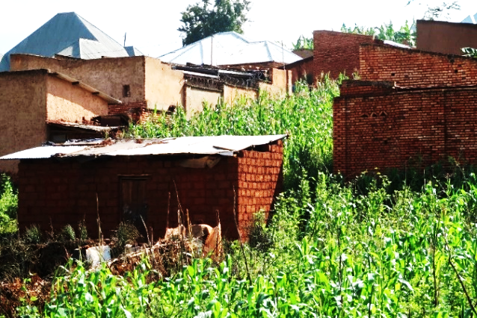
Photo 1: Unplanned construction of residential houses on steep slopes without respect for urban planning standards in KINYAMI I neighborhood of the study area (NDIKUMANA, October 2024)

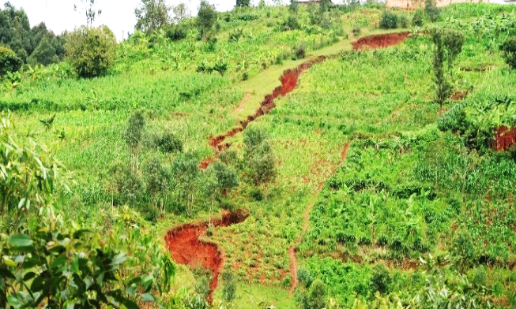
Photo 2: Watershed not protected by contour lines, infiltration ditches, soil-stabilizing grasses, anti-erosion hedges, or masonry drainage channels in the MUREMERA-SAMUTUKU neighborhood of the study area (NDIKUMANA, October 2024)
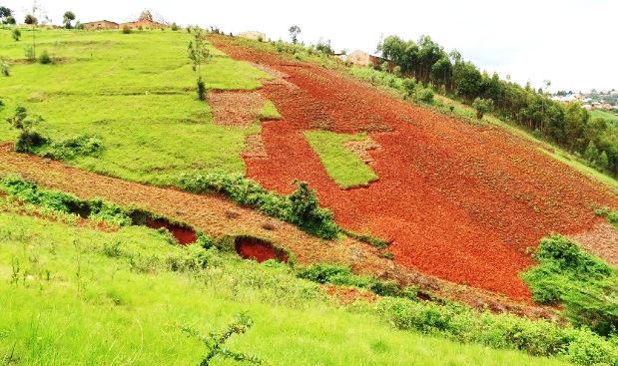
Photo 3: Agricultural farms on steep slopes without protection in the Muremera–Nyabusorongo sub-hill neighborhood of the study area (NDIKUMANA, October 2024)
3.1.3. Prioritization by respondents of existing natural disasters in the study area
First, respondents indicated that the loss of soil fertility leads to a decline in agricultural yields, which subsequently contributes to food insecurity within the community.
Second, gully erosion was reported as a major concern, resulting in the loss of arable land, destruction of biodiversity, and damage to both movable and immovable property.
Third, prolonged periods of insufficient rainfall were identified, causing drought that negatively affects crops and vegetation, thereby reducing agricultural productivity and increasing the risk of famine.
Finally, respondents highlighted the impact of torrential rains, which particularly damage crops and, more broadly, biodiversity. These heavy rains also exacerbate soil erosion, reduce soil fertility, contribute to water pollution, and lead to the destruction of both movable and immovable property.
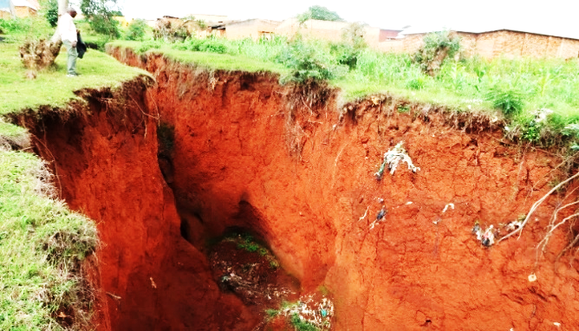
Photo 4: A large gully resulting from the lack of watershed protection through infiltration ditches, soil-stabilizing grasses, anti-erosion hedges, and masonry drainage channels in the RUSUGUTI neighborhood of the study area (NDIKUMANA, October 2024).
3.1.4. Identification and prioritization by respondents of mitigation and resilience strategies for natural risks and disasters in the study area
Therefore, the current situation could be improved if a comprehensive urban land-use master plan is properly established and implemented. This should be complemented by the construction of masonry drainage channels to direct rainwater toward low-lying areas, the installation of soak pits for wastewater in residential and service zones, and the establishment of contour lines, soil-stabilizing grasses, infiltration ditches, and fascines on steep slopes. Additionally, the adoption of agroforestry practices in agricultural farms, the implementation of solid and liquid waste management systems throughout the city, and the rapid control and remediation of gullies would further contribute to mitigating the risks present in the study area.
3.1.5. Determination of existing techniques for risk prevention and natural disaster management in the study area
The implementation of good practices in the study area remains limited. Specifically, there is a low level of adoption of measures such as the rational utilization of the urban perimeter of Ngozi in accordance with an appropriate city land-use master plan, the construction of masonry drainage channels for rainwater discharge to lowlands, the installation of soak pits for wastewater in residential and service areas, the establishment of contour lines, soil-stabilizing grasses, infiltration ditches, and fascines on steep slopes, as well as the rapid control and remediation of gullies upon their occurrence.
In contrast, the adoption of agroforestry practices in agricultural farms is observed at a moderate level.
Photo 5: Contour lines with their vegetation on Muremera Hill
(NDIKUMANA, October 2024)

3.1.6. Detailed and quantified consequences related to natural disasters reported by respondents for the period 2012–2024 in the study area
A detailed and quantified assessment revealed numerous adverse events reflecting the vulnerability of the seven neighborhoods to natural risks and disasters. Notably, heavy rainfall in the study area resulted in the formation of 24 gullies, some measuring up to 15 m in depth and 15 m in width, which have caused 36 human fatalities and serious injuries to 19 additional individuals. These gullies, extending across the north–south and east–west axes and throughout the urban perimeter of Ngozi, have affected a total of 19.2 hectares of agrosylvopastoral land.
Between 2012 and 2024, heavy rainfall events destroyed 270 houses, and accompanying lightning strikes claimed 14 lives. Additionally, fifteen domestic animals in these localities were lost. A substantial decline in agrosylvopastoral production has been recorded in areas impacted by these extensive gullies, some of which extend up to 1.9 km in length, 15 m in depth, and 15 m in width. Agricultural activities have largely ceased in these zones due to gully encroachment, potentially exacerbating food insecurity among local populations.
The development of these gullies within an urban context has also reduced the available land for residential and agricultural use, particularly given the continuous expansion of the city and the growing population of surrounding villages.

4. Discussion of the results
The findings of this study are consistent with previous research on environmental degradation and vulnerability to natural hazards in human-influenced landscapes. According to Elodie (2011), soil cracking generally occurs after prolonged drought periods, creating pathways that facilitate deep water infiltration. These processes can increase soil instability and contribute to erosion and landslides, particularly in areas where soils are already fragile. Field observations and interviews conducted with agropastoralists in the study area confirmed that soil degradation and erosion are more pronounced in zones subjected to intense human activities such as agriculture, grazing, and unplanned urban expansion.
These observations support the argument that human activities significantly accelerate soil degradation and environmental vulnerability. The presence of degraded soils in highly anthropized areas, as highlighted by Elodie (2011), is therefore consistent with the conditions observed in the agrosylvopastoral zones located within the urban perimeter of Ngozi.
With regard to vulnerability to natural risks and disasters, Virtual University for Small States of the Commonwealth (2018) emphasizes that all societies are exposed to disasters, whether of natural or anthropogenic origin. Vulnerability tends to increase when basic needs such as physical security, food availability, and adequate shelter are not sufficiently met. The results of the present study indicate that limited awareness and knowledge of disaster risk prevention and management among local communities constitute significant factors that exacerbate vulnerability. Insufficient dissemination of information and lack of awareness programs reduce the ability of communities to anticipate hazards and adopt preventive measures.
Furthermore, vegetation cover plays a crucial role in protecting soils against erosion, as indicated by Elodie (2011). In the study area, the reduction of vegetation cover due to agricultural expansion, urbanization, and deforestation has weakened the natural protection of soils against rainfall impact and surface runoff. This situation is further aggravated by the fragile nature of the soils in the region, which, according to Georges Feodoroff (1965, cited in Michel Mietton, 1988), have limited resistance to intense rainfall and runoff processes.
The statistical results of this study also reveal disparities in the level of knowledge regarding disaster risk management among different stakeholder groups. Administrative officials and representatives of private organizations demonstrate relatively higher levels of awareness, whereas community members particularly agropastoralists exhibit significant knowledge gaps. These differences highlight the need to strengthen communication mechanisms and knowledge transfer between institutions and local populations. these results are consistent with the findings of Ben et al. (2004), who emphasize that differences in access to information and knowledge between institutions, organizations, and local communities can create inequalities in the perception and management of disaster risks.
According to Jean-Marc Heitz (2005), natural risks and disasters are associated with hazards that often evolve gradually and whose impacts can be difficult to predict. Such hazards may cause substantial losses in human lives, infrastructure, and economic resources. The results of the present study confirm that these risks can significantly affect territorial organization by generating social, economic, and ecological disruptions.
Similarly, Abdessalem et al. (2016) describe disasters as situations involving major disruptions in the functioning of a community or society, often requiring external assistance to recover. In the study area, the combination of environmental fragility, rapid urbanization, and limited awareness of risk prevention strategies contributes to conditions that may increase the probability and impact of natural disasters.
Overall, the results highlight the complex interactions between environmental conditions, human activities, and institutional preparedness in shaping disaster risk in the agrosylvopastoral areas of the urban perimeter of Ngozi.
Conclusion
The results of this study indicate that the population in the study area has a limited understanding of the concepts of risk prevention and natural disaster management. This situation is largely explained by insufficient education, training, and awareness programs related to disaster risk reduction.
Through surveys, focus group discussions, and statistical analyses, the study identified and ranked the major factors contributing to natural risks in the study area. The findings reveal that unplanned urban development, fragile soil conditions, inadequate drainage infrastructure, and limited knowledge of risk prevention and disaster management strategies constitute the principal factors contributing to the current vulnerability of the territory.
Moreover, the limited dissemination of the Risk Prevention Plan among local communities further increases exposure to environmental hazards. Strengthening collaboration and communication between administrative authorities, local communities, and private stakeholders therefore appears essential for improving disaster preparedness and response capacity.
Overall, the study demonstrates that the culture of risk prevention and disaster management remains insufficiently developed among local communities in the agrosylvopastoral areas of the urban.
This manuscript is important for the scientific community because it provides a comprehensive assessment of the current state of knowledge, risk prevention strategies, and natural disaster management practices in agrosylvopastoral areas within the urban perimeter of Ngozi. By analyzing the period from 2012 to 2024, the study offers valuable insights into how communities perceive, prevent, and manage natural disasters in a rapidly evolving urban–rural interface. The findings contribute to a broader understanding of disaster risk reduction in agrosylvopastoral systems, particularly in developing countries where environmental vulnerabilities remain significant. Furthermore, the study may support policymakers, researchers, and local authorities in improving strategies for sustainable land management and strengthening disaster resilience.
The study also reveals that significant gaps still exist in people’s knowledge of risks and in the dissemination of information related to hazards, emergencies, and disasters among local communities and stakeholders.
Therefore, this topic has been important in the past and remains highly relevant today for improving disaster risk management and supporting sustainable development at the interface between urban and rural areas.
The title (Assessment of the State of Knowledge, Risk Prevention, and Natural Disaster Management in the Agrosylvopastoral Areas of the Urban Perimeter of Ngozi 2012–2024) is appropriate because it clearly presents the main focus of the study, the geographical area under investigation, and the period of analysis. It effectively informs readers about the emphasis on knowledge, risk prevention, and disaster management in agrosylvopastoral areas located within the urban perimeter of Ngozi.
Disclaimer (Artificial intelligence)

Author(s) hereby declare that NO generative AI technologies such as Large Language Models (ChatGPT, COPILOT, etc.) and text-to-image generators have been used during the writing or editing of this manuscript.

REFERENCES
Birkmann J., 2016. Measuring Vulnerability to Natural Hazards: Towards Disaster Resilient Societies.
Coppola D., 2017. Introduction to International Disaster Management.
UNDRR, 2020. Human Cost of Disasters: An Overview of the Last 20 Years (2000–2019).
Hallegatte S., Rentschler J., Walsh B., 2018. Building Back Better: Achieving Resilience through Stronger, Faster, and More Inclusive Post-Disaster Reconstruction.
Aitsi-Selmi A., Murray V., 2016. The Sendai Framework for Disaster Risk Reduction: Renewing the Global Commitment to People’s Resilience.
Gaillard J., Mercer J., 2017. From Knowledge to Action: Bridging Gaps in Disaster Risk Reduction.
Mercer J., 2018. Disaster Risk Reduction or Climate Change Adaptation: Are We Reinventing the Wheel?
Field C., Barros V., 2017. Climate Change, Vulnerability and Disaster Risk.
IFRC, 2021. World Disasters Report: Trust, Equity and Local Action in Disasters.
UNDP, 2022. Human Development Report : Uncertain Times, Unsettled Lives.
UNISDR, 2017. Global Assessment Report on Disaster Risk Reduction.
UNDRR, 2019. Global Assessment Report on Disaster Risk Reduction: Risk-Informed Development.
IPCC, 2022. Climate Change 2022: Impacts, Adaptation and Vulnerability.
Kelman I., 2020. Disaster Risk Reduction and Climate Change Adaptation.
Alexander D., 2018. Natural Disasters.
Cutter S., 2017. The Geographies of Disaster.
Shaw R., Izumi T., 2019. Civil Society Organization and Disaster Risk Reduction.
Bankoff G. et al, 2018. Mapping Vulnerability: Disasters, Development and People.
Wisner B., Gaillard J., Kelman I., 2021. The Routledge Handbook of Hazards and Disaster Risk Reduction.
ACF, 2012. EPVC Exercise. Action Against Hunger, Burkina Faso.
Ahmadou A.M., Sanoussi A., and Ilaria T. (eds.), 2019. Agricultural Risk Management: Theory and Applications in the Sahel and West Africa. Rome: PARM (Platform for Agricultural Risk Management) / IFAD. PARM (in collaboration with UCAD – Cheikh Anta Diop University – and the Regional Center (CRA), AGRHYMET CILSS – Permanent Inter-State Committee for Drought Control in the Sahel).
Benson C. et al., 2007. Tools for Integrating Disaster Risk Reduction: Guidance Notes for Development Organizations.
Bernard G., 2004. Challenges related to disaster prevention in metropolitan areas: the example of Givors in the Lyon metropolitan area (France).
D’Ercole R., Thouret J.C., Aste J.P., Dollfus O., Gupta A., 2015. Urban growth and natural risks: introductory presentation. Doctoral School No. 579. Mechanical and Energy Sciences, Materials and Geosciences (SMEMaG).
Gemenne F., Blocher J.M.D., De Longueville F. et al., 2019. Climate change, natural disasters, and population displacement in West Africa.
GIZ, 2017. Training Guide: Risk Prevention and Disaster Management at the Municipal Level in Burundi.
Le Gall M., 2016. Solid Earth: Geodynamics of the Upper Envelopes.
Marcin, 2023. Challenges for Disaster Response and Management.
United Nations, 2009. International Strategy for Disaster Reduction: Draft African Regional Strategy for Disaster Risk Reduction.
Nicolas V., 2018. Perception of risks and climate change in densely populated coastal areas. In Environment, Risks & Health.
Nyengayenge D., 2002. Case study of exemplary forest management in Central Africa: Participatory management of Magara Forest plantations in Burundi. Conservation and sustainable management of Central African tropical rainforest ecosystems
Wisner B. et al., 2004. At Risk: Natural Hazards, People's Vulnerability and Disasters
Taccaliti, F., Marzano, R., Bell, T. L., & Lingua, E. (2023). Wildland–Urban Interface: Definition and Physical Fire Risk Mitigation Measures, a Systematic Review. Fire, 6(9), 343. https://doi.org/10.3390/fire6090343

