Phytosociological Diversity and Community Structure of Herbaceous Flora in Eturnagaram Wildlife Sanctuary, Telangana, India

Abstract
Phytosociological studies provide quantitative information on vegetation structure through parameters such as density, frequency, abundance and Importance Value Index (IVI), which together reflect species dominance and community organization. Herbaceous vegetation constitutes a vital component of tropical dry deciduous forest ecosystems by regulating nutrient cycling, soil stability and regeneration processes. The present investigation documents the diversity, composition and phytosociological structure of herbaceous flora in Eturnagaram Wildlife Sanctuary, Telangana, India. Vegetation sampling was carried out in 100 systematically laid plots (0.1 ha each) across four forest ranges (Tadvai, South Eturnagaram, North Eturnagaram and Pasra) using stratified random sampling. A total of 51 herb species belonging to dominant families such as Asteraceae, Acanthaceae, Amaranthaceae, Euphorbiaceae and Malvaceae were recorded. The herb layer exhibited the highest Shannon–Wiener diversity index (H′ = 3.899) and evenness (0.931), indicating a highly heterogeneous and well-distributed community. Dominant species based on Importance Value Index (IVI) were Nymphaea nouchali (10.01), Alternanthera sessilis (9.83), Celosia argentea (9.33), Barleria cristata (9.22), Tridax procumbens (7.98) and Andrographis paniculata (7.95). The study highlights the ecological significance of the herbaceous stratum in maintaining biodiversity and ecosystem stability in tropical dry deciduous forests of the Eastern Ghats.
Keywords: Herbaceous flora, Phytosociology, Diversity indices, IVI, Tropical dry deciduous forest, Eastern Ghats

Introduction

Biodiversity is essential for human survival and economic well-being and for the ecosystem function and stability. It has attracted world attention because of the growing awareness of its importance on the one hand, and the anticipated massive depletion on the other. In this regard, natural forests are critically important for maintaining biological diversity as they not only contain half of the world’s total biodiversity and also have the highest species diversity and endemism of any ecosystem type (Shalisaheb & Manjula, 2023; Tian et al., 2023). Herbaceous plants are an essential component of forest diversity and driver of ecosystem processes. The distribution of herbaceous plant species diversity is influenced by biotic (e.g., woody plant competition, herbivore and insect predation, pathogens, etc.) and abiotic factors (e.g., habitat factors) (Deng et al., 2025). Herbaceous vegetation constitutes an essential component of forest ecosystems by playing a significant role in nutrient cycling, soil stabilization, and regeneration dynamics. The herb layer contributes substantially to litter production and soil organic matter, thereby influencing microbial activity and nutrient availability (Singh and Singh 1992; Brown 1997). Due to their short life cycles and rapid response to environmental

changes, herbaceous species serve as sensitive indicators of habitat conditions, disturbance and microclimatic variation (Mueller-Dombois and Ellenberg 1974; Chave et al. 2014).
Phytosociology is the branch of science which deals with the study of plant communities, their composition, development, and relationships between the species within them. As per the latest records, development of the saturated Shimla town is still going on and their urgent need to conduct phytosociological and biodiversity studies of the area of concern. Therefore, there is an urgent need to conserve the diversity of tree species before it is wiped out from nature (Thakur et al., 2022). Phytosociological studies provide quantitative information on vegetation structure through parameters such as density, frequency, abundance and Importance Value Index (IVI), which together reflect species dominance and community organization (Curtis and McIntosh 1950; Misra 1968). Such studies are fundamental for understanding plant community composition, biodiversity patterns and ecosystem functioning, particularly in tropical forests where species richness and spatial heterogeneity are high (Mueller-Dombois and Ellenberg 1974).
Tropical dry deciduous forests of India support a rich and diverse herbaceous flora adapted to seasonal moisture availability and canopy openness. Previous studies from the Eastern Ghats and Deccan Plateau have documented the dominance of families such as Asteraceae, Amaranthaceae and Acanthaceae in the herb layer, with species composition strongly influenced by disturbance, grazing and fire (Reddy et al. 2008; Mastan et al. 2015; Naidu et al. 2023). These forests exhibit a heterogeneous understory structure where native herbs coexist with disturbance-tolerant species, reflecting ecological resilience and successional processes (Mandal and Joshi 2014).
Eturnagaram Wildlife Sanctuary, located in the Eastern Ghats region of Telangana, represents one of the oldest protected forest ecosystems in the state and harbors extensive tracts of tropical dry deciduous forest. While several studies have emphasized tree diversity, biomass and carbon stocks in this sanctuary, quantitative ecological investigations on herbaceous flora remain limited. The lack of systematic phytosociological information on the herb layer restricts our understanding of understory biodiversity and its contribution to ecosystem functioning and forest regeneration.
In view of this knowledge gap, the present study was undertaken to analyze the diversity, community structure and dominance pattern of herbaceous flora in Eturnagaram Wildlife Sanctuary using phytosociological parameters such as relative density, relative frequency, relative abundance and Importance Value Index (IVI). The

study also aims to evaluate species diversity and evenness of the herb layer and to provide baseline data for long-term monitoring and conservation of understory vegetation in Eturnagaram Wildlife Sanctuary using phytosociological indices.

Materials and Methods
  - Study area

Eturnagaram Wildlife Sanctuary is located in Mulugu district, Telangana, India (18°15′–19°00′ N and 79°45′–80°30′ E), covering approximately 80,615 ha. The sanctuary comprises four forest ranges: Tadvai, South Eturnagaram, North Eturnagaram and Pasra. Elevation ranges from 200 to 450 m above sea level. The climate is tropical with hot summers and moderate monsoon rainfall (800–1200 mm annually). Vegetation is predominantly tropical dry deciduous forest.

Sampling design

A stratified random sampling method was adopted. A total of 100 plots of 0.1 ha (31.6 × 31.6 m) were laid across the four ranges (25 plots per range). Within each plot, herbaceous vegetation was sampled using nested quadrats of 1 m × 1 m placed along the diagonals.

Data analysis

Phytosociological parameters such as density, frequency, abundance and Importance Value Index (IVI) were calculated following standard formulae. Diversity indices were computed using:
    - Simpson’s index (D)

    - Shannon–Wiener diversity index (H′)

    - Evenness (E = H′ / ln S)

Results
  - Species composition of herbaceous flora

Table 1. IVI of Herb Vegetation in the Eturnagaram wildlife sanctuary, Telangana.

S.no | Species | RD  (%) | RF (%) | RA (%) | IVI
1 | Acalypha indica L. | 2.927 | 4.732 | 1.016 | 8.675
2 | Acanthospermum hispidum DC. | 2.341 | 2.760 | 1.394 | 6.496
3 | Achyranthes aspera L. | 3.171 | 2.997 | 1.739 | 7.906
4 | Aerva lanata (L.) Juss. ex Schult. | 1.805 | 2.208 | 1.343 | 5.356
5 | Aeschynomene aspera L. | 2.634 | 2.839 | 1.525 | 6.998
6 | Ageratum conyzoides (L.) L. | 2.585 | 2.445 | 1.738 | 6.768
7 | Alternanthera sessilis (L.) R.Br. ex  DC. | 4.293 | 3.549 | 1.988 | 9.829
8 | Andrographis paniculata  (Burm.f.) Nees | 2.976 | 3.628 | 1.348 | 7.951
9 | Anisomeles malabarica (L.) R.Br. | 1.707 | 0.946 | 2.965 | 5.618
10 | Argemone mexicana L. | 2.293 | 2.050 | 1.837 | 6.181
11 | Barleria cristata L. | 3.902 | 3.470 | 1.848 | 9.221
12 | Blepharis maderaspatensis (L.)  Heyne ex Roth | 2.146 | 1.656 | 2.130 | 5.932
13 | Blumea axillaris (Lam.) DC. | 2.293 | 2.366 | 1.592 | 6.251
14 | Blumea lacera (Burm.f.) DC. | 2.293 | 2.366 | 1.592 | 6.251
15 | Boerhavia diffusa L. | 1.659 | 2.445 | 1.115 | 5.218
16 | Catharanthus roseus (L.) G.Don | 2.390 | 1.420 | 2.767 | 6.577
17 | Celosia argentea L. | 3.805 | 3.943 | 1.586 | 9.334
18 | Commelina badamica Nandikar &  Gurav | 1.756 | 1.814 | 1.591 | 5.161
19 | Corchorus trilocularis L. | 1.902 | 1.341 | 2.332 | 5.575
20 | Crotalaria hebecarpa (DC.) Rudd | 2.098 | 1.972 | 1.748 | 5.818
21 | Cyanotis fasciculata (B.Heyne ex Roth) | 1.317 | 1.498 | 1.444 | 4.260
22 | Datura metel L. | 1.756 | 0.868 | 3.327 | 5.950
23 | Dicliptera paniculata (Forssk.) I.Darbysh. | 3.268 | 3.076 | 1.746 | 8.090
24 | Eclipta alba (L.) Hassk. | 1.512 | 1.104 | 2.251 | 4.867

25 | Eclipta prostrata (L.) L. (= E. alba) | 1.171 | 1.341 | 1.435 | 3.946
26 | Euphorbia hirta L. | 2.244 | 3.312 | 1.113 | 6.670
27 | Euphorbia indica Lam. | 2.000 | 2.918 | 1.126 | 6.044
28 | Evolvulus alsinoides (L.) L. | 2.244 | 3.549 | 1.039 | 6.832
29 | Heliotropium indicum L. | 2.439 | 3.707 | 1.081 | 7.227
30 | Justicia glauca Rottler | 2.976 | 2.129 | 2.297 | 7.401
31 | Justicia procumbens L. | 1.073 | 0.473 | 3.727 | 5.273
32 | Lemna minor L. | 1.220 | 0.394 | 5.082 | 6.696
33 | Lepidagathis cristata Willd. | 0.878 | 0.868 | 1.663 | 3.409
34 | Leucas aspera (Willd.) Link | 0.780 | 0.552 | 2.323 | 3.656
35 | Malvastrum coromandelianum (L.) Garcke | 0.585 | 0.710 | 1.355 | 2.650
36 | Mesosphaerum suaveolens (L.)  Kuntze | 1.561 | 0.868 | 2.957 | 5.386
37 | Nymphaea nouchali Burm.f. | 1.561 | 0.315 | 8.132 | 10.008
38 | Orthosiphon rubicundus (D.Don) Benth. | 1.610 | 1.104 | 2.396 | 5.110
39 | Parthenium hysterophorus L. | 2.927 | 3.076 | 1.564 | 7.566
40 | Pentanema indicum (L.) Y.Ling | 0.976 | 0.710 | 2.259 | 3.944
41 | Phyllanthus amarus Schumach. & Thonn. | 0.537 | 0.868 | 1.016 | 2.421
42 | Ruellia prostrata Poir. | 1.122 | 1.183 | 1.559 | 3.864
43 | Sida acuta Burm.f. | 0.878 | 0.789 | 1.830 | 3.496
44 | Sida cordata(Burm.f.)Borss.Waalk. | 0.683 | 0.868 | 1.294 | 2.844
45 | Spermacoce pusilla Wall. | 1.561 | 0.946 | 2.711 | 5.218
46 | Sphaeranthus indicus L. | 0.732 | 1.025 | 1.173 | 2.930
47 | Tephrosia purpurea (L.) Pers. | 1.707 | 1.893 | 1.482 | 5.082
48 | Trianthema portulacastrum L. | 2.000 | 1.893 | 1.737 | 5.629
49 | Tribulus terrestris L. | 1.951 | 2.208 | 1.452 | 5.612
50 | Trichodesma indicum (L.) Sm. | 0.585 | 1.656 | 0.581 | 2.822
51 | Tridax procumbens L. | 3.171 | 3.155 | 1.652 | 7.977
 | Total | 100.000 | 100.000 | 100.000 | 300.000

fig 1-
Importance value index (IVI) and phytosociological parameters of herbaceous flora in Eturnagaram Wildlife sanctuary
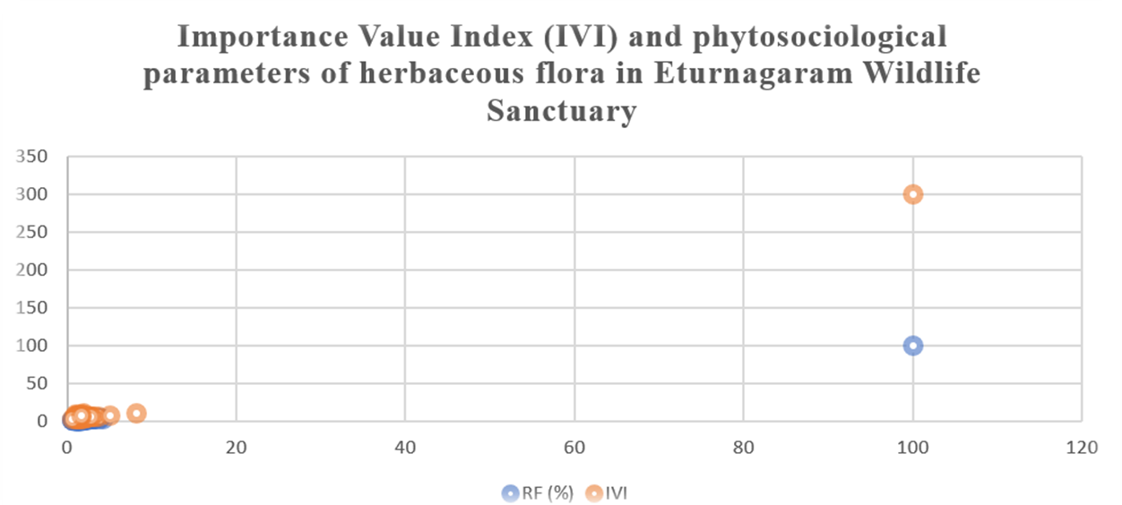

A total of 51 herb species belonging to 27 families were recorded from the sanctuary. Dominant families included Asteraceae, Acanthaceae, Amaranthaceae, Euphorbiaceae and Malvaceae. Common species observed were Acalypha indica, Alternanthera sessilis, Blumea lacera, Euphorbia hirta, Tridax procumbens, Parthenium hysterophorus, Sida acuta and Trianthema portulacastrum.
The herb layer in Eturnagaram Wildlife Sanctuary contained 51 species, indicating the species-rich and structurally complex ground vegetation found in tropical dry deciduous forests. The total Importance Value Index (IVI) of 300 confirms that relative density, frequency, and abundance were distributed proportionally throughout the herbaceous community, indicating a balanced and well-organized understory. Similar herb species richness (40-70 species) has been reported in dry deciduous forests of the Eastern Ghats, Nallamalai Hills, and Deccan Plateau (Reddy et al. 2013; Mastan et al. 2015; Naidu et al. 2023), indicating that the herb diversity of Eturnagaram is on par with well-developed dry deciduous ecosystems.
The IVI pattern revealed dominance by Nymphaea nouchali (IVI = 10.01), Alternanthera sessilis (9.83), Celosia argentea (9.33), Barleria cristata (9.22), Tridax procumbens (7.98), Andrographis paniculata (7.95), Achyranthes aspera (7.91), and Parthenium hysterophorus (7.57). These species are a combination of perennial, seasonal, and disturbance-tolerant herbs, which is typical of dry deciduous forest floors (Reddy et al. 2008; Mastan et al. 2015). In relatively undisturbed forest interiors, shade-

tolerant species typically dominate herb IVI values, whereas in open dry forests, weeds and heliophytic species frequently achieve IVI values of 7 to 15, as reported in the current study (Naidu et al. 2023).
Nymphaea nouchali (8.13), Lemna minor (5.08), Justicia procumbens (3.73), and Datura metel (3.33) had the highest relative abundance (RA), indicating that they lived in thick patches of wet microhabitats within the sanctuary. Such patch-wise dominance is typical in dry deciduous forests, where transient water bodies, shaded depressions, and seasonal wetlands provide localized habitats for aquatic and semi-aquatic herbs (Reddy et al. 2008; Mastan et al. 2015).
Alternanthera sessilis (4.29), Barleria cristata (3.90), Celosia argentea (3.81), Achyranthes aspera (3.17), and Tridax procumbens (3.17) had the greatest relative density (RD) values, indicating that they were extensively dispersed and numerically dominant across the sampling plots. The dominance of Asteraceae, Amaranthaceae, and Acanthaceae herbs in dry deciduous forests is well documented, reflecting their strong reproductive capacity, quick development, and tolerance to grazing and disturbance (Reddy et al. 2008; Gandhi, 2016).
The rather uniform distribution of IVI values among numerous herb species, as opposed to severe dominance by one or two taxa, suggests a heterogeneous and functionally diversified herb layer. Such IVI patterns are characteristic of semi-mature dry deciduous forests, where native forest herbs and disturbance-tolerant weeds coexist due to moderate grazing, canopy openness, and seasonal soil moisture (Mastan et al. 2015; Naidu et al. 2023).
The herbaceous community is also important for nutrient cycling and soil organic carbon dynamics, as fast-growing species like Tridax procumbens, Parthenium hysterophorus, Ageratum conyzoides, and Alternanthera sessilis contribute large amounts of litter and fine roots, which boost soil microbial activity (Brown, 1997; Chave et al. 2014).
Overall, Eturnagaram Wildlife Sanctuary's herb layer, which contains 51 species and has a balanced IVI distribution, reflects a well-developed tropical dry deciduous

understory. The dominance of disturbance-tolerant and moisture-responsive herbs, combined with moderate IVI values, suggests partial canopy openness and seasonal soil moisture variation, but the overall structure reflects a stable and resilient ground vegetation system similar to other dry deciduous forests in peninsular India.
fig 2-
Pie chart showing variation in diversity index

Diversity indices of herb layer

The herb layer exhibited the highest diversity among all vegetation strata (Table 2).

Table 2. Diversity indices of herbaceous flora in Eturnagaram Wildlife Sanctuary

Parameter | Value
Simpson’s dominance (D) | 0.0223
Shannon–Wiener index (H′) | 3.899
Evenness (E) | 0.931
Number of species | 51

These values indicate low dominance and high heterogeneity within the herbaceous community.
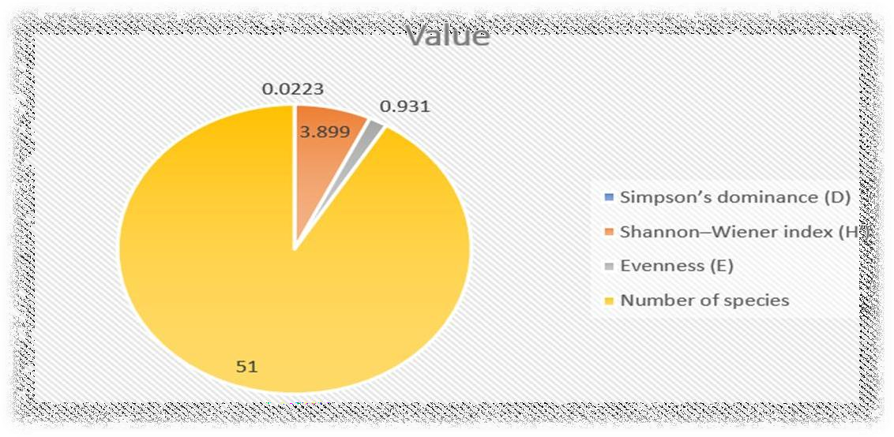

Discussion

The herbaceous layer of Eturnagaram Wildlife Sanctuary shows high species richness and diversity comparable to other tropical dry deciduous forests of the Eastern Ghats and Deccan Plateau. The dominance of Asteraceae and Amaranthaceae reflects adaptive strategies such as rapid growth, prolific seed production and tolerance to grazing and disturbance.
The relatively uniform IVI distribution among many species suggests a heterogeneous and functionally diverse herb layer rather than dominance by a few taxa. This pattern is characteristic of semi-mature dry deciduous forests where native forest herbs coexist with disturbance-tolerant species due to moderate grazing, seasonal moisture and canopy openness.
Aquatic and semi-aquatic herbs such as Nymphaea nouchali and Lemna minor indicate the presence of seasonal wetlands and microhabitats, enhancing overall habitat heterogeneity. High Shannon diversity (H′ = 3.899) confirms that the herbaceous stratum contributes significantly to the sanctuary’s overall biodiversity.

Conclusion

The present study demonstrates that Eturnagaram Wildlife Sanctuary supports a rich and structurally complex herbaceous flora with 51 species and high diversity indices. The herb layer plays a crucial ecological role in maintaining nutrient cycling, soil stability and regeneration processes. Dominance by disturbance-tolerant and seasonal species reflects the adaptive nature of tropical dry deciduous forest understory vegetation.
These findings provide baseline ecological data for monitoring changes in herbaceous biodiversity and for developing conservation strategies aimed at sustaining understory vegetation in protected dry forest ecosystems of Telangana.

Disclaimer (Artificial intelligence)

Author(s) hereby declare that NO generative AI technologies such as Large Language Models (ChatGPT, COPILOT, etc.) and text-to-image generators have been used during the writing or editing of this manuscript

References
- Brown S (1997) Estimating biomass and biomass change of tropical forests: a primer. FAO Forestry Paper 134. Food and Agriculture Organization of the United Nations, Rome.
- Chave J, Réjou-Méchain M, Búrquez A, et al. (2014) Improved allometric models to estimate the aboveground biomass of tropical trees. Global Change Biology 20:3177– 3190. https://doi.org/10.1111/gcb.12629
- Curtis JT, McIntosh RP (1950) The interrelations of certain analytic and synthetic phytosociological characters. Ecology 31:434–455.
- Gandhi DS (2016) Phytosociological studies on herbaceous vegetation of dry deciduous forests of central India. International Journal of Plant Sciences 11:45–52.
- Mandal G, Joshi SP (2014) Analysis of vegetation dynamics and community structure of tropical dry deciduous forests of India. Biodiversity and Conservation 23:2671–2690. https://doi.org/10.1007/s10531-014-0733-8
- Mastan SA, Reddy CS, Naidu MT (2015) Phytosociological analysis of dry deciduous forests of Nallamalai Hills, Eastern Ghats, India. Tropical Ecology 56:97–110.
- Misra R (1968) Ecology workbook. Oxford and IBH Publishing Co., New Delhi.

- Mueller-Dombois D, Ellenberg H (1974) Aims and methods of vegetation ecology. Wiley, New York.
- Naidu MT, Reddy CS, Reddy KN, et al. (2023) Species diversity and stand structure of tropical dry deciduous forests in the Eastern Ghats region of India. Biodiversity and Conservation 32:1123–1145. https://doi.org/10.1007/s10531-023-02567-4

- Reddy CS, Jha CS, Dadhwal VK (2013) Assessment and monitoring of long-term forest cover changes in India using remote sensing and GIS. Environmental Monitoring and Assessment 185:817–829. https://doi.org/10.1007/s10661-012-2572-3
- Reddy CS, Ugle P (2008) Tree species diversity and distribution in tropical forests of Eastern Ghats, India. Journal of Forestry Research 19:123–131.
- Singh JS, Singh SP (1992) Forests of the Himalaya: structure, functioning and impact of man. Gyanodaya Prakashan, Nainital, India.
- Shalisaheb, T., & Manjula, M. (2023). A study of phytosociological attributes of shrubs plant resources in nallamalais. International Journal of Phytology Research, 3(1), 19-25.
- Deng, T., Du, Q., Zhu, Y., & Queenborough, S. A. (2025). Environmental drivers of herbaceous plant diversity in the understory community of a warm-temperate forest. Plant Diversity, 47(2), 282-290.
- Tian, K., Chai, P., Wang, Y., Chen, L., Qian, H., Chen, S., ... & Chen, J. (2023). Species diversity pattern and its drivers of the understory herbaceous plants in a Chinese subtropical forest. Frontiers in Ecology and Evolution, 10, 1113742.
- Thakur, P., Thapa, A., Verma, M., & Tandon, S. (2022). Phytosociological Studies on Tree Vegetation of Jakhu Hill, Shimla, Himachal Pradesh. IOSR Journal of Environmental Science, Toxicology and Food Technology, 16, 46-52.

