Isolation of Methyl 5-oxo-DL-prolinate from Agaricus Bisporus Mushroom Grown in Natural Conditions and Structural Elucidation Using Spectroscopic Methods

ABSTRACT
Background: A. bisporus is one of the most important mushrooms in the world for its consumption and valuable chemical composition
Aims: This study was conducted to chemically profile secondary metabolites from naturally grown A. bisporus.
Study design: The study adopts a practical experimental design, and the analysis is carried out through structural interpretation of the observed results to derive meaningful conclusions.
Place and duration of study: The research work was carried out at "Laboratory of Chemistry and Physicochemical Research of Biologically Active Substances" of Karshi State University, March-June 2025.
Methodology: In this process, secondary metabolites were isolated from A. bisporus fungus at the chloroform fractionation step by column chromatography, the substances were analyzed by GC-MS and the structure was studied using NMR spectroscopic (H, COSY, ROSY, HBMS, HSQC) methods.
Results: At this stage of fractionation, a white amorphous substance was isolated and a mixture of 14 volatile compounds was obtained. They were mainly secondary metabolites belonging to the following classes: complex ester, imide, amine, organic acid, steroids
Between them: the amorphous matter was neatly separated. When the chemical structure of the resulting pure substance was determined by physical research methods, it was found that Methyl 5-oxo-DL-prolinate
Keywords: Agaricus bisporus, secondary metabolite, Methyl 5-oxo-DL-prolinate, NMR, GC-MS, IR, chloroform fraction, chemical structure

- INTRODUTION
Considered to be one of the fungi common in nature, they exhibit significant biological activity along with the development of secondary metabolites of a novel structure, mainly containing terpenoids, nitrogen compounds, steroids, sphingoids, aliphatic compounds, and other structural species, some of which have anti-tumor, anti-neurolysis, antibacterial, anti-angiotensin converting enzyme action (Cao et al., 2024). Proline and Proline-5-oxo derivatives have been identified in Agaricus fungi such as A. placomyces and A. pseudopratensis (Assy et al., 2007), while L-pyroglutamic acid activity has been identified in A. bisporus (Zhankov et al., 2024). The presence of proline in A. bisporus is also known by Usman (Usman et al., 2021) In Agaricus bisporus, compounds such as 1-octen-3-ol, benzyl alcohol, and 3-octanone are known to be large flavor compounds. It has been found that increased levels of isovaleraldehyde and 3-octanone such as isovaleraldehyde and 3-octanone during the last shelf life of the fungus may have contributed to its deterioration in quality (Shao et al., 2022). Volatile components such as dodecane, benzo-2,3-pyrrole, thetradecane, 2,4-bis(1,1-dimethyletyl) phenol, have been identified in secondary metabolites in A. bisporus (Bartkiene et al., 2023). V A from the No0107 sample of bisporus from Guangzhou contained 27.24% of benzyl alcohol, furancarboxaldehyde, benzaldehyde, 2-(1,1-dimethylyl)-3-methyl-Oxirane, 5,6-dihydro-6-pentyl-2H-Pyran-2-one, and 2-Propen-1-ol. The results showed that the source of the fungus, the origin of the climate, cultivation methods were found to affect the taste of Agaricus bisporus (Yan et al., 2015). When MALDI TOF/TOF MS analysis of Agaricus bisporus extract was performed, sugar compounds such as GH27 alpha-glucosidases, GH47 alpha-mannosidases, GH20 hexosaminidases, and alkaline phosphatases were detected (Morosanova et al., 2020). Ergosterol, trilinoliene, brassicasterol, and linoleic acid have been found in the extract of A. bisporus in dichloromethane (Consolacion et al., 2016). In Mongolia, sugars, nitrogenous compounds, and steroids such as urea, ergosterol, mannitol, ergosterol peroxide have been identified from 95% ethanol extracts of Agaricus silvaticusnindg (Munkhgerel et al., 2014). Agaricus blazei (A. blazei) is a fungus with the ability to produce metabolites with a wide variety of biologic effects. It has been found to contain steroids such as ergosterol, which kill tumors (Shimizu et al., 2016). Compounds such as benzoylergostane, N-benzoyl-L-leucine methyl ester, 2 identified ergostanes, and large amounts of degradable insisterol have been identified from the fruit body of Agaricus blazei along with 2 phenylhexane derivatives (Ueguchi et al., 2011). The most abundant components in volatile compounds and butanol have been identified as phenolic and urea compounds, respectively (Petrova et al., 2007).
- MATERIAL AND METHOD

2.1 Preparation of biomass from fruiting bodies
A biomass was prepared from the fruit of A bisporus extracted from the fields of Koson and Kasbi districts of the Kashkadarya region (Nomozova et al., 2026). The resulting extraction mass was placed in a silicon-equipped glass chromatorgraphic (silicagel type:PRAHA-CZECHOSLOVAKIA, pore size: 100/160) ) shield and fractionated in chloroform. At this step, the obtained fractional sum was driven in a rotary vacuum evaporator at a speed of 40-50 μm at 61.5°C under water bathing environment. The composition of the obtained samples was examined by thin-layer chromatographic method, similar samples were isolated and verified by GC-MS analysis.
2.2 GX-MS analysis
Chromatec 5000 gas chromatographide (GC) equipped with HP-5 column (30 m × 0.32 mm × 0.25 μm) was performed. Helium was used as the carrier gas. Temperature of the GC evaporator was initially kept at 80°C for 5 min, then temperature was raised to 300°C at a speed of 4°C/min and held for 30 min. The components were identified from the mass spectra of each component after comparing it with the available spectral data from the MS library NIST 2017.
  - NMR analysis
NMR spectra were acquired on a JNM-ECZ600R spectrometer (600 MHz for 1H and 150 MHz for ¹³C, JEOL, Japan) in CD3OD. TMS (δ 0.00 ppm) was used as an internal standard for 1H NMR shifts, and solvent signals (CD3OD, 49.00 ppm vs. TMS) were used as a reference for ¹³C NMR shifts.
RESULTS AND DISCUSSION
To determine the secondary metabolites of the A. bisporus mushroom grown in natural conditions amorphous substance methyl 5-oxo-DL-prolinate was obtained as a result of fractionation in the chloroform system, and its structure was determined using physical research methods and its mass spectrum was obtained (Fig. 1).

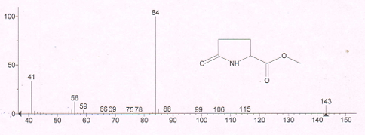
Fig 1. Mass spectrum of methyl 5-oxo-DL-prolinate
In the mass spectrum of methyl 5-oxo-DL-prolinate, the M+ molecular ion was found to be equal to m/e 143 (C6H9NO3). The molecule is shown to form high-intensity m/e 84 (C4H6NO) ions and m/e 112 (C5H6NO2), 59 (C2H3O2) ions during fragmentation.

Image 1: Fragmentation pathways of the molecular ion (M⁺ = 143) showing key product ions at m/z 112, 84, and 59. The scheme illustrates cleavage and rearrangement steps leading to formation of an acylium ion (m/z 59), a lactam-derived fragment (m/z 84), and a rearranged carbonyl-containing ion (m/z 112).

High-intensity signals of methyl 5-oxo-DL-prolinate in the IR spectrum were detected in the downstream regions (Fig. 2).

Fig 2. IR spectrum of Methyl 5-oxo-DL-prolinate
In the IR spectrum of the substance, the presence of a valence vibration of the =N-H bond-specific signal in the proline group = N-H is ν=N-H = 3246.31 cm⁻¹ indicates the presence of an active hydrogen bond in the secondary amine group in the molecule. The 5-oxo-DL-prolinate, located in the heteroсycle of methyl , is 2957.63 cm⁻¹ The presence of a to be invisible in the fields indicates that the five-membered heteroсycle junction is bilaterally linked. The presence of very strong valent vibrations specific to the -C=O carbonyl group in the molecule in the 1681.69 cm⁻¹ regions, and the manifestation of the valent vibration specific to the 5-oxo group in the 1735.97 cm⁻¹ regions indicate the presence of two carbonyl groups in the molecule. In the IR spectrum of methyl of 5-oxo-DL-prolinate, the valent vibrations specific to the –C-C− bond are 1437.12 cm⁻¹ to be invisible in the fields. The valent oscillations specific to the ester-O-CH3 group in the molecule are 1382.96 cm^{−1,} and the deformation vibrations of the Va–CH3 group are 1206.67 cm⁻¹. The proline in the molecule is located in the heteroring –CH2-CH bonds deformation vibrations 684,98; 791.82 will be in the fields.

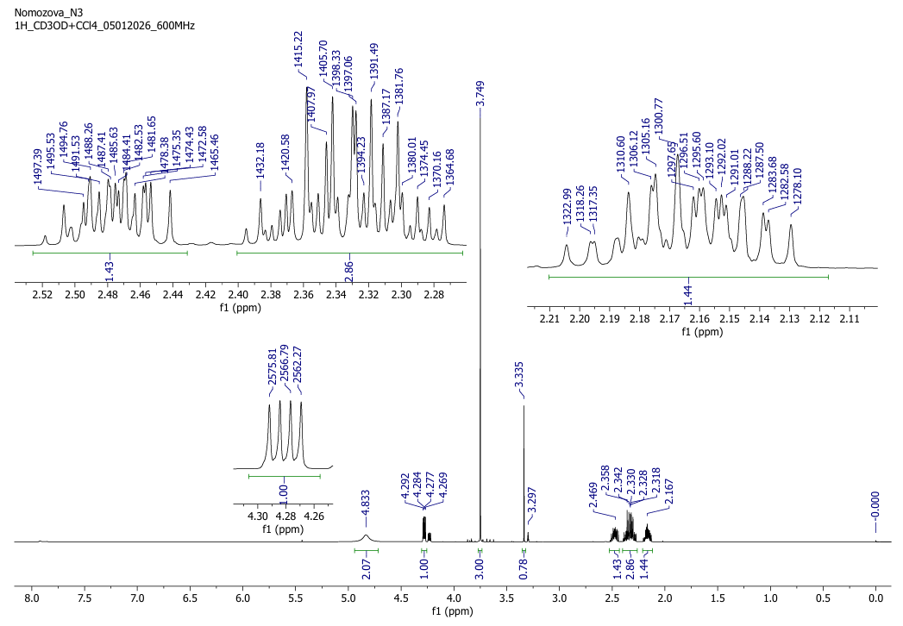
Fig 3. H-NMR spectrum of methyl 5-oxo-DL-prolinate

The presence of a singlet signal specific to the -O–CH3 bond at 3,749 ppm in the H-NMR spectrum of methyl 5-oxo-DL-prolinate (Fig. 3), the presence of –CH3 in the molecule and the presence of a singlet signal specific to the NH bond in the proline ring at 3,335 ppm the presence of a singlet signal specific to the -N-C-H group in the proline ring at 4.28 ppm indicates that the secondary nitrogen-binding C–H bond is located in the proline ring. A multiplete signal is detected at 2.86 ppm of the C-3 carbon –CH2- bond located in the proline ring in the molecule, and the proline ring indicates that the molecule has a proline ring at 2.16–2.47 ppm of the C-4 carbon –CH2- bond. Including the low-intensity presence of the proton-specific quartet signal of the C-2 carbon-based proton-specific quartet signal in the H-NMR spectrum of the substance and the singlet signals of nitrogen-bound hydrogen in the proline ring at 3.29 ppm indicate the presence of DL-isomers in solution without a mixture.
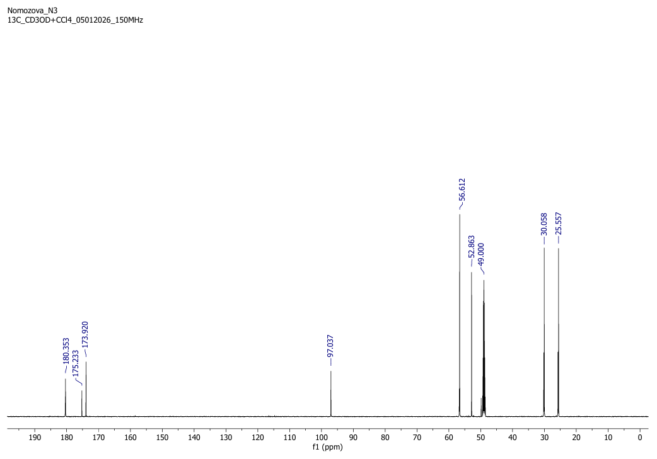
Fig 4. NMR ¹³C spectrum of methyl 5-oxo-DL-prolinate

In spectrum ¹³C of the methyl 5-oxo-DL-prolinate (Fig. 4), the molecule detects a singlet signal of carbon located in the –O-CH3 group at 52.86 ppm a singlet signal of the carbonyl group located in the proline ring at 173.92 ppm (C−5), and a singlet signal of the carbonyl group attached to the proline ring at 180.35 ppm at 56,612 ppm of the 3 carbons located in the proline ring, C-2 carbon, which binds to the carbonyl group, has a +M positive mesomer effect of the electron donor-NH group-bound carbon signals, while at 25,557 ppm (C-3) and 30,058 ppm (C-4) the carbon-specific singlet signals in the proline ring -CH 2-CH2- carbon-specific singlet signals are detected.

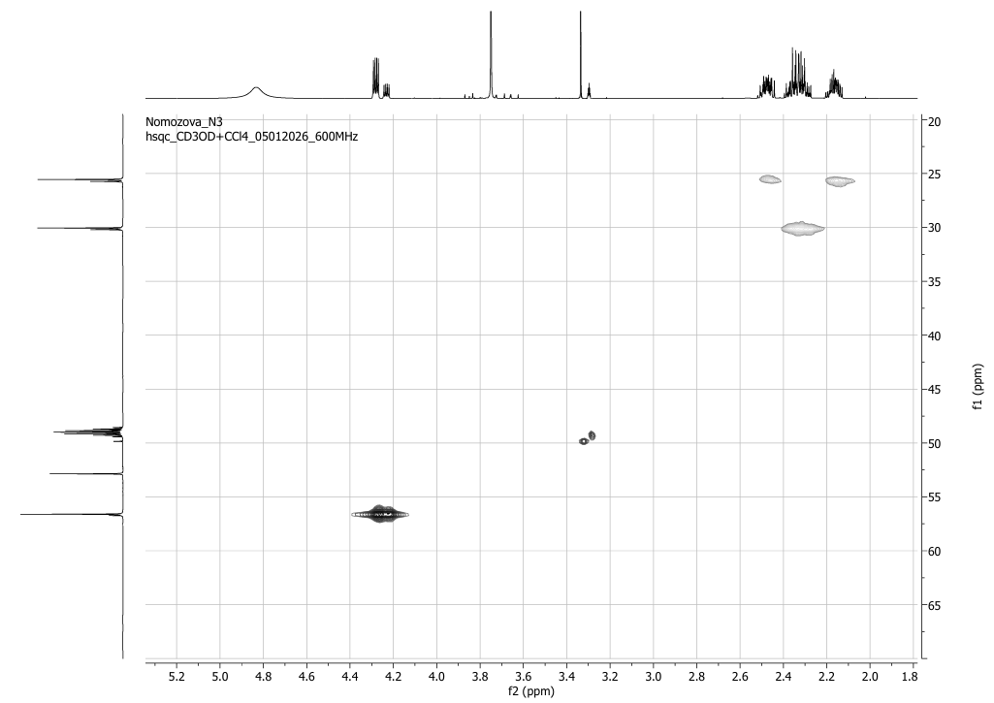
Fig 5. HSQC spectrum of methyl 5-oxo-DL-prolinate
At 56,612 ppm in the HSQC spectrum, the signal of the C-2 carbon in the proline ring indicates that the spin-spin interaction with single proton signals located in the C-2 carbon at 4.28 ppm in the HSQC spectrum indicates that the proton is located in the C-2 carbon (Fig. 5). The carbon signal of the methyl 5-oxo-DL-prolinate to the proline ring at 25,557 ppm (C-3) in the HSQC spectrum Spin-spin effect with a proton located in C-3 carbon at 2.16–2.47 ppm specific to two protons in the HSQC spectrum indicates that the proton is located in C-3 carbon. At 30,058 ppm in the HSQC spectrum, the signal of the C-4 carbon in the proline ring indicates that the proton is located in the C-4 carbon at 2.86 ppm in the HSQC spectrum.

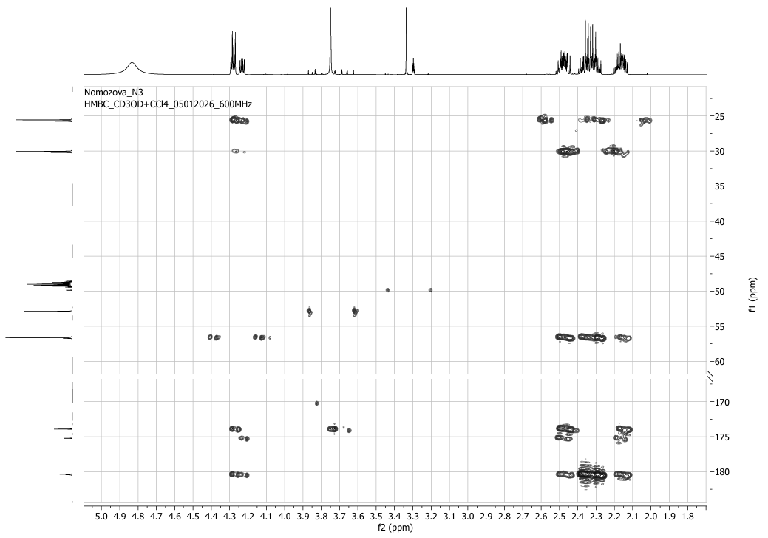
Fig 6. HMBS spectrum of methyl 5-oxo-DL-prolinate
At 180,353 ppm in the HMBC spectrum, the spin-spin interaction of carbon located in the carbonyl group bound to the proline ring at 4.28 ppm in the HMBC spectrum with protons located in the C-2 carbon-denominated region shows their location (Fig. 6). At 2.86 ppm in the HMBC spectrum, with protons located in the C-3 carbon, the SSEC 2J=1.39 Gs spin-spin interaction in the heminal state with the protons located in the C-4 carbon at 173.92 ppm and the C-3 carbon at 25.557 ppm in the geminal state of SSEC 2J=1.31-1.48 Gs spin-spin exposure indicates the location of the C-5, C-4, C-3 carbons in the geminal state.
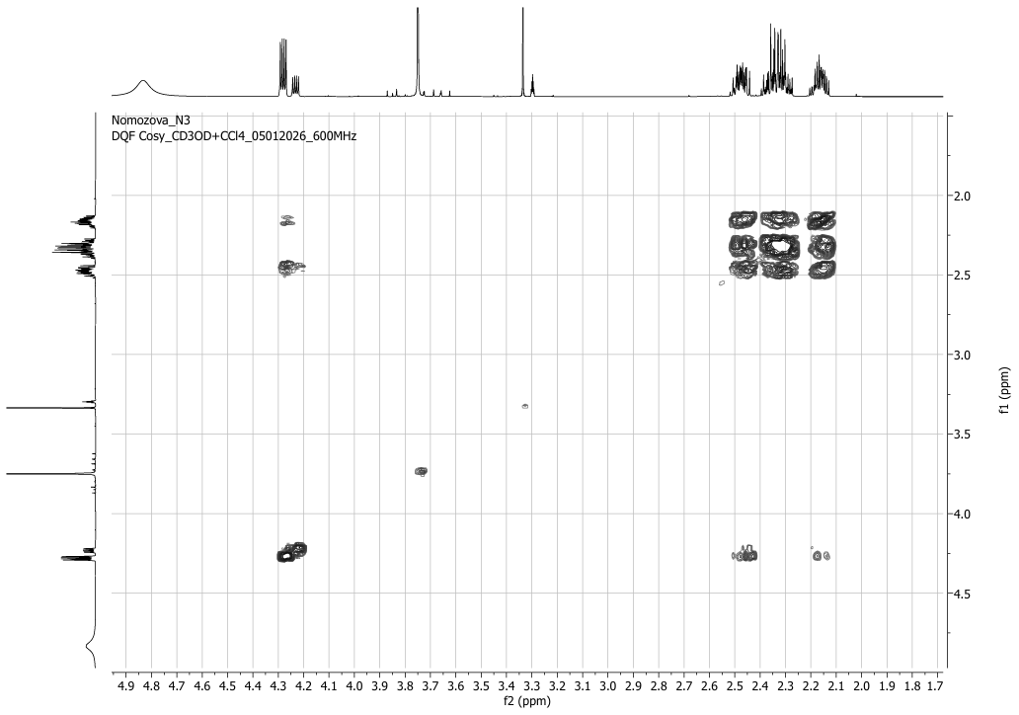Fig 7. COSY spectrum of methyl 5-oxo-DL-prolinate
C-4, C-2 in the COSY spectrum, at 2.16-2.46 ppm. of protons located in carbons and 4.28; Spin-spin interactions with the signal C-3 carbon-based proton at 2.86 ppm indicate that they are side-by-side (Fig. 7).
Image 2: Chemical structure of Methyl 5-oxo-DL-prolinate
This compound, also known as methyl pyroglutamate, is used in organic synthesis, peptizes, and biologically oxidative substances. It is also an organic substance used in molecular modeling and analysis of endothelin receptor ligands (Intagliata et al., 2020). A similar L-Proline (TMS) ester volatile compound has also been detected in A. bisporus (Aoife et al., 2010). Shiitake fungus, on the other hand, is known to have a derivative of 2-Pyrrolidinecarboxylic acid-5-oxo-, ethyl (Joanna et al., 2021). L-pyroglutamic acid, a non-toxic, naturally occurring amino acid derivative, has been shown to act as a natural fungicide to control A. alternata and mitigate post-harvest decay in blueberries (Kai et al., 2026).
In addition to the main compound A identified in naturally grown Agaricus bisporus, the following metabolites were also identified. Metabolites (Table 1).

Table 1. Metabolites identified in the chloroform fraction
- CONCLUSION
This is a complex ester and is part of the phytochemical profile of the fungus A.bisporus This complex ester has been identified as part of the phytochemical profile of the mushroom A. bisporus. In most cases, this compound is detected in aqueous or methanolic extracts of the mushroom. However, it has now been isolated as an amorphous substance in the chloroform fraction.
Disclaimer (Artificial intelligence)

Author(s) hereby declare that NO generative AI technologies such as Large Language Models (ChatGPT, COPILOT, etc.) and text-to-image generators have been used during the writing or editing of this manuscript.

ACKNOWLEDGMENTS

This research work was carried out at the Research Center "Laboratory of Chemistry of Biologically Active Substances and Physico-Chemical Research" at Karshi State University, for which we express our gratitude to the administration of the organization.

References

- Aoife O'Gorman. (2010). Metabolic Profiling and Fingerprinting for the Detection and Discrimination of Mechanical Damage in Mushrooms (Agaricus bisporus) during Storage. Technological University Dublin
- Assya Petrova, Kalina Alipieva, Emanuela Kostadinova, Daniela Antonova, Maria Lacheva, Melania Gjosheva, Simeon Popov and Vassya Bankova. (2007). GC-MS studies of the chemical composition of two inedible mushrooms of the genus Agaricus. Chemistry Central Journal, 1:33. http://journal.chemistrycentral.com/content/1/1/33
- Bartkiene E, Zarovaite P, Starkute V, Mockus E, Zokaityte E, Zokaityte G, Rocha JM, Ruibys R, Klupsaite D. (2023). Changes in Lacto-Fermented Agaricus bisporus (White and Brown Varieties) Mushroom Characteristics, including Biogenic Amine and Volatile Compound Formation. Foods. 12(13):2441. https://doi.org/10.3390/foods12132441
- Cao Jinfeng, Chen Xuhui, Liu Shiwei, Ding Jianhai. (2023). Research Advances in Secondary Metabolites and Biological Activities of Mushroom Genus Fungi. Academic Journal of Agriculture & Life Sciences, 4(1); doi: 10.25236/AJALS.2023.040109.
- Consolacion Y Ragasa, Jo Madeleine Ann Reyes, Maria Carmen S Tan, Robert Brkljača, Sylvia Urban. (2016). Research Article Sterols and Lipids from Agaricus bisporus. International Journal of Pharmaceutical and Clinical Research, 8(10): 1451-1453
- Intagliata S, Helal MA, Materia L, Pittalà V, Salerno L, Marrazzo A, Cagnotto A, Salmona M, Modica MN, Romeo G. (2020). Synthesis and Molecular Modelling Studies of New 1,3-Diaryl-5-Oxo-Proline Derivatives as Endothelin Receptor Ligands. Molecules. 25(8):1851. https://doi.org/10.3390/molecules25081851
- Jankov M, Léguillier V, Gašić U, Anba-Mondoloni J, Ristivojević MK, Radoičić A, Dimkić I, Ristivojević P, Vidic J. (2024). Antibacterial Activities of Agaricus bisporus Extracts and Their Synergistic Effects with the Antistaphylococcal Drug AFN-1252. Foods. 30;13(11):1715. doi: 10.3390/foods13111715
- Joanna Sissons, B.S. (2021). Using instrumental and sensory evaluation to determine flavor components and potential meaty flavor enhancement of raw and cooked Shiitake and Portobello mushrooms. Denton, tx. August.
- Kai Tong, Liangli Dai, Wenhui Rui, Dezhi Zeng, Dan Yu, Yuxue Liao, Mengsheng Deng, Zhaoling Li. (2026). Antifungal potentiality of L-pyroglutamic acid against postharvest decay of blueberry fruit caused by Alternaria alternata. Postharvest Biology and Technology,Volume 231, 113913, ISSN 0925-5214, https://doi.org/10.1016/j.postharvbio.2025.113913
- Morosanova, M. A., Fedorova, T. V., Polyakova, A. S., & Morosanova, E. I. (2020). Agaricus bisporus crude extract: Characterization and analytical application. Molecules, 25(24), 5996.
- Munkhgerel, L., Erdenechimeg, N., Dumaa, M., Zhang, G., Odonmajig, P., & Regdel, D. (2014). Chemical and biological investigation of the Agaricus silvaticus Schaeff ex. Secr. Mongolian Journal of Chemistry, 12, 92–97. https://doi.org/10.5564/mjc.v12i0.180
- Nomozova, M.Z., Kamolov, L. S., Nakhatov I., Nuraliyeva D.I. (2026). Extraction of secondary metabolites from agaricus bisporus fungus // Universum: химия и биология. 2(140), pp 26-30
- Petrova A, Alipieva K, Kostadinova E, Antonova D, Lacheva M, Gjosheva M, Popov S, Bankova V. (2007). GC-MS studies of the chemical composition of two inedible mushrooms of the genus Agaricus. Chem Cent J. 20; 1(33). doi: 10.1186/1752-153X-1-33. PMID: 18096035; PMCID: PMC2228291
- Ueguchi Y, Matsunami K, Otsuka H, Kondo K. (2011). Constituents of cultivated Agaricus blazei. Journal of Natural Medicines 65(2):307-12. DOI:10.1007/s11418-010-0495-5
- Usman, M.; Murtaza, G.; Ditta, A. (2021). Nutritional, Medicinal, and Cosmetic Value of Bioactive Compounds in Button Mushroom (Agaricus bisporus): A Review. Appl. 11, 5943. https://doi.org/10.3390/app11135943
- Shao,Yang-yang and Gao,Hai-yan and Liu,Rui-ling and Fang,Xiang-jun and Chen,Hang-jun, (2022). Effect of harvesting method on the quality and volatile flavor compounds of Agaricus bisporus. Food Science, 43, (5), 218–226. doi:10.7506/spkx1002-6630-20210906-056
- Shimizu T, Kawai J, Ouchi K, Kikuchi H, Osima Y, Hidemi R. (2016). Agarol, an ergosterol derivative from Agaricus blazei, induces caspase-independent apoptosis in human cancer cells. Int J Oncol. 48(4):1670-8. doi: 10.3892/ijo.2016.3391.
- Yan, S. J., Xie, X. M., Lin, S. Z., Xu, X. G., Jiang, S. P., Chen, B., ... & Liu, L. (2015). Study on volatile flavor components from Agaricus bisporus of Tibet. Acta Scientiarum Naturalium Universitatis Sunyatseni, 54, 70-78.

