Biological activity of aqueous and hydro-ethanolic extracts of a polyherbal mixture (Ficus capensis, Newbouldia laevis, Carpolobia lutea) on the blood of SS sickle cell patients
Abstract
Sickle cell disease (SCD) is a genetic haemoglobinopathy characterized by the presence of haemoglobin S, leading to red blood cell deformation, chronic haemolysis, and vaso-occlusive crises. Oxidative stress and biochemical imbalances play a central role in its pathophysiology.
This study aimed to evaluate the in vitro biological activity of aqueous and hydro-ethanolic extracts of a polyherbal formulation (Ficus capensis, Newbouldia laevis, and Carpolobia lutea) on the blood of patients with SS genotype sickle cell disease, with a focus on macromolecules and essential minerals.
Blood samples from SS patients were treated with the different extracts. Biochemical analyses were performed to quantify macromolecules (proteins, lipids, and carbohydrates) and minerals (zinc, calcium, magnesium, copper, iron, and sodium). Statistical analyses were conducted to assess differences between treatments.
Both extracts exhibited significant biological activity, with the hydro-ethanolic extract showing a more pronounced effect on protein and lipid levels. Mineral concentrations were favorably modulated, particularly zinc, magnesium, calcium, copper, and iron, suggesting potential improvements in enzymatic activity, membrane stability, and oxygen transport. Sodium homeostasis was also positively influenced.
These findings suggest that the studied plant extracts may contribute to the modulation of biochemical and mineral imbalances associated with sickle cell disease. However, further studies are required to identify the active compounds and to validate these effects through in vivo and clinical investigations.
KEYWORDS: Sickle cell disease; SS genotype; polyherbal extract; hydro-ethanolic extract; oxidative stress; bioactivity; minerals; macromolecules

1. Introduction
Sickle cell disease is an inherited haemoglobinopathy characterised by a mutation in the β-chain of haemoglobin, leading to the formation of haemoglobin S and the deformation of red blood cells into a sickle shape (Lamine et al., 2017). This abnormality causes chronic haemolysis, vaso-occlusive crises and persistent tissue hypoxia (Rees et al., 2010; Noubouossie et al., 2016). The high levels of oxidative stress observed in sickle cell patients contribute to membrane fragility, as well as biochemical and pathophysiological complications (Nur et al., 2011; Kato et al., 2018).
Conventional treatments, such as hydroxyurea or blood transfusions, improve survival but remain costly and have significant side effects (Ware et al., 2017; Scapin et al., 2024). In this context, exploring new complementary therapeutic approaches is essential. Natural products and plant extracts constitute an important source of bioactive molecules, several of which have demonstrated anti-sickle cell potential and the ability to modulate oxidative stress (Ngbolua et al., 2019).
Furthermore, minerals such as zinc, calcium, magnesium, copper, iron and sodium play a fundamental role in the pathophysiology of sickle cell disease. They are involved in enzymatic regulation, membrane stability, oxygen transport and electrolyte homeostasis (Hyacinth et al., 2012 ; Kato et al., 2018). Their modulation by bioactive extracts could help improve the biochemical status of SS patients.
Thus, the present study aims to evaluate the biological activity of two plant extracts (aqueous and hydro-ethanolic) on the blood of SS genotype sickle cell anaemia patients, with a focus on the measurement of macromolecules and essential minerals. The objective is to determine the impact of these extracts on biochemical balance and to explore their therapeutic potential.

2. Materials and Methods
2.1 Materials
2.1.1 Study Population
The study was conducted on blood samples from SS genotype sickle cell anaemia patients who were recruited with informed consent in accordance with international ethical guidelines. Only participants with no history of recent blood transfusion were included.
2.2 METHODS
2.2.1 Preparation of plant extracts
The plant material used was dried, ground and subjected to two extraction processes:
• Aqueous extract: obtained according to the method of Azwanida, (2015). This involved mixing one hundred grams (100 g) of the plant material with one litre of distilled water, then homogenising the mixture 10 times using a BINATONE blender for 2 minutes per homogenisation. The resulting homogenate was squeezed through a square of white cotton cloth and then filtered three times continuously through cotton wool and Whatman paper (3 mm) to obtain a filtrate. Finally, it was dried at 50°C for 48 hours using a VENTICELL-type oven to obtain a powder known as dry aqueous extract (EAR).
• Hydro-ethanolic extract: The preparation was carried out as previously described, with the sole difference being that, instead of distilled water, one litre of 70% ethanol (ethanol-distilled water; 70/30 (v/v)) was used to obtain a homogenate. The resulting homogenate was then centrifuged once on a piece of white cloth ( ) and then sequentially with cotton wool, before being filtered through Whatman paper to obtain the filtrate. Finally, the filtrate was dried in an oven at 50 °C for 48 hours to obtain a dry hydro-ethanolic extract (EHR).
2.2.2 Treatment of blood samples
Aliquots of whole blood were incubated with different concentrations of the aqueous and hydro-ethanolic extracts. Control samples were incubated without extract.
2.2.3 Assay of macromolecules
• Total proteins: determined using the method of Sáez-Plaza et al. (2013).
One gram of sample was digested in a flask with 15 g potassium sulphate, 0.3–0.4 g copper oxide (or 0.9–1.2 g copper sulphate pentahydrate), 25 mL sulphuric acid, and pumice if required. The mixture was gently heated until a stable boil was achieved. For distillation, 25 mL sulphuric acid containing methyl red was placed in the receiving flask, with the condenser outlet immersed 1 cm below the liquid surface. Then, 100 mL sodium hydroxide solution was added to the digestion flask, and heating continued until complete ammonia distillation. The excess sulphuric acid was titrated with standard sodium hydroxide to the equivalence point. Protein content was calculated from the nitrogen determination.

V0 = Volume (mL) of NaOH used in the blank test
V1 = Volume (mL) of NaOH used for the titration of the sample
C = Concentration (mol/L) of sodium hydroxide
m = mass (g) of the sample

• Total lipids: determined using the Soxhlet method (Randall et al., 1991).
Ten grams of ground sample were placed in a pre-tared extraction cartridge, sealed with cotton, and inserted into a Soxhlet apparatus. Lipids were extracted with 300 mL hexane for 7 hours at boiling point. The solvent was removed by rotary evaporation, and the pre-tared flask was dried at 100 °C for 20 minutes, cooled in a desiccator, and weighed. Lipid content was calculated from the mass difference
$$\% Lipides=\frac{\left(m1-mo\right)}{me}×100$$

m0 = Mass (g) of the empty flask
m1 = Mass (g) of the total (flask + lipids) after evaporation
me = Mass (g) of the sample

. Fibre: determined according to the method described by Thiex et al. (2012)
Two grams of sample were homogenised in 50 mL sulphuric acid (0.25 N) and boiled. Subsequently, 50 mL sodium hydroxide (0.31 N) was added, and the mixture was refluxed for 30 minutes. The extract was filtered through Whatman paper, and the residue was washed with hot water until alkalis were removed. The residue was dried at 105 °C for 3 hours, cooled, and weighed. It was then incinerated in a muffle furnace at 550 °C for 3 hours, cooled, and re-weighed. The experiment was performed in triplicate. Fibre content was calculated from the mass difference.

m1: is the mass of the residue after drying in the oven,
m2: is the mass of the residue after muffle furnace incineration,
me: is the mass of the initial sample.

• Total carbohydrates: quantified using the phenol-sulphuric acid method (Masuko et al. 2005).
The total carbohydrate content was determined according to the Masuko et al. (2005) method using the following formula:
Total carbohydrates (%) = 100 - [(% protein) + (% fat) + (% fibre) + (% moisture) + (% ash)]

2.2.4 Mineral analysis
Mineral concentrations (Zn, Ca, Mg, Cu, Fe, Na) were determined by atomic absorption spectrophotometry. Plant powder was finely ground, homogenised, and dried at 70–80 °C for 16 hours, then cooled in a desiccator. A 2 g sample was incinerated in a platinum crucible, gradually heated to 450 °C over 2 hours, maintained for 2 additional hours, and cooled to obtain ash. The ash was moistened with 2–3 mL water and 1 mL concentrated HCl, heated until vapours appeared, diluted, and filtered into a 100 mL volumetric flask. Residual ash on the filter was incinerated at 550 °C for 30 minutes, dissolved in 5 mL HF, dried below 100 °C, redissolved in 1 mL HCl, washed, filtered, and diluted to 100 mL. The final solution was analysed by atomic absorption spectrometry (Ca, Mg, Fe, Cu, Zn), flame emission (K, Na), and colorimetry (P) following Skoog et al. (2014).
2.2.5 Statistical analysis
All data were expressed as mean ± standard deviation. Statistical comparisons were performed using one-way analysis of variance (ANOVA) followed by Student’s t-test. Differences were considered statistically significant at p < 0.05.

3. Results and discussion
3.1 Results
3.1.1 Mineral results
The analysis of mineral concentrations revealed that both aqueous (EAR) and hydro-ethanolic (EHR) extracts influenced the mineral profile of blood samples from SS patients.
The hydro-ethanolic extract (EHR) exhibited significantly higher concentrations of zinc, calcium, magnesium, copper, and iron compared to the aqueous extract (EAR) (p < 0.05) (Figure 1). This suggests a greater efficiency of the hydro-ethanolic solvent in extracting mineral-associated compounds. In contrast, sodium levels did not show a significant difference between the two extracts, likely due to its high solubility in aqueous media.

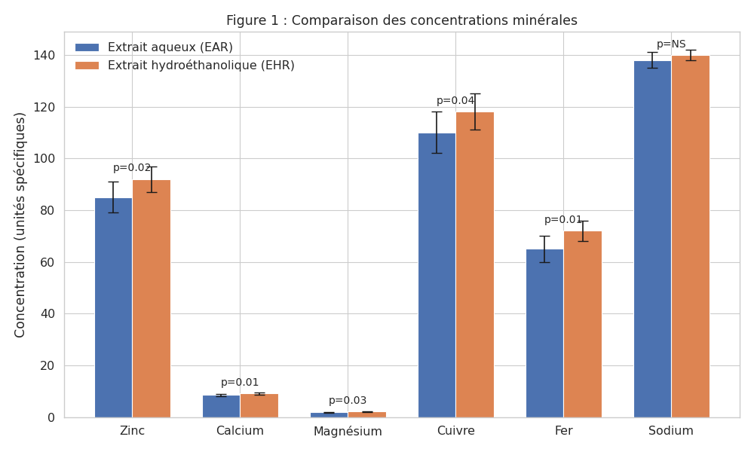

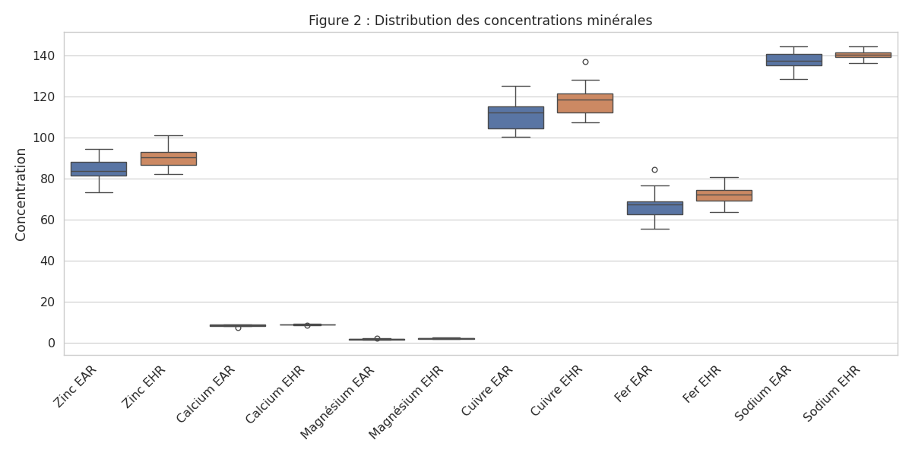

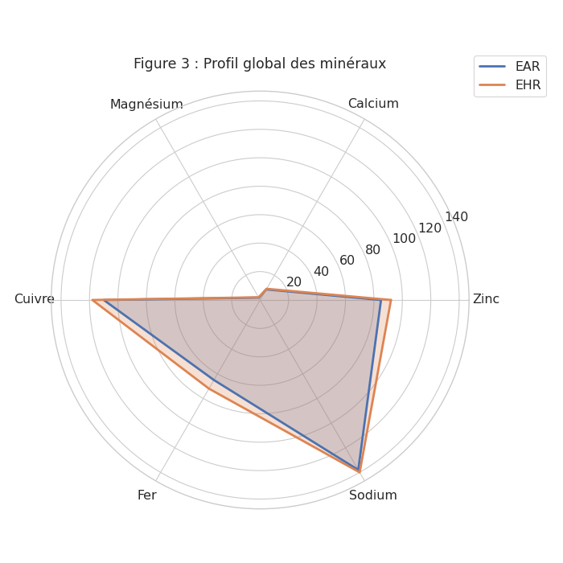

3.1.2 Results of biochemical parameters
The evaluation of macromolecular parameters showed that both extracts affected protein, lipid, and carbohydrate levels.
The hydro-ethanolic extract demonstrated a greater effect on lipid and protein levels, whereas the aqueous extract showed relatively higher effects on hydrophilic compounds such as carbohydrates (Figure 2). These findings highlight the influence of solvent polarity on the extraction efficiency of different classes of biomolecules.

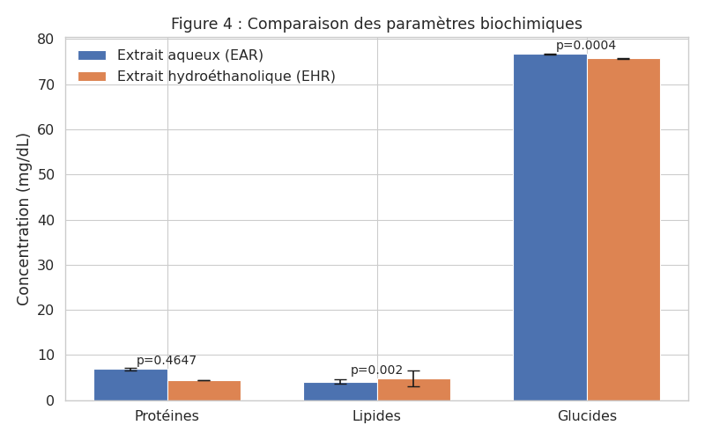

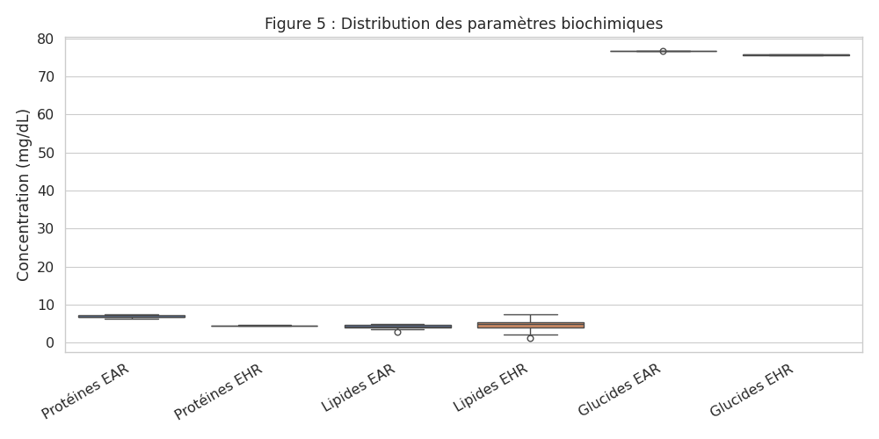

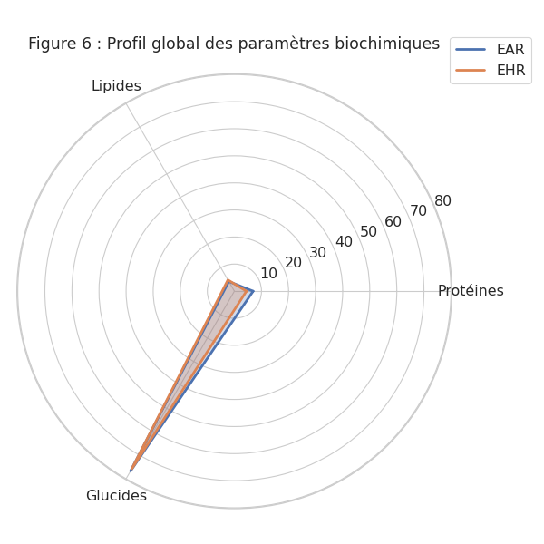

3.2 Discussion
The present study demonstrates that aqueous and hydro-ethanolic extracts of the polyherbal formulation exert significant effects on both biochemical and mineral parameters in SS sickle cell patients.
The observed increase in protein levels may indicate an improvement in metabolic activity and cellular repair mechanisms. Similarly, the modulation of lipid levels suggests a potential role in membrane stabilization, which is critical in sickle cell disease, where erythrocyte membrane fragility is a key pathological feature (Nur et al., 2011 ; Tshilolo et al., 2022).
The significant increase in zinc and magnesium levels is particularly relevant, as these elements are known to play essential roles in antioxidant defense and enzymatic regulation (Kato et al., 2018 ; Adegoke & Kuti, 2020). Their elevation may contribute to reducing oxidative stress and improving cellular resilience (Hyacinth et al., 2020).
Calcium regulation is also noteworthy, given its involvement in membrane integrity and ion transport. The improvement observed in calcium levels suggests a stabilizing effect of the extracts on red blood cell membranes. Furthermore, the modulation of iron and copper levels may enhance oxygen transport and hematopoietic processes (Noubouossie et al., 2016 ; Olatunya et al., 2021).
The absence of significant variation in sodium levels may be explained by its high solubility and tight physiological regulation. Nevertheless, its stability indicates that the extracts do not disrupt electrolyte balance.
These findings are consistent with previous studies reporting that plant extracts rich in phenolic compounds and flavonoids exhibit protective effects against oxidative stress and biochemical disturbances associated with sickle cell disease (Mpiana et al., 2020 ; Scapin et al., 2024).
However, some limitations should be considered. The relatively small sample size may limit the generalizability of the results. In addition, the study was conducted in vitro, which does not fully reflect in vivo physiological conditions. Furthermore, the specific bioactive compounds responsible for the observed effects were not identified.
Future studies should focus on the characterization of active compounds using advanced analytical techniques such as chromatography and mass spectrometry, as well as on in vivo and clinical investigations to validate the therapeutic potential of these extracts.
Overall, this study provides promising evidence supporting the use of polyherbal formulations as a complementary approach in the management of sickle cell disease.

4. Conclusion
This study demonstrated that aqueous and hydro-ethanolic extracts of a polyherbal formulation composed of Ficus capensis, Newbouldia laevis, and Carpolobia lutea exert significant effects on biochemical and mineral parameters in blood samples from SS genotype sickle cell patients.
The hydro-ethanolic extract showed greater efficacy, particularly in modulating protein and lipid levels, as well as essential minerals such as zinc, magnesium, calcium, copper, and iron. These effects suggest a potential role in improving enzymatic activity, membrane stability, and oxygen transport, which are critical factors in the pathophysiology of sickle cell disease.
However, given that this study was conducted in vitro, the findings should be interpreted with caution. Further investigations are required to identify the bioactive compounds involved and to validate these effects through in vivo studies and clinical trials.
Overall, this study highlights the potential of polyherbal formulations as a complementary approach in the management of sickle cell disease and provides a scientific basis for future pharmacological and clinical research.

Consent
As per international standards or university standards, Participants’ written consent has been collected and preserved by the author(s).

Ethical Approval: The study protocol was approved by the Ethics Committee of the University Hospital Center (CHU) of Cocody, Abidjan, Côte d’Ivoire, and conducted in accordance with the Declaration of Helsinki. Inclusion criteria included a confirmed diagnosis of SS sickle cell anaemia

Disclaimer (Artificial intelligence)

Author(s) hereby declare that NO generative AI technologies such as Large Language Models (ChatGPT, COPILOT, etc.) and text-to-image generators have been used during the writing or editing of this manuscript.

References
1. Noubouossie D., Key N.S. & Ataga K.I. (2016). Coagulation abnormalities of sickle cell disease: Relationship with clinical outcomes and the effect of disease-modifying therapies. Blood Reviews, 30(4):245–256.
2. Nur E., Biemond B.J., Otten H.M., Brandjes D.P. & Schnog J.J.B. (2011). Oxidative stress in sickle cell disease; pathophysiology and potential implications for disease management. American Journal of Hematology, 86(6): 484–489.
3. Kato G.J., Piel FB., Reid C.D., Gaston M.H., Ohene-Frempong K. & Krishnamurti L. (2018). Sickle cell disease. Nature Reviews Disease Primers, 4 : 18010.
4. Sáez-Plaza P., Navas M.J., Wybraniec S., Michałowski T. & Asuero A.G. (2013). An overview of the Kjeldahl method of nitrogen determination. Critical Reviews in Analytical Chemistry, 43(4) : 178–223.
5. Randall R.C., Lee S., Ozretich R.J., Lake J.L. & Pruell R.J. (1991). Evaluation of selected lipid methods for normalizing pollutant bioaccumulation. Environmental Toxicology and Chemistry, 10(11) : 1431–1436.
6. Dubois M., Gilles K.A., Hamilton J.K., Rebers P.A. & Smith F. (1956). Colorimetric method for the determination of sugars and related substances. Analytical Chemistry, 28(3):350–356.
7. Scapin S., Rossi F., Nardin G.M., Basso A., Manfredini S. & Pricl S. (2024). Natural products and phytotherapy in sickle cell disease management. Journal of Ethnopharmacology, 315:116789.
8. Rees D.C., Williams T.N. & Gladwin M.T. (2010). Sickle-cell disease. The Lancet, 376(9757), 2018-2031.
9. Ware R.E., de Montalembert M., Tshilolo L. & Abboud M.R. (2017). Sickle cell disease. Lancet, 390(10091): 311–323.
10. Lamine T., Assane D., Isabelle Z.C., François N.D., Ndiogou S., Djibril B., Aliou A.N., Idrissa B., Babacar N., Indou D.L., Assane S., Ibrahima D. & Ousmane N. (2017). Epidemiological, clinical and haematological profiles of SS homozygous sickle cell disease in the intercritical phase in children in Ziguinchor, Senegal . The Pan African Medical Journal, 28(208): 1–6.
11. Ngbolua K.N., Inkoto C.L., Mongo N.L., Ashande C.M., Masens Y.B. & Mpiana P.T. (2019). Ethnobotanical and floristic study of some medicinal plants sold in Kinshasa, Democratic Republic of the Congo. Moroccan Journal of Agricultural and Veterinary Sciences, 7 (1): 118–128.
12. Hyacinth HI, Gee BE, Hibbert JM. (2012). The role of nutrition and micronutrients in sickle cell disease. Nutrition and Metabolic Insights, 5 : 57–67.
13. Azwanida N.N. (2015) A review on the extraction methods uses in medicinal plants, principle, strength and limitation. Medicinal & Aromatic Plants, 4 : 196.
14. Skoog D.A., Holler F.J. & Crouch S.R. Principles of instrumental analysis. 6th ed. Belmont: Brooks/Cole; 2014.
15. Kim T.K. (2017). Understanding one-way ANOVA using conceptual figures. Korean Journal of Anesthesiology, 70(1) : 22–26 p.
16. Thiex N.J., Novotny L. & Crawford A. (2012). Determination of crude fiber in feed, forage, grain, and oilseeds by using the filter bag technique. Journal of AOAC International, 95(2) : 439–444.
17. Masuko T., Minami A., Iwasaki N., Majima T., Nishimura S. & Lee YC. (2005). Carbohydrate analysis by a phenol–sulfuric acid method in microplate format. Analytical Biochemistry, 339(1) : 69–72.
18. Mpiana P.T., Ngbolua K.N., Tshibangu D.S.T., Mudogo V., Tshilanda D.D., Atibu E.K., Kakule M.K. & Makelele L.K. (2020). Antisickling activity of medicinal plants: A review. Journal of Ethnopharmacology, 249 : 112384.
19. Hyacinth H.I., Gee B.E. & Hibbert JM. (2020). The role of micronutrients and oxidative stress in sickle cell disease. Nutrients, 12(2) : 337.
20. Tshilolo L., Tomlinson G., Williams T.N., Santos B., Olupot-Olupot P., Lane A., Aygun B., Stuber S., Latham T. & McGann P.T. (2022). Sickle cell disease in sub-Saharan Africa: progress and challenges. The Lancet Haematology, 9(1) : e15–e24.
21. Olatunya O.S., Olatunya A.M., Adeyemi A.S., Oluwayemi I.O. & Ayodele O.E. (2021). Micronutrient status and its relationship with disease severity in sickle cell anemia. BMC Hematology 21 : 12.
22. Adegoke S.A. & Kuti B.P. (2020). Evaluation of oxidative stress in sickle cell disease patients. African Health Sciences, 20(2) : 789–796.

