phytochemical compounds and microbial load of the dried and roasted Blighia sapida arils

.
ABSTRACT

Blighia sapida, belonging to the Sapindaceae family, is a tropical tree growing in West Africa and consumed for its aril, which is rich in protein and lipids in various forms. To promote the use of this plant in human and animal nutrition, several studies have been conducted to determine some phytochemical compounds and the microbial load of dried (DA) and roasted (RA) arils. The results indicate that the total polyphenol levels are significantly different (p-value < 0.05) and abundant (2277.86-2816.30 mg/100 g (DA-RA)) with identical proportions of tannins and phytates (approximately 65 and 87 mg/100 g, respectively). Oxalates (5.04-8.76 mg/100 g) and hypoglycin A (0.46-1.33 mg/kg) are low. Flavonoids (76.86 ± 14.46-98.22 ± 4.86 mg/100 g) are statistically different for DA and RA. Microbiological contamination of the DA and RA powders is low, with Total Mesophilic Aerobic Germs TMAG (2.05-2.99 log CFU/g) and yeasts and molds (2.18-3.14 log CFU/g) present. Regarding the Staphylococcus aureus and total coliforms were absent from all samples. Aflatoxins were not quantified in the RA powders. Conversely, aflatoxin B1 (0.589 µg/kg) and B2 (0.098 µg/kg) were quantified in the DA powder. Thus, heat treatment such as roasting reduced a number of antinutritional factors (tannins and phytates) and increased resistance to certain pathogens and infections. In summary, phytochemical compounds would be acceptable and microbiological quality less acceptable at the level DA. Only roasted arils could compete with legumes such as soybeans, pistachios, and peanuts. Furthermore, arils can help combat certain cardiovascular diseases, hence their importance in nutrition. However, greater care should be taken during harvesting, and a protocol should be in place to disinfect these arils before use preservation methods are used to limit contamination by these microorganisms.

Keywords: antinutritional compound, aril, Blighia sapida, hypoglycin, aflatoxin

1. INTRODUCTION
Food insecurity remains a major challenge in many developing countries (Gahukar, 2011). This situation contributes significantly to malnutrition (FAO et al., 2018). Since antiquity, humans have used natural resources, particularly plants, for food, shelter, and primary materials in healthcare (Ndiaye et al.,2023) and maintenance of well-being. Blighia sapida a spontaneous tree is of great nutritional importance to humans through the consumption its arils. It is well known for its high protein (Hoba et al., 2018) and fat content. However, it also contains a toxin compound, hypoglycin A, which is present in high concentrations in immature arils, and decreases significantly, as the fruit matures (Gauthier, 2012) and is also water-soluble. In parallel, dietary proteins are one of the most important components of growth (Kouatcho et al., 2014) in poultry feed Therefore, the use of other, cheaper and more readily available protein sources could help to reduce production costs in livestock farming. Furthermore, antinutritional compounds in these arils warrant further investigation. Indeed, these compounds, often rich in phenolic substances, may exhibit antioxidant properties but can also influence feed intake (Lombe et al., 2023) and nutrient utilization. On the other hand, food safety is major concern due to the presence of various microorganisms. Foodborne illnesses are often associated with pathogenic fungi as Aspergillus, Penicillium, Fusarium, etc. including Staphylococcus aureus and Escherichia coli (Koffi et al., 2021). Thus, to enhance the value of Blighia sapida for both human and animal nutrition, various studies have been conducted to determine some phytochemical compounds as well as the microbial load of dried and roasted Blighia sapida arils.
2. material and methods
2.1 Material
This investigation employed the aril of mature Blighia sapida fruit, which was obtained from the Abobo district in northern Abidjan (Côte d'Ivoire). The fruit was transported to the Biocatalysis laboratory and Bioprocesses the same day from Nangui ABROGOUA University (Ivory Coast) for the various analyses where They were stored at room temperature (25 ± 2°C) for use in the various manipulations. Upon arrival the laboratory, the fruits were sorted and cleared of debris. The arils and seeds were separated from their shells by hand, and then gently separated from each other. Fresh arils were cleaned by washing with a large quantity of distilled water (10 L). Then they were wrung out with Wattman paper Number 1 in order to continue analyses.

2.2 Methods
2.2.1 Blighia sapida aril powders
- Drying: Approximately 1 kg of arils were cleaned and sun-dried for two weeks, then sorted to remove damaged arils. The arils were divided into 2 batches. Batch one dried aril was ground using a blender. Then, this resulting powder was sieved using a 500 μm mesh sieve to obtain dried aril powder (DA).
- Roasting: Batch 2 of the dried arils was roasted using a kiln (Forced convection, temperature: 50-300 °C). The arils were placed on perforated plates (with a porosity smaller than the size of the seeds). Roasting lasted 10 minutes at a temperature of 120 °C, then the arils were ground in a blender and sieved using a 500 μm mesh sieve to obtain roasted aril powder (RA).
2.2.2 Determination of the phytochemical compounds of Blighia sapida arils
2.2.2.1- Extraction and quantification of phenolic compounds
Extraction of phenolic compounds: the total content phenolic compounds of B. sapida powders DA and RA were extracts according to the technique described by Rhaman and Punja (2005). One gram of each powder was weighed into a centrifuge tube. Ten milliliters of acetone (80 % v/v) were added. The mixture was homogenized and incubated at 37 °C in a water bath for 30 min, then centrifuged. at 6000 rpm for 10 min. The supernatant was collected and stored in a 50 mL Erlenmeyer flask. The pellet was suspended in 10 mL of acetone (80 %, v/v). The mixture was homogenized and centrifuged under the same conditions as before. The new supernatant was added to the original contents of the 50 mL Erlenmeyer flask. The total supernatant collected was used to determine the total phenolic compounds.
Total phenolic compounds: B. sapida powders DA and RA were measured according to the spectrophotometric method described by Capannesi et al. (2000) using the folin-ciocalteu reagent.
The phytates in the different DA and RA powders were determined according to the method Joutei et al. (2015).
The tannins and flavonoids in the different aril powders DA and RA were determined according to the method of (Aguemon et al. 2018)
The oxalate content of the various DA and RA powders was determined according to the technique of Onwuka (2005).
The hypoglycin A content of B. sapida DA and RA powders was determined according to the method of Ware (2002) using an HPLC HPLC with a C column of 18.5 µm, 25 cm in length, 4.6 mm in diameter and connected to a high-performance liquid chromatograph and a fluorescence detector.
2.2.3 Microbiological analysis of Blighia sapida powders
Sample collection: To ensure uniformity and representativeness of the microorganism distribution and sample representativeness, each batch of DA and RA samples was aseptically mixed with a sterilized spoon before each sampling
Principle: The enumeration technique employed was based on a solid culture medium and was performed using Petri dishes. This method relies on the principle that each viable bacterial cell, when inoculated either within or onto the of an appropriate suitable agar medium, develops into a visible colony after incubation. The total number of colonies counted therefore corresponds to the number of Colony Forming Units (CFU). This step was followed by the preparation of culture media and diluent, as well as the preparation of the stock suspension.
Enumeration of microorganisms
- The total aerobic mesophilic bacteria (TAMB) count for DA and RA was performed according to the method using ISO 4833-1 (2013) on trypticase soy agar.
- Total coliform count: ISO standard 4832-3 (2006) on Mac Conkey Agar.
- Enumeration of staphylococcus aureus: NF standard in ISO 6888-1 (1999) Baird Parker selective agar with potassium tellurite egg yolk
-The enumeration of yeasts and molds for DA and RA was carried out on agar from malt extract (ISO 7957).
Expression of results: Reading and interpretation were done according to the Standard French for these floras and produced according to Standard XP V08-102.
-Aflatoxin levels were determined using the method Chiron (2008).
2.2.4 Statistical analyses
The results of the various experiments and analyses were processed using Excel. Student's t-test was used to compare the means of two samples based on the p-value at the 5% significance level. Statistica 7.1 software with analysis of variance (ANOVA) was used to compare the means of three samples.

3. results and discussion
3.1 Phytochemical compounds of arils
As schown in fig.1A, the antinutritional compounds profile of DA and RA powders are illustrated indicate that the total polyphenol levels of the two types of powders highlighting a significant variation (p-value < 0.05) in total polyphenol content between the two samples. However, the proportions of tannins and phytates in DA and RA powders are significantly equal. As for flavonoids (98.22 ± 4.86 mg/100 g for RA and 76.86 ± 14.46 mg/100 g for DA) and oxalates (8.76 ± 0.65 mg/100 g for DA versus 5.04 ± 0.73 mg/100 g for RA), they are statistically different and with lower concentrations in both powders (fig.1B). The hypoglycin A content of RA (1.33 mg/Kg) was significantly higher (P < 0.05) than that of DA powders (0.41 mg/Kg) (fig. C).
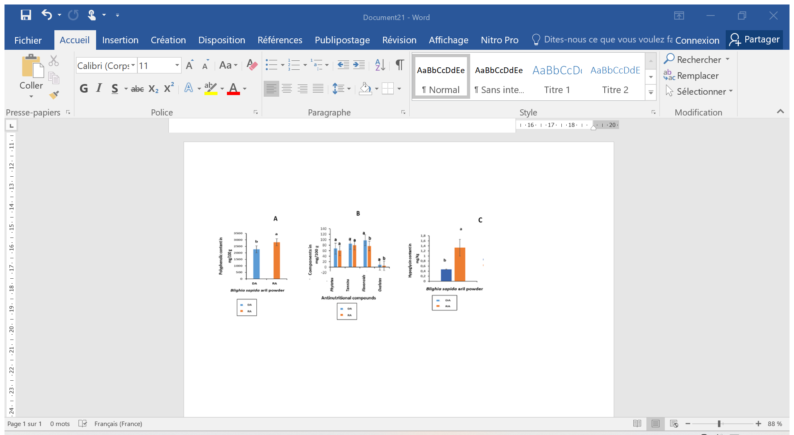

Fig. 1. Polyphenolic and phytochemical compounds Blighia sapida aril powders
DA: dried arils; RA: roasted arils
Means assigned the same letter are not significantly different (p-value > 0.05)

The high polyphenol content of the RA powder could be explained by the presence of Maillard reaction products generated during oven roasting. Indeed, Shahidi and Naczk (2004) reported that Maillard reaction products are brown polyphenolic compounds known to possess antioxidant properties. Ackee arils may serve as a valuable source of natural antioxidants, with potential applications in the management of inflammatory, cardiovascular and neurodegenerative diseases (Ano et al., 2018).
The phytate content of the different aril powders studied ranged from 59.81 and 67.55 mg/100 g, which is higher than the value reported for soybean phytates, approximately 16 mg/100 g (Hubert 2006). Phytates can also bind to proteins and lead to decreased protein solubility, rendering them indigestible by proteases (Kenfack, 2010). Indeed, they significantly influence the in vivo digestibility of proteins when the protein content of the food is 10 %.
Tannins impart an astringent taste that affects palatability, reduces food intake, and consequently hinders body growth. The tannin content of Blighia sapida arils varies around 80 mg/100 g, or 0.08 %, with a total tannin (RA) value lower than that of the arils (DA). The tannin content of peanut meal, trypsin inhibitors found in seed kernels, and a small amount of oxalic acid constitutes 0.16 % of the dry matter (DM) (Richir, 2004).
Flavonoids are the most abundant compounds among phenolic compounds, as observed in the work of N'Guetta et al. (2016) in the seeds of Citrullus lanatus, with a variation of 150.15-154.22 mg/100 g. low concentrations of flavonoids prevent the spread of cellular damage in the liver, while high concentrations (50-250 µmol/L) cause DNA damage (Wätjen et al., 2005) and would lead to an increase in blood pressure (Hubert 2006).
This decrease in oxalates observed in RA could be explained by their destruction during the heat generated by roasting. This phenomenon was observed by Souilah (2015) with some antinutritional factors (trypsin inhibitors) in chickpeas and cowpeas, which decreased by 90 %.
The wide variety of antinutritional compounds found in plant-derived materials, such as toxins, limits their use in food. Hypoglycin A content varies from 0.41 to 1.33 mg/kg in powders (from DA to RA). This variation is thought to be due to its concentration during roasting (Lemmens et al., 2008). Roasting involves a high temperature, resulting in greater water evaporation from roasted arils than from dried ones, and therefore a higher concentration of hypoglycin A in RA. This hypoglycin A content is lower than the recommended value of 100 ppm or less (Ouattara et al., 2011).

3.2 Microbiological
Microbiological study of dried aril powders (DA) and roasted aril powders (RA) of Blighia sapida is confined to Table 1. It shows a significant difference (p value < 0.05), with TMAG values of 2.99 Log CFU/g for DA and 2.05 Log CFU/g for RA. Staphylococcus aureus Total coliforms were absent in all samples. Yeast and mold counts were 3.14 Log CFU/g in DA powder and 2.18 Log CFU/g in RA powder. Aflatoxin levels in Blighia sapida aril powders are confined to Table 2. No aflatoxin determinations were made in the RA powders. In contrast, aflatoxin B1 (0.589 µg/kg) and B2 (0.098 µg/kg) were quantified that in the DA powder, giving a total of 0.687 µg/kg of aflatoxins in this powder.
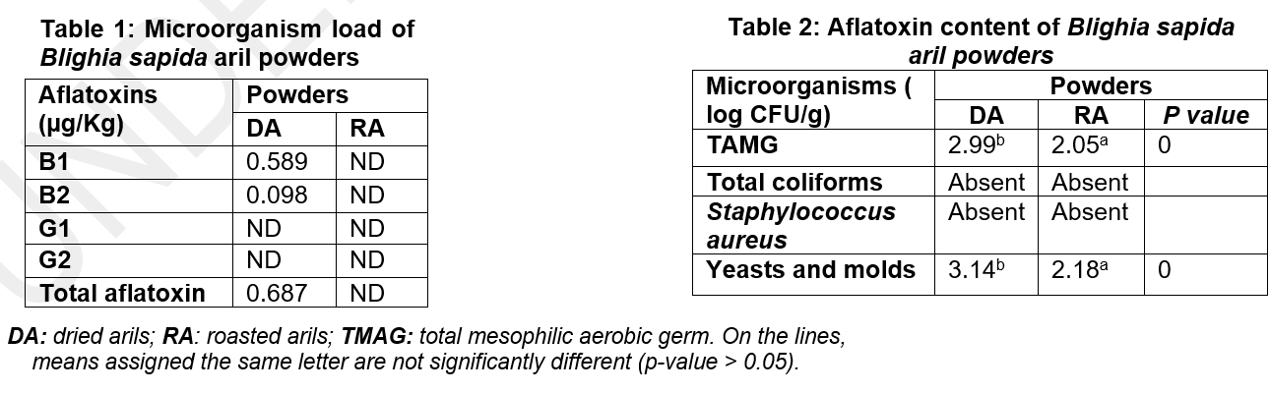

Microbiological analysis of the aril powders (DA and RA) of Blighia sapida shows contamination with TMAG, yeasts, and molds of 2.99 Log CFU/g and 3.14 Log CFU/g (DA) and 2.05 Log CFU/g and 2.18 Log CFU/g (RA), respectively. This contamination could be explained by the method of fruit extraction (Houndji et al., 2013). The fruits are collected directly from the ground during harvesting, favoring only self-opening fruits. In addition, other sources can contribute to microorganism contamination on the surface of the arils, such as air, birds, insects, and the environment. Certain intrinsic characteristics of the arils also contribute to the development of microorganisms. However, the presence of mold hinders the product's long-term preservation. In general, yeasts do not pose health risks, although some can spoil food, rendering it unfit for consumption (FAO, 2007). Therefore, their reduced number in the RA powder could be due to some of their destruction by heat during roasting, as they come from the dried batch. Furthermore, according to Makhloufi (2013), the total flora count is the best tool for assessing the overall microbiological quality of food, and thus serves as a quality indicator. A foodstuff containing more than 5.5 log CFU/g should be considered unfit for consumption, which would indicate that only the RA powder is safe for consumption. The search for indicator microorganisms of fecal contamination allows for judging the hygienic status of a product (Labioui et al., 2009). The absence of pathogenic microorganisms (Staphylococcus aureus) and total coliforms indicates the acceptable hygienic status of aril powders, especially roasted ones, due to the heat treatment they have undergone. Thus, proper heat treatment of arils increases the utilization of their essential elements, as well as their resistance to certain pathogens and infections.
The presence of aflatoxins (B1 and B2) in DA powders (0.687 µg/kg) indicates the presence of Aspergillus flavus contamination (Sifou, 2016). This infestation of Aspergillus flavus, which mainly produces aflatoxin B1 and aflatoxin B2, while it does not produce usually neither aflatoxin G1 neither aflatoxin G2, although a few rare exceptions have been described (Khoury, 2007). It is favored by empirical harvesting conditions. aggravated by poor storage (Houndji et al., 2013). The presence of aflatoxins B only in DA powder could be explained by the fact that RA arils are derived from DA are roasted and aflatoxins are theoretically very heat-stable. The standards set for aflatoxin in Africa are between 10 and 20 mg/kg (Mutegi et al., 2009; Somorin et al., 2012).
4. Conclusion
Thus, heat treatment such as aril roasting has reduced several antinutritional factors and increased resistance to certain pathogens and infections. In short, the phytochemical compounds in Blighia sapida aril powders are acceptable, as is their microbiological quality. Therefore, these arils, especially roasted ones, could compete with legumes such as soybeans, pistachios, and peanuts. They could also help combat certain cardiovascular diseases, hence their importance in nutrition. However, precautions must be taken regarding the cleaning and storage of the arils to limit contamination by these microorganisms.

DISCLAIMER (ARTIFICIAL INTELLIGENCE)
Author(s) hereby declare that NO generative AI technologies such as Large Language Models (ChatGPT, COPILOT, etc.) and text-to-image generators have been used during the writing or editing of this manuscript.

References
- Aguemon, M. A., Mankambou, J.M., Digbeu, Y.D., Dué E. A. & Kouamé L.P. (2023). Biochemical and Nutritional Parameters from Flour of Ackee Blighia sapida (Sapindaceae) Seeds. Asian Food Science Journal, 2(2): 1-9.
- Ano, R. R. A. A., Koffi, E. N., Adima, A. A., N'Da, K. P. & Anin, A. L. (2018). Biochemical and phytochemical composition of safou fruit cakes (Dacryodes edulis) from Ivory Coast. International Journal of Biological and Chemical Sciences, 12(6): 2535-2546.
- Capannesi, P., Mascini, M. & Parenti, A. (2000). Electrochemical sensor and biosensor for polyphenols detection in olive oils. Food and Chemistry, 71: 553-562
- Chiron, B. (2008). Research and quantification of aflatoxins B1, B2, G1, G2 by HPLC in agri-food materials, Eurofins LARA MO4, 2-535. Review 2, 12p.
- FAO (2007). Good hygiene practices in the preparation and sale of street food in Africa: Tools for training. Edition Food & Agriculture Organization, Italy. 175p.
- FAO, IFAD, WHO, WFP & UNICEF (2018). State of food security and nutrition in the world: building resilience to climate change for food security and nutrition, FAO, Rome, 199p.
- Gahukar, R. T. (2011). Entomophagy and human food security. International Journal of Tropical Insect Science, 31(3): 129-144.
- Gauthier, N. (2012). Pathophysiology of hereditary acyl - coenzyme metabolic diseases HAS revealed by the study d'un model animal deficient in 3- hydroxy-3-methylglutaryl -Coenzyme A lyase. Thesis presented to the Faculty of Graduate Studies in partial fulfillment of the requirements for the degree of Philosophiae Doctor (Ph.D.) in Biochemistry, University of Montreal (Canada), 223 p.
- Hoba, F. M. A., Digbeu, D. Y., Binaté, S., Kouamé, L. P. & Dué, A. E. (2018). Physical Characteristics of the Fruit and Nutritional Potentialities of Dried and Roasted Seeds Arils of (Ackee Apple). International Journal of Trends in Research and Development, 5(2): 596-60.
- Houndji, B. V. S, Ouetchehou, R., Londji, S. B. M., Eamouzou, K. S. S.; Yehouenou, B. et al. (2013). Microbiological and physicochemical characterization of Moringa leaf powder oleifera (Lam.), a traditional leafy vegetable in Benin. International Journal of Biological and Chemical Sciences, 7(1): 75-85.
- Hubert, J. (2006). Biochemical characterization and biological properties of micronutrients from soybean germ. Food and Nutrition. National Polytechnic Institute, thesis in Food Quality and Safety (Toulouse), France 175p.
- ISO 4833-1 (2013). Microbiology of the food chain - Horizontal method for the enumeration of microorganisms - Part 1: Colony counting at 30 °C by the deep plating technique, 9p.
- Joutei, K. A, Glories, Y. & Mercier, M. (2015). Localization of tannins in the grape berry skin. VITIS-Journal of Grapevine Research, 33(3): 133.
- Kenfack, M. B. L (2010). Nutritional and functional properties of Ricinodendron meal, concentrates and isolates proteins Heudelotii and Tetracarpidium conophorum. Thesis for the degree of Doctor at the National Polytechnic Institute of Lorraine (France), 226 p.
- Khoury, A. E. (2007). Mycotoxigenic Fungi and Ochratoxin A (OTA) and Aflatoxin B1 (AFB1) in Lebanese vineyards: Occurrence and Origin. Thesis, presented to obtain the title of Doctor of the National Polytechnic Institute of Toulouse (France) 213p.
- Koffi, A. C., Koffi, A. R., Kossonou, Y. K. & Koffi- Nevry, R. (2021). Antimicrobial activity and phytochemical composition of chili pepper extracts ‟Capsicum sp.” RAMReS Review – African Pharmacopoeia and Traditional Medicine Series, 20(2): 29-38.
- Kouatcho, D. F., Ngoula, F., Kana J. R., Tadondjou, T. C. D & Teguia, A. (2014). Effect of dietary crude protein level on growth parameters and carcass characteristics of quail (Coturnix sp) at starter internship in Western Highland of Cameroon. Asian Academic Research Journal of Multidisciplinary, 1(25): 501-514.
- Labioui, H., Elmoualdi, L., Benzakour, A., El Yachioui, M., Berny, E. H. et al. (2009). Physicochemical and microbiological study of raw milks. Bulletin de la Société de Pharmacie de Bordeaux, 148 : 7-16.
- Lemmens, R. H. M. J, Louppe, D. & Oteng-Amoako, A. A. (2008). Timber 2, Volume 2, Volume 7 of Tropical African Plant Resources. PROTA, 197 p.
- Lombe, M. R., Kamalandua, M. B., Bekomo, I. J., Ngandu, K. O. & Ngbolua, J. P. K-Te-N. (2023). Phytochemical study and evaluation of the antiradical activity of Dioscorea alata L and D. rotundata Pear (Dioscoreaceae). Journal of Applied Biosciences, 185: 19365-19376.
- Makhloufi, A. (2013). Study of the antimicrobial and antioxidant activities of two medicinal plants growing wild in the Bechar region (Matricaria pubescens (Def.) and Rosmarinus officinalis L.) and their impact on the preservation of dates and raw butter. Doctoral thesis in biology, Aboubaker University Belkaid (Algeria), 166 p.
- Mutegi, C. K., Ngugi, H. K., Hendriks, S. L. & Jones, R. B. (2009). Prevalence and factors associated with aflatoxin contamination of peanuts from western Kenya. International Journal of Food Microbiology, 130(1): 27-34.
- Ndiaye, M., Thiam, A., Agoyi , E.E., Assagbadjo, A.E., Dieng, B. & Noba, K. (2023). Espèces Végétales Négligées et Sous-Utilisées en Afrique de l’Ouest : Traits Morphologiques, Conservation et Dissémination des Graines de Blighia sapida K.D. Koenig (Sapindaceae) Suivant les Zones Agro-écologiques du Bénin. ESI Preprints, 698-712. https://doi.org/10.19044/esipreprint.10.2023.p698
- Nguetta, A. M. N., Digbeu, Y. D., Binaté, I. S., Kouadio, J. P. E. N., Dsubscribe. S. et al. (2015). Fatty acid composition and physicochemical properties of four varieties of Citrullus lanatus seeds oils cultivated in Ivory Coast. British Biotechnology Journal, 5(3):140-145.
- Onwuka, G. I. (2005). Food Analysis and Instrumentation. Theory and Practice. Naphtali Prints, Lagos, Nigeria; pp. 133-137.
- Ouattara, H., Meite, A., Amonkan, A. K., Kouame, K. G. & Kati-Coulibaly, S. (2011). Aril of Blighia sapida (K. Koenig, 1778): nutritional potential, toxic and deficiency effects linked to its consumption, according to the stage of harvest and the degree of consumption. International Journal of Biological and Chemical. Science, 5(1): 392-401.
- Richir, J. (2004). Valorization of agro-industrial by-products in the feed of the African catfish, Clarias gariepinus (Burchell 1822), in Rwanda, Memoir of Bachelor's degree in Biological Sciences, 88p.
- Shahidi, F. & Naczk, M. (2004). Phenolic in Food and Nutraceuticals, CRC Press, Boca Raton, FL. pp. 489-490.
- Sifou, A. (2016). Validation of a quechers analytical method: for the determination of Ochratoxin A (OTA) in food and study of the presence of emerging Fusarium mycotoxins in rice. Thesis, Mohamed V University of Rabat (Morocco), 165p.
- Somorin, Y. M., Bertuzzi, T., Battilani, P. & Pietri, A. (2012). Contamination by auchratoxins and fumonisins of yam flour from markets in Nigeria. Food Control, 25(1): 53-58.
- Souilah, F. B. (2015). Characterization of the behavior of micronutrients of interest and antinutritional compounds of chickpeas and cowpeas during processing. Master's thesis in Sustainable Agricultural and Agri-food Systems Engineering in the South (SAADS) at the University of Montpellier (France), 47p.
- Ware, G. (2002). Method validation study of hypoglycin A. Determination in Ackee fruit, Journal of AOAC International, 8(4): 933-937.
- Wätjen, W. M., Michels, G., Steffan, B., Niering, P., Chovolou, Y. et al. (2005). Low concentrations of flavonoids are protective in Rat H4IIE cells whereas high concentrations cause DNA damage and apoptosis. Journal of Nutrition, 135(3): 525-531.

