Access, Adherence and Patient-Reported Outcomes of Hydroxyurea Therapy in Sickle Cell Disease: A Cross-Sectional Study from Nigeria

Abstract
Background: Hydroxyurea is the most accessible disease-modifying therapy for sickle cell disease (SCD), but in many low- and middle-income countries its real-world benefit is constrained by gaps in awareness, uptake, continuity, and adherence. We analyzed the full hydroxyurea pathway—uptake, discontinuation, adherence, and patient-reported outcomes—in a Nigerian cross-sectional cohort.
Methods: We conducted a cross-sectional analysis of questionnaire data from 117 adult respondents with self-reported sickle cell disease. Composite scores were derived for patient-reported quality of life (QoL) and disease burden using ordinal survey items. Four multivariable logistic regression models were fitted to identify predictors of current hydroxyurea uptake (all respondents), discontinuation (ever-users), full adherence (current users), and better patient-reported outcome defined as a high QoL composite score. Adjusted odds ratios (aORs) with 95% confidence intervals (CIs) were reported.
Results: The mean age was 30.8 ± 10.2 years, and 83 (70.9%) were female. Current hydroxyurea use was reported by 50 (42.7%), while 17 (14.5%) had discontinued and 8 (6.8%) had never heard of hydroxyurea. Among ever-users, 50 (74.6%) were current hydroxyurea users, while 17 (25.4%) had discontinued treatment. Full adherence among current users was 36 (72.0%). In multivariable analysis, higher disease burden independently predicted hydroxyurea uptake (aOR 2.06, 95% CI 1.02–4.13; p=0.043), whereas lower disease burden predicted full adherence (aOR 0.27, 95% CI 0.08–0.89; p=0.032). Higher disease burden strongly predicted worse patient-reported outcome (aOR 0.19, 95% CI 0.08–0.44; p<0.001). Adherent current users had lower disease-burden scores than non-adherent current users (median 2.00 vs 2.71; p=0.009) and numerically higher QoL scores (median 3.75 vs 3.25; p=0.111). Cost was the dominant barrier to use.
Conclusion: Hydroxyurea use was limited by gaps in uptake, continuity, and adherence. The greatest benefit was seen among patients able to sustain regular treatment, while cost remained the major barrier. These findings support hydroxyurea subsidization, adherence support, and stronger integration of hydroxyurea into comprehensive SCD care in Nigeria.
Keywords:
sickle cell disease; hydroxyurea; adherence; discontinuation; access to care; patient-reported outcomes

Introduction
Sickle cell disease is one of the most important inherited blood disorders globally, with Sub-Saharan Africa bearing the highest burden of morbidity and mortality from the disease.¹ Recent global estimates underscore not only the scale of sickle cell disease burden but also the persistent inequity in outcomes between well-resourced and resource-constrained settings.^{2,3} Nigeria occupies a central position in this burden narrative because of its large absolute number of affected individuals and the structural challenges that often complicate comprehensive care delivery.⁴
Hydroxyurea is a disease-modifying agent for SCD that reduces painful crises, leads to fewer blood transfusions, and has clinical benefit in both adults and children.⁵ Some recent African studies have reinforced that hydroxyurea is feasible, safe, and effective in sub-Saharan settings when delivery systems are strong enough to support consistent treatment and monitoring.^{6.7,8} The benefits of hydroxyurea in low- and middle-income settings remain substantial and cannot be overstated, even in the emerging era of newer agents, haematopoietic stem cell transplantation and gene therapy.⁹
In resource-constrained settings, hydroxyurea performance depends on a sequence of implementation steps: patients must first know about the drug, then be able to access it, commence treatment and adhere to it, in order to achieve meaningful therapeutic exposure.¹⁰ Attrition at any stage of this pathway can erode population-level benefit. In an African setting, patient education, availability and affordability may influence long-term use of hydroxyurea.¹¹ A few Nigerian studies have shown that there is underutilization of hydroxyurea in clinical practice, low uptake by people living with SCD and cost barriers reducing access.^{10,12,13} Without consistent adherence, the biological and clinical benefits of hydroxyurea are substantially diminished.^{5,14} From a health-systems standpoint, discontinuation is not just a patient-level event; it is a measurable failure of retention in chronic disease care. This study aimed to describe hydroxyurea awareness, uptake, discontinuation, and adherence; evaluate barriers to use; and examine their association with patient-reported outcomes.

Methods
This was a cross-sectional analytical study based on a structured online questionnaire dataset of 117 consenting adult respondents (age ≥16 years) living with SCD. All respondents indicated consent electronically before completing the survey. Analysis was performed on the de-identified exported dataset. Data retrieved included age, sex, education, employment status, and monthly income. Disease-related variables included haemoglobin phenotype, number of painful crises in the preceding 12 months, hospital admissions in the preceding 12 months, blood transfusion history, and complications. Hydroxyurea status was captured as current use, non-use, previous use with discontinuation, or no prior awareness. Among current users, self-reported adherence was categorised as always as prescribed, sometimes, or rarely.
Construction of patient-reported outcome measures. Four self-rated wellbeing items—general health, overall quality of life, satisfaction with health, and satisfaction with ability to perform daily activities—were mapped to ordered numerical scores and averaged to create a QoL composite score. Four disease-burden items—extent to which SCD affects day-to-day life, frequency of missed work or school, painful crises, and hospital admissions—were similarly mapped and averaged to create a disease-burden composite score. Higher QoL scores indicated better reported wellbeing, whereas higher disease-burden scores indicated worse perceived or experienced disease burden.
Outcome definitions for multivariable modelling. Four binary outcomes were prespecified. Model 1 assessed current hydroxyurea uptake among all respondents. Model 2 assessed hydroxyurea discontinuation among ever-users, defined as respondents who had either current use or prior use with discontinuation. Model 3 assessed full adherence among current users, defined as self-reported intake of hydroxyurea ‘always as prescribed’. Model 4 assessed a better patient-reported outcome, operationalized as a high QoL composite score (≥4.0).
Categorical variables were summarised as frequencies and percentages. Continuous variables were described using means and standard deviations or medians with interquartile ranges where appropriate. Non-parametric Mann–Whitney U tests were used to compare QoL and disease-burden distributions between adherent and non-adherent current users because the outcome scores were ordinally derived and not assumed to be normally distributed. Binary logistic regression models were fitted with adjusted odds ratios (aORs) and 95% confidence intervals. Model discrimination was summarized using the area under the receiver operating characteristic curve (AUC), and pseudo-R² values are reported as descriptive measures of fit.

Results
A total of 118 persons living with SCD responded to the questionnaire, 1 person did not give consent, leaving a total of 117 respondents to be analyzed. The mean age was 30.8 ± 10.2 years, with a median of 30 years (IQR 23–38). Females accounted for 83 (70.9%) of respondents. Most respondents had at least university education; n=90 (76.9%). Employment status showed- formal employment in 40 (34.2%), self-employment in 26 (22.2%), with students representing 29 (24.8%). With regards to income, 38 (32.5%) reported no income while 34 (29.1%) had income below N100,000 monthly. See Table 1
The dominant haemoglobin phenotype was HbSS in 91 (77.8%) of respondents, while HbSC accounted for 20 (17.1%). About 46 (45.5%) reported 1–2 crises in the preceding 12 months, 29 (28.7%) reported 3–5 crises, and 26 (25.7%) reported more than five crises. The majority of respondents (n=69, 59.0%) reported at least one hospital admission in the preceding year, with a substantial minority (n=44, 37.6%) experiencing ≥2 admissions. A history of blood transfusion was common, reported by 87 (74.4%). See Table 1

Table 1. Respondent baseline characteristics.
Characteristic | Number (%)
Age, years | 30.8 ± 10.2
Age, median (IQR) | 30 (23–38)
Sex
Female | 83 (70.9%)
Male | 34 (29.1%)
Education
Primary school | 5 (4.3%)
Secondary school | 22 (18.8%)
University | 58 (49.6%)
Postgraduate education | 32 (27.4%)
Employment status
Employed | 40 (34.2%)
Self-employed | 26 (22.2%)
Student | 29 (24.8%)
Unemployed | 21 (17.9%)
Retired | 1 (0.9%)
Average monthly income
No income | 38 (32.5%)
Less than N100,000 | 34 (29.1%)
N100,000–N200,000 | 19 (16.2%)
N200,001–N300,000 | 7 (6.0%)
N300,001–N400,000 | 3 (2.6%)
N400,001–N500,000 | 1 (0.9%)
More than N500,000 | 5 (4.3%)
Prefer not to say | 10 (8.5%)
Haemoglobin Penotype
HbSS | 91 (77.8%)
HbSC | 20 (17.1%)
HbSβ-thalassaemia | 1 (0.9%)
Other | 3 (2.6%)
Do not know | 2 (1.7%)
Painful crises in last 12 months
1–2 | 46 (45.5%)
3–5 | 29 (28.7%)
>5 | 26 (25.7%)
No response | 16 (13.7%)
Hospital admissions in preceding 12 months
0 | 39 (33.3%)
1 | 32 (27.4%)
2–3 | 23 (19.7%)
>3 | 23 (19.7%)
Ever transfused
Yes | 87 (74.4%)
No | 30 (25.6%)
Data are presented as n (%) unless otherwise stated. Percentages for painful-crisis categories are based on non-missing responses for that item.
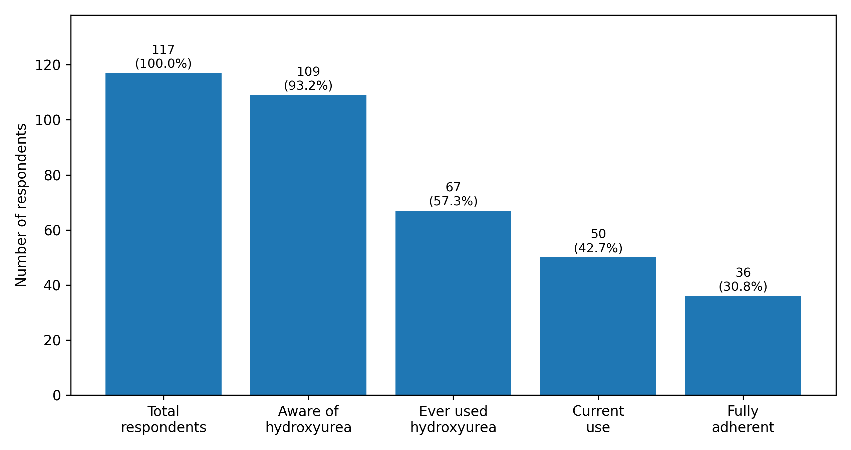
Figure 1. Hydroxyurea access cascade. The cascade demonstrates attrition from awareness to ever-use, current use, and full adherence, highlighting the distinction between drug availability and successful long-term treatment exposure.

Of the 117 respondents, 109 (93.2%) were aware of hydroxyurea and 67 (57.3%) had previously used it (ever-users). Of the 67 ever-users of hydroxyurea, 50 (74.6% of ever-users and 42.7% of all respondents) were current users, while 17 (25.4% of ever-users and 14.5% of all responders) had discontinued hydroxyurea therapy. Eight (6.8%) had never heard of hydroxyurea. See Fig. 1
Among the 50 current hydroxyurea users, 36 (72.0%) reported taking the drug always as prescribed, while 13 (26.0%) took it sometimes and 1 (2.0%) took it rarely. Regarding the perceived effect of hydroxyurea on painful crises, 24 (48.0%) current users reported a significant reduction in pain crises, 12 (24.0%) had a slight reduction, whereas 9 (18.0%) were unsure and 5 (10.0%) reported no change. Twenty-nine current users (58.0%) thought hydroxyurea improved their quality of life, 20 (40.0%) were unsure, and one respondent did not think it improved quality of life.
A composite quality-of-life (QoL) score was generated from four self-reported domains: general health, overall quality of life, satisfaction with health, and satisfaction with the ability to perform daily activities. Among current hydroxyurea users, adherent patients had higher median QoL composite scores than non-adherent patients (median 3.75 [IQR 3.00–4.25] vs 3.29 [IQR 2.69–3.73]), however, this difference was not statistically significant (p = 0.111). On the other hand, adherent users had statistically significantly lower disease-burden composite scores (median 2.00 [IQR 2.00–2.75] vs 2.71 [IQR 2.50–3.00], p=0.009). See Fig. 2

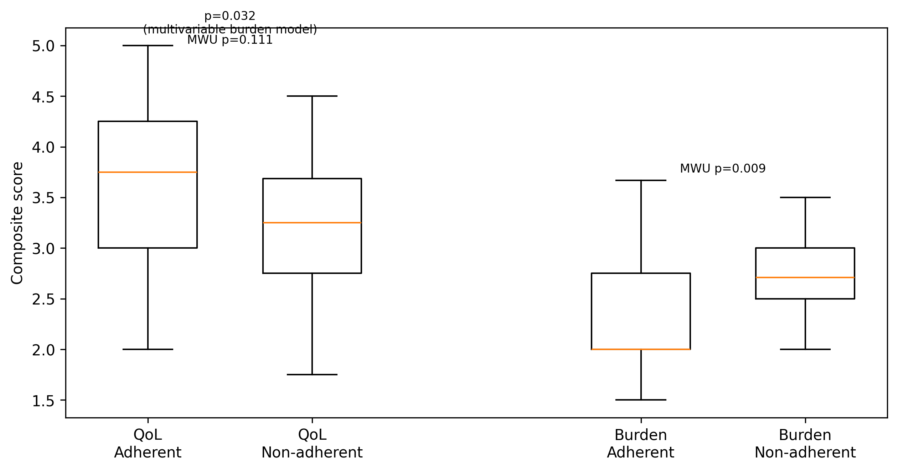
Figure 2. Composite patient-reported outcomes among current hydroxyurea users by adherence status. Adherent users had numerically higher QoL scores (Mann–Whitney p=0.111) and significantly lower disease-burden scores (p=0.009) than non-adherent users.

Table 2: Quality of Life Assessment
QoL domain | Questionnaire item | Response options | Score assigned
General health status | How would you describe your general health currently? | Very poor, Poor, Neither poor nor good, Good, Very good | 1–5
Overall quality of life | How would you rate your overall quality of life? | Very poor, Poor, Neither poor nor good, Good, Very good | 1–5
Satisfaction with health | How satisfied are you with your health? | Very poor, Poor, Neither poor nor good, Good, Very good | 1–5
Satisfaction with daily activities | How satisfied are you with your ability to perform daily activities? | Very poor, Poor, Neither poor nor good, Good, Very good | 1–5
Each item was scored on a 5-point ordinal scale, where 1 = very poor and 5 = very good. The QoL composite score was calculated as the mean of the four domain scores, with higher scores indicating better perceived quality of life.
Table 3: Disease Burden Assessment
Domain | Questionnaire item | Response options | Score assigned
Impact on daily life | To what extent does sickle cell disease affect your day-to-day life? | Not at all; Slightly; Moderately; Severely | 1–4
Missed work/school | How often do you miss work or school because of sickle cell disease? | Never; Occasionally; Frequently; Very frequently | 1–4
Painful crises (past 12 months) | How many painful crises have you had in the last 12 months? | 1–2; 3–5; >5 | 1.5, 4, 6
Hospital admissions (past 12 months) | How many times have you been admitted to hospital in the last 12 months? | 0; 1; 2–3; >3 | 0, 1, 2.5, 4
Each domain was converted to a numerical score, with higher values indicating greater disease burden. For categorical frequency ranges (painful crises and hospital admissions), mid-point estimates were assigned. The disease burden composite score was calculated as the mean of the four domain scores for each respondent.
Table 4. Self-reported adherence to Hydroxyurea in 50 current users
Category | n | %
Always as prescribed | 36 | 72.0
Sometimes | 13 | 26.0
Rarely | 1 | 2.0

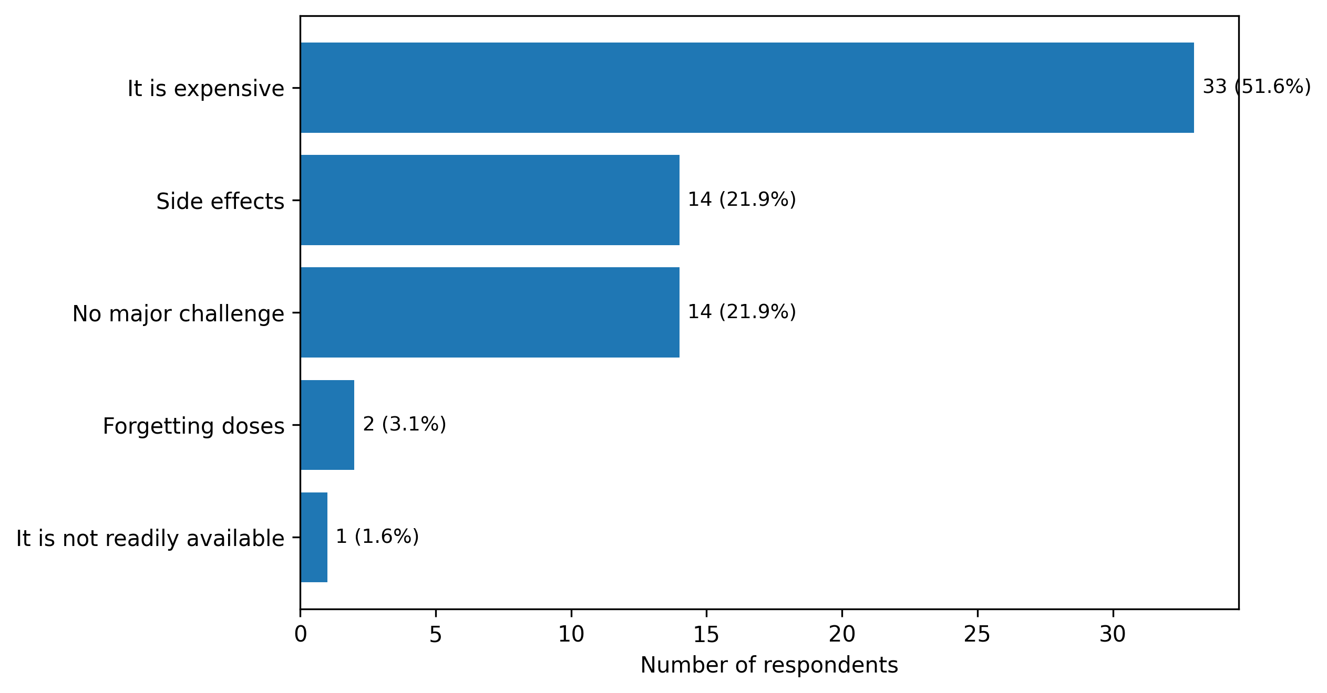
Figure 3. Barriers to hydroxyurea use among respondents

In the adjusted uptake model that included age, sex, higher education, income ≥N100,000, and disease burden, only disease burden remained independently associated with current hydroxyurea use (aOR 2.06, 95% CI 1.02–4.13; p=0.043). Monthly income ≥N100,000 showed a positive but non-significant direction of association (aOR 1.88; p=0.198). The model had modest discrimination (Area under curve- AUC- 0.64).
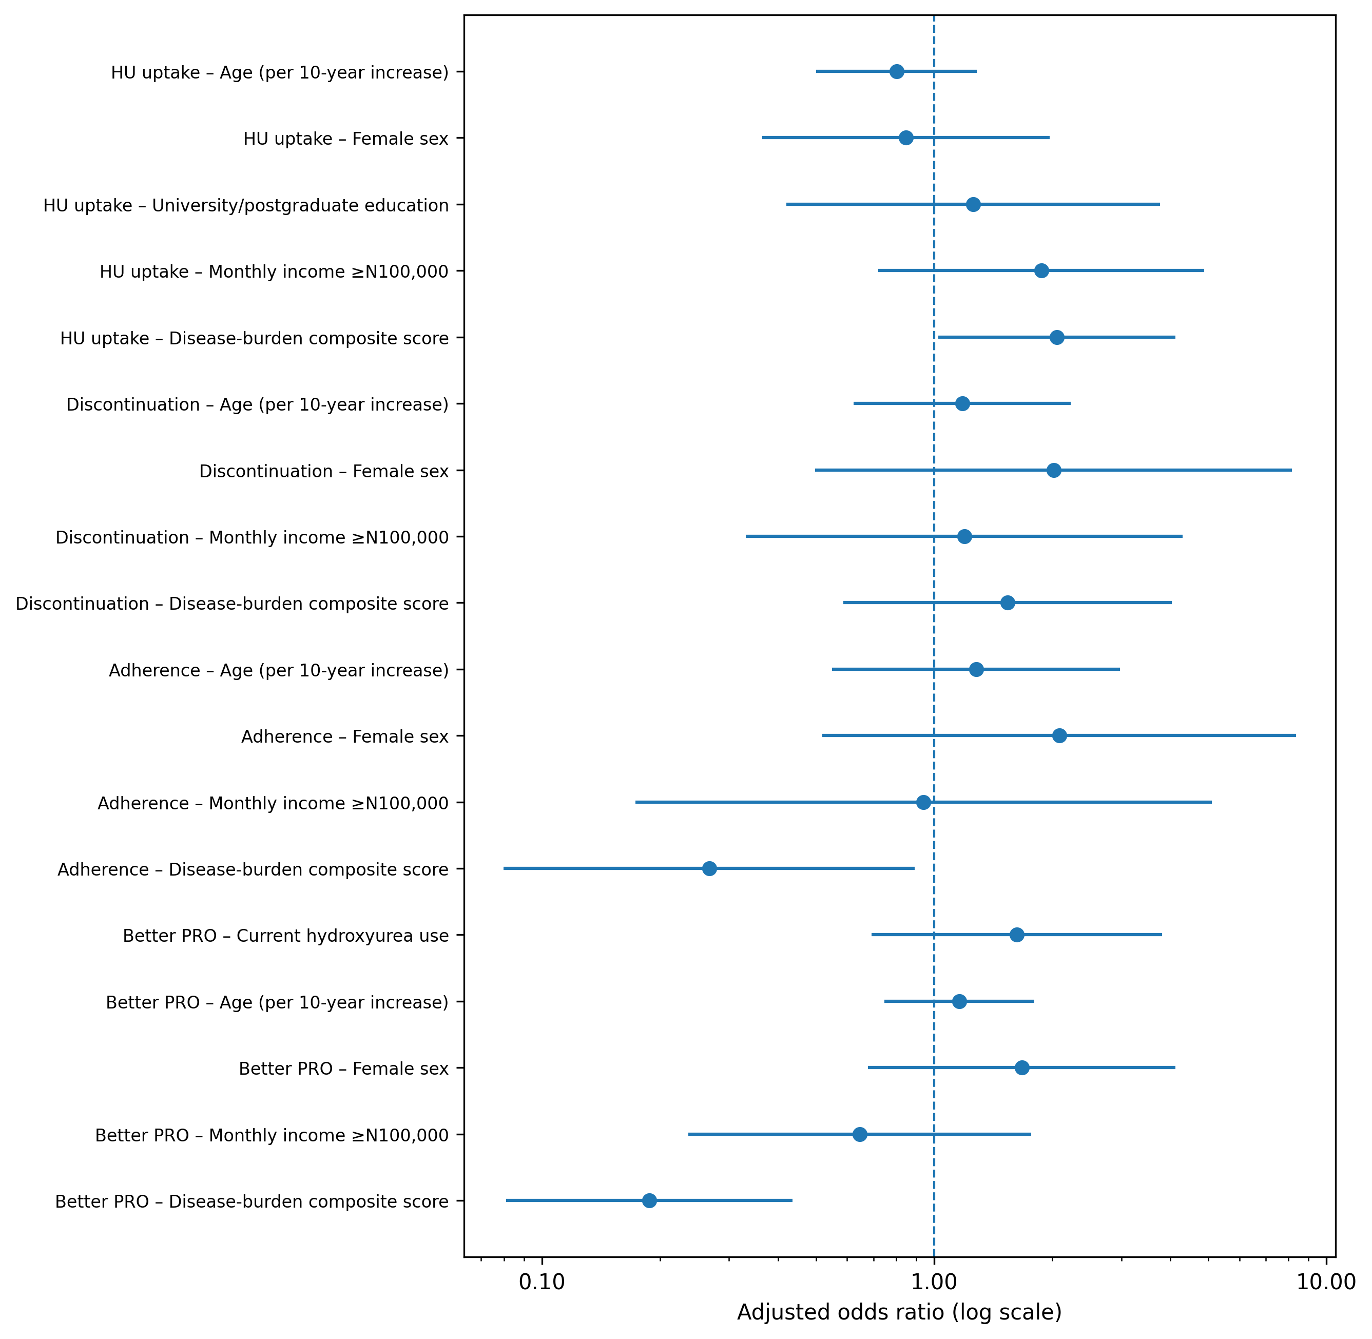
Figure 4. Forest plot of adjusted odds ratios from the multivariable models. Uptake was more likely in respondents with higher disease burden, whereas adherence and better patient-reported outcome were less likely as disease burden increased.

Adherence to hydroxyurea was assessed using self-reported medication-taking behaviour based on the question: “If you are on hydroxyurea, how regularly do you take it?” Responses were categorized as “always as prescribed,” “sometimes,” or “rarely” and dichotomized into adherent (“always as prescribed”) and non-adherent (“sometimes” or “rarely”). In the adherence model among current users, higher disease burden independently predicted lower odds of full adherence (aOR 0.27, 95% CI 0.08–0.89; p=0.032). Age, sex, and income were not independently associated with adherence. The model showed acceptable discrimination (AUC 0.72).
In the model for high QoL composite score, current hydroxyurea use was not independently associated with better outcome after adjustment (aOR 1.62, 95% CI 0.69–3.81; p=0.265). By contrast, higher disease burden was strongly and independently associated with lower odds of better patient-reported outcome (aOR 0.19, 95% CI 0.08–0.44; p<0.001). This model had the strongest discrimination of the four primary models (AUC 0.74).
Table 5. Multivariable predictors of uptake, discontinuation, adherence, and better patient-reported outcome.
Predictor/model | Adjusted OR | 95% CI | p value
Model 1: Current hydroxyurea uptake (all respondents, n=117)
Age (per 10-year increase) | 0.80 | 0.50–1.29 | 0.359
Female sex | 0.85 | 0.36–1.97 | 0.702
University/postgraduate education | 1.26 | 0.42–3.77 | 0.682
Monthly income ≥N100,000 | 1.88 | 0.72–4.88 | 0.198
Disease-burden composite score | 2.06 | 1.02–4.13 | 0.043
Model performance | Pseudo R²=0.045 | AUC=0.64
Model 2: Hydroxyurea discontinuation (ever-users, n=67)
Age (per 10-year increase) | 1.18 | 0.62–2.23 | 0.612
Female sex | 2.02 | 0.50–8.17 | 0.326
Monthly income ≥N100,000 | 1.19 | 0.33–4.30 | 0.787
Disease-burden composite score | 1.54 | 0.59–4.03 | 0.380
Model performance | Pseudo R²=0.029 | AUC=0.63
Model 3: Full adherence among current users (n=50)
Age (per 10-year increase) | 1.28 | 0.55–2.97 | 0.568
Female sex | 2.08 | 0.52–8.36 | 0.301
Monthly income ≥N100,000 | 0.94 | 0.17–5.11 | 0.943
Disease-burden composite score | 0.27 | 0.08–0.89 | 0.032
Model performance | Pseudo R²=0.125 | AUC=0.72
Model 4: Better patient-reported outcome: high QoL score (all respondents, n=117)
Current hydroxyurea use | 1.62 | 0.69–3.81 | 0.265
Age (per 10-year increase) | 1.16 | 0.75–1.80 | 0.511
Female sex | 1.67 | 0.68–4.13 | 0.265
Monthly income ≥N100,000 | 0.65 | 0.24–1.77 | 0.395
Disease-burden composite score | 0.19 | 0.08–0.44 | 0.000
Model performance | Pseudo R²=0.134 | AUC=0.74
Higher QoL composite score (≥4.0) was used as the binary outcome for Model 4. OR, odds ratio; CI, confidence interval; AUC, area under the receiver operating characteristic curve.
Hydroxyurea uptake remained suboptimal despite high overall awareness in 109 (93.2%) of the total respondents. Eight persons (6.8%) had never heard of hydroxyurea, while 42 (35.9%) were aware of the drug but were not currently taking it, and 17 (14.5%) had discontinued treatment. When respondents were asked about the main challenge associated with hydroxyurea use, the most frequently reported barrier was cost, cited by 33 (28.2%) of the responders. Other reported challenges included adverse effects of the drug (n=14, 12.0%), forgetfulness (n=2, 1.7%), and poor availability (n=1, 0.9%). Fourteen respondents (12.0%) reported no major challenge. Among the 17 respondents who had discontinued hydroxyurea, 5 (29.4%) identified cost as their main challenge, while 3 (17.6%) cited side effects and 1 (5.9%) reported forgetting doses.

Discussion
This study evaluated the use of hydroxyurea among persons living with SCD in a resource-constrained setting, with particular emphasis on the access–adherence–outcomes pathway. The study population consisted mostly of young adults, with a mean age of 30.8 years, reflecting the improving survival of persons living with SCD into adulthood in this setting.^{15,16} The predominance of female responders may reflect health-seeking behaviour by the females.¹⁷ A high proportion of respondents had tertiary education, suggesting a relatively informed cohort; however, this did not translate into favourable socioeconomic status, as a substantial proportion reported low or no income. This highlights the persistent economic vulnerability associated with SCD despite educational attainment.¹⁸
Most responders’ haemoglobin phenotype was HbSS, which is in keeping with the known epidemiology of SCD in Nigeria and explains the significant disease burden observed.^{19,20} Although nearly half of the respondents reported 1–2 crises annually, a considerable proportion experienced frequent crises (>3 episodes), indicating disease severity. There was also a high rate of hospitalisation, with nearly 60% requiring at least one admission and over one-third experiencing multiple admissions within the preceding twelve months. The high prevalence of prior blood transfusion suggests that transfusion is used as part of supportive care and may reflect the cumulative burden of complications in SCD in this setting.²¹
A key finding of this study was the discordance between awareness and utilization of hydroxyurea. Although most of the responders were aware of hydroxyurea, only a little over half had ever used it, and less than half were current users. Therefore, availability of hydroxyurea in our environment did not translate into consistent uptake and sustained use. The gap in uptake of hydroxyurea in the responders may be due to; a small but relevant lack of awareness gap in the less than a tenth of them who had never heard of it, a substantial initiation gap in about a third of those who were aware of hydroxyurea but not on treatment, and a retention gap in about a quarter of those who were ever-users but discontinued treatment.
Our findings revealed that higher disease burden independently predicted hydroxyurea uptake (aOR 2.06, p=0.043), suggesting that patients with more severe disease were more likely to initiate therapy. This is consistent with clinical practice patterns in LMICs, where hydroxyurea is often reserved for patients with frequent crises, hospitalizations, or transfusion requirements, rather than being used proactively.^{22,23} However, this pattern has important implications. When treatment is preferentially initiated in more severe disease, cross-sectional comparisons between users and non-users may underestimate the apparent benefit of hydroxyurea. This likely explains why current hydroxyurea use was not independently associated with better patient-reported outcomes in the responders (p=0.265).
In this study, adherence (and not just current use) was the key determinant of improved outcomes. Almost three-quarters of the current users were adherent to hydroxyurea and they had significantly lower disease-burden scores (p=0.009). Adherent users also had numerically higher QoL scores, although not statistically significant (p=0.111). On the other hand, higher disease burden was independently associated with lower odds of adherence (p=0.032). These findings suggest a clinical paradox where patients with higher disease burden who have the greatest need for hydroxyurea were also least likely to adhere fully to the drug, thereby reducing its potential benefit. Therefore, improving outcomes in SCD requires not only increased availability or access to hydroxyurea, but also improved adherence support, especially for those with severe disease.^{10,24} In addition, the effectiveness in our settings is mediated through adherence and continuity, rather than exposure alone. Our study also showed that disease burden was the strongest predictor of patient-reported outcomes, as a higher disease burden was significantly associated with lower odds of better QoL (p<0.001).
Financial toxicity was the major barrier to hydroxyurea uptake and sustained use. This finding is consistent with several studies across sub-Saharan Africa, where out-of-pocket financing remains a major determinant of access to chronic therapies. A notable proportion of respondents who had discontinued hydroxyurea identified cost as their main challenge, supporting the interpretation that financial toxicity contributes not only to poor uptake but also to treatment interruption and non-sustained use. ^{25,26} Although not all discontinuations were directly attributable to affordability, the prominence of cost among those who discontinued therapy reinforces the importance of affordability in determining the real-world effectiveness of hydroxyurea in our environment.
Based on our findings, recommended strategies to improve hydroxyurea outcomes in a low-medium income setting should include: subsidization, health insurance coverage, or inclusion in national essential medicines reimbursement schemes. Structured adherence support schemes are necessary to improve patient education, follow-up systems, and simplified monitoring pathways.

Conclusion
In conclusion, this study demonstrated that despite the high awareness of hydroxyurea, effective and sustained therapeutic exposure was suboptimal, with attrition occurring at multiple points along the treatment cascade. Disease severity appeared to drive treatment initiation, but sustained benefit was concentrated among patients who were able to maintain consistent adherence. Financial barriers, particularly cost, remain the dominant constraint on optimal use. These findings highlight the need for policy-driven interventions focused on affordability, continuity, and adherence support, rather than drug availability alone, to maximize the impact of hydroxyurea in SCD care.

Study Limitations
This cross-sectional questionnaire-based study included self-reported adherence and outcomes, which may be subject to recall bias. Although respondents were from different geographic zones in Nigeria, the sample may not be fully representative of all SCD populations. Additionally, clinical and laboratory parameters were not available to complement patient-reported measures.
Consent
As per international standards or university standards, respondents’ informed consent has been collected and preserved by the author(s).
Disclaimer (Artificial intelligence)

Author(s) hereby declare that NO generative AI technologies such as Large Language Models (ChatGPT, COPILOT, etc.) and text-to-image generators have been used during the writing or editing of this manuscript.

References
- Adigwe OP, Onoja SO, Onavbavba G. A Critical Review of Sickle Cell Disease Burden and Challenges in Sub-Saharan Africa. J Blood Med. 2023 May 31;14:367-376
- GBD 2021 Sickle Cell Disease Collaborators. Global, regional, and national prevalence and mortality burden of sickle cell disease, 2000-2021: a systematic analysis from the Global Burden of Disease Study 2021. Lancet Haematol. 2023 Aug;10(8):e585-e599. doi: 10.1016/S2352-3026(23)00118-7. Epub 2023 Jun 15. Erratum in: Lancet Haematol. 2023 Aug;10(8):e574. doi: 10.1016/S2352-3026(23)00215-6.
- Kumar A and Bhattacharya S (2024) Sickle cell disease: a comparative perspective on global and national initiatives. Front. Hematol. 3:1457158.
- Piel FB, Rees DC, DeBaun MR, Nnodu O, Ranque B, Thompson AA, et al. Defining global strategies to improve outcomes in sickle cell disease: a Lancet Haematology Commission. Lancet Haematol. 2023;10(8):e633-e686. doi:10.1016/S2352-3026(23)00096-0
- Charache S, Terrin ML, Moore RD, Dover GJ, Barton FB, Eckert SV, et al. Effect of hydroxyurea on the frequency of painful crises in sickle cell anemia. N Engl J Med. 1995;332(20):1317-1322. doi:10.1056/NEJM199505183322001
- Paul George, Grace Kalmus, Peter A. Lane, Wilbur Lam, Joseph Lipscomb, David Howard,Evaluating the long-term benefits of hydroxyurea in pediatric sickle cell anemia, Blood Advances,Volume 9, Issue 14,2025,Pages 3585-3593
- Tshilolo L, Tomlinson G, Williams TN, Santos B, Olupot-Olupot P, Lane A, Aygun B, Stuber SE, Latham TS, McGann PT, Ware RE; REACH Investigators. Hydroxyurea for Children with Sickle Cell Anemia in Sub-Saharan Africa. N Engl J Med. 2019 Jan 10;380(2):121-131.
- McGann PT, Ware RE. Hydroxyurea therapy for sickle cell anemia. Expert Opin Drug Saf. 2015;14(11):1749-58. doi: 10.1517/14740338.2015.1088827. Epub 2015 Sep 14
- Odame I, Bazuaye GN. Transfusions, disease-modifying treatments, and curative therapies for sickle cell anemia in Africa: where are we now? Hematology Am Soc Hematol Educ Program. 2024;2024(1):234-239. doi:10.1182/hematology.2024000550
- Korubo KI, Onodingene NM, Okoye HC, Omunakwe HE. Perception to hydroxyurea therapy in patients with sickle cell disease: Report from 3 centres. Ann Afr Med. 2021 Apr-Jun;20(2):127 – 131. Doi:10.4103/aam.aam_36_20. PMID34213480
- Namaganda P, Nantume P, Mubiru KR, Twimukye A, Wiltshire CS. Understanding patient-related barriers to hydroxyurea use among adolescent and adult patients with sickle cell disease in Mulago and Kiruddu hospitals, Uganda, a qualitative study. BMC Health Serv Res. 2024 May 27;24(1):666.
- Okocha EC, Gyamfi J, Ryan N, Babalola O, Etuk EA, Chianumba R, et al. Barriers to therapeutic use of hydroxyurea for sickle cell disease in Nigeria: a cross-sectional survey. Front Genet. 2022;12:765958. doi:10.3389/fgene.2021.765958.
- Ryan N, Dike L, Ojo T, Vieira D, Nnodu O, Gyamfi J, et al. Implementation of the therapeutic use of hydroxyurea for sickle cell disease management in resource-constrained settings: a systematic review of adoption, cost and acceptability. BMJ Open. 2020;10:e038685. doi:10.1136/bmjopen-2020-038685.
- Chianumba RI, Ofakunrin AOD, Morrice J, Olanrewaju O, Oniyangi O, Kuliya-Gwarzo A, et al. Outcome of hydroxyurea use in SCD and evaluation of patients’ perception and experience in Nigeria. Front Genet. 2022;13:826132. doi:10.3389/fgene.2022.826132.
- Kayle M, Docherty SL, Sloane R, Tanabe P, Maslow G, Pan W, Shah N. Transition to adult care in sickle cell disease: A longitudinal study of clinical characteristics and disease severity. Pediatr Blood Cancer. 2019 Jan;66(1)
- Charles T. Quinn, Zora R. Rogers, Timothy L. McCavit, George R. Buchanan,Improved survival of children and adolescents with sickle cell disease,Blood,Volume 115, Issue 17,2010,Pages 3447-3452
- Oluwasayo B. Ogunlade & Adesola A. Ogunfowokan (2021). The Relationship between Health Seeking Behaviour and Health Related Quality of Life of Female Market Traders in Ile-Ife, Southwest Nigeria. Saudi J Nurs Health Care, 4(12): 482-488.
- Khan H, Krull M, Hankins JS, Wang WC, Porter JS. Sickle cell disease and social determinants of health: A scoping review. Pediatr Blood Cancer. 2023 Feb;70(2):e30089. doi: 10.1002/pbc.30089. Epub 2022 Dec 10
- Kotila T, Aworanti O, Akunwata C, Ogundeji P, Oresanya S, Adewale A, Alabi R, Fasola F, Olaniyi J. Haemoglobin variants in nigeria: real-world data from a point-of-care device. Ann Hematol. 2025 Oct;104(10)
- Kingsley, Akaba, Ofem Enang, Ofonime Essien, Annette Legogie, Omini Cletus, and Olukayode Oshatuyi. 2019. “Prevalence of Sickle Cell Disease and Other Haemoglobin Variants in Calabar, Cross River State, Nigeria”. Annual Research & Review in Biology 33 (5):1-6.
- Culp-Hill R, Srinivasan AJ, Gehrke S, Kamyszek R, Ansari A, Shah N, Welsby I, D'Alessandro A. Effects of red blood cell (RBC) transfusion on sickle cell disease recipient plasma and RBC metabolism. Transfusion. 2018 Dec;58(12):2797-2806
- Power-Hays A, Ware RE. Effective use of hydroxyurea for sickle cell anemia in low-resource countries. Curr Opin Hematol. 2020 May;27(3):172-180.
- Power-Hays A, Ware RE. Effective use of hydroxyurea for sickle cell anemia in low-resource countries. Curr Opin Hematol. 2020 May;27(3):172-180. doi: 10.1097/MOH.0000000000000582. PMID: 32205588
- López Rubio M, Argüello Marina M. The Current Role of Hydroxyurea in the Treatment of Sickle Cell Anemia. J Clin Med. 2024 Oct 25;13(21):6404. doi: 10.3390/jcm13216404. PMID: 39518543; PMCID: PMC11546997
- Airuthia Y, Alanazi RB, Alotaibi SF, Alanazi M. Quality of Life and Out-of-Pocket Expenditures for Sickle Cell Disease Patients in Saudi Arabia: A Single-Center Study. Healthcare (Basel). 2024 Oct 29;12(21):2146
- Adelakun Odunyemi, Md Tauhidul Islam, Khurshid Alam, The financial burden of noncommunicable diseases from out-of-pocket expenditure in sub-Saharan Africa: a scoping review, Health Promotion International, Volume 39, Issue 5, October 2024, daae114

