Study of D+³He and T+³He reactions by using Double Folding Potential at astrophysical relevant energies

.
ABSTRACT:

Aims: The microscopic double folding potential is more superior over the conventional square-well potential as it more realistic to represents the nuclear interactions and the introduction of an imaginary potential provides an effective and compact way to model absorption in nuclear well.
Study design: The computations of nucleus-nucleus potential are implemented in the framework of double folding model function with DDM3Y-Reid and DDM3Y-Paris effective N-N interaction. Among different kind of the effective interaction, the so-called DDM3Y interaction was used in the double folding potential calculations.

Methodology: At astrophysical energy regime, the study of the nuclear fusion cross-sections is formidable on account of the massive vastness of the Coulomb barrier, yield in a minute worth of the fusion cross-section. All achievement in the results on S-function towards light particles can gives a clear insights about Big Bang nucleosynthesis. Presently, we have theoretically examined the E dependence of S-function and nuclear fusion σ(E) for fusion reaction of light nuclei for ³He(D,P)⁴He and ³He(D,N+P)⁴He nuclear system using complex potential with Coulomb repulsive potential.
Results: The calculation of the cross section and S-function cooked in the foundation of the SRTM potential function approach.
Conclusion: Theoretical computed results matched with the experimental results.

Keywords: [Double Folding Potential, Woods-Saxon Potential, VMC, DDM3Y }

1. INTRODUCTION:

Nuclear astrophysics is crosswalk of astrophysics and nuclear physics [1-3]. Nuclear physics take part a crucial character in meaningful events happening in the stellar core, this leads to the development of the aforementioned very spicy regulation of modern science is known as nuclear astrophysics. We use deuteron nucleus as a projectile which is the simplest of the all nuclei and which consist of a proton and a neutron. There are several method to recreate the experimental results using the optical potential as well as double folding (DF) potentials function [4]. In double folding model, we use nucleon-nucleon interaction potential DDM3Y – type potential [5]. The double folding model potential function is dependent on nuclear matter distribution. The double folding potential can describe the interaction field interplay among the hitting system. The DFP model provided the valuable information about the projectile and target nuclei. The fundamental information in the DF model function computation are the mass of the hitting particles and the effective N-N interaction between the projectile nucleus and the target nucleus [6].

As double folding model potential is density dependent, we need to know the density distribution of the nucleus. The mass distribution of the systems have many versions such as Gaussian, Fermi and Variational Monte Carlo (VMC) distribution [7]. For double folded function computations, the Gaussian distribution of mass has been used that is an exponential function of distance. The Fermi matter distribution also has exponentially decreasing function of distance. Out of numerous kind of effective interplay, the DDM3Y-type interplay has been applied for the computation of DF function. This interplay is acting on a small distance for systems and does not depends on densities [8].

The interaction between two particles is one of the most crucial features in nuclear physics. An important step in examining these-interplay is the computation of ion-ion interaction function that can help us to study the σ(E) of the reactions. In literature, the cross-section is a probability that a specific nuclear reaction will take place. The reaction cross-sections are additionally considered. We studied the well-known Double Folding potential model to pay out the present investigation.

In this work, we have calculated the nuclear cross-section of ³He(D,P)⁴He and ³He(D,N+P)⁴He nuclear reactions and compared them with the experimental results found in the previous work. To explain the fusion cross-section, the compound nucleus model can be used, which is a two-step process, and later Li et al. introduced SRTM approach [9] which dominates over the compound nucleus model. As an advancement over the earlier works, where authors have used constant square-well or phenomenological space-varying potentials. In the present work, we adopt the density-dependent DF function approach towards calculation of S-function and nuclear σ(E) of few ³He-induced fusion reactions: ³He(D,P)⁴He and ³He(D,N+P)⁴He nuclear reactions.

In Sec. 2, we present the concept of a theoretical framework for σ(E) calculation. This included S-function and double-folding potential. The computed results and comparison with the experimental result are made in Sec. 3. We close with a summary and conclusion in Sec. 4.

2. THEORETICAL FRAMEWORK

In nuclear astrophysics, Big Bang nucleosynthesis is the creation of different types chemical elements by fusion reactions within stellar environment. Big Bang nucleosynthesis has occurred since the original creation of H, He and Li during the Big Bang. Quantum tunneling is a crucial physical phenomenon for nuclear fusion reactions. The temperature in the stars is generally insufficient to allow interacting particles to defeat the mutual Coulomb potential and achieve thermonuclear reaction in the stars. Quantum tunneling phenomena increases the probability of penetrating this nuclear barrier.

The nuclear σ(E) has been expressed in equation (1):
σ(E) = $\frac{\text{S(E)}}{\text{E}}$ · exp(-2πλ) (1)
Here, E = projectile energy and S(E) = S-function.
Now, Sommerfeld parameter (λ) is expressed in equation (2) as
λ = $\frac{\text{(Z}\text{₁}\text{ Z}\text{₂}\text{ e²)}}{\text{(ħ v)}}$ (2)
Here, Z₁,Z₂ = charge numbers of nuclei and A₁ and A₂ = mass number.
Coulomb barrier has been given by Eq. (3)
$V_{CB}$ = $\frac{\text{e²}}{\text{4πε}\text{₀}}$· $\frac{\text{Z}\text{₁}\text{ Z}\text{₂}}{\text{R}}$ = (1.44) · $\frac{Z_{1}Z_{2}}{R_{0}(A_{1}^{1/3}+A_{2}^{1/3})}$ (3)
where $R_{0}$ = constant parameter
R = centre to centre distance of interacting nuclei.
The nuclear fusion cross-section at astrophysical relevant energy for light nuclei can be computed applying the DF function, supposing a nuclear function of the following form:
V_{eff}(r) = V_{Coulomb}(r) + V_{centrifugal}(r) + V_{nuclear}(r) (4)
In the above mensioned equation the Coulomb potential (Satchler, 1983) [10] is owing to the interplay between the target and projectile in proton atomic numbers over a sphere of radius R.
V_{Coulomb}(r) = 1.44 ($\frac{\text{Z}\text{1}\text{ Z}\text{2}}{\text{r}}$) , for r > R [MeV]
= 1.44 ($\frac{\text{Z}\text{1}\text{ Z}\text{2}}{\text{2R}}$) .(3 – $\frac{r^{2}}{R^{2}}$ ) , for r <= R [MeV] (5)
The middle term of equation (4) has been is given by

V_{centrifugal}(r) = $\frac{\text{ℏ}\text{2}\text{ l(l+1)}}{\text{2μr}\text{2}}$ (6)

Here, μ = reduced mass and l = angular momentum and r = radial distance and h = planck’s constant.

The rest part of the total function is the nuclear interaction V_{nuclear}(r) derived by double folded process. This effective potential term for chosen V_{NN} as nucleon-nucleon interaction could be represented by equation (6).

V_{F} (r) = ∫ ∫ ρ₁(r₁) ρ₂(r₂) V_{NN}(s)d³r₁d³r₂ (7)

Where r = distance between the two nuclei; r₁,r₂ = distances measured from the centre of particle. The angle between r₁ and r is θ₁ and that of r₂ and r is θ₂. The N-N separation may be put down in terms of r, r₁, r₂ and represented by the equation (7).

$\vec{s}$ = $\vec{r}$ – $\vec{r}$₁ + $\vec{r}$₂ (8)

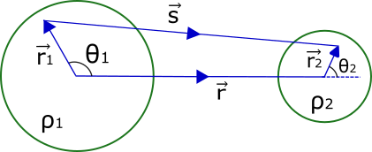

Figure 1: A schematic diagram of DF function.for the target and projectile nucleus.

In DF function, the density distributions of both the interacting nuclei has been used. The typical Woods-Saxon distribution of matter density are given by equation (9)
ρ(r) = ρ_{o}/[1+exp(r-c)/a ] (9)

Where ρ_{o} = 2.607 (fermi⁻³), c = $R_{0}A_{x}^{1/3} ;$x = t (stationary particle) or p (moving particle), a = 0.486(fermi)
In the folding calculation, we have used the most general one, the DDM3Y-Reid nucleon–nucleon realistic interaction represented by
$v_{NN}(r) =$ v(r) + $J_{00}$(E) δ (r) (10)
The Yukawa-type interplay N–N interaction potential model v(r) involves of a small-distance repellent part; also a relatively large-distance captivating term, has been given by
v(r) = 7999$\frac{exp(-4r)}{4r} - 2134\frac{exp⁡(-2.5r)}{2.5r}$ (11)
The last term in Eq. (10) is J₀₀, which has a energy dependence linearly. This term represents the nucleon exchange component as in Eq. (12)
${ J}_{00}$(E) = -276[ 1- $\frac{0.005Elab}{Ap}$ ] Mev.${fm}^{3}$ (12)
Thus, $U_{N}$(r) can be constitute by
${ U}_{N}$(r) = $C_{r}$ $U_{DF}$(r) $+ iC_{i}$ $U_{iDF}$(r) (13)
where the imaginary component is introduced as
${ U}_{iDF}$(r) = - $\frac{1}{r} \frac{d}{dr} (U_{DF}$(r)) (14)
The Schrodinger equation for the entire interplay function of Eq. (4) has been given by
(-$▽^{2}$ + $\frac{2μU(r)}{{\text{h}}^{2}}$ - $k^{2}$ )ψ(r) = 0 (15)
Here, k = $\sqrt{\frac{2μE}{{\text{h}}^{2}}}$ ; E = energy;
$μ$= reduced mass system, ${\text{h}}^{2}$ = Planck's constant,
and ψ(r) = sum of the nuclear wave function and Coulomb wave function:
ψ(r) = ${\text{ψ}\text{(r)}}_{N}$ + ${\text{ψ}\text{(r)}}_{C}$ (16)
In Eq. (16), ${\text{ψ}\text{(r)}}_{C}$= Coulomb wave function of incoming particle,
${\text{ψ}\text{(r)}}_{N}$is = nuclear wave inside the well.
Equation (15) has been turn down to a r-dependent differential equation and has been given by Eq. (17):
( -$\frac{d^{2}}{{dr}^{2}}$ + $\frac{l(l+1)}{r^{2}}$ + $\frac{2μU(r)}{{\text{h}}^{2}}$ - $k^{2}$) ψ(r) = 0 (17)
resolution ψ(r,t) of the equ. (17) relating to Schrodinger equation (17) for the working system can be given by equation (18):
ψ(r,t) = $\frac{1}{\sqrt{4πr}}$ ψ(r) exp(-$\frac{iEt}{h}$) (18)
Here, the nuclear σ(E) has been expressed by Eq. (19):
σ(E) = $\frac{π}{k^{2}}$ (1 - ${|η|}^{2}$ ) (19)
Here, $η$ is defined as $e^{2iδ_{0}}$ and k = wave number. As the selected potential function is an imaginary one, the related $δ_{0}$ will be a imaginary one and has been expressed by equation (20):
Cot($δ_{0}) = W_{r} + i$ $W_{i}$ (20)
Here, W_{r} and W_{i} are related appropriate with real component and imaginary component for the complex wave number.
Now, wave number expressed by
K(r) = $\sqrt{\frac{\text{2μ}}{\text{ħ²}}\text{ (U(r) - E}\text{) ]} }$
= $\sqrt{\frac{\text{2μ}}{\text{ħ²}}[\text{(}U_{C}\text{(r) + }U_{cent}\text{(r)+}U_{N}\text{(r) - E}\text{) ]} }$
= $\sqrt{ \frac{\text{2μ}}{\text{ħ²}}\text{[(}U_{C}\text{(r)+}C_{r}U_{DF}\text{(r)+ i}C_{i}U_{iDF}\text{(r)- E}\text{) ]} }$ [for l = 0] (21)
= $\sqrt{ \frac{\text{2μ}}{\text{ħ²}}[U_{C}\text{(r)+}C_{r}U_{DF}\text{(r)- }\text{E ]}}$ × $\sqrt{1+i\frac{C_{i}U_{iDF}\text{(r)}}{ [U_{C}\text{(r)+}C_{r}U_{DF}\text{(r)- E ]}}}$
≈ $\sqrt{ \frac{\text{2μ}}{\text{ħ²}}[U_{C}\text{(r)+}C_{r}U_{DF}\text{(r)- }\text{E ]}}$ + $\frac{i}{2}$ $\sqrt{\frac{\text{2μ}}{\text{ħ²}} \frac{C_{i}U_{iDF}\text{(r)}}{\sqrt{[U_{C}\text{(r)+}C_{r}U_{DF}\text{(r)- E]}}} }$
= K_{r}(r) + i K_{i}(r)
At r = R, KR = K_{r}R + iK_{i}R
Here, Z ≡ Z_{r} + iZ_{i} for Z = KR, Z_{r} = K_{r}R, Z_{i} = K_{i}R.
For real term and imaginary term of Z, the variable Wr and Wi are designated as
$W_{r }= {\text{Ω}}^{2} \frac{Re Z_{r} sin(2Z_{r})+Z_{i} sin(2Z_{i})}{2[\sin^{2}(Z_{r}) +\sinh^{2}(Z_{i})]} - 2$ ${\text{Ω}}^{2}[ln(\frac{2R}{R_{c}})+2C+P(kR_{c})]$

$W_{i }= {\text{Ω}}^{2} \frac{Re Z_{r} sin(2Z_{r}) -Re Z_{i} sin(2Z_{i})}{2[\sin^{2}(Z_{r}) +\sinh^{2}(Z_{r})]}$ (22)
where R_{c} = ℏ² / Z₁Z₂μe² and C ≅ 0.577 .
The energy (E) conditional function P(kR_{c}) has been given by
P(kR_{c}) ≡ Re[ψ(−i / kR_{c})] + ln(kR_{c}); ψ(x) ≡ Γ′(x) / Γ(x)
where Γ(x) is the Gamma function, and
Q(y) = $\frac{1}{y^{2}}$ $\sum_{s=1,2,..}{\frac{1}{(s^{2} + y^{-2})}}$ − C + ln(y) (23)
The nuclear cross-section has been finalised as
σ = $\frac{\text{π}}{\text{k}\text{2}}$ $\frac{-4W_{i}}{W_{r}^{2} +{(1-W_{i})}^{2} }$
= $\frac{\text{π}}{\text{k}\text{2}}$ $\frac{1}{{\text{Ω}}^{2}}$ { $\frac{-4{\text{ω}}_{i}}{{\text{ω}}_{r}^{2} +{({\text{ω}}^{2}-\frac{1}{{\text{Ω}}^{2}})}^{2} }$ } (24)
Here, Ω² = (exp(π/kr) − 1) / 2π as Gamow penetration formula. The remaining term in Eq. (24) within {} is named as S-function, which relates E and nuclear σ(E).
Now, we can write
S(E) = $\frac{K^{2}}{\text{π}}$ × Ω²σ(E) = − $\frac{-4{\text{ω}}_{i}}{{\text{ω}}_{r}^{2} +{({\text{ω}}^{2}-\frac{1}{{\text{Ω}}^{2}})}^{2} }$ (25)
where ω = (W_{r} + iW_{i}) / Ω² = W/Ω² = ω_{r} + iω_{i} . The variables in equation (13) controlls the nature of wave in region r ≤ R inside the nuclear well. The real term and the imaginary term of the complex phase shift δ_{r} and δ_{i} determine the Coulomb wave nature outside the well r ≥ R.

3. results and discussion

The SRTM function describes a quantum mechanical process where particles (electrons or nuclei) tunnel through potential barriers only at specific "resonant" energy levels, allowing for highly efficient, controlled transmission. This model emphasizes that resonance requires matching not just energy, but also damping/lifetime, often producing sharper peaks in transmission or nuclear fusion cross-sections than standard models. Using Selective Resonant Tunnelling Model (SRTM), X.Z. Li [11] computed nuclear σ(E) of D+T nuclear system applying simple imaginary square-shaped and made comparison with experimental data from Ref. [12]. In 2004, Li. et. al. again using selective resonant tunneling model approach, computed D+³He and D+D system nuclear cross section. All the computations provide a comprehensible illustration of the regarding cross sections of the light element nucleosynthesis. In 2019, Singh et. al. [13] computed nuclear σ(E) along with S-function for few low weight nuclei such as D+T, D+D,³D+He. Using SRTM, Khan et. al. [14] in 2023 computed the same for the resonant cross section for p+¹¹B and D+D. The quantum tunnelling model using double folding potential was used by V. Durant et. al. [15] in 2018 in support of computation regarding nuclear σ(E) of ¹⁶O + ¹⁶O reaction. In the present work, quantum tunnelling model followed by double folding potential has been used for the computation of nuclear cross section of ³He + ⁴He nuclear reactions. We made the comparison between our computational data and the experimental data from Ref [12].

The thermonuclear fusion reactions have occurred via quantum tunneling phenomenon of the interacting systems. The fusion cross-section is a valuable quantity applicable towards examination of stellar reactions inside astrophysical energy regime i.e. low energy nuclear cross section. At astrophysical energy regime, the astrophysical S-function is an important astrophysical observable for the calculation of nuclear cross-section. The P-P chain reactions are the reason of energy production in lower massive stars. Initial condition, two ¹H fused to create a ²H particle, releasing enormous amount of energy. In later condition, the constructed ²H imprisoned a ¹H to produce a ³He nucleus and then two interacting ³He nuclei fused together to create a ⁴He particle. Thereafter, a ³He particle and a ⁴He particle experience fusion to yield ⁷Be and a γ particle. One can find many other nuclear reactions implicated in Big Bang processes plus E creation in stellar environment.

A star gets its shining power from the energy yield of a nuclear fusion reaction. Initially, one can introduced the DFP function with an additional term i.e. the complex potential. For the computation regarding ³He(D,P)⁴He and ³He(D,N+P)⁴He system reactions, one can invoked that distance modified complex function wherein lies the originality of this assignment as in literature such computations was carried out applying simple square variable nuclear well [16-18]. The quantum mechanical process does a vital role towards nuclear reaction amid low E regime [19].One can explored S(E) – function regarding ³He(D,P)⁴He system at low E range. After that, one can made contrasts of computed results and experimental data in figure 2. Present work, the computational exploration were conduct for low E towards ³He(D,P)⁴He nuclear system. The merit of the variables applied towards ³He(D,P)⁴He system is depicted in Table 1.

Secondly, we have computed the S - function towards ³He(D,P)⁴He system at the low energy regime. We have built a differentiation between the calculated result and experimental data for the ³He(D,N+P)⁴He nuclear structure and showed the outcomes in figure 3 and we have a good concurrence among them. Table 1 shows the different merit of variables applied towards ³He(D,N+P)⁴He structure.

Table 1: Potential Parameters for the ³He(D,P)⁴He, ³He(D,N+P)⁴He nuclear reactions

Reactions | U_{DF} (R)(MeV) | Ui_{DF}(R) (MeV) | R₀ (fm) | Energy, Cross-section (keV, mili-barn)
³He(D,N+P)⁴He | -8.40 | -0.20 | 3.8 | 589,792
³He(D,N+P)⁴He | -5.00 | -0.15 | 3.821 | 886,70.8

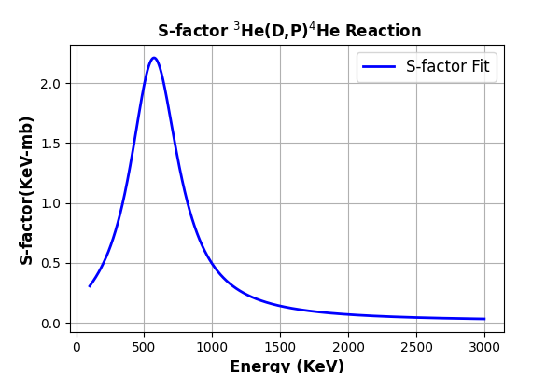

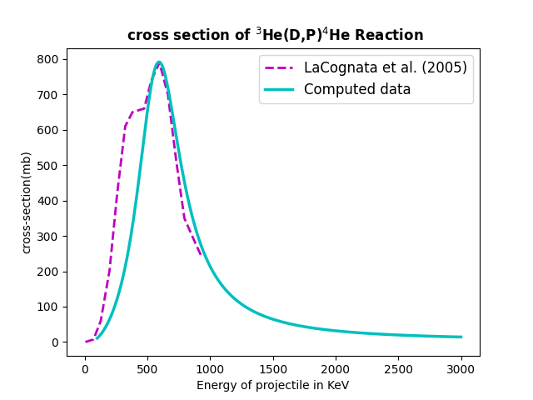

Figure 2: case Fitting of astrophysical S-function by using Eq. (25). Lower Panel: contrast between experimental data shown by broken line (cyan colour) and computed data solid line towards ³He(D,P)⁴He reaction. The experimental data are taken from works of LaCognata et al (2005) [20]
.

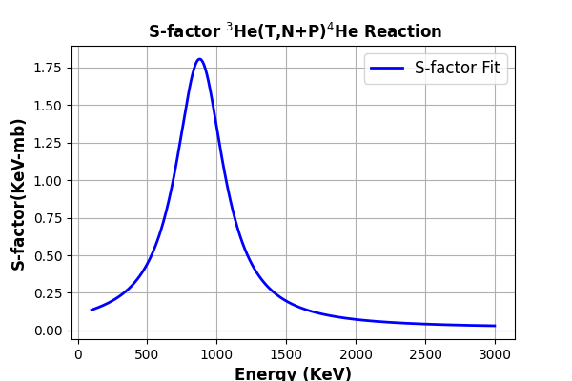

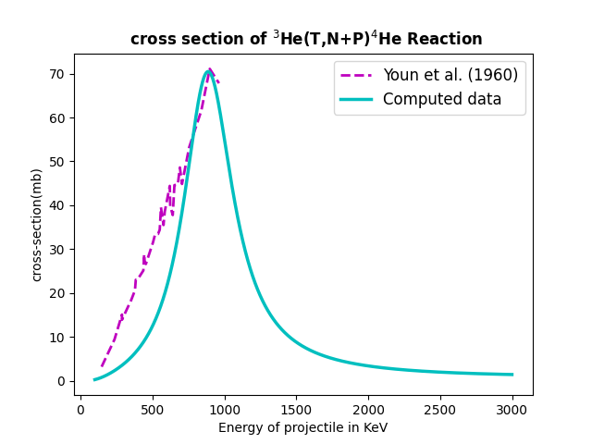

Figure 3: case Fitting of S-function by applying Eq. (25). Below case: contrast between experimental data shown by broken line (cyan colour) and computed data solid line for the ³He ³He(D,N+P) reaction. The experimental data are taken from works of Youn et al(1960)[21]

4. Conclusion

The S-function are widely applied in physics for the exploration towards nuclear σ(E) pertinent corresponding Gamow peak. One can examined ³He(D,P)⁴He and ³He(D,N+P)⁴He system substantially lower Coulomb nuclear barrier. Even if it had numerous models to examine the nuclear σ(E), DFP approach is a famous function for examining the experimental results. One may observe that the nuclear σ(E) provides a smooth concurrence among computed data and experimental data and all the outcome appeared in figure-2 and 3.

One of the aims of the present work was to examine the suitability of the DDM3Y N-N for colliding system description of light-ion nuclear systems. The interaction potential for ³He(D,P)⁴He and ³He(D,N+P)⁴He Double-Folding Potential was explored. The double folding model function was interpreted using the incorporation of nuclear mass function of the two hitting system and N-N interplay function. The mass distribution function of the system is Fermi & Gaussian distribution in nature.

As an illustration of the use of the double-folding potential, we take the particular interaction of ³He(D,P)⁴He and ³He(D,N+P)⁴He. In double-folded model function, the free variable is in our hand. We kept this value as unity to explore the conduct of the double-folding potential model. The folded nuclear potential model is a well-known model for examining the mean field N-N interplay between two colliding system. Within the framework of our approach the nucleus-nucleus collision process is modelled as double-folding potential model.

COMPETING INTERESTS DISCLAIMER:
Authors have declared that they have no known competing financial interests OR non-financial interests OR personal relationships that could have appeared to influence the work reported in this paper.
Disclaimer (Artificial intelligence)

Author(s) hereby declare that NO generative AI technologies such as Large Language Models (ChatGPT, COPILOT, etc.) and text-to-image generators have been used during the writing or editing of this manuscript.

References

- I.A. Bonnell and M.R. Bate, Accretion in stellar clusters and the collisional formation of massive stars, Mont. Not. Royal Astron. Soc., (2002) 336-659
- J.M. Carpenter, 2MASS Observations of the Perseus, Orion A, Orion B, and Monoceros R2 Molecular Clouds Astro.J, 120(6) (2000) 3139
- P. Caselli and C. Ceccarelli, Our astrochemical heritage, Astron. Astrophys. Rev.20(2012) 56.
- Sh. Hamada, B. Alshahrani, Abd Elrahman Elgamala, n. Darwish, I. Bondouk, Analysis of ⁶Li + ¹⁶O elastic scattering using different potentials, Rev. mex. Fis..66 ,3 (2020)
- Dao T. Khoa and W. von Oertzen, A nuclear matter study using the density dependent M3Y interaction, Physics Letters B 304 (1993) 8-16
- Z. Long et al., Double Folding Model Calculation Applied to the Real Part of Interaction Potential, High Engy Phys. Nucl. Phys. 31(7) (2007)
- Y. Sert, Elastic Scattering with Double Folding Model: ⁸B + ²⁷Al, Journal of Science and Technology, 14(1) (2021) 241-248
- N.A. El-Nohy et al., Theoretical Behaviour of ⁸B+²⁰⁸pb Elastic Scattering within Double Folding Model, IAARJ, 1(1)(2019) 67-76
- X. Zhong et al., Sub-Barrier fusion and selective resonant tunneling, Phys. Rev. C 61(2000) 024610
- G. R. Satchler, Direct Nuclear Reaction, International Series of Monographs on Physics (Oxford University Press, 1983).
- C. L. Liang, Selective resonant tunnelling – turning hydrogen-storage material into energetic material, Curr. Sci, 108(5) (2015)
- J. L. Osborne et al., Towards a high-precision measurement of the ³He(α,γ)⁷Be cross section at LUNA Nucl. Phys. A 419 (1984) 115
- V. Singh, D. Atta, Md. A. Khan and D.N. Basu, Astrophysical S-factor for deep sub-barrier fusion reactions for light nuclei. Nucl. Phys. A 986 (2019) 98 – 106
- Md. A. Khan, S.H. Mondal, M. Alam and M. Hasan, Study of Fusion Reactions of Light Nuclei at Low Energies Using Complex Nucleon-Nucleus Potential Function Bul J. Phys., 50 (2023) 354-366
- V. Durant, P. Capel, L. Huth, A.B. Balantekin, A. Schwenk, Double-folding potentials from chiral effective field theory Phys. Lett. B, 782(10) (2018) 668-674
- X.Z. Li, Nuclear physics for nuclear fusion, Fusion Sci Tech. 41( 2002)
- X.Z. Li, Q.M. Wei and B. Liu, A new simple formula for fusion cross section of light nuclei, Nucl. Fusion 48 (2008) 125003
- C.L. Liang, Z.M. Dong and X.Z. Li, Curr. Sci., 108, 4 (2015)
- E. Yildiz and I. H. Sarpun, A-Applied sci. Eng., 2020, 21(1), pp. 205 –209
- M. LaCongata et al., Bare-nucleus astrophysical factor of the He-3(d,p)He reaction via the Trojan horse` method, Phys. Rev. C,.72(2005)065802
- L.G.Youn et al., Zhurnal Eksperimental`noi i Teoret. Fiziki39(1960)225

