A Low-Cost IoT-Based Gas Sensor Approach for Real-Time Monitoring of Mango Fruit Ripening and Spoilage in Storage Conditions
Abstract
Post-harvest losses of perishable fruits due to improper storage and delayed spoilage detection remain a major challenge in the food supply chain. This study presents the design and development of a low-cost (~INR 2000, ≈24 USD), IoT-enabled gas sensor system for real-time monitoring of mango fruit freshness based on ethylene emission. The system integrates an Arduino Uno microcontroller with MQ-3 gas sensor, a DHT11 temperature–humidity sensor, and an infrared (IR) module for automated detection and analysis. Mango varieties Kesar and Banganapalli were used as model fruits to evaluate the system performance. Experimental results demonstrated a clear correlation between ethylene concentration and ripening stages. The highest ethylene concentration was recorded as 213 ppm and 241 ppm for Kesar and Benganapalli mangoes respectively. The developed system provides continuous monitoring and displays real-time data, enabling early detection of spoilage. This approach offers a cost-effective solution for warehouse management, reducing post-harvest losses and improving food quality assurance. Industrial applications include real-time monitoring of fruit storage warehouses and cold-chain logistics systems to ensure optimal freshness and reduce economic losses.It can also be deployed in food export industries and supermarket supply chains for automated quality control and spoilage prevention.
Keywords
IoT; Gas sensors; Fruit freshness; Ethylene detection; Arduino; Post-harvest storage; Mango
1. Introduction
Fruits are an essential component of a balanced diet due to their high content of vitamins, minerals, and bioactive compounds. However, their perishable nature leads to significant post-harvest losses during storage and transportation. It is estimated that improper storage conditions and lack of monitoring systems contribute substantially to fruit spoilage in supply chains (Kader, 2005; Vanin et al., 2009; Gaikwad et al., 2024; Patil et al., 2025).
Ethylene (C₂H₄) plays a crucial role as a plant hormone regulating physiological and biochemical changes in climacteric fruits such as mango (Zanoni et al., 1995; Baietto and Wilson, 2015; Yin et al., 2023). The emission of ethylene increases significantly during ripening and reaches peak levels during senescence and decay, making it a reliable indicator of freshness evaluation (Saltveit, 1999; Wills et al., 2007).
Traditional methods for assessing fruit quality rely on visual inspection or destructive testing, which are subjective and inefficient. Recent advances in sensor technologies and the Internet of Things (IoT) have enabled the development of smart monitoring systems for real-time detection of spoilage (Jayasinghe and Sammani, 2022). Gas sensors such as MQ-series sensors have been widely used to detecting volatile organic compounds (VOCs) associated with food degradation (Bala Naga Pranav et al., 2021; Rakshitha Kiran, 2024).
Several studies have showed the application of gas sensors and embedded systems for monitoring fruit freshness. For instance, Arduino-based systems integrated with gas and environmental sensors have been successfully employed for real-time quality assessment (Chhanwal and Anandharamakrishnan, 2012; Kodali et al., 2016). However, most existing systems lack continuous monitoring capabilities and integrated environmental analysis.
Therefore, the present study aims to develop an IoT-based gas sensor system capable of real-time monitoring of fruit ripeness and spoilage by integrating gas sensing with temperature and humidity measurements.
2. Materials and Methods
2.1 Experimental Setup
An experimental system was developed using an embedded platform integrating gas sensing and environmental monitoring modules. The setup consisted of an Arduino Uno microcontroller interfaced with MQ-3 gas sensor, DHT11 temperature–humidity sensor, IR sensor module, and a 16×2 LCD display. (Arduino, 2023; González-Buesa and Salvador, 2019).
The entire system was powered using a regulated 5 V DC supply. Data acquisition and processing were performed in real time using embedded C programming in Arduino IDE. (Barr, 2002; Deen et al., 2023).
2.2 Hardware Description
2.2.1 Arduino Uno
The Arduino Uno functions as the central microcontroller unit of the system, interfacing with MQ-3 gas sensor. It is an open-source development board based on the ATmega328P microcontroller, featuring 14 digital input/output pins (including 6 PWM outputs) and 6 analog input pins. The board is programmable via the Arduino Integrated Development Environment (IDE) using a USB connection and can be powered either through USB or an external power supply (7–20 V). Its versatility and ease of integration make it suitable for sensor-based monitoring applications (Arduino, 2023; Aishwarya et al., 2023).
2.2.2 MQ-3 Gas Sensor
The MQ-3 gas sensor, originally designed for detecting ethanol vapors, was utilized in this study for the detection of ethylene gas after appropriate calibration. The sensor operates on a 5V DC power supply, which also activates an internal heating element required to maintain stable sensing conditions. A load resistor (typically ~200 kΩ) is connected between the output and ground to regulate sensitivity and ensure a stable analog output signal.
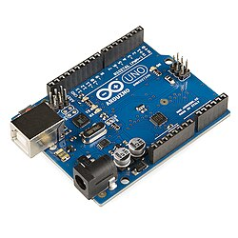 | 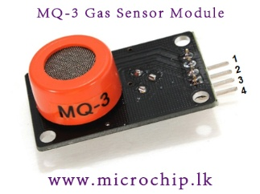
- Arduino Uno | - MQ3 Gas sensor
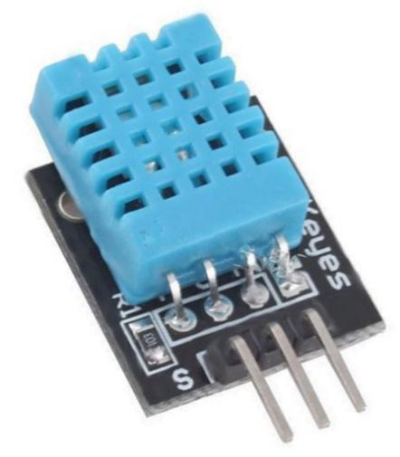 | 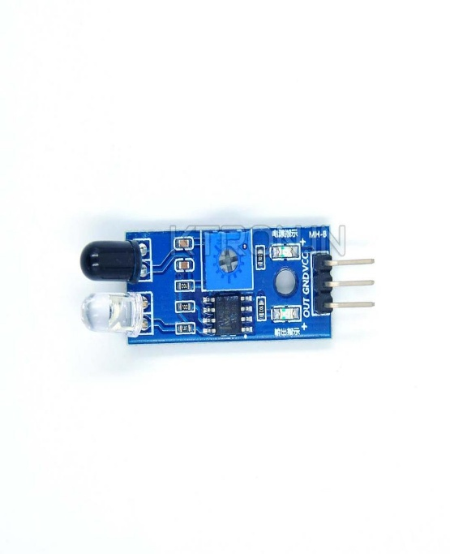
(c) DHT11 Sensor | (d) IR Sensor Module
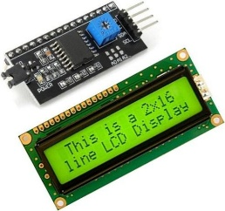 | 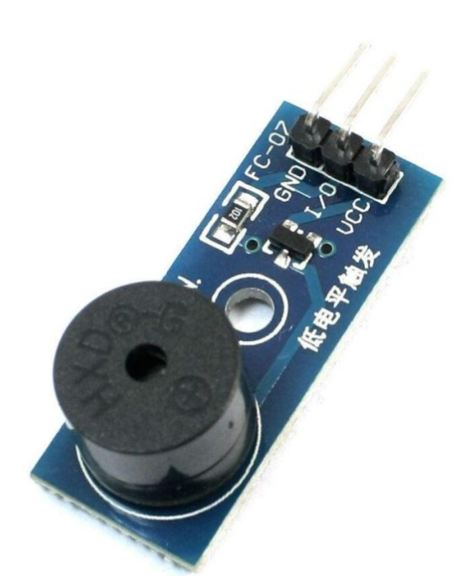
(e) LCD Display | (f) Buzzer
Fig. 1. Hardware components

The sensor functioned effectively within a temperature range of −10°C to 70°C and at relative humidity levels below 95%. Before measurements, a preheating period of approximately 20 seconds is required to stabilize the sensor response and obtain consistent readings.
For ethylene detection, the sensor response was monitored after calibration against ethylene concentration levels, enabling relative measurement of ethylene evolution during storage. The MQ-3 sensor exhibited measurable sensitivity to ethylene within the experimental range used in this study, allowing it to be applied as a low-cost gas sensing approach for monitoring postharvest ripening changes (Bala Naga Pranav et al., 2021; Patil et al., 2025).
2.2.3 DHT11 Sensor
The DHT11 is a digital temperature and humidity sensor operating within a temperature range of 0°C to 50°C and a relative humidity range of 20% to 90%. It employs a capacitive sensing element for humidity measurement and a thermistor for temperature measurement. The sensor operates on a 3.3V–5V DC power supply with low power consumption (~2.5 mA), making it suitable for energy-efficient applications.
Communication is achieved through a single-wire serial interface, requiring only one data pin for transmission. The sensor provides direct digital output, eliminating the need for analog-to-digital conversion. It has a response time of approximately one second, enabling near real-time environmental monitoring (Nagajyothi et al., 2022; Saini et al., 2024).
2.2.4 IR Sensor Module
The IR sensor module consisted of an infrared (IR) emitter LED and a receiver photodiode arranged in parallel. It includes three main pins: a 5V power input, a reference (ground) pin, and a digital output pin (D0). The module operates by continuously emitting an IR beam from the emitter. When an object enters the sensing range, the emitted radiation is reflected and detected by the receiver, causing the digital output (D0) to switch to a high state.
In this study, the IR module was utilized to detect the presence of fruits, thereby initiating the sensing and data acquisition process (Maranga et al., 2023).
2.2.5 LCD Display
The Liquid Crystal Display (LCD) is an electronic display module widely used in embedded systems for visual output. In this study, a 16×2 LCD module, capable of displaying 16 characters across two rows, was employed. Compared to other display technologies such as seven-segment displays and LEDs, LCDs offer advantages including low cost, ease of programming, and the ability to display alphanumeric and custom characters. (Arduino, 2023)
The LCD is interfaced with a microcontroller through a display controller, which processes command and data signals to drive the display panel. In the proposed system, the LCD was used to present real-time output data, including sensor readings and system status (Arduino, 2023; Chander and Kumari, 2020).
2.2.6. Buzzer
A buzzer is an audio signalling device that converts electrical signals into sound and is commonly used in alarms, timers, and user feedback systems. It may be classified as active (with an internal oscillator) or passive (requiring an external driving signal). Predefined threshold values can be programmed to trigger alerts or initiate system responses (Nandeshwar et al., 2023; Thakur and Khan, 2023).

2.3 Software Requirement
2.3.1 Embedded C
Embedded C is a widely used programming language for the development of embedded systems due to its efficiency, portability, and low-level hardware control (Barr, 2002). It is an extension of the C programming language tailored for programming microcontrollers and embedded devices.
An embedded system is a combination of hardware and software designed to perform a specific function. Common examples include household appliances such as washing machines, which integrate processors and programmed instructions to execute predefined tasks. Embedded C enables efficient interaction with hardware components, making it a preferred choice for real-time and resource-constrained applications (Barr, 2002; Gubbi et al., 2013).
2.3.2 Arduino IDE
Arduino is an open-source prototyping platform based on user-friendly hardware and software (Arduino, 2023).. The Arduino Integrated Development Environment (IDE) is used to write, compile, and upload code to the microcontroller board via a USB interface.
Arduino boards can read analog and digital signals from sensors and convert them into corresponding outputs, such as controlling actuators or displaying data. The Arduino IDE utilizes a simplified version of C/C++, allowing ease of programming and rapid development. Its integrated design eliminates the need for external programmers, making it highly accessible for embedded system development (Arduino, 2023; Deen et al., 2023).
2.4 Working Principle
The proposed system operates by continuously monitoring key environmental parameters such as temperature, humidity, and gas concentration using integrated sensors. The DHT11 sensor measures ambient temperature and relative humidity and transmits the data to the Arduino microcontroller for processing. The analog output from the MQ-3 sensor is connected to an analog input pin of the Arduino (e.g., A0). The microcontroller reads this signal using an analog-to-digital conversion process, generating values in the range of 0–1023 corresponding to an input voltage of 0–5V. Higher gas concentrations produce higher output voltages and corresponding digital values.
The Arduino processes these sensor inputs and displays the results via an output interface as shown in Fig.2. Additionally, predefined threshold values can be used to trigger alerts or system responses. Thus, the system enables real-time monitoring and assessment of fruit freshness based on environmental and gas emission parameters (Liu et al., 2018; Pereira et al., 2021; Yin et al., 2023).

Arduino Uno
Buzzer
LCD screen
Power Supply
IR Sensor
DHT 11
MQ-3 Gas sensor

Fig.2. Block diagram

- 2.5 Experimental Procedure for Fruit Freshness Detection
- 2.5.1 Procurement and Initial Assessment
Fresh mangoes of two varieties, Kesar and Banganapalli, were procured directly from a certified local farm (Tilothama Garden, Sangareddy, Telangana, India). Upon procurement, the fruits were subjected to a thorough visual inspection to identify any defects, bruises, or early signs of spoilage. Only healthy and uniformly matured mangoes were selected for further experimentation to ensure consistency in results.
- 2.5.2 Sensor Setup and Calibration
An MQ-3 gas sensor, known for its sensitivity to ethanol and ethylene vapors, was employed due to its cost-effectiveness, ease of integration with IoT systems, and suitability for detecting volatile organic compounds associated with fruit ripening.
Prior to experimental use, the sensor was calibrated under controlled conditions using known concentrations of ethylene gas. A calibration curve was generated to establish the relationship between sensor output and ethylene concentration (ppm). The calibration process involved exposing the sensor to standard gas mixtures and adjusting the output to ensure accurate measurements (Wills et al., 2007; Pathange et al., 2006).
For each experimental batch, the MQ-3 sensor was placed inside a sealed but ventilated chamber containing the mangoes. The sensor position was standardized at a fixed distance of approximately 5 cm from the fruit surface to minimize variability due to airflow and uneven gas distribution.

- 2.5.3 Controlled Monitoring Environment
The experiments were conducted in an enclosed indoor environment to minimize the influence of external factors such as airflow, dust, and direct sunlight. Along with ethylene concentration, ambient temperature and relative humidity were continuously monitored using calibrated digital sensors, as these parameters significantly influence the metabolic activity and ripening behavior of mangoes.
During the experimental period, a fruit chamber made of thermocol sheets was used to maintain controlled conditions. The temperature inside the chamber was maintained between 32°C and 37°C, while relative humidity ranged from 80% to 88%, representing typical ripening conditions.
- 2.5.4 Data Collection Protocol
The monitoring was carried out continuously for both mango varieties until the fruits reached the spoilage stage. Ethylene concentration measurements were recorded daily at a fixed time, preferably during morning hours, to maintain consistency and minimize diurnal variations. Prior to each measurement, the sensor was allowed to stabilize for approximately 5 minutes to ensure accuracy and reliability of the readings.
In parallel with sensor-based measurements, visual observations were systematically conducted to assess ripening characteristics, including changes in peel color and overall appearance. All sensor outputs, along with relevant environmental parameters, were automatically logged using a microcontroller-based data acquisition system. The collected data were transmitted and stored in a cloud-based database, enabling real-time monitoring as well as efficient retrieval for subsequent analysis.
- 2.5.5 Data Analysis and Interpretation
Ethylene concentration data were plotted against time (days) to analyze the climacteric ripening pattern characteristic of mangoes (Wills et al., 2007). The resulting curve typically exhibited an initial lag phase, followed by a rapid increase in ethylene production (climacteric peak), and a subsequent decline during overripening.
Temperature and humidity data were analyzed alongside ethylene levels to evaluate their influence on ripening dynamics. Furthermore, physical observations were correlated with ethylene emission patterns, consistent with non-destructive sensing approaches (Pathange et al., 2006; Jayasinghe and Sammani, 2022)
- 2.6 Working Algorithm
The system operates in a sequential manner beginning with the detection of fruit using an IR sensor. Once the presence of fruit is identified, the system acquires gas concentration data using the MQ-3 sensor. Simultaneously, environmental parameters such as temperature and humidity are recorded using the DHT11 sensor. All the collected sensor data are then processed by the Arduino microcontroller, which acts as the central processing unit of the system. Finally, the processed information is displayed in real time on an LCD screen for user interpretation. A threshold-based classification approach was implemented to enhance monitoring efficiency and to trigger a buzzer alert to prevent food spoilage (Gubbi et al., 2013; B. Mounica et al., 2022).
3. Results and Discussion
3.1 Cost Analysis of the Fruit Freshness Detector
The total cost of the developed fruit freshness detection system was approximately INR 2000 (24 USD), demonstrating its affordability and suitability for both research and practical applications. The system was constructed using readily available and cost-effective electronic components, including an Arduino Uno microcontroller, MQ-3 gas sensor, a DHT11 temperature and humidity sensor, and an LCD display module. The detailed cost distribution of individual components is presented in Table 1. The low-cost nature of the system highlights its potential for large-scale deployment in agricultural storage and supply chain monitoring (Katare et al., 2023; Gaikwad et al., 2024; Patil et al., 2025).
- Table 1. cost of fruit freshness detector
S. No. | Components | Cost (INR.) | Cost (USD)
1 | Arduino UNO | 470 | 5.6
2 | MQ-3 Sensor | 240 | 2.9
3 | DHT11 Module | 70 | 0.8
4 | IR Sensor Module | 150 | 1.8
5 | Buzzer | 30 | 0.4
6 | 12 V Battery | 800 | 9.6
7 | LCD Display | 190 | 2.3
8 | Connecting Wires | 50 | 0.6
TOTAL COST |  | 2000 | 24
3.2 Evolution of Gas Concentration in Kesar Mangoes
The experimental investigation of Kesar mangoes demonstrated a well-defined and systematic evolution of ethylene concentration throughout the ripening period, clearly exhibiting the characteristic behavior of climacteric fruits (Kader, 2005; Wills et al., 2007; Seymour et al., 1993). Ethylene, being a key phytohormone, plays a central regulatory role in initiating and coordinating the ripening process. As observed in Fig. 3, the ethylene concentration increased from 76 ppm on Day 1 to a peak value of 213 ppm on Day 11, representing the climacteric maximum. This peak corresponds to the stage at which the fruit undergoes the highest rate of respiration and biochemical transformation (Seymour et al., 1993).
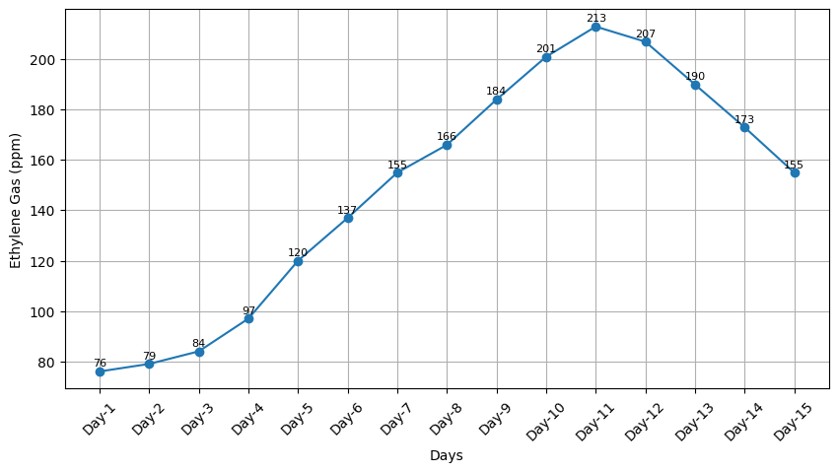
Fig. 3. Ethylene gas variation during kesar mangoes ripening
Between Day 6 and Day 11, a sharp increase in ethylene concentration was recorded, rising from 137 ppm to 213 ppm. This phase represents the climacteric rise, which is characterized by autocatalytic ethylene production—where ethylene stimulates its own synthesis through positive feedback mechanisms. This leads to a rapid escalation in metabolic activity, including a significant increase in respiration rate. As a consequence, several important ripening attributes develop simultaneously: fruit softening due to breakdown of cell wall polysaccharides, accumulation of sugars enhancing sweetness, reduction in organic acids altering taste balance, and synthesis of carotenoid pigments responsible for the transition from green to yellow coloration (Seymour et al., 1993). The observed colour change in Fig. 4 strongly correlates with this increase in ethylene concentration, confirming the direct relationship between ethylene levels and visual ripening indicators (Seymour, 1993).
After reaching the peak on Day 11, the ethylene concentration began to decline, decreasing slightly to 207 ppm on Day 12 and more significantly to 155 ppm by Day 15. This decline marks the transition from the climacteric peak to the post-climacteric or senescence phase (Wills et al., 2007; Kader, 2005). During this stage, the fruit shifts from constructive metabolic activities to degradative processes. Enzymatic activities responsible for tissue breakdown become dominant, leading to excessive softening, loss of structural integrity, and leakage of cellular contents. Additionally, prolonged exposure to high ethylene concentrations accelerates oxidative processes and membrane degradation, further contributing to quality deterioration. By Day 15, the mangoes were observed to be over-ripened and unsuitable for consumption, indicating the completion of the senescence process (Fig. 4). The decline in ethylene levels during this phase can be attributed to reduced biosynthetic activity and the exhaustion of metabolic substrates.
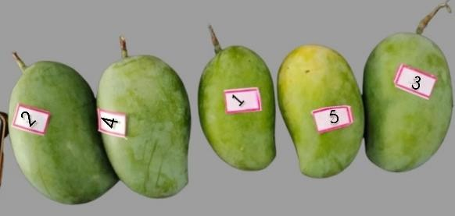
- (a) Day 1 (b) Day 3
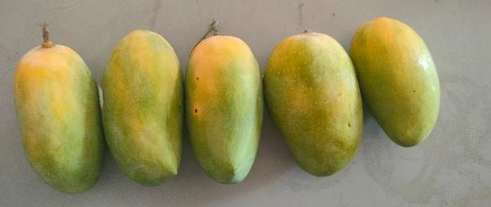
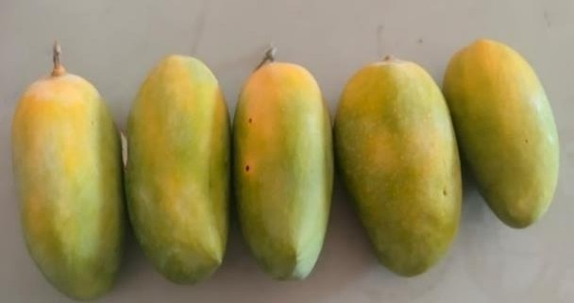
- (c) Day 5 (d) Day 7

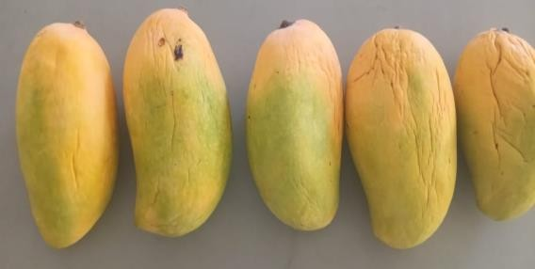
- (e) Day 9 (f) Day 11
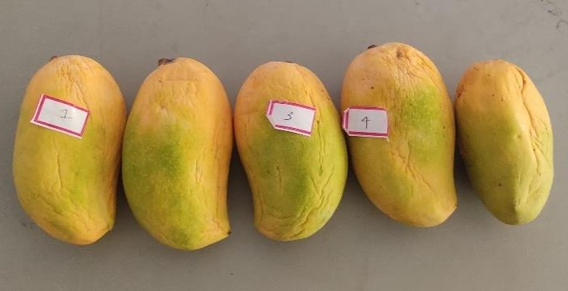
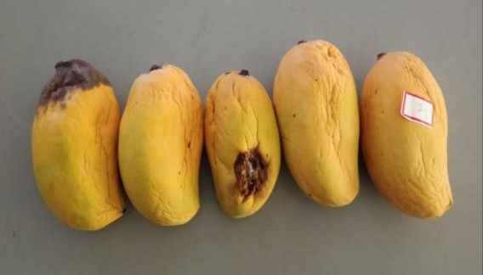
- (g) Day 13 (h) Day 15
- Fig.4. Day-wise Variation in Ripening of Kesar Mangoes
The environmental conditions maintained during the experiment—temperature between 32°C and 37°C and relative humidity between 80% and 90%—played a crucial role in ensuring consistent ripening behavior (Kader, 2005). Elevated temperatures within this range enhance enzymatic activity and respiration rates, thereby accelerating ethylene production and ripening progression. Similarly, high relative humidity helps in minimizing moisture loss and maintaining fruit turgidity, preventing premature shriveling. The stability of these conditions ensured that the observed variations in ethylene concentration were predominantly governed by intrinsic physiological processes rather than external environmental fluctuations.
Furthermore, the continuous monitoring of ethylene using the MQ-3 sensor demonstrated its capability to effectively capture dynamic changes in gas concentration in a non-destructive manner (Wang and Zhang, 2010; Yin et al., 2023). The sensor response closely followed the expected climacteric trend, indicating its suitability for real-time ripening assessment. This highlights the potential application of such sensor-based systems in post-harvest management, storage optimization, and supply chain monitoring of mangoes (Ghasemi-Varnamkhasti et al., 2019; Kodali et al., 2016).
3.3 Evolution of Gas Concentration in Banganapalli Mangoes
The ripening behavior of Banganapalli mangoes, as evaluated through ethylene concentration measurements, also exhibited a distinct climacteric pattern, reinforcing the classification of mango as a climacteric fruit (Kader, 2005; Seymour et al., 1993). As illustrated in Fig. 5, the ethylene concentration followed a three-stage progression: an initial gradual increase, a rapid climacteric rise, and a subsequent decline associated with senescence (Seymour et al., 1993).
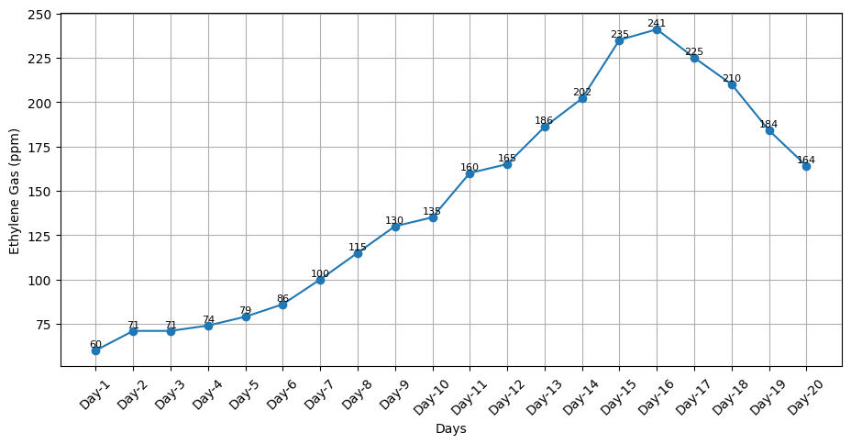
Fig. 5. Ethylene gas variation during Banganapalli mangoes ripening
During the early stage (Day 1 to Day 5), ethylene levels increased steadily, indicating the initiation of internal physiological and biochemical processes associated with ripening. This pre-climacteric phase is marked by the activation of metabolic pathways that prepare the fruit for rapid transformation. Enzymatic systems begin to develop, and processes such as starch hydrolysis, protein synthesis, and pigment degradation are initiated. However, these changes are largely internal, and the fruit retains its firm texture and green colour, indicating that external ripening indicators lag behind biochemical activity.
A pronounced increase in ethylene concentration was observed between Day 6 and Day 13, corresponding to the climacteric rise phase. This stage is characterized by a surge in respiration and a significant increase in ethylene biosynthesis. The autocatalytic nature of ethylene production amplifies the ripening signal, resulting in synchronized physiological changes across the fruit. These include rapid softening due to enzymatic degradation of pectin and hemicellulose, development of characteristic aroma compounds through volatile synthesis, and conversion of chlorophyll into carotenoids, leading to visible colour changes as shown in Fig. 6. The coordination of these processes ensures uniform ripening and enhances the sensory attributes of the fruit.
The climacteric peak was reached around Day 15–16, representing the stage of optimal ripeness. At this point, the fruit exhibits the best balance of sweetness, texture, aroma, and visual appeal, making it highly suitable for consumption and commercial distribution (Kader, 2005). The peak ethylene concentration at this stage reflects the maximum metabolic activity and serves as a critical indicator for determining harvest-to-market timing.
Beyond the peak, ethylene concentration began to decline, signaling the onset of the post-climacteric or senescence phase. During this stage, the fruit undergoes progressive deterioration driven by degradative enzymatic activities. Structural components of the cell wall continue to break down, leading to excessive softness and loss of firmness. Additionally, oxidative stress and microbial activity may increase, further compromising fruit quality. Although the fruit may remain edible for a short period after the peak, its shelf life is significantly reduced, and sensory attributes begin to decline (Wills et al., 2007; Kader, 2005).
The environmental conditions maintained during the study—temperature ranging from 32°C to 37°C and relative humidity between 80% and 90%—provided an optimal environment for natural ripening (Kader, 2005). These conditions ensured consistent enzymatic activity and minimized external stress factors, allowing for accurate observation of intrinsic ripening behavior. The controlled environment also enhanced the reliability of ethylene measurements by reducing variability caused by temperature and humidity fluctuations.
Overall, the observed ethylene emission pattern in Banganapalli mangoes closely mirrors that of Kesar mangoes, although slight variations in the timing of peak concentration and ripening duration may be attributed to varietal differences in metabolic rate, enzyme activity, and tissue composition (Seymour et al., 1993). The ability to capture these differences through sensor-based monitoring further demonstrates the robustness and applicability of the proposed approach for comparative analysis of fruit ripening characteristics (Gubbi et al., 2013; Pereira et al., 2021; Yin et al., 2023).

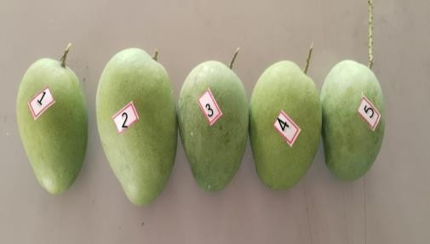  - Day 1 | 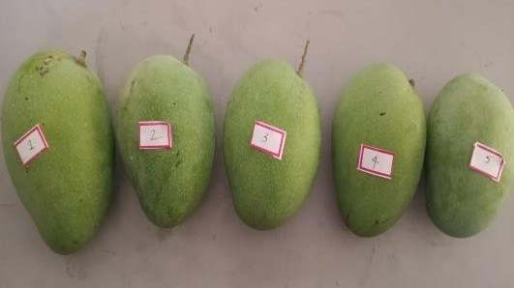  - Day 4
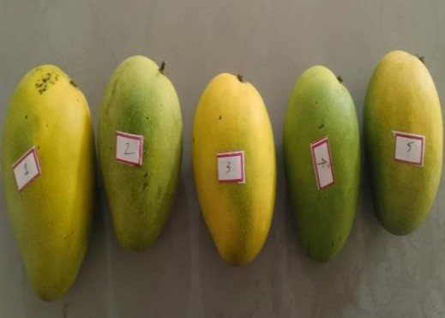  - Day 8 | 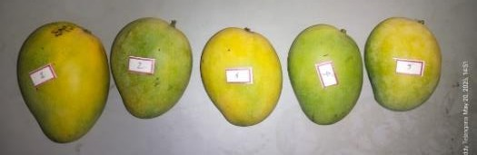  - Day10
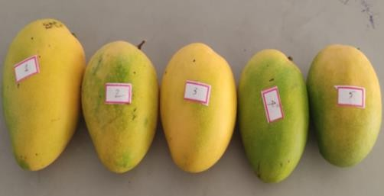  - Day 12 | 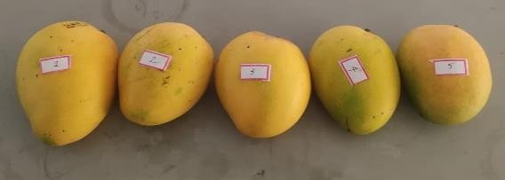  - Day 16
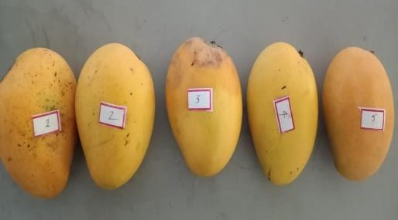  - Day 18 | 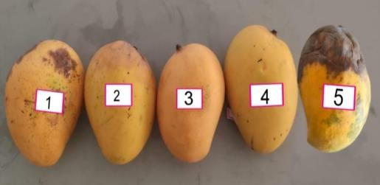  (h) Day 20
Fig. 6. Day-wise Variation in Ripening of Banganapalli Mangoes

Author’s Contribution:
This work was carried out in collaboration among all authors. Author GR conceptualized and supervised the work and KC given guidance during work carried out. All authors read and approved the final manuscript.
4. Conclusion
A low-cost Arduino-based system (INR 2000) was developed for real-time monitoring of fruit freshness using ethylene gas detection. By integrating MQ-3 and DHT11 sensors, the system continuously tracked changes during mango ripening.
Experimental results showed that ethylene concentration increased from approximately 60 ppm at the initial stage to over 200 ppm during ripening, with values beyond this threshold indicating the onset of senescence. The system demonstrated consistent and reliable sensor response in detecting these changes.
This approach offers a simple, economical, and non-invasive solution for reducing post-harvest losses and improving food quality management, with potential applications in agriculture and supply chain monitoring.
Limitations of the Study
- The MQ-3 sensor, although low-cost, is not highly selective to ethylene and may respond to other volatile gases present during fruit ripening.
- The system was tested under controlled laboratory conditions (thermocol chamber), which may differ from real storage or supply chain environments.
- The study considered only two mango varieties, which may limit generalization to other fruits or cultivars.
- Environmental factors such as airflow and external humidity variations were not actively controlled.
- The threshold values for classification were partly based on experimental observations, which may vary under different conditions.
Acknowledgement:
The t authors acknowledge the support and facilities provided by CAE Sangareddy, PJTAU.
Conflict of interest:
The authors declare that they have no known competing financial or intellectual conflict of interest.
Disclaimer (Artificial intelligence)
Author(s) hereby declare that NO generative AI technologies such as Large Language Models (ChatGPT, COPILOT, etc.) and text-to-image generators have been used during the writing or editing of this manuscript.

References
Aishwarya, V., Sai, G. N., Chaitanya, K., Reddy, S. S., & College, A. C. E. E. (2023). Food Storage Monitoring System Using Arduino. 14(06), 434–442.
Arduino. (2023). Arduino official documentation. Arduino, Italy.
Baietto, M., & Wilson, A.D. (2015). Electronic-nose applications for fruit identification, ripeness and quality grading. Sensors, 15(1), 899–931.
Bala Naga Pranav, S., Kumar T.R., K., Hari Prakash, J., Sharan, S., & Ganesan, M. (2021). Freshness Estimator for Fruits and Vegetables Using MQ Sensors. ICACC 2021, IEEE.
Barr, M. (2002). Programming Embedded Systems in C and C++. O’Reilly Media.
B. Mounica, Ch. Gayathri Devi, K. Vishnu Vardhan, I. Anil Kumar, & Chinmaya Kumar Pradhan. (2022). IoT Based Food Spoilage Detection System Using Arduino. International Journal of Engineering Technology and Management Sciences, 9(7), 110–116.
Chander, B.R., & Kumari, G.S. (2020). Food Quality Monitoring System by Using Arduino.
Chhanwal, N., & Anandharamakrishnan, C. (2012). Electronic nose for food quality evaluation. Trends in Food Science and Technology, 26(1), 27–39.
Deen, A.A.J., Sarawanan, T.C., Rajagopal, H., Sethu, D., Jothi, N., & Kolandaisamy, R. (2023). Arduino Based Smart IoT Food Quality Monitoring System. ICAROB Proceedings.
Gaikwad, P.D., Pophale, A.D., Palande, S.D., Baviskar, K.S., & Pirjade, N.J. (2024). Fruit Freshness Detection and Monitoring Using IoT.
Ghasemi-Varnamkhasti, M., et al. (2019). Electronic nose and its application in food analysis. Trends in Food Science and Technology, 86, 221–231.
González-Buesa, J., & Salvador, M.L. (2019). Arduino-based low-cost device for fruit respiration measurement. Computers and Electronics in Agriculture, 162, 14–20.
Gubbi, J., Buyya, R., Marusic, S., & Palaniswami, M. (2013). Internet of Things: A vision, architectural elements, and future directions. Future Generation Computer Systems, 29(7), 1645–1660.
Jayasinghe, P.K.S.C., & Sammani, S. (2022). Detection of Freshness of Fruits using Machine Learning Techniques. SLJoT, 3(01), 8–17.
Kader, A.A. (2005). Increasing food availability by reducing postharvest losses of fresh produce. Postharvest Biology and Technology, 43(1), 1–3.
Katare, S., Suryawanshi, S., Humane, R., Meshram, H., & Thakare, R. (2023). IoT Based Monitoring of Fruit Freshness Using Arduino Nano. IRJET.
Kodali, R.K., et al. (2016). IoT-based smart storage system for agricultural products. IEEE Conference.
Liu, Y., et al. (2018). Applications of gas sensors in food quality monitoring. Food Engineering Reviews, 10(3), 193–209.
Maranga, D.O., Mwita, V., Okari, F., & Oruko, C. (2023). Smart fruit basket system.
Nagajyothi, D., Sree, P.H., Devi, M.R., Madhavi, G., & Ahammad, S.H. (2022). IoT-Based Prediction of Pesticides and Fruit Disease Detection Using SVM and Neural Networks. International Journal of Mechanical Engineering, 7(1), 1281–1287.
Nandeshwar, V., Bhuyar, S., Bhutada, P., Bhutada, M., Bhutada, R., & Berlikar, B. (2023). Food Spoilage Detection System Using Arduino.
Patil, B.N., Gupta, S.V., Argade, K.S., & Deshmukh, M.D. (2025). IoT Sensor-Based Gas Detection Device for Stored Fruits.
Pathange, L.P., et al. (2006). Non-destructive evaluation of apple maturity using electronic nose. Journal of Food Engineering, 77(4), 1018–1023.
Pereira, P. F. M., Cacho, J., Ferreira, V., & López, R. (2021). Electrical gas sensors for food freshness monitoring. Trends in Food Science & Technology, 118, 36–44.
Rakshitha Kiran. (2024). Integration of MQ-5 Gas Sensors with Arduino Board. Journal of Electrical Systems, 20(10s), 2154–2165.
Saini, A., Harshini, E., Kaparthi, R., & Krishna Chaithanya, J. (2024). Fruit Freshness Detection Using NodeMCU.
Saltveit, M.E. (1999). Effect of ethylene on quality of fresh fruits and vegetables. Postharvest Biology and Technology, 15(3), 279–292.
Seymour, G.B., Taylor, J.E., & Tucker, G.A. (1993). Biochemistry of Fruit Ripening. Springer.
Thakur, U.N., & Khan, A. (2023). A Prototype to Prevent Fruits from Spoilage Using Sensors with Machine Learning. Engineering Proceedings.
Vanin, S., et al. (2009). Modelling ethylene production during fruit ripening. Journal of Food Engineering.
Wang, J., & Zhang, T. (2010). A review of gas sensors for food quality monitoring. Sensors and Actuators B: Chemical, 144(1), 1–8.
Wills, R., McGlasson, B., Graham, D., & Joyce, D. (2007). Postharvest: An Introduction to the Physiology and Handling of Fruit and Vegetables. CAB International.
Yin, L., Jayan, H., Cai, J., El-Seedi, H.R., Guo, Z., & Zou, X. (2023). Spoilage Monitoring and Early Warning for Apples Using Gas Sensors. Foods, 12(15).
Zanoni, B., et al. (1995). Modelling of ethylene production in climacteric fruits. Journal of Food Engineering.

