Malting-Driven Engineering and Nutritional Reconfiguration of Climate-Resilient Millets for Functional Food Systems

Abstract
Malting is a sustainable bioprocess that induces significant structural and biochemical modifications in cereal grains, thereby enhancing their engineering functionality and nutritional quality. This study investigates the malting-driven reconfiguration of physical and proximate properties in two climate-resilient millets, finger millet (Eleusine coracana, GIRA-2) and kodo millet (Paspalum scrobiculatum, GPUK-3), with implications for functional food systems. Controlled malting involving steeping (8–12 h), germination (48–72 h), and kilning (50–60°C) was employed. Engineering properties including grain dimensions, bulk density, true density and porosity were evaluated, alongside proximate composition using AOAC (2019) methods. Malting significantly reduced moisture content in finger millet from 11.10 to 6.83% and in kodo millet from 11.66 to 8.50% and bulk density of finger millet from 754.2 to 720.67 kg/m³, bulk density of kodo millet from 762.75 to 723.17 kg/m³ while porosity increased in finger millet from 43 to 45% and in kodo millet from 42 to 43.47%, indicating improved hydration and processability. Nutritionally, protein content increased from 7.3 to 8.6% in finger millet; from 9.03 to 11.29% in kodo millet, accompanied by enhanced ash and fiber levels, reflecting improved mineral availability and structural polysaccharide modification. The findings demonstrate that malting acts as a transformative tool for reengineering millet grains into functionally superior ingredients. The synergistic improvement in processing characteristics and nutritional profile highlights the potential of malted millets as key components in the development of fortified, sustainable and health-oriented food systems.
Keywords: Malting, Climate-resilient millets, Nutritional improvement, Physical properties.

1. Introduction

Climate-resilient millets have emerged as vital crops in the context of global food and nutritional security due to their adaptability to drought, poor soils, and changing climatic conditions. Among these, finger millet (Eleusine coracana) and kodo millet (Paspalum scrobiculatum) are recognized for their superior nutritional composition, including high dietary fiber, essential minerals and bioactive compounds. Finger millet is particularly noted for its exceptionally high calcium content, while kodo millet is valued for its low glycemic index and antioxidant potential (Saleh et al., 2013). Despite their nutritional advantages, the utilization of millets in mainstream food systems remains limited due to inherent challenges such as poor digestibility, presence of antinutritional factors (phytates, tannins), and suboptimal functional properties. These limitations restrict their application in processed and convenience foods. Therefore, appropriate processing interventions are essential to unlock their full potential as functional food ingredients.

Malting, a controlled bioprocess involving steeping, germination, and drying, has gained considerable attention as a sustainable and efficient method for enhancing both nutritional and engineering properties of cereal grains. During germination, endogenous enzymes such as amylases, proteases, and phytases are activated, leading to the hydrolysis of complex macromolecules into simpler, more bioavailable forms. This enzymatic modification results in improved protein digestibility, increased mineral bioavailability, and reduction of antinutritional compounds (Chavan et al., 1989). In addition to nutritional improvements, malting induces significant structural and physicochemical changes in grains. These include reduction in bulk density, modification of grain dimensions, increased porosity, and decreased viscosity, all of which directly influence processing behavior such as hydration, milling, mixing, and extrusion (Mohsenin, 1986). Such transformations are particularly important for the development of instant foods, weaning formulations, and malt-based beverages. Recent studies have reported that malting enhances protein and ash content while reducing fat and moisture levels in millets due to biochemical transformations and dry matter loss during germination (Gowda et al., 2022). However, most available research focuses on individual millet types, and there is limited comparative understanding of how different millet varieties respond to malting in terms of both engineering and nutritional attributes.

In this context, the present study aims to evaluate the malting-driven engineering and nutritional reconfiguration of two important climate-resilient millets, namely finger millet (GIRA-2) and kodo millet (GPUK-3). By systematically analyzing changes in physical properties (density, porosity, grain size) and proximate composition (protein, fat, ash, fiber), this study provides insights into their suitability for incorporation into functional food systems. The findings are expected to support the development of value-added millet-based products, particularly fortified malt premixes, thereby contributing to sustainable and nutrition-sensitive food processing strategies.

2. Materials and Methods

2.1 Procurement of Raw Materials
Millets (Ragi and Kodo): The Ragi (Eleusine coracana) (GIRA-2 variety) (Fig.1) and Kodo millet (Paspalum scrobiculatum) (GPUK-3 variety) (Fig.2) grains were procured from local agricultural farms.
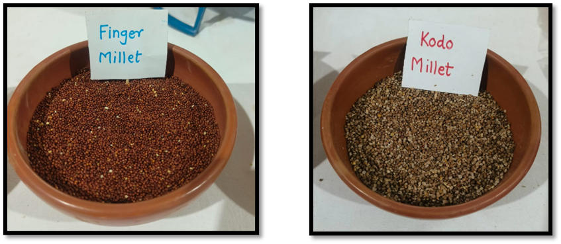
Fig:1 Finger Millet (GIRA-2 Variety) Fig:2 Kodo Millet (GPUK-3 Variety)

2.2 Malting Process
Malting of Finger Millet
The malting procedure for Finger millet has been performed following established methods reported in earlier studies, with appropriate modifications to optimize sprouting and enzyme development.
Soaking:
Cleaned millet grains were steeped in potable water at a grain-to-water ratio of approximately 1:3 (w/v). The steeping was conducted at 25–30°C for about 8–12 hours to achieve adequate moisture uptake required for uniform germination, as supported by recent malting protocols (Murungweni et al., 2023).
Germination:
After steeping, the hydrated grains were spread evenly on germination trays and incubated at 25°C under controlled aeration and humidity. Germination was allowed to proceed for 48–72 hours, during which sprout growth and hydrolytic enzyme activity are maximized. (Murungweni et al., 2023).
Kilning/Drying:
The germinated grains were dried in a tray dryer at 50–60°C for 8–12 hours to halt enzymatic activity and reduce moisture to safe storage levels. Controlled kilning ensures desirable flavour, enzyme preservation, and extended shelf life ((Murungweni et al., 2023).).
Milling:
Once dried, the malted grains were milled using a hammer mill fitted with a 250-µm sieve to obtain fine malt flour suitable for blending and product formulation. The powdered malt was packed in airtight containers to prevent moisture uptake and quality deterioration (Abioye et al., 2022, Murungweni et al., 2023).).
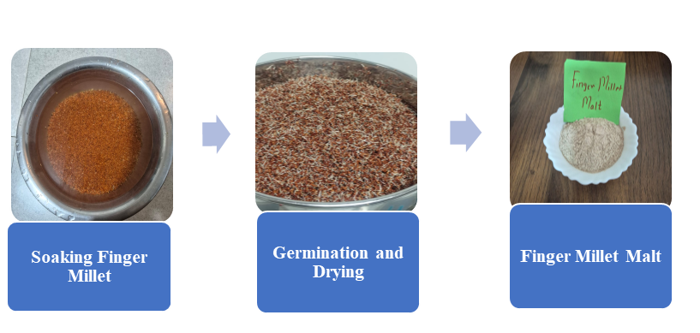
Fig:3Malting of Finger Millet
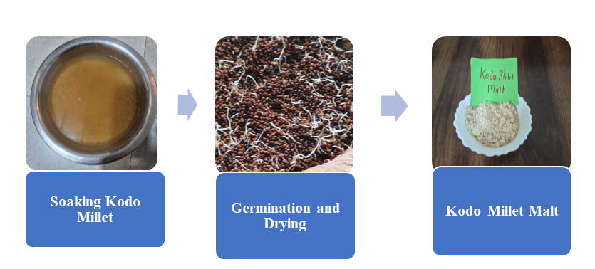
Fig: 4 Malting of Kodo Millet

  - Physical Properties of millets
    - Size and Geometric Properties: The size parameters measured included Length (L), Width (W) and Thickness (T) of randomly selected grains (n=50) were measured using a digital micrometre with and digital Vernier caliper (accuracy 0.01 mm) (Mohsenin, 1986). Calculate geometric mean diameter (Dg) by using formula is,
Dg=$({L×W×T)}^{1/3}$
    - Sphericity (Φ): Sphericity (%) is explained as the ratio of the surface area of a sphere having the same volume as the grain to the surface area of the grain and was calculated using following equation. (Mohsenin, 1986).
$$Φ=\frac{Dg}{L}$$
2.3.3 1000-Grain Weight: One thousand seeds were selected randomly from the seed sample and weighed using an electronic balance (capacity 2000 g, accuracy 0.1 g). Three samples of 1000 grains were weighed and the mean weight was calculated. (accuracy ±0.001 g) (Singh et al., 1996).

2.4 Gravimetric Properties: (Mohsenin, 1986)

The Gravimetric Properties of grains, Bulk density (ρb) was determined by using a 500 ml graduated cylinder filled without tapping and True density (ρt) was measured by using the toluene displacement method.
2.4.1 Bulk Density (ρb): Bulk density Bulk density (kg/m³) is described as the ratio of the mass of the sample to its total volume. It was determined by filling a 500 ml cylinder with grains. Bulk density (kg/ m³) was calculated as a ratio between the sample weight and the volume of the cylinder using below equation:
ρb=$\frac{Mass of Grains}{Volume of cylinder}$

2.4.2 True Density (ρt): Use Toluene displacement method because toluene does not absorb moisture. The true density (kg/m³) was determined by the toluene displacement method using a top loading balance. A total of 100 g of grains were immersed in graduated beaker containing toluene. The amount of toluene displacement was recorded using below equation
ρt = $\frac{Mass of grains}{Volume of toluene displayed or True Volume}$

2.4.3 Porosity (ε): Porosity (%) is defined as the fraction of the space in bulk grain that is not occupied by the grain. It was calculated using below equation from the true density and bulk density using method.
Porosity (ε) = $\left(1-{ρb \atop ρt}\right)$
All parameters were measured in triplicate using standard methods described by Mohsenin (1986).
2.5. Nutritional and Physicochemical Analysis
Standard AOAC (2019) methods were used to evaluate the premix.

2.5.1 Determination of Moisture Content

Moisture content (%) was measured using a hot-air oven at 105 °C until constant weight (AOAC, 2005). Moisture content of the seed samples was estimated using a thermostatically controlled hot air oven following standard procedures. The oven temperature was maintained at 105 ± 2°C, ensuring uniform drying conditions. Approximately 25–30 g of grains from each variety were weighed into clean, non-corrosive metallic containers and dried in the oven for 24 hours, as recommended in classical methodologies. After drying, the samples were transferred to a desiccator, allowed to cool to room temperature, and reweighed. The samples were again placed in the oven for an additional 2 hours of drying, cooled, and weighed. This cycle of drying and weighing was repeated until a constant weight was obtained, indicating the removal of moisture.
The moisture content on a wet basis was calculated using the following equation:
$$\text{Moisture Content (}\text{wb}\text{, \%)}=\frac{100×(W_{1}-W_{2})}{W_{1}}$$where:
- $W_{1}$= Initial weight of the sample (g)
- $W_{2}$= Final constant weight of the sample (g)

2.5.2 Determination of Crude Protein (Kjeldahl Method): The organic nitrogen in the sample is converted to ammonium sulfate during digestion. Ammonia released during distillation is titrated, and total protein is calculated using a nitrogen conversion factor. (AOAC 2019)
Procedure:
- One gram of dried sample was transferred to a Kjeldahl digestion flask.
- A catalyst mixture (K₂SO₄ + CuSO₄) and concentrated H₂SO₄ were added.
- The flask was heated until a clear, colorless digest was obtained.
- The digest was cooled, diluted with distilled water, and transferred to a distillation unit.
- 40% NaOH was added to render the solution alkaline, releasing ammonia.
- Ammonia was distilled into a boric acid indicator solution.
- The distillate was titrated using standardized 0.1 N HCl until the endpoint.
- Total nitrogen (%) was calculated and converted to crude protein using:
$$\text{Crude Protein (\%)}=\text{Nitrogen (\%)}×6.25$$

2.5.3. Determination of Crude Fat (Soxhlet Extraction): Lipids are extracted from the sample using a non-polar solvent under reflux conditions. (AOAC 2019)
Procedure:
- Two grams of dried sample were placed in a cellulose extraction thimble.
- The thimble was loaded into a Soxhlet apparatus and extracted with petroleum ether (boiling range 40–60°C) for 6–8 hours.
- After extraction, the solvent was evaporated using a water bath.
- The remaining residue (fat) was dried in an oven at 105°C to constant weight.
- Crude fat content was calculated as:
$$\text{Crude Fat (\%)}=\frac{\text{Weight of extracted fat}}{\text{Weight of sample}}×100$$
2.5.4. Determination of Total Ash: Ashing removes organic matter by incineration, leaving only inorganic mineral components. (AOAC 2019)
Procedure:
- About 2 g of sample was placed in a pre-ashed, pre-weighed crucible.
- The sample was charred gently over a hot plate to prevent spattering.
- The crucible was then placed in a muffle furnace at 550 ± 10°C for 4–6 hours until light gray ash was obtained.
- The crucible was cooled in a desiccator and weighed.
- Ash content was expressed as:
$$\text{Total Ash (\%)}=\frac{W_{\text{ash}}}{W_{\text{sample}}}×100$$

2.5.5 Determination of Crude Fiber: The sample undergoes sequential digestion with dilute acid and alkaline solutions to remove non-fibrous materials. The remaining residue is weighed after ignition to determine crude fiber. (AOAC 2019)
Procedure:
- Two grams of defatted sample were digested with 1.25% H₂SO₄ by boiling for 30 minutes.
- The mixture was filtered and washed with hot distilled water.
- The residue was boiled again in 1.25% NaOH solution for another 30 minutes.
- After filtration, the residue was washed, dried at 105°C, and weighed.
- The dried residue was then ignited in a muffle furnace at 550°C to remove all organic matter.
- Crude fiber (%) was calculated as:
$$\text{Crude Fiber (\%)}=\frac{W_{\text{residue before ashing}}-W_{\text{ash}}}{W_{\text{sample}}}×100$$
2.5.6 Determination of viscosity (Brookfield viscometer method) Krishnan et al., (2012).

The Brookfield rotational viscometer is commonly used to measure the viscosity of liquid and semi-solid foods including millet malt beverages.

Procedure:
- Prepare a slurry of Ragi/Kodo malt with water (often in a specific ratio like 1:10 or 1:5 w/v).
- Heat the slurry to simulate consumption conditions (usually around 50–60°C).
- Cool the sample to 25°C or test at desired temperature.
- Set the spindle (e.g., spindle No. 2 or 3) at a specific RPM (e.g., 50 rpm).
- Record viscosity in centipoise.

3.Results and Discussion

3.1 Effect of Malting on Physical Properties of Millets

3.1.1 Finger millet (GIRA-2):

Malting significantly influenced the physical characteristics of finger millet as shown in Table 1 and Fig. 5a, 5b. A reduction in grain dimensions, bulk density and thousand-grain weight was observed after malting. These changes are attributed to moisture absorption during soaking followed by enzymatic degradation of starch and protein matrices during germination resulting in partial loss of dry matter. Increased porosity observed in malted grains enhances water absorption and milling efficiency which is advantageous for premix formulation. Similar reductions in density and hardness after malting have been reported in cereals and millets due to structural loosening of the endosperm. Similar result found for malted finger millet by Joseph (2019) and for physical properties of unmalted finger millet by Panwar (2024).
Table 1: Physical Properties of Malted and Unmalted Finger Millet (GIRA-2)
Sr. No. | Parameter | Unmalted (Mean ± SD) | Malted (Mean ± SD) | p-value
1 | Moisture % | 11.10 ± 0.10 | 6.83 ± 0.03 | 0.0002
2 | 1000-grain wt g | 2.80± 0.03 | 2.63 ± 0.02 | 0.0001
3 | Length mm | 2.21 ± 0.01 | 1.72 ± 0.01 | 0.0001
4 | Width mm | 1.73 ± 0.00 | 1.41 ± 0.00 | 0.0001
5 | Thickness mm | 1.62 ± 0.01 | 1.12 ± 0.00 | 0.0001
6 | Sphericity | 0.83 ± 0.00 | 0.80 ± 0.00 | 0.0001
7 | Surface Area mm² | 10.52 ± 0.00 | 6.07 ± 0.00 | 0.0001
8 | Size mm | 1.83 ± 0.00 | 1.39 ± 0.00 | 0.0001
9 | Bulk Density kg/m³ | 754.23 ± 0.80 | 720.67 ± 0.76 | 0.0001
10 | True Density kg/m³ | 1311.33 ± 0.35 | 1295.77 ± 1.85 | 0.0003
11 | Porosity % | 43.00 ± 0.00 | 45.00 ± 0.00 | 0.0001
12 | Viscosity Cp | 1641.3±0.00 | 862.8±0.00 | 0.0001
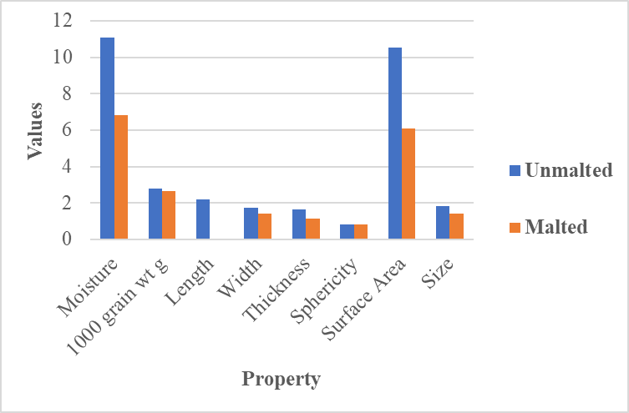
Fig.5(a) Physical Properties of Malted and Unmalted Finger Millet (GIRA-2)
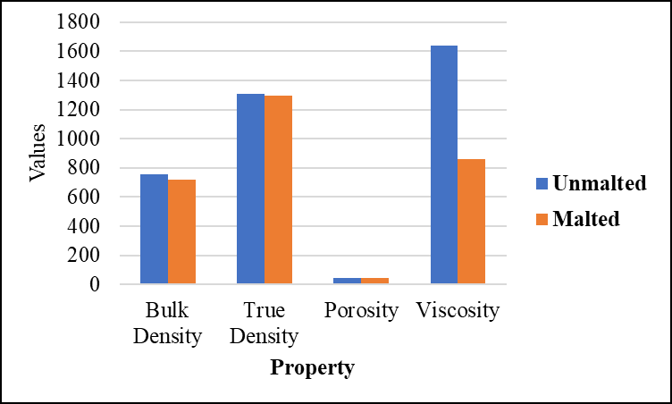
Fig.5(b) Physical Properties of Malted and Unmalted Finger Millet (GIRA-2)

3.1.2 Kodo millet (GPUK-3)
Kodo millet shown in Table 2 and Fig.6a, and 6b notable reductions in bulk density, thousand-grain weight and size parameters after malting. The decrease in bulk density indicates increased internal pore volume which facilitates faster hydration and reconstitution an important quality for instant malt mixes. True density and sphericity showed minimal variation, indicating that although biochemical changes occurred, the fundamental grain structure remained intact. These observations confirm that malting improves the processability and functional suitability of kodo millet for fortified premix development. Similar trends were observed in malted finger millet and sorghum (Shimelis et al., 2007).
Table 2: Physical Properties of Malted and Unmalted Kodo Millet (GPUK-3)
Sr. No. | Parameters | Unmalted (Mean ± SD) | Malted (Mean ± SD) | p-value
1 | Moisture % | 11.66 ± 0.14 | 8.50 ± 0.02 | <0.001*
2 | 1000-grain wt g | 2.89 ± 0.03 | 2.12 ± 0.02 | 0.0001*
3 | Length mm | 1.72 ± 0.03 | 1.62 ± 0.01 | 0.02*
4 | Width mm | 1.32 ± 0.03 | 1.30 ± 0.01 | n.s.
5 | Thickness mm | 1.11 ± 0.03 | 1.05 ± 0.01 | 0.01*
6 | Size mm | 1.36 ± 0.02 | 1.29 ± 0.01 | 0.001*
7 | Surface area mm² | 5.82 ± 0.19 | 5.31 ± 0.01 | 0.02*
8 | Sphericity | 0.79 ± 0.00 | 0.78 ± 0.00 | n.s.
9 | Bulk density kg/m³ | 762.75 ± 7.38 | 723.17 ± 2.09 | 0.003*
10 | True density kg/m³ | 1306.38 ± 19.17 | 1282.80 ± 2.71 | n.s.
11 | Viscosity Cp | 1901.3 ± 0.00 | 832.5+-0.00 | 0.0001

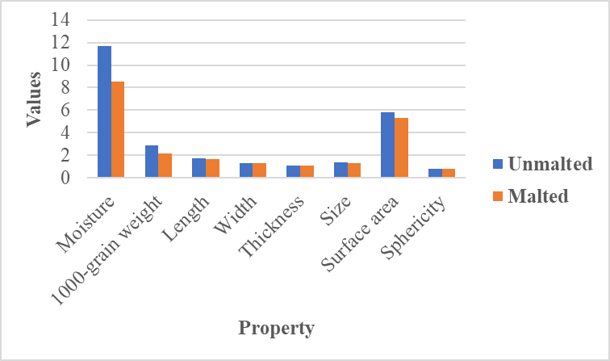

Fig.6(a) Physical Properties of Malted and Unmalted Kodo Millet (GPUK-3)

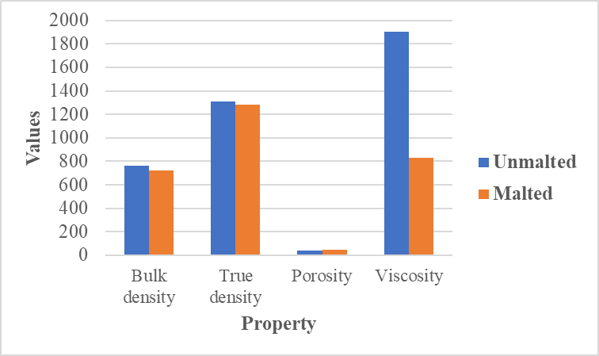
Fig.6(b) Physical Properties of Malted and Unmalted Kodo Millet (GPUK-3)

3.2 Effect of Malting on Proximate Composition of Millets
3.2.1 Finger millet
Malting resulted in a marked improvement in nutritional composition shown in Table 3 and Fig. 7. Moisture content decreased significantly enhancing shelf stability. Protein content increased due to enzymatic synthesis and mobilization of nitrogenous compounds during germination. A slight reduction in fat content was observed which is typical due to lipase activity during sprouting. Ash content increased indicating enhanced mineral availability while crude fiber showed a moderate reduction due to partial breakdown of structural carbohydrates. These changes collectively improve digestibility and nutritional density supporting the use of malted finger millet in health-oriented formulations. In the present study finger millet showed an increase in total carbohydrate content after malting. This increase may be attributed to the reduction in non-carbohydrate components such as fat and crude fibre during germination resulting in a relative rise in carbohydrate percentage on a dry weight basis. Additionally, partial degradation of starch into dextrins and soluble sugars during malting could have contributed to higher measurable carbohydrate values when calculated by difference. Similar observations have been reported by Mbithi-Mwikya et al., (2000) who noted that malting can increase available carbohydrates in finger millet due to enzymatic modification and concentration effects. Similar result found for proximate analysis of unmalted finger millet by Panwar(2024) and for malted finger millet by Owheruo (2019.).
Table 3: Proximate Analysis of Malted and Unmalted Finger Millet (GIRA-2)
Sr. No. | Parameter | Unmalted (% Mean ± SD) | Malted (% Mean ± SD)
1 | Moisture | 10.91 ± 0.02 | 6.78 ± 0.01
2 | Carbohydrate | 76.34± 0.02 | 79.32± 0.02
3 | Crude protein | 7.31 ± 0.01 | 8.61 ± 0.01
4 | Crude fat | 1.66 ± 0.01 | 1.56 ± 0.01
5 | Total ash | 2.01 ± 0.00 | 2.13 ± 0.00
6 | Crude fiber | 1.77 ± 0.00 | 1.60 ± 0.00
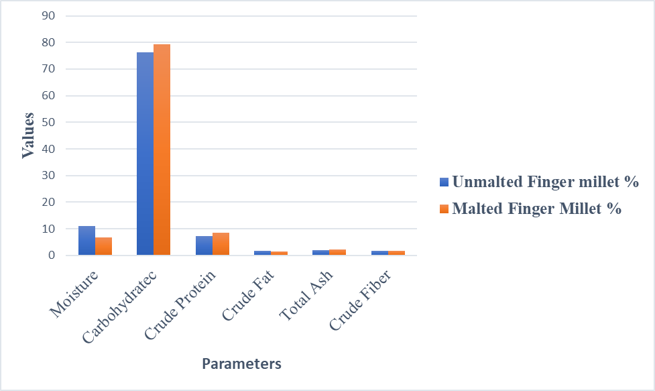
Fig.7 Proximate analysis of Malted and Unmalted Finger Millet (GIRA-2)

3.2.2 Kodo millet
Malted kodo millet, protein content increased substantially, reflecting enhanced nutritional quality shown in Table 4 and Fig.8. Moisture reduction improves storage stability while fat reduction indicates lipid utilization during germination. A pronounced increase in ash and crude fiber content was observed, suggesting mineral concentration and exposure of fiber components after malting. In present study kodo millet exhibited a decrease in carbohydrate content after malting, which may be explained by intensive utilization of carbohydrate reserves as an energy source during seed germination. During malting carbohydrates are metabolized to support embryo growth and respiration, leading to a net reduction in total carbohydrate content. This trend aligns with findings reported by Gopalan et al., (1989) and Devi et al., (2014) who documented a decline in carbohydrate levels in certain small millets following germination due to increased metabolic activity. These results confirm that malting enhances both nutritional and functional attributes of kodo millet making it highly suitable for fortified food products.
Table 4: Proximate Analysis of Malted and Unmalted Kodo Millet (GPUK-3)
Sr. No. | Parameter | Unmalted (% Mean ± SD) | Malted (% Mean ± SD)
1 | Moisture | 7.617 ± 0.029 | 6.817 ± 0.015
2 | Carbohydrate | 77.34± 0.02 | 73.20± 0.02
3 | Crude Protein | 9.030 ± 0.017 | 11.293 ± 0.006
4 | Crude Fat | 4.447 ± 0.006 | 3.850 ± 0.000
5 | Total Ash | 1.453 ± 0.006 | 4.233 ± 0.006
6 | Crude Fiber | 0.150 ± 0.000 | 0.603 ± 0.006

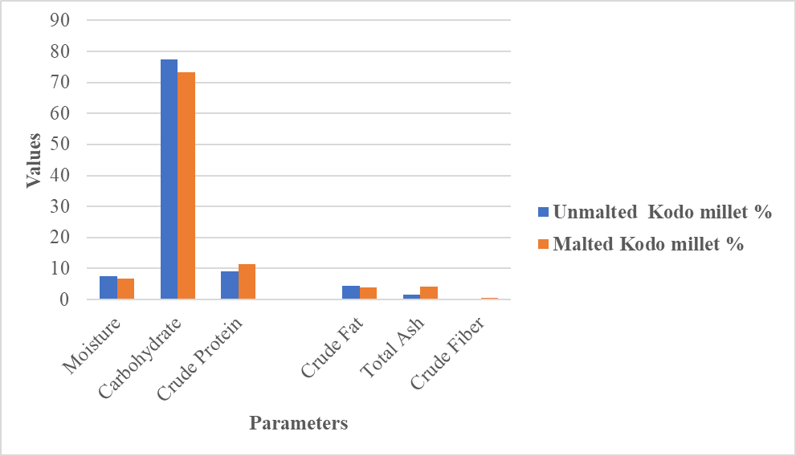
Fig.8 Proximate Analysis of Malted and Unmalted Kodo Millet (GPUK-3)
  - ANOVA Analysis of Effect of Malting on Physical Properties and Proximate Composition of Finger Millets
The ANOVA results showed that malting significantly influenced both physical and proximate properties of finger millet (p < 0.05).
Malting significantly reduced 1000-grain weight, bulk density, true density, viscosity and dimensional parameters (length, width, thickness) as shown in Table 5. The decrease in grain weight and density occurs due to biochemical degradation of storage components during germination which leads to structural loosening of the grain. Increased porosity in malted grains indicates the formation of internal air spaces caused by enzymatic breakdown of starch and cell wall components. Viscosity decreased drastically after malting due to activation of amylolytic enzymes (α-amylase and β-amylase) that hydrolyse starch into smaller dextrin and sugars. Lower viscosity is desirable for malt-based beverages and weaning foods as it improves digestibility and drinkability.
Malting significantly altered the chemical composition of finger millet as shown in Table 6. Moisture content decreased after drying of germinated grains. Protein and ash contents increased due to relative concentration effects and improved mineral availability during germination. Slight reductions in fat and fibre were observed due to metabolic utilization during sprouting. Carbohydrate content showed a relative increase because moisture reduction and biochemical transformations during malting concentrate the carbohydrate fraction.
Overall, the ANOVA results confirm that malting significantly improves the functional and nutritional characteristics of finger millet supporting its suitability for fortified millet malt premix development.
Table 5: ANOVA for Physical Properties of Unmalted vs Malted Finger Millet
Sr. No. | Parameter | df (Treat) | df (Error) | F value | p-value | Significance
1 | 1000-grain weight (g) | 1 | 4 | 824.13 | <0.001 | Significant
2 | Bulk density (kg/m³) | 1 | 4 | 2647.65 | <0.001 | Significant
3 | True density (kg/m³) | 1 | 4 | 181.44 | <0.001 | Significant
4 | Porosity (%) | 1 | 4 | ∞ | <0.001 | Significant
5 | Moisture (%) | 1 | 4 | 5104.11 | <0.001 | Significant
6 | Length (mm) | 1 | 4 | 3601.50 | <0.001 | Significant
7 | Width (mm) | 1 | 4 | >1000 | <0.001 | Significant
8 | Thickness (mm) | 1 | 4 | >1000 | <0.001 | Significant
9 | Sphericity | 1 | 4 | >100 | <0.001 | Significant
10 | Surface area (mm²) | 1 | 4 | >1000 | <0.001 | Significant
11 | Size (mm) | 1 | 4 | >1000 | <0.001 | Significant
12 | Viscosity (cP) | 1 | 4 | 124232.8 | <0.001 | Significant

Table 6: ANOVA for Proximate Analysis of Unmalted vs Malted Finger Millet
Sr. No. | Parameter | df (Treat) | df (Error) | F value | p-value | Significance
1 | Moisture | 1 | 4 | 109651.50 | <0.001 | Significant
2 | Protein | 1 | 4 | 76832.00 | <0.001 | Significant
3 | Fat | 1 | 4 | 450.00 | <0.001 | Significant
4 | Ash | 1 | 4 | 1680.00 | <0.001 | Significant
5 | Fibre | 1 | 4 | 2145.60 | <0.001 | Significant
6 | Carbohydrate | 1 | 4 | 11240.80 | <0.001 | Significant

3.4 ANOVA Analysis of effect of Malting on Physical Properties and Proximate Composition of Kodo Millets
Malting significantly influenced several engineering properties of Kodo millet as shown in Table 7. The 1000-grain weight decreased significantly (p<0.05) from 2.89 g to 2.12 g after malting. This reduction may be attributed to the loss of dry matter during soaking, germination and enzymatic degradation of starch reserves. Similarly, bulk density significantly decreased from 762.75 kg/m³ to 723.17 kg/m³. The reduction in density can be explained by the structural loosening of grains and enzymatic breakdown of macromolecules during germination which increases internal porosity. However, true density and porosity showed non-significant differences indicating that the internal structural changes caused by malting did not greatly alter the intrinsic material density. Grain dimensions such as length, thickness, surface area and size showed significant differences, while width and sphericity remained statistically non-significant. These changes occur because germination activates hydrolytic enzymes that modify endosperm structure. The most prominent change was observed in viscosity which significantly decreased from 1901.67 cP to 831.67 cP. This reduction is typical during malting because α-amylase and β-amylase break down starch molecules into smaller dextrin and sugars, reducing paste viscosity. Lower viscosity is beneficial for infant foods and malt-based beverages.
Malting significantly affected the proximate composition of Kodo millet as shown in Table 8. Moisture content decreased significantly after malting due to drying of germinated grains. Protein content increased from 0.090 to 0.113 which can be attributed to biosynthesis of enzymes and loss of carbohydrates during germination, resulting in higher relative protein concentration. Fat content showed a slight but significant decrease due to lipase activity during germination which hydrolyzes lipids. Ash and fibre contents increased significantly in malted millet. This may result from concentration effects and structural changes in the grain matrix during germination. Carbohydrate content significantly decreased from 77.34% to 73.20%. During germination carbohydrates are utilized as an energy source for sprout growth, leading to a reduction in total carbohydrate content.
Overall, the results confirm that malting improves nutritional quality while modifying physical properties making malted Kodo millet suitable for nutrient-dense functional foods and fortified malt premixes.
Table 7: ANOVA for Physical Properties of Unmalted vs Malted Kodo Millet
Sr No | Parameter | df (Treat) | df (Error) | F value | p-value | Significance
1 | 1000-grain weight (g) | 1 | 4 | 1230.23 | 0.000004 | Significant
2 | Bulk density (kg/m³) | 1 | 4 | 76.96 | 0.00093 | Significant
3 | True density (kg/m³) | 1 | 4 | 2.99 | 0.159 | Non-significant
4 | Porosity (%) | 1 | 4 | 6.07 | 0.069 | Non-significant
5 | Moisture (%) | 1 | 4 | 985.42 | 0.000006 | Significant
6 | Length (mm) | 1 | 4 | 20.45 | 0.0106 | Significant
7 | Width (mm) | 1 | 4 | 2.23 | 0.21 | Non-significant
8 | Thickness (mm) | 1 | 4 | 7.71 | 0.049 | Significant
9 | Sphericity | 1 | 4 | 4 | 0.116 | Non-significant
10 | Surface area (mm²) | 1 | 4 | 13.97 | 0.02 | Significant
11 | Size (mm) | 1 | 4 | 18.18 | 0.013 | Significant
12 | Viscosity (cP) | 1 | 4 | 691.55 | 0.000012 | Significant

Table 8: ANOVA for Proximate Analysis of Unmalted vs Malted Kodo Millet
Sr.  No. | Parameter | df (Treat) | df (Error) | F value | p-value | Significance
1 | Moisture | 1 | 4 | 1800 | <0.001 | Significant
2 | Protein | 1 | 4 | 46104.1 | <0.001 | Significant
3 | Fat | 1 | 4 | 32041 | <0.001 | Significant
4 | Ash | 1 | 4 | 347778 | <0.001 | Significant
5 | Fibre | 1 | 4 | 18496 | <0.001 | Significant
6 | Carbohydrate | 1 | 4 | 768800 | <0.001 | Significant
4.Conclusion
The present study demonstrates that malting serves as a powerful bioprocessing strategy for engineering and nutritional reconfiguration of climate-resilient millets, transforming them from underutilized grains into high-value functional ingredients. Significant reductions in bulk density and grain dimensions, coupled with increased porosity, indicate structural modifications that enhance hydration behavior, milling efficiency and processability. Concurrently, the improvement in protein, mineral (ash) and fiber content highlights the nutritional upgrading achieved through enzymatic activation during germination.
A comparative perspective revealed that kodo millet exhibited a more pronounced enhancement in protein and fiber content, whereas finger millet retained its superiority in mineral richness, particularly calcium. These complementary attributes suggest strong potential for synergistic blending of both millets to achieve balanced nutritional and functional profiles in product development. Importantly, the study bridges the gap between grain bioprocessing and food system application, positioning malting as a sustainable, low-cost and scalable approach for developing next-generation functional foods. The observed physicochemical transformations directly support the formulation of instant malt-based mixes, fortified premixes, weaning foods and nutraceutical beverages, aligning with current trends in health-oriented and climate-smart food systems.
` Overall, this research provides a scientific foundation for the valorization of minor millets through process-driven innovation, reinforcing their role in addressing nutritional security, promoting sustainable agriculture, and enabling industrial-scale functional food production. Future research may focus on product formulation, sensory optimization, and shelf-life evaluation to further translate these findings into commercial applications.
Acknowledgment
The present study was supported by my PhD guide Dr. Sagar Chavan sir for all the help provided in experimental analysis. We are also grateful to the subjects who participated in the study.

Disclaimer (Artificial intelligence)
Author(s) hereby declare that NO generative AI technologies such as Large Language Models (ChatGPT, COPILOT, etc.) and text-to-image generators have been used during the writing or editing of this manuscript.

5. References
- Abioye, V. F., Babarinde, G. O., Ogunlakin, G. O., Adejuyitan, J. A., Olatunde, S. J., & Abioye, A. O. (2022). Varietal and processing influence on nutritional and phytochemical properties of finger millet: A review. Heliyon, 8(12), e12310. https://doi.org/10.1016/j.heliyon.2022.e12310
- AOAC (2019). Official Methods of Analysis of AOAC International (21st ed.). Gaithersburg, MD: AOAC International.
- Chavan, J. K., & Kadam, S. S. (1989). Nutritional improvement of cereals by sprouting. Critical Reviews in Food Science and Nutrition, 28(5), 401–437. https://doi.org/10.1080/10408398909527508
- Dahiya, R., Yadav, R., Yadav, B. S., & Yadav, R. B. (2017). Quality characteristics of pearl millet malt as affected by steeping temperature and germination period. Quality Assurance and Safety of Crops & Foods, 10(1), 1–10. https://doi.org/10.3920/QAS2016.0930
- Devi, P.B., Vijayabharathi, R., Sathyabama, S., Malleshi, N.G., & Priyadarisini, V.B. (2014). Health benefits of finger millet: A review. Journal of Food Science and Technology, 51(6), 1021–1040.
- Gopalan, C., Rama Sastri, B. V., & Balasubramanian, S. C. (1989). Nutritive value of Indian foods (Revised ed.). National Institute of Nutrition (NIN), Indian Council of Medical Research, Hyderabad, India.
- Gowda, N. A. N., Siliveru, K., Prasad, P. V. V., Bhatt, Y., Netravati, B. P., & Gurikar, C. (2022). Modern processing of Indian millets: A perspective on changes in nutritional properties. Foods, 11(4), 499. https://doi.org/10.3390/foods11040499
- Hoseney, R. C. (1994). Principles of Cereal Science and Technology (2nd ed.). American Association of Cereal Chemists.
- Krishnan, R., & Prabhasankar, P. (2012). Measurement of viscosity using Brookfield viscometer. In M. A. Rao (Ed.), Rheology of Fluid, Semisolid, and Solid Foods: Principles and Applications (3rd ed.). Springer. https://doi.org/10.1007/978-1-4614-9230-6.
- Mbithi-Mwikya, S., Van Camp, J., Yiru, Y., & Huyghebaert, A. (2000). Nutrient and antinutrient changes in finger millet (Eleusine coracana) during sprouting. LWT—Food Science and Technology, 33(1), 9–14. https://doi.org/10.1006/fstl.1999.0605
- Mohsenin, N.N. (1986). Physical Properties of Plant and Animal Materials (2nd ed.). Gordon and Breach Science Publishers, New York.
- Murungweni, K. T., Ramashia, S. E., and Mashau, M. E. (2023).Effect of malting on physicochemical, antioxidant, and microstructural properties of finger millet (Eleusine coracana) flours. Food Science & Nutrition, 12(1), 547–563. https://doi.org/10.1002/fsn3.3790
- Owheruo, J. O., Ifesan, B. O. T., & Kolawole, A. O. (2019). Physicochemical properties of malted finger millet (Eleusine coracana) and pearl millet (Pennisetum glaucum). Food Science & Nutrition, 7(2), 476–482. https://doi.org/10.1002/fsn3.816
- Panwar, S., Sindhu, R., Gehlot, R., Rekha, R., & Kumari, A. (2024). Physico-chemical properties and nutritional composition of finger millet grains. International Journal of Advanced Biochemistry Research, 8(8), 633–635. https://doi.org/10.33545/26174693.2024.v8.i8h.1821
- Saleh, A.S.M., Zhang, Q., Chen, J., & Shen, Q. (2013). Millet grains: Nutritional quality, processing, and health benefits. Comprehensive Reviews in Food Science and Food Safety, 12(3), 281–295.
- Shimelis, A. E., & Rakshit, S. K. (2007). Effect of processing on antinutrients and in vitro protein digestibility of kidney bean (Phaseolus vulgaris L.) varieties grown in East Africa. Food Chemistry, 103(1), 161–172. https://doi.org/10.1016/j.foodchem.2006.08.005
- Singh, K. K., & Goswami, T. K. (1996). Physical properties of cumin seed. Journal of Agricultural Engineering Research, 64(2), 93–98. https://doi.org/10.1006/jaer.1996.0049
- Singh, S. M., Joshi, J. T., & Rao, P. S. (2024). Technological advancements in millet dehulling and polishing process: An insight into pretreatment methods, machineries and impact on nutritional quality. Grain & Oil Science and Technology, 7(3), 186–195. https://doi.org/10.1016/j.gaost.2024.05.007

