Purification and Characterization of Pectinase from Aspergillus niger Produced via Submerged Fermentation Using Wheat Bran

Abstract
This study isolated, screened, and identified a pectinase producing fungus from vegetable waste dumpyard soil and also cultured the isolated fungus under optimized conditions to obtain pectinase enzyme as well as purified and investigated the biochemical characteristics of the purified enzyme. The fungal strain was isolated on pectinase screening agar medium containing 1% pectin and obtained a clearance zone. It was identified as A. niger and cultivated for enzyme production using SmF. The purification of exopectinase was carried out by ammonium sulphate precipitation, dialysis and chromatographic techniques (gel filtration). Among the different ammonium sulfate saturation ranges (0–20%, 20–40%, 40–60%, 60–80%, and 80–100%), the 70–80% fraction showed the highest enzyme activity. This fraction exhibited maximum protein content, total exopectinase activity, specific activity, purification fold, and recovery percentage. The molecular weight of the purified enzyme was subsequently determined using SDS-PAGE. The Sephadex G-100 purified samples revealed a distinct band with molecular weight of 60 kDa..Studies on characterization of purified enzyme revealed that the A. niger showed good production of exopectinase. Studies on the characterization of the purified enzyme revealed that A. niger showed efficient exopectinase production. In the present investigation, exopectinase activity from A. niger was stable and showed maximum activity at pH 6.0 (0.076U/mL). The enzyme exhibited higher activity at an optimum temperature of 40°C (0.685U/mL) and retained approximately (57.4%) of its activity after 30 minutes of incubation, indicating good thermal stability. Among all the metal ions tested, KCl enhanced enzyme activity by (18.15%) whereas FeCl₃ exhibited a maximum inhibition of 76.93% and CoCl₂ showed complete inhibition of enzyme activity.

Key words: Pectinases, A. niger, Wheat bran, Purification, & Characterization, Submerged Fermentation

1. Introduction
Pectinases are heterogeneous groups of enzymes that can catalyze the breakdown of pectin. The most studied pectinases are polygalacturonase, pectate lyase, pectin lyase, and pectinesterase (Mat Jalil et al 2023). The application of new enzymes with beneficial biochemical and physicochemical characteristics and low-cost production in commercial processes has always been considered as essential research (KC et al., 2020). Globally 2021 also witnessed a forecast of the global market growth of enzymes to about US $6.32 billion in terms of enzyme applications (Ametefe et al., 2022). It is worth noting that small-scale fruit companies could use locally produced pectin enzymes for extraction and clarifying fruit juices (KC et al., 2020; Zhang Z et al., 2021). The use of agricultural wastes for pectinase production is geared towards the creation of an environmentally or ecologically friendly way of producing valuable products (Bano and Padmadeo, 2017; Dutta K et al., 2021)
In addition, recent advancements in fermentation optimization and metabolic engineering have further improved enzyme yield and industrial applicability (Liujen chen et al., 2025). Moreover, recent research has focused on the utilization of agricultural wastes and statistical optimization techniques to increase pectinase production in fungal systems (Ali et al., 2025).
However these advancements, most studies have primarily focused on process optimization, strain improvement, and large-scale production. Despite, there is still limited information on the comparative influence of specific growth factors on pectinase production and enzyme characteristics in different Aspergillus species. Additionally, systematic evaluation of enzyme activity, stability, and response to external factors such as pH, temperature, and metal ions remains insufficiently explored.
Microbial sources, particularly fungal species such as Aspergillus, are widely preferred due to their high enzyme productivity and ease of cultivation. Recent investigations (2023-2025) have reported enhanced pectinase production from Aspergillus species using agro-waste substrates, with optimum activity typically observed at pH 5–7 and temperatures around 40–45 °C. (Mwaheb et al., 2025). Furthermore, advancements in fermentation technology and enzyme engineering have contributed to improved enzyme efficiency, stability, and industrial applicability. (Zhao et al., 2025)
However these advancements, most studies have primarily focused on process optimization, strain improvement, and large-scale production. Despite, there is still limited information on the comparative influence of different growth factors on pectinase production and enzyme characteristics in Aspergillus species. Specifically, systematic studies evaluating the combined effects of growth factors on enzyme activity, stability, and physicochemical properties under submerged fermentation conditions remain insufficient.

Hence, the present study aims to investigate the Purification and Characterization of Pectinase from Aspergillus niger Produced via Submerged Fermentation Using Wheat Bran”.

2. Material and Methods
2.1 Sample collection: 30 Soil samples, collected from the 5 different sites viz., Mulugu road, Hasanparthy, Narsampet, Kazipet and Janagaon, where the vegetable wastes were dumped which were obtained from different areas of in and around the Warangal city, Telangana state in sterile polythene bags and were immediately transferred to the laboratory for microbial assessment and analysis
2.2 Isolation of fungi: Potato dextrose agar (PDA) medium containing (gm/L): potato infusion, 200; dextrose, 20.0 and agar, 15.0 was chosen as growth medium for preliminary isolation of fungi. The dilution-plate method (Johnson and curl, 1972) was employed for the isolation purpose. After serial dilutions inoculum were spread on potato dextrose agar medium. The plates were incubated in an inverted position at 28ºC for 7 days (Kaur and Kaur, 2014).
2.3 Primary screening of pectinolytic fungi: Selection and isolation of potential pectinolytic fungi were assessed by using 0.1 mL of inoculum from the enriched medium, they were plated on pectin agar media contains 0.2%, NaNO₃; 0.1%, K₂HPO₄; 0.05%, MgSO₄. 7H₂O; 0.05%, KCl; 10 mg, FeSO₄.7H₂O; 3%, Sucrose; 0.001%, ZnSO₄ and 0.001%, CuSO₄ supplemented with 1% pectin, incubated at 28±1ºC for 4-5 days. After 5 days of incubation, plates were flooded with iodine- potassium iodide solutionand observed for zone of hydrolysis around the wells (Reddy and Sreeramulu, 2012).
2.4 Pectinase production under submerged fermentation (SmF): Cultures grown in 250 ml Erlenmeyer flask containing 100 mL of pectin broth (pH 7.0), contains 0.2%, NaNO₃; 0.1%, K₂HPO₄; 0.05%, MgSO₄.7H₂O; 0.05%, KCl; 0.01%, FeSO₄.7H₂O; 3%, sucrose; 0.001%, ZnSO₄; 0.001%, CuSO₄ and 1% of pectin were used for assay of pectinase and exopolygalacturonase enzymes. After the sterilization of the Erlenmeyer flasks containing fermentation medium, young fungal mycelia of 3 day old cultures at the growing edges were used to inoculate aseptically. Inoculated flasks were incubated in the orbital shaker operating at 120-180 rpm at 28±1 ºC for 16 days. The incubation period of 16 days was chosen to ensure maximum enzyme production under the given experimental conditions. 10 mL of incubated broth from the culture flasks was withdrawn at different time intervals. The supernatants obtained from the centrifugations were used as enzyme sources for assay and quantification of protein content.
2.5 Enzyme recovery: After incubation, the culture medium was filtered to remove mycelium using Whatmann No.5 filter paper, the filtrate was centrifuged at 5000 rpm for 10 min. The clear supernatant was used as the extracellular enzyme source.
2.6 Quantitative assay for exopectinase activity: The exopectinase activity was assayed by DNS (Dinitrosalicylic acid) method (Miller, 1959) using 1% pectin as substrate. Reaction mixture containing equal amounts of 1% pectin (1.0 mL) prepared in citrate buffer (0.05 M; pH 5.0) and partially purified enzyme (1.0 mL) was incubated at 50ºC in water bath for 30 min. The reaction was terminated by addition of 3ml of 3,5-dinitrosalicilic acid (DNS) reagent and the contents were boiled for 15 min. After cooling the color developed was read at 540 nm. The amount of reducing sugar released was quantified using galactouronic acid as standard. The standard curve was constructed by plotting absorbance at 540 nm versus concentration of galacturonic acid㎍/mL. The enzymatic activity of filtrate was expressed as Unit per ml (U/ml), which is defined as the amount of enzyme, which liberates 1 μmole of reducing sugar per mL per minute under assay conditions.
Units/ml enzyme = (μmole of galacturonic acid equivalent released) (DF) (2)
(30) (X)
DF= dilution factor of enzyme
2= Total volume (in milliliter) of assay
X=Volume (in milliliter) of enzyme used
30=Time of assay (in minute) as per unit definition
Total activity (units)
Specific activity = Total protein (mg)
Total activity of the sample × 100
Recovery percentage = Total activity of the crude extract
Specific activity of the sample
Purification fold = Specific activity of the crude
2.7 Purification of pectinase from A. niger: For purification studies filtrates of 16 days old SmF using wheat bran was taken. The enzyme assay was done as described in previous sections.
2.8 Ammonium sulphate fractionation: Extracellular pectinase was isolated and partially purified from the culture filtrate by ammonium sulphate precipitation followed by dialysis. The culture broth was clarified by centrifugation at 10,000 rpm for 20 min at 4 °C using a refrigerated centrifuge (e.g., Remi C-24 BL, Germany) to remove suspended particles. The clarified supernatant was subjected to cumulative stepwise ammonium sulphate fractionation under chilled conditions. Solid ammonium sulphate (analytical grade, e.g., HiMedia Laboratories, India) was gradually added with continuous stirring using a magnetic stirrer (Remi 2MLH) in an ice bath to reach successive saturation levels. The saturation was increased sequentially to 10%, 20%, 30%, 40%, 50%, 60%, 70%, 80%, 90%, and finally 100%. At each step, the solution was equilibrated for 2 h at 4 °C and kept overnight to ensure complete protein precipitation. The precipitated proteins were recovered by centrifugation at 10,000 rpm for 20–30 min at 4 °C.
After removal of the precipitate at each stage, additional ammonium sulphate was added to the same supernatant to reach the next saturation level, confirming the cumulative (stepwise) nature of fractionation. Each precipitated fraction corresponding to its respective saturation range was collected separately, dissolved in minimal volume of suitable buffer (e.g., 0.05 M citrate buffer, pH 5.0), and stored at 4 °C for further analysis.
2.9 Dialysis: The precipitated protein fraction exhibiting maximum pectinase activity was dissolved in 0.05 M sodium citrate buffer (pH 5.5). The sample was transferred into a dialysis membrane (molecular weight cut-off 10–12 kDa; e.g., dialysis tubing from HiMedia Laboratories, India) and dialyzed against 400 mL of the same buffer. Dialysis was carried out at 25 °C for 16 h with continuous stirring using a magnetic stirrer (Remi 2MLH). The dialysis buffer was replaced twice at regular intervals to ensure efficient removal of ammonium sulphate and other low-molecular-weight impurities. Following dialysis, the protein solution was centrifuged at 10,000 rpm for 15–20 min at 4°C using a refrigerated centrifuge (e.g., Remi C-24 BL, Germany). The clear supernatant obtained was used for the estimation of pectinase activity and protein concentration as described earlier.

2.10 Purification by chromatographic technique
2.10.1 Gel filtration chromatography: The dialyzed enzyme fraction was further purified by gel filtration chromatography as per the standard method (Keller et al, 2006) with certain modifications. It was loaded on sephadex G-100 column (35×1.5 cm, bed volume 60 ml) and eluted with 0.01M Tris-HCl buffer (pH 6.0) with the flow rate of 20 ml/h. Total 40 fractions of 3 ml each were subsequently collected and its protein content was measured by taking A280 on spectrophotometer (UV-VIS 1601 Shimadzu, Japan). The fractions bearing high A280 were collected and evaluated for its pectinase activity. The fractions were analyzed for higher enzyme activity and were pooled together for further characterization.
2.10.2 SDS polyacrylamide gel electrophoresis: SDS–PAGE was performed according to the method described by Laemmli (1970). All required reagents and solutions were prepared freshly. For sample preparation, the purified enzyme solution was mixed with an equal volume of 2× sample loading buffer, boiled for 5 min, and then cooled to room temperature prior to loading. Electrophoresis was carried out using a 12% resolving gel and a 2.5% stacking gel. Protein samples containing 100–120 µg were loaded into the wells. Standard molecular weight markers were run simultaneously alongside the samples to estimate protein size.
The gels were run at a constant voltage of 80 V through the stacking gel, followed by 120 V through the resolving gel until the tracking dye reached the bottom of the gel. After electrophoresis, the gel was stained with Coomassie Brilliant Blue R-250 and destained using a methanol–acetic acid solution until clear protein bands were visible.
2.11 Determination of molecular weight: The molecular weight of purified enzyme was determined by gel filtration through sephadex G-100 as well as SDS-PAGE using standard molecular weight marker protein (14.3 KDa α-lactalbumin, 20.1 kDa trypsin inhibitor, 29.0 kDa carbonic anhydrase, 44.3 kDa ovalbumin, 66.4 kDa bovine serum albumin and 97.2 kDa phosphorylase b)
2.12 Characterization of purified pectinase: The purified pectinase was analyzed to define its characterization by studying its pH, temperature and the influence of metal ions.
2.13 Effect of pH on enzyme activity: The partially purified pectinase was incubated at various pH ranges (2.0, 3.0, 4.0, 5.0, 6.0, 7.0, 8.0 and control) in sodium acetate buffer with 1 ml of 1% pectin as substrate at 40˚C for 30 minutes and assayed according to the method described by Miller (1959). The experimental set up was done in triplicates and the enzyme activity was estimated. The stability was determined after incubating the enzyme at pH 2.0 – 8.0 at room temperature and residual activity is determined.
2.14 Effect of temperature on enzyme activity: The optimum temperature needed for maximum activity of the purified enzyme was determined by varying the reaction temperature from 25ºC to 100˚C for 30 minutes and assayed according to the method described by Miller (1959). The thermal stability of pectinase was determined by measuring the residual activity after incubating the enzyme at temperature ranges from 25˚C to 100˚C for 30 min. All sets have been performed in triplicates and the enzyme activity was estimated.
2.15 Effect of metal ions on enzyme activity: The presence of metal ions in the culture media greatly affects the metabolic activity of the microbial cell and act as co-factors in various enzymatic reactions (Priyadarshini et al., 2014). The effect of various metal ions such as Ba⁺², Ca⁺², Co^{+2,} Fe⁺², K⁺, Mg⁺² and Na⁺ at 1 mM concentration was done. The residual activity was determined after incubating the purified pectinase in the respective metal ion solutions for 20min at room temperature.
The residual activity was calculated in percentage with reference to the activity of the enzyme without the metal ions (The activity in the absence of metal ions was calculated as 100%). (% residual activity is the remaining activity after 20 min incubation of enzyme with corresponding metal ions).
2.16 Statistical analysis: In order to evaluate and determine the significant of the findings and also to compare the differences among the findings, the statistical analysis was used. One way Analysis of Variance (ANOVA) and Duncan Multiple Range Test (DMRT) using SPSS Statistics, version 17.0 were used to analyze the significant different of the mean of experimental data.
3. Results and discussion
A total of approximately 20 isolates exhibiting pectinase production were obtained and subjected to primary screening on pectin agar plates (Fig. 1). Among these, isolates showing distinct zones of pectin hydrolysis were considered positive for pectinolytic activity. For further selection, colonies producing a clear zone of hydrolysis greater than 2.0 mm in diameter were shortlisted and subjected to secondary screening.
The selection criterion of >2.0 mm pectinolytic zone was adopted to ensure the identification of potent enzyme producers. Zones smaller than 2.0 mm are often influenced by limited enzyme diffusion, low secretion efficiency, or experimental variation, and may not reliably indicate significant enzymatic activity. In contrast, a larger hydrolysis zone reflects enhanced extracellular enzyme production and effective substrate degradation, thereby serving as a robust indicator of high pectinase activity. This threshold enabled the elimination of weak producers and facilitated the selection of a promising isolate for further studies.
The most efficient isolate was selected based on its superior pectinolytic activity and was subjected to molecular identification. Sequencing was carried out by Macrogen Laboratories (South Korea) (www.macrogen.com), and the obtained nucleotide sequence was analyzed using BLAST against the NCBI GenBank database. The isolate was identified as Aspergillus niger, and the sequence was deposited in GenBank under the accession number MN826319.
3.1 Morphological and Microscopic Characterization
The selected isolate was further characterized based on its macroscopic and microscopic features. The colony morphology and microscopic structures were consistent with the typical characteristics of Aspergillus niger (Table .1)
Table 1. Morphological and microscopic characteristics of the selected isolate
Parameter | Result
Colony growth | Rapid
Colony shape | Circular
Colony surface color | Initially white, turning black on maturation
Colony texture | Powdery to granular
Colony margin | Entire to slightly irregular
Reverse pigmentation | Pale yellow to colorless
Elevation | Slightly raised
Sporulation | Abundant, forming black conidial heads
Hyphae | Septate, hyaline
Conidiophores | Smooth-walled, hyaline, erect
Vesicle | Globose
Phialide arrangement | Biserrate
Conidia | Spherical, rough-walled, black
Conidial arrangement | Radiating chains forming dense conidial heads

The observed morphological and microscopic features are in agreement with previously reported descriptions of Aspergillus niger, thereby supporting the molecular identification.
The above selected strain was screened further for pectinase production on different reported mediums, out of which potato dextrose agar media and pectin agar mediums were found to be supportive mediums for the maximum enzyme production by the strain. Pectinases production by A. niger was enhanced to some extent with all the agroindustrial byproducts. Maximum production was observed with 1% concentration of wheat bran and this isolate was used for production of exopectinase by submerged fermentation.
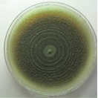
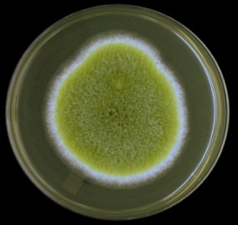
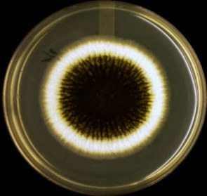
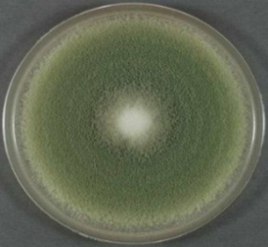

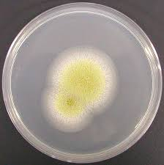
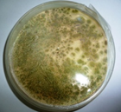
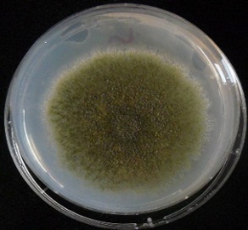
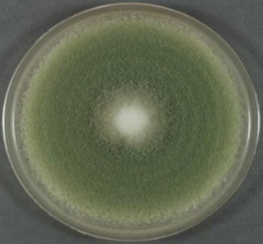
BUF AF RFB BUF1
Aspergillus niger Aspergillus flavus RV FV

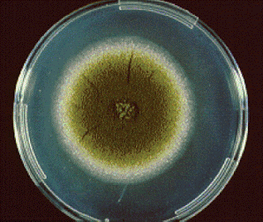
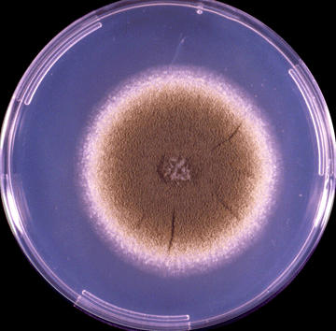

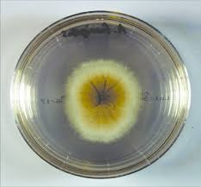
BV2 NV HF1 HF2

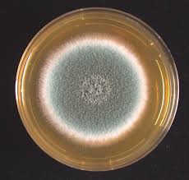
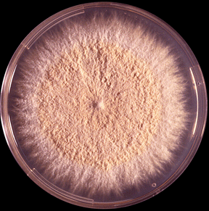
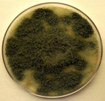
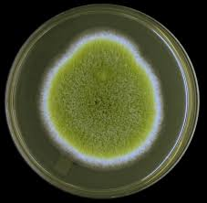
BF2 CV AF1 BF3

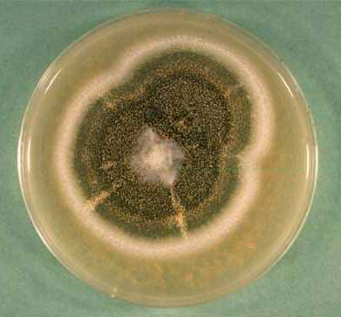
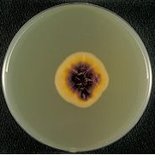
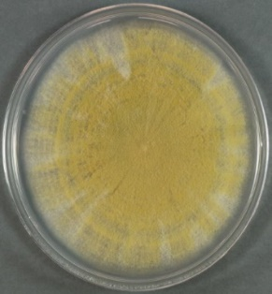
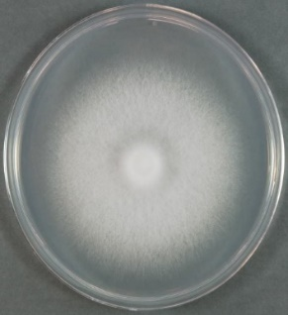
KAF WLRV WL HF

Fig. 1. Isolated fungi on Petri dishes
3.2 Purification of enzyme: The results of purification of exopectinase from A. niger was given (Table 2.0). Surprisingly, the exopectinase produced underSmF using wheat bran by A. niger was found that 70-80% ammonium sulphate saturation was optimum with totalprotein 19 mg, total exopectinase activity of 29.0 U and specific activity of 1.52 U/mg. The yield was145% with the purification fold 2.28. Yeild values exceeding 100% in protein purification often arise due to experimental factors such as measurement variability, enzyme activation during purification or removal of inhibitors that increaseapparent activity rather than actual increase in protein amount. At 80-90% ammonium sulphate saturation total protein of 19.6 mg with total exopectinase activity and specific activity which were observed as 22.5 U and 1.14 U/mg respectively. At this saturation yield was 112 % with purification fold 2.10. Protein concentration is expressed as mg/mL, whereas total protein was expressed as (mg) and was calculated multiplying the protein concentration (mg/mL) by the corresponding sample volume (mL). All units have been standardised and are used consistently throughout the table. Total activity of enzyme ‘U’ was calculated according to the formula described in the materials and methods section.
Table 2. Partial purification of exopectinase enzyme produced by A. niger under SmF using wheat bran and its specific activity and yield
Ammonium sulphate saturation | Protein  (mg/mL) | Total protein  (mg) | Pectinase  (U/mL) | Total  pectinase  activity(U) | Specific  activity  (U/mg) | Purification  fold | Yield (%)
Crude | 1.50 | 30 | 1.000 | 20.0 | 0.666 | 1.00 | 100
0-10% | 0.30 | 6 | 0.620 | 12.4 | 2.06 | 3.09 | 62
10-20% | 0.41 | 8.2 | 0.780 | 15.6 | 1.9 | 2.85 | 78
20-30% | 0.58 | 11.16 | 0.810 | 16.2 | 1.5 | 2.25 | 81.00
30-40% | 0.72 | 14.4 | 0.950 | 19.0 | 1.34 | 2.01 | 95
40-50% | 0.80 | 16 | 1.200 | 24.0 | 1.5 | 2.25 | 120
50-60% | 0.85 | 17 | 1.220 | 24.4 | 1.43 | 2.14 | 122
60-70% | 0.91 | 18.2 | 1.355 | 27.1 | 1.48 | 2.22 | 135
70-80% | 0.95 | 19 | 1.450 | 29.0 | 1.52 | 2.28 | 145
80-90% | 0.98 | 19.6 | 1.125 | 22.5 | 1.14 | 2.10 | 112
90-100% | 0.50 | 10 | 0.900 | 13.0 | 1.8 | 1.77 | 65

3.3 Sephadex G-100 purified exopectinase obtained from A. niger: The dialyzed sample was further purified by Sephadex G-100 column chromatography and analyzed for its elution profile, purification profile, SDS-PAGE.
3.4 Elution profile of Sephadex G-100 purified exopectinase obtained from A. niger: The elution profile of dialyzed ammonium sulphate precipitated and dialyzed exopectinase samples on Sephadex G-100 column are presented in fig. 2.
Fig. 2 Elution profile of Sephadex G-100 purified exopectinase obtained from A. niger
A total of 26 fractions (5 mL each) were eluted. From the eluted fractions, the highest absorbance at 280 nm was recorded by fraction 5 followed by 4 and 6 (enzyme and protein). The fractions before 4 and after 10 recorded the lowest activities. Hence, the fractions 4, 5 and 6 which showed a single peak were pooled together and one part of this was taken for the purification profile study.
Patil et al. (2012) reported that the fractions from 10 to 22 expressed highest polygalacturonase activity by Penicillium sp. when subjected to gel filtration on Sephadex G-100 column chromatography. El-Batal et al. (2013) also expressed the enzyme activity between the fraction numbers 16 to 20 when subjected to gel filtration on Sephadex G-100 column chromatography.
Table 3. Steps in the purification of exopectinase by A. niger
Samples | Total protein content (mg) | Total  exopectinase activity (U) | Specific activity  (U/mg) | Purification fold | Recovery  (%)
Crude extract | 30^{b}±0.1 | 20^{c}±0.1 | 0.666e±0.5 | 1.0^{d}±0.5 | 100ª±0.1
Ammonium sulphate precipitated sample | 19^{c}±0.1 | 29^{b}±0.1 | 1.52e±0.5 | 2.28^{d}±0.5 | 145ª±0.1
Dialyzed sample | 28^{b}±0.1 | 9.20^{c}±0.1 | 0.328e±0.005 | 0.84^{d}±0.005 | 41.8ª±0.1
Sephadex G-100 purified sample | 18^{b}±0.1 | 7.0^{c}±0.1 | 0.388e±0.005 | 1.33^{d}±0.005 | 21.87ª±0.1
Values are expressed as mean± standard error of the mean (SEM)(n=X). Different superscript letters ion (a-e) indicate statistically significant differences between groups at P < 0.005.
P < 0.005

3.5 Protein Content: It can be inferred from Table 3, decrease in the total protein content was observed in the Sephadex purified sample (18 mg) when compared to the dialysate sample (28 mg).
Reduced activity after dialysis may result from enzyme loss through membrane leakage, absorption to tubing,denaturation due to buffer changes, or dilution effects. Exopectinase activity and specific activity from the Table 3, it can be understood that, there was a decrease in the total exopectinase activity (7.0 U) of the Sephadex G-100 purified sample when compared to the dialyzed enzyme extracts (9.2 U). Though the exopectinase activity was decreased, the specific activity of the Sephadex G-100 purified sample (0.388 U/mg) was increased by 0.5 fold when compared to that of the dialyzed enzyme extract (0.328 U/mg). The increase in specific activity is thus, indicative of the progress in purification of the enzyme.
Udenwobele et al. (2014) who reported the reduction in total protein from crude (310, 345 and 300 mg) to dialyzed (10.58, 14.76 and 9.65 mg) of pectinase exhibited from A. niger, A. fumigates and A. flavus respectively.
3.6 Purification fold: It can be observed from the table 3 that the purification fold and recovery percent of the Sephadex G-100 purified sample registered a value of 1.33 and 21.87%, which was higher than that of the dialyzed sample (0.84 and 41.8 %). Comparing the results, it is understood that as the exopectinase sample is being purified, the purification fold is increased in each successive step. On comparing table data can be concluded that the recovery percentage of the isolated enzyme decreased after each step of purification. It can also be observed that the recovery percentage of an enzyme is related to its total activity. Therefore from the tables, it is clear that the recovery percentage of exo-pectinase decreased with decrease in the total exopectinase activity.
Similar findings was observed by Siddique et al. (2012) who reported the final specific activity of the purified PGase from Rhizomucorpusillus as 61.35 U/mg, purification fold and yield as 12.34 and 27.06%, respectively. Yannam et al. (2014) who expressed that the total protein content of the purified polygalacturonase from Aspergillus foetidus decreased from 52.5 mg in the crude sample to 4.24 mg and the specific activity increased from 152.95 U/mg in the crude sample to 525.94 U/mg and achieved a yield of 27.7 % after chromatography. A. fumigatus pectinase was purified with a fold of 4.45, a yield of 26.14%, and specific activity of 38.88 U/mg of protein (Okonji et al., 2019).
It can be concluded from table 3 that the specific activity and purification fold were inversely proportional to the total exopectinase activity, total protein content and recovery% which means that as the total pectinase activity, total protein content and recovery% decrease, the specific activity and purification fold increase, whereas, in the case of recovery%, the value of specific activity and purification fold decreases with decrease in the total pectinase activity. Purification fold is directly proportional to the specific activity of an enzyme and therefore purification fold increases with an increase in specific activity. Hence, it can be confirmed from the above findings that, though the total exopectinase activity and total protein contents were decreased to many folds, there was an increase in the specific activity and purification fold ensuring the good progress in purification of the exopectinase obtained from A. niger. The purified exopectinase was lyophilized and preserved in deep freezer under -20ºC for the application in food industry.
3.7 Determination of molecular weight of pectinase purified from A. niger by SDS-PAGE: The purified exopectinase exhibited a single band on SDSPAGE. On comparing it with electrophoretic mobilities of standard molecular weight markers, it showed molecular weight of 60.0 kDa as shown in Fig 3.
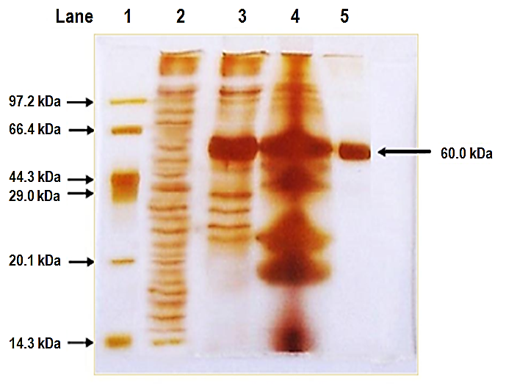
Lane 1 2 3 4 5

97.2 kDa
66.42 kDa
60kDa
44.3 kDa
29.0 kDa

20.1 kDa

14.3 kDa

Fig 3 SDS-PAGE of purified pectinase from A. niger
Lane 1- Protein Marker
2 – Crude exopectinase
3 – Ammonium sulphate precipitated sample
4 – Dialyzed sample
5 – Sephadex G-100 purified sample

According to Oyede (1998) the differences in molecular weights, nature and type of organisms used, substrates employed and analytical methods in addition to the monomeric units of the polypeptides could justify the differences. The present observation is coincides to those reported for some fungal extracellular pectinases, such as the 60 kDa enzyme from Cochlioboluscarbonum (Scott-Craig, 1998). The present findings are in accordance with the observations of Nayebyazdi and Ghanbary (2012) who reported that the purified pectinase from Aspergillus foetidus and A. aculeatus in SDS-PAGE revealed a molecular weight of 79 kDa and 63 kDa respectively. Kusuma and Bhargavi (2014) observed that polygalacturonase obtained from Bacillus subtilis exhibited molecular weight ranging between 43 kDa and 66 kDa.
3.8 Biochemical characterization of exopectinase enzyme:
3.8.1 Temperature optimum: The exopectinase enzyme produced by Aspergillus niger (Fig. 4) under submerged fermentation (SmF) using wheat bran exhibited maximum activity at 40 °C (0.685 U/mL). Enzyme activity increased progressively with temperature from 20 °C to 40 °C, reaching a peak activity (100%) at 40 °C. Beyond the optimum temperature, a decline in enzyme activity was observed. At 50 °C, the enzyme retained approximately 70% of its activity (0.480 U/mL). A sharp decrease in activity occurred with further increases in temperature, and the enzyme showed negligible activity at 80°C. Complete loss of activity (0%) was observed at 90 °C, enzyme denaturation at high temperatures (e.g., 80–90 °C) is generally irreversible indicating thermal inactivation of the enzyme.
3.8.2 Thermal stability: The thermal stability of the purified exopectinase activity produced by A. niger in wheat bran under SmF was found to be retained 74.5% (0.510U/mL) of original activity at 40˚C. At low temperature 20˚C and 30˚C retaining 58.5% (0.120 U/mL) and 64.5% (0.220 U/mL) of its original activity respectively. The enzyme activity retained 68.75% at 50ºC, 7.69% at 60ºC and 40% at 70ºC. Exopectinase enzyme activity exhibited its thermostability after half an hour. (Fig. 4)
Similar view was expressed by Juwon et al. (2012) who reported a decline in the enzyme activity with a temperature more than 40°C. Kaur and Kaur (2014) obtained that the pectinase obtained from Aspergillus sp. showed maximum activity of 186.32 U/mL at a temperature of 35°C.
The thermal stability of the pectinase showed that at 60°C, the enzyme retained 100% activity for 45 min and losing about 50% activity at the end of 120 min of incubation (Okonji, R. E., 2019). El-Batal et al. (2013) also observed 40°C as optimum temperature for enzyme activity and 30°C to 50°C for temperature stability when gamma irradiated Penicillium citrinum was used.
3.8.3 pH optimum: All the enzymes, proteins and pH will affect the ionization state of the amino acids which dictate the primary and secondary structure of the enzyme and hence, its overall activity. A change in pH will have a progressive effect on the structure of the protein and the enzyme activity. The pH dependence of the activity of exo-pectinase from A. niger was shown in figure 4.
The exo-pectinase activity was started at pH 2.0 (0.026 U/mL), reached optimum at pH 6.0 (0.133 U/mL) and declined subsequently. Slight difference in enzyme activity was recorded between pH 4.0 (0.110 U/mL) and 5.0 (0.120 U/mL). No detectable pectinase activity was observed at pH above 10.0. Exo-pectinase enzyme was more active at acidic pH (5.0 -6.0) than alkaline pH (7.0 -8.0)
3.8.4 pH stability: The pH stability profile of purified exopectinase from Aspergillus niger is presented in Fig. 4. The enzyme exhibited moderate stability over a broad pH range (pH 2.0–9.0), with maximum activity observed at pH 6.0 (0.076 U/mL), which was considered as 100% relative activity. At slightly acidic conditions, the enzyme retained 86.8% and 76.3% of its maximum activity at pH 5.0 (0.066 U/mL) and pH 4.0 (0.058 U/mL), respectively. Further decrease in pH resulted in reduced activity, with 52.6% (0.040 U/mL) at pH 3.0 and 26.3% (0.020 U/mL) at pH 2.0.
In the neutral to alkaline range, the enzyme retained 67.1% (0.051 U/mL), 27.6% (0.021 U/mL), and 19.7% (0.015 U/mL) of its activity at pH 7.0, 8.0, and 9.0, respectively.
Overall, the enzyme showed good stability in the acidic to near neutral pH range (pH 4.0–7.0), with a gradual decline in activity under highly acidic and alkaline conditions.
This result is similar to the optimum pH of 5.0 and stability at 4 to 7 reported for Penicillium citrinum (El- Batal Al et al., 2013). A. fumigates pectinase has an optimum pH at 5.0 and decreases significantly below and above this value (Okonji et al., 2019).
The present finding is similar with (Mrudula and Anitharaj 2011) who also observed a maximal activity of pectinase at pH 5.0 from Aspergillus niger.
The present result coincides with the findings of (Irshad et al., 2014) and they reported highest activity of 244.0 U/ml at a pH of 5.5 from Aspergillus niger. Similar view was expressed by (Laha et al., 2014) who demonstrated that the enzyme was stable at a pH 6-8 and showed highest activity at pH 5.0.

a. Temperature optimum b. Thermal stability

c. pH optimum d. pH stability

Fig.4 Characterization of pectinase enzyme produced by A. niger under SmF using wheat bran

3.8.5 Effect of metal ions: The influence of different metal ions on exopectinase activity by A. niger under SmF using wheat bran are summarized in table 4. A significant level of exopectinase activity was enhanced by KCl (0.768 U/mL) fallowed by control (0.650 U/mL) and NaCl (0.596 U/mL). Interestingly, CaCl₂ and MgCl₂ were recorded with similar activity (0.390 U/mL). BaCl₂ (0.270 U/ml) and FeCl₃ (0.150 U/mL) were shown slight inhibition in the enzyme activity, in contrast CoCl₂ showed complete inhibition of enzyme activity.
Among the metal ions tested, KCl enhanced the pectinase activity by 18.15 % whereas NaCl resulted in the reduction in the enzyme activity by 8.4 %. Metal such FeCl₃ exhibited a maximum inhibition of 76.93%, followed by, BaCl₂ 58.5%, CaCl₂ 40% and MgCl₂ 40% whereas, CoCl₂ showed complete inhibition of enzyme activity.
So, it was expressed that wheat bran might have supplied the required metal ions for enzyme activity. The metal ions, K⁺², Na⁺², Mg⁺², and Ca⁺² were showing slight to moderate increase in enzyme activity. Complete inhibition of enzyme activity was obtained by CO⁺².
The inhibition of exopectinase by metal ions such as Co²⁺ and Fe³⁺ may be due to their interaction with active site residues, modification of sulfhydryl groups, displacement of essential cofactors, and induction of conformational changes in the enzyme structure, ultimately leading to loss of catalytic activity.
In addition, result was observed by Joshi et al. (2015) who reported that Mn²⁺ and Fe²⁺ were found to be activators for marine pectinase, while pectinase activity was completely inhibited by Zn²⁺, Al^{3+,}, EDTA, and Cu²⁺ followed by Mn²⁺ (93%), Ba²⁺ (74%), and Ca²⁺ (61%).
A. fumigatus shows that the pectinase activity increased significantly by the monovalent ions but decreases by divalent ions and the trivalent ion (Okonji et al., 2019). Activation of the pectinolytic enzyme has been reported. El-Batal et al. (2013) expressed that the enzyme activity was enhanced in the presence of Mg⁺² and Zn⁺² to 12% and 5% respectively.

Table 4. Effect of metal ions on exopectinase activity by A. niger under SmF in wheat bran

Metals (1 mM) | Residual exopectinase activity (U/mL) and its percentage
Control | 0.650 | 100%
BaCl₂ | 0.270 | 41.5%
CaCl₂ | 0.390 | 60%
CoCl₂ | NA | NA
FeCl₃ | 0.150 | 23.07%
KCl | 0.768 | 118.15%
MgCl₂ | 0.390 | 60%
NaCl | 0.596 | 91.6%

.
4. Conclusions
To the best of our knowledge, this study provides a detailed account of the purification and characterization of pectinase produced by Aspergillus niger isolated from vegetable waste dump yard soil; however, further comparative studies and relevant citations are required to substantiate its novelty. The enzyme was found to be thermostable, exhibiting a broad pH activity range with relatively high activity under acidic conditions. It also demonstrated notable stability at 40°C and in the presence of metal ions such as KCl.
These properties show that the enzyme has strong potential for industrial applications, particularly in processes such as fruit juice clarification, textile processing, and waste biomass degradation. Its stability and cost-effective production from abundant substrates further increase its applicability in biotechnological industries.
Future research should focus on large-scale production (scale-up) to evaluate its commercial feasibility. Additionally, enzyme immobilization techniques could be explored to improve reusability and operational stability. Genetic improvement of the producing strain may also enhance enzyme yield and performance, making it more suitable for industrial exploitation.
Acknowledgements
Authors express profound gratitude to the Head Department of Microbiology, Kakatiya University, Warangal–506009, Telangana, India, for providing the necessary infrastructure and facilities to carry out this research work.

Disclaimer (Artificial intelligence)

Author(s) hereby declare that NO generative AI technologies such as Large Language Models (ChatGPT, COPILOT, etc.) and text-to-image generators have been used during the writing or editing of this manuscript.

References
- Ali, I., Abdullah, R., Saqib, S., Nisar, K., Kaleem, A., Iqtedar, M., ... & Chen, X. (2025). Statistical optimization of pectinases from thermophilic Aspergillus fumigatus BT-4 employing response surface methodology through submerged fermentation using agricultural wastes. BMC biotechnology, 25(1), 1.

- Ametefe, G. D., Lemo, A. O., Orji, F. A., Lawal, A. K., Iweala, E. E. J., & Chinedu, S. N. (2022, September). Pectinase Activities of Selected Fungi Grown on Agrowastes via Solid-state Fermentation. In IOP Conference Series: Earth and Environmental Science (Vol. 1054, No. 1, p. 012003). IOP Publishing.

- Bano, T., & Padmadeo, S. R. (2017). Sustainable industrial development through enzyme technology: an approach toward cleaner production-a literature review. IOSR-JBB, 3(4), 1-7.
- Dutta, K., Shityakov, S., & Khalifa, I. (2021). New trends in bioremediation technologies toward environment-friendly society: a mini-review. Frontiers in Bioengineering and Biotechnology, 9, 666858.

- El-Batal, A. I., Osman, E. M., & Shaima, I. A. M. (2013). Optimization and characterization of polygalacturonase enzyme produced by gamma irradiated Penicillium citrinum. Journal of Chemical and Pharmaceutical Research, 5(1), 336-347.

- Irshad, M., Anwar, Z., Mahmood, Z., Aqil, T., Mehmmod, S., & Nawaz, H. (2014). Bio-processing of agro-industrial waste orange peel for induced production of pectinase by Trichoderma viridi; its purification and characterization. Turk J Biochem, 39(1), 9-18.

- Johnson, L. F., & Curl, E. A. (1972). Methods for research on the ecology of soil-borne plant pathogens. Burgess Publishing Co., Minneapolis, MN

- Joshi, M., Nerurkar, M., & Adivarekar, R. (2015). Characterization, kinetic, and thermodynamic studies of marine pectinase from Bacillus subtilis. Preparative Biochemistry and Biotechnology, 45(3), 205-220.

- Juwon, A. D., Akinyosoye, F. A., & Kayode, O. A. (2012). Purification, characterization and application of polygalacturonase from Aspergillus niger CSTRF. Malaysian journal of microbiology, 8(3), 175-183.

- Kaur, H. P., & Kaur, G. (2014). Optimization of cultural conditions for pectinase produced by fruit spoilage fungi. International journal of advances in research, 3(4), 851-859.

- KC, S., Upadhyaya, J., Joshi, D. R., Lekhak, B., Kumar Chaudhary, D., Raj Pant, B., ... & Raghavan, V. (2020). Production, characterization, and industrial application of pectinase enzyme isolated from fungal strains. Fermentation, 6(2), 59.

- Keller, S. E., Jen, J. J., & Brunner, J. R. (1982). Purification of commercial pectinase by hydrophobic chromatography. Journal of Food Science, 47(6), 2076-2077.
- Kusuma, M. P., & Bhargavi, M. V. (2014). Studies on production, purification and molecular characterisation of polygalacturonase from Bacillus subtilis. European Journal of Biotechnology and Bioscience, 1(5), 1-6

- Laemmli, U. K. (1970). Cleavage of structural proteins during the assembly of the head of bacteriophage T4. nature, 227(5259), 680-685.

- Laha, S., Sarkar, D., & Chaki, S. (2014). Optimization of production and molecular characterization of pectinase enzyme produced from Penicillium chrysogenum. Scholars Academic Journal of Biosciences, 2(5), 326-335.

- Mat Jalil, M. T., Zakaria, N. A., Salikin, N. H., & Ibrahim, D. (2023). Assessment of cultivation parameters influencing pectinase production by Aspergillus niger LFP-1 in submerged fermentation. Journal of Genetic Engineering and Biotechnology, 21(1), 45.

- Miller, G. L. (1959). Use of dinitrosalicylic acid reagent for determination of reducing sugar. Analytical chemistry, 31(3), 426-428.

- Mrudula, S., & Anitharaj, R. (2011). By Aspergillus niger using orange peel as substrate. Global Journal of Biotechnology & Biochemistry, 6(2), 64-71.

- Mwaheb, M. A., Abd El-Aziz, B. M., Abd-Elhalim, B. T., El-Kassim, N. A., & Radwan, T. E. (2025). Correction to: Study of Different Cultivated Plants Rhizosphere Soil Fungi-Mediated Pectinase: Insights into Production, Optimization, Purification, Biocompatibility, and Application. Microbial Ecology, 87(1), 180.

- Nayebyazdi, N. (2012). Pectinase Activity of some Micromycetes isolated from agricultural soils. Journal of Sciences, Islamic Republic of Iran, 23(4), 305-311.

- Okonji, R. E., Itakorode, B. O., Ovumedia, J. O., & Adedeji, O. S. (2019). Purification and biochemical characterization of pectinase produced by Aspergillus fumigatus isolated from soil of decomposing plant materials. Journal of Applied Biology and Biotechnology, 7(3), 1-8.

- Oyede, M. A. (1998). Studies on cell wall degrading enzymes associated with degradation of cassava (Manihot esculenta) tubers by some phytopathogenic fungi (Doctoral dissertation, Ph. D Thesis, Obafemi Awolowo University, Nigeria).

- Patil, R. C., Murugkar, T. P., & Shaikh, S. A. (2012). Extraction of pectinase from pectinolytic bacteria isolated from carrot waste. International Journal of Pharma and Bio Sciences, 3(1), 261-266.

- Priyadharshini, R. I., Prasannaraj, G., Geetha, N., & Venkatachalam, P. (2014). Microwave-mediated extracellular synthesis of metallic silver and zinc oxide nanoparticles using macro-algae (Gracilaria edulis) extracts and its anticancer activity against human PC3 cell lines. Applied biochemistry and biotechnology, 174(8), 2777-2790.

- Reddy, P. L., & Sreeramulu, A. (2012). Isolation, identification and screening of pectinolytic fungi from different soil samples of Chittoor district. International Journal of Life Sciences Biotechnology and Pharma Research, 1(3), 1-10.

- Scott-Craig, J. S., Cheng, Y. Q., Cervone, F., De Lorenzo, G., Pitkin, J. W., & Walton, J. D. (1998). Targeted mutants of Cochliobolus carbonum lacking the two major extracellular polygalacturonases. Applied and Environmental Microbiology, 64(4), 1497-1503.

- Siddiqui, M. A., Pande, V., & Arif, M. (2012). Production, purification, and characterization of polygalacturonase from Rhizomucor pusillus isolated from decomposting orange peels. Enzyme research, 2012(1), 138634.

- Udenwobele, D. I., Nsude, C. A., Ezugwu, A. L., Eze, S. O., Anyawu, C., Uzoegwu, P. Z., & Chilaka, F. C. (2014). Extraction, partial purification and characterization of pectinases isolated from Aspergillus species cultured on mango (Mangifera indica) peels. African Journal of Biotechnology, 13(24) 2445-2454.

- Yannam, S. K., Shetty, P. R., & Obulum, V. S. R. (2014). Optimization, purification and characterization of polygalacturonase from mango peel waste produced by Aspergillus foetidus. Food Technology and Biotechnology, 52(3), 359-367.

- Zhang, Z., Shah, A. M., Mohamed, H., Tsiklauri, N., & Song, Y. (2021). Isolation and screening of microorganisms for the effective pretreatment of lignocellulosic agricultural wastes. BioMed Research International, 2021(1), 5514745.

- Zhao, M., Chen, J., Pan, X., Zabed, H. M., Arsalan, A., & Qi, X. (2025). Advances in Pectinase Engineering for Food Bioprocessing: Novel Sources, Mechanisms, and Optimization Strategies. Journal of Agricultural and Food Chemistry, 73(37), 23078-23097.

