Effect of Ethanolic Extract of Urtica dioica (Stingy Nettle) On Motor Coordination, Fear and Anxiety in Swiss White Mice

Abstract
Introduction: Natural products, like plant extracts either as pure compounds or as standardized extracts, provide unlimited opportunities for new drug discoveries because of their unmatched availability of chemical diversity. Scientific evidence from clinical trials to authenticate the neurophysiological importance of this herb is scanty. Hence, the need for further research to ascertain its efficacy and safety since unregulated or inappropriate use of traditional medicines and practices can have negative or dangerous effects. Objective: This study was carried out to investigate the effect of administration of Urtica dioica on motor coordination, fear and anxiety behavior. Methods: A total of 30 apparently healthy Swiss male albino mice weighing 20-25g were used in the study. After the 14 days of acclimatization, the mice were randomly separated into three (3) groups of ten (10) animals each and were housed in separate cages. The mice in group one (1) serves as the control for the research work and were given water and normal animal feed. Group two (2) of the mice were given feed mixed 400mg/kg of the extract while group three (3) mice were given feed mixed with 800 mg/kg of the extract. The Walking Beam, Light and Dark Transition Box maze were employed for the evaluation of related behaviors while the extracts were mixed with the animals’ feed. So, the extracts were administered to the mice orally. The extracts were administered for a duration of 28days (4 weeks). Results: On line crossing, the control and the low dose group show great similarity and hence, no significance difference between both. However, the high dose group showed a significant reduction in the frequency of line crossing compared to control and low dose group (P≤0.001). Urtica dioica also induced a reduction in the frequency of turns in the Beam walking apparatus at a P≤0.05. High dose showed a significant decrease in the frequency of transition to about 3±0.32 at P≤0.05. Conclusion: These results indicate that repeated administration of Urtica dioica enhances motor function, by reducing oxidative stress and enhancing neuron function, which are critical for movement control. On fear/anxiety study, the animals treated with high dose of the extract significantly spent less time in the light chamber indicating anxiety/fear, thereby showing that the extract of Urtica dioica at high dose can have inhibitory effect on the treated mice whereas at low dose, the effect can be excitatory.

Key words: Urtica dioica, Motor coordination, Fear, Anxiety.

- INTRODUCTION:
Natural products, particularly plant-derived extracts in the form of either isolated compounds or standardised preparations, offer extensive opportunities for novel drug discovery owing to their remarkable chemical diversity (1). This diversity provides a rich source of bioactive molecules with potential therapeutic applications across a wide range of disease conditions. According to Izunwanne et al. (2), more than 80% of the global population relies on traditional medicine to meet their primary healthcare needs, underscoring its continued relevance in contemporary health systems. The utilisation of herbal medicines reflects a long-standing and dynamic interaction between human societies and their natural environments. Medicinal plants are known to contain a broad spectrum of bioactive constituents, many of which exhibit pharmacological properties suitable for the management of both chronic and infectious diseases (3). Consequently, plant-based therapeutics remain an essential focus of scientific investigation, particularly in the search for safe, effective, and accessible treatment options.
Urtica dioica which is commonly known as nettle, stingy nettle or common nettle is a diverse plant being found all over the world with a wide range of distribution. It is a leafy plant found in most parts of Nigeria, but ubiquitous in the Southern parts. It constitutes a nuisance because of its painful stinging effect on the skin when it comes in contact with it, a pain that can last for over 12hours (4). The Igbos call it Agbara or Akuwa; while to the Yorubas, it is Ewe esinsin or Esisi. It is also known as Osokporode in Urhobo (5).
Three smooth-muscle stimulating substances including acetylcholine, histamine, and 5-hydroxytryptamine (5-HT) have been identified in U. dioica (6). Although a number of researches had been carried out on the hormonal, gastrointestinal and hematological effect of Urtica dioica, very few if any of its effect on neurological parameters has been documented despite its rich content of neuroactive phytochemicals namely acetylcholine, histamine and serotonin.
The laudable strides attained in the diagnosis and management of neuromuscular and mood disorders, remain an enigma as most of the drugs used in this context are either scarce or very exorbitant for most individuals especially in third world countries like Nigeria hence the tendency to seek alternate medicine therapy. Scientific evidence from clinical trials to authenticate the neurophysiological importance of this herb is scanty. Hence, the need for further research to ascertain its efficacy and safety since unregulated or inappropriate use of traditional medicines and practices can have negative or dangerous effects (7).

2. MATERIALS AND METHODS
Standard procedures in handling of experimental animals were observed in the course of this study. These include obtaining ethical consent from the department, allowing the animals to acclimatize for two weeks before commencement of experiments and careful handling of animals without being cruel.
2.1 Animals
A total of 30 healthy Swiss male albino mice weighing 20-25g were used in the study and they were acquired from Laboratory Animal House of Michael Okpara University of Agriculture Umudike, Nigeria and transported to the animal house in Imo State University Owerri, where they were used for the study. The animals were housed in hygienic and well-ventilated cages under standard environmental conditions of temperature (23±2°C), humidity (55±15%) and light (natural light). They were fed with normal commercial rodent chew and allowed access to drinking water for 14 days to allow them acclimatize.
2.2 Experimental Design / Grouping
The walking beam and light–dark transition box apparatus were employed to assess motor coordination and anxiety-related behaviour, respectively. These behavioural paradigms provided quantitative measures of locomotor activity, exploratory tendencies, and anxiety levels (8). The experiments were conducted in an enclosed laboratory environment to minimise external noise and were performed under dim lighting conditions in order to reduce potential distractions and stressors for the animals. Prior to the introduction of each subject, the apparatus, including the floor of the maze, was thoroughly cleaned with 70% ethyl alcohol to eliminate residual olfactory cues that could otherwise influence behavioural responses.
Randomly, the mice were arranged into three groups of 10 mice each as follows;
GROUP I – Control received normal food and water,
GROUP II – Received 400 mgkg⁻¹ extract of U. dioica, food and water,
GROUP III – Received 800 mgkg⁻¹ extract of U. dioica, food and water.
2.3 Preparation of extract
Fresh leaves (200g) of U dioica were obtained from a farmer in Okigwe LGA, Imo State and identified by botanists at Michael Okpara University of Agriculture, Umudike. The leaves were dried at room temperature over 7days and powdered using clean pestle and mortar after which it was sieved. The fine powder was then packed in airtight container to avoid the effect of humidity and then stored at room temperature.
The fine particles were soaked in ethanol (2 L) for 72 h so that alkaloids and flavonoids if present will be dissolved. The solution was filtered and the filtrate concentrated using the hot air oven to give a semisolid residue. This product was kept in the refrigerator (1.6◦C or 35 F) for further use. The semi-solid extract was subsequently reconstituted in distilled water at appropriate concentrations for the various experiments.
2.4 ACUTE TOXICITY TEST
The mice were divided into five groups consisting of 5 mice per group. Each group of mice for U. dioica were given a different dosage of the extract (5000mg/kg, 4000mg/kg, 3000mg/kg, 2000mg/kg, 1600mg/kg, 800mg/kg, 400mg/kg, 200mg/kg, and 100mg/kg) orally and deaths in each group within 24-72hours was recorded. The LD₅₀ was calculated using probit kill of the dose, a method patented by Lorke, (9).
2.5 ADMINISTRATION OF EXTRACT
After the 14 days of acclimatization, the mice were randomly separated into three (3) groups of ten (10) animals each and were housed in separate cages.
Group 1 serves as control. Received only normal food and water. Group 2 receives low dose 400 mgkg⁻¹ of ethanol extract of u. dioica, food and water. Group 3 receives high dose 800 mgkg⁻¹ of ethanol extract of u. dioica, food and water.
The extract was mixed with 6 grams of normal rodent chew (6g=average mice food intake) for each mouse in the test group while the control received 6 grams of normal rodent chew per day. The two groups also received 15 milliliters of water per mouse each day. Their daily food and water intake were measured using electronic weighing balance and syringe respectively every 24 hours and their body weight measured every three days for each mouse.

Dose calculation; the calculation of the dosage was done using the standard formula as follows;
Dose = (dose to be administered x weight of the mouse) / (1000 x concentration of the stock solution). The stock solution was prepared by dissolving One gram (1 g) of the extract in twenty milliliters (20 ml) of distilled water.
2.6 EXPERIMENTAL PROTOCOL
2.6.1 Motor Coordination and Equilibrium Using Beam Walking Test
Fig 1. Beam walking apparatus
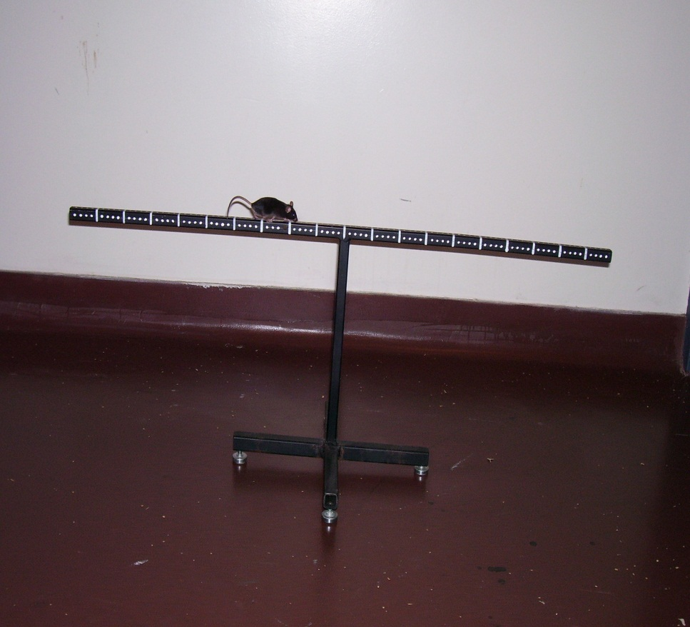

Beam walking is a test of fine motor coordination and balance.
Apparatus
The beam apparatus measured 100 cm in length and 2 cm in width and was elevated to a height of 40 cm above the supporting surface. It was constructed from wood and coated with black paint to minimise visual distractions and ensure consistency across trials. The beam surface was marked at 5 cm and 1 cm intervals to facilitate precise assessment of movement and foot placement. A video camera was positioned 175 cm above the beam to enable continuous recording of the trials. Behavioural performance was scored in real time and subsequently verified through video analysis to ensure accuracy and reliability of the observations.
Procedure
Each subject was transported to the testing room within its home cage in order to minimise handling-induced stress. The mouse was then gently removed from the cage and placed at one end of the balance beam. Once the animal had established a stable grip on the beam, the trial was initiated. Each trial had a maximum duration of two minutes. Testing was conducted under white light during the dark phase of the light–dark cycle to align with the animal’s behavioural rhythms while maintaining sufficient visibility for observation. Between successive trials, the beam apparatus was cleaned with 70% ethanol and allowed to dry thoroughly to eliminate residual olfactory cues and ensure consistency across tests.

What was measured:
Distance traveled: The number of line crosses.
Foot Slips: Number of times one of the mouse’s back feet slip from the beam
Number of turns: Frequency that the animal reversed direction
Fall: Time at which the animal fell off of the beam. If a fall occurred the animal was not placed back on the beam but was returned to the home cage. The trial was not repeated.
2.7 FEAR AND ANXIETY
Anxiety and fear were assessed using the light and dark transition box and elevated plus maze.
LIGHT/DARK TRANSITION BOX
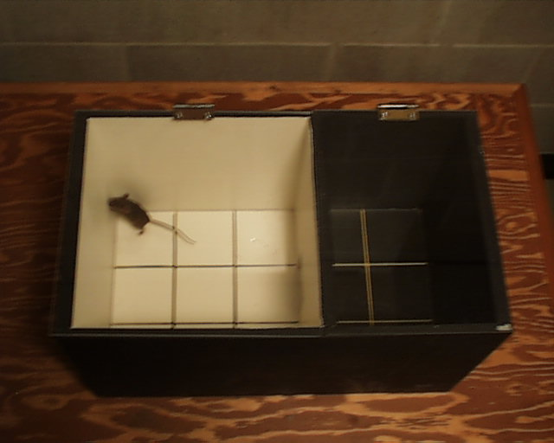
Fig 2. Light and Dark Transition Box Apparatus
Mice were transported to the testing room in their home cages to minimise handling stress. Each animal was gently grasped at the base of the tail and placed in the centre of the white compartment of the apparatus, oriented towards the doorway, and allowed to explore freely for a duration of पाँच minutes. Behavioural activity was recorded and scored throughout this period. Following each trial, the apparatus was cleaned with a 70% ethyl alcohol solution and permitted to dry thoroughly to eliminate residual olfactory cues and ensure consistency between successive tests.
Behaviors scored included the following;
- Transition: number of times the animal moved in or out of the light and dark chambers with all four paws.
- Light box duration: length of time the animal spends in the light chamber.
- Dark box duration: length of time the animal spends in the dark chamber.
- Stretch attends posture: frequency with which the animal demonstrates forward elongation of the head and shoulders followed by retraction to original position.
- Grooming: frequency and duration of time the animal spent licking or scratching itself while stationary.
- Urination: Number of puddles or streaks of urine.
- Defecation: Number of fecal boles produced

3.5 Statistical Analysis
The values were expressed as mean ± SEM. Hypothesis testing method included one way analysis of variance (ANOVA) followed by post hoc performed with Least Significant Difference (LSD) dunnett. P value of less than 0.05 was considered to indicate statistical significance and 0.001 as highly significant respectively.

RESULTS
Effect of the ethanol extract of Urtica dioica on frequency of line crossing
The bar below displays the frequency of line crossing during a beam walking test across three different treatment groups: control, low dose and high dose. The mean frequency for control value is 65±0.23, low dose has a mean value of 72±0.31 while that of high dose is 24±0 12. The control and the low dose group show great similarity and hence, no significance difference between both. However, the high dose group showed a significant reduction in the frequency of line crossing compared to control and low dose group (P≤0.001).

Fig 3. Bar Diagram showing the frequency of line crossing during a beam walking test

Effect of the ethanol extract of Urtica dioica on frequency of foot slip in beam walking
The result below shows that the control has a mean frequency of 3.8±21. that of low dose is 1.2±0.12 while that of high dose is 3.4±0.24. Again, this result showed that at lower dose, the extract significantly decreased the frequency of foot slip compared to that of the high dose.

Fig 4. Bar Diagram showing the frequency of foot slip during a beam walking test

Effect of Urtica dioica on frequency of turning in beam walking
From the result below, it can be seen that the control has a mean value of 10±0.12, that of low dose is 8±0.22 while that of high dose is 7±1.10. This result indicates that at a high dose, Urtica dioica is able to induce a reduction in the frequency of turns in the Beam walking apparatus at a P≤0.05.

Fig 5. Bar Diagram showing the frequency of turning during a beam walking test

Effect of Urtica dioica on Frequency of transition in Light/Dark Box
From the result in the below figure, the control group has a mean frequency of 17±0.22 while that of low dose is 21±0.31. That of the high dose showed a significant decrease to about 3±0.32 at P≤0.05.

Fig 6. Bar Diagram showing the frequency of transition in the Light/Dark Box during a beam walking test

Effect of Urtica dioica on Frequency of line crossing in L/D Transition Box
From the figure below, the control group has a frequency of 36±0.28. That of low dose and high dose showed similar effect with a reduces frequency of 26±0.22 and 26±0.28 respectively at P≤0.05.

Fig 7. Bar Diagram showing the frequency of line crossing in the Light/Dark Box during a beam walking test

Effect of Urtica dioica on light chamber duration in L/D Transition Box
From the figure below, the mean value for the control is 19±0.22. the low dose showed significant increase to about 159±0.10 while at high dose, there was a significant decrease to about 18±0.10 at P≤0.01.

Fig 8. Bar Diagram showing the effect of Urtica dioica on light chamber duration in the Light/Dark Box during a beam walking test

Effect of Urtica dioica on dark chamber duration in L/D transition Box
From the figure below, the control has a mean value of 200.5±0.11. That of low dose is significantly reduced to 170±0.21 at P≤0.05. that of high dose also significantly increase to 290±0.23 at P≤0.01.

Fig 9. Bar Diagram showing the effect of Urtica dioica on the dark chamber duration in the Light/Dark Box during a beam walking test

Effect of Urtica dioica on SAP in L/D transition box
From the figure below, the control group has a mean frequency of 28±023, that of low dose is 28± 1.41. There is no significant difference between both at P≥0.05. At high dose, it showed a significant increase to about 56±0.31 at P≤0.05.

Fig 10. Bar Diagram showing the effect of Urtica dioica on SAP in the Light/Dark Box during a beam walking test

DISCUSSION
Urtica dioica (stinging nettle) according to these findings, increases motor coordination in mice especially at low dose. The extract helps restore motor function, especially in models of neuronal damage, by reducing oxidative stress and enhancing neuron function, which are critical for movement control. Furthermore, Urtica dioica has also been linked to the improvement of brain monoaminergic systems, enhancing metabolism and functioning within the central nervous system (CNS). In addition to improving motor performance in rat model, the antioxidant-rich nature of the plant helps protect the brain from general oxidative damage, which is associated with better motor and cognitive health. Finally, this studies also suggest that high doses might have sedative effects.
On fear and anxiety, the findings in the Light/Dark transition box shows that the High Dose (HD) treated mice turned out to be more fearful and anxious than the control and Low Dose (LD) treated mice because the HD treated mice spent more time in the dark chamber indicating presence of fear and anxiety. The animals treated with HD of the extract also significantly spent less time in the light chamber indicating anxiety/fear, thereby showing that the extract of Urtica dioica at high dose can have inhibitory effect on the treated mice (15 - 18) whereas at low dose, the effect can be excitatory. The amygdala controls the level of Fear and anxiety (19). Stimulation of the amygdala for instance is associated with fear and feeling of terror in the animals (20).

CONCLUSION
Therefore, it is likely that the leaves of Urtica dioica contain a lot of chemical compounds, such as cardiac glycosides which has been reported to decrease contraction of the heart (21). This could be responsible for the anxiolytic properties on the cells of the amygdala however at high dose, it inhibits excitability (anxiogenic effect). This finding again is consistent with the previous work of Izunwanne et al (2).

Ethical Approval
This study includes ethical Approval from the department, allowing the animals to acclimatize for two weeks before commencement of experiments and careful handling of animals without being cruel.

Disclaimer (Artificial intelligence)

Author(s) hereby declare that NO generative AI technologies such as Large Language Models (ChatGPT, COPILOT, etc.) and text-to-image generators have been used during the writing or editing of this manuscript.

REFERENCES
- Konrad L, Hans- MüllerH, LenzC, LaubingerH, AumuellerG, Lichius JJ. Antiproliferative Effect on Human Prostate Cancer Cells by a Stinging Nettle Root (Urtica dioica) Extract. Planta Med. 2000; 66(1): 44-47.
- Izunwanne, DI, Mobisson, SK, Nwafor, CC, Ifedi, IC., Onwukaike, CI and Izunwanne, HA (2024): Excitatory Effect of Urtica dioica on Locomotor Behaviour of Mice Using the Open Field Maze Task. Journal of Complementary and Alternative Medical Research Volume 25, Issue 2, Page 34-42.
- Izunwanne, DI., Egwurugwu, JN, and Emegano, CL (2020): Effect of Tiger Nut Meal on PSA, Relative Organ Weight Sperm Cell and Histological Changes in Androgen-induced Benign Prostate Hyperplasia in Adult Male Wistar Rats. European Journal of Medicinal Plants 31(15): 1-10
- Oliver F, Amon EU, Breathnach A, Francis DM, Sarathchandra P, Kobza Black A, Greaves MW (1991). Contact urticaria due to the common stinging nettle (Urtica dioica)-histological, ultrastructural and pharmacological studies. Clin. Exp. Dermatol. 16:1-7
- Omisanjo O, Ikuerowo S, Izuagba E, Esho J, Adegboyega O. (2012): Effect of The Plant Extracts Pygeum Africanum And Urtica Dioica On Lower Urinary Tract Symptoms Due To Benign Prostatic Hyperplasia In Nigerian Men. The Internet Journal of Urology. Volume 9 Number 2.
- Collier HOJ, Chesher GB (1956). Identification of 5-hydroxytryptamine in the stinging nettle (Urtica dioica). Brit. J. Pharmacol. 11:186
- Wells CE. (Rev.) The central nervous system and behavior. American Medical Association Archives of Neurology. 2003; 1(4):464–466.
- Walsh V RN, Cummins R A. (1976): The open field test: critical review. Psychological Bulletin. 83:482-504.
- Lorke DA. (1983): New approach to practical acute toxicity testing. Archives of Toxicology. 54:275-287.
- Trullas, R., & Skolnick, P. (1993). Differences in fear motivated behaviors among inbred mouse strains. Psychopharmacology, 111: 323-331
- Brown, R. E., Corey, S. C., & Moore, A. K. (1999). Differences in measures of exploration and fear in MHC-congenic C57BL/6J and B6-H-2K mice. Behavior
- McFadyen, M.P., Brown, R.E. & Carrey, N. (2002). Subchronic methylphenidate administration has no effect on locomotion, emotional behavior, or water maze learning in prepubertal mice. Developmental Psychobiology, 41: 123-132.
- Podhorna, J. & Brown, R.E. (2002). Strain differences in activity and emotionality do not account for differences in learning and memory performance between C57BL/6 and DBA/2 mice. Genes, Brain and Behavior, 1:96-110.
- Yan QJ, Asafo-Adjei PK, Arnold HM, Brown RE, Bauchwitz RP (2004). A phenotypic and molecular characterization of the fmr1-tm1Cgr Fragile X mouse. Genes, Brain and Behavior 3:337-359.
- Evans WC (1989) Trease and Evans Pharmacognosy. (13th edn), Bailere Traiadal, London. pp. 101-104.
- Jethro K (1994) Medicinal Plant Information. Back to Eden publishing CO, Lonia Linda, CA, USA. pp. 11- 276.
- Kiehn O (2011) Development and functional organization of spinal locomotor circuits. Curr Opin Neurobiol
- Kiehn O, Dougherty K (2013) Locomotion: Circuits and physiology. Springer Science + Business Media, LLC. pp. 46-48
- Koofreh GD, Ekpenyong C, Nwangwa J, Antai AB (2012) Locomotor and exploratory behaviour in mice with treated oral artemether suspension. Research in Neuroscience 1: 17-24.
- Madhusudhanan N, Lakshmi T, Kumar SG, Venu G (2011) In vitro antioxidant and free radical scavenging activity of aqueous and ethanolic flower extract of Nymphaea alba. Int J Drug Dev Res 3: 252-258.
- Costall B, Jones BJ, Kelly ME, Naylor RJ, Tomkins DM (1989) Exploration of mice in a black and white test box: Validation as a model of anxiety Pharmacol Biochem Behav 32: 777-785.

