Comparative Study of the Phytochemistry and Anti-hemorrhoidal Activity of Hydroethanolic Extracts of Persea americana Mill. Seeds and Nephrolepis Biserrata

.
Abstract
Background: Hemorrhoids are a common condition affecting many adults and significantly reduce quality of life, while conventional treatments are often costly and less accessible. This has led to growing interest in plant-based alternatives like Nephrolepis biserrata and Persea americana seeds, which show anti-inflammatory potential but lack sufficient direct clinical evidence.
Aims: This study aims to compare the anti-hemorrhoidal efficacy of Persea americana seed extracts (SPA) and Nephrolepis biserrata (NB) in rats by evaluating inflammatory, hepatic, and morphological parameters.
Study design: A randomized experimental study in rats with induced hemorrhoids compared the anti-inflammatory, hepatoprotective, and clinical effects of Persea americana seeds and Nephrolepis biserrata extracts obtained via 30/70 water-ethanol extraction.
Place and Duration of Study: Chemical and biological analyses were conducted at LaKReCA (UNSTIM) and URMAPha (University of Abomey-Calavi), in Republic of Benin, between January and December 2025.
Methodology: the phytochemical, antioxidant, and anti-hemorrhoidal properties of Persea americana seeds. The hydroethanolic extract (Water/Ethanol : 30/70) was obtained by maceration. Qualitative and quantitative phytochemical analyses were conducted to identify secondary metabolites. Biologically, the parameters measured after 5 days of treatment in Wistar rats included total protein levels (protidemia), erythrocyte sedimentation rate, ASAT and ALAT levels, as well as variations in the recto-anal coefficient.
Results: Nephrolepis biserrata (NB) shows a higher extraction yield (16.36%) than Persea americana seeds (SPA) (14.36%), while SPA contains more total polyphenols (289.6 mg gallic acid equivalents per gram versus 75 mg). However, NB has a higher flavonoid content (38.5 mg quercetin equivalents per gram versus 35.76 mg) and stronger antioxidant activity, with a half maximal inhibitory concentration of 9.13 × 10⁻³ mg/mL compared to 1.93 × 10⁻² mg/mL for SPA. In treated rats, NB at 250 mg/kg significantly improved inflammatory and biochemical parameters, reducing erythrocyte sedimentation rate from 4.66 to 2, stabilizing serum proteins, and improving liver enzymes (alanine aminotransferase 88.7; aspartate aminotransferase 172.19). It also showed better recto-anal coefficient normalization (0.001558) than SPA. Overall, NB at 250 mg/kg was the most active fraction, although SPA at 500 mg/kg showed partial hepatoprotective effects.
Conclusion: Both extracts exhibit significant anti-inflammatory and antioxidant properties, but NB at 250 mg/kg demonstrates the best overall therapeutic efficacy.

Keywords: anti-hemorrhoidal; Persea americana seeds; Nephrolepis biserrata; phytochemical; antioxidant.

1. INTRODUCTION

Hemorrhoids are a common condition, affecting up to 50% of adults during their lifetime, and represent a significant public health issue, particularly in developing countries (Esmaeilnia Shirvani et al., 2026; Sheikh et al. 2020). Dietary, hygienic, and socio-economic factors contribute to their occurrence, causing pain, bleeding, and discomfort, and significantly affecting quality of life (Arjvand et al., 2023; Jiao et al., 2023; Miassi et al., 2022). Conventional treatments, including corticosteroid ointments, venotonics, or surgical interventions, nevertheless have notable limitations: high cost, limited availability, side effects, and restricted access in rural areas (Garg et al., 2024; Kang et al., 2025; Cengiz et al., 2019).
In this context, the search for local, available, and affordable plant-based remedies offers a sustainable alternative. Plant organs, such as seeds, rhizomes, or leaves, contain bioactive secondary metabolites such as polyphenols, flavonoids, tannins, and saponins, known for their anti-inflammatory and antioxidant effects (Shen et al., 2022; Dias et al., 2021; Tijjani et al., 2020; Vuolo et al., 2019). Previous studies have shown that Nephrolepis biserrate (Giant sword fern), traditionally used in Benin for hemorrhoid treatment, reduces inflammation and oxidative stress (Bassey et al., 2020; Shah et al., 2015; Melford, 2026; Oyawaluja et al., 2024). Likewise, Persea americana seeds, often considered agricultural waste, are also rich in phenolic compounds capable of modulating inflammation and oxidative stress (Lavanya et al., 2026; Colombo and Papetti, 2019; Bangar et al., 2022, Balogoun et al., 2025). Their utilization could therefore provide a natural therapeutic solution while reducing the environmental impact of waste.
Despite these data, few studies have directly demonstrated the anti-hemorrhoidal efficacy of Nephrolepis biserrata and Persea americana seeds, integrating clinical, biological, and histological parameters.
This study aims to evaluate the anti-hemorrhoidal efficacy of extracts from Persea americana seeds and Nephrolepis biserrata in rats, with the goal of identifying a natural therapeutic alternative and valorizing an agro-food waste as a pharmacological resource.

2. material and methods
2.1. Materials
2.1.1. Plant Materials
The plant material consisted, on one hand, of avocado seeds collected from restaurants and local bread vendors in the city of Natitingou, located in the Atacora department, Republic of Benin. On the other hand, the leaves of Nephrolepis biserrata were collected in the morning from palm trees in a plantation located in the commune of Pobè, Republic of Benin.
2.1.2. Chemical materials
The chemical materials specifically included methanol, ethanol, hydrochloric acid, gallic acid, and quercetin, supplied by Sigma-Aldrich and Acros Organics. Various types of laboratory glassware were also used throughout the experiment.
2.1.3. Animal material
The animal material consisted of thirty-five (35) Wistar albino rats with an average body weight of 130 g. These rats were randomly divided into seven (7) groups of five rats each and housed in standard cages for a two-week acclimatization period prior to experimentation. They were maintained at a constant temperature of 22 ± 2°C and subjected to a 12 h light/12 h dark cycle in the animal facility of the Research Unit in Applied Microbiology and Pharmacology of Natural Substances, University of Abomey-Calavi (Fagbohoun et al., 2026).
2.2. Methods
2.2.1. Preparation and chemical analysis of extracts (Fagbohoun et al., 2026)
2.2.1.1. Powder preparation
The seeds were removed from their outer coverings. The dehulled seeds were thoroughly washed, crushed, and dried in an oven at 40°C for 7 days (Sakirigui et al., 2020). The leaves of Nephrolepis biserrata were carefully washed and then air-dried at room temperature for 7 days. The dried vegetal material was then finely ground using an electric grinder. The resulting powder was sieved and stored in glass containers protected from moisture until further use.
2.2.1.2. Preparation of extracts
Sixty grams (60 g) of each powder were mixed with 600 mL of a water/ethanol (96%) solution in a 30 :70 ratios, with the water preheated to 100°C. This method has previously demonstrated efficiency in optimizing the extraction of bioactive compounds (Sakirigui et al., 2025).
After agitation and homogenization, the mixture was filtered using Whatman filter paper. The filtrate was concentrated using a rotary evaporator at 45–50°C under reduced pressure with the aid of a vacuum pump. Final drying was carried out in an oven at 35°C for 72 hours. The dry extract obtained was stored at 4°C in a refrigerator.
2.2.1.3. Qualitative phytochemical screening of hydroethanolic extract of N. biserrata
Qualitative phytochemical screening was performed based on colorimetric and precipitation reactions. The tests were carried out directly on the hydroethanolic extract of each powder according to the method described by Houghton and Raman (1998).
2.2.1.4. Quantitative phytochemical screening of extracts
Quantitative phytochemical analyses were performed according to the method of Harborne (1984), adapted to our laboratory conditions.
2.2.1.4.1. Determination of total polyphenols
Total polyphenol content was determined using the Folin–Ciocalteu colorimetric method. This reagent is reduced during the oxidation of phenolic compounds into a mixture of blue oxides of tungsten and molybdenum. The resulting blue colouration shows maximum absorbance around 750 nm. The absorbance, compared to a standard calibration curve obtained with gallic acid, allowed the quantification of total phenolic content expressed as mg gallic acid equivalents per gram of extract (mg GAE/g) (Fagbohoun, 2014).
2.2.1.4.2. Determination of total flavonoids
Total flavonoid content was estimated using the aluminum chloride (AlCl₃) method. Quercetin was used as the reference compound for establishing the calibration curve (Fagbohoun, 2014).
Polyphenol and flavonoid contents were calculated using the following formula : T = (C × Vr) / (Vp × Cp)
Where : T = content of compounds; C = concentration obtained from the calibration curve ; Vr = reaction volume ; Vp = volume of extract used; Cp = concentration of the extract solution
2.2.1.5. In vitro evaluation of antiradical activity
The antiradical activity of the extracts was evaluated using the DPPH• (2,2-diphenyl-1-picrylhydrazyl) radical scavenging method, following a procedure similar to that described by Fagbohoun (2014). This method is based on the reduction of the stable free radical DPPH• in the presence of a hydrogen-donating compound at a wavelength of 517 nm. The percentage of DPPH radical scavenging was calculated using the following formula :
% DPPH = 100 × (Abs blank – Abs sample) / Abs blank
Where : Abs blank = absorbance of the control (DPPH solution); Abs sample = absorbance of the test sample ;
The IC₅₀ value, defined as the concentration of extract required to neutralize 50% of DPPH radicals, was determined from the graph plotting percentage inhibition against extract concentration. Each test was performed in duplicate (Adjatin et al., 2026).
2.2.2. Evaluation of biological parameters (Fagbohoun et al., 2026)
2.2.2.1. Grouping of animals
Table 1 presents the grouping of rats, the substances administered, and the corresponding doses used. Each group consisted of five (5) rats.
Table 1. Composition of groups
Groups | Substances to be administered | Codes
Group 1: Normal control | Sans induction et traitement à l’eau distillée | GN1
Group 2: Negative Control | Induction sans traitement | GN2
Group 3: Reference control | Induction et traitement à Daflon à 10 mg/kg | RCD 10 mg/kg
Group 4 | Induction et traitement à l’extrait de Persea americana à 250 mg/kg | SPA 250 mg/kg
Group 5 | Induction et traitement à l’extrait de Persea americana à 500 mg/kg | SPA 500 mg/kg
Group 6 | Induction and treatment with Nephrolepis Biserrata at 250 mg/kg | NB 250 mg/kg
Group 7 | Induction and treatment with Nephrolepis Biserrata at 500 mg/kg | NB 500 mg/kg

SPA = hydro-ethanolique extract of Seeds of Persea americana
NB = hydro-ethanolique extract of Nephrolepis biserrata (feuilles de fougères)
2.2.2.2. Induction of hemorrhoids
Hemorrhoids were induced in rats using a 6% croton oil solution prepared by mixing distilled water, pyridine, acetone, and croton oil in a ratio of 1:4:5:10. Prior to induction, the rats were subjected to overnight fasting.
Induction was performed in all groups except the normal control by inserting sterile cotton swabs (4 mm in diameter), soaked with 100 μL of the 6% croton oil solution, into the anus (recto-anal region, approximately 20 mm from the anal opening). This procedure was carried out once daily for three consecutive days (Sulistiarini et al., 2023).
On day 4, blood samples were collected to measure erythrocyte sedimentation rate and total protein levels. Photographs of the animals were also taken.
2.2.2.3. Anti-hemorrhoidal test and measurement of biological parameters
On the fourth day, each rat in the test groups received the corresponding treatment dose (Table 1) orally for 5 days. The animals were weighed and anesthetized using ether.
A 1 cm of the rectum was surgically excised from each rat. The rectal tissues were weighed and analyzed to evaluate weight variations between control and treated groups (Dhaswadikar et al., 2022). Photographs of rats from the different groups were also taken.
2.2.2.4. Recto-anal coefficient (RAC)
The recto-anal coefficient (RAC) was calculated using the following equation:
RAC = Recto-anal tissue weight (mg) / Body weight (g)
2.2.2.5. Inflammatory index
The inflammatory index was assessed on day 9. To evaluate the severity of inflammation in the recto-anal region, a scoring system based on clinical hemorrhoidal presentation and severity index was used. Hemorrhoids were graded on a scale from I to IV : Grade I : Anal cushions bleed but do not prolapse; Grade II : Anal cushions prolapse during straining but reduce spontaneously; Grade III : Anal cushions prolapse during straining and require manual reduction; Grade IV : Prolapsed tissue remains permanently outside and is irreducible (Dhaswadikar et al., 2022).
2.2.2.6. Biochemical parameters
On day 9, blood samples were collected from all animals to measure erythrocyte sedimentation rate, total protein levels, aspartate aminotransferase (ASAT), and alanine aminotransferase (ALAT), in accordance with OECD guidelines (2025).
2.2.3. Data processing and analysis
The collected data were entered into Microsoft Excel 2013 and subjected to appropriate statistical analyses. All results were expressed as mean ± standard deviation. Analysis of variance (ANOVA), followed by Tukey’s multiple comparison test, was used to compare percentages and variation rates. The level of statistical significance was set at 5% (p < 0.05).

3. results and discussion
3.1. Yield and Physical Appearance of the Extract
Table 2 presents the two plant extracts obtained using the hydroethanolic solvent (30/70), coded as SPA (Persea americana seeds) and NB (Nephrolepis biserrata). Both extracts have a pasty appearance, reflecting a concentration of compounds soluble in water and alcohol (hydrosoluble and liposoluble).
Table 2. Physical Appearance and Codes
Extracts | Physical appearance | Extraction yield (%) | Codes
Persea americana seeds water/ethanol (30/70) | Paste | 14.36 ± 1.44 | SPA
Nephrolepis biserrata water/ethanol (30/70) | Paste | 16,36 ± 1,83 | NB

The extraction yield of NB (16.36 ± 1.83%) is higher than that of SPA (14.36 ± 1.44%), suggesting a better affinity of the constituents of Nephrolepis biserrata. The comparison highlights a quantitative difference without a change in physical appearance, implying that the chemical composition could be very similar.
These results are consistent with the literature, which shows that hydroethanolic solvents promote the extraction of polyphenols and other lipid-soluble bioactive metabolites (Azwanida et al., 2015; Komlaga et al., 2015).
3.2. Phytochemical Composition of extracts
Table 3 presents the phytochemical composition of the SPA (Persea americana) and NB (Nephrolepis biserrata) extracts. Both extracts contain reducing compounds, alkaloids, flavonoids, quinones, saponins, and terpenoids, indicating a shared bioactive potential.
The analysis shows that NB has a slightly higher flavonoid content (38.5 mg QE/g) than SPA (35.76 mg QE/g), whereas SPA exhibits a significantly higher total polyphenol concentration (289.6 mg GAE/g versus 75 mg GAE/g) (p < 0.05). Additionally, catechic tannins and anthocyanins are present only in SPA, suggesting a more chemically diverse profile.
Table 3. Phytochemical Composition of Nephrolepis biserrata (NB) and SPA (Persea americana seeds)
Compounds | Reducing compound | Alkaloids | Flavonoids (mgEQ/g) | Tanins catechic | Tanins gallic | Anthocyanins | Leuco-anthocyanins | Quinonics compound | Saponin | Terpenoids | Mucilages | Cartenoids | Free Anthracenics | O-heterosides | Polyphenols totaux (mgEAG/g)
SPA | + | + | 35,76 ± 0,01 | + | + | + | + | + | + | + | - | - | + | - | 289,6 ± 0,05
NB | + | + | 38,5 ± 0,01 | - | + | - | + | + | + | + | - | - | + | - | 75 ± 0,03

The comparison highlights a qualitative dominance of SPA, whereas NB retains certain specific compounds, such as leuco-anthocyanins. The discussion suggests that these differences may influence antioxidant properties, with polyphenols being strongly correlated with this activity, as noted by Martins (2016). Similarly, Heinrich (2020) indicates that phytochemical diversity determines biological effects. Thus, SPA appears more promising overall, but NB could exhibit targeted activities due to its content of metabolites that were not quantified in this study.
3.3. Antioxidant Activity by the DPPH Assay
Figure 1, which illustrates the antioxidant activities, shows that the NB (Nephrolepis biserrata) extract has a lower IC₅₀ (9.13 × 10⁻³ mg/mL) compared to SPA (Persea americana) (1.93 × 10⁻² mg/mL), indicating a higher radical-scavenging activity. The analysis confirms the functional superiority of NB, despite its lower total polyphenol content observed previously.

Fig. 1. Antioxidant Activity by the DPPH Assay
The comparison suggests that antioxidant activity depends not only on the quantity but also on the structure and reactivity of the compounds, particularly the flavonoids, which are more abundant in NB. These results complement the previous data: SPA is quantitatively richer, but NB appears to be qualitatively more effective. As shown by Jain et al. in 2025 polyphenols contribute significantly to antioxidant activity, while Rauf et al. in 2024 emphasize the critical role of flavonoid structure. Therefore, NB appears to be more potent.
3.4. Evaluation of Anti-Hemorrhoidal Activity
3.4.1. Distribution of Experimental Groups
The table 1 in the Materials and Methods section summarises the distribution of experimental groups and the treatments administered to the rats. Group 1 (GN1) served as the normal control, without induction or treatment, receiving only distilled water. Group 2 (GN2) served as the negative control, subjected to induction without treatment. Group 3 (RCD 10 mg/kg) received Daflon following induction. Groups 4 (SPA 250 mg/kg), 5 (SPA 500 mg/kg), 6 (NB 250 mg/kg) and 7 (NB 500 mg/kg) were treated with seeds of Persea americana and Nephrolepis biserrata extract at doses of 250 mg/kg and 500 mg/kg, respectively, after induction.
This setup allows for a comparative evaluation of treatment efficacy. The experimental design is appropriate, as it enables clear comparisons between the absence of treatment, the standard treatment, and the tested extract, thereby facilitating interpretation of potential therapeutic effects.
3.4.2. Effect of Treatments on Erythrocyte Sedimentation Rate in Rats After Hemorrhoid Induction
Figure 2 shows the evolution of the erythrocyte sedimentation rate (ESR) in rats after hemorrhoid induction, including control groups (GN1 and GN2) and treated groups. The control groups display a stable ESR (GN1: 2 to 2; GN2: 2.67 to 2), indicating that the inflammatory state remains moderate and stable without treatment, which serves as a reference for evaluating the effect of the extracts.
The treated groups reveal more marked variations: SPA 250 mg/kg and NB 250 mg/kg decrease from 4.33 to 2 and from 4.66 to 2, respectively, demonstrating a notable anti-inflammatory effect (p < 0.05). Higher doses (SPA 500 mg/kg and NB 500 mg/kg) show a different response: stability for SPA and a slight increase for NB, suggesting a non-linear dose-dependent effect.

Figure 2. Erythrocyte Sedimentation Rate in Rats After Hemorrhoid Induction

This figure indicates that, although SPA is rich in polyphenols and NB in flavonoids, other compounds present (tannins, saponins, and terpenoids) may contribute to the observed results (Zhang & Tsao, 202016). These synergistic effects are consistent with the observations of Al-Khayri et al. (2022), who highlight the complementary role of flavonoids and secondary compounds in inflammation. Thus, the anti-inflammatory efficacy depends on both the dose and the qualitative composition of the extracts, in comparison with a stable reference provided by the control groups.
3.4.3. Effect of the Extract on Total Protein Levels in Rats After Hemorrhoid Induction and Treatment
Figure 3 shows the evolution of mean serum protein levels in rats after hemorrhoid induction, including the control groups (GN1, GN2) and the groups treated with RCD, SPA, and NB. The control groups exhibit contrasting patterns: GN1 increases from 58.07 to 62.4 mg/dL (p < 0.05), indicating a slight natural rise, whereas GN2 decreases from 57.5 to 48.5 mg/dL, suggesting physiological variability or stress induced by the experimental model.

Figure 3. Total Protein Levels in Rats After Hemorrhoid Induction and Treatment
The analysis of the treated groups reveals that SPA 250 mg/kg induces the greatest increase (65.67 → 67.57 mg/dL), followed by SPA 500 mg/kg and NB 250 mg/kg, indicating that the plant extracts promote recovery or maintenance of serum protein levels (p < 0.05). NB 500 mg/kg and RCD show more moderate effects. Comparison with the control groups indicates that the extracts, particularly SPA and NB at moderate doses, improve biochemical parameters in addition to their previously observed anti-inflammatory effects.
Considering the earlier results on ESR and antioxidant activity, it appears that polyphenols may stabilize plasma proteins and reduce oxidative stress, as highlighted by Jomova et al. in 2025 Furthermore, Yahfoufi et al. in 2018 report that flavonoids, by modulating inflammation, contribute to maintaining serum protein levels, suggesting a synergistic effect between the qualitative compounds present (tannins, saponins, and terpenoids) and the overall therapeutic effect.
3.4.4. Effect of the Extracts on the Variation of the Recto-Anal Coefficient in Rats After Hemorrhoid Induction
Figure 4 presents the mean variation of the recto-anal coefficient (RAC) after treatment, including the control groups (GN1, GN2) and the tested extracts. The control groups GN1 (0.00335) and GN2 (0.00510) serve as physiological references, with GN2 showing a higher variation, possibly related to persistent inflammation without treatment.
The analysis shows that NB 250 mg/kg produces the lowest variation (0.00156), suggesting a better restoration of recto-anal integrity compared to the other groups. SPA 250 mg/kg (0.00473) and SPA 500 mg/kg (0.00361) present values comparable to GN1, while RCD 10 mg/kg is close to the GN1 control (p < 0.05). NB 500 mg/kg also approaches the control values, indicating a non-linear dose-dependent effect.

Figure 4. Variation of the Recto-Anal Coefficient in Rats After Hemorrhoid Induction
Comparison with the previous results (ESR and serum proteins) suggests that the anti-inflammatory and antioxidant efficacy is reflected in an improvement of the RAC, as reported by Damavandi et al. (2023) for polyphenol-rich extracts that reduce morphological markers of the mucosa. Furthermore, Nwozo et al. (2023) emphasize that the modulation of inflammatory mediators by flavonoids improves tissue function, which is consistent with the low variation observed for NB 250 mg/kg, possibly due to the synergistic effect of flavonoids, tannins, and saponins.
3.4.5. Inflammatory Index
The table presents the clinical assessment of haemorrhoids after treatment, including the control groups GN1 and GN2 and the extracts SPA and NB. The control groups did not receive any treatment and remained at grade II, characterized by spontaneous prolapse of the anal cushions. All treated groups (RCD 10 mg/kg, SPA 250 and 500 mg/kg, NB 250 and 500 mg/kg) reached grade I, indicating limited bleeding without prolapse, thus demonstrating a clear improvement.
Table 4. Clinical Assessment of Hemorrhoids After 5 Days of Treatment Across Experimental Groups (Fagbohoun et al., 2026)

Groups | before Treatment | after treatment | Appreciation after treatment
GN1 | 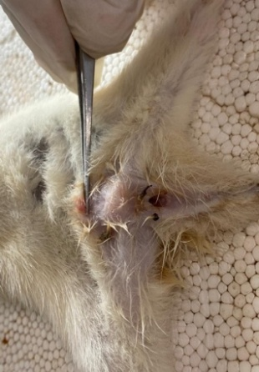 | 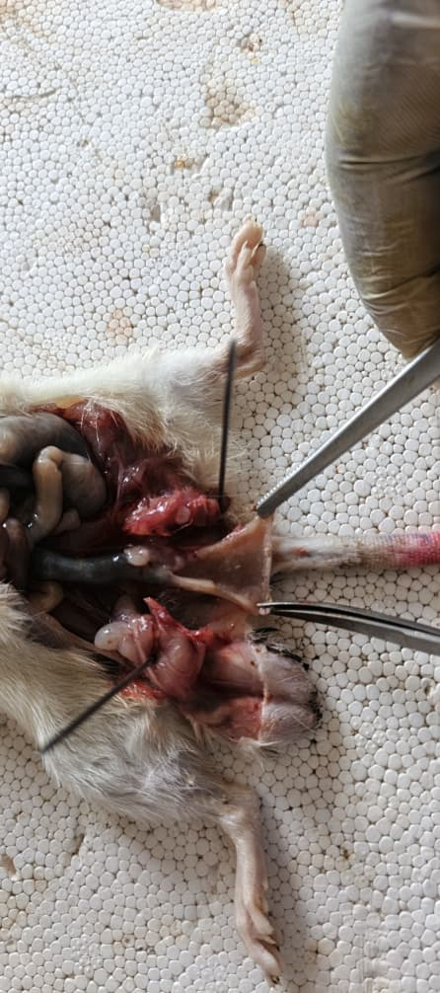
GN2 | 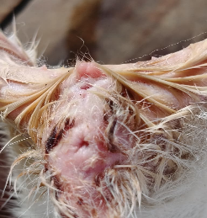 | 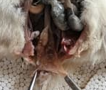  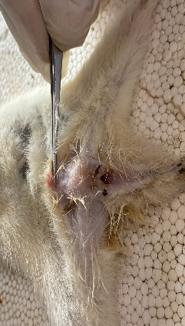 | Grade II: The anal cushions prolapse through the anus during straining but reduce spontaneously
RCD 10 mg/kg | 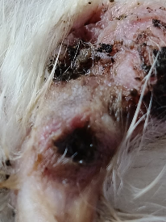 | 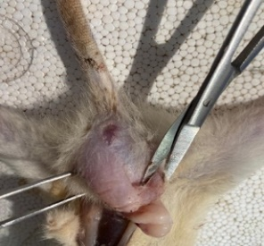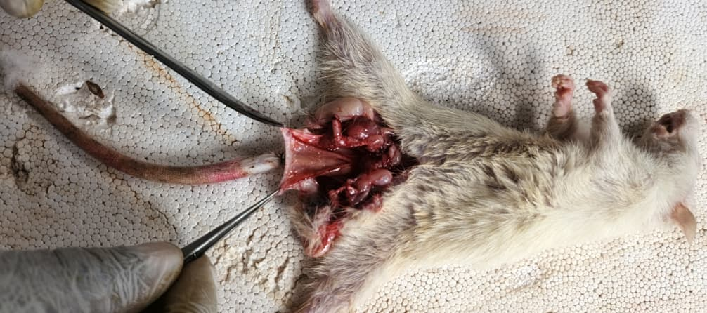 | Grade I: The anal cushions bleed but do not prolapse
SPA 250 mg/kg | 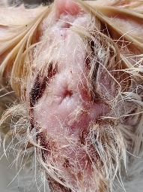 | 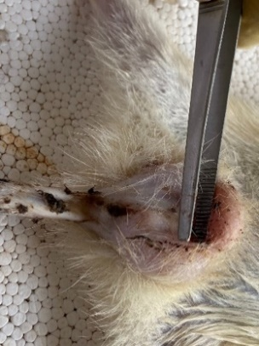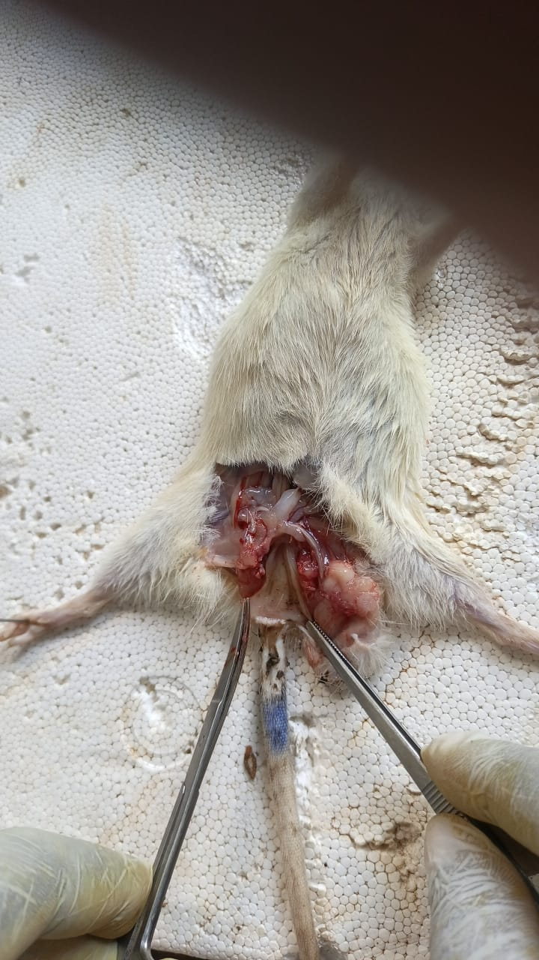 | Grade I: The anal cushions bleed but do not prolapse
SPA 500 mg/kg | 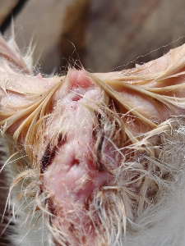 | 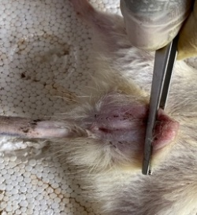  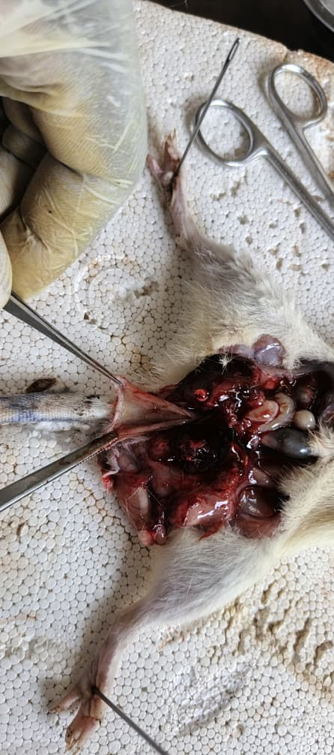 | Grade I: The anal cushions bleed but do not prolapse
Lot NB à 250 mg/kg | 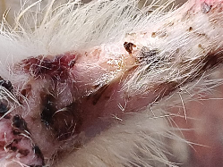 | 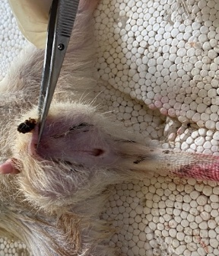  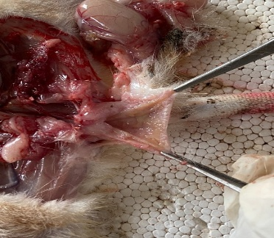 | Grade I: The anal cushions bleed but do not prolapse
Lot NB à 500 mg/kg | 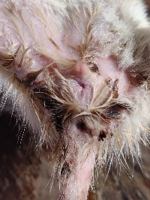 |  | Grade I: The anal cushions bleed but do not prolapse

Comparative analysis shows that SPA and NB exhibit similar efficacy, consistent with the previous results on ESR reduction and hepatic protection, suggesting that their bioactive compounds (polyphenols, flavonoids, tannins) act synergistically to reduce inflammation and stabilize the recto-anal mucosa. As reported by Ahmad et al. (2024) and Zhang et al. (2016), these compounds modulate local inflammation and enhance tissue recovery, confirming the therapeutic potential of these plant extracts in the treatment of hemorrhoids.
3.4.6. Effect of Extracts on Serum ASAT Levels in Rats After Hemorrhoid Induction and Treatment
Figure 5 shows the mean AST levels after 5 days of treatment, comparing the SPA (Persea americana) and NB (Nephrolepis biserrata) extracts as well as the control groups GN1 and GN2. The control groups display contrasting levels: GN1 (325.22 U/L) remains moderate, whereas GN2 (438.98 U/L) indicates greater hepatic stress (p < 0.05).

Figure 5. ASAT Levels in Rats After Hemorrhoid Induction and Treatment
Comparative analysis reveals that SPA 500 mg/kg produces the greatest reduction in AST (115.05 U/L), suggesting a superior hepatoprotective effect compared to NB, which shows higher values (NB 250 mg/kg: 172.19 U/L; NB 500 mg/kg: 163.25 U/L) (p < 0.05). At a moderate dose, SPA 250 mg/kg (313.52 U/L) is less effective than NB 500 mg/kg, indicating that the response depends on both dose and qualitative composition. Previous results on ESR and serum proteins suggest that SPA’s greater AST reduction may be related to its richness in polyphenols and other synergistic compounds. As shown by Li et al. in 2018 and Datta et al. in 2023 these compounds modulate oxidative stress and inflammation, explaining the observed superior hepatoprotective effect of SPA compared to NB.
3.4.7. Effect of Extracts on Serum ALAT Levels in Rats After Hemorrhoid Induction and Treatment
Figure 6 presents the mean ALT (alanine aminotransferase) levels in rats 5 days after treatment, including the control groups (GN1 and GN2) and the SPA (Persea americana) and NB (Nephrolepis biserrata) extracts. GN1 (50.22 U/L) shows a value close to normal, whereas GN2 (118.47 U/L) indicates higher hepatic stress without treatment, serving as a critical reference (p < 0.05).

Figure 6. ALAT Levels in Rats After Hemorrhoid Induction and Treatment
Comparative analysis reveals that NB (250 and 500 mg/kg) produces the lowest ALT values (88.7 and 81.25 U/L), suggesting better hepatoprotection than low-dose SPA (156.13 U/L). At a higher dose, SPA (90.73 U/L) aligns with NB, indicating a dose-dependent effect. The comparison highlights the increased efficacy of NB in moderating ALT elevation, reinforced by its content of flavonoids and phenolic compounds.
In the discussion, these results corroborate our previous observations on the reduction of inflammatory markers and the improvement of ESR and serum proteins. As shown by Gezer et al. (2024), plant flavonoids attenuate hepatic stress by lowering ALT levels through antioxidant and anti-inflammatory mechanisms. Similarly, Alanazi et al. (2025) demonstrate that polyphenols, such as resveratrol, protect the liver by reducing hepatic enzymes in animal models.
4. Conclusion
the extracts of persea americana and nephrolepis biserrata exhibit interesting anti-inflammatory and antioxidant properties, with an improvement in biochemical and hematological parameters in treated rats. however, nephrolepis biserrata at 250 mg/kg shows the best overall efficacy, particularly on inflammation and the recto-anal coefficient. these findings suggest promising therapeutic potential, although further studies are needed to identify the active compounds and confirm clinical effectiveness.
Ethical Approval
Animal ethic committee approval has been collected and preserved by the author(s)
AcknowledgEments
We thank the University of Technical Sciences, Engineering and Mathematics (UNSTIM) for financial support.
Disclaimer (Artificial intelligence)
Author(s) hereby declare that NO generative AI technologies such as Large Language Models (ChatGPT, COPILOT, etc.) and text-to-image generators have been used during the writing or editing of this manuscript.

References

Adjatin, A. R., Sakirigui, A., Kpotanme, P., Yovo, F., Fagbohoun, L., Houngbeme, A. G., Agbangla, C., & Gbenou, J. D. (2026). Phytochemical characterization, antioxidant and antihemorrhoidal activities of hydroethanolic extract of Cleome viscosa L. IOSR Journal of Applied Chemistry, 19(4), 1–10. https://doi.org/10.9790/5736-1904010110
Arjvand, F., Moeeni, M., Najafi, B., & Nosratnejad, S. (2023). Factors affecting inequality in the quality diets: A scoping review. Value in Health Regional Issues, 37, 105–112. https://doi.org/10.1016/j.vhri.2023.05.003
Azwanida, N. N. (2015). A review on the extraction methods used in medicinal plants: Principle, strength and limitation. Medicinal and Aromatic Plants, 4, 1–6. https://doi.org/10.4172/2167-0412.1000196
Balogoun, N., Sakirigui, A., Yovo, F., Klotoé, J.-R., Dougnon, V., & Dramane, G. (2025). Comparative phytochemical and anti-inflammatory assessment of Persea americana seed and Nauclea latifolia root extracts. European Journal of Biomedical and Pharmaceutical Sciences, 12(9), 460–465.
Bangar, S. P., Dunno, K., Dhull, S. B., Siroha, A. K., Changan, S., Maqsood, S., & Rusu, A. V. (2022). Avocado seed discoveries: Chemical composition, biological properties, and industrial food applications. Food Chemistry: X, 16, 100507. https://doi.org/10.1016/j.fochx.2022.100507
Bassey, M., Johnny, I., Umoh, O., & Douglas, F. (2020). Phytomedicinal potentials of species of Nephrolepis (Schott.). World Journal of Pharmaceutical Research, 9, 1400–1410. https://doi.org/10.20959/wjpr20204-17133
Cengiz, T. B., & Gorgun, E. (2019). Hemorrhoids: A range of treatments. Cleveland Clinic Journal of Medicine, 86(9), 612–620. https://doi.org/10.3949/ccjm.86a.18079
Colombo, R., & Papetti, A. (2019). Avocado (Persea americana Mill.) by-products and their impact: From bioactive compounds to biomass energy and sorbent material for removing contaminants: A review. International Journal of Food Science and Technology, 54(4), 943–951. https://doi.org/10.1111/ijfs.14143
Dhaswadikar, S. R., Parmar, K. M., Kamble, S. K., et al. (2022). Anti-hemorrhoidal potential of standardized leaf extract of Dolichandrone falcata. Phytomed Plus, 2, 100172. https://doi.org/10.1016/j.phyplu.2021.100172
Dias, M. C., Pinto, D. C. G. A., & Silva, A. M. S. (2021). Plant flavonoids: Chemical characteristics and biological activity. Molecules, 26(17), 5377. https://doi.org/10.3390/molecules26175377
Esmaeilnia Shirvani, A., Pakdaman, K., Maleki, Z., Soraneh, S., Rezaei Chegini, F., Pakdaman, K., Vali, M., Nikbakht, H. A., Shojaie, L., & Ebrahimi, P. (2026). Worldwide prevalence of haemorrhoids: A systematic review and meta-analysis. Annals of Medicine, 58(1), 2606433. https://doi.org/10.1080/07853890.2025.2606433
Fagbohoun, L. (2014). Etude chimique de colorants naturels et matériaux résineux traditionnels au Bénin dans le domaine artisanal (Doctoral dissertation, Université d’Abomey-Calavi).
Garg, S., Dixit, M., Malhotra, I., Singh, M., & Singh, V. (2024). From manifestations to innovations: A deep dive into psoriasis, its clinical diversity, conventional treatments, and emerging therapeutic paradigms. International Immunopharmacology, 143(Part 3), 113508. https://doi.org/10.1016/j.intimp.2024.113508
Harborne, J. B. (1998). Textbook of phytochemical methods: A guide to modern techniques of plant analysis (5th ed.). Chapman and Hall Ltd.
Heinrich, M., Appendino, G., Efferth, T., Fürst, R., Izzo, A. A., Kayser, O., et al. (2020). Best practice in research—Overcoming common challenges in phytopharmacological research. Journal of Ethnopharmacology, 246, 112230. https://doi.org/10.1016/j.jep.2019.112230
Houghton, D. J. P., & Raman, A. (1998). Laboratory handbook for the fractionation of natural extracts. Extracts Science.
Jain, P. K., Parashar, A. K., & Shrivastava, V. (2025). A review on exploring the health benefits and antioxidant properties of bioactive polyphenols. Discovery Food, 5, 367. https://doi.org/10.1007/s44187-025-00637-7
Jiao, L. (2024). Social determinants of health, diet, and health outcome. Nutrients, 16(21), 3642. https://doi.org/10.3390/nu16213642
Kang, S. I. (2025). Latest research trends on the management of hemorrhoids. Journal of Anus, Rectum and Colon, 9(2), 179–191. https://doi.org/10.23922/jarc.2024-090
Komlaga, G., Agyare, C., Dickson, R. A., Mensah, M. L. K., Annan, K., Loiseau, P. M., & Champy, P. (2015). Medicinal plants and finished marketed herbal products used in the treatment of malaria in the Ashanti region, Ghana. Journal of Ethnopharmacology, 172, 333–346. https://doi.org/10.1016/j.jep.2015.06.041
Lavanya, P., Priyanga, G., & Theagarajan, R. (2026). Avocado seeds (Persea americana). In A. K. Gupta (Ed.), Underutilized seeds (pp. 1–15). Springer. https://doi.org/10.1007/978-981-95-4802-6_3
Martins, N., Barros, L., & Ferreira, I. C. F. R. (2016). In vivo antioxidant activity of phenolic compounds: Facts and gaps. Trends in Food Science & Technology, 48, 1–12. https://doi.org/10.1016/j.tifs.2015.11.008
Melford, C. M. (2026). Evaluating the therapeutic effects of aqueous leaf extract of Nephrolepis biserrata on biochemical, haematological, physical, atherogenic and histopathological parameters in testosterone propionate-induced benign prostatic hyperplasia in male Wistar rats. Asian Journal of Research in Medical and Pharmaceutical Sciences. https://doi.org/10.9734/AJRIMPS/2026/V15I1364
Miassi, Y. E., Dossa, F. K., Zannou, O., et al. (2022). Socio-cultural and economic factors affecting the choice of food diet in West Africa: A two stage Heckman approach. Discovery Food, 2, 16. https://doi.org/10.1007/s44187-022-00017-5
OECD. (2025). Test No. 407: Repeated dose 28-day oral toxicity study in rodents. OECD Guidelines for the Testing of Chemicals. Paris: OECD Publishing.
Oyawaluja, B. O., Oyawaluja, A. A., Akinyimika, D. E., Odukoya, O. A., & Coker, H. A. (2024). Antioxidant profiling, phytochemical investigation and pharmacognostic evaluation of Nephrolepis biserrata (Sw.) Schott (Nephrolepidaceae). Tropical Journal of Phytochemistry and Pharmaceutical Sciences, 3(2), 208–215. https://doi.org/10.26538/tjpps/v3i2.8
Rauf, A., Ahmad, Z., Formanowicz, D., Ribaudo, G., & Alomar, T. S. (2024). Editorial: Antioxidant potential of polyphenolic and flavonoid compounds. Frontiers in Chemistry, 12, 1463755. https://doi.org/10.3389/fchem.2024.1463755
Sakirigui, A., Yayi Ladékan, E., Fagbohoun, L., Chabi Sika, K., Assogba, F., & Gbenou, J. D. (2020). Comparative phytochemical analysis and antimicrobial activity of extracts of seed and leaf of Persea americana Mill. Academic Journal of Medicinal Plants, 8(5), 58–63. https://doi.org/10.15413/ajmp.2020.0114
Sakirigui, A., Yovo, F., Chabi Sika, K., Ezin, C., Yayi Ladékan, E., & Gbénou, J. D. (2025). Influence of heat treatment on the extraction, phytochemical composition and antimicrobial activity of Syzygium aromaticum extracts alone and in combination. IOSR Journal of Applied Chemistry, 18(5), 01–07. http://dx.doi.org/10.9790/5736-1805010107
Shah, M. D., Gnanaraj, C., Haque, A. T., & Iqbal, M. (2015). Antioxidative and chemopreventive effects of Nephrolepis biserrata against carbon tetrachloride (CCl₄)-induced oxidative stress and hepatic dysfunction in rats. Pharmaceutical Biology, 53(1), 31–39. https://doi.org/10.3109/13880209.2014.909502
Sheikh, P., Régnier, C., Goron, F., & Salmat, G. (2020). The prevalence, characteristics and treatment of hemorrhoidal disease: Results of an international web-based survey. Journal of Comparative Effectiveness Research, 9(17), 1219–1232. https://doi.org/10.2217/cer-2020-0159
Shen, N., Wang, T., Gan, Q., Liu, S., Wang, L., & Jin, B. (2022). Plant flavonoids: Classification, distribution, biosynthesis, and antioxidant activity. Food Chemistry, 383, 132531. https://doi.org/10.1016/j.foodchem.2022.132531
Sulistiarini, R., Puranti, A., & Prabowo, W. C. (2023). Phytochemicals and anti-hemorrhoidal activities of Tapak Liman (Elephantopus Scaber) leaves. JABET, 6, 436. https://doi.org/10.5455/jabet.2023.d139
Tijjani, H., Zangoma, M. H., Mohammed, Z. S., Obidola, S. M., Egbuna, C., & Abdulai, S. I. (2020). Polyphenols: Classifications, biosynthesis and bioactivities. In C. Egbuna & G. Dable Tupas (Eds.), Functional foods and nutraceuticals (pp. 1–19). Springer. https://doi.org/10.1007/978-3-030-42319-3_19
Vuolo, M. M., Lima, V. S., & Maróstica Junior, M. R. (2019). Phenolic compounds: Structure, classification, and antioxidant power. In M. R. S. Campos (Ed.), Bioactive compounds (pp. 33–50). Woodhead Publishing. https://doi.org/10.1016/B978-0-12-814774-0.00002-5
Zhang, H., & Tsao, R. (2016). Dietary polyphenols, oxidative stress and antioxidant and anti-inflammatory effects. Current Opinion in Food Science, 8, 33–42. https://doi.org/10.1016/j.cofs.2016.02.002
Fagbohoun, L., Sakirigui, A., Adjatin, A. R., Agbodjento, E., Yovo, F., & Saloufou, K. I. (2026).
Anti-hemorrhoidal activity of hydroethanolic extract of Nephrolepis biserrata with phytochemical characterization, antioxidant potential and in vivo evaluation in a rat model.
World Journal of Pharmacy and Pharmaceutical Sciences, 15(4), 1307–1325. https://www.wjpps.com/Wjpps_controller/abstract_id/25022

