A Comparative Quantitative Phytochemical Analysis of Ethyl Acetate Extract of Tuber of Gloriosa Superba, Fruit of Solanum Nigrum and Leaf of Grewia Hirsuta Vahl

Abstract: Gloriosa superba, a member of the Liliaceae family and commonly known as flame lily. The plant's most popular and widespread use in traditional medicine is primarily directed against rheumatism and gout. Solanum nigrum Linn., commonly known as black nightshade, is a frequently consumed medicinal herb belonging to the Solanaceae family. Grewia hirsute vahl belonging to the extensive flowering plant family Malvaceae. G. hirsuta has revealed a significant presence of phenolics, alkaloids, and flavonoids, the bioactive compounds analysis of the ethyl acetate (ETOAC) solvent extract of plants were analysed by standard methods. The extract were analysed for the presence of secondary metabolites (alkaloids, flavonoids, phenolic compounds, carbohydrate, reducing sugar, and proteins). Overall these plants are holds significance both botanically and medicinally, serving as a valuable resource within its ecosystem and contributing to traditional healthcare systems. Across millennia, humanity has depended on an extensive range of plant components to combat and forestall ailments. The vast assortment of medicinal plants and herbs, each harboring an array of phytochemicals with robust biological properties, signifies substantial therapeutic promise. These phytochemicals manifest a wide spectrum of effects, enhancing resilience against chronic diseases. This analysis offers valuable information for further exploration of its medicinal properties and development of novel therapeutic agents.
Keywords: Gloriosa superba, Solanum nigrum, Grewia hirsuta, phytochemicals, Malvaceae, medicinal properties
1. INTRODUCTION
Gloriosa superba, a member of the Liliaceae family, is an herbaceous medicinal climber characterized by its striking tuberous growth, bloom from November to March annually. It is recognized under its trade name 'Glory lily', while in English, it goes by the name 'Malabar glory lily'. In Hindi and Sanskrit languages, it is referred to as 'Kalihari' and 'Agnisikha' respectively.
The tubers of the plant hold traditional significance including chronic ulcers, colic, bruises, sprains, hemorrhoids, leprosy, cancer, and even as a labor pain inducer. Additionally, it is utilized for addressing intestinal worms, bruises, infertility, skin problems, and impotence.
However, it's crucial to note that Gloriosa superba is categorized as one of the seven upavishas in Indian medicine. While these herbs are esteemed for their therapeutic properties, they may prove fatal if misused (Jana 2011).
Solanum nigrum Linn., commonly known as black nightshade, Originating from Southeast Asia, it has spread widely across temperate to tropical regions in Europe, Asia, and the America. Contemporary studies indicate that steroidal saponins constitute the primary pharmacologically active components of S. nigrum.
It is abundant in natural compounds that exhibit diverse structural patterns and beneficial characteristics. Researchers have identified around 188 phytochemical compounds from this plant species. These compounds encompass steroids, alkaloids, organic acids, flavonoids, phenyl propanoids and their glycosides, along with various other bioactive substances (Xiang et al., 2019).
The genus “Grewia” was named in honor of Botanist Nehemiah Grew, renowned as the father of plant anatomy. Belonging to the extensive flowering plant family Malvaceae as classified by the Angiosperm Phylogeny Group, Grewia was initially categorized within either the Tiliaceae or Sparrmanniaceae families due to its resemblance to certain traits of each genus. The application of Grewia leaves on the skin has been reported to yield beneficial effects such as enhancing connective tissue and possessing anti-toxic properties. The genus Grewia holds significant scientific exploration potential due to its remarkable medicinal value. Employed in Indian folklore for centuries, it has been utilized to address numerous ailments including stomach upsets, fevers, coughs, inflammations, respiratory infections, rheumatism, and blood disorders. Recent research has unveiled additional beneficial attributes such as radioprotective qualities, antifertility effects, anti-hyperglycemic properties, and efficacy against diseases like cancer, Alzheimer’s, and diabetes. Scientific investigations have further identified Grewia plants as valuable sources of nutrition, boasting antimicrobial and antiviral properties (Khattab et al., 2015).

2. METHODOLOGY
2.1. Collection and Preparation of plant material
In this investigation plant parts were collected from Jabalpur District and its surroundings. The plant samples were taxonomically identified from the State Forest Research Institute Jabalpur M.P. India.

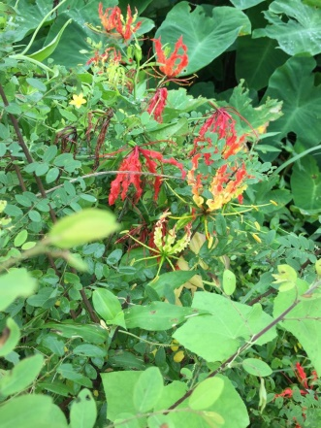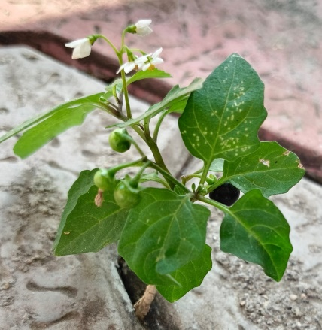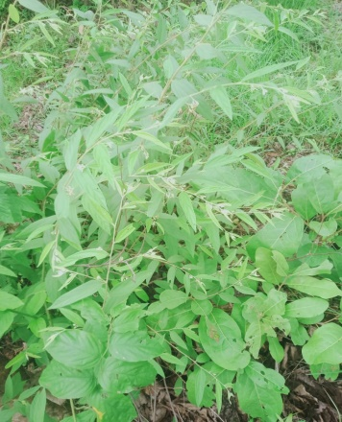
Figure: 1 a) Whole plant of Gloriosa superba b) Whole plant of Solanum nigrum c) Whole plant of Grewia hirsuta

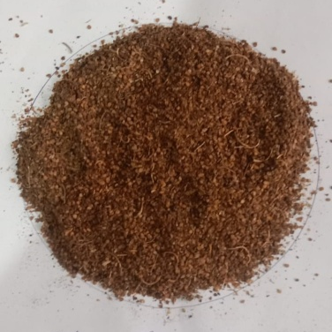
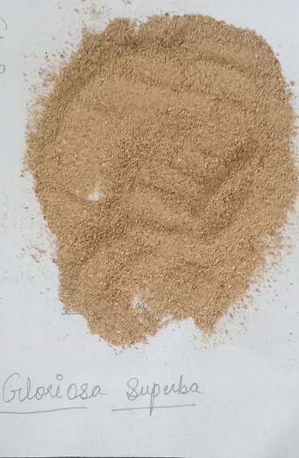
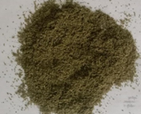

Gloriosa superba Solanum nigrum Grewia hirsuta

Figure: 2 Crushed Plant materials

2.2. Preparation of plant extract
The dried powdered leaf underwent defatting using petroleum ether (60 to 80°C) through hot extraction in a soxhelet apparatus. Subsequently, the defatted powder was further extracted with Ethyl Acetate, and the resulting concentrated ethyl acetate extracts were utilized for analysis.
The bioactive compounds analysis of the ethyl acetate (ETOAC) solvent extract of plants were analysed by standard methods as described. The extract were analysed for quantity of secondary metabolites (alkaloids, flavonoids, phenolic compounds).
2.3. Total Flavonoid content (TFC)
Flavonoids content of isolated crude were determined this method (Jia et al., 1999). Take a clean test tube and add 0.5 ml of the sample (Extract) containing 1.25 ml of distilled water. Then added 0.075 ml of 5 % sodium nitrite solution and allowed to stand for 5 min. Added 0.15 ml of 10 % aluminium chloride, after 6 min 0.5 ml of 1.0 M sodium hydroxide were added and the mixture were diluted with another 0.275 ml of distilled water. The absorbance of the mixture at 510 nm was measured immediately. Querocitene was used as a standard with varied conc. from 200 ppm to 1000 ppm. The flavonoid content was expressed as mg Querocitene equivalents/g sample and same procedure were done with Extract.
2.4. Total phenolic content (TPC)
Capacity of total phenolic contents was determined using method with slight modification. Total phenolic content of isolated crud was determined by the method described by (Singleton et al., 1965). 1.0 ml of sample was mixed with 1.0 ml of Folin and Ciocalteu's phenol reagent. After 3 min, 1.0 ml of saturated Na₂CO₃ (~35 %) was added to 2 / 3 the mixture and made up to 10 ml by adding distilled water. The reaction was kept in the dark for 90 min, observed under UV-Vis spectrophotometer at 760 nm absorbance. Gallic acid was used as a standard with varied concentration from 200 ppm to 1000 ppm. A calibration curve was constructed with different concentrations of Catechol (0.01- 0.1 mM) as standard. The results were expressed as mg of Catechol equivalents/g of extract and same procedure was done with Extract.
2.5. Total Alkaloids Content (TAC)
Alkaloid content isolated from crude were determined this method (Jia et al., 1999). Take a clean test tube and add 0.5 ml of the sample (Extract) containing 1.25 ml of distilled water. Then added 0.075 ml of 2 N Hydrochloric acid, than added 1.25 ml Bromo crysol green, added 1.25 ml 0.1M Phosphate buffer saline than added 1ml chloroform and allowed to stand for 30 min for incubation in than pool out upper phase with the help of micropipette and take it. pH maintained of 7.4. The absorbance of the mixture at 470 nm was measured. Colchicine was used as a standard with varied conc. from 200 ppm to 1000 ppm. The Alkaloid content was expressed as mg colchicine equivalents/g sample and same procedure were done with Extract.
3. RESULT AND DISCUSSION

Table 1: Qualitative Phytochemical Analysis of Ethyl acetate extract of all three Medicinal plants

S. NO. | TEST NAME | GLORIOSA  RESULTS | SOLANUM NIGRUM |  | GREWIA HIRSUTA
- Test for Carbohydrate
 | Molish test: | -ve | +ve |  | +ve
- Test for on Reducing Polysaccharide
 | Iodine Test:  Tannic acid test for starch: | +ve | -ve |  | -ve
- Test for Protein

 | Biuret test: | +ve | +ve |  | +ve
- Test for Glycoside
 | Test for deoxysugar (Keller Killiani test): | +ve | +ve |  | -ve
- Test for Flavonoids
 | Lead acetate test: | +ve | +ve |  | +ve
- Test for Alkaloids
 | Mayer’sTest:  Wagner’s test: | +ve | +ve | +ve
- Test for Phenolic compound

 | Ferric Chloride Test: | +ve | +ve | +ve
- Test for Organic compound
 | Oxalic acid:  Malic acid: | +ve | +ve | +ve
9.Test for Inorganic compound
 | Sulphate Test:  Chloride Test: | +ve | +ve | -ve
- Test for Coumarins Glycoside
 | Conc. H₂SO₄ test: | -ve | -ve | -ve

+ve: Positive result (presence confirmed)
-ve: Negative result (absence confirmed)

3.1. QUANTITATIVE ANALYSIS OF ETHYL ACETATE EXTRAT OF MEDICINAL PLANTS
The quantitative analysis of secondary metabolites is essential to estimate the concentration of these compounds in the plant and for understanding its pharmacological potential. Secondary metabolites such as, flavonoids, phenolic compounds, and alkaloids, contribute to the plant's medicinal properties.

3.1.1. Total Flavonoid Content (TFC)
The quantitative estimation of the total flavonoid content was determined based on the absorbance values recorded at different concentrations. The increasing absorbance values suggest that flavonoid content is directly proportional to concentration, a common characteristic observed in spectrophotometric analysis of phytochemicals.
The quantitative estimation of the total flavonoid content of Grewia hirsuta Vahl was determined based on the absorbance values recorded at different concentrations. At a concentration of 20 µg/mL, the absorbance was recorded as 0.119. As the concentration increased to 60 µg/mL, the absorbance values were observed to be 0.129 and 0.142 in two separate readings, confirming consistency in the measurement. A further increase in concentration to 80 µg/mL resulted in an absorbance of 0.155, while the highest concentration of 100 µg/mL showed an absorbance of 0.166. The increasing absorbance values suggest that flavonoid content is directly proportional to concentration, a common characteristic observed in spectrophotometeric analysis of phytochemicals.
Table 2: Quantitative estimation of Total flavonoid content of Ethyl-acetate leaf extract of Grewia hirsuta Vahl.

Concentration | Absorbance
20 | 0.119
40 | 0.129
60 | 0.142
80 | 0.155
100 | 0.166

Figure 3: Standard curve of Total flavonoid content of Grewia hirsuta Vahl.

Table 3: Total flavonoid Content of Grewia hirsuta
PLANT | TFC
Grewia hirsuta | 124.541

3.1.1.1. Comparative TFC of All Three Plants
The comparative quantitative estimation of total flavonoid content (TFC) in the three plants based on ethyl-acetate extraction reveals significant variation among them. Grewia hirsuta exhibited the highest TFC, measuring 124.541µg/mg, indicating its rich flavonoid composition.
Gloriosa superba followed with a moderate TFC of 96.262 µg/mg, while Solanum nigrum recorded the lowest TFC at 53.013 µg/mg. These results suggest that Grewia hirsuta is the most potent source of flavonoids among the three, followed by Gloriosa superba, with Solanum nigrum containing comparatively lower flavonoid content.
Table 4 : Comparative Quantitative estimation of Total flavonoid content of all three plants
PLANT | TFC
Gloriosa superba | 96.262
Solanum nigrum | 53.013
Grewia hirsuta | 124.541

Figure 4. Comparative Total flavonoid content of all three plants

3.2.2. Total Phenolic Content
The quantitative estimation of the total phenolic content was determined using absorbance measurements at varying concentrations. Direct relationship between concentration and phenolic content were occurring.
The quantitative estimation of total phenolic content in Solanum nigrum was conducted using ethyl acetate as the extraction solvent. The absorbance values corresponding to different concentrations of the extract were recorded to assess the phenolic content. The data obtained revealed a progressive increase in absorbance with increasing concentration, indicating a positive correlation between phenolic content and extract concentration.
At the lowest concentration of 20 µg/mL, the absorbance was recorded at 1.534. As the concentration increased to 40 µg/mL and 60 µg/mL, the absorbance values rose to 1.627 and 1.720, respectively. This trend continued at higher concentrations, with absorbance values reaching 1.830 at 80 µg/mL and 1.910 at 100 µg/mL. The steady rise in absorbance suggests that the ethyl acetate extract of Solanum nigrum contains a substantial amount of phenolic compounds, which are known for their antioxidant properties.
Table 5: Quantitative estimation of Total Phenolic content of Ethyl-acetate fruit extract of Solanum nigrum
Concentration | Absorbance
20 | 1.534
40 | 1.627
60 | 1.72
80 | 1.83
100 | 1.91

Figure 5: Standard curve of Total Phenolic content of Ethyl-acetate fruit extract of Solanum nigrum

Table 6: Total Phenolic Content of Solanum nigrum with respect of standard Gallic acid
PLANT | TPC
Solanum nigrum | 49.59 µg/mL

3.2.2.1 Comparative Total Phenolic Content of all three plants

The total phenolic content (TPC) of three plants Gloriosa superba, Solanum nigrum, and Grewia hirsuta was quantitatively estimated to evaluate their phenolic composition. Among the plants analyzed, Solanum nigrum exhibited the highest TPC, with a value of 49.59 µg gallic acid equivalent per gram of extract. In comparison, Grewia hirsuta and Gloriosa superba showed lower phenolic content, with TPC values of 34.033µg and 25.2 µg gallic acid equivalents per gram, respectively. These findings indicate that Solanum nigrum has a significantly higher concentration of phenolic compounds, which are known for their antioxidant properties, compared to the other two plants. This suggests that Solanum nigrum may possess greater potential for pharmacological activities, such as combating oxidative stress, and highlights the importance of phenolic compounds in determining the therapeutic value of these plants.
Table 7 Comparative Quantitative estimation of Total Phenolic content of all three plants
PLANTS | TPC
Gloriosa superba | 25.2
Solanum nigrum | 49.59
Grewia hirsuta | 34.033

Figure 6. Comparative Total phenolic content of all three plants
3.2.3. Total Alkaloid Content
The quantitative estimation of the total alkaloid content using ethyl acetate extraction was conducted by measuring the absorbance at different concentrations. The results indicated a progressive increase in absorbance with increasing concentration.
The quantitative estimation of the total alkaloid content of Gloriosa superba using ethyl acetate extraction was conducted by measuring the absorbance at different concentrations. The results indicated a progressive increase in absorbance with increasing concentration.
At 20 µg/mL, the absorbance was recorded as 0.658, which increased to 0.687 at 40 µg/mL. Resulted in an absorbance of the highest concentration tested, 100 µg/mL, exhibited the maximum absorbance of 0.756.
Table 8: Quantitative estimation of Total Alkaloid content of Gloriosa superba

Concentration | Absorbance
20 | 0.658
40 | 0.687
60 | 0.701
80 | 0.734
100 | 0.756

Figure 7: Standard curve of Total Alkaloid content of Gloriosa superba

Table 9: Total Alkaloid Content of Gloriosa superba with the respect of standard colchicine.

PLANT | TAC
Gloriosa superba | 539.581 µg/mL

3.2.3.1 Comparative Total Alkaloid Content of all three plants
The total Alkaloid content (TAC) of three plants Gloriosa superba, Solanum nigrum, and Grewia hirsuta was quantitatively estimated to evaluate their alkaloid composition. Among the plants analyzed, Gloriosa superba exhibited the highest TAC, with a value of 539.581 µg/mL µg colchicine equivalent per gram of extract. In comparison, Grewia hirsuta and Solanum nigrum showed lower alkaloid content, with TAC values of 425.55µg/mL and 536.139µg/mL colchicine equivalent per gram, respectively. These findings indicate that Gloriosa superba has a significantly higher concentration of alkaloid compounds, which are known for their antimicrobial, anti-HIV, and antiparasitic properties, compared to the other two plants. This suggests that Gloriosa superba may possess greater potential for pharmacological activities, and highlights the importance of alkaloid compounds in determining the therapeutic value of these plants.
Table 10: Comparative Quantitative estimation of Total Alkaloid content of all three plants
PLANTS | TAC
Gloriosa superba | 539.581 µg/mL
Solanum nigrum | 536.139µg/mL
Grewia hirsuta | 425.55µg/mL

Figure 8. Comparative Total alkaloid content of all three plants
4. CONCLUSION
The qualitative phytochemical analysis of Gloriosa superba using ethyl acetate-based extraction revealed the presence of various bioactive compounds. Alkaloids were confirmed by Wagner’s test, which gave a positive result.
The total Alkaloid content (TAC) of Gloriosa superba was successfully quantified using a standard colchicine curve. The results indicated a concentration-dependent increase in absorbance. This suggests that Gloriosa superba contains a notable amount of Alkaloid compounds, which are well-known for their antioxidant properties. These findings highlight the potential of Gloriosa superba as a valuable source of Alkaloid compounds. Further studies recommended exploring their specific bioactivity and therapeutic applications.
The phytochemical analysis of Solanum nigrum using ethyl acetate solvent revealed the presence of several bioactive compounds, Phenolic compounds were present, as evidenced by the positive result in the ferric chloride test.
The total phenolic content (TPC) of Solanum nigrum was successfully quantified using a gallic acid standard curve. The results indicated a concentration-dependent increase in absorbance. This suggests that Solanum nigrum contains a notable amount of phenolic compounds, which are well-known for their antioxidant properties. These findings highlight the potential of Solanum nigrum as a valuable source of phenolic compounds.
A qualitative phytochemical analysis of Grewia hirsuta Vahl using ethyl acetate as the solvent was conducted to determine the presence of various bioactive compounds. One of the secondary metabolites is Flavonoids, known for their antioxidant and anti-inflammatory properties were confirmed by a positive result in the lead acetate test.
The quantitative estimation of the total flavonoid content in Grewia hirsuta demonstrated a direct, linear relationship between concentration and absorbance, indicating the presence of a significant amount of flavonoids in the extract. The absorbance values suggest that Grewia hirsuta is a rich source of flavonoids, which are known for their antioxidant and potential pharmacological properties. These findings highlight the potential therapeutic value of Grewia hirsuta in managing oxidative stress and related diseases.
Future efforts will combine phytochemistry with pharmacology, toxicology, and materials science to fully exploit these plants. For example, Gloriosa superba’s alkaloids might inspire new chemotherapeutic agents.
Disclaimer (Artificial intelligence)
Author(s) hereby declare that NO generative AI technologies such as Large Language Models (ChatGPT, COPILOT, etc.) and text-to-image generators have been used during the writing or editing of this manuscript.

References
Jana, S., & Shekhawat, G. S. (2011). Gloriosa superba: A plant with therapeutic potential and toxicity. Pharmacognosy Reviews, 5(9), 87-94.
Jia, Z., Tang, M., & Wu, J. (1999). The Determination of flavonoid Contents in Mulberry and Their Scavenging Effects on Superoxide Radicals. Food Chemistry, 64(4), 555-559.
Khattab, H. A., El-Shitany, N. A., Abdallah, I. Z., Yousef, F. M., & Alkreathy, H. M. (2015). Antihyperglycemic potential of Grewia asiatica fruit extract against streptozotocin-induced hyperglycemia in rats: Anti-inflammatory and antioxidant mechanisms. Oxidative Medicine and Cellular Longevity, 2015, 549743.
Singleton, V. L., Orthofer, R., & Lamuela-Raventós, R. M. (1999). Analysis of Total Phenols and Other Oxidation Substrates and Antioxidants by Means of Folin–Ciocalteu Reagent. Methods in Enzymology, 299, 152-178.
Xiang, L., Wang, Y., Yi, X., & He, X. (2019). Steroidal alkaloid glycosides and phenolics from the immature fruits of Solanum nigrum. Fitoterapia, 137, 104268

