Original Research Article
Optimization of activated carbon production from coffee husks using a Box-Behnken design

.
ABSTRACT

The constraints of ecological transition require the development of environmentally friendly technologies for industrial wastewater treatment. In this context, this study focuses on the production of activated carbon from coffee husks, an abundant local agricultural waste. The objective is to reduce both environmental impact and production costs while ensuring high adsorption performance for pollution control. The process was optimized using a four-factor Box–Behnken experimental design implemented with Design-Expert software (version 13.0.5.0). The investigated variables included the concentration of the activating agent (orthophosphoric acid), impregnation time, calcination temperature, and calcination time. The iodine number was selected as the response variable. Based on 27 experimental runs, optimal conditions were identified at 15% activating agent, 10 hours of impregnation, and calcination at 400 °C for 120 minutes, yielding an iodine number of 346.367 mg.g⁻¹. The predicted values were in good agreement with the experimental results. Statistical analysis confirmed the adequacy and reliability of the model (R² = 0.9778, predicted R² = 0.8719, Adequacy = 22.96), indicating a strong predictive capability. SEM–EDS analysis and methylene blue adsorption measurements revealed a high mesoporous surface area of 762.74 m².g⁻¹. These findings demonstrate the feasibility of producing eco-efficient activated carbon from coffee husks.

Keywords: optimization; box-behnken design; activated carbon; coffee husks.

1. INTRODUCTION
Activated carbon (AC) is a highly porous carbonaceous material with a large specific surface area, giving it a high capacity to adsorb molecules present in liquid and gaseous phases (Abuiboto et al., 2016). Activated carbon is used in many sectors because of its versatility and effectiveness in trapping contaminants (Mohammad, 2023). Thanks to its porous structure, AC retains many organic and inorganic substances such as dyes (Aboua et al., 2018), pesticides and heavy metals (Légbré et al., 2023) present in domestic and industrial wastewater through surface adsorption. It is also used to purify air and gases (Nwabanne et al., 2012). This adsorbent is used in other applications. These include the removal of unwanted colours, tastes and odours, or the purification of water (Boughaita et al., 2018), and the purification of various food, chemical and pharmaceutical products (Nasly et al., 2016; Mohammad, 2023).
Activated carbon is obtained from organic substances or natural raw materials rich in carbon, which undergo a carbonisation process followed by activation (physical or chemical) designed to develop a complex network containing micropores, mesopores and macropores (Bologoun et al., 2015; Manoiloval & Ruskova, 2019). These materials are of plant, mineral or animal origin. Various plant-based raw materials are therefore being studied. These include: bark, sawdust and wood residues, coconut shells, coffee shells, cocoa shells, banana skins (kokora et al., 2020), olive pits, palm nut shells (Konan et al., 2021), nem bark (Ouedraogo et al., 2021), and mineral raw materials (lignite, coal, etc.). The choice of these raw materials influences the porous structure and specific surface area, and therefore the adsorption efficiency of the charcoal obtained (Malini et al., 2023).
Several factors explain the extensive use of these raw materials in the production of ca, including the reduction in production costs due to their high availability (Bernard and Jimoh, 2013) and the quality of the resulting activated carbon.In addition, their environmental benefits are generating increasing interest within the scientific community.
For this work, coffee husks, a material that is widely available, accessible and inexpensive in Côte d'Ivoire (Ivory Coast), were used to produce AC. However, this waste is far from being ordinary waste; it has many valuable uses depending on the context. It can be used as an energy source (biofuel) thanks to its high carbon content and interesting calorific value (approximately 18–20 mj.kg⁻¹) (Lubwama & Yiga, 2017), as a soil improver and organic compost due to its high organic matter, potassium, nitrogen and phosphorus content (Natalani et al., 2020).
The chemical method was chosen for this study. Commonly used activating agents such as ZnCl₂, KOH, NaOH, K₂CO₃, KCl, and H₃PO₄ were selected for their significant contribution to the development of mesopores (Balogoun et al., 2015) for future adsorption studies. Travis et al. (2013) demonstrated that activating coffee grounds with KOH produces highly microporous carbons capable of adsorbing significant quantities of CO₂. Similarly, Lebgre et al. (2023) and Campbell et al. (2024) used KOH to transform coffee grounds into an effective porous adsorbent for cadmium and hexavalent chromium, respectively. Furthermore, Ilmawati et al. (2025) highlight that pretreatment with ZnCl₂ catalyses the thermal degradation of cellulose and lignin, thereby promoting the formation of mesopores and micropores in coffee grounds. Furthermore, Ilmawati et al. (2025) note that NaOH is among the conventional bases used in the production of activated carbons.The main objective of this work is to use coffee husks to prepare high-quality, viable activated carbon using H₃PO₄ as an activator.
2. MATERIALS AND METHODS
2.1. Methodology for producing activated carbons
Thus, activated carbon was prepared using a Box-Behnken experimental design in order to optimise the preparation conditions. This design made it possible to study four factors comprising 27 trials, to which three centre points were added. The associated statistical tests made it possible to evaluate the quality of the model (descriptive and predictive), its validation (analysis of variance) and the significance of the coefficients (student's t-test) (Yirdawa et al., 2023; Laisné et al., 2024). In addition, the reduced number of experimental trials required to evaluate several parameters and their interactions is a major advantage of the method.

2.1.1. Pre-treatment of coffee husks
The coffee husks were thoroughly washed with distilled water to remove impurities, then dried at 110°C for 24 hours in an oven. This drying process is necessary to remove not only free water, but also a large proportion of the water adsorbed within the lignocellulosic matrix. They were then ground and sieved to obtain the particle size suitable for the study (1 mm˂Ø˂2 mm).

2.1.2. Preparation of activated carbon
The activated carbon from coffee husks was prepared using chemical activation with orthophosphoric acid. The pre-treated coffee husks were impregnated in a solution of orthophosphoric acid (1 N) for 10 hours, then dried at 110 °C for 24 hours. Table 1 shows the characteristics of the Box Behnken design applied during the preparation of the activated carbon.

Table 1. Characteristics of the problem
Coded factor | Factor | Unit | Center point | Step change
A | Activating agent | % | 10.0000 | 5.0000
B | Impregnation time | Hour | 10.0000 | 4.0000
C | Calcination temperature | °C | 400.0000 | 50.0000
D | Carbonisation time | min | 90.0000 | 30.0000

2.1.2.1 Construction of the experience matrix and the experimentation matrix
The Box-Behnken design consists of all combinations in which two factors are modified by their high and low levels while the other two are kept at the central point. Thus, the formula for calculating the number of experiments (N) in this type of design is: N=2k(k−1) +C0, where “k” represents the number of factors and C0 the number of central points (Esther et al., 2019). In the present study, 27 trials were conducted with 4 operational factors and the addition of 3 central points. The table presents the experimental matrix for this study (Table 2).
Table 2. Experiment matrix
N°Exp | A | B | C | D
1 | -1.0000 | -1.0000 | 0.0000 | 0.0000
2 | 1.0000 | -1.0000 | 0.0000 | 0.0000
3 | -1.0000 | 1.0000 | 0.0000 | 0.0000
4 | 1.0000 | 1.0000 | 0.0000 | 0.0000
5 | -1.0000 | 0.0000 | -1.0000 | 0.0000
6 | 1.0000 | 0.0000 | -1.0000 | 0.0000
7 | -1.0000 | 0.0000 | 1.0000 | 0.0000
8 | 1.0000 | 0.0000 | 1.0000 | 0.0000
9 | -1.0000 | 0.0000 | 0.0000 | -1.0000
10 | 1.0000 | 0.0000 | 0.0000 | -1.0000
11 | -1.0000 | 0.0000 | 0.0000 | 1.0000
12 | 1.0000 | 0.0000 | 0.0000 | 1.0000
13 | 0.0000 | -1.0000 | -1.0000 | 0.0000
14 | 0.0000 | 1.0000 | -1.0000 | 0.0000
15 | 0.0000 | -1.0000 | 1.0000 | 0.0000
16 | 0.0000 | 1.0000 | 1.0000 | 0.0000
17 | 0.0000 | -1.0000 | 0.0000 | -1.0000
18 | 0.0000 | 1.0000 | 0.0000 | -1.0000
19 | 0.0000 | -1.0000 | 0.0000 | 1.0000
20 | 0.0000 | 1.0000 | 0.0000 | 1.0000
21 | 0.0000 | 0.0000 | -1.0000 | -1.0000
22 | 0.0000 | 0.0000 | 1.0000 | -1.0000
23 | 0.0000 | 0.0000 | -1.0000 | 1.0000
24 | 0.0000 | 0.0000 | 1.0000 | 1.0000
25 | 0.0000 | 0.0000 | 0.0000 | 0.0000
26 | 0.0000 | 0.0000 | 0.0000 | 0.0000
27 | 0.0000 | 0.0000 | 0.0000 | 0.0000

Furthermore, the experimental matrix is obtained by replacing the coded factors with their actual values (Table 3).
Table 3. Experimental design
N°Exp | [Activating agent] | Impregnation time | Calcination temperature | Carbonisation time
 | % | Heure | °C | min
1 | 5.0000 | 6.0000 | 400.0000 | 90.0000
2 | 15.0000 | 6.0000 | 400.0000 | 90.0000
3 | 5.0000 | 14.0000 | 400.0000 | 90.0000
4 | 15.0000 | 14.0000 | 400.0000 | 90.0000
5 | 5.0000 | 10.0000 | 350.0000 | 90.0000
6 | 15.0000 | 10.0000 | 350.0000 | 90.0000
7 | 5.0000 | 10.0000 | 450.0000 | 90.0000
8 | 15.0000 | 10.0000 | 450.0000 | 90.0000
9 | 5.0000 | 10.0000 | 400.0000 | 60.0000
10 | 15.0000 | 10.0000 | 400.0000 | 60.0000
11 | 5.0000 | 10.0000 | 400.0000 | 120.0000
12 | 15.0000 | 10.0000 | 400.0000 | 120.0000
13 | 10.0000 | 6.0000 | 350.0000 | 90.0000
14 | 10.0000 | 14.0000 | 350.0000 | 90.0000
15 | 10.0000 | 6.0000 | 450.0000 | 90.0000
16 | 10.0000 | 14.0000 | 450.0000 | 90.0000
17 | 10.0000 | 6.0000 | 400.0000 | 60.0000
18 | 10.0000 | 14.0000 | 400.0000 | 60.0000
19 | 10.0000 | 6.0000 | 400.0000 | 120.0000
20 | 10.0000 | 14.0000 | 400.0000 | 120.0000
21 | 10.0000 | 10.0000 | 350.0000 | 60.0000
22 | 10.0000 | 10.0000 | 450.0000 | 60.0000
23 | 10.0000 | 10.0000 | 350.0000 | 120.0000
24 | 10.0000 | 10.0000 | 450.0000 | 120.0000
25 | 10.0000 | 10.0000 | 400.0000 | 90.0000
26 | 10.0000 | 10.0000 | 400.0000 | 90.0000
27 | 10.0000 | 10.0000 | 400.0000 | 90.0000

2.1.2.1 Development of the mathematical model
The response designated by Y was linked to factors coded A to D via a mathematical model (1).

$Y = b0 + b1× A + b2 × B + b3 × C + b4 × D + b11 × A²+ b22 × B²+ b33 × C²+ b44 × D² + b12 × (A×B) + b13 × (A×C) + b23 × (B×C) + b14 × (A×D) + b24 × (B×D) + b34 × (C×D)$ (1)
Where Y is the response (iodine number). A, B, C and D are coded factors related to acid concentration, impregnation time, carbonisation temperature and carbonisation time, respectively. b₀ is a constant, b₁ represents the weight of the acid concentration, b₂ represents the weight of the impregnation time, b₃ represents the weight of the carbonisation time and b₄ represents the weight of the carbonisation temperature. b₁₂ is the interaction effect between acid concentration and impregnation time, b₁₃ is the interaction effect between acid concentration and carbonisation time, and b₁₄ is the interaction effect between acid concentration and carbonisation temperature. b₂₃ is the interaction effect between impregnation duration and carbonisation time, b₂₄ is the interaction effect between impregnation duration and carbonisation temperature, and b₃₄ is the interaction effect between carbonisation time and carbonisation temperature. The coefficients of the quadratic terms that reflect the non-linear effects of the factors (squared variables) on the iodine index are b₁₁ for the square of the acid concentration, b₂₂ for the square of the impregnation time, b₃₃ for the square of the carbonisation temperature, and b₄₄ for the square of the carbonisation time.
Design Expert software version 13.0.5.0 was used to generate the experimental design, estimate the coefficients, and analyse the results.

2.2. Characterisation of the selected activated carbon
2.2.1. Surface morphology and elemental composition
The surface morphology of the AC was characterised using a scanning electron microscope (SEM). Prior to analysis, the coal sample was prepared. It was carefully spread on the pad of a carousel sample holder, then metallised by depositing a thin layer of gold. This step is essential to improve the conductivity of the sample and ensure optimal observation with the SEM. After metallisation, the sample was placed in the microscope's analysis chamber for observation.
In addition, the elemental analysis of the AC was carried out using the method described above. When examining the surface morphology, the interaction of the electron beam with the coal sample causes the emission of characteristic secondary X-rays, allowing the identification of the chemical elements present on the surface of the sample.
2.2.2. Specific surface area by the methylene blue method
The mesoporous surface area of activated carbon (AC) was determined by methylene blue (MB) adsorption. To do this, 0.8 g of AC was placed in contact with 100 mL of a 2 mg.L⁻¹ MB solution in a 250 mL erlenmeyer flask under agitation. Periodic samples were centrifuged and then analysed using a UV-visible spectrophotometer to determine the equilibrium time and concentration (C_{r}) of the residual solution (Balogoun et al., 2015). The maximum adsorption capacity (Q_{m}) was then calculated using the following equation 2:

$Q_{m}=\frac{{(C}_{e}-C_{r})×V}{m}$ (2)
With :
Q_{m,} maximum adsorption capacity of charcoal for MB (mg.g⁻¹) ; C_{e,} the initial concentration of the MB solution (mg.L⁻¹) ; C_{r}, the equilibrium concentration of the MB solution (mg.L⁻¹); m, the mass of carbon (g); V, the volume of the MB solution (mL).
In addition, the Langmuir specific surface area S_{MB} (determined using MB) is calculated using equation 3 :

$S_{BM}=Q_{m}N_{A}×S$ (3)
With :
S_{MB}, specific surface area determined using MB as adsorbate (m².g⁻¹); S, area occupied by a MB molecule (175 Å²); NA, Avogadro's number.

2.2.4. Iodine number
The microporosity of activated carbons was evaluated using the iodine number method according to (Abuiboto et al., 2016). Thus, 0.2 g of activated carbon was placed in contact with 20 mL of an iodine solution (0.02 mol.L⁻¹) under agitation for 10 minutes. After filtration, 10 mL of the filtrate was titrated with sodium thiosulphate (0.1 mol.L⁻¹) using starch as an indicator. The iodine index was then calculated using an appropriate formula (equation 4).

$I_{2}=\frac{{│C}_{0}-\frac{C_{thio}×V_{thio}}{2V_{I2}}│×M_{I2}V_{ads} }{m_{AC}}$ (4)
With
Co: Initial concentration of iodine solution (mol.L⁻¹), C_{thio}: Concentration of sodium thiosulphate solution (mol.L⁻¹), V_{thio:} Volume of thiosulphate added at equivalence (ml), V_{I2}: Volume of iodine titrated (ml), M_{I2}: Molar mass of iodine (g.mol⁻¹), V_{ads}: Adsorption volume (ml), m_{AC}: Mass of activated carbon (g).
3. RESULTS AND DISCUSSION
3.1. Optimisation of activated carbon synthesis
Table 4 below presents the complete matrix of the experimental design, including the actual levels of the factors for each trial, as well as the corresponding iodine index value obtained.
Table 4 shows that the iodine index varies significantly depending on the preparation conditions, with values ranging from 228.367 to 346.367 mg.g⁻¹. Optimal performance is achieved with an activating agent concentration of 15%, an impregnation time of 10 hours, a moderate calcination temperature (400 °C) and a prolonged calcination time (120 minutes), with a value of 346.367 mg.g⁻¹. These results confirm the value of the experimental design in determining the optimal conditions for preparing activated carbon.
In comparison, the work of (Kokora et al. 2020) on coffee husks reported an iodine index of 506.73 mg.g⁻¹ at 450 °C for 1 hour with 60% orthophosphoric acid using the conventional method. Optimisation using the Box–Behnken Design (BBD) thus shows a reduction of approximately 75% in the amount of H₃PO₄ used, confirming its economic and ecological potential. Similarly, Kra et al. (2015) obtained a microporosity of 243 mg.g⁻¹ at 60% H₃PO₄, corroborating the value of these statistical methods for producing high-quality activated carbon while limiting the use of chemicals that cause environmental pollution.
In other words, multi-parameter optimisation using design of experiments simultaneously reduces reagent consumption, improves microporosity and reduces the environmental impact of processes. More recently, Buenaño et al. (2024) demonstrated that statistical optimisation can increase adsorption efficiency while minimising emissions and chemical waste. Thus, the use of BBD appears to be a reliable strategy for improving the quality of activated carbon, reducing operational costs and limiting pollution linked to chemical activation agents.
Table 4. Experimental design matrix and actual response
 | Factor 1 | Factor 2 | Factor 3 | Factor 4 | Iodine number
N° | [Activating agent] | Impregnation time | Calcination temperature | Carbonisation time | Real values
 | % | h | °C | min | mg.g⁻¹
1 | 10 | 6 | 400 | 60 | 311.033
2 | 10 | 6 | 350 | 90 | 287.55
3 | 5 | 10 | 400 | 120 | 259.05
4 | 15 | 14 | 400 | 90 | 316.947
5 | 10 | 10 | 400 | 90 | 292.1
6 | 5 | 14 | 400 | 90 | 228.367
7 | 10 | 10 | 450 | 60 | 330.033
8 | 10 | 10 | 400 | 90 | 292.1
9 | 10 | 6 | 450 | 90 | 278.5
10 | 15 | 10 | 350 | 90 | 295.6
11 | 10 | 10 | 350 | 60 | 315.04
12 | 10 | 10 | 450 | 120 | 328.333
13 | 15 | 10 | 400 | 60 | 300.2
14 | 10 | 10 | 350 | 120 | 322.5
15 | 5 | 10 | 350 | 90 | 248.667
16 | 15 | 10 | 400 | 120 | 346.367
17 | 10 | 14 | 400 | 120 | 340.033
18 | 10 | 14 | 350 | 90 | 289.917
19 | 10 | 14 | 400 | 60 | 283.65
20 | 15 | 10 | 450 | 90 | 296.817
21 | 5 | 10 | 450 | 90 | 263.883
22 | 15 | 6 | 400 | 90 | 233.083
23 | 5 | 6 | 400 | 90 | 247.333
24 | 10 | 14 | 450 | 90 | 328.85
25 | 5 | 10 | 400 | 60 | 298.117
26 | 10 | 10 | 400 | 90 | 293.1
27 | 10 | 6 | 400 | 120 | 267.9
3.1.1. Determination of significant factors
The estimates and statistics for the various coefficients are presented in Table 5.
The significance of the various coefficients in the model was assessed by comparing the different p-values, bearing in mind that a coefficient is considered significant if its p-value is less than 0.05. Consequently, it appears that the significant factors are: A, B, C, AB, AD, BC, BD, A², B², C² and D² are significant terms. Thus, the equation 5 established is as follows:

$Y = 292.43 + 20.30 × A + 13.53 × B + 5.60 × C - 21.82× A² - 11.98× B² + 9.59 × C² + 24.16 × D² + 25.71 × (A×B) + 21.31 × (A×D)+ 12.00× (B×C)+ 24.88× (B×D)$ (5)

Table 5. Coefficients based on coded factors
Factor | Coefficient estimate | Standard error | P-value
Intercept | 292.43 | 4.02 | < 0.0001
A-Activator Agent | 20.30 | 2.01 | < 0.0001
B-Impregnation time | 13.53 | 2.01 | < 0.0001
C-Calcination temperature | 5.60 | 2.01 | 0.0165
D-Calcination time | 2.18 | 2.01 | 0.2999
AB | 25.71 | 3.48 | < 0.0001
CA | -3.50 | 3.48 | 0.3342
AD | 21.31 | 3.48 | < 0.0001
CB | 12.00 | 3.48 | 0.0048
BD | 24.88 | 3.48 | < 0.0001
CD | -2.29 | 3.48 | 0.5227
A² | -21.82 | 3.01 | < 0.0001
B² | -11.98 | 3.01 | 0.0018
C² | 9.59 | 3.01 | 0.0079
D² | 24.16 | 3.01 | < 0.0001
3.1.2. Overall performance and reliability of model predictions
In order to assess the statistical relevance of our optimisation model and the quality of the fit to the experimental data, a statistical analysis was conducted. Table 6 presents the key values from this study, providing an overview of the model's performance.
The predicted R² of 0.8719 reasonably corresponds to the adjusted R² of 0.9518; that is, the difference is less than 0.2. Adequacy accuracy measures the signal-to-noise ratio. A ratio greater than 4 is desirable. Your ratio of 22.959 indicates an adequate signal. This model can be used to navigate the design space. The same observations were made by Emeji and Patel (2024) using the Box-Behnken design in their study on biodiesel production.

Table 6. Statistical study values
Standard deviation | 6,96 | R² | 0.9778
Average experimental response | 292,41 | Adjusted R² | 0.9518
CV % | 2,38 | Predicted R² | 0.8719
CV % | 2,38 | Adequacy Accuracy | 22.9595
3.1.3. The conformity between measured results and model predictions
Figure 1 presents a comparative study of the actual response measured during the experiments and the response predicted by our model, thus providing a visualisation of the model's fit to the data.
Actual
Predicted

Figure 1. Comparative study of actual response and predicted response
As shown in Figure 1, the experimental and predicted values align closely along the correlation line, indicating a very good agreement between the observed data and those estimated by the model.
3.1.4. Impact of interaction between factors on response
-Figure 2a) shows that the iodine number varies according to the concentration of H₃PO₄ and the duration of impregnation. It decreases when the activating agent remains low (5%) while the impregnation time increases, whereas an increase in the activating agent with a short impregnation time (6 hours) leads to a slight increase before falling below 12.44%. On the other hand, the simultaneous increase in both factors leads to a more marked increase in the iodine number, with a maximum value of 316.947 mg.g⁻¹ obtained at 15% activating agent and 14 hours of impregnation. This optimal zone reflects better interaction between the phosphoric acid and the carbonaceous substrate, promoting pore opening, in line with the observations of Mamane et al. (2016). Conversely, low iodine number values are attributed to concentrations of activating agent or impregnation times that are too low to effectively develop porosity, a result also reported by Tchakala et al. (2012) and Lékéné et al. (2018).
-Figure 2b) shows that the iodine value increases when one of the factors (H₃PO₄ concentration or temperature) is kept at a low level while the other increases. Thus, for 5% to 15% activating agent at 350 °C, the iodine number increases from 248.667 to 295.6 mg.g⁻¹. When the concentration remains at 5% and the temperature varies from 350 to 400 °C, the increase is smaller (248.667 to 263.667 mg.g⁻¹). However, the simultaneous increase in both factors produces the most pronounced effect, with values ranging from 248.667 to 302.823 mg.g⁻¹. A maximum response of 308.568 mg.g⁻¹ is obtained at 11.653% activating agent and 445.112 °C, before overactivation causes a decrease, in agreement with Gratuito et al. (2008). Overall, these results show that adequate levels of H₃PO₄ concentration and temperature promote the development of micropores, as reported by Gratuito et al. (2008) and Balogoun et al. (2015).
According to Figure 2c), the effect of the activating agent on the iodine number is modulated by the calcination time, and vice versa. It can be observed that at a low concentration of activating agent (5%), the iodine number tends to decrease with increasing calcination time, falling from a value greater than 280 mg.g⁻¹ to approximately 259.05 mg.g⁻¹ at 120 minutes. Conversely, at 60 minutes of calcination, the iodine number increases from more than 280 mg.g⁻ ¹ (at 5% activating agent) to approximately 300 mg.g⁻¹ for a concentration of 14% activating agent. When both factors (activating agent concentration and calcination time) increase simultaneously, an increase in the iodine number ranging from 300 mg.g⁻¹ to a maximum of approximately 340.033 mg.g⁻¹ is observed. The areas of strong response can be explained by the fact that the combined increase in the concentration of the activating agent and the calcination time promotes the creation of micropores (Ngueabouo et al., 2022). These results are consistent with those of Balogoun et al. (2015), who observed an increase in the iodine number when the H₃PO₄ ratio was below a certain limit, before reaching a plateau. Areas of low response suggest that the concentrations of activating agent and calcination times are insufficient and therefore limit the development of the specific surface area (Lékéné et al. 2018).
-Figure 2e) shows that the iodine number varies greatly depending on the duration of impregnation and calcination. After 6 hours of impregnation and 60 minutes of calcination, it reaches 311.033 mg.g⁻¹, then drops to 267.9 mg.g⁻¹ when calcination is increased to 120 minutes, probably due to partial destruction of the micropores (Gratuito et al. 2008). By keeping calcination low and increasing impregnation to 9.94 hours, the iodine number rises to 314.449 mg.g⁻¹ before falling back to 283.65 mg.g⁻¹ at 14 h, confirming that beyond a certain threshold, increasing the time reduces porosity (Tchakala et al., 2012). The combination of high levels (14 hours; 120 minutes) gives the maximum value, 346.367 mg.g⁻¹, reflecting optimal development of microporosity, in agreement with the observations of Reffas et al. (2010).
-Figure 2f) shows that the iodine number increases overall with temperature and calcination time, rising from approximately 292 to 330 mg.g⁻¹, with maximum values at the highest levels of these parameters. The best values are recorded at the highest levels of temperature and calcination time. This increase in the iodine number can greatly improve the adsorption capacity of activated carbon in aqueous media, as confirmed by Kouahou et al. (2023), who observed a similar improvement by increasing these parameters on coconut shell-derived carbons. This trend can be explained by the improved structure of the micropores, which are essential for adsorption, optimised by prolonged calcination at moderate temperatures. However, excessive temperatures can partially destroy them (Kouadio et al., 2019). It should also be noted that at low temperatures or short durations, the iodine number remains high, which represents an energy advantage.

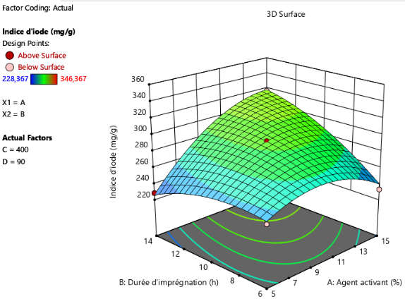
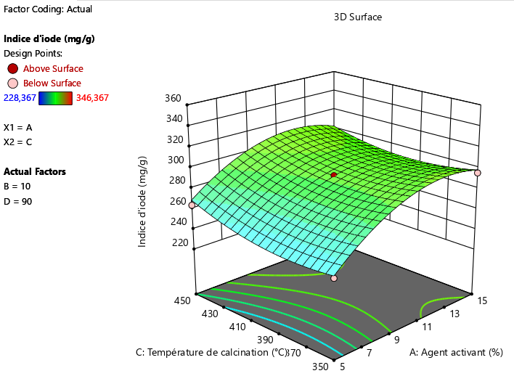
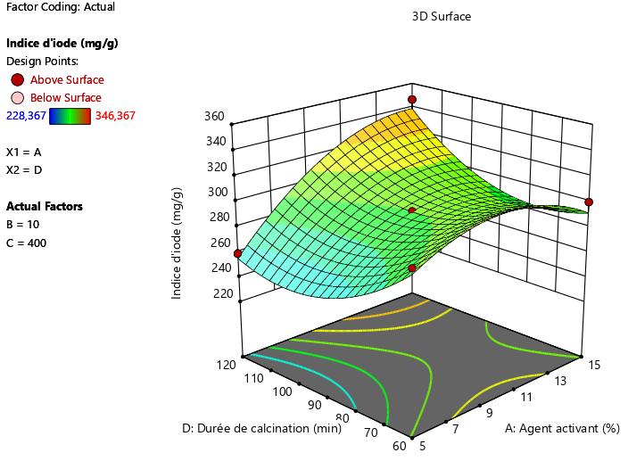
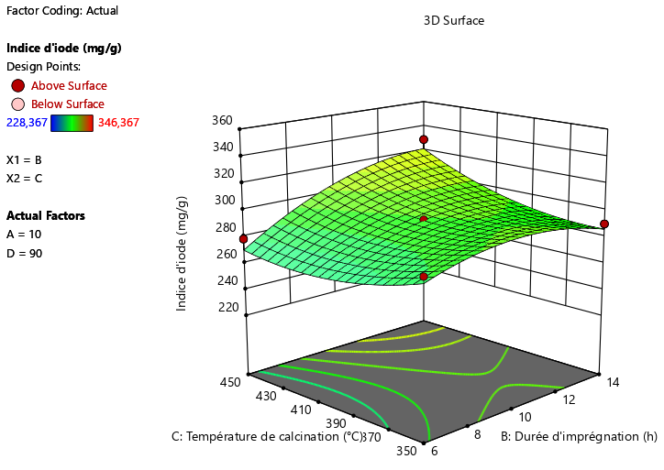
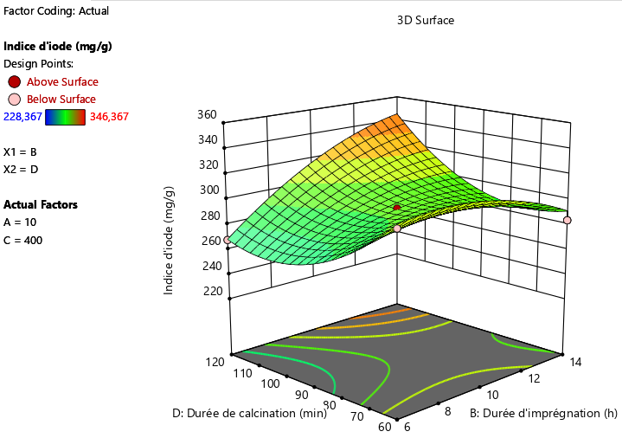
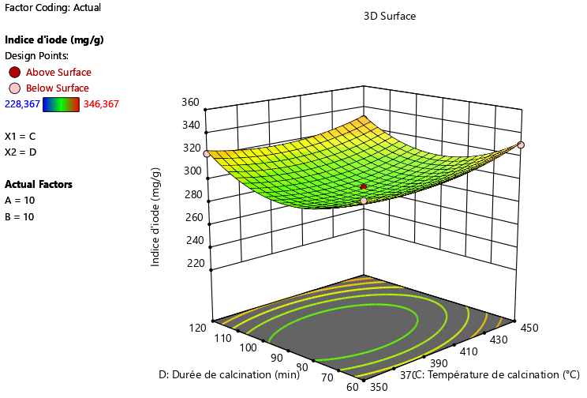
a)
b)
c)
d)
e)
f)
Iodine number (mg.g⁻¹)
B : Impregnation time (h)
A : Activating agent (%)
Iodine number (mg.g⁻¹)
C : Calcination temperature (°C)
A : Activating agent (%)
Iodine number (mg.g⁻¹)
Iodine number (mg.g⁻¹)
D : Calcination time (min)
C : Calcination temperature (°C)
B : Impregnation time (h)
Iodine number (mg.g⁻¹)
Iodine number (mg.g⁻¹)
D : Calcination time (min)
D : Calcination time (min)
C : Calcination temperature (°C)
B : Impregnation time (h)
A : Activating agent (%)

Figure 2. Study of pairwise factor interactions while holding the others constant.
3.2. Characteristics of activated carbon
3.2.1. Morphology of activated carbon
The morphology of activated carbon was studied using an SEM/EDS system. Figure 3 shows the images obtained using a HIROX SH 4000 M device and a Bruker EDS system with an XFlash 6/30 detector. This figure shows a regular surface of activated carbon regardless of scale. In other words, a homogeneous distribution of particles of varying sizes is observed, interspersed with cavities that are more or less pronounced depending on the scale.
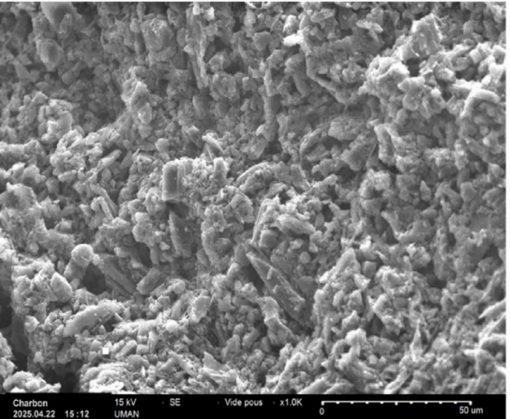
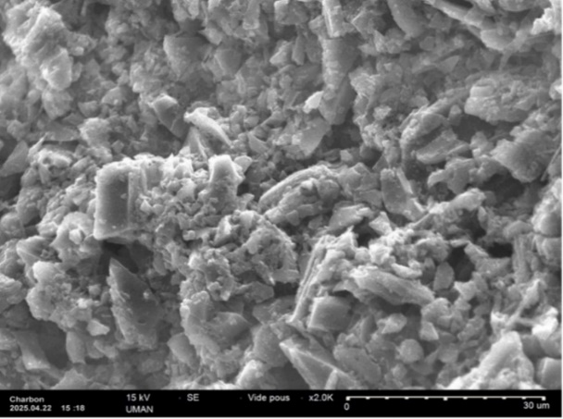
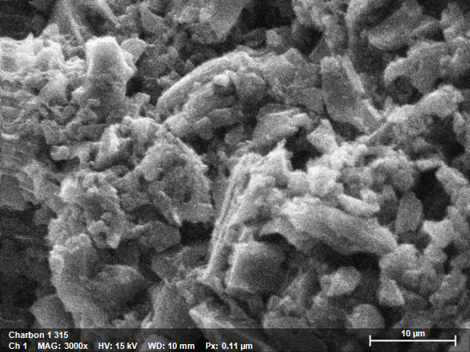
A : 50 µm
B : 30 µm
C : 10 µm
Carbon
2025.04.22
Carbon
2025.04.22
Carbon 1 315

Figure 3. Surface morphology of activated carbon using SEM
3.2.2. Specific surface area by the methylene blue method
The specific surface area of activated carbon, estimated at 762.74 m².g⁻¹ using the methylene blue method, demonstrates a high adsorption capacity for large organic compounds, in line with the observations of Kifuani et al. (2012). This high mesoporousness results from activation with orthophosphoric acid (H₃PO₄), an effect already demonstrated by other authors, including Arami-Niya et al. (2010) and Reffas et al. (2010). This value exceeds that obtained by Vandeponseele (2016) on coffee husk charcoal prepared using the traditional method, with a specific surface area of 705 m².g⁻¹ at 60% H₃PO₄. Although both approaches allow for significant development of mesoporousness, the application of a design of experiments proves to be more effective and better suited to a sustainable development approach.

3.2.3. Basic composition
Figure 4 and Table 7 show the basic components of activated carbon. The spectra reveal the heterogeneous distribution of chemical elements on the surface of the AC, with a clear predominance of carbon, followed at some distance by oxygen and other compounds of varying significance. Table 4 summarises the content as 71.79% carbon and 21.74% oxygen, which is characteristic of activated carbon. Smaller quantities of aluminium (Al), phosphorus (P) and iron (Fe) were also identified, potentially resulting from impurities or contamination during the process, with phosphorus probably linked to the use of H₃PO₄ (García et al., 2023).
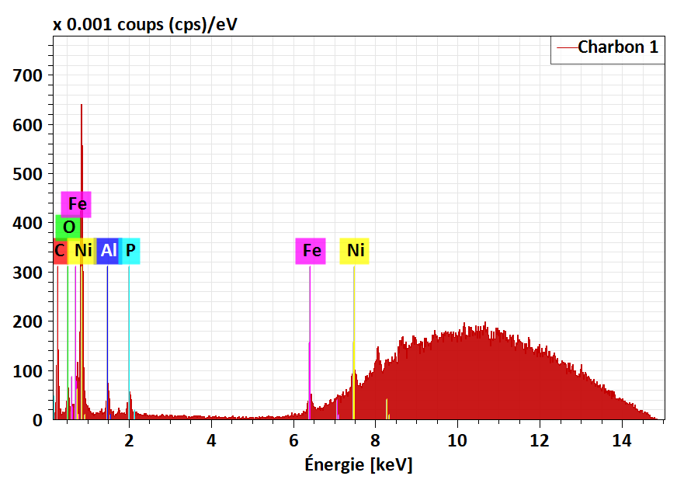
Carbon
Energy (keV
X-ray intensity (×10⁻³ cps/eV)

Figure 4. EDS spectrum of activated carbon

Table 7. Chemical element content of the activated carbon
Element | C | O | Al | P | Fe | Ni
Content (%) | 71.79 | 21.74 | 3.19 | 2.45 | 0.82 | 0.00

Furthermore, although the study provides promising results, several limitations should be acknowledged. The adsorption performance of the activated carbon was evaluated solely using the iodine number and methylene blue index, which primarily reflect micro- and mesoporosity. While these indicators provide valuable insight into the pore structure, they do not fully represent adsorption behaviour under real wastewater conditions. In addition, no experiments were conducted using actual industrial wastewater, which typically contains complex matrices with competing ions and organic compounds that may significantly influence adsorption efficiency.
Future work should therefore include the evaluation of adsorption performance using real wastewater, as well as a detailed investigation of adsorption kinetics and isotherm models. Furthermore, the regeneration and reusability of the activated carbon should be assessed to determine its long-term applicability and economic viability.

4. Conclusion
The percussors used in this study are coffee husks for the preparation of activated carbon with H₃PO₄. The optimisation of parameters (concentration of the activating agent, impregnation time, temperature and calcination time) was conducted according to a Box-Behnken design, with the iodine number as the response. This optimisation made it possible to achieve, under optimal conditions, i.e. 15% activating agent, 10 hours of impregnation, 400°C calcination temperature for 2 hours, an iodine number of 346.367 mg.g⁻¹. The measured iodine values align remarkably well with the values estimated by the model. This research has demonstrated the potential of coffee husks as a precursor for the production of activated carbon and the relevance of using the design of experiments to improve production conditions in line with sustainable development.

DISCLAIMER (ARTIFICIAL INTELLIGENCE)

Author(s) hereby declare that NO generative AI technologies such as Large Language Models (ChatGPT, COPILOT, etc.) and text-to-image generators have been used during the writing or editing of this manuscript.

REFERENCES
Abuiboto, M. C. N., Avom, J. & Mpon, R. (2016). Evaluation of the properties of activated carbon from Moabi (Baillonella toxisperma Pierre) residues by iodine adsorption in aqueous solution. Revue des sciences de l’eau, 29(1), 51–59.
Aboua, K. N., Soro, D. B., Diarra, M., Dibi K., N’Guettia, K. R. & Traoré, K. S. (2018). Study of the adsorption of methyl orange dye on activated carbon in an aqueous medium: influence of the concentration of the chemical activation agent. Revue des sciences de l’eau, 32(4) 1-12.
Campbell, R., Xiao, B., & Mangwandi, C. (2024). Production of activated carbon from spent coffee grounds (SCG) for removal of hexavalent chromium from synthetic wastewater solutions, Journal of Environmental Management, 366, 121682.
Nwabanne, J.T & Igbokwe, P.K. (2012). Application of response surface methodology for preparation of activated carbon from palmyra palm nut. Journal of New York Science, 5(9) (2012) 18-25.
Yirdawa, G., Dessieb, A., Birhan, T. A. (2023). Optimization of process variables to prepare activated carbon from Noug (Guizotia abyssinica cass.) stalk using response surface methodology. Heliyon, 9, 1-14.
Laisné, E., Thivet, J., Manavalan, G., Petnikota, S., Mikkola, J.-P., Thyrel, M., Hu, T., Lima, E. C., Naushad, M., Lassi, U. & dos Reis, G. S. (2024). Box-Behnken design for the synthesis optimization of mesoporous sulfur-doped carbon-based materials from birch waste: Promising candidates for environmental and energy storage application. Colloids and Surfaces A: Physicochemical and Engineering Aspects, 692, 133899
Nasly, Y. D. Capparelli, A.L., Marino, D.J., Navarro, A.F., Peñuela, G.A. & Ronco, A.E. (2016). Adsorption of pharmaceuticals and personal care products on granular activated carbon. Journal of surface engineered materials and advanced technology, 6, 183-200.
Balogoun, C. K., Bawa, M. L., Osseni, S., & Aina, M. (2015). Preparation of activated carbon by chemical means using phosphoric acid derived from coconut shells. International journal of biological and chemical sciences, 9(1), 563-580.
Travis, W., Gadipelli, S., & Guo, Z. (2013). Superior CO₂ adsorption from waste coffee ground derived carbons. RSC Advances, 5(37), 1-6.
Légbré, O. N., Soro, D.B., Yaya, C., Kossonou, N. R., Mamadou, K., Méite, L., Aboua, K. N. & Traore, K. S. (2023). Influence of the functionalization of activated carbon from coffee husks on the adsorption kinetics of cadmium. International journal of advanced research, 11(4) 123-138.
Campbell, R., Xiao, B., & Mangwandi, C. (2024). Production of activated carbon from spent coffee grounds (SCG) for removal of hexavalent chromium from synthetic wastewater solutions. Journal of environmental management, 366, 121682.
Ilmawati, W. O. S., Nurmayasari, Purnawati, D., Sholihun, & Nugraheni, A. D. (2025). Activated carbon from waste coffee grounds for effective methylene blue removal in textile wastewater treatment. Trends in Sciences, 22(12), 1-18.
Manoilova, L. & Ruskova, К. (2019). Activated carbon obtaining from various raw material / via chemical activation for the purpose of environmental purification – overvew. International Scientific Journal mechanization in agriculture & conserving of the resources, 204-206.
Kokora, A. F., Kouadio, L. D., Soro, D. B., N’Guettia, K. R., Dembele, A. & Traore, K. S. (2018). Élimination d’un colorant de textile sur des adsorbants issus de déchets agricoles. Revue ivoirienne de science et technologie, 31, 39-54.
Konan, K. G., Meite L., Soro, D. B., Aboua, K. N., Dibi, K., Kossonou, N. R., Traoré, S. K. & Mamadou K. (2021). Application of an experimental design methodology to optimize the synthesis conditions for activated carbon from palm kernel shells. International Journal of current microbiology and applied sciences, 10(06), 539–547.
Ouedraogo, C. E., Aboua, K. N., Soro, B. D., Diarra, M., Méité, L., Taoré, K.S. & Koné, M. (2021). Production and characterozation of activated carbon from neem bark (Azadirachta indica). International journal of environnemental science technology, 18, 3371-3378.
Malini, K., Selvakumar, D. & Kumar, N.S. (2023). Activated carbon from biomass: Preparation, factors improving basicity and surface properties for enhanced CO₂ capture capacity. Journal of CO₂ utilization, 67, 1-10.
Mohammad, T. (2023). A Review on activated carbon: synthesis, properties, and applications. European journal of advances in engineering and technology, 10(1), 114-123.
Bernard, E. & Jimoh, A. (2013) Adsorption of Pb, Fe, Cu, and Zn from industrial electroplating wastewater by orange peel activated carbon, International journal of engineering and applied science, 4, 97-104.
Kokora, M. B., Kouamé, N. A. & Kouassi, K. A. (2020). synthèse, caractérisation et application à l’adsorption. Revue des sciences et technologies, 12(3), 45-58.
Lubwama, M. & Yiga, V. A. (2017). Characteristics of briquettes developed from rice and coffee husks for domestic cooking applications in Uganda. Renewable energy, 1-51.
Ntalani, H., Ndinga, A.M., Mpolo, I.G.N.B. & Ouamba, J.M. (2020). Trials of biodegradable solid household waste recovery through composting in urban areas in Congo. Afrique science, 16, 59-69.
Vandeponseele, A. (2016), Valorisation chimique du marc de café : utilisation des fluides pressurisés pour l’extraction de molécules d’intérêt. Thèse de doctorat de l’université Savoie Mont Blanc, France, p.185
Esther, B., Jimah, A., Yahya, M.D. & Manase, A. (2019). Activated carbon prepared from shea butter shells using the Box-Behnken response surface methodology. Research journal of chemical sciences, 9(1) 1-10.
Kra, N. A., Kouadio, D. O., Atheba, G.P. Coulibaly, A. B., N’guadi, B., Gbassi, K. G. & Trokourey, A. (2015). Modelling the adsorbent properties of activated carbons derived from two varieties of Acacia (auriculiformis and mangium). International journal of innovation and scientific research, 13, 542-553.
Buenaño, L., Ali, E., Jafer, A., Zaki, S.H., Hammady, F.J., Alsaadi, S.B.K., Morad, M.K., Ramadan, M.F., Omran, A.A., Alawadi A., Alsalamy, A. & Kazemi, A. (2024). Optimization by Box–Behnken design for environmental contaminants removal using magnetic nanocomposite. Scientific reports, 14, 1-12.
Emeji, I. C. & Patel, B., (2024). Box-Behnken assisted RSM and ANN modelling for biodiesel production over titanium supported zinc-oxide catalyst. Energy, 308, (2024) 1-17
Mamane, O. S., Adamou, Z. & Ibrahim, D. (2016). Preparation and characterization of activated carbon based on Balanites Eagyptiaca and Zizyphus Mauritiana shells. Journal de la société ouest-africaine de chimie, 41, 59-67.
Tchakala, I., Bawa, L. M., Djaneye, B. G., Doni, K. S. & Nambo, P. (2012). Optimization of the process for preparing activated carbon chemically (H₃PO₄) from shea nut shells and cotton seed hulls. International journal of biological and chemical sciences, 6(1), 461-478.
Lékéné, M., Diouf, P. N. & Ndiaye, P. (2018). Influence of contact time on hemicellulose depolymerization and porosity formation in activated carbon production. Journal of materials and environmental science, 9(3), 1025-1034.
Gratuito, M. K. B., Panyathanmaporn, T., Chumnanklang, R. A., Sirinuntawittaya, N. B. & Dutta A. (2008). Production of activated carbon from coconut shell. Scientific research publishing, 32(10), 934-942.
Ngueabouo, A.M.S., Tagne, R. F. T., Tchuifon, D. R. T., Fotsop, C. G., Tamo, A. K. & Anagho, S. G. (2022). Strategy for optimizing the synthesis and characterization of activated carbons obtained by chemical activation of coffee husk. Materials advances, 3, 8361–8374.
Bhatnagar, A., Hogland, W., Marques, M. & Sillanpää, M. (2013). An overview of the modification methods of activated carbon for its water treatment applications. Chemical engineering journal, 219, 499-511.
Girgis, B. S.,-Nasser, A. A. & El-Hendawy. (2002). Porosity development in activated carbons obtained from date pits under chemical activation with phosphoric acid. Microporous and mesoporous materials, 52(2), 105-117.
Kouahou, N. G., Fotsop, C. G., Adoum, A. L., Donlifack, A. C., Kamdem, T. A., Teikam, K. G., Tiegam Tagne, R. F. & Kamgaing, T. (2023). Optimized preparation of activated carbon with high porosities based on puck shells (Afrostyrax lepidophyllus) by response surface methodology and physico-chemical characterization. Royal society open science, 10, 1-15.
Kouadio, L. D., Koffi C. L., Diarra A. M., Kouyaté, A. Yapo, Y. H. A. Akesse V. P. D., Kouamé, B. D., Kone, M., Traore, K. S. (2019). Préparation et caractérisation de charbon actif issu de la coque de cacao. International journal of innovation and applied studies, 26, 1280-1292.
Kifuani, K. M. A., Noki, P. V., Ndelo, J. D. P., Mukana, D. W. M, Ekoko, G. B., Ilinga, B. L. & Mukinayi, J. M. (2012). Adsorption de la quinine bichlorhydrate sur un charbon actif peu coûteux à base de la bagasse de canne à sucre imprégnée de lʼacide phosphorique. International journal of biological and chemical sciences, 6(3), 1398-1413.
Arami-Niya, A., Daud, W.W. & Mjalli, F. (2010). Production of palm shell-based activated carbon with more homogeneous pore size distribution. Journal of applied sciences, 10, 3361-3366.
Reffas, A., Bernardet, V., David, B., Reinert, L., Bencheikh, L. M., Dubois, M., Batisse, N. & Duclaux, L. (2010). Carbons prepared from coffee grounds by H₃PO₄ activation: characterization and adsorption of methylene blue and Nylosan Red N2RBL. Journal of hazardous materials, 175, 779-788.
García, I., Manduca, Artiles, M. & Jáuregui-Haza, U. J. (2023). Water contamination by trace metals and the use of activated carbon for their removal. Science. Environment, and climate, 6(1), 9-44.

