Regeneration of spent Transformer Oil using Coconut Shell derived Activated Carbon

Abstract
The reliability of power transformers depends on the insulating oil, which performs the critical dual role of dielectric medium and coolant. Degradation from thermal and oxidative stress produces harmful contaminants like acids and moisture which severely reduce the dielectric strength of the oil, thus necessitating sustainable regeneration to rejuvenate its functionality. The need for sustainable alternatives as adsorbent abounds because conventional adsorbents such as activated alumina are non-renewable and expensive. This study investigated the regeneration of spent transformer oil using activated carbon derived from coconut shells as a low-cost and eco-friendly adsorbent. The coconut shells were carbonized at 800 °C and chemically activated with 1 M sodium bicarbonate to enhance porosity and surface area. The degraded transformer oil was treated under controlled conditions, and its physicochemical properties including moisture content, viscosity, acid number, color, and dielectric breakdown voltage were analyzed before and after regeneration. The regeneration performance was assessed at varied temperatures of 60,80 and 100 ⁰C at constant time of 30 min. Also, regeneration performance was assessed at contact time of 45 and 60 min at a constant temperature of 80 ⁰C. The results revealed a significant improvement in oil quality: Acid number reduced from 4.21 mg KOH/g to 2.11 mg KOH/g (49.8 % performance recovery), viscosity decreased from 9.19 cP to 8.67 cP (5.66 % recovery) and dielectric breakdown voltage increased from 7.8 kV to 25.2 kV (223 % recovery). These findings confirm that coconut shell–based activated carbon effectively restores the properties of spent transformer oil, providing a sustainable, economical, and environme.

Keywords: regeneration, adsorbent, degradation, physicochemical, spent transformer oil, dielectric strength, coconut shell, activated carbon

1.0 Introduction
The performance of power transformers is critical for electricity distribution networks because transformers depend heavily on insulating oils to provide both electrical insulation and cooling functions. Over a long period of operation, degradation occurs in transformer oils due to thermal stress, oxidation, and moisture absorption leading to the formation of sludge, acids, and other contaminants that compromise dielectric strength. The regeneration process helps improve critical properties of the oil. Although there are conventional approaches to addressing spent transformer oil which could involve either complete replacement or industrial regeneration processes, both method present significant economic and environmental challenges. In developing nations like Nigeria, where power infrastructure maintenance budgets are constrained, the cost of transformer oil replacement poses a substantial burden. Recent data indicates that Nigerian electricity distribution companies spend an average of ₦4.5 million annually per transformer on oil replacement. (Liu et al., 2015; Saffidine et al, 2017; Basu et al, 2020, NERC, 2020).

There are physical and chemical methods that are conventionally used to regenerate transformer oils. The physical methods include mechanical filtration, thermal settling and decantation, vacuum dehydration and degassing under vacuum. Using these methods, suspended particles are removed, heavier particles settle to enable decantation, moisture content is reduced and dielectric strength of the oil is improved (Selvi et al, 2024).
The chemical methods include oxidation and precipitation, hydrogen peroxide assisted oxidation and acid-alkali neutralization. Through these methods, soluble oxidized species are decomposed and removed, harmful residues are reduced and dielectric properties are improved, and acid degradation products are removed (Macuzic and Jeremic, 2002; Hassanpour, 2021; Yusupov and Avazov, 2025). Unfortunately, due to the expensive cost of transformer oil replacement and the improper disposal of spent transformer oil, environmental hazards occur, because these oils may contain polychlorinated biphenyls (PCBs) and other toxic compounds (Pelitli et al., 2015).
.
Also, conventional mineral based adsorbent such as activated alumina, bentonite and fuller’s earth being used for oil regeneration are non-renewable and difficult to dispose without posing hazard in the environment. These challenges have spurred interest in the development of sustainable regeneration methods that can extend transformer oil service life while minimizing costs and environmental impact. Agricultural waste materials have emerged as promising alternative for transformer oil regeneration due to their adsorptive properties and economic advantages. Nigeria generates approximately 50 million tonnes of agricultural waste annually, including coconut shells, palm kernel shells, and rice husks (FAO, 2021). Coconut shell is a by-product of coconut oil processing and its high carbon content makes it a potential raw material for activated carbon production.
Some studies have been carried out to investigate the use of coconut shells as adsorbent in the regeneration or rejuvenation of spent/degraded transformer oil. Okafoagu et al. (2025) demonstrated that activated carbon derived from palm kernel shells could increase breakdown voltage from 10 kV to 60 kV while reducing acidity from 0.821 mg KOH/g to 0.003mg KOH/g. Similarly, Adeoye and Olatunji (2019) found that acid-activated Nigerian clay achieved 80 % sludge removal efficiency. These findings suggest that locally available agro-waste materials may offer a cost-effective alternative to commercial adsorbents like Fuller's earth. Yahya et al. (2015) reported that the adsorptive capacity of agro-wastes adsorption lies in their porous structure and surface chemistry and when properly activated through pyrolysis or chemical treatment, these materials develop extensive surface areas (300-1000 m²/g) and functional groups that can trap polar compounds. Chairul et al (2020) investigated the regeneration of aged transformer oil based on a laboratory scale process using fuller’s earth. The breakdown voltage increased by 50% and the content of dissolved decay product of the oil was decreased by 25.24% resulting to 84.62% decrease in total acid number.
The carboxyl and phenolic groups on activated carbon surfaces effectively remove acidic degradation products from transformer oil (Zhang et al., 2026). This adsorption process not only restores oil properties but also aligns with circular economy principles by valorizing agricultural byproducts (Yahya et al., 2015). Despite these advantages, significant research gaps remain in optimizing agro-waste adsorbents for field applications. Most studies have focused on laboratory-scale experiments under controlled conditions, leaving questions about scalability and long-term performance (Vu et al., 2020; Selvi et al., 2024; Yusupov and Avazov, 2025). In addition, there is limited comparative data on the effectiveness of different agro-waste materials, particularly those abundant in sub-Saharan Africa. The variability in local agricultural waste composition also presents challenges for standardizing treatment protocols (Zhang et al., 2024).
Coconut shell–synthesized activated carbon, owing to its functional surface groups and enhanced porosity, can efficiently adsorb acidic degradation products and moisture from spent transformer oil. Consequently, the regenerated oil will exhibit significant improvements in physicochemical properties, thereby validating CSAC as a viable, eco-friendly, and economical adsorbent for transformer oil regeneration. The current study focused on synthesizing adsorbent from coconut shells and determining the optimum conditions suitable for the regeneration of the spent transformer oil using physicochemical method. Properties such as pore volume, pH, moisture content, ash content of the coconut activated carbon (CSAC) were analyzed. The physicochemical characteristics such as the viscosity, total acid number, moisture content and dielectric breakdown voltage of both the spent and regenerated oil were analyzed to evaluate the effectiveness of coconut shell activated carbon (CSAC) in restoring critical physicochemical properties of degraded transformer oil, The potential of coconut shell-derived activated carbon as a sustainable and cost-effective alternative to conventional adsorbents for transformer oil regeneration was established.

2.0 Materials and Methods
2.1 Materials

2.1.1 Sample Collection

A 5 L sample of spent transformer oil was collected from a decommissioned 500 kva distribution transformer at the Bayelsa State Electricity Board (BSEB) maintenance facility situated in Nembe local government area, Bayelsa State, Nigeria. The transformer had been in service for 8 - 12 yr. The sample was collected from different point to ensure representative samples of spent oil. The oil was transported in sealed, light-proof 10 L containers to prevent further oxidation during storage.
Coconut shells from matured coconut were sourced from a farm in Aluu, Rivers State, Nigeria. The shells were manually cleaned to remove organic residues. Samples were bagged and labeled before transporting them to the laboratory for processing.

The following equipment, apparatus and materials were used: A gasoline powered grinding machine; An electronic weighing balance (Kerro series P5C); Muffle furnace (The Select-Horn); 500 μm stainless-steel; Buchner funnel; filter paper; atomic absorption spectrophotometer (AAS) (Perkin Elmer Buck Scientific 210); BET analyzer (Micromeritics ASAP 2020); 250ml conical flask; A desktop constant temperature drying oven (DNP-9022A); Ostwald viscometer; burette and pipette; magnetic stirrer (A 78-1); Scanning Electron Microscope (JSM-7610F Tokyo, Japan).
The reagents used were 1 M sodium bicarbonate (NaHCO₃) and 0.5 M acetic acid. All reagents and chemicals used were of analytical grade and were purchased from Bernaco Enterprise, Nigeria.
2.2 Methods
2.2.1 Preparation of Activated Carbon
The raw coconut shells were washed thoroughly with tap water to remove coarse dirt and debris, and then rinsed multiple times with distilled water to eliminate soluble impurities (Boadu et al., 2020). The cleaned shells were dried for 24 h to remove residual moisture and prevent microbial degradation (Boadu et al., 2020). The dried coconut shells were ground into fine particles using a gasoline powered grinding machine. The resulting powder was sieved through a 500 μm mesh screen to ensure uniform particle size. The sieved material was stored in airtight containers to prevent moisture absorption before chemical treatment. A 30 g sample of the sieved coconut shell powder was impregnated with 1M solutions of sodium bicarbonate (NaHCO₃) and left at room temperature for 3 h. The chemically treated material was carbonized at 800 °C for 40 min in a select-horn muffle furnace. The activated carbon was then washed with 0.5 M glacial acetic acid and distilled water until neutral pH (⁓7) was achieved, followed by drying using the drying oven for 1 h and stored in an airtight container (Figure 1).
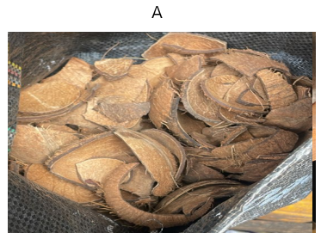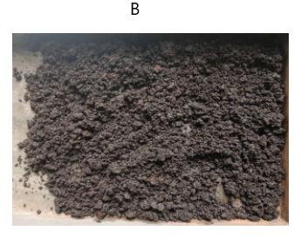

Figure 1. Processing coconut shells (A:raw coconut shells); B: Ground and carbonized shell at 800 °C)
2.2.2 Analysis of the spent and regenerated transformer oil
(1). Moisture Content Determination
The hygroscopic moisture content was evaluated using the ASTM D2974 (2014) method, as described by Boadu et al. (2018). Clean empty petri-dish was oven dried at 110 ºC, cooled in a desiccator, and weighed. A 1.0 g sample of the coconut shells activated carbon (CSAC) was measured into the empty petri-dish, and the weight was recorded. The petri- dish and its content was then oven dried at 110 ºC to a constant weight for 3 h. The percentage moisture content was calculated using Equation 1.
X_{o} = $\frac{W_{1}-W_{2}}{W_{1}}$ $×$ 100 % (1)
X_{o} = Moisture content on wet basis; W₁= Initial Weight Sample (g); W₂= Final weight of sample after drying (g)
(2). Ash Content
The ash content was accessed following the ASTM D2974 (2014) method, as prescribed by Vera et al. (2012). Dry activated carbon sample (I.0 g of coconut shells) was placed in a metal tray heat diffuser and moved to a preheated select-Horn furnace set at 750 ⁰C for 90 min. After this, the melting pots and their contents were transfer to a desiccator to cool. The melting pots and their contents were reweighed, and the weight loss was noted as ash content of the activated sample. Then the % ash content (dry basis) for each sample was calculated using the Equation 2.
Ash (%) = $\frac{W_{p\&S}-W_{p}}{W_{0}}$ $×$ 100% (2)
Where: W_{p} = Weight of petri-dish(g); W_{p& s}= Weight of petri-dish and sample after ashing (g);
W_{O} = Dry weight of carbon sample before ashing.
(3). Pore Volume Measurement
A 1.0 g of coconut shell activated carbon was put into a beaker containing 20 mL of distilled water and heated to boil for 5 min to ensure uniform dispersion. After boiling, the mixture was filtered, and the solid residue was dried and weighed. The pore volume was calculated using Equation 3 (Evbuomwan et al., 2013).
Pore volume = $\frac{Increase in sample^{'}s weight }{Density of water }$ (3)

(4). pH Measurement
A 1.0 g of coconut shell activated carbon was mixed with 3 mL of deionized water. The mixture was heated and stirred for about 3 min to ensure thorough dispersion of the sample. After heating, the solution was filtered, and the pH of the filtrate was measured using a digital pH meter (Boadu et al., 2018).

- Determining the functional groups in the coconut shell activated carbon
This was carried out using Fourier transform infrared (FTIR) spectroscopy. The spectra were recorded with a Digilab Excalibur FTS 3000 series spectrometer over the range 400 – 4000 cm⁻¹ at a resolution of 4 cm⁻¹. Samples were prepared as KBr pellets. FTIR analysis provided insight into the surface chemistry by revealing characteristic functional groups associated with the activated carbon (Boadu et al., 2018).
- Determining the surface morphology of the coconut shell activated carbon
This was done using scanning electron microscopy (SEM) equipped with a semi-in-lens objective lens and high-power optics. SEM was used to observe structural features and surface texture of the activated carbon, and supply valuable information on its physical characteristics (Boadu et al., 2018).
2.2.3 Spent transformer oil regeneration process using coconut oil synthesized adsorbent
A 50 mL of the pretreated spent transformer oil was measured into a beaker, and 0.5 g of the prepared coconut shell activated carbon was added and thoroughly mixed. The mixture was homogenized using a magnetic stirrer with a hot plate and set at temperatures of 60 °C, 80 °C, and 100 °C, maintaining a stirring speed of 750 rpm for 30 min. After mixing, the oil was purified by gravity filtration using a funnel stuffed with sterilized cotton wool. The filtrate (regenerated oil) was collected in a conical flask. The regenerated oil samples obtained at different temperatures were analyzed, and the temperature that produced the best-quality oil was maintained for further tests, during which the contact time was varied at 45 and 60 minutes. The physiochemical properties of the recycled oil, including moisture content and acid value, were then determined as described earlier.
3.0 Results and Discussion
3.1 Analysis of the coconut shell activated carbon
3.1.1 Determining the physicochemical properties of coconut shell activated carbon
The physicochemical properties of the coconut shell activated carbon (CSAC) were evaluated to determine its suitability as an adsorbent for spent transformer oil regeneration. The coconut shell was successfully converted into activated carbon with suitable physical and chemical properties, confirming its potential for use as an adsorbent. Characterization was performed to measure the quality of the adsorbent, and the result obtained are presented in Table 1. The low moisture content (1.414 %) indicates effective drying of the activated carbon, enhancing its adsorption efficiency. This low level minimizes the likelihood of microbial activity and water interference in adsorption. Compared to the 19.7 % reported by Macuzic and Jeremic (2002), the result demonstrates superior preparation and improved adsorptive readiness. The reduced water retention also suggests a higher surface area and better pore accessibility for the adsorption of polar compounds present in spent transformer oil. The low moisture content indicates the effectiveness of the carbonization and drying process, while the high pore volume directly relates to the material capacity for adsorption.

The Ash Content represents the non-carbonaceous, inert mineral residue remaining after the volatile and carbonaceous components have been removed (Table 1). A high ash content is generally undesirable in an adsorbent because the mineral matter occupies pore volume, effectively diluting the active carbon sites and reducing the overall adsorption
Table 1. Physichochemical properties of the synthesized coconut shell adsorbent
S/N | Paremeter | Value | Unit
1. | Moisture Content | 1.414 | %
2. | Ash Content | 16.8 | %
3. | Pore Volume | 0.379 | cm³

capacity. The low ash content obtained in the prepared CSAC is consistent with that presented by Okafoagu et al., (2025) who emphasized that low mineral content is critical for maximizing effective surface area in high-quality adsorbents. This result confirms the effectiveness of the purification steps carried out during the preparation, ensuring the final material is predominantly active carbon.
The Pore Volume is the most critical physical parameter, as it directly governs the adsorbent's capacity (Table 1). The substantial pore volume achieved signifies a highly developed internal pore structure a vast network of interconnected micro-, meso-, and macropores. This internal surface area is where the physical adsorption (physisorption) of contaminant molecules occurs. In the context of transformer oil, a high pore volume is essential for capturing both small polar molecules (moisture) and large organic molecules (sludge and complex acids). High pore volume is a prerequisite for achieving high adsorption capacity, especially for complex, multi-component systems like degraded transformer oil. The measured pore volume therefore confirms that the activation process in this study was highly successful in etching out a large internal surface, providing the massive area required for effective oil purification (Vu et al., 2020; Ali et al., 2021).
The low moisture and ash contents indicate effective drying and minimal inorganic residue, which are critical parameters for adsorbent efficiency. The moderate pore volume demonstrated that the activation process developed sufficient internal voids for contaminant adsorption. These findings show that the prepared coconut shell activated carbon possessed desirable characteristics vis-a-vis high surface activity, good porosity, and chemical stability making it a suitable and eco-friendly adsorbent for transformer oil regeneration.
3.1.2 Investigating the surface morphology of coconut shell activated carbon
This provides a high-magnification visual assessment of the activated carbon's surface morphology and texture. The investigation was conducted using Scanning Electron Microscopy (SEM), and the result obtained is presented in Figure 2. The figure typically reveal a highly heterogeneous and fractured surface structure. The key features observed are the irregular pores and voids created during the carbonization and activation processes. This visible porosity supports the high pore volume measurements and confirms the destruction of the precursor's initial structure. Furthermore, the rough surface texture increases the external surface area available for adsorption and ensures that the contaminant molecules have multiple pathways to enter the internal pore system. Consistent with the findings of Okafoagu et al. (2025), a high degree of surface irregularity is vital for efficient mass transfer in solid-liquid adsorption applications. The SEM analysis, therefore, confirms the successful physical activation and transformation of the coconut shell into a material with the necessary structural characteristics to serve as an efficient, high-surface-area adsorbent for transformer oil regeneration.
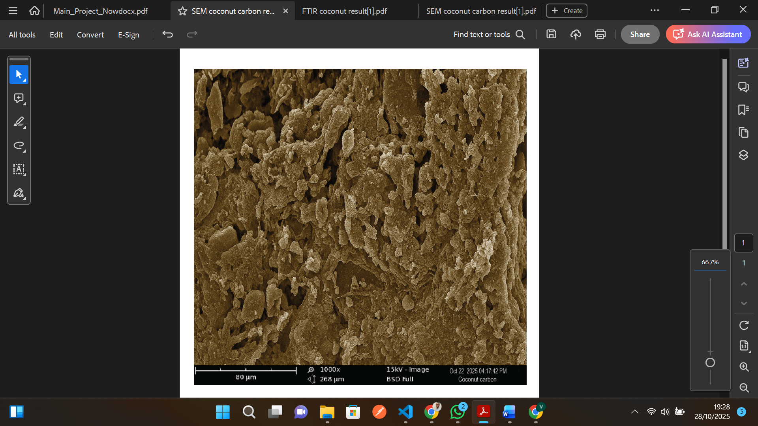
Figure 2. Surface morphology of coconut shell activated carbon obtained from scanning electron microscopy
3.1.3 Determining the functional groups present in coconut shell activated carbon
The Fourier Transform Infrared (FTIR) spectroscopy (Figure 3) provides vital information on the surface chemistry of the activated carbon, specifically identifying the functional groups available on the pore surfaces. These functional groups are the chemical attachment points that govern the selective removal of contaminants via chemisorption. The most important features observed include a broad, strong absorption band typically seen around 3200-3500 cm⁻¹, which is characteristic of O-H stretching vibrations (indicating hydroxyl functional groups). Furthermore, a peak appearing in the range of 1600-1750 cm⁻¹ is often attributed to the C=O carbonyl or quinone stretching vibration. The presence of these oxygen-containing surface groups is paramount, as they are polar. The polar groups on the AC surface O-H, C=O exhibit a strong chemical affinity for the polar contaminants in the oil (i.e., acidic oxidation products and moisture). This electrostatic attraction allows the AC to selectively chemisorb these detrimental contaminants, thereby purifying the dielectric fluid. This finding directly aligns with the work of Ali et al. (2021), who demonstrated that the presence of these oxygenated groups significantly enhances the adsorption of polar species via mechanisms such as hydrogen bonding and complexation, providing the chemical basis for the AC's high selectivity and the effectiveness demonstrated in the regeneration experiments.
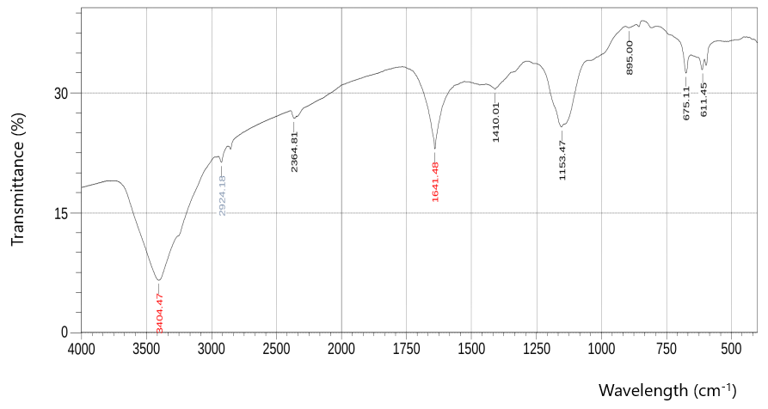
Figure 3. Functional groups present in coconut shell activated carbon obtained using FTIR

3.2 Analysis of the spent transformer oil
This was done to determine the quality of the spent transformer oil. The parameters assessed included moisture content, total acid number (TAN), dielectric breakdown voltage and viscosity. The results obtained are presented in Table 2. The results show that the moisture content, total acid number, dielectric breakdown voltage, and viscosity were 15,000 ppm, 4.21 mgKOH/g, 7.8 kV, and 9.19 cP. Comparing these with standard of moisture content (<35 ppm), total acid number (< 0.003 mgKOH/g), dielectric breakdown voltage (8.0 ± 0.5 kV), and visocity (> 30 cP) show that the spent transformer oil was degraded as the values of the parameters assessed were out of the range specified in the IEC (2003), ASTM D445 (2014), IEC (2020) and IEC (2018). The oil showed severely compromised, with an extremely low dielectric breakdown voltage (BDV) and an excessively high total acid number (TAN), alongside high moisture content. The low BDV indicates a severe loss of electrical insulation strength, and aging which introduced contaminants like moisture and polar degradation products that act as conductive weak spots, drastically reducing the oil’s insulating strength. The high TAN confirms significant oxidation leading to the formation of corrosive carboxylic acids. These acidic components threaten the structural integrity of the transformer by promoting internal corrosion and accelerating further oil breakdown, thus establishing the severe and urgent need for an effective adsorbent-based regeneration process.

Table 2. Physicochemical properties of spent transformer oil
Property | Test Method | Unit | Measured Value | Typical transformer oil (Reference)
Moisture content | Karl Fischer Titration | ppm | 15,000 | < 35 | IEC (2014)
Total acid number (TAN) | Acid–Base Titration | mgKOH/g | 4.21 | < 0.003 | IEC (2003)
Dielectric breakdown voltage | IEC Method | kV | 7.8 | 8.0 ± 0.5 | ASTM D445
Viscosity | Ostwald Viscometer | cP | 9.19 | > 30 (tested over a 2.5 mm gap) | IEC (2018)

3.3 The regeneration of spent transformer oil
3.3.1 Investigating the effect of temperature on the performance of regeneration of spent transformer oil
The temperature was varied (60, 80, and 100 ºC) at constant contact time of 30 min, and the results obtained are presented in Table 3. The results show that the lowest value of dielectric breakdown voltage of the spent transformer oil after regeneration was 20.6 kV and the highest was 24.2 kV obtained at 60 ºC and 100 ºC, respectively. The minimum viscosity of the regenerated transformer oil was 8.67 cP and the maximum was 8.95 cP obtained at 100 ºC and 60 ºC, respectively. The least total acid number of the regenerated transformer oil was 2.63 mgKOH/g and the highest was 3.16 mgKOH/g obtained at 100 ºC and 80 ºC, respectively.
Table 3. Effect of temperature on regeneration Performance
Temperature (°C) | Dielectric breakdown voltage (kV) | Viscosity (cP) | Total Acid Number (mgKOH/g)
60 | 20.6 | 8.95 | 3.68
80 | 21.5 | 8.81 | 3.16
100 | 24.2 | 8.67 | 2.63

The regeneration temperature demonstrated a crucial influence on the dielectric breakdown voltage (BDV) of the oil. As the temperature increased, the BDV exhibited a corresponding significant improvement. This finding is directly explained by the inherent instability of aged oil: the low initial BDV of 7.8 kV prior to regeneration was primarily caused by moisture and polar contaminants. When the temperature is elevated during the adsorption process, two synergistic effects occur: enhanced kinetics and increased adsorption. The increased thermal energy enhances the mobility and diffusion rate of the contaminants, accelerating their movement toward the activated carbon's surface. Simultaneously, higher temperatures promote the adsorption of polar acidic by-products onto the coconut shell activated carbon (CSAC), thereby restoring the oil's capability to withstand electrical stress and fulfilling its essential role as a dielectric medium. This finding validates previous research on agro-waste adsorbents; for instance, Okafoagu et al. (2025) also reported a substantial increase in BDV, demonstrating that activated carbon derived from agricultural waste is highly effective in restoring dielectric strength.
The viscosity of the oil was observed to decrease consistently as the regeneration temperature was increased, following its expected thermal behavior (See Table 3). This reduction is primarily a physical phenomenon as increasing temperature lowers the internal resistance to flow by reducing the intermolecular forces within the oil. This physical relationship is fundamental to insulating oil behavior, as (coolants in transformers) of this work. From an operational standpoint, this is a beneficial outcome, as lower viscosity enhances the oil's function as an efficient coolant by improving its flow rate and ability to transfer heat away from the transformer windings.
A marked reduction in total acid number (TAN) was achieved as temperature increased, decreasing from 3.68 mgKOH/g at 60 °C to 2.63 mgKOH/g at 100 °C (Table 3). This decline demonstrates efficient adsorption and removal of acidic oxidation products by coconut shell activated carbon, aided by enhanced diffusion and activation of adsorption-sites-at-higher-temperatures. The decrease in TAN reflects the elimination of carboxylic acids and other polar compounds responsible for oil acidity. According to Venkatasubramanian et al., (2022), temperature promotes surface reactivity and aids contaminant desorption from the oil phase. Although the final TAN remains above the 0.3 mgKOH/g threshold for unused transformer oil, the significant reduction confirms the adsorbent’s high efficiency and potential for sustainable regeneration applications

3.3.2 Investigating the effect of contact time on the performance of regeneration of spent transformer oil
The variation in contact time from 45 to 60 min on the performance of the regeneration of spent transformer oil was carried out at constant temperature of 80 ºC, and the results obtained are presented in Table 4. The table shows that the dielectric breakdown voltage increased from 23.4 kV to 25.2 kV as the contact time increased from 45 min to 60 min. Comparing this with a dielectric breakdown voltage of 7.8 kV of the spent transformer oil before regeneration gave a maximum regeneration efficiency of 223.97 % . The result shows that longer contact time between the synthesized coconut shell adsorbent and the spent transformer oil facilitated the removal of moisture, acids, sludge which usually reduce the dielectric strength.
The contact time had a negligible direct effect on the viscosity of the regenerated oil, showing only a minimal change from a viscosity of 9.0 6 cP at 45 min to a viscosity of 9.50 cP at 60 min. This result is expected because viscosity is primarily a
Table 4. Effect of Contact Time on Regeneration Performance
Contact Time (min) | Dielectric breakdown voltage (kV) | Viscosity (cP) | Total acid number (mgKOH/g)
45 | 23.4 | 9.06 | 3.16
60 | 25.2 | 9.50 | 2.11

physical property that depends on temperature rather than the duration of solid-liquid contact; it is largely determined by the oil’s molecular structure and thermal state, which emphasizes that effective heat transfer relies on maintaining consistent viscosity. Any slight reduction in viscosity over time is likely attributable to the gradual disaggregation and settling of colloidal sludge particles, which are removed by the coconut shell activated carbon, rather than any fundamental alteration of the base oil. The key implication is favorable: the regeneration process effectively removes chemical contaminants, as evidenced by the concurrent reduction in TAN, without compromising the critical physical property of viscosity necessary for efficient transformer cooling and heat transfer.
The acid number decreased from 3.16 mgKOH/g to 2.11 mgKOH/g with increasing contact time from 45 min to 60 min. This demonstrates that prolonged exposure enhances the adsorption of acidic and polar compounds, resulting in the stability of the oil. With this result, the highest acidic regeneration efficiency of 49.88 % of the spent transformer was achieved after 60 min. The gradual reduction in the total acid number confirms the continued removal of oxidation by-products over long contact time.
3.0 Conclusion
This study was undertaken to investigate the regeneration of spent transformer oil using activated carbon (AC) derived from coconut shell, an abundantly available agro-waste material. Based on the highly positive regeneration results obtained, the study concludes that coconut shell activated carbon is a veritable adsorbent for industrial transformer oil reclamation. The substantial increase in the Breakdown Voltage (BDV) to 25.2 kV far exceeds the minimum acceptable BDV for in-service oil (typically 20 kV) and places the quality of the reclaimed oil well within the acceptable standard for continued operation and reuse. Concurrently, the reduction of the Total Acid Number (TAN) to 2.11 mgKOH/g confirms the effective elimination of corrosive oxidation products. In the industry, this level of performance allows the oil to be re-entered into the transformer operational cycle, significantly extending the lifespan of the fluid and the transformer itself. This is critical for asset management and reducing replacement costs. Furthermore, compared to conventional non-renewable adsorbents like Fuller’s Earth, the utilization of coconut shells a readily available agro-waste offers a sustainable, local, and cost-effective solution, aligning perfectly with modern industrial goals of waste-to-wealth conversion and adherence to environmental standards. While the final measured properties demonstrate substantial recovery and approach the industry standards, they indicate that the oil is not yet fully restored to "new oil" specifications. This slight shortfall suggests that the laboratory-scale batch adsorption methodology may require future optimization, potentially involving a continuous flow system or a higher adsorbent dosage,

COMPETING INTERESTS DISCLAIMER:
Authors have declared that they have no known competing financial interests OR non-financial interests OR personal relationships that could have appeared to influence the work reported in this paper.

Disclaimer (Artificial intelligence)

Author(s) hereby declare that NO generative AI technologies such as Large Language Models (ChatGPT, COPILOT, etc.) and text-to-image generators have been used during the writing or editing of this manuscript.

Reference
- Ali M., Deenesh N.K., Kadir, G., Hasnan, K., Nayan, N. (2021). Effect purification process on the thermal conductivity and breakdown voltage of inhibited, isoparaffinic transformer oil used in electric train. Journal of physics, 1878 (1)
- ASTM International. (2014). ASTM D2974—Standard test methods for moisture, ash, and organic matter of peat and other organic soils. ASTM International.
- ASTM International. (2022). Standard test method for kinematic viscosity of transparent and opaque liquids (ASTM D445). ASTM International.
- Basu N., Gupta D.P., Jundhare P.R., Dev, T.K., Gulavani, N.S., (2020). Effect of transformer oil reconditioning on oil properties and dissolved gases. 17th india council international conference, 17(1): 1-5.
- Boadu, K. B., Asare, R., & Tuffour, B. (2018). Characterization of activated carbon derived from coconut shells for adsorption applications. International Journal of Scientific & Engineering Research, 9(7), 451–460.
- Boadu, K. B., Owusu, P. A., & Tuffour, B. (2020). Production and optimization of coconut shell activated carbon for industrial applications. Journal of Environmental Chemical Engineering, 8(5), 104–119.
- FAO. (2021). FAOSTAT statistical database. Food and Agriculture Organization of the United Nations.
- International Electrotechnical Commission (IEC) (2003). Insulating liquids Determination of acidity (IEC 62021-1)
- IEC. (2018). IEC 60156: Insulating liquids—Determination of the breakdown voltage at power frequency. International Electrotechnical Commission.
- International Electrotechnical Commission. (2020). IEC 60296: Fluids for electrotechnical applications – Mineral insulating oils for electrical equipment. IEC.
- Macuzic I., and Jeremic B. (2002). Modern approach to problems of transformer oil purification, Tribology in industry, 24(3,4), 40-44.
- Nigerian Electricity Regulatory Commission (NERC). (2022). Annual operational and financial report. Nigerian Electricity Regulatory Commission.
- Okafoagu S. O., Edeh, I., & Evbomwan, B. O. (2025). Regeneration of Spent transformer oil using Bentonite clay palm kernel shell. Chemical science international journal, 34(3), 60–72.
- Okofoagu, S. O., Edeh, I. (2025). Sustainable reclamation of Spent Transformer Oil Using Bentonite and Palm Kernel Shell. Chemical Science International Journal, 34(4), 127-152. DOI: https://doi.org/10.9734/CSJI/2025/v34i4983
- Pelitli V., Dogan O., and Koroglu, H.J.. (2015). Transformer oils potential for PCBs Contamination. International journal of metallurgical and materials Engineering Sustainable Energy Reviews, 46, 218–235. . Doi: https://dx.doi.org/10.15344/2455-2372/2015/114
- Saffidine L., Zafour, A.H., Fofana I., Skender, A., Guerbas F., Boucherit, A. (2017). Transformer oil reclamation by combining several strategies enhanced by the use of four adsorbents. The institution of engineering and technology. 11(11): 2912-2920.
- Selvi, S.T., Krishna, N., Jeevanantham G., Abhishek R. (2024). Adsorptive removal of impurities from transformer oil using activated carbon, fourth international conference on advances in electrical, computing, communication and sustainable technologies, 24; 1-8
- Venkatasubramanian R.P., Liu Q., Wang Z.D. and Marshall P. (2015). assessment of regenerated oil through accelerated thermal ageing Experiment, international universities power engineering conference, 15(1): 1-4, https://doi.org/10.1109/UPEC.2015.7339927
- Vu T.T., La T.V., Vu, M.K., Huynh, D.C., Tran, N.K. (2020). Highly efficient adsorbent for the transformer oil purification by ZnO/Graphene composite, Arabian journal of chemistry, 13(11), 7798-7808
- Yahya, M. A., Al-Qodah, Z., & Ngah, C. Z. (2015). Agricultural waste materials as potential sustainable precursors used for activated carbon production: A review. Renewable and Sustainable Energy Reviews, 46, 218–235.
- Yusupov D. and Avazov B. (2025). Experimental analysis of the process of purifying transformer oil from various impurities under the influence of a constant electric field and mathematically modelled results. Liquid and gaseous energy resources, 5(2), 19-30
- Zhang G., Yao, Y., Wang, W., Zhang, X. (2026). Hydrogen production waste insulating oil based on DBD plasma (laboratory). Journal of the energy institute. 125. https://doi.org/10.1016/j.joei.2025.102280

