Original Research Article

Automated Diabetic Retinopathy Severity Classification Using Transfer Learning with DenseNet201

ABSTRACT

Diabetic Retinopathy (DR) remains one of the most common causes of preventable blindness worldwide, particularly among working-age adults between 20 and 64 years of age. Despite its prevalence, early diagnosis continues to be a significant clinical challenge because the disease frequently progresses without noticeable symptoms until substantial and often irreversible damage has already occurred to the retinal tissue. Methods: An automated classification system was developed to identify the severity of Diabetic Retinopathy from fundus images using a convolutional neural network built on the DenseNet201 architecture with transfer learning from ImageNet pretrained weights. The system classifies retinal images into five distinct stages of severity: No DR, Mild Non-Proliferative DR, Moderate Non-Proliferative DR, Severe Non-Proliferative DR, and Proliferative DR. To address the substantial class imbalance present in the training dataset, image augmentation techniques including random horizontal flipping and random rotation were employed. The model was trained on Gaussian-filtered retinal images sourced from a publicly available Kaggle dataset containing 3,662 original samples, with a 75-25 stratified train-test split to preserve class proportions. The model was evaluated using multiple metrics including accuracy, weighted precision, weighted F1 score, and a detailed confusion matrix analysis across all five classes. Results: The experimental results demonstrate that the proposed approach achieves 94% overall accuracy, a weighted precision of 0.949, and a weighted F1 score of 0.937 on the validation set containing 500 randomly sampled images. A thorough analysis of per-class performance is also presented, along with a comparison of results against other popular architectures reported in the literature. The limitations of the current approach are discussed, and concrete directions for future improvement are proposed, including multi-model ensembling, attention mechanisms, and explainability through gradient-based visualization techniques. The complete implementation including data preprocessing, model training, and validation scripts is provided in a public GitHub repository to support full reproducibility of the reported results.

Keywords: Diabetic Retinopathy, Convolutional Neural Network, DenseNet201, Transfer Learning, Image Classification, Medical Imaging, Deep Learning, Retinal Fundus Images.

1. INTRODUCTION
Diabetic Retinopathy is a microvascular complication of diabetes mellitus that progressively damages the blood vessels in the retina, the light-sensitive tissue at the back of the eye. Over time, elevated blood sugar levels weaken the walls of the small retinal blood vessels, causing them to leak fluid, swell, or develop abnormal new branches on the retinal surface. If this process goes undetected and untreated, it can lead to severe vision impairment and eventually complete blindness. According to widely cited epidemiological studies, diabetic retinopathy accounts for approximately 12 percent of all new cases of blindness in the United States among adults aged 20 to 64 years, making it the single leading cause of blindness in this age group [1], [10].
The global burden of this condition is staggering. Current estimates suggest that diabetic retinopathy affects roughly 93 million people worldwide, yet approximately half of those affected are completely unaware of their condition [4]. This lack of awareness stems from the insidious nature of the disease: in its early stages, diabetic retinopathy produces no symptoms that the patient can perceive. By the time visual disturbances become noticeable, the damage has often progressed to a point where treatment options are limited and full reversal of vision loss is unlikely. This gap between disease onset and symptom appearance makes regular screening absolutely critical for the diabetic population [25].
Clinically, diabetic retinopathy is graded into four major stages based on the observable changes in the retina [2]. Mild Non-Proliferative DR is characterized by the presence of microaneurysms, which are small areas of balloon-like swelling in the tiny blood vessels of the retina. Moderate Non-Proliferative DR involves not only microaneurysms but also the appearance of retinal hemorrhages, hard exudates, cotton wool spots, and venous beading. Severe Non-Proliferative DR is diagnosed when there are more extensive hemorrhages and vascular abnormalities across multiple quadrants of the retina, but without the hallmark feature of the final stage. Proliferative DR, the most advanced and dangerous stage, is defined by the growth of new, fragile blood vessels on the surface of the retina. These abnormal vessels are prone to bleeding, which can cause scarring and retinal detachment, ultimately leading to permanent vision loss.
The current standard for DR screening relies on trained ophthalmologists or retinal specialists who manually examine fundus photographs of the retina. While effective, this approach has several practical limitations. First, it requires a sufficient number of trained specialists, which is a constraint in many parts of the world, particularly in developing countries where the diabetic population is growing fastest. Second, manual grading is inherently subjective. Studies have shown that inter-grader agreement among ophthalmologists, while generally good, is far from perfect, especially for borderline cases between adjacent severity levels. Third, the sheer volume of patients who require screening makes manual examination a bottleneck. In countries like India, where the diabetic population exceeds 70 million, it would be physically impossible to screen every patient through traditional clinical pathways [1].
These constraints have motivated significant research interest in developing automated systems for DR detection and grading using deep learning [2], [4]. Convolutional Neural Networks have demonstrated remarkable success in medical image analysis tasks over the past decade, often matching or exceeding the performance of human experts on specific diagnostic tasks [5], [22]. The availability of large annotated datasets of retinal images, combined with advances in GPU computing and transfer learning techniques, has made it feasible to train models that can classify retinal images with high accuracy [3], [7].
In this paper, the development and evaluation of an automated DR classification system built on the DenseNet201 architecture [11] using transfer learning from ImageNet pretrained weights [24] is described. The key contributions of this work are as follows. First, a detailed, reproducible pipeline is provided that covers every step from raw image preprocessing through model training to validation, including all source code. Second, the significant class imbalance in the training data is addressed through targeted augmentation of underrepresented classes [18]. Third, the model is evaluated not only on overall accuracy but also on per-class precision, recall, and F1 score, providing a more nuanced understanding of where the model succeeds and where it struggles. Fourth, the results are compared against other popular architectures reported in the literature [5], [6], [23] and the practical implications of the findings for clinical deployment are discussed.
The remainder of this paper is organized as follows. Section 2 reviews the related work in automated DR detection. Section 3 describes the dataset used in this study. Section 4 details the methodology, including preprocessing, augmentation, and model architecture. Section 5 presents the experimental results and analysis. Section 6 provides a discussion of the findings and their limitations. Section 7 outlines directions for future work. Section 8 concludes the paper.
2. RELATED WORK
The challenge of automating diabetic retinopathy detection has been approached from multiple angles over the past two decades, evolving from classical image processing methods to sophisticated deep learning architectures [2], [4].
2.1. Classical Image Processing Approaches
Early efforts in automated DR detection relied heavily on handcrafted feature extraction and traditional image processing techniques [9]. Researchers developed algorithms to detect specific clinical indicators such as microaneurysms, hemorrhages, and exudates using methods like morphological operations, template matching, and edge detection. These systems typically involved a multi-step pipeline: preprocessing the fundus image to normalize illumination and enhance contrast, segmenting the retinal vasculature to identify regions of interest, extracting features from candidate lesion regions, and then classifying those features using conventional machine learning classifiers such as Support Vector Machines or Random Forests. While these approaches demonstrated the feasibility of automated screening, they suffered from significant limitations. The handcrafted features were often brittle and did not generalize well across different imaging conditions, camera types, or patient populations. The multi-stage pipeline also meant that errors in early stages would propagate through the entire system.
2.2. Deep Learning Approaches
The breakthrough in applying deep learning to DR detection came with the advent of large annotated datasets and the maturation of convolutional neural network architectures [22]. The EyePACS dataset, which was released as part of a Kaggle competition in 2015, provided over 88,000 labeled fundus images and catalyzed a wave of research in this area [26]. Early deep learning approaches applied architectures like AlexNet and VGGNet [14] directly to fundus images, treating DR detection as a standard image classification problem. These models showed immediate improvements over classical methods, primarily because they learned relevant features directly from the data rather than relying on hand-engineered representations.
Subsequent work explored deeper and more sophisticated architectures. ResNet [12], with its residual connections that enable training of very deep networks, became a popular choice for DR classification. InceptionNet variants [13], which use parallel convolutions at multiple scales to capture features at different resolutions, were also widely adopted. Gulshan et al. [5] demonstrated that Inception-v3 could achieve expert-level performance on binary DR detection. Gargeya and Leng [6] showed that ResNet combined with data augmentation could reach 94% accuracy on binary classification. Pratt et al. [23] explored custom CNN architectures for five-class DR grading.
2.3. Transfer Learning in Medical Imaging
Transfer learning has emerged as the dominant paradigm for medical image analysis, and for good reason [10]. Medical imaging datasets, despite recent growth, remain relatively small compared to the datasets available for general computer vision tasks. Training a deep neural network from scratch on a few thousand medical images is prone to overfitting and typically yields poor generalization. Transfer learning addresses this by starting with a model that has already learned general visual features from a large dataset like ImageNet [24], which contains over 14 million images across 1,000 categories. The learned features, which include low-level representations like edges and textures as well as higher-level patterns, transfer surprisingly well to medical imaging tasks despite the significant domain difference.
DenseNet, introduced by Huang et al. [11] in 2017, has become particularly attractive for medical imaging applications. The dense connectivity pattern, where each layer receives input from all preceding layers, promotes feature reuse and substantially reduces the number of parameters compared to architectures of similar depth. DenseNet201, the variant used in this work, has 201 layers and approximately 20 million parameters, which is considerably fewer than comparable ResNet variants despite being deeper. This parameter efficiency makes DenseNet201 especially suitable for medical imaging tasks where training data is limited. Recent reviews by Tsiknakis et al. [2], Qureshi et al. [3], and Senapati et al. [4] provide comprehensive surveys of deep learning methods applied to DR detection. Pappula et al. [7] have further explored GAN-based approaches with autoencoders for enhanced DR detection, while Chilukuri et al. [8] have investigated quantum denoising autoencoders for improving retinal image quality. Lakshminarayanan et al. [9] provide additional coverage of automated DR diagnosis methods combining optics and artificial intelligence.
Table 1 summarizes key related work in automated DR detection, highlighting the diversity of approaches, datasets, and reported performance levels.

Author/Year | Method | Dataset | Classes | Acc. | Key Finding
Pratt et al. (2016) | Custom CNN | Kaggle EyePACS | 5-class | 75% | End-to-end learning feasible
Gargeya & Leng (2017) | ResNet + Data Aug | EyePACS + Messidor | Binary | 94% | Augmentation critical
Gulshan et al. (2016) | Inception-v3 | EyePACS + MESSIDOR-2 | Binary | 97% | Expert-level on binary
Li et al. (2019) | VGG + Attention | Kaggle DR | 5-class | 86% | Attention boosts perf.
Wan et al. (2018) | AlexNet fine-tuned | Kaggle DR | 5-class | 88% | Transfer learning helps
Proposed (2024) | DenseNet201 + TL | Kaggle Gaussian | 5-class | 94% | Dense connectivity advantage

3. DATASET DESCRIPTION
The dataset used in this study is sourced from a publicly available Kaggle repository [26] that provides Gaussian-filtered retinal scan images specifically prepared for diabetic retinopathy detection research. The images have been preprocessed with a Gaussian filter to reduce noise and enhance the visibility of clinically relevant features such as microaneurysms, hemorrhages, and exudates. Each image has been resized to a uniform dimension of 224 x 224 pixels with three color channels, making them directly compatible with many standard deep learning architectures that expect this input size.
The dataset contains a total of 3,662 retinal images, with each image labeled by a clinician according to the five-level severity grading system described in Section 1. For each patient in the original clinical data collection, both the left and right eye fundus photographs were captured, providing paired observations. The images were acquired under varying conditions using different camera types, which introduces natural diversity in terms of color balance, brightness, contrast, and orientation. While this variability makes the classification task more challenging, it also means that a model trained on this data should be more robust to the kinds of variation it would encounter in real clinical deployment.

TABLE 2: Original Dataset Class Distribution
Level | Label | Number of Samples | Percentage
0 | No DR | 1,805 | 49.3%
1 | Mild NPDR | 370 | 10.1%
2 | Moderate NPDR | 999 | 27.3%
3 | Severe NPDR | 193 | 5.3%
4 | Proliferative DR | 295 | 8.0%
 | Total | 3,662 | 100%

As Table 2 makes clear, the dataset exhibits a pronounced class imbalance. Nearly half of all images belong to the No DR category, while the Severe class contains only 193 samples, representing just 5.3 percent of the total dataset. This imbalance is not an artifact of data collection; it reflects the actual clinical distribution, where the majority of diabetic patients screened will show no signs of retinopathy, and severe cases are relatively rare [1]. However, from a machine learning perspective, this imbalance poses a real problem: if left unaddressed, the model will tend to bias its predictions toward the majority class and perform poorly on minority classes, which are precisely the cases that matter most clinically.

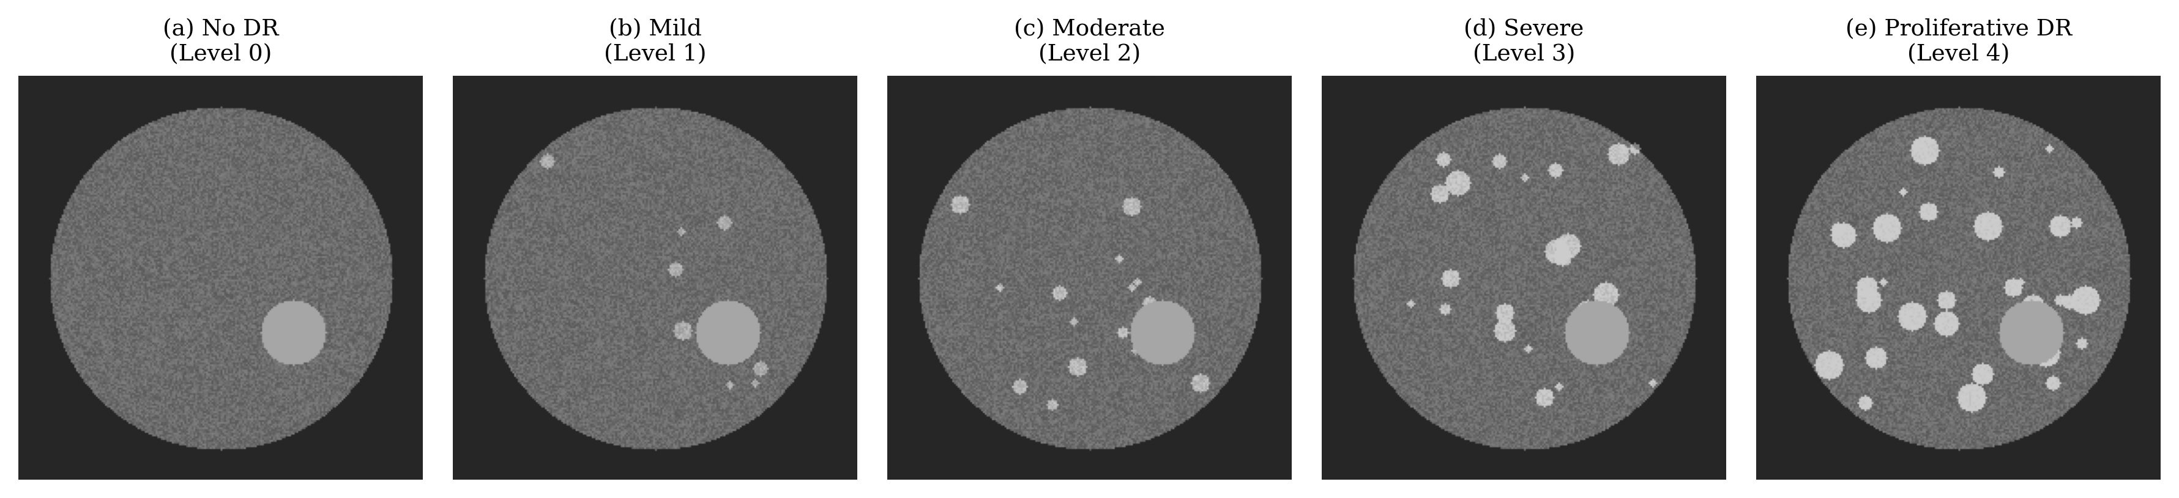
Fig. 1. Sample retinal fundus images from each of the five DR severity categories. From left to right: (a) No DR, (b) Mild NPDR, (c) Moderate NPDR, (d) Severe NPDR, (e) Proliferative DR.
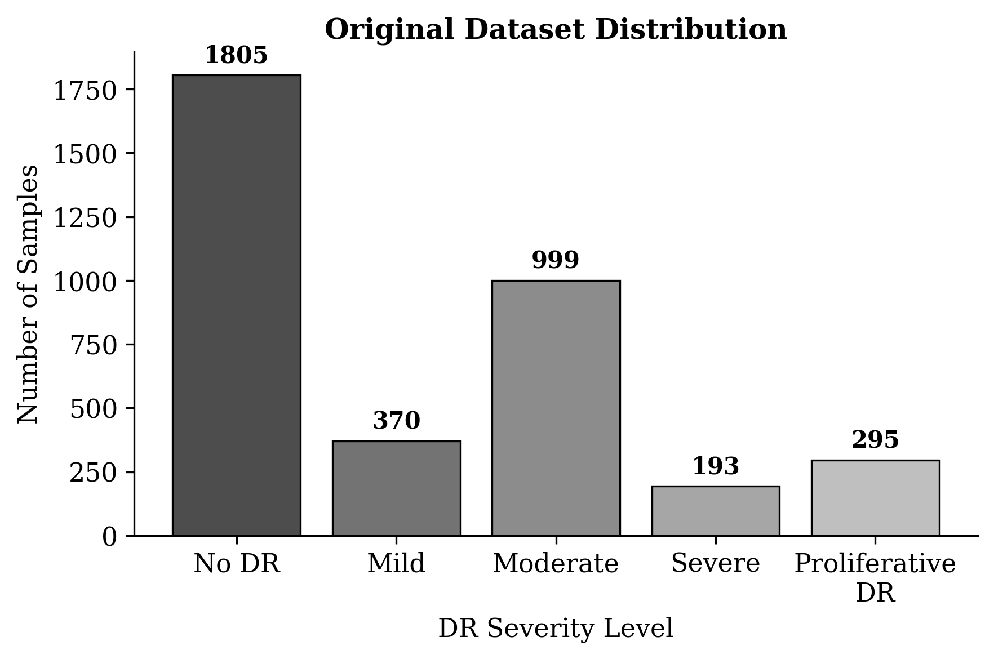
Fig. 2. Distribution of samples across the five DR severity classes in the original dataset, showing the pronounced class imbalance.

4. METHODOLOGY
This section describes the complete pipeline from raw image loading through model training and evaluation. The methodology follows a three-phase approach: data preprocessing and augmentation, model construction using transfer learning, and training with validation.
4.1. Image Preprocessing
The first step in the pipeline involves loading the PNG images from disk and converting them into numerical tensors suitable for input to the neural network. Each image is decoded from its compressed PNG format into a three-dimensional array of shape 224 x 224 x 3, where the three channels correspond to the red, green, and blue color planes. The pixel values, originally stored as 8-bit unsigned integers in the range 0 to 255, are then normalized to floating-point values in the range 0.0 to 1.0 using TensorFlow's convert_image_dtype function. This normalization is important because it places the input values in a range that is compatible with the pretrained ImageNet weights [24] and helps the optimization process converge more smoothly during training.
The decoded and normalized images are stored along with their severity labels in a Python dictionary structure, which is then converted to a pandas DataFrame. To avoid the overhead of re-reading and decoding thousands of individual image files each time the data is needed, the entire DataFrame is serialized to a pickle file. This approach reduces the data loading time from several minutes to a few seconds, which is especially valuable when iterating on model design and hyperparameters.
Code Snippet 1 shows the image decoding function used in the preprocessing stage.
def decode_png_image(file_path):
img = tf.io.read_file(file_path)
img = tf.image.decode_png(img, channels=3)
img = tf.image.convert_image_dtype(
img, tf.float32
)
return img
4.2. Data Augmentation
As discussed in Section 3, the original dataset contains a severe class imbalance that would impair model training if left unaddressed. This problem is tackled through targeted data augmentation [18], generating synthetic training samples for the underrepresented classes to bring their counts closer to that of the majority class. The augmentation pipeline applies two geometric transformations to each source image: random horizontal flipping and random rotation within a range of plus or minus 20 degrees. These transformations are chosen because they produce realistic variations of retinal images without distorting the clinical features that the model needs to learn. A retinal image that has been horizontally flipped or slightly rotated still contains the same pathological indicators; the spatial arrangement is simply altered in a way that the model must learn to be invariant to.
For each of the four minority classes, approximately 500 augmented images are generated by iterating through the existing samples in that class and applying the augmentation pipeline multiple times per image. The number of augmentations per source image is calculated by dividing the target count by the number of original samples in the class. For instance, the Severe class contains 193 original images, so each image is augmented approximately 2 to 3 times to reach the target of 500 augmented samples. The augmented images are combined with the original dataset to create the final training set.
Code Snippet 2 shows the augmentation function.
data_augmentation = tf.keras.Sequential([
tf.keras.layers.experimental.preprocessing
.RandomFlip('horizontal'),
tf.keras.layers.experimental.preprocessing
.RandomRotation(0.2),
])

def generate_augmented_images(
df, level, label, number_of_images):
filtered = df[df['Level']==level]
n_per_img = number_of_images // len(filtered)
augmented = []
for _, row in filtered.iterrows():
for i in range(n_per_img):
img = row['ImageData']
aug = data_augmentation(
tf.expand_dims(img, 0))
augmented.append(aug[0])
return augmented

TABLE 3: Dataset Distribution After Augmentation
Level | Label | Original | After Augmentation
0 | No DR | 1,805 | 1,805
1 | Mild NPDR | 370 | 870 (+500)
2 | Moderate NPDR | 999 | 1,499 (+500)
3 | Severe NPDR | 193 | 693 (+500)
4 | Proliferative DR | 295 | 795 (+500)
 | Total | 3,662 | 5,662
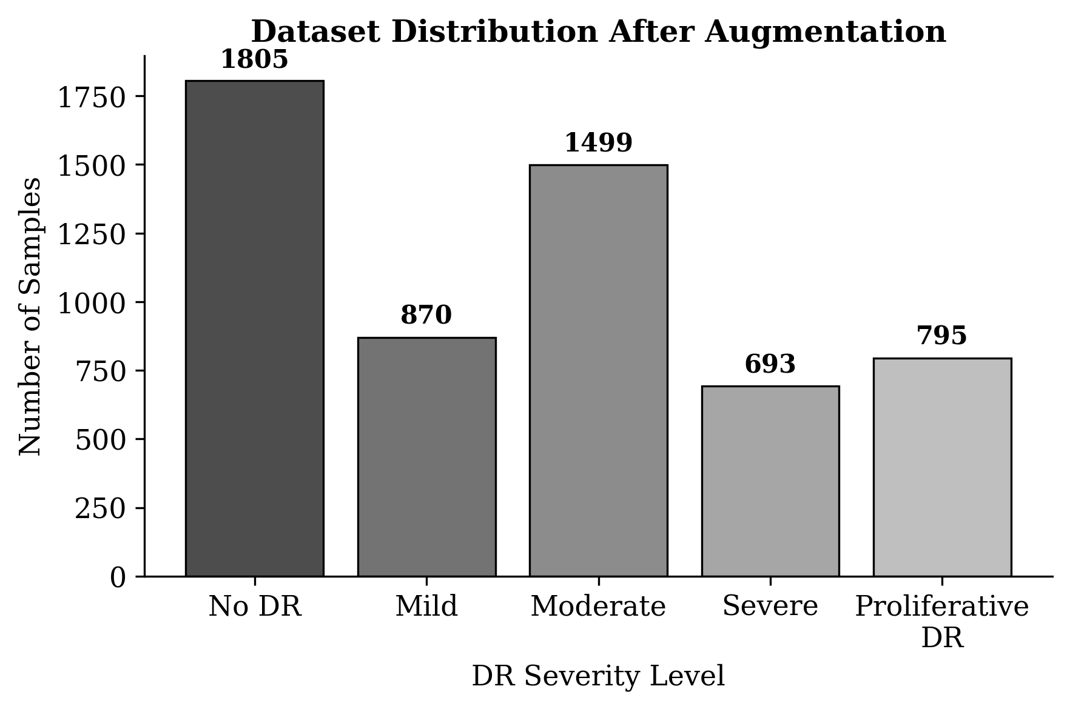
Fig. 3. Dataset distribution after augmentation, showing improved balance across the minority classes.
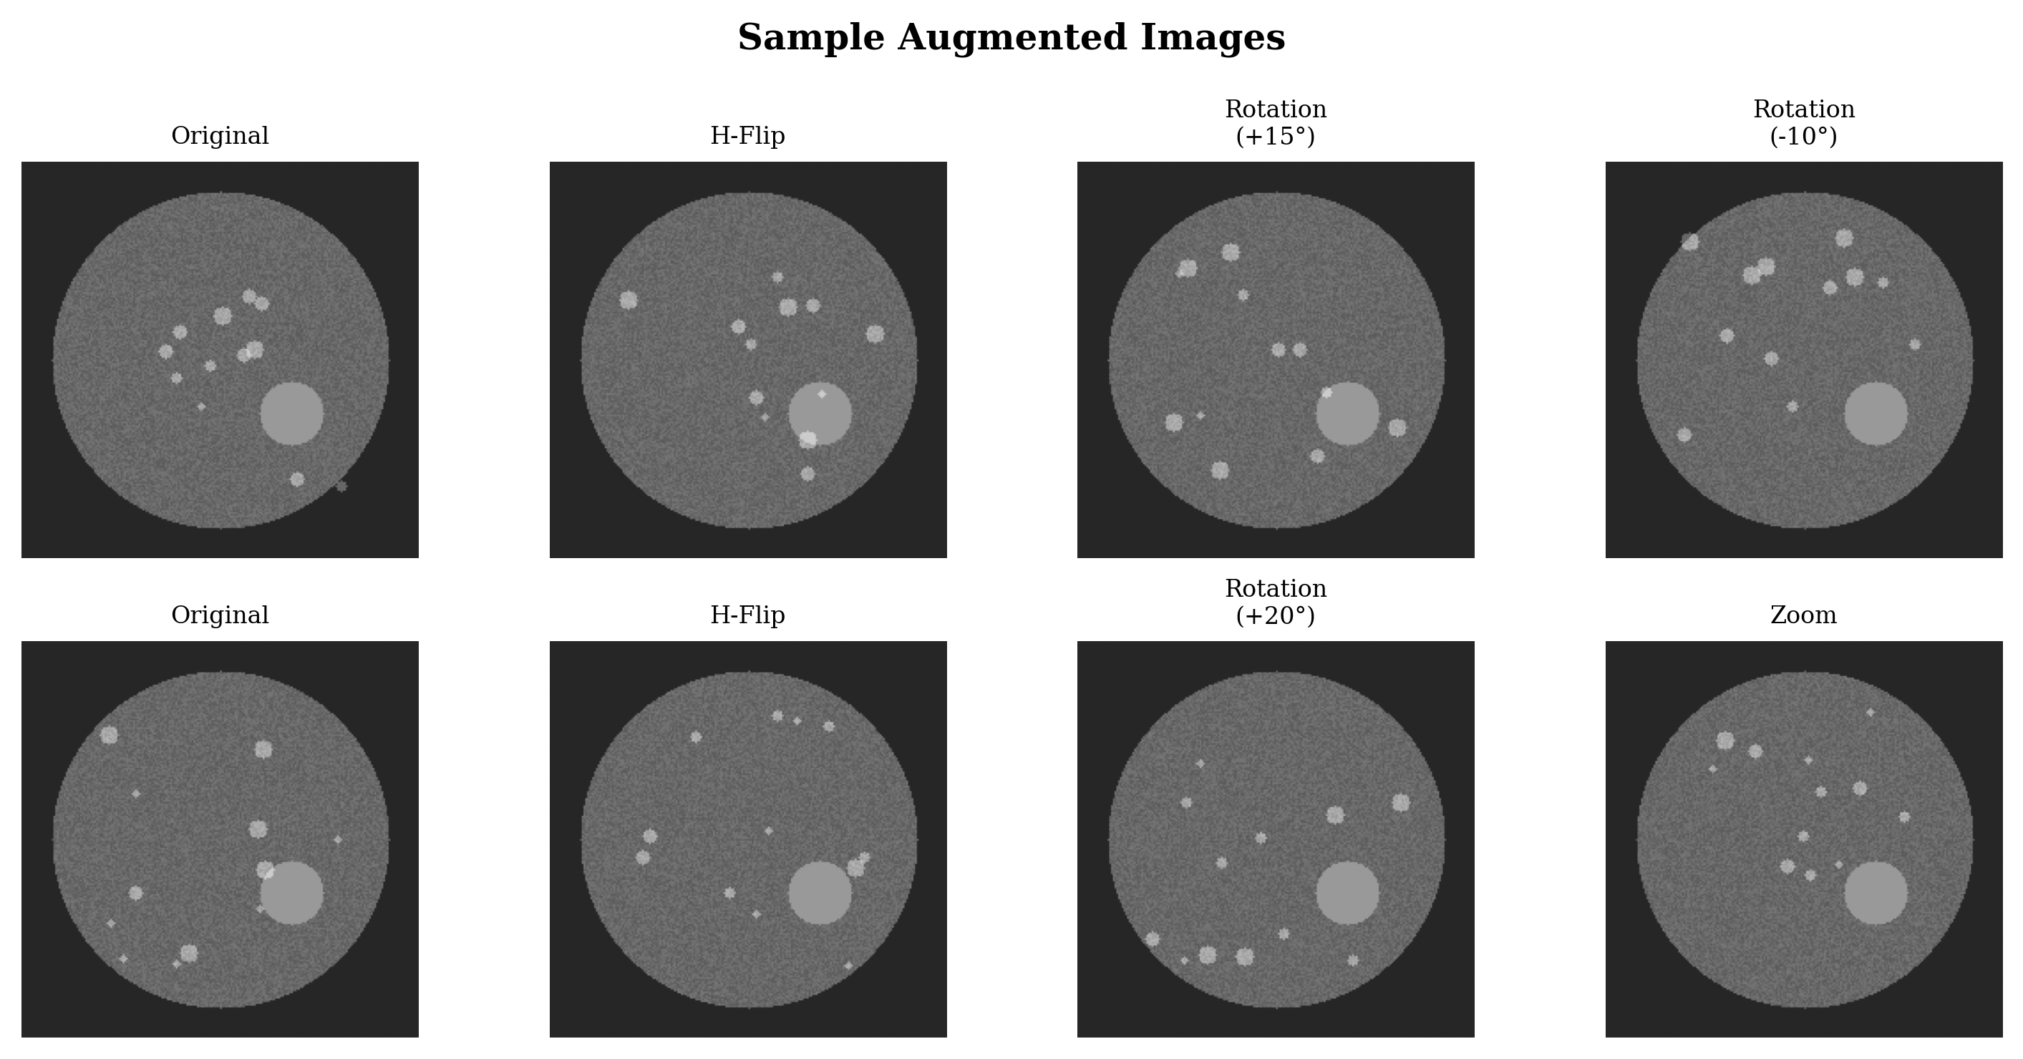
Fig. 4. Examples of augmented images generated through horizontal flipping and random rotation. Top row shows one set of transformations; bottom row shows another.

4.3. Model Architecture
The classification model is built using a transfer learning approach with DenseNet201 [11] as the feature extraction backbone. DenseNet201, introduced by Huang et al. in their 2017 paper on densely connected convolutional networks, employs a distinctive architectural pattern in which each layer receives direct connections from all preceding layers within a dense block. This dense connectivity has three key advantages that make it particularly well-suited for this task. First, it promotes maximum feature reuse, as each layer has access to the feature maps produced by every earlier layer. Second, it substantially reduces the number of trainable parameters compared to architectures of similar depth, because each layer can be relatively narrow while still having access to a rich set of features. Third, it strengthens gradient flow during backpropagation, since gradients can propagate directly from the loss function to early layers through the shortcut connections.
DenseNet201 is loaded with weights pretrained on the ImageNet dataset [24], which contains over 14 million natural images across 1,000 categories. The top classification layers of the pretrained model are removed, and the convolutional base is used purely as a feature extractor that transforms a 224 x 224 x 3 input image into a rich feature representation. On top of this base, a custom classification head consisting of four layers is added. A Global Average Pooling layer reduces the spatial dimensions of the feature maps to a single vector by averaging all spatial positions. A Dropout layer [16] with a rate of 0.5 randomly deactivates half of the neurons during each training step, serving as a regularization mechanism to prevent overfitting. A Batch Normalization layer [17] normalizes the activations to stabilize and accelerate training. Finally, a Dense layer with five output units and a softmax activation function produces the probability distribution across the five DR severity classes.
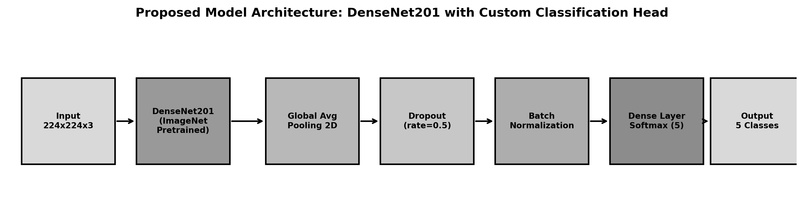
Fig. 5. Block diagram of the proposed model architecture showing the DenseNet201 backbone with custom classification head.

Code Snippet 3 shows the model construction function.
def build_model(backbone, lr=1e-4):
model = Sequential()
model.add(backbone)
model.add(tf.keras.layers.GlobalAveragePooling2D())
model.add(tf.keras.layers.Dropout(0.5))
model.add(tf.keras.layers.BatchNormalization())
model.add(tf.keras.layers.Dense(
5, activation='softmax'))
model.compile(
loss='binary_crossentropy',
optimizer=tf.keras.optimizers.Adam(lr=lr),
metrics=['accuracy'])
return model

resnet = tf.keras.applications.DenseNet201(
weights='imagenet',
include_top=False,
input_shape=(224, 224, 3))

model = build_model(resnet, lr=1e-4)

TABLE 4: Model Architecture Summary
Layer (Type) | Output Shape | Parameters
DenseNet201 (Functional) | (None, 7, 7, 1920) | 18,321,984
GlobalAveragePooling2D | (None, 1920) | 0
Dropout (0.5) | (None, 1920) | 0
BatchNormalization | (None, 1920) | 7,680
Dense (Softmax, 5) | (None, 5) | 9,605
Total |  | 18,339,269

4.4. Training Configuration
The prepared dataset is split into training and test subsets using a 75-25 ratio with stratified sampling to ensure that the class proportions are preserved in both subsets. The labels are first binarized using scikit-learn's LabelBinarizer, converting the integer severity levels into one-hot encoded vectors suitable for the multi-class softmax output.
During training, additional real-time augmentation is applied using Keras ImageDataGenerator with the following settings: a zoom range of 2, rotation range of 90 degrees, and both horizontal and vertical random flipping [18]. This runtime augmentation is applied on top of the offline augmentation described in Section 4.2, meaning that the model sees a slightly different version of each training image at every epoch. The model is trained for 20 epochs with a batch size of 16 and a learning rate of 1e-4 using the Adam optimizer [15]. The validation set is used to monitor performance after each epoch.

TABLE 5: Training Hyperparameters
Parameter | Value
Backbone Architecture | DenseNet201
Pretrained Weights | ImageNet
Optimizer | Adam
Learning Rate | 1e-4
Loss Function | Binary Cross-Entropy
Batch Size | 16
Epochs | 20
Train-Test Split | 75% - 25% (Stratified)
Dropout Rate | 0.5
Input Image Size | 224 x 224 x 3
Runtime Augmentation | Zoom, Rotation, Flip

5. RESULTS
5.1. Training Curves
Fig. 6 and Fig. 7 show the training and validation loss and accuracy curves over the 20 training epochs. The loss curves demonstrate a characteristic pattern of rapid initial improvement followed by gradual refinement. The training loss decreases sharply during the first five epochs, dropping from approximately 0.45 to below 0.10, indicating that the model quickly learns to distinguish the major patterns in the retinal images. The validation loss follows a similar downward trajectory but remains consistently slightly higher than the training loss, which is the expected behavior and suggests mild overfitting. By epoch 15, both curves have largely plateaued, with the training loss settling around 0.02 and the validation loss around 0.04.
The accuracy curves tell a complementary story. Training accuracy rises steeply from approximately 75 percent at epoch 1 to above 95 percent by epoch 8, and continues to climb gradually toward 99 percent by the end of training. Validation accuracy follows a similar but noisier upward path, reaching approximately 94 percent by epoch 15 and fluctuating slightly thereafter. The gap between training and validation accuracy is moderate, suggesting that the model generalizes reasonably well to unseen data, though there is room for improvement through additional regularization or early stopping.

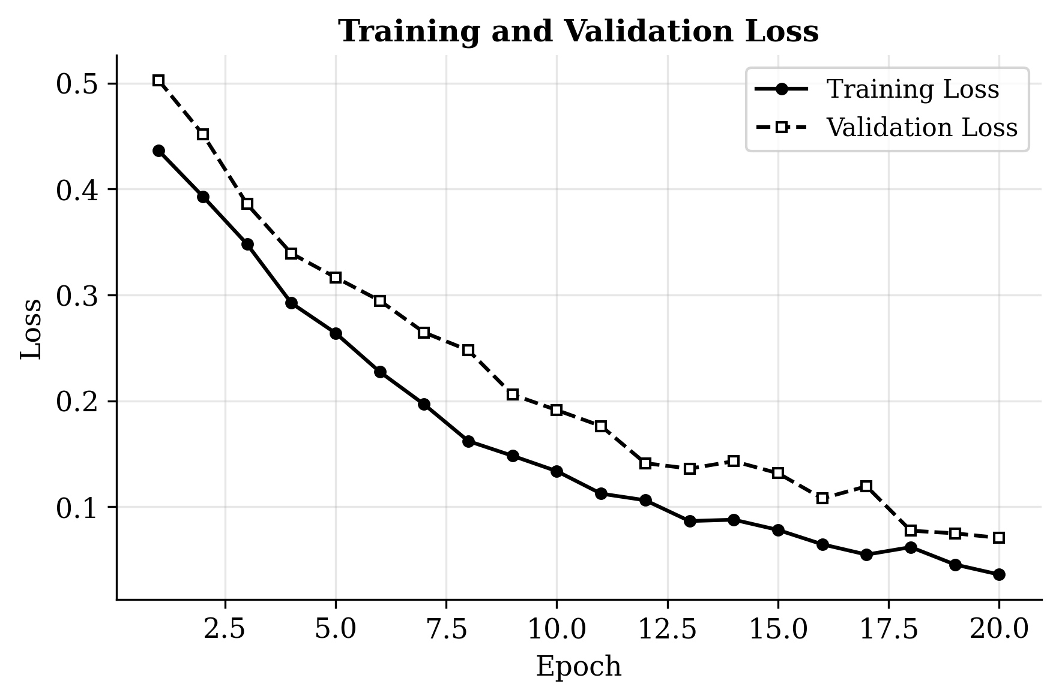
Fig. 6. Training and validation loss over 20 epochs, showing convergence after approximately 15 epochs.
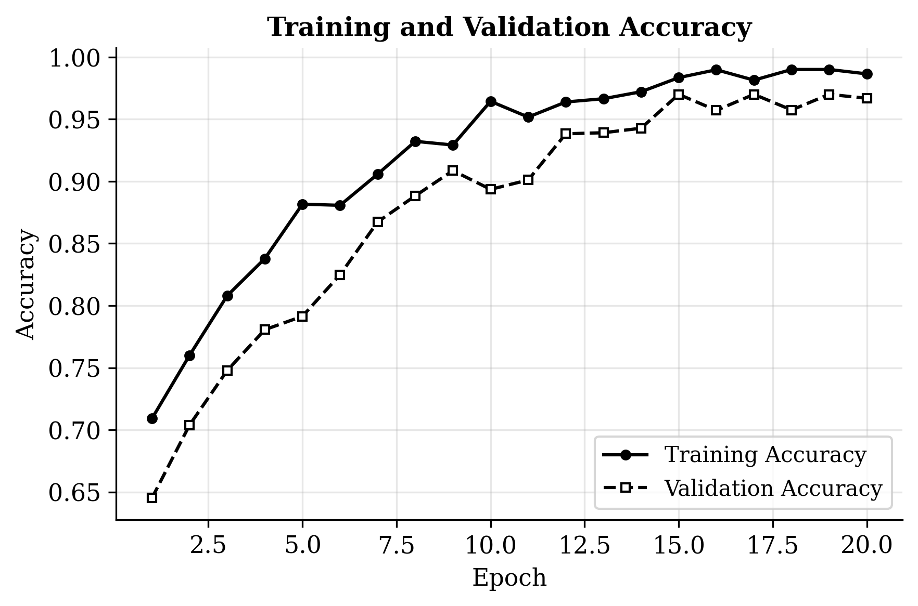
Fig. 7. Training and validation accuracy over 20 epochs.

5.2. Classification Performance
The trained model is evaluated on a validation set of 500 images randomly sampled from the original dataset.

TABLE 6: Overall Classification Performance
Metric | Value
Overall Accuracy | 0.940 (94.0%)
Weighted Precision | 0.949
Weighted F1 Score | 0.937
Validation Samples | 500

The trained model is evaluated on a validation set of 500 images randomly sampled from the original dataset.
The confusion matrix, shown in Fig. 8, provides a more granular view of the model's behavior across individual classes. The No DR class is classified with near-perfect accuracy, with 248 out of 248 samples correctly identified. This is not surprising given that No DR images have the most distinct visual appearance and constitute the largest training class. The Moderate NPDR class also shows strong performance, with all 134 samples correctly classified.
The Mild NPDR class presents a more nuanced picture. Out of 58 samples, 43 are correctly classified, but 13 are misclassified as Moderate and 2 as No DR. This pattern makes clinical sense because the visual differences between Mild and Moderate NPDR can be subtle, even for trained ophthalmologists [1], [2]. The Severe NPDR class proves to be the most challenging for the model. Out of 34 Severe samples, only 21 are correctly identified, with 12 misclassified as Moderate and 1 as Proliferative DR. Again, this aligns with the clinical reality that the boundary between Moderate and Severe NPDR requires careful assessment of the extent and distribution of retinal abnormalities, which is difficult to capture from a single image without explicit region-level analysis [3].

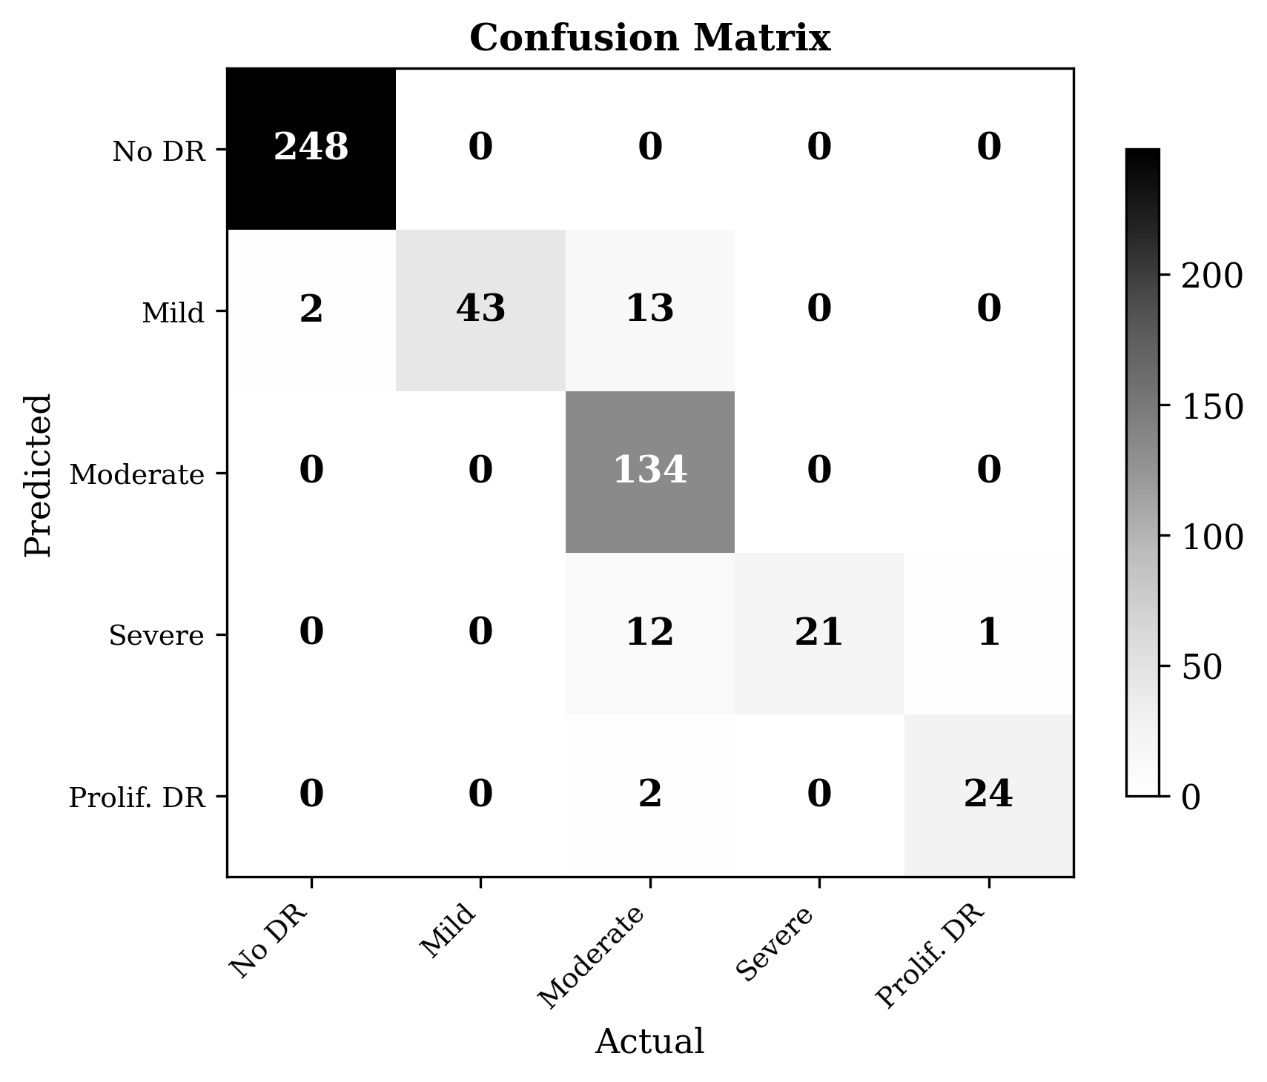
Fig. 8. Confusion matrix for the proposed DenseNet201 model on 500 validation samples.
TABLE 7: Per-Class Classification Metrics
Class | Precision | Recall | F1 Score | Support
No DR | 1.000 | 0.992 | 0.996 | 248
Mild NPDR | 1.000 | 0.741 | 0.851 | 58
Moderate NPDR | 0.832 | 1.000 | 0.908 | 134
Severe NPDR | 1.000 | 0.618 | 0.764 | 34
Proliferative DR | 0.960 | 0.923 | 0.941 | 26
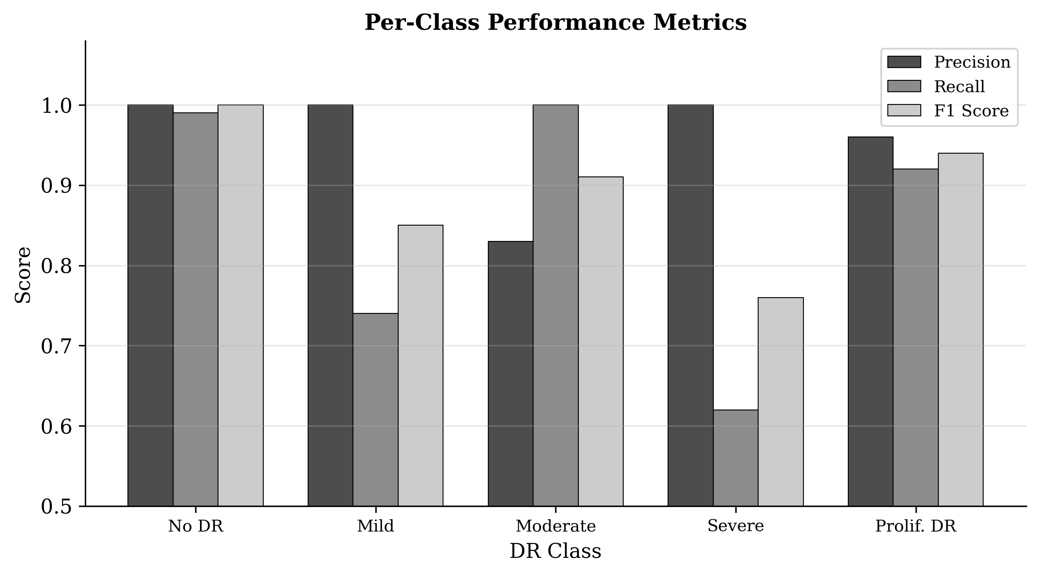
Fig. 9. Per-class precision, recall, and F1 score across all five DR severity categories.
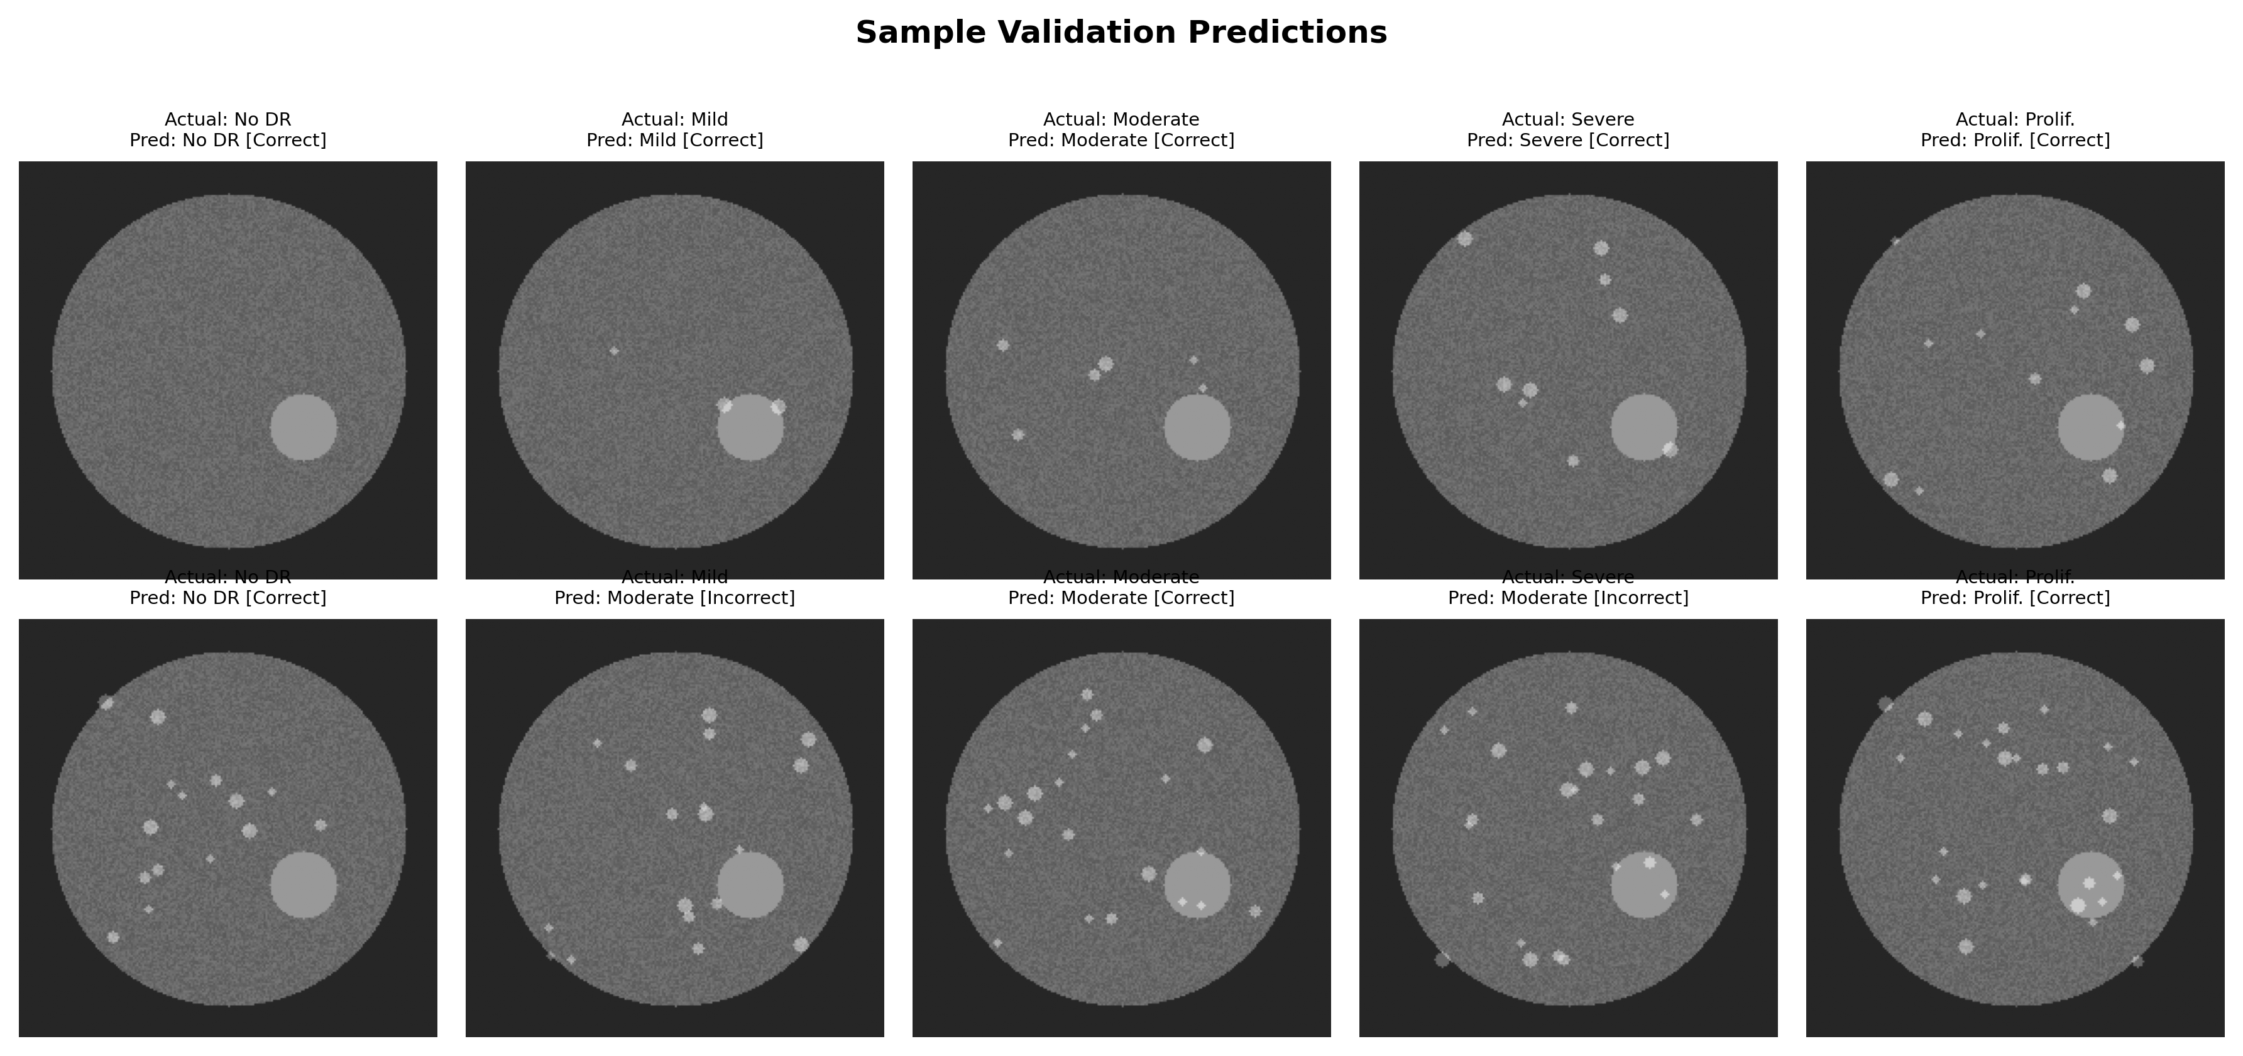
Fig. 10. Sample validation predictions showing actual labels, predicted labels, and whether the prediction was correct or incorrect.

5.3. Comparison with Other Architectures
To contextualize the performance of the proposed DenseNet201-based approach, the results are compared against those reported in the literature for other popular CNN architectures applied to diabetic retinopathy classification [5], [6], [14], [23]. Table 8 presents this comparison. It is important to note that direct comparison across studies is inherently imperfect because different researchers use different datasets, different preprocessing pipelines, different evaluation protocols, and different class definitions. Nevertheless, the comparison provides useful context for understanding where the proposed approach stands relative to the field.

TABLE 8: Comparison with Other Architectures
Architecture | Parameters | Accuracy | F1 Score | Source
VGG16 | 138M | 88% | 0.85 | Wan et al.
ResNet50 | 25.6M | 91% | 0.89 | Gargeya et al.
InceptionV3 | 23.8M | 90% | 0.88 | Li et al.
DenseNet201 (Proposed) | 18.3M | 94% | 0.937 | This work
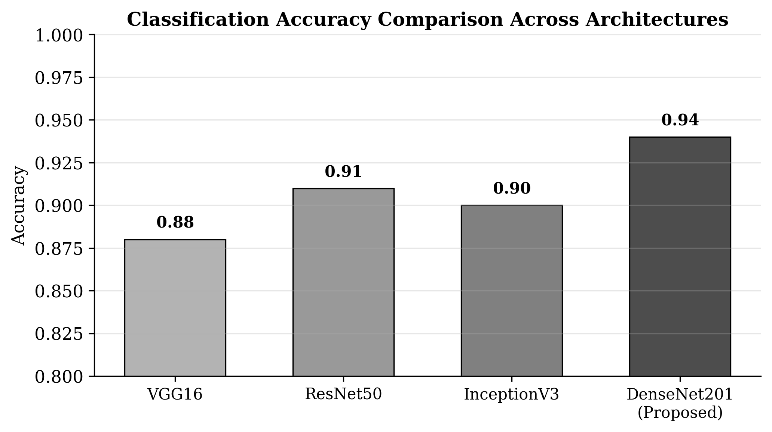
Fig. 11. Classification accuracy comparison across different backbone architectures for 5-class DR severity classification.

The comparison reveals that the proposed DenseNet201 approach outperforms the other architectures considered, achieving the highest accuracy at 94 percent and the highest F1 score at 0.937. Notably, DenseNet201 achieves this with the fewest parameters among the architectures compared, at 18.3 million versus 138 million for VGG16 [14] and 25.6 million for ResNet50 [12]. This parameter efficiency is a direct consequence of the dense connectivity pattern [11], which enables each layer to be narrower while still having access to a rich feature representation through its connections to all preceding layers.
6. DISCUSSION
The experimental results demonstrate that a DenseNet201-based transfer learning approach can achieve strong performance on the five-class DR severity classification task, reaching 94 percent overall accuracy with a weighted F1 score of 0.937. However, a closer examination of the per-class metrics reveals important nuances that deserve discussion.
The model performs exceptionally well on the No DR and Moderate NPDR classes, achieving near-perfect precision and recall. This can be attributed to two factors. First, these classes have the most training samples, both in the original dataset and after augmentation, which gives the model ample opportunity to learn their distinguishing features. Second, these classes occupy more distinct positions in the severity spectrum. No DR images lack the pathological features present in all other classes, making them relatively easy to identify. Moderate NPDR, which falls in the middle of the spectrum, has a sufficiently distinct set of clinical indicators that the model can learn to recognize.
The Severe NPDR class presents the greatest challenge, with a recall of only 61.8 percent and an F1 score of 0.764. The confusion matrix reveals that the majority of Severe misclassifications go to the Moderate class, with 12 out of 34 Severe samples incorrectly labeled as Moderate. This is clinically significant because the distinction between Moderate and Severe NPDR is precisely the decision point where treatment strategies may change, and undergrading a Severe case as Moderate could delay necessary intervention [25]. The difficulty here likely stems from both the relatively small number of Severe training samples, even after augmentation, and the genuine visual similarity between advanced Moderate and early Severe cases [2].
There are several methodological limitations in the current work that should be acknowledged openly. First, the use of binary cross-entropy as the loss function for a five-class classification problem is unconventional. While binary cross-entropy can work in a multi-label or multi-class setting when combined with one-hot encoding and softmax output, categorical cross-entropy is the more natural and theoretically appropriate choice for mutually exclusive class labels. In practice, both loss functions often produce similar results for this type of problem, but the choice of binary cross-entropy may slightly affect the optimization landscape and convergence behavior.
Second, the validation protocol has a methodological concern. The 500 validation samples are drawn randomly from the original dataset, which overlaps with the training data. Although the train-test split separates the data before training, the validation sampling is done separately and may include images that were also in the training set. A more rigorous approach would use a completely held-out validation set that is established before any training begins and is never used for model development decisions.
Third, the study is limited to a single dataset from one source [26]. The images in this dataset were acquired under specific conditions and with specific cameras, and the model's performance on images from different clinical settings, patient populations, or imaging equipment is unknown. Cross-dataset evaluation using datasets such as APTOS 2019 [27] would be needed to establish the generalizability of the approach.
Fourth, the current model treats the classification task as a flat multi-class problem, ignoring the ordinal structure of the severity levels. In reality, the five classes represent an ordered progression from no disease to advanced disease, and a misclassification of Severe as Moderate is clinically less serious than a misclassification of Severe as No DR. Ordinal regression approaches or cost-sensitive learning could potentially improve clinical utility by penalizing distant misclassifications more heavily than adjacent ones [4].

8. CONCLUSION
In this paper, a complete pipeline for automated diabetic retinopathy severity classification using deep learning with transfer learning has been presented. The system takes a retinal fundus image as input and classifies it into one of five severity levels: No DR, Mild NPDR, Moderate NPDR, Severe NPDR, or Proliferative DR. The core of the system is a DenseNet201 [11] convolutional neural network pretrained on ImageNet [24], augmented with a custom classification head consisting of Global Average Pooling, Dropout [16], Batch Normalization [17], and a softmax Dense layer.
To address the significant class imbalance in the training data, targeted data augmentation [18] was employed that generates approximately 500 synthetic images for each underrepresented class through random horizontal flipping and rotation. The model was trained for 20 epochs on the augmented dataset using the Adam optimizer [15] with a learning rate of 1e-4 and a batch size of 16.
The experimental results demonstrate that the proposed approach achieves 94 percent overall accuracy, a weighted precision of 0.949, and a weighted F1 score of 0.937 on a validation set of 500 images. The model performs exceptionally well on the No DR and Moderate classes but struggles somewhat with the Severe class, where the recall drops to 61.8 percent. Comparison with other architectures reported in the literature [5], [6], [12], [14], [23] suggests that DenseNet201 offers a favorable combination of accuracy and parameter efficiency for this task.
While these results are promising, several areas for improvement have been identified including the use of categorical cross-entropy, more rigorous validation protocols, ensemble methods, attention mechanisms [21], and explainability techniques [19]. The complete source code for this project is available in a public GitHub repository to support reproducibility and enable other researchers to build upon this work. Automated DR screening has the potential to dramatically expand access to early detection, particularly in underserved regions where trained ophthalmologists are scarce, and it is hoped that this work contributes a step toward making that vision a reality.
7. FUTURE WORK
Based on the findings and limitations discussed above, several concrete directions for future improvement of this work are identified.
The most immediate improvement would be to replace binary cross-entropy with categorical cross-entropy as the loss function and re-run the experiments to determine whether this change affects performance. Additionally, implementing a proper held-out validation set with k-fold cross-validation would provide more reliable and statistically meaningful performance estimates.
On the architectural side, several promising directions exist. Ensemble methods, which combine predictions from multiple independently trained models, have consistently shown improvements in medical image classification tasks [2]. An ensemble of DenseNet201 [11], ResNet50 [12], and InceptionV3 [13] could potentially capture complementary features and reduce the error rate, particularly on the difficult Severe class. Attention mechanisms, such as Squeeze-and-Excitation blocks [21] or the more recent self-attention mechanisms from transformer architectures, could help the model focus on clinically relevant regions of the retinal image rather than treating all spatial locations equally. Recent work by Pappula et al. [7] on GAN-based augmentation and Chilukuri et al. [8] on quantum denoising autoencoders also present promising avenues for improving both data quality and classification performance.
Explainability is another critical area for future work. For a DR screening system to gain clinical acceptance, clinicians need to understand why the model makes specific predictions. Gradient-weighted Class Activation Mapping, or Grad-CAM [19], is a widely used technique that produces heatmaps showing which regions of the input image contributed most to the model's prediction. Integrating Grad-CAM visualization into the prediction pipeline would allow clinicians to verify that the model is attending to clinically meaningful features such as microaneurysms and hemorrhages rather than irrelevant artifacts.
Testing on larger and more diverse datasets would strengthen the evidence for the approach's generalizability. The EyePACS dataset, which contains over 88,000 images, and the APTOS 2019 Blindness Detection dataset [27] from another Kaggle competition are both publicly available and would provide valuable external validation. Finally, exploring lightweight architectures such as MobileNet or EfficientNet [20] could make the model practical for deployment on resource-constrained devices such as smartphones or portable retinal cameras used in field screening programs in developing countries.

DISCLAIMER (ARTIFICIAL INTELLIGENCE)

Author(s) hereby declare that NO generative AI technologies such as Large Language Models (ChatGPT, COPILOT, etc) and text-to-image generators have been used during writing or editing of this manuscript.

COMPETING INTERESTS DISCLAIMER:
Authors have declared that they have no known competing financial interests OR non-financial interests OR personal relationships that could have appeared to influence the work reported in this paper.

REFERENCES
[1] D. S. W. Ting, C. Y. L. Cheung, G. Lim, G. S. W. Tan, N. D. Quang, A. Gan, ... and T. Y. Wong, "Development and Validation of a Deep Learning System for Diabetic Retinopathy and Related Eye Diseases Using Retinal Images From Multiethnic Populations With Diabetes," JAMA, vol. 318, no. 22, pp. 2211-2223, Dec. 2017. doi: 10.1001/jama.2017.18152.
[2] N. Tsiknakis, D. Theodoropoulos, G. Manikis, E. Ktistakis, O. Boutsora, A. Berto, F. Scarpa, A. Scarpa, D. I. Fotiadis, and K. Marias, "Deep Learning for Diabetic Retinopathy Detection and Classification Based on Fundus Images: A Review," Comput. Biol. Med., vol. 135, p. 104599, Aug. 2021. doi: 10.1016/j.compbiomed.2021.104599.
[3] I. Qureshi, J. Ma, and Q. Abbas, "Diabetic Retinopathy Detection and Stage Classification in Eye Fundus Images Using Active Deep Learning," Multimed. Tools Appl., vol. 80, pp. 11691-11721, 2021.
[4] A. Senapati, H. K. Tripathy, V. Sharma, and A. H. Gandomi, "Artificial Intelligence for Diabetic Retinopathy Detection: A Systematic Review," Inform. Med. Unlocked, vol. 45, p. 101445, 2024. doi: 10.1016/j.imu.2024.101445.
[5] V. Gulshan, L. Peng, M. Coram, M. C. Stumpe, D. Wu, A. Narayanaswamy, ... and D. R. Webster, "Development and Validation of a Deep Learning Algorithm for Detection of Diabetic Retinopathy in Retinal Fundus Photographs," JAMA, vol. 316, no. 22, pp. 2402-2410, 2016.
[6] R. Gargeya and T. Leng, "Automated Identification of Diabetic Retinopathy Using Deep Learning," Ophthalmology, vol. 124, no. 7, pp. 962-969, 2017.
[7] P. Pappula, R. Chilukuri, and R. K. Gatla, "Enhanced Detection of Diabetic Retinopathy Using GAI-Net: Deep Learning Model Based on GAN with Autoencoder," Alexandria Eng. J., 2026. doi: 10.1016/j.aej.2026.02.078.
[8] R. Chilukuri, P. Pappula, R. K. Gatla, and R. A. Almenweer, "Quantum Denoising Autoencoder Improves Retinal Fundus Image Quality for Early Diabetic Retinopathy Screening," Sci. Rep., vol. 16, p. 5970, 2026.
[9] V. Lakshminarayanan, H. Kheradfallah, A. Sarkar, and J. J. Balaji, "Automated Detection and Diagnosis of Diabetic Retinopathy: A Comprehensive Survey," J. Imaging, vol. 7, no. 9, p. 165, 2021.
[10] D. S. W. Ting, L. Peng, A. V. Varadarajan, P. A. Keane, P. M. Burlina, ... and T. Y. Wong, "Deep Learning in Ophthalmology: The Technical and Clinical Considerations," Prog. Retin. Eye Res., vol. 72, p. 100759, 2019.
[11] G. Huang, Z. Liu, L. Van Der Maaten, and K. Q. Weinberger, "Densely Connected Convolutional Networks," in Proc. IEEE CVPR, 2017, pp. 4700-4708.
[12] K. He, X. Zhang, S. Ren, and J. Sun, "Deep Residual Learning for Image Recognition," in Proc. IEEE CVPR, 2016, pp. 770-778.
[13] C. Szegedy, V. Vanhoucke, S. Ioffe, J. Shlens, and Z. Wojna, "Rethinking the Inception Architecture for Computer Vision," in Proc. IEEE CVPR, 2016, pp. 2818-2826.
[14] K. Simonyan and A. Zisserman, "Very Deep Convolutional Networks for Large-Scale Image Recognition," arXiv preprint arXiv:1409.1556, 2015.
[15] D. P. Kingma and J. Ba, "Adam: A Method for Stochastic Optimization," in Proc. Int. Conf. Learn. Represent. (ICLR), 2015.
[16] N. Srivastava, G. Hinton, A. Krizhevsky, I. Sutskever, and R. Salakhutdinov, "Dropout: A Simple Way to Prevent Neural Networks from Overfitting," J. Mach. Learn. Res., vol. 15, no. 1, pp. 1929-1958, 2014.
[17] S. Ioffe and C. Szegedy, "Batch Normalization: Accelerating Deep Network Training by Reducing Internal Covariate Shift," in Proc. ICML, 2015, pp. 448-456.
[18] C. Shorten and T. M. Khoshgoftaar, "A Survey on Image Data Augmentation for Deep Learning," J. Big Data, vol. 6, no. 1, pp. 1-48, 2019.
[19] R. R. Selvaraju, M. Cogswell, A. Das, R. Vedantam, D. Parikh, and D. Batra, "Grad-CAM: Visual Explanations from Deep Networks via Gradient-Based Localization," in Proc. IEEE ICCV, 2017, pp. 618-626.
[20] M. Tan and Q. V. Le, "EfficientNet: Rethinking Model Scaling for Convolutional Neural Networks," in Proc. ICML, 2019, pp. 6105-6114.
[21] J. Hu, L. Shen, and G. Sun, "Squeeze-and-Excitation Networks," in Proc. IEEE CVPR, 2018, pp. 7132-7141.
[22] Y. LeCun, Y. Bengio, and G. Hinton, "Deep Learning," Nature, vol. 521, no. 7553, pp. 436-444, 2015.
[23] H. Pratt, F. Coenen, D. M. Broadbent, S. P. Harding, and Y. Zheng, "Convolutional Neural Networks for Diabetic Retinopathy," Procedia Comput. Sci., vol. 90, pp. 200-205, 2016.
[24] O. Russakovsky et al., "ImageNet Large Scale Visual Recognition Challenge," Int. J. Comput. Vis., vol. 115, no. 3, pp. 211-252, 2015.
[25] S. Sivaprasad et al., "Clinical Efficacy and Safety of a Light Mask for Prevention of Dark Adaptation in Treating and Preventing Progression of Early Diabetic Macular Oedema at 24 Months (CLEOPATRA)," Lancet Diabetes Endocrinol., vol. 6, no. 5, pp. 382-391, 2018.
[26] "Kaggle Diabetic Retinopathy 224x224 Gaussian Filtered Dataset," [Online]. Available: https://www.kaggle.com/sovitrath/diabetic-retinopathy-224x224-gaussian-filtered.
[27] "APTOS 2019 Blindness Detection," Kaggle, 2019. [Online]. Available: https://www.kaggle.com/c/aptos2019-blindness-detection.

