Original Research Article

Seismic Attenuation Models for Peak Ground Acceleration Along Source-to-Site Trajectories from the Pacific Subduction Zone to the City of Querétaro, México

.
ABSTRACT

This article presents four seismic attenuation relationships to estimate the Peak Ground Acceleration (PGA) in rock from interplate earthquakes in the city of Querétaro, Mexico, by analyzing specific source-to-site trajectories: Jalisco-Colima, Michoacán, Guerrero, and Oaxaca. The motivation for this study lies in the fact that, to date, the state of Querétaro has a PGA attenuation relationship limited to earthquakes with epicenters in Guerrero. While previous research has analyzed trajectories from Colima, Guerrero, and Oaxaca, it has omitted data from earthquakes with epicenters in Michoacán.
This research proposes a functional form that considers the variables of moment magnitude, depth, and hypocentral distance, excluding the site effect variable to focus on the response in rock. The regression analysis was performed using the one-stage maximum likelihood method. The attenuation relationships obtained in this research are compared with previously developed models, and the observed differences are shown through attenuation curves and residual analysis.
The attenuation relationships were validated using seismic data from actual data observations records. It is concluded that the proposed models allow for the estimation of PGA with overestimations and underestimations of 1.44, 1.81, 2.01, and 1.91 for seismic events with epicenters in Jalisco-Colima, Michoacán, Guerrero, and Oaxaca, respectively. Trajectory analysis allowed for the estimation of average Peak Ground Acceleration values ​​in the city of Querétaro of 0.09 cm/s², 0.67 cm/s², 0.37 cm/s², and 0.13 cm/s² for earthquakes with epicenters in Jalisco-Colima, Michoacán, Guerrero, and Oaxaca.

Keywords: attenuation relationships, peak ground acceleration, interplate earthquakes, Mexican Volcanic Belt.

1. INTRODUCTION

Most earthquake epicenters in México are concentrated in the Pacific Ocean subduction zone, specifically in the states of Oaxaca, Guerrero, Chiapas, Jalisco, Michoacán and Colima (SSN, 2026). Due to their origin, they are classified as interplate earthquakes and have historically caused significant human and material losses around the epicenter and in the Mexican Volcanic Belt (Mexican Geological Survey, 2017).

The Mexican Volcanic Belt (MVB) is a geological province that extends from west to east, from Nayarit to Veracruz and constitutes one of the most geologically and geophysically relevant regions in México (Gómez-Tuena et al., 2005). This area is also home to a large part of the country’s population and infrastructure, which increases its vulnerability to seismic events (INEGI, 2025). Despite this, most of the states located within the MVB lack their own seismic resistant design codes, as a consequence they adopt criteria from regulations developed for other regions, such as the Complementary Technical Standards of the Mexico City Building Regulations or the Civil Works Design Manual of the Federal Electricity Commission (Pérez-Gavilán et al., 2018). This practice can result in the under-or over-design of structures, as local site conditions are not adequately considered.

For the seismic design of a structure, absolute maximum ground motion accelerations are adopted, which can be estimated through attenuation relationships by mathematically representing it as a function of characteristic variables of a seismic event; such as those associated with the source, the propagation medium and the site response (Ordoñez Sacapi & Salazar Riera, 2023).

Peak Ground Acceleration (PGA) is one of the variables commonly used in attenuation relationships and its units are usually expressed in cm/s². The PGA variable is commonly used to describe the intensity and damage caused by an earthquake at a specific location, since inertial forces depend directly on acceleration (de la Blanca et al., 2012).

Currently, the study of seismic attenuation is a topic of great interest in damage prevention. Understanding how seismic intensity decreases with epicentral distance, how frequently this decrease occurs, and how it relates to the properties of the medium are fundamental for an accurate characterization of seismic hazard (García, 2001).

Previous studies have examined the amplification differences of earthquakes with epicenters in the states of Colima and Guerrero, extending into the interior of the country. These studies concluded that the presence of the MVB is the primary factor that controls regional differences in seismic amplification. They also showed that this effect is visible starting at 50 km from the source for earthquakes in Colima, where the relative amplitude reaches a factor of 3 at epicentral distances of 125 km and decreases at 240 km. In contrast earthquakes in Guerrero presented higher amplitudes than those in Colima at epicentral distances greater than 240 km (Shapiro et al., 1997; Cruz-Jiménez et al., 2009). Furthermore, Clemente-Chávez et al., (2014) observed that a quarter of the northeastern of the MVB presents low levels of amplification.

Seismic attenuation relationships have also been developed from interplate earthquakes, such as the Ordaz (1989) model based on 64 earthquakes obtained from the Guerrero Accelerograph Network, with magnitudes 5.0 ≤ Mw ≤ 8.0 and distances less than 350 km, which has a standard deviation of 0.25. Subsequently, García (2006) presented a model developed from interplate earthquakes with epicenters between Colima and Oaxaca, magnitudes 5.0 ≤ Mw ≤ 8.0, distances less than 400 km, with a standard deviation of 0.33. Later, Clemente et al., (2012) developed a seismic attenuation relationship for the state of Queretaro obtained from three seismic events in Guerrero, 5.2 ≤ Mw ≤ 6.6, distances less than 380 km, which has a standard deviation of 0.21.

To date, only one attenuation relationship has been developed for the state of Querétaro, describing the ground motion acceleration associated with subduction earthquakes. Clemente-Chávez & Figueroa-Soto (2018) analyzed seismic signals along trajectories in the subduction zone, specifically from the states of Colima, Guerrero and Oaxaca toward the state of Querétaro. They concluded that earthquake accelerations with epicenters in Oaxaca are highest in the MVB, followed by Colima and Guerrero; however, their analysis does not include earthquakes with epicenters in Michoacán.

Within the international context, recent NGA-Subduction project GMMs have been developed by incorporating records of larger magnitude earthquakes and more precise site characterization. For example, Zhao et al., (2016) and Abrahamson et al., (2016) proposed ground-motion prediction equations (GMPEs) for subduction zones in Japan and globally, respectively, agreeing on the implementation of scaling functions to address the saturation of events with M_{w} magnitudes greater than 7.1 and 7.8. Along similar lines, Montalva et al., (2017) demonstrated that the use of directly measured site parameters, such as V_{S30}, reduces uncertainty in acceleration predictions for the region. Additionally, studies in deep alluvial environments, such as that by Tiwari et al., (2024) in India underline that local geology and sediment thickness can amplify seismic signals up to 3.2 times, highlighting the critical need to integrate detailed site effects to improve the reliability of seismic hazard assessments in urban infrastructure.

Rivas Nieto (2020) obtained Peak Ground Acceleration attenuation relationships for crustal earthquakes in the MVB using the one-stage maximum likelihood method. He divided the region into four zones according to the characteristics of the sectors described in Ferrari et al. (2012). For the West, Central, and East zones, models with good fit were presented, and they also included the site effect variable in their equations. He attempted to deduce a general attenuation relationship for the entire study area; however, due to the dispersion of the data, the degree of approximation obtained was low.

For this reason, this research developed PGA attenuation relationships in rock for the city of Querétaro using interplate earthquake records from four trajectories originating from the Pacific Ocean subduction zone. This information can be used for future studies aimed at delineating seismic hazard in the MVB.

2. Methodology

2.1 Data

To calculate the attenuation relationships, 351 velocity records from 51 interplate seismic events that occurred between 2011 and 2022 were used, with moment magnitudes (Mw) between 5.0 and 7.7 and depths from 3.2 to 24.1 km, distributed in four main trajectories towards the city of Querétaro.

Following the methodology proposed by Clemente-Chávez et al. (2012) and Clemente-Chávez and Figueroa-Soto (2018), individual trajectories were defined from the seismic origin to the site of interest. This approach allows for the specificization of both the source direction and the influence of local stratigraphy, achieving a reduction in the standard deviation of the residuals compared to attenuation models that average multiple trajectories (e.g., García 2006). Thus, trajectory analysis allows for the characterization of ground motion attenuation as a specific function of the source-site distance.

For this reason, the direction of the trajectories was defined by seismological stations with rocky emplacement using the HVSR technique (European Commission, Havenith, 2004) and taking as a reference studies carried out by Clemente-Chávez et al., (2014), Pérez-Moreno et al., (2021) and Martínez-Rivera et al., (2022), starting from the states on the Pacific Ocean coast, Colima, Jalisco, Michoacán, Oaxaca and Guerrero towards Querétaro.

Seismic stations belonging to the broadband network of the National Seismological Service were considered; the UNM station of the GEOSCOPE observatory; the JRQG, TXMV, R2E0F, RB158, R8296 and R03C7 stations of the UNAM Geosciences Institute and the UAQ-CH seismological station temporarily installed on the historic campus of the Autonomous University of Queretaro in collaboration with the Institute of Earth Sciences Research of the Michoacan University of San Nicolas de Hidalgo.

Figure 1 show the defined trajectories for Jalisco-Colima, Michoacán, Guerrero and Oaxaca from the seismic stations that did not present significant impedance contrasts.

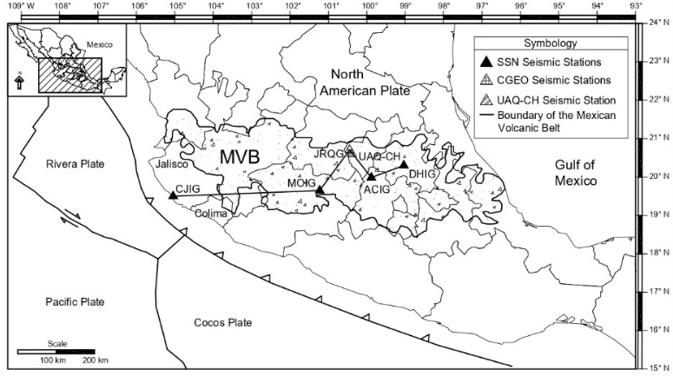  a) | 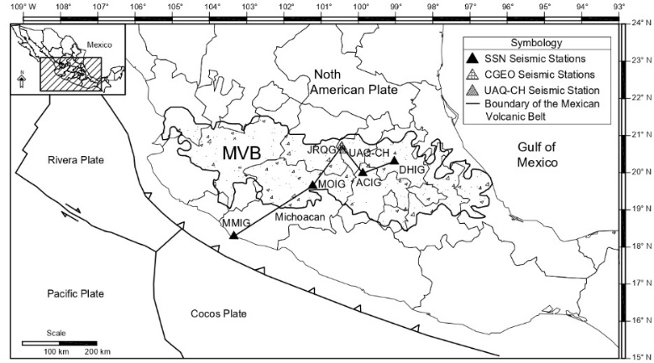  b)
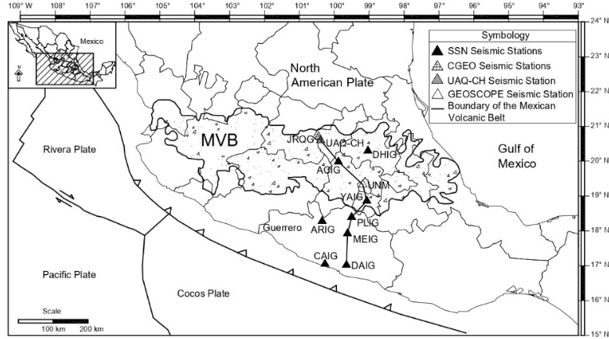  c) | 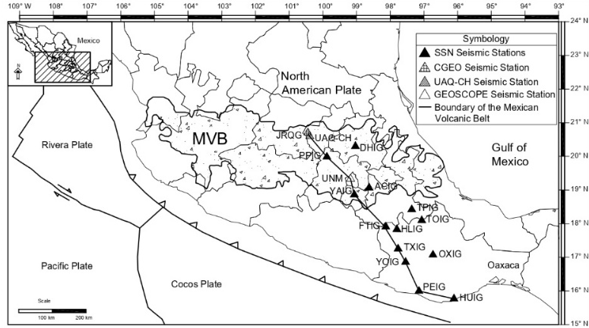  d)
Figura 1 a) Jalisco/Colima- Querétaro Trajectory, b) Michoacán-Queretaro Trajectory, c) Guerrero-Querétaro Trajectory and d) Oaxaca-Querétaro Trajectory
Subsequently, seismic traces were obtained from stations located in the state of Querétaro, as this is the primary site of interest in this research. Using the earthquakes recorded at JRQG and UAQ-CH as a reference, the search for seismic traces at each station along the path corresponding to the earthquake’s epicenter was conducted. For a seismic event to be considered, it had to have at least three seismic traces (North-South, East-West and Vertical) at three stations within the defined trajectory, seismic events that did not meet this characteristic were discarded.

The following aspects were considered as acceptance criteria: seismic records showing the arrival of P and S waves, as well as a Signal-to-Noise ratio > 2. The seismic traces were subjected to a baseline correction (Boore, 2005), deconvolved to remove the instrumental response and derived to convert from velocity units to acceleration (cm/s²). Figure 2 illustrates the described characteristics.

Finally, the maximum ground motion accelerations, PGA, were obtained from mean squares of the maximum acceleration of the orthogonal components (Boore et al., 2006):

$PGA={\left(\frac{A_{E}^{2}+A_{N}^{2}}{2}\right)}^{\frac{1}{2}}$ (1)

where PGA is the maximum ground acceleration in cm/s². A_{E} is the maximum acceleration of the East-West component; A_{N} is the maximum acceleration of the North-South component.

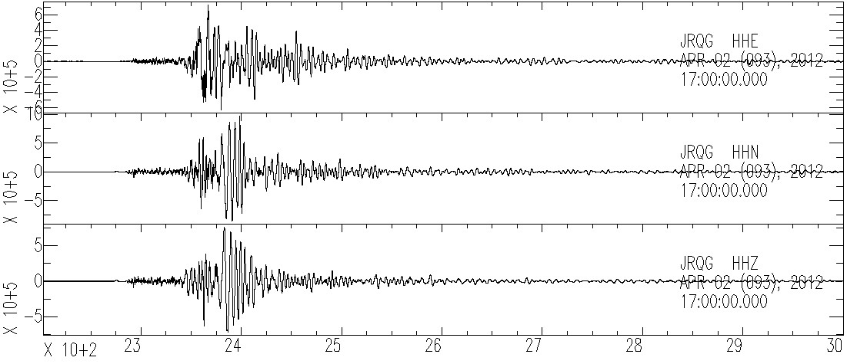
Figure 2 Seismic signal with S/R ratio > 2

Table 1 presents the 5 earthquakes used for the Jalisco/Colima-Querétaro trajectory, from which 18 acceleration data points were obtained. Table 2 shows the 7 earthquakes included in the Michoacán-Querétaro trajectory, from which 32 acceleration data points were obtained. Table 3 presents the 21 seismic events for the Guerrero-Querétaro trajectory, from which 145 acceleration data points were obtained from the various stations located along this trajectory. Finally, Table 4 shows the 18 earthquakes considered for the Oaxaca trajectory, from which 156 acceleration data points were obtained.

Table 1. Earthquakes for the Jalisco/Colima-Querétaro Trajectory
Magnitude (Mw) | Latitude (N°) | Longitude (W°) | Depth (km) | UTC Date | UTC Time
5.6 | 18.50 | -103.99 | 3.20 | 20/02/2013 | 21:23:09
5.6 | 18.82 | -104.74 | 13.50 | 23/10/2016 | 22:59:29
5.9 | 18.95 | -104.81 | 3.50 | 09/02/2018 | 14:05:48
5.9 | 18.88 | -105.27 | 15.70 | 30/06/2018 | 03:56:49
5.3 | 18.45 | -103.88 | 6.00 | 19/09/2022 | 19:30:42
*Note: UTC (Coordinated Universal Time). Source: SSN (2026)

Table 2. Earthquakes for the Michoacán-Querétaro Trajectory
Magnitude (Mw) | Latitude (N°) | Longitude (W°) | Depth (km) | UTC Date | UTC Time
6.4 | 17.92 | -103.07 | 20.00 | 11/04/2012 | 22:55:10
5 | 17.87 | -102.50 | 23.30 | 29/09/2015 | 15:02:15
5.1 | 18.14 | -103.52 | 5.00 | 17/07/2018 | 08:54:37
5.0 | 17.77 | -101.90 | 5.00 | 19/04/2022 | 12:44:10
7.7 | 18.22 | -103.29 | 15.00 | 19/09/2022 | 18:05:09
5.4 | 18.14 | -103.25 | 16.00 | 20/09/2022 | 19:04:29
6.9 | 18.01 | -103.18 | 12.00 | 22/09/2022 | 06:16:09
*Note: UTC (Coordinated Universal Time). Source: SSN (2026)
Table 3. Earthquakes for the Guerrero-Querétaro Trajectory
Magnitude (Mw) | Latitude (N°) | Longitude (W°) | Depth (km) | UTC Date | UTC Time
5.2 | 16.71 | -99.68 | 8.00 | 26/04/2011 | 11:07:28
5.6 | 16.61 | -98.91 | 12.00 | 05/05/2011 | 13:24:07
7.5 | 16.26 | -98.46 | 18.00 | 20/03/2012 | 18:02:48
5.3 | 16.46 | -98.54 | 20.00 | 01/04/2012 | 22:23:48
5 | 16.49 | -98.49 | 12.10 | 15/01/2013 | 19:20:27
5.2 | 17.11 | -100.81 | 15.20 | 05/04/2013 | 01:58:48
5 | 16.51 | -98.61 | 20.00 | 06/08/2013 | 20:17:30
5.1 | 16.51 | -98.58 | 17.40 | 16/08/2013 | 15:33:00
5.1 | 16.83 | -100.11 | 5.00 | 06/10/2013 | 15:10:56
7.1 | 17.01 | -101.46 | 18.00 | 18/04/2014 | 14:27:21
5.0 | 17.35 | -101.31 | 18.00 | 19/04/2014 | 14:58:15
6.5 | 16.98 | -100.92 | 10.00 | 08/05/2014 | 17:00:14
5.9 | 17.03 | -100.89 | 10.00 | 10/05/2014 | 07:36:00
5.1 | 16.52 | -100.47 | 10.00 | 23/07/2014 | 00:28:14
5.1 | 17.11 | -100.82 | 16.20 | 04/08/2014 | 00:21:50
5 | 17.00 | -99.73 | 8.50 | 13/02/2017 | 07:29:30
5.0 | 16.85 | -100.45 | 5.70 | 18/08/2017 | 05:15:12
5 | 16.99 | -99.85 | 21.70 | 25/12/2017 | 20:23:11
Magnitude (Mw) | Latitude (N°) | Longitude (W°) | Depth (km) | UTC Date | UTC Time
5.3 | 16.53 | -98.74 | 8.10 | 22/08/2018 | 18:03:08
5.0 | 16.83 | -100.10 | 17.50 | 30/01/2020 | 06:47:22
5.0 | 16.51 | -98.53 | 16.00 | 14/10/2022 | 23:28:02
*Note: UTC (Coordinated Universal Time). Source: SSN (2026)
Table 4. Earthquakes for the Oaxaca-Querétaro Trajectory
Magnitude (Mw) | Latitude (N°) | Longitude (W°) | Depth (km) | UTC Date | UTC Time
5.1 | 15.23 | -95.65 | 16.30 | 18/02/2012 | 01:37:58
5.3 | 16.18 | -98.54 | 12.60 | 20/03/2012 | 18:35:38
5.2 | 16.36 | -98.29 | 5.60 | 20/03/2012 | 20:14:40
5 | 15.87 | -98.58 | 14.20 | 22/03/2012 | 16:46:42
5.2 | 16.15 | -98.35 | 5.00 | 13/04/2012 | 10:10:03
5.4 | 16.26 | -98.28 | 4.60 | 22/09/2012 | 12:29:57
5.5 | 15.88 | -98.67 | 16.90 | 29/09/2012 | 07:11:10
5.8 | 15.83 | -98.48 | 4.80 | 10/03/2014 | 00:37:57
6 | 16.32 | -97.88 | 7.40 | 08/05/2016 | 07:33:59
5.7 | 16.21 | -98.00 | 4.40 | 27/06/2016 | 20:50:31
5.2 | 15.93 | -98.38 | 15.00 | 21/12/2017 | 03:23:32
7.2 | 16.22 | -98.01 | 16.00 | 16/02/2018 | 23:39:39
5 | 15.95 | -98.73 | 14.60 | 20/03/2018 | 16:43:55
5.3 | 16.02 | -98.70 | 12.00 | 20/03/2018 | 17:46:54
5.1 | 15.40 | -94.65 | 24.10 | 29/06/2018 | 09:16:39
5.5 | 15.96 | -98.67 | 15.80 | 22/04/2019 | 20:15:23
5.1 | 16.25 | -98.32 | 6.90 | 11/01/2020 | 14:22:02
5.1 | 16.21 | -98.07 | 6.70 | 15/01/2020 | 08:15:23
*Note: UTC (Coordinated Universal Time). Source: SSN (2026)
2.2 Regression Analysis

The functional form proposed by Boore et al., (2003) was implemented. The general structure is described by equation 2, thus satisfying the physical conditions for scaling ground motion with distance and magnitude.

$\log_{10}PGA=C_{1}+C_{2}M+C_{3}H+C_{4}R-glog_{10}\left(R\right)+ϵ_{e}+ϵ_{r}$ (2)

where PGA is the maximum ground motion acceleration in gales (cm/s²); C_{i} are the coefficients determined by means of the regression model; M is the seismic moment magnitude (Mw); H is the hypocentral depth in km; R is the hypocentral distance in km, $ϵ_{e}+ϵ_{r}$ are random variables that take a specific value for each seismic record and event.

The specific considerations were made to simplify the model based on the available information, these consisted of defining the distance as hypocentral, in addition to not considering any variable related to the site effect, because the seismic records used were taken from stations on bedrock.

2.2.1 Regression Analysis

The one-stage maximum likelihood method described by Boore et al., (1993) was applied to calculate the attenuation ratio coefficients because it provides more reliable approximations compared to the least squares method (Contreras Luarte, 2009). The formulation used is shown below:

$Y=\left[\begin{matrix}\log_{10}{(A_{1})} \\ \log_{10}{(A_{2})} \\ . \\ \log_{10}{(A_{N})}\end{matrix}\right]$ (3)

$B=\left[\begin{matrix}C_{1} \\ C_{2} \\ C_{3} \\ C_{4} \\ g\end{matrix}\right]$ (4)

$X=\left[\begin{matrix}1 & M_{1} & H_{1} & R_{1} & \log_{10}{(R_{1})} \\ 1 & M_{2} & H_{2} & R_{2} & \log_{10}{(R_{2})} \\ 1 & . & . & . & . \\ 1 & M_{N} & H_{N} & R_{N} & \log_{10}{(R_{3})}\end{matrix}\right]$ (5)

where N is the total number of records corresponding to each earthquake, thus equation 2 can be written as:

$Y=XB+e$ (6)

where e is the vector of deviations composed of $ϵ_{r}$ and $ϵ_{e}$

Equation 6 is linear and the parameters are obtained from an iterative process, assuming that the components of e are normally distributed with mean zero and variance-covariance matrix V.

The likelihood of the sample of observations is (Searle, 1997):

$L={(2π)}^{-\frac{N}{2}}{\left\lceil V\right\rceil }^{-\frac{1}{2}}\exp\left[-\frac{1}{2}{\left(Y-XB\right)}^{T}V^{-1}(Y-XB)\right]$ (7)

where T indicates matrix transposition and | | denotes the determinant. Thus, for a given V, maximizing the likelihood function L with respect to matrix B is equivalent to minimizing:

${\left(Y-XB\right)}^{T}V^{-1}(Y-XB)$ (8)

The solution Searle (1997) is:

$\hat{B}={(X^{T}V^{-1}X)}^{-1}X^{T}V^{-1}Y$ (9)

The variance-covariance matrix V describes how the errors of all observations vary together. It has a diagonal block structure, where each block corresponds to an earthquake and includes the covariances between records of the same event. The variance of an individual component is $σ_{r}^{2}+σ_{e}^{2}$. The normalized matrix ν is defined as:

$σ^{2}ν=V$ (10)

Where $σ^{2}=σ_{r}^{2}+σ_{e}^{2}$ and the matrix ν is also a block diagonal:

$ν=\left[\begin{matrix}ν_{1} & 0 & 0 & 0 \\ 0 & ν_{2} & . & 0 \\ . & . & . & . \\ 0 & 0 & . & ν_{Ne}\end{matrix}\right]$ (11)

Where N_{e} is the number of earthquakes. The matrix ν_{i} corresponding to each earthquake is given by:

$ν_{i}=\left[\begin{matrix}1 & y & . & y \\ y & 1 & . & . \\ . & . & . & . \\ y & y & . & 1\end{matrix}\right]$ (12)

Where $y=σ_{e}^{2}/\left(σ_{r}^{2}+σ_{e}^{2}\right)$. The range of matrix ν_{i} is R_{i}, the number of records for earthquake i. Substituting equation 10 into equation 9, we obtain:

$\hat{B}={\left(X^{T}ν^{-1}X\right)}^{-1}X^{T}ν^{-1}Y$ (13)

Replacing equation 10 in 7, we obtain the probability:

$L={(2π)}^{-\frac{N}{2}}{\left|σ^{2}ν\right|}^{-\frac{1}{2}}\exp\left[-\frac{1}{2}{\left(Y-XB\right)}^{T}{\left(σ^{2}ν\right)}^{-1}(Y-XB)\right]$ (14)

Using the natural logarithm in expression 14 we obtain:

$\ln\left(L\right)=-\frac{N}{2}\ln\left(2π\right)-\frac{N}{2}\ln{{(σ)}^{2}-\frac{1}{2}\ln\left|ν\right|-\frac{1}{2}{\left(Y-XB\right)}^{T}ν^{-1}(Y-XB)/σ^{2}}$ (15)

The likelihood equation L must be maximized with respect to y, B and $σ^{2}$. Differentiating function 15 with respect to $σ^{2}$:

$σ^{2}={\left(Y-X\hat{B}\right)}^{T}ν^{-1}(Y-X\hat{B})/N$ (16)

To obtain the value of y, the values of $\hat{B}$, $σ^{2}$ and the probability L are calculated by maximizing with respect to $\hat{B}$ and $σ^{2}$.
An unbiased estimate for the value of $σ^{2}$ is:

$σ^{2}={\left(Y-X\hat{B}\right)}^{T}ν^{-1}(Y-X\hat{B})/(N-5)$ (17)

where N-5 indicates the degrees of freedom.

2.2.2 Goodness of Fit Assessment

Two paired-samples goodness-of-fit techniques were used to verify whether the observed data significantly matched the proposed data.

The first, the Wilcoxon Signed-Rank test, is used when the sample size is small (n < 30) and the assumptions of normality are not met. This test requires that the pairwise differences (D_{i}= Y_{i} - X_{i}) be symmetric and orderable random variables. The null hypothesis (H_{o}: M_{D} = 0) states that the median of the theoretical differences is zero, while the alternative (H_{a}: M_{D} ≠ 0) indicates a difference other than zero. The procedure consists of eliminating null differences, assigning ranks to the absolute values of the differences, and calculating the test statistic T as the sum of the ranks corresponding to the positive differences. The decision is based on comparing T with the critical values, defined for a significance level α= .05, rejecting H_{o} if T falls outside the interval defined by these (Infante-Gil & de Lara, 2012).

The second test applied was Chi-square, which is based on the comparison between observed and expected frequencies. To ensure the validity of the approximation, the expected frequencies must be greater than five. The null hypothesis is rejected when the calculated statistic exceeds the critical value of the Chi-square distribution with k - 1 degrees of freedom, considering a significance level of .05 (Infante-Gil & de Lara, 2012).

3. results and discussion

After performing the corresponding iterations that maximized the value of equation 15, the following seismic attenuation relationships were obtained for each trajectory:

Jalisco/Colima- Querétaro Trajectory

$logPGA=-2.9755+0.9060 M_{w}+0.0012H-0.0041R-0.5421\log_{10}{(R)}$ (18)

Michoacán-Querétaro Trajectory

$logPGA=-1.5751+0.7164M_{w}-0.0001H-0.0051R-0.5179\log_{10}{(R)}$ (19)

Guerrero-Querétaro Trajectory

$logPGA=-1.7595+0.8007M_{w}-0.0026H-0.0040R-0.7480\log_{10}{(R)}$ (20)

Oaxaca-Querétaro Trajectory

$logPGA=0.7622+0.4132 M_{w}-0.0032H-0.0025R-1.0816\log_{10}{(R)}$ (21)

3.1 Goodness of Fit Assessment

For the Wilcoxon Signed-Rank test (T- test) on the Jalisco/Colima-Querétaro trajectory, 15 seismic data points were considered. A T-value of 57 was obtained, in contrast to a Tcrit= 20 obtained from the tables of critical values for a two-tailed 5% significance level. Since T > Tcrit, the null hypothesis is accepted, indicating that there are no significant differences between the medians of the observed and predicted values.

For the evaluation of the goodness of fit in the Michoacán-Querétaro trajectory, the Wilcoxon T analysis was also used from 29 seismic record data, resulting in a value of T= 222 and a Tcrit= 114. Since T > Tcrit the null hypothesis cannot be rejected.

For the Guerrero-Querétaro trajectory, the Chi-square goodness of fit test was used. The 142 seismic acceleration data points were grouped into five categories in logarithmic form. Table 5 shows the grouped dataset, where n_{i} are the observed PGA values and n_{pi} are the predicted values:

Table 5. Chi-square test result
 |  | n_{i} |  | n_{pi} | X²
$$-∞$$ | -1.11 | 24 |  | 18 | 2.00
-1.11 | -0.40 | 35 |  | 38 | 0.24
-0.40 | 0.31 | 44 |  | 51 | 0.96
0.31 | 1.02 | 25 |  | 23 | 0.17
1.02 | $$+∞$$ | 14 |  | 12 | 0.33
 |  |  |  | $$\sum{χ^{2}}$$ | 3.70

With a significance value of 5% and 4 degrees of freedom, a critical value in tables, $χ^{2}$ equal to 9.49 was obtained, which when compared with the $χ^{2}$ value of the test, 3.70, indicates that the null hypothesis can be accepted, that is, the deduced attenuation relationship fits the data adequately.

The Chi-square test was also used for the Oaxaca-Querétaro trajectory. Table 6 shows the test results, where a $χ^{2}$ value of 4.96 was obtained, which is still less than the critical value, therefore the null hypothesis is accepted.

Table 6. Chi-square test result
 |  | n_{i} |  | n_{pi} | X²
$$-∞$$ | -0.52 | 40 |  | 43 | 0.21
-0.52 | -0.12 | 44 |  | 43 | 0.02
-0.12 | 0.28 | 39 |  | 38 | 0.03
0.28 | 0.68 | 13 |  | 17 | 0.94
0.68 | $$+∞$$ | 13 |  | 8 | 3.13
 |  |  |  | $$\sum{χ^{2}}$$ | 4.33

3.2 Residue analysis

Estimation errors were evaluated on a logarithmic scale as the difference between the observed and predicted values of PGA as indicated in equation 22. The standard deviation of the residuals is also reduced, which can be associated with under- or overestimation values of the predicted PGA (Contreras Luarte, 2009).

$\log_{10}\left(PGA observed\right)-\log_{10}{(PGA predicted)}$ (22)

The residual analysis as a function of the hypocentral distance showed random behavior in all trajectories (Figure 3), Jalisco/Colima-Querétaro, Michoacán-Querétaro, Guerrero-Querétaro and Oaxaca-Querétaro, which indicates stability in the proposed attenuation models (Villalobos-Escobar et al., 2023).

The standard deviations obtained were 0.16 for Colima, 0.26 for Michoacan, 0.31 for Guerrero and 0.29 for Oaxaca, which correspond to under- or overestimation factors of 1.44, 1.81, 2.01 and 1.91, respectively.

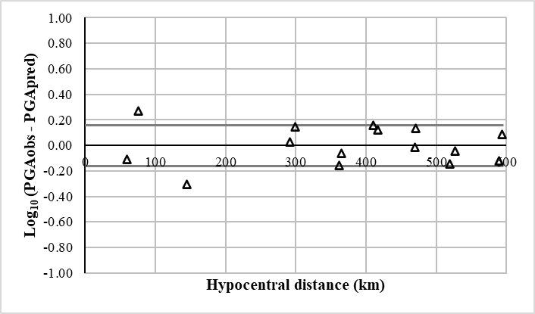  a) | 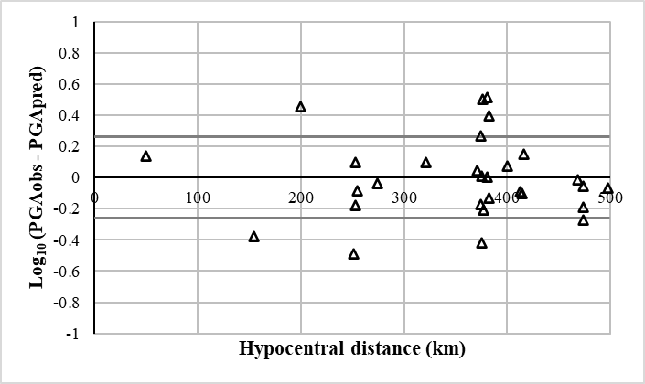  b)
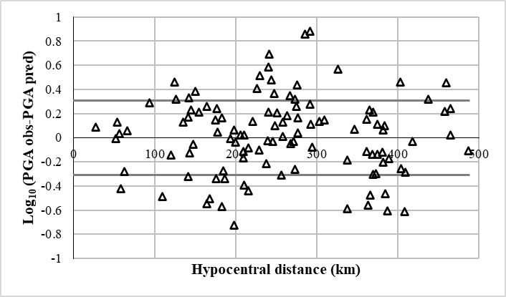  c) | 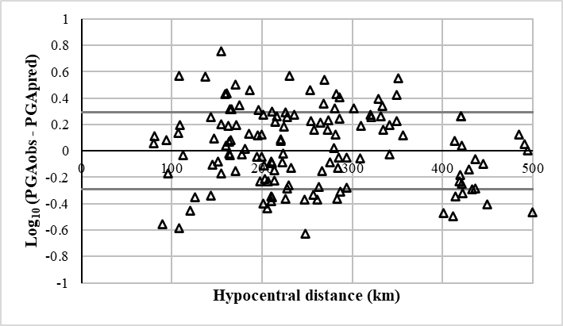  d)
Figure 3 Residue analysis for the a) Jalisco/Colima-Querétaro trajectory; b) Michoacán-Querétaro trajectory; c) Guerrero-Querétaro trajectory and d) Oaxaca-Querétaro trajectory

3.3 Review with other models

The attenuation relationships obtained in this work were compared with the following models: Ordaz (1989), García (2006) and Clemente et al., (2012), presented in equations 23, 24 and 25, using additional seismic events.

$\log_{10}{PGA}=1.76+0.300M_{w}-logR-0.0031R$ (23)

where log₁₀PGA is the maximum ground acceleration (cm/s²); M_{w} is the seismic moment magnitude and R is the hypocentral distance.
$\log_{10}{PGA}=2.5+0.12M_{w}-0.0037R-\left(1.82-0.16M_{w}\right)\log\left(R+0.0075*{10}^{0.474M_{w}}\right)$ (24)
$$-0.003H$$

where log₁₀PGA is the maximum ground acceleration (cm/s²); M_{w} is the seismic moment magnitude, R is the distance and H is the depth.
$\log_{10}{PGA=\left(-0.25+0.325M_{w}-0.00608H\right)+\left(-0.0125+0.00126M_{w}-0.00005 H\right)R}$ (25)
$$+(-0.00429-0.00672M_{w}+0.00135H)logR$$

where log₁₀PGA is the maximum ground acceleration (cm/s²); M_{w} is the seismic moment magnitude and R is the hypocentral distance and H is the depth.

The fit was assessed based on the average of the differences between observed and predicted values, a value close to zero indicates a better fit. The standard deviation was used as a measure of dispersion, a lower deviation indicates less dispersion of the data (Villalobos-Escobar et al., 2023).

3.3.1 Jalisco/Colima-Querétaro Trajectory

Table 7 shows the observed PGA values (PGA_{obs}) and predicted PGA values from the previously described models. Figure 4 graphically presents the results summarized in Table 7, obtained from equations 18, 23 and 24.

Table 7. PGA values for the Jalisco/Colima-Querétaro trajectory
H km | Mw | R km | Stations | PGA_{obs} | Ordaz (1989) | García (2006) | This research
15.7 | 5.9 | 67.91 | CJIG | 17.91 | 30.73 | 19.03 | 12.01
15.7 | 5.9 | 411.91 | MOIG | 0.14 | 0.43 | 0.22 | 0.18
15.7 | 5.9 | 515.96 | JRQG | 0.06 | 0.17 | 0.07 | 0.06
40.77 | 5.2 | 389.76 | TXMV | 0.021 | 0.33 | 0.10 | 0.05

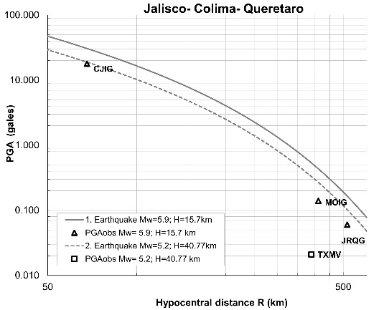  - Attenuation of seismic waves compared with the Ordaz (1989) model | 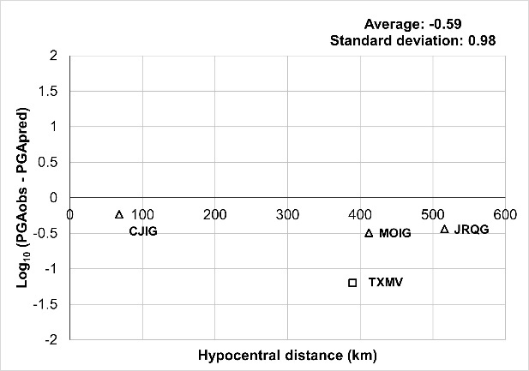  - Residual analysis with reference to the Ordaz (1989) model
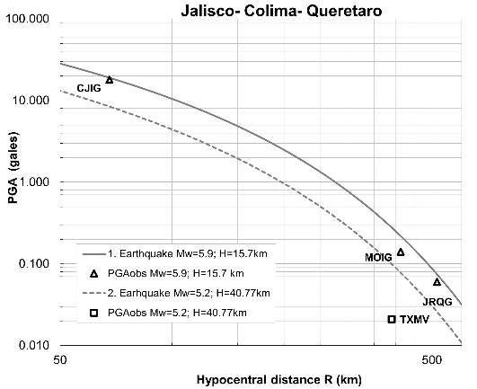  - Attenuation of seismic waves compared with the Garcia (2006) model | 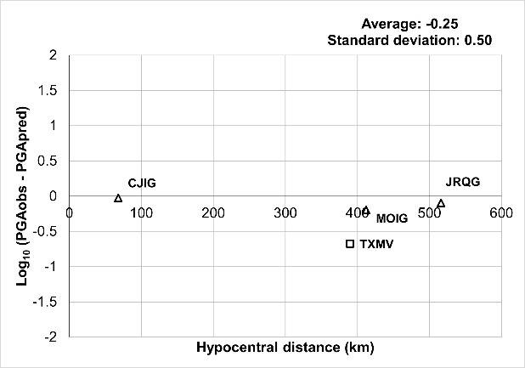  - Residual analysis with reference to the Garcia (2006) model
Figure 4 Comparison of models for the Jalisco/Colima-Querétaro trajectory
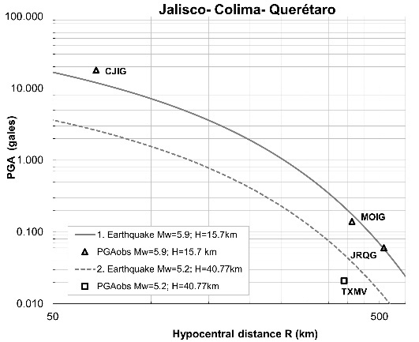  - Attenuation of seismic waves compared with the model developed in this research | 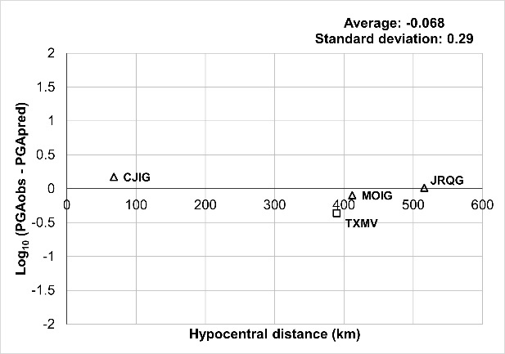  - Residual analysis with respect to the model developed in this research
Figure 4 Comparison of models for the Jalisco/Colima-Querétaro trajectory (continuation)
When evaluating the behavior of the attenuation models under the conditions of this study, it is observed that the Ordaz (1989) model tends to overestimate accelerations along the hypocentral distances considered, also showing a more pronounced attenuation beyond 400 km. This behavior is reflected in the residual analysis, where a progressive decrease with distance is observed, suggesting that the model's assumptions have limitations in adequately capturing energy dissipation at large distances for the specific events in this region.

On the other hand, the PGA estimates from the García (2006) model show close convergence with observed values ​​in the 100 km range or less; however, beyond that distance, a more rapid decay than expected is observed. This trend could be linked to the fact that the original model adjustment prioritized short-distance records, which would limit its representativeness in areas farther from the seismic source.

In contrast, the model proposed in this research slightly underestimates accelerations for distances less than 100 km, but shows remarkable consistency with observations between 100 and 500 km; that is, it adequately represents the decay of ground motion acceleration at intermediate distances. Furthermore, this model exhibits a lower standard deviation and a near-zero average residual, suggesting a better overall fit and greater predictive capacity under the evaluated scenario.

3.3.2 Michoacán-Querétaro trajectory

Figure 5 graphically presents the results summarized in Table 8, obtained from equations 19, 23 and 24.

Table 8. PGA values for the Michoacán-Querétaro trajectory
H km | Mw | R km | Stations | PGA_{obs} | Ordaz (1989) | García (2006) | This research
23.3 | 5.0 | 96.93 | MMIG | 1.53 | 9.40 | 4.34 | 3.02
23.3 | 5.0 | 220.22 | MOIG | 0.14 | 1.72 | 0.66 | 0.46
23.3 | 5.0 | 424.29 | JRQG | 0.05 | 0.21 | 0.06 | 0.03
48.8 | 4.9 | 301.71 | TXMV | 0.01 | 0.65 | 0.18 | 0.13
39.0 | 6.2 | 352.26 | TXMV | 0.11 | 0.96 | 0.51 | 0.56

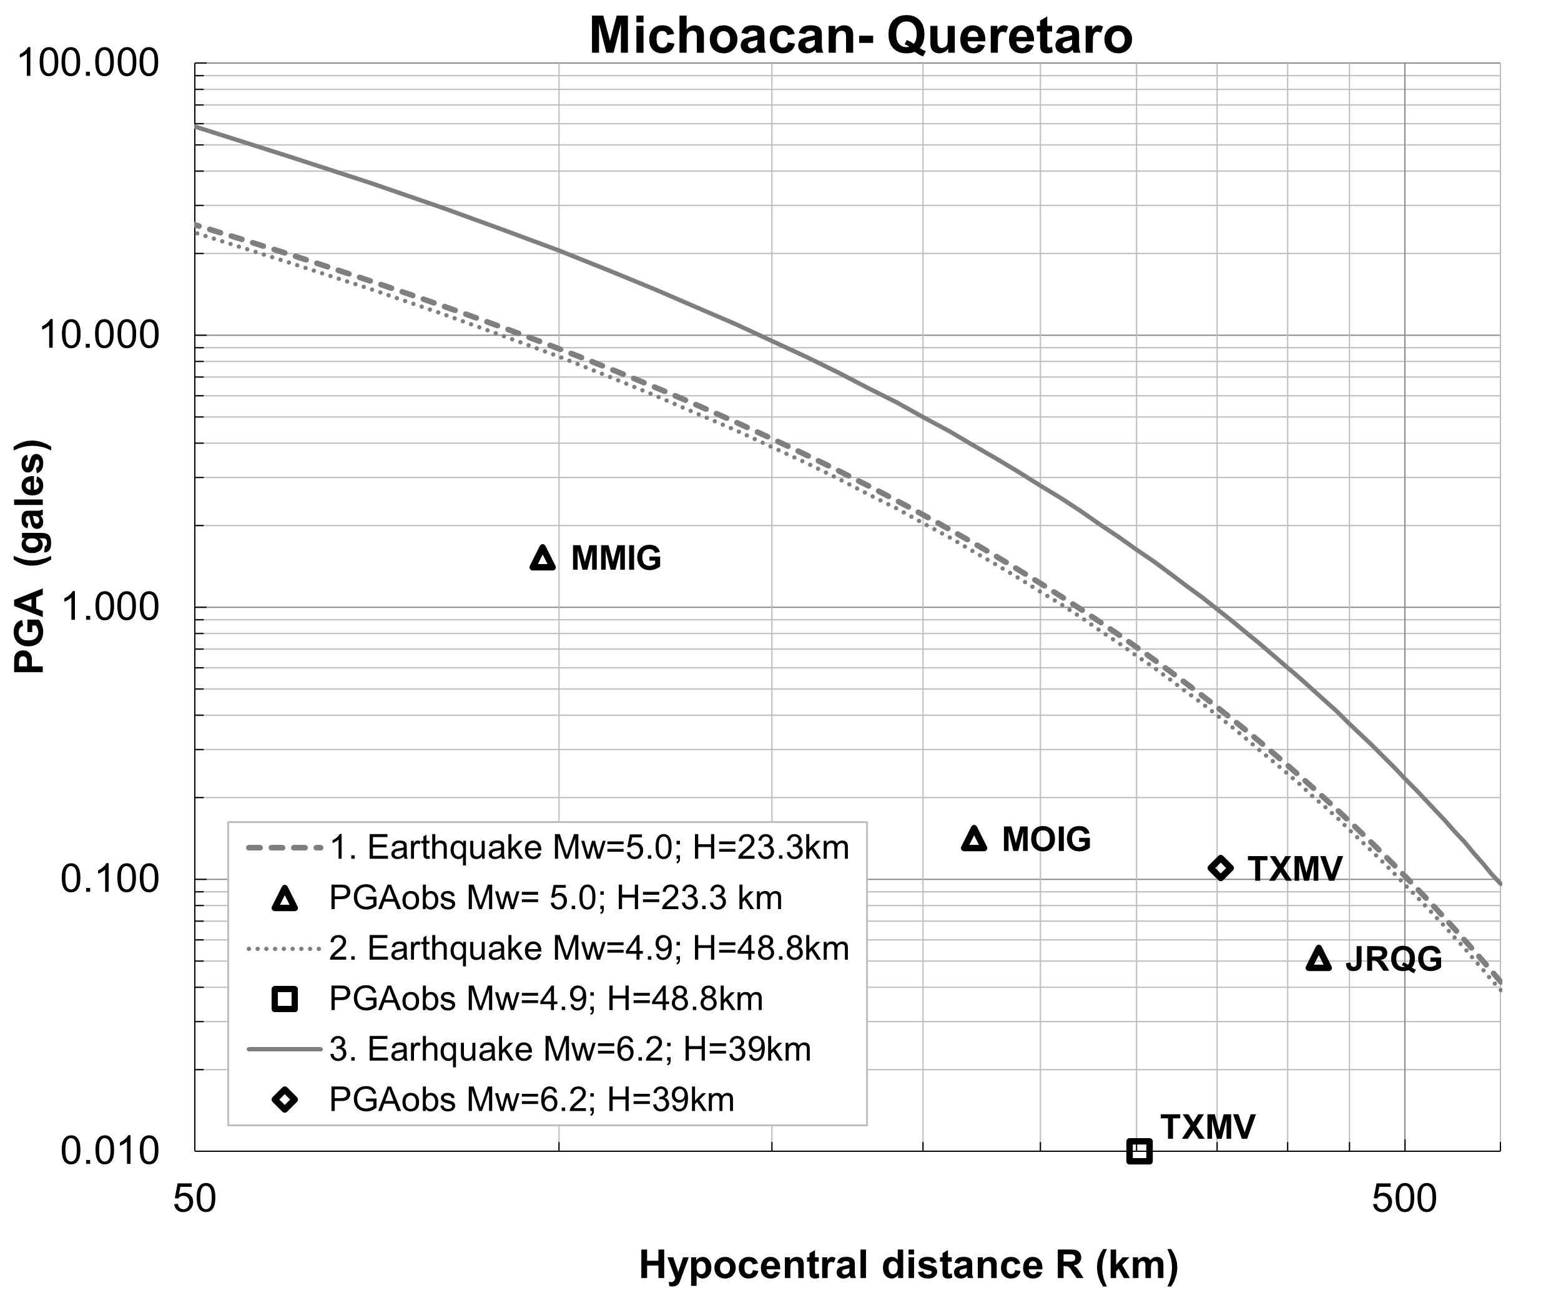  - Attenuation of seismic waves compared with the Ordaz (1989) model | 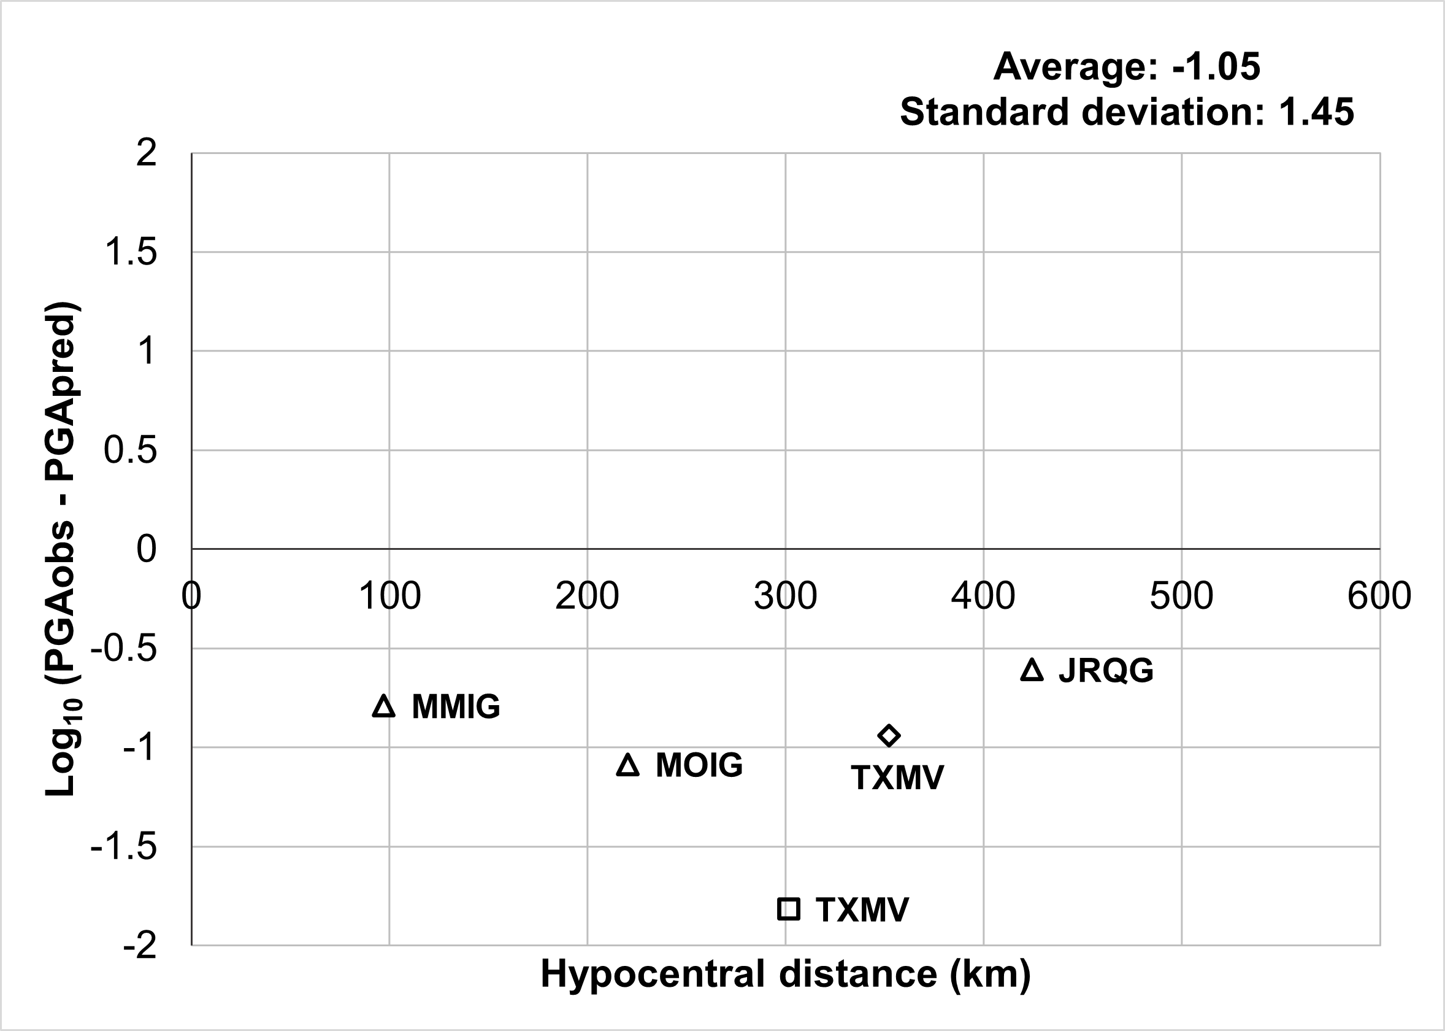  - Residual analysis with reference to the Ordaz (1989) model
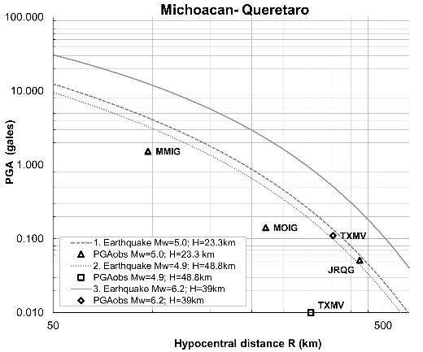  - Attenuation of seismic waves compared with the Garcia (2006) model | 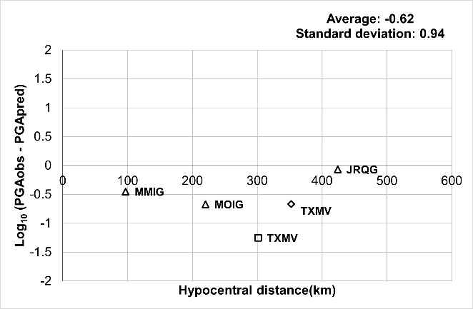  - Residual analysis with reference to the Garcia (2006) model
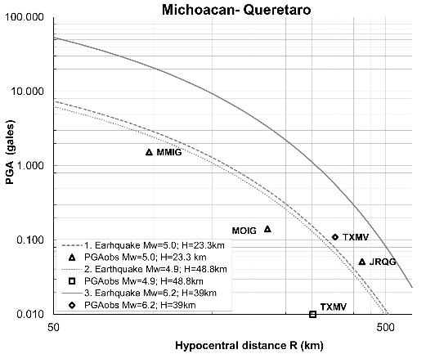  - Attenuation of seismic waves compared with the model developed in this research | 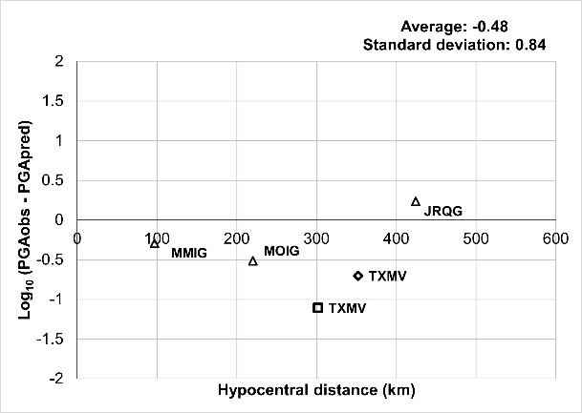  - Residual analysis with respect to the model developed in this research

Figure 5 Comparison of models for the Michoacán-Querétaro trajectory
Analysis of the attenuation graphs shows that the accelerations predicted by the three models tend to overestimate the observed PGA in the first 400 km. It is important to consider that these discrepancies may be influenced by differences in the methodologies and datasets used in the formulation of each model. In this context, the Ordaz (1989) model shows a tendency toward overestimation along the analyzed hypocentral distance, suggesting a less pronounced attenuation than observed. Meanwhile, the García (2006) model presents estimates higher than those observed up to approximately 400 km, after which it shows a clearer convergence with the data.

The model developed in this research exhibits an overestimation of accelerations before 400 km and an underestimation at greater distances, as was observed at station JRQG. However, within the established comparative frameworks, this model shows the lowest standard deviation and a residual average closest to zero.

The overestimation of the PGA indicates the possible influence of factors not considered in the current formulation. One alternative to reduce this discrepancy would be to explicitly include frequency dependence in the model, as reported by Cruz-Jiménez et al., (2009), who observed that attenuation tends to be lower at high frequencies and higher at low frequencies. Incorporating this factor could contribute to improving the accuracy of ground motion acceleration estimation and optimizing the representation of the seismic attenuation phenomenon.

3.3.3 Guerrero-Querétaro Trajectory

Figure 6 graphically presents the results summarized in Table 9, obtained from equations 20, 23, 24 and 25.

Table 9. PGA values for the Guerrero-Querétaro trajectory
H km | Mw | R km | Stations | PGA_{obs} | Ordaz (1989) | García (2006) | Clemente et al., (2012) | This research
28.0 | 5.0 | 240.24 | YAIG | 0.13 | 1.36 | 0.50 | 0.41 | 0.27
28.0 | 5.0 | 321.53 | UAQ-CH | 0.08 | 0.57 | 0.18 | 0.12 | 0.10
28.0 | 5.0 | 346.74 | DHIG | 0.04 | 0.44 | 0.14 | 0.08 | 0.08
18.0 | 6.0 | 345.19 | TMXV | 0.06 | 0.90 | 0.50 | 0.55 | 0.52
10.65 | 5.2 | 345.89 | TXMV | 0.05 | 0.51 | 0.20 | 0.16 | 0.12

Comparing the estimated and observed PGA values, the models of Ordaz (1989) and García (2006) show a tendency to overestimate acceleration within the analyzed distance range. This behavior is reflected in the PGA residual analysis, which reveals a decrease in residuals with increasing distance. The models of Clemente et al. (2012) and the one proposed in this study also overestimate accelerations, although they exhibit less data dispersion within the framework of the residual analysis.

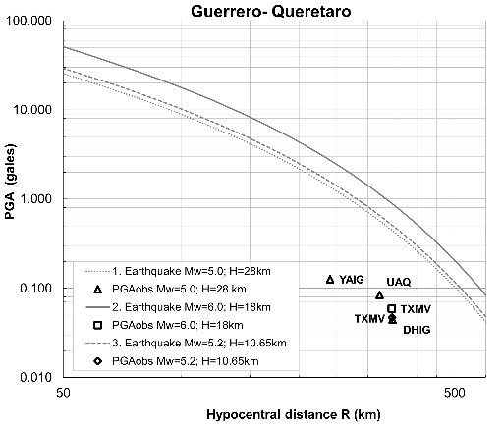  - Attenuation of seismic waves compared with the Ordaz (1989) model | 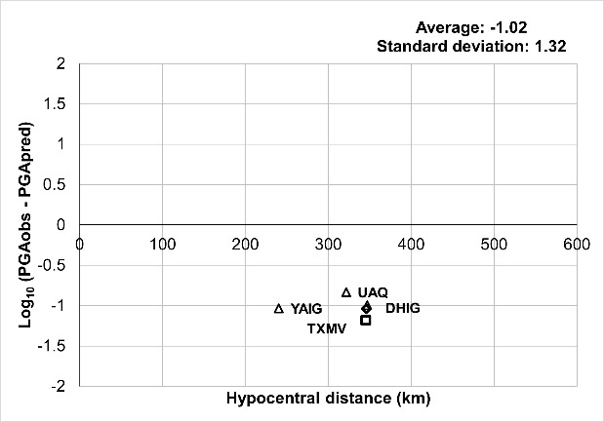  - Residual analysis with reference to the Ordaz (1989) model
Figure 6 Comparison of models for the Guerrero-Querétaro trajectory
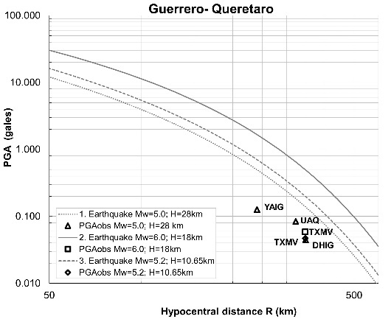  - Attenuation of seismic waves compared with the Garcia (2006) model | 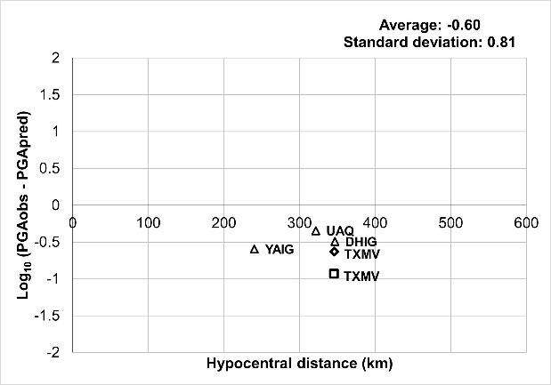  - Residual analysis with reference to the Garcia (2006) model
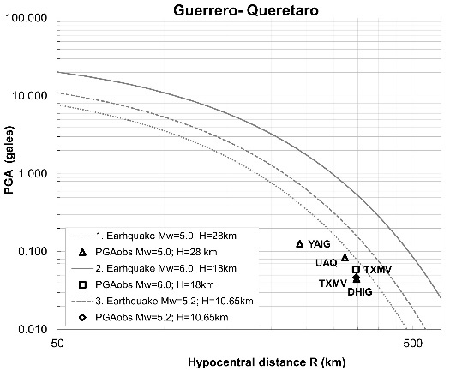  - Attenuation of seismic waves compared with the Clemente et al., (2012) model | 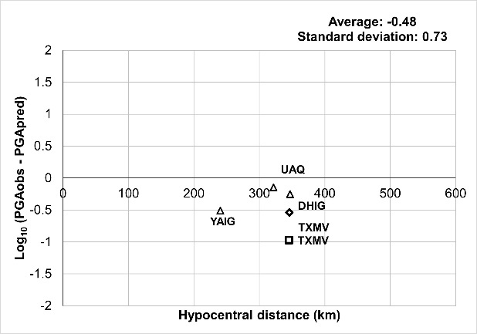  - Residual analysis with reference to the Clemente et al., (2012) model
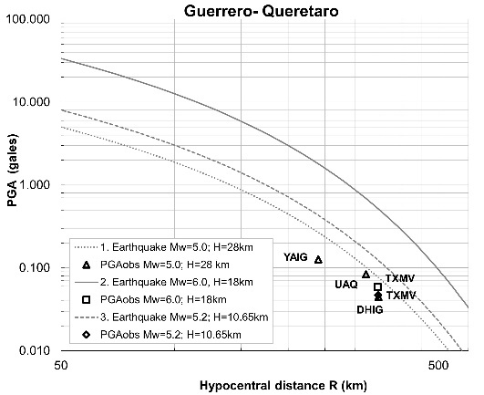  - Attenuation of seismic waves compared with the model developed in this research | 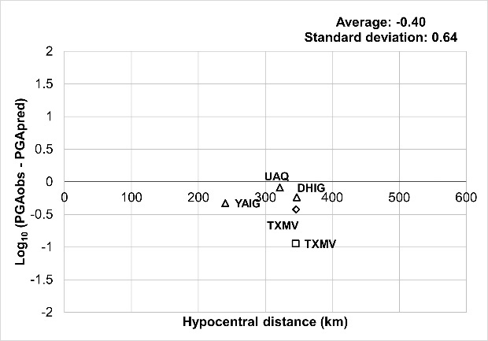  - Residual analysis with respect to the model developed in this research

Figure 6 Comparison of models for the Guerrero-Querétaro trajectory (continuation)

3.3.4 Oaxaca-Querétaro Trajectory

Figure 7 graphically presents the results summarized in Table 10, obtained from equations 21, 23 and 24.

Table 10. PGA values for the Oaxaca-Querétaro trajectory
H km | Mw | R km | Stations | PGA_{obs} | Ordaz (1989) | García (2006) | This research
6.9 | 5.1 | 98.44 | JRQG | 0.34 | 9.81 | 5.22 | 2.79
6.9 | 5.1 | 114.62 | FTIG | 0.53 | 7.51 | 3.91 | 2.16
6.9 | 5.1 | 166.94 | TOIG | 0.27 | 3.55 | 1.73 | 1.06
6.9 | 5.1 | 223.20 | TPIG | 0.42 | 1.78 | 0.80 | 0.56
6.9 | 5.1 | 237.23 | CHIG | 0.51 | 1.51 | 0.67 | 0.48
6.9 | 5.1 | 271.83 | YAIG | 0.09 | 1.03 | 0.43 | 0.34
6.9 | 5.1 | 493.63 | YOIG | 0.05 | 0.12 | 0.04 | 0.05
40.2 | 5.9 | 510.51 | TXMV | 0.03 | 0.17 | 0.07 | 0.07
20.0 | 7.4 | 655.48 | TXMV | 0.27 | 0.14 | 0.13 | 0.12

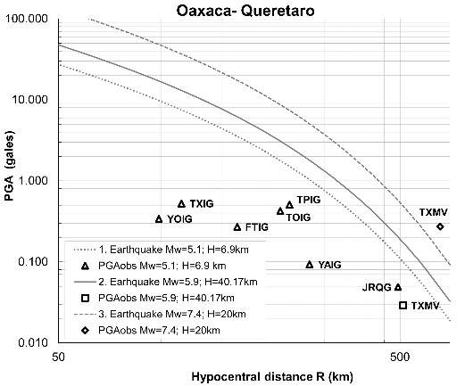  - Attenuation of seismic waves compared with the Ordaz (1989) model | 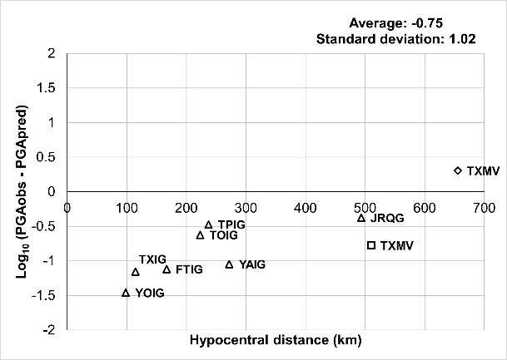  - Residual analysis with reference to the Ordaz (1989) model
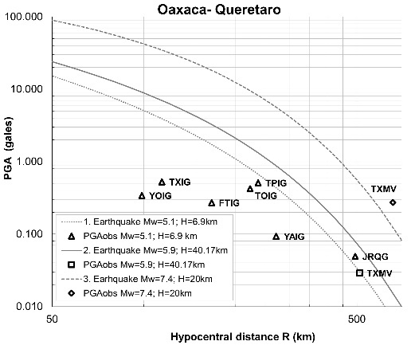  - Attenuation of seismic waves compared with the Garcia (2006) model | 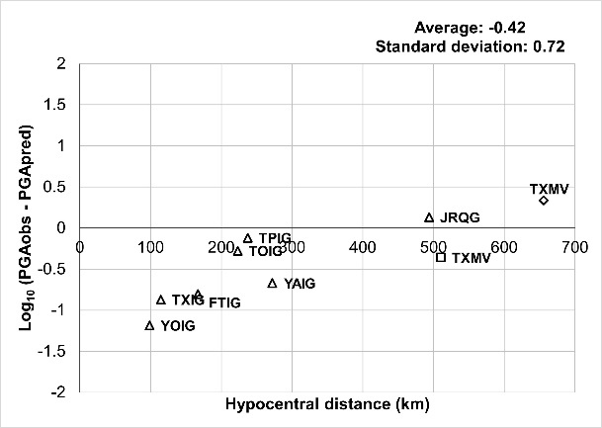  - Residual analysis with reference to the Garcia (2006) model
Figure 7 Comparison of models for the Oaxaca-Querétaro trajectory
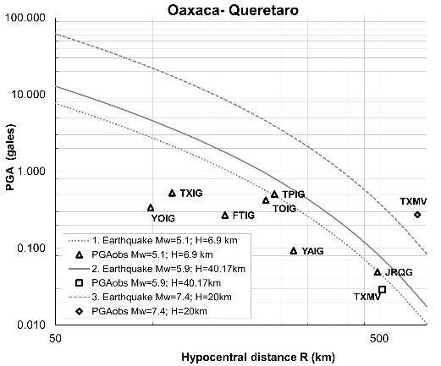  - Attenuation of seismic waves compared with the model developed in this research | 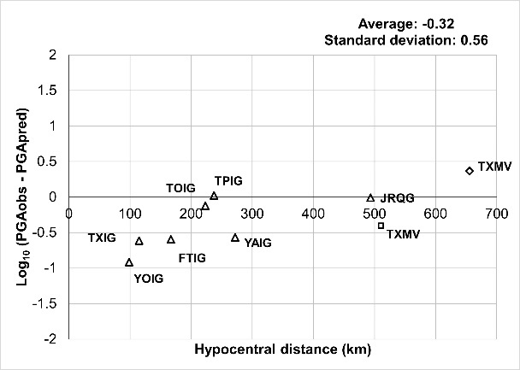  - Residual analysis with respect to the model developed in this research
Figure 7 Comparison of models for the Oaxaca-Querétaro trajectory (continuation)

Analyzing the behavior of each model individually against the observed data reveals that the attenuation curve corresponding to the Ordaz (1989) model tends to overestimate acceleration at distances less than 500 km. The García (2006) model shows a tendency to overestimate acceleration at distances less than 450 km and tends to underestimate it at greater distances. Finally, under the conditions of this analysis, the model developed in this research shows the lowest standard deviation and a residual average close to zero, suggesting a better fit to the observed data.

4. Conclusion

Four attenuation relationships were developed to estimate the peak ground acceleration (PGA) in rock for the city of Querétaro based on earthquakes with epicenters in the Mexican subduction zone that occurred between 2011 and 2022. Although the proposed models tend to overestimate accelerations, they exhibit fewer relative data dispersion compared to the models developed by Ordaz (1989), García (2006), and Clemente et al. (2012).

The observed differences can be attributed to the geological complexity of the Trans-Mexican Volcanic Belt, due to the interaction of multiple tectonic, volcanic, and structural processes (Gómez-Tuena et al., 2005). Another possible cause is the number of seismic records used. While the models for estimating the PGA of earthquakes with epicenters in Guerrero by Ordaz (1989) and Clemente et al. (2012) were developed from 64 and 3 earthquakes, respectively, this research used 21 earthquakes. In this same context, Ordaz (1989) and García (2006) employ attenuation models that average multiple trajectories, in contrast to the models developed by Clemente et al. (2012) and in this study, which were defined from individual trajectories.

Compared to the attenuation relationships of Ordaz (1989), García (2006) and Clemente et al., (2012), the attenuation models in this study show a lower standard deviation, suggesting a tighter statistical fit to the analyzed data sample. This allows for estimating the PGA with overestimations and underestimations of ${}_{-}^{+}{1.44}$, ${}_{-}^{+}{1.81}$, ${}_{-}^{+}{2.01}$, ${}_{-}^{+}{1.91}$ for earthquakes with epicenters in Jalisco-Colima, Michoacán, Guerrero and Oaxaca.

The trajectory analysis allowed for the estimation of average expected peak ground acceleration values in Querétaro of 0.09 cm/s², 0.67 cm/s², 0.37 cm/s² and 0.13 cm/s² for earthquakes with epicenters in Jalisco-Colima, Michoacán, Guerrero and Oaxaca. These values explain why earthquakes originating in Michoacán were felt in the city.

Finally, the results presented can be used in conjunction with other disciplines for seismic hazard assessment in the study areas. Future research could incorporate additional variables, such as frequency and the influence of different soil types, to improve the accuracy of PGA estimates.

COMPETING INTERESTS DISCLAIMER:
Authors have declared that they have no known competing financial interests OR non-financial interests OR personal relationships that could have appeared to influence the work reported in this paper.
Disclaimer (Artificial intelligence)
Author(s) hereby declare that NO generative AI technologies such as Large Language Models (ChatGPT, COPILOT, etc.) and text-to-image generators have been used during the writing or editing of this manuscript.

References

SSN. (2026). Annual Seismicity Maps. Institute of Geophysics, National Autonomous University of Mexico. http://www.ssn.unam.mx/sismicidad/mapas-de-sismicidad-anual/

Mexican Geological Survey. (2017). Seismology of Mexico. https://www.sgm.gob.mx/Web/MuseoVirtual/Riesgos-geologicos/Sismologia-de-Mexico.html

Gómez-Tuena, A., Orozco-Esquivel, M. T., & Ferrari, L. (2005). Igneous Petrogenesis of the Trans-Mexican Volcanic Belt. International Archives of the Bulletin of the Mexican Geological Society, 57(3), 227-283. DOI: https://doi.org/10.18268/bsgm2005v57n3a2

INEGI. (2025). Demographic and Social Information. https://www.inegi.org.mx/programas/ccpv/2020/

Pérez-Gavilán, J.J., Aguirre, J., & Ramirez, L. (2018). Seismicity and structural safety in buildings: lessons learned in Mexico. International Archives of Public Health in Mexico, 60(S1), 41-51.

Ordoñez Sacapi, G. E., & Salazar Riera, M.V. (2023). Development of a User Manual for the RCrisis Program and its Application to Seismic Threats in the Quito Canton, Pichincha Province. Bachelor's Thesis. Salesian Polytechnic University, Ecuador, 144 p.
De la Blanca, G. A., Sánchez, F. V., Stich, D., Pérez, F. D. F. M., Comino, J. A. L., Soto, J. M., & Bernal, M. N. (2012). Source and ground-motion parameters of the 2011 Lorca earthquake. International Archives of Earth Physics, 24, 41.

García, J. D. (2001). Seismic attenuation. Application to intraplate earthquakes in Central Mexico. Doctoral Thesis. Complutense University of Madrid, Madrid, p. 161.

Shapiro, N. M., Campillo, M., Paul, A., Singh, S K., Jongmans, D., & Sánchez-Sesma F. J. (1997). Surface-wave propagation across the Mexican Volcanic Belt and the origin of the long-period seismic-wave amplification in the Valley of Mexico. Geophysical Journal International, 128(1), 151-166.

Cruz-Jiménez, H., Chávez-García, F. J., & Furumura, T. (2009). Differences in attenuation of ground motion perpendicular to the Mexican subduction zone between Colima and Guerrero: An explanation based on numerical modeling. Bulletin of the Seismological Society of America, 99(1), 400-406. DOI: https://doi.org/10.1785/0120080167

Clemente-Chavez, A., Zúñiga, F. R., Lermo, J., Figueroa-Soto, A., Valdés, C., Montiel, M., Chavez, O., & Arroyo, M. (2014). On the behavior of site effects in central Mexico (the Mexican Volcanic Belt, MVB), based on records of shallow earthquakes that occurred in the zone between 1998 and 2011. Natural Hazards and Earth System Sciences, 14(6), 1391-1406.

Ordaz, M. (1989). Seismic Risk and Design Spectra in the State of Guerrero. 8th National Congress on Earthquake Engineering, Guerrero, Mexico.

García, J. D. (2006). Estimation of Strong Ground Motion Parameters for Interplate and Intraslab Earthquakes in Central Mexico. Doctoral Thesis. Complutense University of Madrid, Madrid, 173 p.

Clemente Chávez, A., Moisés Arroyo, G., Zúñiga, R., Figueroa, Á., Pérez, M. A., & López, C. S. (2012). Ground Motion Attenuation Relationship for Peak Ground Acceleration (PGA) over the Mexican Volcanic Belt (MVB); Path-Specific Analysis: Guerrero-Querétaro. International Archives of Earthquake Engineering, 87, 67–93.

Clemente-Chávez, A., Figueroa-Soto, A. (2018). Differences in Seismic Attenuation over the Mexican Volcanic Belt (MVB): A Study of Subduction Seismicity via Paths Leading to the MVB Zone. International Archives of the Annual Meeting Proceedings of the Mexican Geophysical Union (RAUGM), 38, 145.

Zhao, J. X., Liang, X., Jiang, F., Xing, H., Zhu, M., Hou, R., & Somerville, P. G. (2016). Ground‐motion prediction equations for subduction interface earthquakes in Japan using site class and simple geometric attenuation functions. Bulletin of the Seismological Society of America, 106(4), 1518-1534.

Abrahamson, N., Gregor, N., & Addo, K. (2016). BC Hydro ground motion prediction equations for subduction earthquakes. Earthquake Spectra, 32(1), 23-44.

Montalva, G. A., Bastías, N., & Rodriguez‐Marek, A. (2017). Ground‐motion prediction equation for the Chilean subduction zone. Bulletin of the Seismological Society of America, 107(2), 901-911.

Tiwari, A., Rana, N., & Singh, G. P. (2024). A PGA amplification study for Varanasi city (India): Implications for seismic hazard assessment. J. Ind. Geophys. Union, 28(6), 417-429.

Rivas Nieto, et al. (2020). Application of the Maximum Likelihood Method for Computing Attenuation Relationships for Peak Ground Accelerations in the Trans-Mexican Volcanic Belt. International Archives of Science and Technology Perspectives, 3(5), 10-30.

Ferrari, L., Orozco-Esquivel, T., Manea, V., & Manea, M. (2012). The dynamic history of the Trans-Mexican Volcanic Belt and the Mexico subduction zone. Tectonophysics, 522, 122-149.

European Commission & Havenith, H. B., et al. (2014). Guidelines for the implementation of the H/V spectral ratio technique on ambient vibrations measurements, processing and interpretation. European Commission. Eurepean Commission-EVG1-CT-2000-00026-SESAME. https://hdl.handle.net/2268/250698

Pérez-Moreno, L. F., Rodríguez-Pérez, Q., Zúñiga, F. R., Horta-Rangel, J., Pérez-Rea, M. de la L., & Pérez-Lara, M. A. (2021). Site response evaluation in the Trans-Mexican Volcanic Belt based on HVSR from ambient noise and regional seismicity. Applied Sciences, 11(13), 6126. DOI: https://doi.org/10.3390/app11136126

Martínez Rivera, J. M. (2022). Analysis of the Site Effects of Cortical Earthquakes in the Neovolcanic Axis. Master's Thesis. Autonomous University of Querétaro, Querétaro, 115 p.

Boore, D. M. (2005). On Pads and Filters: Processing Strong- Motion Data. Bulletin of the Seismological Society of America, 95(2), 745-750. DOI: https://doi.org/10.1785/0120040160

Boore, D. M., Watson-Lamprey, J., & Abrahamson, N. A. (2006). Orientation-independent measures of ground motion. Bulletin of the Seismological Society of America, 96(4A), 1502–1511.

SSN. (2026). Earthquake Catalog. Institute of Geophysics, National Autonomous University of Mexico. https://doi.org/10.21766/SSNMX/EC/MX

Boore, D. M., Gibbs, J. F., Joyner, W. B., Tinsley, J. C., & Ponti, D. J. (2003). Estimated Ground Motion From the 1994 Northridge, California, Earthquake at the Site of the Interstate 10 and La Cienega Boulevard Bridge Collapse, West Los Angeles, California. Bulletin of the Seismological Society of America, 93(6), 2737-2751. DOI: https://doi.org/10.1785/0120020197

Boore, D. M., Joyner, W. B., & Fumal, T. E. (1993). Estimation of response spectra and peak accelerations from western North American earthquakes: an interim report. US Geol. Surv. Open-File Rept, 93(509), 72.

Contreras Luarte, V. A. (2009). Spectral attenuation curves for Chilean earthquakes. Undergraduate Thesis. University of Chile, Chile, 215 p.

Searle, S. R. (1997). Linear models. John Wiley & Sons Inc., Ithaca, N.Y.

Infante-Gil, S., & de Lara, G. P. Z. (2012). Statistical methods, an interdisciplinary approach (3rd ed.). Texcoco, Edo. From Mexico: Editorial College of Postgraduates.

Villalobos-Escobar, G. P., Márquez-Ramírez, V. H., Castro, R. R., & Peña-Alonso, T. A. (2023). Empirical Ground-Motion Relations in Northeastern México from intraplate moderate earthquakes. Journal of Earthquake Engineering, 27(3), 769–786.

