A study of the Thermodynamic Characteristics of Air-Cl₂-H₂S Plasma in an Air Circuit Breaker

.
ABSTRACT

The air circuit breaker (ACB) is a reliable protection device that uses ambient air to extinguish electric arcs and interrupt circuits. It is primarily employed in power distribution systems to secure circuits and equipment against overcurrents, short circuits, and faults. Operating in ambient air exposes the device to environmental stressors such as humidity, saline conditions, and dust, with a specific emphasis on corrosive atmospheres. Hydrogen sulfide (H₂S) and chlorine (Cl₂) are corrosive agents that react with metals such as copper, aluminium, and silver. These reactions increase the resistance of insertion contacts, cause excessive overheating, and lead to short-circuiting, which may result in control unit malfunctions. They also contribute to increased friction, mechanical failures, and stainless-steel spring breakages. While previous studies focused on the effects of metal oxides and carbon monoxide present in aerosols, a gap remains regarding the specific influence of corrosive species such as H₂S and Cl₂. The objective of this study is to assess the impact of H₂S and Cl₂ on the thermodynamic properties of the circuit breaker’s air plasma during the current interruption phase. The Gibbs free energy minimization method is applied to determine the equilibrium composition of the mixture required for the calculation of thermodynamic properties. The results show that the presence of H₂S and Cl₂ increases plasma density while reducing specific enthalpy, heat capacity, and sound velocity.

Keywords: Corrosion, Plasma, Thermodynamic Properties, Atmosphere, Minimization

1. INTRODUCTION

Since the advent of electricity, the safe management of electrical current has been a major challenge. From production to consumption, electrical energy is transported through several grids, including interconnection, transmission, and distribution networks. This involves stepping down from High Voltage (HV), typically around 220,000 V near power plants, to Low Voltage (LV) around 400 V for end-users (Ziani, 2009). To ensure maintenance, operation, and protection, switching devices must be integrated into these grids (Quéméneur, 2016). Given the complexities of interrupting a circuit, particularly at high amperage or voltage, significant effort has been devoted to developing specialized switching devices. Over time, switches, contactors, disconnectors, and fuses have evolved into the modern circuit breaker. Today, circuit breakers offer a breaking capacity that far exceeds other techniques, providing high reliability and safety. However, these devices are often deployed in harsh environments, exposed to adverse conditions such as humidity, heat, dust, and corrosive atmospheres. Such exposure, particularly to dust and corrosive gases, significantly impacts their performance and operational lifespan (Schneider, 2021). Previous research has extensively studied electric arc interruption in various media. For instance, Yaguibou et al. investigated the influence of aerosols on circuit breaker performance, concluding that they negatively affect air circuit breaker operation (Wepari et al., 2025; Yaguibou et al., 2019; Wepari et al., 2018; Wepari et al., 2018; Yaguibou et al., 2022) by deteriorating the plasma’s thermophysical properties. This can lead to interruption failure, the formation of oxide layers in the breaking chamber, and post-interruption leakage currents (Yaguibou et al., 2019; Wepari et al., 2018). Similarly, Cressault et al. and Banouga et al. demonstrated that metallic vapours in the plasma increase electrical conductivity while decreasing specific enthalpy and thermal conductivity (Cressault et al., 2008; Cressault et al., 2013; Cressault et al., 2023; Banouga et al., 2025; Banouga et al., 2025; Banouga et al., 2022; Banouga et al., 2024). Conversely, Kagoné et al. and Kohio et al. showed that water vapour can enhance arc interruption performance by increasing the thermal conductivity of the plasma, thereby reducing arc extinction duration (Kagone et al., 2012; Kagone et al., 2020; Kagone et al., 2020; Kohio et al., 2019; Kagone et al., 2018; Kagone et al., 2019; Kagone et al., 2020).To our knowledge, no study has so far examined the simultaneous impact of chlorine (Cl₂) and hydrogen sulphide (H₂S) on the thermophysical properties of air plasma in low-voltage circuit breakers. The primary objective of this work is to analyze the influence of chlorine (Cl₂) and hydrogen sulphide (H₂S) on the thermodynamic properties of air plasma during the current interruption phase under atmospheric pressure and local thermodynamic equilibrium (LTE). In this state, the plasma is characterised by a unique local temperature, where collisional processes dominate, allowing the use of the Maxwell-Boltzmann distribution and the Saha equation to determine the species composition. Within a temperature range from 2,000 K to 30,000 K, this study specifically involves calculating the mass density, specific enthalpy, and specific heat at constant pressure.
In the first section, we describe the theoretical framework used to determine the thermodynamic properties of the plasma mixture. The plasma composition is calculated by assuming local thermodynamic equilibrium (LTE), where species concentrations are determined through the minimisation of Gibbs free energy. This approach accounts for the various chemical species resulting from the dissociation and ionisation of the initial gas mixture within a temperature range of 2, 000 K to 30, 000 K.
The second section presents the calculation results for mass density, specific enthalpy, and specific heat capacity at constant pressure. These properties are essential for understanding energy transport and the arc cooling efficiency during the current interruption phase.
Finally, in the third section, we conclude and outline perspectives for future study.

2. material and methods

In plasma physics, evaluating thermodynamic properties requires precise knowledge of the number density of the plasma species. In this study, the equilibrium composition was determined using the Gibbs free energy minimization method, as expressed in Equation 1
with $μ_{i}^{0}$the chemical potential of species $i$, R the ideal gas constant, T the temperature of particle $i$, and $y_{i}$ the numerical density of particle $i$, $N$ the number of species in the plasma and P pressure.
This method requires knowledge of the chemical potentials of the various species. In chemistry and physics, these chemical potentials are determined from the specific enthalpy and specific entropy of each species, as shown in equation 2.
$E_{f}$, $H_{i}^{0}$, $S_{i}^{0}$ are respectively for species $i$, the enthalpy of formation, the specific enthalpy and specific entropy.
The specific data of the different species are determined by the following equations from the data tabulated by McBride et al. (McBride et al., 2002).
We perform a second-order Taylor series expansion at point Y of the Gibbs free enthalpy. Next, we introduce Lagrange multipliers and solve the system using the Newton-Raphson method to obtain the number densities (McBride et al., 2002, Cayet et al., 1996; Bendjebbar et al., 2012). For this study, we have considered 100 chemical species, including twenty-three (23) monoatomic species (e⁻, O, N, H, Cl, H⁺, H⁻, O⁻, O⁺, N⁺, N⁻, Cl⁻, Cl⁺, S⁺, S⁻, O⁺⁺, N⁺⁺, S⁺⁺, Cl⁺⁺, O⁺⁺⁺, N⁺⁺⁺, S⁺⁺⁺, Cl⁺⁺⁺), twenty-seven (27) diatomic species ( H_{2,} O₂, N₂, S₂, Cl₂, HCl, OH, NO, NH, SH, SO, SCl, SN, ClO, H₂⁺, H₂⁻, O₂⁺, O₂⁻, OH⁺, OH⁻, NO⁺, N₂⁺ N₂⁻, NH⁺, SH⁻, SO⁻, S₂⁻), and fifty (50) polyatomic species (HNO, H₂O, HNO₂, HO₂, HNO₃, H₂O₂, H₂S, H₂SO₄, HOCl, O₃, N₃, NO₂, N₂O, NH₂, N₃H, N₂H₂, NH₃, N₂H₄, NO₃, NOCl, NO₂Cl, N₂O₃, N₂O₄, N₂O₅, NH₂OH, NH₂NO₂, NO₂, SCl₂, SO₂Cl₂, SO₃, S₂Cl₂, S₂O, S₃, S₄, S₅, S₆, S₇, S₈, ClO₂, Cl₂O, HO₂⁻, H₂O⁺, H₃O⁺, N₂O⁺, NH₄⁺, NO₃⁻, NO₂⁻, SCl₂⁺, SO₂⁻).
Thus, using the number densities of the different species, we can calculate the thermodynamic properties. Density represents the amount of matter contained within a given volume of plasma, and we determine this parameter using Equation 4 (Adinda et al., 2007):
where $x_{i}$, $M_{i}$ R, and T represent the molar fraction, molar mass of species $i$, molar gas constant, absolute temperature respectively.
The mass enthalpy (J/kg) of the arc is the amount of energy per unit mass that the plasma carries. It is a key thermodynamic property for understanding and modelling the behaviour of plasma at very high temperatures. It is primarily a function of the temperature and chemical composition of the plasma and is given by equation 5 (Andre et al., 1995):
where $M$ represents the average molar mass, $M=\sum_{i}^{N}{x_{i}M_{i}}$, and represents the Debye–Huckel term (Capitelli et al., 2012 and, Andre et al., 1995). is the enthalpy correction of Debye–Huckel due to Coulombian interaction between charged particles. The correction of enthalpy can be obtained by using the relation between:
With the Debye length
And
the correction to pressure is given by:

e is the elementary charge,
The specific heat (J/kg/K) ($c_{p}$) is the amount of energy required to raise the temperature of a substance by 1°. This indicated the ability of the system to store heat. when the thermodynamic transformation of the system is performed at constant pressure, the specific heat can be calculated as (Wepari et al., 2025., Andre et al., 1995):
where $∆T=100K$ represents the variation in temperature.
The speed of sound in plasma is crucial for modelling and designing circuit breakers. This allows us to determine whether the flow is subsonic or supersonic. It also governs the speed at which the pressure waves generated by the arc propagate in the breaking chamber. Finally, the extinction of the arc depends on its ability to cool down and deionise quickly, which are related to the speed of sound. It was calculated using the equation (Drellishak et al., 1963.; Anderson 2000):

The isentropic coefﬁcient is deﬁned as:
This equation (11) can be written as (Burm 2005; Burm et al., 1999; Henderson et al., 2008)
With is molar heat capacity at constant pression and molar heat capacity at constant volume.
For an ideal, non-reacting gas, it is . Often the isentropic coefﬁcient is written as (Anderson 2000).

We employed Mayer's formula to calculate .

3. results and discussion

The validation of our calculation program, developed using MATLAB, involved comparing our results with previous studies. The composition and thermodynamic properties of a pure air plasma have already been studied by authors such as Boulos et al., D’Angola et al., Colonna et al., Capitelli et al., and Pascal et al. (Andre et al., 1995; Boulos et al., 1994; D’Angola et al., 2008; Colonna et al., 2013, Capitelli et al., 2000). We compared our results (Table 1) with those of Pascal et al., D’Angola et al., and Boulos et al. (Andre et al., 1995; Boulos et al., 1994; D’Angola et al., 2008), focusing on mass density, specific enthalpy, and specific heat capacity at selected temperatures: 2,050 K, 3,050 K, 5,050 K, 7,050 K, 10, 050 K, 15, 050 K, and 20, 050 K. The maximum relative deviation between our results and those of the three cited authors is approximately 5% for the mass density. Regarding specific enthalpy, the discrepancies vary between 0% and 6% compared to the data from Pascal et al. and Boulos et al. The deviations range from 0.9% to 8% in comparison with the data from D'Angola, with a peak of 13% around 2,050 K. Finally, for the specific heat capacity at constant pressure, we observe variations of 1% to 5% with Pascal's data, 1% to 9% with D'Angola's, and 0% to 3% with Boulos', with a peak of 13% at 20, 050 K. These discrepancies may be attributed to the nature of the input data and the calculation method for the equilibrium composition. Overall, the results show very good agreement with the literature, allowing us to conclude that our calculation program is valid.

Table 1. Comparison table

Masse volumique (kg,
Temperature (K) | Pascal | D’Angola | Boulos | results | Discrepancy between our data and Pascal. (%) | Discrepancy between our data and D’Angola et all. (%) | Discrepancy between our data and Boulos et al. (%)
2,050 | 1.71E-01 | 1.69E-01 | 1.71E-01 | 1.69E-01 | 1.36 | 0 | 1.42
3,050 | 1.12E-01 | 1.11E-01 | 1.12E-01 | 1.11E-01 | 1.17 | 0.09 | 1.36
5,050 | 5.76E-02 | 5.72E-02 | 5.77E-02 | 5.69E-02 | 1.21 | 0.51 | 1.35
7,050 | 3.07E-02 | 3.11E-02 | 3.19E-02 | 3.05E-02 | 0.69 | 2.00 | 4.53
10,050 | 1.70E-02 | 1.69E-02 | 1.71E-02 | 1.69E-02 | 0.83 | 0.24 | 1.36
15,050 | 7.70E-03 | 7.50E-03 | 7.68E-03 | 7.87E-03 | 2.14 | 4.68 | 2.35
20,050 | 4.50E-03 | 4.40E-03 | 4.54E-03 | 4.58E-03 | 1.73 | 3.91 | 0.96
Mass enthalpy (j/kg)
2,050 | 2.02E+06 | 2.34E+06 | 2.06E+06 | 2.06E+06 | 2.02 | 13.44 | 0.18
3,050 | 3.91E+06 | 4.25E+06 | 3.93E+06 | 3.93E+06 | 0.51 | 8.27 | 0.08
5,050 | 1.00E+07 | 1.04E+07 | 1.00E+07 | 1.00E+07 | 0.037 | 3.53 | 0.06
7,050 | 2.68E+07 | 2.71E+07 | 2.74E+07 | 2.67E+07 | 0.37 | 1.23 | 2.32
10,050 | 4.86E+07 | 4.90E+07 | 4.87E+07 | 4.86E+07 | 0.02 | 0.90 | 0.14
15,050 | 1.16E+08 | 1.20E+08 | 1.18E+08 | 1.09E+08 | 6.28 | 9.20 | 7.83
20,050 | 1.84E+08 | 1.81E+08 | 1.82E+08 | 1.74E+08 | 5.39 | 4.07 | 4.41
Heat Capacity (j/kg/K)
2,050 | 1309.5 | 1400.80 | 1344.75 | 1340.4 | 2.31 | 4.51 | 0.32
3,050 | 2913.3 | 2854.35 | 2712.1 | 2781.6 | 4.73 | 2.62 | 2.50
5,050 | 2927.9 | 2974.50 | 2832.15 | 2832.5 | 3.37 | 5.01 | 0.012
7,050 | 14291 | 13969.5 | 13767.75 | 13503 | 5.84 | 3.45 | 1.96
10,050 | 4895 | 4824.13 | 4953.65 | 4763 | 2.77 | 1.28 | 4.00
15,050 | 21673 | 21535.6 | 21607.5 | 21026 | 3.08 | 2.42 | 2.77
20,050 | 7148 | 6409.63 | 6116.95 | 7071 | 1.09 | 9.35 | 13.49

The study is conducted at atmospheric pressure and under the local thermodynamic equilibrium (LTE). The percentage of contaminant ranges from 1ppm to 1.5.10⁵ ppm (or 10⁻⁴ % to 15%. As this is a theoretical study and given the lack of available field data regarding the specific impurity composition, an equimolar distribution of 50% Cl₂ and H₂S 50% was assumed within the total impurity percentage.

Knowledge and understanding of the equilibrium plasma composition are essential for modelling thermodynamic properties. Thus, Figure 1 illustrates the evolution of the equilibrium composition of an air plasma contaminated with 10⁴ ppm of impurities. The figure displays three distinct phases in the evolution of the equilibrium composition. The first phase (T˂ 5000 K), characterized by temperatures below 5000 K, is dominated by neutral species, with N₂ and O₂ as the majority components. The impurities introduce corrosive species such as HCl, SO₂, SO, and ClO. Additionally, the presence of N₂O, NCl, NClO, NO, and Cl₂ is observed. The second phase (5,000 K ˂ T˂ 15,000 K) spans the range between 5000 K and 15000 K. The dominant species are N, O, and N₂, while the emergence of S, Cl, and H is noted. Molecular ions NO⁺ and N₂⁺ appear around 8000 K. This phase also marks the formation of negative ions O⁻ and N⁻, which contribute to a reduction in electron number density. This phenomenon could significantly influence the electrical conductivity of plasma. In the third phase (T˃ 15000 K), for temperatures exceeding 15000 K, the O⁺ and N⁺, become the majority species. The formation H⁺, S⁺, S⁺⁺, S⁺⁺⁺, Cl⁺ and Cl⁺⁺, is observed. The number densities of N, O, Cl, and H drop continuously as they undergo ionization. Electroneutrality is established primarily between electrons and NO⁺ ions for temperatures below 7000 K, and between electrons and the ions O⁺ and N⁺ for temperatures above 7000 K.

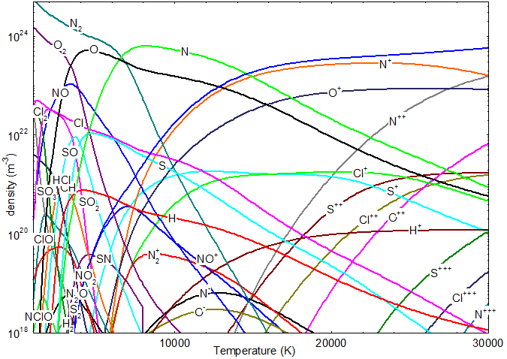
Fig. 1. Evolution of numerical density as a function of temperature for 10⁴ ppm of impurities

Figure 2 illustrates the variation of plasma mass density as a function of temperature in the presence of impurities. A sharp decrease in all mass density curves is observed at temperatures below 10,000 K, followed by a more gradual decline up to 30,000 K. This reduction is primarily attributed to thermal expansion, as well as the dissociation and ionization of the gas species. As the temperature rises, the particles within the plasma gain significant kinetic energy and move more intensely, leading to an increase in the molar volume. Since mass density is defined as the ratio of mass to volume and the total mass remains constant, the density necessarily decreases.
At higher temperatures, ionization further contributes to the reduction in mass density by producing a greater number of ions and electrons. The increased number of particles raises the internal pressure, forcing the system to expand to maintain constant pressure.
The presence of H₂S and Cl₂, however, leads to an increase in density compared to pure air plasma. Hydrogen sulfide and chlorine allow heavier particles into the plasma, such as SH, SO, SCl, SN, ClO, HOCl, NOCl, SCl₂, SO₃, S₂O, S₃, ClO₂, and Cl₂O, thereby increase the volumetric mass of the mixture. For example, at 2,500 K, the mass density of pure air is 0.14 kg·m⁻³. This value rises to 0.17 kg·m⁻³ when the air contains 20% impurities, representing an increase of 21.4%. Therefore, the presence of chlorine and hydrogen sulfide leads to an increase in plasma density.

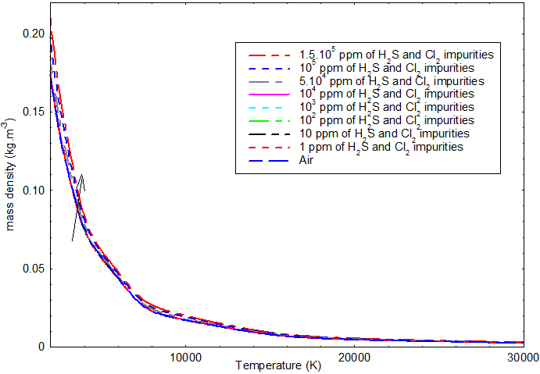

Fig. 2. Evolution of mass density as a function of temperature

Figure 3 illustrates the evolution of plasma mass enthalpy as a function of temperature in the presence of chlorine (Cl₂) and hydrogen sulfide (H₂S). The curves increase with temperature and exhibit areas with rapid variations corresponding to the dissociation reactions of molecules and the ionization of molecules and atoms as the temperature rises. The presence of impurities leads to a modification of the plasma mass enthalpy. The curves are practically indistinguishable at temperatures below 6,000 K. Beyond 6,000 K, the increase in the Cl₂ and H₂S content leads to a reduction in mass enthalpy. For instance, at 15,000 K, the value of the specific enthalpy of air is 1.11E08 J/kg, whereas air contains 20% impurities, and it decreases to 8.77 E7 J/kg. This represents a reduction of about 21%

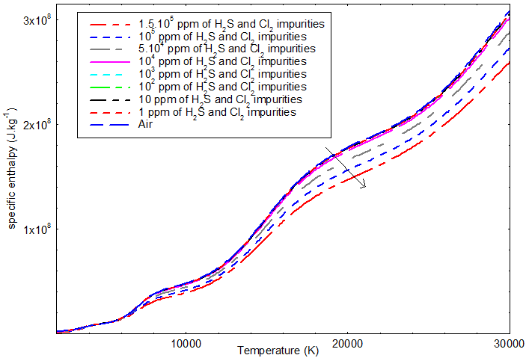

Fig. 3. Evolution of specific enthalpy as a function of temperature

Figure 4 shows that the evolution of specific heat strongly depends on both the temperature and composition of plasma. The heat varies according to the energy absorbed by the dissociation and ionization processes. We can observe the appearance of peaks in regions where the enthalpy varies rapidly. The curves show the trends with a first peak around 3500 K, a second around 7000 K, and a third peak around 15000 K. These different peaks represent the dissociation reactions (of molecules) and ionization (of molecules and atoms). Indeed, for temperatures below 3,000 K, the heat capacity is dominated by the kinetic and rotational energy of the molecules. It increases sharply with temperature, forming peaks around 3,500K and 7,000K. These peaks are due to the massive absorption of energy to break the molecular bonds. Thus, the first peak (at ~3,500 K) corresponds to the dissociation of molecules of NO, SO₂, S₂O, SO₃, H₂O, SCl, S₂, HCl, and SH, and the second peak corresponds to the dissociation of molecules of NH, SN, O₂, and N₂. The third peak in heat capacity occurs around 15,000K. This time, the energy is mainly absorbed to ionize the atoms. This phenomenon is more energy-intensive than dissociation. The atoms involved in this ionization are primarily H, S, O, and N.
Moreover, the presence of H₂S and Cl₂ reduces the specific capacity over the total temperature range.

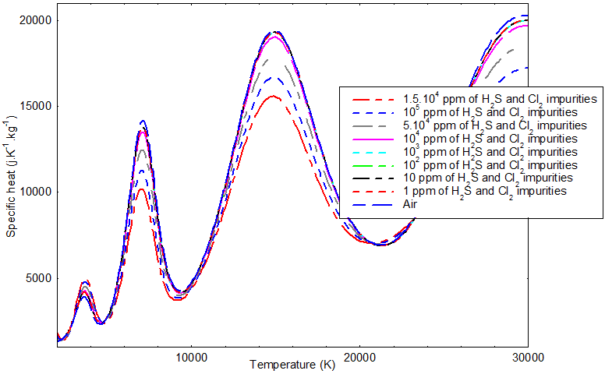
Fig. 4. Evolution of heat capacity as a function of temperature

Figure 5 shows the evolution of the speed of sound in air plasmas contaminated with Cl₂ and H₂S. The speed increases with the rise of temperature. It plays a crucial role in the process in the extinction electric arc inside a circuit breaker by creating a very powerful convection current around the arc, leading to its cooling; this increases the electrical resistance of the arc. Higher arc resistance reduces the current and dissipates energy, facilitating arc interruption. The presence of H₂S and Cl₂ leads to a decrease in the speed of sound in the plasma. This decrease in sound propagation is due to the presence of heavy particles in the plasma, which could enhance the power outage.
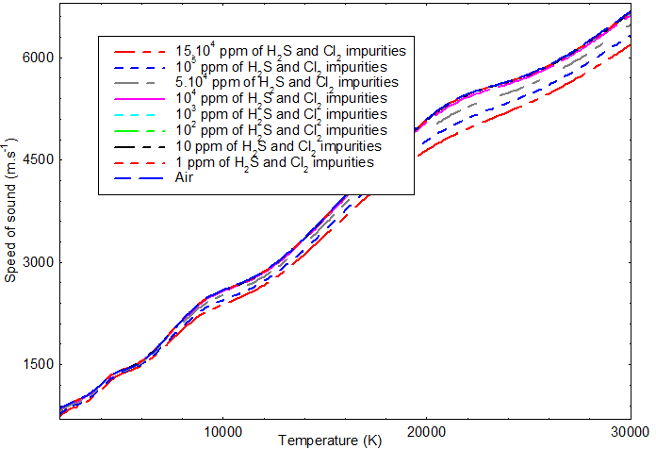

Fig. 5. Evolution of the speed of sound as a function of temperature

In summary, the presence of hydrogen sulfide and chlorine modifies the thermodynamic properties of the air plasma, which could negatively affect the current interruption process. Beyond the modification of the thermodynamic properties of the plasma during the power outage phase, the deposition of hydrogen sulfide and chlorine from the environment or anthropogenic activities impacts the condition of the circuit breakers and their operation. Hydrogen sulfide (H₂S) causes silver sulfidation, with the phenomenon accelerating with temperature. Hydrogen sulfide causes the tarnishing of silver surfaces exposed to air and the appearance of dendrites on electronic and power circuits (Shneider, 2021, Pompanon et al., 2022; Bruno et al., 2023; Perrenot et al., 2019). Then we notice an increase in the resistance of the exposed pin contacts, excessive heating of the device and short-circuiting of the circuits leading to the malfunction of the control unit. Chlorine (Cl₂) causes corrosion of metals through oxidation. This leads to increased friction, risks of mechanical failure, and breakage of stainless-steel springs (Shneider, 2021).

4. Conclusion

In conclusion, the presence of Cl₂ and H₂S in the air plasma significantly impacts its behaviour. This impurity leads to a complete modification of the plasma’s thermodynamic properties due to the appearance of heavy particles, resulting in an increase in mass density compared to pure air plasma. We also observe decreases in specific enthalpy, heat capacity, and speed of sound; the latter one is attributed to the presence of these heavy particles. They are also influenced by the dissociation and ionization of molecules and atoms within the plasma.
In addition to thermodynamic effects, we observe physical modifications of the circuit breakers due to contact corrosion, sulphurization, blackening, and contact breakage. HCl is a corrosive gas that can damage the components of the circuit breaker. The presence of HCl and other reactive species have a direct impact on contact erosion and the longevity of the device. The presence of Cl₂ and H₂S modifies the thermal and chemical properties of the air plasma, which can affect the effectiency of this blowing. Sulphur and chlorine atoms can react with the materials of the contacts and insulators of the circuit breaker, accelerating their degradation and reducing the lifespan of the device. Also, H₂S is highly toxic and flammable.
Overall, we can conclude that the presence of H₂S and Cl₂ in the plasma has a detrimental impact on the performance and reability of the circuit breakers. For future studies, we will focus on a study on transport coefficients and on the radiative properties in order to confirm the effect of this mixture on the performance of the air circuit breaker.

Disclaimer (Artificial intelligence)
Author(s) hereby declare that NO generative AI technologies such as Large Language Models (ChatGPT, COPILOT, etc.) and text-to-image generators have been used during the writing or editing of this manuscript.

References

Adinda V. D. B., 2007. Measurement and Calculation of Thermodynamic Properties of Plasma in the Waste Pyrolysis Reactor. PhD Thesis Universiteit Gent Vakgroep Toegrpaste.
Adjigkiga B., Wepari C.Y., Abdoul K.K., Ibrahim P., Niéssan K., Zacharie K., and François Z., 2025. Determination of the Transport Coefficients of an Air Plasma Contaminated by AgSnO2 Alloy Vapour. Journal of Physical Science, Vol. 36(2), 1–18, https://doi.org/10.21315/jps2025.36.2.1
Adjigkiga B., Abdoul K. K., Wepari C. Y., Niessan K., Zacharie K., and François Z., 2024 . Détermination des propriétés thermodynamiques d’un plasma d’air contaminé par de la vapeur d’alliage AgSnO2. Canadian Science Publishing. 00: 1–10, dx.doi.org/10.1139/cjp-2023-0052.
Anderson JD, 2000. Hypersonic and High Temperatur Gas Dynamics. American Institute of Aeronautics and Astronautics.
Andre, P., 1995. Etude de la composition et des propriétés thermodynamiques des plasmas thermiques à l’équilibre et hors d’équilibre thermodynamique. Ph.D. Thesis, Université Blaise Pascal de Clermont-Ferrand II (France).
Banouga A., Kagoné A. K., Yaguibou W. C., Kohio N., Koalaga Z., Zougmoré F., 2022. Equilibrium Composition of a Plasma in the Low Voltage Air Circuit Breaker Contaminated by the Vapor of AgSnO2 Alloy Electrical Contacts, Advances in Materials Physics and Chemistry, 12, 69-81, DOI : https://doi.org/10.4236/ampc.2022.125006
Bendjebbar F, André P, Benbakkar M, Rochette D, Flazi S and Vacher D., 2012. Plasma Formed in Argon, Acid Nitric and Water Used in Industrial ICP Torches", Plasma Science and Technology, Vol.14, No.8, Doi : 10.1088/1009-0630/14/8/01.
Bruno A., Frank M., Sebastian S., 2023. Tarnishing (Ag₂S) Layer on Silver-Plated Electrical Contacts: Its Influence on Electrical Contact Resistance. IEEE Transactions on Components, Packaging and Manufacturing Technology, Volume: 13, Issue: 1, pp 45 –58. Doi: 10.1109/TCPMT.2023.3238672.
Burm KTAL, 2005. The isentropic exponent and relation for monoatomic plasmas. Physics Letters A 336(2–3):200–203.
Burm KTAL, Goedheer WJ and Schram DC, 1999. The isentropic exponent in plasmas. Physics of Plasmas 6(6):2622–2627.
Cayet S and Dudeck M., 1996. Equilibre chimique dans des mélanges gazeux en déséquilibre thermique". Journal de Physique III, EDP Sciences. 6 (3), pp.403420. DOI: 10.1051/jp3:1996130
Boulos I.M., Fauchais P., and Pfender E., 1994. Thermal Plasmas: The Fundamentals and Applications (New York: Plenum Press) pp 413-417.
Capitelli M., Colonna G., Gorse C., and A. D'Angola A., 2000. Transport properties of high temperature air in local thermodynamic equilibrium, Eur.Phys. J.D, 11 279-289.
Capitelli M, Gianpiero C, Antonio D, 2012 Fundamental Aspects of Plasma Chemical Physics: Thermodynamics, Springer Series on Atomic, Optical, and Plasma Physics 66, DOI 10.1007/978-1-4419-8182-0 6, © Springer Science+Business Media, LLC.
McBride B. J., Michael J. Z and Gordon, S. 2002. Thermodynamic Properties of Individual Species. Nasa Glenn Coefficients for Calculating. Glenn Research Center, 297.
Cressault, Y., Hannachi, R., Teulet, P., Gleizes, A., Gonnet, J. and Battandier, J., 2008. Influence of Metallic Vapours on the Properties of Air Thermal Plasmas. Plasma Sources Science and Technology, 17, Article ID: 035016, https://doi.org/10.1088/0963-0252/17/3/035016
Cressault, Y., Murphy, A.B., Teulet, P., Gleizes, A. and Schnick, M., 2013. Thermal Plasma Properties for Ar-Cu, Ar-Fe and Ar-Al Mixtures Used in Welding Plasmas Processes: II. Transport Coefficients at Atmospheric Pressure. Journal of Physics D: Applied Physics, 46, Article ID: 415207, https://doi.org/10.1088/0022-3727/46/41/415207
Cressault, Y., Kimpeler, S., Moser, A. and Teulet, P., 2023. Thermophysical Properties of Air-Pa66-Copper Plasmas for Low-Voltage Direct Current Switches. Plasma Physics and Technology, 10, pp 52-55, https://doi.org/10.14311/ppt.2023.1.52
Colonna G., D’Angola A., Laricchiuta A., Bruno D., and Capitelli M., 2013. Analytical Expressions of Thermodynamic and Transport Properties of the Martian Atmosphere in a Wide Temperature and Pressure Range. Plasma Chem Plasma Process. 33:401–431, doi 10.1007/s11090-012-9418-4.
D'Angola A., Colonna G., Gorse C., and Capitelli M., 2008. Thermodynamic and transport properties in equilibrium air plasmas in a wide pressure and temperature range, Eur. Phys. J. D 46, pp 129–150.
Drellishak K. S, Knopp C. F, and Ali bulent cambel, 1963. Partition functions and thermodynamic properties of argon plasma, Northwestern university, technical documentary report no. Aedc-tdr-63-146.
Henderson SJ and Menart JA, 2008. Equilibrium properties of high–temperature air for a number of pressures. Journal of Thermophysics and Heat Transfer 22(4):718–726.
Kagone A.K., Koalaga Z., and Zougmore Z., 2012. Calculation of air-water vapor mixtures thermal plasmas transport coefficients. IOP Conf. Series: Materials Science and Engineering. 29, 012004. doi:10.1088/1757-899X/29/1/012004
Kagone A.K., Kohio N., Yaguibou W.C., Koalaga Z., and Zougmore F., 2020. Transport Coefficients of Air - PMMA Mixtures Thermal Plasmas. American Journal of Materials Science and Engineering. Volume 8, n° 1, pp. 22-28, DOI:10.12691/ajmse-8-1-4.
Kagone A.K., Kohio N., Yaguibou W.C., Koalaga Z., and Zougmore F., 2020. Calculation of the Chemical Composition of Air - PMMA Mixtures Thermal Plasmas. American Journal of Physical Chemistry. Volume 9, n° 2, pp. 27- 35, doi:10.11648/j.ajpc.20200902.12
Kagone A.K., Kohio N., Yaguibou W.C., Koalaga Z., and Zougmore F., 2018. Thermodynamic properties calculation of air – water vapor mixtures thermal plasmas. Global Journal of Pure and Applied Sciences. Voume 24, n° 1, pp. 37 - 49, DOI: https://dx.doi.org/10.4314/gjpas.v24i1.5 .
Kagone A.K., Kohio N., Yaguibou W.C., Koalaga Z., and Zougmore F., 2019. Water Vapor Influence on Thermodynamic Properties of Air-water Vapor Mixtures Plasmas at Low Temperatures. International Journal of Physics. Volume 7, n° 3, 66 - 72, DOI:10.12691/ijp-7-3-1.
Kagone A.K., Kohio N., Yaguibou W.C., Koalaga Z., and Zougmore F., 2020. Influence of Metallic Copper Vapors on the Chemical Composition of a Mixture of Air and Water Vapor Thermal Plasmas in the Temperature Range 1000 K to 20000K. American Journal of Nano Research and Applications. Volume 8, n° 3, 50-57, doi: 10.11648/j.nano.20200803.13
Kohio N., Kagone A.K., Yaguibou W.C., Koalaga Z., Zougmore F., 2019. Water Vapor Influence on Thermodynamic Properties of Air-water Vapor Mixtures Plasmas at Low Temperatures. International Journal of Physics. Volume 7 n° 3, pp. 66 -72, DOI:10.12691/ijp-7-3-1.
Pompanon F., Fouvry S., Alquier O., 2022. Influence of the relative humidity and H₂S - SO₂ polluted air on the fretting wear behavior of silver-plated electrical contacts. WEAR journal, Volumes 508–509. 204455. https://doi.org/10.1016/j.wear.2022.204455
Perrenot P., Pairis S., Bourgault D., and Caillault N., 2019. Sulphur corrosion effect on the electrical performance of silver films elaborated by physical vapor deposition. Vacuum. Volume 163. pp 26-30; https://doi.org/10.1016/j.vacuum.2019.01.024
Quéméneur J, 2016. Etude des forces à l’origine du déplacement d’un arc électrique dans un disjoncteur basse-tension, PhD Thesis, Université Paul Sabatier-Toulouse III, tel-01489236/.
Disjoncteurs et interrupteurs CEI. Schneider Electric. 2021, LVPED508016FR–03. https://www.productinfo.schneider-electric.com.
Wepari, C.Y., Aly R.K., Ibrahim P., Niessan K., Karim K., and Zacharie K., 2025. Calculation and Analysis of the Thermodynamic Properties of Air-Aerosols Mixtures. Advances in Materials Physics and Chemistry, 15(5), 75-89. https://doi.org/10.4236/ampc.2025.155005
Wepari C.Y., Niessan K., Abdoul K.K., and Zacharie K., 2018. Impact of Aerosol on Transport Coefficients of Air Thermal Plasmas in Circuit Breakers. International Journal of Engineering Research. Volume 7, Number 4, pp. 43-47, DOI : 10.5958/2319-6890.2018.00094.6.
Wepari C.Y., Niessan K., Abdoul K.K., Zacharie K., and François Z., 2018. Influence des aérosols sur la composition à l’équilibre d’un plasma d’air. Journal International de Technologie, de l’Innovation, de la Physique, de l’Energie et de l'Environnement., pp. 5-1 à 5-19.
Yaguibou W.C., Korsaga E., Kagone A., Kohio N., Koalaga Z., Zougmore F., 2019. Coefficients de transport des plasmas -air dans un disjoncteur électrique. Journal de physique de la SOAPHYS, Volume 1, pp. C19A11-1 à C19A11-5, DOI: 10.46411/jpsoaphys.19.01.011
Yaguibou W. C, Korsaga E., Korbeogo A.R., Koalaga Z., and Zougmore F., 2022. Study of the Composition of A Plasma of Dry Air Contaminated by Al₂O3, CO, Fe₂O₃ and SiO₂. Advances in Materials Physics and Chemistry. Volume 12 Numéro 8, pp.177- 193, DOI : https://doi.org/10.4236/ampc.2022.128013
Ziani A, 2009. Etude de l’arc électrique dans les appareils de coupure de haute et moyenne tension, PhD Thesis, Universitè des sciences et de la technologie Houari Boumediene, n°: 02/2009-D/EL.

