Extensive Vitamin K Antagonist-Induced Skin Necrosis Leading to Fatal Septic Shock: A Case Report

Abstract
Background: Vitamin K antagonist (VKA)-induced skin necrosis is a rare but life-threatening complication, typically occurring during the initiation phase of anticoagulation therapy. Its disseminated presentation is exceptional and poses a major diagnostic and therapeutic challenge. Despite its rarity, mortality rates remain high, particularly when complicated by secondary infection and multi-organ failure. The coexistence of leukocytoclastic vasculitis on biopsy adds further complexity to an already difficult clinical picture.
Case Presentation: We report the case of a 46-year-old woman with known moderate mitral stenosis in sinus rhythm, who developed extensive necrotic skin lesions involving the upper and lower limbs, face, and trunk, fifteen days after initiation of acenocoumarol therapy for a new-onset episode of atrial fibrillation. Laboratory findings revealed a supratherapeutic INR of 6.12, associated cardiac decompensation, severe inflammatory syndrome, and acute kidney injury. Protein C and Protein S deficiency were excluded. Despite intensive care management, the patient rapidly progressed to septic shock secondary to Pseudomonas aeruginosa superinfection. Skin biopsy unexpectedly revealed leukocytoclastic vasculitis, raising a complex differential diagnosis.
Discussion: This case illustrates the diagnostic complexity surrounding severe VKA-induced skin reactions. The clinical timeline strongly suggested coumarin-induced thrombotic necrosis; however, histological evidence of leukocytoclastic vasculitis introduced the possibility of drug-induced vasculitis or septic purpura as contributing or alternative etiologies. The absence of heparin bridging at the time of VKA initiation likely represents the pivotal preventable factor in this fatal outcome.
Conclusion: This exceptional case underscores the importance of rigorous INR monitoring during VKA initiation, the necessity of systematic heparin bridging, and the need to consider multiple competing diagnoses when facing severe cutaneous complications of anticoagulation therapy. Early skin biopsy and prompt dermatological assessment are essential to guide management in such cases.
Keywords: Skin necrosis; acenocoumarol; leukocytoclastic vasculitis; septic shock; anticoagulation; heparin bridging; atrial fibrillation; Protein C deficiency

1. Introduction
Vitamin K antagonists (VKAs), including acenocoumarol and warfarin, remain widely used anticoagulants in the management of thromboembolic conditions, valvular heart disease, and cardiac arrhythmias such as atrial fibrillation(AF). Despite their therapeutic efficacy, VKAs carry a narrow therapeutic index and are associated with a spectrum of adverse effects. Among the most severe and potentially fatal cutaneous complications is VKA-induced skin necrosis (VKASN), a rare yet devastating condition that warrants heightened clinical awareness.
VKASN is estimated to occur in 0.01–0.1% of patients initiating coumarin-based therapy[1]. It typically presents within the first few days of treatment initiation, predominantly affecting adipose-rich areas such as the breasts, buttocks, thighs, and abdomen. A systematic review by Al-Niaimi et al. identified over 90 case reports of warfarin-induced skin necrosis involving three or more body regions, underscoring the exceptional nature of disseminated presentations and highlighting male sex as an independent predictor of mortality[2]. The classical pathogenic mechanism involves a transient hypercoagulable state resulting from the paradoxical early depletion of Protein C — a vitamin K-dependent anticoagulant protein with a short half-life of 6–8 hours — prior to the depletion of procoagulant factors II, VII, IX, and X, leading to microvascular thrombosis and subsequent tissue necrosis[3,4].
However, cases involving extensive or disseminated cutaneous involvement are exceptionally rare, and their pathogenesis may be multifactorial, encompassing thrombotic, inflammatory, and infectious mechanisms[5,6]. Adding further diagnostic complexity, isolated case reports and case series have documented the emergence of leukocytoclastic vasculitis(LCV) — an immune-mediated small-vessel vasculitis — as a rare but distinct cutaneous complication of coumarin-based anticoagulation, including acenocoumarol[7,8]. When such presentations are compounded by supratherapeutic anticoagulation, systemic infection, and multi-organ failure, the clinical and diagnostic challenge becomes formidable.
The pathogenesis of leukocytoclastic vasculitis involves several immunological pathways. Toll-like receptors, mainly Toll-like receptor 4 (TLR4), play a considerable role in host defense against microorganisms [9]; TLR4-mediated dendritic cell (DC) stimulation enhances production of the chemokine CCL20, biasing recruitment towards CCL20- responsive CCR6+ T cells. In adoptive transfer experiments, CCR6+ T cells produce an arteritis pattern with media-invasive T cells damaging vascular smooth muscle cells, and CCR6+ T cells dominate the vasculitic infiltrates in patients with panarteritic giant cell arteritis [10]. Vascular endothelial growth factor (VEGF) is a key regulator of angiogenesis [11], and its plasma level is higher in the acute phase of vasculitic disease than in the resolution phase [12]. Furthermore, programmed death ligand-1 (PDL-1) is responsible for T cell activation, proliferation, and cytotoxic secretion to produce immune responses [13]; inhibition of PDL-1 results in uncontrolled activation of T-lymphocytes, releasing inflammatory cytokines that attract other immune cells and produce a phenotype of vascular and endothelial injury, followed by intimal hyperplasia — resulting in vessel occlusion and distal ischemia — as well as neovascularization of the vessel wall, thereby facilitating the influx of immune cells into the otherwise protected vascular wall [14]. Understanding these mechanisms is essential for interpreting the complex histopathological findings encountered in severe coumarin-related cutaneous complications.
The 2020 ESC Guidelines for the management of atrial fibrillation specifically recommend NOACs over VKAs in eligible patients, reserving VKA use for those with specific indications such as mechanical heart valves or moderate-to-severe mitral stenosis. In such patients, initiation of VKA therapy must be accompanied by heparin bridging to mitigate the prothrombotic window generated by early Protein C depletion [15].
We present a case of extensive, rapidly progressive VKA-induced skin necrosis in a patient with mitral stenosis and new-onset atrial fibrillation, which culminated in fatal septic shock, and in which histopathological findings revealed an unexpected diagnosis of leukocytoclastic vasculitis. This case contributes to the limited literature on disseminated VKASN and highlights the critical importance of preventive anticoagulation strategies.

2. Case Presentation

2.1 Patient History and Initial Presentation
A 46-year-old female patient with a known history of valvular heart disease — moderately severe mitral stenosis and moderate mitral regurgitation in sinus rhythm, followed since 2017 — presented to the emergency department with extensive and rapidly progressive necrotic skin lesions. Her baseline medical treatment included spironolactone 25 mg/day, furosemide 40 mg/day, and propranolol 40 mg/day. She reported no prior thromboembolic events, no personal or family history of coagulopathy, and no prior exposure to anticoagulant agents. She presented with dyspnoea at NYHA class III, evolving over 20 days, and bilateral lower limb oedema.
Fifteen days prior to admission, her private cardiologist had initiated acenocoumarol therapy following a new episode of atrial fibrillation identified during routine follow-up, without concomitant heparin bridging. The patient reported that the onset of cutaneous lesions was strictly concomitant with the commencement of VKA therapy, initially appearing as purpuric patches before rapidly evolving into extensive necrotic plaques involving the upper and lower extremities, the face, and the trunk. No loading dose reduction strategy was implemented, and no INR monitoring had been performed prior to presentation.

2.2 Clinical Findings
On physical examination, the patient was conscious (Glasgow Coma Scale 15/15), with a blood pressure of 128/70mmHg and a heart rate of 120bpm. Cardiac auscultation revealed irregularly irregular heart sounds consistent with atrial fibrillation and a grade 4/6 diastolic rumble at the mitral area, consistent with her known mitral stenosis. Pulmonary auscultation was clear, with no crackles. Lower limb oedema was present bilaterally.
Cutaneous examination revealed diffuse, confluent necrotic skin lesions with sharply demarcated borders, affecting greater than 30% of the total body surface area. The lesions exhibited a livedo-like pattern peripherally with central eschar formation, including extensive haemorrhagic purpuric macules of various types: necrotic lesions at the extremities of all four limbs with nodular infiltration and bullae sensitive to palpation, skin sloughing of both lower limbs, and petechial facial involvement on the chin with ecchymosis on the bridge of the nose.
The classical tell-tale sequence of pain, petechiae progressing to sharply demarcated ecchymosis, bullae formation, and gangrenous necrosis was consistent with that described in the foundational case series by Nazarian et al.[1].
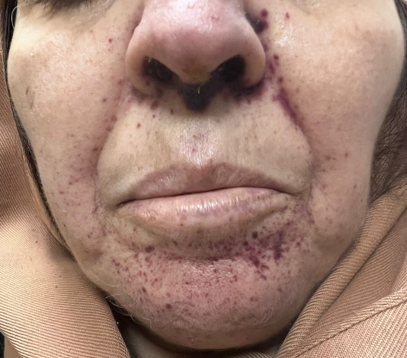
Figure 1: The photo showing Petechial facial involvement on the chin and ecchymosis on the bridge of the nose.
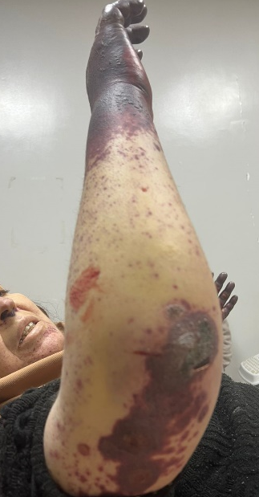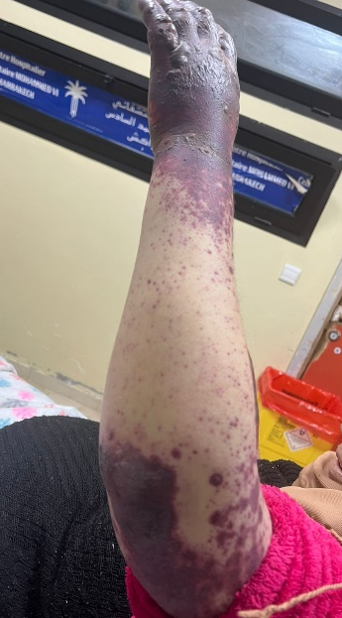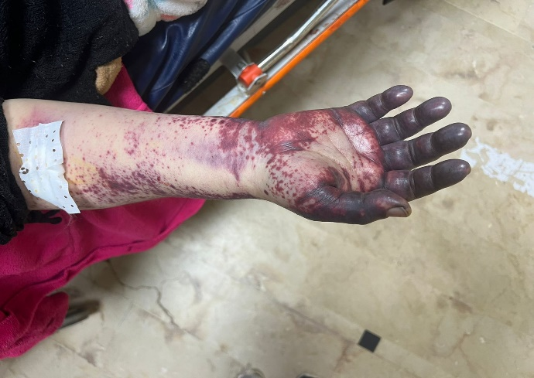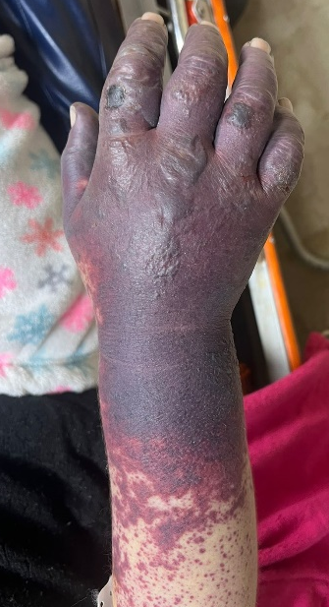
Figure 2: The photos showing petechial purpura of the arm and forearm with necrosis of the extremities and Nodular infiltration and bullae sensitive to palpation.

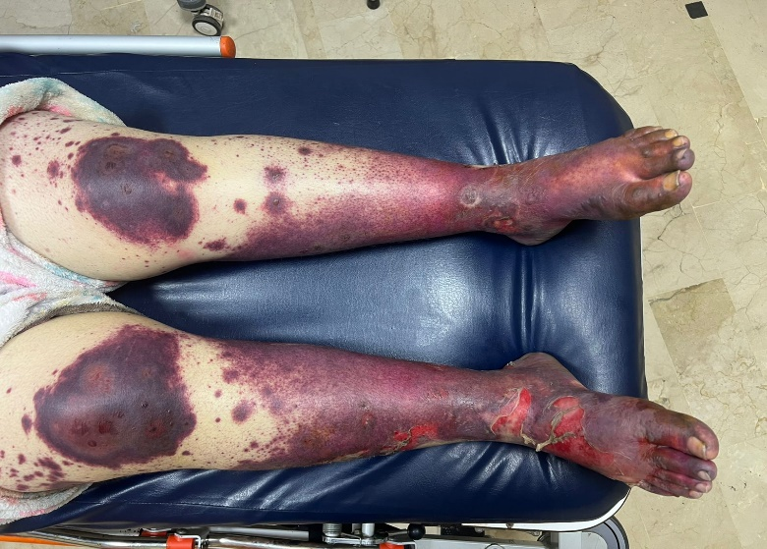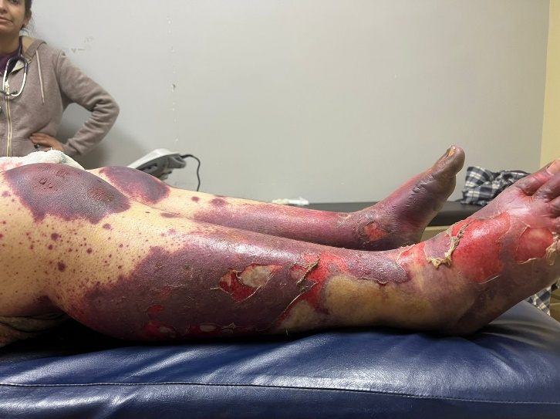
Figure 3: The photos showing Extensive hemorrhagic purpuric macules of Of the legs, thighs, and feet. with necrosis of the extremities, Nodular infiltration, bullae sensitive to palpation and Skin sloughing.

2.3 Electrocardiographic, Laboratory, and Investigational Results
The initial 12-lead ECG demonstrated atrial fibrillation with a ventricular rate of 120 bpm, a normal cardiac axis, narrow QRS complexes, and no secondary repolarization abnormalities. (figure 4)
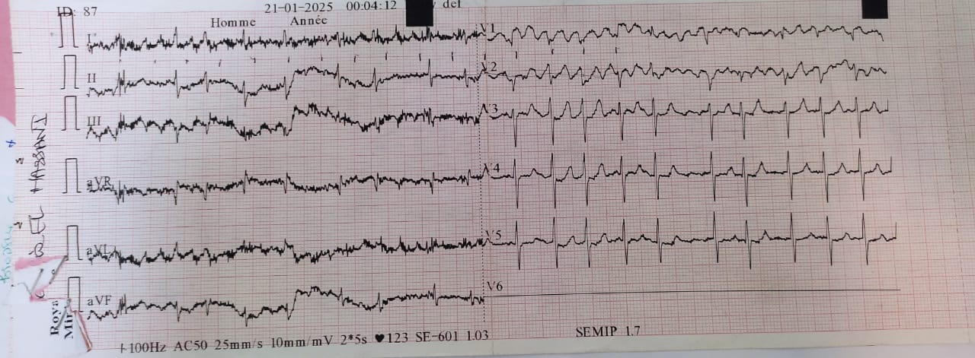
Figure 4: ECG showing a tachy atrial fibrillation
Transthoracic echocardiography confirmed rheumatic valvular disease with moderate to severe mitral stenosis and moderate mitral regurgitation. Left ventricular dimensions were normal, with preserved longitudinal systolic function. Both atria were dilated and free of intracavitary thrombus. The right ventricle was non-dilated with preserved systolic function. Pulmonary artery systolic pressure (PASP), estimated via the tricuspid regurgitation jet, was 42 mmHg, consistent with moderate pulmonary hypertension. A small-to-moderate pericardial effusion was noted. The inferior vena cava was non-dilated and compliant.
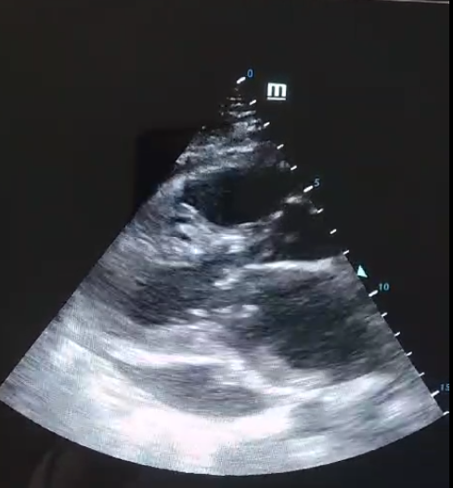
Figure 5: Transthoracic echocardiography showing rheumatic valvular disease with moderate to severe mitral stenosis and moderate mitral regurgitation.

Initial laboratory investigations revealed the following significant findings:
Coagulation profile: INR of 6.12, indicating massive supratherapeutic acenocoumarol overdose. INR subsequently decreased to 3.45 and then 2.87 following initiation of management.
Cardiac biomarkers: Elevated BNP consistent with cardiac decompensation in the context of underlying mitral stenosis and new-onset AF. CPK: 2,863 U/L; LDH: 1,018 U/L.
Inflammatory markers: Markedly elevated C-reactive protein (CRP) at 262 mg/L and white blood cell count at 27,500/mm³ with neutrophilic predominance (PMN: 23,700/mm³), indicative of severe systemic inflammatory response syndrome (SIRS). Procalcitonin was elevated at 5.58 ng/mL, raising high suspicion for bacteremia. Haemoglobin was 14 g/dL and platelet count was 213,000/mm³.
Renal and metabolic profile: Elevated serum creatinine at 20.5 mg/L (urea: 1.6 g/L) consistent with acute kidney injury (AKI) with an estimated glomerular filtration rate (eGFR) of 25 mL/min/1.73m², likely secondary to hypoperfusion. Serum electrolytes revealed hyponatraemia (Na+: 133 mEq/L) and hyperkalaemia (K+: 5.9 mEq/L). Liver function tests showed mildly elevated transaminases (ASAT: 111 U/L; ALAT: 76 U/L). 24-hour urine protein was 0.45 g/L.
Thrombophilia screen: Protein C activity was 74% and Protein S activity was 71%, both within normal limits, effectively excluding hereditary deficiency as a predisposing factor. This finding is noteworthy, as hereditary Protein C deficiency is classically implicated in VKASN pathogenesis, yet up to 30–40% of reported cases occur without any identifiable thrombophilia [2].
Immunological workup: Weakly positive antinuclear antibodies (speckled pattern, low titre), negative anti-dsDNA antibodies, negative ANCA, and absent cryoglobulins.
Microbiological analysis of skin swab cultures yielded growth of Pseudomonas aeruginosa, confirming secondary bacterial superinfection of the necrotic lesions. Blood cultures were subsequently positive for P. aeruginosa bacteremia, a recognized cause of ecthyma gangrenosum and fulminant septic presentations[16].
A punch skin biopsy was performed from the active border of a necrotic lesion. Histopathological examination unexpectedly revealed leukocytoclastic vasculitis (LCV), characterized by neutrophilic infiltration of small vessel walls, fibrinoid necrosis, and leukocytoclasis — without the expected features of purely thrombotic coumarin necrosis (i.e., fibrin thrombi within dermal vessels with minimal inflammatory infiltrate). This histological pattern, previously described in association with acenocoumarol by Jiménez-Gonzalo et al.[4] and with warfarin by Elantably et al. [5], added significant complexity to the diagnosis.

2.4 Clinical Course and Outcome
The patient was admitted to the Intensive Care Unit (ICU) within 48 hours of presentation, in a state of refractory septic shock secondary to P. aeruginosa bacteremia arising from the superinfected necrotic wounds. VKA therapy was immediately discontinued, and vitamin K was administered intravenously to reverse supratherapeutic anticoagulation. Intravenous piperacillin-tazobactam was initiated empirically based on local antimicrobial protocols and subsequently adjusted in accordance with microbiological susceptibility profiles.
Aggressive resuscitation measures, including fluid administration, vasopressor support, broad-spectrum antimicrobial therapy, wound care, and multi-organ supportive care were initiated. Parenteral nutrition was commenced given the extent of cutaneous involvement and associated nutritional compromise. Serial wound assessments were performed with wound debridement as clinically indicated.
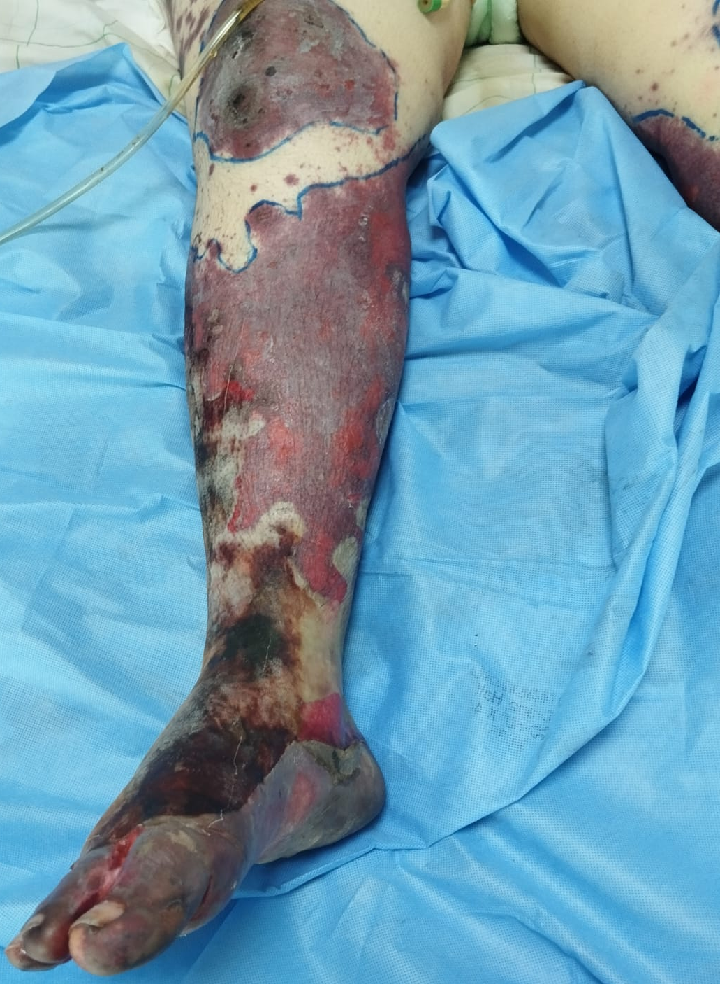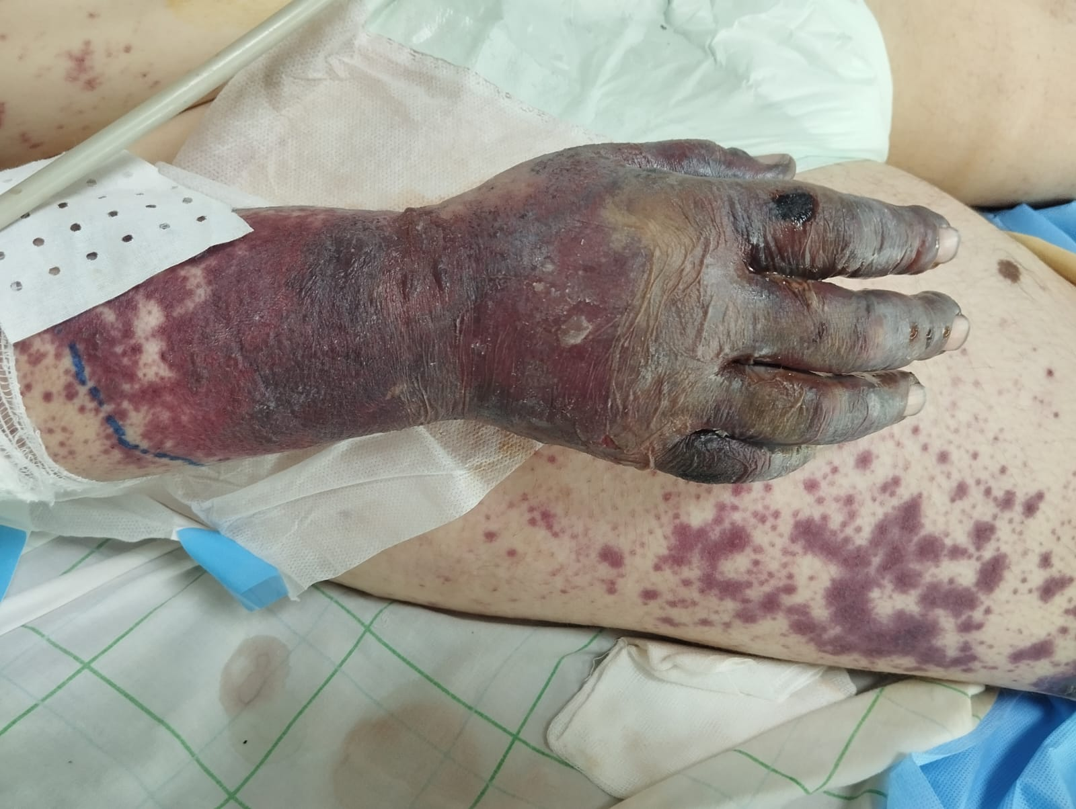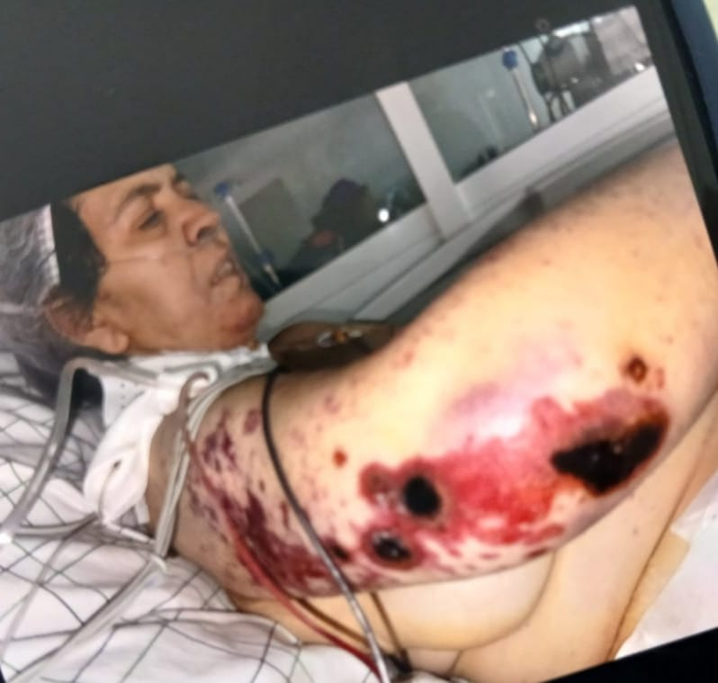
Figure 6: deterioration of skin lesions, with expanding areas of necrosis.

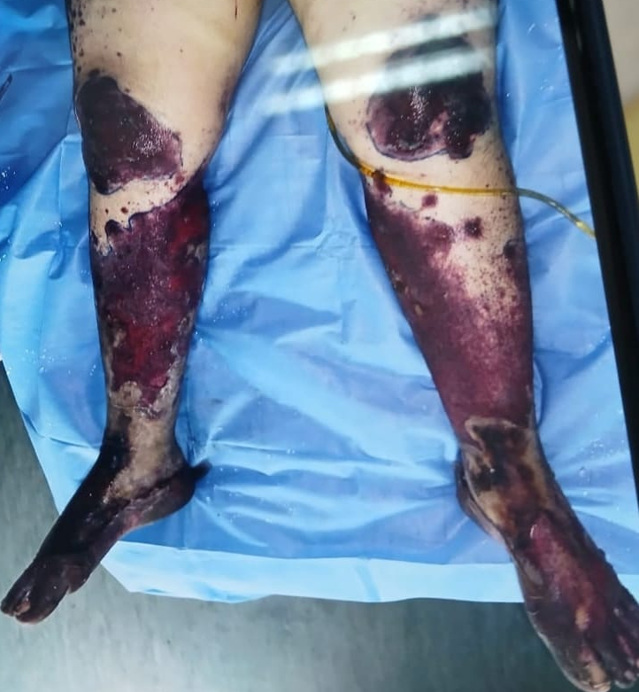
Figure 7: deterioration of skin lesions, with expanding areas of necrosis H12 before death.

Despite these intensive interventions, the patient's clinical condition continued to deteriorate, with progressive haemodynamic instability, worsening renal failure requiring continuous renal replacement therapy, and respiratory compromise necessitating mechanical ventilation. She died within two weeks of hospital admission from multi-organ failure in the context of uncontrolled septic shock. The case was presented to the institutional multidisciplinary committee, and the family was informed of the clinical circumstances and outcome.

3. Discussion

3.1 VKA-Induced Skin Necrosis: Epidemiology and Classical Pathogenesis
VKA-induced skin necrosis is a well-recognized but rare complication of coumarin-based anticoagulation, with an estimated incidence of less than 0.1% among treated patients [1]. The classical mechanism involves an imbalance between pro- and anticoagulant vitamin K-dependent proteins during the early phase of VKA initiation. Because Protein C has a shorter half-life (approximately 6–8 hours) compared to procoagulant factors II, IX, and X, its levels fall more rapidly, transiently establishing a prothrombotic state. This leads to fibrin thrombus formation within small dermal and subcutaneous vessels, resulting in ischemia and necrosis [3,4].
Classically, VKASN manifests between days 3 and 6 of VKA initiation, almost invariably within the first 10 days [1]. The late-onset presentation observed in our patient — emerging 15 days after acenocoumarol commencement — parallels previously documented atypical cases, including that described by Essex et al. in which necrosis appeared 46 days after warfarin initiation [17], and a fatal late-onset case reported by Bayrakçı and Korkmaz in which warfarin-induced skin necrosis similarly resulted in a lethal outcome despite intensive care [5]. A case from Ghana further illustrates the occurrence of this rare condition across diverse clinical and geographic settings, underscoring that VKASN is not confined to specific patient populations [6]. Such cases challenge the classical mechanistic framework and suggest that additional pathogenic pathways — including immune-mediated injury — may operate alongside or independently of the prothrombotic window. A systematic review identified male sex and multi-site involvement as independent predictors of mortality in warfarin-induced skin necrosis, underscoring the need for heightened vigilance in such presentations [2].
Risk factors for VKASN include hereditary or acquired Protein C or Protein S deficiency, initiation of VKA therapy without heparin bridging, administration of high loading doses, and female sex. Notably, both Protein C and Protein S deficiencies were excluded in the present case, raising important questions about alternative or complementary pathogenic mechanisms. The absence of identifiable thrombophilia in the setting of disseminated necrosis further underscores the likelihood of multifactorial disease.

3.2 Diagnostic Complexity: Thrombotic Necrosis, Vasculitis, or Septic Purpura?
The histopathological finding of LCV in this case introduces a significant diagnostic dilemma. LCV is a small-vessel vasculitis defined histologically by the presence of granulocytes in perivascular or extravascular locations, fibrinoid necrosis, and leukocytoclasis. Drug-induced LCV accounts for 10–30% of all LCV cases, with clinical presentation typically involving palpable purpura and hemorrhagic bullae[8]. Three non-mutually exclusive diagnoses warrant consideration in this case:
(a) Drug-induced vasculitis (acenocoumarol): Although acenocoumarol is not a classic causative agent of drug-induced vasculitis, isolated case reports have implicated coumarin derivatives in immune-mediated vascular injury. Jiménez-Gonzalo et al. reported a case of acenocoumarol-induced LCV in a 54-year-old female with mitral stenosis and atrial fibrillation — strikingly similar to our patient — in which cutaneous vasculitis emerged three weeks after acenocoumarol initiation[7]. Elantably et al. further documented warfarin-induced LCV confirmed by both biopsy and rechallenge in a patient with rheumatic heart disease and a mechanical mitral valve [8]. The temporal association between drug initiation and lesion onset in our case, combined with LCV on histology and the absence of alternative identified causes, supports this possibility.
(b) Septic purpura and ecthyma gangrenosum: Pseudomonas aeruginosa bacteremia is a well-established cause of ecthyma gangrenosum and septic emboli, which can histologically mimic or coexist with vasculitis. The presence of cutaneous P. aeruginosa superinfection complicates the interpretation of the biopsy, as secondary infectious vasculitis cannot be excluded. P. aeruginosa bacteremia carries a significant mortality burden, particularly in immunocompromised or critically ill patients [16].
(c) Coumarin-induced thrombotic necrosis with secondary inflammatory changes: In advanced stages of VKASN with superinfection, histological specimens may demonstrate inflammatory infiltrates overlying the primary thrombotic injury, potentially masking or modifying the underlying pathology. The supratherapeutic INR of 6.12 may have further promoted hemorrhagic transformation within ischemic lesions.
The absence of Protein C/S deficiency, the disseminated distribution of lesions (involving >30% BSA across multiple anatomical regions), the histological LCV pattern, the positive immunological workup(weakly positive ANA), and the presence of concomitant bacterial superinfection collectively suggest a multifactorial pathogenesis — rather than a purely classical coumarin-induced thrombotic mechanism. This case adds to the growing literature demonstrating that coumarin-related cutaneous toxicity extends beyond classical skin necrosis and may encompass immune-mediated vascular injury as a distinct pathological entity.

3.3 The Role of Supratherapeutic Anticoagulation
An INR of 6.12 at presentation represents a substantially supratherapeutic level. While overdose alone does not cause skin necrosis — which paradoxically results from a prothrombotic imbalance — supratherapeutic anticoagulation may have exacerbated haemorrhagic transformation within ischemic lesions, accelerated wound breakdown, impaired cutaneous healing, and promoted the progression from limited to disseminated cutaneous involvement. Moreover, elevated INR in the context of active bacteremia and critical illness is an independent predictor of adverse outcomes.
The absence of structured INR monitoring during the 15-day period between VKA initiation and hospital admission is a significant clinical lapse. Current evidence-based guidelines recommend close INR monitoring during the first weeks of VKA therapy, with target INR ranges tailored to the underlying condition [9]. In patients with mitral stenosis and atrial fibrillation — as in the present case — VKA therapy is mandated given the contraindication to DOACs; however, this mandates even more rigorous initial monitoring.

3.4 Prevention: The Critical Role of Heparin Bridging and Safe VKA Initiation
The preventive strategy most effectively supported by current evidence for averting VKASN is the concomitant use of therapeutic heparin bridging during VKA initiation. Unfractionated heparin or low-molecular-weight heparin (LMWH) should be initiated simultaneously with VKA and maintained until a stable therapeutic INR is achieved (typically 2.0–3.0 for AF). This approach prevents the prothrombotic window generated by the early relative depletion of Protein C, irrespective of underlying thrombophilia status.
In the present case, the absence of heparin bridging at VKA initiation — compounded by the likely use of an unmonitored initial dose — may have been the critical predisposing factor, even in the absence of demonstrable Protein C deficiency. This failure to bridge represents both a clinical and a systems-level gap. The 2020 ESC Guidelines for atrial fibrillation management endorse NOACs over VKAs in eligible patients with non-valvular AF, largely due to their more predictable pharmacokinetic profile and the absence of the early prothrombotic paradox seen with VKA initiation [9]. In patients with valvular AF and mitral stenosis — for whom VKA remains the standard of care — heightened vigilance during initiation is thus paramount.
Furthermore, clinicians must maintain a high index of suspicion for VKA-related cutaneous complications from the outset of therapy, with early histopathological assessment when purpuric or necrotic skin lesions appear. Prompt wound assessment, early dermatological involvement, and infectious disease consultation are essential components of multidisciplinary management.

4. Conclusion
This exceptional case of extensive VKA-induced skin necrosis, culminating in fatal septic shock, illustrates the severe end of the spectrum of coumarin-related adverse events. It challenges the classical pathogenic framework by demonstrating histopathological features of leukocytoclastic vasculitis in the absence of Protein C or Protein S deficiency, thereby highlighting the potential for multifactorial pathogenesis, including drug-induced immune-mediated vascular injury and infectious co-etiologies. The disseminated extent of cutaneous involvement, combined with rapid progression to bacteremia and multi-organ failure, represents a rare but catastrophic clinical phenotype.
For cardiologists and clinicians initiating VKA therapy — particularly in the context of new-onset atrial fibrillation superimposed on structural heart disease — this case serves as a critical reminder of three imperatives: (1) systematic use of heparin bridging during VKA initiation, regardless of thrombophilia status; (2) rigorous, frequent INR monitoring in the early treatment phase with targeted dose adjustment; and (3) a high index of suspicion for VKA-related cutaneous complications, with early histopathological and microbiological assessment when such lesions appear.
While VKA-induced skin necrosis remains rare, its consequences can be catastrophic. Awareness, early prevention, and prompt interdisciplinary diagnosis are the cornerstones of management and the only means of averting a potentially fatal outcome.

Consent
Written informed consent was obtained from the patient's next of kin for the publication of this case report and any accompanying images, in accordance with institutional ethical guidelines.

Disclaimer (Artificial intelligence)

Author(s) hereby declare that NO generative AI technologies such as Large Language Models (ChatGPT, COPILOT, etc.) and text-to-image generators have been used during the writing or editing of this manuscript.

References
[1]Nazarian RM, Van Cott EM, Zembowicz A, Duncan LM. Warfarin-induced skin necrosis. J Am Acad Dermatol. 2009;61(2):325–332. doi:10.1016/j.jaad.2008.12.039
[2]Al-Niaimi F, Cox N, Griffiths C, George S. Systematic review of warfarin-induced skin necrosis case reports and secondary analysis of factors associated with mortality. Clin Exp Dermatol. 2022;47(2):270–279.doi:10.1111/ced.14927
[3]Comp PC, Elrod JP, Karzenski S. Warfarin-induced skin necrosis. Semin Thromb Hemost. 1990;16(4):293–298.
[4]Warkentin TE. Limb Ischemic Necrosis Secondary to Microvascular Thrombosis: A Brief Historical Review. Semin Thromb Hemost. 2024;50(5). doi:10.1055/s-0044-1779693
[5]Bayrakçı S, Korkmaz P. A Case Of Late-onset Warfarin Induced Skin Necrosis Resulting In Mortality. Hitit Med J. 2023;5(1):59–61. doi:10.52827/hititmedj.1173309
[6]Nsaful J, Adjei YO. Warfarin-induced skin necrosis: a rare condition. Ghana Med J. 2020;54(4):269–273. doi:10.4314/gmj.v54i4.10
[7]Jiménez-Gonzalo FJ, Medina-Pérez M, Marín-Martín J. Acenocoumarol-induced leukocytoclastic vasculitis. Haematologica. 1999;84(6):569–570.
[8]Elantably D, Mourad A, Elantably A, et al. Warfarin induced leukocytoclastic vasculitis: an extraordinary side effect. J Thromb Thrombolysis. 2020;49(1):149–152. doi:10.1007/s11239-019-01924-8
[9]Hamad MA, Al-Balas HA. Toll-like receptors in host defense against microorganisms. Mediterr J Hematol Infect Dis. 2022;14(1):e2022022. doi:10.4084/MJHID.2022.022
[10]Deng J, Ma-Krupa W, Gewirtz AT, Younge BR, Goronzy JJ, Weyand CM. Toll-like receptors 4 and 5 induce distinct types of vasculitis. Circ Res. 2009;104(4):488–495. doi:10.1161/CIRCRESAHA.108.185777
[11]Khallaf SM, Mohammed DA, ElNaggar MGM, Abdel-Hameed MR, Bakry R. Predictive and prognostic values of serum VEGF in patients with multiple myelomas receiving bortezomib-based therapy. Ann Oncol. 2021;32(Suppl 5):S781. doi:10.1016/j.annonc.2021.08.139
[12]Topaloglu R, Sungur A, Baskin E, Besbas N, Saatci U, Bakkaloglu A. Vascular endothelial growth factor in Henoch-Schönlein Purpura. J Rheumatol. 2001;28(10):2269–2273.
[13]Abdel Hafeez LA, Mansor SG, Zahran AM, et al. Expression of programmed death ligand-1 (PDL-1) in Acute Myeloid Leukemia Patients and its relation to post induction Response. SECI Oncology Journal. 2021;9(2):106–111. doi:10.21608/secioj.2021.170554
[14]Daxini A, Cronin K, Sreih AG. Vasculitis associated with immune checkpoint inhibitors — a systematic review. Clin Rheumatol. 2018;37:2579–2584.

[15]Hindricks G, Potpara T, Dagres N, et al. 2020 ESC Guidelines for the diagnosis and management of atrial fibrillation. Eur Heart J. 2021;42(5):373–498. doi:10.1093/eurheartj/ehaa612
[16]Falagas ME, Rafailidis PI. Bacteremia due to Pseudomonas aeruginosa: clinical features and prognostic factors. Expert Rev Anti Infect Ther. 2007;5(5):841–851.
[17]Essex DW, Wynn SS, Jin DK. Late-onset warfarin-induced skin necrosis: case report and review of the literature. Am J Hematol. 1998;57(3):233–237.

