Balloon aortic valvuloplasty as a bridge to urgent hip fracture surgery in a frail elderly patient with severe aortic stenosis: A case report

Abstract
Severe aortic stenosis in frail older adults requiring urgent hip fracture surgery represents a major therapeutic challenge. Delaying orthopaedic repair may worsen outcomes, whereas proceeding directly to surgery in the setting of critical aortic stenosis carries substantial perioperative risk. We report the case of an 89-year-old frail woman living in a nursing home, with Alzheimer’s disease, hypertension, osteoporosis, and known severe calcific aortic stenosis, who was admitted for a left pertrochanteric hip fracture after a ground-level fall. Transthoracic echocardiography confirmed severe aortic stenosis with a peak velocity of 4.8 m/s, a mean gradient of 63 mmHg, and an indexed aortic valve area of 0.42 cm²/m², with preserved left ventricular ejection fraction. Because immediate orthopaedic surgery was considered to carry prohibitive anesthetic risk, a multidisciplinary team selected balloon aortic valvuloplasty as a bridge strategy. The procedure reduced the peak-to-peak transvalvular gradient from 75 to 20 mmHg, and post-procedural echocardiography showed a mean gradient of 26 mmHg with preserved ventricular function. Gamma nail fixation was successfully performed under general anesthesia the following day. This case highlights that balloon aortic valvuloplasty may serve as a pragmatic short-term bridge to urgent hip fracture repair in carefully selected frail patients with severe aortic stenosis who are poor candidates for immediate definitive valve intervention. Decisions should remain individualized and based on a multidisciplinary Heart Team assessment.
Keywords: balloon aortic valvuloplasty, severe aortic stenosis, hip fracture, frailty, bridge therapy, perioperative risk

Introduction
Severe aortic stenosis is a progressive valvular disease whose advanced stage is characterized by marked obstruction of left ventricular outflow and a high risk of adverse clinical events if left untreated [1]. In older adults presenting with hip fracture, its coexistence creates a major therapeutic challenge because orthopedic repair should not be unduly delayed, yet surgery in the setting of critical aortic stenosis carries substantial perioperative risk [2].
The impact of aortic stenosis on outcomes after hip fracture in older adults has been specifically examined by Keswani et al., who showed that this valvular disease is associated with worse prognosis in an already frail population [3]. More recently, Terré et al. emphasized that the combination of acute hip fracture and severe aortic stenosis represents a complex management scenario requiring individualized decisions regarding timing of surgery, cardiovascular optimization, and the possible role of preoperative valvular intervention [2].
The ESC/EACTS guidelines highlight the central role of the Heart Team in the assessment of severe valvular heart disease, taking into account not only anatomical severity but also frailty, functional status, and the expected clinical benefit of an invasive strategy [4]. Likewise, the 2024 American guideline on perioperative cardiovascular management for non-cardiac surgery stresses the importance of early identification and appropriate evaluation of severe valvular disease when urgent surgery is contemplated [5]. The ACC/AHA valvular heart disease guideline similarly underscores that intervention should be guided by multidisciplinary assessment and by the likelihood of meaningful clinical benefit, particularly in elderly and dependent patients [6].
In this context, balloon aortic valvuloplasty retains a limited but relevant role as a bridge-to-surgery strategy. In patients with hip fractures, Ferré et al. suggested that preoperative valvuloplasty may be associated with lower mortality despite a longer delay to surgery [7]. Debry et al. also reported that balloon aortic valvuloplasty may be considered in selected patients with severe aortic stenosis requiring urgent non-cardiac surgery, although its benefit remains highly dependent on careful patient selection [8]. Its contemporary role as a temporary therapeutic option has been further revisited in recent reviews, which support its use in selected clinical settings rather than as definitive treatment [9–12].
We report the case of an 89-year-old institutionalized and highly frail woman with severe calcific aortic stenosis who presented with a left pertrochanteric hip fracture and underwent balloon aortic valvuloplasty as a bridging strategy before urgent osteosynthesis.

CASE PRESENTATION

An 89-year-old woman living in a nursing home, with a medical history of Alzheimer-type dementia, hypertension, osteoporosis, osteoarthritis, and severe calcific aortic stenosis known since 2021, was admitted for a closed left pertrochanteric hip fracture after a ground-level fall onto her buttocks, resulting in complete functional impairment of the left lower limb.
From a geriatric standpoint, she was a highly frail institutionalized patient with a GIR score of 2, known cognitive impairment, usual ambulation with a walker, and reduced functional autonomy. Her long-term treatment included amlodipine, memantine, low-dose acetylsalicylic acid, paracetamol, macrogol, and intermittent vitamin supplementation.
Preoperative cardiac assessment confirmed very severe aortic stenosis involving a severely calcified tricuspid aortic valve. Transthoracic echocardiography showed a peak velocity of 4.8 m/s, a mean gradient of 63 mmHg, an indexed aortic valve area of 0.42 cm²/m², and a left ventricular ejection fraction of 65% (Figure 1).
The left ventricle was non-dilated, concentrically hypertrophied, and showed no significant systolic dysfunction. In this setting, immediate orthopedic surgery was considered to carry a high anesthetic risk because of the severity of the aortic stenosis.
After multidisciplinary discussion involving cardiologists, anesthesiologists, geriatricians, and orthopaedic surgeons, balloon aortic valvuloplasty (BAV) was selected as a bridging strategy before orthopaedic surgery.
BAV was performed through the right femoral approach using two inflations with a 20 × 40 mm balloon under rapid pacing (Figure 2). Before dilation, the peak-to-peak transvalvular gradient was 75 mmHg, and the left ventricular end-diastolic pressure was 18 mmHg. After the procedure, the residual peak-to-peak gradient was 20 mmHg, with a left ventricular end-diastolic pressure below 5 mmHg. Postprocedural echocardiography showed a preserved left ventricular ejection fraction of approximately 60%, good global and segmental wall motion, and a decrease in the mean transaortic gradient to 26 mmHg. Moderate aortic regurgitation persisted, together with a heavily calcified mitral valve with moderate regurgitation and a small pericardial effusion without hemodynamic consequences.
The immediate course in the cardiac intensive care unit was hemodynamically favorable. However, telemetry revealed several episodes of non-sustained ventricular tachycardia, leading to the initiation of bisoprolol at 1.25 mg/day.
After cardiac stabilization, the patient underwent gamma nail fixation of the left pertrochanteric fracture under general anesthesia the following day (Figures 3A, 3B). The postoperative orthopaedic course was uncomplicated, with early mobilization, weight-bearing allowed, a clean surgical wound, and satisfactory radiographic findings.
The hospital course was marked by several moderate medical complications, including postoperative anemia with a hemoglobin level of 8.9 g/dL (reference range in women: 12.0-16.0 g/dL), requiring transfusion of one unit of packed red blood cells; moderate malnutrition with corrected hypoalbuminemia at 33.7 g/L (reference range: 35-50 g/L); vitamin D deficiency at 19.7 ng/mL (sufficiency usually >30 ng/mL); and a postoperative inflammatory syndrome without an identified infectious source.
Renal function remained preserved. Return to the nursing home was authorized after clinical stabilization, with continuation of baseline therapy, addition of bisoprolol, thromboprophylaxis with enoxaparin, vitamin supplementation, and planned cardiology follow-up. The chronological sequence of clinical events is summarized in Figure 4.

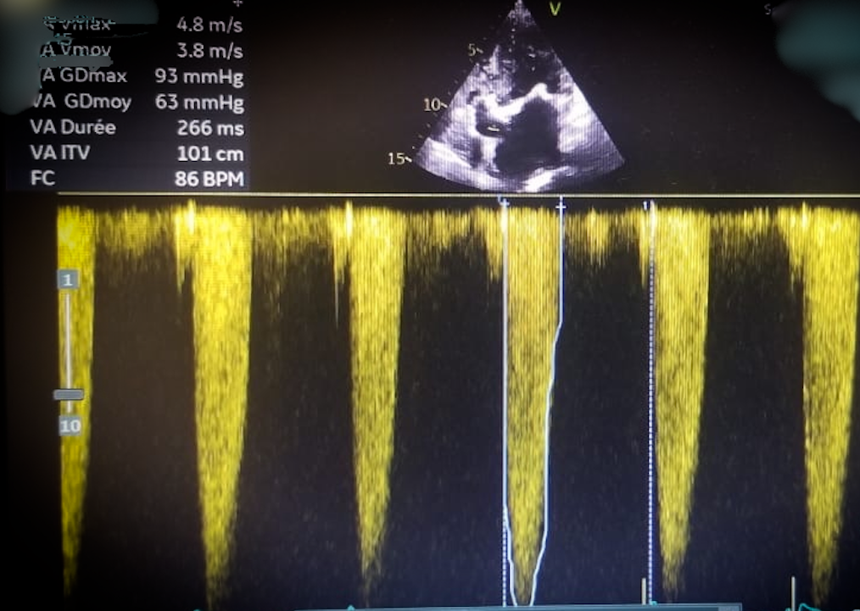
Figure 1. Continuous-wave Doppler echocardiography obtained in the apical five-chamber view, demonstrating severe aortic stenosis. The Doppler spectrum (white) shows a peak transvalvular velocity of 4.8 m/s with a maximum gradient of 93 mmHg and a mean gradient of 63 mmHg, consistent with hemodynamically significant severe aortic valve obstruction.

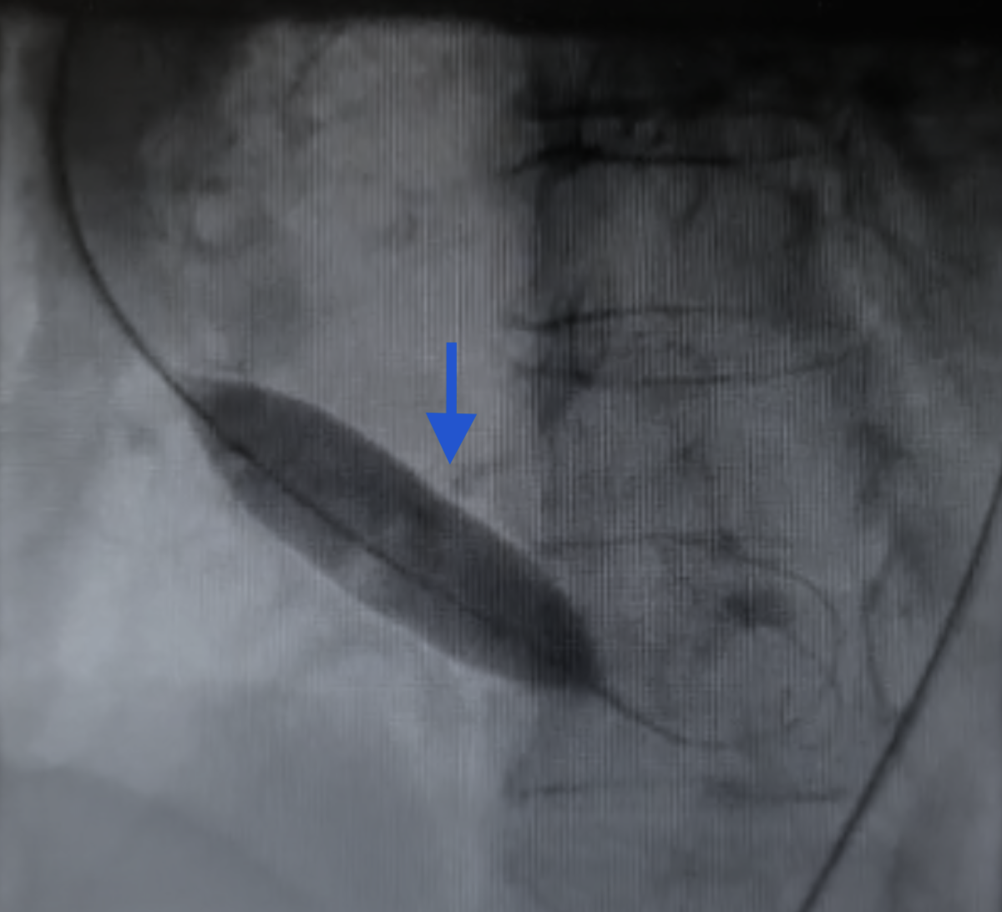
Figure 2. Fluoroscopic image obtained during balloon aortic valvuloplasty (BAV) in a left anterior oblique (LAO) projection. The inflated valvuloplasty balloon is positioned across the aortic valve, illustrating the dilatation phase of the procedure. The blue arrow indicates dense calcifications of the aortic valve, consistent with severe calcific aortic stenosis.

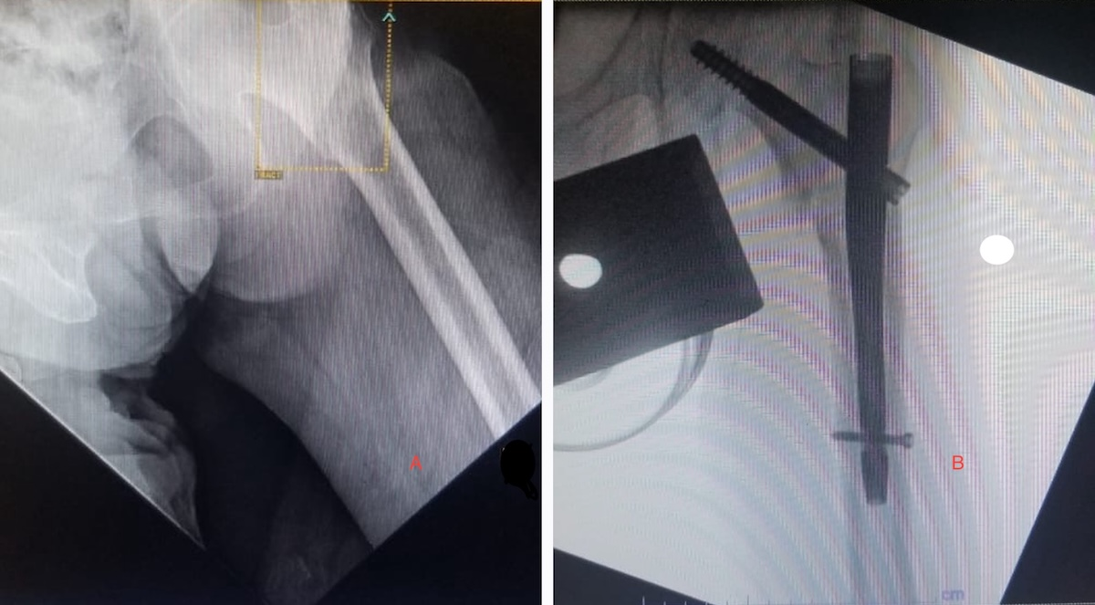
Figure 3. Radiographic images of the left hip before and after surgical fixation. (A) Preoperative radiograph showing a left pertrochanteric femoral fracture. (B) Postoperative fluoroscopic image showing fixation with a gamma nail.

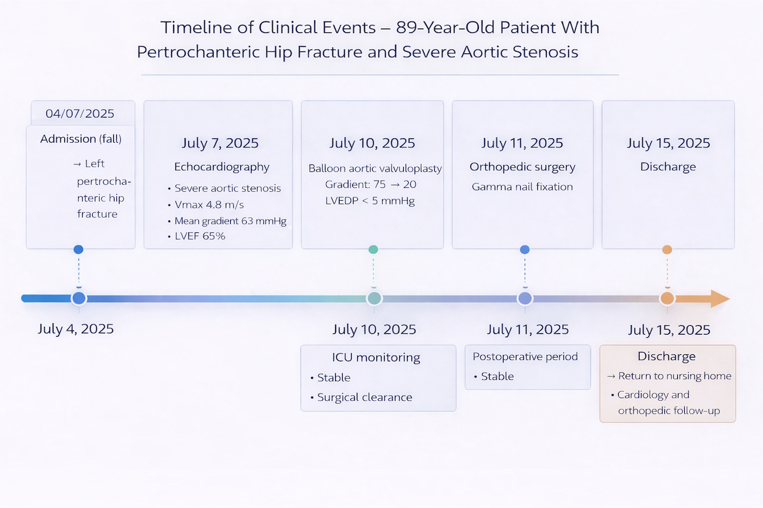
Figure 4. Timeline of clinical events.
Clinical course of an 89-year-old patient with severe aortic stenosis and left pertrochanteric hip fracture managed with balloon aortic valvuloplasty as a bridge-to-surgery followed by gamma nail fixation.

Discussion
This case illustrates a classic situation in interventional cardiogeriatrics: a very elderly, frail, and dependent patient in whom the need for urgent orthopaedic surgery conflicted with an initially prohibitive anesthetic risk related to severe aortic stenosis. Ahmed et al. summarized this clinical dilemma well, showing that the coexistence of acute hip fracture and severe aortic stenosis places the clinician under a dual constraint: avoiding excessive delay in surgery while limiting perioperative cardiovascular risk [13].
In our patient, echocardiography confirmed very severe aortic stenosis, with a peak velocity of 4.8 m/s, a mean gradient of 63 mmHg, and an indexed aortic valve area of 0.42 cm²/m², while left ventricular ejection fraction remained preserved. This profile corresponds to hemodynamically critical stenosis, the presence of which before major non-cardiac surgery justifies specialist assessment. The ESC/EACTS guidelines support this approach by emphasizing decision-making based on overall risk, frailty, and goals of care [4]. The 2020 ACC/AHA valvular heart disease guidelines reinforce the same principle, underscoring that valve intervention is meaningful only if it is expected to improve prognosis or quality of life [6].
The strategy selected in this case was balloon aortic valvuloplasty (BAV). Ferré et al. are the authors whose findings are most directly applicable to our scenario, as their study specifically addressed preoperative BAV in the setting of hip fracture with severe aortic stenosis; they concluded that this strategy may reduce in-hospital mortality despite a longer time to surgery [7]. In a broader population of patients requiring urgent non-cardiac surgery, Debry et al. showed that BAV is a feasible invasive option, although it should not be considered automatically superior to conservative management in all patients [8]. Together, these findings argue not for systematic use, but for careful patient selection.
The review by Terré et al. provides a particularly useful decision-making framework in this setting. The authors emphasized that management of severe aortic stenosis in patients with hip fractures must be individualized according to baseline condition, orthopedic urgency, feasibility of transcatheter aortic valve implantation (TAVI), and the expected benefit of temporary hemodynamic optimization [2]. This perspective closely matches our case. In our patient, BAV was not chosen as a durable alternative to valve replacement, but rather as a proportionate measure aimed at reducing the immediate hemodynamic burden and thereby making orthopaedic surgery feasible.
The hemodynamic result observed after the procedure supports the relevance of this choice. The peak-to-peak gradient decreased from 75 to 20 mmHg, and the post-valvuloplasty mean gradient was 26 mmHg, allowing sufficient stabilization for osteosynthesis the following day. This “temporary but meaningful” benefit is consistent with the observations of Baber et al., who noted that BAV still has a role in selected situations despite the TAVI era [10]. Cortese et al. made a similar point by describing the “return” of BAV in clinical contexts where a rapid and less burdensome solution is needed [11]. Nwaejike et al. also emphasized the bridge concept, showing that BAV retains value when it allows patients to pass through a critical stage before definitive treatment or another urgent intervention [12].
More broadly, the contemporary literature on BAV emphasizes that its main value lies in carefully selected scenarios. Recent reviews have shown that it may serve as a bridge to definitive treatment, a bridge to decision, or a bridge to urgent extracardiac surgery, without constituting a durable solution for aortic stenosis [9]. In our case, this concept applies fully: the objective was not to provide definitive treatment for the valvular disease, but to achieve temporary hemodynamic improvement in order to enable urgent hip surgery.
The geriatric dimension of this case is also essential. In theory, the patient’s age and the severity of her aortic stenosis might have prompted consideration of TAVI. However, valvular heart disease guidelines make clear that age alone is not sufficient to justify a definitive invasive strategy [4,6]. Advanced dementia, functional dependence, institutionalization, and overall frailty markedly limited the expected benefit of TAVI in this patient. In this context, BAV appeared to be a more proportionate option, focused on the immediate clinical goal rather than on long-term correction of the valvular lesion. After multidisciplinary discussion, TAVI was not retained because the patient’s overall clinical condition was considered poorly compatible with the expected benefit of definitive valve intervention.
It should also be emphasized that hip fracture imposes a strong time constraint. A clinical report in very high-risk patients suggests that BAV may be useful before major non-cardiac surgery when it helps patients pass through a critical operative stage [14]. Although the level of evidence remains limited, this observation further supports the coherence of our strategy.
Finally, our case highlights that the success of this approach depended not only on the valve procedure itself, but also on overall coordination of care. Management involved cardiologists, anesthesiologists, orthopedic surgeons, and geriatricians, in line with recent perioperative recommendations [5]. The overall course was favorable despite episodes of non-sustained ventricular tachycardia, transfusion-requiring postoperative anemia, and several moderate geriatric complications. This suggests that, in selected highly frail patients, a BAV bridge-to-surgery strategy may help reconcile hemodynamic safety with the orthopedic imperative.
This case nevertheless has several limitations. First, it is a single-case observation, which precludes broad extrapolation. Second, BAV remains a transient intervention whose benefit is essentially short term, thereby limiting its relevance beyond the immediate operative objective [8,9]. Finally, in the absence of an individual comparator, it is impossible to state formally that the favorable postoperative outcome was solely attributable to BAV, even though the pathophysiological and hemodynamic coherence strongly support this interpretation.
Overall, this case shows that balloon aortic valvuloplasty may represent a relevant bridge-to-surgery strategy in a very elderly and frail patient with severe aortic stenosis requiring urgent hip fracture surgery. It confirms that, in this setting, decision-making should be guided less by a theoretical valvular approach than by an integrated assessment of real clinical benefit, overall prognosis, and goals of care.

Conclusion
This case illustrates that balloon aortic valvuloplasty may represent a relevant bridge-to-surgery strategy in highly frail geriatric patients with severe aortic stenosis who require urgent hip fracture surgery. In our patient, this approach provided rapid hemodynamic improvement, with a marked reduction in the transaortic gradient, thereby making osteosynthesis possible under safer perioperative conditions. Beyond the technical result, this observation underscores the importance of individualized multidisciplinary decision-making that integrates valvular severity, orthopedic urgency, frailty, cognitive status, and the actual clinical benefit expected from an invasive strategy. In this setting, BAV should not be viewed as a definitive treatment for aortic stenosis, but rather as a temporary stabilization measure when neither surgical valve replacement nor immediate transcatheter aortic valve implantation appears appropriate. Thus, in carefully selected patients, BAV may offer a pragmatic way to reconcile the orthopedic imperative with cardiovascular safety.

Consent

As per international standards or university standards, patient(s) written consent has been collected and preserved by the author(s).

Disclaimer (Artificial intelligence)

Author(s) hereby declare that NO generative AI technologies such as Large Language Models (ChatGPT, COPILOT, etc.) and text-to-image generators have been used during the writing or editing of this manuscript.

Références
- Otto CM, Prendergast B: Aortic-valve stenosis—from patients at risk to severe valve obstruction. N Engl J Med. 2014, 371(8):744-756. 10.1056/NEJMra1313875
- Terré JA, Torrado J, George I, et al.: Aortic stenosis management in patients with acute hip fracture. JACC Adv. 2024, 3(5):100912. 10.1016/j.jacadv.2024.100912
- Keswani A, Lovy A, Khalid M, et al.: The effect of aortic stenosis on elderly hip fracture outcomes: a case control study. Injury. 2016, 47(2):413-418. 10.1016/j.injury.2015.10.015
- Vahanian A, Beyersdorf F, Praz F, et al.: 2021 ESC/EACTS Guidelines for the management of valvular heart disease. Eur Heart J. 2022, 43(7):561-632. 10.1093/eurheartj/ehab395
- Thompson A, Fleischmann KE, Smilowitz NR, et al.: 2024 AHA/ACC/ACS/ASNC/HRS/SCA/SCCT/SCMR/SVM Guideline for Perioperative Cardiovascular Management for Noncardiac Surgery: a report of the American College of Cardiology/American Heart Association Joint Committee on Clinical Practice Guidelines. J Am Coll Cardiol. 2024, 84(19):1869-1969. 10.1016/j.jacc.2024.06.013
- Otto CM, Nishimura RA, Bonow RO, et al.: 2020 ACC/AHA Guideline for the Management of Patients With Valvular Heart Disease: a report of the American College of Cardiology/American Heart Association Joint Committee on Clinical Practice Guidelines. Circulation. 2021, 143(5):e72e227. 10.1161/CIR.0000000000000923
- Ferré F, Viarnes M, Martin C, et al.: Is preoperative balloon aortic valvuloplasty of interest for severe aortic stenosis in hip fracture surgery? Injury. 2021, 52(6):1438-1444. 10.1016/j.injury.2020.09.048
- Debry N, Delhaye C, Azmoun A, et al.: Balloon aortic valvuloplasty for severe aortic stenosis before urgent non-cardiac surgery. EuroIntervention. 2021, 17(8):e680-e687. 10.4244/EIJ-D-20-01423
- Zhong J, Kamp N, Bansal A, et al.: Balloon aortic valvuloplasty in the modern era: a review of outcomes, indications, and technical advances. J Soc Cardiovasc Angiogr Interv. 2023, 2(4):101002. 10.1016/j.jscai.2023.101002
- Baber U, Kini AS, Sharma SK: Aortic stenosis: role of balloon aortic valvuloplasty. Cardiol J. 2013, 20(5):499-507. 10.5603/CJ.2013.0132
- Cortese B, Sanchez EG, Stefanini GG, et al.: Balloon aortic valvuloplasty review: the revenge during the transcatheter aortic valve implantation era. Minerva Cardiol Angiol. 2022, 70(5):572-580. 10.23736/S2724-5683.22.05997-X
- Nwaejike N, Mills K, Stables RH, et al.: Balloon aortic valvuloplasty as a bridge to aortic valve surgery for severe aortic stenosis. Interact Cardiovasc Thorac Surg. 2015, 20(3):429-435. 10.1093/icvts/ivu398
- Ahmed T, Safdar A: The management dilemma: concomitant acute hip fracture and severe asymptomatic aortic stenosis. Cureus. 2020, 12(4):e7527. 10.7759/cureus.7527
- Calicchio F, Guarracino F, Giannini C, et al.: Balloon aortic valvuloplasty before noncardiac surgery in severe aortic stenosis: a single-center experience. J Cardiovasc Med (Hagerstown). 2017, 18(2):109-113. 10.2459/JCM.0000000000000331

