Iron Deficiency in Older Adults Hospitalized for Acute Heart Failure: Prevalence, Clinical Correlates and One-Year Outcomes in a Moroccan Prospective Study

Abstract
Background: Iron deficiency is a common comorbidity in patients with heart failure. This association is often underrecognized in clinical practice, despite its important implications for symptoms and prognosis. Iron deficiency has been associated with worse symptoms, impaired functional status, and poorer clinical outcomes. Data from North Africa remain scarce, particularly in older adults hospitalized for acute or decompensated heart failure

Methods: A single-center (Ibn Rochd University Hospital in Casablanca) prospective observational study was conducted in the Cardiology Division. The study included consecutive patients aged ≥65 years admitted for acute heart failure, including both de novo presentations and acute decompensation of previously known chronic heart failure during a 12-month period. Iron deficiency was defined as a ferritin concentration <100 ng/mL, or 100-299 ng/mL with transferrin saturation <20%. Clinical, laboratory, and echocardiographic data were collected at admission. Patients were followed for one year for a composite outcome of heart failure rehospitalization or all-cause death.
Results: Fifty patients were included; the median age was 84 years (range, 65-104). Men and women were equally represented. Hypertension was present in 82%, diabetes in 32%, and active smoking in 18%. Functional limitation was substantial, with 50% of patients in NYHA class II, 40% in class III, and 10% in class IV. Anemia occurred in 52% of this cohort, and among those with Anemia, 82% of those were iron deficient. Among patients with iron deficiency, 63% were anemic and 37% were not. Echocardiographic findings displayed LVEF <45% for 38%; LV end-diastolic diameter >55 mm 24%; TAPSE <16 mm 24%; elevated pulmonary artery systolic pressure 40%; and a PASP/TAPSE ratio >3 mmHg/mm of 30%. At one year, event-free survival for the composite endpoint of heart failure rehospitalization or all-cause death was 94%. Given the very low number of events observed during follow-up, subgroup comparisons were descriptive and should be interpreted cautiously.
Conclusions: In this cohort of Moroccan patients hospitalized for acute heart failure, iron deficiency was highly prevalent and was frequently present in the absence of overt anemia. The data has highlighted the need for routine iron testing during the inpatient stay; as this will allow for the identification of patients who may later qualify for intravenous iron therapies after they have undergone a period of medical stabilization.
Keywords: heart failure; iron deficiency; anemia; acute heart failure; prognosis; Morocco.

Introduction

Heart failure contributes to the hospitalizations, decline in function, and deaths from any cause of older adults. Often, people with heart failure experience acute heart failure, frailty, impaired kidney function, multiple illnesses, and episodes of worsening heart failure symptoms or poor heart function. These conditions worsen symptoms and complicate heart failure treatment and reduce clinical outcomes both in the short- and medium-term. Therefore, identifying the presence of modifiable comorbidities that may be addressed during hospitalization is an important clinical goal for older adults with heart failure [1,2].

Iron deficiency is one of the most commonly reported non-cardiac comorbidities of heart failure. Iron deficiency has been associated with lower exercise tolerance, more symptoms, poorer quality of life, and poorer clinical outcomes. It is important to note that iron deficiency can also negatively affect fatigue, shortness of breath, and function in patients with heart failure even if they do not have anemia, and may go unnoticed as an important abnormality because the hemoglobin concentration stays within normal limits. Thus, relying on hemoglobin concentration alone for determining whether or not a patient has an abnormal quality of life as a result of iron deficiency could result in underdiagnosing an important problem [3,4].
There has been a growing interest in iron deficiency related to patients with heart failure over the last 10 years. Systematic assessment of iron status in patients with heart failure is now supported by many contemporary studies and guidelines as it has been shown that intravenous iron therapy can alleviate symptoms and reduce heart-failure events in certain patients. Currently available data mainly stems from populations in the western part of the world and there is little contemporary information available regarding iron status of patients living in North Africa, particularly with regards to older people who are hospitalized due to acute heart failure [2,3,5-7].

This research aimed to determine how common iron deficiency is among senior patients who are admitted for acute heart failure to a hospital in Morocco as well as assess the relationship between iron deficiency, anemia, echocardiographic data, and one-year outcome of the cohort.

Materials and Methods
We performed a prospective observational study in the cardiology department of Ibn Rochd University Hospital, Casablanca, Morocco. The study period extended over one year. This tertiary-care center receives a substantial number of older adults with acute cardiovascular conditions and provides an appropriate setting in which to examine the burden of comorbidities in patients hospitalized for acute heart failure.
Eligible patients were 65 years of age or older and were hospitalized for patients aged ≥65 years admitted for acute heart failure, including both de novo presentations and acute decompensation of previously known chronic heart failure according to clinical, laboratory, and echocardiographic criteria. Patients presented with acute infection and requiring immediate alternative management (severe inflammatory disease), patients with known hematologic malignancy or continuing iron supplementation were excluded from this study. At the same time, some patients included in the cohort could still present with intercurrent or concomitant infectious conditions noted during hospitalization, which reflects the complexity of older adults admitted with acute heart failure.
For the purpose of these analyses, data collected during the admission for all admission records included descriptive characteristics of patients (demographics, cardiovascular risk factors), previous medical history and chronic treatment and basic clinical findings (New York Heart Association (NYHA) Functional Classification). Laboratory testing included hemoglobin, ferritin, transferrin saturation, renal function, thyroid profile, lipid profile, natriuretic peptides, and other routinely available biomarkers.
Iron deficiency was defined according to contemporary guideline-based criteria as ferritin <100 ng/mL, or ferritin 100-299 ng/mL with transferrin saturation <20% [2,3,6,7]. Anemia was assessed using the admission hemoglobin value. Transthoracic echocardiography was performed within 48 hours of admission and included left ventricular ejection fraction, left ventricular end-diastolic diameter, TAPSE, pulmonary artery systolic pressure, and the PASP/TAPSE ratio. These parameters were chosen because they provide a practical overview of left ventricular systolic function, chamber remodeling, right ventricular systolic performance, and right ventricular-pulmonary arterial coupling, all of which are relevant in acute heart failure and may influence prognosis.
The primary study objective was to determine the prevalence of iron deficiency. Secondary objectives were to examine its relationship with anemia and to describe selected clinical, biological, and echocardiographic features, as well as one-year outcomes in the cohort.
Continuous variables were summarized as mean ± standard deviation or median with range, depending on distribution . Categorical variables were expressed as counts and percentages. Group comparisons used Student's t test or the Mann-Whitney U test for continuous variables and the χ² test or Fisher's exact test for categorical variables, with p < 0.05 considered statistically significant. Given the modest sample size and limited number of events, outcome analyses should be interpreted as exploratory.

Results
A total of 50 patients were included. The median age was 84 years (range, 65–104), and men and women were equally represented. There were several significant cardiovascular predisposing factors in this population: 82% of patients were hypertensive, 32% diabetic, and 18% of participants smoked cigarettes (Table 1, Figure 1). Functional limitation at presentation was substantial, with half of the cohort in NYHA class II, 40% in NYHA class III, and 10% in NYHA class IV (Figure 2).

Table 1. Baseline clinical characteristics of the study population
Variable | Value
Sample size | 50
Age, median (range), years | 84 (65-104)
Male sex | 25 (50%)
Female sex | 25 (50%)
Hypertension | 41 (82%)
Diabetes mellitus | 16 (32%)
Active smoking | 9 (18%)
NYHA class II | 25 (50%)
NYHA class III | 20 (40%)
NYHA class IV | 5 (10%)
Anemia | 26 (52%)
Iron deficiency | 41 (82%)

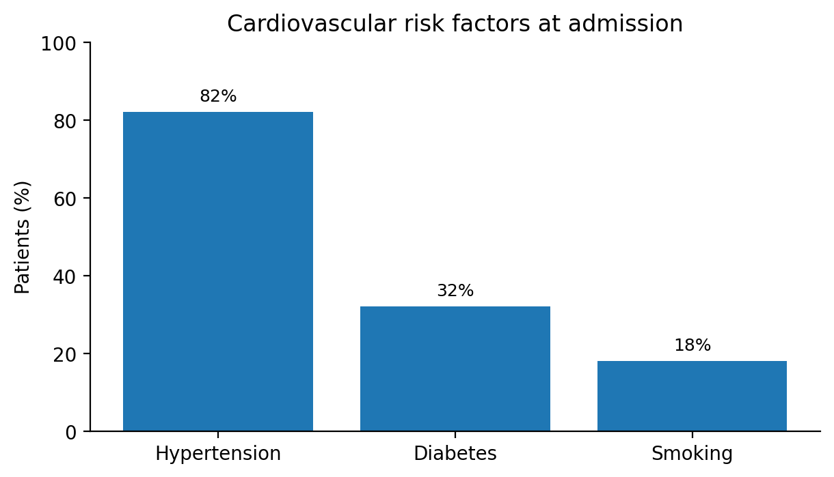
Figure 1. Prevalence of major cardiovascular risk factors at admission.

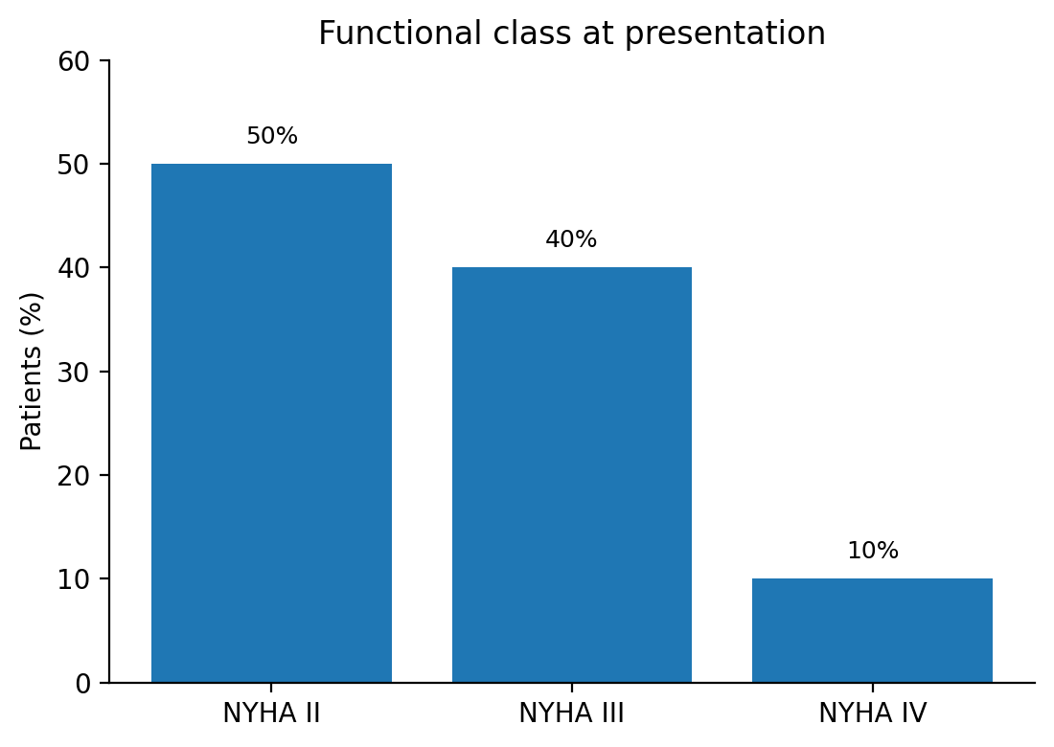
Figure 2. Functional class distribution according to NYHA category.
Fifty-two percent of patients were documented with anemia while 82% had documented iron deficiency. Iron deficiency was not confined to patients who were anemic as 65% of the individuals who were iron deficient were also anemic and 35% were not. Therefore, an appreciable proportion of patients would have been missed had hemoglobin been utilized as the sole test to screen for iron deficiency (Figure 3). A statistically significant relationship was found between iron deficiency and anemia (p < 0.001).

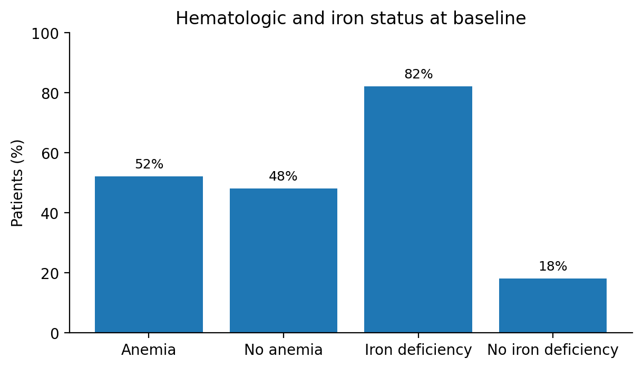
Figure 3. Baseline prevalence of anemia and iron deficiency.
Selected echocardiographic abnormalities were frequent. LVEF was below 45% in 38% of patients, LV end-diastolic diameter exceeded 55 mm in 24%, TAPSE was below 16 mm in 24%, pulmonary artery systolic pressure was elevated in 40%, and the PASP/TAPSE ratio exceeded 3 mmHg/mm in 30% (Table 2). Biologically, macrocytic anemia was rare (4%). Reduced creatinine clearance was documented in 76% of patients, BNP was elevated in 98%, thyroid disorders were present in 14%, and concomitant infection was noted in 78% of cases. The latter finding likely reflects the high degree of medical complexity in this population and may also have influenced the inflammatory milieu and iron biomarker profile.
Table 2. Selected echocardiographic and laboratory results.

Variable | Value
LVEF <45% | 19 (38%)
LV end-diastolic diameter >55 mm | 12 (24%)
TAPSE <16 mm | 12 (24%)
Elevated pulmonary artery systolic pressure | 20 (40%)
PASP/TAPSE ratio >3 mmHg/mm | 15 (30%)
Macrocytic anemia | 2 (4%)
Renal dysfunction based on creatinine clearance | 38 (76%)
Elevated total cholesterol | 38 (76%)
Elevated BNP | 49 (98%)
Thyroid disorder | 7 (14%)
Concomitant infection | 39 (78%)

In exploratory analysis, there was an increased occurrence of anemia among patients living outside of the Ibn Rochd catchment area (74%) and with atrial fibrillation (68%). These observations should be interpreted cautiously due to sample size and lack of adjustment.
One-year event-free survival for the composite endpoint of heart failure rehospitalization or all-cause death was 94% (Figure 4). At first sight, this outcome appears favorable for a cohort with a median age of 84 years hospitalized for acute heart failure.Exploratory analysis suggested a possible increase in risk among patients with iron-deficiency anemia, but this finding should be interpreted with great caution given the very small number of events, whereas non–iron-deficiency anemia did not appear to modify risk. However, these findings must be interpreted with great caution because the number of events was very small and the study was not powered for prognostic comparisons.

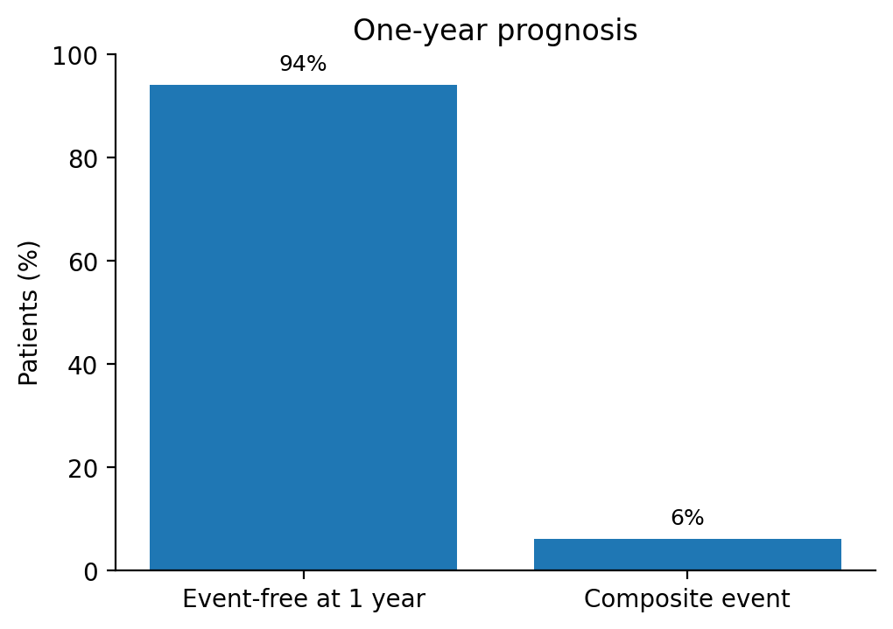
Figure 4. One-year event-free survival for the composite endpoint.

Discussion
The principal finding of this study is the very high prevalence of iron deficiency in older adults hospitalized for acute heart failure. More than four out of five patients met conventional biochemical criteria for iron deficiency, and more than one-third of iron-deficient patients were not anemic. This distinction matters clinically, because iron deficiency in heart failure has prognostic and functional implications that are only partially captured by hemoglobin concentration alone [3-5,7]. From a practical standpoint, this is one of the most relevant messages of the study: in older adults with acute heart failure, routine blood count is not an adequate surrogate for iron assessment.
The prevalence rate we determined was considerably higher than the reported 50% prevalence rate confirmed in multiple chronic heart failure cohorts [3,5]. Several factors may explain this difference. This discrepancy could largely be due to the older age demographic represented by our population, the acute nature of presentation in these patients, the high burden of comorbidity, and known dynamic fluctuation of iron markers seen throughout decompensations [15]. The high prevalence of renal dysfunction and the frequent presence of infection or inflammatory conditions in our cohort may also have contributed to functional iron deficiency.
The limited overlap of iron deficiency and anemia as identified in our data is worthy of attention. Although we have found that iron deficiency and anemia were significantly correlated, the correlation does not exist with perfect correlation. For example, more than one-third of iron-deficient subjects were not anemic. The findings of our study are also in agreement with other research findings related to heart failure and that iron deficiency is an important, independent clinical condition, not simply the cause of low hemoglobin. The role of iron in mitochondrial enzyme systems, oxidative metabolism and skeletal muscle energy is also important because the absence of iron will hinder physical performance and well-being where the oxygen carrying capacity has not yet been compromised. Consequently, this visualizes the reasons for excessive fatigue and limited effort tolerance in some patients despite having seemingly normal hemoglobin levels [3-5,7].

From a pathophysiological perspective, our findings are plausible. Heart failure may promote intestinal congestion and reduced nutrient absorption, whereas chronic inflammation and hepcidin-mediated sequestration can limit iron availability. Renal dysfunction may further exacerbate this imbalance through inflammation, reduced erythropoietin activity, and impaired metabolic reserve. In hospitalized older adults, poor oral intake, frailty, recurrent illness, and polypharmacy may also contribute. These mechanisms are likely to coexist in many patients. The high prevalence of iron deficiency observed in this study therefore probably reflects the combined influence of nutritional, inflammatory, renal, and cardiovascular factors rather than a single isolated pathway [4,21]. This is one reason why reliance on anemia alone leads to underdiagnosis.
The therapeutic implications are increasingly important. Notable studies such as FAIR-HF and CONFIRM-HF showed improvements in symptoms, exercise capacity, and quality of life with intravenous ferric carboxymaltose in symptomatic patients with iron deficiency [8-10]. AFFIRM-AHF extended this strategy to patients stabilized after acute heart failure and suggested a reduction in recurrent heart-failure hospitalizations, alongside a measurable benefit in health-related quality of life [13,14]. More recent studies have provided a less uniform signal. IRONMAN suggested a possible clinical benefit [16], whereas HEART-FID and FAIR-HF2 did not show a clear advantage across their primary efficacy outcomes [17,18]. Overall, the available evidence continues to support a beneficial effect of intravenous iron on heart-failure hospitalization, whereas its impact on cardiovascular and all-cause mortality remains less certain [19]. The contemporary guidelines recommend screening patients with heart failure for iron deficiency; intravenous iron therapy may be considered for appropriately selected symptomatic patients with either reduced or mildly reduced ejection fractions [2,3,6]. More recent trials and meta-analyses published after the 2023 ESC focused update have added important nuance to this field, but they should be interpreted as subsequent evidence rather than as part of the guideline basis itself.
Exercise caution when interpreting the prognostic results of this investigation. The small sample and the very few events (as well as the possibility of missing events outside of this institution) suggest that the one-year outcome analysis is exploratory/hypothesis-generating and not conclusive. Therefore, the exploratory observation that iron deficiency anemia is associated with a higher risk should not be considered definitive but rather a potential signal-generating observation that may warrant increased investigation in larger, multi-center cohorts.
Our findings support the implementation of routine iron studies during hospitalization for acute heart failure in our setting. In older adults, where dyspnea, fatigue, and reduced exercise tolerance can be multifactorial, identifying a potentially modifiable contributor such as iron deficiency is clinically attractive. The high rate of iron deficiency in our cohort suggests that systematic screening could have substantial practical yield.

The research has many limitations. The study was performed at just one major hospital and therefore cannot be generalized to other locations. The number of patients in this study was small as well as having a very low number of events, so the one-year prognostic estimate was imprecise and therefore the sub-group comparisons could not have been meaningful. Because many of the clinical events occurred at facilities other than ours and therefore are not known to us, we likely did not capture all of the clinical events that occurred due to complications from their iron deficiency anemia. Due to the high incidence of other illnesses and infections present in this group of patients at the same time of the iron studies, the diagnosis of the patients’ iron deficiency anemia was negatively impacted by the high frequency of concomitant disease and therefore may not be representative of this group. Finally, there were some variables missing, and certain data that were available were only provided in aggregate, so we could not carry out any further analyses.

Conclusion

This was a prospective cohort study, where older adults (>65 years) receiving acute or decompensated chronic heart failure at one centre were studied to determine if iron deficiency is common in this population, including those without obvious evidence of anemia. Routinely assessing iron status during hospitalisation may identify patients who might subsequently benefit upon clinical stabilisation, by considering evidence-based intravenous iron therapy for iron deficiency. Further studies across more than one centre, and with a larger sample size, are necessary to elucidate the prognostic importance of iron deficiency in this population..
Consent:
As per international standards or university standards, patient(s) written consent has been collected and preserved by the author(s).
Ethical Approval:

As per international standards or university standards written ethical approval has been collected and preserved by the author(s).

Disclaimer (Artificial intelligence)

Author(s) hereby declare that NO generative AI technologies such as Large Language Models (ChatGPT, COPILOT, etc.) and text-to-image generators have been used during the writing or editing of this manuscript.

References
1. Savarese G, Becher PM, Lund LH, Seferovic P, Rosano GMC, Coats AJS. Global burden of heart failure: a comprehensive and updated review of epidemiology. Cardiovasc Res. 2023 Jan 18;118(17):3272-3287. doi: 10.1093/cvr/cvac013.
2. McDonagh TA, Metra M, Adamo M, Gardner RS, Baumbach A, Böhm M, et al. 2021 ESC Guidelines for the diagnosis and treatment of acute and chronic heart failure. Eur Heart J. 2021 Sep 21;42(36):3599-3726. doi: 10.1093/eurheartj/ehab368.
3. Beavers CJ, Ambrosy AP, Butler J, Davidson BT, Gale SE, Piña IL, et al. Iron Deficiency in Heart Failure: A Scientific Statement from the Heart Failure Society of America. J Card Fail. 2023 Jul;29(7):1059-1077. doi: 10.1016/j.cardfail.2023.03.025.
4. Alnuwaysir RIS, Hoes MF, van Veldhuisen DJ, van der Meer P, Beverborg NG. Iron Deficiency in Heart Failure: Mechanisms and Pathophysiology. J Clin Med. 2021 Dec 27;11(1):125. doi: 10.3390/jcm11010125.
5. Klip IT, Comin-Colet J, Voors AA, Ponikowski P, Enjuanes C, Banasiak W, et al. Iron deficiency in chronic heart failure: an international pooled analysis. Am Heart J. 2013 Apr;165(4):575-582.e3. doi: 10.1016/j.ahj.2013.01.017.
6. McDonagh TA, Metra M, Adamo M, Gardner RS, Baumbach A, Böhm M, et al. 2023 Focused Update of the 2021 ESC Guidelines for the diagnosis and treatment of acute and chronic heart failure. Eur Heart J. 2023 Oct 1;44(37):3627-3639. doi: 10.1093/eurheartj/ehad195.
7. Masini G, Graham FJ, Pellicori P, Cleland JGF, Cuthbert JJ, Kazmi S, et al. Criteria for Iron Deficiency in Patients With Heart Failure. J Am Coll Cardiol. 2022 Feb 1;79(4):341-351. doi: 10.1016/j.jacc.2021.11.039.
8. Anker SD, Comin Colet J, Filippatos G, Willenheimer R, Dickstein K, Drexler H, et al. Ferric carboxymaltose in patients with heart failure and iron deficiency. N Engl J Med. 2009 Dec 17;361(25):2436-2448. doi: 10.1056/NEJMoa0908355.
9. Filippatos G, Farmakis D, Comin-Colet J, Dickstein K, Lüscher TF, Willenheimer R, et al. Intravenous ferric carboxymaltose in iron-deficient chronic heart failure patients with and without anaemia: a subanalysis of the FAIR-HF trial. Eur J Heart Fail. 2013 Nov;15(11):1267-1276. doi: 10.1093/eurjhf/hft099.
10. Ponikowski P, van Veldhuisen DJ, Comin-Colet J, Ertl G, Komajda M, Mareev V, et al. Beneficial effects of long-term intravenous iron therapy with ferric carboxymaltose in patients with symptomatic heart failure and iron deficiency. Eur Heart J. 2015 Mar 14;36(11):657-668. doi: 10.1093/eurheartj/ehu385.
11. Anker SD, Kirwan BA, van Veldhuisen DJ, Filippatos G, Comin-Colet J, Ruschitzka F, et al. Effects of ferric carboxymaltose on hospitalisations and mortality rates in iron-deficient heart failure patients: an individual patient data meta-analysis. Eur J Heart Fail. 2018 Jan;20(1):125-133. doi: 10.1002/ejhf.823.
12. Lewis GD, Malhotra R, Hernandez AF, McNulty SE, Smith A, Felker GM, et al. Effect of Oral Iron Repletion on Exercise Capacity in Patients With Heart Failure With Reduced Ejection Fraction and Iron Deficiency: The IRONOUT HF Randomized Clinical Trial. JAMA. 2017 May 16;317(19):1958-1966. doi: 10.1001/jama.2017.5427.
13. Ponikowski P, Kirwan BA, Anker SD, McDonagh T, Dorobantu M, Drozdz J, et al. Ferric carboxymaltose for iron deficiency at discharge after acute heart failure: a multicentre, double-blind, randomised, controlled trial. Lancet. 2020 Dec 12;396(10266):1895-1904. doi: 10.1016/S0140-6736(20)32339-4.
14. Jankowska EA, Kirwan BA, Kosiborod M, Butler J, Anker SD, McDonagh T, et al. The effect of intravenous ferric carboxymaltose on health-related quality of life in iron-deficient patients with acute heart failure: the results of the AFFIRM-AHF study. Eur Heart J. 2021 Aug 17;42(31):3011-3020. doi: 10.1093/eurheartj/ehab234.
15. Tkaczyszyn M, Skrzypczak T, Michałowicz J, Ponikowski P, Jankowska EA. Iron deficiency as an emerging therapeutic target in patients stabilized after an episode of acute heart failure. Cardiol J. 2021;28(6):962-969. doi: 10.5603/CJ.a2021.0165.
16. Kalra PR, Cleland JGF, Petrie MC, Thomson EA, Kalra PA, Squire IB, et al. Intravenous ferric derisomaltose in patients with heart failure and iron deficiency in the UK (IRONMAN): an investigator-initiated, prospective, randomised, open-label, blinded-endpoint trial. Lancet. 2022 Dec 17;400(10369):2199-2209. doi: 10.1016/S0140-6736(22)02083-9.
17. Mentz RJ, Garg J, Rockhold FW, Butler J, De Pasquale CG, Ezekowitz JA, et al. Ferric Carboxymaltose in Heart Failure with Iron Deficiency. N Engl J Med. 2023 Sep 14;389(11):975-986. doi: 10.1056/NEJMoa2304968.
18. Anker SD, Friede T, Butler J, Talha KM, Placzek M, Diek M, et al. Intravenous Ferric Carboxymaltose in Heart Failure With Iron Deficiency: The FAIR-HF2 DZHK05 Randomized Clinical Trial. JAMA. 2025 Jun 10;333(22):1965-1976. doi: 10.1001/jama.2025.3833.
19. Graham FJ, Pellicori P, Kalra PR, Ford I, Bruzzese D, Cleland JGF. Intravenous iron in patients with heart failure and iron deficiency: an updated meta-analysis. Eur J Heart Fail. 2023 Apr;25(4):528-537. doi: 10.1002/ejhf.2810.
20. Anker SD, Karakas M, Mentz RJ, Ponikowski P, Butler J, Khan MS, et al. Systematic review and meta-analysis of intravenous iron therapy for patients with heart failure and iron deficiency. Nat Med. 2025 Aug;31(8):2640-2646. doi: 10.1038/s41591-025-03671-1.
21. Anand IS, Gupta P. Anemia and Iron Deficiency in Heart Failure: Current Concepts and Emerging Therapies. Circulation. 2018 Jul 3;138(1):80-98. doi: 10.1161/CIRCULATIONAHA.118.030099.

