Risk Stratification, Treatment Approach and Short-Term Outcomes of Acute Pulmonary Embolism in a Moroccan Tertiary Cardiology Department: A Retrospective Study

Abstract
Background: Acute pulmonary embolism (PE) is a major cardiovascular emergency associated with substantial morbidity and mortality, particularly when diagnosis is delayed. Because the clinical spectrum varies widely (mild dyspnea to near-cardiac collapse), it is important for clinicians to classify patients according to risk shortly after diagnosis so that they may use that classification to determine the level of treatment intensity and monitoring needed. There is very little information available about northern Africa tertiary cardiac care centers. The aim of this study was to describe the clinical characteristics, risk classification (based on the ESC guidelines), treatment patterns and short-term outcomes of patients with acute PE who were hospitalized in the Cardiology Department of Ibn Rochd University Hospital in Casablanca.
Methods: A retrospective observational study was conducted to review and analyze the data of all consecutively hospitalized patients diagnosed with acute PE between January 2024 and December 2025 (a 2-year study period). Recorded demographic data, clinical presentation and treatment, as well as risk classification and in-hospital outcomes were collected through chart review. Patients were classified according to the latest ESC guidelines for risk classification dated 2019.
Results: Twenty-two men and thirty-two women were included (n = 54); women accounted for 59.3% of the cohort. Mean age was 60 ± 18 years (range, 22–88 years). The most common predisposing factors were prolonged immobilization (81%), obesity (52%), recent surgery (28%), hormonal or postpartum exposure (28%), active cancer (15%), and previous venous thromboembolism (7%). High-risk PE was observed in 17% of patients, while intermediate-high-risk PE accounted for 44%. In addition, 39% of study patients were classified as intermediate-low risk. No patient in this study was classified as a low-risk patient. Anticoagulation was the first-line treatment for acute pulmonary embolism (acute PE), with 30% of patients taking direct oral anticoagulants, 30% receiving subcutaneous low-molecular-weight heparin, followed by oral vitamin K antagonists, 25% receiving intravenous unfractionated heparin followed by oral vitamin K antagonists, and 15% receiving subcutaneous low-molecular-weight heparin only. Five (9%) of the patients received systemic thrombolysis. The mean length of hospital stay was 7 ± 3 days; 87% required ICU admission during hospitalization. The in-hospital mortality rate was 9 out of 54 (16.7%). The high-risk group had 55.6% mortality (5 out of 9) and the intermediate-high-risk group had a 16.7% mortality (4 out of 24).
In our cohort, most of the acute PE cases occurred in terms of early risk (intermediate/high early risks); included a transient provoking factor (patients had multiple factors that might cause them to experience acute PE) and were often obese. The large amount of in-hospital mortality associated with acute PE emphasizes the importance of early severity assessment, initiation of anticoagulation, appropriate escalation of treatment, and developing an organized written follow-up system after hospital discharge.
Keywords: pulmonary embolism; risk stratification; anticoagulation; thrombolysis; prognosis; Morocco.
1. Introduction
Acute pulmonary embolism (PE) continues to be a leading cause of cardiovascular morbidity and mortality. Patients may experience a wide variety in severity of PE, ranging from mild symptoms to complete hemodynamic collapse. The prognostic value of the patient as defined upon presentation will determine the intensity of treatment and level of monitoring; therefore, risk stratification is an essential component in the acute management of PE (1-5).
The current management of PE is based on new European Society of Cardiology (ESC) risk stratification that utilizes hemodynamic status, echocardiographic assessment of right ventricular dysfunction (RVD), several cardiac biomarkers and clinical prognostic scores (1,9-11). Electrocardiographic findings can support the early bedside assessment of acute PE, but they are not diagnostic on their own (12).
While anticoagulation therapy remains the mainstay in managing most patients' PE, there is still ongoing development concerning some aspects of management for patients with intermediate and high-risk PE. Recent publications have highlighted ongoing developments in reperfusion timing, catheter-based interventions, and multidisciplinary pathways for the management of acute PE (13,14). These developments are particularly relevant for tertiary hospitals managing the most critically ill patients and requiring timely decisions regarding thrombectomy, transfer for interventional care, or other advanced procedures (2,15,16).
In Morocco and North Africa, hospital data are scarce regarding the epidemiology of PE severity, treatment patterns and short-term outcomes related to PE in tertiary cardiology units.
In this context, understanding how PE is actually stratified and managed in resource-constrained tertiary centers is clinically important.
The present study was therefore designed to describe the epidemiologic profile, ESC-based risk stratification, treatment management, and short-term outcomes of patients hospitalized for acute PE in the Cardiology Department of Ibn Rochd University Hospital in Casablanca over a two-year period.
2. Methods
2.1 Study design and setting
This was a retrospective, observational, descriptive study conducted in the Cardiology Department of Ibn Rochd University Hospital, a tertiary care center in Casablanca, Morocco, over a two-year period (January 2024 to December 2025).
2.2 Study Population
Consecutive adult patients admitted to the hospital during the study period with documented acute PE were included in the study. The diagnosis of PE was primarily confirmed via CTPA. Ventilation perfusion scans were an acceptable diagnostic tool in some patients where there was no other possible acceptable method of diagnosis and were documented in the medical record as a valid diagnostic method. For patients with hemodynamic instability, a transthoracic echocardiogram was used as an adjunct to provide evidence for the diagnosis and assess right ventricular involvement when the immediate definitive imaging was not possible (17-19). Patients were excluded if medical records were incomplete and did not allow risk stratification, or if the patient had been managed primarily in another department before being secondarily referred.
2.3 Data collection
Data were sourced and compiled from medical records, hospital discharge logs, and a computerized information system. The type of variables recorded included demographic information, cardiovascular risk factors, thromboembolic risk factors, pulmonary embolism (PE) severity profile, mode of treatment, respiratory/hemodynamic support given, any complications that arose during the hospitalization, length of stay in the hospital, whether the patient spent a part of their hospitalization in the intensive care unit (ICU), if they died during their hospitalization, and the availability of a follow-up at 30 days and/or three months of the patient’s discharge.
2.4 Risk Stratification
The 2019 ESC framework was used to assess the risk of patients with pulmonary embolism (PE). High-risk PE was defined by hemodynamic instability, including sustained hypotension, obstructive shock, or cardiac arrest. All patients with stable hemodynamics (sufficient blood flow) were classified as intermediate-high risk if the patient exhibited right ventricular dysfunction and had elevated cardiac biomarkers. PESI or sPESI was systematically assessed from the available clinical data and incorporated into ESC-based risk stratification (20,21). An intermediate-low risk classification was issued if either right ventricular dysfunction or elevated cardiac biomarkers was noted without the identification of both. Low-risk PE was defined as hemodynamically stable pulmonary embolism in patients with a favorable clinical prognostic score (e.g., PESI class I–II or sPESI = 0), without evidence of right ventricular dysfunction or cardiac biomarker elevation.
2.5 Therapeutic treatment
The attending team made decisions regarding treatment based on the patient's clinical presentation, ESC-based severity profile, comorbidities and resources available in their location. Management typically followed contemporary guideline recommendations, with anticoagulation recommended first line treatment, and systemic thrombolysis used only in high-risk PE, or selected unstable intermediate-high-risk cases. Supportive therapies included oxygen supplementation, non-invasive ventilatory support, vasopressor support, invasive mechanical ventilation, and ICU admission when clinically indicated.
2.6 Statistical analysis
The data will be analyzed descriptively using Microsoft Excel. Data will be reported using the mean ± standard deviation (SD) and the range if available for continuous variables. For categorical variables, the numbers and percentages will be reported. Due to the limited sample size and the descriptive nature of the project, no inferential statistical comparisons will be completed.
2.7 Ethical aspects
The study was completed in accordance with institutional guidelines for retrospective studies utilizing blinded hospital records. Patient confidentiality was maintained throughout the data collection and analysis process.
3. Results
3.1 Baseline characteristics
The cohort included 32 women and 22 men, for a total of 54 patients. Women slightly predominated in the cohort, as shown in Figure 1. Mean age was 60 ± 18 years (range, 22–88 years). The cohort had a substantial burden of cardiovascular risk factors (hypertension, diabetes, and dyslipidemia were each identified in 20% of patients, and active smoking was identified in 34%).
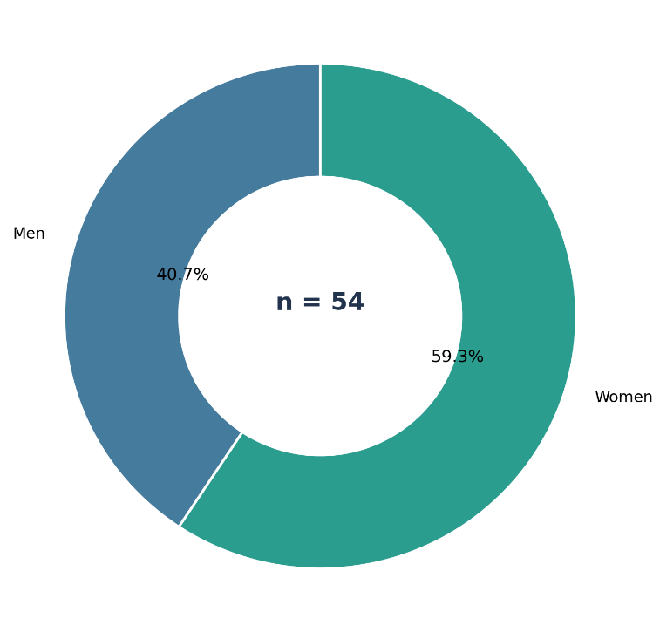
Figure 1. Sex distribution of the study cohort (n = 54).

3.2 Predisposing factors
With respect to venous thromboembolism (VTE) predisposition, the main factor was prolonged immobilization, as recorded for 81.0% of cases. Of the patients sampled, 52.0% were obese (body mass index ≥30 kg/m²). Recent surgery (<1 month) was present in 28.0% of patients. Hormonal or postpartum exposure was identified in 28% of the overall cohort. Active malignancy had been documented in 15.0% and chronic heart or respiratory failure in 13.0%. There were 9.0% of patients who had a history of miscarriages, 7.0% who had a history of deep venous thrombosis and/or pulmonary embolism and 5.0% who had suffered a stroke/transient ischemic attack. No cases of thrombophilia or systemic inflammatory disorders were documented. A provoking factor was identified in 91.0% of cases, whereas only 9.0% were classified as unprovoked VTE. The distribution of the main predisposing factors is summarized in Figure 2.
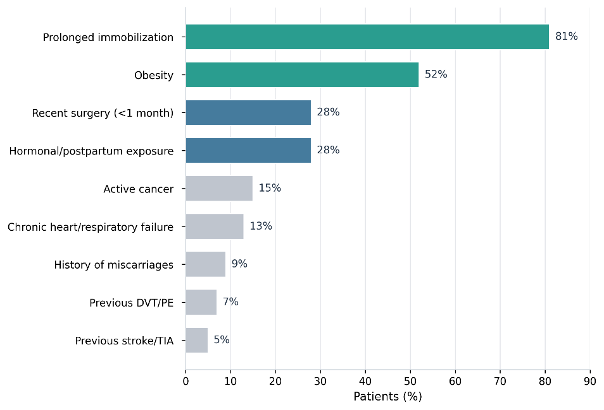
Figure 2. Major predisposing factors for venous thromboembolism among hospitalized patients with acute pulmonary embolism.

3.3 ESC risk stratification
ESC-based assessment showed that the cohort was predominantly composed of patients with clinically significant early risk. Intermediate-high-risk PE was the most frequent category, followed by intermediate-low-risk and high-risk PE, while no patient fulfilled low-risk criteria (Figure 3). This pattern is consistent with the referral profile of a tertiary cardiology department.
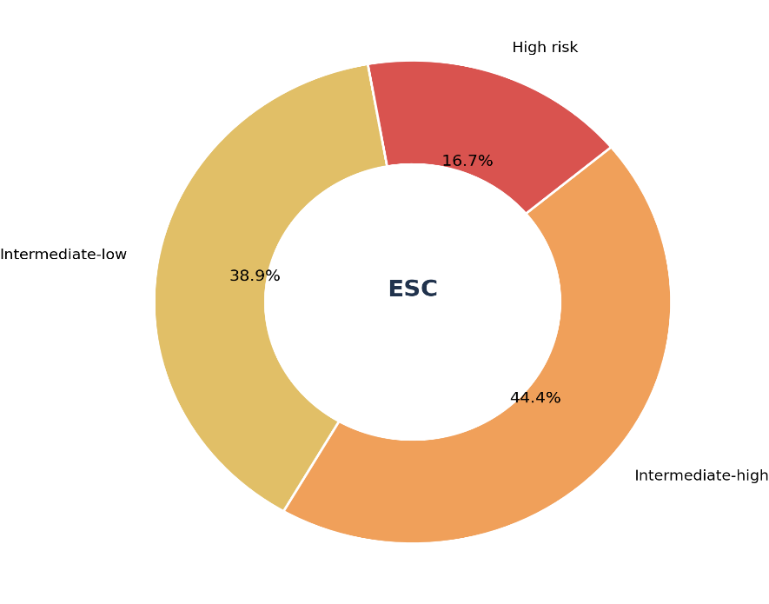
Figure 3. ESC-based early risk stratification of acute pulmonary embolism in the study cohort.

3.4 Treatment management
Anticoagulation was administered in all patients and remained the keystone of management. Sixteen patients (30%) received direct oral anticoagulants, almost exclusively rivaroxaban, with one patient receiving apixaban. Sixteen patients (30%) received LMWH followed by a vitamin K antagonist, 14 (25%) received UFH followed by a vitamin K antagonist, and 8 (15%) received LMWH without oral anticoagulant relay during hospitalization. Systemic thrombolysis was performed on 5 patients (9%) of whom 3 were in the high-risk category and 2 were in the unstable intermediate-high-risk group. The anticoagulant regimens used during hospitalization are shown in Figure 4.
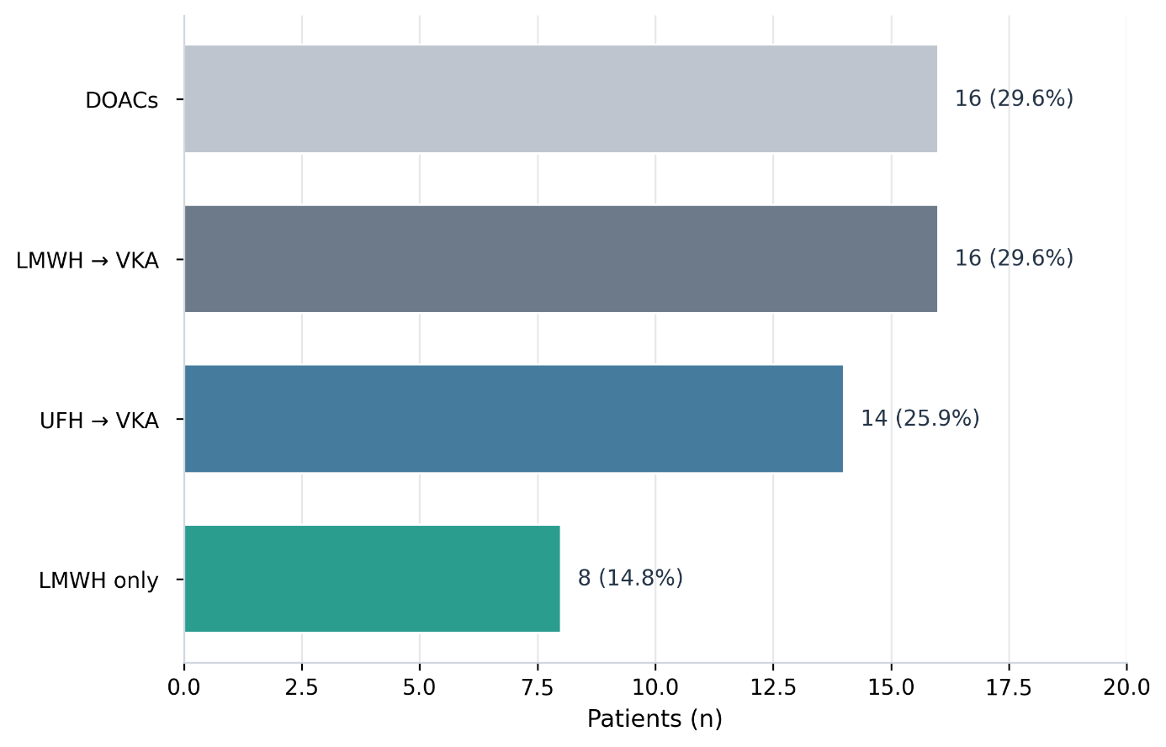
Figure 4. Anticoagulant strategies used during hospitalization.

Supportive therapies were commonly used during hospitalization including oxygen therapy in 34%, non-invasive ventilatory support in 34%, vasopressor support in 15%, and invasive mechanical ventilation in 15% of patients. Supportive care requirements are presented in Figure 5.
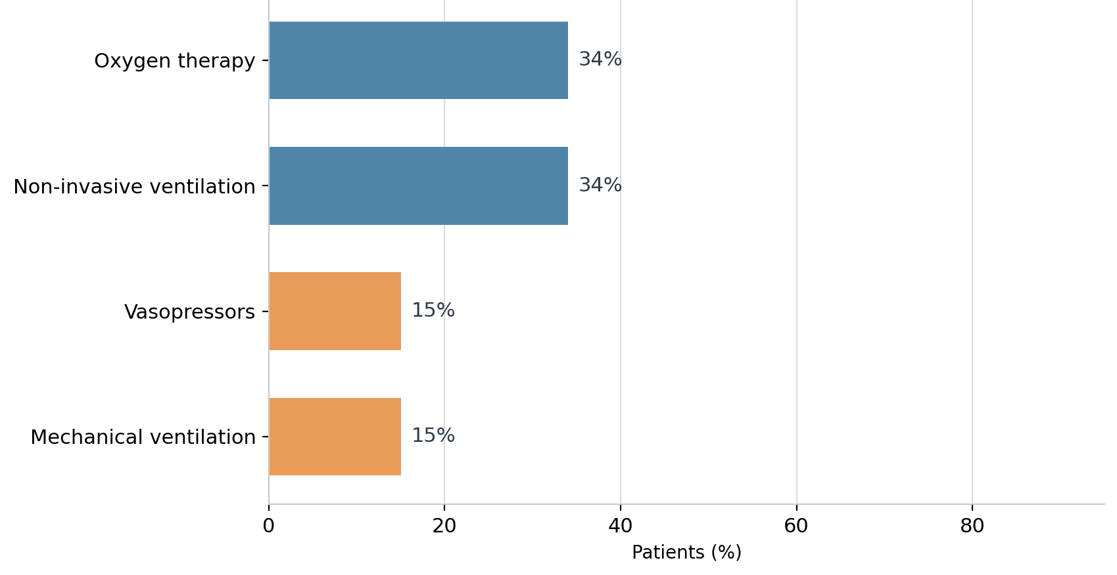
Figure 5. Supportive care requirements during hospitalization.

3.5 In-Hospital Outcomes
The mean length of hospital stay was 7 ± 3 days. The majority of patients (87%) were admitted to the intensive care unit, reflecting the severity of the study population. No bleeding complications were documented during hospitalization. Recurrent thromboembolic events occurred in 2 patients (4%), and in-hospital mortality was 9/54 (16.7%). Among high-risk patients, 5 died, corresponding to a mortality rate of 55.6%. Among intermediate-high-risk patients, 4 of 24 died (16.7%). Short-term in-hospital outcomes are summarized in Figure 6, while mortality by ESC risk category is detailed in Figure 7.
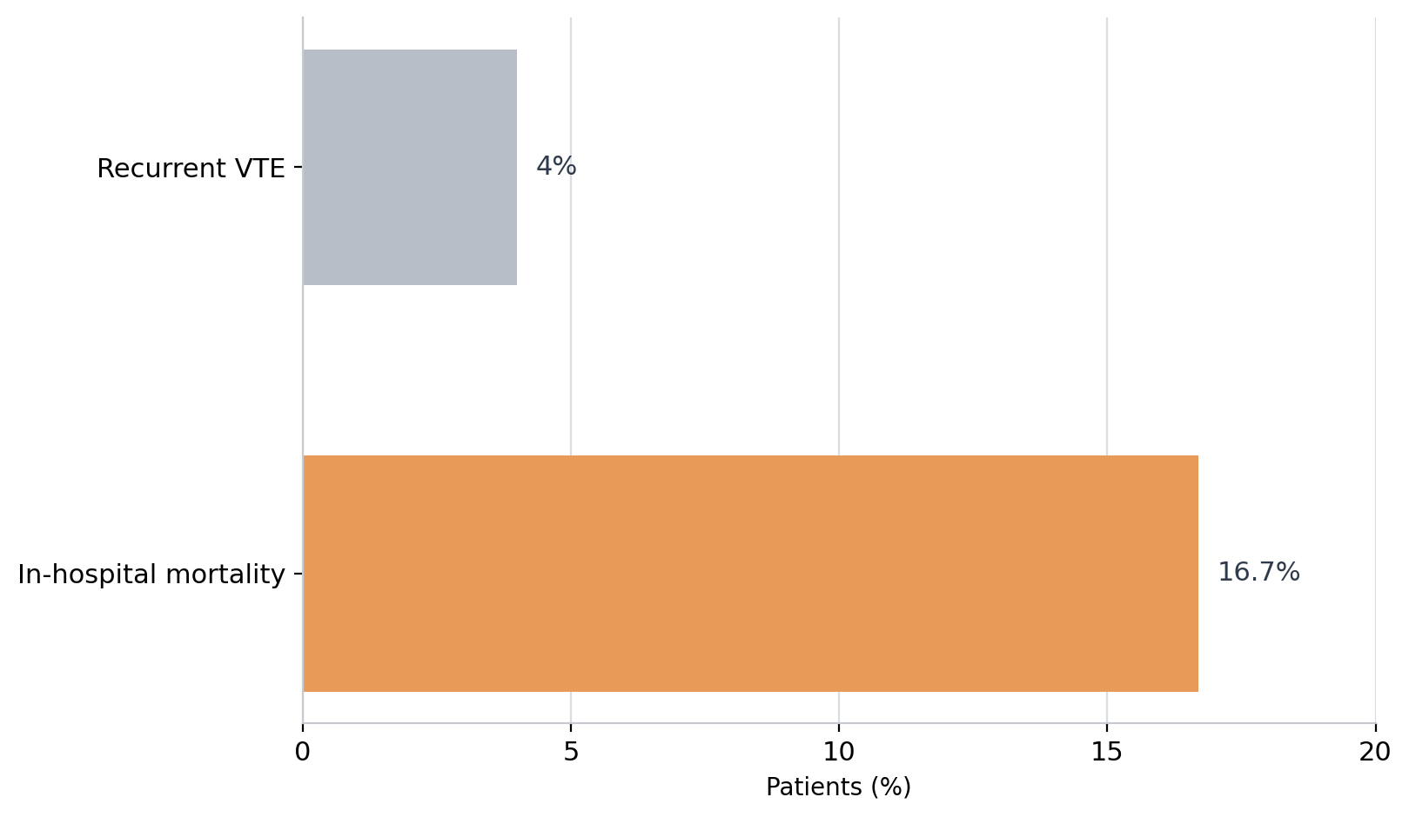
Figure 6. Short-term in-hospital outcomes.

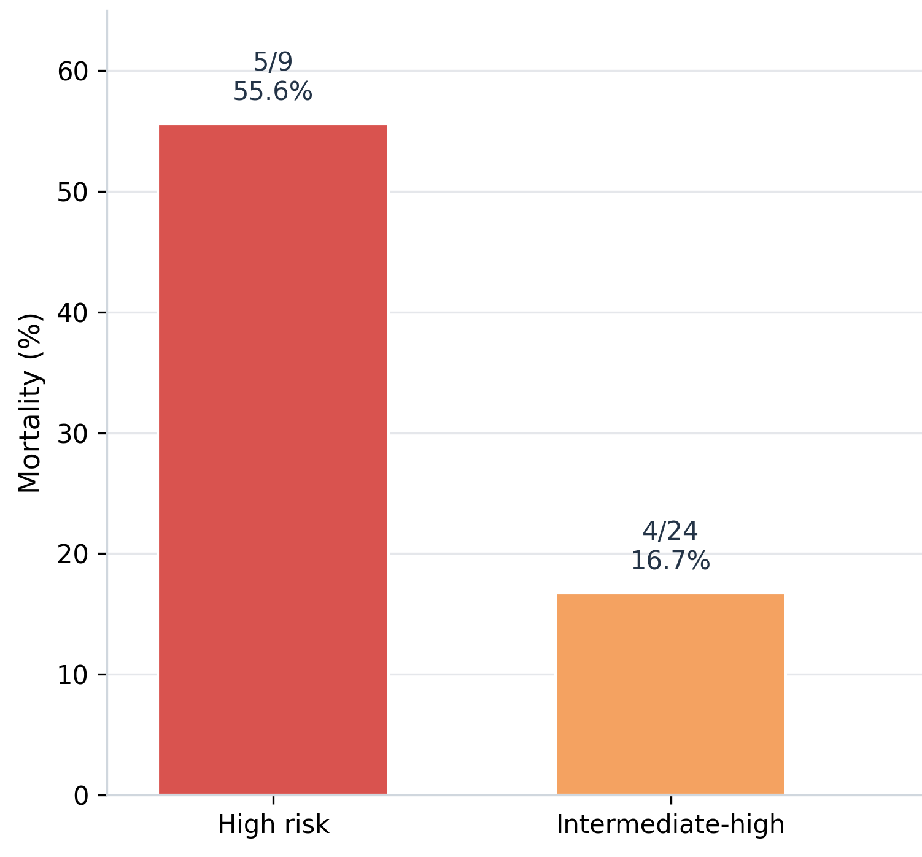
Figure 7. In-hospital mortality according to ESC risk category.

3.6 Follow-Up
Follow-up data were available for all 45 patients discharged alive (83% of the 54 patients). No recurrent events were documented at 30 days, and no deaths were recorded during the 3-month follow-up period.
Table 1 summarizes early risk stratification and in-hospital mortality. Table 2 summarizes the anticoagulant strategies used during hospitalization.
Table 1. Early risk stratification and in-hospital mortality
Risk category | n (%) | Deaths, n | Mortality (%)
High risk | 9 (17) | 5 | 55.6
Intermediate-high risk | 24 (44) | 4 | 16.7
Intermediate-low risk | 21 (39) | 0 | 0
Low risk | 0 (0) | 0 | 0
Overall | 54 (100) | 9 | 16.7
Table 2. Anticoagulant strategies used during hospitalization
Treatment regimen | n (%)
Direct oral anticoagulants | 16 (30)
LMWH followed by VKA | 16 (30)
UFH followed by VKA | 14 (25)
LMWH without oral relay | 8 (15)
Systemic thrombolysis | 5 (9)
4. Discussion
This study suggests that acute PE managed in our tertiary cardiology department was predominantly severe at presentation, with most patients classified as intermediate or high early risk. This severity profile probably reflects referral bias toward more complex or unstable cases rather than the full spectrum of PE seen in general emergency practice. It may also help explain the high ICU utilization and the substantial in-hospital mortality observed in our cohort. The importance of risk stratification in the management of acute PE is recognized by all stakeholders; it provides continuity between bedside assessment and the intensity of monitoring and treatment provided to the patient throughout the hospital course. Both the latest ESC guidelines and several recent systematic reviews have clearly demonstrated that the first prognostic discriminator is the patient's hemodynamic status (i.e., hypotensive), whereas hemodynamically stable patients need to be further stratified based upon right ventricular dysfunction, biomarker levels, and established clinical scoring systems (1,9-11). This predominance of individuals with either intermediate/high-risk or high-risk profiles points to significant referral bias towards more severely affected patients compared to patients presenting to the emergency department who will not be seen by a cardiologist for similar risk profiles (6,14).
There are also a variety of direct practical implications of our identified risk factors; for example, the high prevalence of prolonged immobilization in our cohort supports improved thromboprophylaxis, earlier mobilization, and closer monitoring, should be performed for bedridden/postoperative patients to reduce the incidence of PE managed in hospitals. Studies in the literature continue to report that other major risk factors for venous thromboembolic disease are: immobilization; trauma; surgery; cancer; obesity; hormonal exposures; and older age (2,5,16,22,23). Diagnostic evaluation may be even more challenging in pregnancy, which remains a special clinical situation in suspected PE (24). Therefore, from a preventive standpoint, our findings should stimulate the routine establishment of VTE prevention protocols at a local level for patients who are either postoperatively or medically immobilized .
Another important result was the high prevalence of obesity, which was observed in 52% of our sample. Obesity is not merely an underlying comorbidity; it also has a direct impact on the likelihood of thrombosis, resulting from chronic venous stasis, a chronic inflammatory state, endothelial dysfunction and impaired fibrinolytic activity. Recent expert statements and consensus documents have reinforced the clinical importance of obesity in venous thromboembolic disease and have also addressed practical issues regarding the use of direct oral anticoagulants in obese patients (16). In our setting, the high prevalence of obesity supports routine measurement and documentation of body mass index, as well as systematic screening for associated cardiometabolic conditions such as diabetes, reduced mobility, and hypertension.
All patients received anticoagulant therapy as the mainstay of treatment consistent with currently accepted guidelines (1,14). Results demonstrate that traditional modalities are still very much utilized in everyday clinical practice. For example, 30% of patients received an oral direct anticoagulant; however, considerably more were treated with an injectable anticoagulant and switched to a vitamin K antagonistic agent afterward. Factors which may influence these data include physician preference, severity of clinical condition, frequency of patient monitoring, financial issue, and the fact that many of these patients were initially unstable. Direct oral anticoagulants are increasingly used in routine practice after initial stabilization, although treatment selection remains influenced by severity, monitoring constraints, and resource availability.
Only 9% of patients received systemic thrombolysis, mainly patients with high-risk PE. This pattern confirms the principle that reperfusion is generally reserved for hemodynamically unstable patients or selected patients at high risk of becoming hemodynamically unstable (1,14). Thrombolysis remains a treatment with potential clinical benefit, but this must always be balanced against an increased risk of bleeding. For intermediate-high-risk PE, the key challenge is therefore not indiscriminate thrombolysis, but rather early identification of the subset most likely to deteriorate despite anticoagulation (10,11). Recent work has stressed the need for better predictors of early decompensation within this group, because current algorithms still leave uncertainty regarding the timing of intensive monitoring and escalation.
The pursuit of alternative therapies for catheter-based interventions along with the advent of multidisciplinary pulmonary embolism (PE) response team models are also relevant to our findings. Catheter-based treatment was not a continual practice at our facility; however, there has been a report of increasing literature support for the use of mechanical thrombectomy and catheter-directed thrombolysis as therapeutic options to systemic thrombolysis in specific patient populations (13,14). Multidisciplinary PE response pathways may facilitate decision-making in complex cases, although their availability remains limited in many settings.
Caution is warranted when interpreting our mortality data. The overall in-hospital mortality rate of 16.7% is higher than rates for many broad-based PE registry studies; this is not surprising given the predominance of patients with severe PE among our study population. The mortality rate in high-risk patients was 55.6%, which is consistent with historical data for obstructive cardiogenic shock and asystole due to PE. Contemporary population-based data still confirm that mortality in high-risk PE remains very high and that reperfusion therapy is often underused in routine care (1,15). Limited technological capacity, delayed diagnosis, and restricted access to advanced reperfusion strategies may all have contributed to poorer outcomes in our setting.
No recurrent events were documented during short-term follow-up among surviving patients.
The apparently favorable short-term follow-up findings should be interpreted with great caution. Because follow-up was retrospective and relied on available records, recurrent events, persistent symptoms, and complications occurring outside our institution may have been missed. The absence of documented events therefore should not be interpreted as proof of absence of post-discharge morbidity.
These findings must also be interpreted in light of the retrospective design, the limited sample size, and the single-center nature of the study. Recent reviews point out the importance of post-PE syndrome, persistent exercise intolerance, recurrent venous thromboembolism, chronic thromboembolic pulmonary hypertension, and reduced quality of life after discharge (20). Structured post-discharge follow-up, therefore, is still essential, especially in patients with obesity, cancer, persistent dyspnea, or residual right ventricular dysfunction (25).
In our center, advanced catheter-based reperfusion strategies were not routinely available. This is clinically relevant because a substantial proportion of patients had intermediate-high-risk or high-risk PE, a subgroup in whom escalation pathways may be required. Our findings therefore support efforts to improve referral organization and access to advanced reperfusion options for selected severe cases.
Our findings also have consequences for cancer-associated and outpatient PE management. Although active cancer was present in only 15% of patients, this subgroup remains clinically important because the balance between recurrence, bleeding, and survival differs from that in non-cancer patients. As a result, outpatient management using direct oral anticoagulants (DOACs) has gained increasing attention for carefully selected patients with low risk, and may be implemented even in certain cases of PE related to cancer; however, this will require standardized triage processes, reliable follow-up, and a consistent infrastructure, all of which may not currently exist in all public sectors (2,14).
There are several limitations associated with our study. Due to the fact that this was a retrospective study, there was potential for the introduction of an information bias related to retrospective data collection and no control over missing data. The number of subjects who formed the basis of the current study was limited and represented a single institution, thus limiting the external generalization of these results. Moreover, as the study population was comprised entirely from a tertiary care cardiology cohort, we are highly confident that there was a significant over-representation of patients with severe PE (pulmonary embolism). Additionally, variables that may have had an impact on patient prognosis, including but not limited to certain laboratory tests, standard definitions of bleeding, and long-term functional status, were not available for every patient in this study. However, the available data is of value because it will provide much needed local-based real-world evidence from an area where little data exists; furthermore, this study provides the opportunity to emphasize important clinical priorities that need to be addressed in order to improve patient care.
Improving thromboprophylaxis for immobilized and postoperative patients in Morocco, standardizing the assessment of PE severity at admission, and expanding access to acute reperfusion strategies should be considered key priorities. Establishing a local or national PE registry would probably be one of the most useful following steps, as it would permit better benchmarking, clarify treatment patterns, and help identify where delays or lost opportunities occur.
Another aspect of interest is that provoked PE predominated in our cohort; only one case was deemed 'apparently' unprovoked. Our cohort is consistent with what has been observed with unprovoked PE in some western registries; it contrasts with what has been seen in other cohorts where unprovoked cases represent a greater percentage of total cases; therefore, it seems that there is a substantial amount of severe PE occurring in our institution that can be connected to identifiable short-term triggers. From a public health perspective, provoked PE may be partly preventable through improved perioperative prophylaxis, earlier mobilization, risk-adjusted thromboprophylaxis, and better documentation of hormonal exposure and cancer status at admission (1,2,5,16).
The issue of the high rate of admission to Intensive Care Units is another important topic to mention in regards to this study. Many studies limit admission to those who are in hemodynamic instability or at risk of deterioration, however based on data from this study, approximately 87% of patients were in need of admission to an Intensive Care Unit which can be attributed to how badly they were affected by the disease itself and how the facility was setup within their organization. Some Tertiary facilities with cardiology services have utilized admission to an Intensive Care Unit as a means to protect the patient from further deterioration when they have significant right ventricular strain, significant hypoxemia or are not on a predictable course early on in their hospitalization and not necessarily have full shock. This may be a rational approach in the absence of highly granular deterioration scores, especially for intermediate-high-risk PE, but it also underlines the pressure that acute PE places on critical care resources.
Future prospective studies with standardized collection of prognostic scores, biomarkers, echocardiographic data, bleeding outcomes, and structured follow-up are needed to better define outcomes and optimize triage and treatment pathways in our setting.
This study has several limitations. First, its retrospective design exposed it to information bias and incomplete documentation. Second, the sample size was relatively small for a two-year period, which may reflect the single-center design and the fact that only patients hospitalized in a tertiary cardiology department were included. Third, the study population likely overrepresented more severe PE cases, limiting generalizability to the broader PE population. Fourth, no inferential statistical analysis was performed, so the findings should be considered descriptive. Finally, follow-up data may have underestimated post-discharge complications and recurrent events occurring outside our institution.
No inferential statistical analysis was performed; therefore, the study should be interpreted as descriptive rather than comparative.
5. Conclusion
Our study shows that acute PE managed in this Moroccan tertiary cardiology department was most often diagnosed at an intermediate or high early-risk stage and remained associated with substantial in-hospital mortality. The findings underline the importance of early severity assessment, prevention of provoked PE, timely access to appropriate reperfusion pathways for selected severe cases, and more structured post-discharge follow-up.
ETHICAL APPROVAL: As per international standards or university standards written ethical approval has been collected and preserved by the author(s).

Disclaimer (Artificial intelligence)

Author(s) hereby declare that NO generative AI technologies such as Large Language Models (ChatGPT, COPILOT, etc.) and text-to-image generators have been used during the writing or editing of this manuscript.

REFERENCES
- Konstantinides SV, Meyer G, Becattini C, Bueno H, Geersing GJ, Harjola VP, et al. 2019 ESC Guidelines for the diagnosis and management of acute pulmonary embolism developed in collaboration with the European Respiratory Society (ERS). Eur Heart J. 2020;41(4):543-603. doi:10.1093/eurheartj/ehz405.
- Khandait H, Harkut P, Khandait V, Bang V. Acute pulmonary embolism: Diagnosis and management. Indian Heart J. 2023;75(5):335-342. doi:10.1016/j.ihj.2023.05.007.
- Wrenn JO, Kabrhel C. Emergency department diagnosis and management of acute pulmonary embolism. Br J Haematol. 2024;205(5):1714-1716. doi:10.1111/bjh.19725.
- Gottlieb M, Moyer E, Bernard K. Epidemiology of pulmonary embolism diagnosis and management among United States emergency departments over an eight-year period. Am J Emerg Med. 2024;85:158-162. doi:10.1016/j.ajem.2024.09.016.
- Lutsey PL, Zakai NA. Epidemiology and prevention of venous thromboembolism. Nat Rev Cardiol. 2023;20(4):248-262. doi:10.1038/s41569-022-00787-6.
- Zuin M, Bikdeli B, Ballard-Hernandez J, Barco S, Battinelli EM, Giannakoulas G, et al. International Clinical Practice Guideline Recommendations for Acute Pulmonary Embolism: Harmony, Dissonance, and Silence. J Am Coll Cardiol. 2024;84(16):1561-1577. doi:10.1016/j.jacc.2024.07.044.
- Piovella F, Iosub DI. Acute pulmonary embolism: risk assessment, risk stratification and treatment options. Clin Respir J. 2016;10(5):545-554. doi:10.1111/crj.12264.
- Brailovsky Y, Allen S, Masic D, Lakhter D, Sethi SS, Darki A. Risk stratification of acute pulmonary embolism. Curr Treat Options Cardiovasc Med. 2021;23(7):48. doi:10.1007/s11936-021-00923-4.
- Erol S, Gürün Kaya A, Arslan F, Ayöz S, Gürsoy Çoruh A, Kul M, et al. Agreement Between Transthoracic Echocardiography and Computed Tomography Pulmonary Angiography for Detection of Right Ventricular Dysfunction in Pulmonary Embolism. Anatol J Cardiol. 2024;28(8):393-398. doi:10.14744/AnatolJCardiol.2024.3562.
- Cimini LA, Pruszczyk P, Jiménez D, Weekes A, Zuin M, Vanni S, et al. Right ventricular dysfunction on echocardiography to predict mortality in acute pulmonary embolism: an individual patient data meta-analysis. J Thromb Haemost. 2025 Dec 15:S1538-7836(25)00899-2. doi:10.1016/j.jtha.2025.11.020.
- Lyhne MD, Bikdeli B, Jiménez D, Kabrhel C, Dudzinski DM, Moisés J, et al. Right ventricular-pulmonary artery coupling for prognostication in acute pulmonary embolism. Eur Heart J Acute Cardiovasc Care. 2024;13(12):817-825. doi:10.1093/ehjacc/zuae120.
- Sullivan AE, Holder TA, Beckman JA, Green CL, Patel MR, Fortin TA, et al. Utility of electrocardiographic findings in acute pulmonary embolism. Eur Heart J Open. 2023;3(6):oead121. doi:10.1093/ehjopen/oead121.
- Yuriditsky E, Zhang RS, Ahuja T, Bangalore S, Horowitz JM. The latest in the management of pulmonary embolism. Breathe (Sheff). 2025;21(2):240100. doi:10.1183/20734735.0100-2024.
- Guarnieri G, Landi A, Barco S, Cassina T, Merlani P, Milzi A, et al. Contemporary management of acute pulmonary embolism. Int J Cardiol. 2025;436:133422. doi:10.1016/j.ijcard.2025.133422.
- Zhong X, Webster J, Morris EJA, Oguzman E, Shapiro S, Shepperd S, et al. Temporal trends in hospital-recorded pulmonary embolism in England before, during and after the COVID-19 pandemic (2008-2024): a population-based observational study. Lancet Reg Health Eur. 2025;58:101433. doi:10.1016/j.lanepe.2025.101433.
- Zuin M, Piazza G, Barco S, Bertoletti L, Ciurzynski M, Skoro-Sajer N, et al. Obesity and Acute Pulmonary Embolism: Clinical Implications and Knowledge Gaps. J Am Coll Cardiol. 2025;86(20):1885-1899. doi:10.1016/j.jacc.2025.09.1504.
- Diaz-Lorenzo I, Alonso-Burgos A, Friera Reyes A, Pacios Blanco RE, de Benavides Bernaldo de Quiros MDC, Gallardo Madueño G. Current Role of CT Pulmonary Angiography in Pulmonary Embolism: A State-of-the-Art Review. J Imaging. 2024;10(12):323. doi:10.3390/jimaging10120323.
- Low CL, Kow RY, Abd Aziz A, Mohd Yusof M, Lim BC, Kamarudin NA, et al. Diagnostic Yield of CT Pulmonary Angiogram in the Diagnosis of Pulmonary Embolism and Its Predictive Factors. Cureus. 2023;15(6):e40484. doi:10.7759/cureus.40484.
- Saini SK, Khan ZS, Do V, Keijzers G. Computed tomography pulmonary angiogram ordering, adherence to decision rules and yield in the emergency department: An observational study. Emerg Med Australas. 2024;36(5):726-731. doi:10.1111/1742-6723.14428.
- Aujesky D, Obrosky DS, Stone RA, Auble TE, Perrier A, Cornuz J, et al. Derivation and validation of a prognostic model for pulmonary embolism. Am J Respir Crit Care Med. 2005;172(8):1041-1046. doi:10.1164/rccm.200506-862OC.
- Jiménez D, Aujesky D, Moores L, Gómez V, Lobo JL, Uresandi F, et al. Simplification of the pulmonary embolism severity index for prognostication in patients with acute symptomatic pulmonary embolism. Arch Intern Med. 2010;170(15):1383-1389. doi:10.1001/archinternmed.2010.199.
- Lo Faro V, Johansson T, Johansson Å. The risk of venous thromboembolism in oral contraceptive users: the role of genetic factors-a prospective cohort study of 240,000 women in the UK Biobank. Am J Obstet Gynecol. 2024;230(3):360.e1-360.e13. doi:10.1016/j.ajog.2023.09.012.
- Yonis HGH, Mørch LS, Løkkegaard E, Kragholm K, Møller AL, Torp-Pedersen C, et al. Contemporary Hormonal Contraception and Risk of Venous Thromboembolism. JAMA. 2025;333(15):1358-1361. doi:10.1001/jama.2024.28778.
- Hammache M, Simard C, Hamel S, Ouellet S, Jolicoeur G, Wou K, et al. Diagnosing Pulmonary Embolism During Pregnancy. Chest. 2025;168(4):1007-1017. doi:10.1016/j.chest.2025.05.014.
- Coquoz N, Lechartier B, Yerly P, Bridevaux PO. [Post-pulmonary embolism syndrome: Litterature review 2024]. Rev Med Suisse. 2024;20(895):2099-2103. doi:10.53738/REVMED.2024.20.895.2099.

