Epidemiology, Risk Factors and Diagnostic Features of Acute Pulmonary Embolism in a Moroccan Tertiary Cardiology Department: A Retrospective Descriptive Study

Abstract
Background: Acute pulmonary embolism (PE) constitutes a leading cause of illness and death from cardiovascular disease around the world. Even with better ways to diagnose and treat PE, it is still difficult to manage, especially in places where local data are limited. In Morocco, there is little recent hospital-based information about the clinical characteristics of patients admitted with acute PE.
Aim: This study aims to describe the epidemiology, risk factors, clinical presentation, and diagnostic features of patients with acute PE admitted to the cardiology department at Ibn Rochd University Hospital.
Methods: A retrospective descriptive study of consecutive patients admitted to the cardiology department of Ibn Rochd University Hospital, Casablanca, conducted for acute PE confirmed by CTPA between January 2024 and December 2025. Demographic characteristics, thromboembolic risk factors, clinical presentation, electrocardiographic findings, echocardiographic features, and CTPA findings were extracted from medical records and analyzed descriptively.
Results: Fifty-four patients were included, with a mean age of 60 ± 18 years (range 22–88); 58% were women. At least one provoking or contributing factor was found in 98% of patients. Prolonged immobilization was the most common risk factor, present in 81% of cases. Obesity, recent surgery, hormonal exposure or postpartum status among women, active cancer, chronic heart disease or chronic respiratory disease, history of miscarriage by females, prior history of venous thromboembolism, were all reported to be risk factors for pulmonary embolism. The most common presenting symptom was dyspnea, followed by chest pain (98%), and ECG changes were frequently observed (S1Q3 pattern [50%], anterior T-wave inversions [44%], and sinus tachycardia [37%]). A right ventricular dilation was observed in 65% of participants via an echocardiogram, systolic dysfunction was also seen in 48% of patients, and all cases were confirmed on a CTPA. Proximal emboli were noted in 72% of patients and 69% of patients demonstrated bilateral involvement.
Conclusion: In this single-center Moroccan study, acute PE occurred mainly in middle-aged and older adults and was slightly more common in women. Identifiable thromboembolic risk factors were frequent, especially immobilization, obesity, surgery, cancer, and hormonal exposure. CTPA was the basis of diagnosis, while echocardiography provided important information on right ventricular involvement. The results show the need for better prevention, earlier diagnosis, and larger multicenter studies on pulmonary embolism in Morocco.
Keywords: Pulmonary embolism; Venous thromboembolism; ; Epidemiology; Computed tomography pulmonary angiography; Echocardiography;

1. Introduction
Pulmonary embolism (PE) is a frequent and potentially fatal complication of venous thromboembolism (VTE). Pulmonary embolism refers to the occlusion of the pulmonary artery or one of its branches due to thrombosis, air, fat or tumour that originates from somewhere in the body (22). Together with deep vein thrombosis, it is a major cause of preventable cardiovascular death and an important reason for emergency hospital admission. PE is thought to develop in approximately 10% of patients with acute deep vein thrombosis (DVT), and it can lead to approximately 10% of hospital deaths (24). Despite major progress in diagnosis and treatment, acute PE is still a clinical challenge because it can present in many different and often non-specific ways, from isolated dyspnea to syncope, obstructive shock, or sudden death. In routine practice, diagnosis relies on the structured integration of clinical probability assessment, laboratory testing, and imaging, particularly computed tomography pulmonary angiography (CTPA), which has become the principal confirmatory examination in most centres (1–4). CTPA is the gold standard for PE diagnosis. These attributes have resulted in a significant increase in the number of trauma patients undergoing imaging for diagnosing PE since the 1990s (25).
Recent data suggest that the epidemiology of PE is evolving. Globally, PE is the third leading cause of cardiovascular-related deaths, after coronary artery disease and stroke (23). More frequent use of CTPA, together with wider use of diagnostic pathways and increased awareness of thromboembolic disease, has led to more diagnosed cases and changes in hospitalization patterns (5–7). At the same time, important clinical doubts remain, particularly in intermediate-risk patients, in those with right ventricular dysfunction, and in individuals with multiple interacting prothrombotic conditions (4,8–10). The burden of PE is strongly influenced by age, immobilization, surgery, cancer, obesity, chronic disease, pregnancy-related states, and hormonal exposure (1,4,8,11–14).
Right ventricular dysfunction is a key element of early risk stratification because acute pressure overload of the right ventricle is linked to clinical deterioration and short-term mortality (9,10,15,16). In this context, echocardiography and CTPA complement each other by helping confirm the diagnosis and assess severity and hemodynamic consequences (9,10,15–17).
In Morocco and North Africa, hospital-based data on acute PE are still limited. These data are important because risk factors, access to diagnostic tools, referral patterns, and delays in diagnosis may differ from those described in large European or North American cohorts. Ibn Rochd University Hospital in Casablanca is a tertiary referral center receiving patients from emergency departments, peripheral hospitals, and several medical specialties. A clearer picture of the local profile of patients admitted for acute PE may help identify preventable factors, improve recognition, and direct future multicenter research.
The aim of this study was to describe the epidemiology, risk factors, clinical presentation, and diagnostic features of patients with acute PE admitted to the cardiology department at Ibn Rochd University Hospital. Instead of testing a specific cause, the goal was to give a clear overview of PE in this setting and point out practical steps for prevention and earlier diagnosis.

2. Materials and Methods
The retrospective descriptive study was conducted from January 2024 to December 2025 on the cardiology unit (P37 for patients) at the Ibn Rochd University Hospital in Casablanca, Morocco (a tertiary referral facility for the greater Casablanca-Settat area and receiving patients from other emergency and non-emergency departments such as general/internal medicine, pulmonary medicine and/or periphery institutions). Patient records were eligible for inclusion if there were time stamped patient charts that contained the complete records of consecutive patients who were diagnosed with an acute pulmonary embolism (PE), with the diagnosis of PE confirmed by computerized tomography pulmonary arteriography (CTPA). In addition, patient records with incomplete patient information (e.g., missing date of admission, and/or discharging) or incomplete patient test results (e.g., inconclusive or incidental findings), as well as patients that were diagnosed outside the study parameters (January 2024 - December 2025) will not be included in this study.
Data were extracted from paper and electronic medical records, imaging reports, laboratory results, and the hospitalization register using a standardized form. Variables comprised demographic characteristics, cardiovascular and thromboembolic risk factors, presenting symptoms and signs, laboratory data, electrocardiographic and echocardiographic findings, CTPA results, and final diagnostic classification.
Obesity was defined as a body mass index of at least 30 kg/m² when this information was available in the medical record. Surgery that was performed less than one month prior constitutes recent surgery. A prolonged period of immobility may have occurred due to bed rest, decreased mobility, and documentation of a recent immobile condition in the medical record. A provoked pulmonary embolism (PE) is the occurrence of PE when there is an identifiable cause present, such as immobility, surgery, cancer, hormonal treatment and/or being recently postpartum.
The analysis was descriptive. Quantitative variables were given as mean ± standard deviation, and qualitative variables as numbers and percentages. Unless otherwise stated, percent return is based on total count of the total study population. For variables with missing data, percent return is determined using the number of patients available and had the data required to calculate percent return. Microsoft Excel was utilized for data entry and analysis for this study.
Institutional approval was obtained from Ibn Rochd University Hospital's ethical committee for this investigation, which was undertaken in compliance with the Declaration of Helsinki. During the conduct of the study, patient anonymity was preserved when collecting and analyzing data.

3. Results

3.1. Baseline characteristics

Fifty-four patients met the inclusion criteria. The mean age was 60 ± 18 years (range 22–88), and women accounted for 58% of cases, with a female-to-male ratio of 1.2.

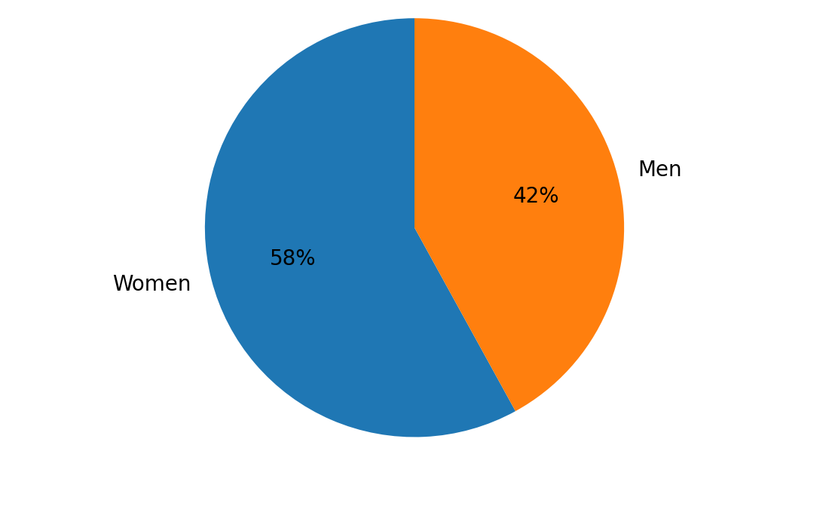
Figure 1. Sex distribution of the study population.

At least one provoking or contributing risk factor was identified in 98% of patients. Prolonged immobilization was the most frequent, observed in 81%. Obesity was present in 52%. The presence of recent surgical history was recorded in 28%, and active cancer in 15%. A history of previous venous thromboembolism was recorded in 7%, and 13% had a history of chronic heart failure and chronic respiratory diseases. A history of stroke or transient ischemic attack was recorded in 5%. There was no history of thrombophilia or systemic inflammatory diseases.

Hormonal exposure or postpartum status were recorded in 28% and 9%, respectively, of the 100 women. In addition, 20% of each of the women had hypertension, diabetes mellitus, and dyslipidemia. Thirty-four percent of women reported that they smoked.
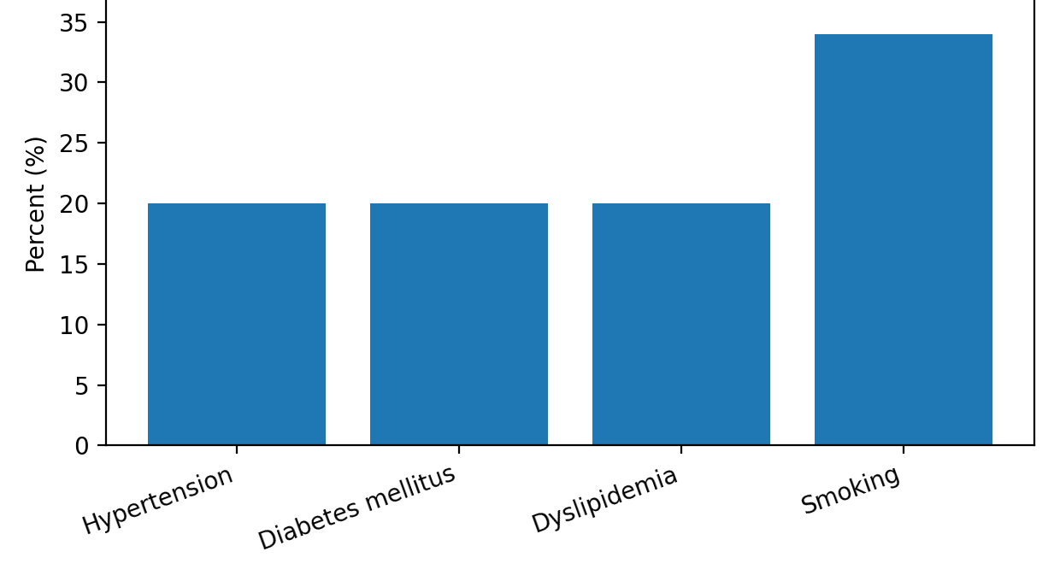
Figure 2. Distribution of cardiovascular risk factors.
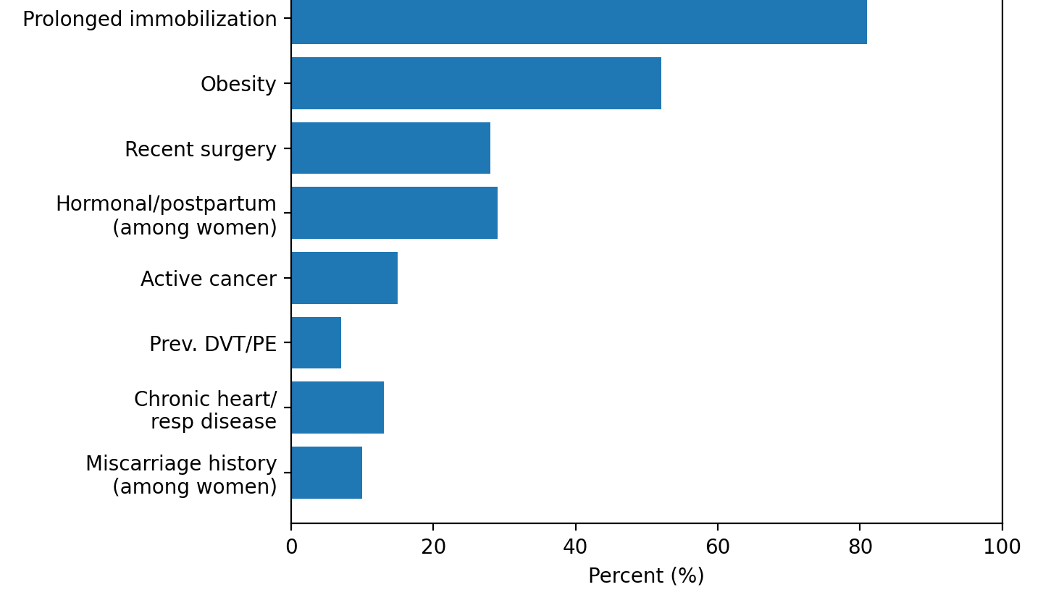
Figure 3. Distribution of thromboembolic risk factors.

The majority had at least one cardiovascular risk factor, leading to the occurrence of pulmonary embolism with the manifestation of its various symptoms.

3.2. Clinical presentation

Dyspnea was the most common presenting symptom (98%), followed by chest pain (65%). Cough or hemoptysis occurred in 13%, while syncope was rare (1%). Tachycardia above 100 beats/min was present in 34% of patients, and oxygen saturation below 90% in 35%.

Complete documentation of the clinical probability assessment was not obtained. Of the patients with clinical probability assessment available, 48% were classified as having a high Wells score, and 36% of patients met criteria for a high Geneva score. These results suggest that, in many cases, PE was already considered likely before imaging was performed.
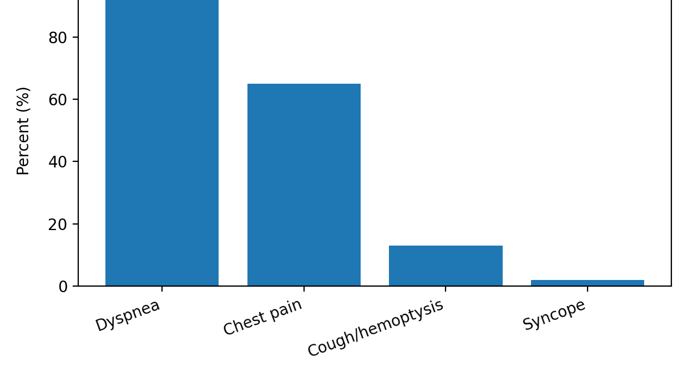
Figure 4. Main presenting symptoms.

3.3. Laboratory and electrocardiographic findings

All tested patients had elevated D-dimer levels. Troponin and/or BNP or NT-proBNP were increased in 65%, suggesting frequent right ventricular strain or myocardial involvement. Electrocardiographic abnormalities were common but non-specific. The most frequent findings were S1Q3 pattern (50%), anterior T-wave inversion (44%), sinus tachycardia (37%), right bundle branch block (17%), right ventricular hypertrophy (RBBB)(11%), and atrial fibrillation (5%).
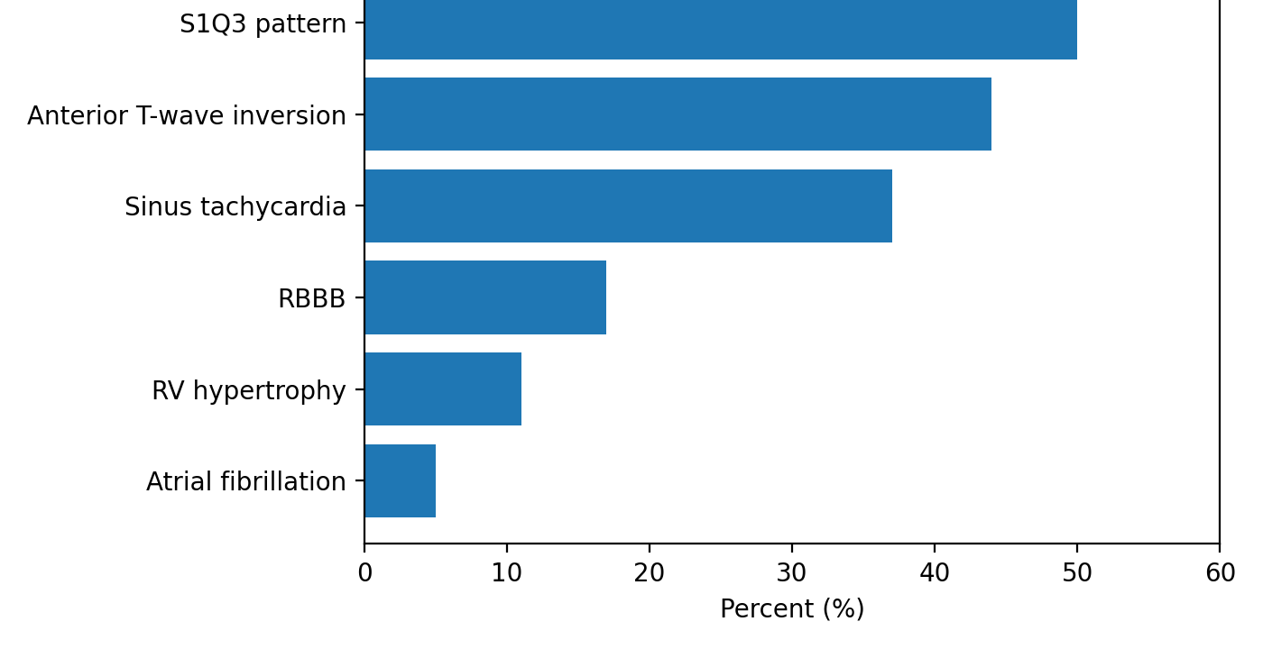
Figure 5. Electrocardiographic abnormalities in acute pulmonary embolism.

3.4. Echocardiographic findings
Transthoracic echocardiography showed significant right ventricular involvement. Right ventricular dilatation was present in 65%, and right ventricular systolic dysfunction was present in 48%. McConnell’s sign was present in 30%, and paradoxical septal motion was present in 52%. Right ventricular hypertrophy was present in 13%. Pulmonary artery dilatation associated with a shortened pulmonary acceleration time was present in 93%. Dilatation of the inferior vena cava was present in 28%, and a floating right atrial thrombus was present in 4%. The left ventricular ejection fraction was preserved in 87%. Other signs of right ventricular overload were present in 28%.

3.5. CTPA findings

CTPA confirmed the diagnosis in all 54 patients. Approximately 72% of patients had proximal pulmonary embolism involving the main or lobar pulmonary arteries. Segmental and subsegmental pulmonary embolism occurred in 22% and 6% of patients, respectively. Emboli were found on one side in 31% of patients and in both sides in 69% of patients. Evidence of right ventricular strain was observed in 28% of patients on CT imaging.

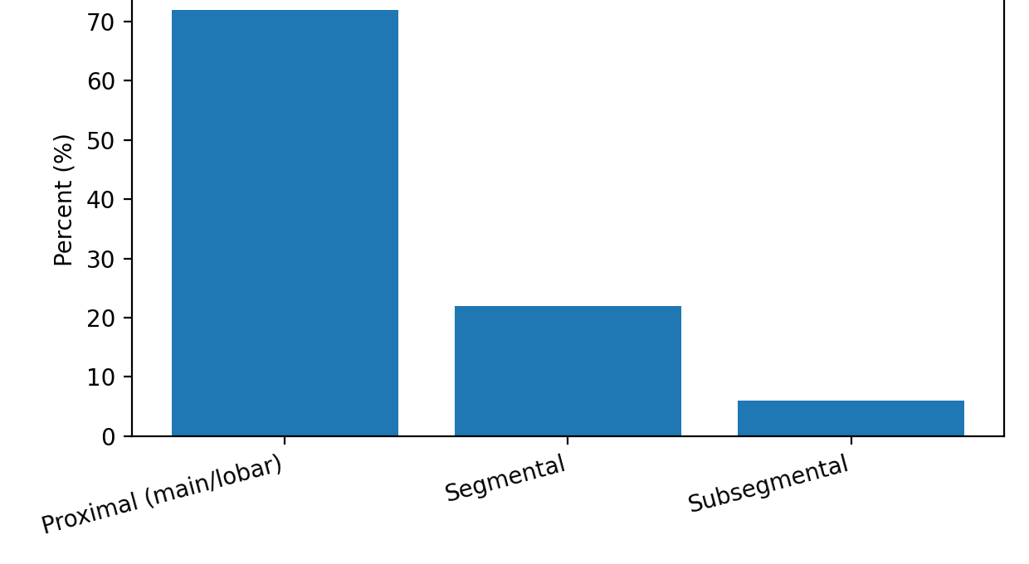
Figure 6. Anatomical distribution of pulmonary embolism on CTPA
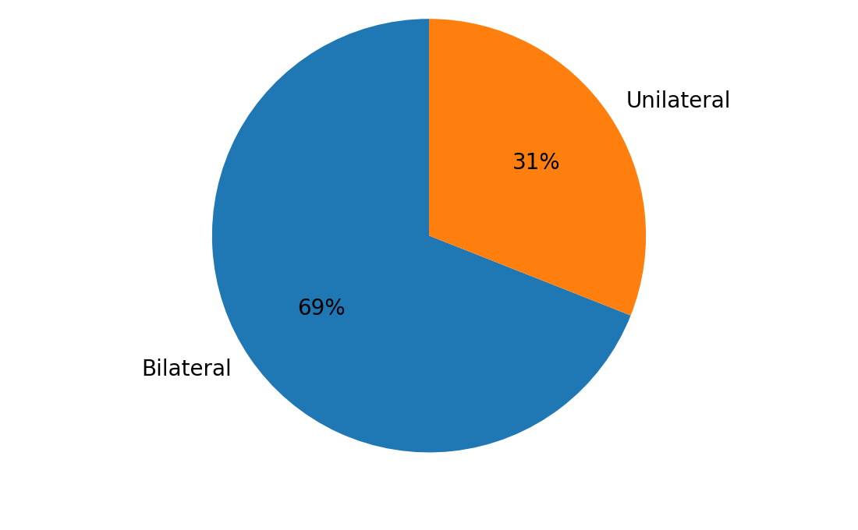
Figure 7. Unilateral versus bilateral pulmonary embolism on CTPA.

Diagnosis of acute PE was based on compatible clinical presentation, supportive ancillary findings, and confirmatory CTPA. PE was provoked in 91% of patients and unprovoked in 2%. Deep venous thrombosis with pulmonary embolism was noted in 7% of cases.

.

4. Discussion

This retrospective study aimed to investigate the profile of patients admitted for acute pulmonary embolism in a tertiary center for cardiology in Morocco. The main findings were the high frequency of identifiable thromboembolic risk factors, particularly prolonged immobilization, obesity, recent surgery, active cancer, and female-specific hormonal or postpartum exposure. Dyspnea and chest pain were the main presenting symptoms, whereas syncope was uncommon. CTPA was the universal confirmatory imaging tool, and echocardiography often showed right ventricular involvement.

The mean age of 60 years in our series is broadly consistent with contemporary reports showing that PE mainly affects middle-aged and older adults, although the exact age distribution varies according to the study setting and population profile (1,5,7). The slight female predominance observed in our cohort may reflect the interaction between general thromboembolic risk factors and sex-specific exposures. This observation is clinically relevant because a meaningful proportion of women in our series had hormonal exposure or postpartum status, while obesity was also highly prevalent. Recent literature confirms that hormonal contraception and reproductive factors remain important modifiers of VTE risk, particularly when combined with other prothrombotic conditions (11–14).

The predominance of prolonged immobilization in our study likely reflects the referral profile of a tertiary hospital with many recently hospitalized and medically frail patients. Immobilization is a common trigger for venous thromboembolism (VTE), especially in postoperative and chronically ill patients (1,4). In addition, since the patients we studied had a high incidence of VTE, this indicates that preventive measures need to be taken to decrease the number of patients developing VTE after surgery. More than one-half of our patients had obesity, which is a known prothrombotic state and may further increase the risk of VTE when when combined with reduced mobility, surgery, or hormonal exposure (8,18). In practice, combinations of risk factors are often more informative than isolated exposures when assessing PE likelihood.

Recent surgery and active cancer were also frequent in our cohort, in conformity with established data from the literature (1,4,8). These factors are important not only from an epidemiological perspective but also from a therapeutic standpoint because they influence recurrence risk, bleeding risk, and the duration and choice of anticoagulation. The very low proportion of unprovoked PE in our study may reflect the hospital-based nature of the population, in which comorbidities and clinically apparent triggers are common. It may also indicate underdocumentation of inherited thrombophilia or other less obvious predisposing conditions in routine practice.

The symptom profile in this series reflects the classic but non-specific presentation of acute PE. Dyspnea and chest pain were most common, while cough, hemoptysis, and syncope were less frequent. This pattern is in keeping with other clinical series and underlines the need to consider PE in patients with unexplained acute dyspnea, especially when chest pain, hypoxemia, or known risk factors are present (1,3,4). Clinical probability scores, including Wells and Geneva, were not systematically documented, as is often the case in retrospective studies. However, among patients with available scores, many were already classified as high probability before imaging. This illustrates the value of structured clinical assessment, particularly where indiscriminate imaging may increase unnecessary radiation, contrast use, and resource consumption (4,6,19).

Electrocardiographic abnormalities were as expected. Sinus tachycardia was the most common non-specific finding, with a frequent S1Q3 pattern, anterior T-wave inversion, and right bundle branch block. While none of these signs is diagnostic alone, their presence is able to their presence may reinforce clinical suspicion and suggest right ventricular strain in the appropriate context. (1,15,20).

The echocardiographic findings are clinically important. Right ventricular dilatation and dysfunction were common, and several markers of acute right ventricular overload were frequently present. Contemporary evidence continues to support the prognostic importance of right ventricular dysfunction in acute PE, particularly among normotensive patients in whom early clinical deterioration may still occur (9,10,15–17). Although echocardiography is not routinely used to confirm the diagnosis in hemodynamically stable patients, it remains useful for risk stratification and for assessing possible hemodynamic impact. Our findings support its function as a complementary investigation to CTPA (1,9,10,17,21).

In our series, CTPA was central to the diagnosis of PE, confirming all cases and showing mainly proximal and bilateral involvement. Since only confirmed cases were included, the study was not intended to assess diagnostic yield. However, it clearly reflects the key place of CTPA in the diagnostic approach. In our setting, a more systematic assessment of pretest probability may help make better use of imaging while averting delays in diagnosis (5,6,19).

Several limitations should be acknowledged. The retrospective design may have led to missing data, differences in record quality, and possible misclassification. The small sample size and the fact that this was a single-center study also limit how far these outcomes can be generalized. In addition, some variables, such as referral source, biomarker thresholds, treatment details, and in-hospital outcomes, were not documented consistently. For this reason, we chose to focus on a descriptive profile of the study population rather than on comparative assessments or outcome modeling. In spite of these limitations, the study is important given the scarcity of local PE data, and hospital-based series are an important step toward broader multicenter research.

5. Conclusion

Acute pulmonary embolism in our department most often occurred in patients with provoking factors, such as prolonged immobilization, obesity, recent surgery, active cancer, and female hormonal and postpartum factors. The main presenting symptoms were dyspnea and chest pain, and the echocardiogram often showed right heart involvement. CTPA remained the reference imaging modality for diagnostic confirmation and anatomical assessment.These data emphasize three key aspects that need to be improved: thromboprophylaxis in high-risk patients, early detection of PE in patients presenting with combined risk factors, and the importance of systematic diagnostic pathways. Larger multicenter studies in Morocco are needed to better define the epidemiology, management, and outcomes of PE across hospital settings.

ETHICAL APPROVAL : As per international standards or university standards written ethical approval has been collected and preserved by the author(s).
CONSENT : As per international standards or university standards, patient(s) written consent has been collected and preserved by the author(s).
Disclaimer (Artificial intelligence)

Author(s) hereby declare that NO generative AI technologies such as Large Language Models (ChatGPT, COPILOT, etc.) and text-to-image generators have been used during the writing or editing of this manuscript.

References
- Konstantinides SV, Meyer G, Becattini C, et al. 2019 ESC Guidelines for the diagnosis and management of acute pulmonary embolism developed in collaboration with the European Respiratory Society (ERS). Eur Heart J. 2020;41(4):543-603. doi:10.1093/eurheartj/ehz405
- Khandait H, Harkut P, Khandait V, Bang V. Acute pulmonary embolism: Diagnosis and management. Indian Heart J. 2023;75(5):335-342. doi:10.1016/j.ihj.2023.05.007
- Wrenn JO, Kabrhel C. Emergency department diagnosis and management of acute pulmonary embolism. Br J Haematol. 2024;205(5):1714-1716. doi:10.1111/bjh.19725
- Zuin M, Barco S, Bikdeli B. International Clinical Practice Guideline Recommendations for Acute Pulmonary Embolism: Harmony, Dissonance, and Silence. J Am Coll Cardiol. 2024;84(15):1487-1504. doi:10.1016/j.jacc.2024.07.044
- Gottlieb M, Moyer E, Bernard K. Epidemiology of pulmonary embolism diagnosis and management among United States emergency departments over an eight-year period. Am J Emerg Med. 2024;85:158-162. doi:10.1016/j.ajem.2024.09.016
- Saini SK, Jiao Y, Coughlin P, et al. Computed tomography pulmonary angiogram ordering, adherence to decision rules and yield in the emergency department: An observational study. Emerg Med Australas. 2024;36(5):726-731. doi:10.1111/1742-6723.14428
- Zhong X, Moulson N, de Belder M, et al. Temporal trends in hospital-recorded pulmonary embolism in England before, during and after the COVID-19 pandemic (2008-2024): a population-based observational study. Lancet Reg Health Eur. 2025;56:101433. doi:10.1016/j.lanepe.2025.101433.
- Yuriditsky E, Rosovsky R. The latest in the management of pulmonary embolism. Breathe (Sheff). 2025;21(2):240100. doi:10.1183/20734735.0100-2024
- Erol S, Gürün Kaya A, Arslan F, et al. Agreement Between Transthoracic Echocardiography and Computed Tomography Pulmonary Angiography for Detection of Right Ventricular Dysfunction in Pulmonary Embolism. Anatol J Cardiol. 2024;28(8):393-398. doi:10.14744/AnatolJCardiol.2024.3562
- Lyhne MD, Bikdeli B, Jiménez D, et al. Right ventricular-pulmonary artery coupling for prognostication in acute pulmonary embolism. Eur Heart J Acute Cardiovasc Care. 2024;13(12):817-825. doi:10.1093/ehjacc/zuae120
- Faro VL, Vinogradova Y, Coupland CAC, Hippisley-Cox J. The risk of venous thromboembolism in oral contraceptive users: the role of genetic factors-a prospective cohort study of 240,000 women in the UK Biobank. Am J Obstet Gynecol. 2024;230(3):269.e1-269.e14. doi:10.1016/j.ajog.2023.09.012
- Yonis HGH, Mørch LS, Løkkegaard E, et al. Contemporary Hormonal Contraception and Risk of Venous Thromboembolism. JAMA. 2025;333(15):1358-1361. doi:10.1001/jama.2024.28778
- Cui M, Zhang Y, Wang H, et al. Risk factors of pulmonary embolism in postpartum women. Front Med (Lausanne). 2025;12:1617052. doi:10.3389/fmed.2025.1617052
- Hammache M, Simard C, Hamel S, et al. Diagnosing Pulmonary Embolism During Pregnancy. Chest. 2025;168(4):1007-1017. doi:10.1016/j.chest.2025.05.014.
- Ajah ON. Pulmonary Embolism and Right Ventricular Dysfunction: Mechanism and Management. Cureus. 2024;16(9):e70561. doi:10.7759/cureus.70561
- Cimini LA, Pruszczyk P, Jiménez D, et al. Right ventricular dysfunction on echocardiography to predict mortality in acute pulmonary embolism: an individual patient data meta-analysis. J Thromb Haemost. 2025 Dec 15:S1538-7836(25)00899-2. doi:10.1016/j.jtha.2025.11.020.
- Guarnieri G, Quartuccio M, Ielasi A, et al. Contemporary management of acute pulmonary embolism. Int J Cardiol. 2025;436:133422. doi:10.1016/j.ijcard.2025.133422.
- Zuin M, Piazza G, Barco S, et al. Obesity and Acute Pulmonary Embolism: Clinical Implications and Knowledge Gaps. J Am Coll Cardiol. 2025;86(20):1885-1899. doi:10.1016/j.jacc.2025.09.1504.
- Low CL, Cheah FK, Mohd Nor NS, et al. Diagnostic Yield of CT Pulmonary Angiogram in the Diagnosis of Pulmonary Embolism and Its Predictive Factors. Cureus. 2023;15(6):e40484. doi:10.7759/cureus.40484
- Sullivan AE, Holder TA, Beckman JA, Green CL, Patel MR, Fortin TA, Jones WS. Utility of electrocardiographic findings in acute pulmonary embolism. Eur Heart J Open. 2023 Nov 27;3(6):oead121. doi:10.1093/ehjopen/oead121.
- Diaz-Lorenzo I, Aschoff AJ, Sánchez M, et al. Current role of CT pulmonary angiography in the diagnosis and prognosis of acute pulmonary embolism. J Imaging. 2024;10(12):323. doi:10.3390/jimaging10120323.
- Tamizifar, B., Beiki, A., & Raoofi, E. (2016). Long Term Clinical Course of Hemodynamic Stable Pulmonary Embolism. Journal of Advances in Medicine and Medical Research, 18(6), 1–8. https://doi.org/10.9734/BJMMR/2016/28236
- Peracaula, M., Sebastian, L., Francisco, I., Vilaplana, M. B., Rodríguez-Chiaradía, D. A., & Tura-Ceide, O. (2024). Decoding Pulmonary Embolism: Pathophysiology, Diagnosis, and Treatment. Biomedicines, 12(9), 1936. https://doi.org/10.3390/biomedicines12091936
- Shah, I. K., Merfeld, J. M., Chun, J., & Tak, T. (2022). Pathophysiology and Management of Pulmonary Embolism. The International journal of angiology : official publication of the International College of Angiology, Inc, 31(3), 143–149. https://doi.org/10.1055/s-0042-1756204
- Yaghoobpoor, S., Fathi, M., Taher, H. J., Farhood, A. J., Bahrami, A., Eshraghi, R., ... & Gholamrezanezhad, A. (2024). Computed tomography pulmonary angiography (CTPA) for the detection of pulmonary embolism (PE) among trauma patients: a systematic review and meta-analysis. Emergency radiology, 31(4), 567-580.

Table 1. Baseline characteristics and major risk factors
Variable | Value
Number of patients | 54
Age, mean ± SD (years) | 60 ± 18
Female sex | 31/54 (57.4%)
Hypertension | 11/54 (20.4%)
Diabetes mellitus | 11/54 (20.4%)
Dyslipidemia | 11/54 (20.4%)
Smoking | 18/54 (33.3%)
Prolonged immobilization | 44/54 (81.5%)
Obesity | 28/54 (51.9%)
Recent surgery | 15/54 (27.8%)
Active cancer | 8/54 (14.8%)
Previous DVT/PE | 4/54 (7.4%)
Hormonal exposure or postpartum status* | 9/31 (29.0%)
Miscarriage history* | 3/31 (9.7%)
Chronic heart or respiratory disease | 7/54 (13.0%)

* among women

Table 2. Clinical, ECG, echocardiographic, and CTPA findings
Finding | Value
Dyspnea | 53/54 (98.1%)
Chest pain | 35/54 (64.8%)
Cough/hemoptysis | 7/54 (13.0%)
Syncope | 1/54 (1.9%)
Tachycardia >100 beats/min | 18/54 (33.3%)
Oxygen saturation <90% | 19/54 (35.2%)
Elevated D-dimer | 100% of tested patients
Elevated troponin and/or BNP/NT-proBNP | 65% of tested patients
Sinus tachycardia on ECG | 20/54 (37.0%)
S1Q3 pattern | 27/54 (50.0%)
Anterior T-wave inversion | 24/54 (44.4%)
Right bundle branch block | 9/54 (16.7%)
Right ventricular dilatation on echocardiography | 35/54 (64.8%)
Right ventricular dysfunction | 26/54 (48.1%)
McConnell’s sign | 16/54 (29.6%)
Paradoxical septal motion | 28/54 (51.9%)
Proximal PE on CTPA | 39/54 (72.2%)
Bilateral PE on CTPA | 37/54 (68.5%)
CT signs of right ventricular strain | 15/54 (27.8%)

