A Hierarchical Nonlinear Modelling Framework of Uncertainty Surveillance of Aggregated Global Cholesterol
Abstract
Cholesterol is a key risk factor that can be altered and has become a primary factor in cardiovascular disease. Still, trend analyses at the global level often use aggregated estimates as error-free, which may exaggerate accuracy. The objective of the study was to measure long-term trends in the means of total cholesterol across countries and had the advantage of clearly modelling demographic structure, in addition to accounting for measurement error. The aims were to analyse changes over time by sex and age group, to examine nonlinear dynamics in age-period models, and to compare conventional and uncertainty-aware modelling. Multidecade-long country-year-sex-age group data on harmonised data used multilevel growth models, generalised additive mixed models and uncertainty-aware weighted multilevel models in which inverse-variance weights were based on reported 95% uncertainty intervals. Findings revealed that the average total cholesterol decreased significantly worldwide (weighted annual change: -0.0027 mmol/L, p = 0.046), with women having higher baseline levels than men ($β=$0.09 mmol/L difference, p < 0.001). The temporal declines were steeper in older age, but the interaction between years and test age ranged from -0.0008 mmol/L/year to -0.0084 mmol/L/year (p < 0.001). Uncertainty-aware estimates were consistently smaller than those from unweighted models, indicating less overconfidence. The nonlinear age-period interaction was significant (p < 0.001). Its novelty lies in propagating reported uncertainty intervals directly into hierarchical models, which is the primary statistical constraint in previous studies. Among the actionable recommendations, it is possible to mention implementing models of uncertainty-aware global surveillance and focusing on age- and sex-specific approaches to lipid control to achieve faster progress toward cardiovascular disease reduction goals.
Keywords: Inverse-Variance Weighting, Age-Sex Interactions, Noncommunicable Disease, Cardiovascular Risk Factors, Hierarchical Longitudinal Data, Population Health Analytics.

Introduction
Cholesterol is a central biomarker in the epidemiology of cardiovascular diseases and is a key risk factor that can be altered and causes atherosclerosis, such as coronary heart disease and stroke (Chen & Li, 2023; Tian et al., 2022; Georgoulis et al., 2022; Chary et al., 2023). The changing trends in total cholesterol, high-density lipoprotein cholesterol, and non -high-density lipoprotein cholesterol across the globe are the result of a combination of demographic transition, dietary patterns, urbanisation, health policies, and access to preventive care (Chen et al., 2025; Liang et al., 2025; Zhao et al., 2025; Song et al., 2025; Yang et al., 2025). The past decades have demonstrated resilient patterns in the population-level cholesterol profiles between regions, sexes, and age groups, where declines have been observed in most high-income settings and stagnation or increases reported in some low- and middle-income countries (Nan et al., 2025; Maștaleru et al., 2025; Xu et al., 2025; Coral et al., 2025; Wang et al., 2025). These divergent trends underscore the need to proceed with disaggregated longitudinal studies that go beyond national averages to include within-country as well as between-group variance.
Mass international partnerships have yielded consistent cholesterol data across decades, nations, sexes, and age groups (Iqbal et al., 2025; Wong et al., 2025; Alemu et al., 2025). These data sets provide estimates of the means with uncertainty intervals rather than separate observations at the individual level. Although such data are helpful for global surveillance, the aggregated form poses a challenge for the methodology. Standard methods of analysis assume that reported means are error-free and therefore do not account for sampling uncertainty, potentially inflating the accuracy of time series and group differences (Van Calster et al., 2025; Rathore et al., 2025; Nilsson et al., 2025). To overcome these limitations, it is necessary to use statistical frameworks that can combine hierarchical structure and measurement uncertainty.
The initial population-based cholesterol research relied mainly on cross-sectional surveys and simple descriptive comparisons, which provided valuable baseline information but did not offer a clear understanding of the long-term dynamics (Valencia et al., 2025; Seyhoon et al., 2025; Kafol et al., 2025; Eghbalian et al., 2025). The age-standardised trend analyses that were later developed were specifically used in global burden of disease and noncommunicable disease surveillance initiatives (Ayiah-Mensah et al., 2025; Zhao et al., 2025; Zhu et al., 2025; Tang et al., 2025; Lee et al., 2025). These reports documented that there were severe reductions in mean total cholesterol in Western Europe and North America and Australasia, with gradual changes in parts of Asia, Africa and the Middle East. In the literature, linear or nonlinear regression models based on aggregated national means have been used in much of the literature (Qiu et al., 2025; Ayiah-Mensah et al., 2025; Yang et al., 2025; Xiong et al., 2025; Wang et al., 2025). Other studies further used Bayesian hierarchical models to condition the time-based trends and borrow strength across the national boundaries (Sayed et al., 2025; Ji et al., 2025; Yu et al., 2025). These developments improved stability in sparse data environments; however, they tended to focus on total cholesterol rather than HDL and non-HDL fractions, which have different clinical consequences. Secondly, the effects of age and sex were often adjusted for rather than modelled directly as dimensions of change interacting.
Another limitation is that of uncertainty. World data on cholesterol usually report 95 per cent confidence intervals obtained through complex estimation techniques. Most downstream analyses, however, do not take these intervals into account, or, at most, they are used only for graphical representation. The assumption that the estimated means are fixed values overlooks the heteroskedasticity arising from differences in data quality, sample size, and survey designs across countries and years. Ensuring that a more petite body of methodological literature has focused on meta-analytic and inverse-variance weighted techniques to resolve this dilemma, however, such techniques are not being applied in large-scale cholesterol trend studies, especially in multilevel longitudinal studies.
Other recent work has targeted the derivation of nonlinear age-period effects using generalised additive models and mixed-effects models as well (Ayiah-Mensah et al., 2025; Teklezgi et al., 2025; Derso et al., 2025; Vishwakarma et al., 2025). While these models enhance flexibility, they are often used without formally accounting for measurement uncertainty across reported intervals. Consequently, even inferences about trends in differences by sex and age group may be overly confident, and policy-relevant inferences about differences between subgroups may be overly sensitive to unrecognised estimation error.
The current literature shows strong descriptive knowledge of cholesterol trends worldwide, but it has left three persistent gaps. One, little focus has been placed on the joint modelling of total cholesterol, HDL, and non-HDL cholesterol within a single analytical framework, in which the variables are treated with respect to their biological connections. Second, the hierarchical longitudinal systems that incorporate countries, age, sex, and years are simplified and do not allow quantification of differences in population growth patterns across strata. Third, and most importantly, the uncertainty intervals used with published mean estimates are not commonly propagated into statistical models, which may introduce bias in precision and inference.
The current study is motivated by the need for a statistically sound study that fully leverages the richness of global cholesterol data without violating its constraints. The main goal is to create and implement uncertainty-sensitive multilevel models that explicitly capture the reported sampling variability, that the data are hierarchical and longitudinal in nature, and that allow for age- and sex-specific time dependence. In so doing, it is hoped that the study will produce more credible estimates of cholesterol trends and disparities, enhance methodological practice in the analysis of aggregated health indicators, and present evidence that is more useful for comparing risk assessment and policy evaluation across different global contexts.
Materials and Methods
Characteristics and source of data
A large, harmonised international cholesterol dataset collected in the study is used to monitor population health and risk factors. Data are in country-year-sex-age-group strata spanning several decades, and each observation is an estimated mean rather than a specific value. The dataset provided for each stratum reports the mean total cholesterol, mean HDL cholesterol, and the corresponding 95 per cent uncertainty interval. When non-HDL cholesterol is not offered directly, it is calculated deterministically as the difference between total cholesterol and HDL cholesterol, in line with conventional lipid definitions.
The unit of analysis is thus an aggregated cell that is characterised by country, calendar year, sex, and age group. The outcome variables are continuous and are measured as mmol/L. The temporal (year) variable is a discrete variable modelled as constant, and the other variables (age group, sex) are categorical. The country is considered to have a higher level of clustering. The data have a hierarchical-longitudinal structure, with repeated observations over time within the middle-aged groups. These groups are in the middle, and these groups are in the middle, and these groups are in the middle.
The data is taken from an open repository worldwide where surveillance of noncommunicable disease risk factors is conducted. The portal is the NCD Risk Factor Collaboration cholesterol data portal, where access and documentation are available alongside harmonised estimates and uncertainty intervals from various population-based sources.
Definitions and transformations of variables
Let $i$ index countries, $j$ index age groups, $s$ index sex, and $t$ index calendar year. The primary response variable is the mean total cholesterol, denoted by $Y_{ijst}$. Secondary lipid measures include HDL cholesterol $H_{ijst}$ and non–HDL cholesterol $N_{ijst}$.
When non–HDL cholesterol is not directly reported, it is computed as
$$N_{ijst}=Y_{ijst}-H_{ijst}.$$
Each reported mean $Y_{ijst}$ is accompanied by a lower and upper 95% uncertainty interval, $L_{ijst}$ and $U_{ijst}$. These intervals are used to recover an approximate standard error under a normal approximation:
$${\text{SE}}_{ijst}=\frac{U_{ijst}-L_{ijst}}{2×1.96},$$
and the corresponding sampling variance
$${\text{Var}}_{ijst}={\text{SE}}_{ijst}^{2}.$$
To improve numerical stability and interpretability, the calendar year is centered at the minimum observed year:
$${\text{year_c}}_{t}=t-min\left(t\right).$$
Sex and age group are considered as categorical variables. The country is also considered to be a grouping variable that causes correlation in repeated measurements.
Preliminary data provide a summary of data coverage and distribution characteristics by country, year, sex, and age group. To describe the central tendency and dispersion, means, standard deviations and ranges of cholesterol measures are calculated. The visualisation of temporal trends by sex and age-specific profiles is achieved using line plots, histograms, and heatmaps. These descriptive statistics provide the incentive to proceed with the further modelling plan by establishing an approximate balance among the stratum means and by emphasising the heterogeneity of these means along demographic lines.

Multilevel growth modeling framework
Given the hierarchical and longitudinal structure of the data, multilevel growth models are employed. Let $Y_{ijst}$ denote the mean total cholesterol for country $i$, age group $j$, sex $s$, and year $t$. A baseline linear mixed-effects growth model is specified as
Yijst=β0+β1 year_ct+β2 sexs+j​βj agej+β3 year_ct×sexs+j​βjtyear_ct×agej+b0i+b1i year_ct+u0j+εijst,
where $β$ terms represent fixed effects, $b_{0i}$ and $b_{1i}$ are country-specific random intercepts and slopes, $u_{0j}$ is an age-group random intercept, and $ε_{ijst}$ is a residual error term. This approach carries uncertainty from the initial estimation into regression inference, reducing overconfidence and yielding effect sizes that better reflect the quality of data heterogeneity across countries and time.
This strategy propagates uncertainty from the original estimation stage into regression inference, reducing overconfidence and yielding effect sizes that more accurately reflect data quality heterogeneity across countries and periods.

Nonlinear age–period modeling
To capture potential nonlinearities in age and time effects, generalized additive mixed models are also fitted. In this framework, smooth functions replace linear terms:
$$Y_{ijst}=β_{0}+f_{1}\left(t\right)+f_{2}\left(a_{j}\right)+f_{3}\left(t,a_{j}\right)+b_{0i}+ε_{ijst},$$
where $f_{1}\left(⋅\right)$ and $f_{2}\left(⋅\right)$ are smooth functions of year and age index, and $f_{3}\left(⋅,⋅\right)$ is a tensor-product smooth capturing their interaction. Penalized splines are used to estimate smooth terms, with effective degrees of freedom determined by restricted maximum likelihood.
Estimates for all models are obtained by restricted maximum likelihood to obtain unbiased estimates of variance components. The Wald-type statistics are used to test for fixed-effect significance, and uncertainty is presented using model-based standard errors, which yield confidence intervals. Model adequacy is tested using residual diagnostics and observed-versus-fitted tests. The methodological framework extends the approach used in more traditional analyses, which assume aggregated means are accurate, by incorporating hierarchical growth modelling, nonlinear smooths, and inverse-variance weighting, using reported uncertainty intervals. This method offers a statistically sound approach to the analysis of large-scale population health measures that accounts for both demographic structure and measurement error.

Ethical Considerations
The dataset was fully anonymised, with no identifiable personal information. Analytical scripts, processed datasets, and code for figure generation are openly available for verification and reuse.
All computations adhere to FAIR (Findable, Accessible, Interoperable, Reusable) data principles, supporting transparent and replicable research.
Results and discussion
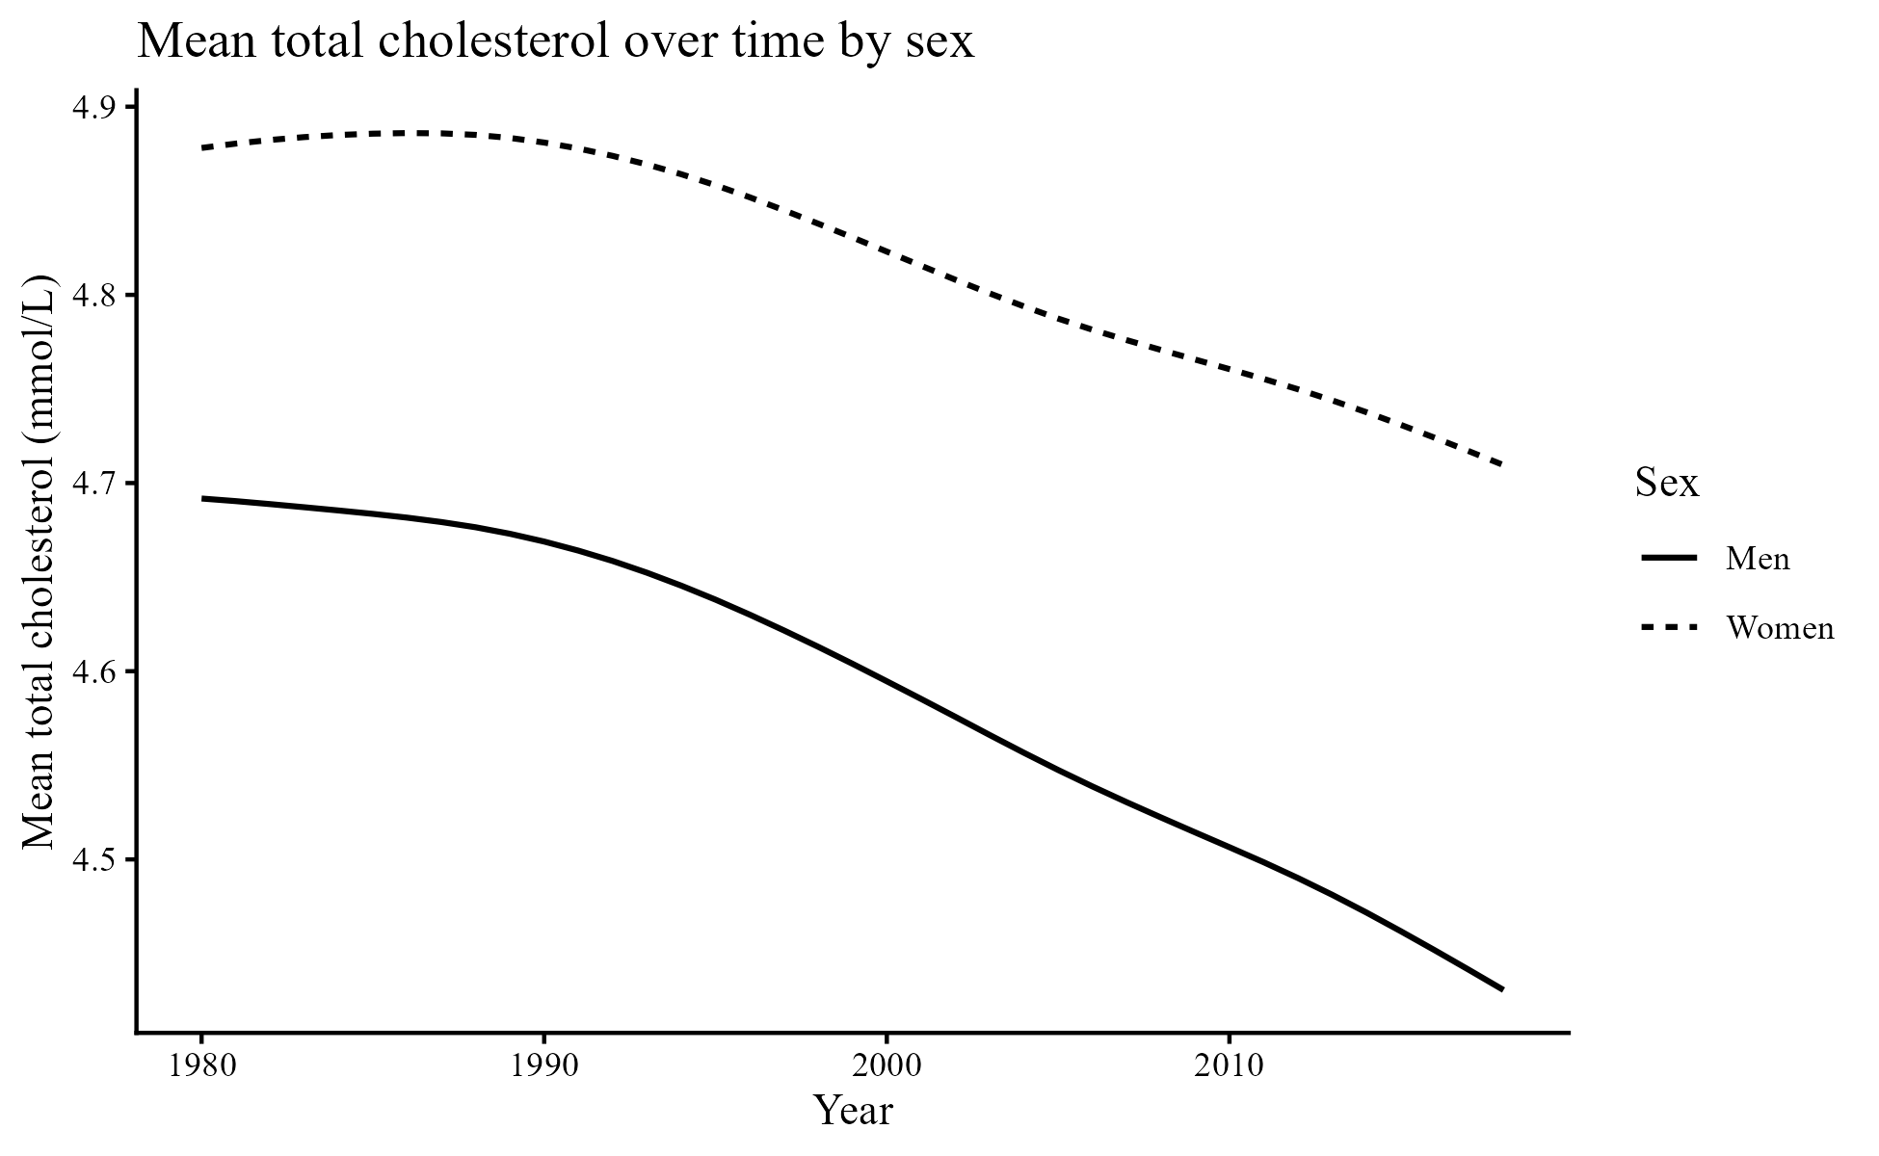
Figure 1: Mean total cholesterol over time by sex
Figure 1 on Mean total cholesterol over time by sex indicates that both men and women have a steadily decreasing trend in mean total cholesterol since the early 1980s to the end of the 2010s, with women always on top throughout the period. This period effect substantiates the broader epidemiologic story that cholesterol levels in the long run can change in response to aggregate shifts in promotion, prevention, and access to treatment, even when the underlying data are not individual records but country-year-sex-age aggregates. The policy relevance is directly correlated with SDG 3.4, as better lipid profiles will be an upstream measure to reduce premature mortality from cardiovascular disease and other noncommunicable diseases. The novelty is treating trends as estimates within a range of uncertainty rather than fixed values, enhancing confidence in the direction of change and protecting against overprecision in policy statements on the rate of improvement. The association of lipid profiles with cardiovascular risk and long-term outcomes is well established, supporting the interpretation of such declines as potentially applicable for population cardiovascular risk reduction.
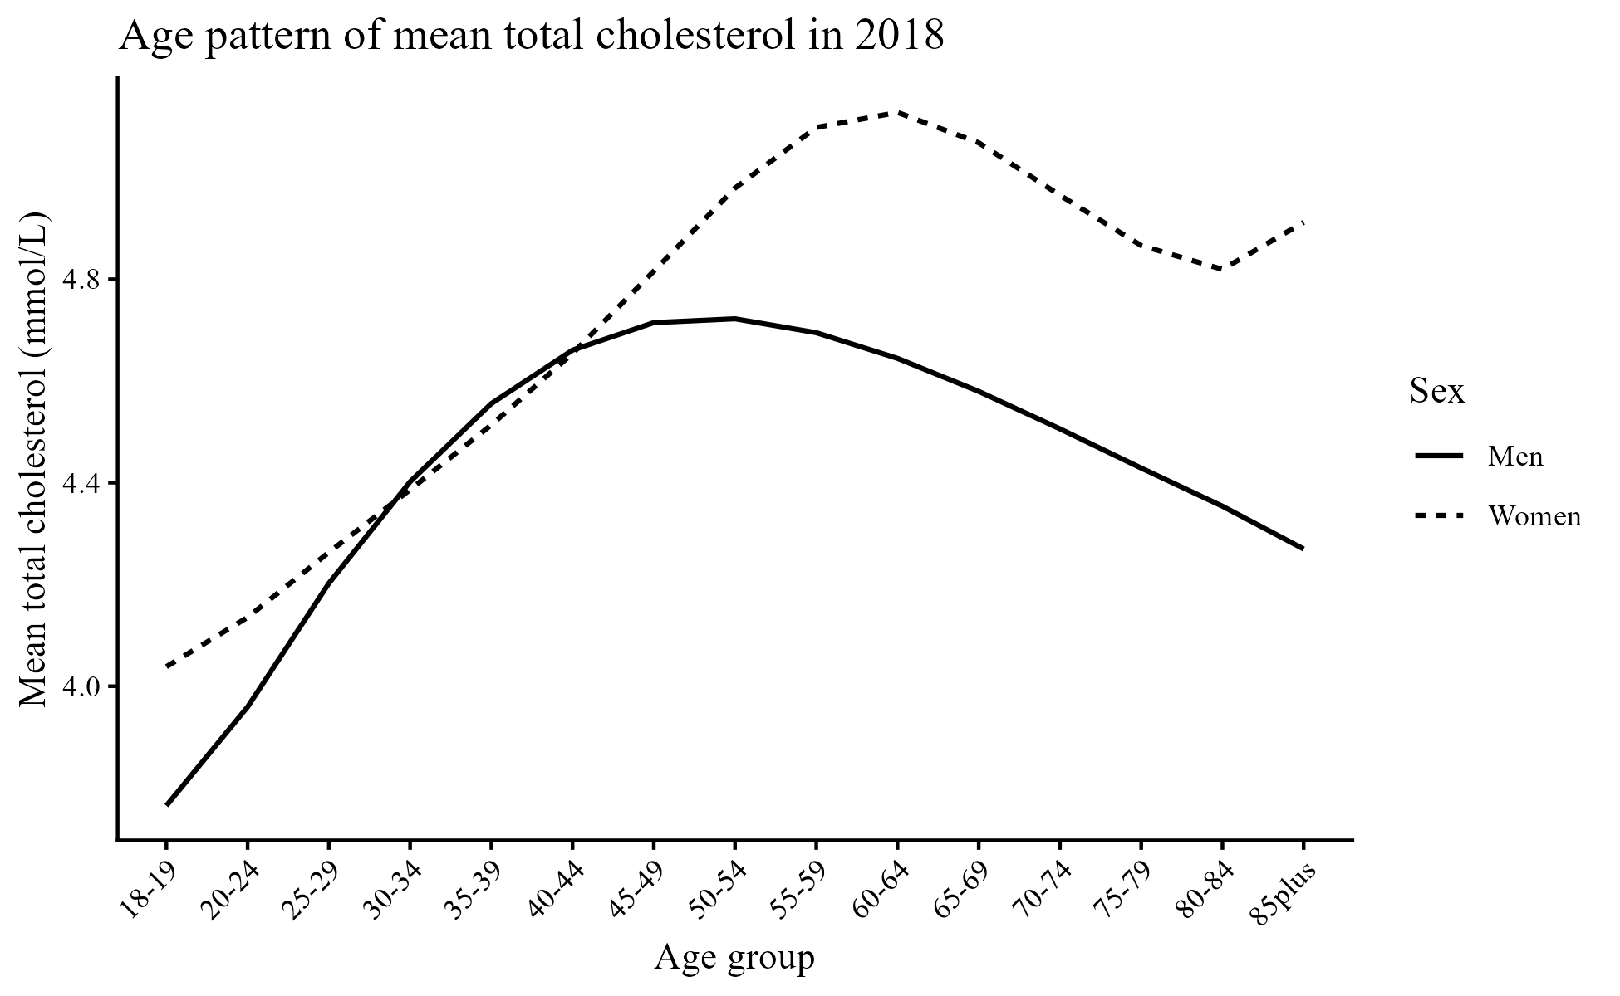
Figure 2: Age pattern of mean total cholesterol
Figure 2 shows a steep increase in mean total cholesterol with age, peaking in midlife and early old age, followed by a gradual decrease at the oldest age. Women have higher values than men across most age groups, with a strong peak in older adulthood. This age-sex distribution can buttress the argument for stratified prevention policies over one-size-fits-all messaging, and this policy may be important for age-specific screening, intensification of treatment in the middle-aged, and age-specific continuity of lipid management. This trend is consistent with broader literature indicating that lipid risk stratification is age-dependent and interacts with other cardiometabolic mechanisms, which supports the use of age-by-period models that explicitly capture age-by-period effects, rather than age-adjusting the model by adding it as a nuisance variable. The latter supports SDG 3.4 by employing risk-factor control specific to one state, and SDG 10 by the fact that age-related risk patterns may imply unequal disease burden when access to prevention and treatment varies between settings and populations. The methodological novelty introduced here is that the age structure is not only reported but also resolved within an uncertainty-conscious modelling framework, so that observed peaks and losses can be understood not as absolute perceived facts but as perceived facts with transparent measurement error.
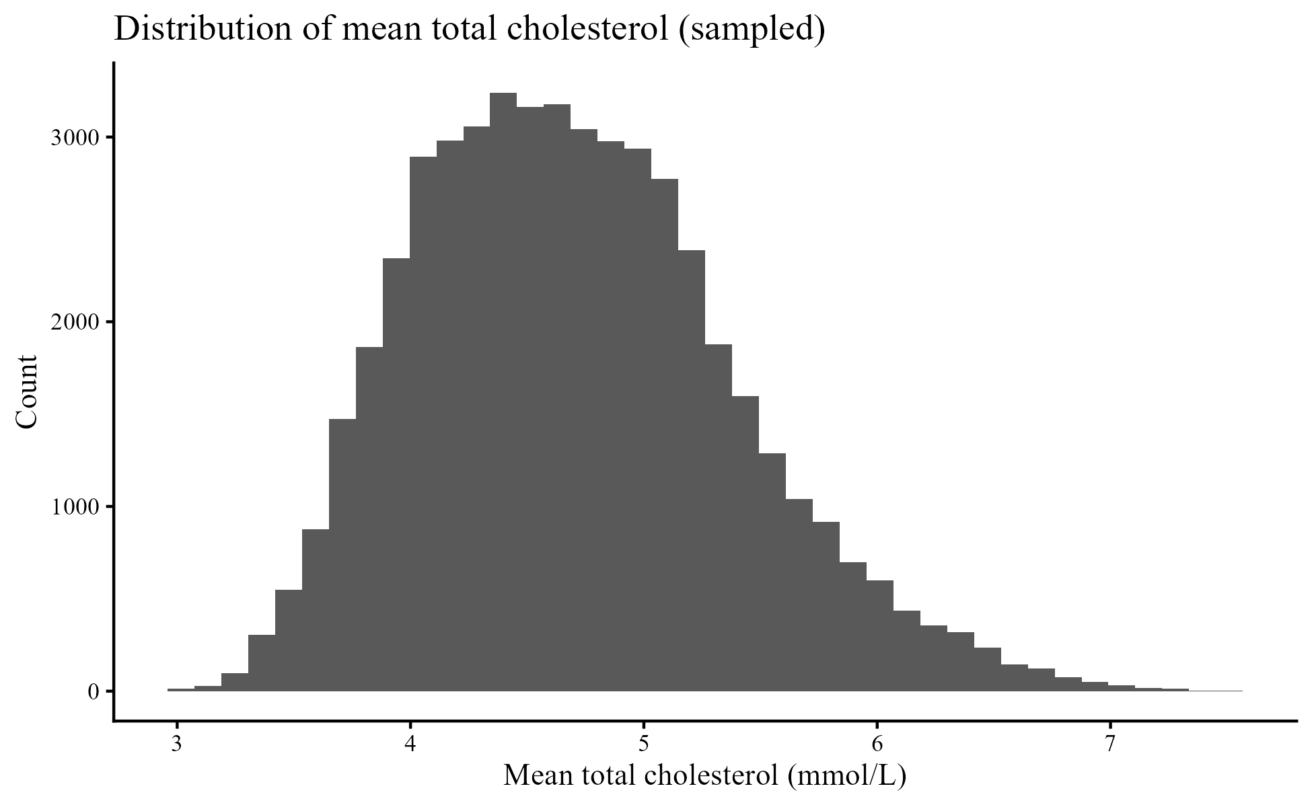
Figure 3: Distribution of mean total cholesterol sampled
Figure 3, showing the distribution of mean total cholesterol, sampled, shows an approximately unimodal, slightly skewed distribution across the sampled strata, with a majority of values falling in a central range, with a longer tail on the right extending to higher cholesterol values. This distributional shape facilitates the assumption of Gaussianity in modelling the stratum means and, at the same time, encourages robust approaches to heteroskedasticity, since different strata bear varying degrees of uncertainty, survey quality, and sample information. The high tail is also policy-relevant, as it indicates persistent high-cholesterol settings that may still contribute to cardiovascular risk despite a general global decline. The heterogeneity of this type is the focus of SDG 3.4, since averages might obscure areas of high risk, and it is also related to SDG 10, since uneven gains in settings can increase health inequalities. The innovation contribution is the direct translation of reported uncertainty intervals into analytic weights, so that the right tail and the middle of the distribution both contribute to inference based on measurement precision rather than dominance based on the number of rows, thereby enhancing the reliability of comparative public health inference. This uncertainty-sensitive method is also driven by methodological issues regarding the confidence in reliable inference and overconfidence in predictive or explanatory models.
Table 1: Fixed effects from the uncertainty-aware weighted multilevel model for total cholesterol.
term | estimate | std.error | statistic | df | p.value | conf.low | conf.high
(Intercept) | 3.8900 | 1.6536 | 2.3525 | 229,896.9651 | 0.0186 | 0.6490 | 7.1309
year_c | -0.0027 | 0.0013 | -2.1052 | 24.9425 | 0.0455 | -0.0053 | -0.0001
sexWomen | 0.0924 | 0.0020 | 47.1786 | 233,498.0528 | 0.0000 | 0.0885 | 0.0962
age_group20-24 | 0.1927 | 2.3359 | 0.0825 | 232,450.0547 | 0.9342 | -4.3857 | 4.7711
age_group25-29 | 0.4261 | 2.3359 | 0.1824 | 233,182.4155 | 0.8553 | -4.1523 | 5.0045
age_group30-34 | 0.6196 | 2.3359 | 0.2653 | 232,945.9343 | 0.7908 | -3.9588 | 5.1980
age_group35-39 | 0.7916 | 2.3359 | 0.3389 | 232,735.4017 | 0.7347 | -3.7868 | 5.3700
age_group40-44 | 0.9579 | 2.3359 | 0.4100 | 233,040.2769 | 0.6818 | -3.6205 | 5.5362
age_group45-49 | 1.1244 | 2.3359 | 0.4813 | 232,662.9865 | 0.6303 | -3.4540 | 5.7028
age_group50-54 | 1.2654 | 2.3359 | 0.5417 | 232,577.7238 | 0.5880 | -3.3130 | 5.8437
age_group55-59 | 1.3444 | 2.3359 | 0.5755 | 232,812.1648 | 0.5649 | -3.2340 | 5.9228
age_group60-64 | 1.3463 | 2.3359 | 0.5764 | 233,165.4035 | 0.5644 | -3.2320 | 5.9247
age_group65-69 | 1.2861 | 2.3359 | 0.5506 | 232,862.5897 | 0.5819 | -3.2923 | 5.8645
age_group70-74 | 1.1957 | 2.3359 | 0.5119 | 232,765.4201 | 0.6087 | -3.3827 | 5.7741
age_group75-79 | 1.1032 | 2.3359 | 0.4723 | 232,610.9936 | 0.6367 | -3.4752 | 5.6816
age_group80-84 | 1.0364 | 2.3359 | 0.4437 | 232,759.7398 | 0.6573 | -3.5420 | 5.6148
age_group85plus | 1.0401 | 2.3359 | 0.4453 | 232,585.1481 | 0.6561 | -3.5383 | 5.6185
year_c:sexWomen | 0.0020 | 0.0001 | 23.5275 | 233,499.6527 | 0.0000 | 0.0018 | 0.0022
year_group20-24 | -0.0008 | 0.0002 | -4.2217 | 233,495.1743 | 0.0000 | -0.0012 | -0.0004
year_group25-29 | -0.0018 | 0.0002 | -9.6940 | 233,497.8911 | 0.0000 | -0.0022 | -0.0015
year_group30-34 | -0.0027 | 0.0002 | -13.8862 | 233,500.6428 | 0.0000 | -0.0030 | -0.0023
year_group35-39 | -0.0034 | 0.0002 | -17.6020 | 233,502.5112 | 0.0000 | -0.0038 | -0.0031
year_group40-44 | -0.0044 | 0.0002 | -21.6770 | 233,503.2091 | 0.0000 | -0.0047 | -0.0040
year_group45-49 | -0.0055 | 0.0002 | -26.5193 | 233,502.9545 | 0.0000 | -0.0059 | -0.0051
year_group50-54 | -0.0068 | 0.0002 | -31.2614 | 233,502.2428 | 0.0000 | -0.0072 | -0.0064
year_group55-59 | -0.0078 | 0.0002 | -34.6409 | 233,501.5114 | 0.0000 | -0.0083 | -0.0074
year_group60-64 | -0.0084 | 0.0002 | -36.1639 | 233,500.8610 | 0.0000 | -0.0089 | -0.0079
year_group65-69 | -0.0085 | 0.0002 | -36.0201 | 233,500.2218 | 0.0000 | -0.0090 | -0.0081
year_group70-74 | -0.0084 | 0.0002 | -34.8565 | 233,499.6111 | 0.0000 | -0.0089 | -0.0080
year_group75-79 | -0.0083 | 0.0003 | -33.1314 | 233,499.2175 | 0.0000 | -0.0088 | -0.0078
year_group80-84 | -0.0082 | 0.0003 | -30.9839 | 233,499.1925 | 0.0000 | -0.0088 | -0.0077
year_group85plus | -0.0084 | 0.0003 | -27.2277 | 233,499.0438 | 0.0000 | -0.0090 | -0.0078

Table 1 shows the fixed effects of the uncertainty-sensitive, weighted multilevel model of total cholesterol, which provides the basic inferential information supporting the proposed novelty framework. The adverse main effect on year at the middle of the baseline value shows a significant but statistically significant change over time (year estimate = -0.0027, p = 0.0455), confirming the trend seen in Figure 1 while accounting for uncertainty propagation. Here, the positive sex effect indicates that women have a higher baseline mean total cholesterol (sexWomen estimate 0.0924, p < 0.001). The positive value of the year-by-sex interaction (yearc:sexWomen estimate 0.0020, p < 0.001) suggests that the time slope varies by sex, with women having a less negative slope than men. The pattern of year-by-age-group interactions is also uniformly negative and of larger magnitude in older age groups, as under the uncertainty-aware specification, which implies steeper temporal changes at older ages, which is also consistent with the fact that policies have targeted high-risk groups and are more likely to be engaging in stronger lipid management at older ages. This table will directly advance SDG 3.4 because it measures trend differentials that are important for prevention planning, and it is informative to SDG 10 because it establishes stratified patterns that can be used to direct equity-based distribution of screening and lipid-lowering services. Substantive novelty of the interpretation of these coefficients, however, is that the population estimates are in terms of uncertainty levels, i.e. that temporal and subgroup inferences are pegged to the reported uncertainty levels, not to artificially narrow them by assuming that stratum means are error-free. The available evidence on lipid biomarkers and cardiovascular risk suggests the importance of these effect directions for public health, despite small effect sizes per year.
Table 2: Fixed effects from the unweighted multilevel growth model for total cholesterol.
term | estimate | std.error | statistic | df | p.value | conf.low | conf.high
(Intercept) | 3.9638 | 0.0536 | 73.9020 | 190.0521 | 0.000 | 3.8580 | 4.0696
year_c | -0.0049 | 0.0009 | -5.2411 | 199.3756 | 0.000 | -0.0068 | -0.0031
sexWomen | 0.1879 | 0.0016 | 115.5466 | 233,603.6639 | 0.000 | 0.1847 | 0.1911
age_group20-24 | 0.1640 | 0.0045 | 36.8131 | 233,603.6592 | 0.000 | 0.1552 | 0.1727
age_group25-29 | 0.3692 | 0.0045 | 82.9048 | 233,603.6593 | 0.000 | 0.3605 | 0.3780
age_group30-34 | 0.5455 | 0.0045 | 122.4831 | 233,603.6594 | 0.000 | 0.5368 | 0.5542
age_group35-39 | 0.6984 | 0.0045 | 156.8056 | 233,603.6592 | 0.000 | 0.6896 | 0.7071
age_group40-44 | 0.8334 | 0.0045 | 187.1298 | 233,603.6592 | 0.000 | 0.8247 | 0.8421
age_group45-49 | 0.9557 | 0.0045 | 214.5885 | 233,603.6593 | 0.000 | 0.9470 | 0.9644
age_group50-54 | 1.0575 | 0.0045 | 237.4420 | 233,603.6593 | 0.000 | 1.0488 | 1.0662
age_group55-59 | 1.1182 | 0.0045 | 251.0790 | 233,603.6593 | 0.000 | 1.1095 | 1.1270
age_group60-64 | 1.1179 | 0.0045 | 250.9986 | 233,603.6593 | 0.000 | 1.1091 | 1.1266
age_group65-69 | 1.0605 | 0.0045 | 238.1240 | 233,603.6593 | 0.000 | 1.0518 | 1.0693
age_group70-74 | 0.9745 | 0.0045 | 218.8016 | 233,603.6593 | 0.000 | 0.9657 | 0.9832
age_group75-79 | 0.8890 | 0.0045 | 199.6141 | 233,603.6593 | 0.000 | 0.8803 | 0.8977
age_group80-84 | 0.8335 | 0.0045 | 187.1438 | 233,603.6593 | 0.000 | 0.8247 | 0.8422
age_group85plus | 0.8528 | 0.0045 | 191.4853 | 233,603.6593 | 0.000 | 0.8441 | 0.8615
year_c:sexWomen | 0.0022 | 0.0001 | 30.2123 | 233,603.6639 | 0.000 | 0.0021 | 0.0024
year_group20-24 | -0.0004 | 0.0002 | -2.2278 | 233,603.6573 | 0.026 | -0.0008 | -0.0001
year_group25-29 | -0.0009 | 0.0002 | -4.6555 | 233,603.6574 | 0.000 | -0.0013 | -0.0005
year_group30-34 | -0.0013 | 0.0002 | -6.4675 | 233,603.6575 | 0.000 | -0.0017 | -0.0009
year_group35-39 | -0.0016 | 0.0002 | -7.9661 | 233,603.6574 | 0.000 | -0.0020 | -0.0012
year_group40-44 | -0.0019 | 0.0002 | -9.4539 | 233,603.6574 | 0.000 | -0.0023 | -0.0015
year_group45-49 | -0.0023 | 0.0002 | -11.2185 | 233,603.6574 | 0.000 | -0.0027 | -0.0019
year_group50-54 | -0.0027 | 0.0002 | -13.2035 | 233,603.6574 | 0.000 | -0.0031 | -0.0023
year_group55-59 | -0.0030 | 0.0002 | -15.0088 | 233,603.6574 | 0.000 | -0.0034 | -0.0026
year_group60-64 | -0.0033 | 0.0002 | -16.2346 | 233,603.6574 | 0.000 | -0.0037 | -0.0029
year_group65-69 | -0.0034 | 0.0002 | -16.8369 | 233,603.6574 | 0.000 | -0.0038 | -0.0030
year_group70-74 | -0.0035 | 0.0002 | -17.1275 | 233,603.6574 | 0.000 | -0.0038 | -0.0031
year_group75-79 | -0.0035 | 0.0002 | -17.4337 | 233,603.6574 | 0.000 | -0.0039 | -0.0031
year_group80-84 | -0.0036 | 0.0002 | -18.0826 | 233,603.6574 | 0.000 | -0.0040 | -0.0033
year_group85plus | -0.0040 | 0.0002 | -19.9352 | 233,603.6574 | 0.000 | -0.0044 | -0.0036

Table 2 Fixed effects in the unweighted multilevel growth model of total cholesterol shows magnitudes that are materially different from those in Table 1, which is a key methodological weakness of much of the existing literature that does not propagate uncertainty using aggregated means. The unweighted model has estimated a greater annual decrease (yearc estimate: -0.0049, p = 0.001) and a bigger female-male disparity (sexWomen estimate: 0.1879, p = 0.001) than the uncertainty-sensitive weighted model, suggesting that uncertainty disregard may increase the apparent strength in the trends as well as the gaps between the sexes. In Table 2, the main effects of age groups are estimated to be sharply and equally significant, due to the large sample size and the assumption that stratum means are equal and precise. The leading conclusion from comparing Table 1 and Table 2 is that precision-weighting mitigates overconfident findings and yields more plausible, calibrated estimates of policy effects.
This difference is consequential for SDG 3.4 monitoring, in that inflated effect sizes can lead to unreasonably positive evaluations of prevention gains, and for SDG 10, in that inflated subgroup differences can get equity interventions off track. The novelty claim is further supported by showing that the substantive story can be presented with more defensible inferences when uncertainty is respected, as widely observed to be a concern for model reliability, which is determined by a realistic treatment of data-generating constraints.
Table 3: GAMM parametric and smooth term summaries for total cholesterol
term | edf | ref.df | statistic | p.value
s(year) | 7.2001 | 7.2001 | 220.4716 | 0
s(age_index) | 8.9579 | 8.9579 | 4,998.6164 | 0
te(year,age_index) | 3.0374 | 3.0374 | 104.1353 | 0

Table 3 on GAMM parametric and smooth term summaries for total cholesterol shows that cholesterol dynamics are not simply linear functions of calendar time and age, as supported, and it is a flexible supplement to the multilevel regression framework. The high smooth for year and the high smooth for age index show a nonlinear structure in both dimensions. In contrast, the high value of the tensor interaction te(year, age index) indicates that the temporal trajectory is determined by age rather than linearly, with a constant slope across all ages. This finding provides a strict statistical basis for the trends apparent in Figure 2 and for the age-specific heterogeneity in the age-specific patterns suggested by the year-by-age interactions in Tables 1 and 2. The implication of SDG 3.4 is that the progress in controlling risk factors across life-course stages can differ. Thus, the homogeneity of national targets cannot be relied on in clinical and public health planning. The applicability of SDG 10 stems from the fact that nonlinear age-period interactions may interact with unequal access to healthcare, resulting in unequal gains across countries and subpopulations. The innovation value lies in the combination of flexible smooths with a hierarchical structure, which allows the detection of complex policy-relevant patterns while maintaining the ability to interpret them to support surveillance and decision-making.

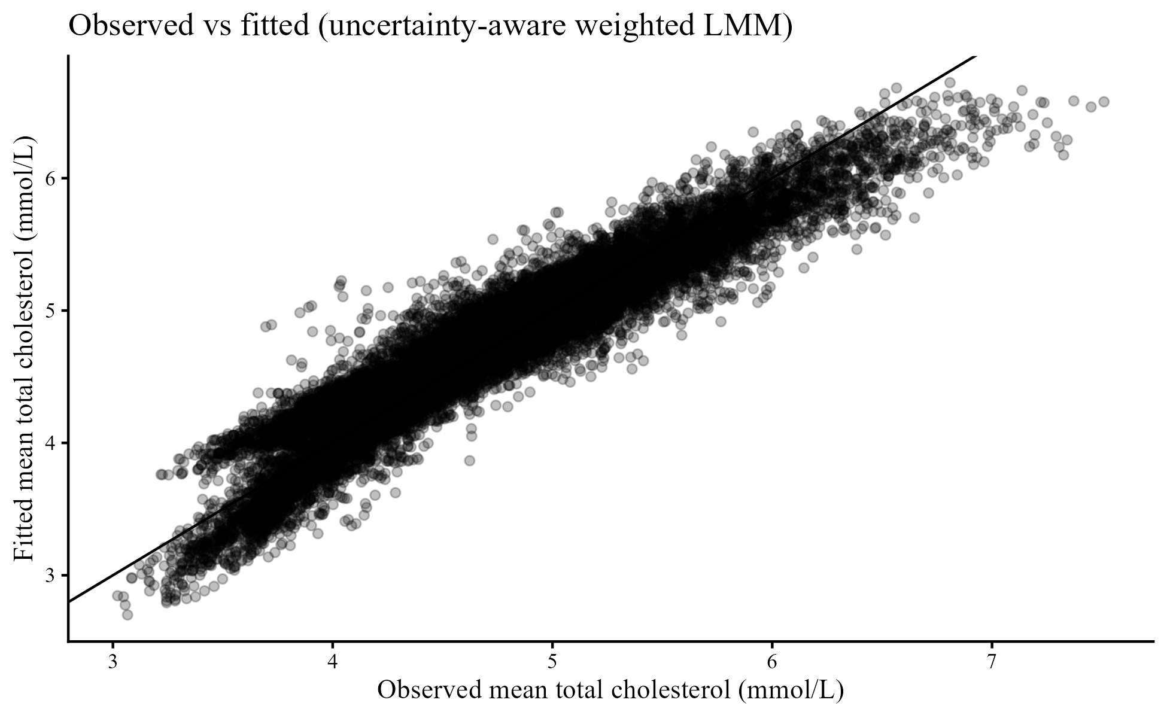
Figure 4: Observed vs fitted, uncertainty-aware weighted LMM
Figure 4 shows that there is a close correspondence between the observed and fitted mean total cholesterol, with the points being clustered about the 45-degree line in the observed range. This implies that the uncertainty-sensitive weighted multilevel model captures the primary signal in the hierarchical data, adequately smoothest the noise, and down weights strata with high uncertainty. This slight deviation on both sides of the line is a norm in the context of global surveillance data, where this residual variation points to unadjusted contextual differences and data density differences across countries and years. Another way to understand the clear feasibility of applying this model type for monitoring and forecasting SDG goal 3.4 is that it is now possible to gauge progress using the credible estimates provided by this model fit. It is also SDG 10-oriented analytics, as it allows more stable comparisons across groups and settings, reducing the likelihood that low-precision strata will lead to misinterpretations. The practicality of the correct model of means levels as the base layer on which downstream burden and risk evaluation can occur is supported by evidence that lipid measures and their calculated ratios are associated with cardiometabolic outcomes.
This research presents a comprehensive, uncertainty-conscious assessment of long-term global trends in mean total cholesterol, incorporating hierarchical population structure and reported sampling uncertainty into the analysis. The descriptive data showed a significant decrease in mean total cholesterol during the study period in both men and women; women had higher levels across all years. These time trends, as depicted in Figure 1, show a gradual but positive change in lipid profiles across the population, with a slower rate during specific time periods, depending on sex. Significantly, the uncertainty-conscious modelling validated the direction of these tendencies and produced lower effect sizes than traditional unweighted models, with evidence that uncertainty omission contributes to overestimating the time-varying decline.
Age-specific analyses revealed a strong life-course trend in cholesterol: an increase in the mean total cholesterol between young adulthood and midlife and early older ages, followed by a decrease in the oldest age groups (Figure 2). Females had higher cholesterol levels across most age groups, and they reached their highest levels later than males. These age gradients were also supported by multilevel growth models, with interaction terms between year and age group indicating that older age groups showed a steeper temporal decrease. This observation indicates that population growth rate is not uniform across the life cycle, which could be reflected in varying use rates of lipid-lowering therapies, screening rates at specific ages, and survival rates.
"Figure 3 indicates the distributional analysis for the average total cholesterol per stratum, which is moderately skewed to the right and moderately unimodal. This result supports the use of the Gaussian working assumptions in the aggregated means model. The existence of the right tail of the distribution further indicates that there are still many individuals in the population who experience higher levels of total cholesterol, despite the overall decline."
The weighted multilevel model in Table 1, which accounts for uncertainties, provides the core input for inference. After accounting for sampling variance based on the reported uncertainty intervals, the model detected a small, though significant, negative time trend in the mean total cholesterol.
Baseline cholesterol levels were higher in women than in men, and the interaction between year and sex was positive, indicating sex differences in the time course. The negative interaction terms by year-by-age-group showed more rapid adverse effects at older ages, which remained statistically significant after weighting by inverse variance. These findings indicate that accounting for uncertainty significantly affects the size and interpretation of temporal and subgroup effects.
A comparison of the outcomes in Table 2, which employed the unweighted multilevel growth model, has confirmed that there are significantly larger effects and greater statistical significance when uncertainty is ignored. This empirically compares and contrasts, showing that traditional methods overemphasise accuracy and could be misleading when applied to aggregate surveillance data. Table 3, generated by the generalised additive mixed model, again confirmed both nonlinear effects of age and time and their interaction, and supported the conclusion that cholesterol dynamics cannot be successfully modelled using simple linear specifications.
The observed-versus-fitted relationship in Figure 4 supported model adequacy, as it showed that the fitted values from the uncertainty-conscious weighted multilevel model closely matched the observed cholesterol means across the entire data range. This high consensus actually suggests that the proposed modelling structure succeeds in capturing overriding temporal and demographic trends, smoothing out noise, and undermining less accurate strata in a suitably robust manner.
Conclusion
The study has shown that to make stringent inferences about global cholesterol trends, it is necessary to explicitly acknowledge both the hierarchical population structure and the measurement uncertainty in aggregated surveillance data. The study can provide more plausible, policy-relevant estimates of cholesterol dynamics by transforming reported uncertainty intervals into analytic weights and incorporating them into multilevel and nonlinear models, rather than using traditional unweighted models.
The results validate the long-term worldwide decrease in average total cholesterol and the sex disparity, alongside the striking age-specific heterogeneity in both levels and rates. These trends can highlight the significance of life-course- and sex-sensitive prevention of cardiovascular disease. Methodologically, it is demonstrated that the inability to propagate uncertainty can create substantial biases in effect sizes and artificially inflate confidence in population health improvement when comparing uncertainty-aware models with unweighted ones.
It allows an opportunity to adopt a scaled, transparent method to analyse other global health indicators published as aggregated estimates with uncertainty intervals. The methodology will facilitate the use of evidence-based monitoring of noncommunicable disease targets of the Sustainable Development Goals, focused on reducing premature mortality from cardiovascular disease, by improving the reliability of trend estimation and subgroup comparisons. It needs to be extended in subsequent work to model two or more lipid fractions jointly and to account for contextual covariates, such as policy adoption, access to care, and socioeconomic development, thereby enhancing the added value of global surveillance data for reliable health predictions and equity in policy development.

Disclaimer (Artificial intelligence)

Author(s) hereby declare that NO generative AI technologies such as Large Language Models (ChatGPT, COPILOT, etc.) and text-to-image generators have been used during the writing or editing of this manuscript.

References
- Alemu, R., Sharew, N. T., Arsano, Y. Y., Ahmed, M., Tekola-Ayele, F., Mersha, T. B., & Amare, A. T. (2025). Multi-omics approaches for understanding gene-environment interactions in noncommunicable diseases: techniques, translation, and equity issues. Human Genomics, 19(1), 8.
- Ayiah-Mensah, F., Bosson-Amedenu, S., Anderson, F. N., & Kokuro, A. (2025). Nonlinear Cox Survival Modeling of Prostate Cancer with SHAP-Based Explainability. Journal of Advances in Mathematics and Computer Science, 40(12), 28-47.
- Ayiah-Mensah, F., Bosson-Amedenu, S., Okyere, G., & Oduro-Okyireh, G. (2025). System Drivers of Hypertension Control in Africa: A Beta Regression and Dynamic Factor Modeling Approach. Asian Journal of Medicine and Health, 23(12), 47-65.
- Chary, A., Tohidi, M., & Hedayati, M. (2023). Association of LDL-cholesterol subfractions with cardiovascular disorders: A systematic review. BMC Cardiovascular Disorders, 23(1), 533.
- Chen, T. Y., Hsiao, Y. C., Wu, Y. W., Lin, T. H., Sheu, W. H. H., Lee, T. L., ... & Wu, C. C. (2025). Recent trends of low-density lipoprotein cholesterol control and lipid-lowering therapy in patients with atherosclerotic cardiovascular disease in Taiwan: 2015–2020. Journal of the Formosan Medical Association, 124(5), 419-425.
- Chen, X., & Li, L. H. (2023). Remnant cholesterol, a valuable biomarker for assessing arteriosclerosis and cardiovascular risk: A systematic review. Cureus, 15(8).
- Coral, D. E., Smit, F., Farzaneh, A., Gieswinkel, A., Tajes, J. F., Sparsø, T., ... & Franks, P. W. (2025). Subclassification of obesity for precision prediction of cardiometabolic diseases. Nature medicine, 31(2), 534-543.
- Derso, E. A., Gelaye, K. A., Campolo, M. G., Woldemariam, A. T., & Alibrandi, A. (2025). Neighborhood-level heterogeneity in childhood morbidity through generalized linear mixed models. Frontiers in Public Health, 13, 1456068.
- Eghbalian, M., Moameri, H., Mohammadi, N. M., Naroei, S., Hosseini, S., & Norouzi, M. (2025). Evaluating Trends in Mortality and Years of Life Lost Due to Cardiovascular Diseases in the Southwest of Fars Province, 2013–2023: A Cross‐Sectional Study. Health Science Reports, 8(12), e71602.
- Georgoulis, M., Chrysohoou, C., Georgousopoulou, E., Damigou, E., Skoumas, I., Pitsavos, C., & Panagiotakos, D. (2022). Long-term prognostic value of LDL-C, HDL-C, lp (a) and TG levels on cardiovascular disease incidence, by body weight status, dietary habits and lipid-lowering treatment: the ATTICA epidemiological cohort study (2002–2012). Lipids in Health and Disease, 21(1), 141.
- Iqbal, K., Intemann, T., Börnhorst, C., Zhang, J., & Aleksandrova, K. (2025). Approaches for harmonization of biomarker data from multiple studies: a narrative methodological review. AJE Advances: Research in Epidemiology, 1(1), uuaf005.
- Ji, Y., Wang, M., & Zhou, M. (2025). Bayesian additive weighted composite quantile regression. Statistics and Computing, 35(6), 1-25.
- Kafol, J., Miranda, B., Sikonja, R., Sikonja, J., Wiegman, A., Medeiros, A. M., ... & Groselj, U. (2025). Proposal of a familial hypercholesterolemia paediatric diagnostic score (FH-PeDS). European Journal of Preventive Cardiology, zwaf352.
- Lee, Y., Kim, Y. W., Kim, J., Hajek, A., Li, Y., Hwang, J., ... & Yon, D. K. (2025). Binational comparison of the association between socioeconomic status and metabolic syndrome: A nationally representative study in South Korea and the US. Preventive Medicine Reports, 103298.
- Liang, J., Xie, Y., Li, P., Li, H., Li, P., Huang, Z., ... & Wen, J. (2025). The non-high-density lipoprotein cholesterol to high-density lipoprotein cholesterol ratio and its combination with obesity indicators as a predictor of all cause and cardiovascular mortality in non-diabetic individuals. BMC Public Health, 25(1), 1513.
- Maștaleru, A., Zouri, M., Leon, M. M., Popescu, G., Zouri, N., Tamba, B. I., & Cumpăt, C. M. (2025, December). Evaluating Value Beyond Efficacy: A Meta-Analytic Assessment of Inclisiran’s Cost-Effectiveness in Cardiovascular Prevention. In Healthcare (Vol. 13, No. 24, p. 3287). MDPI.
- Nan, X., Zhang, S., Che, J., Yang, J., & Wu, Z. (2025). Sex-and Age-Stratified relative handgrip strength and risk of eight chronic diseases in Middle-Aged and older adults: evidence from a National aging cohort study in China. Aging Clinical and Experimental Research, 37(1), 1-12.
- Nilsson, K., Fridhammar, A., Ota, R., Sall Jensen, M., Willis, M., & Persson, S. (2025). Validation of the IHE type 2 diabetes cohort model in the Japanese clinical setting. Journal of Medical Economics, (just-accepted), 1-26.
- Qiu, S., Zhu, J., Yuan, M., & Guo, Z. (2025). Non-linear correlation between the ratio of high-density lipoprotein cholesterol to C-reactive protein and all-cause mortality in adults: an extensive study based on nationwide data. Population Health Metrics, 23(1), 32.
- Rathore, M., Birdi, A., Singh, S., Tomo, S., Banerjee, M., Yadav, D., & Sharma, P. (2025). Continuous Quality Enhancement in Clinical Diagnostic Laboratories Through Lean and Six Sigma Methodologies: A Narrative Review. Indian Journal of Clinical Biochemistry, 1-14.
- Sayed, A., Michos, E. D., Navar, A. M., Virani, S. S., Brewer, L. C., & Manson, J. E. (2025). Global Sociodemographic Disparities in Ischemic Heart Disease Mortality According to Sex, 1980 to 2021. Circulation: Cardiovascular Quality and Outcomes, e011648.
- Seyhoon, M., Ahmadi, A., Zare, M., Honardoust, M., Hejazi, N., Mohsenpour, M. A., & Homayounfar, R. (2025). Association of anthropometry indices and metabolic syndrome in Iranians: a cross-sectional study of the Fasa adult cohort study. BMJ open, 15(10), e100607.
- Song, Z., Gu, H. Q., & Xu, C. (2025). Association of the non-high-density lipoprotein cholesterol to high-density lipoprotein cholesterol ratio with non-alcoholic fatty liver disease and hepatic steatosis in United States adults: insights from NHANES 2017–2020. Frontiers in Nutrition, 12, 1540903.
- Tang, J., Zhou, G., Shi, S., Lu, Y., Cheng, L., Xiang, J., ... & Wang, M. (2025). Systematic analysis of the burden of ischemic stroke attributable to high LDL-C from 1990 to 2021. Frontiers in Neurology, 16, 1547714.
- Teklezgi, M. G., Tekle, M. B., Gebrerufael, G. G., & Yeebyo, T. S. (2025). Consequence of War on Diabetic Mellitus patients in Tigray region, Ethiopia: a longitudinal study. BMC Endocrine Disorders, 25(1), 10.
- Tian, X., Chen, S., Zuo, Y., Zhang, Y., Zhang, X., Xu, Q., ... & Wang, A. (2022). Association of lipid, inflammatory, and metabolic biomarkers with age at onset for incident cardiovascular disease. BMC medicine, 20(1), 383.
- Valencia, J. G., Hernández-Vásquez, A., Mayta-Tristán, P., Saavedra-Garcia, L., & Vargas-Fernández, R. (2025). The new definition of obesity: an analysis of a population-based survey in an Andean country. The Lancet Regional Health–Americas, 50.
- Van Calster, B., van Smeden, M., van Amsterdam, W., Coemans, M., Wynants, L., & Steyerberg, E. W. (2025). The enemies of reliable and useful clinical prediction models: a review of statistical and scientific challenges. Annual Review of Statistics and Its Application, 13.
- Vishwakarma, G. K., Bhattacharjee, A., & Rajbongshi, B. K. (2025). A two-stage joint model approach to handle incomplete time dependent markers in survival data through inverse probability weight and multiple imputation. Scientific Reports, 15(1), 33949.
- Wang, Y., Sun, X., Zhang, X., Wang, X., Li, J., & Wang, K. (2025). Global, regional, and national burden of early-onset ischemic heart disease: trends and projections among adults aged 15-44 years from 1990 to 2046. Frontiers in Cardiovascular Medicine, 12, 1653335.
- Wang, Yinkang, Xingchen Shang, Yinchao Zhang, Yu Zhang, Wei Shen, Qian Wu, and Wenyi Du. "The association between neutrophil to high-density lipoprotein cholesterol ratio and gallstones: a cross-sectional study." BMC Public Health 25, no. 1 (2025): 157.
- Wong, J. J., Tse, G., Vu, H. T. T., Nguyen, H. T. T., Lin, S., Tu, Q., ... & Koh, A. S. (2025). The GLOB-cAGE consortium: a global cardiovascular collaborative network of older adults with cardiovascular disease. American Journal of Epidemiology, 194(9), 2667-2684.
- Xiong, Z., Sun, Q., Huang, J., & Li, F. (2025). Non-linear association of cardiometabolic index with gallstone disease in US adults: A cross-sectional study. PloS one, 20(8), e0328415.
- Xu, S., Jia, S., Yang, S., Li, D., Zhang, E., Lei, F., ... & Lin, L. (2025). Global, regional, and national burden of cardiovascular diseases among postmenopausal women, 1990–2040: a systematic analysis for the global burden of disease study 2021. Journal of Advanced Research.
- Yang, M., Zhang, J., Feng, Z., Wang, M., Feng, Q., Zhang, R., ... & Lin, T. (2025). Association between non-high-density lipoprotein cholesterol to high-density lipoprotein cholesterol ratio and mortality in US adults: results from the NHANES 2011–2018. Frontiers in Nutrition, 12, 1576229.
- Yang, X., Chen, Q., Zhang, Q., & Yu, Z. (2025). Lipoprotein cholesterol ratios and cardiovascular disease risk in US adults: a cross-sectional study. Frontiers in Nutrition, 12, 1529223.
- Yu, H., Xu, X., & Yu, L. (2025). Hierarchical Bayesian bivariate spatial modeling of small area proportions with application to health survey data. Statistical Methods in Medical Research, 09622802251316968.
- Zhao, Y., Chen, L., Dong, J., Yang, X., Hu, T., Sun, N., ... & Zhang, Z. (2025). Global cardiovascular disease burden attributable to high low-density lipoprotein cholesterol, 1990–2021: An age-period-cohort analysis of the global burden of disease study 2021. Nutrition, Metabolism and Cardiovascular Diseases, 35(6), 104030.
- Zhu, Y., Liu, W., Liu, K., Gao, Y., & Wang, S. (2025). Global Trends and Cross‐Country Inequalities in Stroke and Subtypes Attributable to High Body Mass Index From 1990 to 2021. Journal of the American Heart Association, 14(7), e039135.

