Original Research Article
Assessment of Farmer Producer Organizations and their Perceived Benefits among Member Farmers in West Garo Hills, Meghalaya
ABSTRACT
Farmers Producer Organizations (FPOs) have emerged as an important institution for improving the livelihood of farmers in Meghalaya. West Garo Hills district has the highest number of FPOs in the state with a total of 15 FPOs. Farmers in the district face challenges related to markets, inputs and crop damages which make it necessary to study the role and perceived benefits of FPOs which is functioning in West Garo Hills district. The study was conducted in West Garo Hills district of Meghalaya during 2024-25. A total of four FPOs were selected purposively. The study covered 25 member farmers from each FPO, comprising a total sample of 100 FPO members. The study aimed to assess the socio-economic changes of the FPO member farmers in the district, perceived benefits of FPO members and identify the factors influencing these benefits. Data were collected using a structured interview schedule based on the KAP (Knowledge, Attitude and Practice) approach. Results showed that the farmer members were found to have high social participation (48%) and low risk perception (63%). The results further showed that communication behaviour improved significantly with medium-level communication increasing from 41% to 69% after joining the FPO. Access to agricultural information also found to have increased notably after joining the FPO (i.e., institutional sources increased from 46% to 98%). Multinomial Logistic Regression analysis revealed that social participation and risk perception significantly influenced perceived benefits at the 5% level of significance. The findings indicate that FPO membership improves farmers’ access to information, communication behaviour, and social benefits, although market-related benefits remain limited.
Keywords: FPO, West Garo Hills, social participation, perceived benefits, sustainability, farmers, etc.

INTRODUCTION
The economy of India is heavily dependent on agriculture. Approximately, 86% of the nation’s farmers are small and involved in agriculture and related industry activities, accounting for about 54.6% of the entire workforce who have less than 1 hectare of land (GoI, Agricultural Census, 2015-16). These small farmers are unable to benefit from economies of scale due to a lack of necessary volume in both inputs and outputs (Kumar et al., 2023). In addition, agricultural marketing involves a large number of intermediaries who often operate in a way that lacks transparency, which can lead to a little bit of the money that the end consumers pay (Nikam et al., 2019). Due to a limited commercial surplus available to farmers, they are compelled to sell their agricultural output via middlemen or traditional marketing methods (Gangwar et al., 2022). Since they have very little capital to invest, rely on family labour, employ traditional manufacturing methods and produce, they are at the receiving end of the market resources which is necessary to engage in global value chains (Singh et al., 2018).
In addressing the challenges that the farmers faced, Farmers Producer Organisations (FPOs) have become vital organizations with great potential. Primary producers like farmers, fishermen, weavers, etc. (own and run FPOs), which are legally recognized organizations. Under the chairmanship of a well-known economist Y.K. Alagh, FPO was incorporated into the Companies Act, 1956, as a new part IX-A in 2002, with the aims to improve income realization for FPO members (who are producers) by aggregation and where possible, value addition (Mukherjee et al., 2020). It may take the shape of a manufacturing enterprise, a cooperative organization, or any other entities that allows for the distribution of earnings or benefits among its members. The main aim was to combine appealing features of the cooperative and corporate sectors for the advantage of primary producers, particularly those who are small and marginalized farmers (Lade et al., 2022). The producer organization has emerged as one of the most effective ways to deal with the issues facing in agriculture and it has done so, more importantly, greater access to markets, inputs, technologies and better investments. Due to the increase in overall land ownership as a result of increased fragmentation, producer organizations now have a critical role to play in the current agricultural environment (Deore et al., 2022).
Through their own organization, FPOs have been an instrumental in improving producers’ income. Small and marginal farmers in India frequently struggle with issues such as lack of access to high-quality inputs and weak market linkages, which compel them to depend on intermediaries. Low income and little bargaining power in agri-marketing channels make agriculture an unprofitable industry. As a result, farmers will be better able to overcome these obstacles by forming their own organization, such as an FPO. By lessening the exploitation that many small and marginal farmers experienced, this would have helped raise farmers' incomes. By giving farmers collective power for better access to production technology, FPOs are seen as a way to raise the standard of living for small farmers. Value addition, superior inputs and marketing are the services which helps them to raise their earnings (Gurung et al., 2024).
The study aimed to study the socio-economic characteristics of FPO members, assess perceived benefits of FPO membership and identify the significant difference between socio-economic and the perceived benefits. The current research looked at how the social, psychological and communication conduct of its members altered, as well as the advantages they received in joining the FPO. It also intends to give data-driven insights that will support mechanisms and targeted policy actions to enhance and maintain the long-term sustainability of FPOs in Meghalaya and beyond.
MATERIALS AND METHODS
- Locale of the Study
A study was conducted in West Garo Hills district of Meghalaya. The location of the study was selected purposively as the district has maximum number of FPO. West Garo Hills is one largest district of Meghalaya located in the Western part of the state. It has an area of 3,614 sq. km which makes it a largest district in Garo Hills.
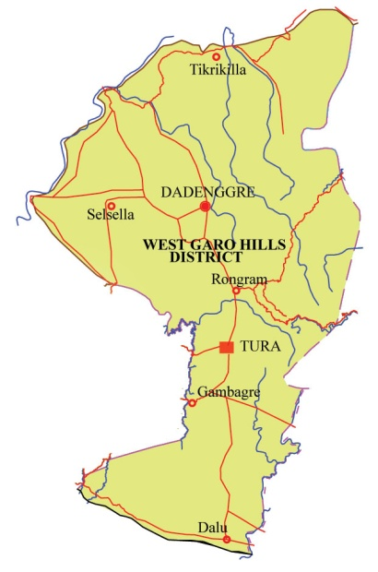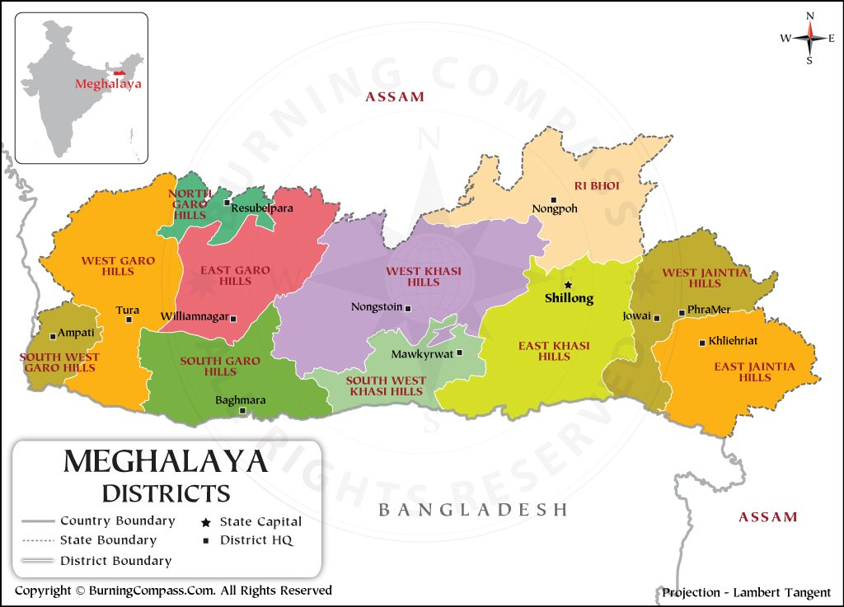
Fig. 1 Map of Study Area
- Selection of FPOs
A total of four FPOs namely Mikasal Farmer Producer Company Ltd, Tikrikilla Agrofed Producer Company Ltd, Demdema Agrofed Producer Company Ltd and Bitegram Agrifed Producer Company Ltd. were selected purposively based on their operational duration of more than three years.
- Selection of the Respondents
From each selected FPO, 25 farmer members were selected randomly making total of 100 respondents. These 100 farmer members were considered unit for the study. Primary data were collected through face to face interview of the respondents with pre- structured interview schedule based on the KAP approach. The study was conducted during the year 2024–2025.
- Variables
The research considers the following ten variables as follows:
Sl. No. | Independent Variables | Measurement tools
 | Gender | Observation
 | Education level | Formal education
 | Family Members | In number
 | Farming experience | In years
 | Size of operational Land Holding | In Hectare
 | Risk Perception | Rating Scale was developed for the study
 | Social participation | Rating Scale was developed for the study
 | Source of information | Structured Schedule was developed for the study
 | Communication Behaviour | Rating Scale was developed for the study
Sl. No. | Dependent Variables | Measurement tools
 | Perceived Benefits | Rating Scale was developed for the study

5. Analytical Framework
The study is based on the concept that socio-economic and behavioural factors influence the level of benefits perceived by FPO members.
6. Analytical Tools
6.1. Multinomial Logistic Regression (MLR)
Multinomial Logistic Regression (MLR), extension of the binomial logistic regression model. It is used when the outcome variable is categorical with more than two unordered categories. The model helps in identifying the influence of independent variables on different levels of perceived benefits. The model is specified as:
$$\ln\left(\frac{P\left(Y=j\right)}{P\left(Y=r\right)}\right)=β_{0j}+\sum_{i=1}^{k}{β_{ij}X_{i}}$$
Where, $X_{i}$ represents that i^{th} independent variable, i is the number of explanatory variables and $β_{ij}$is the regression coefficient corresponding to the i^{th} independent variable for the j^{th} category of perceived benefits.
MLR was employed to examine the relationship between perceived benefits and selected independent variables. It was employed with the following H₀ and H₁ hypothesis.
H₀: There was no significant difference between independent variables with dependent variables.
H₁: There was significant difference between independent variables with dependent variables.
7. Limitations of the Study
The study is limited to a sample of 100 respondents from a single district, which may affect generalization. The cross-sectional design does not capture long-term impacts of FPO membership.
RESULTS AND DISCUSSION
1. Profile of Respondents
The personal characteristics of members were studied and shown in Table 1. It is observed that more than half (60%) farmers belonged to middle age grouped followed by young (30%) and old (10%) age group. The majority of the respondent farmers (59%) were female and male were only 41 percent. Majority of the farmer members have educational level of below class X (45%) followed by high school (22%), higher secondary (8%), graduation (5%) and illiterate (20%). Majority of the respondents have medium family size (59%) with 4-6 family members followed by large family size (28%) with 7 and above members and small (13%) with up to 3 members. The study showed that, 37 percent of farmer members were having low level of farming experience, followed by medium level (43%) and high level (20%) of farming experience. Further, it is revealed that majority (38%) of the respondent were small farmers with operational land holding below 1 Ha, followed by marginal (36%), semi-medium (19%) and medium (7%) farmers. 48 per cent of the farmer members had high social participation, followed by 39 per cent had medium and 13 per cent had low social participation. The farmers were also found having low (63%) level followed by medium (30%) level and high (7%) level of risk perception.
Table 1 Personal Profile of Respondents
Sl. No. | Characteristics | Categories | Frequency | Percentage
1. | Age | Young age (<35 years) | 30 | 30
1. | Age | Middle age (35-55 years) | 60 | 60
1. | Age | Old age (>55 years) | 10 | 10
2. | Gender | Male | 41 | 41
2. | Gender | Female | 59 | 59
3. | Educational Level | Illiterate (No schooling) | 20 | 20
3. | Educational Level | Below Matric (Primary till 9th passed) | 45 | 45
3. | Educational Level | High School (10th standard passed) | 22 | 22
3. | Educational Level | Higher Secondary (12th standard passed) | 8 | 8
3. | Educational Level | Graduate | 5 | 5
4. | Family members | Small(up to 3) | 13 | 13
4. | Family members | Medium(4-6) | 59 | 59
4. | Family members | Large (7 and more) | 28 | 28
5. | Farming experiences (in years) | Low (<17 years) | 37 | 37
5. | Farming experiences (in years) | Medium (17-27 years) | 43 | 43
5. | Farming experiences (in years) | High (>27 years) | 20 | 20
6. | Size of Operational Landholding | Marginal (below 1.00 hectare) | 36 | 36
6. | Size of Operational Landholding | Small (1.00-2.00 hectare) | 38 | 38
6. | Size of Operational Landholding | Semi-medium (2.00-4.00 hectare) | 19 | 19
6. | Size of Operational Landholding | Medium (4.00-10.00 hectare) | 7 | 7
7. | Social Participation | Low Social Participation | 13 | 13
7. | Social Participation | Medium Social Participation | 39 | 39
7. | Social Participation | High Social Participation | 48 | 48
8. | Risk Perception | Low Risk Perception | 63 | 63
8. | Risk Perception | Medium Risk Perception | 30 | 30
8. | Risk Perception | High Risk Perception | 7 | 7

2. Changes in Source of Agricultural Information
The data in Fig 2 represents the source of agricultural information before joining and after joining of FPO. It is found that 92% of the respondents received the agricultural information from fellow farmers, 93% from neighbours and relatives and 85% received from local leader before joining the FPO. After joining the FPO, cent percent of the respondents received the agricultural information from neighbours and relatives and 94% from fellow farmers where 88% received from local leader showing only the slight changes in personal-localite channel. Under personal cosmopolite channel, less than half (46%) of the respondents received from KVKs, FPO Personnel, State Department, Banks or Micro credit institution and 91% of the respondents received from input dealers before joining the FPO. After joining the FPO, almost all (98%) the respondents received from KVKs, FPO Personnel, State Department, Banks or Micro credit institution and 90% from input dealers showing a slight decreased as some of the farmers stopped being rely on dealers after joining the FPO. In the case of mass-media channels, only 29%, 12% and 9% received from mobile phone, internet and farm publications and half (50%) of the respondents received from television. But after joining the FPO, 63%, 57% and 24% of the respondents received information from mobile phone, internet and farm publications showing a slight increase in their responds however farmers who rely on television for agricultural information was found no change after joining the FPO. It was observed that personal-localite channel such as fellow farmers, neighbours and relatives and local leaders remained the dominant agricultural sources both before and after joining the FPO.

Fig. 2 Distribution of farmer members (in %) on Source of Agricultural Information before and after joining of FPO

3. Change in Communication Behaviour of the FPO members
The data in Table 2 represents the communication behaviour of the farmer members before and after joining the FPO. The data reveals a change in the communication behaviour before and after joining the FPO. It is observed that the majority (41%) of the respondents had medium level of communication behaviour, followed by low (40%) level and high (19%) level of communication behaviour before becoming the FPO membership. Similarly after joining, majority (69%) were found having medium level of communication behaviour with an increased by 28 per cent, followed by high (22%) level and low (9%) level of communication behaviour. These results indicate that there was an improvement in communication behaviour of the farmer members after joining the FPO. These changes may be due to the opportunities provided by the FPOs such as trainings, demonstrations, group discussions and direct interaction with officials and experts. It also encourages farmers to communicate within the group and with experts, thereby increasing their knowledge in farming and boosting confidence in them which enhanced their communication behaviour.

Table 2 Distribution of the respondents according to their Communication Behaviour
Category | Before |  | After
Category | Frequency | Percentage | Frequency | Percentage
Low Communication Behaviour | 40 | 40 | 9 | 9
Medium Communication Behaviour | 41 | 41 | 69 | 69
High Communication Behaviour | 19 | 19 | 22 | 22

4. Perceived Benefits of the members
The data in Table 3 represents the perceived benefits of members after joining the FPO. The variables are categorised into five components viz., Improved access to markets; Access to Inputs and Technology; Financial Benefits; Social Benefits and Other Benefits. Less than half (36.4%) of the respondents found to have increased in facilities for Market access which comprises of access better markets for produce, receiving better prices for the produce through the FPO and reducing of marketing costs (e.g., transportation, middlemen). Around half of the respondents (55.6%) get assistance and Access to inputs and technology through FPO which comprises of providing access to quality inputs (seeds, fertilizers, etc.) at reasonable prices and availability of inputs, new technologies and farming practices and assistance in quality control of products. Under Financial benefits, it was revealed that 41.5% of the respondents get benefitted financially which comprises of increase in income and provides stable and reliable income. Majority (73.4%) farmers were found to have acknowledged Social benefits which consists a sense of community and belonging within the FPO, provide a platform for sharing knowledge and experiences with other farmers and increased social standing and influence. Under Other benefits, around half (50.48%) of the respondents showed improvement in bargaining power, because of FPO membership farmers said to have more confident about the future of farming and improve in communication skills. As per data collection, it was observed that the farmers heavily rely on middlemen to sell their products rather than relying on FPO leading to less improvement in markets. Patel et al. (2024) in his study found that the perceived benefits experienced by FPO members include access to essential inputs at lower prices, credit facilities and infrastructure support.
4.1 Overall test relationship
Table 4 below revealed that the probability of the model chi-square (48.819) was 0.004 which was significant at 1% level of significance (i.e., p<0.05). It can be suggested that there is an existed relationship between the independent variables viz., ‘Age’, ‘Gender’, ‘Educational level’, ‘Family members’, ‘Farming experience’, ‘Social Participation’, ‘Source of Agricultural Information’, ‘Communication Behaviour’ and ‘Risk perception’ and the dependent variable namely Perceived Benefits. Further, it can be suggested that the full model fits the data and overall model is useful for predicting the dependent variable.

Table 3 Distribution of the Respondents According to their Perceived Benefits
Sl. No. | Perceived Benefits | Consolidated score | Percentage
 | Improved access to markets | 546 | 36.4
 | - The FPO has helped me access better markets for my produce.  - I receive better prices for my produce through the FPO.  - The FPO has reduced my marketing costs (e.g., transportation, middlemen). | 546 | 36.4
 | Access to Inputs and Technology | 1390 | 55.6
 | - The FPO provides access to quality inputs (seeds, fertilizers, etc.) at reasonable prices and availability of inputs.  - The FPO facilitates access to new technologies and farming practices.  - I have received training or information on improved farming techniques through the FPO.  - FPO provides assistance in quality control of products. | 1390 | 55.6
 | Financial Benefits | 830 | 41.5
 | - I have increased my income due to FPO membership.  - The FPO has provided me with a stable and reliable income. | 830 | 41.5
 | Social Benefits | 1835 | 73.4
 | - I feel a sense of community and belonging within the FPO.  - The FPO provides a platform for sharing knowledge and experiences with other farmers.  - The FPO has increased my social standing and influence | 1835 | 73.4
 | Other Benefits | 1262 | 50.48
 | - The FPO has improved my bargaining power.  - I am more confident about the future of my farming because of the FPO.  - Improved communication skills | 1262 | 50.48

Table 4 Model Fitting Information

Model | Model Fitting Criteria | Likelihood Ratio Tests
Model | -2 Log Likelihood | Chi-Square | df | Sig.
Intercept Only | 175.687 | 48.819 | 26 | 0.004
Final | 126.868 | 48.819 | 26 | 0.004

4.2 Strength of MLR relationship
It can be revealed from the Table 5 that the pseudo-R² viz., Cox & Snell R² and the Nagelkerke R² values of 0.441 and 0.503 respectively determined that between 44.10% and 50.30% of variability in dependent variable ‘Perceived Benefits’ was explained by the set of independent variables viz., ‘Age’, ‘Gender’, ‘Educational level’, ‘Family members’, ‘Farming experience’, ‘Social Participation’, ‘Source of Agricultural Information’, ‘Communication Behaviour’ and ‘Risk perception’ used in the model. It indicates that independent variables play an important role in influencing how farmers value the benefits of being a member of the FPO.
Table 5 Pseudo R-Square
Cox and Snell | Nagelkerke
0.441 | 0.503
4.3 Relationship of Dependent variables and Independent Variables
The method of multinomial logistic regression was used ascertaining the relationship between dependent variables and independent variables, the study employed the ‘likelihood ratio test.’ The likelihood ratio test as showed in Table 6 concluded that independent variables viz., ‘Social Participation’ and ‘Risk perception’ were significant at 5% level of significance with respect to low and medium categories of ‘Perceived benefits.’ It was seen that farmers who are more socially active such as those who are involved in community development activities, interact with other members and who attend programs, meetings and trainings are more likely to gain more benefits from the FPO leading greater satisfaction and perceived benefits. Likewise, those with greater risk perception like interest rates on loans, market fluctuations, climate change and wastage of products due to poor storage are more likely to perceived high benefits and value the support provided by FPO more. These findings are supported by previous studies (Patel et al., 2024; Kumar et al., 2023), which indicate the role of social participation and awareness in enhancing the benefits of FPO membership.

Table 6 Likelihood Ratio Tests

Effect | Model Fitting Criteria | Likelihood Ratio Tests
Effect | -2 Log Likelihood of Reduced Model | Chi-Square | Sig.
Intercept | 126.868ª | 0.000 | .
Family members | 127.432 | 0.564 | 0.754
Farming experience | 130.641 | 3.773 | 0.152
Social Participation | 134.343 | 7.476 | 0.024
Source of Agricultural Information | 128.804 | 1.936 | 0.380
Communication Behaviour | 130.563 | 3.695 | 0.158
Risk perception | 135.127 | 8.259 | 0.016
Age | 134.557 | 7.689 | 0.104
Gender | 129.404 | 2.536 | 0.281
Educational level | 139.104 | 12.236 | 0.141

CONCLUSION
The study shows that FPO membership has made various improvements in farmers’ livelihood. There was an improvement in social participation, agricultural information access and communication behaviour. Farmers also experienced certain benefits such as access to inputs and technology; financial benefits; social benefits, enhanced knowledge sharing and other benefits. Statistical analysis showed that social participation and risk perception significantly influence perceived benefits at the 5% level. Farmers with higher social participation and better awareness of risks tend to perceive greater benefits from FPO membership. The findings suggest that strengthening farmers’ social networks and enhancing their awareness can improve the effectiveness of FPOs. Therefore, efforts should focus on promoting active participation, enhancing risk awareness and capacity-building among members to maximize the benefits derived from FPOs.
Disclaimer (Artificial Intelligence)
Author(s) hereby declare that NO generative AI technologies such as Large Language Models (ChatGPT, COPILOT, etc.) and text-to-image generators have been used during the writing or editing of this manuscript.
Ethical considerations
All respondents were informed about the purpose of the study and their consent was obtained before data collection.
Ethical approval
All authors hereby declare that all experiments have been examined and approved by the appropriate ethics committee and have therefore been performed in accordance with the ethical standards laid down in the 1964 Declaration of Helsinki.
COMPETING INTERESTS DISCLAIMER:

Authors have declared that they have no known competing financial interests OR non-financial interests OR personal relationships that could have appeared to influence the work reported in this paper.

Disclaimer (Artificial intelligence)

Author(s) hereby declare that NO generative AI technologies such as Large Language Models (ChatGPT, COPILOT, etc.) and text-to-image generators have been used during the writing or editing of this manuscript.

REFERENCES
- Deore, P., Rathod, M. K. and Shelake, C. (2022). Economic Impact of Farmer Producer Company on its Members: A Case of Belauri Municipality. Journal of Agricultural Extension Management; 23, 0976-3120. https://epubs.icar.org.in/index.php/JAEM/article/view/159152 .
- Gangwar, L.S., Hasan, S.S., Prakash, B., Sharma, A.K., Singh, K. and Pathak, A.D. (2022). Farmer producer organizations and innovative policy options for enhancing farmers’ income in India. Indian Journal of Agricultural Marketing, 36(1), 51-63.
- Government of India. (2015–16). Agricultural Census 2015–16. Ministry of Agriculture and Farmers Welfare. https://agcensus.da.gov.in . Accessed on 22 April 2026.
- Gurung, R., Choubey, M. and Rai, R. (2024). Economic impact of farmer producer organisation (FPO) membership: empirical evidence from India. International Journal of Social Economics, 51(8), 1015-1028. doi: https://doi.org/10.1108/IJSE-06-2023-0451.
- Kumar, S., Kumar, R., Meena, P.C. and Kumar, A. (2023). Determinants of performance and constraints faced by Farmer Producer Organizations (FPOs) in India. Indian Journal of Extension Education, 59(2), 1-5. doi: http://doi.org/10.48165/IJEE.2023.59201.
- Lade, A. H., Ahire, R. D., and Lad, A. S. (2022). Farmer producer organization—boon for farming community. Journal of Agricultural Extension Management, 23(1), 25-40. https://epubs.icar.org.in/index.php/JAEM/article/view/159043
- Mukherjee, A., Singh, P., Maity, A., Shubha, K. and Burman, R.R. (2020). Enhancing livelihood security of dairy farmers through farmers’ producer company: a diagnostic study of Bundelkh and region. Range Management and Agroforestry, 41(1),156-167. https://rmaj.in/rma/article/view/88.
- Nikam, V., Singh, P., Ashok, A. and Kumar, S. (2019). Farmer producer organizations: Innovative institutions for upliftment of small farmers. Indian Journal of Agricultural Science, 89(9), 1383-1392. http://epubs.icar.org.in/ejournal/index.php/IJAgS/article/view/93451/37637.
- Patel, H., Devi, G., Kumar, M., and Karmur, A. (2024). Benefits Perceived by Members and Factors Influencing Membership of Farmer Producer Organizations in Middle Gujarat. Indian Journal of Agricultural Marketing, 38(2), 13-23.
- Singh, G., Budhiraja, P. and Vatta, K. (2018). Sustainability of farmer producer organisations under agricultural value networks in India: a case of Punjab and Gujarat. Indian Journal of Agricultural Economics, 73(3). doi: https://doi.org/10.22004/ag.econ.343375.

